**PHYSICO-MECHANICAL PROPERTIES OF FUEL BRIQUETTE MADE FROM RAW AND TORREFIED NEEM AND TROPICAL ALMOND TREE BRANCHES USING DIFFERENT ORGANIC BINDERS**

**ABSTRACT**

This study examines the physico-mechanical properties of briquettes produced from Neem (*Azadirachta indica*) and Tropical Almond (*Terminalia catappa*) branch residues, processed in both raw and torrefied forms, using cassava starch flour and African locust bean (*Parkia biglobosa*) pulp as binding agents. A total of 36 samples were produced with varying biomass-to-binder ratios and evaluated for their suitability as solid biofuels. Key parameters measured included maximum density, relaxed density, relaxation ratio and density ratio. Additionally, the briquettes were tested for shatter, tumbling and water resistance. The briquettes demonstrate excellent physical and mechanical properties that ensure their reliability as biofuels and a good promise of their resilience during transport, storage, and usage.

**Keywords:** African Locust Bean (Pulp), Biomass Briquette, Neem tree, Tropical Almond tree, Torrefaction.

**1.0 INTRODUCTION**

The increasing population in developing countries raises the need for a balanced energy to light and heat homes, cook, run transportation and communication systems, and power industries. The lack of dependable and affordable energy in both urban and rural areas is a major challenge, leading to heavy reliance on firewood and fossil fuels, which causes significant environmental and health issues. Approximately 85% of annual greenhouse gas emissions come from fossil fuel use (Huang *et al.,* 2018). Reducing dependence on these harmful and expensive energy sources and aiming for sustainable and reliable environmental conditions is a key priority in the global energy sector. Researchers have been exploring and developing eco-friendly renewable energy resources, as fossil fuel depletion is inevitable and advancements in renewable energy technologies are crucial for resource and environmental sustainability. Among the alternative energy sources, biomass stands out as the only carbon-based option that requires minimal modifications for use in traditional energy applications and is widely available.

Biomass, a natural, organic non-fossil resource derived from photosynthesis, encompasses the earth's living matter within the biosphere and serves as a significant energy storehouse (Bergman *et al.,* 2005). Biomass is one of the largest energy resources globally (Omoniyi & Ojo, 2023). Biofuels derived from biomass can be used in heat and power generation as well as transportation, unlike solar and wind energy, which are used solely for electricity generation. Kumar and Singh (2017), reported that biomass is the main cooking and heating energy source for about three-quarters of people in countries in the global south, accounting for 14% of total global energy use. With advancements in conversion technologies, biomass-derived energy fuel is predicted to provide up to 15% of the world's primary energy consumption by 2030, making it a significant renewable energy resource (Zhao, 2018). According to Bajwa *et al.,* (2018), biomass resources can be categorized into woody, non-woody, and sourcing (agricultural residue and harvested natural materials). Biomass in the form of wood and agricultural wastes is one of the third largest alternative sources of primary energy in the world, aside from coal and oil (Chen *et al.,* 2009).

Renewable energy sources, such as agricultural waste and forest residues, are widely available but remain largely untapped (Akorede *et al.,* 2017). If harnessed properly, these resources can significantly meet the country's energy demand (Falemara *et al.,* 2018). Notable examples are waste from Neem tree and Tropical Almond tree branches residues. The Neem tree (*Azadirachta indica*) is reported to be a fast-growing, small to medium-sized evergreen tree that sheds most of its leaves in the dry season and blooms in full foliage during rainy season, reaching an average height of 5 to 20 meters within the first 3 to 5 years of planting (Abidina *et al.,* 2020). Introduced into Nigeria from Ghana in 1928, the Neem tree is currently grown on more than 3,500 hectares of land in Northern Nigeria, with a density of about 1,200 trees per hectare (Fujinmi *et al.,* 1990). It is used in various commercial products like shampoo, soaps, bug repellent, toothpaste, and medicine. On the other hand, the Tropical Almond Tree (*Terminalia catappa*) is a large, spreading tree found throughout the tropics in coastal environments, often planted for shade and ornamental purposes (Mbah *et al.,* 2013). It is tolerant of strong winds, salt spray, and moderately high salinity, and its timber is a useful and decorative hardwood (Olatidoye *et al.,* 2011). Due to their abundance, residues from these trees can cause environmental nuisance if not properly dispose of. Direct burning is the most common way to reduce or eliminate these residues, which harms the environment and living organisms. Harnessing the bioenergy potential of these biomass species will help expand the global biomass and biofuel production market and aid in solving Nigeria’s and global energy problems (Edmund, 2015). One method of converting biomass for energy is briquette production through carbonized or uncarbonized densification and manufacturing processes (ITTO, 2008).

A wide range of biomass thermochemical conversion techniques exists which include; combustion, pyrolysis, gasification, liquefaction, carbonization, and torrefaction (Bui *et al.,*2015; Toor, et al. 2011). These techniques rely solely on oxygen supply, reaction time and temperature for the solid product, liquid, and gas biofuels to be produced. Torrefaction is a new technology to upgrade biomass for combustion and gasification applications. It is also referred to as a mild form of pyrolysis that occurs at temperatures between 200 and 300oC where a solid uniform product is produced (Pestano & Jose, 2016), with the aim of improving properties such as higher heating value and carbon content which is usually carried out at a temperature range between 200-300°C for residence time of 30-60 minutes in a nitrogen rich or less oxygen environment at atmospheric pressure (Saleh *et al*.,2013). The main benefits of the pre-treatment of biomass fuel via torrefaction include; lower transportation cost, limited size reduction which reduced milling cost, reduction of waste materials, low grinding energy and so on (Tumuluru *et al.*, 2011).

In terms of temperature, Chen, & Kuo, (2011), reported that torrefaction is categorized into light (200 to 235°C), mild (235 to 275 °C) and severe (275 to 300 °C). Moisture and low molecular weight volatiles in the biomass are released during light torrefaction, while during mild torrefaction hemicelluloses disintegration and volatile release are smoothed. In the case of severe torrefaction, hemicelluloses are almost exhausted completely and cellulose is thermally degraded to a greater amount (Rousset *et al.,* 2011). Progress on torrefaction of different biomass materials for solid fuel production has been reported (Kim *et al.,* 2015; Akogun and Waheed, 2019, Sarker *et al.,*2021). Pahla *et al.,* (2017) manufactured high-quality biochar with characteristics similar to bituminous coal from landfill food waste. A biochar with higher heating value little above 26 MJ/kg was formed as against the initial 19.76 MJ/kg. The mass and energy yields were also discovered to be 60% and 70%, respectively, which is desirable for total process efficiency. They reported that a rise in carbon content was responsible for the increase in higher heating value. Cardona *et al.,* (2019), torrefied eucalyptus-tree leftovers to produce a solid fuel with 29% higher energy density than raw biomass and properties equivalent to lignite coal.

Briquettes are blocks of combustible biomass materials that can be used as solid fuel for kindling fires in rural and urban households as well as industries (Ominiyi & Ojo, 2023). The process of briquetting involves compressing loose biomass materials into a solid product of any shape that can be used as fuel, similar to wood, coal, or charcoal. Biomass materials for briquette production are readily available and in large quantities, they includes olive refuse and waste paper (Yaman *et al.,* 2000), sawdust and coconut fiber (Chin & Siddique, 2000), Neem wood residues (Sotande *et al.,* 2010), empty fruit bunches of oil palm plants (Kenechukwu & Kevin, 2013), rice bran and palm kernel (Mohammed & Olugbade, 2015), mixtures of corn cobs and rice husks (Nurhayati *et al.,* 2016), rice husk, corn cobs, and bagasse (Muazu & Stegemann, 2017), empty fruit bunch (Nazari & Idroas, 2019) and Sawdust (Emerhi, 2011; Ohagwu *et al.,* 2022; Namadi *et al.,* 2023 & Omoniyi & Ojo, 2023). Compressing biomass into fuel briquettes improves energy density compared to the original materials (Zhao *et al.,* 2001; Chou *et al.,* 2009), enhances thermal conversion (Oke *et al.,* 2016), and results in convenient, uniformly sized briquettes that offer significant advantages in storage and transportation (Mohammed & Olugbade, 2015). This process requires the addition of a binding agent to hold biomass particles together, affecting the briquette's strength, thermal stability, combustion performance, and cost (Altun *et al.,* 2001). It has been reported that higher amounts of starch binder level could be a way to improve the briquettes' calorific value (Nurhayati *et al.,* 2016).

Various binding agents were used in briquette formation, including starch and molasses (Chin & Siddique, 2000), gum arabic and starch (Sotande *et al.,* 2010), cow dung, wood ash, and starch (Emerhi, 2011), okra (Ohagwu *et al.,* 2022), and African locust bean (Parkia biglobosa) pulp (Namadi *et al.,* 2023). Despite significant research in biomass-to-energy conversion via briquetting, there is limited information on the Physico-mechanical characteristics of raw, torrefied and briquetted biomass fuel. This study aims to determine the influence of some organic binders and their proportion on Physico-mechanical Properties of raw and torrefied briquettes made using Neem and Almond branch residues.

**2.0 MATERIALS AND METHOD**

This section highlights the materials used in the study and the procedure followed ranging from feedstocks acquisition to the production of biofuel briquette.

**2.1 Materials**

Materials used in the study includes; feedstocks which comprises Neem and Tropical Almond tree branch residues with thickness (90mm and below) obtained from trimming activities withing the academic area of Bayero University, Kano Old Campus (Latitude 11°57´57"N to 11°59´12" N and Longitude 8°28´18"E to 8°29´06"E). Others are traditionally and locally made cassava starch flour (Manihot esculenta), African locust bean (Parkia biglobosa) pulp, metal pot, spoon, measuring cup, water, Electric muffle furnace (Nabertherm 30-3000℃, Model: LT 40/12/B180), Electrothermal thermostatic drying oven (BZF-6021), Metal container, Metal tong, Electronic digital caliper, Digital Analytical balance, Sieve, WQS Vibrating Screen (WA600014/042996) and Digital Multi-meter (MASTEC-345).

**2.2 Method**

The neem and tropical almond tree branch residues, crushed to a size of ≤ 20mm, were sun-dried for ten (10) days at an average daily temperature of 39°C to lower their moisture content. Stones and other debris that could hinder the briquette-making process were removed using wire mesh. After drying, the residues were further griund using hammer mills and sieved. Particles that passed through a 1.18mm sieve and retained by 0.6mm were kept and stored in an air-tight container for later use. Binder from cassava flour C (hot) and African locust bean pulp P (hot) and their mixtures were each prepared by dissolving 33.33g (representing 30% by weight of the biomass) into 50ml of water at room temperature in the first instance, stirred for a minute for uniformity and then poured into a pot containing 250ml of water heated at 100°C, stirred gently and cooked for two minutes to form the binder. A similar method was adopted in binder preparation using cold water throughout without heating the mixture to produce cold-pulp binder P (cold). Table 1 highlighted the percentage proportion and nomenclature of the biomass residues (feedstocks) and binders as used in the current study. Torrefaction process was carried-out by placing a known mass of biomass feedstock contained in a metal container directly into the muffle furnace (Nabertherm 30-3000℃) heated at an operating temperature of 256°C. After 30 minutes of residence, the feedstock was taken out and left to cool. To avoid combustion, the metal container was covered with its cover plate before being taken out of the furnace. The feedstock was kept in a sealed container for further characterization after cooling.

Table 1: Mixtures of briquettes residues, Binder proportion and their nomenclature.

|  |  |  |
| --- | --- | --- |
|  | **Briquette Residues proportion/Percentage (100%)** | **Nomenclature** |
| 1 | 100% NTB | 100% Neem Tree Briquette |
| 2 | 100% ATB | 100% Almond Tree Briquette. |
| 3 | 50%+50% NATB | 50% Neem and 50% Almond trees Briquette. |
| 4 | 100% TNTB | 100% Torrefied Neem Tree Briquette |
| 5 | 100% TATB | 100% Torrefied Almond Tree Briquette. |
| 6 | 50%+50% TNATB | Torrefied 50% Neem and 50% Almond trees Briquette. |
|  | **Binder proportion/Percentage (100%)** |  |
| 1 | 100%C (Hot) | 100% hot-prepared cassava starch binder |
| 2 | 100%P (Hot) | 100% hot-prepared African Locust bean pulp binder |
| 3 | 100%P (Cold) | 100% cold-prepared African Locust bean pulp binder |
| 4 | 50%C+50%P (Hot) | 50+50% hot-prepared blend of cassava flour and locust bean pulp binder |
| 5 | 25%C+75%P (Hot) | 25+75% hot-prepared blend of cassava flour and locust bean pulp binder |
| 6 | 75%C+25%P (Hot) | 75+25% hot-prepared blend of cassava flour and locust bean pulp binder |

The biomass and binder were combined in a ratio of 3:1. A total of Thirty-six (36) different briquette samples were produced from the raw and torrefied biomass residues using different organic binders and their blends. Six distinct types of briquettes were created using residues from the Neem tree (100% NTB), the Tropical Almond tree (100% TAB), and a 50/50 blend of the Neem and Almond tree residues (50/50% NATB) and their torrefied samples using varying binder proportions, Production of the briquettes was carried-out with the aid of a molder capable of producing 27.77kg cylindrical briquettes per day, as described by Namadi *et al.* (2024). The produced briquettes were allowed to dry naturally in the sun for ten days. Three (3) replicas of each experiment were conducted and the average results was presented. Plate 1 (a)–(i) depicts the various stages of the briquette-making process.

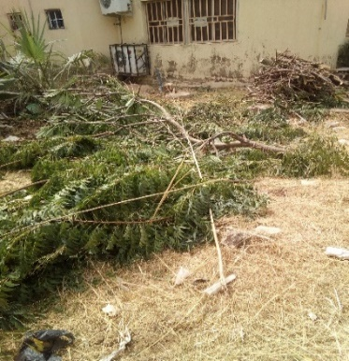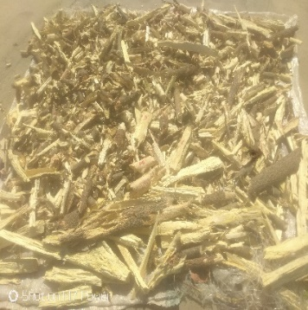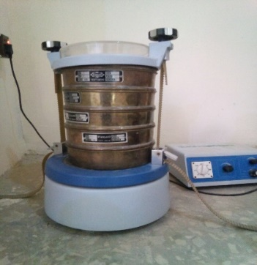

(a) (b) (c)

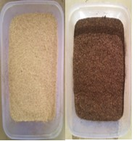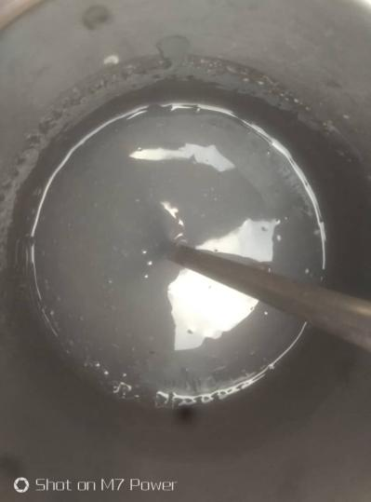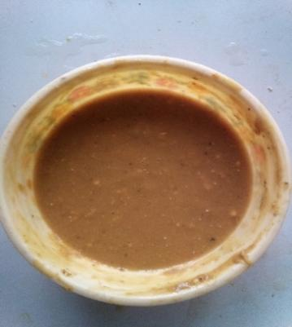

(d) (e) (f)

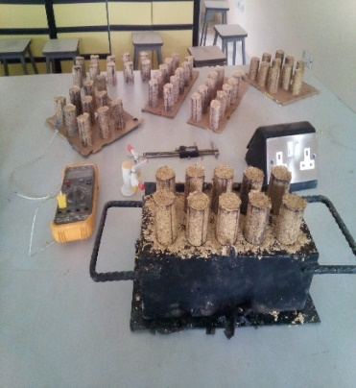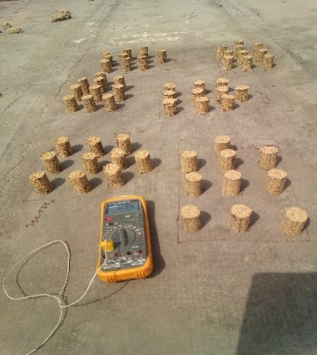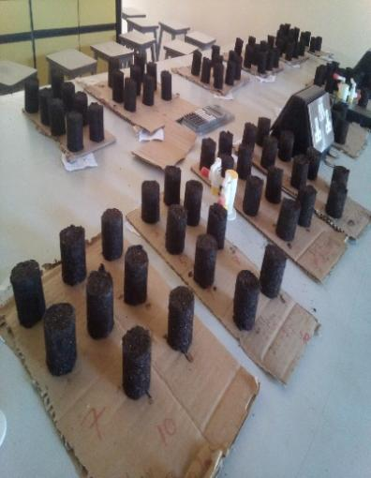

(g) (h) (i)

Plate1: Cross-section of briquette production processes: (a) Waste biomass residues from trimming activities, (b) Sun-drying of sorted and shredded residues (c) Sieving process of shredded residues (d) Raw and Torrefied samples of pulverized biomass residues (e) Prepared cassava flour binder (g) Prepared African locust bean Pulp binder (g) Produced briquettes (h)-(i) Drying of the raw and torrefied briquette fuels.

**2.2.1 Determination of Physical and Mechanical Properties of the Briquettes**

**Maximum and Relaxed Densities**

The maximum density $ρ_{m}$ and relaxed density $ρ_{r}$ of the briquettes were determined following the methods outlined by Olorunnisola (2007). The mass of each briquette was measured using a digital scale, and its volume was calculated with dimensional measurements using vernier calipers, both immediately after production (for maximum density) and after drying (for relaxed density).

The relaxation ratio, $RR$ and density ratio $DR$ of the briquette were obtained using equation (1) and (2) as demonstrated by Oladeji and Enweremadu, (2012):

$$RR=\frac{ρ_{m}}{ρ_{r}} (1)$$

$$DR=\frac{1}{RR} (2)$$

**Shatter index**

The shatter index is used to measure how durable the briquettes are. The durability of the briquettes was assessed using the shatter index, as described by Mandal *et al.* (2019). This involved repeatedly dropping the briquettes from a height of 1.5 meters onto a concrete surface. The amount of material remaining intact after each drop indicated the briquette's breakability, and the overall percentage of material lost was calculated using the formula provided by Sengar *et al.* (2012);

$$Percentage of weight loss=\frac{W_{a}-W_{b}}{W_{a}} ×100 (3)$$

$$\% Shattered=100-\% weight loss (4)$$

where; $W_{a},W_{b}$ = weight of briquette before and after shattering in grams.

**Water Resistance Test**

The porosity of briquettes impacts their water absorption capacity. A water absorption test was conducted to measure the amount of water absorbed under specific conditions. The resistance to water penetration test was used to evaluate how well the briquettes withstand exposure to water, such as during rainy seasons or in humid environments. It was ascertained by submerging the briquette fully in water at room temperature (27°C) for 30 seconds, and the increase in weight was recorded to determine the percentage of water absorbed, following the method reported by Ikubanni *et al.* (2020). The water gain percentage was calculated using equation (5) as reported by Ramani *et al*. (2022).

$$\% Water gained by the briquettes=\frac{W_{a}-W_{b}}{W_{b}}×100 (5)$$

where $W_{a}$ and $W_{b}$ are the weight of the briquette before and after water immersion. The percentage resistance to water penetration was calculated by extraction as shown in equation (6);

$$\% Resistance to water Penetration=100-\left(\%water gained\right) (6)$$

**Tumbling Resistance Test**

The durability of the briquettes was further tested using a tumbling test, which assessed their resistance to breakage upon impact. The test was carried out using a sieve shaker according to British Standards for fuels EN 15210-1 (2009) as reported by Ohagwu *et al.* (2022). As illustrated in Plate 2 (a-c), the mass of the briquette samples was first recorded using a digital scale, then placed on a vibrating screen and set into vibrations for 10 minutes, after which the briquette’s mass was re-calculated to determine their durability.

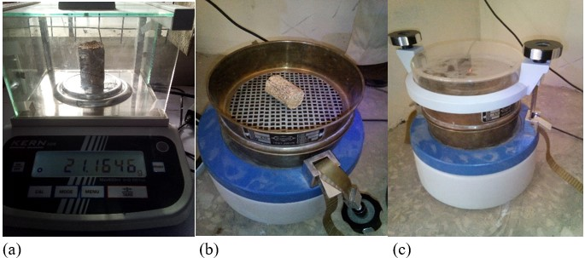

Plate 2: Cross-section of tumbling resistance test of the briquette (a) Briquette mass measurement

(b) Briquette placed on a vibrating screen (c) Tumbling resistance set-up.

Tumbler resistance was evaluated as a percentage of weight loss that occurred during the process (Ramani *et al.,* 2022):

$$\% Weight loss=\frac{W_{a}-W_{b}}{W_{a}}×100 (7)$$

where $W_{a}$ and $W_{b}$ are the weight of the briquette before and after tumbling process. The percentage durability index was calculated by extraction as shown by equation (8);

$$Durability index=100-\left(\%weight loss\right) (8)$$

**3. RESULTS AND DISCUSSION**

This section presents the results obtained from the evaluation of the briquettes' physico-mechanical properties, including the maximum and relaxed densities, relaxation and density ratios, shatter, tumblance, and water resistance tests. The findings are also discussed here:

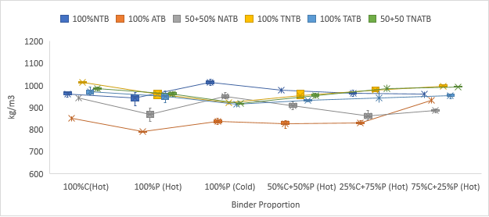

Figure 1: Maximum Density of raw and torrefied material briquettes

As shown in figure 1, the maximum density of the material briquettes obtained after release from the mold varied from 789.72 kg/m³ to 1015.04 kg/m³ for one hundred percent Almond Tree Briquette (100% ATB) bonded with one hundred percent hot-prepared Locust bean Pulp (100% P-hot) and one hundred percent Neem tree briquette (100% NTB) bonded with one hundred percent cold-prepared locust bean pulp (100% P-cold) for the raw samples. For torrefied samples, the maximum density ranged from 913.62 kg/m³ to 1013.65 kg/m³ for one hundred percent Torrefied Almond Tree Briquette (100% TATB) bonded with one hundred percent cold-prepared locust bean pulp (100% P-cold) and one hundred percent Torrefied Neem Tree Briquette (100%TNTB) bonded with one hundred percent hot-prepared cassava starch (100%C). According to the minimal values obtained in the study, the maximum density of the torrefied briquettes is 15% higher than that of the raw briquettes. The values obtained for both raw and torrefied briquettes surpass the range reported for corncob briquettes (Oladeji and Enweremadu, 2012) and favorably above 739.61-987.65 kg/m³ reported for briquettes made from water hyacinth and phytoplankton scum binder (Davies and Davies, 2013). The results obtained for all the briquettes in this study exceeded the minimum value of 600 kg/m³ needed for efficient transportation and storage, as noted by Gilbert *et al.* (2009). Therefore, torrefied briquettes are considered to be more efficient for transportation, storage and practical application and possessed more energy per unit volume.

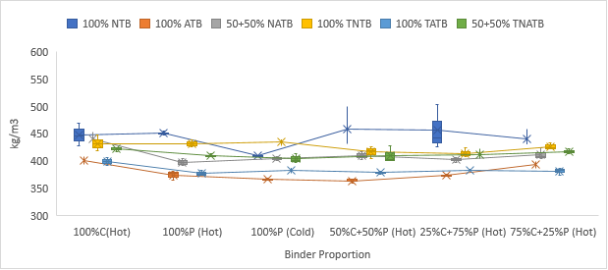

Figure 2: Relaxed Density of raw and torrefied material briquettes

The relaxed density of the briquettes as shown in figure 2 varied between 363.64 kg/m³ and 457.67 kg/m³ for 100% ATB and 100% NTB produced using 50%P+50%C (hot) binder mix. These figures are higher than those previously reported for corncob briquettes (Oladeji and Enweremadu, 2012) and fall within the range observed for neem wood residue briquettes using starch and gum arabic as binders (Sotande *et al.,* 2010); and 327 kg/m³ to 472 kg/m³ for raw and torrefied cornhusk and sawdust feedstocks (Akogun *et al.*, 2020). The higher density values for both raw and torrefied briquettes in this study suggest effective compaction during the briquette-making process, resulting in high-quality briquettes.

1. 100% NTB

(b) 100% ATB

(c) 50+50% NATB

(d) 100% TNTB

(e) 100% TATB

(f) 50+50% TNATB

Figure 3: Relaxation and Density ratio of (a) 100%NTB (b) 100% TAB (c) 50+50% NATB

(d) 100%TNTB (e) 100% TATB (f) 50+50% TNATB.

The relaxation ratio (Figure 3) ranged from 2.09 to 2.52 for 100% NTB and 100% TATB briquettes made using 100%P (hot). These values align with the 1.82-2.86 range reported for corncob briquettes of 4.70mm particle size (Oladeji & Enweremadu, 2012) and are lower than the 2.66-2.80 range for sawdust briquettes using African locust bean pulp and cassava starch binders (Namadi *et al.,* 2023). According to Sing et al. (2021), a lower relaxation ratio signifies higher stability, whereas a higher ratio indicates reduced stability. The findings indicate that the briquettes examined in this study are stable and capable of withstanding high impact during practical application. Also, the density ratio ranged between 0.40 to 0.48 for 100% NTB briquettes produced using 100%P (cold) and 100%P (hot) and a blend of 50%C+50%P (hot).These figures are consistent with the 0.35-0.55 range for corncob briquettes of 4.70mm particle size (Oladeji and Enweremadu, 2012), but higher than the 0.37 reported for sawdust briquettes bonded with hot-prepared locust bean pulp binder (Namadi *et al.,* 2023). Briquettes with a 100P+0C (cold) binder had the lowest density ratio. The study also observed that the maximum density and relaxation ratio are directly proportional, meaning that as one increases, the other increases as well.

Figure 4: Percentage shatter resistance test of Raw and Torrefied material briquettes

As depicted in Figure 4, the shatter resistance percentage for briquettes made from raw biomass materials ranged from 39.06% to 99.86% for 50+50% NATB made using 100%P (hot) and 50+50% NATB made using 100%C (hot). Consequently, torrefied samples recorded values between 72.95% to 99.78% for 100% TNTB made using 100%P (hot) and 100% TATB (100%C hot). Higher values observed are comparable to the 90.73 to 99.24% reported for briquettes made using greenhouses waste of peppers, tomatoes, and eggplant (Kabas *et al.,* 2022), 93.45 to 98.74% reported for raw and torrefied cornhusk and sawdust briquettes at 200, 250 and 300℃ (Akogun *et al.,* 2020) and 98.87 to 99.82% for briquettes made from the mixture of biomass and coal (Ramani *et al.,* 2022).

High percentage of shatter resistance indicates the briquette’s ability to withstand shocks and impacts during handling and transportation (Ramani *et al.,* 2022). It was observed that briquettes made with hot-prepared pulp 100%P (hot) had the lowest resistance to shattering mostly, resulting in greater weight loss during testing, similar to the findings of Namadi *et al.* (2023). A shatter index above 86% is recommended for optimal briquette fuel performance (Lubwama *et al.,* 2019). Remarkably, 83% of the samples analyzed in this study exceeded this benchmark, showcasing excellent structural integrity and suitability for fuel applications. Briquette samples that have been torrefied appear to be more resistant to breaking than their counter-parts. This has been attributed to its low moisture content and the torrefaction process's elimination of volatile particles, which promotes the biomass particles' improved adherence and results in a denser and more compact material.

Figure 5: Percentage Tumbling resistance of Raw and Torrefied material briquettes.

Tumbling resistance, as displayed in Figure 5, varied from 86.94% to 99.98% for briquettes made from 100% NTB bonded with 100%P (hot) and 100% ATB bonded with 100%C (hot) and a blend of 75%C+25%P (hot). These values are higher than the 69.09–86.70% reported by Ramani *et al.* (2022) for briquettes made from biomass blends and the 67.41–77.85% observed for briquettes produced using a screw press (Tayde *et al.,* 2010). However, they are closer to the ranges 93.58–95.68% and 83.85–97.95% for sawdust briquettes bonded with okra (Ohagwu *et al.,* 2022) and for mixtures of groundnut husk, sawdust, and soybean straw using a piston-press (Tayde *et al.,* 2010), respectively.

In terms of tumbling resistance test, the binder performance of the raw residues briquettes samples were ranked as: 100%C (hot) > 50%C+50%P (hot) > 75%C+25%P (hot) > 25%C+75%P (hot) > 100%P (cold) > 100%P (hot), while those from torrefied residues briquettes are: 100%C (hot) > 25%C+75%P (hot) > 50%C+50%P (hot) > 75%C+25%P (hot) > 100%P (cold) > 100%P (hot). All briquettes, except those produced using 100% NTB with 100%P (hot) binder, achieved a tumbling resistance of ≥90%, meeting the recommendations set by Tayde *et al.* (2010) and Bajwa *et al.* (2018) for high-quality briquettes that can endure significant impacts during transportation and are suitable for industrial and household applications. The higher shatter and tumbling resistance percentages found in the study suggest that the organic binders used are capable of producing high-quality briquettes. These briquettes maintain their structural integrity during transport, storage, and handling, minimizing material losses and reducing the formation of fine particles or dust that are undesirable for fuel briquettes.

Figure 6: Percentage water resistance test of Raw and Torrefied material briquettes.

As shown in Figure 6, the percentage of water resistance of the material briquettes ranged from 33.13% to 96.12% for 100% ATB made using 100%P (hot) and 50+50% TNATB made using 100%C (hot) binder. These values are greater than 17.49%-52.20% reported by Ramani *et al.* (2022) for briquettes made from de-oiled cake of mahua seed, rice husk, charcoal and grasses; and are closer to 52.0% - 97.1% for briquettes made using water hyacinth and phytoplankton scum as binder (Davies and Davies, 2013). Torrefied briquettes are expected to have a longer lifespan and provide more efficient energy output because they require less energy to remove moisture, which otherwise lowers the fuel's calorific value. Briquettes made with raw materials using locust bean pulp (hot/cold) recorded the highest water absorption, indicating poor performance in humid conditions and a tendency to disintegrate during handling, transportation, and usage. Briquettes made with torrefied residues perform better in terms of resistance to water penetration, with a minimum value of 42.27% as opposed to their raw counterparts with a minimum value of 33.13%.

**Conclusion**

This study evaluated the physico-mechanical properties of briquettes produced from Neem (*Azadirachta indica*) and Tropical Almond (*Terminalia catappa*) branch residues in both raw and torrefied forms, using cassava starch flour and African locust bean (*Parkia biglobosa*) pulp as binders. The results revealed that the torrefied briquettes generally outperformed their raw counterparts across key parameters, including maximum density (789.72–1015.04 kg/m³ raw; 913.62–1013.65 kg/m³ torrefied), relaxed density (363.64–458.21 kg/m³ raw; 377.39–434.51 kg/m³ torrefied), relaxation ratio (2.09–2.48 raw; 2.12–2.52 torrefied), and density ratio (0.40–0.48 raw; 0.40–0.47 torrefied). Furthermore, briquettes made from different binder proportions from both raw and torrefied exhibited superior mechanical resilience, with higher values recorded for shatter resistance (39.69%–99.86% raw; 72.95%–99.78% torrefied), tumbling resistance (86.94%–99.98% raw; 90.95%–99.84% torrefied), and water resistance (33.13%–96.02% raw; 40.28%–96.12% torrefied). These improvements suggest enhanced durability, structural integrity, and moisture resistance of the briquettes, making them better suited for transportation, storage, and practical usage as solid biofuels. In conclusion, torrefaction process significantly enhances the overall performance of the briquettes, positioning torrefied briquette as more reliable option for sustainable energy applications.

**References**

Abidina, A., Bello, M.B. & Abubakar, B. (2020). Conservation of Neem Tree in Katsina State, Northwest Nigeria. International Journal of Natural Resource Ecology and Management. Special Issue: Forest and Wildlife Management. Vol. 5(1):1-5 doi: 10.11648/j.ijnrem.20200501.11.

Akogun O.A, Waheed, M.A. Ismaila, S.O & Dairo, O.U. (2020) Co-briquetting characteristics of cassava peel with sawdust at different torrefaction pre-treatment conditions. Energy source part A. Recov. Utiliz Environ Effect 1-19, http//doi.org:10.1080/15567036.2020.1752333.

Akogun, O. A and Waheed, M. A. (2019). Property Upgrades of Some Raw Nigerian Biomass through Torrefaction Pre-Treatment- A Review. Journal of Physics: Conference Series. 1378 032026, doi:10.1088/1742-6596/1378/3/032026.

Akorede, M. F., Ibrahim, O., Amuda, S. A., Otuoze A. O. and Olufeagba, B. J. (2017). Current status and outlook of Renewable Energy Development in Nigeria. Nigerian Journal of Technology (NIJOTECH),36(1) pp. 196 – 212, ISSN: 0331-8443, Electronic ISSN: 2467-8821, <http://dx.doi.org/10.4314/njt.v36i1.25>.

Altun, N.E., Hicyilmaz, C. and Kök, M. V. (2001). Effect of different binders on the combustion properties of lignite part I. Effect on thermal properties. J Therm Anal Calorim ;65:787–95.

Arinola, S. O., Oje, O. J and Omowaye-Taiwo, O. A. (2019). Evaluation of Physicochemical Properties and Phytochemical composition of African Locust Bean (Parkia Biglobosa) Pulp, *Applied Tropical Agriculture Volume 24, No 1, 64-69.*

Bajwa, D.S., Peterson, T. Sharma, N., Shojaeiarani, J. and Bajwa, S.G. (2018). A review of densified solid biomass for energy production. *Renewable and Sustainable Energy Reviews* 96:296–305. https://doi.org/10.1016/j.rser.2018.07.040.

Bergman, P.C.A. (2005). *Combined Torrefaction and Pelletisation:* the TOP Process, Report ECN-C-05-073, Petten, ECN, The Netherlands.

Bui, H.H, Tran, K.Q & Chen, W.H (2015). *Pyrolysis of microalgae residues - A Kinetic study*. *Bioresource Technology.* **199** :362–366.

Cardona, S., Gallego, L. J., Valencia, V., Martínez, E., & Rios, L. A. (2019). *Torrefaction of eucalyptus-tree residues: A new method for energy and mass balances of the process with the best torrefaction conditions. Sustainable Energy Technologies and Assessments, 31, 17–24.* doi:10.1016/j.seta.2018.11.002.

Chen, L., Xing, L.and Han, L. (2009). Renewable energy from agro-residues in China: Solid biofuels and biomass briquetting technology. Renew. *Sustain. Energy Rev.;* *13*, 2689–2695.

Chen, W.H & Kuo, P.C. (2011). *Torrefaction and co-torrefaction characterization of hemicellulose, cellulose and lignin as well as torrefaction of some basic constituents in biomass.* *Energy*, **36** :803–11.

Chin, O. C. and Siddiqui, K. M. (2000). Characteristics of some biomass briquettes prepared under modest die pressure. Biomass and Energy 18: 223-228.

Chou, C.S., Lin S.H., Peng, C.C. and Lu, W.C. (2009). The optimum conditions for preparing solid fuel briquette of rice straw by a pistonmold process using the Taguchi method. Fuel Process Technol 90: 1041–1046.

Davies, R.M and Davies, O. A. (2013). Physical and Combustion Characteristics of Briquettes Made from Water Hyacinth and Phytoplankton Scum as Binder. Hindawi Publishing Corporation. Journal of Combustion. Volume 2013, Article ID 549894, <http://dx.doi.org/10.1155/2013/549894>.

Edmund, O. (2015). Combustion Analysis and Devolatilazation kinetics of Gmelina, Mango, Neem and Tropical Almond Woods under Oxidative Condition, International Journal of Renewable Energy Research*,5 (4):1024-1033.*

Emerhi, E. A. (2011). Physical and combustion properties of briquettes produced from sawdust of three hardwood species and different organic binders. Pelagia Research Library, Advances in Applied Science Research, 2 (6):236-246, ISSN: 0976-8610.

Falemara, B.C., Joshua, V.I , Aina. O.O, and Nuhu R.D (2018). Performance Evaluation of the Physical and Combustion Properties of Briquettes Produced from Agro-Wastes and Wood Residues. *Recycling,* *3*: 37; doi:10.3390/recycling3030037.

Fujinmi, A. O., Adedeji, S. K., Hassan, W. A., and Babatunde, G. M. (1990). Inclusion of neem seeds as feedstuff in rabbit concentrate ration. Appl. Rabbit Res., 13: 125-6.

Gilbert, P., Ryu, C., Sharif, V. and Switchenbank, J. (2009). Effect of processing parameters on pelletisation of herbaceous crops. Fuel. 2009;88:1491-1497.

Huang,Y., Q. Yi, G. Wei, J. Kang, W. Li, J. Feng, and K. Xie. 2018. Energy use, greenhouse gases emission and cost effectiveness of an integrated high– and low–temperature Fisher–Tropsch synthesis plant from a lifecycle viewpoint. *Applied Energy*, 228: 1009-1019.

Ikubanni PP, Agboola OO, Olabamiji TS, Adediran AA, Anisere T, Oladimeji S, (2020). Development and performance assessment of piston-type briquetting machine. Earth and Environmental Science. 2;445(1):012005.

ITTO. 2008. *Annual Review and Assessment of the World Timber Situation*. Japan, International Tropical Timber Organisation.

Kabas, Ö., Ünal, I., Sözer, S., Selvi, K. C. and Ungureanu, N. (2022). Quality Assessment of Biofuel Briquettes Obtained from GreenhouseWaste Using a Mobile Prototype Briquetting Machine with PTO Drive. Energies, 15, 8371. <https://doi.org/10.3390/en15228371>.

Kenechukwu, U. and Kevin, A. (2013). Evaluation of Binders in the Production of Briquettes from Empty Fruit Bunches of *Elais Guinensis*. *International Journal of Renewable and Sustainable Energy.* 2(4): 176-179. doi: 10.11648/j.ijrse.20130204.17.

Kim, Y. H.; Na, B. I.; Ahn, B. J.; Lee, H. W. and Lee, J. W. (2015). *Optimal condition of torrefaction for high energy density solid fuel of fast growing tree species. Korean Journal of Chemical Engineering, 32(8), 1547–1553.* doi:10.1007/s11814-014-0360-4.

Kumar D., Singh B. (2017): Role of biomass supply chain man-agement in sustainable bioenergy production. Biofuels, 10(1), pp. 109–119, <http://dx.doi.org/10.1080/17597269.2017.1368060>.

Lubwama, M., Yiga, V.A., Muhairwe, F. and Kihedu, J. (2019). Physical and combustion properties of agricultural residue bio-char bio-composite briquettes as sustainable domestic energy sources, *Renewable Energy.* doi: <https://doi.org/10.1016/j.renene.2019.10.085>.

Mandal, S., Kumar, G.P., Bhattacharya, T.K., Tanna, H.R and Jena, P.C. (2019). Briquetting of pine needles (Pinus roxburgii) and their physical, handling and combustion properties. Waste Biomass Valorization 10 (8): 2415–2424. https://doi.org/ 10.1007/s12649-018-0239-4.

Mbah, B. O., Eme, P. E. and Eze, C.N. (2013). Nutrient Potential of Almond seed (*Terminalia catappa*) sourced from three states of Eastern Nigeria. *African Journal of Agricultural Research* 8(7): 629-633.

Mohammed, T.I. and Olugbade, T. O (2015). Characterization of briquettes from rice bran and palm kernel shell. Int. J. Mater. Sci. Innovations 3(2):60–67.

Muazu, R. I. and Stegemann, J. A. (2017). Biosolids and microalgae as alternative binders for biomass fuel briquetting. J Fuel Process Technol. [doi.org/10.1016/j.fuel.2017.01.019](http://dx.doi.org/10.1016/j.fuel.2017.01.019).

Namadi, S. Musa, A. O. & Gana, U. M. (2023). “Physical and Proximate Analysis of Fuel Briquette made using African Locust Bean (Parkia Biglobosa) Pulp as a Binder”. *Asian J. Res. Rev. Phys., vol. 7, no. 3, pp. 32-43,* DOI: 10.9734/AJR2P/2023/v7i3143.

Namadi, S., Musa, A.O. and Gana, U, M. (2024). Design, Construction and Performance Evaluation of a Low-Cost Portable Moulder for Biofuel Briquette Production. International Journal of Novel Research in Physics Chemistry & Mathematics. Volume 11 (2): 31-43. Doi: https://doi.org/10.5281/zenodo.13149522.

Nazari, M.M and Idroas, M. Y. (2019). Production of Carbonized Briquette Made from Empty Fruit Bunch (EFB) by Carbonization Treatment. Proceeding International Conference on Advanced Research in Renewable Energy (ICARRE 2019) (eISBN: 978-967-16859-1-4), Pp: 44-50.

Nurhayati, A.Y., Hariadi, Y.C. and Hasanah, W. (2016). Endeavoring to Food Sustainability by promoting corn cob and rice husks briquetting to fuel energy for small scale industries and household communities, Agriculture and Agricultural Science Procedia 9 (9: 386-395.

Ohagwu, C.J, Nwakaire, J.N, Amaefule, D.O, Nwaezeh, C.D & Anyanwu, C.N. (2022). Physicomechanical and fuel properties of sawdust briquettes using Abelmoschus esculentus waste as a binder. Agricultural Engineering International: CIGR Journal.;24(2):83-94.

Ojaomo, E. K., Maliki, O. B. and Olusanya, A. J. (2015). Development of a Simple Briquetting machine for Small Scale Application International Journal of Engineering Research & Technology (IJERT) Vol. 4 Issue 05, ISSN: 2278-0181. IJERTV4IS050826.

Oke, P. K, Olugbade, T. O. and Olaiya, N. G. (2016). Analysis of the effect of varying palm kernel particle sizes on the calorific value of palm kernel briquette. Br J Appl Sci Technol 14(2):1–5.

Oladeji, J.T, & Enweremadu, C.C. (2012). The effects of some processing parameters on physical and densification characteristics of corncob briquettes. International Journal of Energy Engineering. 2012;2(1):22-27. DOI: 10.5923/j.ijee.20120201.04.

Olatidoye, O. P., Sobowale S. S, Akinlotan, J. V. And Olorode, O. O. (2011). Chemical Composition and Physicochemical Characteristics of Tropical Almond Nuts (Terminalia Catappa L) Cultivated In South West Nigeria. Journal of Medical and Applied Biosciences, ISSN 2277-0054.

Olorunnisola, A.O. (2007). “Production of fuel briquettes from waste paper and coconut husk admixtures,” *Agricultural Engineering* *International*, vol. 1X, article EE 06 066.

Omoniyi, T. E. & Ojo, O.O. (2023). Design and fabrication of an improved low-cost biomass briquetting system for rural communities. Journal of the Ghana Institution of Engineering (2023) 23:4 https//doi.org/10.56049/jghie.v23i4.118.

Pahla, G, Ntuli, F. & Muzenda, E. (2017). “Torrefaction of landfill food waste for possible application in biomass co-firing. Waste Management” <https://doi.org/10.1016/j.wasman.2017.10.035>

Pestaño, L.D.B. and Jose, W.I. (2016) *Production of Solid Fuel by Torrefaction Using Coconut Leaves as Renewable Biomass*. Int. Journal of Renewable Energy Development, 5(3), 187-197. <http://dx.doi.org/10.14710/ijred.5.3187-197>

Ramani, M., Savaliya, L and Chauhan, P. M (2022). Development and Experimental Investigation of Briquetting Machine for Use in Rural Area. *12(11): 2868-2878, 2022; Article no.IJECC.92030. ISSN: 2581-8627.* DOI: 10.9734/IJECC/2022/v12i1131279.

Rousset, P., Aguiar, C., Labbé, N. & Commandré, J.M (2011). Enhancing the combustible properties of bamboo by torrefaction. *Bioresource Technology,* **102** :8225–31.

Saleh, S., Hansen, B.B., Jensen, P.A. and Johansen K.D. (2013). “Efficient fuel pre-treatment: simultaneous torrefaction and grinding of biomass”. Energy Fuel: 27(12):7531-7540.

Sarker, T. R., Nanda, S., Dalai A. K. and Meda, V. (2021). A Review of Torrefaction Technology for Upgrading Lignocellulosic Biomass to Solid Biofuels. Bioenergy Research, 14:645-669, https://doi.org/10.1007/s12155-020-10236-2

Sengar, S.H., Mohod, A.G., Khandetod, Y. P, Patil, S. S & Chendake, A.D. (2012). “Performance of briquetting machine for briquette fuel,” *International Journal of Energy Engineering*, vol. 2, no. 1, pp. 28–34, 2012.

Singh, H., Adeleke, A.A, Singh, C., Ikubanni, P.P, Orhadahwe, T.A, & Agboola, O.O. (2021). Agglomeration of Pet Coke and Rice Straw as Mixed Fuel for Power Generation. Pet Coal; 63(2): 356-365.

Sotannde, O. A., Oluyege, O. A and Abah, G. B. (2010). Physical and Combustion properties of charcoal briquettes from neem wood residues. International Agrophysics, 24: 189-194, DOI: 10.1007/s11676-010-0010-6.

Sotannde, O. A., Oluyege, O. A. and Abah, G. B. (2010). Physical and Combustion properties of charcoal briquettes from neem wood residues. International Agrophysics, 24: 189-194, DOI: 10.1007/s11676-010-0010-6.

Tayde, S., Pohare, J And Mahalle, D.M. (2010). Physical and thermal properties of briquettes by piston press and screw press, *International Journal of Agricultural Engineering,* Vol. 3(2): 223 -227.

Toor, S. S , Rosendahl, L, and Rudolf, A. (2011). *Hydrothermal liquefaction of biomass: A re- view of subcritical water technologies*. *Energy,* **36** :2328–42.

Tumuluru, J.S, Sokhansan, S., Hess, J.R., Wright, C.T and Boardman R.D. (2011). *A review on biomass torrefaction process and product properties for energy applications.* Ind. Biotechnology, 7(5):384-401.

Yaman, S., Şahan, M., Haykiri-açma, H., Şeşen, K. and Küçükbayrak, S. (2000). Production of fuel briquettes from olive refuse and paper mill waste. Fuel Process Technol 68(1):23–31.

Zhao, G. (2018). Assessment of potential biomass energy production in China towards 2030 and 2050. Int’l Journal of Sustain Energy ;37 (1):47-66.

Zhao, Y., Chang, H., Ji, D. and Liu, Y. (2001). The research progress on the briquetting mechanism of fine coal. Coast. Conserv. 24:12–24.