Journal Name: | Asian Journal of Research and Reviews in Physics
Manuscript Number: | Ms_AJR2P_131792
Title of the Manuscript: | Development of IoT Smart Voltmeter for Real time Voltage Monitoring
Type of the Article | Original Research Article

PART 1: Comments

 | Reviewer’s comment  Artificial Intelligence (AI) generated or assisted review comments are strictly prohibited during peer review. | Author’s Feedback (Please correct the manuscript and highlight that part in the manuscript. It is mandatory that authors should write his/her feedback here)
Please write a few sentences regarding the importance of this manuscript for the scientific community. A minimum of 3-4 sentences may be required for this part. | This manuscript aims to explore the development of an IoT digital voltmeter to provide flexible and reliable voltage measurements wirelessly. The development of a wireless voltmeter with the ability to measure both AC and DC voltages and transmit data for remote monitoring can enhance various applications in electronics and electrical engineering such as farming, engineering, and manufacturing.
Is the title of the article suitable?  (If not please suggest an alternative title) | Yes.
Is the abstract of the article comprehensive? Do you suggest the addition (or deletion) of some points in this section? Please write your suggestions here. | Yes, the abstract provides a comprehensive overview of the article, and no need for adding or deleting points.
Is the manuscript scientifically, correct? Please write here. | - The flow chart of the program design (Figure 2) is not clear enough and has mistakes. Specifically, this part is shown in the figure below and needs to be changed. For example, what is the next step after performing ‘BCD conversion’?, and the step of ‘variable mode selection’ can be replaced by ‘Is mode pin high?’ if yes it will measure AC voltage else it will measure DC voltage. I suggest redesigning the flowchart.  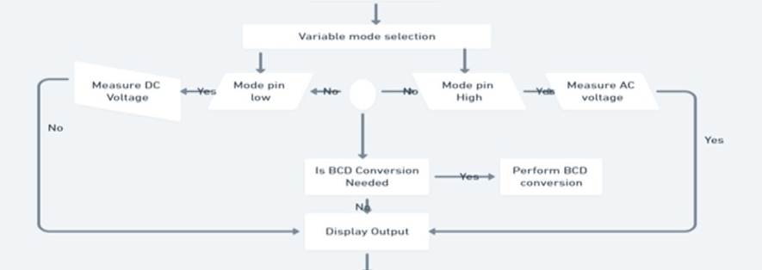  - The author needs to explain the program design more clearly.  - A related work section needs to be added to this article, containing the recent research in the field and what the author achieved compared to the other works.  - What is the function used to calculate performance measurements such as accuracy, error, and efficiency for AC and DC voltage?
Are the references sufficient and recent? If you have suggestions of additional references, please mention them in the review form. | - All the references are related to the manuscript topic, however some are outdated such as 1994, 1985, 2008, etc. Please use more resent works on IoT applications in voltage measurement and improvements in ESP32 microcontrollers to enhance this article.  The reference style used is not consistent. Please ensure to follow the same citation style based on the journal guidelines. All references should consist of Author Names, year of publication, Publication Titles, Journal Names, Volumes, URLs, and DOIs.
Is the language/English quality of the article suitable for scholarly communications? | The language quality is generally good.

Optional/General comments

PART 2:

 | Reviewer’s comment | Author’s comment (if agreed with the reviewer, correct the manuscript and highlight that part in the manuscript. It is mandatory that authors should write his/her feedback here)
Are there ethical issues in this manuscript? | (If yes, Kindly please write down the ethical issues here in detail)

Reviewer Details:

Jawaher Abdulwahab Fadhil, University of Duhok, Iraq

