**SEASONAL AND ANNUAL VARIATIONS OF SOLAR QUIET OF THE HORIZONTAL MAGNETIC FIELD ALONG THE AFRICAN GEOMAGNETIC EQUATOR DURING THE ASCENDING PHASE OF SOLAR CYCLE 24**

**Abstract**

The seasonal and annual variation of the solar quiet of the horizontal magnetic field along the African geomagnetic equator during the ascending phase of solar cycle 24 has been investigated. We used magnetic field measurements obtained from International Real-time Magnetic Observatory Network (INTERMAGNET) stations in Ethiopia, Addis Ababa (AAE) and Mbour (MBO) in Senegal and African Meridian B-field Education and Research (AMBER) arrays data at Yaoundé (CMRN), Cameroon and Adigrat (ETHI), Ethiopia for the duration from January 2009 to December 2014. The results showed that in the African equatorial region, the equinoctial peaks of solar quiet of Horizontal component of the magnetic field (SqH) were generally higher than the peaks during the D and J seasons. The largest seasonal SqH values were observed during the March equinox and December equinox in the year 2014 while the largest annual values were observed in the year 2014. There was a solar activity and a dependence on the local time for the annual geomagnetic field variation in SqH. The SqH magnitude increased with increasing activity of the sun, with the highest attained amplitudes in the years 2012 and 2014 which were high solar activity years. The daily peaks were seen at around local noon for all the stations under this study. The maximum peaks during the years when the solar activity was low occurred slightly earlier than peaks during high years when it was high.

Key words: Horizontal magnetic field, seasonal variation, annual variation, solar cycle 24

1. **Introduction**

The magnetic field of the Earth is produced by the ionospheric dynamo and electric current  
system moving through its ionosphere. Geomagnetic field variations may be temporal, spatial or longitudinal, secular or transient, quiet daily or disturbance daily [1]. Some of the geomagnetic field variations which are of much significance to space weather observations at equatorial latitudes are the solar quiet (Sq) variation and the storm- time variation [2]. The geomagnetic field variations at the surface of the Earth’s when the geomagnetic conditions are quiet occurring within a period of 24 hours are termed are called solar quiet or Sq variations [3]. Also of much interest is the Equatorial Electrojet current (EEJ) [4], flowing as an eastward current that is enhanced or intensified in the ionosphere’s E-region between heights of 100km and 120km at the geomagnetic equator [5]. The dynamics of the equatorial ionosphere varies from one sector to another. In Africa the dynamics in the West and East African sectors are different [6]. This electrodynamic longitudinal variation is effected by longitudinally varying magnetic field of the Earth which modulates the neutral winds in the thermosphere together with the ionosphere’s plasma density [7]. There is need to further investigate into this disparity in African equatorial region in the inclining phase of solar cycle 24 to establish the physical processes that contribute to this variation for various seasons under quiet and disturbed conditions. The ionosphere which is the atmospheric region ranging from above 60km to 1000km altitude is known for large ion densities which are sufficient to affect radio wave propagation. The current system in the ionosphere is attributed to a dynamo action of the horizontal wind system and its electrical conductivity as a result of the electrons and ions found in the ionosphere [8]. The ionospheric current is more concentrated at the dip equator due to the accelerated value of electrical conductivity of the upper atmosphere at the region which arises from an inhibition of hall current which arises since the geomagnetic field is horizontally structured and the ionosphere is horizontally stratified [5]. It has therefore continued to attract research interest due to its increasing application in radio-communication. The current study seeks to find the effect of these currents particularly the EEJ in the African equatorial region to establish its annual and seasonal trends for planning of space events. The annual and seasonal variability of the solar quiet (Sq) and storm time fluctuations has been studied in the recent by a number of researchers. Ranasinghe et al [9] investigated inter-hemispheric field aligned currents (IHFACs) seasonal variation for the solar cycle 23 and 24. This was done by analyzing geomagnetic field data within the equatorial region using time series. The results showed that the night side IHFACs flowed in a common direction as the noon side in June solstice and in December solstice. The night sector was also observed to depend on the solar cycle. Idowu & Adimula, [10] used data from six MAGDAS magnetic observatories to characterize the horizontal component of earth’s magnetic field. They investigated its seasonal, annual and hourly variations in some stations along the 210O magnetic meridian from the year 2007 to 2009. The results indicated that the highest values of Sq were realized during equinoxes at around 1300LT. the highest annual magnitude recorded was 70.96nT in 2009 while the lowest value was 27.25nT in the same year. Omondi et al [11] studied the variation of the geomagnetic field at the quiet time based at the East African equatorial region. The results showed that local time and activity of the sun affected the Sq(H) and the mean of Sq. The highest amplitudes occurred between 1100LT and1200LT and it increased as the solar activity increased. This dependence on local time was attributed to changes in solar heating and the varying rates of ionization. Owalabi et al [12] studied seasonal variation of worldwide solar quiet of the horizontal magnetic field intensity. They investigated the variations of Sq over the various seasons Winter (November, December, January and February), Summer (May, June, July, August), Autumn (September, October) and Spring (March, April), using data from 64 geomagnetic stations for the year 1996 across the globe. The seasonal variations were studied across various latitudes and longitudes. Their results showed that Sq(H) exhibited transient variations with varying amplitude according to seasons of the year. The December solstice Sq(H) magnitude of ~ 440 nT ~~and~~ located at the high latitudes south eastern part of the globe, was greater than June solstice Sq(H) magnitude of ~ 320 nT ~~and~~  located at the high latitudes north eastern part of the globe. The autumn Sq(H) magnitude of 240 nT – 440 nT at the high latitudes North western ~~and~~ with values ranging from 220 nT – 320 nT at the high latitude south eastern part of the globe was greater than the spring Sq(H) magnitude of 220 nT – 300 nT at the high latitudes north western part of the globe and 220 nT at the high latitudes south western part of the globe. Rabiu et al [5] investigated the variability of equatorial ionosphere inferred from geomagnetic field measurements. They used ground based geomagnetic field data of horizontal and vertical field intensities obtained at the isolated terrestrial equatorial station of Ibadan (07.22◦N 03.58◦E). The values of Sq daily variation rose from the early morning period to maximum at about local noon and fell to lower values towards evening. The ionospheric current responsible for the magnetic field variations was inferred to build up at the early morning periods and attain maximum intensity at about local noon. The daytime variations in resultant solar quiet daily variations in horizontal and vertical fields were generally greater than night time. The rising rate of the ionospheric Sq current was generally greater than the decay rate. The vertical daytime ExB drift velocity in the ionospheric F region and the daytime strength of the equatorial electrojet were inferred to have seasonal variation. The scattering of variation was more on the disturbed condition than the quiet condition. This was due to the ionospheric disturbances originating from external drives, such as, space weather effects and storms. The seasonal variation was attributed to seasonal shift in the mean position of the Sq current system of the ionospheric electroject and the electrodynamics effects of local winds.

In the present paper we investigate the solar quiet seasonal and annual variations of the Earth’s magnetic field along the African equatorial regions using data for the stations: Adigrat (ETHI), Addis Ababa (AAE), Younde (CMRN) and Mbour (MBO) during the ascending phase of solar cycle 24. This work brings out the features of solar quiet seasonal and annual variations over four stations in the African equatorial region for the years 2009, 2010, 2011, 2012, 2013 and 2014.

**2.0 Data acquisition and methodology**

**2.1 Data sources**

**2.1.1Geomagnetic indices data**

Geomagnetic activity indices: planetary magnetic index, Kp and Disturbance storm time (Dst) index used to identify the most quiet and highest disturbed days of every month for the whole study period were obtained from the website: [*http://wdc.kugi.kyoto-u.ac.jp/cgi-bin/kp-cgi*](http://wdc.kugi.kyoto-u.ac.jp/cgi-bin/kp-cgi) of world data centre for geomagnetism located at Kyoto, Japan.

**2.1.2 Magnetic field data**

Magnetic field measurements were obtained from International Real-time Magnetic Observatory Network (INTERMAGNET) stations in Ethiopia, Addis Ababa (AAE) and Mbour (MBO) in Senegal and African Meridian B-field Education and Research (AMBER) arrays data at Yaoundé (CMRN), Cameroon and Adigrat (ETHI), Ethiopia for the duration from January 2009 to December 2014 whose geomagnetic locations are as in Figure 1.

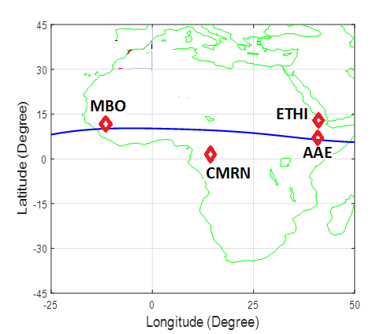

Figure 1: Plot of geomagnetic locations of magnetometer network for: AAE, ETHI, CMRN and MBO

Geographic and geomagnetic location information of Magnetometer network for: AAE, ETHI, CMRN and MBO were used in this study is given in Table 1:

Table 1: Geographic and geomagnetic locations of AAE, ETHI, CMRN and MBO

|  |  |  |  |  |  |
| --- | --- | --- | --- | --- | --- |
| STATION ID | STATION NAME | Geographic Latitude | Geographic Longitude | Geomagnetic Latitude | Geographic Longitude |
| AAE | Addis Ababa | 9.0oN | 38.8oE | 0.9oN | 110.5oE |
| ETHI | Adigrat | 14.3oN | 39.5oE | 5.80oN | 111.06oE |
| CMRN | Yaunde | 3.87oN | 11.52oE | 5.30oS | 83.12oE |
| MBO | Mbour | 14.43oN | 16..97oW | 2.06oN | 58.24oE |

**2.2 Methodology**

**2.2.1. Quiet time classification**

The classification criterion for selecting quiet time was Kp values ≤ 2 and Dst > -20nT starting from 1st January, 2009 and ending on 31st December, 2014 [13].

The H- component for a single day from stations under study was calculated using equation 1,

 (1)

The daily baseline for the geomagnetic field component that was used in this study was obtained using equation 2,

 (2)

where H1, H2, H23 and H24 are the hourly values of H during the 4 hours flanking local midnight [5].

Night time values are preferred because the ionospheric E-region which provides the dynamo current disappears at night and the magnetic field around midnight is considered to be constant, constituting only the main field [14].

Hourly deviations of H component from midnight baseline, ΔH were calculated by getting the difference between the values of midnight baseline for a given day and the hourly values of that given day using equation 3,

 (3)

where t=1 to 24 LT (Hours) [5].

During quiet conditions, it is expected that the geomagnetic field displays a pattern of  
variation similar to periodic function in which, the magnitude at 00:00 LT (Hrs) is the same as the magnitude at 24:00 LT (hrs). However, it is usually not so and a non-cyclic variations correction needs to be done on the availed data [15].

In this study, the hourly deviations were rectified for non-cyclic variations by linearly adjusting the daily hourly magnitudes of ΔH by considering the hourly departures ΔH at 01:00LT, 02:00LT,……., 24:00LT as V1, V2,…………,V24 then taking the non-cyclic variation factor as shown by equation 4,

  (4)

The linearly modified values for the hours become equation 5 and 6

 (5)

 (6)

t is the local time from 1 to 24 hours [5].

These corrected hourly departures on non-cyclic variation gave the solar variation in H for each day, Sq (H). An average of daily variations was established for all the quiet days of individual months within the study period to get mean monthly variations in Sq. The approximation of seasonal variations was then done by finding the average of the monthly values for every season. The grouping of the months into seasons was done as: December solstice or D season covering the months of November, December January and February, March equinox or March E season covering March and April, June solstice or J season covering the months of May, June, July and August and September equinox or September E season which took care of September and October in accordance to the works of [5]. The monthly averages of SqH variations across all years were obtained using MATLAB software to define the solar quiet annual variation of the H- field. The results for Sq seasonal variations are shown in Figure 2, Figure 3, Figure 4 and Figure 5 while results for annual variations are shown on Figure 6.

1. **Results and discussions**

**3.1. The solar quiet (Sq) seasonal variation over AAE, ETHI, CMRN and MBO from 2009 to 2014**

Figures 2-5 shows the plots of Sq seasonal variation over AAE, ETHI, CMRN and MBO for the years 2009, 2010, 2011, 2012, 2013 and 2014.

* + 1. **Seasonal variation of SqH at Addis Ababa, Ethiopia for the years 2009, 2010, 2011, 2012, 2013 and 2014**

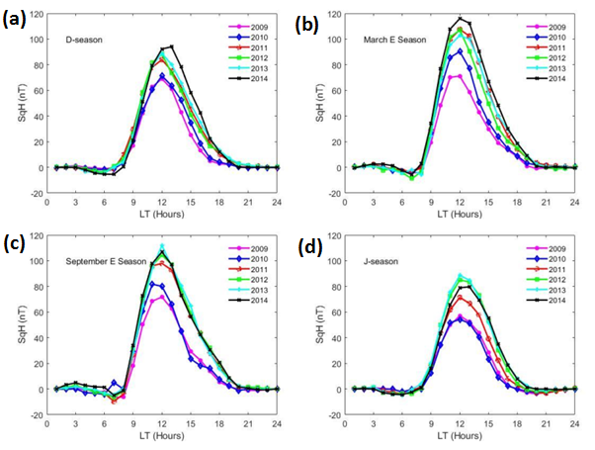

Figure 2: Seasonal variation of SqH at Addis Ababa (AAE), Ethiopia from 2009-2014: (a) D-season (b) March E season (c) September E season (d) J-Season

The peak at Addis Ababa station occurred at local noon for all the seasons. The E-seasons recorded the highest maximums in 2012 of around 110nT with peaks at local noon as indicated by Figure 2(b) and 2(c). The minimum peaks for E-seasons were in 2010 of 90nT. Low peaks were recorded during the J season and D season and the lowest amplitude occurred in 2010 during the J season of 50nT as indicated by Figure 2(a) and 2(d). It was noted from Figure 2(a), 2(b), 2(c) and 2(d) that the magnitudes during the day were greater than those at night for all the seasons.

* + 1. **Seasonal variation of SqH at Yaounde, Cameroon for the years 2009, 2010, 2011, 2012, 2013 and 2014**

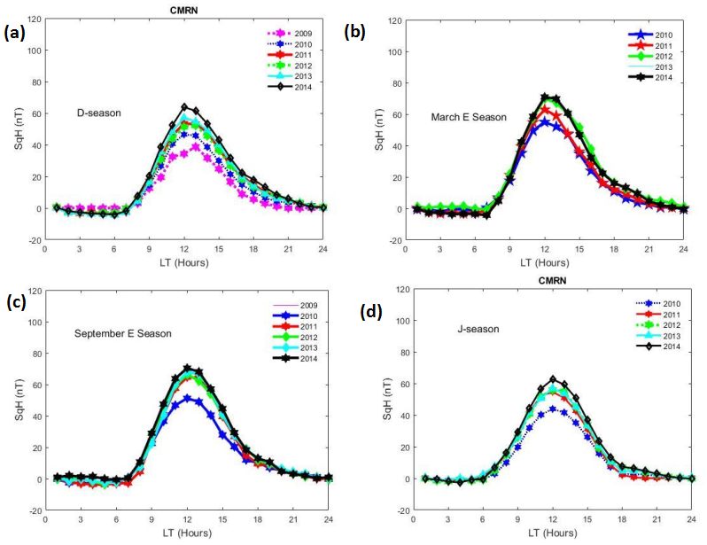

Figure 3: Seasonal variation of SqH at Yaounde (CMRN), Cameroonfrom 2009-2014: (a) D-season (b) March E season (c) September E season (d) J-Season

Yaoundé station recorded the highest peak of 70nT in the year 2014 during the March Equinox. The peaks occurred at local noon for all the seasons as indicated by Figures 3(a), 3(b), 3(c) and 3(d). The minimum peak was recorded in the year 2010 during the J season of about 40nT as indicated by Figure 3(d). The E-seasons recorded higher values of SqH than J and D seasons. The daytime magnitudes were higher than night time magnitudes in each of the seasons in the entire study period as indicated by Figure 3(a), 3(b), 3(c) and 3(d). This was attributed to the high ionization rates during the day as compared to during the night.

* + 1. **Seasonal variation of SqH at Adigrat, Ethiopia for the years 2009, 2010, 2011, 2012, 2013 and 2014**

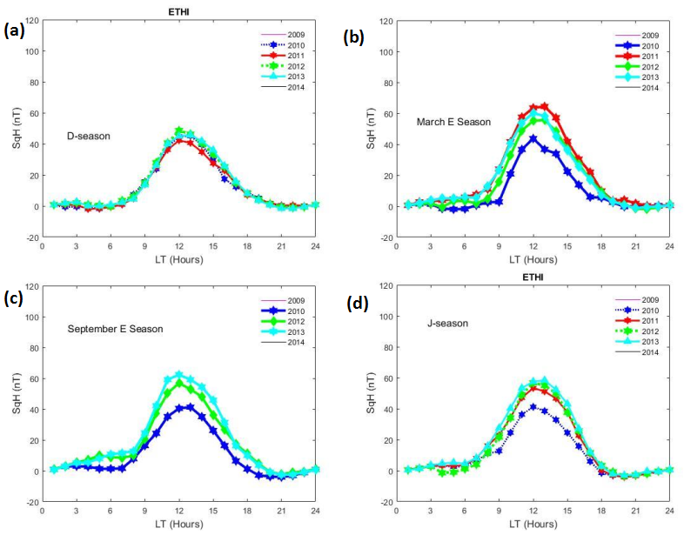

Figure 4: Seasonal variation of SqH at Adigrat (ETHI), Ethiopiafrom 2009-2014: (a) D-season (b) March E season (c) September E season (d) J-Season

Adigrat station showed the highest value of SqH of about 65nT in the year 2012 during the  
March Equinox. The E-seasons recorded generally higher values than J and D seasons as clearly indicated by Figures 4(a), 4(b), 4(c) and 4(d). This was attributed to an enhancement in density of electrons at the equatorial region. The enhanced electron density increases the electrical conductivity during the equinoctial overhead sun. The dynamics of the corresponding electric field also contribute [10]. The SqH seasonal variation peaked slightly before noon during March Equinox but peaked at local noon in the other seasons. This is linked to the increased equatorial electron density that leads to an increase in the electrical conductivity as a result of the overhead position of the sun at the equinox. The minimum for this station occurred in 2010 during the J season. Adigrat also recorded higher daytime magnitudes of Sq as compared to the night time magnitudes. This was attributed to the high rates of ionization during the day than at night.

* + 1. **Seasonal variation of SqH at M'bour, Senegal** **for the years 2009, 2010, 2011, 2012, 2013 and 2014**

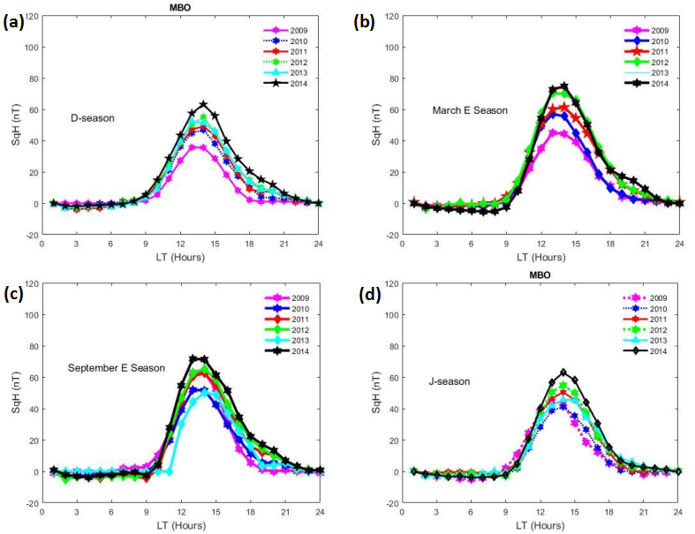

Figure 5: Seasonal variation of SqH at M'bour (MBO), Senegal from 2009-2014: (a) D-season (b) March E season (c) September E season (d) J-Season

Mbour station is an EEJ station. It recorded a maximum SqH of about 78nT during March  
Equinox of 2014 as indicated by Figure 5(b). The E-seasons recorded higher values than J and D seasons as indicated by Figures (5(a), 5(b), 5(c) and 5(d). The minimum peak of 45nT occurred in the year 2010 during the J season as indicated by Figure 5(d). The amplitude of the SqH seasonal peaked between 12.00LT to 2.00LT for all the years under study in MBO.

In summary, the geomagnetic field is observed to exhibit a seasonal variation across all the  
stations under this study. The SqH exhibited roughly the same pattern for D, E and J seasons for the four stations with a maximum of the SqH around 110nT, 70nT, 65nT and 75nT for Addis Ababa, Yaoundé, Adigrat and Mbour respectively during the day. These maximums occurred during the E- seasons while the minimums occurred during J- seasons which were consistent with the results from earlier studies by [16]. The SqH magnitude was small in the D- seasons and J-seasons. The peak at Addis Ababa and Yaoundé stations occurred at local noon for all the seasons. This was attributed to the high ionization rates at around local noon in these stations. The difference in peak time for SqH seasonal variation was as a result of the movement in the average position of the system of Sq current of electrojet in each season and the local wind electrodynamics. The peak at Adigrat occurred slightly before local noon in the E-seasons but occurred at local noon during the D and J seasons, while the peak at Mbour occurred between 1200LT- 1400LT for all the seasons. This was due to the effects of EEJ in Mbour. For Addis Ababa, the E- seasons both recorded the highest maximums in 2012 of around 110nT with peak at local noon. The minimums for E-seasons were in 2010 of about 85nT.The highest peak for CMRN was observed in the year 2014 during the March equinox while the lowest peak for this station was recorded in the year 2010 during the J-season. For Adigrat station, the maximum peak occurred in the year 2012 during the March equinox while the minimum peak was in the year 2010 during the J-season. Adigrat station lacked data for the years 2009 and 2014. Finally, the peaks for Mbour were 78nT in March Equinox which was the maximum and 65nT during the D and J seasons as minimum. Like the other stations, it was clearly noted at MBO that the E-seasons recorded higher values of Sq than the J and D seasons. This was attributed to fact that during the equinoxes the rate of ionization was higher than in the J and D. The highest peaks were recorded in the year 2014 for all the seasons, followed by 2012 then 2011. This was consistent with the sunspot number progression. This study realized that the morning values of SqH were smaller than evening values after the peak which occurred at around local noon. This is because the SqH is dependent on local time and as the time approaches noon and there is increased ionization until around noon when it attains a peak value after which the values decrease towards evening again with decreasing ionization rates.

**3.2. The solar quiet (Sq) Annual variation over AAE, ETHI, CMRN and MBO from 2009 to 2014**

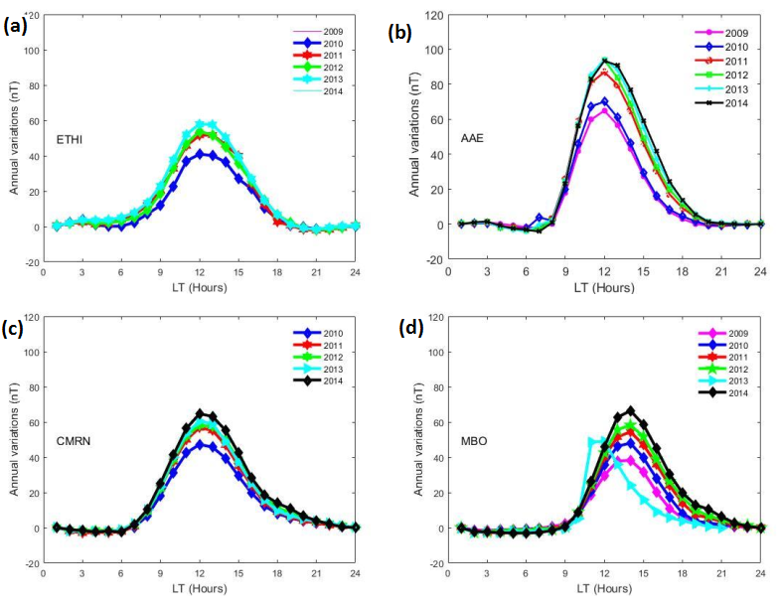

Figure 6: Annual variation of SqH from 2009 to 2024 at: (a) ETHI (b) AAE (c) CMRN (d) MBO

The amplitude of the annual SqH showed local time dependence as indicated in Figures 6(a), 6(b), 6(c) and 6(d). There was a constant increase in amplitude from morning; a peak value was reached at about 1200LT followed by a gradual decrease to a minimum value of about 0nT attained during the evening hours. The highest values were recorded in the year 2014. The peaks at AAE and MBO stations which were within the EEJ zone, were 98nT and 68nT respectively, which were both higher than those for ETHI and CMRN, stations which were outside the EEJ zone which were 58nT and 52nT respectively. This was due to the enhancement of SqH with the equatorial electrojet current at the EEJ region. The SqH magnitude at Adigrat, a station which was off the EEJ region was less than that at Addis Ababa which was within the EEJ region whereas the magnitude at Cameroon. Astation off the EEJ region was also less than that at Mbour which was within the EEJ region. This was in agreement with the description given by [3] on how the daily range of the field of H component is intensified across the magnetic equator. The annual variation was observed to be a function of solar activity as indicated by the SqH value increasing with the rising phase of solar cycle 24 from 2009 to 2014. These results were in agreement with the results reported by [11, 17]**.** It was also evident from this study that the annual SqH values for AAE and ETHI were higher than those at MBO and CMRN. This was attributed to the longitudinal change of the geomagnetic major field that influences the nonmigratory tides. This was in agreement with the work done by [18]. From the results of this study, it was observed that the magnitudes of SqH at the African equatorial region attained a peak at around local noon but the SqH values in the evening through the night up to early morning was generally around 0nT with the morning values being lower than the evening values which were slightly greater than 0nT. This was attributed to a higher rate of ionization in the morning as the amplitude attains a peak with increasing solar heating as compared to a slower rate of recombination after the noon peak. The enhancement in the range of SqH observed in AAE and MBO was seen to be due to the EEJ. This is because the two stations lied within the EEJ belt where the Eastward current consisting primarily of Hall current; EEJ and the Pederson current which is found in the set of the worldwide SqH current, overlap giving the total current.

**Conclusions**

We have studied and presented results on the seasonal and annual variations of solar quiet of the horizontal magnetic field along the African geomagnetic equator during the ascending phase of solar cycle 24. In the African equatorial region, the equinoctial peaks of SqH were generally higher than the peaks during the D and J seasons. The largest seasonal SqH values were observed during the March equinox and December equinox in the year 2014 while the largest annual values were observed in the year 2014. There was a solar activity and a dependence on the local time for the annual geomagnetic field variation in SqH. The SqH magnitude increased with increasing activity of the sun, with the highest attained amplitudes in the years 2012 and 2014 which were high solar activity years. The daily peaks were seen at around local noon for all the stations under this study. The maximum peaks during the years when the solar activity was low occurred slightly earlier than peaks during high years when it was high.

# **References**

[1]Auster, H. U. (2008). How to measure Earth's magnetic field Physics Today, 61(2). 76-77

[2]Brown, G.M., (1986). The change in Sq(H) amplitude on abnormal quiet days, Geophys. J. R. astr. Soc., **86,** 467–473.

[3]Chapman, S. (1951). Some phenomena of the upper Atmosphere, proceedings of the physical society of London B, vol. 64, 833-843.

[4]Anandarao, B.G. & Raghavarao, R., (1987). Structural changes in thecurrents and fields of the equatorial electrojet due to zonal andmeridional winds, J. geophys. Res., **92,** 2514–2526.

Auster, H. U. (2008). How to measure Earth's magnetic field Physics Today, 61(2). 76-77.

[5]Rabiu, B. A., Nagarajan, N., Okeke, F. N., & Ayiribi, A. E. (2007). variability of equatorial ionosphere infered from geomagnetic field measurements. *A journal of science and technology vol. 8 No. 2*, 609.

[6]Rabiu, A. B., Yumoto, K., Falayi, E. O., Bello, O. R., & MAGDAS/CPNGroup. (2011).  
Ionosphere over Africa: Results from geomagnetic field measurements during international  
Heliophysical YearIHY. *Journal of Sun and Geosphere , 6*, 61-64.

[7]Zhang, K., Wang, W., Wang, H., Dang, T., Liu, J., & Wu, Q. (2018). The longitudinal variations of upper thermospheric zonal winds observed by the CHAMP satelite at low and midlatitudes. *Journal of Geophysical Research : Space Physics* , 9652-9668.

[8]Butcher, E.C., (1987). Currents associated with abnormal quiet days inSq(H), Geophys. J. R. astr. Soc., **88,** 111–123.

[9]Ranasinghe, M., Fujimoto, A., & Jayarante, C. (2021). seasonal variation of inter-hemispheric field -aligned currents deduced from time series analysis of the equatorial geomagnetic field data during solar cycle 23-24. *Earth, Planets and Space* , 146.

[10]Idowu, A., & Adimula, A. (2020). Characterization of magnetic field horizontal component in selected stations along the 210 degree MM. *Nigeria Journal of Pure and Applied Physics, 10* (1), 16-19.

[11]Omondi, G., Baki, P., & Ndinya, B. (2016). Quiet Time Geomagnetic Field Variations in the Equatorial East African Region During the Inclining phase of Solar Cycle 24. *International Journal of Astrophysics and Space Science.* , 21-25.

[12]Owolabi, T. P., Rabiu, A. B., Olayanju, G. M. & Bolaji, O. S. (2014).Seasonal Variation of Worldwide Solar Quiet of the Horizontal Magnetic Field Intensity Applied Physics Research; Vol. 6, No. 2; 2014, ISSN 1916-9639, E-ISSN 1916-9647.

[13]Yamazaki, Y., Richmond, A. D., Liu, N., Pedatella, N., Maute, A., & Sassi, F. (2014). Day -today variation of the equatorial electrojet during quiet periods. *Journal of Geophysical Research on Space physics*, 6966-6980.

[14[Onwumechili, C. A. (1997). The Equatorial Electrojet. *Gordon and Breach Science publisher*.

[15]Rastogi, R. G., Kitamura, T., & Kitamura, K. (2004). Geomagnetic Field Variations at the Equatorial Electrojet station in Sri Lanka, Peredinia. *Annales Geophysicae* , 2729-2739.

[16]Yizengaw, E., Moldwin, M. B., Zesta, E., Biouele, C. M., Damtie, B., Mebrahtu, A., et al. (2014). The longitudinal variability of equatorial electrojet and vertical drift velocity in the African and American sectors. *Annales Geophysicae , 32*, 231-238.

[17]Shinbori, A., Koyamana, Y., Nose, M., Hori, T., Otsuka, Y., & Yatagai, A. (2014). Long-term variation in the upper atmosphere as seen in the geomagnetic solar quiet daily variation. *Earth, Planets and Space , 66* (1), 155.

[18]Abbas, M., Joshua, B., Bonde, D., & Gwani, M. (2013). Longitudinal and Seasonal Variation along the magnetic Equator Using MAGDAS/CPMN. *International Journal of Marine ,Atmospheric and Earth Sciences* , 8-16.