Original Research Article
ARDUINO CONTROLLED PHOTOELECTROCHEMICAL CELL INSTRUMENT FOR MEASURING SEMICONDUCTOR ELECTRICAL CONDUCTIVITY TYPE.

Abstract: This work is aimed at developing a device to determine the conductivity type of semiconductors using a photoelectrochemical (PEC) cell instrument. The developed device is a compact device that consists of a 12 V and 5 V DC regulated power supply, a voltage sensing unit, an arduino microcontroller unit, a digital liquid crystal display unit, a light bulb, a data logger, and two probes for taking readings of electric potential while an experiment is carried out in the PEC unit. The microcontroller is programmed using arduino C+ codes for current and voltage estimation. The conductivity type of semiconductor is therefore determined using the difference between obtained voltage under light and dark conditions estimated from the developed device.
Keywords: Photoelectrochemical cell, arduino-microcontroller, semiconductors, voltage.
1. Introduction
In all academic years of degree programs, experimental courses are offered, and they call for creative approaches to help students develop their technique. In situ data acquisition in laboratories gives students information to study and understand physical chemical phenomena and the data acquisition during reaction requires them to develop efficient tools for studying simple systems (Molina et al., 2019).
In the last few years, the developments in computing technology have made it possible for teachers and educators to design and build their own relatively economical measuring devices, which are able to interact with the environment and respond to environmental conditions and changes. This has been enabled by Physical Computing technology, which uses many different types of microcontrollers in order to sense and respond to environmental conditions (Petry et al., 2016). The most common of these is Arduino, an open-source platform which allows students and educators to design and implement arrangements that use sensors and actuators to interact with the natural environment. These arrangements are easily modified and transformed, and the elements they are built from are relatively cheap (Oprea & Miron, 2013). These microcontrollers, especially the Arduino platform, have found their niche in various analytical instrument designs (Cvjetkovic & Matijevic, 2016). Recent examples include monitoring of indoor environmental quality (Karami et al., 2018), automatic titrator (Famularo et al., 2016) photometers (McClain, 2014), and microcontroller based conductivity measurement device (Obagade & Olusola, 2019). Considering all these features of the arduino platforms, as well as the works and results of other researchers, authors have chosen to use this platform to build an automated device to determine the electrical conductivity type of various semiconductors using photoelectrochemical (PEC) cell technique.
PEC experiment basically is carried out in a device that consists of photoactive materials such as semiconductors or photosensitizers that absorb light and produce charge carriers. These are separated and consumed in redox reactions at the surface of the photo-catalyst or the (electro) catalysts attached to the photoactive material. A PEC cell hereby simultaneously combines light absorption, charge generation and separation, hole, electron, ionic and molecular transport in a single device (Rongé et al., 2014). The electrical conductivity type of a semiconductor can be determined using a PEC cell measurement set-up. Working and counter electrodes are connected to a voltmeter and placed in a suitable electrolyte to form a solid/liquid junction. Once connected, the voltages between the two electrodes are measured both under dark and under illumination. The difference between these two voltage values gives the open circuit voltage of the liquid/solid junction or the PEC signal.
PEC signal = voltage under light (V_{L}) – voltage under dark (V_{D}) (1)
The sign of the PEC signal determines the conductivity type of the semiconducting layer (Nowotny et al., 2007). PEC signals produce positive values for p-type and negative values for n-type. The difference in the magnitude of (V_{L}) and (V_{D}) indicates how suitable the doping density of the semiconducting layer is for its incorporation in fabricated electronic devices (Ojo et al., 2019).
However, in order to promote photoelectrochemical measurement, a number of photoelectrochemical systems have used an external power supply to illuminate the PEC cell set-up (Yotsumoto et al., 2016). A typical schematic diagram of the experimental set-up for PEC cell measurement is shown in Figure 1.
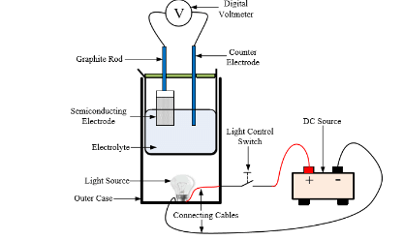
Figure 1: Typical schematic diagram of the experimental set-up for PEC cell measurement adapted from (Olusola et al., 2017)
In the present report, we describe a compact construction using an Arduino-based circuit for the electronic voltage sensing and data acquisition. Besides, the device also determines the time for experiment under light and dark conditions. We provided all the instructions necessary for the software and hardware construction. This device is an inexpensive and stable alternative for scholars.
2. Material and methods
The hardware and software elements make up the two main parts of the created Arduino-controlled photoelectrochemical cell device. While the hardware interface required the design and development of various parts, including the microcontroller unit, power supply unit, and sensor unit, the software section comprises the integrated development environment (IDE) used for editing and compiling the program. Other parts includes a real-time clock (RTC) for timing purposes, a keypad for data entry, an Secure Digital (SD) card for storing output data, and a liquid crystal display (LCD) segment for displaying input, output, and other pertinent data in the device. Figure 2 shows the circuit diagram of the developed instrument.
2.1 Power supply unit
The power supply of the device is a multiple output power supply because in this research, output of 12 V and 5 V are needed to power the instrument. As shown in Figure 2, the circuit diagram of the power supply unit consists of a center-tapped transformer which steps the voltage down from 220 V (AC) to a pulsating 12 V (AC). The pulsating AC signal is then converted to DC using four IN4007 diodes, a full wave rectifier filtered with 1000 µF and 10 µF capacitors to remove ripples from the input signal. Since the bulb for the light section during the PEC experiment required 12 V, therefore, a 7812 voltage regulator was connected to the positive output of the power supply to supply a 12 V regulated supply to power the bulb. A voltage regulator is a system designed to automatically maintain a constant voltage. The output of the 7812 voltage regulator was also connected to the input of a 7805 voltage regulator and the output of a 7805 voltage regulator was connected to the positive of a 10 µf capacitor and also one leg of the resistor. Resistors are used to reduce current flow, adjust signal levels, divide voltages, bias active elements, and terminate transmission lines, among other uses. The second leg of the resistor was connected to a light emitting diode (LED) to act as an indicator. A 7905 voltage regulator was connected to the negative output after the capacitor. The output of the power supply was used to supply a 12 V to the light bulb and a 5 V to the microcontroller (arduino).
2.2 Sensing unit
The PEC unit basically is where the experiment will be carried out and it will basically have an opening where a beaker can fit into easily. This opening will have opaque object used around it to obstruct light rays from entering the beaker during the experiment. Beneath the beaker, a light bulb will be placed in a manner that allows the beaker sit properly without being slant. Furthermore, two wires with crocodile clips connected from the amplifier to take readings will be available in the PEC unit. A voltage amplification unit is designed to increase the level of voltage of the applied input signal. Its design is based on achieving the highest possible voltage gain. The voltage gain of an amplifier is nothing but the ratio of output to the input value.
A_{v =} $\frac{Vout}{Vin}$ (2)
The voltage amplifier used is a programmable gain amplifier (PGA). It is usually implemented before the analog to digital converter (ADC).

2.3 Other related circuitry
The device's components have a variety of applications, as indicated in the circuit design in figure 2. Firstly, the keypad, which enables you to enter the device's operational hours. Because the experiment is conducted by measuring the voltage generated inside the electrolytic solution while light is both on and off, respectively, if you wish to use this equipment for an experiment for 30 minutes, you input 60 minutes rather than 30 minutes. Press 6 and 0 before entering on the keypad for a 30-minute operation. The light will be on for the first thirty minutes then turn off for the following thirty. A 4 x 4 keypad is utilized in this design. A real time clock (RTC) manages when switches are turned on and off while the system is in operation. The real time clock (RTC) is based on the DS3231 clock chip driven by a temperature compensated 32 kHz crystal oscillator. The temperature compensated crystal oscillator (TCXO) provides a stable and accurate reference clock, and maintains the RTC to within ±2 minutes per year accuracy from - 40°C to 85°C. Operations carried out are visualized using a Liquid Crystal Display (LCD). LCDs are thin flat plate which uses the light modulatory properties of crystals to either allow light to pass through it or prevent it thereby producing meaningful information as the output. The LCD of this gadget shows information such as the time entered using the keypad and readings taken throughout the experiment. At the end of every experiment, the readings are automatically saved in SD card located SD card reader of the device.
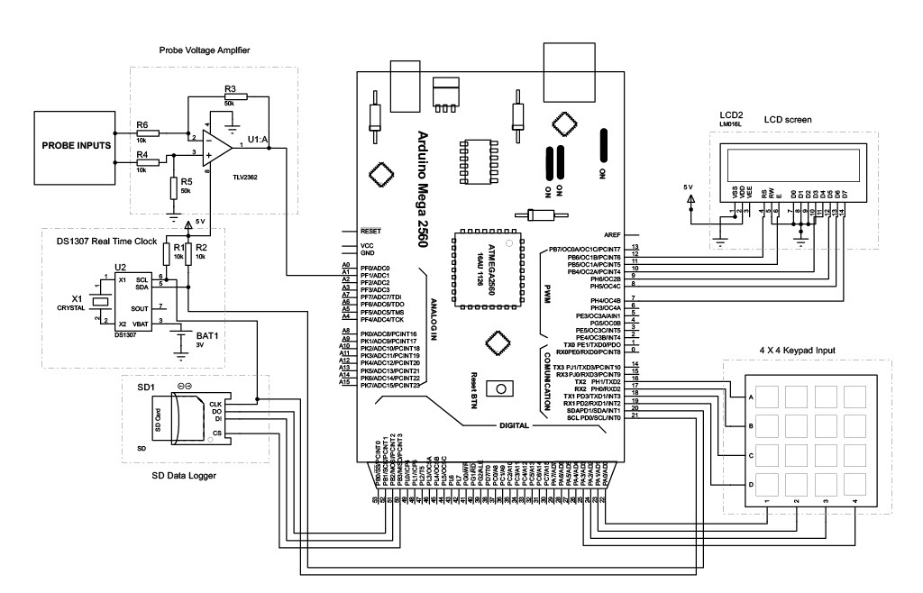
Figure 2: Complete circuit diagram of the developed device.

2.4 Cost analysis
The comparison between the developed and current devices is shown in figures 3 and 4 demonstrating how the latter is more affordable and compact. The total estimated cost incurred is N29,150.00 compared to the cost of acquiring a standard adjustable variable DC power supply which goes for about N30.000.00 and a standard electrometer goes for about N300,000.00;

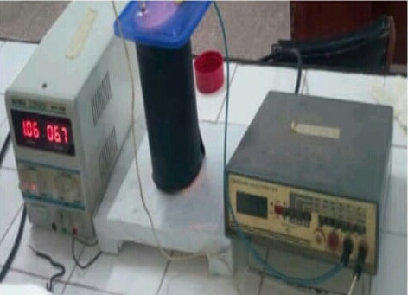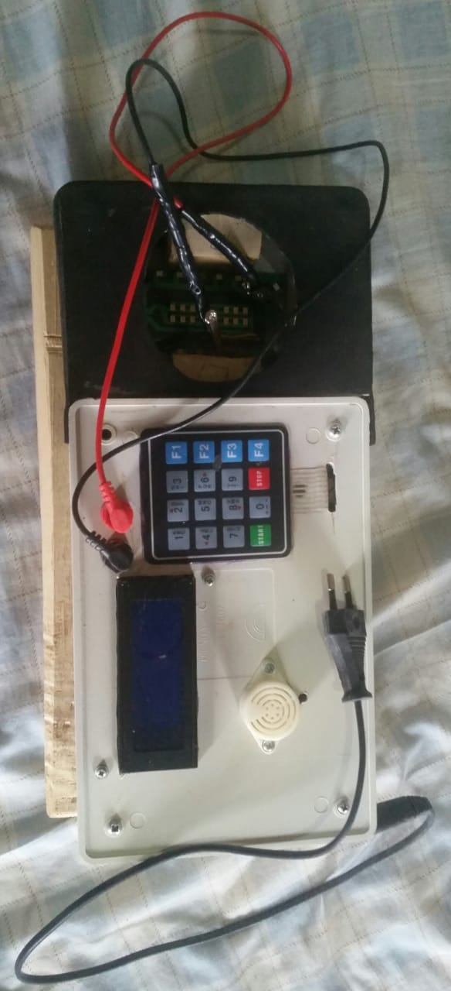
Figure 3: Current device Figure 4: Developed device

3. Results and Discussion
In order to confirm the effectiveness and precision of the low cost implemented instrument, several photoelectrochemical experiments were performed in the Condensed Matter Laboratory of the Federal University of Technology, Akure. A carbon electrode was employed as the counter electrode along with different glass/FTO/semiconducting electrodes. These two electrodes were immersed in distilled water (H₂O) and voltage readings were acquired under light and dark conditions. The photoelectrochemical experiment was carried out using three different zinc selenide (ZnSe) samples as the semiconducting electrodes. These ZnSe samples were grown independently using various counter electrodes (copper, carbon, and zinc) at various deposition potentials. The measurements made using the developed device were compared to measurements made using standard instruments that were set up experimentally. The results are shown in Figures 5 to 7.
The photoelectrochemical cell measurements shown in Figures 5 to 7 reveal the different behaviours exhibited by the semiconducting materials. Figure 5 shows the correlation results of thin films grown using a copper anode electrode labeled S1, S2, S3, S4, S5, and S6 for the corresponding deposition potentials of 1000, 900, 800, 700, 600 and 500 mV. After several PEC cell measurements were carried out at a designated time of 2 minutes on the outlined thin films, the developed device and the available standard device achieved a p-type electrical conductivity constant across a range of deposition potentials.

Figure 5: Correlation results of the developed device and available standard device for photoelectrochemical cell measurement of ZnSe grown using copper electrode.
Figure 6 shows the result of the PEC cell measurements for a carbon anode electrodes used to grow ZnSe thin films at various deposition potentials of (1000, 900, 800, 700, 600, and 500) mV, which were designated as A1, A2, A3, A4, and A5 and A6, respectively. Following numerous measurements carried out on the described thin films at a predetermined time of 2 minutes, both the developed device and the available device achieved p-type electrical conductivity with a strong correlation between the two values.

Figure 6: Correlation results of the developed device and available standard device for photoelectrochemical cell measurement of ZnSe grown using carbon electrode.
In the measurement results shown in Figure 7, ZnSe thin films were grown on zinc anode electrodes at different deposition potentials of (1000, 900, 800, 700, 600, and 500) mV, which were designated as D1, D2, D3, D4, D5 and D6 respectively. Following several experiments on the described thin film at a predetermined time of 2 minutes, both the developed device and the available standard device attained n-type electrical conductivity.

Figure7: Correlation results of the developed device and available device for photoelectrochemical cell measurement of ZnSe grown using zinc electrode.
4. Conclusion
This paper has presented an arduino based photoelectrochemical cell instrument that measures semiconductor electrical conductivity type in a given time by reading the voltages under light and dark conditions.The developed instrument can be used to measure both elemental and compound-based semiconductors deposited on a conducting substrate.The results obtained implies that the developed instrument shows a good performance compared with the standard values already established in literatures. Conclusively, it is low cost and easy to use instrument with a satisfactory performance.
5. References
Cvjetkovic, V. M., & Matijevic, M. (2016). Overview of architectures with arduino boards as building blocks for data acquisition and control systems. International Journal of Online Engineering, 12(7), 10–17. https://doi.org/10.3991/ijoe.v12i07.5818
Famularo, N., Kholod, Y., & Kosenkov, D. (2016). Integrating Chemistry Laboratory Instrumentation into the Industrial Internet: Building, Programming, and Experimenting with an Automatic Titrator. Journal of Chemical Education, 93(1), 175–181. https://doi.org/10.1021/acs.jchemed.5b00494
Karami, M., McMorrow, G. V., & Wang, L. (2018). Continuous monitoring of indoor environmental quality using an Arduino-based data acquisition system. Journal of Building Engineering, 19, 412–419. https://doi.org/10.1016/j.jobe.2018.05.014
McClain, R. L. (2014). Construction of a photometer as an instructional tool for electronics and instrumentation. Journal of Chemical Education, 91(5), 747–750. https://doi.org/10.1021/ed400784x
Molina, R., Orcajo, G., & Martinez, F. (2019). KBR (Kinetics in Batch Reactors): a MATLAB-based application with a friendly Graphical User Interface for chemical kinetic model simulation and parameter estimation. Education for Chemical Engineers, 28, 80–89. https://doi.org/10.1016/j.ece.2018.11.003
Nowotny, J., Bak, T., Nowotny, M. K., & Sheppard, L. R. (2007). Titanium dioxide for solar-hydrogen I. Functional properties. International Journal of Hydrogen Energy, 32(14), 2609–2629. https://doi.org/10.1016/j.ijhydene.2006.09.004
Obagade, T. A., & Olusola, O. I. (2019). Development of a Microcontroller Based Conductivity Measurement Device for Semiconductor Thin-Films Application. IOSR Journal of Applied Physics, 11(3), 38–44. https://doi.org/10.9790/4861-1103023844
Ojo, A. A., Cranton, W. M., & Dharmadasa, I. M. (2019). Next Generation Multilayer Graded Bandgap Solar Cells. In Next Generation Multilayer Graded Bandgap Solar Cells. https://doi.org/10.1007/978-3-319-96667-0
Olusola, O. I., Madugu, M. L., & Dharmadasa, I. M. (2017). Investigating the electronic properties of multi-junction ZnS/CdS/CdTe graded bandgap solar cells. Materials Chemistry and Physics, 191, 145–150. https://doi.org/10.1016/j.matchemphys.2017.01.027
Oprea, M., & Miron, C. (2013). Applied Physics Projects Using the Arduino Platform. The 8th International Conference on Virtual Learning ICVL 2013, 204–210.
Petry, C. A., Pacheco, F. S., Lohmann, D., Correa, G. A., & Moura, P. (2016). Project teaching beyond Physics: Integrating Arduino to the laboratory. Proceedings of 2016 Technologies Applied to Electronics Teaching, TAEE 2016. https://doi.org/10.1109/TAEE.2016.7528376
Rongé, J., Bosserez, T., Martel, D., Nervi, C., Boarino, L., Taulelle, F., Decher, G., Bordiga, S., & Martens, J. A. (2014). Monolithic cells for solar fuels. Chemical Society Reviews, 43(23), 7963–7981. https://doi.org/10.1039/c3cs60424a
Yotsumoto, S., De Cássia Silva Luz, R., & Damos, F. S. (2016). Visible LED light photoelectrochemical sensor for detection of L-Dopa based on oxygen reduction on TiO2 sensitized with iron phthalocyanine. Electrochemistry Communications, 62, 1–4. https://doi.org/10.1016/j.elecom.2015.10.018

