**Pneumococcal Conjugate Vaccines in India– A Review of Disease Burden, Serotypes, Choice of Vaccine and Dosing Schedules**

**ABSTRACT**

* India has almost a quarter of the global childhood pneumonia burden, with an estimated 8 million severe cases, >50% of whom need hospitalization or even intensive care, constituting a huge health burden. India sees at least 0.1 million deaths due to pneumococcal infections every year in children <5 years. Fatality rates in pneumococcal infections are overall 6-7%, ranging from 11% in severe cases to 60% in hospitalized cases and invasive pneumococcal disease (IPD). Almost half of pneumococcal infections show multi drug resistance to antibiotics, and therefore prevention via vaccination is the best approach. The inclusion of pneumococcal vaccination in the Universal Immunization Programme (UIP) of India in 2017 has been a required and welcome move. This article reviews the pneumonia burden, pneumococcal serotypes in India, and the various available pneumococcal conjugate vaccines (PCV) with their features and coverage. Further areas of research include impact studies of PCV in India, as well as evolving serotype prevalence for developing future relevant vaccines.
* **cut short**
* **Keywords:** Pneumococcal pneumonia, invasive pneumococcal disease (IPD) pneumococcal serotypes, pneumococcal conjugate vaccine (PCV), Childhood infections

**INTRODUCTION AND EPIDEMIOLOGY**

-Space between each paragraph at the beginning, and this should be for the entire article like this.

Also, Write the abbreviations mentioned for the first time in the article

* **Global Pneumonia Burden**
* Global Pneumonia burden in under 5 years age group is around 120-150 million, with
* incidence of 14/1000.1,2 Hospitalizations in Community Acquired Pneumonia (CAP)
* are around 20-30% overall but increase in <5 years to up to 57%.3
* World over pneumonia results in 2.5-3 million annual deaths, out of which 0.5-1
* million are in children <5 years (0.75 million in 2019) which is around 14% of all
* deaths under 5 years of age.4 Overall, pneumonia is the 4th leading cause of death in the world and the leading cause in children <5 years. Almost 50-60% world’s <5-year pneumonia deaths occur in developing countries.1
* Annually 1.6 million children under <5 years, die from pneumococcal infections (pneumonia + invasive pneumococcal disease-IPD) and nearly 90% of these deaths occur in children from low and lower-middle income countries.5 According to the results of a study evaluating the global disease burden of pneumonia in children under the age of 5 years, pneumococcal diseases accounted for approximately 11% of overall deaths.6
* **Pneumonia Burden in India**
* In 2015, an estimated 50 million pneumonia cases, in the under-5 population, occurred in India. This accounted for almost a quarter of the global childhood pneumonia burden.7,8 Of these an estimated 8 million were severe cases. In 2015, India, Nigeria, Indonesia, Pakistan, and China contributed to more than 54% of all global pneumonia cases, with 32% of the global burden from India alone.1 In 2015, in children <5 years, the CAP burden in India was around 400/1000. The burden of severe pneumonia was and 68/1000, which was much greater than global average of 14/1000 and the average for developing countries (200/1000).8 Resource-poor nations, where the prevalence of childhood pneumonia is approximately 15 times higher than in resource-rich countries, bear a disproportionate share of the worldwide burden.9 The need for hospitalization in severe CAP cases in children <5 years can be as high as 56%.3
* The top contributors to India’s pneumococcal pneumonia burden are Uttar Pradesh
* (UP), Bihar, Madhya Pradesh (MP), and Rajasthan.7,8 In Uttar Pradesh and Madhya
* Pradesh, more than half of all children aged younger than 5 years were estimated to
* have had pneumonia in 2015 (565 and 563 cases per 1000 children). By contrast the states of Kerala and Tamil Nadu had the lowest incidence of pneumonia (137 and 169 per 1000 children). Figure 1 shows the % children, CAP cases and mortality in the top four Indian states.10
* In India, annually around 0.35-0.4 million children <5 years die of pneumonia.3 India contributes the highest number of deaths due to pneumonia, accounting for about 20% of global mortality among under five children.10
* In India, childhood pneumonia contributes to 14-20% of under-5 mortality (average
* 17.5%), being higher in lower socioeconomic regions/slums.10,11 Overall case fatality rate is around 1-2% (8-10% in children 1-6 months). In severe CAP cases mortality rises to around 10% and goes up to 64% in children <6 months.12 Mortality is significantly higher in children with lack of breast feeding (68%,), incomplete immunisation (40%), severe malnutrition (36%), and delayed hospital referral (67%). 15-20% of CAP presents as severe episodes, and up to 24 % of patients presenting to hospitals with severe CAP require admission to an ICU and mortality rates for these patients range from 17 to 49 %.13.14
* **Figure 1: Regional Pneumonia Cases and Mortality Contribution in India10**
* 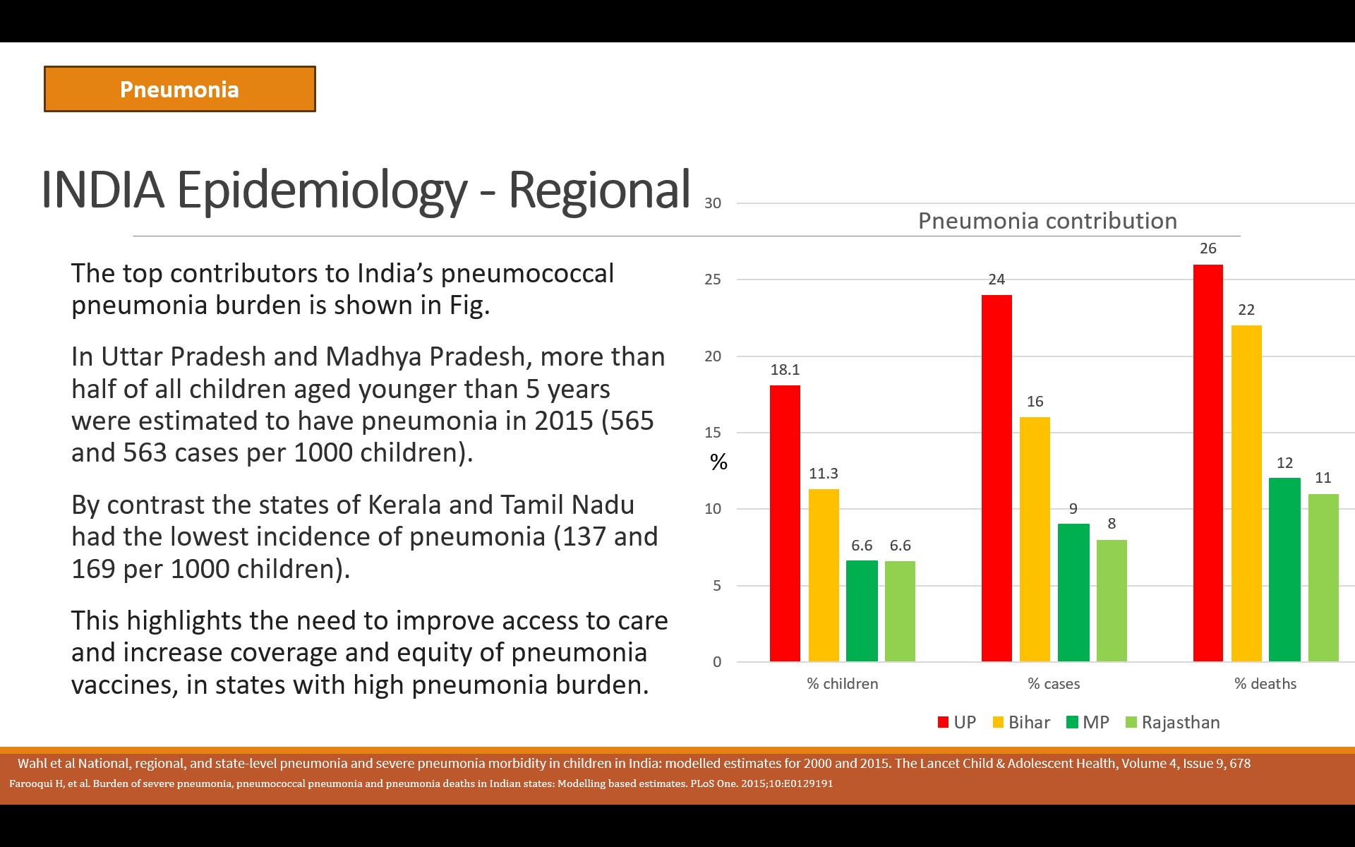
* **Risk factors**
* Among the under 5 years children, those < 6 months are at highest risk. Infants (2–11
* months) have almost 5-10 times higher incidence of CAP than the 1-5 years age group.15 Childhood mortality attributed to pneumonia decreases rapidly with age, from approximately 67% of all deaths at 6 months to 14% at 18 months, and reaches a
* plateau of 6% between 30 and 54 months of age. Incidence decreases more gradually
* with age: approximately 39% observed at 6 months, 22% at 18 months, 19% at 30
* months, 13% at 42 months, and 7% at 54 months.16
* Infants/Children living in crowded environments or unhygienic conditions, with
* indoor pollution exposure especially with incomplete immunization, nonexclusive
* breastfeeding, low birth weight, and malnourishment, are identified to be at
* significantly risk factors.13,17 Other risk factors include heart, lung and kidney disease,
* and conditions and treatment causing immunosuppression.18
* To accelerate actions for reducing deaths due to childhood pneumonia, an initiative
* named “Social Awareness and Actions to Neutralize Pneumonia Successfully
* (SAANS)” has been launched in all the Indian States/ UTs since 2019.12
* The SAANS initiative encompasses three-pronged strategy:
* i) Guidelines on treatment and management of childhood pneumonia.
* ii) Capacity building service providers for identification and standardized
* management of CAP
* iii) Communication (SAANS) campaign during the period of November – February to
* ensure greater awareness on childhood pneumonia among families and parents.
* A training package has been designed for early identification and standardized
* management of pneumonia for Medical and Community Health Officers, Nurses, and
* allied Health workers for preventing pneumonia deaths in children.
* **PNEUMOCOCCAL PNEUMONIA**
* **Incidence, Morbidity and Mortality**
* Pneumococcus is the most common organism contributing to two thirds of CAP and most of Community Acquired Bacterial Pneumonia (CABP).18 This can amount to 16-18 million cases in India <5 years. There are around 1.6 million severe pneumococcal infection cases needing hospitalization, and India sees at least 0.1 million pneumococcal (pneumonia and invasive pneumococcal disease -IPD) deaths every
* year in children <5 years.11,20
* Fatality rates in pneumococcal infections are high. The overall case fatality rate is 6-7% and range from 11% in severe pneumonia to as high as 60% in hospitalized cases and IPD.21 In low-income countries, fatality due to pneumococcal meningitis is close to 59% and among survivors, about 25–50% suffer serious neurological sequelae.
* In the Alliance for Surveillance of Invasive Pneumococci (ASIP) Study Group, 4377 patients were enrolled between Jan 1, 2011, and June 30, 2015.21 361 patients
* had culture-proven pneumococcal disease. 132 (58%) presented with pneumonia, 78
* (35%) presented with meningitis, and 16 (7%) had other clinical conditions. 131/4377
* (3%) died overall however among culture proven pneumococcal disease, that was
* almost a 30% mortality rate. A total of 29/361 (8%) patients with IPD (meningitis)
* died, but among IPD cases that was almost a 37% mortality rate. Therefore, culture
* proven pneumococcal disease has high mortality in India.
* The antimicrobial resistance pattern in pneumococcal isolates from India, during the period 2009–2017, showed multi drug resistance to 3 or more antibiotics in 47%.22 In
* 2019, bacterial antimicrobial resistance was associated with an estimated 4.95 million
* deaths globally, of which 1.27 million were directly attributable to antibiotic resistance.23 Vaccine Serotypes had a high prevalence of resistance to all six beta-
* lactam antibiotics (penicillin, amoxicillin, meropenem, cefotaxime, ceftriaxone and
* cefuroxime), macrolide and cotrimoxazole, and multidrug resistance.
* Approximately 51% of the global infant population has not received the complete
* pneumococcal vaccine series, and pneumococcal infections contribute highest to
* world’s vaccine preventable mortality (almost 15% overall for pneumococcal as
* compared to less than 6% for other infections vaccine preventable infections). 24,25
* **Pneumococcal Serotypes in India**
* The most common pneumococcal serotypes causing pneumonia and IPD in India are
* mainly: 1, 3, 5, 6A, 6B, 9V, 14, 19A, 19F, and 23F.26-31 Figure 2a and 2b show invasive pneumococcal serotype distribution in India from 1990-2016 and 2016-19.26,27 Nasopharyngeal pneumococcal carriage (NPC) was seen in 48-53% Indian children by 18-36 weeks with 6A, 6B, 14, 23F, and 19A/F as the common serotypes.32
* **Figure 2: Invasive Pneumococcal Serotype Distribution in India**

* **b) 2016-2019**27
* 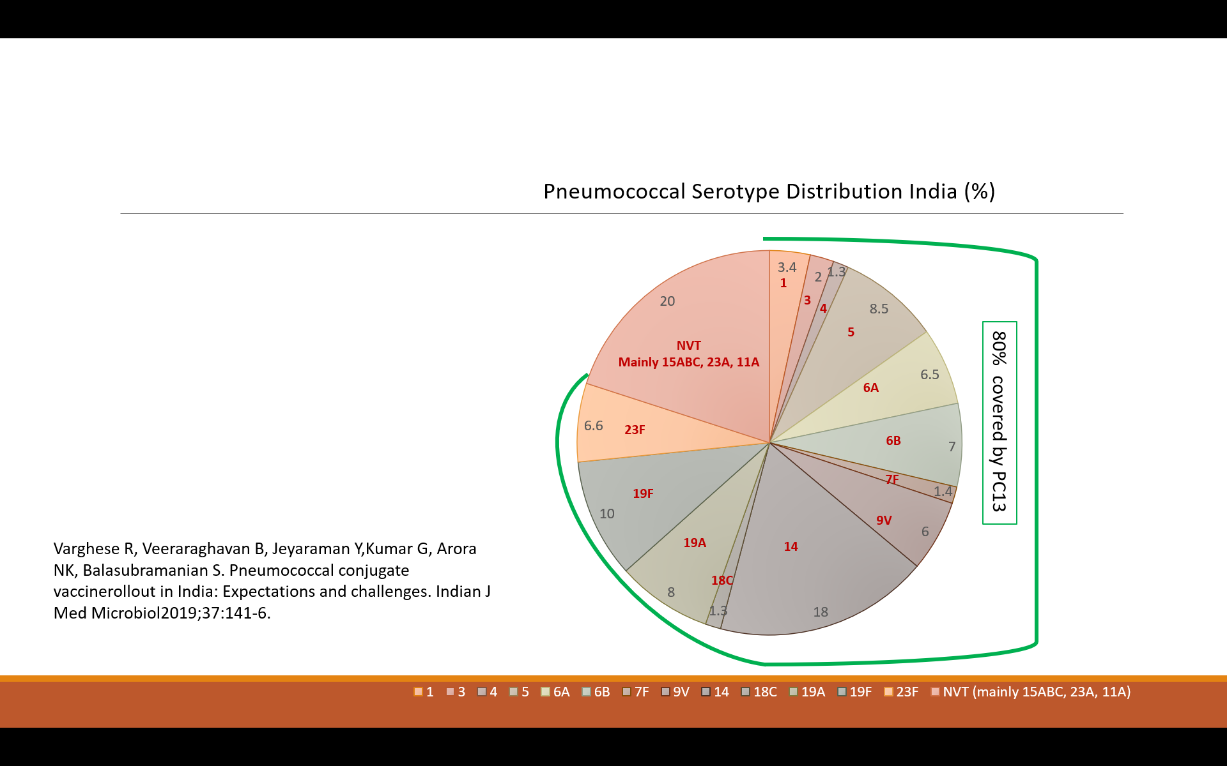
* Among the Non-Vaccine Types (NVTs), 15ABC (16.0% of NVTs = 3.2% overall), 23A (14.6% of NVTs = 2.9% overall), and 11A (10.0% of NVTs=2% overall) were most common.27
* A baseline genetic characterization of pneumococcal isolates detected prior to introduction of PCV in India (through *PNEUMONET and PIDOPS* projects 2009-2017) revealed 19F as the most common serotype followed by 14, 1, 6A and 6B in diseased children 2 years or less, whereas in the 3-5 years age group with disease, 19A followed by 19F, 5, 1 and 6B were most common. NVTs in disease and carriage groups for both age-groups was 15ABC and 11A respectively. (Figure 3).28
* **Figure 3: Pneumococcal serotype distribution age-wise in disease and carriage (2009-2017)28**

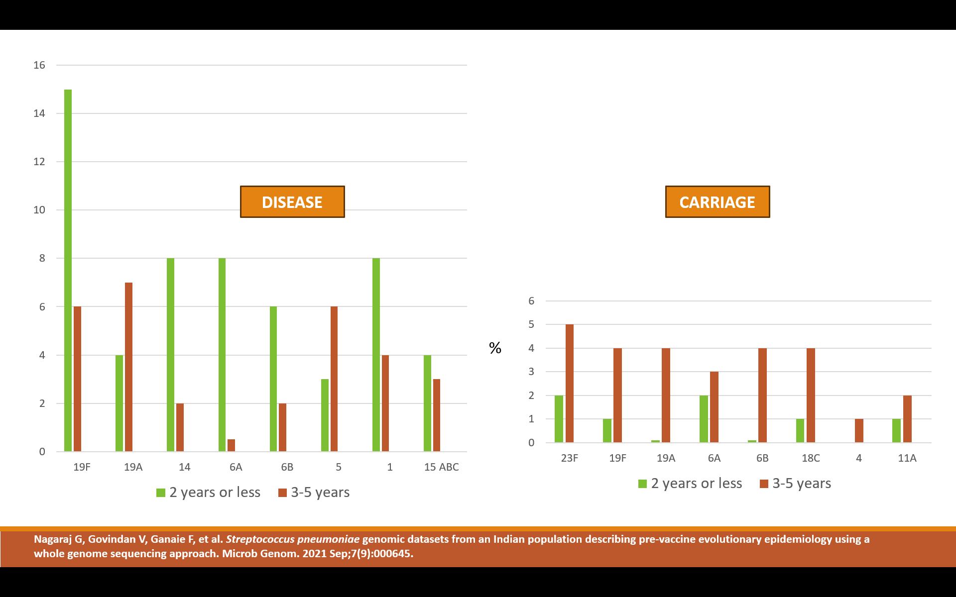In pneumococcal pneumonia, serotype 6A, 6B, 14, 19F and 23F and 14 are most prevalent serotypes in South Asia and India (Figure 4a).29

* The prevalence of co-colonization by multiple serotypes was found to range
* from as low as 1% to as high as 50%. For IPD, serotype 14, 19F, 6A, 6B, 5 and 1 are
* the most common serotypes (Figure 4b).30 19A is common in pneumococcal disease in India, while NPC common serotypes are 6A, 6B, 19A, 19F, 23F and 18C.28
* Serotype 3 infections are characterized as having severe clinical manifestations including empyema, bacteraemia, cardiotoxicity, and meningitis; consequently, with a fatality rate of 30%–47%.33 Serotype 3 is also the commonest serotype to cause necrotizing pneumonia seen in up to 4% IPD cases.34 Serotype 4 has been observed in up to 10% of outbreak cases like daycare settings in children and also seen to have high invasive disease potential.28,35
* Serotypes associated with resistance to common antibiotics are serotypes 6B, 9V, 14, 19A, 19F, and 23F.29,36
* **Figure 4: Most prevalent serotypes in India for pediatric pneumococcal pneumonia and invasive pneumococcal disease (% population<5 years)29,30**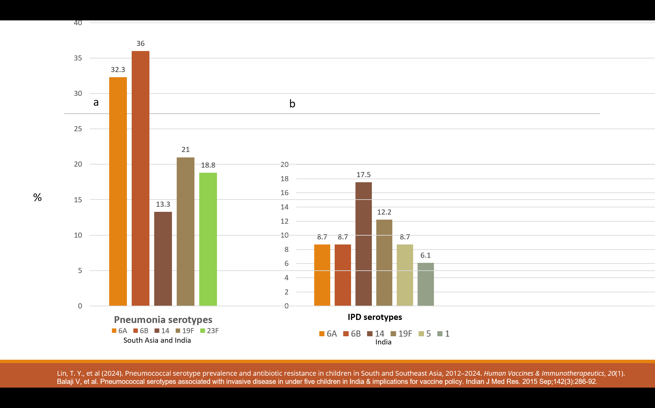
* **PNEUMOCOCCAL VACCINES**
* **Types of Pneumococcal vaccines**
* Pneumococcal vaccines are either polysaccharide (PPSV) or polysaccharide-
* conjugated vaccines (PCV). While PPSV cover 23 serotypes giving wider protection,
* these vaccines have a weaker immunological response that may be inadequate in
* young children with immature immunity, especially infants.37 PCV generates a
* stronger immunological response and longer lasting protection, but its complex
* conjugating technology limits the number of serotypes. Even so, the PCV vaccines
* have now evolved to those with 10 and 13 serotypes, and up to 20 serotypes globally.
* The introduction of PCV vaccination globally has not only greatly reduced the rates
* of pneumococcal pneumonia, but also helped reduce the overall incidence of CAP,
* severe pneumonia, IPD, hospitalization, and all-cause mortality (Figure 5).38,39
* **Figure 5: Global Impact of introducing Pneumococcal Conjugate Vaccine (PCV)**
* 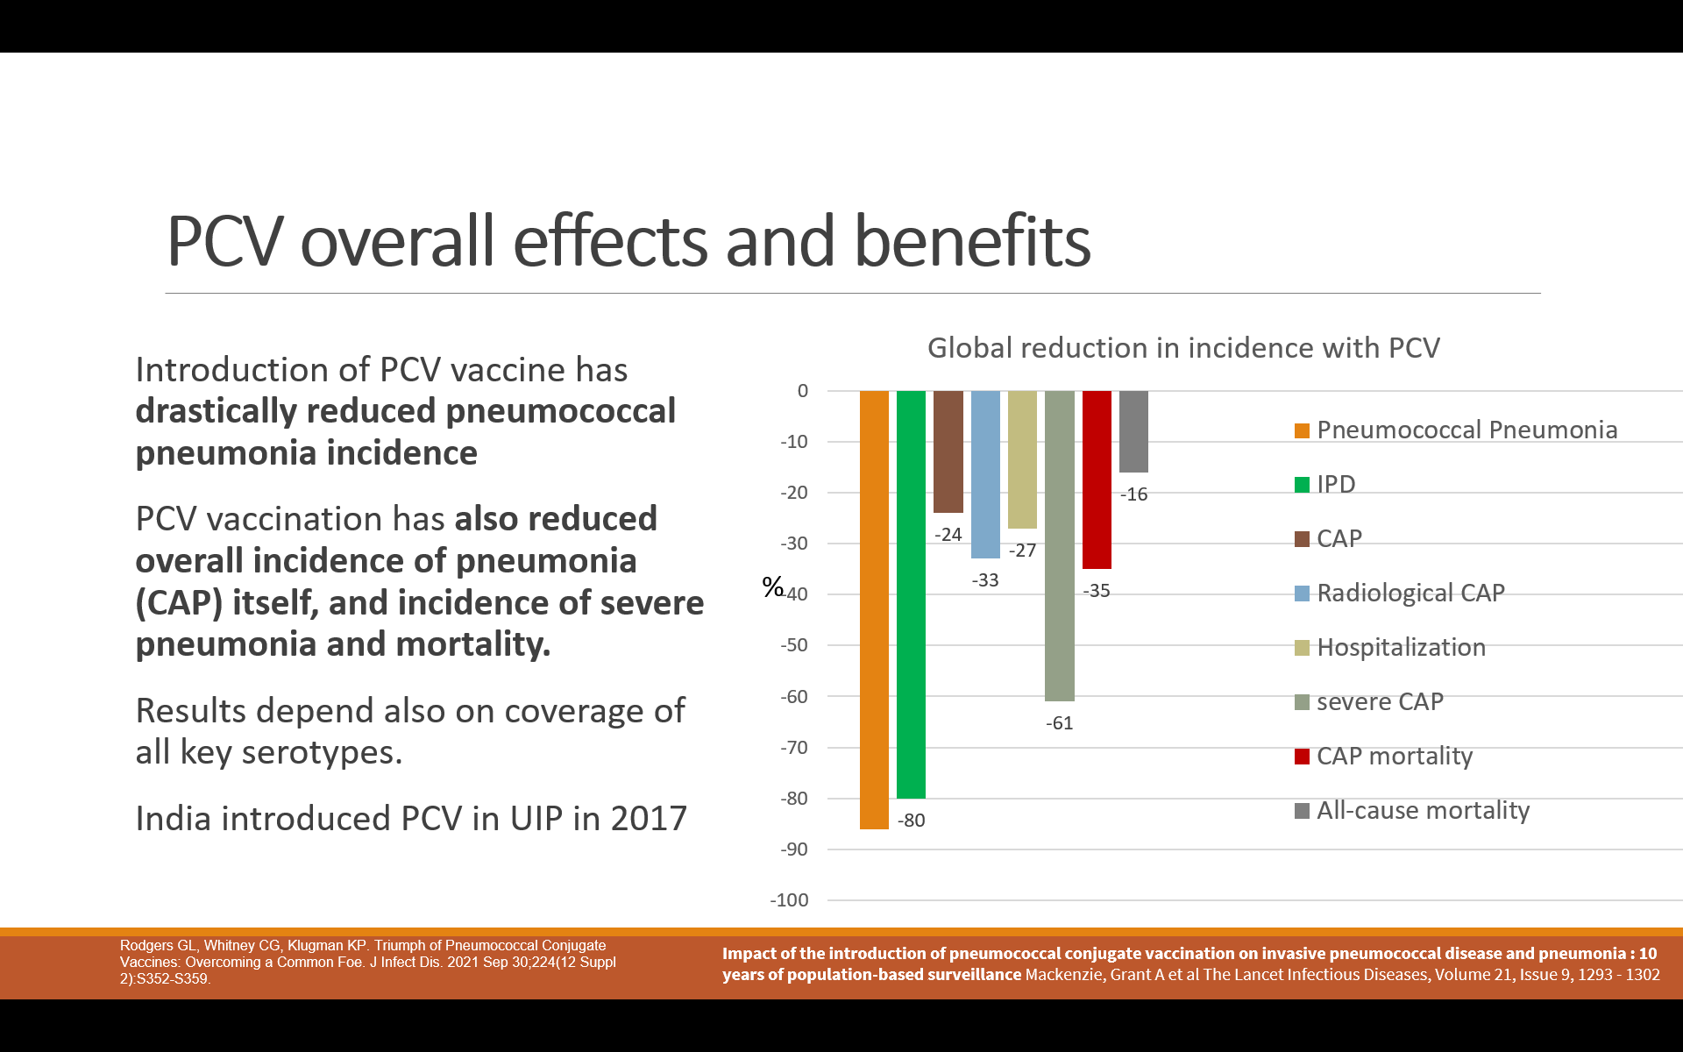

CAP (Community Acquired Pneumonia); IPD (Invasive Pneumococcal Disease)

* **Pneumococcal Vaccines in India**
* The inclusion of pneumococcal vaccination in the Universal Immunization
* Programme (UIP) of India in 2017 is a required and welcome move. In India,
* PCV10, PCV13 and PCV14 are currently available for use. PCV10 is available from two different sources with slightly different serotype inclusions [*Synflorix* from GSK - PCV10(s) and *Pneumosil* from Serum Institute - PCV10(p)].
* PCV13 is also available from 2 different sources - both vaccines contain the same 13 serotypes but differ in their conjugating protein [*Prevnar13* (PCV13-CRM197*)* from Pfizer, and *VAXIMUNE13* (PCV13-TT) from G/C Chemie Pharmie Ltd], the latter approved after showing non inferiority to the former in a randomized, double-blind, multi-centre, study, comparing the immunogenicity and safety of both vaccines in healthy infants aged 6 to 8 weeks.40
* Recently PCV14 has also been introduced in India. Both, PCV10 of Serum Institute and PCV14 are included in the National Immunization Program (NIP). The average serotype coverage is highest for PCV13 [78-80%], with 67-68% for PCV10(s), 72-73% for PCV10(p) and 73-74% for PCV14.26,27, 30,31
* Table 1 compares the serotypes in all these vaccines. As seen, PCV10 lacks serotype
* 3, while PCV-10(s) lacks serotype 3, 6A and 19A, all important serotypes for
* pneumococcal infections in India. 6A is also absent in PCV14. Serotype 3 has shown
* almost 30% higher mortality rates, and even though its antibody titres may be less
* protective than other serotypes, high OPA (Opsonophagocytic activity) titres can
* provide some protection, therefore justifying its inclusion in PCV.33
* **Table 1: PCV Vaccine Serotypes (PCV13 covers all relevant serotypes)**

|  |  |  |  |  |
| --- | --- | --- | --- | --- |
| **Relevant Serotypes - India** | **PCV10 (p)** | **PCV10 (s)** | **PCV13** | **PCV14** |
| * **1** | * **+** | * **+** | * **+** | * **+** |
| * **3** |  |  | * **+** | * **+** |
| * **4** |  | * **+** | * **+** | * **+** |
| * **5** | * **+** | * **+** | * **+** | * **+** |
| * **6A** | * **+** |  | * **+** |  |
| * **6B** | * **+** | * **+** | * **+** | * **+** |
| * **7F** | * **+** | * **+** | * **+** | * **+** |
| * **9V** | * **+** | * **+** | * **+** | * **+** |
| * **14** | * **+** | * **+** | * **+** | * **+** |
| * **18C** |  | * **+** | * **+** | * **+** |
| * **19A** | * **+** |  | * **+** | * **+** |
| * **19F** | * **+** | * **+** | * **+** | * **+** |
| * **23F** | * **+** | * **+** | * **+** | * **+** |

* 6A and 6B show some cross-reactivity, however 6B seroconversion rate (% achieving geometrical mean titres GMT of 0.35 mcg/ml) after primary series is up to 18% higher for 6B than 6A.41 Furthermore, up to 15% of the serum samples that show high OPA against 6B may not do so against the 6A strain. On average, up to 6 times more anti-6B antibodies were needed for 50% opsonophagocytic killing of the type 6A than the type 6B strain.42 Although pneumococcal type 6B conjugate vaccines elicit antibodies that cross-react with type 6A, not all anti-6B antibodies are functionally cross-reactive. The 6A serotype also gives cross protection to 6C, which is not true with 6B.43 So infant PCV vaccination especially for primary series <6 months age when pneumococcal mortality risk is highest, should ideally include the 6A strain.
* Similarly, the neutralizing antibody response against serotype 19A remained
* significantly lower than the response against 19F both in vaccinated infants and in
* animals (mice).44 It is uncertain whether the levels and functional activity of the cross-reactive antibodies induced in infants by 19F conjugate will be sufficient to provide protection against diseases caused by the cross-reactive serotype 19A. Countries using PCVs not containing 19A have shown significant increases in IPD due to 19A serotype***,*** as seen in a global study showing 61-79% decline in 19A serotype in <5 years with PCV13 relative to before, as compared to a 1·6-2·3-fold rise of 19A with PCV10 vaccination.45 The same has also been seen in the Indian serotype data prevalence for 19A till 2016, and thereafter when PCV10 was introduced in UIP (4.1 vs 8%) (Figure 2).26,27
* Reported serotypes in India not covered by PCV10, PCV13 or PCV14 (Non-Vaccine Types - NVTs) are 15ABC, 23A and 11A, that are covered in PCV20 (11A/15B) and PCV21 (11A/5ABC/23A).29 The serotypes 23F and 33F that are included in PCV14, have low mortality and contribute to around 3.5% cases globally, however their prevalence or relevance has not been documented in India and appears to be ≤1%.26,46 PCV13, followed by PCV10 (p) impart the best coverage for serotypes of invasive pneumococcal disease, so may be most apt especially for children under 6 months of age who are at highest risk of severe infection, hospitalization, invasive disease and mortality due to pneumococcal infections*.26,27*
* **Conjugation method**
* In the development of vaccines against these bacteria only a few protein carriers have
* been utilised, such as tetanus toxoid (TT), cross reactive, non-toxic mutant of diphtheria toxoid (CRM197), diphtheria toxoid (DT), and Haemophilus influenzae protein D.45 In India, PCV13 is now available with both TT (tetanus toxoid) conjugation and CRM197 as conjugated carrier proteins. TT-conjugation has been widely used for decades documenting its safety, and provides a consistent, specific and predictable immune response. CRM197 is a genetically altered, enzymatically inactive protein with a single amino acid substitution that makes it nontoxic.
* TT and CRM conjugation present complex immunological mechanisms that need more research. TT can show immune enhancement occurring when specific T-helper cells to one vaccine antigen increase the response to the same antigen in another vaccine like Hib-TT, due an increase of carrier driven T-cell mediated co-stimulatory signals. Carrier induced epitopic suppression (CIES) may sometimes be seen with TT due to the presence of pre-existing immunity to the carrier protein or TT conjugate protein overload, having the potential to suppress the subsequent immune response to an antigen conjugated to the same carrier. The co-administration and combinations of vaccines containing a given conjugate protein can induce bystander interference to unrelated antigens as seen with conjugate vaccines utilizing CRM197 which when co-administered with DTaP/Hib vaccines consistently reduced anti-Hib IgG responses compared to schedules where CRM197 was not co-administered.47 However, the impact on vaccine effectiveness of the above immunological processes with conjugating carrier proteins, on seroconversion and seroprotection attained by various co-administered vaccines have not been studied adequately, so the clinical relevance is not known.
* The safety and immunogenicity with TT conjugation is comparable to CRM197. A randomized, double-blind, multi-centre, study, to assess and compare the immunogenicity and safety of PCV13-TT vaccine with the reference PCV13-CRM197 conjugated vaccine performed in 344 healthy infants aged 6 to 8 weeksacross six centres in India, showed non-inferiority in rates of seroconversion and protective opsonophagocytic antibody (OPA) titres.41  There was no statistical difference (0.18% and 0.19%) between the cumulative reported incidence of AEFI between PCV13-TT and PCV13- CRM197 in a post marketing study in China from 2020 to 2022 during which a total of 4,76,150 doses of PCV13-TT and 1,439,808 doses of PCV13-CRM197 were administered.48
* **Dosing Schedules**
* The recommended vaccination schedule for PCV13 and PCV-10 by Indian Academy of Paediatrics is given in Figure 6.49 The IAP recommends the primary series (3p) at 6, 10 and 14 weeks along with other vaccines (Diphtheria-Pertussis-Tetanus), Hib, HepB and injectable Polio Vaccine (IPV) along with oral rotavirus vaccine. In addition, a booster is recommended at 12-15 months completing the 3p+1 PCV vaccination schedule.
* For lower income countries, WHO has recommended that PCVs be administered using either a 2p+1 or 3p+0 schedule in infants, with the primary doses of each schedule administered by six months of age and the booster dose of the 2p+1 administered at 9 months of age or later. Intervals between primary doses can vary, but are generally at least 8 weeks apart for the 2p+1 schedule and at least 4 weeks apart for the 3p+0 schedule.50,51 Some countries like the UK, with mature PCV immunization programs and a high level of herd immunity, follow a 1p + 1 schedule (one primary at 14 weeks with booster at 9-12 months).52.

**Figure 6: IAP PCV Immunization Recommendation49**

* 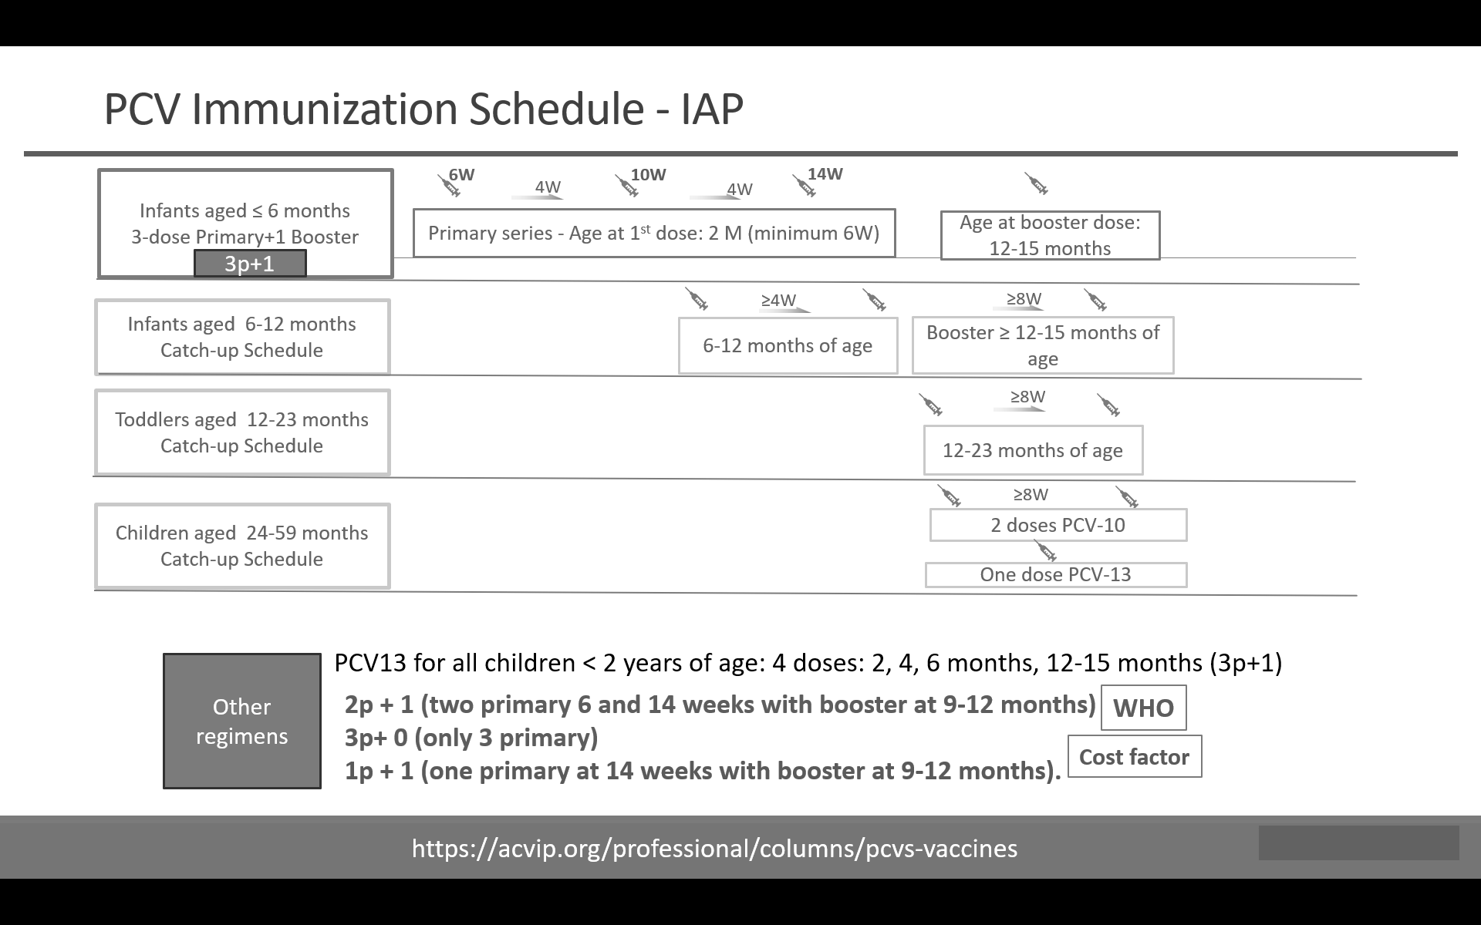
* W-weeks; M-months
* Seropositivity levels following 3p+1 and 2p+1 schedules were similar in studies but
* small differences favouring 3p+1 schedules were seen overall for serotypes 6B and
* 23F. A study revealed that serotypes 6B and 23F required at least three primary infant doses to produce a response over the 0.35 µg/mL correlate of the protection threshold.53 Reduction in pneumococcal NPC with 3p is better compared to 2p at 6
* months of age. 2p doses produced lower antibody levels (GMTs) than 3p (pre-booster) for 6A, 6B, 5 and 23F by ELISA, and for 23F by OPA.54 Booster dosing at 15 months resulted in significant increases in antibody titres, and there was no difference in protective GMTs between 2p vs 3p doses post booster except for serotype 23F. However, it is important to keep in mind that the risk of pneumococcal infections, and mortality are highest in first 6 months of life, and a 3p regimen corresponds with other recommended vaccination schedules in first 6 months of the infant. A 3p/2p + 0 schedule would likely result in many children failing to sustain protective levels of antibody into the second year of life and not be protected adequately against IPD.
* For PCV13, a 3p schedule was associated with statistically significantly fewer
* breakthrough infections than a 2p schedule with an incidence ratio of 12.9 (95% CI:
* 4.1–40.4) in the first year of life.54 Therefore, 3p primary series schedule gives best
* protection in first 6 months, when risk of severe CAP and IPD is highest. Booster
* gives added protection from 2nd year of life onwards. So 3p+1 is overall the best
* regimen especially for developing countries with high <5 years pneumonia incidence,
* burden and mortality.
* Catch-up vaccination is showed in Figure 4. Children 2-5 years old who are unvaccinated or have received incomplete PCV13 series, receive 1 dose PCV13 if there is no associated medical condition. In those 2 years and above with medical conditions, 2 doses PCV13 are given 8 weeks apart if unvaccinated or received <3 past PCV doses, and 1 PCV13 dose, if received 3 prior doses. All children with medical conditions should be given 1 dose of PPSV23 at least 8 weeks after the PCV13 series is complete.55
* **CONCLUSION**

**I shortened it. It is not reasonable for it to be larger than the abstract**

* The introduction of PCV in the universal immunization programme (UIP) has been welcome in India. Focus should be towards completing the primary immunization series in 6 months when the risk of both infection and morbidity-mortality is highest. Booster is important to confer immunity from the 2nd year of life to cover the under 5-year vulnerable period for children. PCV13 has optimal coverage of serotypes and is now also available as TT conjugated in India. It is important to conduct more research on the prevalent serotypes in India currently, and also emerging non-vaccine serotypes to foster evidence-based introduction of future PCV vaccines beyond PCV13. Further, conduction of impact studies, and real-world data collection, to record benefits of vaccination in India in terms of reduction in pneumococcal pneumonia burden, morbidity and mortality in children after introduction of PCV in UIP is of immense relevance to direct health resources and frame future immunization policies.
* **COMPETING INTERESTS DISCLAIMER:**
* Authors have declared that they have no known competing financial interests OR non-financial interests OR personal relationships that could have appeared to influence the work reported in this paper.

**If I found more recent references, that would be better, especially the early references.**

**References**

1. McAllister DA, Liu L, Shi T, Chu Y, Reed C, Burrows J, et al. Global, regional, and national estimates of pneumonia morbidity and mortality in children younger than 5 years between 2000 and 2015: a systematic analysis. Lancet Glob Health. 2019 Jan;7(1):e47-e57. Available from <https://pmc.ncbi.nlm.nih.gov/articles/PMC6293057/>
2. UNICEF [Internet] Child Health-Pneumonia. Updated Nov 2024, Cited Jan 2025. Available from <https://data.unicef.org/topic/child-health/pneumonia/>
3. Bhat JI, Charoo BA, Mukherjee A, Ahad R, Das RR, Goyal JP, et al. Risk of Hospitalization in Under-five Children with Community-Acquired Pneumonia: *A Multicentric Prospective Cohort Study.* Indian Pediatr 2021;58: 1019-1023. Available from <https://pubmed.ncbi.nlm.nih.gov/34837360/>
4. WHO [Internet]. Pneumonia Factsheet. Cited Dec 2024. Available from <https://www.who.int/news-room/fact-sheets/detail/pneumonia>
5. Lin TY, Shah NK, Brooks D, Garcia CS, Summary of invasive pneumococcal disease burden among children in the Asia-Pacific region, Vaccine, 2010; 28(48):7589-7605. Available from <https://pubmed.ncbi.nlm.nih.gov/20674872/>
6. Ceyhan M, Ozsurekci Y, Aykac K, Hacibedel B, Ozbilgili E. Economic burden of pneumococcal infections in children under 5 years of age. Hum Vaccin Immunother. 2018 Jan 2;14(1):106-110. Available from <https://pmc.ncbi.nlm.nih.gov/articles/PMC5791583/>
7. Pandey A, Galvani AP. The burden of childhood pneumonia in India and prospects for control. The Lancet Child & Adolescent Health, Sep 2020; 4(9): 643 – 645. Available from <https://www.thelancet.com/journals/lanchi/article/PIIS2352-4642(20)30238-8/fulltext>
8. Wahl B, Knoll MD, Shet A, Gupta M, Kumar R, Liu L, et al. National, regional, and state-level pneumonia and severe pneumonia morbidity in children in India: modelled estimates for 2000 and 2015. The Lancet Child & Adolescent Health, Sep 2020; 4(9): 678 – 687. Available from <https://www.thelancet.com/journals/lanchi/article/PIIS2352-4642(20)30129-2/fulltext>
9. Farooqui H, Jit M, Heymann DL, Zodpey S. Burden of severe pneumonia, pneumococcal pneumonia and pneumonia deaths in Indian states: Modelling based estimates. PLoS One. 2015;10:E0129191. Available from <https://journals.plos.org/plosone/article?id=10.1371/journal.pone.0129191>
10. Yadav KK, Awasthi S. Childhood Pneumonia: What's Unchanged, and What's New? Indian J Pediatr. 2023 Jul;90(7):693-699. Available from <https://pmc.ncbi.nlm.nih.gov/articles/PMC10196299/>
11. Cause of Death Statistics report of Registrar General India (2017-19). Available from: <https://sansad.in/getFile/loksabhaquestions/annex/1714/AU1004.pdf?source=pqals>
12. Bokade CM, Madhura AD, Bagul AS, Thakre SB. Predictors of mortality in children due to severe and very severe pneumonia. Niger Med J. 2015 Jul-Aug;56(4):287-91. Available from <https://pmc.ncbi.nlm.nih.gov/articles/PMC4697219/>
13. Phua J, Dean NC, Guo Q, Kuan WS, Lim HF, Lim TK. Severe community-acquired pneumonia: timely management measures in the first 24 hours. *Crit Care* Aug 2016; 20(1): 237. Available from <https://pmc.ncbi.nlm.nih.gov/articles/PMC5002335/>
14. Gupta, N, Bhadrala N. Risk factors for acute severe pneumonia in under five children. *International Journal of Contemporary Pediatrics*, 2019; *6*(3), 949–954. Available from <https://www.ijpediatrics.com/index.php/ijcp/article/view/2485>
15. Awasthi S, Pandey CM, Verma T, Mishra N, Lucknow CAP Group. Incidence of community acquired pneumonia in children aged 2-59 months of age in Uttar Pradesh and Bihar, India, in 2016: An indirect estimation. PLoS One. 2019 Mar 20;14(3):e0214086. Available from <https://journals.plos.org/plosone/article?id=10.1371/journal.pone.0214086>
16. Goodman D, Crocker ME, Pervaiz F, McCollum ED, Steenland K, Simkovich SM, et al; HAPIN Investigators. Challenges in the diagnosis of paediatric pneumonia in intervention field trials: recommendations from a pneumonia field trial working group. Lancet Respir Med. 2019 Dec;7(12):1068-1083. Available from <https://pmc.ncbi.nlm.nih.gov/articles/PMC7164819/>
17. Sutriana VN, Sitaresmi MN, Wahab A. Risk factors for childhood pneumonia: a case-control study in a high prevalence area. Clin Exp Pediatr. 2021 Nov;64(11):588-5956. Available from <https://pmc.ncbi.nlm.nih.gov/articles/PMC8566796/>
18. Mandell LA. Streptococcus Pneumoniae Infections. [Goldman's Cecil Medicine (Twenty Fourth Edition)](https://www.sciencedirect.com/book/9781437716047/goldmans-cecil-medicine), 2012. Available from <https://www.sciencedirect.com/topics/medicine-and-dentistry/pneumococcal-pneumonia>
19. File TM Jr. Streptococcus pneumoniae and community-acquired pneumonia: a cause for concern. Am J Med. 2004 Aug 2;117 Suppl 3A(3):39S-50S. Available from <https://pmc.ncbi.nlm.nih.gov/articles/PMC7147208/>
20. [Wahl B,](mailto:Brian Wahl, PhD)[Sharan A](https://www.thelancet.com/journals/langlo/article/PIIS2214-109X(19)30081-6/fulltext), [Deloria M Knoll, Kumar R,  Liu L, Chu,Y, et al.](https://www.thelancet.com/journals/langlo/article/PIIS2214-109X(19)30081-6/fulltext) National, regional, and state-level burden of *Streptococcus pneumoniae* and *Haemophilus influenzae* type b disease in children in India: modelled estimates for 2000–15 The Lancet Global Health, Volume 7, Issue 6, e735 - e747. Available from <https://pubmed.ncbi.nlm.nih.gov/31097277/>
21. Manoharan A, Manchanda V, Balasubramanian S, Lalwani S, Modak M, Bai S, et al. Invasive pneumococcal disease in children aged younger than 5 years in India: a surveillance study, The Lancet Infectious Diseases, Volume 17, Issue 3, 2017, Pages 305-312. Available from <https://pubmed.ncbi.nlm.nih.gov/27956163/>
22. Nagaraj G, Govindan V, Genaie F, Hawkins PA, Gladstone RA, Venkatesha VT, et al *Streptococcus pneumoniae* genomic datasets from an Indian population describing pre-vaccine evolutionary epidemiology using a whole genome sequencing approach. Microb Genom. 2021 Sep;7(9):000645. Available from <https://pubmed.ncbi.nlm.nih.gov/34494953/>
23. Murray CJL, Ikuta KS, Sharara F, Swetschinski L, Robles Aguilar G, Gray A, et al. Global burden of bacterial antimicrobial resistance in 2019: a systematic analysis. The Lancet. 2022;399(10325):629–655. Available from <https://www.thelancet.com/journals/lancet/article/PIIS0140-6736(21)02724-0/fulltext>
24. Muhoza P, Danovaro-Holliday MC, Diallo MS, Murphy P, Sodha SV, Requejo JH, et al. Routine Vaccination Coverage — Worldwide, 2020. MMWR Morb Mortal Wkly Rep 2021;70:1495–1500. Available from <https://www.cdc.gov/mmwr/volumes/70/wr/mm7043a1.htm>
25. CDC [Internet]. Vaccine Preventable Deaths and the Global Immunization Vision and Strategy, 2006—2015. Accessed Jan 2025. Available from <https://www.cdc.gov/mmwr/preview/mmwrhtml/mm5518a4.htm>
26. Singh J, Sundaresan S, Manoharan A, Shet A. Serotype distribution and antimicrobial susceptibility pattern in children≤5years with invasive pneumococcal disease in India - A systematic review. Vaccine. 2017 Aug 16;35(35 Pt B):4501-4509.Available from

<https://pubmed.ncbi.nlm.nih.gov/28711387/>

1. Varghese R, Veeraraghavan B, Jeyaraman Y, Kumar G, Arora NK, Balasubramanian S. Pneumococcal conjugate vaccine rollout in India: Expectations and challenges. Indian J Med Microbiol.2019;37:141-6. Available from <https://www.sciencedirect.com/science/article/pii/S0255085720302140>
2. Nagaraj G, Govindan V, Ganaie F, Venkatesha VT, Hawkins PA, Gladstone RA, et al. *Streptococcus pneumoniae* genomic datasets from an Indian population describing pre-vaccine evolutionary epidemiology using a whole genome sequencing approach. Microb Genom. 2021 Sep;7(9):000645. Available from <https://pmc.ncbi.nlm.nih.gov/articles/PMC8715438/>
3. Lin TY, Chiu CH, Woo PC, Razak Muttalif A, Dhar R, Choon Kit L, et al. Pneumococcal serotype prevalence and antibiotic resistance in children in South and Southeast Asia, 2012-2024. Hum Vaccin Immunother. 2024 Dec 31;20(1):2417554. Available from <https://pubmed.ncbi.nlm.nih.gov/39478351/>
4. Balaji V, Jayaraman R, Verghese VP, Baliga PR, Kurien T. Pneumococcal serotypes associated with invasive disease in under five children in India & implications for vaccine policy. Indian J Med Res. 2015 Sep;142(3):286-92. Available from <https://pubmed.ncbi.nlm.nih.gov/26458344/>
5. Govindan V, Ganaie F, Nagaraj G, Hussain A, Ravi Kumar. KL. Pan India distribution of pneumococcal serotypes (PIDOPS) causing invasive pneumococcal disease and pneumonia in children between 6 weeks and 5 years and their antimicrobial resistance – Phase I, Pediatric Infectious Disease, 2016; 8(2):47-51. Available from <https://www.sciencedirect.com/science/article/abs/pii/S2212832816300285>
6. Apte A, Dayma G, Naziat H, Williams L, Sanghavi S, Uddin J, et al. Nasopharyngeal pneumococcal carriage in South Asian infants: Results of observational cohort studies in vaccinated and unvaccinated populations. J Glob Health. 2021 Sep 4;11:04054. Available from <https://pubmed.ncbi.nlm.nih.gov/34552723/>
7. Luck JN, Tettelin H, Orihuela CJ. Sugar-Coated Killer: Serotype 3 Pneumococcal Disease. Front Cell Infect Microbiol. 2020 Dec 23;10:613287. Available from <https://pubmed.ncbi.nlm.nih.gov/33425786/>
8. Cathalau M, Michelet M, Rancé A, Martin-Blondel G, Abbo O, Dubois D, et al. Necrotizing pneumonia in children: Report of 25 cases between 2008 and 2018 at a French tertiary care center, Archives de Pédiatrie, 2024; 31(3):183-187
9. Zivich P.N, Grabenstein JD., Becker-Dreps SI, Wber DJ. Streptococcus pneumoniae outbreaks and implications for transmission and control: a systematic review. Pneumonia. 2018;10:11
10. Antibiotic Resistant Streptococcus pneumoniae. CDC.gov [Internet]. Updated and Accessed December 2024. Available from : <https://www.cdc.gov/pneumococcal/php/drug-resistance/index.html#:~:text=Before%202000:%20Seven%20serotypes%20caused,seven%20(not%2019A)%20serotypes>.
11. Golos M, Eliakim‐Raz N, Stern A, Leibovici L, Paul M. Conjugated pneumococcal vaccine versus polysaccharide pneumococcal vaccine for prevention of pneumonia and invasive pneumococcal disease in immunocompetent and immunocompromised adults and children. Cochrane Database Syst Rev. 2019 Feb 20;2019(2):CD012306. Available from <https://pmc.ncbi.nlm.nih.gov/articles/PMC6381862/>
12. Rodgers GL, Whitney CG, Klugman KP. Triumph of Pneumococcal Conjugate Vaccines: Overcoming a Common Foe. J Infect Dis. 2021 Sep 30;224(12 Suppl 2):S352-S359. Available from <https://pubmed.ncbi.nlm.nih.gov/34590137/>
13. Gambia Pneumococcal Surveillance Group; Impact of the introduction of pneumococcal conjugate vaccination on invasive pneumococcal disease and pneumonia in The Gambia: 10 years of population-based surveillance. Lancet Infect Dis. 2021 Sep;21(9):1293-1302. Available from <https://pubmed.ncbi.nlm.nih.gov/34280357/>
14. A Phase III Study to check the Safety and efficacy of the PCV 13 Vaccine in Healthy Infants in India in prevention of Pneumococcal disease caused by Streptococcus pneumonia. CTRI/2022/11/047443. Available from<https://ctri.nic.in/Clinicaltrials/pmaindet2.php?EncHid=NzE5OTA=&Enc=&userName>. (Data on file - GCCPL)
15. Zhao Y, Li G, Xia S, Ye Q, Yuan L,Li H, et al. Immunogenicity and Safety of a Novel 13-Valent Pneumococcal Vaccine in Healthy Chinese Infants and Toddlers. Front. Microbiol.2022; 13:870973. Available from <https://www.frontiersin.org/journals/microbiology/articles/10.3389/fmicb.2022.870973/full>
16. Väkeväinen M, Eklund C, Eskola J, Käyhty H. Cross-Reactivity of Antibodies to Type 6B and 6A Polysaccharides of *Streptococcus pneumoniae* evoked by Pneumococcal Conjugate Vaccines, in Infants, *The Journal of Infectious Diseases*, Volume 184, Issue 6, 15 Sepr 2001,789–793. Available from <https://pubmed.ncbi.nlm.nih.gov/11517443/>
17. Grant LR, Hanquet G, Sepúlveda-Pachón IT, Theilacker C, Baay M, Slack MPE, Jodar L, Gessner BD. Effects of PCV10 and PCV13 on pneumococcal serotype 6C disease, carriage, and antimicrobial resistance. Vaccine. 2024 Apr 30;42(12):2983-2993.Available from <https://pubmed.ncbi.nlm.nih.gov/38553292/>
18. Jakobsen H, Sigurdsson VD, Sigurdardottir S, Schulz D, Jonsdottir I. Pneumococcal serotype 19F conjugate vaccine induces cross-protective immunity to serotype 19A in a murine pneumococcal pneumonia model. Infect Immun. 2003 May;71(5):2956-9. Available from <https://pubmed.ncbi.nlm.nih.gov/12704178/>
19. Bennett JC, Deloria Knoll M, Kagucia EW, Garcia Quesada M, Zeger SL, Hetrich MK, et al. PSERENADE Team. Global impact of ten-valent and 13-valent pneumococcal conjugate vaccines on invasive pneumococcal disease in all ages (the PSERENADE project): a global surveillance analysis. Lancet Infect Dis. 2024 Dec 17:S1473-3099(24)00665-0. Erratum in: Lancet Infect Dis. 2025 Jan 17:S1473-3099(25)00032-5. Available from <https://pubmed.ncbi.nlm.nih.gov/39706204/>
20. Grant LR, Slack MPE, Theilacker C, Vojicic J, Dion S, Ralf-Rene Reinert RR, et al. Distribution of Serotypes Causing Invasive Pneumococcal Disease in Children from High-Income Countries and the Impact of Pediatric Pneumococcal Vaccination. Clinical Infectious Diseases, Feb 2023; 76(3): e1062–e1070. Available from <https://pubmed.ncbi.nlm.nih.gov/35789262/>
21. Findlow H, Borrow R. Interactions of conjugate vaccines and co-administered vaccines. Hum Vaccin Immunother. 2016;12(1):226-30. Available from <https://pmc.ncbi.nlm.nih.gov/articles/PMC4962715/>
22. Hu R, Liu Y, Zhang L, Kang G, Xu B, Li M, et al. Post-marketing safety surveillance for both CRM197 and TT carrier proteins PCV13 in Jiangsu, China. Front Public Health. 2023 Oct 16;11:1272562. Available from <https://pubmed.ncbi.nlm.nih.gov/37908689/>
23. ACVIP.org [Internet]. Pneumococcal Conjugate Vaccines (PCVs): IAP Advisory Committee on Vaccines and Immunization Practices. March 2021. Cited January 2025. Available from <https://acvip.org/professional/columns/pcvs-vaccines>
24. WHO [Internet]. Vaccination schedule for Pneumococcal Disease. Cited January 2025. Available from <https://immunizationdata.who.int/global/wiise-detail-page/vaccination-schedule-for-pneumococcal-disease?ISO_3_CODE=&TARGETPOP_GENERAL=>
25. Lee J. Pneumococcal conjugate vaccines: choice of schedule and product development. Clin Exp Pediatr. 2020 Jul;63(7):259-260. Available from <https://pmc.ncbi.nlm.nih.gov/articles/PMC7374003/#:~:text=Choice%20of%20PCV%20schedule%20and,using%20the%202p%2B1%20schedule>.
26. Slotved, HC, Fuursted K. 1 + 1 dose schedule for pneumococcal child vaccination: new normal? The Lancet Infectious Diseases, Aug 2023; Volume 23, Issue 8, 884 – 885. Available from <https://www.thelancet.com/journals/laninf/article/PIIS1473-3099(23)00065-8/fulltext>
27. Scott P, Rutjes AW, Bermetz L, Robert N, Scott S, Lourenço T, Egger M, Low N. Comparing pneumococcal conjugate vaccine schedules based on 3 and 2 primary doses: systematic review and meta-analysis. Vaccine. 2011 Dec 6;29(52):9711-21. Available from <https://pubmed.ncbi.nlm.nih.gov/21821080/>
28. Feemster K, Weaver J, Buchwald U, Banniettis N, Cox KS, McIntosh ED, et al. Pneumococcal Vaccine Breakthrough and Failure in Infants and Children: A Narrative Review. Vaccines (Basel). 2023 Nov 24;11(12):1750. Available from <https://pubmed.ncbi.nlm.nih.gov/38140155/>
29. CDC [Internet]. Pneumococcal Disease – Pneumococcal Vaccine Recommendations. Cited January 2025. Available from <https://www.cdc.gov/vaccines/vpd/pneumo/hcp/recommendations.html>