# STUDY ON EXPONENTIAL POISSON LINDLEY DISTRIBUTION; ITS PROPERTIES, SIMULATIONS AND ITS APPLICATION TO ENGINEERING

Abstract

This study extends the continuous Poisson Lindley distribution with the aid of an existing link function. It studied the probability density function (pdf) and the cumulative distribution function (cdf) of the new distribution and presents appropriate plots. Statistical Properties of the ExPLinD were studied and represented using plots. Some of these properties include its moments, moment generating function (mgf), characteristics function and quantile function. Reliability studies was carried out and relevant charts showing the plot of the survival function and hazard functions were presented. Simulation studies of the ExPlinD was done using different parameter values and different number of variables. Simulation studies of Explind shows that the average estimates tend to be closer to the true parameter asymptotically which is in order with first order asymptotic theory. The ExPLinD was fitted to an Engineering data and compared to some closely related distributions. It provided a better fit compared to the related distribution

Introduction

Some of the popular distributions handy in reliability studies are well documented in literature. These distributions include exponential, weibull, lindley, lognormal and gamma distributions. The Lindley distribution is a one parameter probability distribution that was investigated in context of fiducial statistic as a counter example of Bayesian theory by Lindley (1). It is a combination of exponential and gamma distributions. It’s superiority over the exponential distribution was shown by Ghitany *et al*. (2) while studying its mathematical and statistical properties, estimating it’s parameter and applying it to waiting time data. Afterwards, many researchers have studied this distribution, for instance, Mazucheli and Achcar (3) applied the distribution to competing risks lifetime data, they propose it as possible alternative to exponential and Weibull distributions. Krishna and Kumar (4) estimated the parameter of the distribution with progressive Type-II censoring scheme and showed that it may be better lifetime model than exponential, lognormal and gamma distributions in some real life situations. Singh and Gupta (5) used the distribution under load sharing system models. Al-Mutairi *et al*. (6) developed an inferential procedure of the stress-strength parameter when both stress and strength variables follow Lindley distribution and discovered that the distribution is useful when the data has an increasing failure rate. All these make the use of Lindley distribution in lifetime data analysis more frequent than the exponential distribution.. It also has simple and tractable mathematical properties. Over the years several two parameter extensions and three parameter extension of the distributions have been studied, such as the transmuted Lindley distribution by Merovci *et al*., (7) the exponentiated Power Lindley distribution by Ashour *et al*., (8) Generalized Lindley distribution by Nadarajah et al., (9) Transmuted Generalized Lindley distribution by Elgarhy *et al*., (10) Extended Power Lindley distribution by Alkarni et al.,(11) a two-parameter Lindley distribution by Shanker et al., (12) the Lomax-Lindley distribution by Yahaya et al.(13) Transmuted Two-Parameter Lindley distribution by Al-khazaleh et al., (14), three-parameter Lindley distribution by Shanker et al.,(15) and the continuous Poisson Lindley Distribution by Onwuka *et. al*.(16). The various three parameter Lindley generalization which have been defined over the past decade assembled flexibility and strength in modeling different shapes of lifetime data, this has resulted in loss of interest in studying Lindley generalisation with more than three parameters (Hamed and Alzaghal, (17). There are several ways of adding one or more shape parameter to a distribution to increase its flexibility in modeling data which have been studied in existing literature. A brief summary is given by Ieren et. al. (18). This current studies uses one of these two parameter extensions of the Lindley distribution and an existing Exp-G, a member of the Weibull-G family (19) as a link function to formulate a new three parameter continuous distribution called the Exponential Poisson Lindley Distribution (ExPLinD). It is an important distribution as it has the continuous Poisson Lindley (PLinD), exponential Lindley distribution and the Lindley distribution as sub-distributions. The rest of the paper proceeds as follows: section 2.1 defines the distribution, statistical properties and their plots are studied in section 2.2, sections 2.3 and 2.4 respectively shows reliability analysis and estimation of parameters of ExPLinD, sections 3.1 and 3.2 carry out simulation studies and application of ExPLinD to real-life data. Summary and conclusions are presented in section 4.

2.0 Material and Methods

2.1.1 Pdf and cdf of ExPLinD.

We present the pdf and cdf of ExPLinD using the pdf and cdf of Exp-G by Tahir et. al.(19) in equations 2.1 and 2.2 as link function, pdf and cdf of continuous PLinD (reference) in equations 2.3 and 2.4.  (2.1)

 (2.2)

respectively, where G(x) and g(x) are the cdf and the pdf of the continuous PLinD respectively.

 (2.3)

 (2.4)

Where θ > 0, 𝛌 > 0 x > 0,  and  are the parameters of the PLinD.

Using equation (2.3) and (2.4) in (2.1) and (2.2) and simplifying, we obtain the cdf and pdf of the Exponential-Poisson Lindley distribution (ExPLinD) as equations 2.5 and 2.6





 (2.5)



 (2.6)

Where x > 0, α, θ, 𝛌 > 0 where α and 𝛌 are shape parameters and θ is a scale parameters of ExPLinD.

**2.1.2Graphical representation of the PDF and CDF**

Given some values for the parameters θ, 𝛌, and α, some possible shapes for the pdf and the cdf of ExPLinD are provided in Figures 1 and 2.

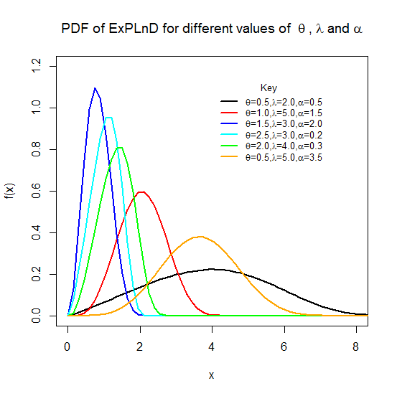 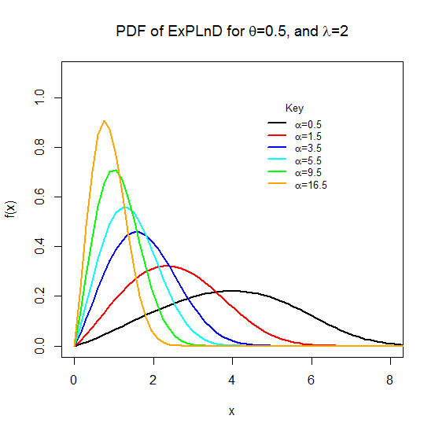

**Figure** **1: PDF of the ExPLinD for Different Parameter Values**.

Figure **1** indicates ExPLinD has different shapes which are as a result of the changes in the value of the additional parameter. This shows the ability of the model to capture datasets with different shapes.

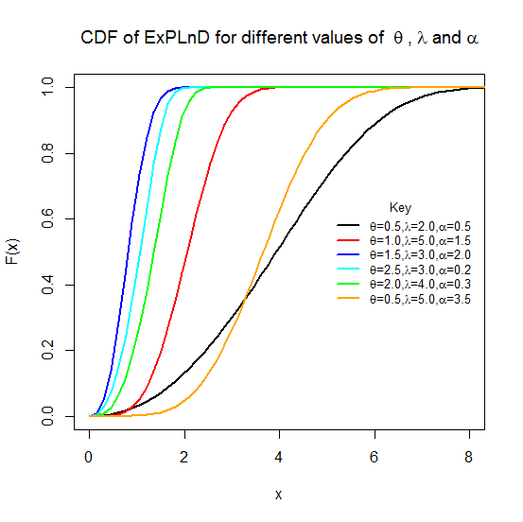 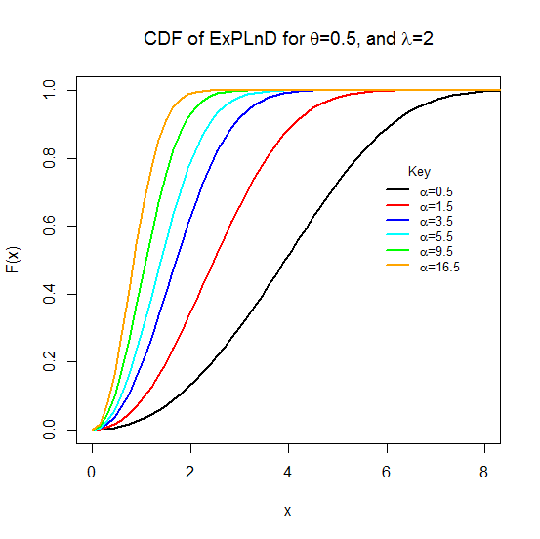

**Figure** **2**: **CDF of the ExPLinD for Different Parameter Values**.

Figure 2 shows that the ExPLinD is a valid probability distribution as the cdf increases as x increases and approaches 1 assymptotically.

## 2.2 Statistical properties of ExPLinD

Some statistical properties of ExPLinD are presented in this section. Recall the pdf of ExPLinD in Equation 6

Simplification of the above pdf as follows:

 (3)

The pdf becomes:



Using binomial expansion, we have:



By substituting the result above, we obtain:



Again using binomial expansion gives:



Hence;



Again we have







Again by binomial expansion we obtain:











Let 

Such that

 (7)

## 2.2.1 Moment of ExPLinD.

 (8)

Substituting Eqn 7 into Eqn 8 yeilds

 (9)

Using integration by substitution, we have:

let 



Substituting for and in the integral above gives:







 (10)

## 2.2.2 Moment Generating Function of ExPLinD.



 (11)

## 2.2.3 Characteristics Function of ExPLinD.



 (12)

2.2.4 Quantile Function of ExPLinD

Let *Q(u)* = $F^{-1}$*(u)* be the quantile function (qf) of F(x) for 0 *< u <*1.

Recall thecdf of the ExPLinD in Eqn (5), inverting it give the quantile function. 

Inverting F(x) = u

 (13)

Simplifying equation (3.56) above, we obtain:









 (14)

From the expression above, it can be seen that  is the Lambert function of the real argument, because the Lambert function is defined as: 

Recall that the Lambert function has two branches with a branching point located at. The lower branch,  is defined in the interval  and has a negative singularity for. The upper branch, , is defined for . Hence, equation (3.57) can be written as:

 (15)

Now for any  and , it follows that  and . Therefore, considering the lower branch of the Lambert function, equation (3.58) can be presented as:

 (16)

Collecting like terms in Eqn (16) and simplifying the result, the quantile function of the ExPLinD is obtained as:

 (17)

where *u* is a uniform variate on the unit interval *(0,1)* and represents the negative branch of the Lambert function.

**2.3 Reliability Analysis of ExPLinD**

**2.3.1 Survival Function**

Survival function is the likelihood that a system or an individual will not fail after a given time. Mathematically, the survival function is given by:

S(*x*) = 1-F(x) (18)

Where F(x) is the *cdf* of the ExPLinD in Eqn (5)





 (19)

Figure 3 is a Plot of the Survival Function of ExPLinD at Chosen Parameter Values.

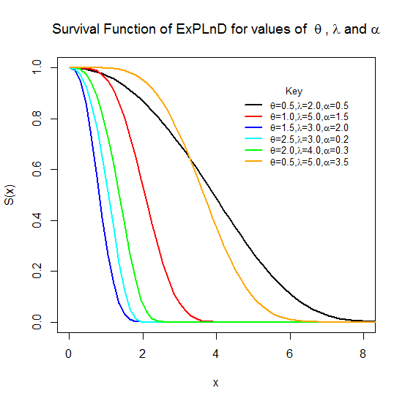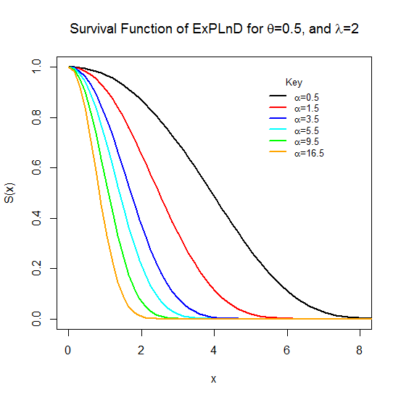

**Figure** **3**: **Survival Function of the ExPLinD for Different Parameter Values**.

Figure 3 shows ExPLinD has a decreasing survival function. This implies that the ExPLinD can be used to model random variables whose survival rate decreases as their age increase.

**2.3.2 Hazard Function of ExPLinD.**

Hazard function is the probability that a component will fail or die for an interval of time. The hazard function is defined as;

 (20)

Where *f(x)* and S(x)are the *pdf* and survival function of the ExPLinD given in Eqns (6) and (19). Substituting and simplifying yields  (21)

The plot of the hazard function at chosen parameter values is shown in Figure **4**

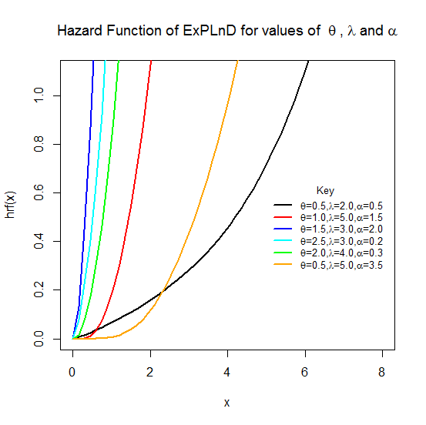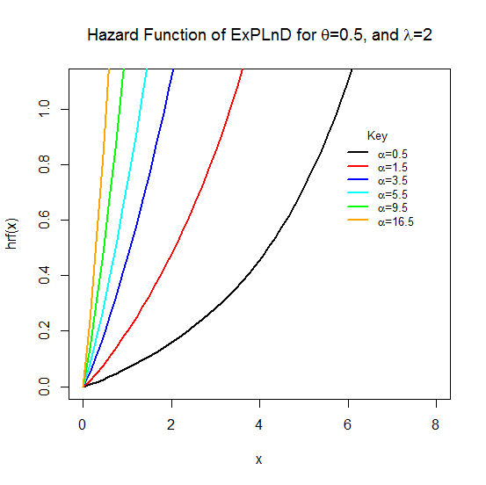

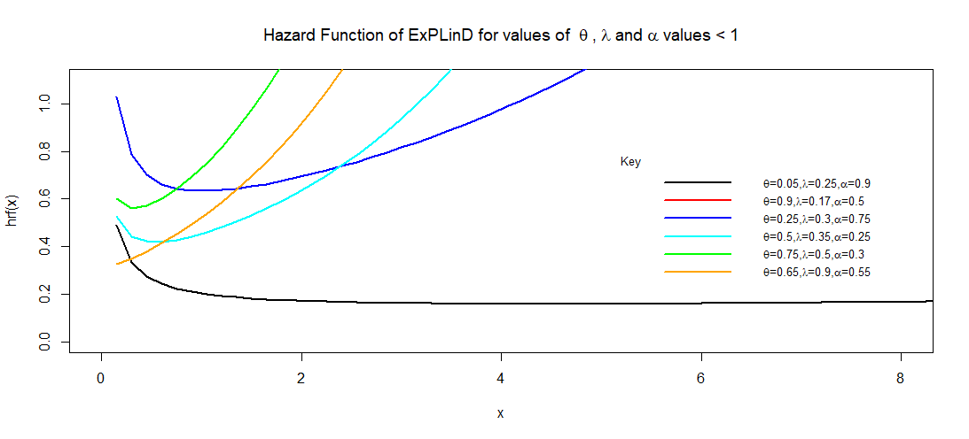

**Figure 4**: **The hazard function of the ExPLinD**.

Figure 4 reveals that the probability of failure for any random variable following ExPLinD increases as the values of the random variable increases, that is, as time goes on, probability of death increases. This implies that the distribution can be used to model random variables with increasing failure rate. Some other failure rate shapes such as bathtub shape and slightly decreasing then constant shape.

**2.4 Estimation of Parameter of ExPLinD.**

Let  be a sample of size ‘n’ independently and identically distributed random variables from the ExPLinD with unknown parameters,α, 𝛌 and θ, defined previously. Recall the pdf of the ExPLinD in Eqn (6). The likelihood function is given by: (22)

Let the log-likelihood function,, therefore

 (23)

Differentiating $l$ partially with respect to α, 𝛌 and θ respectively gives;

 (24)

 (25)

 (26)

The solution of the non-linear system of equations; ,  will give us the maximum likelihood estimates of parameters α 𝛌 and θ. However, the solution cannot be obtained analytically except numerically with the aid of suitable statistical software like R, SAS, Mapple, e.t.c when data sets are available. State the statistical package along with the library used for this study.

**3.1 Simulation Studies of ExPLinD**

In this section, a simulation study is conducted for three different combination of θ, 𝛌 and α. These combination values are given by (i) θ = 0.5, 𝛌 = 0.5 and α = 0.5 (ii) θ = 2.5, 𝛌 = 0.5 and α = 0.5 and (iii) θ = 0.5, 𝛌 = 0.5 and α = 2.5.The performances of the MLEs of the parameters of ExPLinD, ,  and  are evaluated based on two criteria. These are the Mean square error (MSE) and Bias. For every sample size, the average MLEs, mean square errors (MSE), Biases and Absolute biases were computed. The results obtained after performing the MC simulation are provided in Tables 1, 2 and 3 and displayed graphically in Figure 5, 6 and 7. State the justification for the selected parameter values and sample sizes.

Table 1: Simulation Results for the ExPLinD for 

|  |  |  |  |  |  |  |  |  |  |
| --- | --- | --- | --- | --- | --- | --- | --- | --- | --- |
| N | Measures/Criteria | Parameters | | | N | Measures/Criteria | Parameters | | |
|  |  |  |  |  |  |
| n=27 | MLEs | 0.1791 | 0.7859 | 4.649 | n=189 | MLEs | 0.3117 | 0.6443 | 2.858 |
| Biases | 0.3209 | 0.2859 | 4.149 | Biases | 0.1883 | 0.1443 | 2.358 |
| MSEs | 0.1136 | 0.1119 | 18.6705 | MSEs | 0.0678 | 0.0415 | 10.6110 |
| n=54 | MLEs | 0.2094 | 0.7486 | 4.217 | n=297 | MLEs | 0.3500 | 0.6134 | 2.372 |
| Biases | 0.2906 | 0.2486 | 3.717 | Biases | 0.1500 | 0.1134 | 1.872 |
| MSEs | 0.1032 | 0.0860 | 16.7265 | MSEs | 0.0542 | 0.0318 | 8.4240 |
| n=81 | MLEs | 0.2125 | 0.7224 | 4.109 | n=378 | MLEs | 0.3850 | 0.5854 | 1.931 |
| Biases | 0.2875 | 0.2224 | 3.609 | Biases | 0.1150 | 0.0854 | 1.431 |
| MSEs | 0.1036 | 0.0676 | 16.2405 | MSEs | 0.0416 | 0.0233 | 6.4395 |
| n=108 | MLEs | 0.2422 | 0.7109 | 3.767 | n=486 | MLEs | 0.4146 | 0.5631 | 1.562 |
| Biases | 0.2578 | 0.2109 | 3.267 | Biases | 0.0854 | 0.0631 | 1.062 |
| MSEs | 0.0919 | 0.0654 | 14.7015 | MSEs | 0.0309 | 0.0172 | 4.7790 |

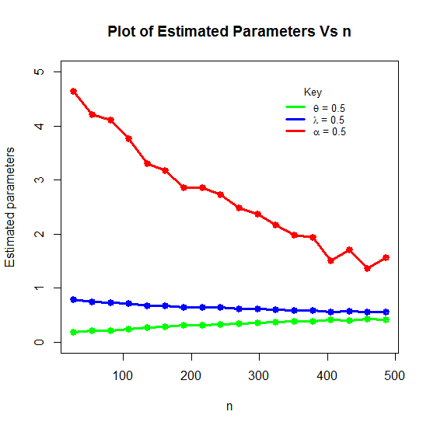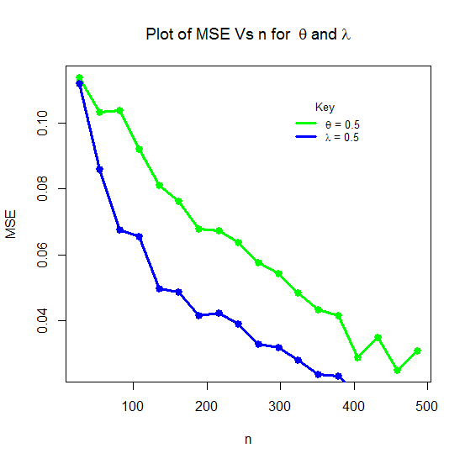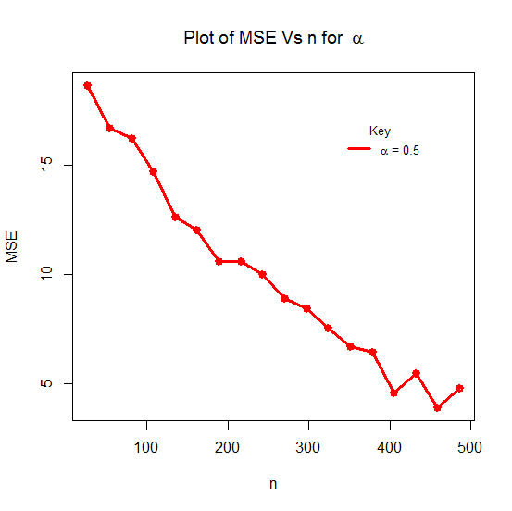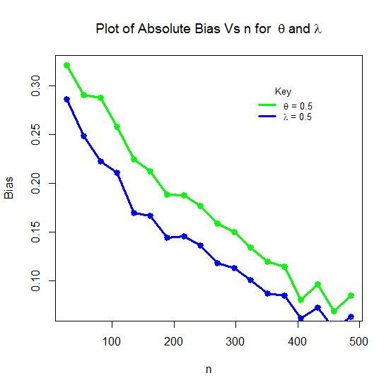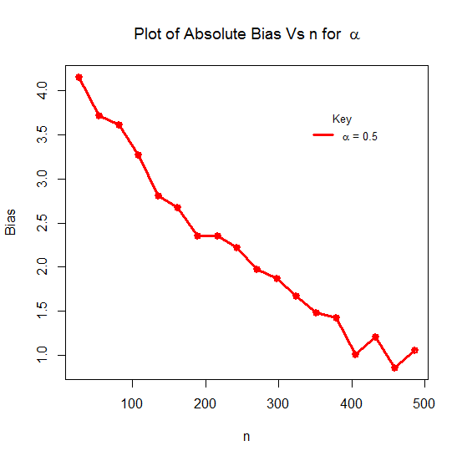

Figure 5: Plots of MLEs, Absolute Biases and MSEs of the ExPLinD for

Table 2: Simulation Results for the ExPLinD for 

|  |  |  |  |  |  |  |  |  |  |
| --- | --- | --- | --- | --- | --- | --- | --- | --- | --- |
| N | Measures/Criteria | Parameters | | | n | Measures/Criteria | Parameters | | |
|  |  |  |  |  |  |
| n=27 | MLEs | 1.3879 | 0.7660 | 3.407 | n=189 | MLEs | 2.3087 | 0.5379 | 0.977 |
| Biases | 1.1121 | 0.2660 | 2.907 | Biases | 0.1913 | 0.0379 | 0.477 |
| MSEs | 1.9511 | 0.1283 | 13.0815 | MSEs | 0.3456 | 0.0139 | 2.1465 |
| n=54 | MLEs | 1.6002 | 0.6929 | 2.777 | n=297 | MLEs | 2.4746 | 0.5050 | 0.563 |
| Biases | 0.8998 | 0.1929 | 2.277 | Biases | 0.0254 | 0.0050 | 0.063 |
| MSEs | 1.6093 | 0.0796 | 10.2465 | MSEs | 0.0463 | 0.0018 | 0.2835 |
| n=81 | MLEs | 1.8891 | 0.6247 | 2.030 | n=378 | MLEs | 2.4965 | 0.5007 | 0.509 |
| Biases | 0.6109 | 0.1247 | 1.530 | Biases | 0.0035 | 0.0007 | 0.009 |
| MSEs | 1.1023 | 0.0486 | 6.8850 | MSEs | 0.0063 | 0.0003 | 0.0405 |
| n=108 | MLEs | 2.1086 | 0.5827 | 1.490 | n=486 | MLEs | 2.4927 | 0.5013 | 0.518 |
| Biases | 0.3914 | 0.0827 | 0.990 | Biases | 0.0073 | 0.0013 | 0.018 |
| MSEs | 0.6998 | 0.0331 | 4.4550 | MSEs | 0.0132 | 0.0004 | 0.0810 |

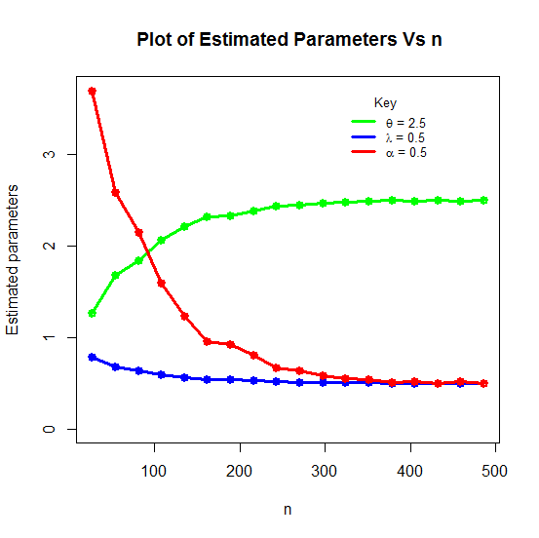

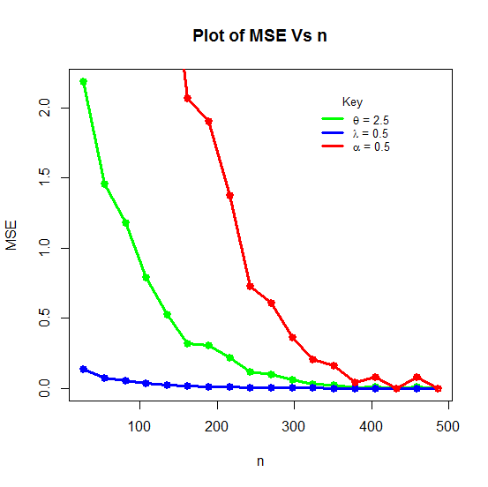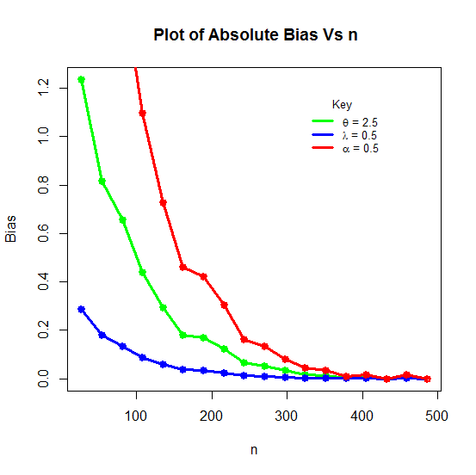

Figure 6: Plots of MLEs, Absolute Biases & MSEs of the ExPLinD for 

Table 3: Simulation Results for the ExPLinD for 

|  |  |  |  |  |  |  |  |  |  |
| --- | --- | --- | --- | --- | --- | --- | --- | --- | --- |
| N | Measures/Criteria | Parameters | | | n | Measures/Criteria | Parameters | | |
|  |  |  |  |  |  |
| n=27 | MLEs | 0.3863 | 0.5962 | 4.180 | n=189 | MLEs | 0.4902 | 0.5057 | 2.620 |
| Biases | 0.1137 | 0.0962 | 1.680 | Biases | 0.0098 | 0.0057 | 0.120 |
| MSEs | 0.0309 | 0.0218 | 4.2000 | MSEs | 0.0021 | 0.0007 | 0.3000 |
| n=54 | MLEs | 0.4198 | 0.5483 | 3.495 | n=297 | MLEs | 0.4987 | 0.5006 | 2.515 |
| Biases | 0.0802 | 0.0483 | 0.995 | Biases | 0.0013 | 0.0006 | 0.015 |
| MSEs | 0.0181 | 0.0078 | 2.4875 | MSEs | 0.0003 | 0.0001 | 0.0375 |
| n=81 | MLEs | 0.4358 | 0.5350 | 3.265 | n=378 | MLEs | 0.4986 | 0.5006 | 2.515 |
| Biases | 0.0642 | 0.0350 | 0.765 | Biases | 0.0014 | 0.0006 | 0.015 |
| MSEs | 0.0143 | 0.0048 | 1.9125 | MSEs | 0.0003 | 0.0001 | 0.0375 |
| n=108 | MLEs | 0.4574 | 0.5224 | 3.005 | n=486 | MLEs | 0.5000 | 0.5000 | 2.500 |
| Biases | 0.0426 | 0.0224 | 0.505 | Biases | 0.0000 | 0.0000 | 0.000 |
| MSEs | 0.0094 | 0.0028 | 1.2625 | MSEs | 0.0000 | 0.0000 | 0.0000 |

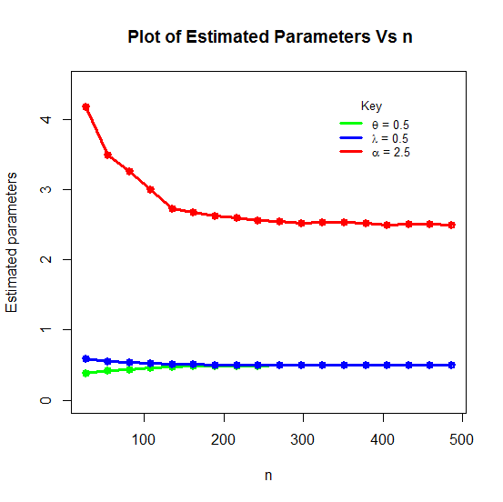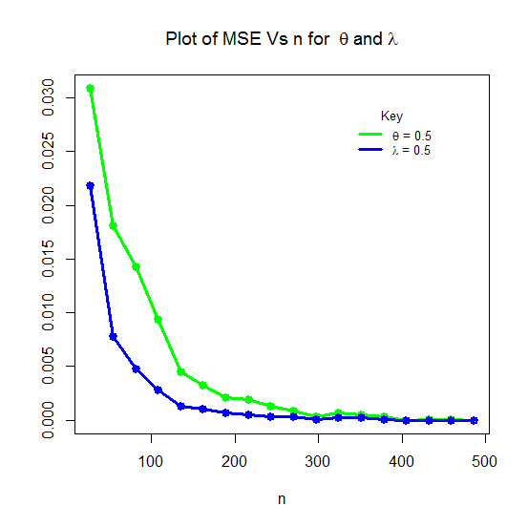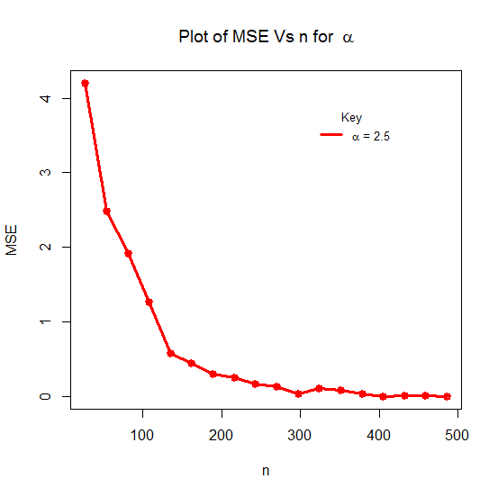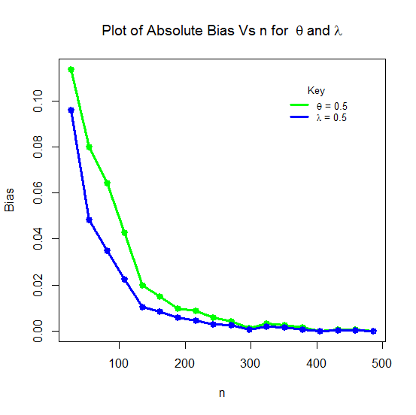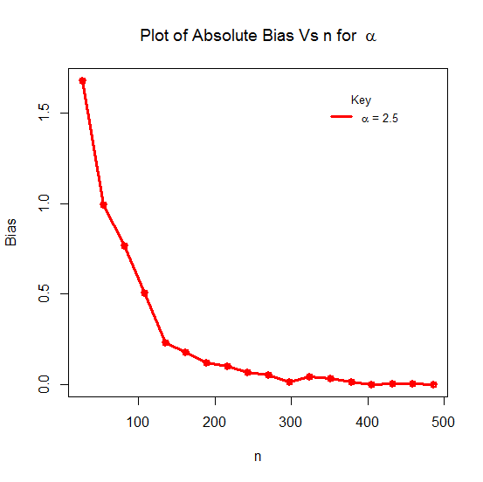

Figure 7: Plots of MLEs, Absolute Biases & MSEs of the ExPLinD for 

The results in Tables 1-3 and Figures 5-7 show the averages of the MLEs (Mean), their biases (Absolute Bias) and mean square errors (MSEs) for the parameters of the ExPLinD. Based on the values from the Tables and the visual illustration in the Figures, the average estimates get closer to the true parameters values when sample size increases and the biases and mean square errors all tend to zero as sample size increases which is expected for every normal parameter.

**3.2 Applications of the ExPLinD to Real Life Data**

This part of chapter four presents a dataset, its descriptive statistics and application to some selected generalized probability distributions. It has compared the adequacy of the ExPLinD to that of six other models. The models are: Poisson-Lindley distribution (PLinD), Exponential-Lindley distribution (ExLinD), inverse exponential distribution (INExD), inverse Lindley distribution (INLinD), exponential distribution (ExD) and Lindley distribution (LinD).Some criteria which will enable us carry out the comparisons are: AIC (Akaike Information Criterion), CAIC (Consistent Akaike Information Criterion), BIC (Bayesian Information Criterion) and HQIC (Hannan Quin information criterion). The formulas for these statistics are given as follows:





 and



Where ƖƖ denotes the log-likelihood function evaluated at the *MLEs*, k is the number of model parameters and n is the sample size.

Decision bench mark: The model with the lowest values of these statistics would be chosen as the best model to fit the data.

**Dataset**: This data set represents the strength of carbon fibers tested under tension at gauge lengths of 10mm. It has been used previously by Kundu and Raqab (20), Bi and Qui (21). The observations are as follows: 1.901, 2.132, 2.203, 2.228, 2.257, 2.350, 2.361, 2.396, 2.397, 2.445, 2.454, 2.474, 2.518, 2.522, 2.525, 2.532, 2.575, 2.614, 2.616, 2.618, 2.624, 2.659, 2.675, 2.738, 2.740, 2.856, 2.917, 2.928, 2.937, 2.937, 2.977, 2.996, 3.030, 3.125, 3.139, 3.145, 3.220, 3.223, 3.235, 3.243, 3.264, 3.272, 3.294, 3.332, 3.346, 3.377, 3.408, 3.435, 3.493, 3.501, 3.537, 3.554, 3.562, 3.628, 3.852, 3.871, 3.886, 3.971, 4.024, 4.027, 4.225, 4.395, 5.020.

Table 4: Summary Statistics for Data Set

|  |  |  |  |  |  |  |  |  |  |  |
| --- | --- | --- | --- | --- | --- | --- | --- | --- | --- | --- |
| Parameters | n | Mini |  | Median |  | Mean | Maximum | Variance | Skewness | Kurtosis |
| Values | 63 | 1.901 | 2.554 | 2.996 | 3.421 | 3.0593 | 5.02 | 0.38554 | 0.63285 | 0.28634 |

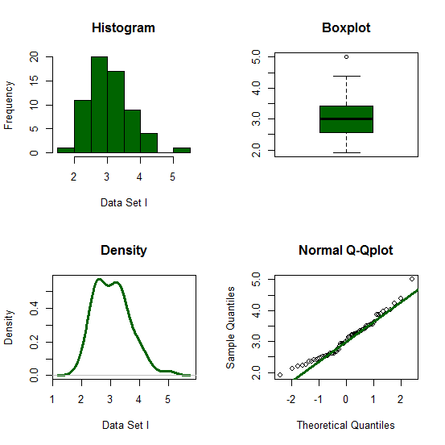

Figure 8: A graphical summary of dataset

Descriptive statistics in Table 4 and the graphical summary in Figure 8 shows that the dataset on the strength of carbon fibers tested under tension at gauge lengths of 10mm is slightly skewed to the right or positively skewed which is proper for skewed models.

Table 5: Maximum Likelihood Parameter Estimates for Dataset I

|  |  |
| --- | --- |
| Distribution | Parameter Estimates |
| ExPLinD | =0.4083674, =0.3516601, =0.4083674. |
| PLinD | =0.4598007, =0.4555799. |
| ExLinD | =0.7488845, =0.6868056. |
| INLinD | =3.584214 |
| INExD | =2.942385 |
| LinD | =0.5389887 |
| ExD | =0.3269008 |

Table 6: The Statistics *ℓ*, AIC, CAIC, BIC and HQIC for Dataset I

|  |  |  |  |  |  |  |
| --- | --- | --- | --- | --- | --- | --- |
| Distribution |  | *AIC* | *CAIC* | *BIC* | *HQIC* | Ranks |
| ExPLinD | -1.554066 | 2.891869 | 3.298648 | 9.3221273 | 5.420585 | 1st |
| PLinD | 0.2701584 | 4.540317 | 4.740317 | 8.826586 | 6.226127 | 2nd |
| ExLinD | 2.876741 | 9.753482 | 9.953482 | 14.03975 | 11.43929 | 3rd |
| LinD | 121.3576 | 244.7153 | 244.7809 | 246.8584 | 245.5582 | 4th |
| INLinD | 131.8826 | 265.7652 | 265.8308 | 267.9083 | 266.6081 | 5th |
| INExD | 133.4229 | 268.8458 | 268.9114 | 270.9889 | 269.6887 | 6th |
| ExD | 133.4458 | 268.8915 | 268.9571 | 271.0347 | 269.7344 | 7th |

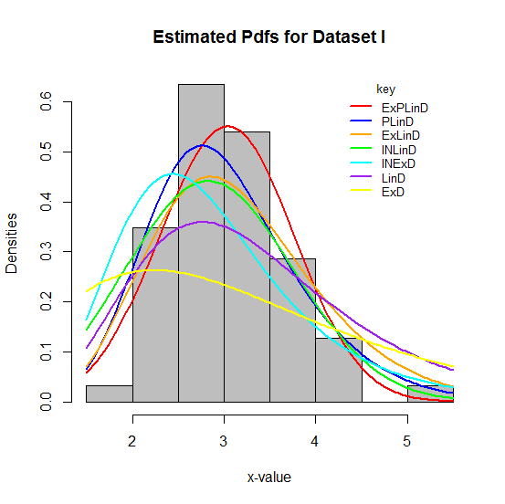 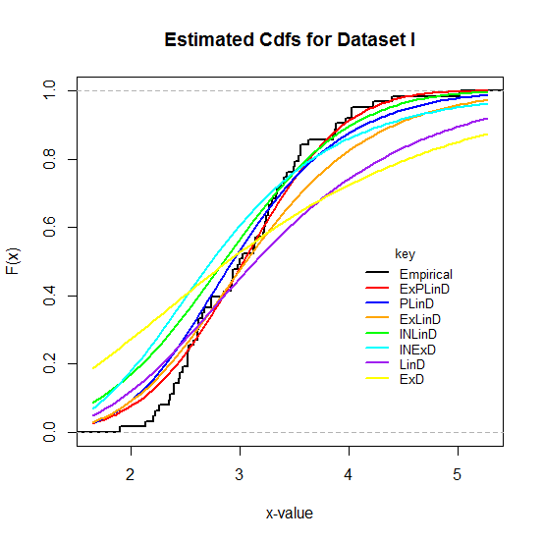

Figure 9:Histogramand Plots of the Estimated Densities and cdfs of the Fitted Distributions to Dataset.

## **4.0 Summary and Conclusions.**

A new three parameter continuous distribution called the Exponential Poisson Lindley Distribution (ExPLinD) was introduced. Its statistical properties and reliability analysis were carried out and appropriate plots presented. Simulation Studies of ExPLinD was carried out and it was applied to real life data in comparison to some stated distributions. Findings indicate that the ExPLinD can be used to model age or time related random variable. Also, the average estimates of the parameters of ExPLinD get closer to the true parameters values when sample size increases and the biases and mean square errors all tend to zero as sample size increases which is expected for every normal parameter. The ExPLinD provided a better fit to the dataset compared to the other stated distributions.

References

Lindley, D.V. Fiducial distributions and Bayes Theorem. *Journal of Royal Statistical Society*. Series B (Methodological), (1958). 20(1): 102–107.

Ghitany, M.E., Atieh, B. and Nadarajah, S. Lindley distribution and its applications. *Mathematics and Computers in Simulation*, (2008). 78(4): 493-506.

Mazucheli, J., Achcar, J.A.,. The Lindley distribution applied to competing risks lifetime data. *Computer Methods and Programs Biomedicine*. 2011 104(2): 188–192.

Krishna, H. and Kumar, K., 2011. Reliability estimation in Lindley distribution with progressively type-ii right censored sample. *Mathematical and Computer in Simulation*, 82(2): 281–294.

Singh, B., Gupta, P.K., 2012. Load-sharing system model and its application to the real data set. *Mathematical Computation and Simulation*, 82: 1615–1629.

Al-Mutairi, D.K., Almutairi, M.E., Kundu, D., 2013. Inferences on stress-strength reliability from Lindley distributions. *Communications in Statistics–Theory and Methods,* 42: 1443–1463.

Merovci, F. (2013). Transmuted Lindley distribution. International. *Journal of Open Problems in Computer Science and Mathematics*, 6(2): 63-74.

Ashour, S. K. and Eltehiwy, M. A. (2015). Exponentiated power Lindley distribution. *Journal of Advanced Research*, 6: 895–905

Nadarajah, S., Bakouch, H. S. and Tahmasbi, R. (2011). A generalized Lindley distribution. *Sankhya B*, 73: 331–359. DOI 10.1007/s13571-011-0025-9.

Alkarni, S. H. (2015). Extended Power Lindley Distribution: A New Statistical Model For Non-Monotone Survival Data. *European Journal of Statistics and Probability*, 3(3): 19-34.

Elgarhy, M., M.Rashed, M. and Shawki, A.W. (2016). Transmuted Generalized Lindley Distribution. *International Journal of Mathematics Trends and Technology,* 29(2): 145-154.

Shanker, R., Kamlesh, K. K. and Fesshaye, H. (2017). A Two Parameter Lindley Distribution: Its Properties and Applications. *Biostatistics and Biometrics Open Access Journal*, 1(4): 555570.

Shanker, R., Shukla, K. K., Shanker, R. and Leonida, T. A. (2017). A Three-Parameter Lindley Distribution. *American Journal of Mathematics and Statistics*. 7(1): 15-26.

Onwuka G. I., Asongo A. I., Bako I. A., Ortese C. A. and Allahde H. (2021). Modeling Neonatal Mortality Rate in Nigeria using a Continuous Poisson-Lindley Distribution. *International Journal of TROPICAL DISEASES And Health,* 42(19): 6-16

Hamad D. and Alzaghal A. (2021). New class of Lindley distributions: properties and applications. *Journal of Statistical Distributions and Applications*, 8, 11 (2021). https://doi.org/10.1186/s40488-021-00127-y.

Tahir, M.H., Zubair, M., Mansoor, M., Cordeiro, G.M., Alizadeh, M. (2016). A new Weibull-G family of distributions. *Hacettepe Journal of Mathematics and Statistics,* 45(2): 629-647.

Ieren, T. G., Oyamakin, S. O. & Chukwu, A. U. (2018a). Modeling Lifetime Data W ith Weibull-Lindley Distribution. *Biometrics and Biostatistics International Journal*, 7(6): 532‒544.

Kundu, D and Raqab, M.Z. (2009) Estimation of R = P(Y < X) for three-parameter Weibull distribution. Statistics and Probability Letters, 79(17); 1839-1846

Bi, Qixuan and Gui, Wenhao. (2017). Bayesian and Classical Estimation of Stress-Strength Reliability for Inverse Weibull Lifetime Models. Algorithms. 10.71.10.71.10.3390/a10020071.