Comparison of Effective Radiation Dose in CT Scan Abdomen Examination of Male and Female Patients with Indosect Application

# ABSTRACT

**Aim:** This study aims to compare the effective dose of radiation in abdominal CT scan examination of male and female patients using IndoseCT version 20.b application. The focus of the study is on abdominal CT scans of adult male and female patients.

**Study Design:** This study used an experimental design with a quantitative approach. The research was conducted in the Radiology unit of Bali Mandara Hospital.

**Methodology:** The study data were taken from the medical records of 30 male and 30 female adult patients who underwent abdominal CT scans at the Radiology Installation of Bali Mandara Hospital. The data were processed with IndoseCT version 20.b application and analyzed with independent t test to compare the effective dose of male and female patients. The CT scan aircraft used was Siemens Somatom Perspective 128 Philips.

**Result:** Based on the calculation of the effective dose of the abdomen using the **indosect** application, the results of the effective dose value of the abdomen of male patients are (10.82 ± 3.29) mSv and the effective dose value of the abdomen of female patients is (9.97 ± 3.23) mSv..

**Conclusion:** Based on the results of statistical analysis with the Independent t test, the t count value is 1.014 and the t table value is 2.001 so that H0 is accepted and H1 is rejected, which can be concluded that there is no significant difference in effective dose between male and female patients on abdominal CT scans at the Radiology Installation of Bali Regional Hospital.

*Keywords: CT Scan, effective dose, abdomen, IndoseCT version 20.b*

# INTRODUCTION

Computed tomography scans (CT scans) are a key diagnostic tool in the medical world due to their ability to produce detailed internal images of the body. However, its use poses a risk of exposure to ionizing radiation, which if excessive can increase health risks, such as cancer (Adi, 2023). Therefore, optimizing radiation protection through the application of Diagnostic Reference Level (DRL) is important. In accordance with the Regulation of the Head of BAPETEN NUMBER: 1211/K/V/2021, the CTDIVol value for patients over 15 years old is set at 17 mGy with a DLP of 885 mGy.cm.

CT scans account for most of a patient's radiation exposure (Brenner & Hall, 2007), so radiation dose monitoring is necessary. Effective dose is used to describe the biological risk of radiation exposure and is influenced by Dose Length Product (DLP) (Jayandini, 2023). Anatomical and physiological differences between men and women are thought to affect the distribution and absorption of radiation during CT scan procedures (Dewanto & Santoso, 2023). Ibrahim et al. (2018) showed that male patients have slightly higher CTDIVol and effective dose values than females.

This study aims to determine the effective dose of abdominal CT scan between male and female patients using IndoseCT software version 20.

# MATERIALS AND METHODS

## Materials

* + 1. **Study area**

This study was conducted at the Radiology Installation of Bali Mandara Regional General Hospital (RSUD) Denpasar Jl. Bypass Ngurah Rai No. 548, Sanur Kauh, South Denpasar, Denpasar City, Bali.

### Study site

The tools and materials used in this study include a CT Scan aircraft with specifications of the Siemens Somatom Perspective 128 Philips brand and computer equipment used for processing patient data.

* + 1. **Study design**

This study used IndoseCT software version 20.b which is designed to calculate and record radiation exposure during CT scan procedures.

* + 1. **Study population**

Patients who underwent abdominal CT scan examination at Radiology Installation of Bali Mandara Hospital.

* + 1. **Sample size determination**

The independent variables of this study are CTDIVol and DLP. The dependent variable is the effective dose value. Other parameters that were kept constant were the control variable parameters, namely the tube voltage of 130 kV.

1. **Methods**
   * 1. **Sampling techniques**

Data collection was carried out with the following steps:

* Abdominal CT scan patient data is prepared.
* Patient's initials, gender, age, tube voltage, tube current, CTDIVol and DLP were recorded.
* The data that has been obtained is then processed using the IndoseCT application.
* From the data that has been processed in the IndoseCT application, analysis and decision making are then carried out.

### Study instruments

### The research procedure follows the following flow chart:

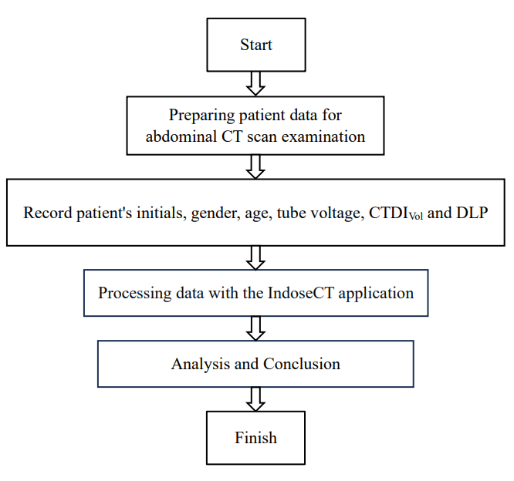

**Figure 1** Research flow **chartenap**

### Data collection method

Calculation of Effective dose with IndoseCT:

CTDIVol, DLP values are inputted and the effective diameter value has been obtained, then the value of the patient's effective dose can be determined. Effective dose in this case can provide an overview of the patient's risk and the probability of cancer in the future. In the measurement of effective dose, the phantom type is Body with abdominal protocol. For more details can be seen in Figure 2.

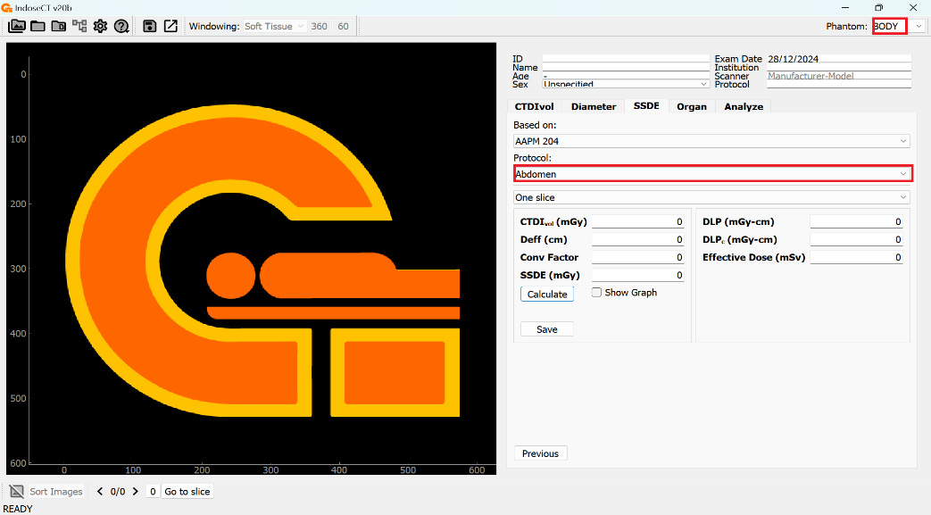

**Figure 2** IndoseCT display on effective dose calculation

### Data management

* H0 : there is no difference in the effective dose of the abdomen between male and female patients.
* H1 : there is a difference between the effective dose of the abdominal section between male and female patients

The statistical test results are then compared between the t value and the t table. If the t value < t table then the hypothesis H0 is accepted and H1 is rejected, if t count ≥ t table then H0 is rejected and H1 is accepted. The formula for determining the calculated t value is shown in Equation 1.

$${ t}_{count}= \frac{({\overline{x}}_{1}-{\overline{x}}_{2})}{\sqrt{\frac{\left(n_{1}-1\right)s_{1}^{2}+\left(n_{2}-1\right)s_{2}^{2}}{n_{1}+n_{2}-2}\left(\frac{1}{n_{1}}+\frac{1}{n_{2}}\right)}} (1)$$

Description:

${\overline{x}}_{1}$: average of sample 1

${\overline{x}}_{2}$: average of sample 2

$s_{1}$: standard deviation of sample 1

$s_{2}$: standard deviation of sample 2

$n_{1}$: many sample data 1

$n_{2}$: many sample datal 2

# RESULTS AND DISCUSSION

In this study, data was collected from 30 adult male patients and 30 adult female patients at the radiology installation of Bali Mandara Hospital. The data obtained are patient initials, patient age, tube voltage (kV), current strength time (mAs), CTDIVol, and DLP. CTDIVol and DLP are then used to calculate the effective dose value with the IndoseCT application. The results can be seen in Table 1 for male patients and Table 2 for female patients. After the effective dose value is obtained, the average value and standard deviation are sought.

Table 1. IndoseCT effective dose calculation data of male patients abdomen

|  |  |  |  |  |
| --- | --- | --- | --- | --- |
| No. | Patient initials | CTDIVol (mGy) | DLP(mGy.cm) | E (mSv) |
|  | GM | 6,05 | 358 | 6,89 |
|  | GW | 8,25 | 522 | 10,05 |
|  | IGMWD | 7,79 | 427,17 | 8,23 |
|  | JB | 8,35 | 535,19 | 10,3 |
|  | RJQ | 11,33 | 746,89 | 14,38 |
|  | IKSE | 8,3 | 516,35 | 9,94 |
|  | H | 6,38 | 374,66 | 7,21 |
|  | IBAS | 7,53 | 469,98 | 9,05 |
|  | DT | 9,79 | 666,9 | 12,84 |
|  | IKSU | 15,89 | 1016,84 | 19,58 |
|  | IWR | 8,25 | 532,31 | 10,25 |
|  | BC | 9,84 | 585,03 | 11,26 |
|  | INMA | 9,18 | 569,68 | 10,97 |
|  | PS | 6,1 | 362,17 | 6,97 |
|  | Y | 6,6 | 424,2 | 8,17 |
|  | IGS | 6,1 | 367,97 | 7,09 |
|  | MM | 12,74 | 857,27 | 16,51 |
|  | NS | 7,04 | 449,66 | 8,66 |
|  | INM | 9,57 | 641,87 | 12,36 |
|  | MD | 9,9 | 627,88 | 12,09 |
|  | IMA | 9,29 | 540,73 | 10,41 |
|  | INGA | 8,74 | 548,95 | 10,57 |
|  | IKS | 8,74 | 794,14 | 15,29 |
|  | KS | 6,21 | 380,81 | 7,33 |
|  | IWD | 8,69 | 530,29 | 10,21 |
|  | IKK | 7,42 | 460,89 | 8,87 |
|  | JMD | 14,57 | 936,04 | 18,02 |
|  | INR | 8,96 | 570,82 | 10,99 |
|  | IMG | 6,65 | 391,81 | 7,54 |
|  | SW | 10,78 | 659,99 | 12,71 |

Table 2. IndoseCT effective dose calculation data of female patients abdomen

|  |  |  |  |  |
| --- | --- | --- | --- | --- |
| No. | Patient initials | CTDIVol (mGy) | DLP(mGy.cm) | E (mSv) |
|  | VA | 11 | 713,04 | 13,73 |
|  | ASB | 8,25 | 420,75 | 8,1 |
|  | NLPP | 10,23 | 628,87 | 12,11 |
|  | DDC | 10,01 | 653,37 | 12,58 |
|  | RDL | 7,04 | 392,31 | 7,55 |
|  | NLDDP | 15,5 | 866,63 | 16,69 |
|  | NPELD | 9,46 | 561,21 | 10,81 |
|  | NH | 6,43 | 360,2 | 6,94 |
|  | DC | 8,05 | 468,22 | 9,02 |
|  | NNS | 7,81 | 480,89 | 9,26 |
|  | IAPM | 11,16 | 689,7 | 13,28 |
|  | NMYS | 9,68 | 643,92 | 12,4 |
|  | MF | 8,14 | 517,89 | 9,97 |
|  | NNR | 6,71 | 429,25 | 8,27 |
|  | NMS | 16,1 | 1001,67 | 19,29 |
|  | F | 8,05 | 441,25 | 8,5 |
|  | IS | 6,71 | 412,15 | 7,94 |
|  | IGAPSA | 9,35 | 601,41 | 11,58 |
|  | NNRA | 6,93 | 396,92 | 7,64 |
|  | NLRS | 11,33 | 696,49 | 13,41 |
|  | SR | 7,53 | 395,42 | 7,61 |
|  | NLOS | 8,3 | 470,27 | 9,05 |
|  | NWR | 7,48 | 379,82 | 7,31 |
|  | NNA | 6,93 | 408 | 7,86 |
|  | S | 9,57 | 605,52 | 11,66 |
|  | NLS | 10,06 | 584,02 | 11,25 |
|  | NNSU | 6,21 | 316,83 | 6,1 |
|  | IAKS | 4,89 | 280,36 | 5,4 |
|  | NMK | 6,98 | 393,08 | 7,57 |
|  | NWN | 5,61 | 326,36 | 6,28 |

Based on Table 1 and Table 2, the average and standard deviation were calculated. The results can be seen in Table 3.

Table 3. Calculation of mean and standard deviation values of CTDIVol, DLP, and effective dose in male and female patients

|  |  |  |  |  |
| --- | --- | --- | --- | --- |
| No. | Gender | CTDIVol (mGy) | DLP (mGy.cm) | E  (mSv) |
| 1 | Male | 8,83 $±$ 2,40 | 562,22 $±$ 170,75 | 10,82± 3,29 |
| 2 | Female | 8,72± 2,55 | 517,86 ± 167,50 | 9,97± 3,23 |

Table 3 shows that male patients have a greater CTDIVol when compared to female patients. In male patients the CTDIVol value is (8.83 ± 2.40) mGy and in female patients the CTDIVol value is (8.72 ± 2.55) mGy. This is also supported by Anggreny's research (2018) in which the results showed that the CTDIVol of male patients was greater than that of female patients. Irsal's research (2020) states that the magnitude of the CTDIVol value is influenced by the patient's organs. As based on research conducted by Sofiana in 2013, it is known that the CTDIVol value is directly proportional to the organ volume of the patient, which means that the greater the organ volume, the greater the CTDIVol. From this, it can be seen that the organ volume of male patients is greater than that of female patients.

The results of Table 3 also show that the effective dose value calculated using the IndoseCT application for male patients is slightly greater when compared to female patients. Male patients have an effective dose value of (10.82 ± 3.29) mSv while female patients have an effective dose value of (9.97 ± 3.23) mSv. The comparison of the average effective dose of male and female patients can be seen in Figure 3.

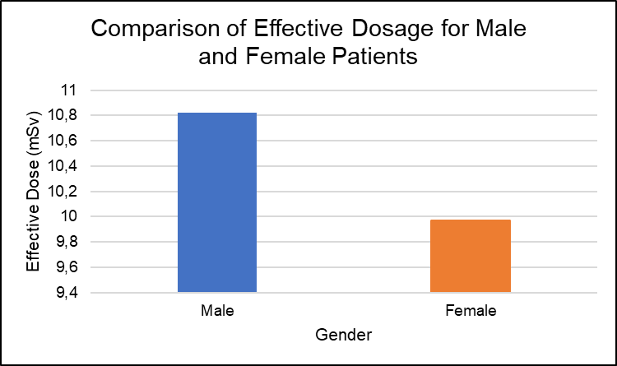

**Figure 3** Comparison chart of the average effective dose of male and female patients

Data analysis in this study using the Independent t test shows that the t value is less than the t table value. Where the t value is 1.014 and the t table value is 2.001. So that H0 is accepted and H1F is rejected, which means that there is no significant difference in effective dose between male and female patients on abdominal CT scan examination at Radiology Installation of Bali Mandara Hospital. The following is the calculation result using equation 1:

Unknown : ${\overline{x}}_{1}$ = 10,8247

${\overline{x}}_{2}$ = 9,9720

$n_{1}$ = 30

${ n}_{2}$ = 30

${ s}_{1}$ = 3,2881

$s_{2}$ = 3,2258

Asked : tcount : …. ?

Settlement:

$$t_{count}= \frac{\left({\overline{x}}_{1}-{\overline{x}}_{2}\right)}{\sqrt{\frac{\left(n_{1}-1\right)s_{1}^{2}+\left(n_{2}-1\right)s_{2}^{2}}{n_{1}+n_{2}-2}\left(\frac{1}{n_{1}}+\frac{1}{n_{2}}\right)}}$$

$$= \frac{\left(10,8247-9,9720\right)}{\sqrt{\frac{\left(30-1\right){\left(3,2881\right)}^{2}+\left(30-1\right){\left(3,2258\right)}^{2}}{30+30-2}\left(\frac{1}{30}+\frac{1}{30}\right)}}$$

$$= \frac{0,8527}{\sqrt{\frac{29\left(10,8116\right)+29\left(10,4055\right)}{58}\left(\frac{2}{30}\right)}}$$

$$= \frac{0,8527}{\sqrt{10,6085\left(0,0667\right)}}$$

$$= \frac{0,8527}{\sqrt{0,7255}}$$

$$= \frac{0,8527}{0,8410}$$

$$= 1,014$$

# CONCLUSION

Based on the research that has been done, it can be concluded that based on the Independent t test shows that the t count value is less than the t table value. Where the t count value is 1.014 and the t table value is 2.001 so that H0 is accepted and H1 is rejected which means that there is no significant difference in effective dose between male and female patients on abdominal CT Scan examination at Radiology Installation of Bali Mandara Hospital.

# RECOMENDATION

Input for the future so that research using the IndoseCT application can be continued on the organ dose calculation feature to the analysis feature on the IndoseCT application for both the abdomen, head and chest cavity so that the use of the IndoseCT application can be further utilized in estimating the dose received by the patient and can be used as a consideration of the dose that can be given to patients to minimize the negative effects of the use of CT Scan aircraft radiation at the Radiology Installation of Bali Mandara Hospital.

**PERINGATAN (ARTIFICIAL INTELLIGENCE)**

Author(s) hereby declares that NO generative AI technologies such as Large Language Models and text-to-image generators have been used during writing or editing of this manuscript.

# CONSENT

All authors declare that a ‘written informed consent was obtained from all the patient;

# REFERENCES

AAPM Report204. (2013). *Size-Specific Dose Estimate (SSDE) in Pediatric and Adult Body CT Examinations*. American Association of Physicists in Medicine. 3-19.

Adi, S. (2023).Application of InDoseCT in Radiation Dose Analysis:Case Study of Abdominal Examination. Indonesian Journal of Medical Imaging, 9(1), 52-60.

Anam, C., Adhianto, D., Sutanto, H., Adi, K., Ali, M. H., Rae, W. I. D., Fujibuchi, T., & Dougherty, G. (2020). Comparison of central, peripheral, and weighted size specific dose in CT. *Journal of X-Ray Science and Technology*, *28*(4), 695–708.

Anam, C., Arif, I., Haryanto, F., Widita, R., Lestari, F. P., Adi, K., & Dougherty, G. (2019). A Simplified Method For The Water-Equivalent Diameter Calculation to Estimate Patient Dose in CT Examinations. *Radiation Protection Dosimetry*, *185*(1), 42–49.

Anam, C., Haryanto, F., Widita, R., Arif, I., & Dougherty, G. (2016). Automated Calculation of Water-equivalent Diameter (DW) Based on AAPM Task Group 220. *Journal of Applied Clinical Medical Physics*, *17*(4), 320–333.

Anam, C., Mahdani, F. R., Dewi, W. K., Sutanto, H., Triadyaksa, P., Haryanto, F., & Dougherty, G. (2021). An improved method for automated calculation of the water-equivalent diameter for estimating size-specific dose in CT. *Journal of Applied Clinical Medical Physics*, *22*(9), 313–323.

Anggreny, Ajeng & Hamar Halide. (2018). Estimation of Effective Dose of Head Patients from CT Examination Results of Siemens Somatom Brand. National Quantum Seminar, Hassanudin University, Physics Study Program.

Ayuna, Dewinta. (2020). How to Read the Z Table. Youtube.<https://youtu.be/CIqYoVpRPMs> (Accessed on November 15, 2024).

Brenner, D. J., Hall, E. J., & Phil, D. (2007). Computed Tomography-An Increasing Source of Radiation Exposure. In *N Engl J Med* (Vol. 357).

Dewanto, T. A., & Santoso, D. R. (2023).Radiation in Medical Imaging:Risks and Long-term Effects.Indonesian Journal of Nuclear Medicine, 10(1), 25-34.

Ibrahim, A. A., Abdullah, B., & Halide, H. (2018).Effective dose estimation of abdominal patients from Siemens SOMATOM brand CT scans.POSITRON, 8(2), 39-42.

ICRP. (2007). The 2007 Recommendations of the International Commission on Radiological Protection (J. Valentin, Trans.). In *Elsevier* (Vol. 103).

Jayandini, O. F. D. (2023). Analysis of Effective Dose and Radiation Dose of Eye Organs of Head Ct Examination Patients Using Indosect and Raysafe X2 Multimeter.Dissertation.Sepuluh Nopember Institute of Technology. Surabaya.

Khoiriyyah, R. M. (2020). Estimation of Radiation Dose and Risk Factors in Computed Tomography Scan of Abdomen at Sultan Agung Islamic Hospital (RSI) Semarang. Thesis.Physics Study Program, Faculty of Science and Technology, Walisongo State Islamic University.Semarang.

Nariswari, N. N. (2018). Analysis of Variation of Exposure Factor and Slice Thickness on CTDIi and Image Quality in Computed Tomography (CT) Scan. Thesis.Department of Physics, Faculty of Mathematics and Natural Sciences, University of Jember.Jember.

Seeram, E. (2018). Computed tomography: a technical review. *Radiologic technology*, *89*(3), 279CT-302CT.

Silvia, H., Milvita, D., Prasetio, H., & Yuliati, H. (2013). Estimation of CTDI Value and Effective Dose of Head, Thorax and Abdomen Patients of Philips Briliance 6 Brand CT-Scan Examination Results. Journal of Physics Unand, 2(2).

Siregar, E. S. B., Gusti, I., Sutapa, N., Wayan, I., & Sudarsana, B. (2019). Determination of Effective Dose in CT Scan Examination of Children's Head with Indosect Software. In Kappa Journal Physics Education Study Program FMIPA Hamzanwadi University December (Vol. 3, Issue 2).

Soediatmoko, E. (2011). Radiation Dose Estimation in Head CT Scan Examination. Thesis, Department of Physics, Faculty of Mathematics and Natural Sciences, University of Indonesia, Depok.

Sofiana, L. (2013). Estimation of Effective Dose in Multi Slice Ct-scan Examination of Head and Abdomen Based on Icrp 103 Recommendations. Dissertation. Brawijaya University. Malang.

Sugiyono. (2021). Statistics for Research. Bandung. Alfabeta.

Yogantara, P. G. K. (2020). Analysis of Effective Dose in Computer Tomography (CT) Scan Examination of Head at RSUD Sanjiwani Gianyar. Thesis Udayana University: Department of Physics, Faculty of Mathematics and Natural Sciences.