Journal Name: | Asian Journal of Language, Literature and Culture Studies
Manuscript Number: | Ms_AJL2C_132843
Title of the Manuscript: | Culturally Responsive Teaching Competence, Digital Cohmpetence, and Language Learning Motivation: A Structural Equation Model of Teaching Competence of Pre-service Teachers
Type of the Article | Original Research Article

PART 1: Comments

 | Reviewer’s comment  Artificial Intelligence (AI) generated or assisted review comments are strictly prohibited during peer review. | Author’s Feedback (Please correct the manuscript and highlight that part in the manuscript. It is mandatory that authors should write his/her feedback here)
Please write a few sentences regarding the importance of this manuscript for the scientific community. A minimum of 3-4 sentences may be required for this part. | In the context of teacher professional development, research on teaching skills for pre-service teachers is of paramount importance. This modeling research provides meaningful alternative examples for in-service teachers. By adjusting the context in which teachers operate, they can apply the findings of this research to their professional lives. In addition, this research inline with the TPACK framework (technological, pedagogical, and content knowledge), it demonstrates that digital competence exerts a significant influence on the quality of teacher pedagogy.
Is the title of the article suitable?  (If not please suggest an alternative title) | Suggestion for the title:  Linking Culturally Responsive Teaching Competence, Digital Competence, and Language Learning Motivation to Pre-service Teachers’ Teaching Competence: A Structural Equation Model
Is the abstract of the article comprehensive? Do you suggest the addition (or deletion) of some points in this section? Please write your suggestions here. | In the abstract, it is necessary to add 1 sentence that contains a gap or an important problem that needs to be addressed. why researchers feel the need to examine the relationship between the research focuses and teachers' teaching competence.
Is the manuscript scientifically, correct? Please write here. | In general, the manuscript is scientifically correct, but needs improvement as follows:.  - This manuscript needs to explain that the components of teacher competence are many, why in this study only measure 3 indicators, namely that the indicators for pedagogical competence, classroom management competence, and student performance assessment competence.  - There are some terms that use non-English, so it is not understood by the reader as in Figure 1. The model showing the relationship between the endogenous variables Culturally Responsive Teaching Competence, Digital Competence, Language Learning Motivation, and Teaching Competence of Pre-service Teachers.  - 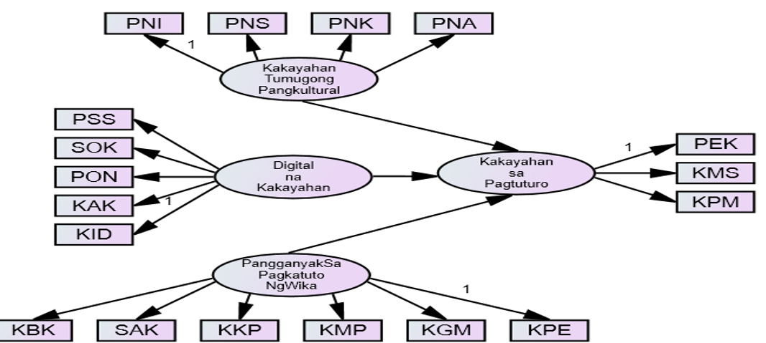
Are the references sufficient and recent? If you have suggestions of additional references, please mention them in the review form. | In general, the references are adequate and up-to-date, but it is necessary to add important references such as the following, in order to further strengthen the concept under study. To explain the concept of teacher comtenece, it is necessary to refer to: https://download.garuda.kemdikbud.go.id/article.php?article=2633791&val=24531&title=Teachers%20competence%20and%20performance%20A%20systematic%20theoretical%20study  And:  https://cdn-contenu.quebec.ca/cdn-contenu/adm/min/education/publications-adm/devenir-enseignant/reference_framework_professional_competencies_teacher.pdf
Is the language/English quality of the article suitable for scholarly communications? | The language used is appropriate for scientific communication

Optional/General comments

PART 2:

 | Reviewer’s comment | Author’s comment (if agreed with the reviewer, correct the manuscript and highlight that part in the manuscript. It is mandatory that authors should write his/her feedback here)
Are there ethical issues in this manuscript? | (If yes, Kindly please write down the ethical issues here in detail)

Reviewer details:

Hanip Pujiati, Jakarta State University, Indonesia

