**Original Research Article**

**Design and Construction of an Automated Solar-Powered Aquaponic System for Teaching and Research Purposes Using Acrylic Glass**

**ABSTRACT**

This research explores the design and construction of an automated solar-powered aquaponic system utilizing acrylic glass as the primary construction material, offering a sustainable approach to food production. Addressing the interconnected challenges of food, water, and energy security, particularly in the context of climate change, this system presents a promising model for smart agriculture in Nigeria. The system integrates fish farming (aquaculture) and soilless plant cultivation (hydroponics) in a symbiotic relationship, minimizing water usage and maximizing resource efficiency. The evaluation of the system's design and construction, including the acrylic glass materials, automation system, and solar power integration, underscores its potential. Future research will focus on long-term performance assessment of the acrylic glass, testing with diverse plant species, and a comprehensive resource efficiency analysis incorporating fish culture data.

**Keywords:** Aquaponics, Automation, Solar Power, Acrylic Glass, Sustainable Agriculture, Hydroponics, Aquaculture.

**1. INTRODUCTION**

It has always been crucial to continually create alternative agricultural techniques, particularly in response to the numerous issues that traditional agriculture faces (Manos and Xydis, 2019). The European Union, the Environmental Protection Agency, and the World Health Organization are just a few of the organizations that frequently suggest using recycled water for irrigation as a good way to formulate water management policies. Studies have shown that hydroponic systems can be used to clean wastewater in addition to producing food (Sundar *et al*. 2021). They are a straightforward technology that permits plants to grow in water without soil (Jayachandran *et al.* 2022). The aqueous solution provides plants with the nutrients they require to grow (Shubham and Shrimanth 2020). The hydroponic system may also be used as a management strategy prior to partially treated effluent being discharged into the environment since plants can absorb nutrients, harmful metals, and emerging contaminants (Cifuentes-Torres *et al*. 2020).

Soil is the traditional growing media used in the conventional cultivation of vegetables and vital herbs. Unfortunately, the labor-intensive nature of this traditional growing method has long been linked to high operational costs and uneven yields brought on by unfavorable and erratic weather. Large amounts of manpower, fertilizers, and water are also needed for conventional farming throughout the crop-harvesting and post-harvest phases. The majority of developing nations, where high-tech agricultural systems are uncommon, are affected by this predicament. Aquaponics is the practice of cultivating plants and aquatic life in regulated settings within a closed system (Maucieri *et al.,* 2018). The Aquaponics method offers a fresh viewpoint on plant cultivation that is very different from traditional farming. The symbiotic ecosystem balance between aquatic species and hydroponic products, such as vegetables and necessary herbs, is the foundation of aquaponics growing systems (Hu *et al.,* 2015; Tyson *et al.,* 2011). The items are regarded as organic because no synthetic fertilizers were utilized during the growth phase. This design greatly lowers the need for chemical fertilizers, running costs, and waste products from aquatic life (such as feces, etc.). Aquaponics systems recycle aquatic life's waste products into nutrients that plants need while also supplying clean water back to the ecosystem. Water usage is low since the nutrient-rich water is being circulated by the system (Moriarty, 1997). Cultivation is possible all year round in net houses or greenhouses to shield plants from insects and the harsh effects of climate change. Because aquaponic systems allow for the construction of vertical or stacked growing spaces, they may also increase output yield per square area. The system frequently runs autonomously with less oversight, requiring fewer human resources.

In Nigeria, aquaculture is mostly practiced in large, intensive culture systems like clay ponds and tanks, where regular water exchange keeps the water quality mostly within permissible bounds. Access to abundant, high-quality river water is required for this farming approach, but as the aquaculture business grows, this resource is becoming scarcer. Moreover, untreated aquaculture water flow pollutes rivers and transmits pathogens to fish culture ponds downstream, frequently leading to disease outbreaks.

Reducing waste and related environmental effects while producing an extra crop is achievable when hydroponics and aquaculture are combined. It is therefore necessary to design and build a solar-powered aquaponic system for urban and rural areas that have inadequate or no access to electricity, even though the cost of electricity may be cheap enough to persuade people to convert from other sources of power. However, as of 2003, less than 45% of Nigerians were connected to the electrical grid (Suleiman, 2023).

Several studies according to Toal *et al* 2017 stressed the significance of manually controlling temperature and pumping in order to maintain optimal operation of aquaponic systems. When automated technology is used, the only human input needed by the system is to replenish consumables like fish food and harvest fish or crops when they are ready.

In order to make the system sustainable and cutting edge, this research aimed to develop and build a solar-powered aquaponic system with excellent efficiency at a low cost for farmers and researchers to use for educational purposes.

1. **MATERIALS AND METHODS**

**2.1 Materials and Design Specification**

The Aquaponics system is designed and constructed using acrylic glass, the system consists of two main parts, with the aquaculture part for raising aquatic animals and the hydroponics part for growing plants. The bio-filter and hydroponic components are combined by using plant support media such as gravel or sand that also function as bio-filter media. Combining bio-filtration with hydroponics is a desirable goal because it eliminate the expense of a separate bio-filter (Mohamand *et al.,* 2013).

Other materials used are silicon sealant (for joining the acrylic glass), light gravel (used as a growing medium in hydroponic components), an aquarium pump, 1 inch PVC pipe, 1 inch PVC Tee joint, 1 inch PVC elbow joint, 1 inch PVC ball valve as control tap, 1 inch PVC Back-knot, 1 inch PVC socket, thick angle iron bar (used as housing frame for the entire system).

The Solar system components include a 1Kva (12V) inverter, 2piece of 12V (100AmpH) VRLA battery, a 80A PMW charge controller, a 320watts mono-crystalline solar panel, 4mm solar cable and other accessories.

Other tools are: Drill; drill bit, arc saw cutter, wrench for screw, wire strippers, welding electrode, scouring knife, sellotape, measuring tape.

**2.2. Methods**

**2.2.1. Aquaponics system design:**

The aquaculture section has three (3) units of culture tanks measuring 40/40/60cm and a treatment tank also measuring 40/40/60cm. The volume capacity of each culture and treatment tank is 96liters (Plate 1).

The hydroponic component also made of acrylic glass measures 20/60/120cm and a volume capacity of 144liters (Plate 2).

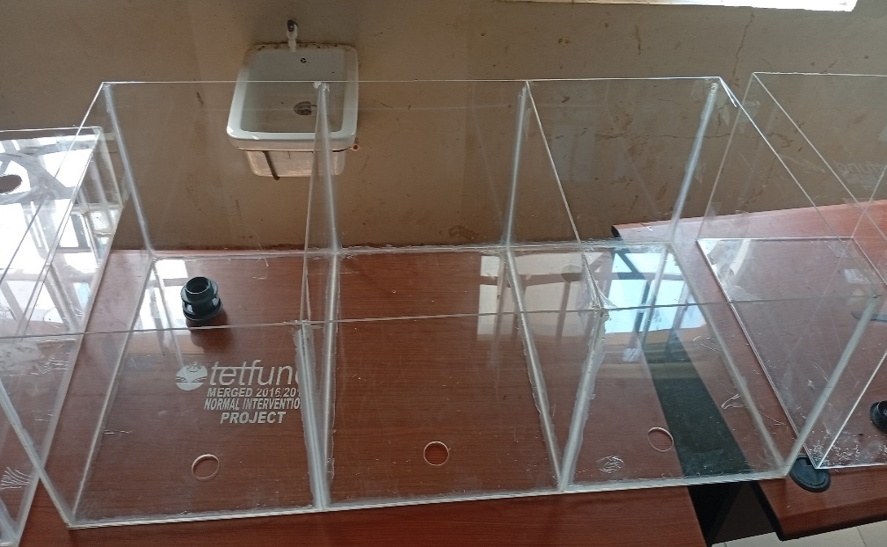

**Plate 1: Culture tank**

**2.2.1.1 *Cutting of Acrylic glass into size and joining:***

The acrylic glass comes in sheets of 4/8ft and the thickness is 4mm, which was cut into size and shape as described above with the aid of the scouring knife, held together with sellotape after which the silicon sealant is applied and allowed to stay for at least 24-48hours for total hardening of the sealant.

**2.2.1.2 *Installation of culture tanks into the iron frame:***

The culture tank after assembling is inserted into the constructed angle bar iron frame which is done to house the entire system firmly.

**2.2.1.3 *Installation of the water line:***

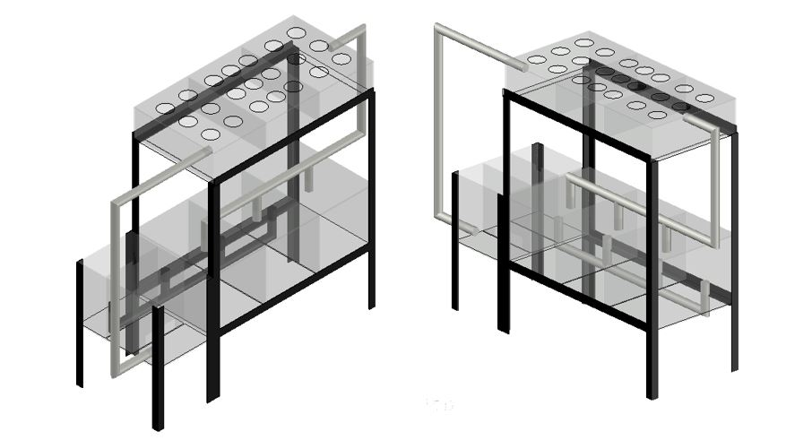The three culture tanks were arranged in series and connected to each other via a 1 inch Tee joint with drainage 1inch pipes on one side of the tank and linked to the treatment unit which is the sedimentation tank. The water flows from the culture tank section into the sedimentation tank and settles down, which later passes through the filtration tank to the clean water tank where the water is sent to the hydroponic section via a suction submersible aquarium pump. The system was created to regulate the flow of water rising into the hydroponic section from the treatment tank and falling into the culture tanks by gravity and

**Figure 2.: Aquaponic showing water line installation design**

the water recirculates for 24 hours every day. The mechanism of bringing water up and down helps to support microorganism growth by providing enough oxygen and necessary ventilation into the fish culture tanks and hydroponic substrates.

**2.2.1.4 *Setting up the hydroponic system:***

The acrylic sheets was cut to the precise dimensions needed - 20/60/120cm (Plate 2). A high-quality, waterproof adhesive specifically designed for bonding acrylic was used in joining the glass*.* The inlet and outlet fittings, pipes, pump, and other necessary valves or connectors were fitted into the hydroponic. The system was inserted into the support iron frame for good leveling and stability.

Light gravel was sprinkled into plant pots, keeping the mesh of the plastic trays to help filter the dirt to avoid clogging the pumps and water pipes. Pebbles serve as a biofilter medium, providing ample surface area for the growth of nitrifying bacteria. This bacterial activity is essential for the conversion of toxic ammonia to less harmful nitrate, thereby improving water quality.

Aeration is provided by means of air pumps that deliver compressed air through flexible tubing to submerged air stones in both the fish culture tank and the hydroponic grow bed. The air stones

function to disperse the compressed air into microbubbles, thereby enhancing the gas-liquid interface and promoting the dissolution of oxygen into the aqueous environment.

pH meter is used to check the pH of water. The ideal pH for an aquaponics aquarium is around 7.0. If it runs to level 7.2, it should lower it, but if it is below 6.8, it must be adjusted to high. Leave the system in place for 24 hours to ensure all chlorine in the water is dispersed.

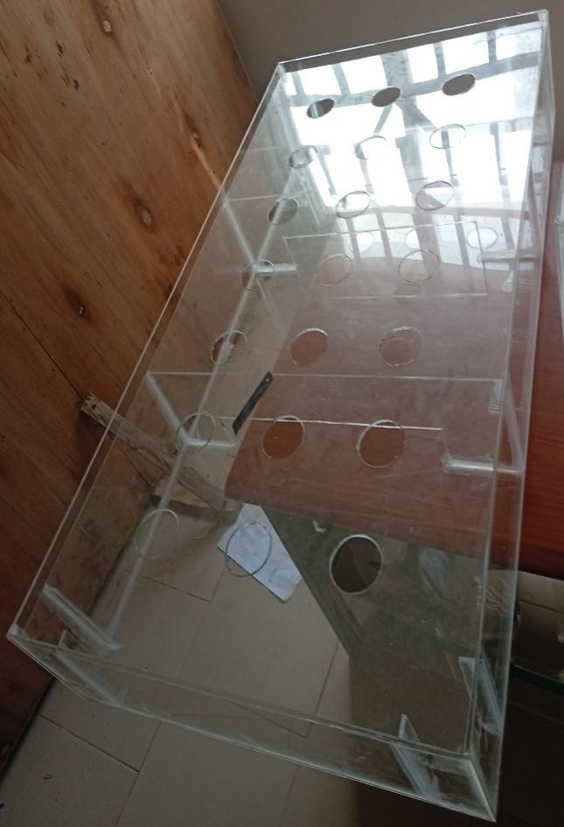

**Plate 2.: Hydroponic tank**

**2.2.2. Solar Inverter System Installation**

**2.2.2.1 *Solar Panel Installation***

The 320W monocrystalline solar panel was securely mount onto a pre-installed mounting structure using appropriate bolts and clamps. The panel was oriented correctly and at the optimal tilt angle.

4mm² solar cable was connected to the solar panel's output terminals using MC4 connectors. Proper polarity (positive to positive, negative to negative) was ensured. The cables were secured to the mounting structure to prevent strain and damage.

The 80A charge controller was mounted in a convenient location near the batteries, following the manufacturer's instructions.

The positive and negative terminals of the two 12V (100Ah) batteries were connected in parallel to double the capacity (200Ah while keeping the voltage at 12V). 10mm² sized battery cables was use to secure connections between the two batteries while double-checking the polarity before connecting.

The battery terminals was connected to the charge controller's battery input terminals, again while ensuring correct polarity.

The solar panel cables was connected to the charge controller's PV input terminals, while also observing correct polarity.

**2.2.2.2 *Inverter Installation***

The inverter's DC input terminals is connected to the battery terminals directly, ensuring correct polarity and using a disconnect switch for safety.

The inverter's AC output is then connected to a suitable AC power outlet or distribution panel that will connect the Aquaponic system, while ensuring the wiring and outlet are rated for the inverter's output.

It was ensured that all components (solar panel frame, charge controller, inverter) are properly grounded for safety using appropriate grounding cables and connections.

**2.2.1.6 *Solar Inverter System Testing and Verification***

All connections were inspected visually for tightness and correct polarity. The voltage at the solar panel, battery terminals, charge controller, and inverter input were also verified.

The inverter was turned on and tested with a load specifically a light bulb. The system's performance was observed and it was ensured that all components of the Aquaponic System are working correctly.

**3. RESULTS AND DISCUSSION**

This research investigates the impact of aquaponics on fish growth performance and resource utilization. The central hypothesis is that the biofiltration processes within the aquaponic system will lead to significant improvements in water quality parameters, resulting in enhanced fish growth rates relative to a control group. The study will quantify the water savings achieved through the implementation of aquaponics and analyze the system's contribution to the production of safe and nutritious food. The broader implications of these findings for sustainable development and climate change adaptation will be explored.

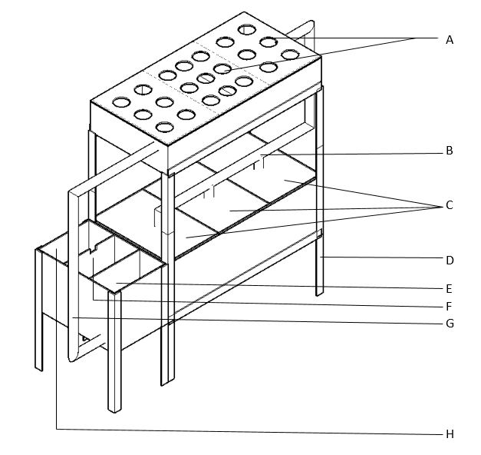

**Figure 3: Structure of an Aquaponic System**

A – PLANT HOLES  
B – WATER INLET FROM HYDROPONIC TO FISH CULTURE TANK  
C – FISH CULTURE TANKS  
D – ANGLE BAR IRON FRAME  
E – SEDIMENTATION TANK  
F – SCREEN TANK  
G – OUTLET FROM CLEAN WATER TANK TO HYDROPONIC  
H - CLEAN WATER TANK

**3.1 System Design and Construction**

The three-component design (fish tank, grow bed, treatment tank) proved effective in facilitating water circulation and nutrient flow (Figure 1). This modular approach is commonly recommended in aquaponics (Rakocy *et al*., 2006). The choice of deep water culture (DWC) for the grow bed offered efficient nutrient uptake and good oxygenation for the plant roots (Lennard & Goddek, 2019). The sizing of the components was crucial; while fish stocking density data isn't presented here, the tank volume was designed with anticipated fish loads in mind, following guidelines for tilapia culture (Popma & Masser, 1999). The grow bed area was calculated based on the chosen lettuce variety and recommended planting density. The sump tank played a vital role in maintaining water volume stability and housing the pump, simplifying maintenance (Savidov *et al.*, 2005).

Acrylic glass offered excellent transparency, allowing for easy visual monitoring of the system, a key advantage highlighted by Ulery, *et al.* (2011) for its use in similar applications. Its light transmission properties are known to be beneficial for plant growth, as demonstrated by studies such as those by Tibbitts *et al*. (1997), who examined the impact of different types of acrylic sheets on plant growth in controlled environments, and Jones *et al.* (2003), who found that acrylic panels allow sufficient light for optimal photosynthesis in greenhouse settings. Additionally, Terfa, (2013) highlighted that the UV-transmitting capability of acrylic enhances plant growth by promoting a full spectrum of light necessary for photosynthesis. However, joining the acrylic panels required careful selection of a suitable, food-grade adhesive. Ensuring a watertight seal was crucial. Long-term durability, particularly regarding scratching and algae buildup, will require further investigation.

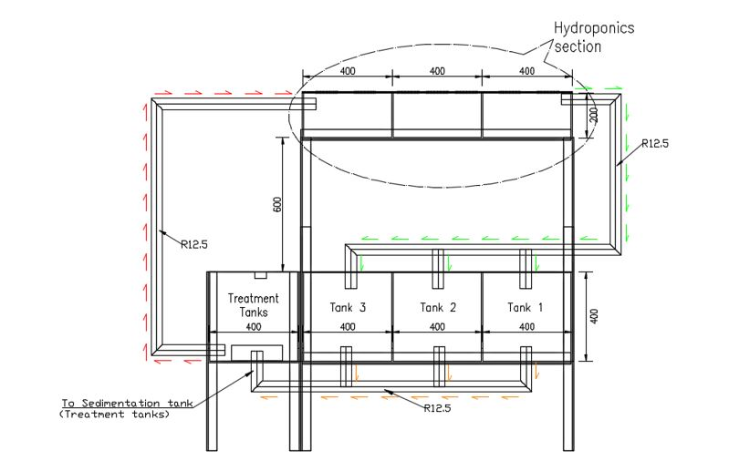

**Figure4: Aquaponic System Design.**

**3.2 Automation System Performance**

The automated system will effectively maintain water temperature within the optimal range for plant growth, pH and nutrient levels (nitrates, nitrites, ammonia) within acceptable limits. The automation system will significantly reduce manual labor and contribute to consistent environmental conditions, which is crucial for optimal plant growth.

**3.3 Solar Power Integration**

The solar panel array (320watts) generated a substantial portion of the system's energy needs. The performance of the solar panels is influenced by factors like solar irradiance, temperature, and panel angle (Duffie & Beckman, 2013). The tilt angle of the panels was optimized for the location's latitude to maximize solar energy capture (Huld *et al*., 2012). The charge controller (80 A) will efficiently regulated the power flow from the solar panels to the battery bank (two 12V (100Ah)). Maximum Power Point Tracking (MPPT) charge controllers are known to improve energy harvest from PV systems (Kabalci *et al*., 2013), and the use of such a controller likely contributed to the system's efficiency. The use of solar power significantly reduced the system's reliance on grid electricity, promoting sustainability and reducing the system's carbon footprint (IRENA, 2021).

**3.4 System Efficiency and Sustainability**

Aquaponics, in general, offers significant water savings compared to traditional agriculture (FAO, 2014). Even without fish data, the design's closed-loop nature has the potential to minimize water loss. The system's reliance on fish waste as a nutrient source reduces the need for external chemical fertilizers, contributing to environmental sustainability. The automation and solar power components further enhance the system's sustainability by reducing energy consumption and manual labor.

**4. CONCLUSION**

This research demonstrates the successful design and construction of an automated, solar-powered aquaponic system using acrylic glass, offering a sustainable approach to food production. Addressing the interconnected challenges of food, water, and energy security, particularly in the context of climate change, this system presents a promising model for smart agriculture in Nigeria. The evaluation of the system's design and construction, including the acrylic glass materials, automation system, and solar power integration, underscores its potential. Future research will focus on long-term performance assessment of the acrylic glass, testing with diverse plant species, and a comprehensive resource efficiency analysis incorporating fish culture data.

**REFERENCES**

Cifuentes‐Torres, L., Mendoza‐Espinosa, L. G., Correa‐Reyes, G., & Daesslé, L. W. (2021). Hydroponics with wastewater: a review of trends and opportunities. *Water and Environment Journal*, *35*(1), 166-180. <https://doi.org/10.1111/wej.12617>

Duffie, J. A., & Beckman, W. A. (2013). *Solar engineering of thermal processes*. John Wiley & Sons.

FAO. (2014). *The state of food and agriculture 2014. Innovation in family farming*. Food and Agriculture Organization of the United Nations.

Hu, Z., Lee, J. W., Chandran, K., Kim, S., Brotto, A. C., & Khanal, S. K. (2015). Effect of plant species on nitrogen recovery in aquaponics. *Bioresource technology*, *188*, 92-98.

Huld, T., Müller, R., & Gambardella, A. (2012). A new solar radiation database for estimating PV performance in Europe and Africa. *Solar energy*, *86*(6), 1803-1815.

IRENA. (2021). *World Energy Transitions Outlook: 1.5°C Pathway*. International Renewable Energy Agency, Abu Dhabi.

Jayachandran, A., Shikha, J., Shikha, S., Poonam, M., Subhashree, S., Kuldeep, K., & Bhargav, K. (2022). Hydroponics: An art of soil less farming. *The Pharma Innovation Journal*, *11*(9), 1049-1053.

Jones, F. H., Hutton, B. M., Hadley, P. C., Eccles, A. J., Steele, T. A., Billington, R. W., & Pearson, G. J. (2003). Fluoride uptake by glass ionomer cements:: a surface analysis approach. *Biomaterials*, *24*(1), 107-119.

Kabalci, Y., Kabalci, A., & Ayhan, A. (2013). Maximum power point tracking methods and control of photovoltaic systems. *Renewable and Sustainable Energy Reviews*, *26*, 280-296.

Lennard, W., & Goddek, S. (2019). Aquaponics: the basics. *Aquaponics food production systems*, *113*.

Manos, D. P., & Xydis, G. (2019). Hydroponics: are we moving towards that direction only because of the environment? A discussion on forecasting and a systems review. *Environmental Science and Pollution Research*, *26*(13), 12662-12672. https://doi.org/10.1007/s11356-019-04933-5

Maucieri, C., Nicoletto, C., Junge, R., Schmautz, Z., Sambo, P., & Borin, M. (2018). Hydroponic systems and water management in aquaponics: A review. *Italian Journal of Agronomy*, *13*(1), 1-11.

Moriarty, D. J. (1997). The role of microorganisms in aquaculture ponds. *Aquaculture*, *151*(1-4), 333-349.

Popma, T., & Masser, M. (1999). *Tilapia life story and biology.* Southern Regional Aquaculture Center Publication No. 283

Rakocy, J. E., Masser, P., & Losordo, T. M. (2006). Recirculating aquaculture tank production systems: aquaponics-integrating fish and plant culture. *SRAC Publication*, *454*, 1-16.

Savidov, N. A., Hutchings, E., & Rakocy, J. E. (2005). Fish and plant production in a recirculating aquaponic system: a new approach to sustainable agriculture in Canada. In International conference and exhibition on soilless culture (ICESC). 742, 209-221, September 2005.

Shubham, S. N., & Shrimanth V. L. (2020). A Survey on Hydroponics based Smart Agriculture. *Adalya Journal,* 9(1), 1133-1137.

Suleiman, U. G. (2023). Effect of renewable energy development on sustainable development of small and medium enterprises potentials in Nigeria. *Research Journal of Business and Economic Management*, *6*(1), 1-11.

Sundar, P., Jyothi, K., & Sundar, C. (2021). Indoor hydroponics: A potential solution to reuse domestic rinse water. *Biosciences Biotechnology Research Asia*, *18*(2), 373-383. https://doi.org/10.13005/bbra/2924

Terfa, M. T. (2013). Growth, stomatal responses and postharvest characteristics of Rosa x hybrida: the influence of air humidity and light quality.

Tibbitts, T. W., & Krizek, D. T. (1997). History of the ASHS Working Group on Growth Chambers and Controlled Environments, 1969-96: A case study of involvement. *HortScience*, *32*, 16-20.

Toal, R., Claggett, K., & Goh, J. (2017). Smart and sustainable aquaponics. Electr. Eng. Sr. Thesis, p. 44, 2017.

Tyson, R. V., Treadwell, D. D., & Simonne, E. H. (2011). Opportunities and challenges to sustainability in aquaponic systems. *HortTechnology*, *21*(1), 6-13.

Ulery, B. D., Nair, L. S., & Laurencin, C. T. (2011). Biomedical applications of biodegradable polymers. *Journal of polymer science Part B: polymer physics*, *49*(12), 832-864.