**Economic Feasibility of Rice Husk Biochar Application in Paddy Production**

**Abstract**The study examined the effects of incorporating rice husk biochar into the soil as a natural fertilizer for paddy production. It was applied in four different treatment levels (T1, T2, T3, T4). The analysis focused on production costs, yield, gross income, and benefit-cost ratio (BCR) during dry and wet conditions. During dry season, the results indicated that T3 achieved the highest yield (9.20 ± 0.557 tons/ha), gross returns (6,440,000 ± 389,743 Tsh/ha), and benefit-cost ratio (BCR) (2.13 ± 0.129) and significantly outperformed T4, which had the lowest production cost (2,985,170 Tsh/ha). Both T1 and T2 produced intermediate results without any significant differences. In the wet season, T3 similarly performed better than the other treatments with a yield of 9.07 ± 0.351 tons/ha, gross returns of 6,346,667 ± 245,832 Tsh/ha and BCR of 2.10 ± 0.081, while T4 continued to show the lowest production cost. Combined seasonal results confirmed T3 as the most productive and profitable with the highest yield (9.13 tons/ha), gross returns (6393333.33 Tsh/ha), and BCR (2.11). Although T4 had the lowest production cost, it also resulted in less favorable economic returns. Overall, the findings show that T3 is the optimal approach for maximizing productivity in paddy production and economic efficiency.

**Keywords:** Benefit-cost ratio, Biochar, Gross income, Paddy, Production

**4.1 Introduction**

Rice (*Oryza sativa* L.) is the basis of world agriculture, which provides food to a considerable part of the world’s population (Alam *et al.,* 2024). For thousands of years, over half of the world's human population has made rice a staple diet, significantly improving global food security and reducing hunger (Rezvi *et al.,* 2023). The two primary species, *Oryza glaberrima* and *Oryza sativa*, are significant. The former is extensively dispersed, while the latter is mostly grown in the western part of Africa. These varieties of rice can adapt to different climatic and geographic conditions, which makes them very important crops all over the world (Mohidem *et al.,* 2022; Rezvi *et al.,* 2023). Rice can flourish in both flooded and non-flooded conditions, which gives it a unique ability to supply food for over half of the world's population (Heredia *et al.,* 2022). The Food and Agriculture Organization (FAO) has introduced rice as a very important crop for maintaining global food security due to its ability to fight against world hunger (Kobayashi *et al.,* 2023; Li & Siddique, 2020).

In Tanzania, rice is the second-most important food crop after maize. Only 18% of agricultural households cultivate it, but it is quite important for job creation and a source of funding, mainly in rural areas (Dioko, 2022; Suvi *et al.,* 2021). Tanzania is one of the top rice producers in Africa, ranking 22nd in the world of rice in the national agriculture industry (Busungu, 2023). Intending to become a significant rice producer and exporter in Africa, the Tanzanian government has made several investments in the rice industry to increase production efficiency. Tanzanian smallholder farmers produce the majority of the country's rice under rainfed conditions, while others expand the existing lowland areas for irrigation (Boniphace *et al.,* 2015; Rugumamu, 2014; Therkildsen, 2011). In Tanzania, the production process begins with the preparation of land and later the application of other agricultural techniques required to be employed, such as irrigation, for the maximization of yields (Materu *et al.,* 2018; Wilson & Lewis, 2015). Despite efforts made to increase production through modernized farming technology and better seed varieties, there are still several indicated enduring issues, including poor infrastructure, expensive agricultural inputs, and a lack of enough capital for farmers (Msangya *et al.,* 2023). The cost of producing rice in Tanzania varies based on different factors such as agricultural inputs, location of farming activities, adoption of new technology, and farm size. Of these, irrigation expenses are especially important (Mgale & Yunxian, 2021; Mkubya *et al.*, 2023). Gross returns from rice production are subject to the influence of market demand, rice quality, yields, and prices, with fluctuations influenced by both domestic and international factors (Kulyakwave *et al.,* 2019; Wilson & Lewis, 2015). However, issues like restricted capital availability, expensive agricultural inputs and poor infrastructure still exist and continue to prevent the agricultural industry from reaching its full potential.

Tanzanian rice production is expensive due to the various inputs, including the adoption of new technologies, labor costs and availability, land acquisition, agricultural tools and materials and other external factors like the current condition of the market as well as government regulations that have a big impact on the livelihood of farmers (Shimonishi *et al.,* 2022). Recognizing these rice farming challenges is crucial to advancing sustainable rice farming, ensuring food security, and raising economic growth. Therefore, by understanding the benefits and challenges faced by rice production in Tanzania, financial institutions, other stakeholders, and government bodies need to support the sustainability of the agricultural sector in Tanzania (Lamanna *et al.*, 2021).

The application of rice husk biochar (RHB) in irrigated paddy cultivation has received wide

spread attention as a sustainable agricultural strategy. RHB, a product formed from rice husk pyrolysis, has been proven to have several crop cultivation benefits, including nutrient availability, water-holding capacity, and increased soil fertility (Lehmann & Joseph, 2015; Pandian *et al.,* 2024). Calculating the Benefit-Cost Ratio (BCR) is crucial for determining the economic sustainability of implementing RHB into paddy production.

The BCR is a financial indicator that evaluates the benefits and costs of any intervention or investment (Boardman *et al.,* 2018). A BCR of more than 1 suggests that the benefits of employing RHB outweigh the expenses, making it a financially feasible alternative for farmers. Several investigations have been undertaken to evaluate the BCR of employing RHB in irrigated paddy production, yielding encouraging outcomes. Sigh *et al*. (2020) found that the BCR of RHB treatment in paddy fields was much greater than conventional techniques, implying a good return on investment. Furthermore, Dickinson *et al.* (2014), Pratt and Moran (2010) and Shackley *et al.* (2011) found a favorable BCR for employing RHB in rice fields, highlighting the potential economic and environmental benefits of this sustainable technique. These findings aim to find out the most profitable rate of using RHB into paddy farming for boosting profitability and create a more sustainable agricultural system. This research assessed the production costs associated with each treatment and analysed the seasonal interaction among the production cost, gross returns, and the BCR.

**4.2 Materials and Methods**

**4.2.1 Description of the study area**

The study was conducted at the Mkindo farmer-managed irrigation scheme, located in Mkindo village within the Hembeti Ward of the Mvomero District in the Morogoro Region, Tanzania, as illustrated in Figure 1. This irrigation scheme is positioned between latitudes 6°16' and 6°18' south and longitudes 37°32' and 37°36' east, with an elevation ranging from 345 to 365 meters above mean sea level. It lies approximately 85 kilometers north of the Morogoro Municipality. The irrigation infrastructure, established between 1980 and 1983, utilizes water from the perennial Mkindo River. The system features a well-organized layout that includes a lined main canal, unlined secondary canals, tertiary canals, and drainage systems (Gowele *et al.,* 2021; Reuben *et al.,* 2016). Originally, in 1985, the area under cultivation was only 17 hectares; however, it has since expanded to approximately 740 hectares, with 300 hectares currently devoted to rice cultivation.

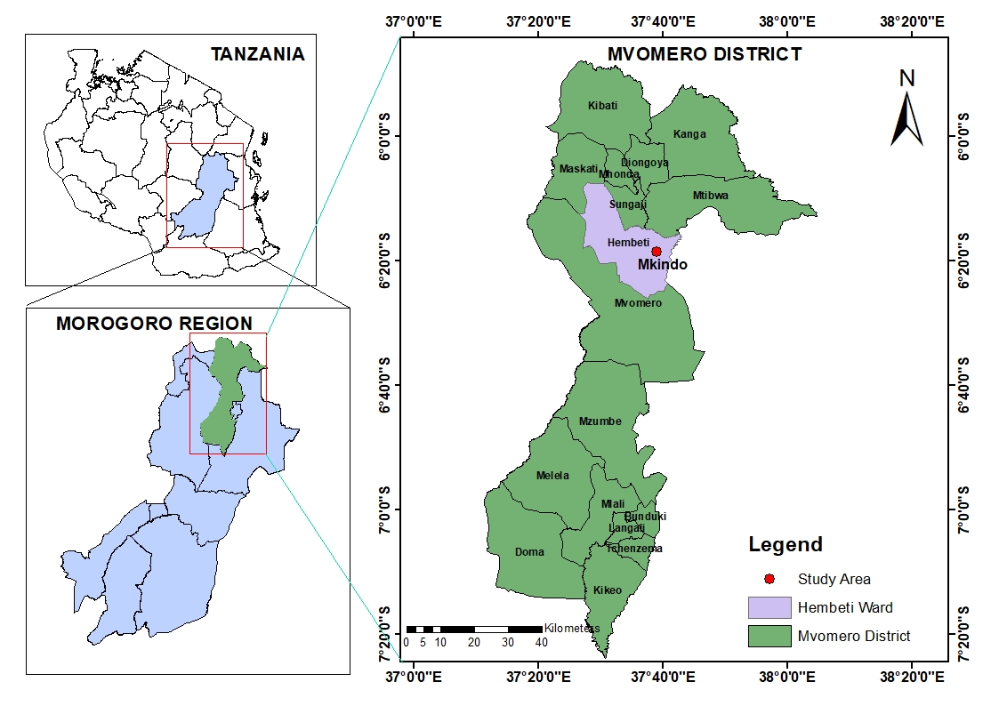

**Figure 1:** Location of the study area

**4.2.2 Climate of the study area**

The study area experiences a bimodal rainfall regime throughout the year, characterized by two distinct rainy seasons. The short rains, referred to locally as "vuli," occur from October to December (OND), while the long rains, known as "masika," take place from March to May (MAM). In the Mkindo area, the long rains yield a significant amount of precipitation, ranging from 123.9 to 246.7 mm per month, contributing to a total of 580.8 mm for the season. In contrast, the short rains result in lower rainfall, ranging from 52.8 to 115.5 mm per month, which totals to 267.8 mm for the season. Overall, the average annual rainfall in this region ranges from 716.5 to 2 158.96 mm.

In terms of temperature, the experimental area experiences variations throughout the year. Between February and June, the average monthly maximum temperature ranges from 33.9 °C to 27.7 °C, while the minimum temperature fluctuates between 20.0 °C and 16.5 °C. Between September and January, the average maximum temperature ranges from 30.3°C to 32.8°C, with minimum temperatures varying from 16.9°C to 20.2°C, as illustrated in Figure 2.

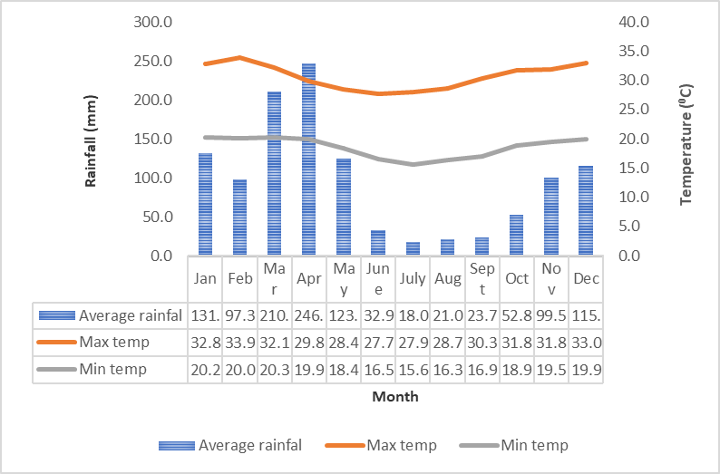

**Figure 2:** Average Monthly Rainfall, Maximum and Minimum Temperature from 1999 – 2023 (Source: Mtibwa Sugar Estate Meteorological Station)

**4.2.3 Experimental design and layout**

The experiment was designed as a complete randomized design, incorporating four treatments that corresponded to varying levels of biochar: 0 ton/ha (T1), 5 ton/ha (T2), 10 ton/ha (T3) and 15 ton/ha (T4), with each treatment replicated three times, as illustrated in Figure.3. Each plot measured 2 m by 5 m (10 m²) and was separated by a 1 m buffer zone. Treatments were randomly assigned to plots within each block. Transplanting was done at the age of ten days at a spacing of 25 cm by 25 cm with one seedling per hill, following the method outlined by Gowele *et al.,* (2020, 2021). The experiment took place during the short rainy season, running from October 2023 to February 2024, and the long rainy season, running from March 2024 to July 2024.

**4.3 Biochar preparation and agronomic practices**

The agronomic tasks performed included nursery and field preparation, transplanting, fertilizer application and weeding. During land preparation, the field was effectively puddled using a power tiller to soften the soil. To ensure uniform moisture distribution, land leveling was conducted and drainage outlets were created at the ends of each plot to facilitate water outflow during the rainy season.

The biochar utilized in this study was sourced from rice husks. It was produced using a locally made pyrolysis device fashioned from a repurposed 200-liter metallic oil drum, which served as the biochar reactor. Fresh rice husks were collected from nearby milling machines, meticulously cleaned and subjected to pyrolysis under limited oxygen conditions. The burning was initiated at the bottom of the reactor, maintaining an internal temperature between approximately 250°C and 350°C, which is optimal for producing rice husk biochar without ash residue (Hidayat *et al.*, 2023). After five hours, the husks were converted into biochar. The resulting biochar was subsequently cooled with fresh water to prevent ash formation and allowed to dry for three days. The designated rates of rice husk biochar (0 ton/ha, 5 ton/ha, 10 ton/ha and 15 ton/ha) were uniformly applied to the experimental plots (T1, T2, T3 and T4, respectively) and thoroughly mixed into the soil.

The SARO (TXD 306) rice variety, which is well-suited for the conditions of the Mkindo irrigation scheme, was utilized in this study (Kahimba *et al.,* 2014). The nursery was established using viable seeds, selected by immersing them in a saline solution until they achieved a buoyancy similar to that of an egg. Seeds that floated were discarded as they were deemed inferior. To promote rapid seedling emergence and growth, the selected seeds were soaked in freshwater before being broadcast onto the prepared nursery in the field. After ten days, the seedlings were transplanted into the experimental plots.

For the fertilizers applied, T1 received the full dose of 125 kg/ha each of urea and diammonium phosphate (DAP). T2 was treated with 62.5 kg of urea and 62.5 kg of DAP, while T3 received 31.25 kg of urea and 31.25 kg of DAP. T4 received no chemical fertilizers. In the plots where chemical fertilizers were applied, the entire amount of DAP was applied at once on the fifth day after transplanting (DAT), while Urea was applied in two splits, at 30 and 60 DAT. Additionally, biochar was applied once before transplanting at the specified rates.

Two PVC pipes, each measuring 30 cm in length and 76.2 mm in diameter, were installed in each plot such that the lower 20 cm of the pipe that was perforated was buried beneath the soil surface while the 10 cm that was unperforated extended above the soil. These pipes were positioned near the plot bunds for easy access, serving as piezometers for effective water management (Mboyerwa *et al.,* 2021). Throughout both the dry and wet seasons, weeding was carried out four times, and pesticide spraying was conducted three times to address whitefly infestations and other pests. All the list of materials and instruments are listed below as seen in Table 1.

**Table 1**: Table Materials and instruments used in the study.

|  |  |  |
| --- | --- | --- |
| **s/no** | **Materials and Tools** | **Specifications/size** |
|  | Tape Measure | The steel tape measure of 5 meters |
|  | PVC pipes (24 Piezometers) | 30 cm length,76.2mm diameter |
|  | V- notch weir | Notch Angle of 90°, Cd of 0.60 |
|  | Pegs | 2-meter length, 60 Pieces |
|  | Spray paint | White spray |
|  | Metallic drum (biochar reactor) | 200 liters |
|  | Lysimeter | Open and close one end |
|  | Leveling wooden float | Simple hand wooden bar |
|  | Paddy marker | Steel paddy maker with 25cm spacing |
|  | Rice husk biochar (RHB) | 180 Kg of Rice husk Biochar |
|  | Rice Seeds | Saro 5 TXD 306 |
|  | Push weeder | Simple hand metallic push weeder |
|  | Organic Fertilizer | DAP, UREA |
|  | Pesticides sprayer | 16 liters |
|  | Pesticides and herbicides | Weeds, insects, and fungi control |
|  | Weigh spring balance | Electronic |
|  | Moisture meter | Electronic |

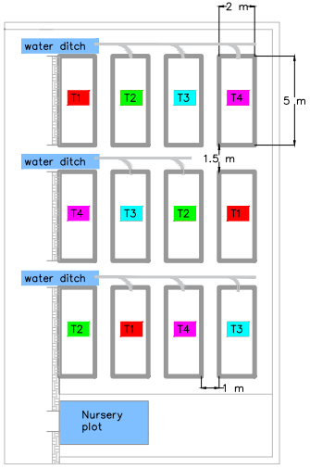

**Figure 3:** Set up of the experiment

**4.4 Data collection**

Assessment of the economic feasibility of using RHB on paddy production. The total cost of materials and agronomic activities for each treatment was recorded, and gross returns were calculated based on selling produce at harvest. Net returns are derived by deducting total costs from gross returns and BCR is obtained by dividing gross returns by total production costs for each treatment as shown in equation 1. If BCR is greater than 1.0, the project is considered worthwhile. If it's less than 1.0, the project is not advisable, and if it's equal to 1.0, net returns match production costs.

$BCR=\frac{grossreturns({Tsh}/{Ha})}{production\cos{t}({Tsh}/{Ha})}$…………………………………………………………………….eqn 1

**4.5 Data analysis**

The data obtained were analyzed using R software, and means were compared using the least significant difference (LSD) test at a 5% probability level (Cox *et al.,* 1985; Gomez & Gomez, 1984).

**4.6 Results**

**4.6.1 Assessing the production cost incurred for each treatment for paddy production**

The costs incurred for each treatment were identified and documented from the start to the end of the experiment as fixed and variable costs. Rice cultivation expenses for the treatments T1, T2, T3 and T4 were computed through the addition of all incurred costs of production parameters and recorded. Both Table 3 and Table 2 indicates the production parameters, which are comprised of land plowing (power tiller), nursery bed preparation, puddling (power tiller), rice husk biochar application, paddy field leveling, transplanting, weeding, spraying pesticides and herbicides, harvesting (combine harvester), irrigation water fees, preparation of paddy seeds, preparation of pesticides and herbicides, and fertilizer cost. Labor and land preparation costs were determined based on the current state of the Mkindo irrigation scheme, and other parameters such as seed, herbicides and fertilizer expenses were estimated using the current market prices for different times of the year based on cultivation season.

**Table .2:** Overall information cost obtained from the scheme.

|  |  |  |  |  |
| --- | --- | --- | --- | --- |
| Serial No. | Activity | | Cost per unit per acre (Tshs) | Cost per unit per hectare (Tshs) |
| **Agricultural inputs** | | | | |
|  | Fertilizer (DAP) – 1500 per Kg | T1 (125 kg/ha - full dose) | 75 000 | 187 500 |
| T2 (62.5kg/ha - Half dose) | 37 500 | 93 750 |
| T3 (31.25kg/ha - Quatre dose) | 18 750 | 46 875 |
| T4 (0 kg/ha) | 0 | 0 |
|  | Fertilizer (UREA) – 1500 per Kg | T1 (125 kg/ha - full dose) | 75 000(150000 for twice) | 187 500(375000 for twice) |
| T2 (62.5kg/ha - Half dose) | 37 500(75000 for twice) | 93 750(187500 for twice) |
| T3 (31.25kg/ha - Quatre dose) | 18 750(37500 for twice) | 46 875(93750 for twice) |
| T4 (0 kg/ha) | 0 | 0 |
|  | Paddy seeds | | 25 000 | 61 775 |
|  | Pesticides | | 10 000 | 24 710 |
|  | Irrigation water fee | | 30 000 | 74 130 |
|  | Herbicides | | 10 000 | 24 710 |
| **Machine/Labor Charges for agronomic practices** | | | | |
|  | Biochar production/preparation | 0 t/ha (T1) | 0 | 0 |
| 5 t/ha (T2) | 40 500 | 100 000 |
| 10 t/ha (T3) | 81 000 | 200 000 |
| 15 t/ha (T4) | 121 500 | 300 000 |
|  | Ploughing (power tiller) | | 100 000 | 247 100 |
|  | Nursery bed preparation | | 5 000 | 12 355 |
|  | puddling (power tiller) | | 100 000 | 247 100 |
|  | Rice husk biochar Application | | 20 000 | 49 420 |
|  | Paddy field Levelling | | 25 000 | 62 500 |
|  | Transplanting | | 100 000 | 247 100 |
|  | Weeding | | 100 000(200000 for twice) | 247 100(494200 for twice) |
|  | Spraying pesticides/ Herbicides | | 10 000 | 24 710 |
|  | Harvesting (combine harvester) | | 160 000 | 395 360 |

(Source: Mkindo Irrigation Scheme)

**Table 3:** The overall cost of fieldwork (Per Hectare) for paddy production Dry season and Wet Season (Tsh)

|  |  |  |  |  |  |  |  |  |  |
| --- | --- | --- | --- | --- | --- | --- | --- | --- | --- |
| **S/n** | **Activity** | **Dry season** | | | | **Wet season** | | | |
| **T1** | **T2** | **T3** | **T4** | **T1** | **T2** | **T3** | **T4** |
| **Agricultural inputs** | | | | | | | | | |
| 1 | DAP | 187500 | 93 750 | 46875 | 0 | 187500 | 93750 | 46875 | 0 |
| 2 | Urea | 375000 | 187500 | 93 750 | 0 | 375000 | 187500 | 93 750 | 0 |
| 3 | Paddy seeds | 61775 | 61 775 | 61775 | 61775 | 61775 | 61775 | 61775 | 61775 |
| 4 | Pesticides | 24710 | 24 710 | 24710 | 24710 | 24710 | 24710 | 24710 | 24710 |
| 5 | Irrigation water fee | 74130 | 74 130 | 74130 | 74130 | 74130 | 74130 | 74130 | 74130 |
| 6 | Herbicides | 24710 | 24 710 | 24710 | 24710 | 24710 | 24710 | 24710 | 24710 |
| **Farm hiring/Machine/Labor Charges for agronomic practices** | | | | | | | | | |
| 7 | Biochar production/preparation | 0 | 100 000 | 200000 | 300000 | 0 | 100000 | 200000 | 300000 |
| 8 | Ploughing (power tiller) | 247100 | 247 100 | 247100 | 247100 | 247100 | 247100 | 247100 | 247100 |
| 9 | Nursery bed preparation | 12355 | 12 355 | 12355 | 12355 | 12355 | 12355 | 12355 | 12355 |
| 10 | puddling (power tiller) | 247100 | 247 100 | 247100 | 247100 | 247100 | 247100 | 247100 | 247 100 |
| 11 | Rice husk biochar Application | 49420 | 49 420 | 49420 | 49420 | 49420 | 49420 | 49420 | 49420 |
| 12 | Paddy field Levelling | 62 500 | 62 500 | 62 500 | 62 500 | 62 500 | 62 500 | 62 500 | 62 500 |
| 13 | Transplanting | 247100 | 247 100 | 247100 | 247100 | 247100 | 247100 | 247100 | 247 100 |
| 14 | Weeding | 494200 | 494200 | 494200 | 494200 | 494200 | 494200 | 494200 | 494200 |
| 15 | Spraying pesticides/ Herbicides | 24710 | 24710 | 24710 | 24710 | 24710 | 24710 | 24710 | 24710 |
| 16 | Harvesting (combine harvester) | 395360 | 395360 | 395360 | 395360 | 395360 | 395360 | 395360 | 395360 |
| 17 | Farm hiring | 720000 | 720000 | 720000 | 720000 | 720000 | 720000 | 720000 | 720000 |
|  | **Total** | **3247670** | **3066420** | **3025795** | **2985170** | **3247670** | **3066420** | **3025795** | **2985170** |

The analysis showed the lowest production cost (Tsh/ha) was in Treatment T4(2985170 ± 0.0), which had a significant difference with T3 (3025795 ± 0.0), whereas T1(3247670 ± 0.0) and T2 (3066420 ± 0.0) were not significantly different from either of T3 and T4. Regarding gross returns (Tsh/ha), the highest value was achieved in Treatment T3 (6393333.33 ± 295882.860), significantly differing from T1 (5856666.67 ± 557661.785), T2 (5728333.33 ± 156002.137) and T4 (5226666.67 ± 433020.400), with no significant differences among T1, T2, and T4 (Figure 4 and 5).

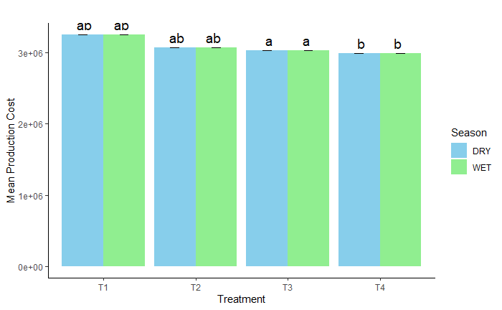

**Figure .4:** Treatments mean production cost for dry and wet season

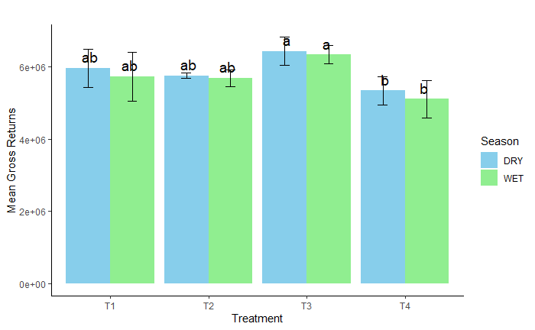

**Figure .5:** Treatments Mean Gross return for the dry and wet season

**4.6.2 Influence of RHB on the paddy production cost and returns**

The ANOVA results (Table 4) during the dry season indicated significant Treatment

effects on yield, benefit-cost ratio, production cost, and gross returns. T3 outperformed T4 with higher yield (9.20 ± 0.557 ton/ha), gross returns (6 440 000 ± 389 743 Tsh/ha) and BCR (2.13 ± 0.129). T1 had the highest production expenses of all treatments and T4 had the lowest production cost (2 985 170 Tsh/ha), though at the expense of lower economic and production results. T1 and T2 produced intermediate results, with no significant differences. Overall, T3 outperforms in both economic and productivity indicators (Figure .6).

**Table 4:** Post-Hoc Analysis of Treatment Effects on Production Cost, Yield, Gross Returns, and Benefit-Cost Ratio (Dry Season)

|  |  |  |  |  |
| --- | --- | --- | --- | --- |
| **Variable** | **Treatment** | | | |
| **T1** | **T2** | **T3** | **T4** |
| Production Cost (Tsh/ha) | 3247670±0.0ab | 3066420±0.0ab | 3025795±0.0a | 2985170±0.0b |
| Yield in ton/ha | 8.53±0.757ab | 8.23±0.115ab | 9.20±0.557a | 7.63±0.551a |
| Yield (Kg/ha) | 8533.33±757.188ab | 8233.33±115.470ab | 9200.00±556.776a | 7633.33±550.757a |
| Gross Returns (Tsh/ha) | 5973333.33±530031.446ab | 5763333.33±80829.038ab | 6440000.00±389743.505a | 5343333.33±385529.938a |
| BCR | 1.84±0.163ab | 1.88±0.026ab | 2.13±0.129a | 1.79±0.129a |

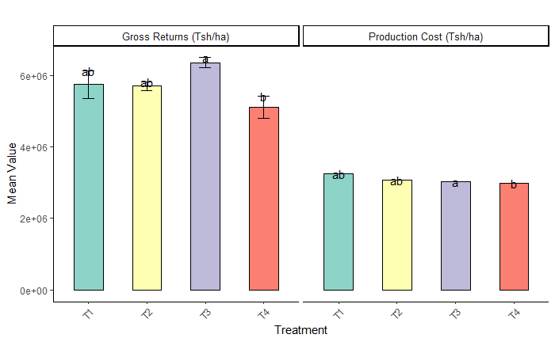

**Figure .6:** Treatments Comparison of Gross returns and Production cost for dry season

Conversely, the wet season exhibited significant effects on yield, gross returns, and BCR. Treatment T3 outperformed treatment T4 in terms of yield (9.07 ± 0.351 tons/ha), gross returns (6,346,667 ± 245,832 Tsh/ha) and BCR (2.10 ± 0.081). Treatment T4 had the lowest production costs of all the treatments applied while treatments T1 and T2 had intermediate results. Treatment T3 seems to be most effective in both productivity and economic efficiency (Table 5 and Figure .7).

**Table 5:** Post-Hoc Analysis of Treatment Effects on Production Cost, Yield, Gross Returns, and Benefit-cost Ratio (Wet Season)

|  |  |  |  |  |
| --- | --- | --- | --- | --- |
| **Variable** | **Treatment** | | | |
| **T1** | **T2** | **T3** | **T4** |
| Production Cost (Tsh/ha) | 3247670±0.0ab | 3066420±0.0ab | 3025795±0.0a | 2985170±0.0b |
| Yield in ton/ha | 8.20±0.964ab | 8.13±0.321ab | 9.07±0.351a | 7.30±0.755b |
| Yield (Kg/ha) | 8200.00±964.365ab | 8133.33±321.455ab | 9066.67±351.188a | 7300.00±754.983b |
| Gross Returns (Tsh/ha) | 5740000.00±675055.553ab | 5693333.33±225018.518ab | 6346666.67±245831.921a | 5110000.00±528488.410b |
| BCR | 1.77±0.208ab | 1.86±0.073ab | 2.10±0.081a | 1.71±0.177b |

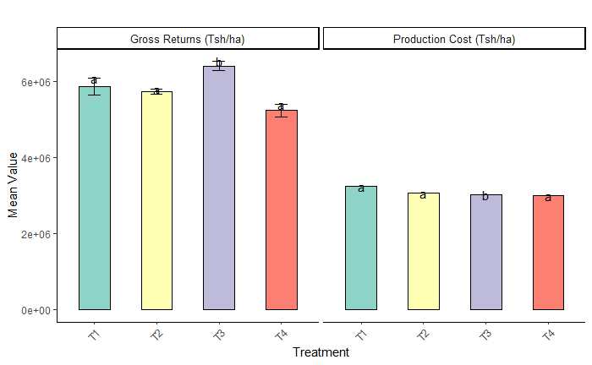

**Figure 7:** Treatments Comparison of Gross returns and Production cost for the wet season

**4.6.3 Seasonal interaction of Production cost, Gross returns and BCR**

Combined seasonal ANOVA results (Table 6) showed significant differences across treatments for all the variables analyzed, which were yield, BCR, production cost and gross returns. The yield had highly significant treatment effects, F=9.032, p=0.000553 and the highest yields were observed in Treatment T3, which was 9.13 tons/ha, 9133.33 kg/ha and was significantly higher than Treatments T1, T2 and T4, which did not differ among themselves. Similarly, gross returns were highest for T3 at Tsh 6393333.33/ha, F=9.032, p=0.000553, followed by lower but statistically indistinct returns among T1, T2, and T4. Production costs differed significantly among treatments F=6.513×10²⁹, p<0.001, with the lowest cost for T4 of Tsh 2985170/ha, which was lower than T3, though not T1 or T2. Economic efficiency (BCR), was highest for T3 (2.11), significantly greater than T1 (1.80), T2 (1.87), and T4 (1.75), which showed no significant differences. These results confirm that T3 is the most productive and profitable treatment by both productivity and economic parameters as shown in Figure .8.

**Table .6: Post-Hoc Analysis of Agricultural Performance Variables Across Treatments for Combined Seasons**

|  |  |  |  |  |
| --- | --- | --- | --- | --- |
| **Variable** | **Treatment** | | | |
| **T1** | **T2** | **T3** | **T4** |
| Production Cost (Tsh/ha) | 3247670±0.0a | 3066420±0.0a | 3025795±0.0b | 2985170±0.0a |
| Yield in ton/ha | 8.37±0.797ab | 8.18±0.223a | 9.13±0.423b | 7.47±0.619a |
| Yield (Kg/ha) | 8366.67±796.660a | 8183.33±222.860a | 9133.33±422.690b | 7466.67±618.601a |
| Gross Returns (Tsh/ha) | 5856666.67±557661.785a | 5728333.33±156002.137a | 6393333.33±295882.860b | 5226666.67±433020.400a |
| BCR | 1.80±0.172a | 1.87±0.051a | 2.11±0.098b | 1.75±0.145a |

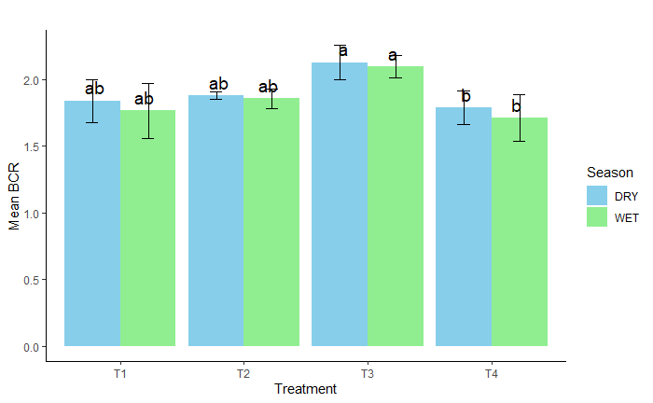

**Figure .8: BCR comparison between dry and wet season**

**4.7 Discussion**  
The results bring into the limelight the importance of treatment interventions, especially on different variables such as biochar application rates, paddy production costs, yields, gross returns, and economic efficiency. The T3 treatment with a 10 t/ha biochar application rate consistently proved superior in all the productivity and economic indicators used in both dry and wet seasons. With the highest yield (9.20 tons/ha dry season, 9.07 tons/ha wet season) and gross returns (6 440 000 Tsh/ha dry season, 6 346 667 Tsh/ha wet season), T3 outperformed other remaining treatments (T1, T2, and T4). Furthermore, T3 had the highest BCR, indicating its economic viability and sustainability. On the other side, treatment T4 with RHB only, had the lowest production cost at 2985170 Tsh/ha but the lowest gross returns. Treatments T1 and T4 with moderate application of RHB respectively had moderate gross returns.

According to the findings of this study, the optimal application rate of RHB for maximizing the BCR is 10 tons per hectare. This highlights RHB's potential as a method for increasing financial gains while also promoting an eco-friendly environment by minimizing agricultural waste as stated by Asadi *et al*.(2021) and Karam *et al*.(2022). A study conducted by Asai *et al.,*(2009) in northern Thailand found that applying RHB to paddy fields resulted in a BCR of 1.8, implying that the benefits of enhanced rice yields and improved soil qualities surpassed the costs of producing and applying RHB. Similarly, Yao *et al.* (2011) found a BCR of 2.1 for the usage of RHB in paddy fields, adding to the economic viability of this technique. Additionally, biochar can stimulate the growth of beneficial soil microorganisms, which can outcompete weeds for resources. However, the effectiveness of biochar for weed suppression may vary depending on factors such as the type of biochar used, application rate, and environmental conditions (Pandian *et al.,* 2024; Zhao *et al.,* 2022).

**4.8 Conclusion and Recommendation**

**4.8.1 Conclusion**

The application of RHB in paddy production significantly influences the performance of paddy production. Among the treatments, Treatment T3 performed the best, being economical and optimal in paddy farming in achieving the highest yield for the maximization of profitability in irrigated paddy agriculture. The minimized production cost in Treatment T4 having application rate of 15 tons/ha (RHB) makes it less attractive due to its lower yield and economic returns for large-scale commercial production.

These findings indicate that RHB application on soil not only improves soil health but also increases productivity and economic returns, provided as one of the useful agronomic practices in the sustainability of paddy farming. On the other hand, the intermediate performance of Treatment T1 and Treatment T2 shows the importance of evaluating cost-effective rates for maximizing economic returns without unnecessary costs.

**REFERENCES**

Alam, M., Lou, G., Abbas, W., Osti, R., Ahmad, A., Bista, S., Ahiakpa, J. K., & He, Y. (2024). Improving Rice Grain Quality Through Ecotype Breeding for Enhancing Food and Nutritional Security in Asia–Pacific Region. *Rice*, *17*(1), 47.

Asadi, H., Ghorbani, M., Rezaei-Rashti, M., Abrishamkesh, S., Amirahmadi, E., Chengrong, C., & Gorji, M. (2021). Application of rice husk biochar for achieving sustainable agriculture and environment. *Rice Science*, *28*(4), 325–343.

Asai, H., Samson, B. K., Stephan, H. M., Songyikhangsuthor, K., Homma, K., Kiyono, Y., Inoue, Y., Shiraiwa, T., & Horie, T. (2009). Biochar amendment techniques for upland rice production in Northern Laos. 1. Soil physical properties, leaf SPAD and grain yield. *Field Crops Research*, *111*(1–2), 81–84. https://doi.org/10.1016/j.fcr.2008.10.008

Boardman, A. E., Greenberg, D. H., Vining, A. R., & Weimer, D. L. (2018). *Cost-benefit analysis: Concepts and practice*. Cambridge University Press.

Boniphace, N. S., Fengying, N., & Chen, F. (2015). An analysis of smallholder farmers’ socio-economic determinants for inputs use: A case of major rice producing regions in Tanzania. *Russian Journal of Agricultural and Socio-Economic Sciences*, *38*(2), 41–55.

Busungu, C. (2023). Past, Present and Future Perspectives of Rice Production in Tanzania. *Agricultural Sciences*, *14*(08), 987–1006. https://doi.org/10.4236/as.2023.148066

Cox, D. F., Gomez, K. A., & Gomez, A. A. (1985). Statistical Procedures for Agricultural Research. In *Journal of the American Statistical Association* (Vol. 80, Issue 390). Wiley. https://doi.org/10.2307/2287932

Dickinson, D., Balduccio, L., Buysse, J., Ronsse, F., Van Huylenbroeck, G., & Prins, W. (2014). Cost-benefit analysis of using biochar to improve cereals agriculture. *GCB Bioenergy*, *7*, 850–864. https://doi.org/10.1111/gcbb.12180

Dioko, M. A. (2022). *Determinants of Smallholder Agricultural Commercialization in Tanzania: A Case of Rice Production in Kilosa District.* The Open University of Tanzania.

Gomez, K. A., & Gomez, A. A. (1984). *Statistical Proceedures for Agricultural Research*. Wiley.

Gowele, G. E., Mahoo, H. F., & Kahimba, F. C. (2020). Comparison of Silicon Status in Rice Grown Under the System of Rice Intensification and Flooding Regime in Mkindo Irrigation Scheme, Morogoro, Tanzania * 1. *Tanzania Journal of Agricultural Sciences*, *19*(2), 216–226.

Gowele, G. E., Mahoo, H. F., & Kahimba, F. C. (2021). Silicon status in soil and its effect on growth and yield of rice under the system of rice intensification and continuous flooding in Mkindo Irrigation Scheme, Morogoro, Tanzania. *Tanzania Journal of Agricultural Sciences*, *20*(2), 237–244.

Heredia, M. C., Kant, J., Prodhan, M. A., Dixit, S., & Wissuwa, M. (2022). Breeding rice for a changing climate by improving adaptations to water saving technologies. *Theoretical and Applied Genetics*, 1–17.

Hidayat, Rahmat, A., Nissa, R. C., Sukamto, Nuraini, L., Nurtanto, M., & Ramadhani, W. S. (2023). Analysis of rice husk biochar characteristics under different pyrolysis temperature. *IOP Conference Series: Earth and Environmental Science*, *1201*(1). https://doi.org/10.1088/1755-1315/1201/1/012095.

Kahimba, F. C., Kombe, E. E., & Mahoo, H. F. (2014). The Potential of System of Rice Intensification (SRI) to Increase Rice Water Productivity: a Case of Mkindo Irrigation Scheme in Morogoro Region, Tanzania. *Tanzania Journal of Agricultural Sciences*, *12*(2), 10–19. http://www.ajol.info/index.php/tjags/article/viewFile/114268/103969

Karam, D. S., Nagabovanalli, P., Rajoo, K. S., Ishak, C. F., Abdu, A., Rosli, Z., Muharam, F. M., & Zulperi, D. (2022). An overview on the preparation of rice husk biochar, factors affecting its properties, and its agriculture application. *Journal of the Saudi Society of Agricultural Sciences*, *21*(3), 149–159.

Kobayashi, K., Wang, X., & Wang, W. (2023). Genetically modified rice is associated with hunger, health, and climate resilience. *Foods*, *12*(14), 2776.

Kulyakwave, P. D., Shiwei, X., & Yu, W. (2019). Households’ characteristics and perceptions of weather variability impact on rice yield: empirical analysis of small scale farmers in Tanzania. *Ciência Rural*, *49*, e20190003.

Lamanna, C., Yet, B., Kimaro, A., Shepherd, K. D., Jones, K., Mayzelle, M., Nowak, A., Salemo, K., & Rosenstock, T. S. (2021). Prioritizing Tanzania’s agricultural development policy to build smallholder climate resilience. *Final Report for the Bill & Melinda Gates Founadtion Grand Challengex Explotations*, *22*.

Lehmann, J., & Joseph, S. (2015). *Biochar for environmental management: science, technology and implementation*. Routledge.

Li, X., & Siddique, K. H. M. (2020). Future Smart Food: Harnessing the potential of neglected and underutilized species for Zero Hunger. *Maternal & Child Nutrition*, *16*, e13008.

Materu, S. T., Shukla, S., Sishodia, R. P., Tarimo, A., & Tumbo, S. D. (2018). Water use and rice productivity for irrigation management alternatives in Tanzania. *Water (Switzerland)*, *10*(8), 1018. https://doi.org/10.3390/w10081018

Mboyerwa, P. A., Kibret, K., Mtakwa, P. W., & Aschalew, A. (2021). Evaluation of growth, yield, and water productivity of paddy rice with water-saving irrigation and optimization of nitrogen fertilization. *Agronomy*, *11*(8), 1–23. https://doi.org/10.3390/agronomy11081629

Mgale, Y. J., & Yunxian, Y. (2021). Price risk perceptions and adoption of management strategies by smallholder rice farmers in Mbeya region, Tanzania. *Cogent Food & Agriculture*, *7*(1), 1919370.

Mkubya, R. W., Damas, P., & Mahoo, H. F. (2023). Socio-Economic Factors Influencing the Adoption of SRI among Smallholder Rice Irrigation Farmers in Morogoro Region, Tanzania. *Tanzania Journal of Agricultural Sciences*, *22*(1), 169–183.

Mohidem, N. A., Hashim, N., Shamsudin, R., & Che Man, H. (2022). Rice for food security: Revisiting its production, diversity, rice milling process and nutrient content. *Agriculture*, *12*(6), 741.

Msangya, B. W., Nambatya, S., & Friday, E. T. (2023). *Chinese Funding of Small-Scale Agriculture on Improving Rural Livelihoods. A Case of Small-Scale Farmers in Kilosa District, Morogoro Region, Tanzania*.

Pandian, K., Vijayakumar, S., Mustaffa, M. R. A. F., Subramanian, P., & Chitraputhirapillai, S. (2024). Biochar – a sustainable soil conditioner for improving soil health, crop production and environment under changing climate: a review. *Frontiers in Soil Science*, *4*(May), 1–17. https://doi.org/10.3389/fsoil.2024.1376159

Pratt, K., & Moran, D. (2010). Evaluating the cost-effectiveness of global biochar mitigation potential. *Biomass and Bioenergy*, *34*(8), 1149–1158.

Reuben, P., Katambara, Z., Kahimba, F. C., Mahoo, H. F., Mbungu, W. B., Mhenga, F., Nyarubamba, A., & Maugo, M. (2016). Influence of transplanting age on paddy yield under the system of rice intensification. *Agricultural Sciences*, *7*(3), 154–163.

Rezvi, H. U. A., Tahjib‐Ul‐Arif, M., Azim, M. A., Tumpa, T. A., Tipu, M. M. H., Najnine, F., Dawood, M. F. A., Skalicky, M., & Brestič, M. (2023). Rice and food security: Climate change implications and the future prospects for nutritional security. *Food and Energy Security*, *12*(1), e430.

Rugumamu, C. P. (2014). Empowering smallholder rice farmers in Tanzania to increase productivity for promoting food security in Eastern and Southern Africa. *Agriculture & Food Security*, *3*, 1–8.

Shackley, S., Hammond, J., Gaunt, J., & Ibarrola, R. (2011). The feasibility and costs of biochar deployment in the UK. *Carbon Management*, *2*(3), 335–356.

Shimonishi, T., Onaka, T., Williams, T. G., Brown, D. G., Ojeda, A., & Buscher, N. (2022). *Impacts of large-scale land acquisitions on smallholder agriculture and livelihoods in Tanzania Impacts of large-scale land acquisitions on smallholder agriculture and livelihoods in Tanzania*.

Singh, J. S., & Singh, C. (2020). Biochar applications in agriculture and environment management. In *Biochar Applications in Agriculture and Environment Management* (Issue April). https://doi.org/10.1007/978-3-030-40997-5

Suvi, W. T., Shimelis, H., & Laing, M. (2021). Farmers’ perceptions, production constraints and variety preferences of rice in Tanzania. *Journal of Crop Improvement*, *35*(1), 51–68.

Therkildsen, O. (2011). *Policy making and implementation in agriculture: Tanzania’s push for irrigated rice* (Issue 2011: 26). DIIS Working Paper.

Wilson, R. T., & Lewis, I. (2015). The rice value chain in Tanzania. *A Report from the Southern Highlands Food Systems Programme, FAO*, *9*.

Yao, Y., Gao, B., Inyang, M., Zimmerman, A. R., Cao, X., Pullammanappallil, P., & Yang, L. (2011). Biochar derived from anaerobically digested sugar beet tailings: characterization and phosphate removal potential. *Bioresource Technology*, *102*(10), 6273–6278.

Zhao, Y., Wang, X., Yao, G., Lin, Z., Xu, L., Jiang, Y., Jin, Z., Shan, S., & Ping, L. (2022). Advances in the Effects of Biochar on Microbial Ecological Function in Soil and Crop Quality. *Sustainability (Switzerland)*, *14*(16), 1–11. https://doi.org/10.3390/su141610411