**Rice Husk Biochar Application Rate and methods for Enhancement of Paddy Production in Irrigated Fields**

**Abstract**

The application of biochar as a soil amendment has recently gained attention due to its potential to improve soil fertility and crop productivity. An experiment was carried out at Mkindo farmer-managed irrigation scheme in Mvomero District, Tanzania. This study evaluated the effect of different application rates of rice husk biochar on growth parameters and water productivity in irrigated paddy fields. Four treatments—T1 (0 ton/ha), T2 (5 ton/ha), T3 (10 ton/ha), and T4 (15 ton/ha), each repeated three times in a complete randomized block design. The measured variables included plant height (PH), number of tillers (NT), number of leaves (NL), number of productive tillers (NPT), root depth, panicle length (PL), total biomass (TB), biomass and paddy yield, along with water productivity. The Data were subjected to the Least Significant Difference test at p<0.05. The findings revealed that paddy treated with T3 (10 tons/ha) considerably increased PH, NT, biomass, and grain production in both wet and dry seasons. In the dry season, T3 produced 9.2 t/ha, while in the wet season produced 9.07 t/ha. The rainy season's water productivity peaked at 0.91 kg/m³, whereas the dry season's was 0.80 kg/m³. Treatment T3 had the greatest economic water productivity, with 272.02 Tsh/m³ (dry) and 306.97 Tsh/m³ (wet). While panicle length peaked in T1, root depth peaked in T4. Nevertheless, T4 showed declining benefits, suggesting that 10 tons/ha was the ideal amount to maximize output and economic efficiency. These findings suggest that a moderate application rate of 10 tons/ha is optimal for improving paddy productivity, water efficiency, and economic returns from rice husk biochar treatment, demonstrating the utility of RHB as a soil supplement in irrigated rice systems.

**Keywords**: Dry Season, Paddy, RHB, Water Productivity, Wet season

**3.1 Introduction**

In sub-Saharan Africa, Tanzania is the second largest rice producer after Madagascar and it is ranked the largest rice producer in East Africa (Msafiri, 2021). As a result, the study focused on the possibility of using rice husk biochar (RHB) to boost rice output in irrigated paddy farming. Rice Husk (RH) is a readily available resource in Tanzania and biochar has been discovered to be vital in restoring degraded soils and holding moisture, thereby reducing the expense of utilizing organic fertilizer and supplementing with inorganic fertilizer for greater paddy production in Tanzania.

According to the Food and Agriculture Organization of the United Nations, rice production in the United Republic of Tanzania has been experiencing steady growth over the past few years. In 2019, the total rice production in the country was estimated at around 2.2 million metric tons (URT, 2019). From 2014 to 2017 the crop contributed about TZS 580 billion per year and ranked second concerning production value (Andreoni *et al.,* 2021b; World Trade Organization, 2019). In 2023/24 production of rice was estimated to rise from 2.2 to 2.4 million metric tons (Mtaki & Snyder, 2023). Tanzania's primary regions for rice production include the Eastern, Southern, and Northern zones. These regions have favorable climatic conditions and access to water resources, making them ideal for paddy cultivation.

While rice production in Tanzania has been increasing which accounts for 681 000 hectares, or approximately 18% of cultivated land (Formiga & Degreenia, 2023; Kulyakwave *et al.,* 2022; Mtaki, 2019). According to Busungu (2023), 18% of agricultural households in Tanzania grow rice and are more marketed by 42% of the total production compared to 28% of maize. Almost 90% of farming households are smallholder farmers who employ traditional technologies for production; hence, the country still relies on imports to meet its domestic demand (Francis, 2022). The government has been implementing various policies and programs to boost domestic rice production and reduce the reliance on imports. Overall, rice production in the United Republic of Tanzania is expected to grow in the coming years, driven by government support, investment in irrigation infrastructure, and increased adoption of modern farming practices.

Rainfall is the main source of water for the majority of farmers in Tanzania, with over three-quarters of the paddy’s planted areas being rainfed while the remaining quarter is irrigated (Andreoni *et al*., 2021a). Further, many paddy farmers are experiencing water shortages (Mtaki and Snyder, 2023) and declining soil fertility due to prolonged cultivation and unsustainable water and soil management (Alavaisha *et al.,* 2022) which accounts for the low rice productivity. Thus, a holistic approach is needed to ensure sustainable soil and water management.

Rice husk biochar (RHB) is a byproduct of the rice milling process and has gained attention as a promising soil amendment for improving soil fertility and crop productivity in paddy fields. It is made from the pyrolysis of rice husk, a common agricultural waste rich in carbon. Numerous studies have examined the efficacy of RHB in enhancing soil properties and plant growth in paddy fields. According to Karam *et al.* (2022), RHB has the capacity to improve soil fertility due to its ability to retain nutrients, high silica content, and high adsorptive capacity. The soil pH, microbial activity, water holding capacity, increased nutrient availability and cation exchange capacity can also be improved with RHB (Lai *et al.,* 2023; Severo *et al.,* 2020). However, the effects of RHB on paddy growth and rice yield may depend on several factors, such as the rate and timing of RHB application, the soil properties and the rice cultivar. A study by Asadi *et al.* (2021) investigated the effects of RHB application on soil physical and chemical properties in a paddy field. The results showed that RHB application significantly increased soil porosity, water-holding capacity, and nutrient availability. The authors concluded that RHB could improve soil structure and fertility in paddy fields.

Similarly, several studies were done by Singh *et al.*(2018), Chen *et al.* (2021) evaluated the impact of RHB on rice growth and yield in a paddy field. The results demonstrated that RHB application significantly increased rice biomass and grain yield, compared to control treatments. The addition of RHB in paddy fields at a rate of 20 and 40 tons/ha increased the yield of rice to over 15% higher than paddy fields without RHB addition. Plant height, tiller’s growth, seed setting rate and number of productive panicles are reported to be influenced by the addition of RHB. Therefore, the authors suggested that RHB could enhance nutrient uptake and water retention in paddy soils, leading to improved crop performance.

Overall, these studies indicate that RHB has significant potential as a soil amendment for enhancing soil properties and crop productivity in paddy fields. However, none of the reported research focused on optimizing RHB application rates and methods to maximize its benefits in paddy field ecosystems. The study was conducted in the Mkindo irrigation scheme located in the Mvomero District of Morogoro Region, where soil organic matter depletion and poor water retention are currently evidenced, leading to excessive water usage during irrigation and hence water shortage. This research assessed water productivity (both economic and physical), growth parameters (including plant height, number of tillers, productive tillers, biomass, and panicle length), and yield in relation to the impacts of RHB on irrigated paddy production. To address the issues of soil moisture retention and nutrient availability, this study aims to fill this gap by determining the optimal RHB application rate to enhance paddy growth and rice yield while promoting efficient water use in irrigated paddy fields.

**3.2 Materials and Method**

**3.2.1 Description of the study area**

The study was conducted at the Mkindo farmer-managed irrigation scheme, located in Mkindo village within Hembeti Ward of the Mvomero District in the Morogoro Region, Tanzania, as illustrated in Figure.1. This irrigation scheme is located between latitudes 6°16' and 6°18' south and longitudes 37°32' and 37°36' east, with an elevation ranging from 345 to 365 meters above mean sea level. It lies approximately 85 kilometers north of the Morogoro Municipality. The irrigation infrastructure, established between 1980 and 1983, utilizes water from a perennial Mkindo River. The system features a well-organized layout that includes a lined main canal, unlined secondary canals, tertiary canals and drainage systems (Gowele *et al.,* 2021; Reuben *et al.,* 2016). Originally, in 1985, the area under cultivation was only 17 hectares; however, it has since then, expanded to approximately 740 hectares, with 300 hectares currently devoted to rice cultivation.

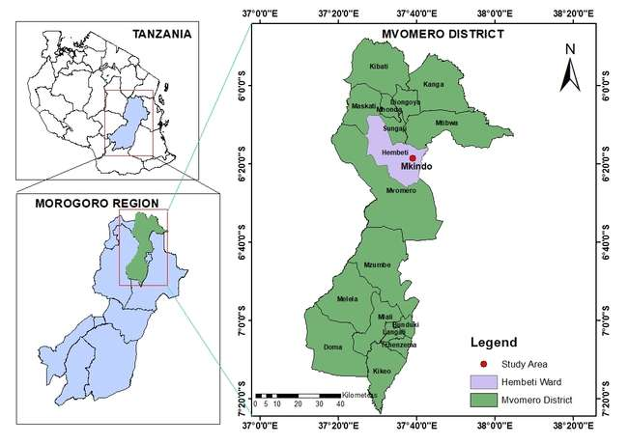

**Figure 1:** Location map of the study area

**3.2.2 Climate of the study area**

The study area experiences a bimodal rainfall regime throughout the year, characterized by two distinct rainy seasons. The short rains, referred to locally as "vuli," occur from October to December (OND), while the long rains, known as "masika," take place from March to May (MAM). In the Mkindo area, the long rains yield a significant amount of precipitation, ranging from 123.9 to 246.7 mm per month, contributing to a total of 580.8 mm for the season. In contrast, the short rains result in lower rainfall, ranging from 52.8 to 115.5 mm per month, which tols to 267.8 mm for the season. Overall, the average annual rainfall in this region ranges from 716.5 to 2 158.96 mm (Aseru et al., 2021)

In terms of temperature, the experimental area experiences variations throughout the year. Between February and June, the average monthly maximum temperature ranges from 33.9°C to 27.7°C, while the minimum temperature fluctuates between 20.0°C and 16.5°C. Between September and January, the average maximum temperature ranges from 30.3°C to 32.8°C, with minimum temperatures varying from 16.9°C to 20.2°C (Aseru et al., 2021)

**3.3 Experimental design and layout**

The experiment was designed as a randomized complete design (RCD), incorporating four treatments that corresponded to varying levels of biochar: 0 ton/ha (T1), 5 ton/ha (T2), 10 ton/ha (T3) and 15 ton/ha (T4), with each treatment replicated three times, as illustrated in Figure.2. Each plot measured 2 m by 5 m (10 m²) and was separated by a 1 m buffer zone. Treatments were randomly assigned to plots within each block. Transplanting was done at the age of ten days at a spacing of 25 cm by 25 cm with one seedling per hill, following the method outlined by Gowele *et al.,* (2020, 2021). The experiment took place during the short rainy season, running from October 2023 to February 2024 and long rainy season, running from March 2024 to July 2024.

**3.4 Biochar preparation and agronomic practices**

The agronomic tasks performed included nursery and field preparation, transplanting, fertilizer application, and weeding. During land preparation, the field was effectively puddled using a power tiller to soften the soil. To ensure uniform of moisture distribution, land leveling was conducted, and drainage outlets were created at the end of each plot to facilitate water outflow during the rainy season.

The biochar utilized in this study was sourced from rice husks. It was produced using a locally made pyrolysis device fashioned from a repurposed 200-liter metallic oil drum, which served as the biochar reactor. Fresh rice husks were collected from nearby milling machines, meticulously cleaned, and subjected to pyrolysis under limited oxygen conditions. The burning was initiated at the bottom of the reactor, maintaining an internal temperature between approximately 250°C and 350°C, which is optimal for producing rice husk biochar without ash residue (Hidayat *et al.*, 2023). After five hours, the husks were converted into biochar. The resulting biochar was subsequently cooled with fresh water to prevent ash formation and allowed to dry for three days. The designated rates of rice husk biochar (0 ton/ha, 5 ton/ha, 10 ton/ha and 15 ton/ha) were uniformly applied to the experimental plots (T1, T2, T3, and T4, respectively) and thoroughly mixed into the soil.

The SARO (TXD 306) rice variety, which is well-suited for the conditions of the Mkindo irrigation scheme, was utilized in this study (Kahimba *et al.,* 2014). The nursery was established using viable seeds, selected by immersing them in a saline solution until they achieved a buoyancy similar to that of an egg. Seeds that floated were discarded as they were deemed inferior. To promote rapid seedling emergence and growth, the selected seeds were soaked in freshwater before being broadcasted onto the prepared nursery in the field. After ten days, the seedlings were transplanted into the experimental plots.

For the fertilizers applied, T1 received the full dose of 125 kg/ha each of urea and diammonium phosphate (DAP). T2 was treated with 62.5 kg of urea and 62.5 kg of DAP, while T3 received 31.25 kg of urea and 31.25 kg of DAP. T4 received no chemical fertilizers. In the plots where chemical fertilizers were applied, the entire amount of DAP was applied at once on the fifth day after transplanting (DAT), while Urea was applied in two splits, at 30 and 60 DAT. Additionally, biochar was applied once prior to transplanting at the specified rates.

Two PVC pipes, each measuring 30 cm in length and 76.2 mm in diameter, were installed in each plot such that the lower 20 cm of the pipe that was perforated was buried beneath the soil surface while the 10 cm that was unperforated extended above the soil. These pipes were positioned near the plot bunds for easy access, serving as piezometers for effective water management (Mboyerwa *et al.,* 2021). Throughout both the dry and wet seasons, weeding was carried out four times, and pesticide spraying was conducted three times to address whitefly infestations and other pests. All the materials and instruments used are as shown in the Table 1

**Table 1**: Table Materials and instruments used in the study.

|  |  |  |
| --- | --- | --- |
| **s/no** | **Materials and Tools** | **Specifications/size** |
|  | Tape Measure | Tape measure of 5 meters |
|  | PVC pipes (24 Piezometers) | 30 cm length,76.2mm diameter |
|  | V- notch weir | Notch Angle of 90°, Cd of 0.60 |
|  | Pegs | 2-meter length, 60 Pieces |
|  | Spray paint | White spray |
|  | Metallic drum (biochar reactor) | 200 liters |
|  | Lysimeter | Open and closed one end |
|  | Levelling wooden float | Simple hand wooden bar |
|  | Paddy marker | Steel paddy maker with 25cm spacing |
|  | Rice husk biochar (RHB) | 180 Kg of Rice husk Biochar |
|  | Rice Seeds | Saro 5 TXD 306 |
|  | Push weeder | Simple hand metallic push weeder |
|  | Organic Fertilizer | DAP, UREA |
|  | Pesticides sprayer | 16 liters |
|  | Pesticides and herbicides | Weeds, insects, and fungi control |
|  | Weigh spring balance | Electronic |
|  | Moisture meter | Electronic |

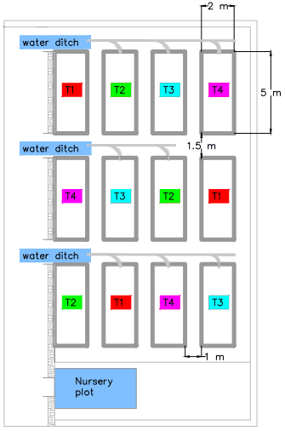

**Figure 2:** Set up of the experiment

**3.5 Data collection**

**3.5.1 Growth attributes and rice yield**

Primary measurements considered in the methodology were obtained throughout various growth stages of paddy to ensure accuracy of the data collected for analysis. Counts for a total number of tillers and productive tillers were conducted during the initial stage, vegetative stage, specifically at 55–60 days after transplanting (DAT). Maximum tillering was observed at 85–90 DAT, with further measurements taken during the harvesting phase at 110–115 DAT. The heights of the plants were measured on weekly basis until they reached maturity using a tape measure. Similarly, the number of leaves was counted every week for each plant to track leaf production over time. Each panicle's length was also measured with a ruler to follow its growth and development till maturity. All the measurements were taken on five representative plants in each plot which were marked using a peg. After harvest, the length of the roots of the five plants taken from each plot was measured to assess root development. Above-ground biomass was harvested for biomass and yield evaluation. Yield was measured using an electronic balance after at a standardized uniform moisture content of 16%. The harvesting of yield assessments was conducted in a 1 m x 1 m quadrant centrally located within every plot to remove any edge effect. All data collected from these measurements, including root lengths, leaf counts, tiller counts, panicle lengths, plant heights, biomass and yield, were carefully recorded to ensure accurate evaluation in the final stage.

**3.5.2 Water productivity**

A structured methodology was used to analyze both the economic water productivity ($EWP$) and physical water productivity ($PWP$) of water used. Economic Water Productivity (TZS m-3) is defined as the monetary worth of output (TZS ha-1) per unit volume of water utilized (m3 ha-1) for each treatment (Igbadun *et al.,* 2006). In this research, EWP was determined as shown in equation 1.

$EWP=\frac{Gross Revenue from Crop Yield(TZS{ ha}^{-1})}{{Total Amount of Water Used(m^{3 } ha}^{-1})}$…………………………………………….(Eq.1)

The gross revenue is calculated as a product of crop yield and its current market price, and the total quantity of water represents the overall quantity of water from irrigation and rainfall used in the production of crops.

On the other hand, physical water productivity (kg m-3) is measured as physical yield output (kg ha-1) per unit of volume of water used (m3 ha-1) for each treatment (Igbadun *et al.,* 2006). It shows the efficiency at which water contributes to crop production. The PWP is calculated as shown in equation 2.

$PWP=\frac{Total Obtained Crop Yield(Kg{ ha}^{-1} )}{{Total Amount of Water Used(m^{3 } ha}^{-1})}$…………………………………………….(Eq.2)

Both of them are indicators based on well-measured water input and crop outputs, having data from field experiments and farmer surveys, along with historical climate data to ensure their reliability.

**3.6 Data analysis**

The data obtained were analyzed using R software, and means were compared using the least significant difference (LSD) test at 5% probability level (Gomez, 1984).

**3.7 Results and Discussion**

**3.7.1 Growth Variables**

**3.7.1.1 Effect of RHB application levels on plant height**

Application of RHB had a significant effect (p<0.05) on plant height with T3 and T4 having significantly taller plants than T1 and T2 (Table 2 and Figure 3). T2 received a smaller dose of RHB (5 ton/ha) while T1 (control) received none. On the other hand, T4 received the highest dose of RHB (15 tons/ha) followed by T3 (10 ton/ha). But in terms of fertilizers, T1 received the highest dose which progressively decreased to zero in T4. This study unveiled the effect of rice husk biochar on plant height in both dry and wet seasons for paddy production. The two graphs show the variations in the height of the plants as it goes on with time within the dry and wet seasons against the different rice husk biochar treatments. It showed promising growth at the beginning of the treatments; however, by the end of the dry season, the rate stabilized. With the middle to late growth period embracing Weeks 7-15-the plant heights stabilize at a certain point since only slight variations are observed; these are particularly between T2 and T4, which reveal marginally higher growth during the wet season. Initial growth trends in the first week remain similar, but T1 as control reveals slightly lower growth at an early stage; hence, indicating that higher applications of RHB are more useful. In due course, with the progress of the seasons, the differences are more marked, and T2, T3, and T4 performed better than T1. On the whole, though RHB improves the growth of paddy plants, especially in the wet season, the differences in final plant height are very minimal among the treatments. Therefore, RHB appears to effectively influence plant height even in the absence of chemical fertilizers indicating its importance as a soil amendment (Figure 4).

|  |  |
| --- | --- |
|  |  |
| (a) | (b) |

**Figure 3.:** Plant height progression over time (a) during the dry season (b) during the wet season under different rates of RHB application

**Figure 4:**  Effects of treatment (RHB) on plant height

**Table 2:** LSD mean comparison across interaction of treatments and season for growth parameters- plant height (PH), number of leaves (NL), number of tillers (NL), and number of productive tillers (NPT). Means with different letters in the same column indicate significant difference at p<0.05

|  |  |  |  |  |  |
| --- | --- | --- | --- | --- | --- |
| **Season** | **Treatment** | **PH (cm) (mean±se)** | **NT (mean±se)** | **NL (mean±se)** | **NPT (mean±se)** |
| DRY | T1 | 123.4 ± 0.87a | 24.90 ± 1.29a | 133.20 ± 3.23a | 21.93 ± 0.66a |
|  | T2 | 122.13 ± 1.30a | 26.43 ± 1.03a | 127.80 ± 2.50a | 22.53 ± 0.47a |
|  | T3 | 128.33 ± 2.13a | 34.17 ± 1.07b | 130.53 ± 5.70a | 27.87 ± 0.35b |
|  | T4 | 128.00 ± 0.81a | 26.13 ± 1.64a | 149.87 ± 3.43a | 23.43 ± 0.81a |
|  |  |  |  |  |  |
| WET | T1 | 99.80 ± 0.70b | 17.80 ± 1.22c | 89.00 ± 6.68b | 14.27 ± 0.55c |
|  | T2 | 101.73 ± 1.37b | 19.27 ± 0.48c | 96.13 ± 2.54b | 14.93 ± 0.67c |
|  | T3 | 102.13 ± 2.51b | 24.57 ± 0.38d | 92.87 ± 10.87b | 20.80 ± 0.93d |
|  | T4 | 97.40 ± 3.30b | 18.07 ± 1.22c | 92.00 ± 3.93b | 13.43 ± 1.23c |

**3.7.2 Effect of RHB application levels on the number of leaves**

RHB application significantly (p<0.05) influenced the number of leaves per plot. In the dry season, paddy plants under T4 had a significantly higher mean number of leaves compared to the rest of the treatments. There was no significant difference in the mean number of leaves among treatments T1, T2, and T3. This goes further to demonstrate the efficacy of RHB on enhancement of growth parameters even under poor soil fertility conditions as T4 had no inorganic fertilizer that was added. The same was applied in the wet season, the number of leaves in the treatments seems to be close to each other but vary significantly when compared to the dry season. This could be due to increased nutrient availability, better water-holding capacity, and increased microbial activities as evidenced in other studies (Adebajo *et* *al.,* 2022; Huang *et al.,* 2022; Li *et al.,* 2023; Tsai & Chang, 2020). The number of leaves under T4 remained consistently higher than the rest of the treatments throughout the growth period (Table 2).

**3.7.3 Effect of RHB application levels on number of tillers**

There was no significant difference (p>0.05) in number of tillers among treatments. In the dry season, plants under T4 showed a consistently higher number of tillers from the start to the end whereas those under T2 had the lowest. However, in the wet season, the NT of all the treatments was significantly lower compared to the dry season; T3 had a significantly higher NT than other treatments in the wet season. Overall, T3 was always performing better for most parameters, especially under NT and NPT, indicating that such treatment might optimize paddy growth under different seasonal conditions as seen in Table 2 and in Figure 5. This further underscores the importance of RHB as a soil amendment in paddy fields.

|  |  |
| --- | --- |
|  |  |
| (a) | (b) |

**Figure 5:** Progression of number of tillers over time (a) in dry season (b) in wet season under different rates of RHB application

**3.7.4 Effect of RHB application levels on the number of productive tillers**

There were no significant differences in number of productive tillers among treatments (p>0.05). Nevertheless, plants under T3 showed the higher mean number of productive tillers while the lowest mean number of productive tillers was observed in T2 (Table.2). From week 1 to week 10 there were no observable productive tillers under any treatment (Figure 7). However, from week 10 onwards, there was a consistent increase in the number of productive tillers for all the treatments with a lull between weeks 12 and 13. Rice husk biochar application in paddy production exhibited varied effects on plant growth parameters, viz., plant height, number of tillers, number of leaves, and number of productive tillers under different treatments and seasons. In both dry and wet seasons, T3 significantly raised NPT over other treatments. Overall, T3 was always performing better for most parameters, especially under NT and NPT, indicating that such treatment might optimize paddy growth under different seasonal conditions as seen in Table 2 and Figure 8 (a, b). The physical appearance of grown paddy in the field under different treatments is shown in Figure 6 (a,b,c, and d).

|  |  |
| --- | --- |
|  |  |
| Productive tillers under T1 | Productive tillers under T2 |
| (a) | (b) |
|  |  |
| Healthy green paddy with productive tillers under T3 | Appearance of productive tillers under T4 |
| (c) | (d) |

**Figure 6:** Photos showing sections of plants in the different treatments

|  |  |
| --- | --- |
|  |  |
| (a) | (b) |

**Figure 7:** Progression of number of productive tillers over time (a) in dry season and (b) in wet season under different rates of RHB application

|  |  |
| --- | --- |
|  |  |
| (a) | (b) |

**Figure 8:** Effects of treatment (RHB) on (a) number of tillers and (b) number of productive tillers

**3.7.5 Effect of RHB application levels on paddy root depth**

The root depth varied significantly among treatments (p<0.05). Both Figure (9) and Table (4) show that mean root depth increases linearly from T1 to T4 for both dry and wet seasons. It could be interpreted from this that with increasing levels of rice husk biochar, the root depth also increases, hence a positive effect on rooting development. From the graph and LSD Table (.4), it's clear that from T1 to T4 of all the treatments, root depth was higher in the dry season compared to that in the wet season. During the dry season, T3 with 196.67 mm and T4 with 233.33 mm were significantly outperformers against T1 and T2 (163.33 mm and 160.00 mm) respectively, with the most superior root depth shown by T4, indicating significant improvement with an increase in higher levels of treatment. In the Wet season, both T3 and T4 are equally significantly higher, at 180.00 and 216.67 mm, respectively, in comparison to T1 and T2, at 153.33 and 150.00 mm, though overall root depths are lower in the Wet than in the Dry season. High benefit contributions from the higher treatment levels, particularly within the Dry season, suggest that biochar mitigates water stress. It would thus appear that RHB provides a favorable environment for root development through increased soil porosity, water-holding capacity, and nutrient availability with consequent improvement of soil structure and fertility in paddy fields (Chen *et al.,* 2021; Tsai & Chang, 2020).

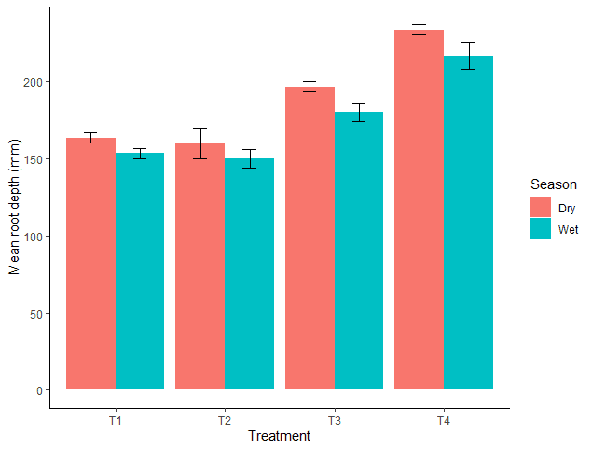

**Figure 9:** Effect of RHB application levels on paddy root depth

The roots from the control treatment (T1) are quite short and thin. Treatment T2 produces longer and more dense roots than the control but still not as long as the ones from treatment T3. The longest most developed root came from Treatment T4, as shown in Table 3.

**Table 3:** Variation of rooting depths in different application of RHB

|  |  |  |  |
| --- | --- | --- | --- |
|  |  |  |  |
| Roots for paddy plant | | Tape measure for rooting length | |
|  |  |  |  |
| 0t/ha-RHB(T1) | 5t/ha-RHB(T2) | 10t/ha-RHB(T3) | 15t/ha-RHB(T4) |

**Table 4**: LSD mean comparison across interaction of treatments and season for root depth (mm) and Panicle length (mm). Means with different letters varied significantly at p<0.05.

|  |  |  |  |  |
| --- | --- | --- | --- | --- |
| **Season** | **Treatment** | **Root depth (mm) (mean±se)** | **Panicle length(mm)(mean±se)** | |
| DRY | T1 | 163.33 ± 3.33a | | 226.00 ± 5.03a |
|  | T2 | 160.00 ± 10.00a | | 223.33 ± 1.76a |
|  | T3 | 196.67 ± 3.33b | | 223.33 ± 1.76a |
|  | T4 | 233.33 ± 3.33c | | 217.33 ± 3.53a |
|  |  |  | |  |
| WET | T1 | 153.33 ± 3.33de | | 217.33 ± 3.71b |
|  | T2 | 150.00 ± 5.77d | | 222.00 ± 1.15b |
|  | T3 | 180.00 ± 5.77e | | 241.33 ± 4.67c |
|  | T4 | 216.67 ± 8.82f | | 216.00 ± 4.62b |

**3.7.6 General interaction of RHB application levels on paddy yield, total biomass and biomass**

Table .5, presents the results of a generalized linear model assessing the effects of season and treatments on yield parameters: total biomass, biomass, and grain yield. The dry and wet season, significantly influences total biomass and biomass yield (p < 0.001), indicating substantial variations in these parameters across different seasons. However, the season has no significant effect on grain yield (p = 0.376).

In contrast, treatment effects on total biomass and biomass are not significant (p > 0.05), suggesting treatments did not markedly alter these yields. However, the grain yield shows a significant response to treatment (p = 0.002), implying that the treatments applied had a notable impact on grain production. The interaction between season and treatment does not significantly affect any of the yield parameters (p > 0.05), indicating that the combined effects of season and treatment on yield parameters are not statistically significant.

Table 7 compares the mean yields of total biomass, biomass, and grain under different treatments and seasons using the Least Significant Difference (LSD) method. During the dry season, all treatments (T1, T2, T3, T4) show higher total biomass and biomass yields compared to the wet season, indicating better performance in dry conditions. Treatment T3 produced the highest total biomass (45.67 ton/ha) and grain yield (9.2 ton/ha) during the dry season, suggesting it may be the most effective treatment in these conditions. In contrast, the wet season yields were generally lower, with T3 still producing the highest grain yield (9.07 ton/ha), but with a much lower total biomass and biomass compared to the dry season.

**Table 5:** LSD mean comparison across interaction of treatments and season for yield parameters

|  |  |  |  |  |
| --- | --- | --- | --- | --- |
| **Season** | **Treatment** | **Total biomass (ton/ha)** | **Biomass(ton/ha)** | **Grain (ton/ha)** |
| **Mean ± Standard Error** | **Mean ± Standard Error** | **Mean ± Standard Error** |
| Dry | T1 | 43.03 ± 1.93a | 35 ± 1.5a | 8.53 ± 0.44ab |
| T2 | 43.17 ± 2.34a | 33.23 ± 2.61a | 8.23 ± 0.07ab |
| T3 | 45.67 ± 1.76a | 33.6 ± 2.43a | 9.2 ± 0.32b |
| T4 | 40.2 ± 1.61a | 30.63 ± 2.33a | 7.63 ± 0.32a |
|  |  |  |  |  |
| Wet | T1 | 27.73 ± 2.56b | 18.33 ± 1.76b | 8.2 ± 0.56cd |
| T2 | 28.07 ± 0.97b | 19.33 ± 1.05b | 8.13 ± 0.19cd |
| T3 | 26.37 ± 1.32b | 16.8 ± 1.6b | 9.07 ± 0.2d |
| T4 | 28.1 ± 1.65b | 18.43 ± 1.2b | 7.3 ± 0.44c |

The data suggests that treatments have a more pronounced impact on grain yield than on biomass, and environmental conditions (season) significantly influence overall productivity. The use of standard error values helps gauge the variability and reliability of these means, with overlapping values indicating less distinct differences among some treatment outcomes, particularly in grain yields across seasons.

**3.7.6.1 Effect of RHB application levels on total biomass (ton/ha)**

The total biomass yield varied significantly between the dry and wet seasons, with all treatments (T1, T2, T3 and T4) producing higher biomass during the dry season compared to the wet season. The highest total biomass yield was observed in the dry season under Treatment T3 (45.67 tons/ha), while the lowest was seen in the wet season under Treatment T3 (26.37 tons/ha). This suggests that the treatments were more effective in promoting biomass accumulation under dry conditions. The significant difference between the two seasons could be attributed to environmental factors that favor biomass production in the dry season, possibly due to better nutrient availability or reduced disease pressure as shown in Figure 10.

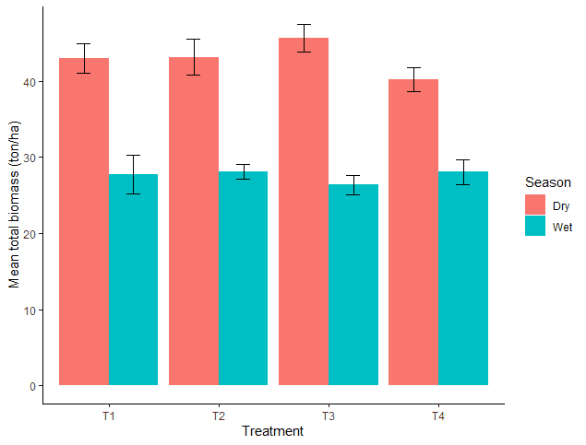

**Figure 10:** Total biomass across treatment and season

**3.7.6.2 Effect of RHB application levels on biomass (ton/ha)**

Like total biomass, the biomass yields also showed a distinct difference between the dry and wet seasons. In the dry season, all treatments resulted in higher biomass yields, with the highest observed in Treatment T1 (35 tons/ha) and the lowest in Treatment T4 (30.63 tons/ha). During the wet season, biomass yields were consistently lower, with Treatment T1 producing the most (18.33 tons/ha) and Treatment T3 the least (16.8 tons/ha). The reduction in biomass during the wet season might be due to excessive moisture leading to unfavorable growing conditions, such as waterlogging, which can reduce root oxygen availability and nutrient uptake efficiency as shown in Figure 11

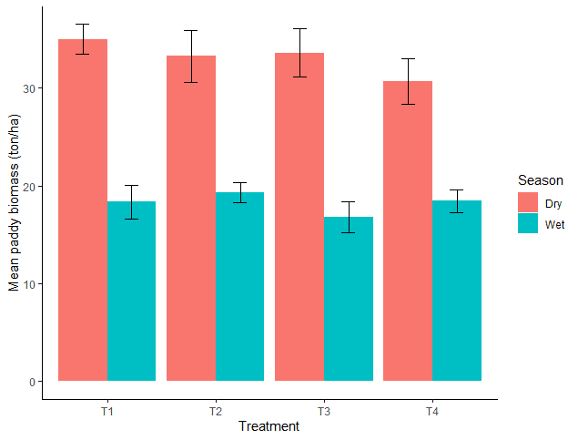

**Figure 11:** Biomass across treatment and season

**3.7.6.3 Effect of RHB application levels on grain (ton/ha)**

Grain yield presented a different trend compared to total biomass and biomass. Although there were variations in yields between the seasons, the differences were less pronounced. In the dry season, Treatment T3 had the highest grain yield (9.2 tons/ha), while Treatment T4 had the lowest (7.63 tons/ha). During the wet season, grain yield was still relatively high, with Treatment T3 again showing the highest yield (9.07 ton/ha), while Treatment T4 had the lowest (7.3 ton/ha). This suggests that grain yield was more resilient to seasonal changes compared to biomass yields. The consistent performance of Treatment T3 across both seasons indicates its potential effectiveness in stabilizing grain production regardless of seasonal variations. The relatively minor variations in grain yield across treatments and seasons highlight that, while total biomass and biomass are influenced by environmental conditions, grain yield may be determined more by genetic factors and specific treatment effects as shown in Figure 12.

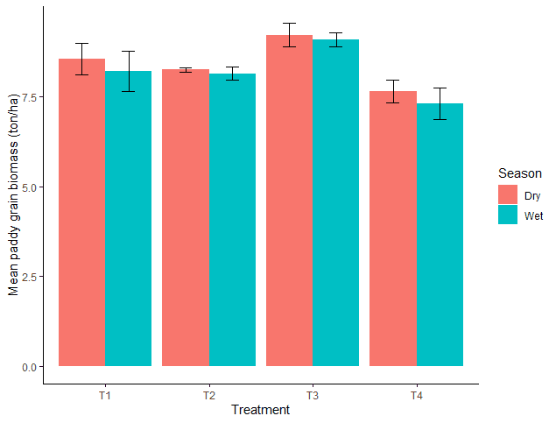

**Figure 12:** Grain across treatment and season

**3.8 Water productivity**

**3.8.1 Physical crop water productivity**

Water productivity in the dry season ranges from 0.66 kg/m3 to 0.80 kg/m3. Treatment with an application rate of 10 tons/ha of rice husk biochar (T3) has the highest water productivity (0.80 kg/m3), followed by T1 (0.74 kg/m3), T2 (0.72 kg/m3) and T4 (0.66 kg/m3). Also, the water productivity ranged from 0.73kg/m3 to 0.91kg/m3 throughout the wet season. Treatment 3 (0.91 kg/m3) and Treatment 4(0.73 kg/m3) exhibited the highest and lowest WP exhibited the highest and lowest WP during the wet season as seen in Figure 13.

This suggests that paddy yield increased the most with a 10 tons/ha rate of RHB with the same amount of water as the other treatments. At this rate of 10 tons/ha, there was a notable improvement in yield and water productivity compared to the remaining treatments (T1, T2, and T4), which shows that RHB positively impacts the soil’s ability to retain water and nutrients, leading to more efficient water use and a higher yield in T3. The application of 5 tons/ha of RHB resulted in a slight yield reduction compared to the control (T1). The use of 5 tons/ha of RHB did not significantly enhance water use efficiency. For the application rate of 15 tons/ha (T4), there is a decrease in yield compared to T3, which suggests that there may be a threshold for the beneficial effect of RHB and beyond this, 10 tons/ha might not provide benefits or could potentially have negative effects on yield and water productivity as seen in Table .6.

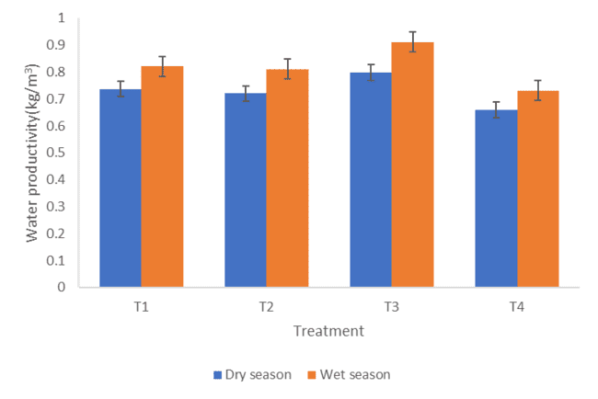

**Figure 13:** Water productivity across treatment and season

**Table 6:** LSD means comparison across interaction of treatments and season for water productivity (Kg/m3)

|  |  |  |  |  |
| --- | --- | --- | --- | --- |
| **Season** | **Treatments** | | | |
|  | **T1** | **T2** | **T3** | **T4** |
| Wet | 0.82±0.06ab | 0.81±0.02ab | 0.91±0.02b | 0.73±0.04a |
| Dry | 0.74±0.04cd | 0.71±0.01cd | 0.80±0.03d | 0.66±0.03c |

.

**3.8.2 Economic water productivity (EWP)**

Application of 10 tons/ha of RHB (T3) gave the highest EWP during both the wet and dry seasons. The economic water productivity in the dry season was as high as 272.02 Tsh/m³ (0.11 US $/m3), while in the wet season it reached 306.97 Tsh/m³ (0.12 US $/m3). It proves that 10 tons/ha of RHB application will not only maximize the paddy yield but also give an economic return per unit of water used irrespective of the seasons.

Also, T4 yielded the lowest value of economic water productivity in both the dry and wet season, with 166.13 Tsh/m³ (0.06 US $/m3) in the dry season and 170.73 Tsh/m³ (0.07 US $/m3) in the wet season. Kadigi *et al.* (2003) conducted the same study on analyzing economic water productivity for paddy crops and the results of this study rely on the same range of economic water productivity of 18.21Tsh/m3 (0.02 US $/m3) with a production amount of 1600kg/ha at an average producer price of 156.25Tsh/kg (0.15 US $/m3). The treatment having the highest application rate of RHB, T4 had the lowest yield and economic water productivity. It therefore, seems that at a higher application rate, such as 15 tons/ha of RHB, there is a point of diminishing returns in yield and economic efficiency, which is economically unfavorable. All the data showed that 10 tons/ha of RHB (T3), maximizes economic returns per unit of applied water in both the dry and wet seasons. Over-application reduces economic efficiency, hence being less beneficial than expected. The wet season in general showed an enhancement in the economic benefits of the application of RHB; however, the optimal level of application is still at 10 tons/ha. The dry season, though less economically productive overall, still shows the 10 tons/ha as the most efficient application rate.

**3.9 Discussion**

The WP results in this study are consistent with investigations conducted under SRI, such as Zhang *et al.* (2012), who found WP in the 0.78-1.09 kg/m3 range. Also, Mboyerwa *et al*. (2021) reveal that the WP of lowland rice ranged from 0.6 to 1.5 kg/m3, which is consistent with the WP of this study. In addition, Asseru *et al.* (2021) found the WP varied from 0.306 - 0.851 kg/m3 in a study conducted at Mkindo. Another study done by Premalatha (2023) has also proven that the use of rice husk biochar promotes the performance of paddy output through increased soil fertility and retained moisture content. runoff caused by excessive rainfall during the dry season resulted in inefficiencies that may According to this study, the wet season has higher water productivity since it receives less rainfall than the dry season, which receives more rain. On the other hand, waterlogging has reduced overall water productivity. This differed from the findings of Materu *et al.* (2018) and Aseru *et al*.(2021), who reported higher water productivity during the dry season.

Therefore, the results indicate that the optimal rate of RHB application for improving water productivity is 10 tons/ha (T3). This rate(T3) maximizes yield and water use efficiency, while higher rates (15 tons/ha) may lead to little yield reduction and water productivity compared to T3 due to absence of industrial fertilizer. This indicates that there is an optimal rate of RHB application for maximizing water use efficiency, beyond which the benefit could diminish or become negative. Lower or higher application rates of RHB (T2 and T4) did not perform as well as the 10-ton/ha rate.

**3.10 Conclusion and Recommendation**

**3.10.1 Conclusion**

In conclusion, this study shows that biochar application has a substantial impact on improving growth parameters, water productivity and yield in irrigated rice fields. The application of rice husk biochar at variable rates caused differential responses in plant height, number of tillers, leaf count, productive tillers, root depth, and panicle length in both treatments and seasonal variation. The results indicated that the application of 10 tons/ha showed the best performance throughout, attaining maximum values for plant height, number of tillers and productive tillers. Besides, this ensured higher grain yield and total biomass particularly during the dry season. While the application of 15 tons/ha produced a deeper root system (T4), moderate application rates like T3 maximized panicle length and maintained the effectiveness of root depth across seasons. Grain yield and total biomass in T3 remained optimal across wet and dry seasons, hence underlining stability in the moderate application of biochar for consistent yield outcomes. Water productivity was also maximized at this rate, where T3 achieved 0.91 kg/m³ in the wet season and 0.80 kg/m³ in the dry season. Economic water productivity also followed the same trend with the highest in T3, which yielded 306.97 Tsh/m³ (0.12 USD/m³) in the wet season and 272.02 Tsh/m³ (0.11 USD/m³) during the dry season. These results imply that rice husk biochar applied at 10 tons/ha optimally enhances paddy yield, economic return, and water productivity. Excessive biochar application (15 tons/ha) was less efficient, showing diminishing returns beyond moderate application levels.

**References**

Adebajo, S. O., Oluwatobi, F., Akintokun, P. O., Ojo, A. E., Akintokun, A. K., & Gbodope, I. S. (2022). Impacts of rice-husk biochar on soil microbial biomass and agronomic performances of tomato (Solanum lycopersicum L.). *Scientific Reports*, *12*(1), 1787.

Alavaisha, E., Tumbo, M., Senyangwa, J., & Mourice, S. (2022). Influence of Water Management Farming Practices on Soil Organic Carbon and Nutrients: A Case Study of Rice Farming in Kilombero Valley, Tanzania. *Agronomy*, *12*(5), 5. https://doi.org/10.3390/agronomy12051148

Andreoni, A., Mushi, D., & Therkildsen, O. (2021a). *Tanzania’s `rice bowl’: Production success*. scarcity persistence and rent seeking in the East African Community.

Andreoni, A., Mushi, D., & Therkildsen, O. (2021b). *Tanzania ’ s ‘ rice bowl ’: Production success , scarcity persistence and rent seeking in the East African Community*.

Asadi, H., Ghorbani, M., Rezaei-Rashti, M., Abrishamkesh, S., Amirahmadi, E., Chengrong, C., & Gorji, M. (2021). Application of rice husk biochar for achieving sustainable agriculture and environment. *Rice Science*, *28*(4), 325–343.

Aseru, G., Tarimo, P. R., Silungwe, F. R., & Mbungu, W. (2021). Effects of Integrating Deficit irrigation and Carbonate Foliar Fertilizers into the System of Rice Intensification on Growth and Yield: A Case study of Mkindo. In *Crdeepjournal.Org*. Tanzania. http://www.crdeepjournal.org/wp-content/uploads/2022/06/Vol-11-2-3-IJBAS.pdf

Busungu, C. (2023). Past, Present and Future Perspectives of Rice Production in Tanzania. *Agricultural Sciences*, *14*(08), 987–1006. https://doi.org/10.4236/as.2023.148066

Chen, X., Yang, S., Ding, J., Jiang, Z., & Sun, X. (2021). Effects of biochar addition on rice growth and yield under water-saving irrigation. *Water*, *13*(2), 209.

Formiga, M., & Degreenia, J. (2023). Report Name : Grain and Feed Annual - Brazil - 2023. *Report*, *Grain and Feed in Brazil*, 39. https://apps.fas.usda.gov/newgainapi/api/Report/DownloadReportByFileName?fileName=Grain and Feed Annual_Brasilia_Brazil_BR2023-0008.pdf

Francis, M. (2022). Adoption and Diffusion of New Rice Technologies in Tanzania: Prospects and Challenges. *Repository.Dl.Itc.U-Tokyo.Ac.Jp*. https://repository.dl.itc.u-tokyo.ac.jp/record/2006887/files/A38140.pdf

Gowele, G. E., Mahoo, H. F., & Kahimba, F. C. (2020). Comparison of Silicon Status in Rice Grown Under the System of Rice Intensification and Flooding Regime in Mkindo Irrigation Scheme, Morogoro, Tanzania * 1. *Tanzania Journal of Agricultural Sciences*, *19*(2), 216–226.

Gowele, G. E., Mahoo, H. F., & Kahimba, F. C. (2021). Silicon status in soil and its effect on growth and yield of rice under the system of rice intensification and continuous flooding in Mkindo Irrigation Scheme, Morogoro, Tanzania. *Tanzania Journal of Agricultural Sciences*, *20*(2), 237–244.

Hidayat, Rahmat, A., Nissa, R. C., Sukamto, Nuraini, L., Nurtanto, M., & Ramadhani, W. S. (2023). Analysis of rice husk biochar characteristics under different pyrolysis temperature. *IOP Conference Series: Earth and Environmental Science*, *1201*(1). https://doi.org/10.1088/1755-1315/1201/1/012095

Huang, J., Zhu, C., Kong, Y., Cao, X., Zhu, L., Zhang, Y., Ning, Y., Tian, W., Zhang, H., & Yu, Y. (2022). Biochar application alleviated rice salt stress via modifying soil properties and regulating soil bacterial abundance and community structure. *Agronomy*, *12*(2), 409.

Kahimba, F. C., Kombe, E. E., & Mahoo, H. F. (2014). The Potential of System of Rice Intensification (SRI) to Increase Rice Water Productivity: a Case of Mkindo Irrigation Scheme in Morogoro Region, Tanzania. *Tanzania Journal of Agricultural Sciences*, *12*(2), 10–19. http://www.ajol.info/index.php/tjags/article/viewFile/114268/103969

Kulyakwave, P. D., Xu, S., Yu, W., & Mwakyusa, J. G. (2022). Analysis of inputs variability on rice growth stages in Mbeya region. *African Journal of Agricultural Research*, *18*(9), 742–751.

Lai, C., Muon, R., Touch, V., Hin, S., Podwojewski, P., Ket, P., Jouquet, P., Degré, A., & Ann, V. (2023). *Impact of Biochar from Rice Husk on Nutrient Distribution and Rice Growth and Yield: A Soil Column Experiment*. Journal of Soil Science and Plant Nutrition. https://doi.org/10.1007/s42729-023-01539-2

Li, Z., Zheng, Z., Li, H., Xu, D., Li, X., Xiang, L., & Tu, S. (2023). Review on rice husk biochar as an adsorbent for soil and water remediation. *Plants*, *12*(7), 1524.

Materu, S. T., Shukla, S., Sishodia, R. P., Tarimo, A., & Tumbo, S. D. (2018). Water use and rice productivity for irrigation management alternatives in Tanzania. *Water (Switzerland)*, *10*(8), 1018. https://doi.org/10.3390/w10081018

Mboyerwa, P. A., Kibret, K., Mtakwa, P. W., & Aschalew, A. (2021). Evaluation of growth, yield, and water productivity of paddy rice with water-saving irrigation and optimization of nitrogen fertilization. *Agronomy*, *11*(8), 1–23. https://doi.org/10.3390/agronomy11081629

Msafiri, D. (2021). *Enhancing Competitiveness of Rice Industry in Tanzania*. REPOA. https://www.repoa.or.tz/wp-content/uploads/2021/08/13.-Rice-PB.pdf

Mtaki, B. (2019). United Republic of Tanzania Grain and Feed Annual- Tanzania Corn, Wheat and Rice Report. *Global Agriculture Information Network*, 1–11. https://apps.fas.usda.gov/newgainapi/api/report/downloadreportbyfilename?filename=Grain and Feed Annual_Dar es Salaam_Tanzania - United Republic of_4-9-2019.pdf-Accessed on 7 December 2020

Mtaki, B., & Snyder, M. (2023). *Grain and Feed Annual (pp. 1--21)*. United States Department of Agriculture. https://apps.fas.usda.gov/newgainapi/api/Report/DownloadReportByFileName?fileName=Grain

Reuben, P., Katambara, Z., Kahimba, F. C., Mahoo, H. F., Mbungu, W. B., Mhenga, F., Nyarubamba, A., & Maugo, M. (2016). Influence of transplanting age on paddy yield under the system of rice intensification. *Agricultural Sciences*, *7*(3), 154–163.

Severo, F. F., da Silva, L. S., Costa Moscôso, J. S., Sarfaraz, Q., Rodrigues Júnior, L. F., Lopes, A. F., Marzari, L. B., & Dal Molin, G. (2020). *Chemical and physical characterization of rice husk biochar and ashes and their iron adsorption capacity*. SN Applied Sciences. https://doi.org/10.1007/s42452-020-3088-2

Singh, C., Tiwari, S., Gupta, V. K., & Singh, J. S. (2018). The effect of rice husk biochar on soil nutrient status, microbial biomass and paddy productivity of nutrient poor agriculture soils. *Catena*, *171*, 485–493.

Singh Karam, D., Nagabovanalli, P., Sundara Rajoo, K., Fauziah Ishak, C., Abdu, A., Rosli, Z., Melissa Muharam, F., & Zulperi, D. (2022). An overview on the preparation of rice husk biochar, factors affecting its properties, and its agriculture application. *Journal of the Saudi Society of Agricultural Sciences*, *21*(3), 149–159. https://doi.org/10.1016/j.jssas.2021.07.005

Tsai, C.-C., & Chang, Y.-F. (2020). Effects of rice husk biochar on carbon release and nutrient availability in three cultivation age of greenhouse soils. *Agronomy*, *10*(7), 990.

URT. (2019). *National rice development strategy phase II (NRDS II) 2019-2030*.

World Trade Organization. (2019). *Trade Policy Review Report by the Secretariat East African Community (EAC)*. *2019*(February).