***Case report***

**Rehabilitation of psediatric mandibular fracture following dashboard injury: Case Report**

**Abstract**

Paediatric maxillofacial fractures make up for 1% - 15% of all facial fractures, which happen because of their distinct anatomical and developmental reasons. These include greater bone flexibility, the ratio between the cranial-to-facial volume, the paranasal sinuses' limited pneumatization, and protective heaters like the buccal fat pad and developing tooth buds. The most common are road traffic accidents (RTA), falls, violence, and sports injuries. This report underscores paediatric mandibular fracture rehabilitation as a result of a dashboard injury. This article is devoted for the description of surgical reconstruction of a 12-year-old child which was diagnosed with bilateral parasymphysial mandibular fractures cause an unrestrained front-seat RTA. A skull X-ray and multidetector CT scans were used to confirm the diagnosis. Under general anesthesia, closed reduction with intermaxillary fixation (IMF) was conducted. This technique is mainly useful in settings with few available resources or where advanced fixation methods are not available.

**Key words:** Fracture mandible, Paediatrics, Road traffic accident, Internal fixation.

**Introduction**

According to the World Health Organization (WHO), road traffic accidents (RTA) are responsible for 20–50 million non-fatal injuries and 1.3 million fatal injuries annually [1]. Among such injuries; dashboard impacts possessing acceleration-deceleration forces which represent a unique diagnostic and management challenges, as abrupt deceleration causes the passenger to collide with the dashboard or steering wheel [2] leading to a wide spectrum of injuries including complex facial injuries, blunt thoracoabdominal injuries, pelvic fractures, and lower extremity trauma [3]. Furthermore, acceleration-deceleration injuries are particularly concerned due to the resulting life-threatening internal injuries i.e. traumatic brain injuries, aortic rupture and spinal fractures [4].

In the head and neck, the incidence of soft tissue injuries exceeds that of facial fractures caused by RTA. Lacerated wounds are the most common types of soft tissue injuries and the orbital region represent the most common site. Lacerated wounds are not associated with higher rates of facial fractures upon comparison with other wounds, except for frontal lacerations. Midfacial fractures have the highest prevalence, followed by upper and lower facial fractures consecutively [5]. Effective management requires a multidisciplinary trauma surgeon together with critical care physicians [6,7], besides the necessity of the availability of advanced imaging modalities i.e. multidetector computerized tomography (MDCT) scans for assessing the extent of injury, particularly in cases with multiple trauma [8]. Treatment plan includes; hemodynamic stabilization, surgical intervention and rehabilitation [9].

There is paucity of reports on RTA related maxillofacial fracture in children. Hence, this study aimed to highlight the management of paediatric maxillofacial fracture caused by dashboard from our centre.

**Case presentation**

A 12-years-old male patient was admitted to our emergency clinic due to a road traffic accident. Upon asking the parents, they clarified that he was sitting in the front passenger seat without fastening his seat belt and upon sudden deceleration his body was projected forwards with his face consequently strongly impacting the adjacent car’s dashboard. The patient was alert, conscious with Glasgow Coma Scale (GCS) of 15/15 [Table 1][10]. No signs of motor affection, no signs of respiratory distress with normal respiration and chest movement with a freely mobile lax anterolateral abdominal wall excluding thoracoabdominal injuries. No fractures in the extremities. The patent was normotensive with no fever. No airway obstruction, mild panfacial edema. Frontal wound about 5 cm was sutured outside our clinic. No bleeding from any facial orifice expects for blood clots in the oral cavity. Multiple abrasions and contusions affect the both central and lateral face regions [Figure 1].

Table 1. Glasgow Coma Scale (GCS) [9].

|  |  |  |
| --- | --- | --- |
| Behavior | Response | Score |
| 1. Eye opening | Spontaneously | 4 |
| To speech | 3 |
| To pain | 2 |
| No response | 1 |
| 2. Verbal response | Oriented | 5 |
| Confused | 4 |
| Inappropriate words | 3 |
| Incomprehensible sounds | 2 |
| No response | 1 |
| 3. Motor response | Obey commands | 6 |
| Localize pain | 5 |
| Normal flexion | 4 |
| Abnormal flexion | 3 |
| Extension | 2 |
| No response | 1 |
| Total score | No brain injury (Normal) | 15 |
| Mild brain injury | 14-13 |
| Moderate brain injury | 12-9 |
| Sever brain injury | 8-3 |
| Brain death | 3 |

On intraoral examination; a mal-occluded tender mobile mandible with a bilateral parasymphysial, closed, unstable, type A mandibular fracture with no injury to the tongue or other oral cavity structures [Figure 2]. The diagnosis was radiologically confirmed by towne’s view x-ray [Figure 3] and Multidetector computerized tomography serial cuts [Figures 4,5]. The patient was sent to the operative theater.

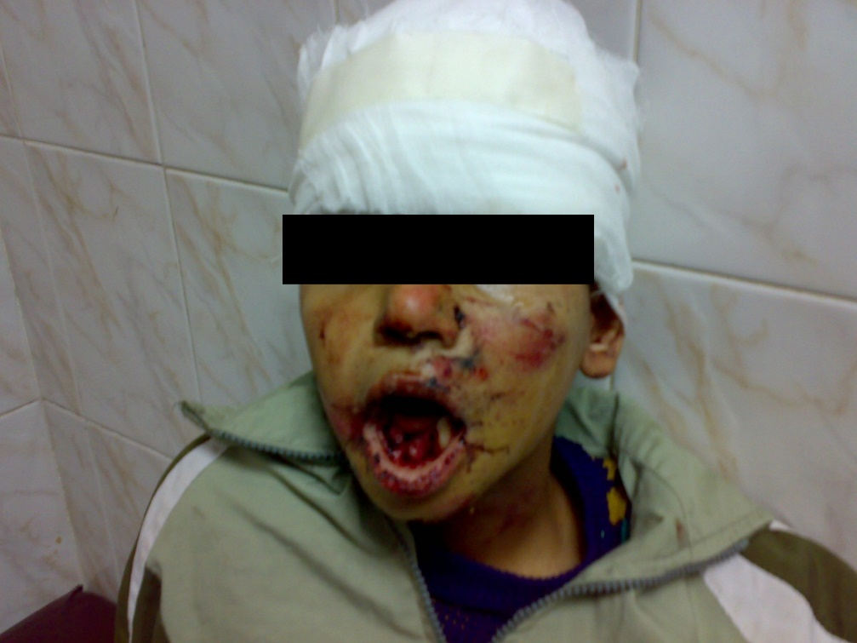

Figure 1. Multiple abrasions and contusions affect the both central and lateral facial regions.

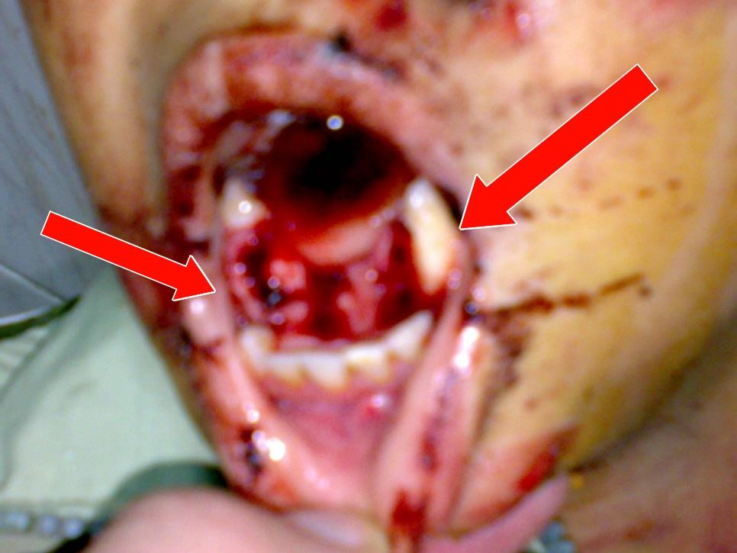

Figure 2. A mal-occluded tender mobile mandible with a bilateral parasymphysial, closed, unstable, type A mandibular fracture.

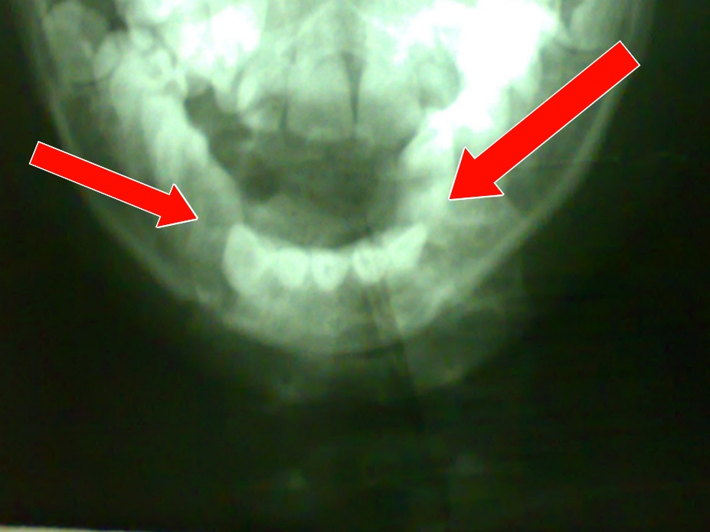

Figure 3. Towne’s view x-ray of the mandibular fracture.

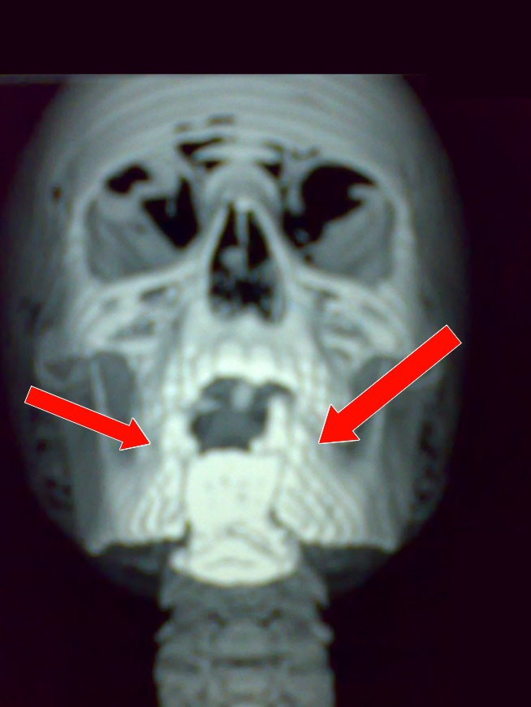

Figure 4. Multidetector computerized tomography of mandibular fracture (Anterior view).

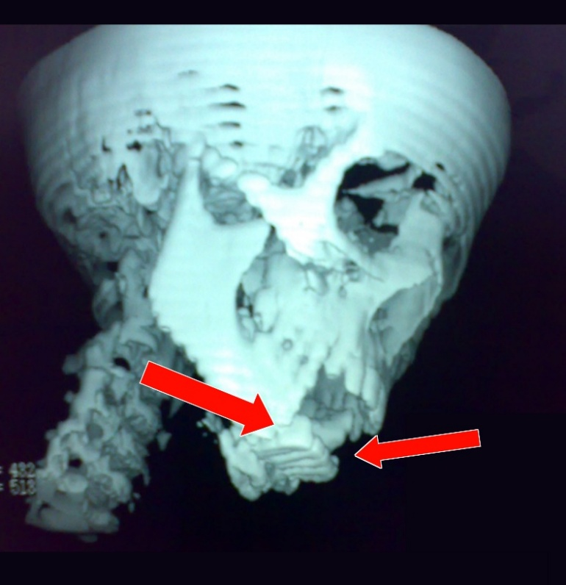

Figure 5. Multidetector computerized tomography of mandibular fracture (Lateral view).

**Operative Management.**

The patient received preoperative prophylactic antibiotics 600 mg IV amoxicillin-clavulanate and 100 mg IV metronidazole. Under general anesthesia using nasotracheal intubation the patient was laid supine with extended head position and the fractures was exposed using jaw retractor [Figure 6].

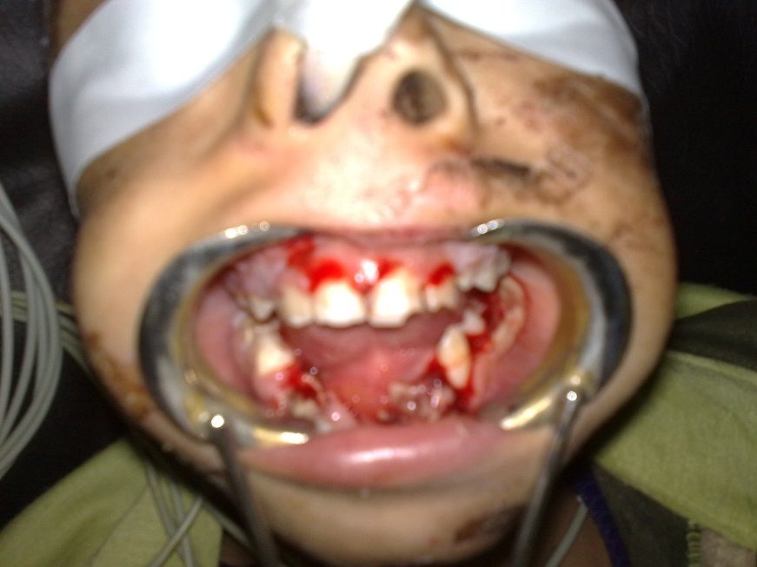

Figure 6. Mandibular fracture exposure using jaw retractor.

By digital manipulation, the displaced parasymphysial fractures were anatomically reduced restoring proper occlusion and symmetry of the mandible. Stainless steel arch bars were placed on the maxillary and mandibular dental arches and fixed using trans-dental wires of 5mm thickness; Intermaxillary Fixation (IMF). Following the removal of the oropharyngeal pack, the patient was placed on elastics stretched between the hooks of both arche bars [Figure 7].

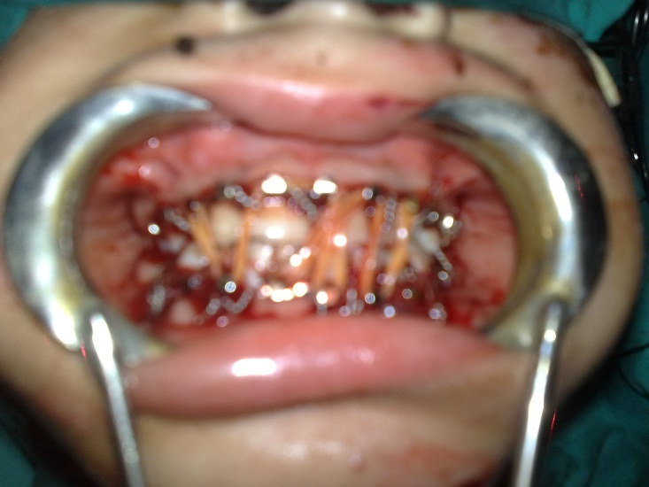

Figure 7. IMF with elastics put in place.

The patient was extubated smoothly in the operating room and transferred to the recovery area for monitoring. The patient started oral fluids 4 hours postoperatively. The postoperative pain was successfully managed using IV perfalgan solution. IV antibiotics (amoxicillin-clavulanate and metronidazole) were continued for 48 hours postoperatively. Post-operative panorama revealed normal occlusions with no complications. The patient was discharged at the 5th postoperative day.

**Discussion**

The elastics were removed after 2 weeks in the outpatient clinic. The patient started eating semisolids. Two weeks later, the dental arches were removed with normal mandibular occlusion [figure 8] and the patient restored his pre-injury life style normally after complete restorion of functional and cosmetic aspects [Figure 9].

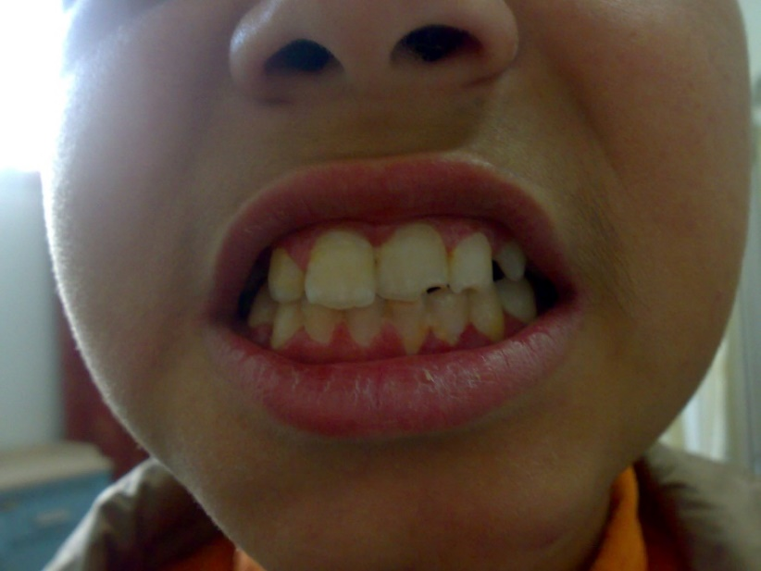

Figure 8. Normal mandibular occlusion after removal of the dental arches.

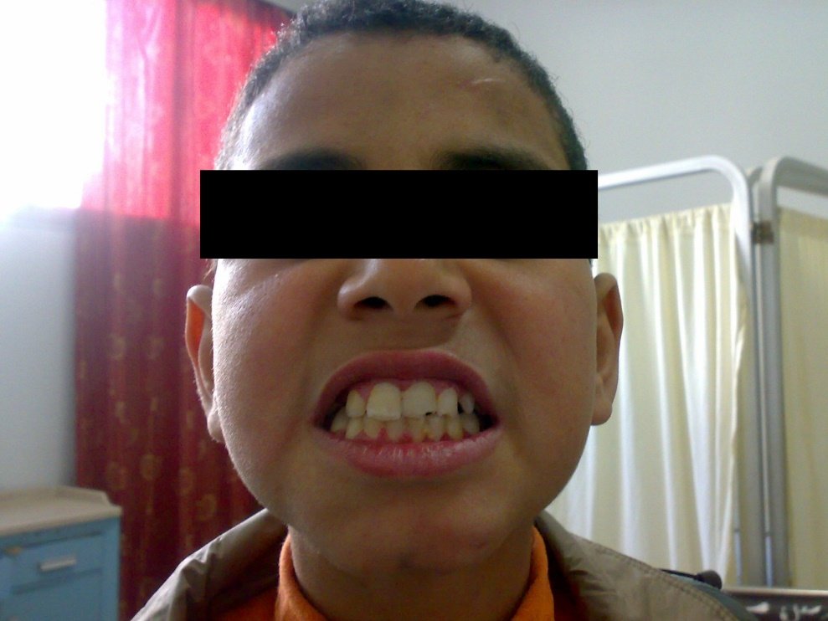

Figure 9. Complete healing of the bone and soft tissue injuries after 1 month of mangment.

Closed reduction with intermaxillary fixation is a preferred approach in young patients to minimize invasiveness while ensuring proper alignment and healing beside being cost-effective in case of the unavailability of other expensive alternatives for fixation e.g., biodegradable plates.

#### Conclusion

#### Closed reduction with intermaxillary fixation (IMF) remains a reliable and less aggressive technique for treating pediatric mandibular fractures, particularly in poor-resource settings. The technique achieves the best anatomical reduction, allows good bone healing, and restores functional and aesthetic outcomes with minimal complications. The success in treating the 12-year-old patient in this case shows the importance of early diagnosis, adequate surgical technique, and postoperative care in achieving maximum recovery. Because of its low cost and simplicity of use, IMF is a first-line treatment of mandibular fractures in children in whom complex fixation methods are not feasible.

#### Consent

#### Patient’s informed written consent was taken to publish his case for academic purpose.

#### Ethical approval

#### As per international standards or university standards written ethical approval has been collected and preserved by the authors.

#### Disclaimer (Artificial intelligence)

#### Authors hereby declare that NO generative AI technologies such as Large Language Models (ChatGPT, COPILOT, etc.) and text-to-image generators have been used during the writing or editing of this manuscript.

**References**

1. Syafiq A, Aj A, Bh H, Raihan N, Ismail N, Ar Z, et al. A 5 years retrospective study on post-mortem cases involving motor vehicle accidents in Hospital Pulau Pinang*. Malaysian J Forensic Sci*. 2017;21-24. E-ISSN 2590-3713
2. O'Donovan S, van den Heuvel C, Baldock M, Byard RW. Causes of fatalities in motor vehicle occupants: an overview. *Forensic Sci Med Pathol.* 2022;18(4):511-515. doi:10.1007/s12024-022-00503-3
3. Bullman TA, Kang HK, Smolenski DJ, Skopp NA, Gahm GA, Reger MA. Risk of motor vehicle accident death among 1.3 million veterans of the Iraq and Afghanistan wars. *Traffic Inj Prev.* 2017;18(4):369-374. doi:10.1080/15389588.2016.1206201
4. AlAbdulaali A, Asif A, Khatoon S, Alshamari M. Designing multimodal interactive dashboard of disaster management systems. *Sensors (Basel).* 2022;22(11):4292. doi:10.3390/s22114292
5. Syed N, Rifqah N, Muhd FR. Are facial soft tissue injury patterns associated with facial bone fractures following motorcycle-related accidents? *J Oral Maxillofac Surg*. 2022;80(11):1784-1794. doi: 10.1016/j.joms.2022.07.144
6. Salem S, Mekhaeel MSF, Protasov A, Nada T, Mohamed A, Noureldin S. Outcomes of a pediatric facial fracture reconstruction: Case report. *Archiv Euromedica.* 2024;14(6):1-8. doi:10.35630/2024/14/6.604
7. Sameh S, Mekhaeel Sh, Protasov V, Taha N, and Elshliby A. “Management of Pediatric Fracture Mandible by Closed Reduction Technique: A Case Report”. *Asian Journal of Case Reports in Surgery*. 2025;8(1):119-26. doi.org/10.9734/ajcrs/2025/v8i160
8. Kumi L, Jeong J, Jeong J, Son J, Mun H. Network-based safety risk analysis and interactive dashboard for root cause identification in construction accident management. *Reliab Eng Syst Saf.* 2025; 256:110814. doi: 10.1016/j.ress.2025.110814
9. Datarkar A, Tayal S. Management of Soft Tissue Injuries in the Maxillofacial Region. In: Bonanthaya, K., Panneerselvam, E., Manuel, S., Kumar, V.V., Rai, A. (eds) Oral and Maxillofacial Surgery for the Clinician. Springer. 2021;(49):997–1012. doi:10.1007/978-981-15-1346-6_49
10. Bodien Y, Barra A, Temkin N, Barber J, Foreman B, Vassar M, et al. Diagnosing level of consciousness: The limits of the Glasgow Coma Scale total score. *J Neurotrauma.* 2021;38(23):3295-3305. doi:10.1089/neu.2021.019