Elimination of Cadmium from wastewater using modified and unmodified tea waste in Kisii County, Kenya

.
ABSTRACT

The problem of poor water quality in Kenya is increasing as a result of pollution of water systems due to discharge of effluents from industrial and agricultural activities, mining action and land dumping of urban waste. Most rural populations in Kisii County generally depend on traditional methods such as filtration to treat the water. In order to eliminate Cadmium (II) ions from waste water, the study evaluated the adsorption approach using tea waste as an environmentally friendly and locally accessible adsorbent using both modified and unmodified biomass tea waste. Sulfuric acid treatment of biomass tea waste improved its efficacy in this study. Initial metal ion concentration, contact time, pH, and sorbent mass were among the parameters that were examined. The experiment's findings showed that 0.7 grams of sorbent mass and 70 mg/l of initial metal ion concentration were ideal values. 95 minutes of contact time and a pH of 6. The metal ion concentration was ascertained using AAS. FT-IR analysis of the biomass tea waste showed the presence of O-H at a maximum of 3395 cm-1, COO- at a maximum of 2448 cm-1, C=O at a maximum of 1594 cm-1, and P-OOH at a maximum of 1216 cm-1. This study show that both modified and unmodified tea waste can be applied to eliminate Cadmium from waste water
Keywords: adsorption; concentration; functional groups; heavy metal.

1. INTRODUCTION
Water is a necessary component of life and has a major effect on environmental and public wellbeing in addition to being the basis for the majority of our economic endeavors. According to the United States Public Health Service (USPHS), contaminated water is defined as having any kind of external material, (natural and artificial) radioactive, or biological) that has the tendency to lower the water's quality to the point where it becomes dangerous. Since they have elevated concentration of poisoning.and threat to both humans and animals, heavy metals are the primary environmental contaminants (Amarasinghe and Williams, 2007). Numerous pathways allow contaminants to enter the systems, including mining operations, residential wastewater, and runoff from agriculture. This increases the amount of species that are metallic discharged into the ecosystem (Churong et al., 2013).

According to WHO recommendations, drinking water can have a cadmium concentration of up to 0.003 mg/L. Cadmium is regarded as a very hazardous metal with no recognized biological purpose, The most common method Cadmium exposure occurs in human is through consuming a product that contains cadmium. Another method that individuals can be exposed to cadmium is through cigarette smoking, burning garbage, and burning fossil fuels (new bigging et al., 2015). Excessive levels of cadmium within the human body might result in infertility, immune system damage, mental illnesses that cause abnormalities in the mind, and stomach pain (Mohod and Dhote, 2013)

The buildup of cadmium throughout the human body, particularly in the kidneys, can result in kidney dysfunction, high blood pressure, liver disease, severe lung damage, and damage to the brain and nerves are just a few of the detrimental health impacts that can result from excessive cadmium exposure, Alopecia anaemia, emphysema, learning disabilities, headaches, development retardation, and arthritis are some of the symptoms (Sathish et al., 2014).

It has been determined that cadmium (Cd) is an extremely hazardous heavy metal (Ferreira et al., 2012). Cadmium has lately surpassed lead and mercury as the most hazardous heavy metal that causes harm to the health of people and the surroundings because of its acute toxicity (kumar et al., 2014). Diarrhea, pulmonary edema, weakness, nausea, vomiting, and headaches are all signs of acute poisoning. Dust from mulberry wood treated with HCI acid has been used to study the biosorption of cadmium on aqueous solution (Shah et al., 2011). Exposure to heavy metals over recommended levels in humans can cause kidney damage, reported in Kenya (Nyaboke et al., 2017).

Heavy metal ions may be removed from solutions in water using several methods related to chemical, biological, and physical processes (Kumar et al., 2014). Chemical oxidation, disinfection, ion exchange, sedimentation, adsorption, electrolysis, filtration, solvent extraction, coagulation, foam flotation, and chemical precipitation are a few of these processes (Hossain et al., 2012). High initial cost linked to other technologies as reverse osmosis, ultra filtration, and nano-filtration (Miretzky et al., 2006).The high cost of this conventional physicochemical methods has prompted increasing interest in conducting research on employing low-cost alternative mechanism and one of the methods is adsorption by using alternative low cost adsorbents has been found to be economically viable, This method is convenient, easy operation, simple in design, ecofriendly in nature and has excellent performance (Ahmad and Kumari 2010).

Many inexpensive adsorbents have been selected based on their ability to obtain heavy metals from water For this reason, adsorption has been used as a less expensive technique of treating water (Amit and Monocha, 2006). However, no concrete research on the use of biomass tea waste treated with sulphuric acid as low cost absorbent in heavy metal removal from wastewater has been conducted in major Counties such as Kisii which is experiencing rapid growth of industries especially in the agricultural sector. Therefore, there was need to look for alternatives adsorbent which are reliable and ecofriendly and hence the need to use tea waste in our study as a possible strategy.

2.0 MATERIALS AND METHODS
2.1 Reagents and Chemicals

All of the reagents and chemicals utilized had analytical quality. (Purity > 98.9%) . Every solution was made using double-distilled water. 0.1 Sodium Acetate was used to create metal solutions in order to keep the ionic strength consistent. Soluble metal salt of Cd²⁺ and as well as KNO3, NaOH, HCl, H₂SO₄, sodium acetate, sodium bicarbonate and potassium bromide were among the chemicals used and were commercially purchased from PYREX East Africa limited with its branch located in Nairobi Kenya.

2.2 Standard solution and stock solution preparation

Cd²⁺ stock solutions with concentrations of 1000 ppm was made from the corresponding salts. Distilled water in a 1000 ml volumetric flask was utilised to dissolve 1.8759g of Cd (NO₃)2.5H₂O, to create the stock solution. Using commercial buffer tablets (pH 4 and 7) and a pH meter (model Hanna GLP 110), the model solution was made with the necessary metal ions under investigation and adjusted to 5.0. Acetic acid and sodium acetate were used to make the acetate buffer, and distilled water was added to the solutions until they reached the 1000 cm⁻³ level. To create each working solution, Distilled water was used to dilute the stock solutions to the appropriate concentration.

2.3 Preparation of the adsorbent
After being locally gathered from the Nyamache tea factory in Kisii County, the tea trash was taken to the Jomo Kenyatta University of Agricultural and Technology labs, where it was extensively cleaned using deionized water and then allowed to dry to remove moisture in an oven preheated to 105°C, then sieved and ground into a fine powder and separated into two parts. One section was handled with 1M sulfuric acid in a 1:2 weight-to-volume ratio, the mixture was heated to 150° C for 24 hours to get rid of the residue. After cooling distilled water was used to rinse each product to get rid of extra acid, and then left in NaHCO₃ (1%) for the entire night (Moyo and Chikazaza, 2013). The modified tea waste was then dried to a consistent weight at 105° C. The resultant powders, which were stored in desiccators ready for use, were marked as MTW (modified tea waste) and UTW (unmodified tea waste).

2.4 Surface Characterization
FTIR spectra using the SHIMADZU FTIR 8400S (Kyoto, Japan) was used to characterize the functional groups found in tea trash. I mg of dried tea waste material, both treated and untreated, was combined with 50 mg of KBr (1:50) to create the FTIR analysis samples. After that, the mixture was vacuum-pressed after being finely powdered into a pellet. An FTIR spectrophotometer was then used to analyze the pellet. The measurement range for the adsorbents' spectra was 600–4000 cm-1. Prior to and following acid treatment, spectra were plotted on the absorbance axis using the same scale.

2.5 Sem Analysis
The texture and surface morphology of the both MTW and UTW was determined using the Scanning Electron Microscope.

2.6 Instrumentation
An air-acetylene flame Shimadzu AAS Model AA 7000, a spectrophotometer for flame atomic absorption was used to test Cd²⁺. To determine how the pH impacted the adsorption of metal ions, a pH meter (pH 211, Hanna instruments) was utilized to record the pH. The organic functional groups in tea debris that were in charge of the adsorption of heavy metal ions were detected using a Fourier transform infrared spectrophotometer (Shimadzu, Japan, Model FTS-8000). The metal adsorption was measured using an atomic absorption spectrophotometer. A mechanical shaker and Scanning Electron Microscope were also employed.

2.7 Adsorption studies
To assess the effectiveness of utilizing modified tea waste and unmodified tea waste to remove cadmium from aqueous solutions, batch tests were conducted. For these materials, the primary factors influencing bio-sorption, including adsorbent dose, initial metal concentration, pH and contact time were assessed. The stock solution was a cadmium metal standard at 1000 mg/l. To create each working solution, the stock solutions were diluted with distilled water to the appropriate concentration.
The sorption results were used to calculate the metal uptake from modified and unmodified tea trash. $Q_{e}=\frac{\left(c_{i}-c_{o}\right)V}{M}$………………………………………………………………….2.1
where Ci and Ce are the initials and equilibrium metal concentrations, and qe is the metal absorption (mg metal adsorbed per g adsorbent). M is the mass of the dried adsorbent utilized, and V is the reaction mixture's volume (Moyo and Chikazaza 2013).
Pb (II), Cd (II), and Cu (II) removal percentages (R%) in solution were calculated.

$R\% =\frac{Co-Ce}{Co}×100$……………………………………………………………2.2

Where C_{o} and C_{e} are the initial and equilibrium metal concentrations.
The significance of the data was ascertained using statistical analysis employing ANOVA.

3. Results and discussion
The adsorbents' surface appearance and texture were assessed using SEM, and the functional groups in charge of adsorption were examined using FTIR. The effects of the initial metal ion concentration, pH of the solution, contact time, and adsorbent dosage were examined. The findings were presented as the removal effectiveness (% Removal) of the adsorbent.

3.1 Surface characterization of biomass tea waste
Figure 1 illustrates the surface appearance and texture of the tea waste adsorbent as shown in the SEM images. Figure 1 illustrates the tea waste's sluggish rough and restrictive surface before _{H2SO4} treatment. However, as can be observed in fig. 1(b), the biomass tea waste developed distinct pores following treatment with sulfuric acid. The partial breakdown of hemicellulose, cellulose, and lignin brought on by sulfuric acid treatment may be the cause of the morphological changes in the biomass's structure. The adsorption capabilities of the acid-modified tea trash improved as a result of these morphological alterations. (Nthiga et al., 2016). showed similar outcomes with acid-treated orange peel and avocado seed.

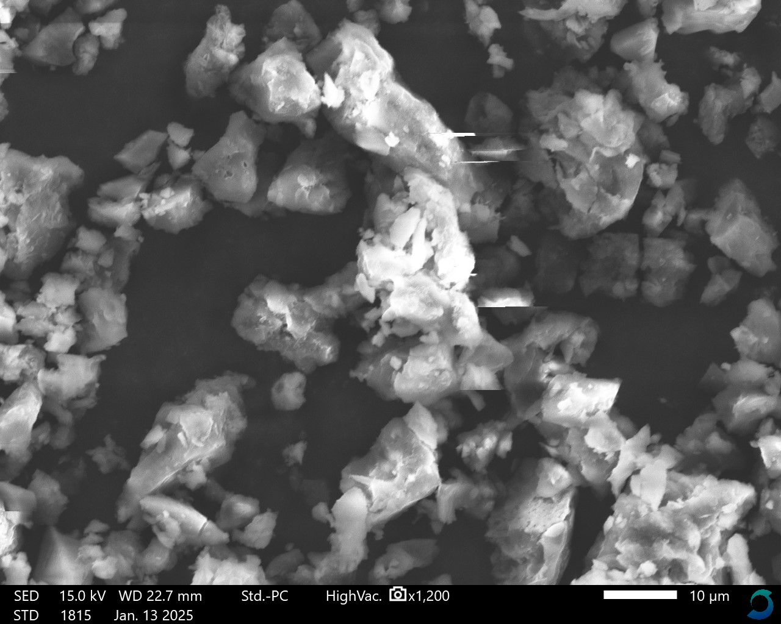
(a)
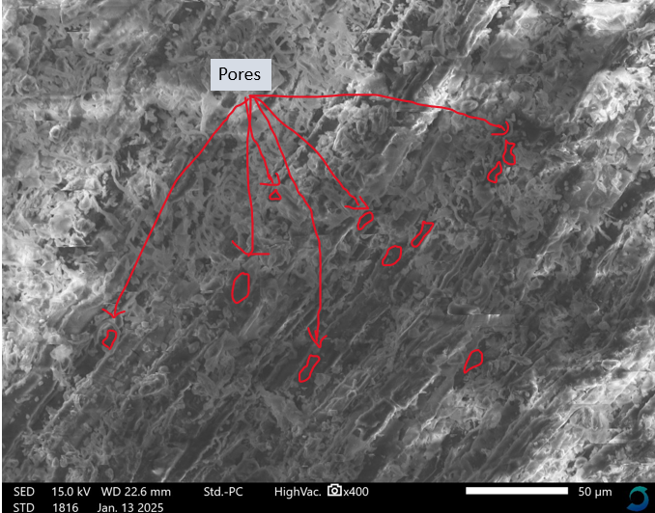
(b)
Fig 1: SEM images for (a) UTW (b) MTW
The existence of the isolated silanols was the cause of the weak absorption bands at Vmax 3885cm-1 for both MTW and UTW (Huang Ma Zhao and (2015). It was determined that the significant absorption bands at Vmax 3392cm-1 of UTW and 3392cm-1 of MTW, respectively, were caused by the hydroxyl groups' stretching vibration when OH was present. For both MTW and UTW, It was discovered that the existence of C=O stretching vibrations was the origin of the absorption band at Vmax 1645 cm-1. (Sych et al., 2012).
The amine group stretching vibrations were suggested by the peak at Vmax1552cm-1 for both MTW and UMT. Both MTW, and the peaks seen at 1413 cm-l ascribed to the –COO-l groups (Nikhil and Bhalerao). For both modified and unmodified tea waste, the band at Vmax1255 cm-1 was connected to the hydrogen-bonded P-O and O-C stretching mode, which are seen in P-O-C and P-OOH. The chemical change may be the cause of the new peak's emergence at 1106 cm-1 (Godlewska et al.,2018. The peaks' shifting indicates how the metal ions and the hydroxyl group on the on the biomass's surface interact chemically (Nthiga et a l.,2016). The ionized linkage P-O- which was present in esters and phosphate was linked to the band at Vmax 1106 cm-l for acid-treated tea waste. It was also attributed to symmetric vibration in P-O-P. While the peak at Vmax 753cm-l was linked to in-plane ring deformation

Figure2: FTIR spectra of unmodified and modified tea waste adsorbent
3.2 Optimization experiments

3.2.1 Effect of pH
The pH still plays a big role in the removal of metal ions because it affects the chemistry of the solution and the surface properties of the adsorbent. Figure 3 shows how pH affects the percentage of cadmium ions removed. By raising the pH of the solution from 2 to 6, the adsorption of cadmium on the MTW and UMTW is considerably impacted. The percentage of metal ion removal rose between pH 2 and pH 6, after which it started to fall. The result show that UTW had a maximum sorption of pH 5.9 while MTW had a maximum adsorption of pH 6.0. maximum adsorption at pH 4.5 was reported (Signh et al., 2012). in raw and acid-treated maize tassel, pH 4.2 and pH 6.1 have been reported (Mwangi et al., 2012).

The percentage removal of Cd (ll) ions increased to a maximum of pH 5.9 and 6.0. Further pH increases resulted in a decrease in adsorption in both MTW and UTW. At a low pH, the protonation of the functional groups is intimately related to the adsorbent's surface. The formation of cadmium hydroxide starts when the pH rises over 6.0. This prevents the ions of the metal from circulating and renders them unavailable for the purpose of adsorption, precipitation affects the adsorption process. These results are also in line with earlier adsorption research that found a pH range of 4 to 5 pH for Cd (ll) ions removal by a variety of adsorbents (Samadi et al., 2014).

Fig 3: Effect of pH on adsorption of Cd²⁺ on UTW and MTW

3.2.2 Effect of contact time
At first, the adsorption of Cd²⁺ increased quickly up to equilibrium time for both MTW and UMT; after the elimination percentage was almost steady this time signifying the achievement of equilibrium conditions, as seen in figure 4. Figure 4 demonstrates that for both MTW and UTW, the maximum adsorption of 75.2% was reached in the first 85 minutes and 96% in the 95 minutes. The agitation time measured in this study i compared to that which Benard and Jimoh (2013) reported using orange peel, but it is comparable to that which was disclosed by (Banarjee et al., 2012) on the investigation of lead adsorption by the peel of a watermelon. this is explained by variations in the adsorbent's nature and experimental conditions and procedures.

Fig 4: Effect of contact time on adsorption of Cd²⁺ on UTW and MTW

3.2.3 Effect of adsorbent dosage
The effect of adsorbent dosage on removal of Cd²⁺ ions was conducted and the outcome recorded in figure 5. The findings in Figure 5 demonstrate that the dosage of the adsorbent affected the absorption of cadmium (II) ions. When the mass of the adsorbent rises, the uptake of cadmium (II) ions increases as well, reaching a maximum of 84.3% and 93.5% for UTW and MTW, respectively. The improved surface texture and micropore structure following acid modification were responsible for the observed increase in percentage removal as shown in the figure 5 increasing the ions' ability to enter the adsorption sites (Anwar et al., 2010).

Fig 5: Effect of mass of the biomass on adsorption of Cd²⁺ onto UTW and MTW
3.2.4 Effect of initial metal ion concentration
Figure 6 illustrates the considerable impact of the initial concentration of metal ions in aqueous solution on the adsorption of ions on UTW and MTW.The findings indicate that the absorption of Cd ions was lower in UMW than in MTW. This demonstrates that the acid treatment improved the metal ion sorption up to a maximum of 98.2 % for MTW and 97% for UTW. The profile of Cd²⁺ sorption was shown to rise as the initial metal concentration increased. This work yielded higher result than a study on the adsorption of copper (II) ions using raw banana peel, which found 88% at 10 mg/L, 5 g (Hossain et al., 2012).

Figure 6: Initial Cd²⁺ ions concentration on adsorption by UTW and MTW

Conclusion
In this study, sulfuric acid was used to chemically modify biomass from unmodified tea waste (UTW). An an increase in the shifted functional groups' number (MTW) for Cd²⁺ ion adsorption was revealed by the FTIR spectra's more strong peaks. The biomass tea waste developed distinct pores following treatment with sulfuric acid. The partial breakdown of hemicellulose, cellulose, and lignin brought on by sulfuric acid treatment may be the cause of the morphological changes in the biomass's structure. Adsorbent dosage, contact time, pH, and initial metal ion concentration all had a significant impact on the adsorption process. For the UTW and MTW removal of Cd²⁺ from wastewater, MTW displayed highest percentage removal for all the parameters under investigation.

References
Amarasinghe, B. M. W. P. K and Williams, R.A. (2007). Tea Waste as a Low Cost Adsorbent for the Removal of Copper and Lead from Wastewater. Chem. Eng. J. 132: 299-309.

Churong, W., Xin, R., Wenxiu, L., Zhifei, H., Chao, K. and Qi, G. (2013) Adsorption of Zinc and Copper Heavy Metal Ions from Smelting Waste Water using Modified Lava Particles. Journal of Environmental Studies, 22 (6); 1863-1869.

Newbigging am, yan x, c le x. cadmium in soybeans and the relevance to human exposure. j. environ. sci. (china). 2015; 37:157–162.

Mohod cv, dhote j. review of heavy metals in drinking water and their effect on human health. int. j. innov. res. sci. eng. technol. 2013;2(7):2992–2996.

Sathish, T., Vinith Kumar, N.V, Dharani, G. and Kirubagaran, R. (2014).Efficacy of mangrove leaf powder for bio remediation of chromium (VI) from aqueous solutions.Applied water science 10:14-174.
Ferreira, R; Sousa, F. W. De, Oliveira, V; Neto, S; Basilio, P; and Fechine, A. (2012). Biomass adsorbent for Removal of Toxic Metal Ions From Electroplating Industry Wastewater. Posted in http://www.interchopen.com. Accessed on 5110/2014

Kumar, R., Mudhoo, A., Lofrano, G. and Chandra, M. (2014). Adsorbent modification and activation methods and adsorbent regeneration: biomass derived biosorbents for metal ion sequestration. Journal of environmental chemical engineering, 2:239-259.

Shah, J; Jan, M.R. A. and Haq, M. Sadia. (2011). Biosorption of cadmium from aqueous solution using mulberry wood sawdust: equilibrium and kinetic studies. Journal of Science .and Technology, 46: 1631-1637

Nyaboke, O.P., Murungi, J.I. and Wafula, A.W. (2017). Concentration of Selected Nutrients and Heavy Metals in river Nyamasogota, Kisii County-Kenya.Journal of the Kenya chemical society, 10(1 ):35-39.

Kumar, R., Mudhoo, A., Lofrano, G. and Chandra, M. (2014). Adsorbent modification and activation methods and adsorbent regeneration: biomass derived biosorbents for metal ion sequestration. Journal of environmental chemical engineering, 2:239-259.

Hossain, M. A; Ngo, H. H; Guo, W. S.and Nguyen, T. V. (2012). Biosorption of Cu ( II ) from water by banana peels based biosorbent. experiments and models of adsorption and desorption. Journal of Water Sustainability, 2(1): 87-104

Miretzky, p; saralegui, a; and cirelli, a. f. (2006). simultaneous heavy metal removal mechanism by dead macrophytes. journal of chemosphere, 62: 247-254.

Ahmad, R. and Kumari, R (2010). Adsorption Studies of Hazardous Malachite Green onto Ginger Waste.Journal of environmental management, 91: 1032 - 1038.

Amit, B. and Monocha, A.K. (2006). Conventional and non-conventional adsorbents for removal of pollutants from water-A-review.Journal of Indian Chemical Technology, 13:203-217.

Moyo, M; and Chikazaza, L. Dekhil, A. B; Hannachi, Y; Ghorbel, A. and Boubaker, T.; (2013). Bioremediation of Lead (II) from Polluted Wastewaters Employing Sulphuric Acid Treated Maize Tassel Biomass. Journal of Chemistry and Ecology,S: 689-695

Nthiga E. W; Jane M; Ahmed H. and Ruth W. Efficacy of Adsorption of Cu (II), Pb (II) and Cd (II) Ions onto Acid Activated Watermelon Peels Biomass from Water. International Journal of Science and Research (IJSR), Vol 5, issue 8, pp. 671- 679, 2016

Huang, Yuxiang, Erni Ma & Guangjie Zhao. (2015). Thermal and Structure Analysis on Reaction Mechanisms during the Preparation of Activated Carbon Fibers by KOH Activation from Liquefied Wood-Based Fibers. Industrial Crops and Products 69: 447–55.
‘
Sych, N. V., Trofymenko, S. I., Poddubnaya, O. I., Tsyba, M. M., Sapsay, V. I., Klymchuk, D. O., & Puziy, A. M. (2012). Porous structure and surface chemistry of phosphoric acid activated carbon from corncob. Applied Surface Science, 261(5), 75–82.

Singh, J. and Ali, A. (2012). Kinetics, Thermodynamics and Breakthrough Studies of Biosorption of Cr (VI) using Arachis hypogea Shell Powder. Resource Journal of Chemical Environment, 16: 69-79.

Nikhil C. T and Bhalerao S.A. Biosorption of Chromium (VI) from aqueous solution using unmodified and nitrilotriacetic acid modified leaves of Ficus benghalensis L. International Journal of Recent Scientific Research, Vol 10, issue 02, pp 31045-31053, 2019. [18]

Godlewska, K., K. Marycz, and I. Michalak. Freshwater green macroalgae as a biosorbent of Cr(III) ions. Journal of Open Chemistry, Vol 16, issue 1, pp. 689-701, 2018.

Mwangi, I.W; Ngila, C. J. and Okonkwo, J.O. (2012). A comparative study of treated and raw maize tassels for removal of selected trace metals in contaminated water. Journal of Toxicological and Environmental Chemistry, 94: 20-39.

Samadi, N., R. Hasanzadeh, and M. Rasad. Adsorption isotherms, kinetic, and desorption studies on removal of toxic metal ions from aqueous solutions by polymeric adsorbent. Journal of Applied Polymer Science. pp 1 - 13, 2014.

Banerjee, K; Ramesh, S. T; Gandhimathi, R; Nidheesh, P. V, and Bharathi, K. S. (2012). A Novel Agricultural Waste Adsorbent, Watermelon Shell for the Removal of Copper from Aqueous Solutions. Iranica Journal of Energy and Environment, 3(2): 143-156.

Anwar, J; Shafique, U; Washeduz, Z; Salman, M. and Anwar, S. (2010). Removal ofPb (II) and Cd (II) from water by adsorption on peels of banana. Journal of Bioresource Technology, 101(6): 1752-1755.

APPENDICES

Appendix 1: Variation (ANOVA) for the effects of pH for Cd (II) ions removal
Source of variation | SS | DF | MS | F | P-Value | F- Critical
Between Groups | 178.846 | 1 | 163.837 | 85.48 | 1.8E-10
Within Groups | 63.395 | 36 | 19.167 |  |  | 4.11
Total | 242.2412 | 37

Appendix 2: Variation (ANOVA) for the effect of sorbent mass for Cd (ll) ions removal

Source of variation | SS | DF | MS | F | P-Value | F- Critical
Between Groups | 1.8986 | 1 | 1.8986 | 54.87 | 1.3-08
Within Groups | 0.9345 | 35 | 0.0346 |  |  | 4.12
Total | 2.8331 | 36

Appendix 3: Variation (ANOVA) for the effect of contact time on Cd (ll) ions removal

Between Groups | 28076 | 1 | 28076 | 65.7 | 1.7-10
Within Groups | 9768.345 | 41 | 427.3416 |  |  | 4.07
Total | 37844.345 | 42

Appendix 4: Variation (ANOVA) for the effect of initial metal ion concentration on Cd (ll) ions removal

Source of variation | SS | DF | MS | F | P-Value | F- Critical
Between Groups | 1472.34 | 1 | 1472.348 | 80.256 | 2.4-10
Within Groups | 698.578 | 32 | 18.3456 |  |  | 4.15
Total | 2170.926 | 33

