**Optimizing Tomato Growth with Plastic Bottle Drip Irrigation in a Natural Farming Framework**

**Abstract**

The current study involves developing a simple drip irrigation system using plastic bottles for the cultivation of tomatoes under a natural farming system. A simple and user-friendly installation process was developed using one-liter waste plastic bottles and medical syringes. Bio-composting of kitchen waste was done to provide nutrients for tomato plants. neem tea was prepared from neem leaves and applied to enhance crop immunity. The highly efficient and precise irrigation system was implemented with the use of 15 litres of water per plant using 525 liters of water for a plot of 35 plants. Positive and good growth in tomato plants under drip irrigation was observed for different agro-morphological observations including plant height, number of branches per plant, number of clusters per plant, and number of fruits per plant. The treated tomato plot yielded 5 kg more fruits in comparison to the flooded plot. With an input cost of ₹710, the output was calculated at 60 kg of tomatoes, priced at ₹30 per kg, resulting in a total of ₹1800. The present research experiment provided a cost-effective and profitable plastic bottle drip irrigation system.

**Introduction**

Tomato (*Solanum lycopersicum*) is one of the most important vegetable crops globally, originating from western South America and domesticated in Central America (**Knapp et al., 2016)**. Beyond its value as a food source, it is extensively utilized in scientific research. Water scarcity is a critical global challenge, particularly affecting arid and semi-arid regions. Climate change, driven by rising global temperatures, exacerbates this issue, leading to significant reductions in crop productivity and water availability (**Kang et al., 2009)**. Among various irrigation methods, micro-irrigation, particularly drip irrigation, is recognized as the most efficient technique, as it delivers water directly to the root zone, maximizing water use efficiency. Despite its advantages, the high cost of drip irrigation systems limits its adoption, particularly among rural farmers.

The natural farming system, rooted in Indian agricultural traditions, emphasizes practices such as no-tillage, no fertilizers, no pesticides, no herbicides, and no weeding, embodying a holistic and sustainable approach to farming. To promote sustainable agriculture, the development and adoption of affordable, environmentally friendly irrigation systems are critical, particularly for small-scale farmers in India. Conventional irrigation methods often require costly equipment and excessive water use, posing challenges for resource-limited farmers (**Riaz et al., 2020)**. In the context of global climate change, eco-friendly irrigation systems like drip irrigation provide a viable solution. These systems align with the principles of natural farming, emphasizing low external inputs, biodiversity conservation, and resource efficiency. Plastic bottles account for approximately 15% of global plastic waste and are a significant contributor to environmental pollution (**Ncube et al., 2021)**. However, these bottles can be repurposed through recycling for agricultural applications such as micro-irrigation systems, seedling containers, self-watering planters, and mulching materials. Such innovative uses of plastic bottles offer cost-effective agricultural solutions, particularly beneficial for small-scale and urban farming practices.

Building on this concept, the present study was designed to develop and evaluate a plastic bottle-based drip irrigation system for tomato cultivation within a natural farming framework. The system was analyzed for its water use efficiency, plant growth, and yield performance in tomato cultivation under natural farming conditions and compared to traditional flood irrigation methods.

**3. Materials and Methods:**

* **Experimental site**

The present experiment was conducted under the ICAR-READY program, specifically as part of the Experiential Learning Programme (ELP), at the Horticulture Crop Cafeteria, Faculty of Agriculture, Medi-Caps University, Indore, during the 2023–2024 academic year.

* **Experimental Material**

The experiment utilized tomato VHT 002 F1 hybrid seeds, sown in a plot measuring 3.0 m × 4.2 m with a spacing of 60 cm × 60 cm between rows and plants. Each plot contained a total of 35 plants.

* **Design of Plastic Bottle Drip Irrigation System**

The irrigation system utilized 1-liter waste plastic bottles and medical syringes. Each plastic bottle was cut open at the bottom, and a syringe fitted with strips was attached to it. Four such bottles were mounted on a single wooden pole, with each bottle delivering water to a single plant (**Figure 1**). The installation process was simple and user-friendly.

* **Nutrition Requirement**

Kitchen waste was utilized as a nutrient source through bio-composting, fulfilling the primary nutrient requirements of nitrogen (N), phosphorus (P), and potassium (K). On average, compost provides approximately 2% nitrogen, 0.5–1% phosphorus, and 2% potassium (**Figure 1**). Additionally, neem tea was prepared from neem leaves and applied to enhance crop immunity.

For compost preparation, 1 kg of kitchen waste was decomposed in 2 liters of water and left to degrade for one week. The resulting 2 liters of composted material were then diluted in a 1:3 ratio and delivered to the plants.

* **Data Collection**

Data was collected at 15-day intervals, recording various growth and yield parameters, including plant height, number of branches, number of clusters, and number of fruits per plant **(Figure 2).** Additionally, fruits were categorized based on size. An economic analysis of the system was performed after the experiment.

**Result**

* **Water usage and efficiency**

The irrigation system using plastic bottles provided one liter of water per bottle at intervals of four to five days. In the control plot, traditional flooded irrigation was applied weekly. This method allowed for highly efficient and precise water usage. A total of 15 liters of water was used per plant, amounting to only 525 liters for a plot of 35 plants. Water is a valuable resource, and its consumption can be costly. Therefore, reducing water usage also minimizes wastewater generation. Implementing efficient water management practices with this method leads to improved operational efficiency overall, resulting in increased productivity within a shorter time frame and at a lower cost.

* **Tomato Plant growth and yield**

Agro-morphological data were taken from all treated and control plants. Results of observation on plant height, number of branches per plant, number of clusters per plant, and number of fruits per plant have shown positive and good growth in tomato plants under drip irrigation through plastic bottles (**Figure 3**). Fruits were also classified according to size. The harvesting of the treated plots yielded 60 kg of tomato and flood-treated plants yielded 55 kg. There was a 5 kg difference.

* **Economic and Environmental Benefits**

Economically, the plastic bottle drip irrigation system proved to be both cost-effective and more profitable compared to the traditional flood irrigation plot. The seed cost for both plots was ₹60. The cost of establishing the plastic bottle drip irrigation system was ₹650, bringing the total input cost to ₹710. Since fertilizer was sourced from kitchen waste, there was no additional fertilizer cost. For plant protection, only neem tea and neem seed kernel extract were used, both of which were prepared by students during practical sessions. With an input cost of ₹710, the output was calculated at 60 kg of tomatoes, priced at ₹30 per kg, resulting in a total of ₹1800. No major challenges were encountered during the experiment.

**Discussion**

The development and application of the plastic bottle drip irrigation system in tomato cultivation under the natural farming system represent an innovative approach to addressing water scarcity and promoting sustainable agricultural practices, particularly for small-scale and urban farmers. This method aligns with the principles of natural farming, which emphasize low external inputs, resource conservation, and the enhancement of biodiversity while addressing the growing challenges posed by conventional irrigation systems**.** A substantial fruit yield can be achieved with significantly reduced water usage. This study demonstrated that the water requirement for tomatoes decreased by 70% compared to traditional flood irrigation methods. Similarly, an earlier study by Fekdu and Teshome (1997) reported a 20% improvement in water use efficiency for tomatoes under drip irrigation. Enhanced water use efficiency through drip irrigation has also been documented in other crops (Stein et al., 1996; Raina et al., 1998), with some studies reporting up to 80% water savings (Bogle and Hartz, 1986). Additionally, prior research has shown that reducing irrigation in tomato cultivation leads to improved water use efficiency (Faveti et al., 2009; Wang et al., 2019). When compared to commercially available drip irrigation systems, this system demonstrates a lower cost, making it more economical. However, from the perspective of labor and workload, the commercially available systems are more efficient and demand less manual effort for operation and maintenance. One of the primary benefits of the plastic bottle drip irrigation system is its efficient use of water. The plastic bottle drip irrigation system, by delivering water directly to the root zone, minimizes evaporation and runoff, ensuring that plants receive a consistent and controlled supply of water. This not only optimizes water use but also reduces the overall water consumption in agricultural practices, making it an eco-friendly and sustainable solution. The simplicity and cost-effectiveness of the system make it particularly advantageous for small-scale farmers in water-scarce areas, who may not have access to expensive irrigation infrastructure. The cost-effectiveness of the plastic bottle drip irrigation system is another significant advantage. As demonstrated in the experiment, the system requires minimal initial investment, with a setup cost of ₹650 for a plot, in contrast to the high costs associated with conventional irrigation systems. The system's affordability, combined with its reliance on low-cost materials such as waste plastic bottles and syringes, makes it an accessible solution for resource-limited farmers. Additionally, the use of kitchen waste for composting eliminates the need for commercial fertilizers, further reducing input costs. The application of the plastic bottle drip irrigation system in tomato cultivation under the natural farming system resulted in a satisfactory yield, with an output of 60 kg of tomatoes, generating a return of ₹1800. This yield was achieved without the use of synthetic fertilizers, relying instead on the nutrients provided by compost made from kitchen waste, which is rich in essential macronutrients like nitrogen, phosphorus, and potassium.

**Conclusion**

Recycled plastic bottles for drip irrigation are one of the best ways to save our environment and prevent water loss on the other hand. In flood irrigation water was not used efficiently. By using recycled plastic bottles raw material cost is reduced. Reusing used bottles also reduces energy consumption because no new plastic is produced from raw materials. This method of cultivation also prioritizes recycling and sustainable practices. Water is the most valuable resource, and its consumption is again an expensive process. Thus, less water usage again resulted in reduced wastewater generation. Efficient water management practices associated with this method can lead to improved operational efficiency. Hence, increased productivity can be obtained in less time and at less cost. The major conclusion of this research is that the development and application of the plastic bottle drip irrigation system for tomato cultivation under a natural farming system offers a viable, low-cost, and environmentally friendly alternative to conventional irrigation techniques. This system enhances water use efficiency, reduces input costs, and aligns with sustainable farming practices. Its simplicity, affordability, and potential for scaling up make it a valuable tool for small-scale and urban farmers, contributing to the broader goal of promoting sustainable agriculture in the face of climate change and water scarcity. Further research and refinement of the system could expand its applicability to other crops and farming contexts.

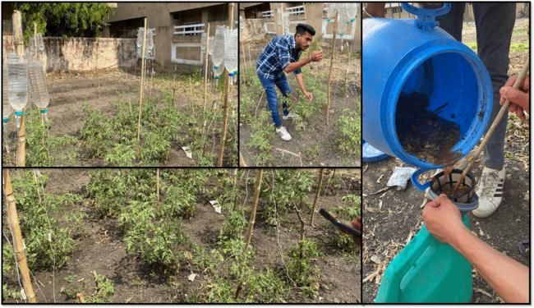

**Figure 1. Experimental design and implementation of a nutrient solution derived from kitchen waste bio-compost**

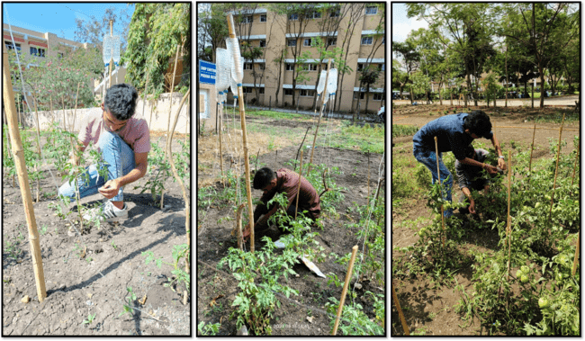

**Figure:** **Quantitative assessment of agro-morphological traits in drip-irrigated tomato plants**

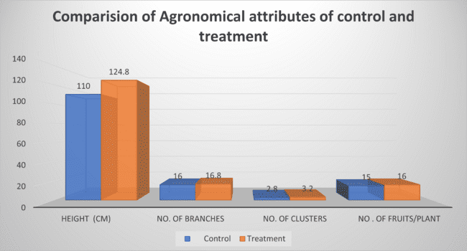

**Figure 3. Comparative analysis of quantitative agro-morphological attributes between treated and control tomato plants**

**Reference**

Knapp S and Peralta IE. 2016. The tomato (*Solanum lycopersicum* L., Solanaceae) and its botanical relatives. The tomato genome, pp.7-21.

Kang Y, Khan S. and Ma X. 2009. Climate change impacts on crop yield, crop water productivity and food security–A review. Progress in Natural Science, **19**(12), pp.1665-1674.

Riaz F, Riaz M, Arif MS, Yasmeen T, Ashraf MA, Adil M, Ali S, Mahmood R, Rizwan M, Hussain Q. and Zia A. 2020. Alternative and non-conventional soil and crop management strategies for increasing water use efficiency. Environment, climate, plant and vegetation growth, pp.323-338.

Ncube, Lindani Koketso, Albert Uchenna Ude, Enoch Nifise Ogunmuyiwa, Rozli Zulkifli, and Isaac Nongwe Beas. 2021 "An overview of plastic waste generation and management in food packaging industries." Recycling **6 (1): 12.**

Yohannes F. and Tadesse T. 1998. Effect of drip and furrow irrigation and plant spacing on yield of tomato at Dire Dawa, Ethiopia. Agricultural Water Management, **35(3),** pp.201-207.

Stein L, White K, Dainello F. 1996. Drip irrigation and Plastic mulch conserve water while maintaing cantaloupe yields and quality. Texas A&M Agricultural Research and Extension Center at Uvalde.

Raina JN, Thakur BC, Bhandaria R. 1998. Effect of drip irrigation and plastic mulch on yield, water use efficiency, and benefit-cost ratio of pea cultivation. Indian J. Soil Sci.

Bogle O, Hartz. 1986. Comparison of drip and furrow irrigation for Muskmelon production. Hortic. Sci., **21**: 242-244.

Favati F, Lovelli S, Galgano F, Miccolis V, Di Tommaso T, Candido V. 2009. Processing tomato quality as affected by irrigation scheduling. Sci. Hortic. **122**, 562–571. https:// doi.org/10.1016/j.scienta.2009.06.026.

Wang X, Yun J, Shi P, Li Z, Li P, Xing Y. 2019. Root growth, fruit yield, and water use efficiency of greenhouse grown tomato under different irrigation regimes and nitrogen levels. J. Plant Growth Regul. **38**, 400–415. [https://doi.org/10.1007/s00344-018- 9850-7](https://doi.org/10.1007/s00344-018-%209850-7).