**COMPARATIVE ANALYSIS OF HELMINTH PREVALENCE IN MARKET AND STREET FAIR SAMPLES: PUBLIC HEALTH IMPLICATIONS**

.

**ABSTRACT**

|  |
| --- |
| **Introduction:** The contamination of food by intestinal helminths poses a significant public health challenge, especially in regions where sanitary conditions are poor. This study addresses the prevalence of parasites in leafy vegetables sold in markets and street fairs.  **Objective:** To analyze and compare the prevalence of intestinal helminths in leafy vegetable samples collected from street fairs and supermarkets in Bahia.  **Methodology:** Ten samples of leafy vegetables were collected from different points of sale, stored in sterile bags, and transported for laboratory analysis. The samples were washed with sterile distilled water, and the resulting sediment was microscopically examined after the addition of Lugol's solution.  **Results and Discussion:** In the market, Entamoeba sp. was the most prevalent species, accounting for 41.25% of occurrences, while in the street fair, Taenia sp. predominated, representing 43.75% of the samples. The comparison revealed significant variations between the locations, reflecting possible differences in hygiene and handling practices.  **Conclusion:** The prevalence of different helminths in both locations highlights the importance of targeted sanitary interventions to improve food safety and reduce the risk of parasitic infection. |

*Keywords: Helminths, Food contamination, Food safety, Public health.*

**1. INTRODUCTION**

Food contamination by pathogens, including intestinal parasites, poses a significant challenge to global public health. This directly impacts food safety and population well-being, especially in regions where fresh foods are consumed without proper supply chains. The presence of parasites in vegetables, such as leafy greens, can be linked to harmful agricultural practices and the use of contaminated water, which increases the risk of infection [1]. Intestinal parasitic infections, like those caused by helminths, are common in areas with poor sanitary infrastructure, affecting millions of people, particularly in tropical and subtropical regions where the incidence is higher [2].

Helminths, such as Ascaris lumbricoides, Trichuris trichiura, and hookworms, are examples of parasites that can be found in contaminated food. These parasites are primarily transmitted through the ingestion of eggs present in improperly washed food or food exposed to compromised sanitary conditions [3]. Fecal-oral transmission, associated with inadequate hygiene, is a common route of infection, highlighting the importance of strict hygiene practices in food production and handling [4]. In this context, epidemiological studies reveal that the consumption of raw food increases the risk of intestinal parasitic transmission, posing a global public health concern [5].

Contamination of fresh foods, especially leafy vegetables, is a persistent issue due to frequent handling and exposure during sales in markets and fairs. Contaminated water and soil are potential sources of parasites, contributing to infection in locations where hygiene measures are insufficient [6]. Additionally, the lack of sanitation practices increases the prevalence of helminths in agricultural products, potentially leading to outbreaks of parasitic diseases in vulnerable communities [7]. The implementation of monitoring programs and effective hygiene procedures can mitigate these risks and improve food safety [6].

The relationship between the presence of parasites in food and the epidemiology of infections is complex and underscores the need for an integrated approach to control and prevention. Studies indicate that monitoring practices, combined with sanitary interventions, are essential to reduce the parasitic load in food and prevent outbreaks [3]. Helminth infections can range from mild symptoms, such as abdominal discomfort, to severe complications, depending on the parasite involved and the host's health status [8]. Assessing the contamination of food sold in environments such as markets and supermarkets is therefore crucial for developing effective public health policies [9].

This study aims to analyze samples of leafy vegetables sold at open markets and supermarkets in Bahia to identify contamination by intestinal helminths. The central question guiding this investigation is: what is the degree of contamination by intestinal helminths in leafy vegetables sold in these locations? The relevance of this research lies in the need to assess food safety and support mitigation strategies to protect public health. Evaluating the extent of this contamination can promote better sanitation practices and contribute to food safety and public health at a regional level.

**2. material and methods**

For the analysis of intestinal helminth contamination in leafy vegetables sold at open markets and supermarkets in the state of Bahia, samples were collected and laboratory analyses were conducted following a rigorous protocol. Initially, a total of 10 leafy vegetable samples were collected from different points of sale and placed in sterile bags to ensure integrity and prevent contamination during transport to the laboratory. Upon arrival at the laboratory, the samples remained in their original collection bags to maintain sterility.

The samples were then subjected to careful washing with sterile distilled water, still within the bags. The resulting wash water was collected in a conical-bottomed glass beaker, which was ideal for the sedimentation of particles. After a 24-hour period, the sediment accumulated at the bottom of the beaker was used for microscopic analysis. An aliquot of the sediment was drawn using a sterile Pasteur pipette and transferred onto a glass slide. To enhance visualization of parasitic structures, a drop of Lugol’s solution was added to the aliquot, followed by the placement of a coverslip.

Microscopic analysis was performed using optical criteria at a final magnification of 1000x, allowing for the specific identification of eggs, larvae, and other parasitic structures. Findings were documented with photographs to enable later identification and comparison with a parasitological atlas, ensuring accuracy in the classification of observed parasites. This methodology allowed for efficient sample collection, preparation, and analysis, ensuring the reliability of the data obtained and the detection of potential intestinal helminth contamination in the tested leafy vegetables.

**3. results and discussion**

Market Samples

Table 01: Total helminth specimens from market samples.

|  |  |  |  |
| --- | --- | --- | --- |
| **Identification** | **Total** | **Average** | **Percentage** |
| Entamoeba sp. | 33 | 6.6 | 41.25 |
| Ascaris lumbricoides | 12 | 2.4 | 15.0 |
| Schistossoma mansoni | 3 | 0.6 | 3.75 |
| Stroguloids stercoralis | 1 | 0.2 | 1.25 |
| Taenia sp. | 10 | 2.0 | 12.5 |
| Ancilostomídeos | 5 | 1.0 | 6.25 |
| Echinococcus granulosus | 1 | 0.2 | 1.25 |
| Enterobius vermicularis | 7 | 1.4 | 8.75 |
| Fascíola hepática | 8 | 1.6 | 10.0 |

An analysis of the market samples (Table 01) revealed that Entamoeba sp. was the most prevalent species, with a total of 33 occurrences, an average of 6.6 per sample, and representing 41.25% of the total. Following this, Ascaris lumbricoides showed 12 occurrences, averaging 2.4 per sample and accounting for 15% of the total. Taenia sp. had 10 occurrences, an average of 2 per sample, representing 12.5% of the total.

Other species, such as Schistosoma mansoni and Strongyloides stercoralis, had fewer occurrences, with 3 and 1 occurrence, respectively, corresponding to 3.75% and 1.25% of the total. This distribution (Graph 01) highlights that, although some helminth species are found more frequently in market samples, others appear more sporadically. These data are essential for understanding the prevalence and distribution of infestations in the tested samples.

Graph 01: Distribution of helminth specimens in market samples.

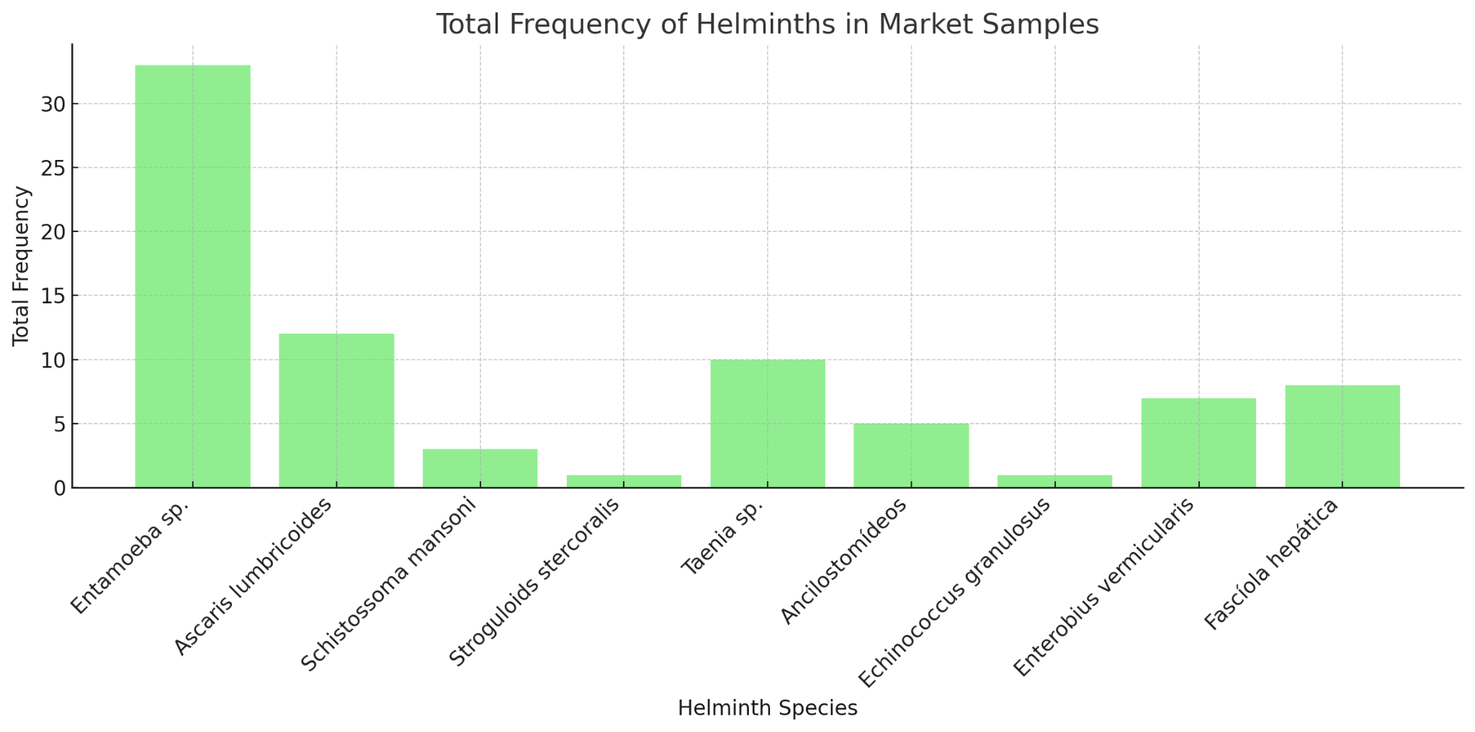

Table 02: Total helminth specimens from open market samples.

|  |  |  |  |
| --- | --- | --- | --- |
| **Identification** | **Total** | **Average** | **Percentage** |
| Taenia sp. | 14 | 2.8 | 43.75 |
| Entamoeba sp. | 12 | 2.4 | 37.5 |
| Ascaris lumbricoides | 2 | 0.4 | 6.25 |
| Enterobius vermicularis | 2 | 0.4 | 6.25 |
| Trichuris trichura | 1 | 0.2 | 3.125 |
| Fasciola hepatica | 1 | 0.2 | 3.125 |

Table 02 provides detailed information about helminth species found in samples collected from the open market. Each row indicates a helminth species, showing the total number of occurrences, the average per sample, and the percentage of the total number of occurrences of all species combined.

Taenia sp. was the most prevalent species, with a total of 14 occurrences, resulting in an average of 2.8 per sample and a significant percentage of the total. Following this, Entamoeba sp. had 12 total occurrences, averaging 2.4 per sample, also showing relevant presence. Conversely, Ascaris lumbricoides and Enterobius vermicularis appeared with lower frequency, each having 2 occurrences and an average of 0.4 per sample, indicating lower prevalence. Trichuris trichiura and Fasciola hepatica were observed only once each, resulting in an average of 0.2 per sample and contributing the lowest percentages of the total.

These data provide a clear understanding of the distribution (Graph 02) of different helminth species in the tested samples, highlighting the most and least frequent species, which can be useful for evaluating contamination patterns and guiding public health measures.

Graph 02: Distribution of helminth specimens in open market samples.

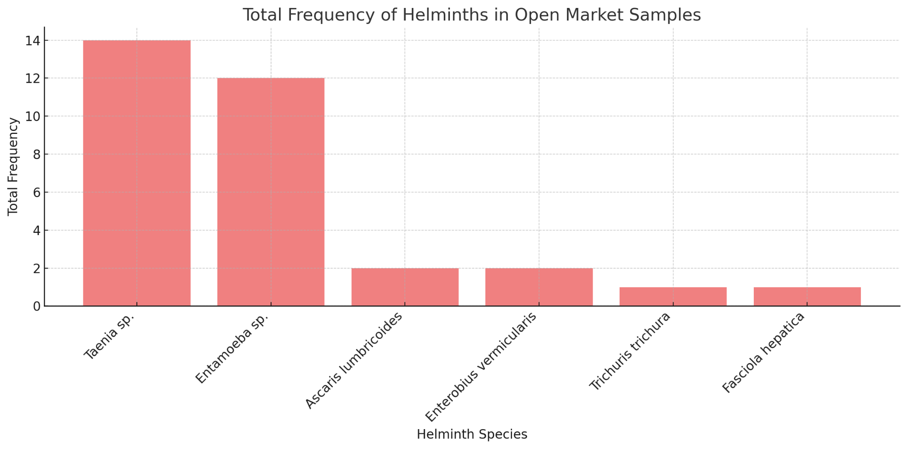

Graph 03 shows a comparison of the total frequency of helminths found in market and open market samples, with blue bars representing market frequencies and green bars representing open market frequencies. The distribution of each species is shown side-by-side, facilitating visualization of differences in prevalence between the two locations.

It is noted that Entamoeba sp. had a high total frequency in the market, but its presence was lower in the open market. Conversely, Taenia sp. was predominant in both locations, with a higher frequency in the open market compared to the market. Species like Ascaris lumbricoides and Enterobius vermicularis had low frequencies in both environments but were present.

It is noteworthy that Schistosoma mansoni appeared in market samples but was not found in open market samples. On the other hand, Trichuris trichiura and Fasciola hepatica showed low frequencies in the open market and minimal or no representation in market samples.

This visual analysis highlights variations in helminth prevalence between the two locations, showing that while some species are common in both, others appear exclusively or in greater quantities in only one environment. These data may reflect differences in contamination factors and occurrence conditions between the market and open market settings.

Graph 03: Comparative analysis between collection locations.

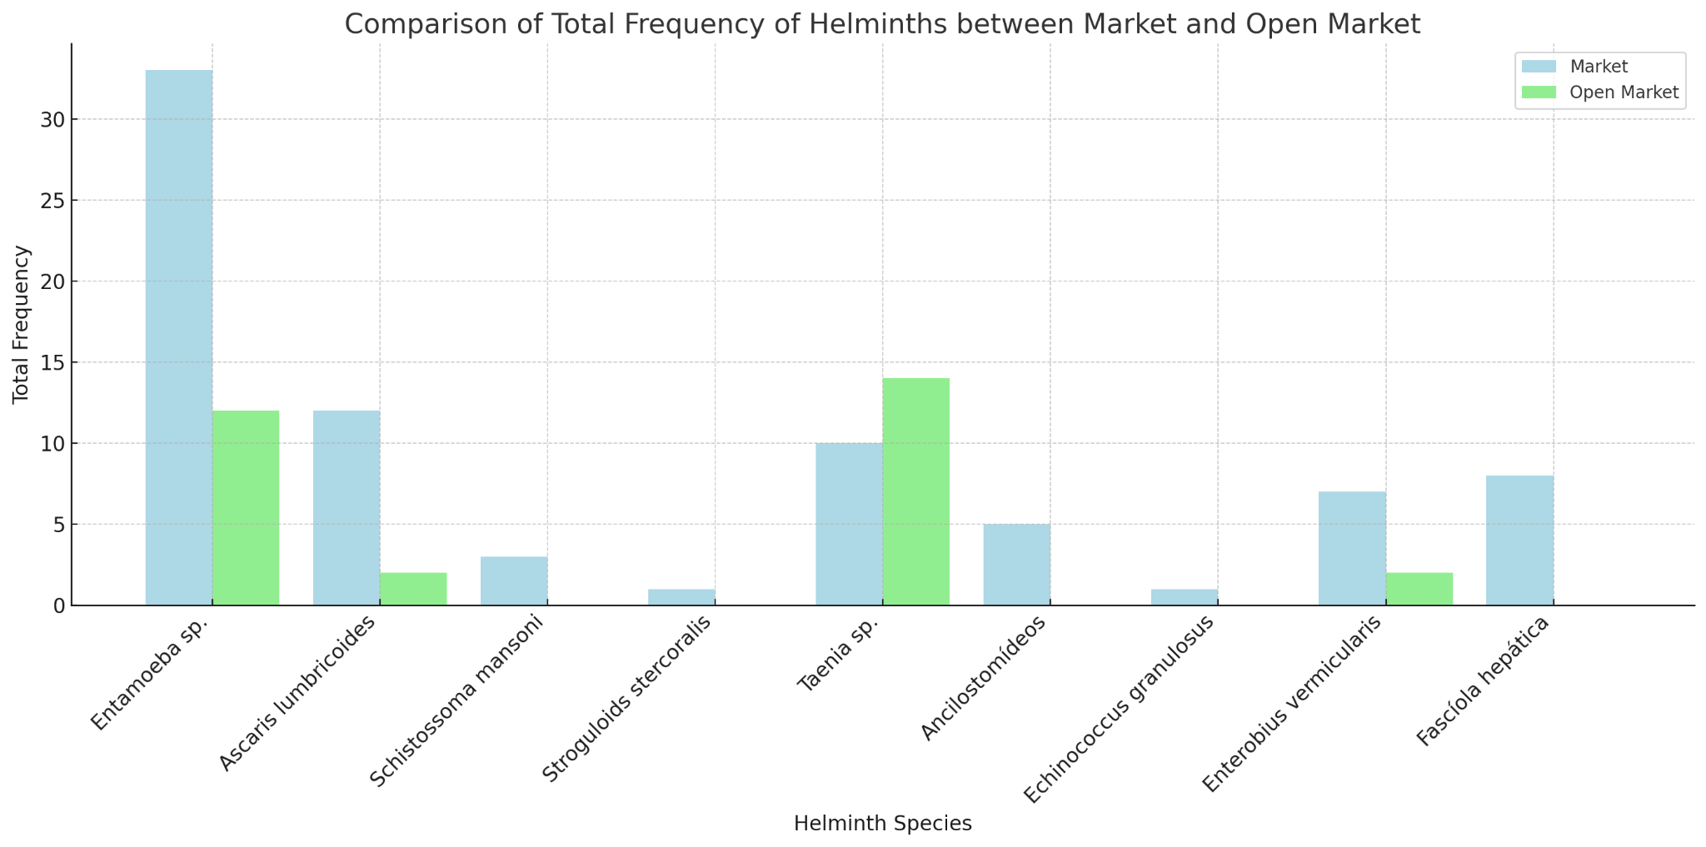

The analysis of helminth samples collected from different locations, such as markets and open markets, shows significant variations in the prevalence of identified species. In the market, Entamoeba sp. stands out as the most prevalent species, with 33 occurrences representing 41.25% of the total and an average of 6.6 per sample. This high frequency may indicate food handling conditions and water contamination sources that favor the spread of this parasite. Other species, such as Ascaris lumbricoides, had lower prevalence, with 12 occurrences [13], and Taenia sp. showed 10 occurrences [14], suggesting distinct contamination patterns [15].

In open market samples, the situation changes. Taenia sp. was the most prevalent species, totaling 14 occurrences and representing 43.75% of the total. Entamoeba sp. followed, with 12 occurrences, corresponding to 37.5%. Meanwhile, Ascaris lumbricoides and Enterobius vermicularis appeared with only 2 occurrences each, indicating lower incidence. Other species, such as Trichuris trichiura and Fasciola hepatica, were observed only once, reflecting minimal representation in the tested samples [16].

Comparing the two locations shows that while Entamoeba sp. was highly prevalent in the market, it had a lower presence in the open market. Conversely, Taenia sp. maintained high frequency in both, being more predominant in the open market. This difference may be attributed to specific environmental and sanitary factors of each location, such as food handling practices and access to clean water. Additionally, the absence of Schistosoma mansoni in the open market and the presence of other helminth species, such as Trichuris trichiura, emphasize differences in contamination conditions between the analyzed environments [17].

These observations have direct public health implications, as the prevalence of different helminth species in distinct locations reflects the need for targeted interventions. For example, the high incidence of Entamoeba sp. in the market suggests the importance of policies that strengthen water safety and food handling hygiene. Conversely, the predominance of Taenia sp. in the open market may indicate the need for stricter control practices for animal-derived food and educational programs on personal and sanitary hygiene for vendors and consumers [18].

**4. Conclusion**

It is concluded that a detailed understanding of the distribution of helminths in different locations is essential for formulating effective intervention strategies. The visual and comparative analysis of occurrences reinforces the importance of continuous monitoring and health education programs to mitigate the risks of parasitic infestations. Improvements in sanitary infrastructure and the quality control of food and water should be prioritized to reduce parasite prevalence and protect public health

**References**

1. Adhikari, S., Hunter, E., Van De Vossenberg, J., & Thomas, J. (2023). A review of latrine front characteristics associated with the risk of microbial infection; reveals a lack of pathogen density data. International Journal of Hygiene and Environmental Health, 254, 100234.

2. Girma, A., & Genet, A. (2024). Prevalence and factors associated with intestinal parasitic infections among preschool children in Ethiopia: A systematic review and meta-analysis. Epidemiology and Parasite Control, 26, 100345.

3. Holland, CV (2023). A walk on the wild side: A review of the epidemiology of Toxocara canis and Toxocara cati in wild hosts. Parasitology: Parasites and Wildlife, 22, 216–228.

4. Mahapatra, S., Ali, M. H., Samal, K., & Moulick, S. (2022). Diagnostic and treatment technologies for detection and removal of helminths in wastewater and sludge. Energy Nexus, 8, 100101.

5. Mota, J. D. O., Boué, G., Prévost, H., Maillet, A., Jaffres, E., Maignien, T., Arnich, N., Sanaa, M., & Federighi, M. (2021). Environmental monitoring program to support microbiological food safety and quality in food industries: a review of research scope and guidelines. Journal of Food Safety and Microbiology, 130, 100789.

6. Nguyen, T. H., Dorny, P., Nguyen, T. T. G., & Dermaauw, V. (2021). Helminth infections in fish in Vietnam: a systematic review. International Journal of Parasitology: Parasites and Wildlife, 13–32, 100456.

7. Tinkler, H. S. (2020). Preventative chemotherapy and anthelmintic resistance of soil-transmitted helminths – Can we learn nothing from veterinary medicine? One Health, 9, 100567.

8. Trevisan, C., Torgerson, P. R., & Robertson, L. J. (2019). Foodborne parasites in Europe: current situation and future trends. Trends in Parasitology, 35(9), 695–710.

9. Che-Kamaruddin, N., et al. (2024). Prevalence and risk factors of fasciolosis in a cattle population on farms in Taiping, Malaysia. Veterinary Parasitology: Regional Studies and Reports, 49, 100998.

10. Foster, T., et al. (2021). Modeling faecal pathogen flows and health risks in urban Bangladesh: Implications for sanitation decision-making. International Journal of Hygiene and Environmental Health, 233, 113669.

11. Lappan, R., et al. (2021). Monitoring diverse enteric pathogens in environmental and host reservoirs with TaqMan array cards and standard qPCR: a methodological comparison study. The Lancet Planetary Health, 5, e297–e308.

12. Mahdavi, F., et al. (2024). Design and evaluation of loop-mediated isothermal amplification for rapid detection of Enterocytozoon bieneusi. Food and Waterborne Parasitology, 35, e00225.

13. Mationg, M. L. S., et al. (2022). “The Magic Glasses Philippines”: a randomized controlled cluster of a health education package for the prevention of intestinal worm infections in school-aged children. The Lancet Regional Health - Western Pacific, 18, 100312.

14. McIntyre, K. M., et al. (2024). Understanding the interests of academics from diverse disciplines to identify prospective focus for a UK-based transdisciplinary network involving farm-to-fork stakeholders on antimicrobial resistance in agricultural systems: An online survey. Uma Saúde, 19, 100884.

15. Mukutmoni, M., et al. (2023). Perceptions and practices of urban slum-dwelling women concerning soil-transmitted helminths infections in Bangladesh: A cross-sectional study. Epidemiology and Parasite Control, 21, e00291.

16. Pawestri, A. R., et al. (2021). Seasonal prevalence, risk factors, and One Health intervention for prevention of intestinal parasitic infection in underprivileged communities on the Thai-Myanmar border. International Journal of Infectious Diseases, 105, 152–160.

17. Razafiarimanga, Z. N., et al. (2022). Risk factors for intestinal parasite harbors in an informal suburb on the west coast of Madagascar. Epidemiology and Parasite Control, 19, e00267.