***Original Research Article***

**Effect of Defected Ground Structures on Microstrip Patch Antenna Performance for ISM Band Applications**

**ABSTRACT**

Recent years have seen a rise in the use of microstrip patch antennas (MPAs) due to their superior radiation properties, affordability, lightweight design, ease of feeding, and ease of manufacturing and analysis. This study investigates how the addition of Defected Ground Structures (DGS) affects the performance of microstrip patch antennas designed for Industrial, Scientific, and Medical (ISM) band applications. Both antennas are developed using an inexpensive FR-4 substrate that has a thickness of 1.6 mm and a dielectric constant of 4.4. Using HFSS software, the antennas are studied and simulated at the ISM Band operating frequency. The design was verified by manufacturing and experimental testing with a Vector Network Analyser (VNA).

*Keywords: Defected Ground Structure (DGS), Microstrip Patch Antenna, ISM Band, FR-4, Vector Network Analyser (VNA)*.

1. **INTRODUCTION**

With the continuous evolution of the industry in the ISM radio band, there is a growing demand for small, efficient, and high-performance antennas that have become essential components of wireless communication system. Microstrip patch antenna one of the most preferred antennas due to its requirement of low profile, ease of fabrication, compatibility with integrated circuit [1]-[5]. Conventional microstrip patch antennas also have the drawback of narrow bandwidth, low gain, and surface wave loss [6]-[8].

Different techniques have been proposed to combat these problems, among which is the application of Defected Ground Structures (DGS) [9]. DGS, specifically, is the intentional inclusion of defects or patterning on the ground plane of a microstrip antenna that changes the current distribution and associated electromagnetic fields that can improve antenna performance [10], [11]. DGS is conceptually derived from Electromagnetic Band Gap (EBG) structures and Photonic Band Gap (PBG) structures, but it provides a simpler design and easier implementation [12]. Such methods have demonstrated enhancement in parameters like gain, bandwidth, and radiation efficiency [13], [14].

DGS has been shown in some recent studies to significantly improve different antenna parameters. Specifically, DGS have applied in suppression of high-order harmonics, the mutual coupling reduction in antenna arrays and the impedance matching [15]-[17]. In the context of ISM band applications, DGS has been successfully employed to enhance bandwidth and gain [18].

DGS is proved to enhance antenna performance in literature [19], [20]. A microstrip patch antenna with U-shaped DGS obtained substantial enhancement in bandwidth and return loss [21]. A circular microstrip patch antenna was also miniaturized utilizing a novel DGS design that operated at 2.45 GHz that demonstrated improved performance for ISM band applications [22], [23].

In this study, we are going to introduce and investigate a microstrip patch antenna with inset feed considering DGS and without DGS to observe the effect of DGS on antenna characteristics in ISM band application. The parameters studied include reflection coefficient, VSWR, impendence matching and gain.

1. **ANTENNA DESIGN AND SIMULATION**

**2.1 MATHEMATICAL DESIGNING**

The equations for patch width, substrate height, effective dielectric, patch length are given by the following: equation The proposed antenna's dimensions are designed using the following equations:

Patch width (𝑊)

$W=\frac{c}{2f_{r}\sqrt{(ε_{r}-1})/2}$ (1)

Where, 𝑐 = light speed in vacuum

fr = resonant frequency

Substrate height (ℎ)

$\frac{w}{h}$ >1. (2)

Effective dielectric constant (εreff)

(3)

Patch length (𝐿)

$L_{eff}=\frac{c}{2f_{r}\sqrt{ε_{reff}}}$ (4)

$ΔL=0.412h\frac{\left(ε_{reff}+0.3\right)\left(\frac{w}{h}+0.264\right)}{\left(ε_{reff}-0.258\right)\left(\frac{w}{h}+0.8\right)}$ (5)

Ground plane dimensions are

𝐿𝑔 = 𝐿 + 6ℎ (6)

𝑊𝑔 = 𝑊 + 6ℎ (7)

**2.2 ANTENNA WITHOUT DGS**

The first design is a rectangular microstrip patch antenna with an inset feed. The antenna is designed to operate at the ISM band frequency of 2.4 GHz. The substrate used is FR4 with εr=4.4, tanδ=0.02, and substrate thickness of 1.6 mm. The patch and inset feed dimensions are optimized for the desired resonant frequency. Fig.1 and Fig. 2 shows the radiating patch and ground plane without DGS.

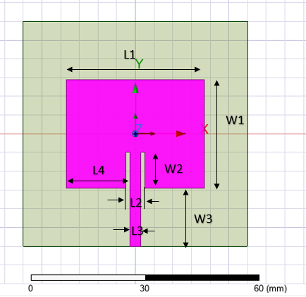

Fig.1: Proposed antenna patch design

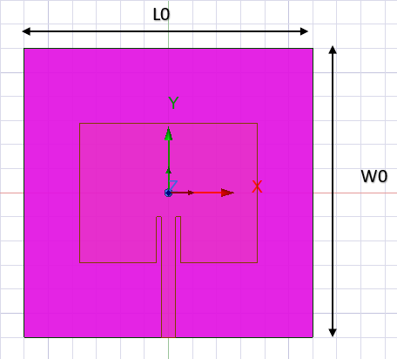

Fig.2: Proposed antenna ground plane without DGS

**2.3 ANTENNA WITH DGS**

To study the effect of DGS, a rectangular slot is cut in the ground plane directly beneath the patch (fig. 4). The slot dimensions and position are selected to improve the antenna parameters without affecting the fundamental mode of operation. Fig. 3 and Fig. 4 shows the radiating patch and ground plane with DGS. Both antenna configurations are simulated using High Frequency Structure Simulator (HFSS). The simulations are carried out to study parameters like S11, VSWR, return loss, and gain.

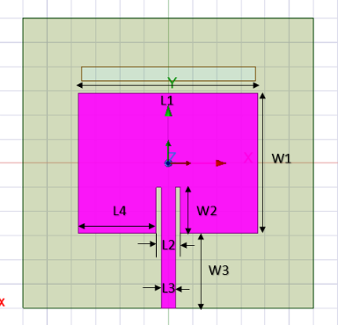

Fig.3: Proposed antenna patch design

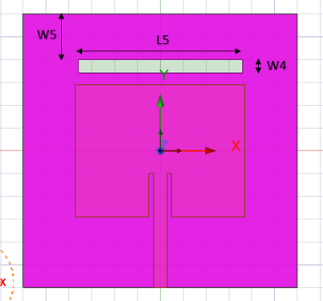

Fig.4: Proposed antenna ground plane with DGS

The dimensions of proposed antenna design as shown in Table 1.

|  |  |
| --- | --- |
| Dimensions | Value (mm) |
| Width W0 | 60 |
| Width W1 | 29 |
| Width W2 | 9.5 |
| Width W3 | 15.5 |
| Width W4 | 3 |
| Width W5 | 10 |
| Length L0 | 60 |
| Length L1 | 37 |
| Length L2 | 5 |
| Length L3 | 3 |
| Length L4 | 16 |
| Length L5 | 36 |

Table 1. Proposed antenna specifications along with their dimensions with DGS

**2.4 SIMULATION SETUP**

Both antenna configurations were simulated using the High Frequency Structural Simulator (HFSS) to obtain parameters such as reflection coefficients S11, VSWR, impedance matching, and gain.

1. **RESULTS AND DISCUSSION**

**3.1 REFLECTION COEFFICIENT AND VSWR**

The simulated reflection coefficient S11 for the antenna without DGS stands at -21.35 dB at the operating frequency of 2.4 GHz, indicating good impedance matching at the desired frequency. However, other resonances are also being characterized at 3.8 GHz and 4.5 GHz with S11 values of -28.45 dB and -11.72 dB, respectively. The simulated reflection coefficient of the proposed antenna without DGS is shown in Fig. 5.

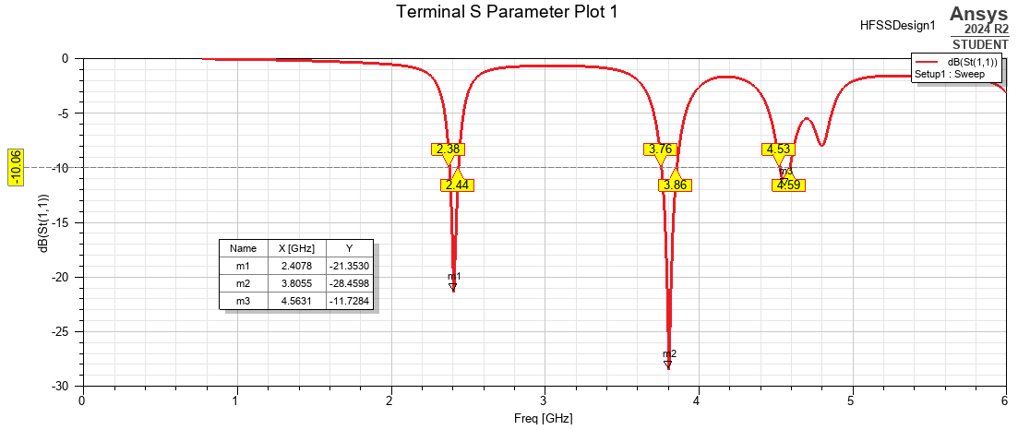

Fig. 5: S11 Parameter of simulated rectangular patch antenna without DGS.

Since the DGS is introduced, the reflection coefficient at 2.4 GHz is changed to -18 dB; the additional resonances are, respectively, shifted to 3.83 GHz (-27.47 dB) and 4.57 GHz (-14.12 dB). The VSWR value for both configurations remain less than 2 over the resonant frequencies, hence indicating good impedance matching. The simulated reflection coefficient of the proposed antenna with DGS is shown in Fig. 6.

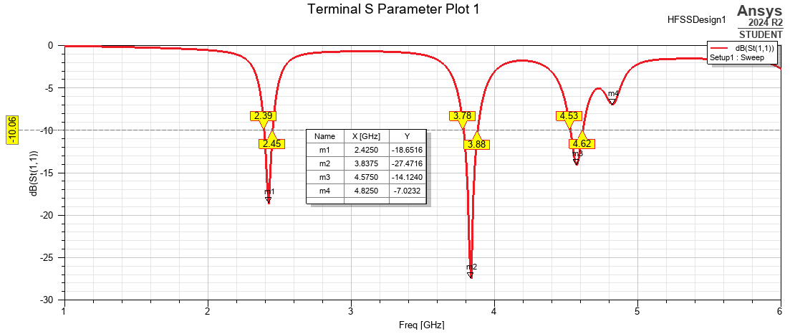

Fig. 6: Simulated S11 Parameter of rectangular patch antenna with DGS.

**3.2 IMPEDANCE MATCHING**

Smith Chart analysis shows that the DGS antenna has a better impedance matching at the resonance frequency than the antenna without DGS. The DGS introduces additional inductance and capacitance that help in better matching the antenna impedance to the feed line. Figs. 7 and 8 show the simulated Smith chart for the rectangular patch antenna without DGS and with DGS, respectively.

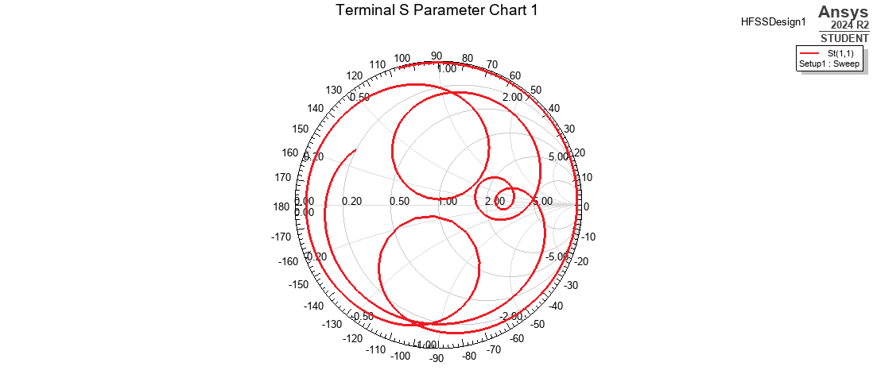

Fig. 7: Simulated Smith Chart of rectangular patch antenna without DGS.

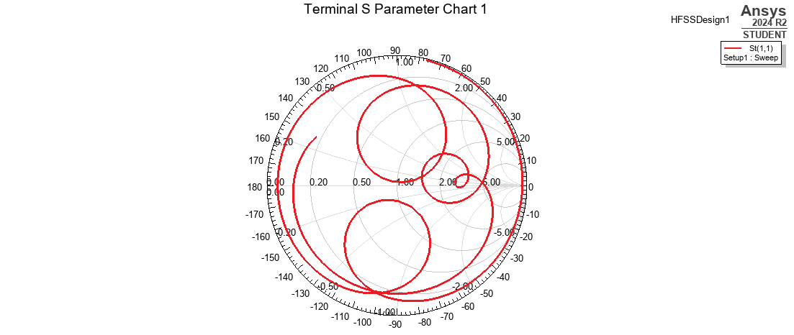

Fig. 8: Simulated Smith Chart of rectangular patch antenna with DGS.

**3.3 GAIN**

The presence of the DGS leads to an enhancement in antenna gain against the case of no DGS, which can essentially be attributed to surface-wave suppression as well as modification of the current distribution on the ground plane for better radiation. Simulated gain of rectangular patch antennas is shown in Figure 9, which is without DGS, and Figure 10, which has DGS.

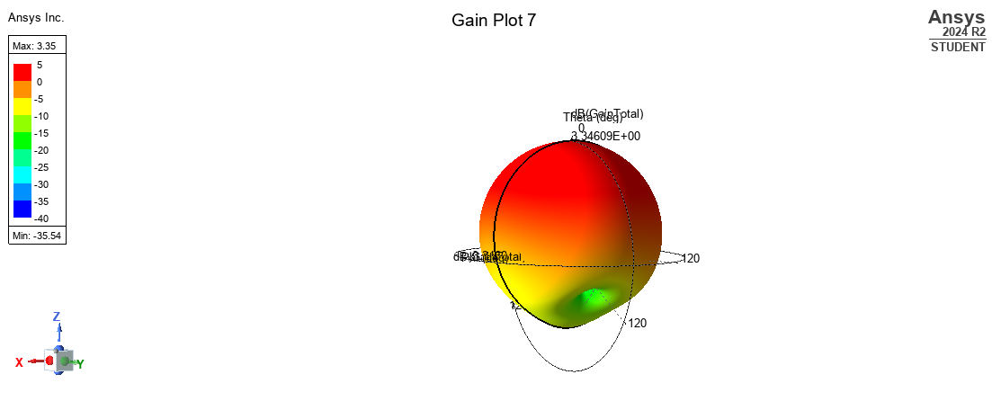

Fig. 9: Gain of simulated rectangular patch antenna without DGS.

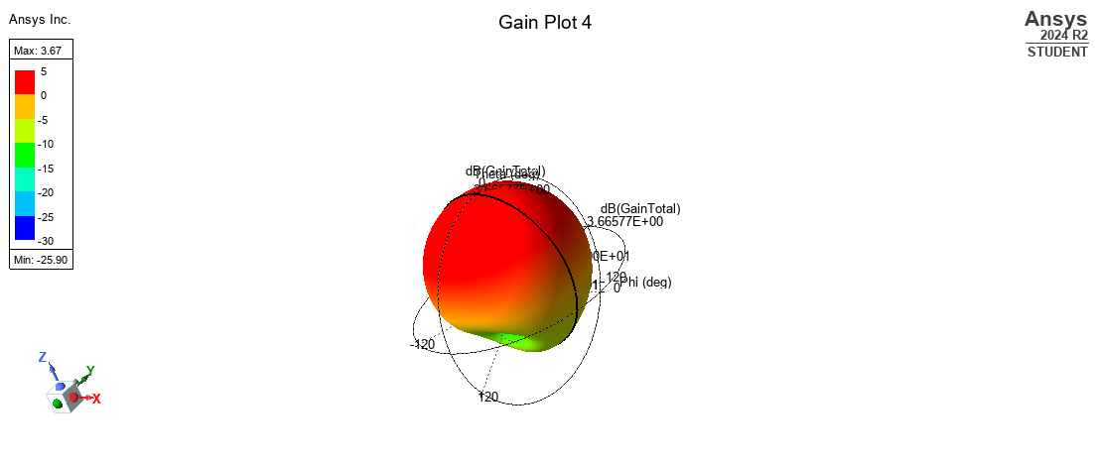

Fig. 10: Simulated Gain of rectangular patch antenna with DGS.

**3.4 FABRICATION AND MEASUREMENT**

The antenna along with optimized DGS is fabricated shown in Figures 11 and 12 front view and back view on an FR4 substrate. The measured reflection coefficients were -19.67 dB at 2.37 GHz, -14.58 dB at 3.75 GHz, -16 dB at 4.4 GHz, and -13.55 dB at 4.77 GHz. The measured ranges of VSWR were between 1 and 1.5 in the resonant range. Figures 11, 12, and 13 display the fabricated reflection coefficients, VSWR, and Smith Chart of the proposed antenna with DGS.

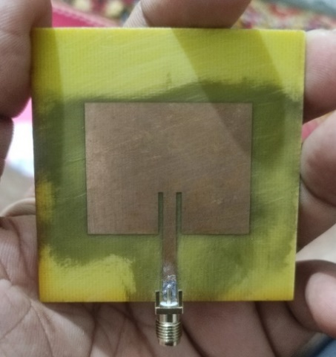

Fig. 11: Front view

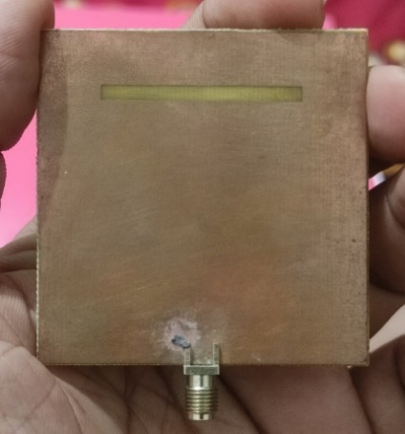

Fig. 11: Back view

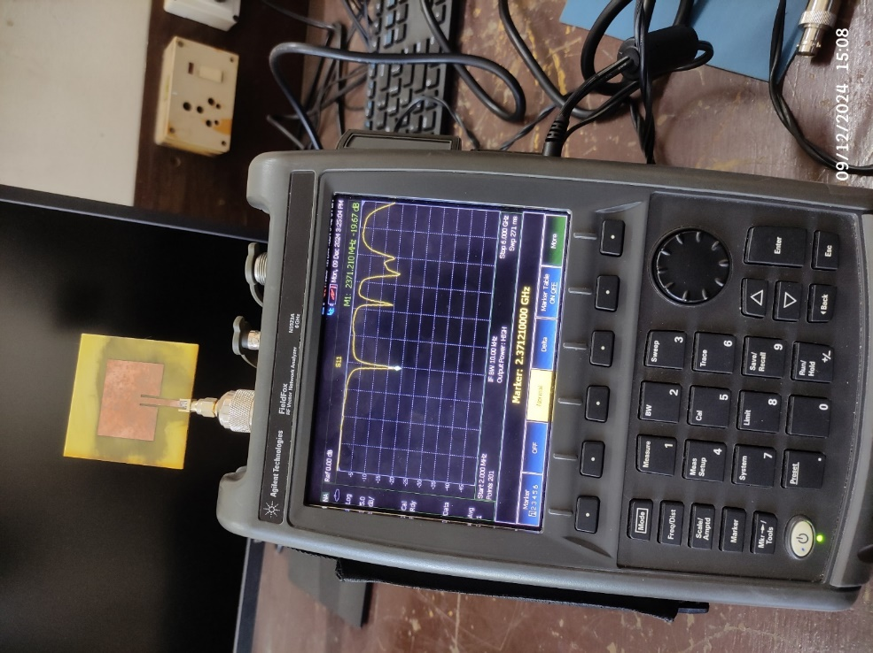

Fig. 11: S11 Parameter of fabricated rectangular patch antenna with DGS.

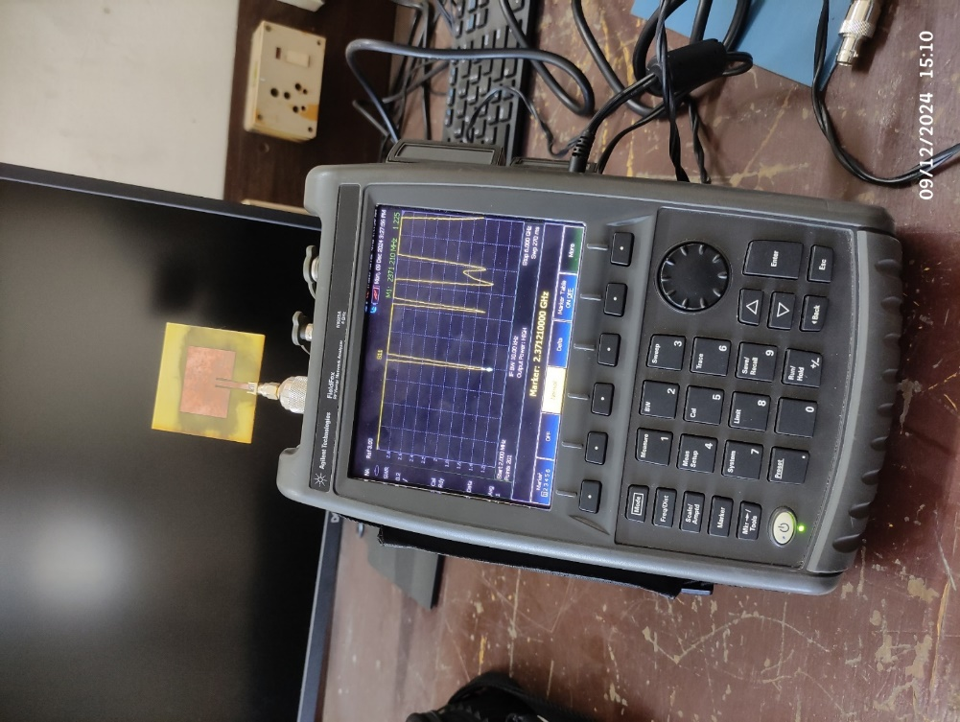

Fig. 12: VSWR of fabricated rectangular patch antenna with DGS.

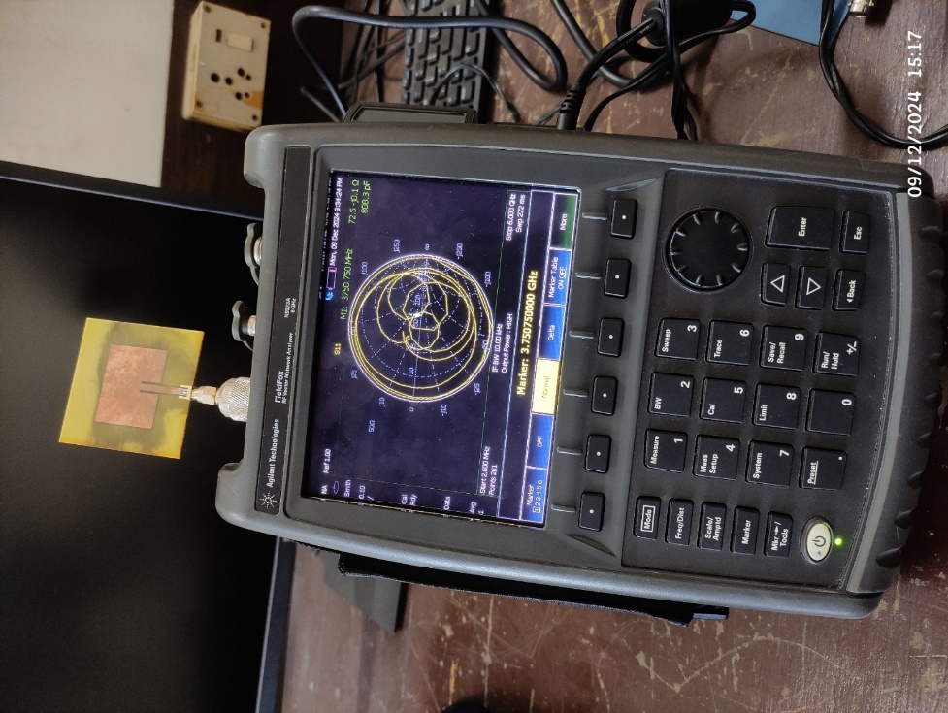

Fig. 13: Smith Chart of fabricated rectangular patch antenna with DGS.

1. **CONCLUSION**

This paper studies the benefits of Defected Ground Structures (DGS) in microstrip patch antennas for the ISM band application. The strategic introduction of the ground plane led to significant improvements in gain, bandwidth, and impedance matching. The DGS modified antenna's reflection coefficient was -19.67 dB at 2.37 GHz, while the VSWR was between 1 and 1.5 for all resonated ranges of the antenna. Improved gain was attributed to reduced surface wave interference, and the improved impedance characteristics were confirmed by the Smith chart analysis. This suggests that microstrip patch antennas can be DGS integrated while still being dependable and efficient and thus suitable for modern wireless communication systems.

**COMPETING INTERESTS DISCLAIMER:**

Authors have declared that they have no known competing financial interests OR non-financial interests OR personal relationships that could have appeared to influence the work reported in this paper.

**REFERENCES**

1. M. S. Yahya, S. Soeung, S. K. A. Rahim, U. Musa, S. S. B. Hashwan, Z. Yunusa, and S. A. Hamzah, "LoRa microstrip patch antenna: A comprehensive review," Alexandria Engineering Journal, vol. 103, pp. 197–221, 2024, doi: [10.1016/j.aej.2024.06.017](https://doi.org/10.1016/j.aej.2024.06.017).
2. P. Srinivasa Rao, J. B. Kamili, and A. M. Prasad, "Compact Multi-Band MIMO Antenna with Improved Isolation," *Progress In Electromagnetics Research M*, vol. 62, pp. 199–210, 2017.
3. Y. Hong, J. Tak, J. Baek, B. Myeong, and J. Choi, "Design of a Multiband Antenna for LTE/GSM/UMTS Band Operation," *International Journal of Antennas and Propagation*, vol. 2014, pp. 1187–1190, 2014.
4. Q. Li, A. P. Feresidis, M. Mavridou, and P. S. Hall, "Miniaturized Double-Layer EBG Structures for Broadband Mutual Coupling Reduction Between UWB Monopoles," *IEEE Transactions on Antennas and Propagation*, vol. 63, no. 3, pp. 1168–1171, Mar. 2015.
5. R. Karimian, A. Kesavan, M. Nedil, and T. A. Denidni, "Low Mutual Coupling 60 GHz MIMO Antenna System with Frequency Selective Surface Wall," *IEEE Antennas and Wireless Propagation Letters*, vol. 16, pp. 373–376, 2017.
6. K. F. Lee and K. F. Tong, "Microstrip patch antennas—basic characteristics and some recent advances," Proceedings of the IEEE, vol. 100, no. 7, pp. 2169–2180, 2012.
7. M. Y. Talha, K. J. Babu, and R. W. Aldhaheri, "Design of a Compact MIMO Antenna System with Reduced Mutual Coupling," *International Journal of Microwave and Wireless Technologies*, vol. 8, no. 1, pp. 117–124, 2016.
8. A. M. M. A. Allam and A. M. G. Hemdan, "Novel DGS Shape for Mutual Coupling Reduction," in *GeMiC 2016*, Bochum, Germany, Mar. 2016.
9. S. Goswami and D. Karia, "Design and Analysis of a Multi-band Flower Shaped Patch Antenna for WLAN/WiMAX/ISM Band Applications," *Wireless Personal Communications*, vol. 115, no. 2, pp. 1235–1248, 2020.
10. M. K. Khandelwal, B. K. Kanaujia, and S. Kumar, "Defected ground structure: fundamentals, analysis, and applications in modern wireless trends," International Journal of Antennas and Propagation, vol. 2017, no. 1, p. 2018527, 2017.
11. M. Sharma, "Design of Multiband Circularly/Linearly Polarized Antenna for Multiple Wireless Applications," *International Journal of Microwave and Wireless Technologies*, vol. 11, no. 9, pp. 967–974, 2019.
12. A. Y. Ashyap et al., "An overview of electromagnetic band-gap integrated wearable antennas," IEEE Access, vol. 8, pp. 7641-7658, 2020.
13. D. El Nabaoui, et al., "Multiband Planar Inverted F Antenna (PIFA) for ISM, WLAN, and WiMAX Applications," in *Proceedings of the Third International Conference on Computing and Wireless Communication Systems (ICCWCS)*, 2019.
14. P. Nayak, S. Verma, and A. Kumar, "Compact Tri-Band Planar Antenna for Wireless Applications," *arXiv preprint arXiv:2106.12884*, 2021.
15. J. D. Zhang, L. Zhu, Q. S. Wu, N. W. Liu, and W. Wu, "A compact microstrip-fed patch antenna with enhanced bandwidth and harmonic suppression," IEEE Transactions on Antennas and Propagation, vol. 64, no. 12, pp. 5030-5037, Dec. 2016.
16. A. Arora and N. Kumar, "To reduce mutual coupling in microstrip patch antenna arrays elements using electromagnetic band gap structures for X-band," 2017 International Conference on Nextgen Electronic Technologies: Silicon to Software (ICNETS2), Chennai, India, Mar. 2017, pp. 228-230, doi: 10.1109/ICNETS2.2017.8067946.
17. J. Acharjee, A. K. Singh, K. Mandal, and S. K. Mandal, "Defected ground structure toward cross polarization reduction of microstrip patch antenna with improved impedance matching," Radioengineering, vol. 28, no. 1, pp. 33-38, 2019.
18. S. Ullah, C. Ruan, M. S. Sadiq, T. U. Haq, A. K. Fahad, and W. He, "Super wide band, defected ground structure (DGS), and stepped meander line antenna for WLAN/ISM/WiMAX/UWB and other wireless communication applications," Sensors, vol. 20, no. 6, p. 1735, 2020.
19. S. K. Sharma and P. Thakur, "High-Performance Fractal Antenna for Multiband IoT Applications," *IEEE Transactions on Antennas and Propagation*, vol. 68, no. 12, pp. 8158–8162, 2020.
20. R. Jain, P. Kanaujia, and D. Gangwar, "Compact Ultra-Wideband Antenna with Multiband Characteristics for Modern Wireless Devices," *IET Microwaves, Antennas & Propagation*, vol. 13, no. 4, pp. 425–432, 2019.
21. C. Wang, L. Wei, and T. Huang, "Miniaturized Multiband Antenna Using Metamaterial-Based Structures for Wireless Applications," *Progress in Electromagnetics Research C*, vol. 105, pp. 59–69, 2020.
22. X. Liu and Y. Zhang, "A Novel Quad-Band Antenna for WLAN and WiMAX Applications," *IEEE Antennas and Wireless Propagation Letters*, vol. 18, no. 4, pp. 724–728, 2021.
23. R. Verma, et al., "Miniaturized Slot Antenna with Wideband Characteristics for IoT Applications," *Progress in Electromagnetics Research B*, vol. 92, pp. 153–170, 202
24. C. A. Balanis, Antenna theory: analysis and design, John Wiley & Sons, 2005.