**Studies on the association between gross lesions of chronic respiratory disease and molecular detection of *Mycoplasma gallisepticum* by PCR in chicken**

**ABSTRACT**

**Aim:** To study the gross & histopathological lesions in suspected cases of chronic respiratory disease and to correlate the gross CRD lesions & molecular detection of *Mycoplasma gallisepticum* by PCR

**Methodology:** The study was conducted in 40 organized poultry farms in and around Hassan, Karnataka during the year 2022-23. A total of 159 birds of different age groups these poultry flocks showing respiratory signs were subjected for post mortem examination and birds with gross lesions in the air sacs, sinuses, trachea and lungs as described by Ley (2008) were considered as cases of CRD and scoring was done based on the severity of lesions in the air sacs. Tissue samples from such birds were subjected to thorough histopathological evaluation to record the microscopic lesions of CRD. The pooled samples from each flock were subjected to PCR to detect the presence of *Mycoplasma gallisepticum*. The association between gross CRD lesions and molecular detection of MG by PCR, was estimated by Fisher’s exact test.

**Results:** 108 birds from 27 farms showed gross lesions *viz.*, catarrhal rhinitis, sinusitis, tracheitis with congestion, hemorrhages & catarrhal exudation, bronchitis with accumulation of caseous material, congestion & consolidation of lungs, and cloudy airsacculitis with deposition of cheesy caseous exudates suggestive of CRD. Histopathological findings revealed moderate to severe catarrhal rhinitis, mucopurulent to severe purulent sinusitis, moderate to severe airsacculitis, moderate to severe catarrhal/hemorrhagic tracheitis, and moderate to severe bronchopneumonia. Out of the 40 flocks, eight flocks (20%) were found positive for MG infection by PCR and these eight flocks were among the 27 flocks with characteristic CRD lesions.

**Conclusion:** There exists a significant positive association between gross CRD lesions and molecular detection of MG by PCR.

**Key words:** *CRD, Mycoplasma gallisepticum, PCR, gross pathology*

1. **INTRODUCTION**

*Mycoplasma gallisepticum* (MG), of the genus Mycoplasma and class Mollicutes, is one of the most important respiratory pathogens of chickens associated with huge economic impacts due to condemnation and downgrading of carcasses, reduced feed and egg production efficiency, and high medication costs (Raviv *et al*., 2007). In broilers, it results in a 20 to 30% reduction in weight gain, 10 to 20% decrease in food conversion efficiency besides 10 to 20% carcass condemnation. In breeders and layers, the disease causes a 10 to 20% decrease in egg production besides 5 to 10% increase in embryo mortality (Stripkovits and Kempf, 1996). Mycoplasma pathogens are constantly present in commercial poultry farms in India where multiple age groups are maintained and complete disinfection of premises is not possible (Rajkumar *et al*., 2018). *Mycoplasma gallisepticum* infections have a long course called “chronic respiratory disease” (CRD) in chickens which is often complicated with respiratory virus infections like Infectious bronchitis, Avian Influenza virus, Newcastle disease as well as *Escherichia coli* (Canter *et al*., 2019). As described by Ley(2008), the characteristic gross pathological lesions in CRD include sinusitis, catarrhal exudate in nasal passages, catarrhal exudate adherent to the tracheal wall with congestion and hemorrhages, caseous bronchitis, pneumonia, and cloudy airsacculitis with cheesy caseous exudates deposited over air sacs. Although culture is regarded as the gold standard for definitive diagnosis of CRD, it is quite difficult in the case of mycoplasma because of its fastidious nature. The polymerase chain reaction (PCR) technique has been widely used as a highly sensitive, specific, accurate and fast detection method for early diagnosis and rapid control of infections in poultry flocks (Yadav *et al*., 2022). The present investigation was conducted in the poultry flocks in and around Hassan, Karnataka to record the gross & histopathological lesions in CRD besides establishing the association between the gross lesions and molecular detection of *Mycoplasma gallisepticum* by PCR.

**2. MATERIALS & METHODS**

The study was designed to record the pathomorphology of Chronic Respiratory Disease in chicken with special reference to *Mycoplasma gallisepticum* infection by gross pathology, histopathology and molecular techniques. The research work was carried out during January 2022 to December 2022 at the Department of Veterinary Pathology, Veterinary College, Hassan, Karnataka Veterinary, Animal and Fisheries Sciences University, Bidar. Forty organized poultry farms in around Hassan, with history of respiratory ailments were considered for the investigation. In each form, after a detailed clinical investigation, the birds that died following respiratory illness were subjected for post mortem examination. Those birds which showed characteristic gross lesions in the air sacs, sinuses, trachea & lungs as described by Ley (2008) were considered as cases of CRD. Samples from such birds were subjected to thorough histopathological evaluation to record the lesions of CRD. Further, the pooled tissue samples from each of the 40 flocks were subjected to PCR to detect the presence of *Mycoplasma gallisepticum*.

**2.1 Collection of clinical samples**

During the study period of twelve months, post mortem examination was conducted on 159 birds of different age groups from 40 different poultry flocks, which died due to respiratory signs and symptoms. After thorough post mortem examination, the gross lesions in the air sacs, infraorbital sinus, trachea & lungs were systematically recorded. The representative tissue samples from infra-orbital sinuses, trachea, lung and air sacs were collected in 10 per cent neutral buffered formalin for histopathology. Pooled tissue samples from the birds with gross lesions of CRD were collected in sterile tubes and transported on ice and processed within 24-48 hours of collection for extraction of nucleic acid for PCR studies.

**2.2 Gross Pathology**

Those birds showing characteristic gross lesions as described by Ley (2008) were considered as cases of Chronic respiratory disease. The lesions comprised of sinusitis, catarrhal exudate in nasal passages, catarrhal exudate adherent to the tracheal wall with congestion and hemorrhages, bronchitis with accumulation of caseous material, congestion of lungs and foamy, cloudy airsacculitis with cheesy caseous exudates deposited over air sacs. Birds showing fibrinous pericarditis & perihepatitis in addition to the above lesions were considered as complicated cases of CRD. Further, the severity of lesions in the air sacs, sinuses and lungs in the CRD affected birds were classified as per standard protocols.

**2.2.1 Scoring of CRD based on air sac lesions**

CRD scoring was given based on the air sac lesions as described by Rajkumar *et. al.,* (2018) with slight modifications. The lesions of CRD were scored as CRD1+ (No Air sac lesion but presence of other lesions of CRD), CRD2+ (Cloudiness of air sac membrane with other lesions of CRD), CRD3+ (Air sacs thickened and meaty in consistency with accumulation of cheesy mass in the air sacs along with other lesions of CRD) and CRD4+ (lesions as in CRD3+ along with fibrinous pericarditis and perihepatitis).

**2.3 Histopathology**

The representative tissue samples from trachea, lungs, infraorbital sinus and air sacsfrom the CRD affected birds were collected in 10% neutral buffered formalin for histopathological examination. Tissues were processed by the routine paraffin embedding technique and sections of 4–5-micron thickness were then stained with routine hematoxylin and eosin method (Luna, 1968). Special staining techniques like Masson’s Trichrome and Alcian Blue were carried out as & when necessary.

**2.4 Polymerase chain reaction for confirmation of *Mycoplasma gallisepticum* infection**

The pooled tissue samples from trachea, lungs and air sacs were collected from necropsied birds with respiratory lesions from each of the 40 poultry flocks investigated, where each flock was considered as a single unit/sample and DNA was isolated from pooled tissue samples with two steps lysis and extraction. The *Mycoplasma gallisepticum* species specific primers (MG IGSR F & MG IGSR R) for 16S–23S rRNA gene with a product size of 812 bp was used for the detection of MG in the pooled samples by standard protocol (Yadav *et.al.,* 2008). The commercial live vaccine strain of *M.gallisepticum*, MG 6/85 (NOBILIS MG 6/85) was used as positive control for PCR studies.

**2.5 Association between gross CRD lesions and molecular detection of MG by PCR**

The association between gross CRD lesions and molecular detection of MG by PCR was estimated by Fisher’s exact test (Lowry, 2004).

**3. RESULTS & DISCUSSION**

**3.1 Clinical signs and necropsy findings**

The major clinical signs in the examined 40 flocks of chicken included respiratory rales, open mouth breathing (Fig-1), coughing/sneezing, nasal discharges, ruffled feathers and poor body condition. Out of the 159 poultry carcasses examined, 108 birds had gross respiratory lesions suggestive for CRD which comprised of sinusitis, presence of catarrhal exudate in nasal passages & sinuses, catarrhal to haemorhagic tracheitis (Fig-3), bronchitis with accumulation of caseous material, congestion & consolidation of lungs, airsacculitis with cloudy air sacs & deposition of cheesy caseous exudates over air sacs (Fig-4). Along with the above lesions, 23 birds showed fibrinous pericarditis & perihepatitis which were considered as complicated cases of CRD. These findings were in consensus with the observations of Rajkumar *et al*. (2017b) and Bharathi *et al*. (2018) albeit with minor variations in the intensity of lesions. The variability in the severity of the gross lesions depends on the virulence and pathogenicity of the strain, concurrent respiratory infections and stress factors (Okwara, 2016).

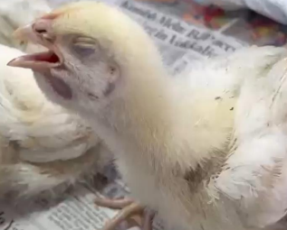

**Fig-1: Open mouth breathing I a chick with CRD**

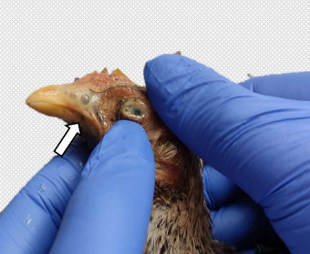

**Fig-2: Turbid & frothy nasal exudates & conjunctivitis in CRD affected bird**

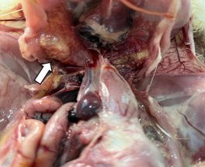

**Fig-3: Cheesy plugs on trachea of a chick (CRD3+)**

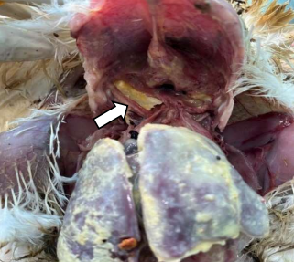

**Fig-4: Cheesy plugs in air sacs of a chick with fibrinous perihepatitis (CRD4+)**

**3.1.1 CRD Scoring based on air sac lesions**

Lesions of different intensities were observed in air sacs of CRD affected birds. Out of the 108 birds identified with CRD lesions, 19 (17.6 %) birds scored CRD1+, 39 (36.11 %) scored CRD2+, 27 (25%) birds scored CRD3+ and the rest 23 (21.29%) scored CRD4+ (Fig-5). The lesions observed in the air sacs ranged from clear air sacs to varying intensities of air sacculitis characterized by cloudiness, thickened and meaty in consistency with accumulation of cheesy material and in complicated cases fibrinous pericarditis and perihepatitis along with air sac lesions. Similar variations in the intensity of air sac lesions have been reported by Rajkumar *et al.* (2017a) in their studies on CRD. Bharathi *et al.* (2018) reported cloudiness in the air sacs in some birds and thickening of the air sac wall with white to yellowish caseous material in few birds while Chandhar *et al*. (2019) observed air sacculitis with caseous exudate in air sacs.

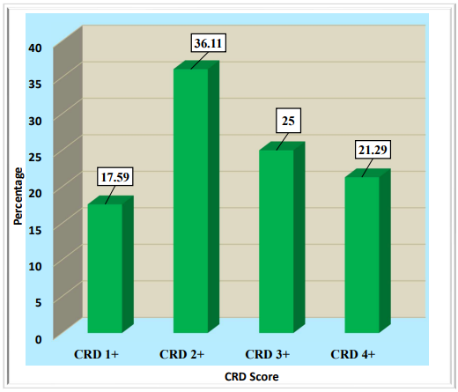

**Fig-5: Scoring of CRD based on Air sac Lesions**

**3.1.2 Gross lesions in the sinuses**

Out of 108 cases, 46 (42.59%) birds showed severe sinusitis with lesions like caseous exudate with swollen infraorbital sinus, 41 (37.96%) birds showed moderate sinusitis with lesions like turbid nasal exudate and 21 (19.44%) birds showed mild sinusitis with lesions like clear nasal exudates in nasal cavity. The observed lesions conformed with the observations of earlier researchers. Karthik *et al*. (2018) reported presence of catarrhal exudate in nasal passage with swelling of infra orbital sinus whereas Bharathi *et al*. (2018) reported serious involvement of infraorbital sinus with caseous material and mucous exudates.

**3.1.3 Gross lesions in the Trachea**

Out of 108 cases identified with Chronic respiratory disease lesions, 61 (56.48%) birds showed catarrhal tracheitis with presence of clear mucous exudates in tracheal lumen, 19 (17.59%) birds exhibited hemorrhagic tracheal mucosa along with mucous exudates, 16 (14.81%) birds showed caseous plugs along with mucous exudates (Fig 6) and 12 (11.11%) birds revealed fibrinous flakes in the tracheal lumen. Similar tracheal lesions have been observed by Yelimaz *et al.* (2011) where highest number of birds exhibited catarrhal / mucous exudates in tracheal lumen. Similarly, Rajkumar *et al*. (2017b) reported mucous/ catarrhal exudate in the birds along with caseous to hemorrhagic flecks in the tracheal lumen.

**3.1.4 Lesions in the Lungs**

Grossly, varying degree of pneumonic changes were observed in the lungs which showed congestions, focal to diffuse consolidation and hemorrhages. In some cases, pneumonic lesions with focal to multifocal white colored necrotic foci, zones of necrosis and caseation were observed in the lungs (Fig 7). Similar findings have been recorded by Rajkumar *et al.* (2017b) where lungs showed severe congestion and consolidation. Gupta *et al.* (2020) observed consolidation and hemorrhages of lungs along with frothy exudate oozing from cut surface of lungs.

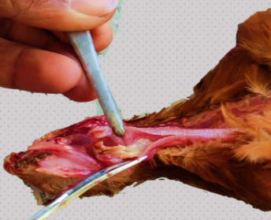

**Fig-6: Caseous plugs in trachea of a chick, along with catarrhal exudate**

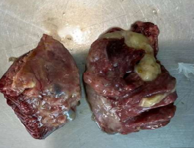

**Fig-7: Consolidated lungs of a CRD affected chick, with caseous plugs**

**3.2 Histopathology**

Histologically nasal chambers showed moderate to severe catarrhal rhinitis along with hyperplastic epithelium and mucosal glandular hypertrophy with moderate to severe lymphoplasmosytic infiltration. The infraorbital sinuses showed lesions suggestive of mucopurulent to severe purulent sinusitis with hyperplasia of epithelium & mucus glands, infiltration of lymphocytes, plasma cells & few heterophils (Fig-8 & 9). These results conformed with the observations of Yelimaz *et al*. (2011), Bharathi *et al*. (2018), Manimaran *et al*. (2019).

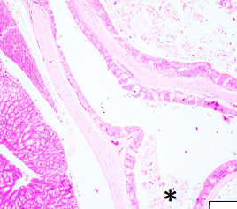

**Fig-8: Infraorbital sinus with mucopurulent exudates, cell debris, & inflammatory cells (asterisk)**

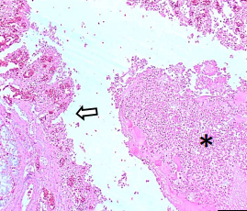

**Fig-9: Denuded epithelium of the infraorbital sinus (arrow) with purulent exudate, cell debris & inflammation (asterisk)**

The air sacs revealed moderate to severe airsacculitis characterized by hyperplastic epithelium, moderate to severe infiltration of mononuclear cells & heterophils along with the presence of denuded epithelium & necrotic cell debris in severe cases (Fig-10 & Fig-11). The severity of the lesions appeared to be consistent with the gross CRD score of the necropsied birds.

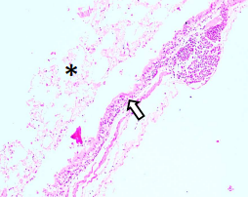

**Fig-10: Hyperplastic lining epithelium of airsacs (arrow), with necrotic cell debris & inflammatory cells (asterisk)**

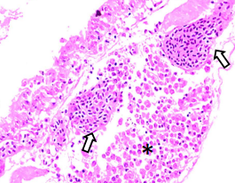

**Fig-11: Congested subepithelial layer of air sacs (arrow) with mononuclear cell infiltration (asterisk)**

Histological lesions in the trachea of CRD affected birds were suggestive of moderate to severe catarrhal tracheitis with hyperplastic mucosal epithelium on most occasions followed by hemorrhagic tracheitis. Some cases presented either fibrinous or caseous exudates in the tracheal lumen along with catarrhal inflammation (Fig-12 & Fig-13). These lesions conformed with the observations of previous researchers Karthik *et al*. (2018), and Manimaran *et al*. (2019) with minor variations. The lesions observed in the nasal chambers, sinuses, air sacs and the trachea could be attributed to the preferential colonization of respiratory epithelium by the mycoplasmatales (Gerlach, 1994) and subsequent inflammatory reactions.

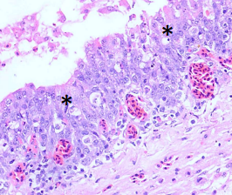

**Fig-12: Hyperplastic tracheal epithelium with mucosal congestion (asterisk)**

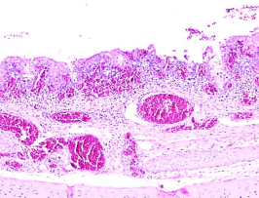

**Fig-13: Necrosis of tracheal epithelium, congestion in the lamina propria & mixed inflammatory cells**

The lungs of CRD affected birds showed moderate to severe bronchopneumonia in most cases followed by broncho-interstitial pneumonia. The major microscopic lesions noticed included varying degrees of congestion, destruction of surface epithelium, infiltration of lymphoplasmacytic & polymorphonuclear inflammatory cells, presence of eosinophilic proteinaceous exudates in the lumen, necrosis and denudation of bronchial epithelium and respiratory atrial muscle thickening Fig-14 & Fig-15). Similar histopathological changes in the lungs of CRD affected birds have been recorded by earlier researchers like Abdanaser *et al*. (2019) and Manimaran *et al*. (2019), albeit with minor variations in the intensity of lesions.

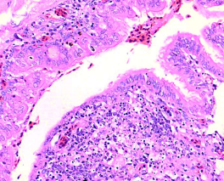

**Fig-14: Necrotic debris in secondary bronchi of lungs with mixed inflammatory cells**

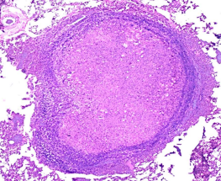

**Fig-15: Obliteration of bronchial lumen with caseous exudate consisting of cell debris & mononuclear cells**

Although the immunity of the respiratory system is quite robust, it is continuously exposed to various microbial agents and other noxious agents. The respiratory system is a frequently vulnerable region where exposure to aerosol contaminants induce an adaptive immune response or have a pathologic effect and hence inflammation is a common finding in the respiratory tract infections (Lopez and Martinson, 2017). Gerlach (1994) reported that Mycoplasmatales prefer to attach and colonize the respiratory mucosa and infection begins with the adsorption of the bacteria to surface of the host cells surfaces. When exposed to *M. gallisepticum,* the host produces a robust inflammatory response that causes respiratory distress in chickens leading to varied magnitude of lesions on the lining of their lungs and air sacs (Beaudet *et al*., 2017). *Mycoplasma gallisepticum* infection might cause a host energy metabolism dysfunction which hampers the normal homeostasis of host cells, exerts oxidative stress and activates various cell signaling pathways that induce inflammatory reaction, apoptosis, and autophagy to cause immune suppression and cell death (Ishfaq *et al*., 2019).

**3.3 Molecular detection of MG by PCR**

Among 40 samples screened for detection of MG infection, eight samples showed a positive band of 812bp (Fig-16). Detection of MG infections using specific primer to amplify specific intergenic spacer region of *Mycoplasma gallisepticum* has been reported by Raviv *et al*. (2007). Yadav *et al*. (2022) also conducted PCR assay in pooled organ samples targeting the IGSR gene which yielded 812 bp product which is in accordance with the present study.

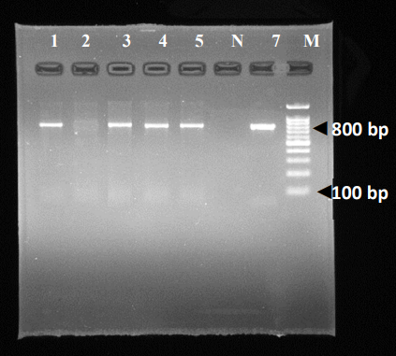

**Fig-16: The tissue samples showing positivity for 16S–23S rRNA using IGSR primer of Mycoplasma gallisepticum (MG) in PCR**

Lane M: 100bp DNA ladder Lane N: No template control Lane 2: Negative control

Lane 7: Positive control Lane 1, 3,4,5: Positive samples

**3.4 Association between gross CRD lesions and molecular detection of MG by PCR**

The association between gross CRD lesions and molecular detection of MG by PCR, were determined by Chi square test, and is presented in Table 1. It was evident that the association between gross CRD lesions and molecular detection of MG by PCR were statistically significant (P= 0.5). These findings were in accordance with the findings of Chandhar *et al*. (2019). Even though the gross lesions were strongly suggestive of CRD, occurrence of MG infection by PCR was found to be on lesser side in the present study. This may be due to bacteria and other species of Mycoplasma which also produce similar lesions as that of *Mycoplasma gallisepticum* (Mahmmoud *et al*., 2022). It has been documented that *Mycoplasma synoviae* have a tropism for the respiratory system and are more prone to cause airsacculitis than synovitis (Khalifa *et al.*, 2013) especially when there is a concurrent infection with either NDV or IBV.

**Table -1: Association between gross CRD lesions and molecular detection of MG by PCR**

|  |  |  |  |  |  |
| --- | --- | --- | --- | --- | --- |
|  | | **GROSS LESIONS** | | **TOTAL** | ***P* value** |
| **INDICATIVE OF CRD** | **NOT INDICATIVE OF CRD** |
| **MG detection by PCR** | Positive | **8** | **0** | **8** |  |
| Negative | 19 | 13 | 32 | ***p=0.028\**** |
| **TOTAL** |  | **27** | **13** | **40** |  |

\***- significant at p=0.05**

In an experimental study, Gracia *et al*. (2005) demonstrated that various strains of MG, stage of infection and different spread patterns can influence the detection of organism in tissue samples. Hossam *et al.* (2016) opined that during acute infections, tissue samples generally have higher DNA copies than chronic infections resulting in higher prevalence in the flocks.

**3.5 Occurrence of *Mycoplasma gallisepticum* (MG) infection in and around Hassan based on PCR detection**

Out of the 40 samples screened for detection of MG infection, eight samples tested positive for MG by PCR accounting to an occurrence of 20 per cent. Singh *et al.* (2013) and Thigilavathi *et al*. (2017) reported 32 per cent and 55 per cent occurrence of MG respectively. Occurrence range of seven to thirteen per cent has been recorded by various workers (Rajkumar *et al*., 2018; Chandhar *et al.,* 2019; Yadav *et al.,* 2022). Numerous factors, including geographic location, sampling strategy like sample size and sample type, rate of infection, biosafety, and biosecurity measures taken in the particular study area, may contribute to the huge difference in MG prevalence and detection rates (Shiferaw *et al*., 2022). Feberwee *et al*. (2005b) opined that reproduction ratio R0 of *M. gallisepticum* is higher than one, implying that once there is an infection in a flock it will spread quickly within the whole flock.

**4. CONCLUSION**

Chronic respiratory disease was found to be a major respiratory disease in chicken with *Mycoplasma gallisepticum* detected in 20 per cent of the samples by PCR. Typical gross & histopathological lesions were recorded in cases of CRD. There existed a strong positive correlation between the molecular detection of MG by PCR and the presence of characteristic gross lesions of CRD as exemplified by the statistically significant association between the two parameters.

**Abbreviations:**

CRD: Chronic Respiratory disease

MG: *Mycoplasma gallisepticum*

PCR: Polymerase Chain Reaction

**References:**

Abdanaser, A., Zyan, K.A.M., Hashem, Y.H.M. and Nouh, M.S.A. 2019. Molecular and

histopathological investigation of Mycoplasma gallisepticum and Mycoplasma

synoviae isolates from chickens. Benha Vet. Med. J., 36 (1): 342-350.

Beaudet J, Tulman E.R., Pflaum K., Liao X., Kutish G.F., Szczepanek S.M., Silbart L.K.

Geary S.J. 2017. Transcriptional profiling of the chicken tracheal response to

virulent Mycoplasma gallisepticum strain Rlow. Infect. Immun., 85: e00343-17.

Bharathi, R., Karthik, K., Mahaprabhu, R., Manimaran, K., Geetha, T., Tensingh Gnanaraj, P. and Roy, P. 2018. Outbreak and management of Mycoplasma gallisepticum infection in desi chicken and turkey flocks in an organized mixed farm. Comp. Clin. Path., 27 (3): 621-625.

Canter, J. A., Tulman, E. R., Beaudet, J., Lee, D. H., May, M., Szczepanek, S. M. and Geary, S. J. 2019. Transcriptional and pathological host responses to coinfection with virulent or attenuated *Mycoplasma gallisepticum* and Low-Pathogenic Avian Influenza A virus in chickens. *Infect. Immun*., **88** (1): 00607-19.

Chandhar, I., Swamy, M., Verma, Y., Dubey, A., and Singh, A. (2019). Prevalence and Pathology of Chronic Respiratory Disease in Broilers. *Int. J. Livest. Res.,* **9** (11): 75-84.

Feberwee, A., Mekkes, D. R., De Wit, J. J., Hartman, E. G. and Pijpers, A. 2005b. Comparison of culture, PCR, and different serologic tests for detection of *Mycoplasma gallisepticum* and *Mycoplasma synoviae* infections. *Avian Dis*., **49** (2): 260-268.

Fletcher and Abdul Aziz (2016). Respiratory system, In *Avian histopathology*, Edt. Abdul-Aziz, T., Barnes, H.J., Fletcher, O.J., Shivaprasad, H.L. and Swayne, D.E. Edn 4th., American association of avian pathologists, Florida, pp. 195-270.

García, M., Ikuta, N., Levisohn, S. and Kleven, S.H., 2005. Evaluation and comparison of various PCR methods for detection of *Mycoplasma gallisepticum* infection in chickens. *Avian Dis.*, **49**(1): .125-132.

Gerlach, H., 1994. Mycoplasma and rickettsia, In Avian Medicine: Principles and Application, Edt. Ritchie, B.W., Harrison, G.J. and Harrison, L.R., Wingers Publishing Inc., Lake Worth, Florida, pp.1053-1063.

Gupta, R., Niyogi, D., Tripathi, K., Joshi, R., Joshi, N., and Singh, S. (2020). Pathomorphological and Immunohistochemical Changes in Lungs of Poultry Affected with Chronic Respiratory Disease in Ayodhya District of Eastern Uttar Pradesh. *Int. J. Livest. Res.,* **10**(7), 104-109.

Hossam, M., Wagih, A., Mona, E., Mahmoud, E., Rehab, E. and Salah, E.D.T., 2016. The recovery and molecular diagnosis of *Mycoplasma gallisepticum* infection in commercial poultry flocks in Egypt. *Ind. J. Sci. Tech.*, **9**: 29.

Ishfaq, M., Zhang, W., Shah, S. W. A., Wu, Z., Wang, J., Ding, L. and Li, J. 2020. The effect of *Mycoplasma gallisepticum* infection on energy metabolism in chicken lungs: Through oxidative stress and inflammation. *Microb. Pathog*., **138** : 103848.

Karthik, K., Bharathi, R., Mahaprabhu, R., Manimaran, K. and Shoba, K. 2018. Chronic respiratory disease outbreak in an organized native chicken farm. *J. Dairy Vet. Anim. Res*, **7** (3): 79-82.

Khalifa, K. A., Sidahmed Abdelrahim, E., Badwi, M. and Mohamed, A. M. 2013. Isolation and molecular characterization of *Mycoplasma gallisepticum* and *Mycoplasma synoviae* in chickens in Sudan. *J. Vet. Med*., 2013.

Ley, D.H. (2008). *Mycoplasma gallisepticum* infection. In: *Diseases of Poultry*, Edt. Saif, Y. M. Edn 12th., Wiley-Blackwell publishing, Oxford, pp. 722-744.

Lopez and Martinson (2017). Respiratory system, mediastinum and pleurae. In: *Pathologic Basis of Veterinary Disease*, Edt. Zachary, J.F. Edn 6th., Elsevier: St. Louis, pp. 471–560.

Lowry, R. 2004. VassarStats: website for statistical computation. Vassar College.

Luna, L. G. 1968. Manual of Histologic staining Methods of the Armed Forces Institute of Pathology. 3 Mc Graw Hill book Co, Newyork.

Mahmmoud, Ebtehal N., Mohammad A. Hamad, and Zahraa N. Khudhur. 2022. Detection of *Mycoplasma gallisepticum* in broiler chickens by PCR. *Open Vet. J.,* **12**(3): 329-334.

Manimaran, K., Mishra, A., Hemalatha, S., Karthik, K. and Ganesan, P.I. 2019. Detection of *Mycoplasma gallisepticum* infection in chickens from Tamil Nadu State of India. *Indian J. Anim. Res*, **53** (1): 115-118.

Okwara, N., 2016. Avian Mycoplasmosis a review. *J. Agric. Vet. Sci.*, **9**: 6-10.

Rajkumar, S., Reddy, M. R. and Somvanshi, R. 2017a. Incidence and risk factors of chronic respiratory disease in Indian poultry flocks.*Int. j. sci. environ. Technol.,* **6** (1): 662-668.

Rajkumar, S., Reddy, M. R. and Somvanshi, R. 2018. Molecular prevalence and seroprevalence of *Mycoplasma gallisepticum* and M. synoviae in Indian Poultry Flocks. *J Anim Res*., **8** (1): 15-19.

Rajkumar, S., Reddy, M.R. and Somvanshi, R. 2017b. Molecular detection and pathology of spontaneous cases of Chronic Respiratory Disease in chicken. *Indian J Vet Pathol.,* **41**: 277-282

Raviv, Z., Callison, S., Ferguson-Noel, N., Laibinis, V., Wooten, R. and Kleven, S. H. 2007. The *Mycoplasma gallisepticum* 16S–23S rRNA intergenic spacer region sequence as a novel tool for epizootiological studies. *Avian Dis*., **51** (2): 555-560.

Shiferaw, J., Shifara, F., Tefera, M., Feyisa, A. and Tamiru, Y. 2022. Seroprevalence and associated risk factors of *Mycoplasma gallisepticum* infection in poultry farms of Hawasa and Bishoftu, Central Ethiopia. *Vet. Med:*101-107.

Singh, D., Mahajan, N. K., Kumar, A., Maan, S. and Kumar, P. 2013. Detection of *Mycoplasma gallisepticum* from field samples of poultry using conventional PCR. *Adv Anim Vet Sci.*, **1** (1S): 11-13.

Stipkovits, L. and Kempf, I. 1996. Mycoplasmoses in poultry. *Rev Sci Tech Title* (International Office of Epizootics)., **15** (4): 1495-1525.

Thilagavathi, K., Sivaseelan, S., Balasubramaniam, G.A., Balasurbramaniam, A., Arulmozhi, A. and Madheswaran, R., 2017. Detection of *Mycoplasma gallisepticum* from field samples of laying chicken using PCR. *Int. j. sci. environ. Technol.*, **4**(6): 2594-2499.

Yadav, J. P., Singh, Y., Jindal, N. and Mahajan, N. K. 2022. Rapid and specific detection of *Mycoplasma gallisepticum* and *Mycoplasma synoviae* infection in poultry using single and duplex PCR assays. *J. Microbiol. Methods*., **192**: 106365.