**Horticulture Technologies: A Web Interface for Farmers and Stakeholders**

**Abstract**

Horticultural crops, including fruits, vegetables, ornamentals, medicinal crops and mushrooms play a significant role in improving the food security, nutrition, health and livelihood security for millions of people. Advancements in crop cultivation and processing methods have significantly enhanced crop yields and extended the shelf life of horticultural products. ICAR-Indian Institute of Horticultural Research (IIHR), a premier research institute in horticulture, dedicated to advancing horticultural science has developed numerous technologies that provide information on various management aspects and bringing awareness benefitting farmers and other stakeholders.

From protected cultivation to post-harvest technologies and integrated pest management, these technologies are instrumental in transforming the horticulture sector. To maximize the impact of these innovations and to ensure these advancements reach a broader audience of farmers and stakeholders involved in horticulture, effective dissemination and large-scale adoption are essential. In this regard, efforts have been made to digitize the horticulture technologies developed at the institute and disseminate the same through web applications which is a cost effective way of communication channel reaching lakhs of farmers. The present study was aimed to design and develop a user-friendly, informative web interface to introduce and showcase these innovative technologies from crop production to value addition for horticultural crop producers and other stakeholders thus making them more accessible. The web interface is structured to facilitate quick navigation through various horticulture technologies, enabling users to easily identify and explore the technology categories most relevant to their needs. This web interface platform can serve as an effective tool for boarder reach in the horticulture technology transfer process to enhance crop productivity and promote sustainable farming.

**Keywords**: horticulture, application, information, dissemination, technologies, web interface

**1. Introduction**

Horticulture is an important sector of agriculture significantly contributing to food security, nutrition, health and improved livelihoods (Chadha et al., 2010). Horticulture encompasses a diverse range of crops, including fruits, vegetables, ornamentals, medicinal plants (Prakash, 2023), and mushrooms. The premier institute, ICAR-Indian Institute of Horticultural Research (IIHR), Bangalore, has been at the forefront of horticultural research and innovation, developing technologies (Dhanajaya *et al*., 2022) that enhance productivity and profitability for farmers. It plays a crucial role in developing and promoting innovative horticultural technologies (Pekkeriet *et al*., 2015), contributing towards increased food, nutritional and socio-economic security (Singh et al., 2021), quality and higher productivity of horticultural crops. Horticultural crops are most prominent source in ensuring nutritional security (Siddiqui *et al*., 2014). Significant innovations in horticulture (Janbandhu, 2024) have taken place through plant breeding, biotechnological interventions, fertilizer and irrigation management, protected cultivation, plant health management, postharvest technology, etc. Through its research and extension services, ICAR-IIHR plays a pivotal role in shaping the future of horticultural practices (Reddy, 2024) in the country. Institute has developed a range of improved varieties and hybrids with multiple disease resistance (Sharma *et al*., 2021) and high yield potential in vegetables, fruits, medicinal and ornamental crops. It has been a key player in contributing to sustainable plant health management in the horticultural sector focusing on safety, cost-effectiveness, and eco-friendliness. Horticulture crop offers higher scope for value addition (Kumar *et al*., 2019). Institute has developed a vast range of processed and value added products with extended shelf life by adopting suitable handling, packaging and storage methods. Horticulture crops are very rich in vitamins and nutrients (Davies and Bowman, 2014). IIHR utilizes advanced research technologies in molecular biology, genetics and biotechnology to improve understanding underlying plant growth. Crop cultivation is labour intensive (Satishkumar and Umesh, 2018) and timely operations are essential for maximizing output. The institute has developed various machineries and implements to facilitate farm mechanization. These improved technologies (Joshi and Varshney, 2022) enable more efficient and sustainable farming practices (Gamage *et al*., 2024), particularly in how water and nutrients are managed (Kumar *et al*., 2024) which can lead to new business ventures and help address critical challenges such as food security, rural development and improvements in nutrition and health. As farmers become more efficient with their use of resources, their overall productivity improves. Technologies developed are commercialized to encourage entrepreneurship (Lather *et al*., 2021), creating employment opportunities in both rural and urban areas, and driving economic growth. ARKA is the trade mark of the technologies developed by ICAR-IIHR. These technologies are instrumental in transforming the horticulture sector, improving food security, and contributing to the economic development of India. Agricultural information and knowledge delivery systems are expected to disseminate highly accurate, specific, and crop management information ensuring that farmers have access to the right information at the right time. Popularization of agricultural technologies is one way of addressing the information needs of farmers (Sebastian and Jeyalakshmi, 2020). Having a centralized, accessible resource can help farmers stay up to date with the latest technologies and best practices. It could potentially bridge the information gap between research institutions and rural areas, enabling more widespread adoption of effective methods. Digital technology can deliver right information (Ingram and Maye, 2020) and need based to the stakeholders. The paper aims to highlight the potential of developing web application to showcase the horticulture technologies from crop production to value addition and post-harvest management. A user-friendly web interface serves as a vital bridge between farmers and the wealth of horticultural knowledge available. The design of a user interface for agricultural systems (Ibrahim and Danmaigoro, 2024) plays a crucial role in ensuring effective interaction between the system and its users to disseminate horticulture technologies for adoption, enhancement of crop productivity and sustainable farming.

**2. Materials and Methods**

The web application was designed using HTML, CSS and JavaScripts with different web pages to edit, debug and build code. HTML is responsible for the content and structure of a webpage, while CSS determines its presentation and style. JavaScript defines the behavior and functionality of the webpage. The design tool uses compilers, code completion functions and graphical designers to enhance the application development process. The web structure was designed using Grid Layout Module to layout the different technologies categorized under six themes. Grid-based User Interface design was used for systematic framework that helps organize and align elements within a layout. Hover effect was embedded so that the design remains responsive. Modal components are added to create pop-up boxes for displaying more information on a particular technology. Different technology images are added to make the system more informative. Navigation bar was provided in the application to browse through different technology categories to improve user experience providing quick access to content. After validating and testing the functionality of the application, it was made public by deploying it to the cloud service ((Sharma et al., 2024). The developed web interface on horticulture technologies was uploaded securely through firebase hosting service and cloud functions which plays a critical role in securely delivering static and dynamic web content through a global Content Delivery Network, ensuring optimal performance and reliability for users to access the web application displaying technology information through web browser.

**3. Results and Discussion**

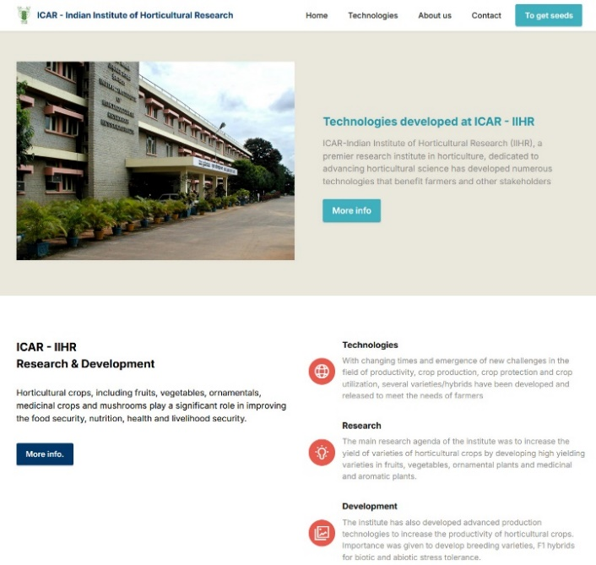

Fig 1 : Technologies developed at ICAR-IIHR

The technologies developed at ICAR-IIHR are categorized into six theme areas viz., Seed and Planting Materials, Biotechnology and Plant Propagation, Fertilization and Irrigation Management, Crop Protection and Health Management, Post-Harvest Technologies and Farm Machinery each focusing on enhancing horticultural productivity, sustainability and quality.

The web application is designed using HTML5 and scripting languages with navigation structure and neatly organized content making it easier for users to find the horticulture technology information they need. The .tabs class styles the tab headers with background, padding, and hover effects for interactivity. At the start of the application the user lands on the homepage where they can choose the technology category from the menu choices built into the user interface. The homepage is designed with tabbed navigation, allowing users to easily switch between different technology sections by clicking on the tabs. Once the user selects a technology within a particular category, a detailed window opens with image and detailed information about each technology. . All the web pages has tabbed navigation where technology information is organized, which separate content into different sections. Active tabs are highlighted with distinct background and text color. The carousel container features tab headers with padding, which creates space around the text, making them more clickable. The background color gives the tabs a distinct look, setting them apart from other sections. Hover effects are applied to the tab headers, so when users move the cursor over a tab, the corresponding section is highlighted making it more interactive. The user can select a tab to view different technology content category. Firebase, a platform designed to support app development and aimed at improving operational performance was used to host the service (Megantoro *et al*., 2024) ensuring fast delivery of high-quality web based content to the users.

A well-designed interface can make a huge difference in how easily users can navigate through a range of information and adopt new technologies. This user-friendly web interface allows users to access the relevant technologies needed for horticulture crop cultivation that can improve the economic condition of many farmers (Das and Singh, 2021). The application is available in the public domain at <https://webapp-iihr.web.app> and also can be accessed from the institute website. The adoption of improved horticultural technologies empowers farmers to grow high-value products (Barua, 2023). The availability of horticulture technology information will significantly benefit farmers and other stakeholders by providing them with the knowledge needed to improve their livelihoods and contribute to the overall growth and development of the agricultural economy.

**4. Conclusion**

The web interface developed to showcase various horticultural technologies ensures that essential knowledge is made accessible to a wide range of stakeholders from farmers to extension workers, researchers, and policymakers. Adopting innovative horticultural practices and technologies offers significant benefits to farmers, not only in terms of improving the nutritional quality of food but also in fostering sustainable farming practices.

**5. References**

* Barua, U., Islam, M., & Medhi, S. (2023). Awareness and Adoption of Climate Resilient Horticulture Technologies by Farmers in Ri Bhoi District of Meghalaya. *International Journal of Economic Plants*, 10(4), 256-262. https://doi.org/10.23910/2/2023.4918a.
* Chadha, K.L., Singh, A.K., & Patel, V.B. (2010). Recent Initiatives in Horticulture. Westville Publishing House. ISBN 10: 9788185873541.
* Davies, F.T., & Bowman, J.E. (2014). Horticulture, food security, and the challenge of feeding the world. In XXIX International Horticultural Congress on Horticulture: Sustaining Lives, *Livelihoods and Landscapes*, 1128: 1-6.
* Das, M., & Singh, A.K. (2021). Horticulture and nutrition: Two sides of the coin. *Indian Horticulture,* 66(5): 37-40.
* Dhanajaya, M.V., Upreti K.K., & Dinesh M.R. (2022). National Horticultural Fair 2021-A Success Story. *Journal of Horticultural Sciences,* 16(2): 315-318.
* Gamage, A., R. Gangahagedara, R., Subasinghe, S., Gamage, J., Guruge, C., Senaratne, S., Randika, T., Rathnayake, C., Hameed, Z., Madhujith, T., & Merah, O. (2024). Advancing sustainability: The impact of emerging technologies in agriculture. *Current Plant Biology,* 40: 100420.
* Ibrahim, U., & Danmaigoro, A. (2024). Human-Computer Interaction in Agricultural User Interfaces. *International Journal of Applied and Scientific Research,* 2(2): 187-198.
* Ingram, J., & Maye, D. (2020). What are the implications of digitalisation for agricultural knowledge?. *Frontiers in Sustainable Food Systems,* 4: 66
* Janbandhu, M. (2024). Advances and Emerging Trends in Horticultural Production and Management. *Journal of Experimental Agriculture International,* 46: 47-69.
* Joshi, P. K., & Varshney, D. (2022). Agricultural Technologies in India: A Review. *NABARD Research and Policy* 5.
* Kumar, D., Malik, N., & Sengar, R.S. (2019). Emerging technologies to enrich agricultural and horticultural crop quality and production. *Annals of Horticulture,* 12(1): 55-61.
* Kumar, S., Wani, Ab W., Kaushik, R., Kaur, H., Djajadi, D., Khamidah, A., Saidah, Alasbali, N., Alreshidi, M., Alam, M.W., Yadav, K., & Wani, A. (2024). Navigating the landscape of precision horticulture: Sustainable agriculture in the digital Age, *Scientia Horticulturae,* 338, 113688. 10.1016/j.scienta.2024.113688.
* Lather, R., Sridevi, V., & Singh, G. (2021). Entrepreneurship opportunities in horticulture sector. *International Journal of Agricultural Sciences,* 17(1): 311-318.
* Megantoro, P., Prastio, R.P., Kusuma, H.F.A., Abror, A., Vigneshwaran, P., Priambodo, D.F., & Alif, D.S. (2022). Instrumentation system for data acquisition and monitoring of hydroponic farming using ESP32 via Google Firebase. *Indonesian Journal of Electrical Engineering and Computer Science*, 27(1): 52.
* Pekkeriet, E., Van Henten, E.J., & Campen, J.B. (2015). Contribution of innovative technologies to new developments in horticulture. *Acta Horticulturae,* 1099: 45-54.
* Prakash, S., Singh, S., & Singh, B. (2023). Promotion of horticulture through hi-techniques. *Progressive Agriculture*, 23(1): 94-98.
* Reddy, P.P. (2024). Hi-Tech Farming for Enhancing Horticulture Productivity. First Edition. CRC Press.
* Satishkumar, M., & Umesh, K.B. (2018). Farmers Strategies to Cope Labour Shortage in Northern and Southern Dry Zones of Karnataka, India. *Current Agricultural Research Journal* 6(2): 206.
* Sebastian, A. J., & Jeyalakshmi, G. (2020). Use of Digital Tools for Horizontal Spread of Agricultural Technologies by Farmers of Kerala. *Journal of Extension Education*, 31(4): 6411-6416.
* Sharma, P., Kaur, M., Shilpa, Sharma, A., & Bhardwaj, N. (2021). Breeding vegetables for protected cultivation: A review. *Himachal Journal of Agricultural Research*, 47(1): 1-17.
* Sharma, L.K., Khanna, R., & Singh, H. (2024). Developing a Web-Based Agro-Application: SL513 SS726, EDIS 2024 (2), Gainesville, FL.
* Sharma, Lakesh, Rishabh Khanna, and Hardeep Singh. 2024. Developing a Web-Based Agro-Application: SL513 SS726, 4 2024. *EDIS* 2024 (2). Gainesville, FL. https://doi.org/10.32473/edis-ss726-2024.
* Siddiqui, M., Yadav, S., Dhua, R., & Ahmad, M. (2014). Ensuring Food Security through Golden Revolution: Prospects, Achievements, and Bottlenecks. *International Food Research Journal,* 21: 1271-1277.
* Singh, A.K., Sanakaran, M., & Murthy, B.N.S. (2021). Horticulture for food, nutritional and socio-economic security in India. *Indian Horticulture,* 66(5): 1-9.