***Review Article***

**Hydroponics: An alternative fodder production technology**

**ABSTRACT**

India's livestock sector struggles due to insufficient fodder and feed supplies, coupled with low productivity of fodder crops. India's livestock milk production lags significantly behind global averages (20-60% lower) largely due to an insufficient fodder. Animal husbandry is an integral component of farming systems and is a significant revenue stream for farmers. Livestock contributes 10 to 45 percent to the agricultural Gross Domestic Product (GDP) in the developing countries and it is one of the fastest growing sub-sectors in agriculture. Plants are grown for a certain period without soil by providing nutrient solutions in hydroponic systems to produce fodder. In India, Hydroponic technology has able to produce fodder through the environmentally friendly practices is important to satisfy the demand of green fodder in the dairy industry. The feeding hydroponics fodder to livestock increases milk yield and composition, dry matter intake, digestibility of nutrients, and it is important to improve the health status and daily body weight gain of calves, sheep, and goats. Hydroponic technology has immense potential to producing fodder through the environmentally friendly practices is important to satisfy the demand of green fodder in India.

**Keywords**: Green fodder, Hydroponics, Nutrient composition, productivity, Advancement and IoT.

**1.INTRODUCTION**

Agriculture and animal husbandry are always interlinked and interrelated in many ways viz., economically, culturally and religious ways. Livestock sector plays a significant role in the welfare of India’s rural population as it employs a major section of the countries labour force and also provides a large share of  
draft power being used to cultivate crop land (Islam et al, 2016). The livestock sector contributes 4.11% Gross domestic product (GDP) and 25.6% of total Agriculture GDP. About 20.5 million people depend on livestock for their livelihood. Total livestock population in India increased from 512.06 million in 2012 to 536.76 million in 2019, indicating a 4.8 Percentage change over the 19th Livestock census, 2012 (20th Livestock Census-All India Report). The nation now has a net deficit in concentrated feed ingredients (28.9%), dry crop residue (23.4%) and green fodder (11.24%) (Roy et al., 2019). According to the Directorate of Economics and Statistics, DAC and FW, 2020, the area used for permanent pastures and other grazing land is 10.34 M ha. This area has been declining over time and the trend is projected to continue. The major constraints for fodder production by livestock farmers include small land holdings, uncertain rainfall, water scarcity or salinity, labor requirements, need for manure and fertilizers, longer growth periods (45-60 days), fencing against wildlife and natural calamities, lack of consistent fodder quality year-round, and the impact of climate change (Naik *et al*., 2023). The dry matter (DM) content and nutritive value of fodder could be reduced due to the temperature rise and increased CO2 concentration in the atmosphere from climate changes (Chapman, 2012). Dairy farmers feed cows excessive concentrate to maintain milk production due to limited green forage, especially in summer. While this boosts milk output, it leads to rumen acidosis and health issues. Green fodder is crucial for cow health and long-term milk production, providing essential nutrients and improving digestion (Hilli et al., 2023). Green fodder provides essential nutrients for growth and production, is easily digested in the rumen, and contains nutraceuticals that promote microbial activity in the rumen (Singh and Rajni, 2017).

**1.1 Constraints in Feed and Fodder Production in India**

In India, livestock production suffers because demand and supply of fodder and feed also productivity of fodder crops. In the absence of suitable policy on pasture and grazing lands and fodder seeds, unilateral implementation of animal husbandry policy permitting increase in the number of livestock without corresponding focus on developing fodder resources has resulted in further degradation of the pastures and fodder resources. (NAAS 2017). Kumar reported issues with forage production in India, competition with food crops, stagnant cultivation area, high-yielding food crop varieties with low crop residues, diversion of crop residues for other purposes, and lack of agricultural loans for forage cultivation.

**Fig 1. Supply and demand scenario of green and dry forages (mt)**

**Figure 2. % Deficit of demand of green and dry forages**

(Sources: IGFRI, 2013)

Figure 1 and 2 concluded that, at the current level of growth in forage resources, there will be an 18.4 % deficit in green fodder and 13.2% deficit in dry fodder in the year 2050. There is a need of hours to look for alternative methods of fodder production, especially green fodder production. Green fodder production through hydroponic technique is one of the efficient and economic methods. Hydroponics is an emerging technology widely adopted in many parts of the world and proved as the most feasible and easily adoptable one for improving the growth and reproduction in farm animals (Gebremedhin, 2015).Several fodder crops such as Cowpea, Bajra, Jowar, Maize, Sunhemp, Ragi, Horsegram can be grown hydroponically, among this maize is most preferred fodder crop in India (Malhi et al., 2020).

**Fig 3. Advantages of Hydroponics or soil less culture:**

Source: (Elmulthum, 2023), (Selyansky, 2018)

**3. Methodology for cultivation of hydroponic fodder**

**Seed preparation and washing**

About seed cost (85–90%) and NaClO or 1–2% H2O2

**Seed soaking:**

fresh aerated water for different periods like 4 h, 8 h, 12–16 h, or overnight, depending on the hardness of the seed coat.

**Germination of seed**

spread the seeds at up to 1 cm depth in plastic or lightweight metallic trays

**Seed rate**

4–7.6 kg/m2 or depending on seed used

**Environmental factors**

Temperature (19 to 22°C), Humidity (average 60%), Light intensity (2000 lux), Length (12–16 h and aeration for 3 minutes at every 2-hour interval) should be maintained.

**Loading seeds in trays and racking**

**Watering and shifting trays**

The germinated seeds are irrigated with fresh tap water or nutrient-enriched solution.

**Harvesting and feeding**:

After 7–12 days depending on crops

(Source: Reddy and Harani, 2023a)

**4. Principle of hydroponic production technology:**

Hydroponics methods provide favorable conditions for growth through controlled environment. The grains that are used for production undergo various chemical and structural changes during growing process such as enzyme activation, which is a necessary step to hydrolyze nutrients to much simpler forms. Grain variety, quality, nutrient supply, pH, water quality, soaking time etc. are important factors that affect the quantity and quality of sprouted fodder. (Ghorbel and Koşum, 2022). The medium provides plants with physical support, regulates the water flow, serves as reservoir of nutrients and permits gas exchange to and from the roots (Thakur et al., 2017).

**Figure 4. Working principle of hydroponics growing system.**

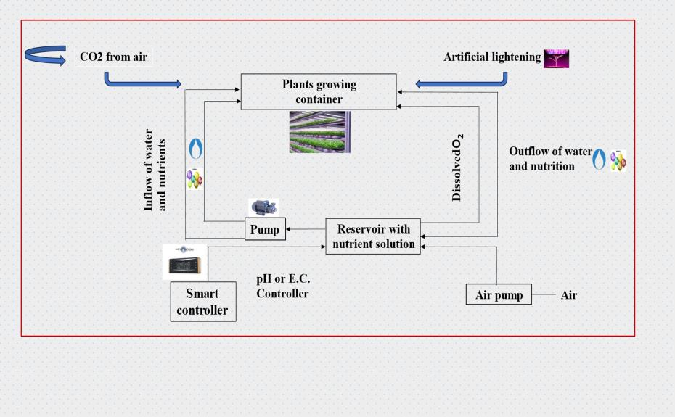

(Source: Hati and Singh, 2021)

**5. Suitability of nutrient solution for hydroponic fodder production system**

In hydroponic systems, the primary method of delivering plant nutrients is through nutrient solutions. Nutrient solutions composed of mostly contain inorganic and organic ions that provide specific nutrition to flourish the plants (Thakur et al., 2023). In hydroponics, plant nutrients are dissolved in water in inorganic and ionic forms. All essential elements for plant growth are supplied through various chemical combinations. Establishing a nutrient solution with a favorable ion ratio is crucial for successful crop cultivation in hydroponic systems (Nguyen *et al*., 2021). Ojo *et al.*, (2024) conduct an experiment to compare organic nutrient solutions (ONS) and commercial nutrient solutions for hydroponically growing maize fodder. It was found that maize fodder irrigated with poultry ONS recorded the highest dry matter yield (196 g) and had significantly higher crude protein (CP) content compared to other ONS and commercial solutions.Adeoye et al., (2024) recommends cattle nutrient solution as hydroponic organic nutrient solution for sorghum red as it enhances fresh and dry matter yields, and nutritive values. carried out experiments to identify suitable nutrient and environmental conditions for Brahmi commercial cultivation in hydroponic system. Brahmi growth was observed to be high in NFT system followed by DFT system with cocopeat as physical support system and syngenta fertilizer as a suitable nutrient recorded higher shoot, root length, fresh and dry weight (Sharma et al., 2023). Gunasekaran et al, (2022) was conducted with biogas slurry as nutrient solution at 2.5%, 5.0% and 7.5% levels for hydroponic fodder maize production by foliar spraying method with six replications. The effect of graded levels on the mean biomass yield on hydroponic fodder maize growth was studied. The recorded biomass yield at the dilution of 2.5% biogas slurry as nutrient was statistically higher compared to other treatments (4.48 kg). In contrast to this study, Nugroho et al, (2015) produced hydroponic fodder maize with higher level of biogas slurry (25%) as nutrient solution for feeding dairy cows

**Table number 1. Nutritional composition differences in conventional and hydroponically grown Maize**

|  |  |  |
| --- | --- | --- |
| **Nutrients** | **Conventional green fodder** | **Hydroponic green fodder** |
| **Protein** | 10.69 | 13.59 |
| **Ether Extract** | 2.28 | 3.53 |
| **Crude Fibre** | 25.97 | 14.14 |
| **Nitrogen Free Extract** | 51.79 | 66.78 |
| **Total Ash** | 9.39 | 3.89 |
| **Acid Insoluble Ash** | 1.42 | 0.35 |

(Source: Indira et al, 2020)

To support these table, hydroponic cultivated maize, wheat, and Sudan grass fodder has higher protein and lipid content, and conventional grown fodder had higher levels of fiber and ash, potentially impacting digestibility and nutrient availability and also, promising methods for enhancing the nutritional quality of fodder, thereby improving livestock health and productivity. (Islam et al*,* 2024)

**6. The effectiveness of hydroponically grown fodder on the growth and performance of ruminants.**

Several studies have shown that feeding cattle with hydroponic fodder enhanced the uptake and digestibility of fodder, which in turn increased the milk production in the cattle. Therefore, hydroponics is an alternative efficient technology for producing quality fodder and year-round supply to the cattle (Akkenapally and Lekkala*,* 2021). Joshiet al., (2024) investigated the effects of hydroponically grown maize fodder, both with and without probiotic supplementation in male Gir calves. The study revealed improvements in the concentrations of total protozoal count, total volatile fatty acids (TVFA), rumen ammonia nitrogen (NH3-N), total rumen nitrogen, TCA precipitable nitrogen (TCA-PN), and non-protein nitrogen (NPN). A similar study conducted by Jediya et al, (2021) concluded hydroponics maize fodder has beneficial effect on growth performance and intake of digestible nutrients in Gir calves and it can replace up to 75% of crude protein of concentrate mixture. The concentrate can be replaced with hydroponic maize fodder at 25% and 50% levels in the diets of Tellicherry buck kids, it achieved better growth and profit. (Jemimah et al., 2023). Substituting grass silage with hydroponic maize fodder enriched with fermented compost tea up to 75% of the diet improved digestibility and rumen fermentation without negatively affecting intake, digestibility, or blood metabolites in Kacang goats. (Sulistijo et al., 2024). The combination of maize and wheat hydroponic fodder resulted in better growth and reproductive performance compared to feeding maize or wheat hydroponic fodder alone. Furthermore, this feeding strategy reduced the cost per kilogram of live weight gain, indicating its potential for enhancing the sustainability and profitability of goat farming systems in the East Champaran region of Bihar (Rajak et al., 2024). Rajkumar et al., (2017) concluded that hydroponics maize fodder can effectively substitute up to 30 per cent of protein in calf starter without compromising the growth performance.Dadhich et al., (2020) found that feeding Rathi calves with hydroponic maize fodder improved ruminal TVFA and nitrogen fractions. The highest values were seen when 25% of CP was met through concentrate mixture and the rest with hydroponic maize fodder. Hydroponic Fodder Maize is more nutritious than conventional fodder maize and calf starter can be replaced with HFM on dry matter basis at 75 percent level without any adverse effect on the haemato-biochemical parameters in cross bred calves (Rani et al., 2019). Bhalerao et al., (2019) concluded that hydroponic green maize is superior in respect of crude protein (CP) content, ether extract (EE) and nitrogen free extract (NFE) than the green maize and lowest crude fibre content indicates higher palatability and inclusion of 40% hydroponic green maize in the diet of Osmanabadi goats increases the DMI, improve the growth performance in terms of body weight, body length, chest girth and wither height and economics in term of body weight gain. Hydroponic fodder supplementation improved reproductive performance in buck kids to some extent by an earlier onset of puberty with greater scrotal circumference and testicular volume, good semen quality, and intense sexual behavior and the supplementation of hydroponic maize fodder also enhanced nutrient digestibility. The inclusion of hydroponically grown maize fodder in the diet of broiler poultry resulted in a significant gain in growth rate and an improved feed conversion ratio. Also, the supplementation of hydroponic maize fodder in the broiler poultry diet was found to reduce the feed cost by Rs. 10.36 per bird. (Murthy et al., 2020)

**7. The influence of age and seed rate on the dry matter yield and nutritive quality of hydroponically cultivated fodder**

The optimal seed rate and age are critical parameters in agro-techniques, directly influencing the productivity, profitability, and quality of fodder production (Ningoji, et al., 2020). Alemnew and Mekuriaw, (2023) concluded that based on fresh fodder biomass yield, dry matter yield, crude protein, and economic benefits, Debark-1 was the recommended barley variety on the 12-day harvesting age, followed by HB-1307, local, and Tila barley varieties. Ashique *et al*., (2024) conducted a study on four different times of harvest (9th, 11th, 13th and 15th days of harvesting) and two fodder crops (maize and cowpea). The results revealed that the higher green fodder yield (26.64 kgm-2) and dry matter yield (3.06 kgm-2) were recorded on the 15th day of harvesting in odder crop Cowpea, whereas lower green fodder yield (18.58 kgm-2) and dry matter yield (2.28 kgm-2) were recorded on the 9th day of harvesting in Maize. In terms of economics, it can be concluded that cowpea has a higher gross return, net return and B:C ratio. Harvesting the crop at 15th day has resulted in higher returns but 13th day of harvesting time was found more economical due to higher increase in the rate of gross and net monetary return.

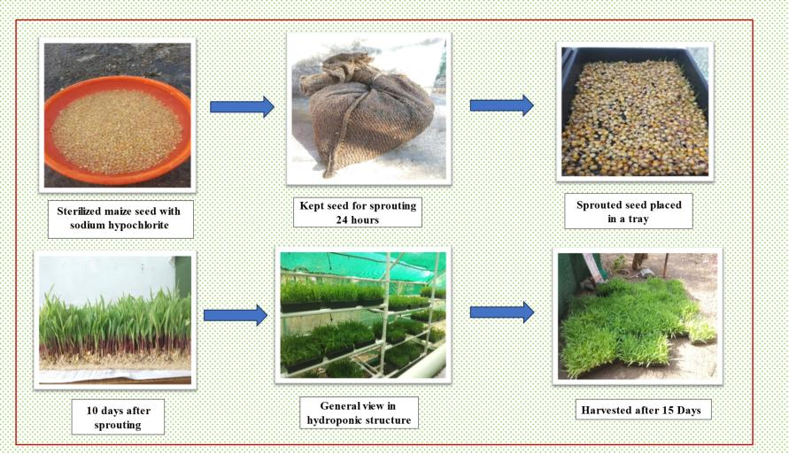

**Figure 5. Schematic view of the operation to be carried out for hydroponically grown maize at AICRP for Dryland Agriculture, Dr. Panjabrao Deshmukh Krishi Vidyapeeth, Akola (M.S.).**

Gunasekaran et al. (2018) found that the highest biomass yield (4.50 ± 0.57 kg/kg of seed) was obtained at a seed rate of 250 g/sq. ft on the 9 th day of growth and there was no significant variation in biomass yield of hydroponic fodder maize regardless of soaking and germination times. However, numerically higher biomass yield was observed with 12 hours of soaking and 24 hours of germination. Studies on sorghum hydroponic fodder quality and quantity studies, varieties Super-1 harvested at 12 day had a good quality (CP) of fodder and it can be alternative of technology providing quality forage and land saving with a short time planting period and continuous production (Chrisdiana, 2018). Among barley green dodder, Behrokh cultivar with seed rate of 800 g/tray is recommended for fodder production in hydroponic systems in semi-arid climate condition of Iran (Afzalinia and Karimi, 2020). Three experiments were conducted to examine the effect of varieties, frequency of watering and harvesting dates on biomass yield and nutritive values of hydroponically sprouted fodder of four different maize varieties viz, s BH-661, BH-140, BH-540 and BH-545 (QPM). It was observed that BH-661 yielded the highest DM yield. The longer harvesting dates decreased fodder yield. The crude protein (CP) and cell wall contents such as neutral detergent fiber (NDF), acid detergent fiber (ADF) and acid detergent lignin (ADL) were higher for sprouted maize varieties than its grain. The in vitro dry matter digestibility (IVDMD) of the maize fodder (71.88%) for all varieties was lower than the mean values for their grain (82.65%) (Bekele et al., 2020). A solar-operated hydroponic system was set up at CTAE, Udaipur using bamboo sticks, shade net, and plastic trays with automatic irrigation managed by Arduino and solar power with three maize seed rates (600 g, 750 g, 900 g per tray) were tested. The highest crude protein (14.81%) and ether extract (3.01%) were observed in the 900g/tray hydroponic fodder after 10 days. Babu and Babu (2024) found that fodder grown under LED lights yielded 3.5 kg per tray with a water use efficiency of 825.9 kg/m³, significantly outperforming non-LED grown fodder. Crude protein and crude fiber content were 12.44% and 9.49%, respectively, under LED lights.

**8. A comparative evaluation of various hydroponic fodders is essential to determine their accessibility and suitability for farmers.**

Selecting the appropriate fodder crops and implementing cost-saving measures, hydroponic fodder production can be optimized to achieve maximum yield with minimal expenditure**.** The results of the study showed that the hydroponic fodder yields from each kg grain were recorded higher in fodder oat (7.96 kg) compared to wheat (6.76 kg) and maize (5.32 kg). Similarly, the crude protein (CP) content of the fodder was higher in wheat (16.16%) compared to oat (13.96%) and maize (12.51%). The cost of hydroponic maize, oat and wheat fodder production were obtained as recorded NPR 20.64, 24.67 and 18.76 per kg, respectively (Upreti et al., 2022). Murthy (2017) conducted an experiment to evaluate four varieties of cereals grains and four verities of Pulses. The high biomass yield after 5 days in cereals was recorded in Bajra (6.37 kg) followed by sorghum (6.1 kg), Barley (5.06 kg) and Maize (4.82 kg). Among pulses Pillipesara (7.58 kg) yielded highest weight followed by Cowpea (7.2 kg), Lucerne (7.09 kg) and Horse gram (5.85 kg). Corn is better used as fodder compared to sorghum, because corn fodder has a greater number of leaves, the growth speed is faster, the production of fresh and dry matter is also higher compared to sorghum fodder. (Wulandari *et al*., 2024). Khanna (2015) summarized that chemical composition (% DMB) indicated CP and EE contents were higher in hydroponic maize fodder as compared to either conventional maize fodder or maize grain while the NFE content was higher compared to conventional maize fodder but lower when compared to the maize grain. Naik et al, (2015a) suggested Maize to be the choice for production of hydroponic fodder due to its easy availability, lower cost, good biomass production and quick growing habit. In another study, Naik et al. (2014) Hydroponics maize fodder of 7 days growth was studied and such hydroponics maize fodder (HMF) had higher CP (13.30 vs11.14, %), EE (3.27 vs 2.20, %), NFE (75.32 vs 53.54, %) and lower CF (6.37 vs 22.25, %), TA (1.75 vs 9.84, %) and AIA (0.57 vs 1.03, %) than Napier bajra hybrid. Garcia-Latorre and Poblaciones, (2024) studied the impact of fungal inoculation on hydroponic wheat and barley under saline conditions. The results showed that fungal treatments improved plant growth and NaCl resistance, with variations in efficacy among different fungi, L15 showed broader bioactivity, L16 was more effective in barley, and L11 was beneficial in wheat but detrimental in barley.

**9. Effect of hydroponic system on fodder Yield and milk productivity of livestock**

The primary goal of any agricultural production technology is to enhance yield, thereby contributing to increased milk production, as agriculture and livestock systems are inherently interdependent. Under such conditions, hydroponic fodder production is particularly appropriate due to its ability to optimize productivity and resource efficiency. Naik *et al*, (2015b) reported fresh yield of 8-10 kg from one kg locally grown maize in 7-10 days under low-cost devises. Assefa et al, (2020) examined that the BH661 exhibited significantly higher dry fodder yield (6.63 kg) per square meter and per kg seed than the other varieties. The 6.0 kg HMF was obtained from one kilogram of maize seed within 7 days without using any nutrients in the irrigated water (Murthy *et al*, 2020). Egamberdieva et al, (2024) analyzes the effect of concentrated forages were replaced by Hydroponic Green Fodder 25, 35, and 45% by nutrient content, respectively and in the control group, a balanced feeding ration was prepared, considering live weight and milk productivity. The results revealed that milk yield of cows increased by 5.6–13.2 percent, and milk fat yield increased by 5.9–12.9% in comparison with the control group. It has been established that the introduction of HGF into the diet of cows improves the qualitative composition of milk and contributes to the increase of milk solids without reducing their physical properties. Arivukodi et al., (2020) reported that 1kg of seed has potential to raise the green fodder about 15-20 kg through hydroponic system with a low-cost technique. All the nutrients like crude protein, fiber, vitamins and minerals get increased in hydroponic fodder that resulted into increase the milk production. It could be concluded from study that feeding hydroponics maize fodder to replace concentrate mixture up to 75 per cent level on CP basis increase the milk yield in Gir cows with decreased in the fat percentage and increase in milk total solids. In hydroponic fodder production, 5-10 kg of green fodder can be grown from 1kg of seeds. This fodder shows an increase in nutritional content, including crude protein, fiber, ether extract, vitamins, and minerals. However, there is a 10-25% loss in dry matter content, varying by grain type and growth duration. Feeding hydroponic fodder to dairy cows enhances milk yield and composition due to improved nutrient intake and digestibility. (Salo, 2019). Jamimah et al, (2018) conducted a study to evaluate the effect of hydroponic maize fodder on milk production in crossbred dairy cattle by replacing CO4 grass. The study had three groups: Treatment 1 (control with no replacement), Treatment 2 (50% replacement of CO 4 grass with hydroponic maize fodder), and Treatment 3 (100% replacement of CO 4 grass with hydroponic maize fodder). Results found that there were no significant differences in milk yield among the three groups, both before and during the trial. In a study, cows in the experimental group had a 6% higher milk yield (549.5 kg) over 305 days of lactation compared to the control group. The average daily milk yield was 1.8 kg (6%) higher. Additionally, the mass fraction of fat in milk increased by 0.4%, protein by 0.35%, resulting in a 17.5% (118 kg) increase in milk fat and a 19% (98.9 kg) increase in milk protein in the experimental group. Limba et al., (2019) assessed the utilization of hydroponic maize fodder to improve feed efficiency and milk production in Rathi cows. The study revealed a significant effect on milk yield, 4% fat-corrected milk yield, fat percentage, and total solids. However, the treatment did not significantly affect SNF%, protein%, and lactose%. Supplementation of 5-10 kg hydroponic fodders per cow per day increases milk production by 8-13%, and meat quality based on the digestibility of the nutrients (Shit, 2019). In the Satara district of Maharashtra, dairy farmers noticed the reduced cost of milk production by 2–3.5/kg feed and improved milk yield by 0.5–2.5 litre/animal/day on feeding hydroponic fodder (Reddy and Harani, 2023b).

**10. Advancements in hydroponic fodder production technologies to enhance efficiency and sustainability in meeting fodder demand**

Advancements in hydroponic fodder production technology offer a promising solution to address growing fodder demands while promoting sustainable livestock farming practices by optimizing resource utilization and maximizing yield in challenging environments. Jabbar and Ali, (2023) carried experiments to enhanced Fodder for these cultivation method (A1: Hydroponics, A2: Cultivation in the field as a comparative treatment) and the second included three concentrations of gibberellin (C0: 0 ppm, C1: 50 ppm, C2: 100 ppm), were taken. The hydroponic treatment was superior in leaf area, chlorophyll content, green fodder yield, dry fodder yield and protein content, the 100 ppm concentration of GA was superior in leaf area, green fodder yield, dry fodder yield and protein content, the interaction between the hydroponic system and 100 ppm concentration of GA was given higher leaf area, green fodder yield, dry fodder yield and protein content. Masucci et al., (2024) conducted research on a water buffalo dairy farm equipped with a fully automated hydroponic system producing approximately 6,000 kg/d of hydroponic barley fodder as fed (up 1,000 kg/d on DM basis)**.** Based on the data obtained from the in vivo study, the water and energy footprints to produce maize silage and hydroponic barley fodder and buffalo milk, as well as income over feed cost, were evaluated. The resource footprint analysis showed potential benefits associated with HBF in terms of water consumption. However, the energy footprint assessment showed that the energy ratio of HBF was less than 1 (0.88) compared with 11.89 for maize silage. Gosavi (2017) designed an IoT-based hydroponic system that uses sensors to capture the pH level of the water solution, electrical conductivity, and luminosity. After data collection, the ARM 7 microcontroller automatically evaluates whether the values exceed the thresholds and makes the necessary adjustments. An LCD display is utilized to visualize the output and debug the system module. In this study, maize treated with nano silica (20–40 nm) is screened for resistance against phytopathogens such as *Fusarium oxysporum* and *Aspergillus niger* and compared with that of bulk silica and shows that silica nanoparticles can be used as an alternative potent antifungal agent against phytopathogens. Ronay and Dumitru, (2015) examined solar-powered hydroponic greenhouses, conducting a financial analysis to assess the economic viability of using renewable energy versus conventional power sources. The results indicated that the investment is economically viable, with a payback period of about 6 years.

**Fig 6. Challenges in Hydroponics production technology**

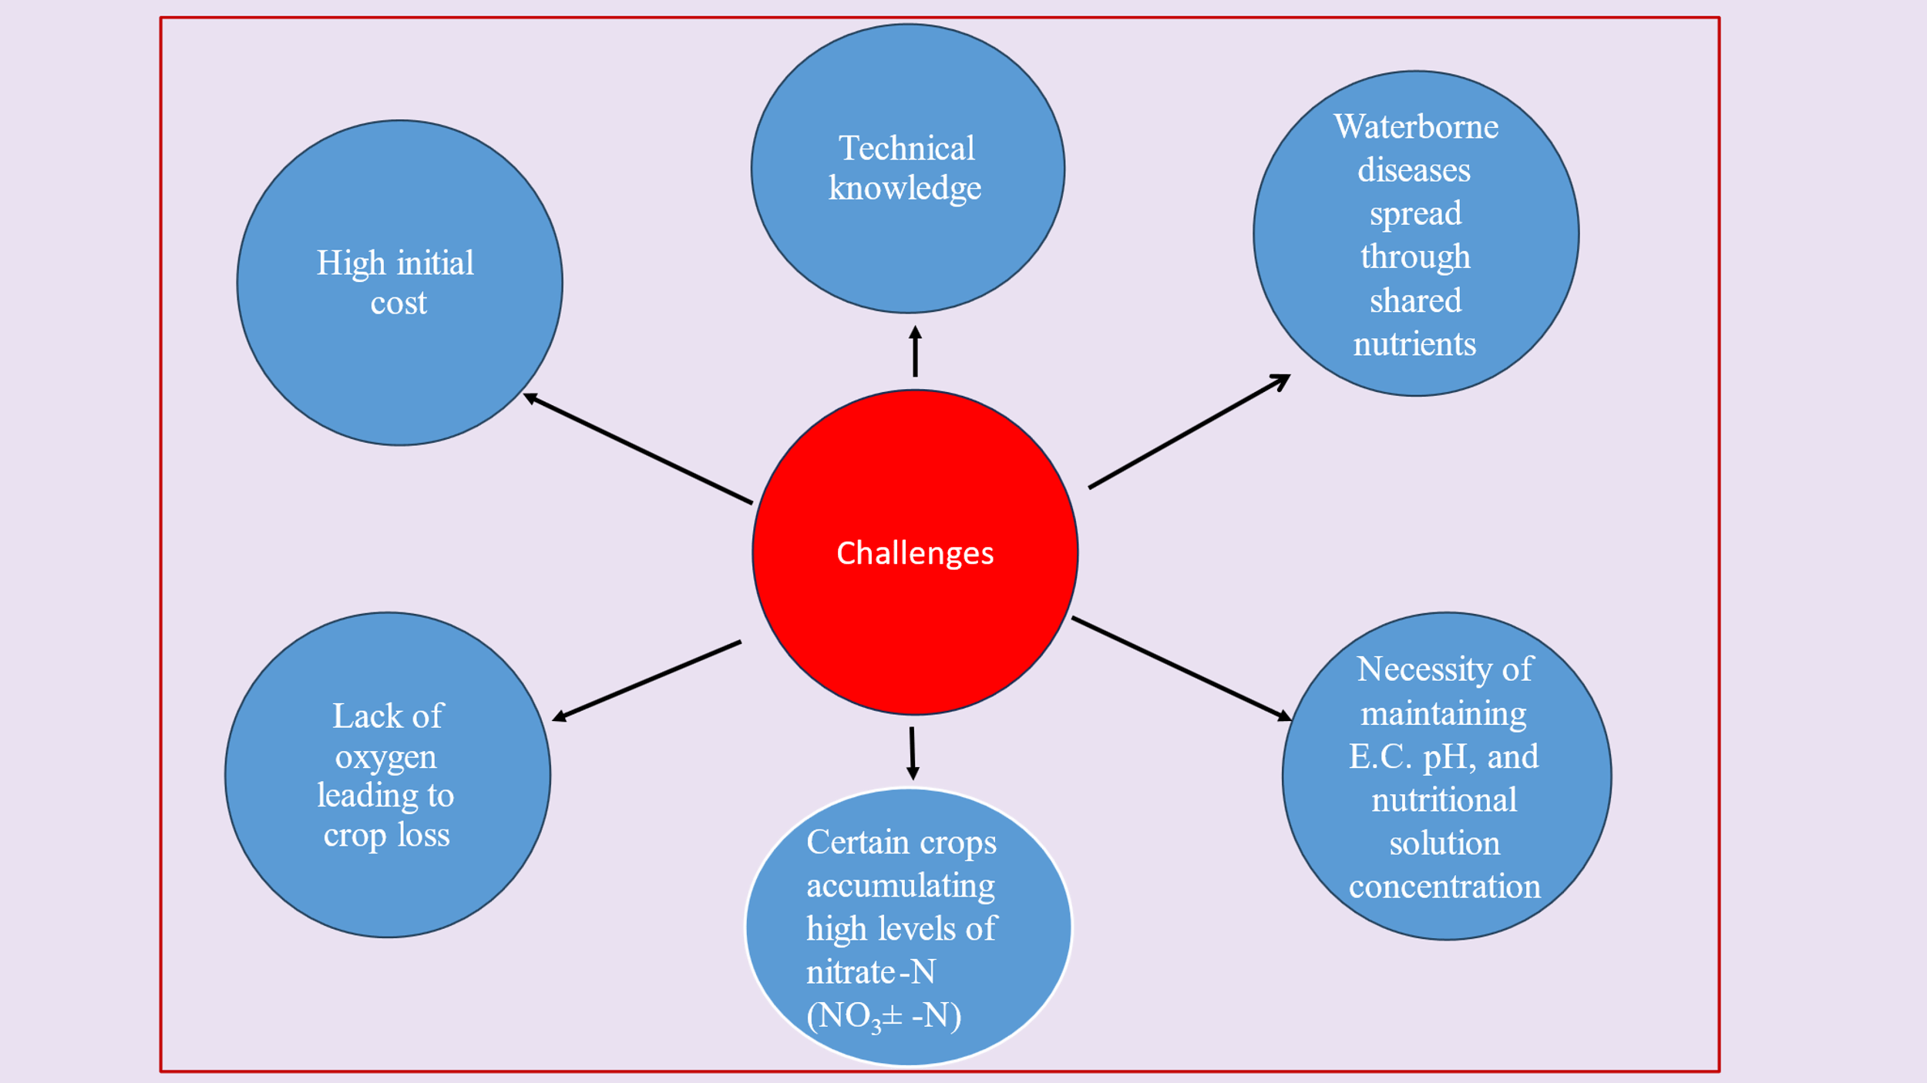

Source: (Sharma et al., 2018), (Guo et al, 2019)

**12. Future scope of hydroponics**

hydroponics, a soilless production method, promises to deliver high quality, nutritious, fresh, residue-free crops, overcoming the problems of climate change, freshwater shortage, necessity of fertile land, and the overwhelming requirement of the expanding food demand. Hydroponics production is now garnering prominence across the world because of its effective resource management and cultivation of high value crops (Kumar and Singh, 2023). Reusing partially treated water for hydroponic plants reduces costs, conserves water, and supports sustainable development goals like zero hunger, no poverty, clean water, and sanitation (Aishwarya and Vidhya, 2023). Hydroponics allows year-round cultivation anywhere, enhancing urban agriculture. This can improve the food supply chain's efficiency and cleanliness, boosting food security amid climate change (Wheeler and Von Braun, 2013). The establishment of the new market for hydroponics crops and vegetables in India is a great challenge as the market demand is driven by traditional or terrestrial farming. Therefore, it is a need of hours to create awareness about hydroponics in our country.

**13. Conclusions**

In the era of burgeoning global population, declining per capita availability, and the shrinking cultivated area of fodder production, hydroponics fodder production are better options especially in vertical farming. This technique intensifies fodder production by offering controlled conditions and minimizing external complexities. The efficacy of hydroponic fodder production is not solely decided by crop selection, age, and seed rate but is also significantly influenced by advancements in technology. Presently, hydroponic systems are extensively utilized to examine plant responses to various stress conditions and to identify suitable genotypes. This method also facilitates biofortification through the provision of optimized nutrient solutions, enhancing the nutritional profile of the produce. Moreover, hydroponics is a new avenue for organic food production methods. By exploiting these advancements, hydroponic systems can substantially contribute to meeting the increasing demand for high-quality fodder supporting sustainable agricultural practices.

**14. DISCLAIMER (ARTIFICIAL INTELLIGENCE)**

Author(s) hereby declares that NO generative AI technologies such as Large Language Models (ChatGPT, COPILOT, etc) and text-to-image generators have been used during writing or editing of this manuscript.

**15. CONFLICT OF INTEREST**

All authors declare that they have no conflict of interest.

**16. REFERENCES**

Adeoye, S., Ojo, V., Ogunbote, O., Ogunbote, O., Adeyemi, T. and Ahmed, A. (2024). Effect of different organic nutrient solutions and day of harvest on growth, biomass yield and chemical composition of hydroponically grown sorghum. Trends in Horticulture. 7(2):40-47.

Afzalinia, S. and Karimi, A. (2020). Barley cultivars and seed rates effects on energy and water productivity of green fodder production under hydroponic conditions. Indian Journal of Agricultural Research. 54(6):792-796.

Aishwarya, J.M. and Vidhya, R. (2023). Study on the efficiency of a hydroponic treatment for removing organic loading from wastewater and its application as a nutrient for the “Amaranthus campestris” plant for sustainability. Sustainability.15:7814.

Akkenapally, J.S. and Lekkala, S. (2021). Hydroponic fodder production: A review, The Pharma Innovation Journal, 10(11): 2435-2439.

Alemnew, Y. and Mekuriaw, Y. (2023). Effects of harvesting age and barley varieties on morphological characteristics, biomass yield, chemical composition, and economic benefits under hydroponic conditions in fogera district, Ethiopia. Advances in Agriculture, Article ID 9315556, pp-10.

Annual Report. (2019). 20th Livestock Census-All India Report, Ministry of Fisheries, Animal Husbandry and Dairying, Government of India, New Delhi.

Arivukodi, J., Poomani, G., Praveena, M. and Gnanavel, G. (2020). A review on using different types of cultivars to produce green fodder under hydroponic system and to increase the efficiency of milk. Journal of Emerging Technologies and Innovative Research. 7(2):930-932.

Ashique, A., Chorey, A.B., Ganvir, M.M. and Chaitanya, V. (2024). Productivity and economics of hydroponic fodders as influenced by harvesting time. Journal of Scientific Research and Reports.30(6):263-267.

Assefa, G., Urge, M., Animut, G. and Assefa, G. (2020). Effect of variety and seed rate on hydroponic maize fodder biomass yield, chemical composition, and water use efficiency. Biotechnology in Animal Husbandry. 36(1):87-100.

Babu, D.A. and Babu, B.C. (2024). Development and evaluation of low cost indoor hydroponic green fodder production system. Journal of Scientific Research and Reports. 30(12):871-880.

Bekele, M., Diba, D. and Yusuf, H. (2020). Watering intervals and harvesting dates affected fodder yield and nutritional values of maize varieties under hydroponic system in Wollega university. American-Eurasian J. Agric. And Environ. Sci. 20(2):89-98.

Bhalerao, S.B., Zinjarde, R.M., Atkare, V.G. and Kadam, N.P. (2019). Effect of feeding of hydroponic maize on growth performance Osmanabadi goats. Journal of Pharmacognosy and Phytochemistry. 8(5):508-511.

Chapman, S.C., Chakraborty, S., Dreccer, M.F., Howden, S.M. (2012). Plant adaptation to climate change opportunities and priorities in breeding. Crop Pasture Sci. 63:251–268.

Chrisdiana, R. (2018). Quality and quantity of sorghum hydroponic fodder from different varieties and harvest time. IOP Conf. Series: Earth and Environmental Science. 119:012014

DAC and FW, GOI, (2020). Agricultural Statistics at a Glance.

Dadhich, R., Dhuria, R.K., Nehra, R., Jain, D. and Sharma, T. (2020). Effect of feeding of hydroponics maize fodder on rumen parameters in Rathi calves. Veterinary Practitioner. 21(1):142-144.

Egamberdieva, Z., Kurbanova, S., Sadikova, C., Akhtamova, M. and Davron. (2024). The use of hydroponic green forages in increasing milk productivity and improving reproductive ability of Holstein cows. BIO Web of Conferences, Genetic Resources 01016:15.

Elmulthum, N.A., Zeineldin, F.I., Al-Khateeb, S.A., Al-Barrak, K.M., Mohammed, T.A., Sattar, M.N., Mohmand, A.S. (2023). Water use efficiency and economic evaluation of the hydroponic versus conventional cultivation systems for green fodder production in Saudi Arabia. Sustainability. 15:822.

Garcia-Latorre, C. and Poblaciones, M.J. (2024). Isolation, identification, and application of endophytic fungi from lavandula stoechas l.: mitigating salinity stress in hydroponic winter cereal fodder. Agronomy. 14 :2501.

Gebremedhin, W. K. (2015). Nutritional benefit and economic value of feeding hydroponically grown maize and barley fodder for Konkan Kanyal goats. Journal of Agriculture and Veterinary Science. 8(7):24–30.

Ghorbel, R. and Koşum, N. (2022). Hydroponic fodder production: an alternative solution for feed scarcity. 6th International Students Science Congress. pp:1-8.

Gosavi, J. V. (2017). Water monitoring system for hydroponics agriculture. vol 5(7):12-17.

Gunasekaran, S., Valli, C., Karunakaran, R., Gopi, H. and Gananaraj, P. T. (2022). Evaluation of growth period and water and light requirement for optimum production of hydroponic maize and horse gram fodder. Org. Agr. 12:75–80.

Gunasekaran, S., Valli, C., Karunakaran, R., Gopi, H., Gnanaraj, P. and Sankaran, V. (2018). Studies on influence of soaking, germination time and seed rate on biomass yield of fodder Maize (*Zea mays* L.) cultivated through fabricated hydroponic fodder production unit. International Journal of Livestock Research. 8(1):190-194.

Guo, J., Yan, Y., Dong, L., Jiao, Y., Xiong, H. and Shi, L. (2019). Quality control techniques and related factors for hydroponic leafy vegetables. Hort Science. 54(8):1330-1337.

Hati, A.J. and Singh, R.R. (2021). Smart Indoor Farms: Leveraging Technological Advancements to Power a Sustainable Agricultural Revolution. AgriEngineering.3:728–767.

Hilli, H., Kapoor, K. and Amandeep. (2023). Forage production in India: bottlenecks and opportunities by opening up new way with an increase in fodder Oats demand: A Review. Asian Journal of Dairy and Food Research. 42(3):275-285.

Indian Grassland and Fodder Research Institute (Indian Council of Agricultural Research). www.igfri.res.in Vision 2050. <https://igfri.icar.gov.in/>, pp 1-40.

Indira, D., Aruna, P., Kanthi, S.S. and Kumar, K. (2020). Hydroponics as an alternative fodder for sustainable livestock production. World Journal of Advanced Research and Reviews. 05(02):087–092.

Islam, B.M., Ahmed, G.U., Islam, A., Khan, S.M, and Akter, F. (2024). Assessment of nutrient content in grain, hydroponic and conventional fodder with focus on maize, wheat and Sudan grass. International Journal of Biosciences. 24(3):187-194.

Islam, M.M., Anjum, S., Modi, R.J. and Wadhwani, K.N. (2016). Scenario of livestock and poultry in India and their contribution to national economy. International Journal of Science, Environment and Technology, 5(3):956 – 965.

Jabbar, M.K. and Ali, F.A. (2023). Providing fast fodder technology from barley crop by using a hydroponic system with different gibberellin concentrations. Trends Agric. Sci. 2(2):131-138.

Jediya, H. K., Shende, K.A., Dhuria, R.K., Vaishnava, R.S. and Barolia, Y.K. (2021). Effect of hydroponic maize fodder supplementation on growth performance, nutritive ratio and intake of digestible nutrient in Gir calves. International Journal of Bio-resource and Stress Management. 12(5):450-454.

Jemimah, R., Gnanaraj, T.P., Muthuramalingam, T., Devi, T. and Bharathidasan, A. (2018). Effect of hydroponic maize fodder with replacement of CO4 grass on milk production in crossbred dairy cattle. International Journal of Agricultural Sciences and Veterinary Medicine. 6(1):105-111.

Jemimah, R.E. Gnanaraj, T.P., Sivakumar, T., Gopinathan, A. and Meenakshi, S.S. (2023). Productive performance and economics of Tellicherry buck kids fed varying levels of hydroponic maize fodder. Indian Journal of Animal Sciences. 92(2): 250–253.

Joshi, M., Sharma, S. K. and Vaishnava, C.S. (2024). Effects of hydroponic maize fodder with and without supplementation of probiotics (*Saccharomysis cerevisiae*) on rumen parameters in calves. International Journal of Bio-resource and Stress Management. 15(5):01-06.

Khanna, C.H. (2015). Effect of feeding rations supplemented with hydroponic maize fodder on nutrient utilization and milk production in lactating graded Murrah buffaloes. Thesis submitted to the Srivenkateswara Veterinary University in partial fulfillment of the requirements for the degree of Master of Veterinary Science. pp:4-5.

Kumar, A. and Singh, J. (2023). Trends in Hydroponics Practice/Technology in Horticultural Crops: A Review. Journal of Plant & Soil Science. 35(2):57-65.

Malhi, G.S., Kaur, M., Sharma, K. and Gupta, G. (2020). Hydroponics technology for green fodder production under resource deficit conditions. Vigyan Varta. 1(5):65-68.

Masucci, F., Serrapica, F., Cutrignelli, M.I., Sabia, E., Balivo, A. and Francia, A.D. (2024). Replacing maize silage with hydroponic barley forage in lactating water buffalo diet: Impact on milk yield and composition, water and energy footprint, and economics. J. Dairy Sci. 107:9426–9441.

Murthy, A. K., Dhanalakshmi, G., Chakravarthy, K. (2017). Study on performance of different fodder crops under low-cost greenhouse hydroponic fodder production system. International Journal of Environment, Agriculture and Biotechnology. 2(2):951-953.

Murthy, K.A., Chakravarthy, K M., and Guduru, D. (2020). Effect of hydroponic maize fodder supplementation on production performance in broilers. Forage Res. 46 (1):98-100.

NAAS (2017). Policy Paper No. 85 Hydroponic Fodder Production in India. National New Delhi: 27p.

Naik, P.K., Dhuri, R.B., Karunakaran, M., Swain, B.K. and Singh, N.P. (2014). Effect of feeding hydroponics maize fodder on digestibility of nutrients and milk production in lactating cows. Indian Journal of Animal Sciences. 84(8):880-883.

Naik, P.K., Swain, B.K. and Singh, N.P. (2015). Production and utilization of hydroponics fodder. Indian Journal of Animal Nutrition.32(1):1-9.

Nguyen, V.Q., Van, H.T., Le S. H., Nguyen, T.H. and Lan N. T. (2021). Production of hydroponic solution from human urine using adsorption–desorption method with coconut shell-derived activated carbon. Environmental Technology and Innovation. 23:101708.

Ningoji, S. N., Thimmegowda, M. N., Boraiah, B., Anand, M. R., Murthy, K.R. and Asha, N.N. (2020). Influence of seed rate on growth, yield and economics of hydroponic fodder maize production. Range Management and Agroforestry. 41(1):108-115.

Nugroho, H. D., Permana, I. G. and Pal, D. (2015). *Media Peternakan*, 38(1): 70–76.

Ojo, V., Adeoye, S., Adeyemi, T., Oyaniran, D., Edward, T., Hassan, V., Okunlola, M. and Arigbede, O. (2024). Agronomic characteristics and chemical composition of hydroponic maize fodder as influenced by animal waste solutions. Trends in Horticulture. 7(1): 4062.

Rajak, S. K., Singh, A.K., Singh, A.K., Rai, A. and Gangwar, A. (2024). Assessment of feeding hydroponic fodder on growth and reproduction performance in Black Bengal goat. Tropical Animal Health and Production 56:388.

Rajkumar, G., Dipu, M.T., Lalu, K., Shyama, K. and Banakar, P.S. (2017). Evaluation of hydroponics fodder as a partial feed substitute in the ration of crossbred calves G. Indian J. Anim. Res. 52:   
1-5.

Rani, J.K., Ally, K., Shyama, K. and Purushothaman, S. (2019). Nutritional evaluation and effect of feeding hydroponic fodder maize on the haemato-biochemical parameters in cross bred calves. J. Vet. Anim. Sci, 50(1), 57 – 62.

Reddy, P. B. and Harani, M. (2023). Hydroponics: A sustainable way of green fodder production. Indian Farming. 73(02):02-05.

Ronay, K., and Dumitru, C.D. (2015). Hydroponic greenhouse energy supply based on renewable energy Sources. Procedia Technology. 19:703-707.

Roy, A. K., Agrawal, R. K., Bhardwaj, N. R., Mishra, A. K. and Mahanta, S. K. (2019). Indian fodder scenario: redefining state wise status. ICAR- AICRP on Forage Crops and Utilization, Jhansi, India. pp:1-21.

Salo, S. (2019). Effects of hydroponic fodder feeding on milk yield and composition of dairy cow: Review. Journal of Natural Sciences. 9(8):1-8.

Selyansky, A.I. (2018). Such greenhouses are the future. Journal Potatoes and vegetables. 7:24-26.

Sharma, M., Raghuvanshi, A.C., Singh, P. and Tejovathi. G. (2023). Analysis of viability of using hydroponics in cultivation of medicinal herb Brahmi (*Bacopa Monnieri* L. west). International Journal of Agricultural Sciences. 19:82-90.

Sharma, N., Acharya, S., Kumar, K., Singh, N., and Chaurasia, O.P. (2018). Hydroponics as an advanced technique for vegetable production: An overview. Journal of Soil and Water Conservation. 17(4):364-371.

Shit, N. (2019). Hydroponic fodder production: an alternative technology for sustainable livestock production in India. Explor Anim Med Res. 9(2):108-119.

Singh, S. and Rajni. (2017). Importance of quality fodder for higher milk production in dairy animals. Indian Farming. 67(11):36–39.

Sulistijo, E. D., Benu, I., Oematan, G., Rosnah, U.S., Hilakore, M.A. and Jelantik. I. G. N. (2024). Enhancing nutrient intake, digestibility, rumen fermentation, and blood metabolites in kacang goats using compost-enriched hydroponic maize fodder. Tropical Animal Science Journal. 47(4): 475-482.

Thakur, O., Patel, S. and Dhruw, A. (2017). Hydroponics: an alternative tool for growing crops. Innovative Farming. 2(1):49-51.

Thakur, P., Wadhwa, W., Kaushal, S. and Shubham. (2023). Nutrient Dynamics for Hydroponic Production System. International Journal of Plant & Soil Science. 35(21): 982-993.

Upreti, S., Ghimire, R.P., and Banskota, N. (2022). Comparison of different cereals for hydroponic fodder production in locally constructed polyhouse at Khumaltar, Lalitpur, Nepal. Journal of Agriculture and Natural Resources. 15(1):27-33.

Wheeler T, Von, B.J. (2013). Climate change impacts on global food security. Science. 341: 508-513.

Wulandari, S., Kusuma, S.B., Utomo, B. and Respati. A.N. (2024). Characterization and production hydroponic fodder for corn (*Zea mays*) and sorgum (*Sorghum bicolor*) at different harvest times. 6th International Conference on Food and Agriculture). IOP Conf. Series: Earth and Environmental Science. 1338:012017.