**Design and development of Cost-Effective Small-Scale Automatic Bin Grain Dryer**

**Abstract** – Early season wheat is harvested with high moisture content, which makes it difficult to store. Selling the wheat in its green form is not cost-effective for the farmer, and grain losses are also high when harvested this way. To minimize grain losses and increase the value and profit margin of the farmer, a grain dryer is necessary for wet grains. This paper presents the development of design parameters for cost-effective small-scale automatic wheat grain dryers. The dimensions of the drying chamber, the amount of moisture to be removed in a batch, heater capacity, and fan capacity were all designed to create the dryer. The resulting wheat dryer has a batch size of 50 kg of threshed wet wheat and was tested in a laboratory for experimental purposes. It can also be used for commercial purposes. The dryer can measure the drying rates of wheat at different initial moisture contents, drying air temperatures, and drying air velocities. The effects of different drying temperatures and air velocities can be investigated using the dryer.

**Keywords**: Drying, Moisture content, Temperature, automatic drying

**1. INTRODUCTION**

Wheat is a staple food for the majority of the population of India and supplies 72 percent of carbohydrates and protein in an average diet with a per capita consumption of 120 kg per year. Wheat occupies a central position in agricultural policies and is grown on about 37 percent of the cropped area and accounts for 76 percent of the total food grain production of India. The area under wheat cultivation in India is 30 million hectares, which produced 99.70 million tonnes of wheat with a record average productivity of 3371 kg/ha (Sendhil et al., 2019).

In India, wheat is grown during the winter or rabbi season. The crop is sown during November-December and harvested around April and May when the rain normally occurs. At this time, due to untimely rain showers wheat crops might be damaged, and natural drying on the field is difficult due to low atmospheric temperature and high relative humidity(Javad et al., 2015). If the crop is left on the field to dry, it will continue to deteriorate because of the slow rate of drying. They are therefore harvested with a high moisture content. This decrease in farmer’s income can be averted if, after harvesting, the wheat can be dried and stored. Drying reduces the amount of water contained in the crop after harvest to an acceptable level for marketing, storage, or processing. Both grain temperature and moisture content are critical in maintaining quality. Mold and insect activities are greatly reduced below 15º C safe moisture levels for storage.

In traditional drying and storage methods, post-harvest losses of agricultural products are very high. This is because each of the products has its season and it is mostly produced more than what is immediately needed. The losses are due to a lack of appropriate preservation and storage facilities (Fashina et al., 2013).

Concerning the hot and humid coastal regions like *Konkan*, the people from the regions have to store a buffer stock of wheat for the monsoon or rainy season. The relative humidity in such coastal regions ranges between 70% to 98%. Therefore, to address this solution an automatic bin grain dryer for wheat having a minimum storage capacity of 50 kg could be very useful for such coastal regions.

**2. MATERIALS AND METHODOLOGY**

To develop an efficient automatic bin dryer for wheat, the following properties and parameters were determined.

**2.1 DETERMINATION OF MOISTURE CONTENT**

The moisture content of the wheat was determined to know the amount of moisture to be removed from the freshly harvested wheat grain. The initial moisture content of wheat grain was measured by a digital moisture meter(Sahay and Singh. 2011).

The amount of moisture to be removed in kg (MR) is given in Eq.1 as:

MR = M [] (Eq.1)

Where,

M is dryer capacity per batch (kg),

Q1 = initial moisture content of the wheat to be dried 20%,

Q2 = maximum desired final moisture content, which is 12%. MR is therefore determined to be 4.5 kg.

**2.2 DETERMINATION OF BULK DENSITY OF WHEAT AT HARVEST**

(Arkema, et al, 1999) Developed an empiricalformula that relates bulk density and moisture content for wheat as stated in Eq.2

TWm =0.7019 + 0.01676Mwb – 0.0011598M2wb + 0.00001824M3wb (Eq. 2)

Wheat harvested at maturity normally has an average moisture content of 20% (wb).

Substituting the value of Mwb = 20% (wb) into Eq.1 gives.

TWm = 0.7019 + 0.01676 (20) – 0.0011598 (20)2+ 0.00001824 (20)3

TWm = 0.7191g/cm3

TWm = 719.1 kg/m3

Where,

TWm=Bulk density (kg/m3)

Mwb= Wet basis moisture content (%)

**2. 3. Experimental Setup**

The present study was conducted at the Department of Agricultural Process Engineering lab, CAET, Dr.BSKKV, Dapoli..

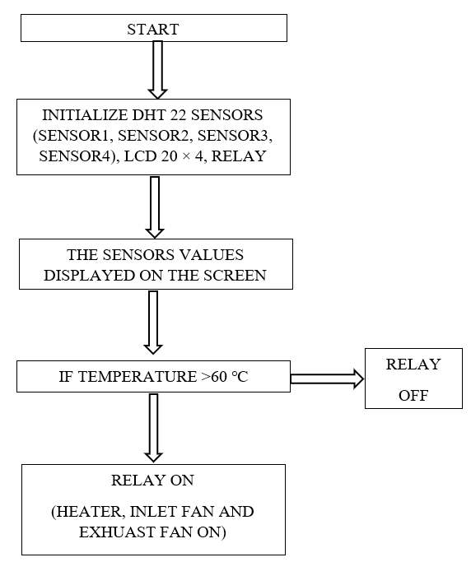

**Fig. 1 Block diagram of developed system**

The developed system consists of a grain storage bin, sensors, microcontrollers, and an LCD display. The storage bin is made of 18-gauge galvanized iron (GI) sheets, measuring 4 × 8 feet, with a capacity of 50 kg. A microcontroller is used to manage the overall operations.

DHT22 sensors, which monitor the temperature and humidity inside the bin, are connected to an Arduino microcontroller. Based on the data collected from the DHT22 sensors, the heater and exhaust fan are activated automatically. A 20 × 4 LCD display is used to show the readings from these sensors. Figure 1 illustrates the overall block diagram of the electronic components of the semi-automatic drying system for wheat.

As per the design of the system, heater was placed in the plenum of the bin and the arrangement of exhaust fan was fitted 8cm from top of the bin. Wheat as a sample grain used for the drying. When put the wheat grains into the bin whichever having a moisture level 24%. Temperature sensors was sensing the temperature present in the bin and if it is greater than the value, Exhaust Fan and Heater was get ON until the level reaches down to normal and the wheat gets dry. These values of temperature and humidity was displayed on the LCD 20*4. Isolated 12V, 30A relay used to control ON/OFF operations of the fan and heater.

**3. RESULT AND DISCUSSION**

**3.1 DESIGN CONSIDERATIONS**

The dryer design prioritized uniform drying through consistent temperature and moisture distribution. To achieve this, inlet air was channelled through a perforated pipe, ensuring even airflow across the grain bed. This perforated pipe also minimized static pressure, reducing the fan's workload. A cylindrical design facilitated uniform agitation, further contributing to drying consistency. A galvanized iron (GI) sheet was selected for the inner wall, perforated pipes, and floor due to its durability and suitability for grain contact. Finally, an appropriately sized heater was incorporated to optimize the drying rate by effectively raising the inlet air temperature.

**3.2 DESIGN OF THE DRYER**

The design of the automatic bin dryer (Figure 1) was based on the following parameters: the amount of moisture to be removed, heater design and capacity, and fan design. The design was based on the ambient temperature of 34℃. The safe drying temperature for wheat drying was considered a maximum of 60℃ (Schirmer *et al*., 2006).

**3.3 DESIGN OF THE DRYING CHAMBERS (DIMENSION)**

The drying chamber size was determined assuming a cylindrical configuration and a batch mass of 50 kg of wheat grain (Tadele et al., 2010).

The bulk density of the wheat grain depicts that 719.1 kg of freshly harvested maize occupies 1 m3 by volume,

1 kg of freshly harvested wheat occupies 1/719.1 = 0.001390 m3

50 kg will occupy 0.001390 × 50 m3 = 0.0695 m3

Since the dryer is cylindrical, assuming a diameter of 600 mm

Volume = base area x height.

0.0695 = π× 0.32 × height

height = 0.0695/ π × 0.32 = 0.03 m = 300 mm.

The drying chamber dimensions were determined to be 600mm in diameter and 300mm in height.

**3.4** **DESIGN OF THE FAN**

An axial fan, was used to force air through the system. Power requirement rises rapidly as air flow rates increase and as the depths of the stored grain increase. Considering all these design issues, an Axial fan was selected and used (Wilcke and Vance, 1993, Peter and Reinyelda, 2022).

Total airflow (cfm) = Aeration rate (cfm/bu) × Bin capacity (bushel)

Aeration rate (cfm/bu) = 21 cfm/bu

Total airflow (cfm) = 21(cfm/bu) × 1.7 (bushel)

Total airflow (cfm) = 35 cfm

Fan power (hp) = (Eq. 3)

Static pressure (in water) = 4.5 in water

Fan power (hp) = (35 × 4.5) ÷ 3178

Fan power (hp) = 0.0495hp

746 watts = 1 hp

Therefore,

Fan (watt) =36 watt

* 1. **DESIGN OF THE HEATER**

The heater was used for drying grain. It was fitted in the centre of the bin so that air gets heated at the inflow and proper air heating was achieved (Dirk and Fred, 2002; Sammy et al., 2017).

Heater capacity = (Eq. 4)

= 35 × 140 ÷ 3000

Heater capacity (watt) =1000 watt

**3.6 DESCRIPTION OF THE DEVELOPED AUTOMATIC DRYER**

The dryer used in the process was a batch type. It had a cylindrical bin that served as the drying chamber, with a perforated pipe and floor. A single pipe was placed in the centre of the cylinder. The upper lid of the cylinder was cut out to serve as an inlet (grain hopper) for the grain to be dried. The heated air was forced into the cylinder by an axial fan blowing directly on a set of heater elements. As the heated air came in contact with the grains in the chamber, it picked up moisture from the grains and released it to the atmosphere through the outlet fan. The schematic view of the bin dryer is shown in fig 2 and pictorial view shown in fig 2.

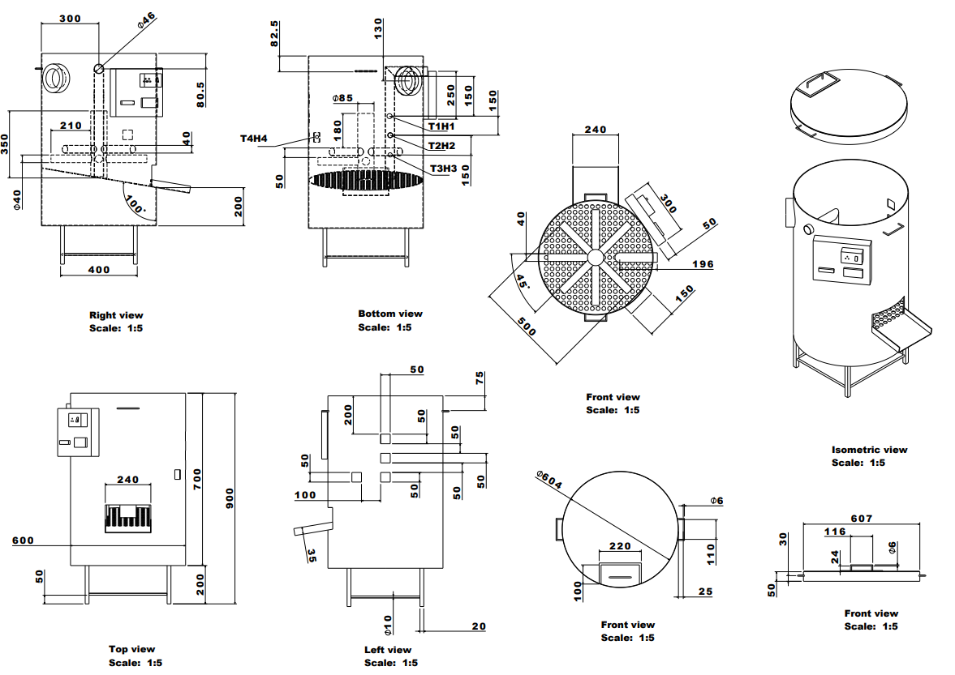 **Figure 2. Schematic view of developed of automatic dryer for wheat grain drying**

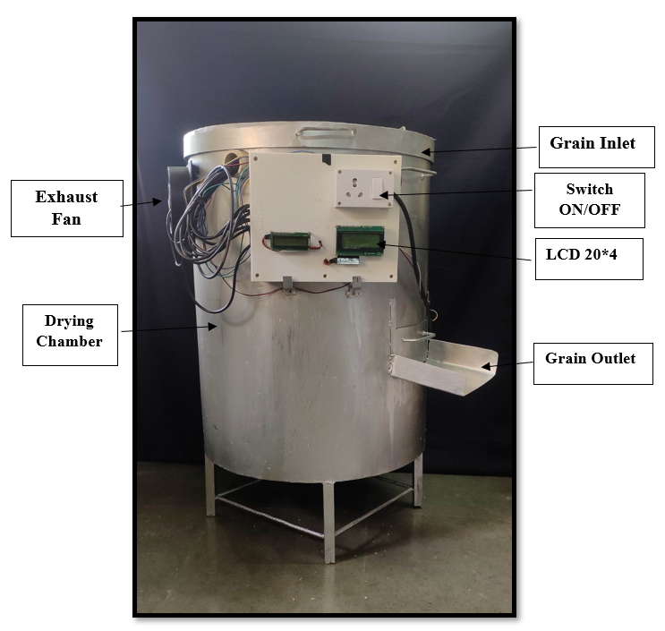

**Figure 3. Pictorial view of automatic bin dryer for wheat grain drying**

**3.7 The drying behavior of wheat grain at various moisture content levels.**

The developed drying system demonstrated effective moisture reduction in wheat grains across initial moisture contents ranging from 16% to 24%, achieving a target moisture content of 12%. Experimental results revealed a direct correlation between initial moisture content and drying time, with durations of 90, 120, 150, 195, and 240 minutes required for 16%, 18%, 20%, 22%, and 24% initial moisture, respectively. Notably, a spatial gradient in drying rates was observed within the bin, evidenced by a more rapid decrease in moisture content at the bottom level compared to the top, middle, and side levels as drying progressed. Furthermore, the moisture removal rate exhibited a gradual increase over time, indicating a potential enhancement in the drying process as the temperature or airflow stabilized. These findings underscore the system's efficacy in reducing wheat moisture content. This finding integrated with the previous study of Midilli et al., 2002; Hossain et al., 2012; Nabnean et al., 2016; Kumar et al., 2018; Yufeng et al., 2019; Tapu et al., 2021; Chokphoemphun et al., 2025; Deepak C.N and A.K. Behura 2025; Ikram et al., 2025; Ibrahim Massaquoi and Alfred Abu, 2025; Verma et al., 2025; at different temperature and relative humidity. The graphical representation of moisture removal over time at different locations within the dryer, as depicted in Figures 3 to 7, further substantiates these observations, highlighting the temporal and spatial variations in moisture reduction profiles.

**Fig. 4 Evolution of Moisture Content Profiles in Wheat Grains During Drying from 16% to 12% (w.b.)**

**Fig. 5 Evolution of Moisture Content Profiles in Wheat Grains During Drying from 18% to 12% (w.b.)**

**Fig. 6 Evolution of Moisture Content Profiles in Wheat Grains During Drying from 20% to 12% (w.b.)**

**Fig. 7 Evolution of Moisture Content Profiles in Wheat Grains During Drying from 22% to 12% (w.b.)**

**Fig.8 Evolution of Moisture Content Profiles in Wheat Grains During Drying from 24% to 12% (w.b.)**

**3.7 COST ANALYSIS OF THE BIN DRYER**

**Fixed Cost:**

1. Cost of machine (C) = Rs. 15139/-

2. Salvage value (S) = 10 % of initial cost

= 0.10 x 15139

= Rs. 1513.9/-

3. Interest rate (I) = 10 %

4. Life of the bin years (L) = 10

5. Annual working hours, h (H) = 350

6. Depreciation (Rs/h) = 

=

= Rs. 3.89/-

1. Interest @ 10% (Rs/h) 

= ×

= 0.237/-

1. Housing (Rs/h) = 1.5 % of Initial cost

= (1.5 x 15139) / (100 x 350)

= Rs. 0.64/h

9. Total fixed cost (Rs/h) = 6 + 7 + 8

= 3.89 + 0.237+ 0.64

Total fixed cost = Rs. 4.767/-

**Variable Cost**

1. Fuel cost (Rs/h) = Electricity Consumed (kWh) × Electricity Charge (Rs/kWh)

= 2.5 × 3

= 7.5

2. Operators cost (Rs /h) = Wage of operator / Working Hours

Considering two operators each working @ Rs. 100/ day

= Wage of operator / Working hours

= (100/6)

= Rs. 16.66/h

3. Repair and maintenance (Rs /h) = 10 % of the initial cost

=

= Rs. 4.32/-

4. Total Variable cost (Rs /h) = 1 + 2 + 3

= 7.5 + 16.66 + 4.32

= 28.48**/-**

Total variable cost (Rs /h) = Rs.28.48/-

**Operating Cost**

Operating cost = Fixed cost + Variable cost

= 4.767 + 28.48**/-**

Operating cost of the machine (Rs /h) = Rs. 33.247/-

Result and discussion

**3.8 Specification and estimation of cost of material required for fabrication of the bin dryer**

The economic analysis for drying wheat seeds using a developed bin dryer is presented in Table 1. This table provides a comprehensive overview of the associated costs, revealing that the price of the dryer amounts to 15139/-. This investment highlights the financial commitment required for such advanced equipment and underscores the efficiency and effectiveness it brings to the seed drying process.

**Table 1. Specification and cost of material required for fabrication of the dryer**

|  |  |  |  |
| --- | --- | --- | --- |
| **Sr. No** | **Material** | **Specification** | **Price** |
| 1 | G.I sheet | 18 gauge, 4×4 feet | 2500 |
| 2 | M.S Angle | 25×25×3 cm | 200 |
| 3 | M.S Metal perforated pipe | Height 35 cm, Diameter 8.5 cm | 300 |
| 4 | M.S perforated sheet | 18 gauge, 3 × 3.8 feet | 830 |
| 6 | 10uf/16v, Radial | Through Hole Radial 6mm diameter | 2.36 |
| 7 | 0.1uF\CERAMIC | SMT Ceramic Capacitor | 1 |
| 8 | 1000uf/16v, 5mm pitch | Electrolytic Capacitor Thru Hole 5mm pitch | 7.67 |
| 9 | DHT22 Sensors | 3pin 5.08mm pitch PCB mount screw type connector | 1362.2 |
| 10 | LED 5mm | Typical RED GaAs ED | 19.47 |
| 11 | 4PIN MKDSN 1.5-5.08 | 4pin 5.08mm pitch PCB mount screw type connector | 454 |
| 12 | 4PIN MKDSN 1.5-5.08 | 4pin 5.08mm pitch PCB mount screw type connector | 159.3 |
| 13 | I2C | Supply voltage 5V | 189 |
| 14 | 1K AXIAL0.4 | AXIAL0.4 MFR Resistor | 3 |
| 15 | ATmega328-PU | 8-bit AVR Microcontroller, 32KB Flash, 1KB EEPROM, 2KB SRAM,  28-pin PDIP, Industrial Grade (-40°C to 85°C) | 529 |
| 16 | KA7805, TO220 | 5V LDO | 14.16 |
| 17 | Relay | Rated current of the interface is 16A, Trigger Voltage (VDC): 5, Trigger Current (mA): 20 | 238 |
| 18 | Exhaust Fan | 172×150×51mm, 230V AC | 950 |
| 19 | Heater | Voltage 230v AC, Power 1000-2000 watts | 1350 |
| 20 | Adaptor | Input voltage 100-240v AC 50-60 Hz | 140 |
| 21 | CPVC Elbow | CPVC 2-inch Elbow 90* | 150 |
| 22 | CPVC Pipe | CPVC 2-inch SDR (11) Pipe (ft) | 240 |
| 23 | Miscellaneous components (wires, box, screw, nuts, soldering metal, socket) | | 500 |
| **Total Material cost** | | | **10139/-** |
| **Fabrication cost** (**50 % of material cost)** | | | **5000/-** |
| **Total cost of machine** | | | **15139/-** |

**4. CONCLUSIONS**

This study successfully developed and evaluated an automated bin dryer designed for efficient wheat drying. The system's design incorporates adjustable parameters, including drying air temperature, air velocity, and batch size, enabling operational flexibility to accommodate varying initial moisture content and environmental conditions. The locally fabricated dryer demonstrates economic viability, with a total construction cost of 15139 INR, making it an accessible solution for both laboratory-scale experimentation and on-farm commercial applications. Furthermore, the developed automated drying system demonstrated efficacy in drying wheat grains with elevated initial moisture content. The system's capacity to operate under variable drying air temperatures facilitates the optimization of drying parameters for specific grain conditions. The results indicate that this automated system provides a practical and efficient solution for farmers, enabling the mitigation of post-harvest losses associated with wet grain storage and facilitating rapid drying. The system's automation and adaptability contribute to a significant reduction in drying time, thereby enhancing operational efficiency and preserving grain quality.

**DISCLAIMER (ARTIFICIAL INTELLIGENCE)**

Author(s) hereby declare that NO generative AI technologies such as Large Language Models (ChatGPT, COPILOT, etc.) and text-to-image generators have been used during the writing or editing of this manuscript.

**REFERENCE**

Arkema, J., Amirante, M., Studman. (1999). CIGR Handbook of Agricultural Engineering, Volume IV. American Society of Agricultural Engineers.

Chokphoemphun, A. D., Mongkolvai, S. H. (2025). Energy assessment and drying characteristics of paddy in a step-down flow convective hot air dryer: experimental investigation and mathematical prediction. *Thermal science and engineering progress*. 59, 103322.

Deepak C.N and A.K. Behura (2025). Impact of sensible and latent heat energy storage combined on drying kinetics and quality of potato slices in a mixed mode solar dryer: Experimental and economic study. *Journal of Energy Storage*. 114, 115774.

Dirk and Fred, (2002). Grain drying system. *Facility design conference of the grain elevator and processing society, Illinois, U.S.A.*

Fashina, A. F. B., Ibrahim, S. B., (2013). Design parameters for a small-scale batch in-bin maize dryer. *Journal of Agricultural Sciences.* 5(4), 90-95. doi:10.4236/as.2013.45B017.

Hossain, M. S. H., Islam, M. A. H., Rahman. (2012). Development and performance evaluation of hybrid dryer for quality grain seeds. *International Journal of Energy Machinery*. 5, 42-52. *International Journal*, 20 (7), 1503-1513.http://dx.doi.org/10.1081/DRT-120005864.

Ibrahim Massaquoi and Alfred Abu. (2025). Construction and testing of solar drying system as an alternative to sun drying. *European journal of applied science, engineering and technology*. 3, 121-134**.**

Javed, A. S., Poonam, (2015). Overview of grain drying and storage problems in India. *International Journal of Engineering Research and General Science.* 3(5), 674-678.

kram, M.I. H., Waseem, M. S., Muhammad, M.M.O., Muhammad, G.H.L. (2025). Central ducts bin-dryer for quality drying of date palm through improved airflow distribution. *Result in engineering.* 25, 104296.

Kumar, S.K., Kumar (2018). Performance Evaluation of Modified STR Dryer for Drying of Paddy in Process of Reducing Post-Harvest Losses. *International Journal of Current Microbiology and Applied Sciences.* 7, 2959-2968.

Midilli, H. K., Yapar. (2002). A new model for single-layer drying. *Drying Technology: An*

Nabnean, S. J., Thepa, K. S., Songprakorp, B.K. B. (2016). Experimental performance of a new design of solar dryer for drying osmotically dehydrated cherry tomatoes. *Renewable Energy.* 94, 147-156.

Peter and Reinyelda. (2022). Design of grain dryer using pressure the flow of air heat forced convection method. *European Journal of Engineering and Technology Research*. 7,6. <http://dx.doi.org/10.24018/ejeng.2022.7.6.2935>.

Sahay K. M. and K.K. Singh. (2011). Unit operations of agriculture processing (II Ed.).

Sammy, G. A., Scott, (2017). Low-temperature grain drying, Agriculture and Natural Resources, FSA1063.

Schirmer, J.D., Müller, P.D.F., Prestes, M.C., (2006). Effects of drying methods and storage period in the industrial quality of wheat. *International Working Conference on Stored Product Protection.* 8(5), 6265.

Sendhil, T.M. and Gyanendra. (2019). Book chapter: Wheat production in India: trends and prospects. <http://dx.doi.org/10.5772/intechopen.86341>.

Tadele, F. K., Hugo, J. H., Stephen, S. K., Yoseph, P. M. B., Bekele, M. B., (2010). The metal silo: An effective grain storage technology for reducing post-harvest insect and pathogen losses in maize while improving smallholder farmers' food security in developing countries. *Crop protection*, 1-6.

Tapu, M.K.U.S., Milufarana, M.N.H. (2021). Design, fabrication and performance study of a small-scale grain seed dryer. *Research & Reviews: A Journal of Agricultural Science and Technology*, 10(2), 11-19.

Verma, R. K., Tangellapalli, D. B. (2025). A novel approach for the active‐mode indirect drying of food grains with high temperature thermal energy storage system. *Heat Transfer*. 54, 460–487.

Wilcke. and Vance. (1993). Selecting fans and determining airflow for grain drying and storage. Proceedings of the Integrated Crop Management Conference. <https://lib.dr.iastate.edu/icm/1993/proceedings/18>.

Yufeng, X. G., Xu, C. W., Wang, Y.J., Li, J. Y., Liu. (2019). Design and test of a novel wheat drying oven based on the real-time utilization of diesel engine waste heat. *Cogent engineering*. 6, 1673118. <https://doi.org/10.1080/23311916.2019.1673118>.