***Original Research Article***

**GROSS ANATOMY OF THE PECTORAL GIRDLE OF COMMON RAVEN (*Corvus Corax*)**

.

ABSTRACT

|  |
| --- |
| The pectoral girdle helps to attach pectoral limb with the body, thereby gives strength, range of motion to the wings and plays a functional role in flight mechanism of birds. Hence this study was conducted to document on gross anatomical features of pectoral girdle bones of adult common raven and to note the differences from the crow and other avian species. The pectoral girdle was disarticulated from the dead carcasses of common raven and the bones were collected by wet maceration technique. The pectoral girdle in common raven comprised of scapula, clavicle and coracoid. The scapula of common raven was a sword shaped bone located parallel to the vertebral column with two extremities and a shaft. The cranial extremity presented a medial projection and a lateral articular facet, the glenoid cavity. The caudal extremity was extended upto the level of cranial border of ilium. The clavicle was ‘U’ shaped with a thicker and broader proximal end like human foot and the distal end was directed ventrally and fused to form small hypocleidium. The coracoid was the strongest bone among pectoral girdle with a hook like medial process and a glenoid fossa in its proximal end and had an elongated facet at the distal end for the sternal attachment. |

*Keywords: gross anatomy, pectoral girdle, scapula, clavicle, coracoid, raven*

1. INTRODUCTION

The skeletal system of avian species consists of pleomorphic individual bones whose morphology is primarily influenced by their function and exhibit species-specific traits (Nickel *et al*., 1977). Its skeleton is evolved and suited for flight, with a large sternum, an open ventral pelvis, forelimb modified to form a wing, and significant vertebral fusion (Dyce *et al*., 2010). The common raven (*Corvus corax*) is a large all-black [passerine](https://en.wikipedia.org/wiki/Passerine) bird belongs to corvidae family. It is the most widely distributed and one of the largest of all [corvids](https://en.wikipedia.org/wiki/Corvidae), found across the [Northern Hemisphere](https://en.wikipedia.org/wiki/Northern_Hemisphere). Its young ones may travel in [flocks](https://en.wikipedia.org/wiki/Flocks_of_birds) but later [mate for life](https://en.wikipedia.org/wiki/Mate_for_life), with each [mated pair](https://en.wikipedia.org/wiki/Mated_pair) defending a [territory](https://en.wikipedia.org/wiki/Territory_(animal)). Common raven prefers omnivorous diet. It differs from the crow by its greater size, larger and heavier black beak, shaggy feathers around the throat, longer bristles above the beak, and a longer, wedge-shaped tail ([Svensson](https://en.wikipedia.org/wiki/Lars_Svensson_(ornithologist)) *et al*., 2022). Flying ravens are distinguished from crows by their tail shape, larger wing area, and more stable soaring style, which generally involves less wing flapping. In flight the feathers produce a creaking sound that has been likened to the rustle of silk (Ali and Ripley, 1986). The pectoral girdle provides strength and range of motion to birds' wings and has a functional purpose in their flight mechanism. The pectoral girdle is the set of bones that supports the wings (Parvez *et al*., 2016) in domestic pigeon. An enormous work has been done on the pectoral girdle of birds like pigeon, crow, owl (John *et al.,* 2014), green-winged macaw and peahen (Indu *et al.,* 2012), Red wattle lapwing (John *et al*., 2015), Indian eagle owl (Saini and Bansal, 2023), Conure (Beaulah *et al*., 2023a), Crested serpent eagle and Brown wood owl (Keneisenuo *et al*., 2020) and Black swan (Rachel *et al.,* 2024). However, to our knowledge, infinitesimal studies have been found on the gross morphology of pectoral girdle bones of common raven. Therefore, this study was aimed to document the general anatomical features of the pectoral girdle bones of the common raven.

2. material and methods

This study was conducted on the bones of pectoral girdle of three adult common raven birds in the Department of Veterinary Anatomy, Veterinary College and Research Institute, Namakkal, Tamil Nadu, India. The birds were collected in half decomposed state from in and around the college campus. The external decomposed parts were removed manually as much as possible and the carcasses were subjected to natural wet maceration (Tamilselvan *et al*., 2024) to separate the bones from their body parts of common raven. After assurance from the concerned subject experts that bone pathology was not observed. The disarticulated bones of pectoral girdle were identified and cleaned by using 10% solution of washing powder in plain water for overnight to remove the tissue debris and meaty colour of the bones followed by soaking in 10% bleaching powder solution for overnight to get clear appearance (Tamilselvan *et al*., 2018). Then the bones were dried under room temperature for about one week. The dried bones were immersed in acetone solution for overnight to remove the fat (Tompsett, 1970). Finally, the gross morphological structures of bones were studied and photographed for documentation.

3. results and discussion

The pectoral girdle of common raven consisted of three separate bones, namely scapula, coracoid and clavicle as reported in crested serpent eagle and brown wood owl (Keneisenuo *et al*., 2020); great Indian horned owl, pigeon, and crow (Sridevi *et al*., 2020). In emu, scapula and coracoid bones were partly fused to form a single bone scapulo-coracoid (Kumar and Singh, 2014). These bones established the link between the trunk and the wing, joined together at their proximal end, where the space created by their union formed the triosseal canal partly homologous to foramen triosseum.

**3.1 SCAPULA**

Scapula was a long sword shaped bone, directed backwards and upwards and ran parallel to the vertebral column as reported in pigeon (Jayachitra and Iniyah, 2021), common hawk cuckoo (Supriya *et al.,* 2019), West African black crowned crane (Girgiri *et al.,* 2022) except in green winged macaw, where the scapula was short and stout bone (Indu *et al*., 2012).

Scapula had two borders (dorsal and ventral border), two surfaces (lateral and medial surfaces) and two extremities (cranial and caudal extremity) (Fig 1) as in other domestic birds. Cranial extremity presented a medial projection and a lateral articular facet, the glenoid cavity for the head of humerus to articulate as observed by Beaulah *et al*. (2023b) in green winged macaw. The caudal extremity of the scapula was extended upto the level of cranial border of ilium and the cranial end was located at the level of last cervical vertebra as opined by (Jayachitra and Iniyah, 2021) in domestic fowl and pigeon.

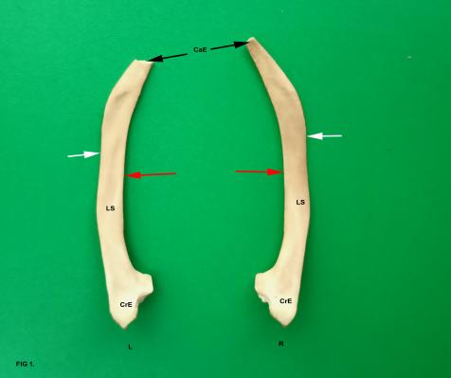

**Fig 1**: Showing the lateral surface (LS) of Left (L) and Right (R) scapula of common raven.   
CrE-Cranial extremity, CaE- Caudal extremity Dorsal boder (white arrows) and

ventral border (red arrows).

The right scapula anteriorly had a small projection followed by a depression and a summit with zenith (acromion or furcular process) and nadir (Coracoid process), nearby and distally there was a circular facet (glenoid cavity) with a central concave area rimmed by concave circle (Fig 2). But this facet was concave and oval in outline in Red wattled lapwing (John *et al.,* 2015). It was prolonged into bow like extension. The dorsal border was slightly convex in the first half followed by a small narrow concave area with well-made convex dorsal area in the posterior part with a narrow but blunt end in this study as that of peahen but in green-winged macaw it presented a sharp downward bend posteriorly. The ventral borders were rounded and concave (Indu *et al*., 2012).

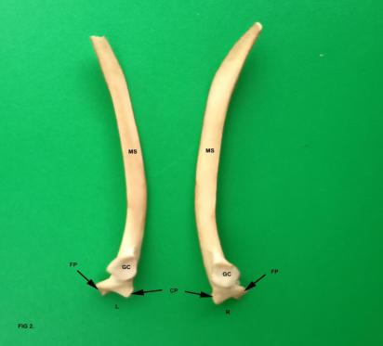

**Fig 2**: Showing the medial surface (MS) of Left (L) and Right (R) scapula of common raven.

GC - Glenoid cavity, FP - Furcular process and CP- Coracoid process.

In its medial surface the middle area was sandwiched with two flat anterior and posterior areas. The lateral surface was rough with an anterior convex part and posterior flat part in common raven as in domestic fowl, whereas in pigeon both the surfaces were flat, which is contradictory to Sharma and Dubal (2018) who reported that the medial surface was convex and lateral surface was concave in Emu.The junction of the medial and lateral part dorsally was broader in the anterior half and very thin in the posterior half.

In the lower part of the medial surface, small thin line separated the surface anteriorly into upper broader area and lower narrow area. This narrow area was also broader posteriorly. Totally it was crescent like but with an anterior two articular areas. The medial most articular area was proximally convex and distally concave and was roughly triangular as that of yellow billed blabber (Supriya *et al*., 2019) and green winged macaw (Beaulah *et al*., 2023b). The other side of the scapula was also similar to the counter part with English alphabet capital letter ‘I’ like with its anterior stroke concave in nature. Between the two facets there was a triangular area with ventral narrow end which was non-articular. The caudal end of the scapula was thin and blunt in common raven, where as in green winged macaw and pigeon, it was thin and pointed and in domestic fowl it was thick and blunt (Beaulah *et al.,* 2023b; Jayachitra and Iniyah, 2021). The caudal end was directed downwards and curved inward, which was also observed in the scapula of the pariah kite (Tomar *et al.,* 2010) and crested serpent eagle (Keneisenuo *et al*., 2020).

In the present study, pneumatic foramen was presented just below the acromion process in the proximal extremity of scapula. This is like the observations of Keneisenuo *et al*. (2020) in crested serpent eagle, John *et al*. (2017) in kite and John *et al*. (2014) in crow, which was absent in pigeon and owl (Sridevi *et al*., 2020). But in pigeon hawk presence of pneumatic foramen was observed just behind the coracoid process, which was not evident in common raven.

**3.2 CLAVICLE**

It is similar to English alphabet letter ‘U’ with its lower bend narrower compared to the upper end (Fig 3). Similar ‘U’ shaped clavicles were observed in green-winged macaw (Indu *et al.,*2012), domestic geese (Shabir *et al*., 2013), pigeon (Parvez *et al*., 2016), Crow (Sridevi *et al.,* 2020), crested serpent eagle and brown wood owl (Keneisenuo *et al.,* 2020). Whereas in peahen (Indu *et al.*, 2012), owl, pigeon, great Indian horned owl (Sridevi *et al.*, 2020), pariah kite (Tomar *et al.*, 2010) and Indian eagle owl (Saini and Bansal, 2023), the clavicle was ‘V’ shaped. The right and left clavicle in common raven was united ventrally into a single wish bone (furculum) and each clavicle was consisted of two extremities and ramus with two surfaces and two borders. The proximal extremity was comparatively wider and thicker than the distal extremity (Fig 3) as reported by Saini and Bansal (2023) in Indian eagle owl. The lower bend in its middle anteriorly got a projection with convex front part and on either side narrow free flat part and posterior part was attached to the middle of the clavicle. From this area on both sides it arose up with an initial curve and straight portion which was two times longer than the curved portion. Each arm of the ‘U’ shaped clavicle was laterally flat upto the lower part and convex in the lower most part. In the medial part the breadth was slowly and progressively reduced from top to bottom. But in great Indian horned owl and pigeon (Sridevi *et al*., 2020); Brown wood owl (Keneisenuo *et al*., 2020), the arms of the clavicle were straight. In the proximal part, the articular area was like a water droplet with its circular broader part anteriorly and the thin pointed part posteriorly. This portion was roughly like the greater cornua of hyoid like human foot. The lateral aspect of the proximal extremity of each arm was presented with minute numerous pneumatic foramina as stated by Keneisenuo *et al*. (2020) in crested serpent eagle, John *et al*. (2014) in crow and John *et al*., 2017) in pigeon hawk and kite. Also, John *et al*. (2014) stated that the number of pneumatic foramina were seven in right clavicle and three in left clavicle of pigeon hawk. Whereas, the foramens were absent in pigeon and owl.

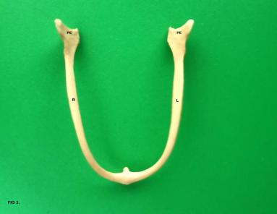

**Fig 3:** Showing anterior view of ventrally fused Right (R) and Left (L) clavicle of common raven. PE- Proximal extremity

Anteriorly, in the proximal part there was rough eminence which was broader dorsally and tapering to a narrow part. The lateral surface of the upper part of the arm of the ‘U’ had a concave triangular area with its narrow part ventrally and the upper part of the triangle dorsally. This is in accordance with the observations in crow but contrast with the observations in pigeon it was elongated and had a terminal pointed apex whereas in great Indian horned owl it was very broad elongated and had a blunt end (Sridevi *et al*., 2020).

The posterior part of the triangle was not straight but proximally convex and distally flat being more in length. In total, the entire arm of the ‘U’ shaped structure was anteriorly concave and posteriorly convex and it was bent backward from the middle to the top. The homologue of hypocleidium was very small and the anterior projection was less prominent (Fig 4) as observed in crow. But the hypocleidium was absent in pigeon and great Indian horned owl (Sridevi *et al*., 2020), pigeon and owl (John *et al*., 2014) and in brown wood owl (Keneisenuo *et al*., 2020). The morphological variations in furcula of birds were directly linked with their flying behaviour.

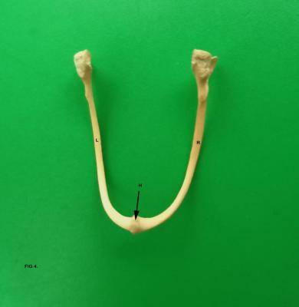

**Fig 4:** Showing Posterior view of fused clavicle of common raven. H- Hypocleidium.   
Right (R) and Left (L) clavicle

**3.3 CORACOID**

Common raven consisted of two coracoid bones as a part of their pectoral girdle, right and left, which were short, thickest among pectoral girdle bones with a shaft and two extremities directed downwards and backwards as reported by Jayachitra and Iniyah (2021) in pigeon and domestic fowl; Keneisenuo *et al*. (2020) in crested serpent eagle and brown wood owl and John *et al*. (2015) in red wattled lapwing. But in Aseel bird, the coracoid was a quadrilateral shaped bone (Gond *et al*., 2024). It articulated with sternum ventrally and with scapula, clavicle and humerus proximally. The shaft of the coracoid was cylindrical and somewhat compressed medially at its middle in this study (Fig 5) as that of crow but contradicted with findings on Pigeon and great Indian horned owl where, the shaft of coracoid was oval in outline (Sridevi *et al*., 2020). Coracoid bone laterally was having a sprout (Procoracoid process) with convex upper part with narrow slanting lower part ending in a point and curved dorsally to join with the shaft. The adjoining area had middle ridge with small groove on either side. The posterior being the larger, nearby was elliptical plate like area with its posterior convex prominent margin. The middle area was very strong for palpation and continued in its distal part from the middle part. The proximal extremity was presented with prominent furcular tuberosity directed medially with acrocoracoid process, below, and lateral to which glenoid fossa and a sharp scapular process (Fig 5). These observations were akin to that of Indu *et al*. (2012) in green wing macaw and peahen. The scapular process was absent in domestic fowl.

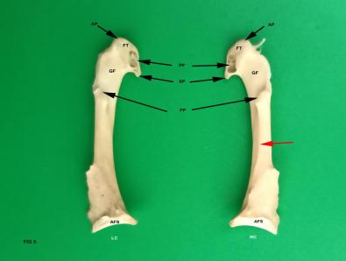

**Fig 5**: Showing medial view of Left (LC) and Right (RC) coracoid of common raven.   
GF- Glenoid fossa, FT-Furcular tuberosity, PF-Pneumatic foramen, SP- Scapular process, AP-Acrocoracoid process, PP- Procoracoid process, Faint line (red arrow) and AFS- Articular facet for sternum.

In this coracoid bone, a large pneumatic foramen (Fig 5) was observed on the medial aspect of the furcular tuberosity in common raven which was also recorded by Keneisenuo *et al.* (2020) in crested serpent eagle and Sridevi *et al*. (2020) in crow. Lateral aspect of distal extremity looked like a triangle, the broader part being the lower most where elongated articular facet for sternum was observed (Fig 6). This part in its distal area was like a concave bend with both medial and lateral ends. From these ends anteriorly it ascended with slight concave bend, reached the proximal part in the posterior part, from the lower sharp end, which was also reported in crested serpent eagle, brown wood owl, pigeon hawk, and kite (Keneisenuo *et al.*, 2020; John *et al.*, 2017). The medial end was sharply concave as concluded by Sridevi *et al.* (2020) in great Indian horned owl followed by pigeon and crow. The posterior border extended up like a thin line upto the top. In the distal extension nearby the sharp end beyond posterior line, there was a small plate like extension upto the lower third of the bone. Its posterior end was running below from top, straight with an alternate concave and convex bends joining the sharp end. In the medial surface, the upper part looked like rough elliptical area with an opening in the lower part continued by a beak like sharp area. The lateral process was not so sharp. In contrast, sharp and well-marked lateral processes were observed in peahen, green winged macaw, great Indian horned owl, and pigeon (Indu *et al.*, 2012; Sridevi *et al.*, 2020)

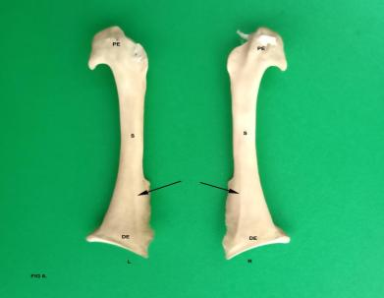

**Fig 6:** Showing Lateral view of Left (L) and Right (R) coracoid of common raven. PE- Proximal extremity, DE- Distal extremity and S- Shaft and faint line (Black arrows).

In coracoid, behind the line, there was an area for entire length which was concave in nature, joining the sharp end lower to the thin line end. The lower third of medial surface looked like a triangle with its left side slanty curly in nature, with convex and concave alternate bends. In the lower half of the broader part of triangle, an elevated area running from the anterior to posterior part, making the base of the triangle very conspicuous and above the base it appeared as if there was another base. The union of narrow end of the triangle was elevated at the junction as projection. Both anterior and posterior end of the triangle looked straight in the beginning and concave in the end, straight portion being larger in the posterior part. The triangle area looked chiseled in its middle part posing a depression, where there was an articular facet for the articulation of sternum (Fig 5) which was also reported in crested serpent eagle and brown wood owl (Keneisenuo *et al.*, 2020), pigeon hawk and kite (John *et al.*, 2017).

4. Conclusion

Conclusion of this study was the pectoral girdle of common raven consisted of paired scapula, clavicle which fused ventrally to form furcula and coracoid bone. The scapula was thin, long bone with sharp caudal end and articular cranial end. The clavicle was ‘U’ shaped with curved arms and broad proximal end and furcula at distal end where the two arms were fused. The shaft of the coracoid was cylindrical and somewhat compressed medially. Proximal end of coracoid was made up a furcular tuberosity which possessed large pneumatic foramen, glenoid fossa and a scapular process. Distal end of coracoid was presented with triangular area with pointed medial and lateral end and articular facet for the sternum.

Disclaimer (artificial intelligence)

Authors hereby declare that, no generative AI technologies such as Large Language Models (ChatGPT, COPILOT, etc) and text-to-image generators have been used during writing or editing of manuscripts.

References

Ali, S., & Ripley, S. D. (1986). Handbook of the birds of India and Pakistan. Vol. 5 (2nd ed.). Oxford University Press. pp. 261–265.

Beaulah, J. V., Sridevi, P., Kannan, T. A., Ramesh, G., & Ushakumary, S. (2023a). A Study on the comparative anatomy of Pectoral Bones in Pigeon (*Columba livia*) and Conure (*Pyrrhura molinae*). Indian Journal of Veterinary and Animal Sciences Research, 52(3): 106-110.

Beaulah, J. V., Sridevi, P., Kannan, T. A., Ramesh, G., & Ushakumary, S. (2023b). Gross Anatomical Study on the Wing Bones of Green Winged Macaw (*Ara Chloropterus*). Indian Journal of Veterinary Anatomy, 35(1): 8-10.

Dyce, K. M., Sack, W. O. & Wensing, C. J. G. (2010). Textbook of Veterinary Anatomy. (4th ed.) Saunders Elsevier.

Girgiri, I. A., Malah, M. K., & Nuhu, I. S. (2022). Morphology of the Sternum, Pectoral Girdle and Wing of West African Black-Crowned Crane (*Balearica pavoninapavonina*). Sahel Journal of Veterinary Sciences, 19(4): 10-15.

Gond, S. P., Jaiswal, S., Singh, A., Asthana, S., & Singh, N. (2024). Gross anatomical studies on the pectoral girdle of Aseel bird. International Journal of Veterinary Science and Animal Husbandry, 9(3): 286-28.

Indu, V. R., Lucy, K. M., Sreeranjini, A. R., Maya, S., Ashok, N., & Sayam, K. V. (2012). A comparative study on the pectoral girdle of green winged macaw and pea hen. Journal of Veterinary and Animal Sciences, 43: 56-58.

Jayachitra, S., & Iniyah, K. (2021). Comparative gross anatomy of pectoral girdle in domestic fowl (*Gallus domesticus*) and pigeon (*Columba livia).* Haryana Vet. 60(2): 289-290.

John, M. A., Sasan, J. S., Singh, A.D. and Choudry, A.R. (2014). Comparative morphometry of the shoulder girdle of Pigeon (*Columba livia*), Crow (*Corvus splendens*) and Owl (*Otus bakomoena*). Indian Veterinary Journal., 91(04): 43-45.

John, M. A., Baba, M. A., Massarat Khan, M. K., Dar, F. A., & Sheikh, A. R. (2015). Gross morphological studies on sternum and shoulder girdle of red wattled lapwing (*Vanellus indicus*). Indian Journal of Veterinary Anatomy, 27(2): 18-20.

John, M. A., Choudhury, A. R., Khan, M., Ahmad, K., Baba, M. A., Dar, F. A., & Rafiq, A. (2017). Comparative anatomical studies on shoulder girdle of pigeon hawk (*Falco columbarius*) and kite (*Millvus migrans*). Indian Journal of Veterinary Anatomy, 29(1): 25-27.

Keneisenuo, Choudhary, O.P., Debroy, S., Arya, R.S., Kalita, P.C., Doley, P.J., Rajkhowa, T.K. and Kalita, A. (2020). Comparative gross anatomical studies on the shoulder girdle of crested serpent eagle (*Spilornis cheela*) and brown wood owl (*Strix leptogrammica*). Indian Journal of Animal Research. 54(5): 570-572.

Nickel, R., Schummer, A. and Seiferle, E. (1977). Anatomy of the Domestic Birds, (Chapter: skeleton of the head), Verlag Paul Parey, Berlin and Hamburg, pp-20 - 25.

Parvez, M. N. H., Akter, M., Gofur, M., & Sarder, M. (2016). Gross morphometry of pectoral girdle of domestic pigeon (*Columba livia*). *Int J Livestock Res.,* 6(6): 32-38.

Rachel, S., Venkatesh, V., Kumar, S. R., Tejaswini, N., Srija, B., Gayathri, M., &   
Jyothi, S. U. (2024). Gross anatomical study on bones of pectoral girdle in black swan (*Cygnus atratus*). International Journal of Advanced Biochemistry Research. 8(9):1072-1074.

Saini, S., & Bansal, S. (2023). Gross anatomy of the skeleton of pectoral limb in Indian eagle owl (*Bubo bengalensis*). International Journal of Veterinary Science and Animal Husbandry, 8(4): 145-148.

Sathyamoorthy, O. R., Thirumurugan, R., Senthil Kumar, K., &Jayathangaraj, M. G. (2012). Gross anatomical studies on the sternum and clavicle of spot-billed pelican (*Pelecanus philippensis*). Tamilnadu Journal of Veterinary and Animal Sciences, 8(3): 166-170.

Shabir, M., Hamadani, H., Khan, M., Baba, M.A. and Khan, A.A. (2013). Gross Morphometry of pectoral girdle of domestic geese *(Anser anser domesticus). Indian J. of Poult. Sci.,* 48(2): 273-275.

Sharma, A and Dubal, S.C. (2016). Gross Anatomical study of pectoral limb of small Indian kite (*Milvus migrans govinda*). Indian Journal of Veterinary Anatomy, 28(2): 57-60.

Sridevi, P., Rajalakshmi, K., & SivaKumar, M. (2020). Comparative gross anatomical studies on the shoulder girdle of great Indian horned owl, pigeon and crow. *J. Entomol. Zool. Stud,*8(2): 51-54.

[Svensson, L.](https://en.wikipedia.org/wiki/Lars_Svensson_(ornithologist)), [Mullarney, K.](https://en.wikipedia.org/wiki/Killian_Mullarney), & [Zetterström, D.](https://en.wikipedia.org/wiki/Dan_Zetterstr%C3%B6m) (2022) [Collins Bird Guide](https://en.wikipedia.org/wiki/Collins_Bird_Guide) (3rd ed.) pp- 380–381.

Tamilselvan, S., Chemmalar, S., & Sivagnanam, S. (2024). Chevron bones and os penis in dog: Structural and Functional Anatomy. Archives of Current Research International. 24(8): 169-177.

Tamilselvan, S., Jaiswal, P., Mrigesh, M., Singh, B., & Mahanta, D. (2018). Morphology of femur, tibiotarsus and fibula of local hill fowl of Uttarakhand. The Indian Journal of Veterinary Sciences & Biotechnology. 13(4): 84–87.

Tomar, M.P.S., Vaish, R., Rajput, N. and Shrivastav, A.B. (2010). Gross morphometrical studies on the pectoral girdle of Pariah kite. Journal of Animal and Veterinary Advances. 9(19): 2482-2484.

Tompsett, D.H. (1970) Anatomical techniques, (2nd ed.) Edinburgh, Livingstone.