**Bibliometric Analysis of Agricultural Water Management Institutions**

ABSTRACT

Water is essential for life, livelihoods, food security, and sustainable development, its efficient management crucial for overall development, thus making this research area more significant and dynamic. This study provides a review of global research on "water institutions" from the past 30 years based on the Scopus database and covering 2611 articles. Key variables analysed include the number of articles per year, leading journals, contributing countries, notable authors, and prevalent keywords. The findings reveal significant growth in the annual number of published articles, with Water Policy identified as the foremost journal. The United States, China, and Australia are the leading contributors, with notable work from authors such as Wurbs RA, Wang Y, and Boelens R. Predominant keywords include water management, policy, and water governance, reflecting major research themes. Despite considerable advancements in water management research, there is a noticeable gap in studies focusing on "water institutions," particularly in India. This highlights the need for more in-depth research on the role and impact of water institutions in effective water management practices.

**Keywords:** Water Institutions, bibliometric analysis, PRISMA, Scopus

**INTRODUCTION**

Water resources are essential for human survival and development, playing a crucial role in maintaining healthy ecosystems and biodiversity. With rising water shortages and frequent water-related conflicts at the macro and local levels, policymakers worldwide are focusing more on the institutional arrangements governing water resource development, distribution, and management. Water resource management especially important in India, which is approaching the end of its useable water resource capacity. Despite currently utilizing only about 57% of its overall water resource potential, India is already using approximately 66% of its irrigation capacity (USAID 2021). This situation is intensified by a growing population and expanding economy, leading to a widening gap between water demand and supply. The expansion of water resources is also hindered by delays in investment, environmental concerns, and political and legal obstacles, especially in inter-regional water transfers.

To address these challenges, many countries, including India, are shifting irrigation management responsibilities from government agencies to farmer associations or community-based organizations, particularly local Participatory Irrigation Management (PIM) groups (Chopra *et al.,* 2021). Supported by national governments and international organizations, this shift aims to enhance local management of irrigation and coordinate water use among villages and irrigation districts. The farmers’ participation in irrigation management is ensured through the constitution and development of Water User Associations (WUAs). Involving farmers in irrigation management through WUAs is popularly known as Participatory Irrigation Management (PIM).

PIM is a collaborative approach to water resource governance that emphasizes the active involvement of farmers in the management of irrigation systems. At its core, PIM seeks to empower farmers by giving them a central role in decision-making processes related to the design, operation, and maintenance of irrigation infrastructure (Sinha 2004). WUAs, as part of the PIM framework, have shown benefits in improving farmer welfare through better water delivery services, increased fee collection, lowering maintenance costs, preventing opportunistic behaviour, and improving the financial stability of irrigation systems. Despite these benefits, sustainable WUAs often face challenges due to farmers' lack of management skills, weak government support, and insufficient efforts to change WUA management.

The importance of water institutions has led to extensive academic research in this area. We utilise this literature to perform a comprehensive bibliometric analysis of research on water institutions using articles indexed in Scopus. Scientific communication through publications is crucial for analysing the growth and impact of research on water institutions. New studies build on previous findings to drive further discoveries, making bibliographic reviews a common and effective method for summarizing existing knowledge despite their limitations. This analysis will determine the scope of coverage and answer key questions through statistical methods, bibliometric indicators, and citation analysis. The study seeks to understand how research interest in water institutions has evolved over the past decades, identify the main research areas, determine leading authors in this field, and highlight the journals that are most influential in publishing this research.  The findings emerging from this study contribute to understanding the connection between water institutions and sustainable regional development.

**METHODOLOGY**

Bibliometric analysis, introduced by Garfield in the mid-20th century as a statistical approach to identifying, organizing, and analysing key components within a research field, was employed in this study. For this study, data was sourced from the Scopus database, recognized as the world’s largest repository of peer-reviewed research literature abstracts and citations. The analysis focused on publications from 1990 to 2023, utilizing specific keywords as shown in Figure 1.

Bibliometric data was extracted from Scopus in csv format, encompassing citation data, bibliographic details, keywords, funding information, and other relevant details like references. The document types considered included articles, books, book chapters, conference papers, and reviews, all written in English. In this study, we used the PRISMA (Preferred Reporting Items for Systematic Reviews and Meta-Analyses) approach for data cleaning, ensuring a thorough and accurate bibliometric analysis of water institutions.

A total of 4,813 documents were found in the initial search. Among the 4813 publications, 642 did not focus on any of the significant keywords chosen. Abstracts that did not focus on Water Institutions:(n=728), Water Law and Policy:(n=164), Ground Water Market:(n=239), Participatory Irrigation Management:(n=429). This left 2611 papers for further bibliometric analysis. Within these 2611 papers, the abstracts related to the following keywords were as follows: Water Institutions (105), Water User Associations (WUA) (294), Participatory Irrigation Management (17), Ground Water Market (4), Performance Assessment (6), Strategic Analysis (12), Water Law and Policy (1059), Water Rights and Administration (1043), Water Sector Performance (66), and Water Management Institutions (5). This detailed categorization helps streamline research efforts, eliminating unnecessary work by highlighting the specific areas of focus within the field.

Figure 1: Flowchart for conducting Bibliometric analysis

**Identifying keywords:** “Water Institutions", "Water Institutional Structure", "Water User Association", “WUA”, "Participatory Irrigation Management", "Water Governance Arrangement", "Pani Panchayat”, "Phad", "Ground Water Market", "Water Law", "Water Policy", "Water Administration", "Water Right" AND “Performance Assessment OR Analysis”, "Strategic Analysis", “Evaluation”, “Prospects”, “Investigation”, “Adaptiveness”, “Nature”, “Impact”.

**Step I:**

**The Framework of Study**

**Selected database**: Scopus

**Downloaded format**: csv

**Exported data information**: citation data, bibliography details, keywords, financing information, & additional details such as references.

**Document type**: article, book, book chapter, conference paper, review

**Language**: English

**Step II:**

**Extraction Of Bibliometric Data**

**Data cleaning: PRISMA**

\***Total documents**: initial search (n = 4813)

\***Removed documents:** duplicates (n = 47), no additional information (n = 68), irrelevant papers (n = 126)

\***Total final documents** (n = 2611)

**Bibliometric software**: the bibliometrix R-package and VOS viewer.

**Step III:**

**Data preprocessing and software.**

**Step IV:**

**Analysis & Visualization**

**Software used for performance analysis and science mapping:**

The bibliometrix R-package 3.1.4, VOS viewer1.6.20, and Microsoft Office Excel 2016.

For performance analysis and science mapping, the tools used were bibliometrix R-package 3.1.4, VOS viewer 1.6.20, and Microsoft Office Excel 2016. Various tables and figures were generated to visualize and analyse the data effectively, with VOS viewer proving particularly useful for creating network maps. The keyword analysis helped to highlight the primary research trends related to water institutions and water user associations.

**RESULTS AND DISCUSSIONS**

**3.1 Overview of Bibliometric Analysis: 1990-2024**

1. **Main information about data**

Between 1990 and 2024, there were a total of 2611 publications in the research field. Among these, 1887 were research articles, 64 were book chapters, 251 were review papers, and 9 were conference papers. Table 1 provides a detailed overview of this information. It is noteworthy that 10,507 authors contributed to this research field, indicating a substantial level of academic involvement. Out of these, 637 documents were single-authored, demonstrating both individual and collaborative efforts in the field. The average number of citations per document is 21.92, reflecting the impact and relevance of the research conducted.

Table 1: Summary of Bibliometric Analysis data.

|  |  |  |  |
| --- | --- | --- | --- |
| **Description** | **Results** | **Description** | **Results** |
| Timespan | 1990:2024 | **AUTHORS COLLABORATION** |  |
| Sources (Journals, Books, etc) | 960 | Single-authored docs | 637 |
| Documents | 2611 | Co-Authors per Doc | 3.03 |
| Annual Growth Rate % | 8.74 | International co-authorships % | 20.83 |
| Document Average Age | 10.8 | **DOCUMENT TYPES** |  |
| Average citations per doc | 21.92 | Article | 1887 |
| References | 107746 | Book | 64 |
| **DOCUMENT CONTENTS** |  | Book Chapter | 271 |
| Keywords Plus (ID) | 8586 | Conference Paper | 9 |
| Author's Keywords (DE) | 5513 | Conference Review | 122 |
| Authors | 10507 | Review | 251 |
| Authors of single-authored docs | 1076 |  |  |

1. **Annual scientific information**

The annual scientific production of articles depicted in figure 2 related to water institutions has shown a steady increase over the years, with notable growth periods in the late 1990s and early 2000s. The last three years, from 2020 to 2023, have seen exceptionally high annual production, indicating a growing interest in the research topic. This trend suggests that the subject of water institutions is gaining increasing attention and will likely continue to be a prominent research area in the future.

1. **Average citation per year**

Figure 3 illustrates the average number of citations per year from 1990 to 2023. The graph indicates an increasing trend in average citations over the years. The average citations remained relatively high, ranging between 2.28 in 2007 and 3.15 in 2019. The average citations per year provide insights into the impact and relevance of research in this field and the importance of water institutions in academic literature.

**3.2 Key journal and author insights in water management**

#### **Analysis of key Journals**

The top 10 journals in the field of water resources and management studies given in table 2, highlighting their research strengths and academic impact. The analysis of the local impact of various sources in water resources and management reveals that Agricultural Water Management and Water Policy are the top two most influential journals in this field.

Agricultural Water Management has an h-index of 36, indicating that it has at least 36 articles, each cited at least 36 times, reflecting substantial influence. This journal has accumulated a total of 4,615 citations (TC) across 127 publications (NP) since its inception in 1997 (PY_start). The m-index, which measures the h-index divided by the number of years since the first publication, stands at 1.286, illustrating a consistent impact over time.

**Table 2: Top 10 leading journals**.

|  |  |  |  |  |  |
| --- | --- | --- | --- | --- | --- |
| **Source** | **h_index** | **m_index** | **TC** | **NP** | **PY_start** |
| Agricultural water management | 36 | 1.286 | 4615 | 127 | 1997 |
| Water policy | 34 | 1.259 | 4749 | 205 | 1998 |
| Environmental science and policy | 30 | 1.2 | 2752 | 60 | 2000 |
| Journal of the American water resources association | 30 | 1.071 | 2817 | 124 | 1997 |
| Water resources management | 30 | 1 | 3410 | 101 | 1995 |
| Journal of hydrology | 29 | 1.318 | 2620 | 68 | 2003 |
| Science of the total environment | 29 | 1.318 | 3408 | 63 | 2003 |
| Water resources research | 27 | 0.818 | 2828 | 70 | 1992 |
| Journal of environmental management | 26 | 1.083 | 2377 | 62 | 2001 |
| International journal of water resources development | 24 | 0.727 | 2217 | 101 | 1992 |

#### **Leading authors and their impact**

The analysis also identifies the most relevant authors in the field. As shown in Fig-4, Wurbs RA leads the list with 25 articles, demonstrating significant contributions to the field. Wang Y follows closely with 23 articles. The h-index is used as a key metric to evaluate these authors. Both Boelens R and Wang Y lead with an h-index of 14, indicating their significant contributions and influence in the field. Following them, Ward FA and Wichelns D each have an h-index of 12. These metrics reflect the academic productivity and influence of each author in the field of water resources and management.

**Figure 4- Bar graph of impact factors of authors**

**3.3 Co- citation networks of keywords**

Keyword analysis is a crucial component of bibliometric analysis, often used to show the knowledge structure within a research domain. Figure 5 presents a word cloud of authors keywords, generated using the biblioshiny app. This visualization includes frequently used keywords by the authors and highlights trends over time through load analysis (Secinaro & Calandra, 2021). The word cloud illustrates those terms such as water management, water planning, water supply, decision making and sustainable development are among the most common keywords in the context of water institutions.

**Figure 5– word cloud 9 (source- Biblioshiny App)**

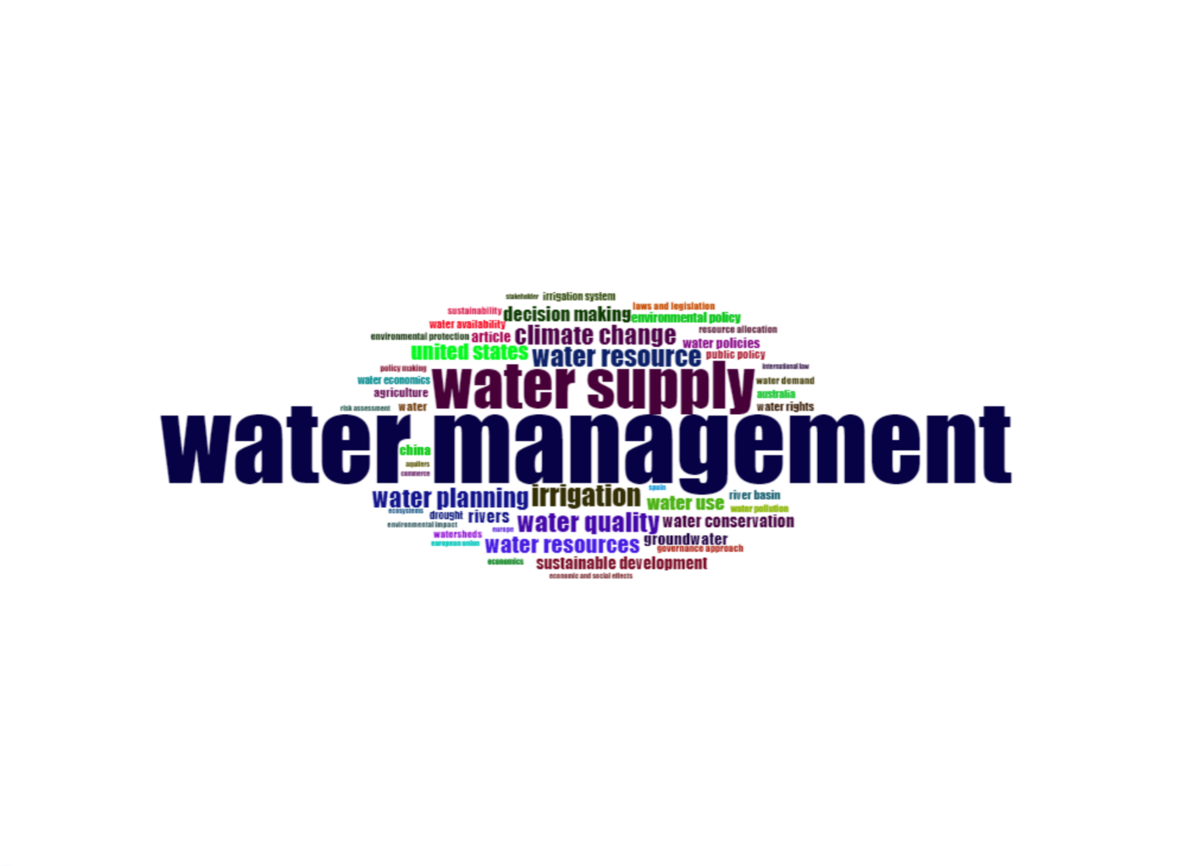

**3.4 Identifying research themes using top cited documents and co-occurrence networks of keywords**

From the analysis of the top 10 most cited documents and the co-occurrence network of keywords, it is evident that "water institutions" is a critical yet under-researched topic. The top cited papers, such as "Sink or Swim? Water security for growth and development" by Grey and Sadoff (2007) and "A look at twenty-first century water resources development" by Gleick (2000) focus on broader themes of water security and resource management (Table 3). These documents highlight the importance of effective water policies and management strategies.

**Table 3 List of top 10 most cited documents**

|  |  |  |  |  |  |
| --- | --- | --- | --- | --- | --- |
| **Sl. no** | **Title of the paper** | **Published year** | **Author(s)** | **Source** | **Total citations** |
| 1 | Sink or Swim? Water security for growth and development | 2007 | Grey, David Sadoff, Claudia W. | Water Policy | 691 |
| 2 | A look at twenty-first century water resources development | 2000 | Gleick, Peter H. | Water International | 585 |
| 3 | A review of multiple criteria analysis for water resource planning and management | 2007 | Hajkowicz, Stefan Collins, Kerry | Water Resources Management | 539 |
| 4 | Beyond panaceas in water institutions | 2007 | Meinzen-Dick, Ruth. | Proceedings of the National Academy of Sciences of the United States of America | 375 |
| 5 | Challenges and Prospects of Sustainable Groundwater Management in the Indus Basin, Pakistan | 2010 | Qureshi, Asad Sarwar McCornick, Peter G. Sarwar, A. Sharma, Bharat R. | Water Resources Management | 205 |
| 6 | Water scarcity, pricing mechanism and institutional reform in northern China irrigated agriculture | 2003 | Yang, Hong Zhang, Xiaohe Zehnder, Alexander J.B. | Agricultural Water Management | 189 |
| 7 | Water markets and trading | 2006 | Chong, Howard Sunding, David | Annual Review of Environment and Resources | 160 |
| 8 | Institutional arrangements for integrated river basin management | 2003 | Jaspers, Frank G.W. | Water Policy | 99 |
| 9 | Institutional changes in global water sector: Trends, patterns, and implications | 2000 | Saleth, R. Maria Dinar, Ariel | Water Policy | 95 |
| 10 | Institutional path dependence and environmental water recovery in Australia's Murray-Darling Basin | 2016 | Marshall, Graham R. Alexandra, Jason | Water Alternatives | 86 |

The co-occurrence network of keywords, as shown in Figure 6, further supports this observation. Using the VOS viewer, 18,618 keywords were analyzed, and 45 keywords were selected based on a minimum of 60 occurrences, revealing significant clusters around related themes.

**Figure 6 – Co- occurrence network of keywords (source – VOS viewer)**

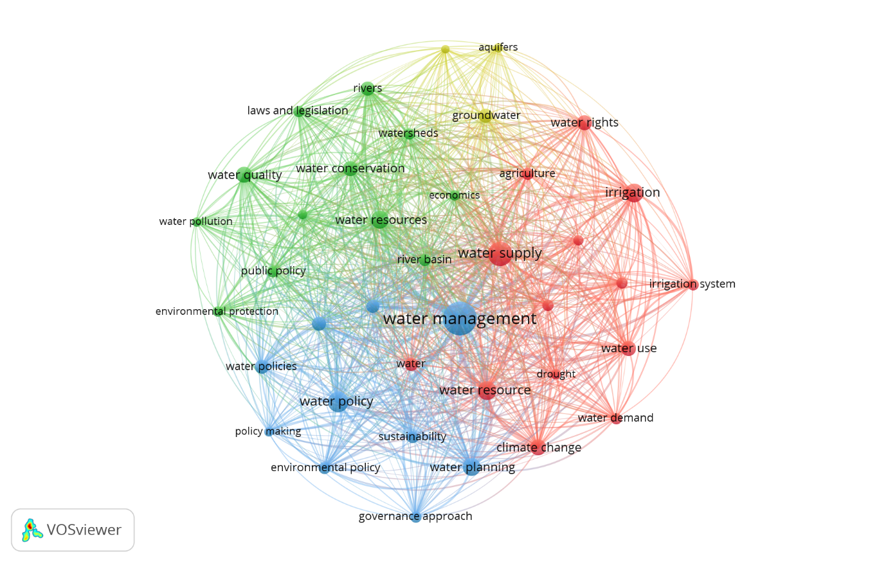

Cluster 1 (red) includes keywords like irrigation, water resources, water supply, and water rights, emphasizing the interconnected nature of agricultural practices and water resource management. Cluster 2 (green) focuses on river basins, water quality, public policy, and water conservation, underscoring the role of legal frameworks and policies in water management.

Cluster 3 (blue) highlights water management, sustainable development, and water policy, showing a strong focus on governance and policy planning. Lastly, Cluster 4 (yellow) deals with groundwater resources and hydrogeology, stressing the geological aspects of water management.

However, the relatively low number of occurrences for keywords related to "water institutions" suggests that this area has received less attention in the research community. This gap highlights the need for further investigation into the role and impact of water institutions in shaping effective water management practices and policies. The analysis underscores the necessity of expanding research efforts to address this critical aspect, ensuring that water institutions are adequately studied to inform sustainable and equitable water resource management.

In conclusion, both the top cited documents and the co-occurrence network of keywords demonstrate that while significant progress has been made in various aspects of water management, there is a clear need for more focused research on water institutions. Addressing this gap will be crucial for developing comprehensive strategies that support sustainable water use and management practices.

### WATER INSTITUTIONS IN INDIA

The water scarcity crisis in India is no longer confined to specific regions but has become widespread, impacting life, industry, and livelihoods. The effectiveness of water institutions is crucial for governance and addressing this crisis. Studies and policies, like the National Water Policy, stress the importance of involving farmers in improving water use efficiency and irrigation system performance. They advocate for sustainable and equitable water resource management. However, the comparative analysis of research publications reveals that India lags significantly in scientific output, with only 59 articles contributing a mere 2.3% of total global publications (fig 7). This underscores the need for enhanced research funding, improved infrastructure, and stronger international collaborations.

Figure 7: Country-wise Research Publications and Collaborations

To understand the historical context and policy framework guiding India's approach to water management, it is essential to examine the evolution of the National Water Policy and its focus on farmer participation. India’s first National Water Policy, adopted in 1987, underscored the importance of involving farmers in irrigation management. The policy recommended "progressive involvement of farmers in various aspects of irrigation system management, particularly in water distribution and collection of water rates."

The National Water Policy of 2002 emphasized a participatory approach to water resources management, involving government agencies, users, and stakeholders. It called for legal and institutional changes to ensure women's participation and advocated for Water Users Associations (WUAs) and local bodies to be involved in the operation, maintenance, and management of water infrastructure, with the goal of eventually transferring management to user groups and local bodies. The National Water Policy of 2012 further advanced this approach by granting WUAs legal authority to collect and keep a portion of water charges and manage water allocation and distribution. Despite these progressive policies, India's research output remains behind other countries, highlighting the need for India to bolster its research initiatives and infrastructure to match global standards.

Irrigation policies, acts, rules, and regulations vary across states in India due to state governments' jurisdiction. To address the need for a legal framework for Participatory Irrigation Management (PIM), the Ministry of Water Resources recommended a model act for state legislatures. This model aimed to facilitate the creation or amendment of irrigation laws to support PIM. Several states have enacted specific legislation to promote farmer participation in irrigation management, reflecting a growing awareness of the importance of involving farmers in irrigation system management.

* “Andhra Pradesh Farmers’ Management of Irrigation Systems Act, March 1997.”
* “The Assam Irrigation Water Users Act, 2004.”
* “The Bihar Irrigation, Flood Management and Drainage Rules, 2003” under the Bihar Irrigation Act, 1997.
* “Chhattisgarh Sinchai Prabandhan Me Krishkon Ki Bhagidari Adhiniyam, 2006.”
* “Goa Command Area Development Act, 1997.”
* “Gujarat Water Users’ Participation Management Act, 2007.”
* “Karnataka State Ordinance for Amendment of the Existing Karnataka Irrigation Act, 1957,” promulgated on 7th June 2000.
* “The Kerala Irrigation and Water Conservation Act, 2003.”
* “Madhya Pradesh Sinchai Prabandhan Me Krishkon Ki Bhagidari Adhiniyam, 1999.”
* “The Maharashtra Management of Irrigation Systems by Farmers Act, 2005.”
* “Nagaland Farmers Participation in Management of Irrigation Systems Act, 2013.”
* “The Orissa Pani Panchayat Act, 2002.”
* “The Rajasthan Sinchai Pranali Ke Prabandh Me Krishkon Ki Sahabhagita Adhiniyam, 2000.”
* “Sikkim Irrigation Water Tax, 2002” and “Sikkim Irrigation Water Tax Act, 2000.”
* “The Tamil Nadu Farmers’ Management of Irrigation System Act, 2007.”
* “The Uttar Pradesh Irrigation Management Act, 2009.”

**CONCLUSION**

While policies have been established to promote farmer involvement in irrigation management, India's research output in water institutions lags significantly, comprising only 2.3% of global publications with 59 articles compared to global leaders. By increasing investment in research and development, improving infrastructure, and fostering both national and international collaborations, India can enhance its scientific output and better implement its water resource management policies, thereby contributing more significantly to global research. The relatively low occurrence of top-cited documents and keywords related to "water institutions" also highlights an underexplored area in the research community, necessitating further investigation into the roles and impacts of these institutions on effective water management practices and policies.

Overall, this study demonstrates that water institutions is an important area of research with significant implications for sustainable regional development. The findings underscore the importance of continued research and collaboration among scholars, policymakers, and practitioners to enhance water governance and achieve equitable and sustainable water resource management. Future research should focus on addressing the identified gaps and exploring innovative solutions to the complex challenges facing water institutions worldwide.

**REFERENCES**

Amarasinghe, U. A., Mccornick, P., & Shah, T. (2009). Projections of irrigation water demand in India: What do recent trends suggest? *International Journal of River Basin Management*, *7*(2), 157–166. <https://doi.org/10.1080/15715124.2009.9635378>

Chopra, A., & Ramachandran, P. (2021). Understanding water institutions and their impact on the performance of the water sector in India. *Water Policy*, *23*(2), 466-486.

Dhawan, V. (2017). Water and agriculture in India: background paper for the South Asia expert panel during the *Global Forum for Food and Agriculture* (GFFA) 2017.

Dinar, A., & Saleth, R. M. (2005). Can water institutions be cured? A water institutions health index. *Water Science and Technology: Water Supply*, *5*(6), 17-40.

Gandhi, V. P., Crase, L., & Herath, G. (2006). *Comparing Indian Irrigation Institutions: What Determines Institutional Behaviour and Performance? Preliminary Empirical Observations*.

Maria Saleth, R., & Dinar, A. (2004). The Institutional Economics of Water: A Cross-country Analysis of Institutions and Performance. *World bank publications*. <https://doi.org/10.4337/9781845421496.00001>

Mingaleva, Z., Chernova, O., & Mitrofanova, I. V. (2023). Bibliometric Analysis of Research Trends in Water Management Aimed at Increasing the Sustainability of the Socio-Economic Development of a Region. *Water (Switzerland)*, *15*(20). <https://doi.org/10.3390/w15203688>

Pang, Y., Marinello, F., Tang, P., Li, H., & Liang, Q. (2023). Bibliometric Analysis of Trends in Smart Irrigation for Smart Agriculture. *Sustainability*, *15*(23), 16420.

Saleth, R. M. (2005). Water Institutions in India: Structure, Performance, and Change. In *Water Resources Development and Management*, 47–80. *Springer*. <https://doi.org/10.1007/3-540-26567-8_3>

Sinha, P. (2004). Status of Participatory Irrigation Management (PIM) in India. In *National Convention of Presidents of Water Users Associations, Ministry of Water Resources India NPIM, New Delhi*.

Swain, M., & Das, D. K. (2008). Participatory irrigation management in India: Implementations and gaps. *Journal of Developments in Sustainable Agriculture*, *3*(1), 28-39.

United States Agency for International Development (USAID), Sustainable Water Partnership (2021). India Water Resources Profile Overview. <https://winrock.org/wp-content/uploads/2021/08/India_Country_Profile-Final.pdf>

Velasco-Muñoz, J. F., Aznar-Sánchez, J. A., Belmonte-Ureña, L. J., & López-Serrano, M. J. (2018). Advances in water use efficiency in agriculture: A bibliometric analysis. *Water*, *10*(4), 377.