Enhancing Cybersecurity Measures in Critical Infrastructure: Challenges and Innovations for Resilience

ABSTRACT

Aim: This review deals with challenges and innovations concerning the enhancement of cybersecurity measures taken for critical infrastructures, which include sectors related to energy grids, healthcare, and transportation networks. The study aims at identification of vulnerabilities, an assessment of advanced threat detection systems, and analysis of network protection protocols for improvements in resilience against cyber threats.
Study Design: The study is a peer literature review from 2019 to 2024 concerning cybersecurity measures in critical infrastructures. The result will therefore, involve a selection from various scholarly journals in an informed approach.
Methodology: The research uses a peer literature review methodology. The databases employed in this paper are Google Scholar, Scopus, IEEE Xplore, and the International Journal of Critical Infrastructure Protection. Articles were selected based on relevance to cybersecurity in critical infrastructure, focusing on advanced threat detection, network protection, and resilience strategies.
Results: The review identifies 25 key studies that show a growth in sophistication in cyber threats against critical infrastructure. Among the promising technologies to mitigate the risks are AI-driven threat detection, blockchain for secure data transmission, and zero-trust architectures. Case studies from the energy and healthcare sectors demonstrate how these technologies can enhance resilience. Yet, resource constraints, lack of standardized protocols, and human error remain significant barriers.
Conclusions: The study concludes that though there has been significant development in the cybersecurity measures of critical infrastructure, continuous innovation and collaboration by all stakeholders are required to overcome the challenges faced. Future research should be directed towards the development of standardized frameworks, better workforce training, and the long-term efficacy of emerging technologies.

Keywords: Cybersecurity, Blockchain, Threat detection, Artificial Intelligence.

1. INTRODUCTION

Cybersecurity in critical infrastructure has become a paramount concern in the face of escalating cyber threats, increased reliance on digital technologies, and the growing sophistication of cyber adversaries [1]. Critical infrastructure encompasses sectors such as energy, water supply, healthcare, transportation, and financial services, all of which are fundamental to national security, economic stability, and public safety [2]. The increased digitization and interconnectivity driven by the development of in the Internet of Things (IoT), Artificial Intelligence (AI), and cloud computing have made critical infrastructure targets of advanced cybersecurity threats [3]. Damage to these sectors due to cyberattacks can cause devastating consequences in terms of disruptions to services, financial losses, and loss of human life [4].

Despite the significant efforts invested in securing critical infrastructure, the evolving nature of cyber threats necessitates continuous advancements in cybersecurity measures and resilience strategies [5]. The global threat landscape has witnessed a surge in cyber incidents targeting critical infrastructure, ranging from ransomware attacks to state-sponsored cyber espionage [6]. These include the 2015 and 2016 cyberattacks on Ukraine's power grid, resulting in disruptions to electricity supplies for thousands of citizens [6], and the ransomware attack on the Colonial Pipeline of the United States in 2021, causing fuel shortages and economic disturbances to the economy [5]. These incidents point out the critical vulnerability of infrastructures to new forms of cyber perils and the urgent need for robust security frameworks. Traditional cybersecurity approaches, such as firewalls, intrusion detection systems, and antivirus software, are increasingly inadequate in countering sophisticated attacks that exploit emerging vulnerabilities in supply chains, industrial control systems (ICS), and operational technologies (OT) [7]. As a result, there is a growing emphasis on integrating advanced threat detection mechanisms, zero-trust architectures, and artificial intelligence-driven security solutions [8].

Critical infrastructure is the backbone of modern society, including energy, health, transportation, water supply, and communication networks. These systems are ever more dependent on digital technologies, which are increasingly exposed to cyber threats [2]. The scale of potential consequences from an adverse cyber intrusion impacting critical infrastructure ranges from citywide power outages to disclosure of sensitive patient information in health systems. These are the areas where enhancement is of utmost priority in ensuring cybersecurity for societal resilience. The sudden increase in ransomware, phishing, and advanced persistent threats among other complex types of cyber-attacks has raised huge concerns for enhanced cybersecurity frameworks. Traditional security, in most cases, stands inefficient against emerging threats, hence the need to adopt innovative cybersecurity solutions [5].

The purpose of this review is to investigate challenges and innovations in critical infrastructure cybersecurity, especially advanced threat detection systems, network protection protocols, and resilience strategies. The subject of critical infrastructure protection also has a current and pressing significance with the series of high-profile cyberattacks targeting the same in recent times. For example, the 2021 Colonial Pipeline ransomware attack disrupted fuel supplies across the eastern United States, showing the vulnerability of energy infrastructures [2]. In addition, the 2020 SolarWinds attack exposed the weak points in supply chain security, affecting numerous organizations, including government agencies [5]. Such incidents indicate that there is a dire need for comprehensive cybersecurity measures to safeguard the critical infrastructure. But more connectivity also means a higher degree of vulnerability to these infrastructures within cyber-attacks. For example, the integration of IoT devices widens the attack surface further by offering various entry points to cybercriminals for their benefit [2]. Increased dependence on cloud-based services, on the other hand, has opened newer avenues for attacks in the forms of data breach and unauthorized access [9]. These are challenges that motivate innovative solutions being developed by both researchers and industry practitioners.

Artificial intelligence and machine learning have provided scopes that are useful in threat detection. Such systems can analyze huge volumes of data in real-time and detect unusual behavior and threats before they become large-scale, as stated by Smith [10]. Similarly, blockchain technological innovation has been adopted to secure the transmission of information; blockchain provides a decentralized, tamper-proof ledger that enhances data integrity [9]. Notwithstanding these developments, challenges still abound. Among the major causes of ineffective cybersecurity in critical infrastructure is the absence of standardized protocols. Although frameworks like the NIST Cybersecurity Framework and the ISO/IEC 27001 standard give guidelines for the implementation of appropriate cybersecurity measures, their adoption remains inconsistent across sectors [2]. This inconsistency can lead to gaps in security, leaving critical infrastructure systems vulnerable to attack. These are major factors, especially in developing countries. Most of the advanced measures of cybersecurity are very costly and require heavy financing, which many organizations may not be able to afford [1]. Besides these technical issues, human error also has a great impact on cybersecurity incidents, and the need for increasing workforce training and awareness programs was felt [10].

Many existing studies also focus on individual security measures without providing a holistic framework for enhancing cybersecurity resilience across different infrastructure sectors [1, 11]. Additionally, while substantial work has been conducted on threat detection and incident response, there is limited research on how organizations can proactively strengthen cybersecurity [5, 12]. Another key research gap pertains to policy and regulatory frameworks, as existing cybersecurity laws and standards often lag behind technological advancements and emerging threats [13]. This study seeks to address these gaps by conducting a review of cybersecurity challenges and innovations in critical infrastructure. While most of the literature so far has focused on one or another cybersecurity threat in isolation, this research will seek to synthesize the literature on challenges and solutions alike, developing a holistic approach to resilience enhancement. Advanced security measures to be reviewed include AI-driven threat intelligence, blockchain-based security protocols, and zero-trust architectures; their effectiveness will also be discussed vis-à-vis cyber-risk mitigation. Additionally, this study will explore the role of policy interventions, cross-sector collaborations, and regulatory compliance in strengthening cybersecurity resilience. By providing a structured analysis of emerging cybersecurity strategies and identifying best practices, this research will contribute to bridging the gap between theoretical cybersecurity frameworks and their practical implementation in critical infrastructure settings. This will eventually lay a sound foundation for further research into cybersecurity innovations and contribute to the ongoing discourse on securing critical infrastructure in an increasingly digitalized and interconnected world.

2. METHODOLOGY

The methodology used for this review relies on a review process that is designed to be thorough, transparent, and reproducible. This systematic approach, is in accordance with Preferred Reporting Items for Systematic Reviews and Meta-Analyses (PRISMA) [14], it involves several steps: the selection of databases, defining the search strategy, inclusion-exclusion criteria for data, extraction of such data, qualitative synthesis of data, and writing up the result. It follows a systematic review design because it purports to provide an overview of key developments and existing research gaps on issues related to cybersecurity through a deliberate examination of critical infrastructure for cybersecurity threats, mitigation strategies, and resilience models. An intensive and systematic search strategy has been adopted for the retrieval of relevant literature from multiple academic databases. These databases are selected based on their reputation to index high-quality cybersecurity and critical journals. Those utilized include Google Scholar, Scopus, IEEE Xplore, and the International Journal of Critical Infrastructure Protection.

Literature Search Strategy

The search strategy for this study involves subject-specific keywords combined with Boolean operations and truncation to maximize retrieval. The key search terms of the strategy employed for this research involved "Cybersecurity," "Critical Infrastructure," "Threat Detection," "Network Security," "Infrastructure Resilience," "Cyber Resilience," and "Risk Mitigation." Limits that were set gave only recent, relevant works which were peer reviewed, published 2019 up to 2024, and in full text. Studies were selected using the four-phase approach: identification, screening, eligibility, and inclusion, recommended by PRISMA [14].

The database search resulted in 303 records. After removing duplicates, 250 unique records remained. Title and abstract screening excluded a number of the studies that were not in line with the focus of the research on cybersecurity in critical infrastructure. The result from this process is 70 full-text articles that were reviewed for eligibility, with a total of 25 studies selected for qualitative analysis (See Figure 1).

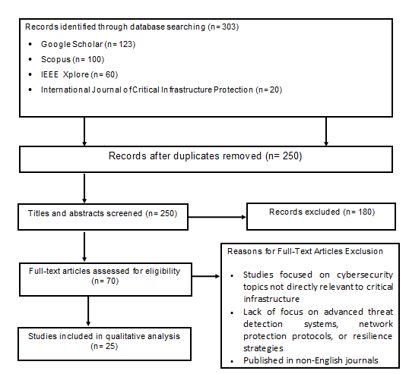

Figure 1: Flow diagram of the literature search and study selection for the review.

The review included studies related to challenges in cybersecurity, detection of threats, network protection, or policy innovations in infrastructure cybersecurity, which supplied empirical research through quantitative or qualitative analysis. Those that excluded such a criterion included general IT security, physical security threats, natural disasters, and poor methodological strength. Despite its comprehensive methodology, the study acknowledges certain limitations. Database restrictions may have excluded some cybersecurity research behind paywalls or published in non-English journals, which could offer additional insights [15]. The study's timeframe limitation, focusing on literature from 2019-2024, may have missed historical cybersecurity advancements. However, the study enriches the further discussion of possible cyber resilience strategies by underlining advanced threat detection systems, regulating policies, and technological innovations protecting critical infrastructure.

3. RESULTS AND DISCUSSION

This review identified 25 key studies on the dynamic evolution of cybersecurity threats to critical infrastructure. The selected studies reveal a growing trend of sophistication in cyber-attacks that call for increasingly sophisticated measures of security. The major conclusions that have been emphasized relate to AI-driven threat detection, blockchain-based security mechanisms, and zero-trust architecture for mitigating such risks. However, some of the major barriers to large-scale implementation continue to be resource constraints, an absence of standardized protocols, and human vulnerabilities.

Emerging Cyber Threats in Critical Infrastructure

The ever-growing dependence on digital systems has left the critical infrastructure sectors highly susceptible to sophisticated cyber-attacks. According to recent reports, ransomware attacks, DDoS attacks, and even APTs have gained momentum that cause destruction to essential services such as energy grids, healthcare, and transportation networks [16]. These cyber-attacks (See Figure 2) leverage all the vulnerabilities created by outdated legacy systems, poor network configuration, and human factors to cause massive operational disruption and data breaches [17]. This has been aggravated by the connectivity of IoT and OT, making the attack surface much larger because of the openings provided to cyber adversaries [18].
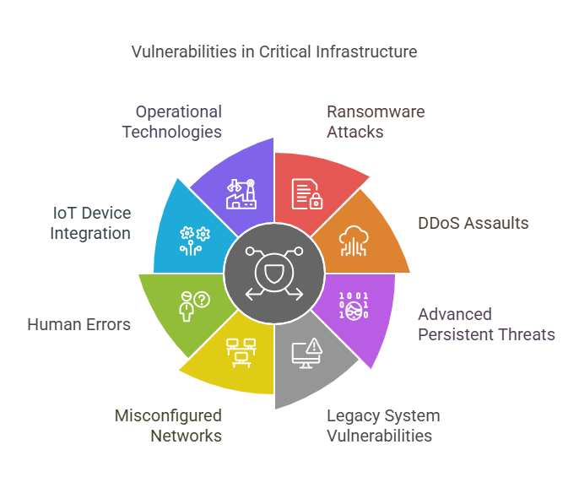
Figure 2: Cyber Threats in Critical Infrastructure

A notable recent example is that of the ransomware attack in 2021 on Colonial Pipeline, which dramatized dire consequences of the cyber intrusion effect on national energy infrastructure and required proactive cybersecurity [19]. Similarly, cyberattacks on healthcare, such as ransomware WannaCry, are devastating implications of compromised data of patients, along with disruptions to systems that are critical in sustaining life, as noted by Adebukola [20]. These make the urgent updating of adaptive frameworks in cybersecurity relevant to counter new threats. Cyberattacks on the transportation sector are also targeting logistics and supply chain disruption by cybercriminals. There is a dire need for critical security in smart transportation systems, such as railway networks and autonomous vehicles, to avoid such big losses in terms of safety and economy [21]. For example, the NotPetya attack disrupted the global shipping operations in 2017 severely; billions of dollars were damaged. The interconnectedness of these critical infrastructure sectors amplifies these risks further, where the failure of one system leads to a cascading failure across industries [22].

Innovations in Cybersecurity for Critical Infrastructure

The rapidly increasing sophistication and frequency of cyberattacks on energy grids, water supply systems, and transportation networks in recent times have put critical infrastructures (See Figure 3) in a situation where the need for cybersecurity has become highly urgent [23, 24]. These systems, which form the backbone of modern society, are highly vulnerable to disruptions that can have catastrophic consequences for public safety, economic stability, and national security [25]. In response, researchers and industry experts have developed a range of technological innovations aimed at enhancing the resilience of critical infrastructure against evolving cyber threats [22, 26, 27]. This review discusses recent cybersecurity innovations, focusing on applications, challenges, and potentials for maintaining the security of critical systems.

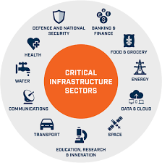

Figure 3: Critical Infrastructure Sectors in Cybersecurity

AI-Driven Threat Detection
Artificial Intelligence (AI) and Machine Learning (ML) have revolutionized cybersecurity by enabling real-time anomaly detection and predictive analytics (See Figure 4). AI-powered intrusion detection systems (IDS) analyze network traffic patterns to identify suspicious activities before they escalate into full-scale cyberattacks [27]. Unlike traditional signature-based detection methods, AI-based solutions have demonstrated superior accuracy, with reduced false positives and faster response times, making them highly effective in mitigating cyber threats [28].

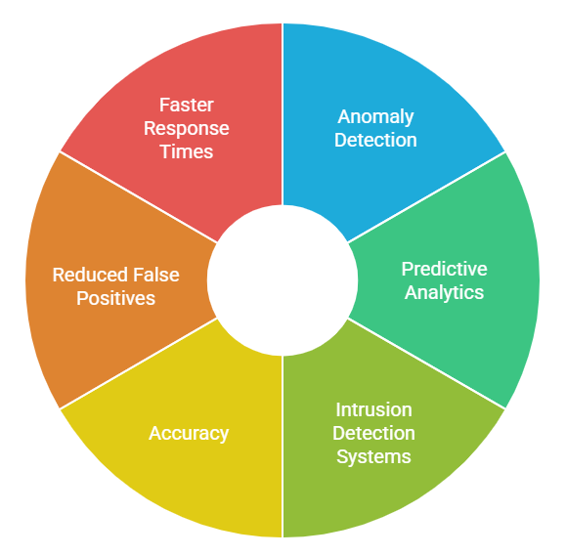

Figure 4: AI and ML Roles in Cybersecurity

Moreover, AI-driven security systems can autonomously adapt to emerging attack patterns, making them particularly valuable for securing dynamic and complex infrastructure networks [22]. However, challenges such as high computational requirements and potential biases in AI models remain significant barriers to implementation [29]. Addressing these limitations will be critical to fully realizing the potential of AI in cybersecurity.

Blockchain for Secure Data Transmission

Blockchain technology has emerged as a powerful tool for securing data transmission and ensuring data integrity in critical infrastructure (See Figure 5). Its decentralized nature mitigates risks associated with data tampering and unauthorized access, providing a robust layer of security [30]. For instance, in the healthcare sector, blockchain has been successfully deployed to safeguard patient records, prevent data breaches, and enhance trust in digital health systems [5, 20].
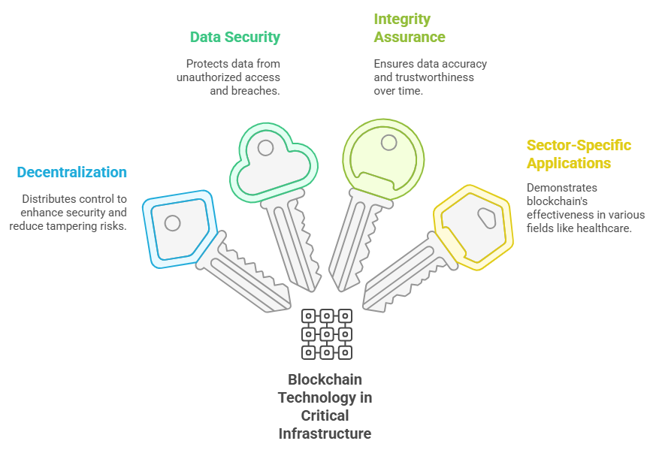

Figure 5: Blockchain Technology in Critical Infrastructure

Smart contracts in blockchain increase the security in an industrial control system by automatically enforcing compliance to mitigate insider threats and cyber intrusions from outside [22]. With such contracts, execution of security policies can be done automatically whereby only the entities authorized to do so will have access to, or even modify critical data. Besides, the supply chain security is enhanced by blockchain through transparent and indelible transaction records that help avoid frauds or counterfeits [28]. Despite these advantages, scalability issues and the enormous overhead in computing for verifying blockchains limit full adaptability. The integration of lightweight blockchains and hybrid architecture integrating blockchain with traditional security mechanisms could help to get overcome these limitations [31].

Zero-Trust Security Architecture

The zero-trust security model (See Figure 6) operates on the principle of "never trust, always verify," implementing stringent access controls and continuous authentication. This approach significantly reduces attack surfaces by eliminating implicit trust within networks, making it highly effective against both insider threats and external cyberattacks [31]. For example, the adoption of zero-trust architectures in energy grids has demonstrated improved resilience and security [22].
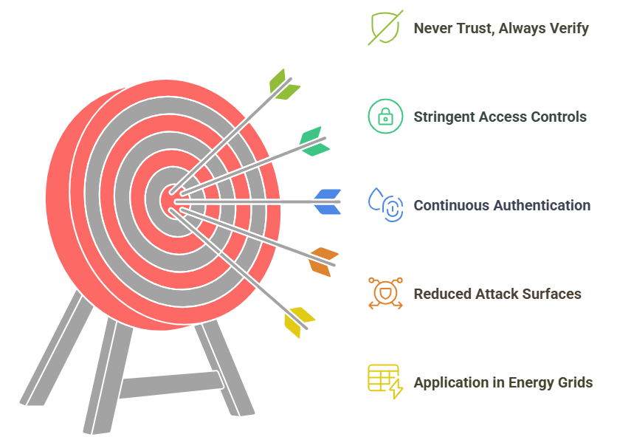

Figure 6: Zero-Trust Security Model

Zero-trust frameworks rely on Multi-Factor Authentication (MFA), identity verification, and strict user access policies to ensure that every access request is checked before permissions are granted. Micro-segmentation, one of the core elements of zero-trust architectures, splits networks into smaller, isolated segments, which in turn limits an attacker's ability to move laterally within a system [26]. Zero-trust architectures, on the other hand, do ensure great security; however, implementation often requires heavy infrastructural changes, which could be very resource-intensive and may be challenging technically. An appropriate trade-off is required to balance enhanced security and operational feasibility [28].

Challenges in Implementing Cybersecurity Measures

Despite recent advancement in cybersecurity technologies, a set of challenges hamper effective security measures in sectors related to critical infrastructure. Resource constraints and high implementation costs act as a significant barrier to the adoption of advanced cybersecurity solutions. The implementation of AI-driven security systems and blockchain technology requires considerable financial investments, which especially creates difficulties for small and mid-sized infrastructure operators to implement such innovations [16]. Another major challenge is the lack of standardized security protocols. The absence of universally accepted cybersecurity frameworks complicates the adoption of best practices across different sectors. Discrepancies in regulatory policies between regions further exacerbate security vulnerabilities, leading to inconsistencies in threat mitigation strategies [19]. Establishing standardized security protocols would enhance interoperability and facilitate a coordinated response to cyber threats. Human factors and insider threats also remain significant concerns. Phishing attacks, poor password management, and accidental security breaches collectively contribute to a major share of cyber incidences [29]. Jiang & Chen [28]. pointed out that insider threats can only be limited and cybersecurity resilience can also be made better with regular employee training and awareness programs.

Future Directions and Recommendations

The research in cybersecurity of critical infrastructure in the future needs to be focused on developing a standardized framework for consistency and interoperability among the sectors [2]. Training programs for the workforce need to be strengthened so that human-induced vulnerabilities in cybersecurity can be minimized. Further, long-term effectiveness studies of AI-driven threat detection and blockchain-based security measures shall help build up resilience against ever-evolving cyber threats. Policymakers and industry leaders must urge further collaboration toward cybersecurity regulations enacted worldwide to keep up with emerging challenges. Investing in next-generation security technologies such as quantum cryptography and secure multi-party computation would be imperative to strengthen digital infrastructure.

Furthermore, integration of cyber resilience strategies at a national security policy level would be required to take a proactive stance against the cyber threats. It therefore follows that cybersecurity is an area in which the development and deployment have to be interdisciplinary with the policy improvements so as not to make the protection of critical infrastructure be compromised by ever-evolving cyber-attacks.

4. CONCLUSION

From this review, critical infrastructures are being targeted at a high increasing rate by sophisticated cyber threats; as such, the adoption of advanced security measures becomes very important. AI-powered threat detection, blockchain-based security mechanisms, and zero-trust architectures represent some of the most promising solutions for mitigating cyber risks. However, the persistence of resource constraints, a lack of standardized protocols, and human-related vulnerabilities requires further innovation and collaboration by stakeholders. The focus of future research should be on developing standardized frameworks, enhancing cybersecurity education, and assessing the long-term implications of cybersecurity measures in strengthing critical infrastructure against evolving cyber threats.

REFERENCES

1. Bada M, Sasse MA, Nurse JRC. Cyber security awareness campaigns: Why do they fail to change behaviour? Cybersecurity. 2019;2(1):10.

2. Olatunji AP, Ajibola OS, Agunbiade NO. Leveraging AI-driven training programs for enhanced organizational security awareness. Int J Sci Res Arch. 2024;13(1):301-311.

3. Blanco-Medina P, Fidalgo E, Alegre E, Vasco-Carofilis RA, Janez-Martino F, Villar VF. Detecting vulnerabilities in critical infrastructures by classifying exposed industrial control systems using deep learning. Applied Sciences. 2021;11(1):367-389.

4. Kuerbis B, Badiei F. The evolving role of cyber norms in critical infrastructure protection. Int J Cybersecur. 2021;9(2):87-105.

5. Kshetri N. Economics of Artificial Intelligence in Cybersecurity. IT Prof. 2021;23:73-77. doi:10.1109/MITP.2021.3100177.

6. Kozak P, Klaban I, Šlajs T. Industroyer cyber-attacks on Ukraine's critical infrastructure. In: 2023 International Conference on Military Technologies (ICMT). Brno, Czech Republic; 2023. p. 1-6.

7. Udroiu A, Vevera V. Lifelong learning for raising cybersecurity awareness. In: INTED2018 Proceedings. IATED; 2018. p. 5381-5387.

8. Ovabor K, Sule-Odu IO, Atkison T, Fabusoro AT, Benedict JO. AI-driven threat intelligence for real-time cybersecurity: frameworks, tools, and future directions. Open Access Res J Sci Technol. 2024;12:040-048. doi:10.53022/oarjst.2024.12.2.0135.

9. Dalaklis D, Nikitakos N, Yaacob R. Cyber security training strategy: dealing with maritime SCADA risks. 2021.

10. Smith J. Cyber resilience in critical infrastructure: A systematic analysis of challenges and solutions. Cybersecurity Rev. 2020;7(3):189-207.

11. Humayun M, Niazi M, Jhanjhi NZ, Alshayeb M, Mahmood S. Cyber security threats and vulnerabilities: a systematic mapping study. Arabian Journal for Science and Engineering. 2020;45:3171-89.

12. Gaber MG, Ahmed M, Janicke H. Malware detection with artificial intelligence: A systematic literature review. ACM Computing Surveys. 2024;56(6):1-33.

13. Hijji M, Alam G. Cybersecurity Awareness and Training (CAT) framework for remote working employees. Sensors. 2022;22(22):8663.

14. Moher D, Liberati A, Tetzlaff J, Altman DG, PRISMA Group* T. Preferred reporting items for systematic reviews and meta-analyses: the PRISMA statement. Annals of internal medicine. 2015 Aug 18;151(4):264-9.

15. Gusenbauer M, Haddaway NR. What’s the best software for systematic reviews? Environ Evid. 2020;9(1):1-13.

16. Alcaraz C, Zeadally S. Critical infrastructure protection: Requirements and challenges for the 21st century. Int J Crit Infrastruct Prot. 2021;34:100476.

17. Sharma S, Agrawal SS, Kumar SA. Unlocking Cybersecurity Horizons: Exploring Cutting-Edge Technologies, Strategies, and Trends in the Dynamic Cyber Threat Landscape. In2024 International Conference on Intelligent Computing and Emerging Communication Technologies (ICEC) 2024 Nov 23 (pp. 1-6). IEEE.

18. Radanliev P. Cyber diplomacy: defining the opportunities for cybersecurity and risks from Artificial Intelligence, IoT, Blockchains, and Quantum Computing. Journal of Cyber Security Technology. 2024 Feb 7:1-51.

19. Cybersecurity and Infrastructure Security Agency (CISA). Colonial Pipeline ransomware attack: Lessons learned. 2022. Available from: https://www.cisa.gov

20. Adebukola A, Navya A, Jordan F, Jenifer N, Begley RD. Cyber security as a threat to health care. Journal of Technology and Systems. 2022;4(1):32-64.

21. Usama M, Ullah U, Sajid A. Cyber Attacks Against Intelligent Transportation Systems. InCyber Security for Next-Generation Computing Technologies 2024 (pp. 190-230). CRC Press.

22. Malatji M, Marnewick AL, Von Solms S. Cybersecurity capabilities for critical infrastructure resilience. Information & Computer Security. 2022 Mar 29;30(2):255-79.

23. Nwoye CC. Next-generation protection protocols and procedures for securing critical infrastructure. International Journal of Research Publication and Reviews. 2024;5(11):4830-45.

24. Adewuyi A, Oladele AA, Enyiorji PU, Ajayi OO, Tsambatare TE, Oloke K, Abijo I. The convergence of cybersecurity, Internet of Things (IoT), and data analytics: Safeguarding smart ecosystems. World Journal of Advanced Research and Reviews. 2024;23(1):379-394.

25. World Economic Forum. The global cybersecurity outlook 2023. Geneva: WEF; 2023. Available from: https://www.weforum.org.

26. Yaseen A. AI-driven threat detection and response: A paradigm shift in cybersecurity. International Journal of Information and Cybersecurity. 2023 Dec 6;7(12):25-43.

27. Jonas D, Yusuf NA, Zahra AR. Enhancing security frameworks with artificial intelligence in cybersecurity. International Transactions on Education Technology. 2023 Nov 15;2(1):83-91.

28. Liu Y, Li S, Wang X, Xu L. A review of hybrid cyber threats modelling and detection using artificial intelligence in IIoT. Computer Modeling in Engineering & Sciences. 2024;140(2):1233-1261.

29. Roshanaei M, Khan MR, Sylvester NN. Enhancing cybersecurity through AI and ML: Strategies, challenges, and future directions. Journal of Information Security. 2024 May 17;15(3):320-329.

30. Gulia P, Gill NS, Yahya M, Gupta P, Shukla PK, Shukla PK. Exploring the Potential of Blockchain Technology in an IoT-Enabled Environment: A Review. IEEE Access. 2024 Feb 26;12:31197-227.

31. Syed NF, Shah SW, Shaghaghi A, Anwar A, Baig Z, Doss R. Zero trust architecture (zta): A comprehensive survey. IEEE access. 2022 May 12;10:57143-79.

