**Climate Change and Agricultural Productivity: Economic Implications with Reference to India**

**Abstract:**

The profound relationship between climate change and agricultural productivity in India is of paramount importance, particularly given the nation's reliance on agriculture as a primary economic sector. This essay explores the economic ramifications of reduced agricultural productivity due to climate change, with a focus on the impacts on farmers and the broader economy. India, with its diverse agro-climatic zones, faces significant challenges such as water scarcity, shifting monsoon patterns, and increased vulnerability to extreme weather events, all of which threaten food security and exacerbate socio-economic disparities. The paper delves into the historical trends in agricultural productivity, the role of climatic factors, and the potential economic consequences of climate-induced agricultural decline. By analyzing the impacts on rural poverty and food security, this research highlights the critical need for adaptive strategies and policies that ensure sustainable agricultural practices. Key questions explored include the potential of technological innovations like genetically modified crops and the role of policy frameworks in mitigating adverse economic effects. This study aims to provide insights that contribute to informed decision-making for sustainable agricultural development in the context of climate change in India.

**Keywords:** Climate Change, Agricultural Productivity, India, Economic Impacts, Food Security, Rural Poverty, Climate Adaptation, Technological Innovation, Sustainability, Policy Framework.

# **Introduction**

The profound interplay between climate change and agricultural productivity has emerged as a critical area of inquiry, particularly within the context of India, a nation whose economy is deeply intertwined with its agrarian roots. As global temperatures steadily rise and weather patterns become increasingly erratic, the implications for agricultural yields and, consequently, economic stability are daunting. India, home to a diverse range of agro-climatic zones, faces unique challenges that include water scarcity, shifting monsoon patterns, and increased vulnerability to extreme weather events. These climatic shifts not only threaten food security but also exacerbate socioeconomic disparities among farming communities, many of whom are already grappling with marginalization and poverty. This essay seeks to explore the economic ramifications of reduced agricultural productivity induced by climate change in India, providing a comprehensive analysis that considers both the microeconomic effects on farmers and the macroeconomic consequences for national growth and development.

## **Overview of agricultural productivity in India**

Agricultural productivity in India has historically been influenced by diverse factors, including climatic conditions, technological advancements, and socio-economic dynamics. With agriculture serving as a primary livelihood for around 58% of the population, understanding its productivity trends is crucial, especially against the backdrop of climate change challenges. Recent projections indicate a decline in agricultural output due to rising temperatures, which threatens food security and disproportionately affects impoverished rural households reliant on agriculture (Jacoby et al.). Moreover, climate change is expected to exacerbate existing vulnerabilities, limiting farmers adaptive capacity and leading to increased poverty levels in rural India (Dasgupta et al.). The interplay between fluctuating weather patterns and the increasing demand for food necessitates a critical evaluation of current agricultural practices, policies, and irrigation techniques to enhance productivity while ensuring sustainability, as the future of food security in India hinges on these adaptations within the agricultural sector.

Table 1- Agricultural productivity in India

|  |  |  |  |  |
| --- | --- | --- | --- | --- |
| **Year** | **Crop** | **Production (Million Tonnes)** | **Yield (kg/ha)** | **Area Harvested (Million hectares)** |
| 2015 | Rice | 104.3 | 2 | 42.2 |
| 2015 | Wheat | 86.5 | 3 | 29 |
| 2015 | Pulses | 17.3 | 700 | 24.6 |
| 2020 | Rice | 118.4 | 2 | 46 |
| 2020 | Wheat | 107.2 | 3.3 | 32.2 |
| 2020 | Pulses | 23 | 900 | 25.3 |
| 2022 | Rice | 121 | 2.1 | 45.9 |
| 2022 | Wheat | 109.5 | 3.4 | 32.3 |
| 2022 | Pulses | 25.6 | 950 | 27 |

*Agricultural Productivity in India (2015-2022)*

## **Importance of studying economic implications**

Analyzing the economic implications of climate change on agricultural productivity in India is crucial for several reasons. First, agriculture sustains the livelihoods of a significant portion of the Indian population, making its vulnerability to climatic shifts a key concern for poverty alleviation strategies. As indicated by recent studies, even modest temperature increases could lead to a marked decline in agricultural productivity, disproportionately affecting the poor and exacerbating existing inequalities in access to resources ((Jacoby et al.)). Furthermore, understanding the dynamics between climate change and food security is not merely an academic exercise; it is essential for crafting effective policy responses. With predicted scenarios of food deficits looming, especially in the face of rising global food prices, comprehensive economic assessments are vital to ensure that India can adapt its agricultural practices and maintain food security for its burgeoning population ((Dasgupta et al.)). Thus, in-depth economic analyses facilitate informed decision-making and equitable policy formulations.

## **Research objectives and questions**

The articulation of research objectives and questions is crucial in delineating the scope of studying the interplay between climate change and agricultural productivity in India. By framing specific inquiries, such as how climate variability impacts crop yields or what economic strategies could mitigate adverse effects, researchers can systematically explore interconnected agricultural dynamics. Critical analysis of technologies, such as genetically modified organisms (GMOs), is essential, given their potential role in enhancing resilience against climate stressors (Birner et al.). Furthermore, employing a Strategic Environmental Assessment (SEA) framework can provide a structured approach to evaluating the socio-economic implications of adopting such technologies (International Water Management Institute (IWMI).). This method not only emphasizes environmental considerations within policymaking but also prioritizes research agendas that address sustainable agricultural practices. Ultimately, the clarity of research objectives and questions directly influences the efficacy of policies aimed at ensuring food security and economic stability in the context of climate-induced challenges.

# **Understanding Climate Change**

Understanding climate change is crucial to addressing its multifaceted implications for agricultural productivity, particularly in India, where agriculture is both a significant economic driver and a primary source of livelihood for millions. Climate change, characterized by rising temperatures, altered precipitation patterns, and increased frequency of extreme weather events, poses serious threats to crop yields and food security. In regions such as the Central Western Ghats, human-induced land use changes exacerbate these challenges by diminishing ecosystems that serve as buffers against climate variability (cite12). The interplay of these factors necessitates comprehensive policy frameworks that integrate climate adaptation strategies with agricultural practices. By leveraging advancements in technology and emphasizing sustainable land management practices, India can enhance its resilience to climate impacts while ensuring economic stability for its farming population. Addressing these interdependencies is critical for understanding how climate change will shape the future of agricultural productivity in the country.

## **Scientific basis of climate change**

The scientific basis of climate change is grounded in a vast array of empirical data that elucidates the rising concentrations of greenhouse gases, predominantly carbon dioxide and methane, resulting from anthropogenic activities. These increases disrupt climate systems, leading to alterations in temperature and precipitation patterns critical for agricultural productivity. In the Indian context, the intersection of climate change with food security is particularly pronounced, as fluctuations in crop yields are directly influenced by changing climatic variables. Research indicates that climate change could compromise the stability of food supplies, thus affecting both the availability and accessibility of essential grains (cite13). Furthermore, specific agricultural practices, such as mixed farming systems prevalent in regions like the Indo-Gangetic Basin and West Bengal, face challenges of water productivity and energy consumption under changing climatic conditions, which further complicates economic implications for farmers and policymakers alike (cite14). Understanding these dynamics is essential for developing adaptive strategies to mitigate adverse effects on agricultural productivity.

## **Historical trends of climate change in India**

The historical trends of climate change in India illustrate a complex interplay between environmental shifts and agricultural productivity, directly impacting economic stability. Over the last century, Indias climate patterns have exhibited notable changes, including increased temperatures and altered precipitation regimes, which have critical implications for crop yields. As highlighted in (Fisher-Vanden et al., 2016), the overexploitation of groundwater, exacerbated by climate variability, has threatened the viability of small-scale farming, crucial for food security. Additionally, the findings from (Olivieri et al.) underscore the socioeconomic ramifications of these climatic shifts, suggesting that while economic growth may continue, climate change is likely to slow poverty reduction efforts, particularly in rural areas reliant on agriculture. This intersection of climate dynamics and agricultural dependence elucidates the urgent need for adaptive strategies to mitigate adverse effects and bolster food productivity, thus ensuring resilience against impending environmental challenges.

Fig 1- Historical trends of climate change in India

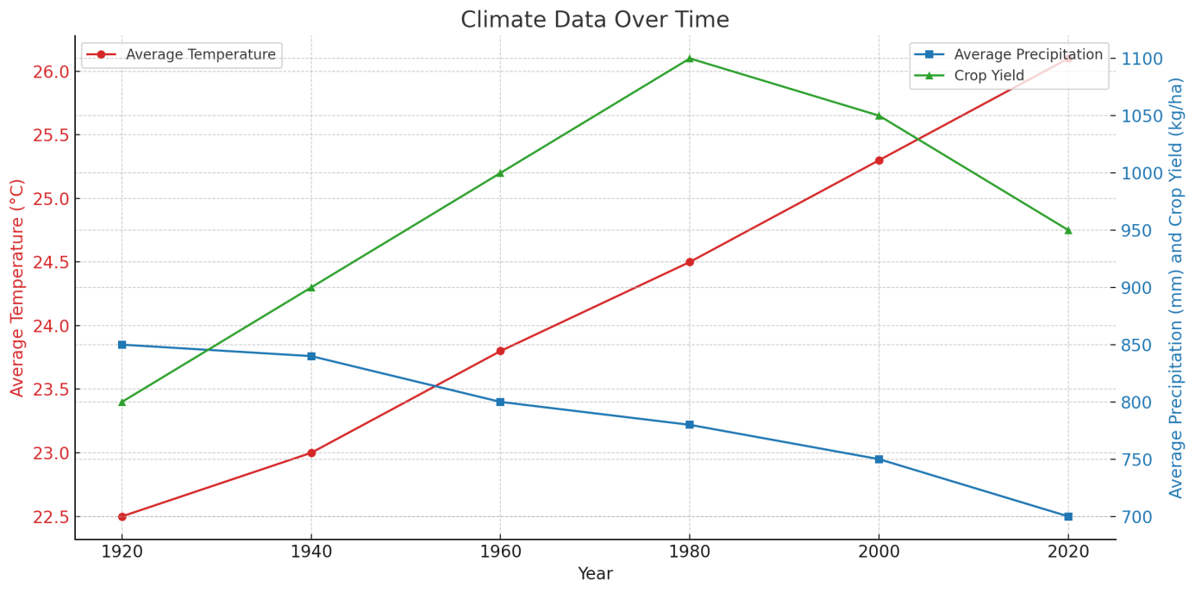

*The chart illustrates the relationship between average temperature, average precipitation, and crop yield over the years from 1920 to 2020. As the average temperature in degrees Celsius has increased, the average precipitation in millimeters has decreased, while crop yield in kilograms per hectare has shown a fluctuating trend. This data highlights the interconnectedness of climate factors and agricultural productivity over time.*

## **Key indicators of climate change affecting agriculture**

The multifaceted impact of climate change on agriculture necessitates a thorough understanding of key indicators that signal these transformations, particularly in India, where agricultural productivity is inherently tied to climatic conditions. Notable indicators include shifts in temperature and precipitation patterns, which have been shown to directly correlate with crop yields and soil health. For instance, increased variability in monsoon patterns can exacerbate both drought and flooding events, thereby complicating sowing and harvesting schedules and negatively affecting food security (Aggarwal et al., 2010). Additionally, the growing prevalence of pests and diseases, driven by climate-induced changes, further undermines agricultural resilience. The effectiveness of adaptation strategies, such as agroecological practices that enhance biodiversity, is contingent on these indicators, highlighting the importance of integrating localized climate data and participatory governance frameworks to foster adaptive capacity within farming communities (Clements et al., 2011). Thus, recognizing and analyzing these indicators is critical for formulating policies that support sustainable agricultural practices amid ongoing climate challenges.

Table 2- Key indicators of climate change affecting agriculture

|  |  |  |  |  |
| --- | --- | --- | --- | --- |
| **Year** | **TemperatureIncrease (°C)** | **RainfallChange (%)** | **CropYieldReduction (%)** | **PesticideUseIncrease (%)** |
| 2020 | 1.1 | -10 | -6 | 15 |
| 2021 | 1.3 | 5 | -8 | 20 |
| 2022 | 1.5 | -15 | -12 | 25 |
| 2023 | 1.6 | 2 | -10 | 18 |

*Key Indicators of Climate Change Affecting Agriculture in India*

## **Regional variations in climate impacts across India**

Indias vast geographic and climatic diversity leads to significant regional variations in the impacts of climate change on agricultural productivity, a phenomenon that necessitates a nuanced analysis given the economic implications. For instance, while northern regions may experience increased crop yields due to elevated temperatures and CO2 concentrations, southern states like Tamil Nadu and Kerala face debilitating effects from increased humidity and erratic monsoon patterns that exacerbate water scarcity and crop failures. According to recent assessments, climate change disproportionately affects poorer, agrarian communities, underscoring a concerning trend where developing areas suffer more severely from these impacts (cite19). Such regional disparities underscore the importance of localized adaptation strategies, as the resultant changes in productivity can significantly skew income and welfare distribution, particularly in the context of Indias overarching economic framework (cite20). Consequently, understanding these variations is critical for formulating effective policy responses aimed at bolstering agricultural resilience and sustainability across the nation.

## **Future projections of climate change scenarios**

The future projections of climate change scenarios posit significant challenges for agricultural productivity, particularly in India, where a substantial portion of the population relies on agriculture for their livelihoods. As climate models predict rising temperatures and altered precipitation patterns, the expected decline in agricultural yields could considerably affect food security and rural welfare. Research indicates that while adaptation strategies may mitigate some impacts, the overall trajectory suggests an adverse effect on the poorest households, exacerbating existing inequalities ((Olivieri et al.)). Specifically, moderate temperature increases are anticipated to reduce agricultural productivity, with more pronounced effects on smallholder farmers who lack access to resources for adaptation ((Jacoby et al.)). Consequently, the implications for poverty reduction efforts are stark: although India may continue to experience economic growth, the distributional impacts of climate change could lead to a modest increase in poverty levels, undermining decades of developmental progress and highlighting the urgent need for targeted interventions in climate policy.

Fig 2- Future projections of climate change scenarios

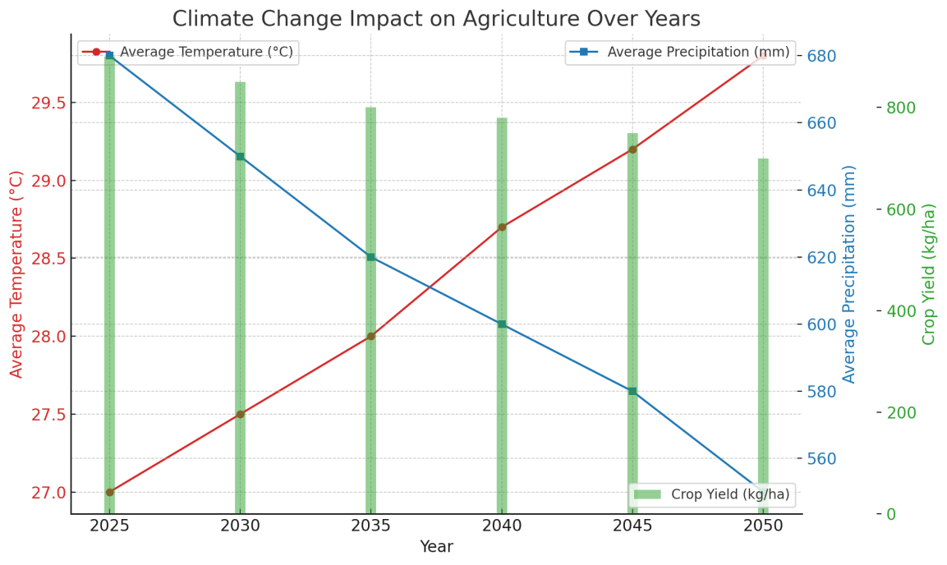

*The chart illustrates the impact of climate change on agriculture from 2025 to 2050, showing trends in average temperature, average precipitation, and crop yield. As the years progress, the average temperature rises, while average precipitation decreases, leading to a decline in crop yield. This highlights the challenges farmers may face due to changing climatic conditions.*

# **Impact of Climate Change on Agricultural Productivity**

The ramifications of climate change on agricultural productivity in India resonate profoundly within the socio-economic fabric of the nation, highlighting the vulnerabilities of the agricultural sector. As rising temperatures and erratic precipitation patterns become increasingly pronounced, projections indicate a significant decline in foodgrain production, leading to potential shortages in domestic supply (cite24). These alterations not only threaten food security but also exacerbate existing inequalities, as the burden of declining agricultural productivity disproportionately impacts the rural poor who depend primarily on agriculture for their livelihoods (cite23). This decline may not translate directly into diminished consumption for most rural households, largely due to their diversification into wage labor; however, it could instigate a subtle yet pervasive increase in poverty levels, estimated to rise by 3-4 percentage points within three decades (cite23). Thus, understanding these dynamics is crucial for formulating policies that mitigate adverse effects and enhance adaptive capacities in the agricultural sector.

## **Effects of temperature changes on crop yields**

Temperature fluctuations, particularly those resulting from climate change, exert significant effects on crop yields, which are critical to agricultural productivity in India. Research indicates that rising temperatures can lead to decreased agricultural outputs, as evidenced by findings that a 1 percent increase in wheat growing season temperature results in approximately a 0.3 percent reduction in yields (cite26). Such detrimental effects may vary regionally; however, the cumulative impact across India could exacerbate food insecurity as demand for staple crops continues to rise. Furthermore, the interaction between temperature changes and agricultural practices necessitates a nuanced understanding of food supply forecasts. For instance, while climate change threatens the availability and stability of food supplies, enhancements in agricultural inputs have somewhat mitigated these effects, leading to a complex dynamic where agricultural resilience is continually tested (cite25). This highlights the urgent need for adaptive strategies to ensure food security amid changing climatic conditions.

Fig 3- Effects of temperature changes on crop yields

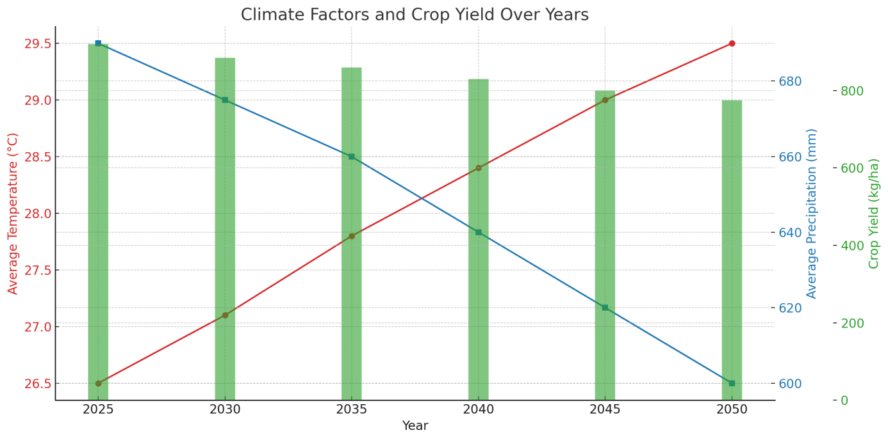

*The chart presents the relationships between average temperature, average precipitation, and crop yield from 2025 to 2050. It highlights a rising trend in average temperature alongside a decline in precipitation. Crop yield has also shown a decreasing trend, suggesting potential challenges for agricultural productivity under changing climate conditions.*

## **Influence of altered precipitation patterns on farming**

The influence of altered precipitation patterns on farming practices in India epitomizes the complex interplay between climate change and agricultural productivity. Variability in rainfall not only disrupts planting schedules but also exacerbates water scarcity and soil erosion, significantly threatening crop yields (IPCC, 2023) (Intergovernmental Panel on Climate Change, 2023). For instance, unseasonal monsoons can lead to waterlogging, adversely affecting root development and crop health, while prolonged dry spells jeopardize irrigation and increase soil salinity. As noted, while elevated CO2 levels can enhance growth through increased photosynthesis, the resultant temperature rises disproportionately escalate evapotranspiration and pest dynamics, ultimately undermining crop resilience ((Gurdeep Singh Malhi et al., 2021)). This intricate relationship underscores the necessity for adaptive agricultural strategies and policies that not only address immediate climatic challenges but also bolster economic stability in farming communities reliant on predictable weather patterns. Ultimately, understanding these interactions is critical for developing effective climate adaptation frameworks in Indias agricultural sector.

Fig 4- Influence of altered precipitation patterns on farming

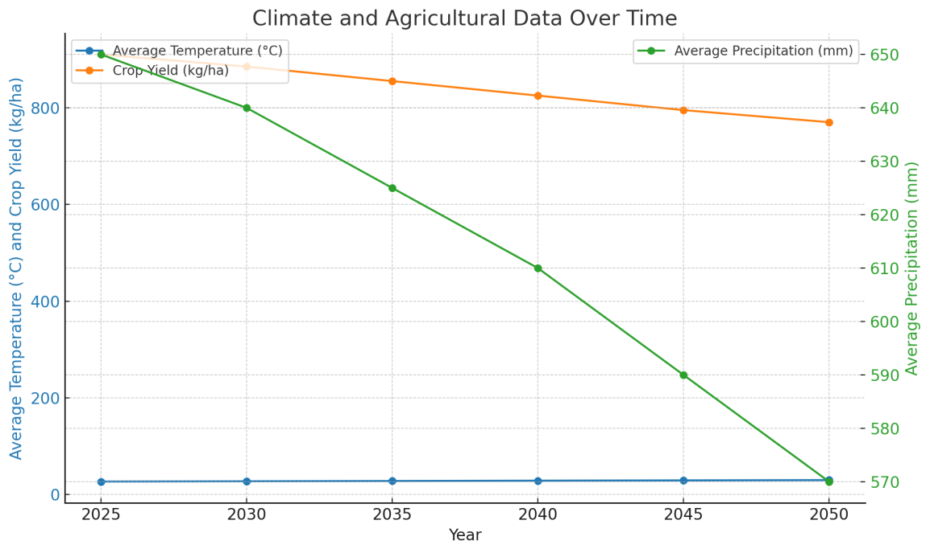

*The chart visualizes climate and agricultural data over time, focusing on average temperature, average precipitation, and crop yield from 2025 to 2050. As the years progress, the average temperature rises while both precipitation levels and crop yield decline. This trend highlights the potential impact of climate change on agriculture.*

## **Impact of extreme weather events on agriculture**

The occurrence of extreme weather events, increasingly exacerbated by climate change, poses substantial threats to agricultural productivity, particularly in vulnerable nations like India. These events, which include intensified droughts, floods, and unseasonal storms, disrupt crop cycles, diminish yields, and ultimately threaten food security. According to research, the agricultural sector serves as a primary conduit through which the impacts of climate change affect rural poverty, as the majority of Indias agrarian population relies heavily on predictable weather patterns for their livelihoods (Hertel et al.). Furthermore, extreme weathers detrimental effects are often regressive, disproportionately impacting poorer households that lack the resources for effective adaptation and resilience (Olivieri et al.). Consequently, the economic implications of these disruptions extend beyond immediate agricultural output, hindering long-term poverty alleviation efforts and exacerbating existing inequalities within the rural landscape of India.

Fig 5- Impact of extreme weather events on agriculture

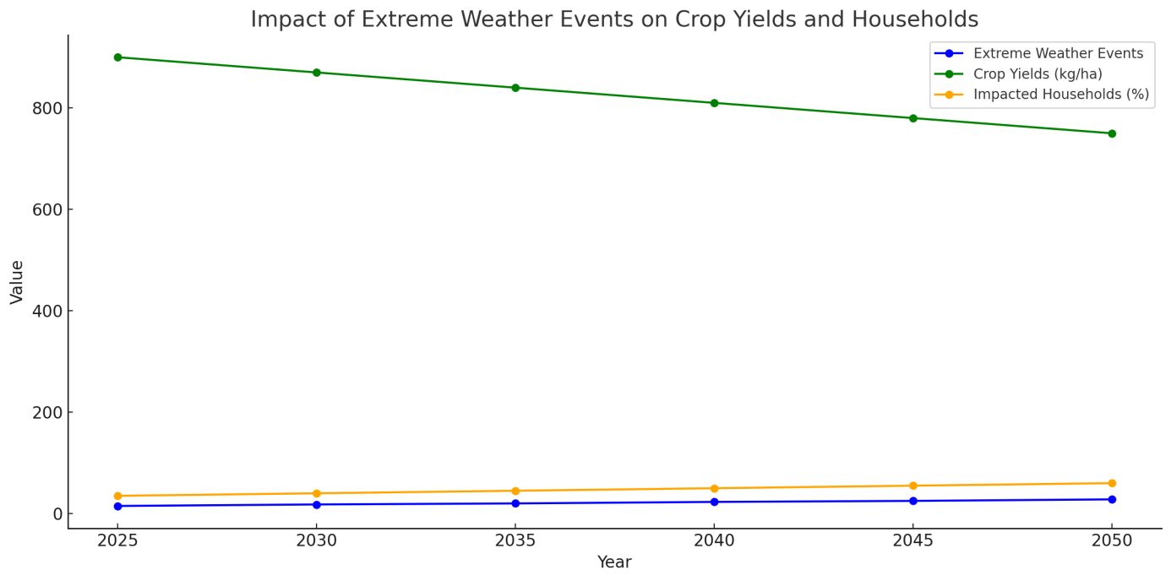

*The chart illustrates the relationship between extreme weather events, crop yields, and the percentage of impacted households from 2025 to 2050. As extreme weather events increase over the years, a decline in crop yields is observed while the percentage of affected households also rises, highlighting the detrimental impact of climate change on agriculture and communities.*

## **Changes in pest and disease dynamics due to climate change**

The intricate relationship between climate change and pest and disease dynamics poses significant challenges for agricultural productivity in India, particularly due to altered temperature and precipitation patterns. Rising temperatures facilitate the proliferation of numerous agricultural pests, increasing their reproductive rates and expanding their geographic range, while simultaneously altering the phenology of crops, thus heightening vulnerability to infestations (see (Earley et al., 2007)). Such shifts can undermine food security by exacerbating crop losses and raising production costs. Additionally, climate variability increases the incidence and severity of plant diseases, as pathogens often thrive in warmer, wetter conditions. These transformations necessitate robust research initiatives to develop adaptive pest management strategies that harness agroecological principles, which prioritize biodiversity and the ecological resilience of agricultural systems (see (Clements et al., 2011)). Ultimately, proactive measures are essential to mitigate adverse economic impacts, safeguarding food supply chains and farmer livelihoods in the face of climate-induced agricultural pressures.

## **Adaptation challenges for farmers in response to climate change**

Farmers in India face a myriad of adaptation challenges in response to climate change, significantly impacting agricultural productivity and economic stability. The increasing unpredictability of weather patterns, characterized by erratic rainfall and extreme temperatures, necessitates the adoption of climate-smart agricultural (CSA) practices, which can enhance resilience and productivity while mitigating greenhouse gas emissions. However, the effective implementation of CSA is hindered by systemic issues, including limited access to information and technologies, inadequate infrastructure, and insufficient financial support ((Biswal et al., 2020)). Moreover, the variability in local conditions necessitates tailored adaptation strategies, which require comprehensive stakeholder engagement and a participatory approach to decision-making ((Clements et al., 2011)). Creating supportive policies and institutional frameworks is crucial for empowering farmers, as their practical knowledge and experiences are vital for developing sustainable agricultural practices that can withstand the pressures of climate change. Thus, addressing these challenges is paramount for ensuring food security and economic viability in the face of climate adversity.

# **Economic Implications of Climate Change on Agriculture**

The economic implications of climate change on agriculture in India are profound, as rising temperatures and changing precipitation patterns have the potential to significantly affect agricultural productivity and food security. Research indicates that climate change will lead to a substantial decline in agricultural productivity in the coming decades, disproportionately impacting the rural poor who rely heavily on agriculture for their livelihood (Jacoby et al.). This decline is compounded by the rising costs of land and labor, which are expected to exacerbate household-level welfare disparities. Furthermore, projections encompassing future foodgrain supply against demand suggest an increasing risk of food shortages, which could intensify food insecurity across India (Dasgupta et al.). The adaptation strategies necessary for mitigating these impacts often favor wealthier landowners, thereby widening the socioeconomic divide and threatening poverty alleviation efforts. Thus, addressing these challenges is critical for ensuring sustainable agricultural practices and safeguarding food security in the face of climatic adversities.

## **Cost of climate change adaptation strategies**

The cost of climate change adaptation strategies in India’s agricultural sector presents significant economic implications, underscoring the need for comprehensive frameworks to guide investments. As noted, adaptation technologies that promote biodiversity and sustainable practices are essential for enhancing agricultural resilience amidst climate variability (Clements et al., 2011). However, these strategies often require substantial financial resources, ranging from investment in innovative agricultural practices to infrastructure development that supports effective water management and soil conservation. The literature reveals that while the anticipated poverty reduction from economic growth remains hopeful, the adverse effects of climate change are disproportionately felt by poorer communities, necessitating targeted financing models that prioritize marginalized farmers (Olivieri et al.). Consequently, establishing mechanisms for participatory governance in adaptation planning becomes vital, as it enables the inclusion of local knowledge and resources, ensuring that strategies are tailored to specific contexts and economic realities that farmers face in a changing climate.

Table 3- Cost of climate change adaptation strategies

|  |  |  |  |  |
| --- | --- | --- | --- | --- |
| **Year** | **Total_Cost_Estimate_USD_million** | **Government_Investment_USD_million** | **Private_Investment_USD_million** | **International_Aid_USD_million** |
| 2020 | 8000 | 3000 | 2000 | 3000 |
| 2021 | 8500 | 3200 | 2500 | 2800 |
| 2022 | 9000 | 3500 | 2800 | 2700 |
| 2023 | 9500 | 3700 | 3000 | 2800 |

*Cost of Climate Change Adaptation Strategies in Agriculture in India*

## **Impact on food security and nutrition**

The intricate relationship between climate change and food security in India presents significant challenges for agricultural productivity, particularly for small and marginal farmers reliant on rainfed agriculture. Variations in rainfall patterns and increased temperature gradients exacerbate yield fluctuations across various crops, ultimately threatening the stability of food supply chains ((Kumar et al., 2013)). These agricultural disruptions not only affect the quantity of food produced but also negatively influence economic factors such as the value derived from agricultural activities. Consequently, such declines jeopardize food security, which is intrinsically linked with poverty levels within agrarian communities ((Kumar et al., 2013)). The National Initiative on Climate Resilient Agriculture (NICRA) was launched to develop and disseminate location-specific strategies aimed at mitigating these adverse impacts, highlighting the urgent need for adaptive measures in light of continuing climatic unpredictability (). Thus, comprehensively addressing these challenges is paramount to safeguarding nutrition and equitable access to food resources amid changing environmental conditions.

## **Economic losses in agricultural sectors**

The economic losses attributed to climate change in agricultural sectors are a pressing concern, particularly in developing economies such as India, where agriculture undergirds the livelihoods of millions. Forecasts indicate a notable decline in agricultural productivity due to increased temperatures, erratic rainfall, and changing climatic conditions, which disproportionately affect poorer households reliant on subsistence farming. Although certain temperate zones may experience beneficial productivity enhancements, the adverse impacts in tropical regions are anticipated to mitigate potential gains, leading to an overall negative outlook for food security (cite41). Furthermore, as land and food prices shift due to climate-induced changes, rural households might not face a steep decline in consumption; however, the magnitude of poverty could rise by 3 to 4 percentage points over the next three decades, exacerbating existing inequalities (cite42). This dynamic illustrates the urgent need for adaptive strategies to mitigate economic losses and enhance resilience within the agricultural sector.

Table 4- Economic losses in agricultural sectors

|  |  |  |  |
| --- | --- | --- | --- |
| **Year** | **EconomicLossInBillionUSD** | **CropType** | **LossPercentage** |
| 2015 | 1.5 | Rice | 10 |
| 2016 | 2 | Wheat | 12 |
| 2017 | 1.8 | Pulses | 15 |
| 2018 | 3.2 | Cotton | 20 |
| 2019 | 2.5 | Sugarcane | 17 |
| 2020 | 4 | Maize | 25 |
| 2021 | 3.5 | Tea | 18 |
| 2022 | 5.1 | Soybean | 22 |

*Economic Losses in Agricultural Sectors Due to Climate Change in India*

## **Effects on rural livelihoods and employment**

The impact of climate change on rural livelihoods and employment in India is profoundly nuanced, with agricultural productivity serving as a critical nexus. As changing climatic conditions disrupt traditional farming practices, rural communities face heightened vulnerability, particularly among smallholder farmers who constitute a significant portion of the agricultural workforce. These shifts not only threaten food security but also jeopardize the socio-economic stability of rural regions reliant on agriculture for employment. Implementing Climate-Smart Agriculture (CSA) practices emerges as essential for building resilience and enhancing productivity in these communities, addressing both mitigation and adaptation strategies (Biswal et al., 2020). Furthermore, integrating gender-responsive approaches within agricultural projects can empower marginalized groups, particularly women, thereby fostering inclusive growth during periods of environmental uncertainty (Anna Knox et al., 2009). Consequently, addressing the effects of climate change on agricultural systems necessitates multifaceted interventions that prioritize sustainable development while safeguarding rural livelihoods and employment opportunities.

## **Role of government policies in mitigating economic impacts**

Government policies play a crucial role in mitigating the economic impacts of climate change on agricultural productivity, particularly within the context of India, where both economic dependence on agriculture and vulnerability to climate variability are pronounced. By implementing adaptive policies that support sustainable agricultural practices, the government can enhance resilience against climatic shocks, directly influencing productivity outcomes. For instance, incentives for carbon sequestration through soil management and tree planting can amplify agricultural sustainability while reducing greenhouse gas emissions, as noted by experts on soil carbon sequestration (Nelson et al.). Additionally, facilitating access to advanced agricultural technologies and promoting efficient nutrient management addresses food security while aligning with climate mitigation goals (Das et al.). Altogether, a strategic policy framework that prioritizes climate adaptation not only addresses immediate agricultural needs but also fosters long-term economic stability, underscoring the interconnectedness of environmental and economic health in mitigating climate-related impacts.

.

## **Examination of specific states affected by climate change**

The examination of specific Indian states reveals the multifaceted impact of climate change on agricultural productivity, particularly in regions heavily reliant on monsoonal patterns. For instance, states like Punjab and Haryana, which are pivotal for Indias food security due to their extensive wheat and rice cultivation, face increasing vulnerabilities stemming from erratic rainfall and rising temperatures. These climatic shifts threaten not only crop yields but also the economic sustainability of farming communities, potentially leading to food deficits as production struggles to meet demand (Dasgupta et al.). Furthermore, states characterized by high susceptibility to climate impacts, such as Maharashtra and Gujarat, illustrate the economic ramifications of decreased agricultural output amid increasing globalization pressures and resource scarcity (Kumar et al.). As these regions navigate the complexities of climate change, assessing their adaptive capacities becomes essential for developing strategies that enhance resilience and safeguard food security in the context of India’s diverse agricultural landscape.

## **Analysis of crop-specific vulnerabilities**

The intricate relationship between climate change and crop-specific vulnerabilities necessitates a nuanced analysis to effectively inform agricultural policy in India. With a significant portion of Indian agriculture reliant on rainfed systems—representing 58 percent of cultivated land and contributing up to 40 percent of total food production—these regions are particularly susceptible to climatic variability . The forecasted production losses in staple crops such as rice, wheat, and maize, estimated to exceed $200 billion by 2050, exemplify the urgent need for comprehensive vulnerability assessments that integrate socio-economic variables alongside climatic data (Aggarwal et al., 2010). Current approaches often fall short, focusing merely on singular metrics of vulnerability rather than a multidimensional framework (Aggarwal et al., 2010). By fostering robust partnerships among meteorological, agricultural, and research institutions, India can enhance its resilience to climate change, thereby mitigating potential losses and fostering sustainable agricultural productivity amidst increasingly erratic weather patterns.

## **Success stories of adaptation in Indian agriculture**

The resilience of Indian agriculture in the face of climate change is evidenced by numerous success stories that illustrate effective adaptation strategies. For instance, the adoption of climate-resilient crop varieties, such as drought-resistant millet and rice hybrids, has notably enhanced productivity amid increasing temperatures and erratic rainfall patterns. Furthermore, innovative practices like rainwater harvesting and integrated pest management have been increasingly implemented, showcasing a shift toward sustainable farming. The significance of robust partnerships among agricultural research institutions, meteorological services, and local farmers cannot be overstated; these collaborations facilitate the timely dissemination of weather data and agricultural advisories, thereby enhancing decision-making capacity ((Aggarwal et al., 2010)). Such initiatives not only mitigate climate vulnerabilities but also bolster food security, demonstrating the pivotal role of tailored adaptation strategies in ensuring economic stability within this critical sector ((Ulka Kelkar and Suruchi Bhadwal)). These multifaceted approaches highlight the potential for sustainable agricultural development amidst climate challenges in India.

## **Comparative analysis with other countries facing similar challenges**

Examining the experiences of other nations grappling with the dual challenges of climate change and agricultural productivity offers crucial insights relevant to Indias situation. For instance, smallholder farming remains a predominant economic force in East African countries like Kenya and Ethiopia, where, despite accounting for a substantial share of agricultural output and employment, growth in agricultural productivity has been stifled by weak institutions and inadequate infrastructure (Abdul Kamara et al.). Similarly, in India, agricultural productivity is heavily impacted by ecological variability exacerbated by climate change, requiring systemic interventions tailored to local contexts. The pathways linking agricultural development and nutritional improvement, though significant, reveal mixed efficacies influenced by economic conditions and market accessibility (Dorward et al., 2014). Thus, learning from the failures and successes of these countries can inform Indias policy responses, fostering resilience in agricultural systems while addressing the interconnected economic and nutritional imperatives inherent in climate adaptation strategies.

## **Lessons learned from regional responses to climate change**

The responses of various regions to climate change have underscored the importance of adaptive strategies in mitigating adverse impacts on agricultural productivity, particularly in contextually vulnerable economies like India. Evidence suggests that localized initiatives, such as the promotion of drought-resistant crop varieties and the implementation of water conservation techniques, have been effective in enhancing resilience and securing food security amidst fluctuating climate conditions (Evans et al., 2019). Moreover, understanding the heterogeneity in socioeconomic conditions enables tailored approaches that better address the needs of specific agricultural communities, mitigating the regressive nature of climate impacts that disproportionately affect the impoverished (Olivieri et al.). These lessons emphasize that adaptive capacity must be bolstered through not only technological innovation but also socioeconomic interventions, reinforcing the notion that regional strategies ought to integrate local knowledge systems while fostering inclusive policies that promote equitable growth in agricultural productivity amidst climate uncertainty.

Table 5- Lessons learned from regional responses to climate change

|  |  |  |  |  |
| --- | --- | --- | --- | --- |
| **Region** | **Adaptation Strategy** | **Impact on Yield (%)** | **Implementation Year** | **Source** |
| Punjab | Crop diversification with resilient varieties | 15 | 2020 | Punjab Agricultural University |
| Haryana | Use of moisture-retaining practices | 10 | 2019 | Indian Council of Agricultural Research |
| Maharashtra | Drip irrigation and efficient water management | 20 | 2021 | Maharashtra Agricultural University |
| Bihar | Promotion of flood-resistant rice varieties | 12 | 2022 | Bihar Agricultural University |
| Tamil Nadu | Agroforestry and intercropping | 18 | 2020 | Tamil Nadu Agricultural University |

*Regional Responses to Climate Change in India*

# **Conclusion**

In conclusion, the interplay between climate change and agricultural productivity in India emerges as a multifaceted challenge fraught with economic implications. The adverse impacts of shifting climatic patterns, such as increased temperature and altered precipitation, threaten to diminish crop yields, jeopardizing food security and rural livelihoods. Moreover, the economic burden of adapting agricultural practices in response to these climatic changes can disproportionately affect the already vulnerable populations within the agricultural sector. As research illustrates, employing advanced techniques such as Statistical Down Scaling Model (SDSM) is essential for generating high-resolution climate data, which can inform economic decisions and policy formulation effectively (Imran Hussain Mahdy et al., 2024). Additionally, fostering collaborative initiatives focused on renewable technologies and sustainable practices could mitigate adverse impacts while enhancing economic resilience (Uma Purushothaman et al., 2023). Ultimately, addressing these challenges requires concerted efforts at local, national, and international levels to bolster adaptive capacity and create sustainable agricultural frameworks capable of withstanding the realities of climate change.

## **Implications for policy and practice**

The implications for policy and practice in the context of climate change and agricultural productivity in India demand a multifaceted approach to sustain both agricultural output and groundwater resources. Effective policies should prioritize the adoption of climate-resilient agricultural practices, particularly as studies indicate a significant decline in crop yields due to rising temperatures and altered precipitation patterns, as evidenced by predicted yield reductions in crops like cotton and potato ((Ajay K. Singh et al., 2021)). Additionally, given the severe groundwater depletion exacerbated by anthropogenic activities, comprehensive management strategies are critical. Utilizing advanced machine learning models can enhance predictive accuracy for groundwater dynamics, enabling policymakers to identify vulnerable districts and implement targeted interventions ((Meir Alkon et al., 2024)). Furthermore, initiatives that promote crop-specific strategies tailored to local climatic conditions will enable farmers to maintain productivity while mitigating climate changes adverse impacts. Such integrative policy frameworks are essential for fostering sustainable agricultural practices in an increasingly uncertain climate.

## **Recommendations for future research**

To effectively address the intricate relationship between climate change and agricultural productivity in India, future research must prioritize a comprehensive multi-dimensional approach that transcends traditional methodologies. Vulnerability assessments, as advocated by (Aggarwal et al., 2010), should incorporate socio-economic variables alongside climate data to better capture the complexities facing farmers. Furthermore, there is a critical need for studies that explore the synergies between mixed farming systems and water productivity within diverse agro-ecological contexts, particularly emphasizing case studies in the Indo-Gangetic Basin and other regions highlighted by (Acharya et al.). Developing appropriate policy frameworks that facilitate institutional collaboration among meteorological services, agricultural research centers, and food security initiatives is essential to support these investigations. Ultimately, establishing robust infrastructural capabilities for weather data collection and dissemination will enhance forecasting accuracy, thereby enabling farmers to make informed decisions in the face of climatic uncertainties.

# References

* Anderson, Kym, Valenzuela, Ernesto . "Climate Change and Food Security to 2050: A Global Economy-wide Perspective". https://core.ac.uk/download/pdf/6459608.pdf
* Jacoby, Hanan, Rabassa, Mariano, Skoufias, Emmanuel . "Distributional implications of climate change in India". https://core.ac.uk/download/pdf/6266145.pdf
* Jacoby, Hanan, Rabassa, Mariano, Skoufias, Emmanuel . "Distributional implications of climate change in India". https://core.ac.uk/download/pdf/6266145.pdf
* Dasgupta, Purnamita, Sirohi, Smita . "Indian Agricultural Scenario and Food Security Concerns in the Context of Climate Change: a Review". https://core.ac.uk/download/pdf/6701391.pdf
* Jacoby, Hanan, Rabassa, Mariano, Skoufias, Emmanuel . "Distributional implications of climate change in India". https://core.ac.uk/download/pdf/6266145.pdf
* Dasgupta, Purnamita, Sirohi, Smita . "Indian Agricultural Scenario and Food Security Concerns in the Context of Climate Change: a Review". https://core.ac.uk/download/pdf/6701391.pdf
* Jacoby, Hanan, Rabassa, Mariano, Skoufias, Emmanuel . "Distributional implications of climate change in India". https://core.ac.uk/download/pdf/6266145.pdf
* Dasgupta, Purnamita, Sirohi, Smita . "Indian Agricultural Scenario and Food Security Concerns in the Context of Climate Change: a Review". https://core.ac.uk/download/pdf/6701391.pdf
* Jacoby, Hanan, Rabassa, Mariano, Skoufias, Emmanuel . "Distributional implications of climate change in India". https://core.ac.uk/download/pdf/6266145.pdf
* Dasgupta, Purnamita, Sirohi, Smita . "Indian Agricultural Scenario and Food Security Concerns in the Context of Climate Change: a Review". https://core.ac.uk/download/pdf/6701391.pdf
* Dominique van der Mensbrugghe . "Climate Change and Economic Growth: Impacts and Interactions". https://core.ac.uk/download/pdf/6234026.pdf
* Dasgupta, Purnamita, Sirohi, Smita . "Indian Agricultural Scenario and Food Security Concerns in the Context of Climate Change: a Review". https://core.ac.uk/download/pdf/6701391.pdf
* Das, Samantak, Mukhopadhyay, Dripto, Pohit, Sanjib . "Mitigating carbon emission through economic instruments: An Indian Perspective". https://core.ac.uk/download/pdf/6356566.pdf
* Nelson, Gerald C. . "Agriculture and climate change: An agenda for negotiation in Copenhagen". https://core.ac.uk/download/pdf/6288818.pdf
* Hubert Charles, J. R. Beddington, I. R. Crute, Lawrence Haddad, David P. Lawrence, James Muir, Jules Pretty, Sherman Robinson, Sandy M Thomas, Camilla Toulmin (2010). "Food Security: The Challenge of Feeding 9 Billion People". 327. pp. 812-818. https://doi.org/10.1126/science.1185383
* Kym Anderson (2009). "Distortions to Agricultural Incentives". https://doi.org/10.1596/978-0-8213-7665-2
* Olivieri, Sergio, Rabassa, Mariano, Skoufias, Emmanuel . "The poverty impacts of climate change : a review of the evidence". https://core.ac.uk/download/pdf/6285112.pdf
* Jacoby, Hanan, Rabassa, Mariano, Skoufias, Emmanuel . "Distributional implications of climate change in India". https://core.ac.uk/download/pdf/6266145.pdf
* Imran Hussain Mahdy, Partha Protim Roy, Rafiqul Bari Kabir (2024). "Assessing climate change impacts with downscaling techniques: A case study". https://www.semanticscholar.org/paper/e5a51f40c9978bf49bd82340ba295203e31f948d
* Uma Purushothaman, Reinhart Philip (2023). "The Impact of Climate Change on India-Russia Relations". https://www.semanticscholar.org/paper/85e27e91a531b5e15104003d256278c1537b0a78
* Jacoby, Hanan, Rabassa, Mariano, Skoufias, Emmanuel . "Distributional implications of climate change in India". https://core.ac.uk/download/pdf/6266145.pdf
* Acharya, N. Sreedhar, Blummel, M., Clement, Floriane, Dey, A., Haileslassie, A., Ishaq, Saba, Khan, M. A., Mit, R., Radha, A. Venkata, Samad, Madar, Shindey, D. N. . "Improving water productivity, reducing poverty and enhancing equity in mixed crop-livestock systems in the Indo-Gangetic Basin: CPWF project report 68". https://core.ac.uk/download/pdf/6405252.pdf
* Kumar, Ajay, Sharma, Pritee (2013). "Impact of climate variation on agricultural productivity and food security in rural India". Kiel: Kiel Institute for the World Economy (IfW). https://core.ac.uk/download/39399559.pdf
* ICAR_CRIDA_NICRA (2017). "Managing Weather Aberrations through Real Time Contingency Planning Annual Report 2016-17". Not Available. https://core.ac.uk/download/287369565.pdf
* Lankford, Bruce, Makin, Ian, Matthews, Nathanial, McCornick, Peter G., Noble, Andrew, Shah, Tushaar (2016). "A compact to revitalise large-scale irrigation systems using a leadership-partnership-ownership ‘theory of change’". https://core.ac.uk/download/41992849.pdf
* Basist, Alan, Dinar, Ariel, Ihsan Ajwad, Mohamed, Kogan, Felix, Kurukulasuriya, Pradeep, Mendelsohn, Robert, Williams, Claude . "Cross-sectional analyses of climate change impacts". https://core.ac.uk/download/pdf/6645078.pdf
* Fisher-Vanden, Karen, Frolking, Stephen E., Grogan, Danielle S., Lammers, Richard B., Nicholas, Robert E., Prusevich, Alexander A., Wrenn, Douglas H., Zaveri, Esha (2016). "Invisible water, visible impact: How unsustainable groundwater use challenges sustainability of Indian agriculture under climate change". University of New Hampshire Scholars\u27 Repository. https://core.ac.uk/download/215531778.pdf
* Olivieri, Sergio, Rabassa, Mariano, Skoufias, Emmanuel . "The poverty impacts of climate change : a review of the evidence". https://core.ac.uk/download/pdf/6285112.pdf
* Dasgupta, Purnamita, Sirohi, Smita . "Indian Agricultural Scenario and Food Security Concerns in the Context of Climate Change: a Review". https://core.ac.uk/download/pdf/6701391.pdf
* Fang, Cheng, Rosegrant, Mark W., Wood, Stanley, You, Liangzhi . "Impact of global warming on Chinese wheat productivity:". https://core.ac.uk/download/pdf/6289008.pdf
* Dominique van der Mensbrugghe . "Climate Change and Economic Growth: Impacts and Interactions". https://core.ac.uk/download/pdf/6234026.pdf
* Fabio Eboli, Ramiro Parrado, Roberto Roson . "Climate Change Feedback on Economic Growth: Explorations with a Dynamic General Equilibrium Model". https://core.ac.uk/download/pdf/6300657.pdf
* Dasgupta, Purnamita, Sirohi, Smita . "Indian Agricultural Scenario and Food Security Concerns in the Context of Climate Change: a Review". https://core.ac.uk/download/pdf/6701391.pdf
* Acharya, N. Sreedhar, Blummel, M., Clement, Floriane, Dey, A., Haileslassie, A., Ishaq, Saba, Khan, M. A., Mit, R., Radha, A. Venkata, Samad, Madar, Shindey, D. N. . "Improving water productivity, reducing poverty and enhancing equity in mixed crop-livestock systems in the Indo-Gangetic Basin: CPWF project report 68". https://core.ac.uk/download/pdf/6405252.pdf
* Aggarwal, P.K., Baethegan, W.E., Cooper, P., Gommes, R., Lee, B., Meinke, H.B., Rathore, L.S., Sivakumar, M.V.K. (2010). "Managing Climatic Risks to Combat Land Degradation and Enhance Food security: Key Information Needs". Elsevier B.V.. https://core.ac.uk/download/pdf/29240278.pdf
* Acharya, N. Sreedhar, Blummel, M., Clement, Floriane, Dey, A., Haileslassie, A., Ishaq, Saba, Khan, M. A., Mit, R., Radha, A. Venkata, Samad, Madar, Shindey, D. N. . "Improving water productivity, reducing poverty and enhancing equity in mixed crop-livestock systems in the Indo-Gangetic Basin: CPWF project report 68". https://core.ac.uk/download/pdf/6405252.pdf
* Earley, Jane, Niggli, Urs, Ogorzalek, Kevin (2007). "Organic Agriculture and the Environmental Stability of Food Supply". https://core.ac.uk/download/10925599.pdf
* Clements, Rebecca, Haggar, Jeremy, Quezada, Alicia, Torres, Juan (2011). "Technologies for climate change adaptation: agricultural sector". UNEP Risø Centre on Energy, Climate and Sustainable Development / Practical Action. https://core.ac.uk/download/316337.pdf
* Evans, J., Garcia-Oliva, F., Hussein, I. A. G., Iqbal, M. H., Kimutai, J., Knowles, T., Meza, F., Mirzabaev, A., Nedjroaoui, D., Tena, F., Türkeş, M., Vázquez, R. J., Weltz, M., Wu, J. (2019). "Desertification". https://core.ac.uk/download/287612220.pdf
* Olivieri, Sergio, Rabassa, Mariano, Skoufias, Emmanuel . "The poverty impacts of climate change : a review of the evidence". https://core.ac.uk/download/pdf/6285112.pdf
* Aggarwal, P.K., Baethegan, W.E., Cooper, P., Gommes, R., Lee, B., Meinke, H.B., Rathore, L.S., Sivakumar, M.V.K. (2010). "Managing Climatic Risks to Combat Land Degradation and Enhance Food security: Key Information Needs". Elsevier B.V.. https://core.ac.uk/download/pdf/29240278.pdf
* Ulka Kelkar and Suruchi Bhadwal . "South Asian Regional Study on Climate Change Impacts and Adaptation: Implications for Human Development". https://core.ac.uk/download/pdf/6248854.pdf
* Clements, Rebecca, Haggar, Jeremy, Quezada, Alicia, Torres, Juan (2011). "Technologies for climate change adaptation: agricultural sector". UNEP Risø Centre on Energy, Climate and Sustainable Development / Practical Action. https://core.ac.uk/download/316337.pdf
* Olivieri, Sergio, Rabassa, Mariano, Skoufias, Emmanuel . "The poverty impacts of climate change : a review of the evidence". https://core.ac.uk/download/pdf/6285112.pdf
* Dorward, Andrew (2014). "How can agricultural interventions contribute in improving nutrition health and achieving the MDGs in least developed countries?". 'S. Karger AG'. https://core.ac.uk/download/17184734.pdf
* Abdul Kamara, Adeleke Oluwole Salami, Zuzana Brixiova . "Working Paper 105 - Smallholder Agriculture in East Africa: Trends, Constraints and Opportunities". https://core.ac.uk/download/pdf/6590805.pdf
* Dasgupta, Purnamita, Sirohi, Smita . "Indian Agricultural Scenario and Food Security Concerns in the Context of Climate Change: a Review". https://core.ac.uk/download/pdf/6701391.pdf
* Kumar, K.S. Kavi, Viswanathan, Brinda . "Vulnerability to Globalization in India: Relative Rankings of States Using Fuzzy Models". https://core.ac.uk/download/pdf/6484088.pdf
* Aggarwal, P.K., Baethegan, W.E., Cooper, P., Gommes, R., Lee, B., Meinke, H.B., Rathore, L.S., Sivakumar, M.V.K. (2010). "Managing Climatic Risks to Combat Land Degradation and Enhance Food security: Key Information Needs". Elsevier B.V.. https://core.ac.uk/download/pdf/29240278.pdf
* Arivudai Nambi Appadurai, Ayesha Dinshaw, Heather McGray, Lubaina Rangwala, Moushumi Chaudhury, Namrata Ginoya, Shreyas Srivatsa (2015). "Scaling Success: Lessons from Adaptation Pilots in the Rainfed Regions of India". World Resources Institute (WRI). https://core.ac.uk/download/75782099.pdf
* Biswal, Sabyasachi, Jat, Mangi Lal, Khatri-Chhetri, Arun, Pathak, Himanshu, Rana, Dharamvir Singh, Sharma, Sheetal (2020). "A compendium of Technologies, Practices, Services and Policies for Scaling Climate Smart Agriculture in Odisha (India)". https://core.ac.uk/download/288633314.pdf
* Clements, Rebecca, Haggar, Jeremy, Quezada, Alicia, Torres, Juan (2011). "Technologies for climate change adaptation: agricultural sector". UNEP Risø Centre on Energy, Climate and Sustainable Development / Practical Action. https://core.ac.uk/download/316337.pdf
* Olivieri, Sergio, Rabassa, Mariano, Skoufias, Emmanuel . "The poverty impacts of climate change : a review of the evidence". https://core.ac.uk/download/pdf/6285112.pdf
* Hertel, Thomas W., Rosch, Stephanie D. . "CLIMATE CHANGE, AGRICULTURE AND POVERTY". https://core.ac.uk/download/pdf/6567635.pdf
* Evans, J., Garcia-Oliva, F., Hussein, I. A. G., Iqbal, M. H., Kimutai, J., Knowles, T., Meza, F., Mirzabaev, A., Nedjroaoui, D., Tena, F., Türkeş, M., Vázquez, R. J., Weltz, M., Wu, J. (2019). "Desertification". https://core.ac.uk/download/287612220.pdf
* Clements, Rebecca, Haggar, Jeremy, Quezada, Alicia, Torres, Juan (2011). "Technologies for climate change adaptation: agricultural sector". UNEP Risø Centre on Energy, Climate and Sustainable Development / Practical Action. https://core.ac.uk/download/316337.pdf
* International Water Management Institute (IWMI). . "IWMI Strategic plan 2009-2013: water for a food-secure world". https://core.ac.uk/download/pdf/6405044.pdf
* Birner, Regina, Falck-Zepeda, José, Gaskell, Joanne, Halsey, Mark, Linacre, Nicholas A., Quemada, Hector, Rosegrant, Mark W. . "Analysis for biotechnology innovations using Strategic Environmental Assessment (SEA):". https://core.ac.uk/download/pdf/6288985.pdf
* Anna Knox, Nata Duvvury, Noni Milici (2009). "Gender in Agriculture Sourcebook". 'World Bank'. https://core.ac.uk/download/75780700.pdf
* Biswal, Sabyasachi, Jat, Mangi Lal, Khatri-Chhetri, Arun, Pathak, Himanshu, Rana, Dharamvir Singh, Sharma, Sheetal (2020). "A compendium of Technologies, Practices, Services and Policies for Scaling Climate Smart Agriculture in Odisha (India)". https://core.ac.uk/download/288633314.pdf
* Clements, Rebecca, Haggar, Jeremy, Quezada, Alicia, Torres, Juan (2011). "Technologies for climate change adaptation: agricultural sector". UNEP Risø Centre on Energy, Climate and Sustainable Development / Practical Action. https://core.ac.uk/download/316337.pdf
* Aggarwal, P.K., Baethegan, W.E., Cooper, P., Gommes, R., Lee, B., Meinke, H.B., Rathore, L.S., Sivakumar, M.V.K. (2010). "Managing Climatic Risks to Combat Land Degradation and Enhance Food security: Key Information Needs". Elsevier B.V.. https://core.ac.uk/download/pdf/29240278.pdf
* (2022). "PDF Technology And Society Issue For The 21st Century And Beyond 3rd Edition". https://www.semanticscholar.org/paper/6b9a593ddc479a15ba70408018fd27fe52e145a6
* Bharath Setturua (2018). "Visualization of Landscape Dynamics in National Parks of Central Western Ghats". https://www.semanticscholar.org/paper/832727f492512c2b46bc510bb63ae9189fe83c5f
* Meir Alkon, Yaoping Wang, Matthew Harrington, Claudia Shi, Ryan Kennedy, Johannes Urpelainen, Jacob Kopas, Xiaogang He (2024). "High resolution prediction and explanation of groundwater depletion across India". 19. https://www.semanticscholar.org/paper/c1c0164176b2abd08708b195683aa7b211a804ae
* Ajay K. Singh, Bhim Jyoti (2021). "Projected Productivity of Cash Crops in Different Climate Change Scenarios in India". 3. pp. 63-87. https://www.semanticscholar.org/paper/9dcdbbf874e81b4c499d0fbd6e5ed08b808dd062
* Intergovernmental Panel on Climate Change (2023). "Climate Change 2022 – Impacts, Adaptation and Vulnerability". https://doi.org/10.1017/9781009325844
* Gurdeep Singh Malhi, Manpreet Kaur, Prashant Kaushik (2021). "Impact of Climate Change on Agriculture and Its Mitigation Strategies: A Review". 13. pp. 1318-1318. https://doi.org/10.3390/su13031318