**Azadirachta indica Natural active ingredients to cure Mpox: *In silico* Targeting VP39**

**Abstract**

Mpox, a viral disease from Central and West Africa, could trigger a pandemic. It has attracted worldwide attention. It is a double-stranded DNA virus from the Poxviridae family. It replicates in the cytoplasm. It must encode its RNA processing machinery, including the capping machinery. Targeting the viral enzyme 2'-O-methyltransferase VP39 could help. It is essential for Mpox replication. This offers a promising avenue for antiviral therapies. In this study, neem compounds were tested as VP39 inhibitors using molecular docking. They are bioactive. Stigmasterol is a strong candidate. It has a binding affinity of -7.98 kcal/mol and interacts with key residues, such as Asn273. Several neem-derived compounds showed binding strengths that suggest potential for drug development. The study shows how important it is to know the viral mechanisms. It also shows the potential of natural products as therapeutics. We used advanced bioinformatics tools, SeamDock and AutoDock, to analyze the protein-ligand interaction. They confirmed VP39 as an important target for new Mpox therapies. The results help in the search for effective antiviral drugs. They highlight neem as a potential source of natural Mpox treatments.

**Keywords:** 2'-O-methyltransferase VP39, Mpox, SeamDock, *Azadirachta indica*, AutoDock

**Introduction**

The Mpox virus is native to Central and West Africa, where it can be transmitted from animals to humans. There is growing concern around the world about the potential of the virus to trigger a pandemic. The Democratic Republic of Congo reported the first documented case in 1970 [1]. The exact number of cases remains unclear. The signs of Mpox are similar to those of a milder form of smallpox [2]. Cases of Mpox have been detected in more than 100 countries, raising concerns of a possible pandemic. Despite these fears, the mortality rate of the latest outbreak is significantly lower than originally thought. Although Mpox remains a public health concern, the lower mortality rate suggests that the disease may not be as dangerous as previously thought. This positive development suggests that efforts to control the spread of the disease are effective [3]. However, vigilance remains crucial to prevent further transmission and mitigate the impact on public health. To date, there are two main variants of the virus: the Central African strain (Clade-I) and the West African strain (Clade-II) are identified around the world [4,5]. Clade-I spreads more easily, leads to more severe disease, and has a mortality rate of up to 11%. Clade-II has a mortality rate of less than 1%. It does not appear to be transmissible from person to person. The current global epidemic has heightened concerns that Clade II could spread and develop into a pandemic. This shows how important it is to promote knowledge and monitor the situation. The World Health Organization (WHO) has declared a public health emergency of international concern (PHEIC) in response to the global Mpox outbreak. This declaration, made under the International Health Regulations (2005), underscores the serious nature of the outbreak and the need for coordinated international action to prevent further spread and mitigate the impact [6]. Recently, the Clade II variant of the current outbreak has also been observed in India. The Indian government has prepared for it and taken all important measures to control the spread of the virus infection [7,8]. As Li et al. (2023) stated, the mortality rate for this disease was between 2% and 7% in the past. But the viral disease is spreading rapidly. Global health organizations such as the WHO and the CDC have become increasingly concerned with it in recent years [9,10].

The 2'-O-methyltransferase VP39 (2'o-MT-VP39) of the Mpox virus is an important enzyme. It methylates the 2'-hydroxyl group of the ribose in the viral mRNA. In this way, it alters the viral copying process. This methylation process stabilizes the viral genes. It contributes to their proper folding and ensures efficient translation in the host cells. VP39 mimics the host's mRNA [11]. This helps the virus to evade the host's immune defenses[12,13]. It enables viral replication and survival. Inhibition of VP39 could interrupt this process. This would impair viral replication and reduce disease symptoms. Thus, VP39 is a promising target for antiviral drugs against Mpox [14]. The scientists want to understand how VP39 causes methylation. This could lead to new drugs that block its activity. These therapies could stop the viral progression of Mpox. To this end, they prevent the enzyme from stabilizing the viral genome. They offer a new way to fight this infectious disease [15-17].

*Azadirachta indica*, or neem, is a medicinal plant. Researchers know it for its antiviral properties. Neem is rich in bioactive compounds such as azadirachtin and nimbin. Researchers have studied it for its potential to treat various viral infections. Its compounds have an antiviral effect via several mechanisms. They are therefore a versatile remedy against viral diseases[18]. Research shows that the extract of the plant is highly effective against HSV, HIV, the dengue virus, and hepatitis B. For example, quercetin, a flavonoid in neem, inhibits viral replication. It does this by impairing the synthesis of viral proteins[19]. Gedunin and azadirachtin strengthen the immune system. They help the host fight viral infections. Neem extracts can prevent viruses from entering the host cells. This disrupts the early stages of the infection. Neem can inhibit viral replication and enhance the immune response. It therefore offers a promising natural approach to antiviral therapies[20]. This is important for combating new and re-emerging viral threats such as Mpox. Its broad antiviral activity and low toxicity make it a good candidate for research.Here, the study proposed using molecular docking to find new drugs for the Mpox virus. This method can rapidly assess compounds for their ability to bind to viral targets. It may reduce viral virulence.

**Material and Methods**

***PDB Retrieval, Protein Structure, and Ligand Validation***

The 3D file 8B07.pdb shows the 2'-O-methyltransferase VP39 (2'o-MT-VP39) of Mpox. This viral protein supports the poly(A) polymerase in its work and has a small subunit. The RCSB is a global library of structural data on biological macromolecules. These were discovered using techniques like nuclear magnetic resonance (NMR). The RCSB has made this file available. Two chains, A and B, form the structure 8B07. We selected only chain A from the 8B07 structure for further investigation [15,21]. Analysis of the tertiary structure 2'o-MT-VP39 (8B07: chain A) showed high model quality [21]. An excellent ERRAT score supports its reliability. We used a tool, PROCHECK, to check the model's quality and stereochemical properties. This study, especially the Ramachandran plot, gave insights into the amino acid residues. It showed their distribution and location in the different structural regions[22,23]. The plot shows the 3D shape of the amino acids. It divides them into four sections: most favored, extra allowed, generous allowed, and disallowed. The Ramachandran plot is a key tool for studying protein structure. It shows the phi (φ) and psi (ψ) angles of the peptide backbone of each amino acid sequence as a diagram. Scientists can map these torsion angles to see the side chains' arrangement. This helps them understand their connection to the protein backbone. We need this info to find structural problems and test conformation stability. This will help us to learn more about the 3D structure of the protein and how it interacts with other molecules[24,25].We used molecular docking to find new chemotherapies to combat Mpox. We studied natural products from *Azadirachta indica*. We targeted the binding pockets in 2'o-MT-VP39. To start this study, we obtained the 3D structures of all-natural inhibitors in "*.sdf" format from PubChem (<https://pubchem.ncbi.nlm.nih.gov/>)[26]. Our literature search found 13 bioactive compounds in *A. indica*. We then included them in our study. The compounds included: azadiradione, campesterol, epoxyazadiradione, gedunin, linoleic acid, meliantriol, nimbin, oleic acid, quercetin, palmitic acid, scopoletin, stigmasterol, and umbelliferone. To further check these compounds, we used the SwissADME tool. It assesses their ADMET properties: absorption, distribution, metabolism, excretion, and toxicity. This analysis lets us choose the compounds with the best docking scores[27,28]. It identified promising candidates for further study. We aim to find new ways to treat Mpox infections. We will investigate how natural compounds bind to the 2'o-MT-VP39 protein. This research could help develop new cancer drugs. It may improve treatment outcomes for those affected by the disease.

***Molecular Docking***

Molecular docking is a computer method. It predicts how proteins and other molecules, such as ligands, interact in 3D. It helps to find binding sites and understand their interactions. This method uses search algorithms and scoring functions. They find the best 3D position of the ligand in the target protein and estimate its binding affinity. SeamDock, a web server designed for ease of use, simplifies this. It displays a 3D grid of the active site of the target protein. It also visualizes the ligand-protein interactions [29,30]. This tool allows you to view the stereochemistry of the binding site. This includes the binding pocket, the surrounding amino acids, the hydrogen bonds, and the polar contacts. It also shows how these things affect the shape of the protein. SeamDock's user interface and NGL viewer allow for interactive visualization [29-31]. They make the program simple even for non-experts. No complex installations or configurations are required. The docking process starts as soon as we have defined the molecules (ligand and receptor), the search area (docking box), and the simulation parameters[32]. In AutoDock, the process involves two steps: First, prepare a grid parameter file using prepare_gpf4.py to define the search space of the receptor. Then you use autogrid4 to calculate the energy landscape for potential binding sites. The prepare_dpf4.py script generates a docking parameter file. AutoDock4 uses this together with the ligand and receptor structures. It completes the simulation and finds the best ligand-receptor interaction [31,34].

**Result and discussion**

We used the user-friendly online server SeamDock for molecular docking, despite our limited knowledge of biophysics and computer science. SeamDock facilitated the analysis and 3D visualization of ligand-receptor interactions. The predicted docking score was based on the binding energies and affinities of the ligand-receptor complexes. This was done during the docking process. We used AutoDock 4 to dock the ligands to the protein binding sites. We then used evolution to find the best way for the ligand and protein to bind. To this end, we found the configuration with the lowest energy. Factors such as binding energy, solvent effects, entropy, and molecular flexibility must be considered to evaluate the interaction between a ligand and a protein. This information can generate a 3D interaction model and an affinity value. The ERRAT analysis, indicating that 94.815% of residues were above the 95% error cutoff, confirms the reliability of the protein structure used in the modelling (Figure1). 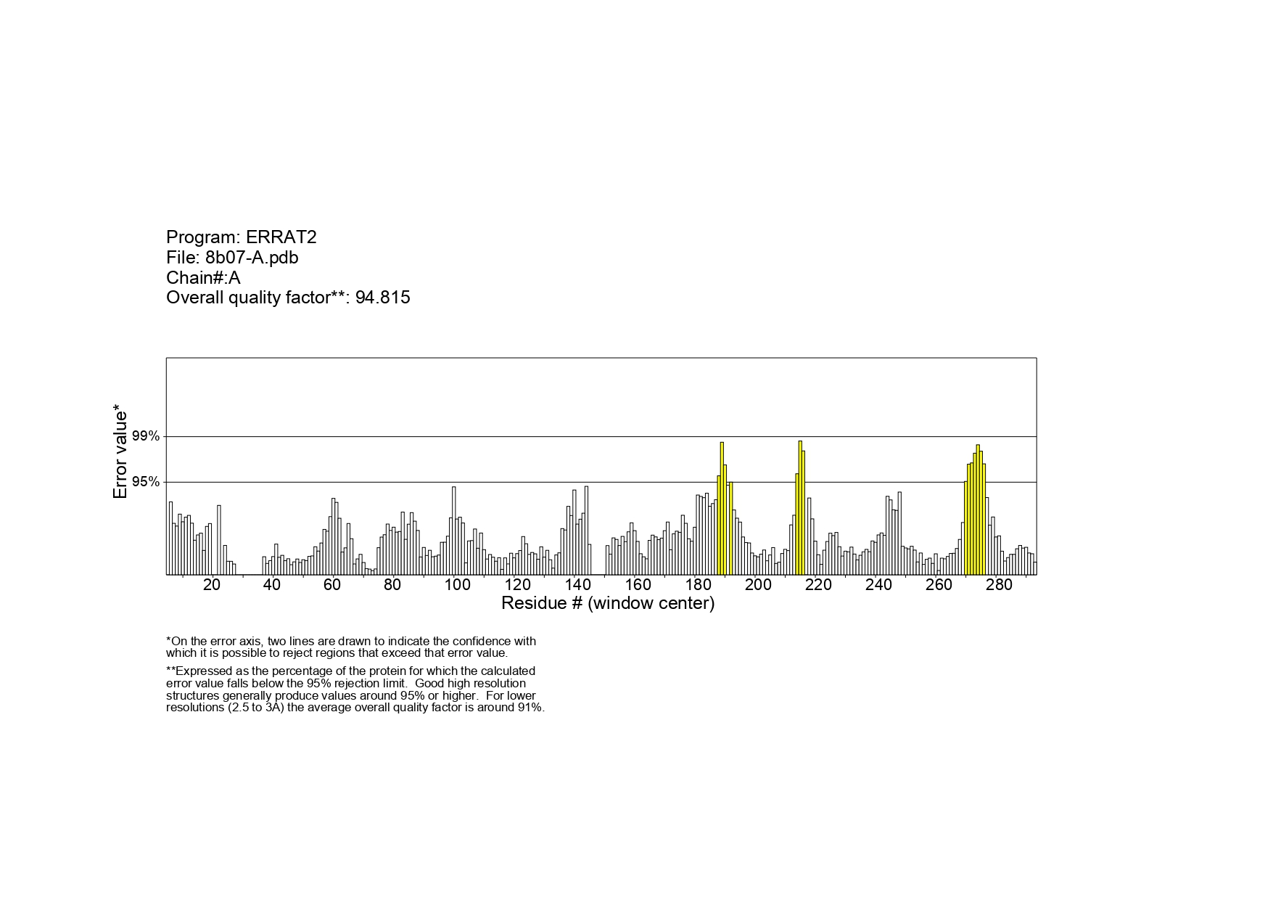

Figure1: ERRAT has checked the general quality.

The ProSA energy profile confirmed this result. It gave a Z-score of -7.22 kcal/mol, showing that the model was reliable (Figure2). The energy profile compared to the amino acid residues confirmed the structure and accuracy of the model.



Figure2: ProSA energy profile of the enzyme

In addition, the PROCHECK tool generated a Ramachandran diagram. It showed that 92.5% of the residues were in favored regions and 7.5% in allowed regions. No residues were found in the allowed or disallowed regions (Figure3). This ensures the quality and precision of the modeled structure. These analyzes confirm the validity and reliability of the proposed 3D model. It is now suitable for further molecular docking and interaction studies. The high accuracy and reliability of the model provide a solid understanding of the 2'o-MT-VP39 binding mechanisms. This may provide information for new therapies.

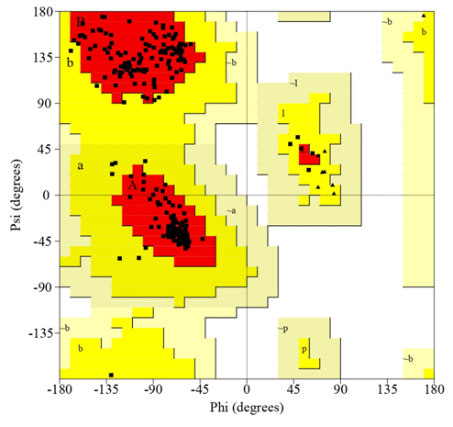

Figure3: Ramachandran diagram of the model protein: residues in the red area are allowed, while residues in the allowed area, residues in the yellow area are generous

We found that stigmasterol binds strongly to the enzyme 2'-O-MT-VP39. The docking value of -7.98 kcal/mol indicates the relative stability of the interaction. Structural analysis showed that stigmasterol forms hydrogen bonds with Asn273. The N-group of Asn273 interacts with the O1 of stigmasterol. It is crucial for the stabilization of the protein-ligand complex. This suggests that Asn273 is a key amino acid in the binding mechanism of the enzyme. The docking results show that the active site of the enzyme is a good ligand interaction site. This indicates its potential as a target for drug development. The strong binding affinity of stigmasterol makes it a good drug target for Mpox[35]. This research provides important insights for the development of better Mpox treatments. It aims to overcome resistance to existing drugs. The results are promising for the search for new antiviral drugs. These results underline the importance of Asn273 for the binding process. They also highlight the potential of stigmasterol as a lead molecule for new drug discovery. This work shows how the technique can be used to find new targets and drugs for mumps treatment.

The **Graph1** analyzes molecular docking results for various natural compounds from *A. indica*. It focuses on their affinity values and interactions with specific amino acids. The results show a range of binding strengths. Some compounds bind with considerable strength and permanence. Others show weaker affinities. Stigmasterol has the strongest binding. Its affinity value is -7.98 kcal/mol. It forms hydrogen bonds with Asn273. It has hydrophobic interactions with Arg76, Tyr77, and Phe293. This strong, stable binding to the protein suggests that stigmasterol may be a good candidate for drug discovery. Azadiradione and campesterol also have strong affinities.

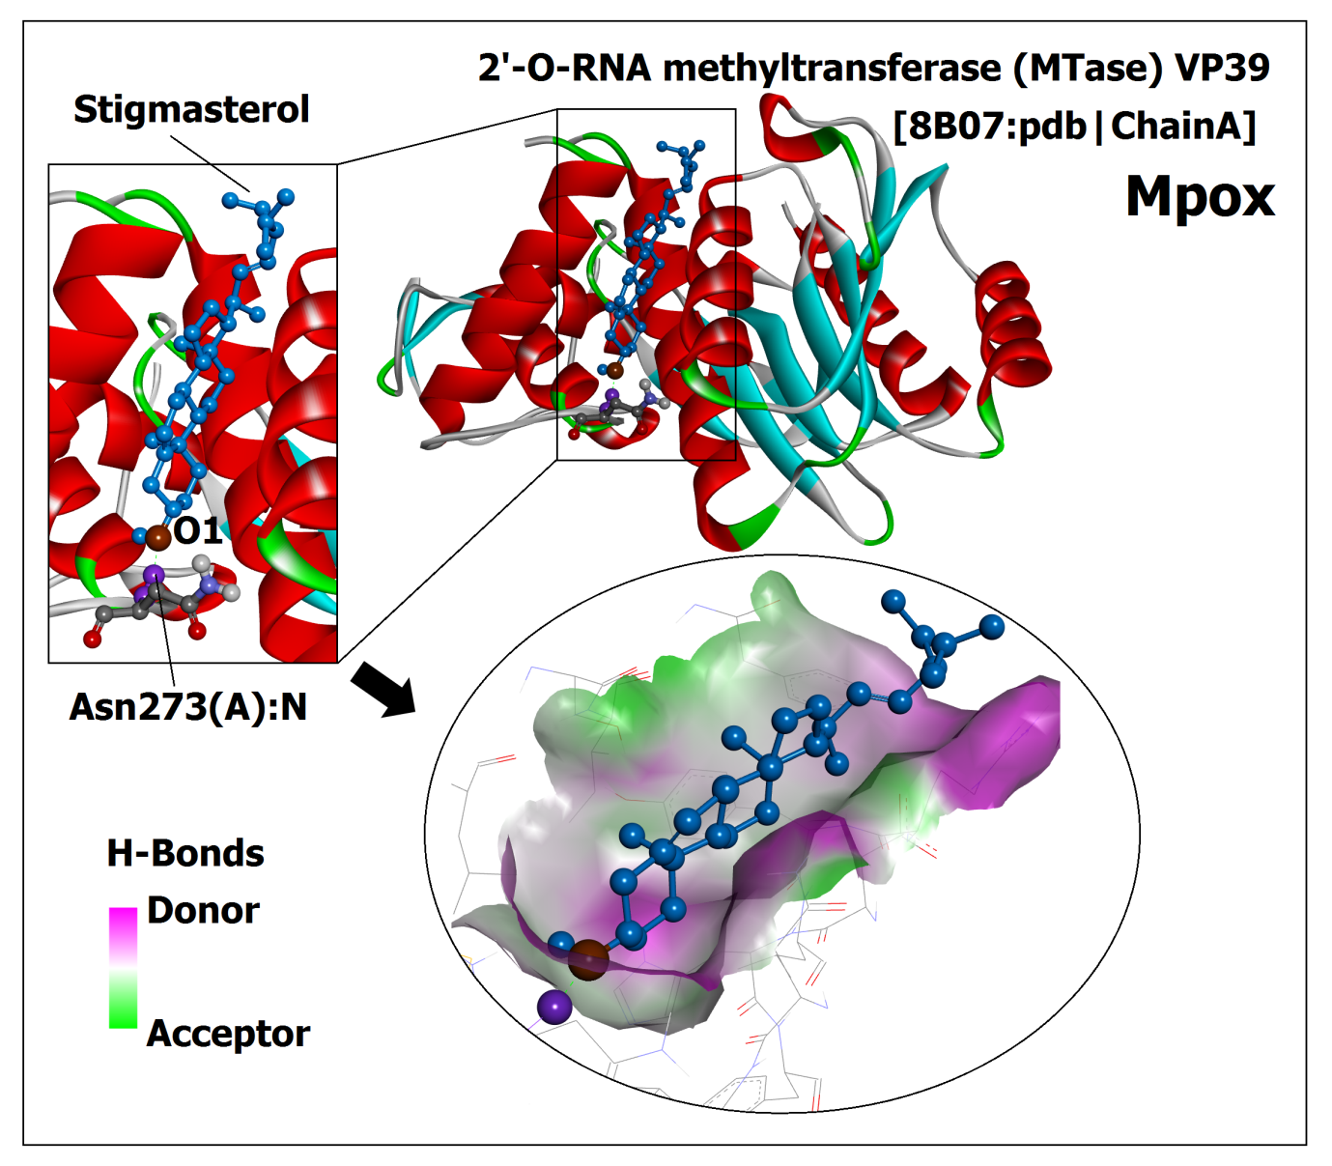

Figure4: Molecular interaction of 2'-O-methyltransferase with stigmasterol

Azadiradione interacts with Tyr77, Asp80, and His81. Campesterol forms key bonds with Asp95 and hydrophobic residues like Phe115 and Leu159. This indicates it is very stable. It forms hydrogen bonds with His99 and Asn104. This lowers its binding potential; with an affinity of -7.73 kcal/mol. Meliantriol and quercetin also bind strongly to important residues, like Asn199 and Gly68. They form hydrogen bonds with them. Nimbin and scopoletin form fewer interactions, resulting in moderate binding strength. Oleic acid and umbelliferone show weaker affinity, with limited hydrogen and hydrophobic bonds. The results show the different levels of molecular interactions. They suggest that stigmasterol, azadiradione, and campesterol are good drug candidates. They bind strongly to target proteins and stay bound. We can further investigate these compounds for their potential uses. We may need to modify the weaker binding partners to improve their affinity[36, 37]. The docking results shed light on how these natural compounds bind. This may help us develop new drugs and therapies. Identifying amino acid residues that bind helps develop targeted therapies. This study shows that compounds from *A. indica* could help make new drugs. It shows the value of molecular docking studies in finding new drugs.

|  |  |  |  |  |
| --- | --- | --- | --- | --- |
| **Compound (**5281426**)** | **Structure** | **Affinity (kcal/mol)** | **Amino acid residues**  **(H-Bond)** | **Amino acid residues**  **(Hydrophobic-Bond)** |
| Stigmasterol  (5280794) | Stigmasterol | -7.98 | Asn273 | Arg76, Tyr77, Asp80, HIsIle102, Phe293 |
| Azadiradione (12308714) | Azadiradione | -7.80 | Tyr77, Asp80, His81 | Tyr77, Asp80, Asn84, Asn273, Lys274, Phe285 |
| Campesterol (173183) | Campesterol | -7.80 | Asp95 | Phe115, Asp117, Val139, Ala158, Leu159 |
| Epoxyazadiradione  (49863985) | Epoxyazadiradione | -7.73 | His99, Asn104, Thr10, Gly105 | Leu111 |
| Meliantriol (185586) | Meliantriol | -7.45 | Asn199, Asn218, Arg220 | Tyr12, His192, Ile213, Tyr214 |
| Quercetin (5280343) | Quercetin | -7.27 | Gly68, Ile94, Asp95, Val,116, Asp138, Arg140 | Val139, Arg140 |
| Nimbin (108058) | Nimbin | -6.96 | Tyr22, Tyr204, Ala206 | Tyr22, Phe180, pro202, Tyr204 |
| Scopoletin (5280460) | Scopoletin | -6.21 | Ile94, Arg114, Val116, Ser141 | Phe115 |
| Oleic Acid (445639) | Linoleic Acid | -6.06 | Tyr204, Asn245 | Lys33 |
| Umbelliferone (5281426) | Umbelliferone (1) | -5.98 | Asn218, Arg220 | His192, Tyr214, Thr215 |

Table1: Amino acid residues of Different Ligands involved in the Hydrogen bond and hydrophobicbond during molecular docking.

The **table2** shows various compounds and their properties. It lists their solubility, absorption, and bioavailability. The compounds are: Sinefungin, stigmasterol, azadiradione, campesterol, epoxyazadiradione, meliantriol, quercetin, nimbin, scopoletin, oleic acid and umbelliferone. These compounds have different lipophilicity (LogP), solubility, permeability, and drug likeness. These are crucial for the evaluation of their pharmacokinetic and pharmacodynamic behavior. Sinefungin, a control substance, is unique. It is hydrophilic and has low LogP values in all models (iLOGP of 0.67, XLOGP3 of -4.31, and WLOGP of -2.38). According to the ESOL, Ali, and Silicos-IT models, it is also very soluble. Its high solubility, especially in water, makes it highly bioavailable despite its low gastrointestinal absorption and lack of blood-brain barrier (BBB) permeability. On the other hand, stigmasterol has a very high lipophilicity (iLOGP 5.08, XLOGP 3 8.56), but does not dissolve well and is not well absorbed by the gastrointestinal tract, making it less bioavailable. It also violates several drug-likeness rules, including those of Lipinski, Ghose, and Veber. It has moderate permeability and poor aqueous solubility.

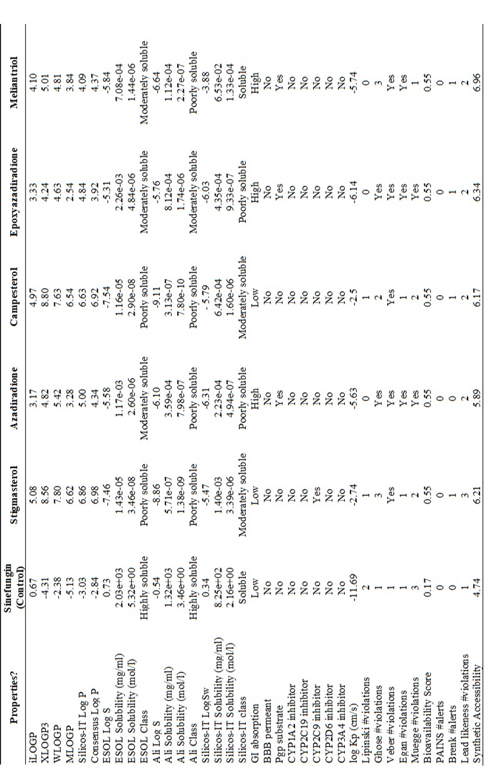

**Table 2**: ADMET profiling of a 2'o-MT-VP39 protein inhibitor from *Azadirachta indica* chosen as a bioactive molecule. *Continue…*

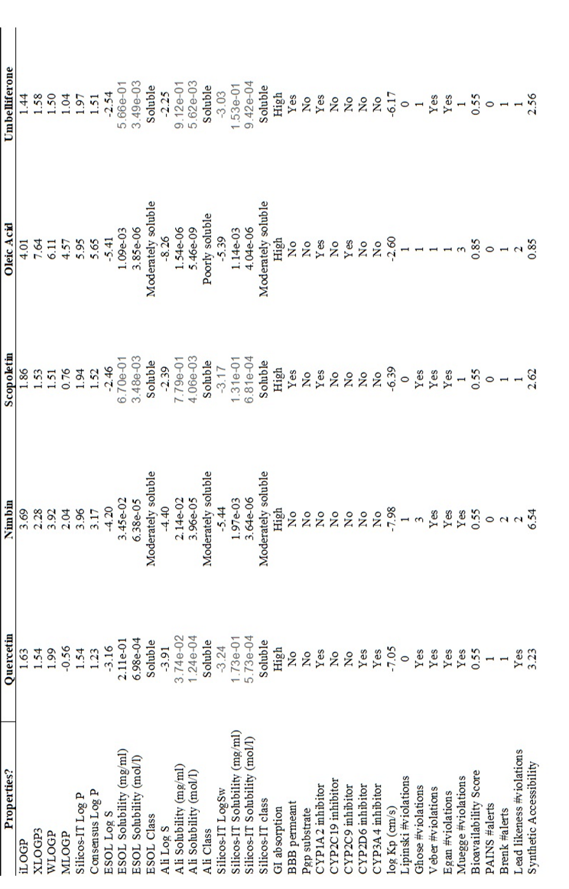

Azadiradione, campesterol, epoxyazadiradione, and meliantriol have moderate lipophilicity and solubility profiles. Azadiradione and epoxyazadiradione have moderate solubility and high gastrointestinal absorption. They are therefore good candidates for oral drug formulations. However, they still violate some important rules of drug-likeness (Ghose, Veber, Egan) and have moderate bioavailability. Campesterol is lipophilic (iLOGP 4.97) but suffers from poor solubility and low GI absorption, which limits its therapeutic potential. Not all compounds in this group can cross the blood-brain barrier (BBB), and some, such as azadiradione and meliantriol, act as P-glycoprotein (Pgp) substrates, which could alter drug transport.

**CONCLUSION**

The lack of specific antiviral treatments for Mpox has driven the search for new, targeted therapies. Using advanced bioinformatics methods, researchers discovered that the crystal structure of 2'-O-methyltransferase VP39 (2'-O-MT-VP39) is an important target for drug development. This enzyme plays a crucial role in the viral replication process, making it an attractive target for therapeutic intervention. The proposed model of the enzyme was validated using several computational tools, including Ramachandran plot analysis, ERRAT, and ProSA, confirming its accuracy and structural reliability. Among the natural compounds tested, stigmasterol proved to be the most promising candidate as it showed the highest binding affinity with the target site of the enzyme. Compared to sinefungin, which served as a control in the docking studies, stigmasterol showed better inhibitory potential. This suggests that stigmasterol may be more effective in blocking the activity of the enzyme and interrupting the viral replication cycle. These preliminary results suggest that stigmasterol is a strong candidate for further investigation. Future research, including in vitro and in vivo studies, will be critical to evaluate drug-likeness, pharmacokinetics, and potential side effects. Ultimately, this research opens new avenues for the development of targeted antiviral treatments against Mpox and provides hope for more effective therapeutic strategies.

**References**

1. Upadhayay S, Arthur R, Soni D, Yadav P, Navik U, Singh R, Singh TG, Kumar P. Monkeypox infection: The past, present, and future. International immunopharmacology. 2022;113:109382.
2. Skvara P, Chalupska D, Klima M, Kozic J, Silhan J, Boura E. Structural basis for RNA-cap recognition and methylation by the mpox methyltransferase VP39. Antiviral Research. 2023;216:105663.
3. Duarte PM, Adesola RO, Priyadarsini S, Singh R, Shaheen MN, Ogundijo OA, Gulumbe BH, Lounis M, Samir M, Govindan K, Adebiyi OS. Unveiling the Global Surge of Mpox (Monkeypox): A comprehensive review of current evidence. The Microbe. 2024:100141.
4. Inungu J, Iheduru-Anderson K, Odio OJ. Recurrent Ebolavirus disease in the Democratic Republic of Congo: update and challenges. AIMS public health. 2019;6(4):502.
5. Americo JL, Earl PL, Moss B. Virulence differences of mpox (monkeypox) virus clades I, IIa, and IIb. 1 in a small animal model. Proceedings of the National Academy of Sciences. 2023;120(8):e2220415120.
6. World Health Organization, WHO Director-General declares mpox outbreak a public health emergency of international concern, 2024. https://www.who.int/news/item/14-08-2024-who-director-general-declares-mpox-outbreak-a-public-health-emergency-of-international-concern.
7. Pal M, Rebuma T, Berhanu W, Endale B, Zende R. Monkeypox: A New Challenge in Global Health Security. American Journal of Epidemiology. 2024;12(3):37-43.
8. MoHFW, Presence of Mpox virus of West African clade 2 confirmed in Isolated Patient. 2024. <https://mohfw.gov.in/?q=hi/node/7676>.
9. Li P, Li J, Ayada I, Avan A, Zheng Q, Peppelenbosch MP, de Vries AC, Pan Q. Clinical features, antiviral treatment, and patient outcomes: a systematic review and comparative analysis of the previous and the 2022 mpox outbreaks. The Journal of Infectious Diseases. 2023;228(4):391-401.
10. CDC, C.f.D.C.a.P. Mpox, 2022. Outbreak cases and data. https://www.cdc.gov/poxvirus/mpox/response/2022/index.html.
11. Zgarbová M, Otava T, Silhan J, Nencka R, Weber J, Boura E. Inhibitors of Mpox VP39 2′-O methyltransferase efficiently inhibit the monkeypox virus. Antiviral Research. 2023;218:105714.
12. Kumar M, Kumar S, Kumar R, Jha MK, Tiwari SN, Gupta P. Serious Concern of Congenital Zika Syndrome (CZS) in India: A Narrative Review. Journal of Pregnancy. 2024;2024(1):1758662.
13. Kmiec D, Kirchhoff F. Monkeypox: a new threat?. International journal of molecular sciences. 2022 Jul 17;23(14):7866.
14. Saghazadeh A, Rezaei N. Insights on Mpox virus infection immunopathogenesis. Reviews in medical virology. 2023 Mar;33(2):e2426.
15. Silhan J, Klima M, Chalupska D, Kozic J, Boura E. The structure of monkeypox virus 2’-O-ribose methyltransferase VP39 in complex with sinefungin provides the foundation for inhibitor design. bioRxiv. 2022:2022-09.
16. Lu J, Xing H, Wang C, Tang M, Wu C, Ye F, Yin L, Yang Y, Tan W, Shen L. Mpox (formerly monkeypox): pathogenesis, prevention, and treatment. Signal Transduction and Targeted Therapy. 2023;8(1):458.
17. Silhan J, Klima M, Otava T, Skvara P, Chalupska D, Chalupsky K, Kozic J, Nencka R, Boura E. Discovery and structural characterization of monkeypox virus methyltransferase VP39 inhibitors reveal similarities to SARS-CoV-2 nsp14 methyltransferase. Nature Communications. 2023 Apr 20;14(1):2259.
18. Alzohairy MA. Therapeutics role of Azadirachta indica (Neem) and their active constituents in diseases prevention and treatment. Evidence‐Based Complementary and Alternative Medicine. 2016;2016(1):7382506.
19. Wylie MR, Merrell DS. The antimicrobial potential of the neem tree Azadirachta indica. Frontiers in pharmacology. 2022 May 30;13:891535.
20. Foka FE, Manamela N, Mufamadi SM, Mufhandu HT. Potential of Azadirachta indica as a Capping Agent for Antiviral Nanoparticles against SARS‐CoV‐2. BioMed Research International. 2022;2022(1):5714035.
21. Szabadka Z, Grolmusz V. Building a structured PDB: The RS-PDB database. In2006 International Conference of the IEEE Engineering in Medicine and Biology Society 2006 Aug 30 (pp. 5755-5758). IEEE.
22. Kumar M, Rana S, Kumar H, Kumar P, Dikhit MR, Mansuri R, Kumar J, Sahoo GC. Computational, structural and functional aspects of hypothetical protein of Aspergillus flavus Pheromone Receptor Pre-A (PRP-A). Journal of Applied Pharmaceutical Science. 2017;7(7):089-97.
23. Kumar P, Kumar M, Kumar H, Rana S, Kumar J, Sahoo GC. In silico targeting methylerythritol phosphate pathway IspD enzyme of Mycobacterium tuberculosis for novel anti-mycobacterial drug discovery. Journal of Applied Pharmaceutical Science. 2020;10(10):023-9.
24. Laskowski RA, MacArthur MW, Moss DS, Thornton JM. PROCHECK: a program to check the stereochemical quality of protein structures. Journal of applied crystallography. 1993;26(2):283-91.
25. Kumar M. In silico efficacy of [S]-8-gingerol (a derivative) with 6-gingerol against PT-domain of Polyketide synthase A (PksA). IP International Journal of Medical Microbiology and Tropical Diseases. 2021;7:62-4.
26. Kim S, Chen J, Cheng T, Gindulyte A, He J, He S, Li Q, Shoemaker BA, Thiessen PA, Yu B, Zaslavsky L. PubChem 2019 update: improved access to chemical data. Nucleic acids research. 2019;47(D1):D1102-9.
27. Daina A, Michielin O, Zoete V. SwissADME: a free web tool to evaluate pharmacokinetics, drug-likeness and medicinal chemistry friendliness of small molecules. Scientific reports. 2017;7(1):42717.
28. Kumari A, Kumar M, Sahoo GC, Kumar J. IN SILICO PREDICTION OF GLABRIDIN POTENCY AGAINST HUMAN TYROSINASE IN HYPERPIGMENTATION CONDITION, IJRAR-International Journal of Research and Analytical Reviews (IJRAR), E-ISSN. 2021:2348-1269.
29. Murail S, De Vries SJ, Rey J, Moroy G, Tufféry P. SeamDock: an interactive and collaborative online docking resource to assist small compound molecular docking. Frontiers in Molecular Biosciences. 2021 Sep 17;8:716466.
30. Jyoti M, Kumari A, Kumar M, Kumar R. Streptomyces tetracycline’s computational behavior against polyketide synthase of aflatoxigenic fungi. IP International Journal of Medical Microbiology and Tropical Diseases. 2023;9(2):85-91.
31. Bugnon M, Röhrig UF, Goullieux M, Perez MA, Daina A, Michielin O, Zoete V. SwissDock 2024: major enhancements for small-molecule docking with Attracting Cavities and AutoDock Vina. Nucleic Acids Research. 2024:gkae300.
32. Mahato JP, Rana S, Kumar M, Sarsaiya S. Homology modeling of Leishmania donovani enolase and its molecular interaction with novel inhibitors. Journal of Pharmacy and Bioallied Sciences. 2017;9(2):99-105.
33. Kumar M, Topno RK, Dikhit MR, Bhawana, Sahoo GC, Madhukar M, Pandey K, Das P. Molecular docking studies of chloroquine and its derivatives against P23pro‐zbd domain of chikungunya virus: Implication in designing of novel therapeutic strategies. Journal of cellular biochemistry. 2019;120(10):18298-308.
34. Hetényi C, Bálint M. Systematic Exploration of Binding Modes of Ligands on Drug Targets. Structural Bioinformatics: Methods and Protocols. 2020:107-21.
35. Kumar M. In silico efficacy of [S]-8-gingerol (a derivative) with 6-gingerol against PT-domain of Polyketide synthase A (PksA). IP International Journal of Medical Microbiology and Tropical Diseases. 2021;7:62-4.
36. Topno SK, Kumar R, RabiDas VN, Pandey K, Chandra G. IgM-based Prevalence of Rubella virus, Cytomegalovirus, and Herpes Simplex Virus-A study from Bihar Region, India. Journal of Scientific Research. 2023;67(4).
37. Kumar M, Sahoo GC, Das VN, Singh K, Pandey K. A Review of miRNA Regulation in Japanese Encephalitis (JEV) Virus Infection. Current pharmaceutical biotechnology. 2024;25(5):521-33.