*Original Research Article*

**“Spatiotemporal Analysis of Land Use and Land Cover Changes in Bengaluru Metropolitan Region (1990–2023) using GIS and Remote Sensing”**

**ABSTRACT**

*Bengaluru Metropolitan Region (BMR) has undergone dramatic land use and land cover (LULC) changes from 1990 to 2023 amid rapid urbanization. This study analyzes the spatiotemporal transformations in BMR’s LULC over the past three decades using geospatial techniques, and evaluates the implications for sustainable urban planning. Multi-date satellite imagery (including LANDSAT and IRS ResourceSat data) was processed in ArcGIS to classify major LULC categories and quantify changes. The findings reveal an explosive growth of urban built-up area expanding roughly seven-fold since 1990 largely at the expense of agricultural land and open spaces. Vegetation cover and water bodies have significantly diminished, with over 200 lakes lost to development, reflecting unplanned urban sprawl.*

*The spatial analysis shows that urban expansion has been concentrated in and around Bengaluru city (the core), extending along key corridors into peripheral districts. These LULC shifts have critical consequences: loss of green cover, increased impervious surfaces, and stresses on water resources and infrastructure. The study’s outcomes underscore the need for balanced urban growth strategies in BMR. It recommends strengthening regional planning institutions, enforcing land use regulations, protecting ecological assets, and promoting polycentric development to achieve more sustainable and livable urbanization. The insights are expected to aid policymakers, planners, and researchers in understanding urban landscape dynamics and formulating informed land use policies.*

**Keyword:** Land Use Land Cover (LULC), Urbanization, Bengaluru Metropolitan Region (BMR), Remote sensing, GIS, Sustainable Planning.

**I. INTRODUCTION**

Urbanization is one of the most significant global transformations of the 21st century. The United Nations (UN) projects that by 2050, nearly 68% of the world's population will reside in urban areas, with much of this growth occurring in developing regions like Asia and Africa (UN DESA, 2018). In India, urbanization has been particularly rapid, with the urban population increasing from 27.8% in 2001 to 31.2% in 2011 and expected to reach 40% by 2036 (Census of India, 2011; World Bank, 2024). As cities expand, managing land use and environmental sustainability becomes a critical challenge (UN-Habitat, 2017). Urban expansion alters land use and land cover (LULC) by converting natural ecosystems into built environments, often leading to loss of vegetation, fragmentation of water bodies, and increased impervious surfaces (Ramachandra & Aithal, 2016). These changes significantly impact hydrology, biodiversity, microclimates, and overall environmental sustainability (Dehingia et al., 2022). Therefore, monitoring and analyzing these changes is crucial for urban planning, environmental management, and sustainable development (Li et al., 2020). The United Nations' Sustainable Development Goal (SDG) 11 emphasizes sustainable cities, highlighting the need for evidence-based planning and resilient urban policies (UN, 2015).

India’s metropolitan regions have experienced unregulated urban sprawl, traffic congestion, resource depletion, and environmental degradation due to rapid expansion (NITI Aayog, 2021). Despite regulatory frameworks like the 74th Constitutional Amendment (1992) and the establishment of Metropolitan Planning Committees (MPCs), urban governance remains fragmented, with overlapping jurisdictions among municipal corporations, development authorities, and parastatal agencies (World Bank, 2013). A major challenge is the absence of updated master plans, with reports indicating that 52% of statutory towns and 76% of census towns lack a structured development plan (Janaagraha, 2021). The lack of effective implementation exacerbates informal urban growth, making it difficult to regulate land use effectively (Sundaresan, 2019).

Bengaluru, known as the Silicon Valley of India, exemplifies urban transformation, growing from a compact city to a sprawling metropolitan region (Sudhira et al., 2004). The Bengaluru Metropolitan Region (BMR) spans 8,005 km² and includes Bangalore Urban, Bangalore Rural, and Ramanagara districts (BMRDA, 2017). Between 1990 and 2023, Bengaluru’s built-up area expanded sevenfold, largely at the expense of agricultural land and open spaces (Ramachandra et al., 2023). Several studies have raised concerns over diminishing green cover, shrinking lakes, and loss of agricultural land, impacting climate resilience and resource sustainability (Hollyhead et al., 2022). Advancements in Geographic Information Systems (GIS) and remote sensing have enabled large-scale LULC change analysis, offering precise temporal and spatial data for planning interventions (Li et al., 2020). Several Indian metropolitan planning agencies, including BMRDA and NIUA, now emphasize GIS-based land monitoring for improved urban governance (NIUA, 2022). By integrating satellite imagery from LANDSAT, Sentinel-2A, and IRS ResourceSat, this study provides a comprehensive spatiotemporal analysis of BMR’s LULC changes from 1990 to 2023, evaluating its implications for sustainable urbanization.

This study aims to analyze LULC transformations in BMR from 1990 to 2023 using GIS and remote sensing, identify the drivers of urban expansion and their spatial distribution, assess the environmental and planning implications of LULC changes, and propose policy recommendations for sustainable urban management in BMR. The subsequent sections present a literature review on urbanization trends and GIS applications, followed by methodology, findings and discussions for better land use planning in metropolitan regions.

**II. LITERATURE REVIEW**

Urbanization trends and their management have been widely studied at global, national, and local levels. The United Nations (UN) reports that the global urban population rose from 30% in 1950 to 55% in 2018 and is projected to reach 68% by 2050 (UN DESA, 2018). The *World Cities Report 2022* highlights that urbanization is an irreversible trend shaping human settlements worldwide but warns of growing environmental concerns, including declining green spaces and rising resource consumption (UN-Habitat, 2022). Developing countries, particularly in Asia and Africa, face the dual challenge of providing adequate infrastructure and mitigating environmental impacts of rapid urban expansion. The *New Urban Agenda* (2016) underscores the importance of sustainable urban planning, integrated land use management, and inclusive development to address these challenges (UN-Habitat, 2017).

A key concern in the literature is the impact of land use and land cover (LULC) changes due to urbanization. Unregulated urban growth often results in the conversion of agricultural fields, forests, and wetlands into built environments, leading to increased impervious surfaces, higher surface runoff, and exacerbation of the urban heat island effect (Ramachandra & Aithal, 2016). Studies across continents have documented how LULC changes contribute to local climate shifts and biodiversity loss (Dehingia et al., 2022). In India, unplanned urbanization has intensified environmental degradation, with significant loss of green cover and water bodies in metropolitan regions like Bengaluru (Hollyhead et al., 2022). As cities expand, LULC monitoring is becoming essential for climate resilience, resource management, and sustainable planning (Li et al., 2020). Remote sensing and GIS technologies have proven invaluable in tracking urban expansion, allowing for accurate spatiotemporal analysis (Ramachandra et al., 2023). The use of machine learning techniques, such as Random Forest classification, has further enhanced the accuracy of LULC mapping and change detection (Li et al., 2020).

India’s urbanization has been rapid and regionally concentrated, with the urban population increasing from 27.8% in 2001 to 31.2% in 2011 and projected to reach 40% by 2030 (World Bank, 2024). Large metropolitan areas have driven much of this growth; in 2010, India had 42 cities with over a million residents, a number expected to reach 68 by 2030 (NITI Aayog, 2021). Bengaluru exemplifies this trend, emerging as a megacity with a population exceeding 10 million. The *McKinsey Global Institute Report (2010)* highlighted that India’s cities are under-planned relative to their size and require substantial infrastructure investment to sustain economic growth. Similarly, the *World Bank’s South Asia Urbanization Report* (Ellis & Roberts, 2016) noted that Indian cities suffer from high population densities but low livability due to inadequate governance and weak urban management frameworks.

Urban governance in India has evolved, yet significant challenges remain. The 74th Constitutional Amendment (1992) sought to decentralize planning authority to local governments and establish Metropolitan Planning Committees (MPCs) in larger urban regions. However, many states have not fully empowered local bodies, leading to fragmented governance structures (NITI Aayog, 2021). In cities like Bengaluru, multiple agencies including the Bruhat Bengaluru Mahanagara Palike (BBMP), Bangalore Development Authority (BDA), and Bangalore Metropolitan Region Development Authority (BMRDA) operate with overlapping mandates, complicating land use management. Additionally, a severe shortage of urban planners further weakens governance; studies by the National Institute of Urban Affairs (NIUA) indicate that many Indian cities lack even one professional planner per 100,000 residents (NIUA, 2022).

Regulatory frameworks for urban planning in India have been inadequate in enforcing planned development. Town planning acts, such as the Karnataka Town and Country Planning Act (1961), provide guidelines for zoning and land use regulation, but enforcement has been weak. Sundaresan (2017) documented widespread violations in Bengaluru, where unauthorized land use conversions, encroachments on ecologically sensitive zones, and illegal constructions occur frequently, often facilitated through informal networks. Such "planning by exception" has resulted in environmental crises, including frequent urban flooding due to the disappearance of natural drainage channels and wetlands (Ramachandra et al., 2016). A 2021 NITI Aayog report found that 65% of India’s 7,933 urban settlements lack a statutory master plan, and even where plans exist, their implementation remains inconsistent (NITI Aayog, 2021).

Several initiatives have been launched to improve urban planning and infrastructure provisioning. The *Smart Cities Mission (2015)* and the *Atal Mission for Rejuvenation and Urban Transformation (AMRUT)* aim to develop systematic urban management tools, including GIS-based master plans (Ministry of Housing and Urban Affairs, 2021). However, implementation challenges persist, and cities like Bengaluru continue to struggle with unchecked urban expansion. The *Annual Survey of India’s City-Systems (ASICS)* by Janaagraha frequently ranks Bengaluru low in planning adequacy, highlighting governance deficits. Recognizing these issues, the Revised Master Plan 2031 for Bengaluru and the Revised Structure Plan 2031 for BMR propose a polycentric growth model to decongest the core city and create planned urban clusters (BMRDA, 2017). If successfully implemented, these measures could help contain sprawl, preserve ecological zones, and support balanced regional development.

GIS and remote sensing studies provide critical insights into Bengaluru’s urban expansion and its implications for sustainability. Sudhira, Ramachandra, and Jagadish (2004) quantified the city’s sprawl patterns, showing how growth has followed major transport corridors. Ramachandra et al. (2012, 2014) linked Bengaluru’s LULC changes with declining ecosystem services, emphasizing the loss of green spaces and water bodies. More recently, Ramachandra, Bharath, and Aithal (2017) used predictive modeling to project the city's future expansion, warning that without corrective measures, Bengaluru could become “unlivable” due to unsustainable urban trajectories.

Overall, the literature underscores the need for integrated urban planning, improved governance, and proactive land use management in fast-growing metropolitan regions. Without intervention, LULC changes in cities like Bengaluru will continue to erode environmental resilience, reduce livability, and strain urban infrastructure. This study builds upon previous research by using updated 2020s satellite imagery and GIS techniques to provide a comprehensive analysis of Bengaluru’s urban expansion, offering policy recommendations for sustainable metropolitan planning.

**III. METHODOLOGY**

This study employs a remote sensing and GIS-based approach to analyze land use and land cover (LULC) changes in the Bengaluru Metropolitan Region (BMR) from 1990 to 2023. The methodology consists of four key components: data acquisition, image classification, change detection, and spatial analysis, structured to meet the study’s objectives. These objectives include (1) preparing LULC maps for BMR at five time points (1990, 2000, 2010, 2020, and 2023), (2) quantifying LULC changes over time, particularly urban expansion and loss of agricultural or vegetated areas, (3) analyzing spatial patterns of urban growth, and (4) deriving planning insights relevant to sustainable urbanization.

For data acquisition, multi-temporal satellite imagery was sourced primarily from the United States Geological Survey (USGS) and Indian Space Research Organisation’s (ISRO) Resourcesat. The datasets used include Landsat-5 TM (30 m resolution) for 1990, Landsat-7 ETM+ (30 m) for 2000, IRS-P6 LISS-III (23.5 m) for 2010, and Landsat-8 OLI (30 m) for 2020, with Sentinel-2A (10 m) data cross-verified for 2020–2023. These images were selected to maintain consistency in spatial resolution and were acquired during dry season months to minimize cloud cover and ensure uniformity in land cover classification. Ancillary datasets, including topographic maps from the Survey of India for geo-referencing and OpenStreetMap and Diva-GIS data for road network verification, were incorporated to enhance spatial accuracy. Additionally, population figures were extracted from census records and gridded population datasets to correlate urban growth with land cover changes.

For image classification, a supervised classification approach was applied to categorize the landscape into five major land cover types: Built-up, Agricultural land, Vegetation, Water bodies, and Wetlands. Classification accuracy was assessed through cross-validation techniques, and necessary refinements were made to correct misclassifications. The LULC change detection process identified significant shifts between land use categories, highlighting urban expansion trends over the three decades.

To interpret urbanization patterns, spatial analysis techniques were applied. The study also incorporated administrative boundaries (taluks and planning zones) to assess the regional implications of LULC changes.

The methodology follows standard urban and regional planning practices and aligns with previous studies on urbanization and land use transformation in metropolitan regions. By integrating satellite imagery, spatial analysis, and policy context, this study provides valuable insights into how land dynamics in BMR have evolved over time, informing future planning strategies.

**IV. GROWTH DYNAMICS OF BENGALURU METROPOLITAN REGION (BMR)**

**4.1 Location and Regional Setting**

The Bengaluru Metropolitan Region (BMR) is a statutory planning region in Karnataka, India, encompassing Bengaluru city and its surrounding peri-urban and rural areas. Covering 8,005 km², it is among the largest metropolitan regions in India (BMRDA, 2017). Administratively, BMR includes Bangalore Urban, Bangalore Rural, and Ramanagara districts, with Bruhat Bengaluru Mahanagara Palike (BBMP) forming the urban core. BBMP’s jurisdiction spans approximately 800 km², while the rest of BMR comprises towns (Yelahanka, Hosakote, Ramanagara, Kanakapura) and rural settlements governed by local municipal councils or panchayats. The region’s geography is characterized by the Deccan Plateau’s undulating terrain (~900 m elevation), no major rivers, and a network of historical man-made lakes that played a crucial role in irrigation and water supply. (Figure 1)

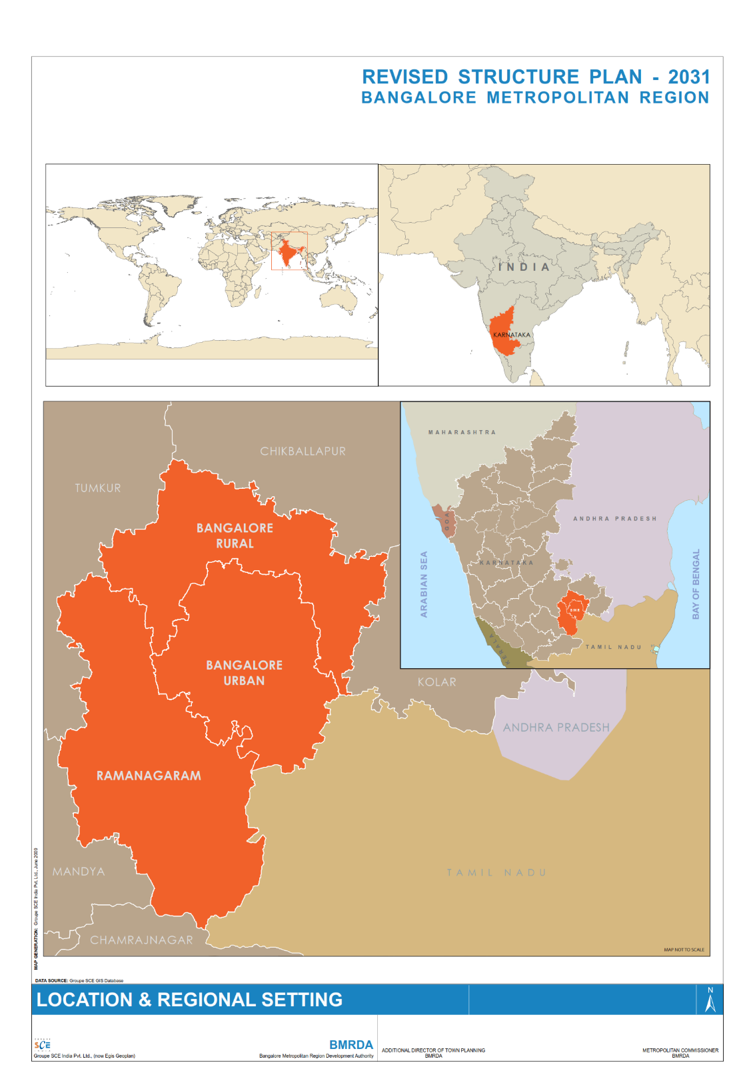

**Figure 1: Location and Regional Setting of BMR**

(Source: BMR Revised Structure Plan, 2016)

**4.2 Demographic Trends**

BMR has witnessed rapid population growth, primarily driven by Bengaluru’s economic expansion. The population was approximately 6.5 million in 1991 and rose to 8.42 million in 2001, with the urban core (BBMP) housing nearly 6 million residents (BMRDA, 2017). By the 2011 Census, BMR’s population reached 11.66 million, reflecting a 38% decadal increase. Bangalore Urban District alone accounted for 9.59 million people in 2011, making up 20% of Karnataka’s total population while occupying less than 5% of its area.

Urbanization has been highly concentrated in BBMP, which housed 77% of BMR’s population by 2011, growing from 48% in 1991 to 73% in 2001. This demographic trend indicates a strong regional imbalance, where Bengaluru city continues to dominate population and economic activities while surrounding areas lag in development.

**4.3 Migration and Urban Expansion**

Bengaluru’s rise as India’s IT and biotechnology hub since the 1990s has attracted migrants from across the country. The city’s population grew by 47% in the 1990s and 35% in the 2000s, significantly higher than national urbanization rates (BMRDA, 2017). Migration has transformed once semi-rural areas into urban townships; for instance, Electronics City and Whitefield formerly agricultural areas are now key IT corridors. Census data indicates a young workforce, high literacy rates (>85%), and a service-industry-driven economy. The expansion of Bengaluru’s employment base has led to peri-urbanization, with villages in BMR experiencing conversion into residential, commercial, and industrial hubs. However, rural areas are shrinking in population share due to decreasing agricultural viability and rising land values.

**4.4 Economic Structure and Regional Disparities**

Bengaluru city is the economic nucleus of BMR, hosting major IT clusters, research institutions, and multinational corporations. The tech industry in the southeastern (Whitefield, Marathahalli) and northern (Hebbal, Devanahalli) corridors has fueled high per capita income growth. However, economic benefits have been unevenly distributed. Peripheral regions remain largely agrarian, with sericulture, horticulture, and small-scale industries dominating (e.g., Ramanagara’s silk market, Kanakapura’s granite quarries). The infrastructure divide is stark: while Bengaluru has an extensive (but congested) road network, peripheral areas lack reliable public transport, consistent water supply, and quality education and healthcare facilities. The BMR Structure Plan 2031 acknowledges this core-periphery disparity and warns of over-centralization risks (BMRDA, 2017).

**4.5 Land Use and Urban Growth Patterns**

Historically, BMR was predominantly agricultural, with built-up areas confined to Bengaluru’s core. In 2001, only ~800 km² was urban/built-up, while rural land covered over 7,000 km² (BMRDA, 2017). However, rapid urban expansion has reshaped the landscape. By 2020, extensive farmland in Bengaluru Rural and Ramanagara had urbanized, particularly along major highways (Tumkur Road NH4, Mysore Road NH275, Old Madras Road NH75, and Bellary Road NH7). The BMR Structure Plan outlines planned growth corridors and new townships to manage expansion, while green belts are designated to contain sprawl, though enforcement remains weak.

**4.6 Environmental and Planning Challenges**

BMR’s environmental assets include forested areas like Bannerghatta National Park and interconnected lake systems. However, Bengaluru has lost over 80% of its lakes since the 1960s, with severe implications for groundwater recharge, flooding, and ecosystem stability (Ramachandra et al., 2016). Encroachments and pollution have drastically reduced the number of healthy lakes, threatening BMR’s water security. Governance remains fragmented; BMR falls under the Bangalore Metropolitan Region Development Authority (BMRDA), but planning responsibilities are shared across multiple agencies (BBMP, BDA, BMRDA, urban local bodies), often leading to uncoordinated development.

BMR is undergoing intense urban transformation, largely shaped by Bengaluru’s economic pull. The concentration of population and economic activities in the core has resulted in land use changes, rural-to-urban transitions, and environmental concerns. The imbalance between Bengaluru’s growth and the underdevelopment of surrounding regions poses significant planning challenges. This study captures these trends through LULC analysis, highlighting how land use dynamics have evolved in response to demographic and economic shifts. The findings offer insights for future urban planning strategies, emphasizing the need for balanced regional growth, environmental sustainability, and improved metropolitan governance.

**V. RESULTS AND DISCUSSIONS**

The land use and land cover (LULC) analysis of Bengaluru Metropolitan Region (BMR) from 1990 to 2023 reveals profound transformations driven by urban expansion, economic growth, and demographic pressures. The findings indicate a substantial increase in built-up areas, a reduction in agricultural and vegetated lands, and fragmentation of water bodies and wetlands. These shifts reflect broader urbanization trends observed in other rapidly developing metropolitan regions in India and globally (Ramachandra & Aithal, 2016).

**5.1 Land Use Changes from 1990 to 2000**

The LULC maps for 1990 and 2000 given in figure 2 illustrate the initial stages of Bengaluru’s metropolitan expansion. In 1990, built-up land was concentrated primarily within the municipal limits, with smaller urban pockets in towns like Yelahanka and Hosakote. The surrounding region was dominated by agriculture, tree cover, and numerous water bodies. By 2000, urban expansion had become more pronounced along major highways, particularly towards Whitefield in the east and along Hosur Road in the south. The built-up area increased from approximately 280 km² in 1990 to 659 km² in 2000, more than doubling within a decade (BMRDA, 2017).

This period saw early signs of unplanned growth, including fragmented suburban developments beyond the contiguous city. The Bangalore Development Authority’s 1995 Comprehensive Development Plan had designated some areas for planned expansion, particularly along the Outer Ring Road, which subsequently developed as expected. However, unplanned peripheral growth also began emerging, setting the stage for future urban sprawl.

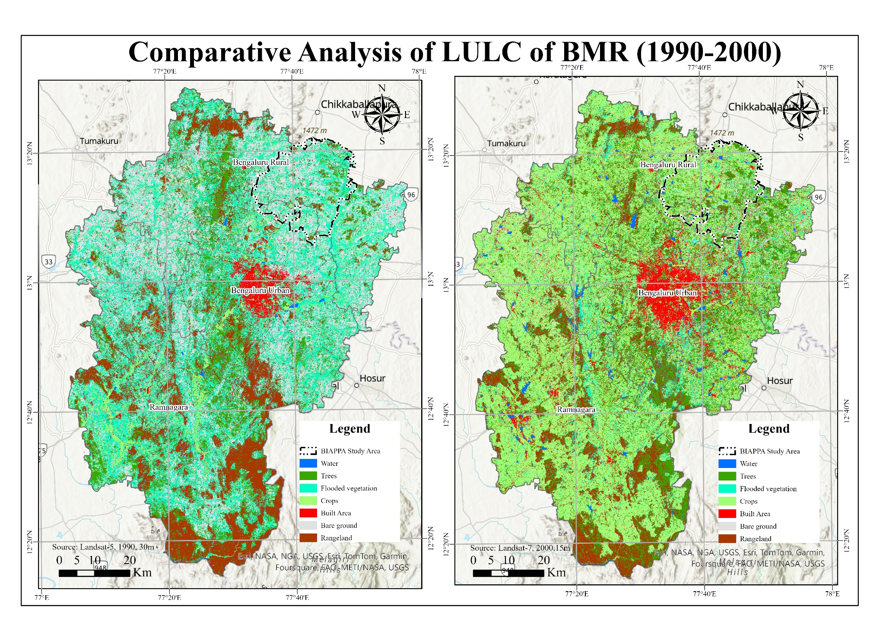**Figure 2: Comparative Analysis of LULC of BMR (1990-2000)**

(Source: Author using GIS)

**5.2 Accelerated Urbanization from 2000 to 2020**

The 2000s and 2010s marked a dramatic shift in BMR’s urban footprint, characterized by intensified land conversion and rapid suburbanization. Between 2000 and 2010, the built-up area expanded from 659 km² to 874 km², with major growth corridors emerging in Whitefield, Electronics City, and Devanahalli. The Kempegowda International Airport, operational since 2008, further accelerated urbanization along Bellary Road, prompting real estate development in previously rural areas. This period witnessed large-scale conversion of agricultural land into residential and commercial layouts, particularly within a 20–30 km radius of the city center.

Between 2010 and 2020, (Figure 3) urban expansion intensified significantly, with built-up land nearly doubling in a single decade from 874 km² in 2010 to 1,773 km² by 2020 (BMRDA, 2020). The urban fabric expanded well beyond BBMP limits, incorporating towns such as Nelamangala (northwest), Doddaballapur (north), Hoskote (east), and Bidadi (southwest). Development followed a star-shaped growth pattern, radiating outward from Bengaluru along major transport corridors (Ramachandra & Bharath, 2017). The fragmentation of green spaces became more evident, with once-contiguous forested areas and plantations reduced to isolated patches.

**5.3 Land Use and Land Cover Analysis of Bengaluru Metropolitan Region (2023)**

The land use and land cover (LULC) analysis for 2023 given in Figure 4, highlights the ongoing transformation of the Bengaluru Metropolitan Region (BMR), characterized by rapid urban expansion and significant shifts in land categories. According to the data, built-up land covers approximately 202,521 hectares, accounting for a substantial increase from previous decades. This expansion has primarily occurred at the expense of agricultural land and rangelands, with cropland occupying 337,640 hectares and rangelands covering 162,033 hectares. The tree cover, at 79,505 hectares, has experienced further fragmentation, while water bodies (17,913 hectares) continue to decline due to encroachments and urban sprawl.

The spatial pattern of urban growth in 2023 indicates intensification in core areas and outward expansion along major corridors. Peripheral towns such as Hoskote, Doddaballapur, and Bidadi have undergone increased urbanization, reflecting Bengaluru’s expanding metropolitan footprint. The persistent conversion of agricultural land into urban land suggests a decline in farming activities, with many plots transitioning into residential, commercial, and industrial uses. Additionally, flooded vegetation has shrunk to 1,423 hectares, indicating further depletion of wetlands, which may have implications for groundwater recharge and urban flooding.

These findings underscore the need for sustainable urban planning and stronger land-use regulations to mitigate uncontrolled urban sprawl while ensuring the preservation of ecological assets in BMR.

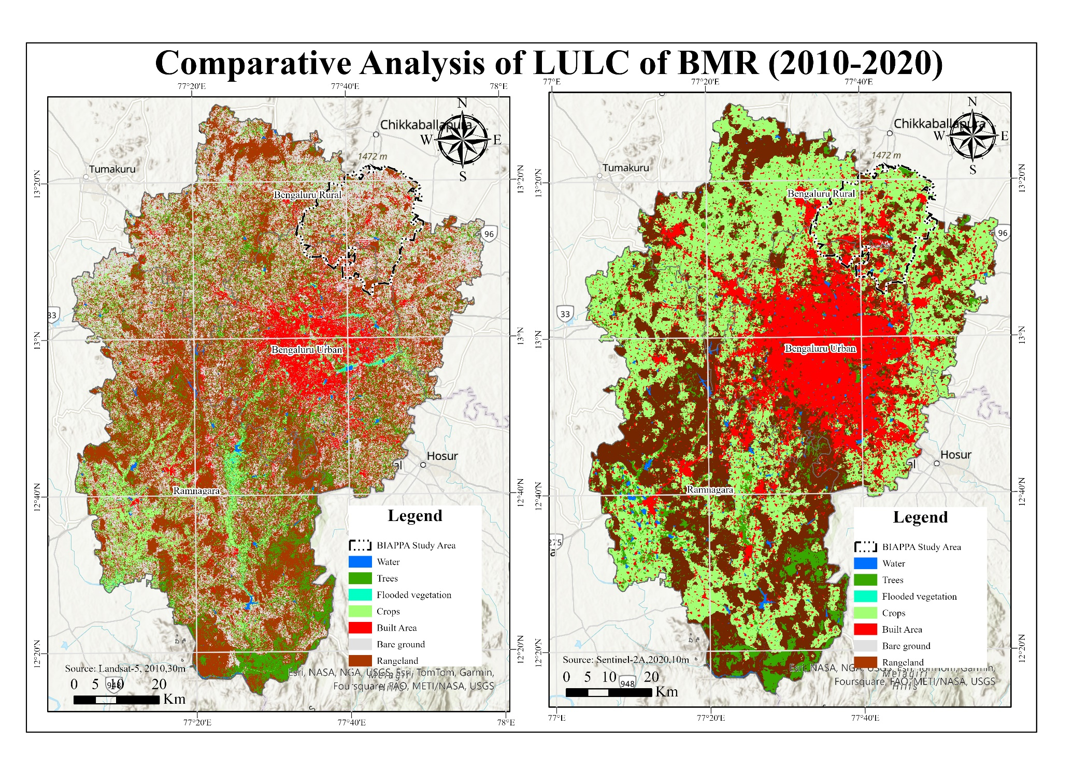**Figure 3: Comparative Analysis of LULC of BMR (2010-2020)**

(Source: Author using GIS)

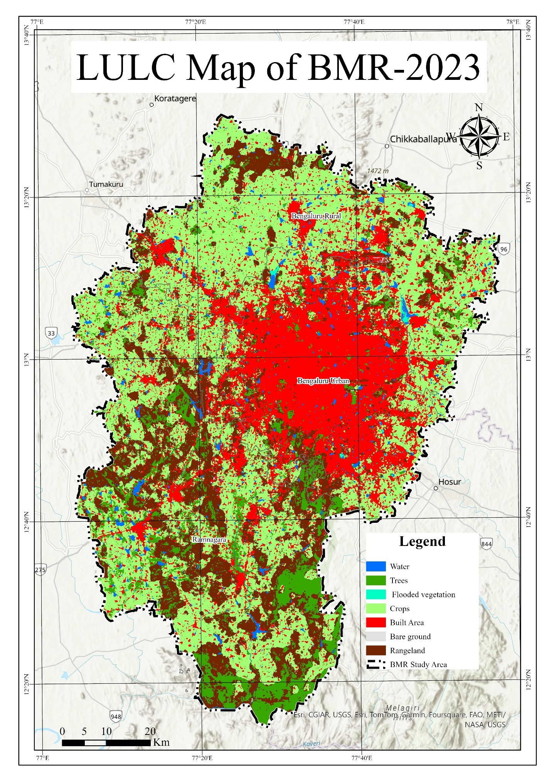**Figure 4: LULC Map of BMR-2023**

(Source: Author using GIS)

**5.4 Transformation of Land Cover Classes**

The land use statistics over time given in Table 1 highlight major shifts in the regional landscape:

**Table 1: Analysis of Land Use Land Cover Changes of BMR (1990-2023)**

|  |  |  |  |  |  |  |
| --- | --- | --- | --- | --- | --- | --- |
| **ID** | **LULC Category/Year** | **1990** | **2000** | **2010** | **2020** | **2023** |
| 1 | **Water Bodies** | 2269 | 9119 | 5232 | 9034 | 17913 |
| 2 | **Trees** | 63977 | 121720 | 95698 | 49988 | 79505 |
| 3 | **Flooded Vegetation** | 290756 | 71969 | 4057 | 295 | 1423 |
| 4 | **Crops** | 53284 | 399351 | 88600 | 322700 | 337640 |
| 5 | **Built Area** | 28009 | 65868 | 87424 | 177277 | 202521 |
| 6 | **Bare Ground** | 212109 | 27951 | 211566 | 719 | 488 |
| 7 | **Range Land** | 151118 | 105544 | 308947 | 241510 | 162033 |
|  | **Total Area in Ha** | **801522** | **801522** | **801522** | **801522** | **801522** |
| **Note: All Values Represented in Hectares (Ha) (Source: Author using GIS Data)** | | | | | | |

1. **Built-up land** increased from ~280 km² (1990) to 659 km² (2000), 874 km² (2010), 1,773 km² (2020), and ~2,025 km² (2023) a 620% increase since 1990. The most intense growth occurred between 2010 and 2020, reflecting a construction boom and expansion of city limits (BMRDA, 2020).
2. **Agricultural land** decreased from ~3,430 km² in 1990 to ~3,230 km² in 2020, reflecting urban encroachment into farmland. The classification for 2010 suggests an anomaly, with a recorded drop to ~920 km², possibly due to confusion with flooded vegetation categories in satellite imagery. However, the overall decline is consistent with field observations, as many peripheral villages were absorbed into the urban fabric.
3. **Vegetation cover** (forests and plantations) declined from ~640 km² in 1990 to ~420 km² in 2023. While total green space remains significant in the outlying rural parts of BMR, dense tree cover within Bangalore Urban District has seen substantial reductions (Ramachandra et al., 2014).
4. **Water bodies** saw both reductions in area and shifts due to restoration projects. In 1990, lakes and reservoirs covered ~22.7 km², dropping to 9.1 km² in 2000 and 9.0 km² in 2020. By 2023, water body area increased slightly (~17.9 km²), likely due to lake rejuvenation initiatives (Bangalore - Unlivable City, 2016). However, numerous lakes and wetlands have been lost to encroachment and pollution, impacting groundwater recharge and contributing to flood risks (Times of India, 2020).

**5.5 Implications of LULC Changes**

The results indicate a metropolitan region undergoing rapid spatial transformation, where urban land expansion has progressively replaced rural and ecological landscapes. The outward spread of Bengaluru has followed a concentric expansion model, with higher density urbanization in core areas and lower-density sprawl towards the periphery. A key concern is the loss of critical environmental assets, particularly lakes and green belts, which play a vital role in climate resilience and flood mitigation (Ramachandra & Aithal, 2016). The fragmentation of peri-urban agricultural zones raises concerns regarding food security, biodiversity loss, and unsustainable land speculation. Many agricultural lands near Bengaluru have been converted into residential layouts or left fallow, waiting for future development approvals. Such trends indicate unregulated land markets, where speculative real estate investments shape urban expansion rather than structured planning.

**VI. CONCLUSION**

This study of land use and land cover (LULC) changes in the Bengaluru Metropolitan Region (BMR) from 1990 to 2023 provides critical insights into the patterns and impacts of urbanization in one of India’s fastest-growing metros. The findings reveal a significant expansion of built-up areas, which has encroached upon agricultural land, green spaces, and water bodies, altering the region’s environmental and spatial structure. The rapid urban growth has been driven by Bengaluru’s economic opportunities, attracting migration and resulting in the continuous outward sprawl of the metropolitan footprint. However, this unregulated expansion has led to the decline of open spaces, loss of lakes, and fragmentation of peri-urban ecosystems, underscoring the environmental costs of unmanaged urbanization. These trends mirror global urbanization challenges but also highlight specific local concerns, particularly Bengaluru’s dominant role in regional growth and the widening gap between planning policies and actual development patterns.

One of the key takeaways from this study is the imbalance in regional development. The concentration of economic activity and infrastructure in the core city has resulted in overburdening of Bengaluru, while surrounding towns and rural areas remain underdeveloped. The LULC analysis indicates that instead of fostering strong secondary urban centers, the region has experienced low-density sprawl, leading to long commutes, increased congestion, and inefficient infrastructure use. This unstructured growth contradicts sustainable urban planning principles, which advocate for polycentric development and balanced regional expansion. The Revised Structure Plan 2031 for BMR acknowledges these issues and proposes decentralized growth nodes, but implementation has been slow. This study reinforces that a well-planned, diversified growth strategy is essential to prevent the further deterioration of urban livability and environmental sustainability. Without proactive policy interventions, BMR risks facing worsening traffic congestion, air pollution, water shortages, and climate vulnerabilities in the coming decades.

Another major insight is the value of remote sensing and GIS in urban planning. The ability to map, quantify, and analyze LULC changes over time provides concrete evidence for policymakers. The study’s findings such as the sevenfold increase in built-up land since 1990 and the loss of over 200 km² of agricultural land highlight the urgent need for stronger land conservation policies. Regular spatiotemporal monitoring of urban expansion should be institutionalized, ideally at five-year intervals, to track the effectiveness of planning measures. The lack of such monitoring in the past contributed to unchecked lake encroachments, layout sprawl, and loss of public spaces. If such systematic geospatial analysis had been integrated into planning, corrective actions could have been taken much earlier. The increasing adoption of GIS-based master plans under programs like AMRUT provides an opportunity to enhance data-driven decision-making in urban management.

The findings of this study have broader implications beyond Bengaluru. Many metropolitan regions in India (Delhi NCR, Mumbai MMR, Chennai CMA) and other developing countries face similar challenges of rapid expansion and sprawl. The lessons from BMR are clear: uncontrolled urbanization leads to inefficient land use and environmental degradation, but strategic, evidence-based planning can help mitigate these issues. The study aligns with Sustainable Development Goal 11 (SDG 11), which advocates for inclusive, safe, resilient, and sustainable cities. For Bengaluru, achieving these goals will require curbing unmanaged sprawl, strengthening regional planning, investing in public transport, and preserving critical natural assets like lakes and green belts.

In conclusion, BMR’s urban evolution over the past three decades reflects the complex duality of urbanization it has driven economic progress but also created major spatial and environmental challenges. This study’s detailed LULC analysis provides an empirical foundation for addressing these issues and guiding future planning strategies. Implementing the recommendations outlined in this study can help steer BMR toward a more sustainable urban trajectory. Future research should focus on predictive modeling of land use trends for 2035 and beyond, along with examining socio-economic drivers like land markets, migration patterns, and policy effectiveness. Ultimately, managing Bengaluru’s expansion is not just about regulating land use—it is about ensuring the region remains livable, economically dynamic, and ecologically resilient for future generations. By learning from past trends and adopting adaptive, data-driven planning, BMR has the potential to become a model for sustainable urbanization in the developing world.

**References**

1. Bangalore Metropolitan Region Development Authority (BMRDA). (2017). *Revised Structure Plan – 2031: Bangalore Metropolitan Region (Final Report)*. Bangalore: BMRDA.
2. Census of India. (2011). *Provisional Population Totals, Census 2011 – Karnataka (Series 30)*. Office of the Registrar General & Census Commissioner, India.
3. Dehingia, H., Das, R. R., Rahaman, S. A., Surendra, P., & Hanjagi, A. D. (2022). Decadal transformation of land use-land cover and future spatial expansion in Bangalore Metropolitan Region, India: Open-source geospatial machine learning approach. *International Archives of the Photogrammetry, Remote Sensing and Spatial Information Sciences*, XLIII-B3-2022, 589–596.
4. Government of India. (2015). *Smart Cities Mission: A step towards Smart India* ([Smart Cities Mission: A step towards Smart India| National Portal of India](https://www.india.gov.in/spotlight/smart-cities-mission-step-towards-smart-india#:~:text=of%20GDP%20%28Census%202011%29,the%20quality%20of%20life%20and)). Ministry of Housing and Urban Affairs, New Delhi. Retrieved from <https://www.india.gov.in/spotlight/smart-cities-mission-step-towards-smart-india>
5. Janaagraha Centre for Citizenship and Democracy. (2021). *Annual Survey of India’s City-Systems 2020*. Bangalore: Janaagraha.
6. McKinsey Global Institute. (2010). *India’s urban awakening: Building inclusive cities, sustaining economic growth*. McKinsey & Company ([Urban Resilience - Urbanisation](https://www.teriin.org/resilient-cities/urbanisation.php#:~:text=,%28UN%20DESA%2C%202014)).
7. National Institute of Urban Affairs (NIUA). (2022). *About NIUA – Shaping India’s Urban Future* ([Welcome to NIUA | NIUA](https://niua.in/#:~:text=The%20National%20Institute%20of%20Urban,since%20its%20establishment%20in%201976)). New Delhi: NIUA. Retrieved from [https://niua.in](https://niua.in/)
8. NITI Aayog. (2021). *Reforms in Urban Planning Capacity in India* (Report of the Advisory Committee). New Delhi: NITI Aayog ([Committee Reports](https://prsindia.org/policy/report-summaries/reforms-in-urban-planning-capacity-in-india#:~:text=,Key%20observations%20and%20recommendations%20include)) ().
9. Ramachandra, T. V., & Aithal, B. H. (2016). Bengaluru’s reality: towards unlivable status with unplanned urban trajectory. *Current Science, 110*(12), 2207–2208 ([Bangalore - Unlivable city (Editorial in Current Science) by T.V. Ramachandra and Bharath H. Aithal | Centre for Ecological Sciences | IISc](https://ces.iisc.ac.in/?q=node/411#:~:text=Urbanization%20and%20loss%20of%20natural,the%20natural%20resources%2C%20such%20as)).
10. Ramachandra, T. V., Mondal, T., Setturu, B., & Aithal, B. H. (2023). Environmental consequences in the neighbourhood of rapid unplanned urbanisation in Bangalore City. *Advances in Environmental and Engineering Research, 4*(4), 052 ([Advances in Environmental and Engineering Research | Environmental Consequences in the Neighbourhood of Rapid Unplanned Urbanisation in Bangalore City](https://www.lidsen.com/journals/aeer/aeer-04-04-052#:~:text=6%2C%20Table%202%29,urban%20areas)). <https://doi.org/10.21926/aeer.2304052>
11. Sudhira, H. S., Ramachandra, T. V., & Jagadish, K. S. (2004). Urban sprawl: metrics, dynamics and modeling using GIS. *International Journal of Applied Earth Observation and Geoinformation, 5*(1), 29–39.
12. Sundaresan, J. (2019). Urban planning in vernacular governance: Land use planning and violations in Bangalore, India. *Progress in Planning, 127*, 1–23 () ().
13. United Nations, Department of Economic and Social Affairs (UN DESA). (2018). *68% of the world population projected to live in urban areas by 2050, says UN* ([UN: 68% of the global population will live in cities by 2050 | Smart Cities Dive](https://www.smartcitiesdive.com/news/global-population-cities-united-nations-2050/523843/#:~:text=%2A%20Currently%2C%2055,22%20million%29%20and%20Sao)). (World Urbanization Prospects: 2018 Revision – Press Release). New York: United Nations.
14. United Nations, General Assembly. (2015). *Transforming our world: the 2030 Agenda for Sustainable Development* (A/RES/70/1) ([Goal 11 | Department of Economic and Social Affairs](https://sdgs.un.org/goals/goal11#:~:text=11)). New York: United Nations.
15. UN-Habitat. (2017). *New Urban Agenda*. Quito: United Nations Conference on Housing and Sustainable Urban Development.
16. UN-Habitat. (2022). *World Cities Report 2022: Envisaging the Future of Cities*. Nairobi: United Nations Human Settlements Programme ([[PDF] UN-Habitat Launches its World Cities Report 2022](https://unhabitat.org/sites/default/files/2022/07/wcr_pr_-_english_press_release_29_06_2022.pdf#:~:text=%5BPDF%5D%20UN,of%20urbanization%20are%20uneven%2C)) ([World Cities Report 2024 - UN-Habitat](https://unhabitat.org/wcr/#:~:text=World%20Cities%20Report%202024%20,its%20implications%20for%20climate)).
17. World Bank. (2013). *Urbanization beyond municipal boundaries: Nurturing metropolitan economies and connecting peri-urban areas in India*. Washington, DC: World Bank.
18. World Bank. (2016). *Leveraging Urbanization in South Asia: Managing Spatial Transformation for Prosperity and Livability* (by Ellis, P. & Roberts, M.). Washington, DC: World Bank.
19. World Bank. (2024). Kouamé, A. T. *Gearing up for India’s rapid urban transformation* ([Gearing up for India’s Rapid Urban Transformation](https://www.worldbank.org/en/news/opinion/2024/01/30/gearing-up-for-india-s-rapid-urban-transformation#:~:text=India%20is%20urbanizing%20rapidly,th%7D%20year%20of%20independence) ). Retrieved January 30, 2024, from World Bank News & Opinion: <https://www.worldbank.org/en/news/opinion/2024/01/30/gearing-up-for-india-s-rapid-urban-transformation>
20. *Times of India*. (2024, March 6). *Why Bengaluru is facing acute water shortage* ([6. Why Bengaluru is facing acute water shortage - Times of India](https://timesofindia.indiatimes.com/t10-march-7-2024/6-why-bengaluru-is-facing-acute-water-shortage/articleshow/108276358.cms#:~:text=,poor%20monsoons%20have%20rendered%20these)). Times News Network. Retrieved from [https://timesofindia.indiatimes.com](https://timesofindia.indiatimes.com/)

**************