A STUDY ON THE IMPROVEMENT OF THE MECHANICAL AND WATER ABSORPTION PROPERTIES OF C. CITRATUS FIBRE REINFORCED POLYESTER COMPOSITE: RESPONSE SURFACE METHODOLOGY APPROACH

ABSTRACT
Lignocellulosic fibre-based composites have gained a significant attention as alternative to synthetic fibres due to their biodegradable, renewable and eco-friendly nature. The study explores the effect of fibre treatment, fibre length and volume fraction on the mechanical and water absorption properties of lemon grass (C. citratus) fibre reinforced polyester composite. The fibres were treated with 6% NaOH solution. The composite samples were fabricated using hand lay-up and compression moulding technique with a mould measuring 300mmx19mmx3.2mm, employing different fibre lengths (10mm, 30mm and 50mm) and volume fractions (10%, 30% and 50%). Unsaturated polyester resin was used as a matrix. It was observed that surface modification of fibre, fibre length and volume fraction affect the mechanical and water absorption properties of the composites. The modified fibre with composition, 10mm fibre length and 50% volume fraction exhibits minimum water absorption of 1.279% and highest tensile strength, tensile modulus, flexural strength, flexural modulus of 33.71±3.28MPa, 2.529±0.188GPa, 54.561±1.162MPa and 2.021±0.110GPa respectively compared to that of the unmodified fibre composite with the same fibre composition.
Keywords: lemon grass, natural fibre, polyester resin, fibre composite, response surface methodology,

1. INTRODUCTION
In recent years, researchers have been exploring the potential of various natural fibers as an alternative reinforcement in polymer composites against the synthetic counterpart for high-performance applications. This is because natural plant fibres are biodegradable, cheap, lightweight, renewable and eco-friendly. Natural fibers, valued for their high specific strength and modulus have garnered attention [1]. On the other hand, synthetic fibers have superior mechanical properties, minimal moisture absorption, and favorable thermal properties [2-4]. However, the non- biodegradable nature of synthetic fibers, such as glass fibers, even after incineration causes environmental degradation [5]. The utilization of petroleum-based polymer composites poses environmental risks. One way to address this problem is through incorporating plant fibres into high strength polymer matrix.
Studies have showed that natural fiber reinforcement in polymer matrices substantially improves the mechanical and physical properties of composites [6][7]. However, the use of natural fiber reinforcement in the polymer matrices is usually hindered because of the lack of compatibility between the polar natural fibers and nonpolar polymer matrices [4][8]. Enhanced compatibility between natural fibers and polymer matrices can be achieved through the use of chemical coupling agent or fiber surface chemical treatment [9][10]. Improper treatment adversely affects the mechanical properties of the composites. Alkaline treatment of natural fiber surfaces is the most widely used method to modify fiber surfaces and improve the interfacial interaction and adhesion between the fiber and polymer matrix.
Various attempts have been made on treatment of plant fibre to improve the interaction between the fibre and polymer matrix. Liu et al [11] have tried to improve the mechanical property of Indian grass fibre by alkali solution and found the improvement in tensile, flexural properties and impact strength. Tavadi et al, [12] improve the mechanical properties of areca fibre reinforced epoxy composite filled with alumina filler of different wt.%. The result demonstrated that treated fibres with 8wt.% Al₂O₃ composited show superior tensile, impact and hardness properties. Walid [13] studied the Physico-mechanical properties of typha angustata (elephant grass) fiber reinforced thermoplastic composites. Water absorption tests revealed that the composites with treated TAF absorbed the less water and 10 wt. % treated fiber reinforced composites have higher tensile strength than all other composites. Irvani, et al [14] investigate the potential of chemical modification in improving the hydrophobic properties and thermal stability of bamboo fibres and sound absorption performance of raw and modified fibres and found that modification of fibres with stearic acid coating improve the contact angle and hydrophobicity of bamboo fibres. Lokantara et al [15] studied the effect of alkali fiber treatment on the tensile strength of composites with a fiber length of 180 mm, fiber treatment using 5% NaOH and without treatment. A maximum tensile strength value of 71,606 MPa in fiber with 5% alkali treatment was observed. Krishnudu, et al. [16] study found that NaOH treated muntigia calabura fibre reinforced epoxy composites exhibit maximum tensile and flexural strength of 84MPa and 185MPa respectively at 20 wt. % of the fibre content and a maximum impact strength of 19.5J/m². Ndukwe, et al [17] predicted the compression strength of bamboo reinforced low density polyethylene using the compression moulding technique. The hardness and compression strength of the examined composites were found to increase when the amount of filler was raised, with the formulation containing 20 wt.% filler having the highest hardness and compression strength values of 59.37 HV and 12.72 MPa, respectively
Lemongrass (Cymbopogon species), one of the most extensively grown perennial plants in tropical and subtropical parts of the world, is an aromatic plant mainly cultivated as a source of essential oils [18][19]. The steam distillation extraction process of lemongrass for essential oil production releases a lignocellulosic biomass or residue. Globally, approximately 30,000,000 tons per annum of lignocellulosic lemongrass residue are generated from industrial extraction processes [20], which are either incinerated or dispose to the environment. This lemongrass waste fibres are reach in cellulose that can serve as a potential raw material source for various areas of application including composites, pulp and paper [21]. This work is aim to find how fibre treatment, fibre length and volume fraction can improve the mechanical and water absorption properties of C. citratus fibre polyester composite.

2. MATERIALS AND METHOD
2.1 Materials
Unsaturated polyester resin, methyl/ethyl ketone peroxide (MEKP-catalyst) and cobalt-6 (accelerator) was obtained from Chris Colon Scientific Company Portharcourt River State Nigeria. The C. citratus bast fibres were extracted from the stem of the plant harvested from Avu forest in Owerri west local government area of Imo state, south-east Nigeria.
2.2 Fiber extraction: The harvested C. citratus stems were water-retted for 7 days and washed with clean water. The retted stems were mashed mechanically with a roller, washed with clean water and the fibres were extracted or shredded from the stems under wet condition and dried on the sun for 14 days.
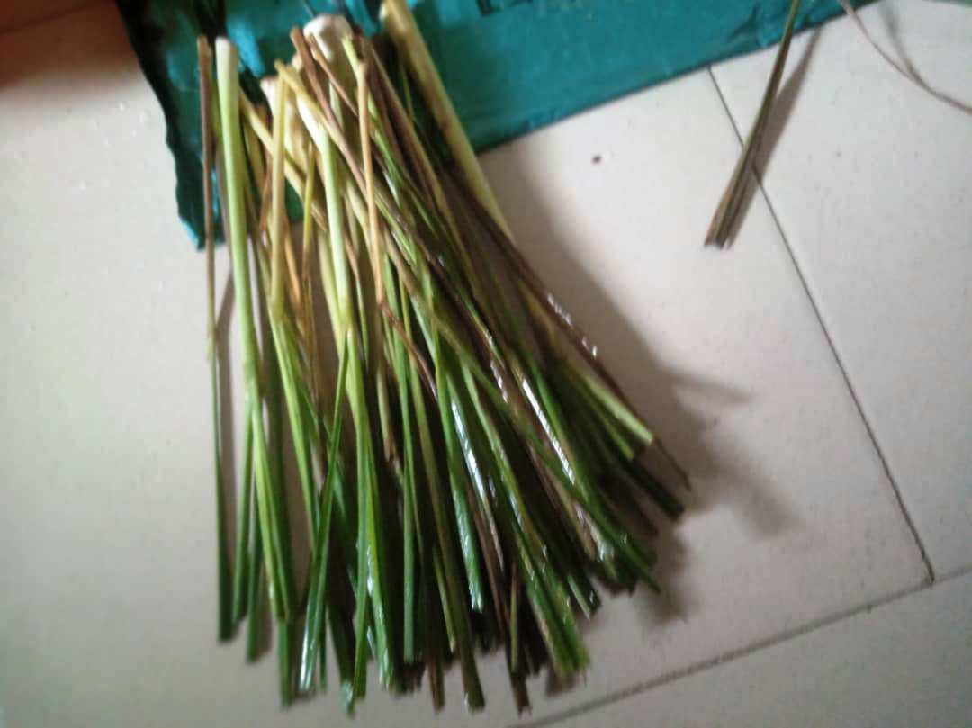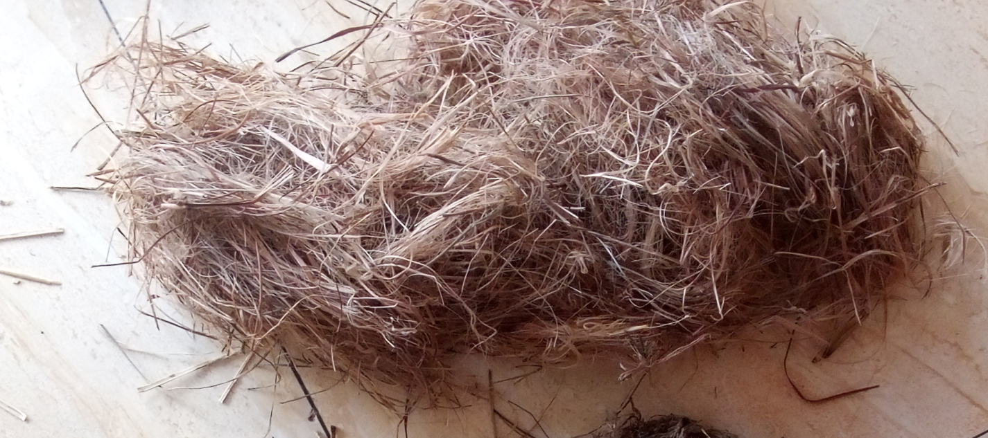
Fig. 1. C. citratus harvested stems and the extracted fibres
2.3 Surface modification of fibers
Fibre treatment was done according to the method of Rosa, et al [22]. The untreated fibers were treated in 6% sodium hydroxide (NaOH) solution for 4 hrs at a room temperature. Then, the fibers were washed in running water and further wash in distilled water containing little quantity of acetic acid to remove any trace of sodium hydroxide solution adhered on the surface of the fibers so that the pH level of fiber is approximately 7 (neutral). The fibres were later dried in an oven at a temperature of 60°C for 24 h. The mechanism of alkali-treatment can be represented by equation (1)
Fibre – OH + NaOH = Fibre -O- Na⁺ + H₂O (1)

2.4 Physical and chemical analysis of a single fibre
Truong method [23] was used to determine the density of untreated and alkali-treated C. citratus grass fibers. Fiber density was measured with a pycnometer using the Archimedes principle. The chemical composition (percentage cellulose, hemicellulose, ash and lignin contents) of C. citratus grass fibre was analyzed by the ASTM standard methods.
The moisture content of C. citratus fibre was determined by weighing the samples in air, M₁ (g). Then, dehydrated for 24 hours in 105˚C controlled oven and re-weighed, M₂ (g). The % moisture content is calculated using equation 2:
%w = $\frac{m_{1}-m_{2} }{m_{1}} x\frac{100}{1}$ (2)

2.5. Fabrication of the composites
The composites were fabricated by hand lay-up method. The mould measuring 300mmx300mmx30mm were lined with polyvinyl alcohol (PVA) and allowed to dry after which petroleum wax was rubbed on the surface of the mould for easy removal of the fabricated composite. The polyester resins, catalyst and accelerator were mixed accordingly in volume (in ml) ratio of 37.5:1 and stir slowly and continuously in a container and poured into the mould containing the fibres. The composite samples were fabricated in batches by combining different fibre length (10mm, 30mm and 50mm) and volume percent fraction (10%, 30% and 50%) with the matrix to produce 9 composite samples as shown in table 1.
Table 1. Fibre composition of composite samples
Composite samples/compositions | Fibre lengths (mm) | Fibre vol. fraction (%)
CP1 (10mmx10%) | 10 | 10
CP2 (10mmx30%) | 10 | 30
CP3 (10mmx50%) | 10 | 50
CP4 (30mmx10%) | 30 | 10
CP5 (30mmx30%) | 30 | 30
CP6 (30mmx50%) | 30 | 50
CP7 (50mmx10%) | 50 | 10
CP8 (50mmx30%) | 50 | 30
CP9 (50mmx50%) | 50 | 50
*CP = C. citratus fibre polyester composite
The fibres were allowed to soak adequately in the thermoset resins before been placed on the 5-tons hydraulic compression moulding machine. Curing was allowed to be completed at room temperature for 24 hours in the mould. It was further postcured at 80ºC in an oven.
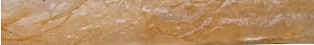
a
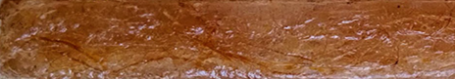
b
Fig. 2 (a) & (b) untreated and treated c. citratus fibre polyester composite

2.6 Water absorption analysis of the composites
The water absorption test was conducted according to ASTM D570 [24] test standard method. Samples of dimensions, 20 mm × 20 mm × 3 mm were used. The specimens were oven-dried for 24 hours at 50°C, then allowed to cool in a desiccator. The initial weight of the oven-dried sample (M_{A}) was recorded. The sample were immersed in water and its weight was monitored every 24 hours until equilibrium water absorption was attained and the weight recorded as M_{B}. Equation 3 was applied to estimate the sample’s water absorption. The average of three samples was reported.
%W = $\frac{m_{B}-m_{A} }{m_{A}}x\frac{100}{1}$ (3)

2.7 Mechanical characterization of the composite
Tensile properties of the composites
The tensile test was performed according to ASTM D-638 [25] using Ametek EZ 250 universal tensile tester with 2 kN load cell. Three (3) dog-bone specimens of dimension 160 mm x 19 mm x 3.2 mm and gauge length of 50 mm were tested at a cross-head speed of 2mm/min and temperature of 22ºC. The load applied and extension produced by the load is recorded. The tensile stress and strain were calculated by equation 4 and 5 respectively, and the average of three samples was reported.
$σ= \frac{F}{A_{0}}$ (4)
ε = ∆L/L (5)
F = load applied, A_{o} is area of sample, L is length of specimen and ΔL is the extension produced.
Flexural properties of composites
The flexural properties were determined according ASTM D790 [26] using 3-point bending test method on Amatek EZ 250 universal tensile tester at average cross-head speed of 2mm/min and span length of 40mm. The specimen of dimension 300mm x 19mm x 3.2mm were used to determine the flexural properties of the composite and the average of three values for each sample recorded.
3.0 RESULTS AND DISCUSSION
3.1 Effect of fibre treatment on the physical properties and chemical composition of the fibres
Table 2 show that alkaline treatment increased the cellulose content and density of the fibre, while the hemicellulose, lignin, ash and moisture content were decreased. The increment in the fibre cellulose contents after treatment gives the fibre more strength and rigidity [27][6]. Also, the decrease in hemicelluloses and lignin contents reduces the hydrophilic nature of the fibre, and makes the fibre surface amorphous for a stronger interfacial bond with the matrix [28][29]. All these brought about enhanced mechanical properties of the composites.
Table 2 Chemical composition and physical properties of unmodified and modified fibres
Fibres | Cellulose (%) | Hemicellulose  (%) | Lignin  (%) | Ash content  (%) | Moisture content (%) | Density  (g/cm³)
Unmodified | 40.20±1.88 | 20.44±1.72 | 24.13±0.88 | 1.56±1.22 | 5.74±0.78 | 0.619±0.22
Modified | 69.71±1.77 | 9.38±2.25 | 12.71±1.44 | 0.74±0.21 | 2.28±1.22 | 1.09±0.87

These chemical compositions of raw fibre obtained in this work (table 2) is compared to other raw lignocellulosic fibres previously reported in the literature as shown in table 3. The raw fibre of C. citratus bast fiber contains over 80% cellulose, hemicellulose and lignin. Cellulose gives fibre its strength and rigidity. Cellulose content in C. citratus fibre is close to that of kenaf and coconut [30][31] and higher than that of banana [32]. This makes C. citratus fibre a better candidate of reinforcement in polymer composite.
Table 3 Chemical composition of C. citratus bast fibre and some common natural fibers.
Fibres | Cellulose (%) | Hemicellulose  (%) | Lignin  (%) | Ash content  (%) | References
C. citratus | 40.20 | 20.44 | 24.13 | 1.56 | Present study
Cola Lepidota | 54.24 | 14.28 | 15.30 | 2.31 | Legrand, et al. [33]
Abaca | 56-63 | 20-25 | 7-13 | - | Marta, et al. [34]
Banana | 37.5 | 28 | 14.7 | - | Sango, et al. [32]
Coconut | 36-43 | 0.5-14.7 | 41-45 |  | Gurunathan, et al [31]
Kenaf | 45-57 | 21.5 | 8-13 | - | Akil, et al. [30]
Sisal | 66-78 | 10-14 | 10-14 | - | Akil, et al. [30]

3.2 Effect of fibre treatment on the mechanical and water absorption properties of C. citratus polyester composite
Table 4 show that alkaline treatment of fibre improved the mechanical properties of the composite. It was observed that sample 3 has the maximum mechanical properties compared to other composite samples. Also, the untreated C. citratus fibre polyester composite with the same fibre compositions has a tensile strength, tensile modulus, flexural strength, and flexural modulus of 18.78MPa, 1.570GPa, 46.067MPa and 1.144GPa respectively.
Table 4 Mechanical properties of C. citratus polyester composites
Sample/  composition | Mechanical properties
 | Tensile strength  (MPa) | Tensile modulus  (GPa) | Flexural strength  (MPa) | Flexural modulus  (GPa)
CP1 | 24.24±1.61 | 1.625±0.273 | 49.165±2.793 | 1.267±0.205
CP2 | 28.80±0.84 | 1.999±0.148 | 52.126±2.199 | 1.831±0.090
*CP3 | 33.71±3.28 | 2.529±0.188 | 54.561±1.162 | 2.021±0.110
CP4 | 19.87±1.45 | 1.753±0.085 | 48.505±1.114 | 1.253±0.100
CP5 | 30.04±4.13 | 2.315±0.244 | 52.674±2.862 | 1.530±0.121
CP6 | 28.91±1.18 | 2.349±0.221 | 51.579±3.261 | 1.488±0.104
CP7 | 26.58±1.06 | 2.144±0.249 | 52.947±3.447 | 1.392±0.092
CP8 | 29.53±1.11 | 2.438±0.204 | 53.403±1.217 | 1.626±0.140
CP9 | 27.29±0.75 | 2.385± 0.068 | 52.105±1.862 | 1.346±0.091
CP. Untreated  (10mmx50%) | 18.78±1.35 | 1.570±0.156 | 46.067±1.081 | 1.144±0.084

These values are lower than that of all the modified fibre polyester composite. This is attributed to poor fiber–matrix adhesion, and this restricts the stress transfer between the fiber and the matrix resulting to poor mechanical properties witnessed on untreated fibre composite [35][36].

Fig. 3 Water absorption properties of C. citratus polyester composites
From Fig. 3, it was also observed that fibre treatment reduces water absorption properties of the composites. Higher water absorption value of 6.193% was observed in untreated fibre composites. This can be attributed to: presence of void, which is created by poor interfacial contact between the fibres and matrix, and high composition of hemicellulose in the untreated fibre structure [37][38]. Hemicellulose contains hydroxyl groups, naturally attracting water and promoting water absorption[39][40][4].
3.3 Effect of fibre length and volume fraction on the mechanical and water absorption properties of the composite
The 3D response surface plot of fig. 4 and 5 shows the variation of fibre length (FL) and volume fraction (VF) on the ultimate tensile strength (UTS) and tensile modulus (TM) of the composite. It was observed that the maximum ultimate tensile strength and tensile modulus of 33.71MPa and 2.529GPa, 54.561MPa and 2.021GPa respectively occurred at fibre length of 10mm and volume fraction of 50%.
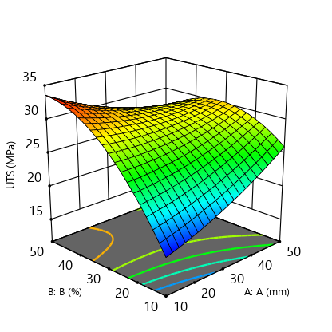
Fig. 4 Tensile strength variation with FL and VF
The ANOVA table for ultimate tensile strength (table 5) show that the F-value is greater than 4 (value greater than 4 is desired) and the probability, p-value is less than 0.05 for fibre vol. fraction term. This show that only the fibre volume fraction has a significant effect on the ultimate tensile strength of the composite. The adjusted R² of 0.9573 show that the quadratic model best fit the data.
Table 5 ANOVA table for tensile strength analysis
Source | Sum of Squares | df | Mean Square | F-value | p-value
Model | 210.47 | 5 | 42.09 | 36.84 | 0.0068
A-A | 2.24 | 1 | 2.24 | 1.96 | 0.2556
B-B | 114.58 | 1 | 114.58 | 100.28 | 0.0021
AB | 62.09 | 1 | 62.09 | 54.35 | 0.0052
A² | 1.70 | 1 | 1.70 | 1.49 | 0.3098
B² | 29.85 | 1 | 29.85 | 26.13 | 0.0145
Residual | 3.43 | 3 | 1.14
Cor Total | 213.90 | 8
R² =0.9840 | Adjusted R²= 0.9573 |  | Predicted R² =0.8756 | Adeq Precision = 19.0430

The predicted R² of 0.8756 is in reasonable agreement with the adjusted R² i.e. the difference is less than 0.2, which showed a good relationship between the predicted and observed value. Adequate precision measures the signal to noise ratio. A ratio greater than 4 is desirable. The adequate precision value of 19.0430 indicates an adequate signal that the model can be used to navigate the design space and is adequate enough to predict UTS of the composite. The model based on actual factors is:
UTS = 5.89264+0.187833A+1.09350B-0.009850AB+0.002304A²-0.009658B² + ε (6)
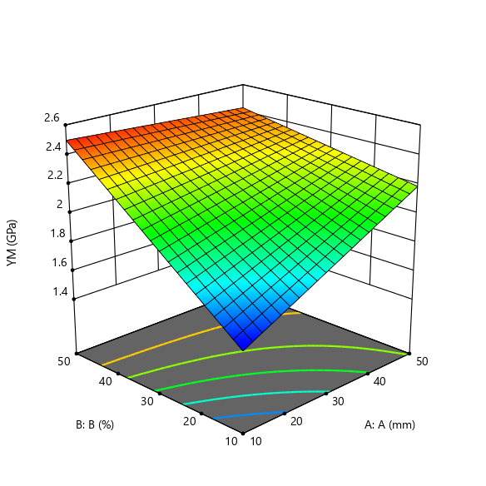
Fig. 5 Tensile modulus variation with FL and VF
The ANOVA table (table 6) for tensile modulus show that both fibre length and volume fraction are significant. The adjusted R² of 0.8681 show that two factor interaction (2-FI) model best fit the data. The predicted R² of 0.7998 showed that the model is adequate enough to predict the young modulus of the composite and adeq. precision of 12.0377 show that this model can be used to navigate the design space. The model based on actual factors is:
YM = 1.09454 +0.020704A+0.028429B-0.000449AB + ε (7)
Table 6 ANOVA table for tensile modulus analysis
Source | Sum of Squares | df | Mean Square | F-value | p-value
Model | 0.7923 | 3 | 0.2641 | 18.55 | 0.0039
A-A | 0.1259 | 1 | 0.1259 | 8.84 | 0.0311
B-B | 0.5376 | 1 | 0.5376 | 37.75 | 0.0017
AB | 0.1289 | 1 | 0.1289 | 9.05 | 0.0298
Residual | 0.0712 | 5 | 0.0142
Cor Total | 0.8635 | 8
R² =0.9175 | Adjusted R²= 0.8681 |  | Predicted R² =0.7998 | Adeq. Precision = 12.0377

Flexural strength and flexural modulus
The 3D response surface plot of figure 6 and 7 show that the maximum flexural strength and flexural modulus of C. citratus fibre polyester composite is 54.561MPa and 2.021MPa respectively, which occurred at a fibre length of 10mm and volume fraction of 50%.
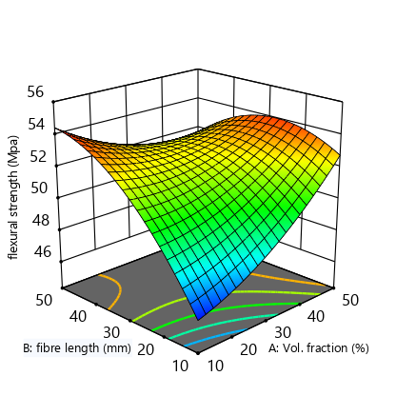
Fig. 6 Flexural strength variation with FL and VF
The ANOVA prediction (table 7) on the effect of fibre length and volume fraction on the flexural strength of the composite show that both fibre length and vol. fraction are significant on the flexural strength of the composite. The fit statistics show adjusted R² of 0.9418, which indicate that the quadratic model best fit the data while the predicted R² 0.7966 and adeq. precision of 15.8571 signifies that the model is adequate enough to predict the flexural strength of the composite and navigate the design space.
FS = 40.88750+0.080212A+0.530504B-0.005836AB+0.002373A²-0.004434B² + ε (8)
Table 7 ANOVA table for flexural strength analysis (CP)
Source | Sum of Squares | df | Mean Square | F-value | p-value
Model | 54.48 | 5 | 10.90 | 26.88 | 0.0107
A-Vol. fraction | 5.42 | 1 | 5.42 | 13.36 | 0.0353
B-fibre length | 19.18 | 1 | 19.18 | 47.30 | 0.0063
AB | 21.79 | 1 | 21.79 | 53.76 | 0.0052
A² | 1.80 | 1 | 1.80 | 4.44 | 0.1256
B² | 6.29 | 1 | 6.29 | 15.52 | 0.0291
Residual | 1.22 | 3 | 0.4054
Cor Total | 55.70 | 8
R² =0.9782 | Adjusted R²= 0.9418 |  | Predicted R² =0.7966 | Adeq. Precision = 15.8571
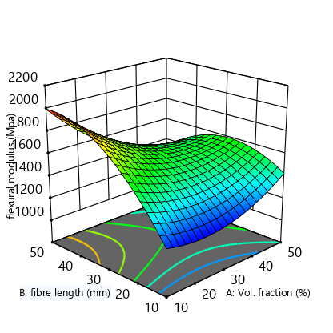
Fig. 7 Flexural modulus variation with FL and VF
The ANOVA result of table 8 showed that fibre length and volume fraction terms are significant. This means that both fibre length and volume fraction have a significant impact on the flexural modulus of the composite. The adjusted R² of 0.9414 show the quadratic model best fit the data while predicted R² of 0.7597 and adeq. precision of 15.1407 show that the model is adequate enough to predict the flexural modulus of the composite.
FM = 784.76451-9.38175A+58.40115B-0.564712AB+0.348303A²-0.545628B² + ε (9)
Table 8 ANOVA table for flexural modulus analysis
Source | Sum of Squares | df | Mean Square | F-value | p-value
Model | 5.914E+05 | 5 | 1.183E+05 | 26.71 | 0.0108
A-Vol. fraction | 70632.01 | 1 | 70632.01 | 15.95 | 0.0281
B-fibre length | 1.826E+05 | 1 | 1.826E+05 | 41.24 | 0.0077
AB | 2.041E+05 | 1 | 2.041E+05 | 46.10 | 0.0065
A² | 38820.77 | 1 | 38820.77 | 8.77 | 0.0595
B² | 95267.29 | 1 | 95267.29 | 21.52 | 0.0189
Residual | 13282.69 | 3 | 4427.56
Cor Total | 6.047E+05 | 8
R² = 0.9780 | Adjusted R²= 0.9414 |  | Predicted R² = 0.7597 | Adeq. Precision = 15.1407

Water absorption properties
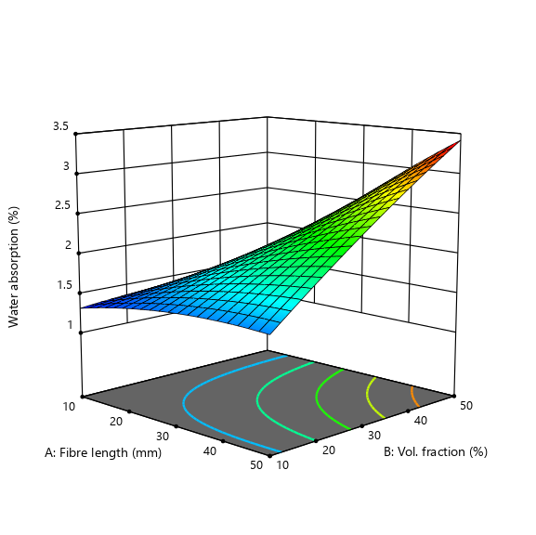
Fig. 8 Water absorption variation with FL and VF
The 3D response surface plot of figure 8 show the variation of fibre length and percentage volume fraction with water absorption of the composite. It was observed that the composite water absorption increases with fibre length and volume fraction. The minimum observed percentage water absorption is 1.279% at a fibre length and volume fraction of 10mm and 50%.
Table 9 ANOVA table for water absorption analysis
Source | Sum of Squares | df | Mean Square | F-value | p-value
Model | 4.19 | 5 | 0.8376 | 35.29 | 0.0072
A-Fibre length | 1.94 | 1 | 1.94 | 81.59 | 0.0029
B-Vol. fraction | 1.41 | 1 | 1.41 | 59.21 | 0.0046
AB | 0.8190 | 1 | 0.8190 | 34.51 | 0.0098
A² | 0.0194 | 1 | 0.0194 | 0.8184 | 0.4323
B² | 0.0079 | 1 | 0.0079 | 0.3329 | 0.6044
Residual | 0.0712 | 3 | 0.0237
Cor Total | 4.26 | 8
R² = 0.9833 | Adjusted R²= 0.9554 |  | Predicted R² = 0.8350 | Adeq. Precision = 16.7276

The ANOVA prediction (table 9) show that fibre length and vol. fraction terms are significant (p < 0.05 and F > 4). This show that both fibre length and vol. fraction affect the water absorption of the composite. The fit statistics show an adjusted R² of 0.9554 indicating that the 2FI model best fit the data while the predicted R² of 0.8350 and adeq. precision of 16.7276 show that the model is adequate enough to predict the water absorption of the composite. The model based on actual factors is:
%W = -0.113572 + 0.019604A + 0.027551B - 0.000400AB + ε (10)

4.0 CONCLUSION
Based on the findings, it is concluded that fibre treatment affects the mechanical and water absorption properties of the C. citratus fibre composite. The modified fibre composites have better mechanical and minimum water absorption properties compared to the unmodified fibre composite. Also, the mechanical and water absorption properties of the composites vary with the fibre compositions. Composite with 10mm length, 50% volume fraction exhibits the maximum mechanical and minimum percentage water absorption.
Ethical approval Not applicable
Consent to participate Not applicable
Consent for publication All authors approved the final manuscript to be published.
Competing interest The authors have no relevant financial or non financial interests to disclose.
Data availability The authors confirm that the data supporting the findings of this study are available within the article
REFERENCES
- Neto J, Queiroz H, Aguiar R, Lima R, Cavalcanti D, Banea MD. A Review of Recent Advances in Hybrid Natural Fiber Reinforced Polymer Composites. 2022, Journal of Renewable Materials 10 (3): 561. https://doi.org/10.32604/jrm.2022.017434
- Prasad V, Alliyankal AV, Jose T, George SC. A Comprehensive Review of Sustainability in Natural-Fiber-Reinforced Polymers. 2024, Sustainability 16 (3): 1223. https://doi.org/10.3390/su16031223.
- Sahu P, Gupta M. 2022. “Water Absorption Behavior of Cellulosic Fibres Polymer Composites: A Review on Its Effects and Remedies. 2022, Journal of Industrial Textiles 51 (5): 7480S–7512S. https://doi.org/10.1177/1528083720974424.
- Ahmad SI, Mohammad J, Zainudin ES, Ridwan Y, Othman YA, Basim AJ, Sain M. Dimensional Stability, Mechanical and Thermal Performance of Flax/Carbon/Kevlar Reinforced Bio-Phenolic/Epoxy Hybrid Composites. 2025, Journal of Natural Fibers, 22:1, 2461491, DOI: 10.1080/15440478.2025.2461491.
- Okubo K, Fujii T, Yamamoto Y. “Development of Bamboo-Based Polymer Composites and Their Mechanical Properties. 2004, Composites Part A, Applied Science and Manufacturing 35 (3): 377–383. https://doi.org/10. 1016/j.compositesa.2003.09.017.
- Haameem J.A, Abdul MM, Afendi M, Marzuki HFA, Fahmi I, Gibson AG. Mechanical Properties of Napier Grass Fibre/Polyester Composites. 2016, Composite Structures, 136 (2), 2016, pp. 1-10.
- Jayamani E, Hamdan S, Rahman Md R, Bakiri MKB. Study of sound absorption coefficient and characterization of rice straw stem fibres reinforced polypropylene composite. 2015, BioResources 10(2), 3378-3392.
- Maneesh T, Singh VK, Gope PC, Chaudhary AK. Evaluation of the mechanical properties o bagasse-glass fibre reinforced composite. 2012, J. Mater, Environ. Sci. 3 (1), 171-184.
- Prakash VRA, Viswanathan R. Fabrication and characterization of silanized echinoidea fillers and kenaf fibre-reinforced Azadirachta-indica blended epoxy multi-hybrid biocomposite. 2019, Int J Plast Technol 23(2):207–217.
- Petchawattana N, Sinjutaratana C, Sirapat C. Mechanical properties of thermal degradation and natural weathering o high density polyethylene/rice husk composite compatibilized with maleic anhydride grated polyethylene. 2012, J. Polym. Res. 19,9921.
- Liu W, Mohanty A.K, Askeland P, Drzal LT, Misra M. Influence of fiber surface treatment on properties of Indian grass fiber reinforced soy protein based biocomposites. 2004, Polymer; 45(22):7589-7596.
- Tevadi AR, Basheer D, Melese KG, Kumaresan K, Mohan N, Kerur MRH, Shashidehara LC. Experimental analysis of mechanical properties and FTIR analysis of areca fibre-reinforced epoxy composites incorporating AI₂O₃. 2025, Journal of industrial textiles. Vol. 55:1-23. DOI:10.1177/15280837241313217.
- Walid BK. Physico-mechanical properties of typha angustata (elephant grass) fiber reinforced thermoplastic. composites. 2019, http://lib.buet.ac.bd:8080/xmlui/handle/ 123456789 /5430.
- Irvani H, Mahabadi HA, Khavanin A. et al. Improving the thermal and hydrophobic properties of bamboo biocomposite as sustainable acoustic absorbers. 2025, Sci Rep 15, 3148 (2025).
- Lokantara IP, Suardana NPG, Surata IW, Winaya INS. Effect of alkali treatment on the tensile strength of lidah mertua fiber/ polypropylene recycled biocomposite. 2019, International Journal of Engineering and Emerging Technology Vol. 4 No. 2.
- Krishnudu M, Venkateshwar PR, Reddy RVA, Reddy MR. Synthesis, characterization and mechanical properties evaluation of muntingia calabura fibre reinforced epoxy composites: Fibre treatment comparison with NaOH and KOH. 2025, Green Technologies and Sustainability, Volume 3, Issue 2, 100155. https://doi.org/10.1016/j.grets.2024.100155.
- Ndukwe AI, Umoh S, Ugwochi C, Ogbuji C, Ngolube C, Aliegu F, Izuegbu L. Prediction of compression strength of bamboo reinforced low-density polyethylene waste (LDPEw) composites. 2022, Composite theory and practice. 22: (3) 142-149.
- Valtcho DZ, Charles LCl, Tess A, Jeffery BC. Lemongrass Productivity, Oil Content, and Composition as a Function of Nitrogen, Sulfur, and Harvest Time. 2011, Agronomy Journal. 103. 805-812. 10.2134/agronj2010.0446.
- Bekele LD, Zhang W, Liu Y, Duns GD, Yu C, Jin L, Li X, Jia Q, Chen Y. Preparation and characterization of lemon grass fibre (Cymbopogon species) for reinforcing application in thermoplastic composite. 2017, BioRes. 12(3), 5664-5681.
- Kaur H, Dutt D, Tyagi CH. Optimization of soda pulpingprocess of lignocellulosic residues of lemon and sofia produced after steam distillation. 2011, BioResources 6:103–120. https://doi. org/ 10. 15376/ biores. 6.1. 103- 120
- Omar L, Kamoga M, Kirabira JB, Byarahanga JK. The potential of C. nardus in the production o pulp or paper industry in: International Conference on computing, mechanical and electronics engineering (ICCMEE, 2015) Singapore, pp. 21-28.
- De Rosa IM, Kenny JM, Puglia D, Santulli C, Sarasini F. Morphological, Thermal and Mechanical Characterization of Okra (Abelmoschus esculentus) Fibers as Potential Reinforcement in Polymer Composites. Composites Science and Technology, 2010, 70, 116-122. https://doi.org/10.1016 /j.compscitech.2009.09.013
- Truong M, Zhong W, Boyko S, Alcock MA. Comparative study on natural fibre density measurement. The Journal of The Textile Institute, 2009, 100(6), pp. 525-529.
- ASTM D570. Standard test method for water absorption of plastics. 2010, ASTM international, west Conshohocken, PA USA.
- ASTM D638. Standard test for tensile properties of plastics. 2010, ASTM international, west Conshohocken, PA USA.
- ASTM D790. Standard test for flexural properties of unreinforced and reinforced plastics and electric insulating materials. 2010, ASTM international, west Conshohocken, PA USA
- Kommula VP, Reddy KO, Shukla M, Marwala T, Reddy EVS, Rajulu AV. Extraction, modification, and characterization of natural lignocellulosic fiber strands from Napier grass. 2016, International Journal of Polymer Analysis and Characterization, 21(1), pp.18-28
- Fiore V, Badagliacco D, Sanfilippo C. et al. Lemongrass Plant as Potential Sources of Reinforcement for Biocomposites: A Preliminary Experimental Comparison Between Leaf and Culm Fibers. 2022, J Polym Environ (2022). https://doi.org/ 10.1007/s10924-022-02545-8. Published: 15 August 2022
- Nayak S, Samal P, Malla C, Pradhan MK, Khuntia SK, Mohapatra J, Jena PK, Patra SK, Nayak BB, Swain S. Enhancement of Mechanical, Thermal and Morphological Properties of Eleusine Indica Grass Fiber Reinforced Epoxy Composites. 2023, Journal of Natural Fibers, 20:1, 2163029, DOI: 10.1080/15440478. 2022.2163029
- Akil HM, Omar MF, Mazuki AAM, Safiee S, Ishak ZAM, Abu Bakar A. Kenaf Fiber Reinforced Composites: A Review. 2011, Materials & Design, 32, 4107-4121. https://doi.org/10.1016/j.matdes. 04.008
- Gurunathan T, Mohanty S, Nayak SK. A Review of the Recent Developments in Biocomposites Based on Natural Fibres and Their Application Perspectives. 2015, Composites Part A: Applied Science and Manufacturing, 77, 1-25. https://doi.org/10.1016/j.compositesa.2015.06.007.
- Sango T, Yona AMC, Duchatel L, Marin A, Ndikontar MK, Joly N, Lefebvre JM. Step-Wise Multi-Scale Deconstruction of Banana Pseudo-Stem (Musa acuminata) Biomass and Morpho-Mechanical Characterization of Extracted Long Fibres for Sustainable Applications. 2018, Industrial Crops and Products, 122, 657-668. https://doi.org/10.1016/j.indcrop.2018.06.050.
- Legrand NBR, Lucien M, Pierre O, Fabien BE, Marcel NP, Jean AA. Physico-Chemical and Thermal Characterization of a Lignocellulosic Fiber, Extracted from the Bast of Cola lepidota Stem. 2020, Journal of Minerals and Materials Characterization and Engineering, 8, 377-392. https://doi.org/10.4236/jmmce.2020.85024
- Marta FV, Elias B, Christoph B, Alexander B, Koon-Yang L. Plant Fibre-Reinforced Polymers: Where Do We Stand in Terms of Tensile Properties? 2017, International Materials Rewiews.
- Shaofeng RU, Renyan Y, Songmei Yang, Can Z. Effects of Physical and Treated with Acetic Anhydride and Alkali. 2023, Journal of Natural Fibers, 20:2, 2285819, DOI: 10.1080/15440478.2023.2285819
- Bahners T, Kelch M, Gebert B, Gebert XLO, Schmidt TC, Gutmann JS, Muessig J. Improvement of Fibre–Matrix Adhesion in Cellulose/Polyolefin Composite Materials by Means of Photo-Chemical Fibre Surface Modification. 2018, Cellulose 25 (4): 2451–2471. https://doi.org/10.1007/s10570-018-1724-4.
- Yan X, Liu CH, Qiao L, Zhu KL, Tan HS, Dong SH, Lin ZT. Crystallization and Dynamic Mechanical Behavior of Coir Fiber Reinforced Poly (Butylene Succinate) Biocomposites. 2022, Journal of Renewable Materials 10 (4): 1039–1048. https://doi.org/10.32604/jrm.2022.017239.
- Nayak S, Khuntia SK. Development and study of properties of moringa oleifera fruit fibers/polyethylene terephthalate composites for packaging applications. 2019, Composites Communications 15:113–19. doi: 10.1016/j.coco. 2019.07.008.
- Kargarzadeh H, Huang J, Lin N, Ahmad I, Mariano M, Dufresne A, et al. Recent developments in nanocellulose-based biodegradable polymers, thermoplastic polymers, and porous nanocomposites. 2018, Progress in Polymer Science; 87:197-227.
- Khalil Abdul HPS, Jawaid M. “Cellulosic/synthetic fibre reinforced polymer hybrid composites: a review. 2021, Carbohydrate Polymers, vol. 86, no. 1, pp. 1–18.

