Modeling and simulation analysis of hybrid vehicle

Abstract
In recent years, with the continuous consumption of oil resources in our country, environmental pollution has become increasingly serious. Therefore, reducing the pollutants emitted by vehicles has received more attention, and it is extremely important to develop new energy vehicles that save energy, no exhaust gas and no pollution.
Before China's battery technology problems are overcome, plug-in hybrid electric vehicles can be used as one of the options for the transition from traditional vehicles to new energy vehicles. The power system of hybrid electric vehicle is complex, and the optimal temperature range of power components is different. Thermal management of hybrid electric vehicle is to coordinate the relevant matching, optimization and control of vehicle engine, air conditioning, battery, motor and other related components and subsystems from the perspective of the vehicle, effectively solve the thermal related problems of the vehicle, make each function module in the optimal temperature operating range, and improve the economy and power performance of the vehicle. Ensure vehicle safety. An accurate hybrid electric vehicle model is the prerequisite for building a thermal management system. Therefore, this paper takes a plug-in parallel hybrid electric vehicle as the research object and builds a simulation model composed of driver module, engine module, battery module, vehicle control unit, transmission module and motor module based on the AMEsim simulation platform.
The performance of hybrid vehicles under two different working conditions of global light vehicle test Cycle NEDC (New European Driving Cycle) and JC08 was simulated. The results show that the matching degree between the simulated speed and the actual control speed is almost exactly coincidence, and the simulation model is accurate and reliable.
Keywords: Hybrid vehicle；AMEsim；Simulation analysis

1 Introduction
In recent years, with the continuous consumption of oil resources in our country, environmental pollution has become increasingly serious. Therefore, reducing the pollutants emitted by vehicles has received more attention, and it is extremely important to develop new energy vehicles that save energy, no exhaust gas and no pollution. In China, the transportation industry is a large carbon dioxide emission industry, in order to avoid global temperature rise and environmental pollution, the transportation industry is under great pressure to reduce emissions. Studies have shown that road transport is the main body of carbon dioxide emissions in China's transport sector: in 2018, of the total emissions of the transport sector, road transport, rail transport, water transport and civil aviation accounted for 73.5%, 6.1%, 8.9% and 11.6%, respectively, with road transport accounting for the highest proportion of 73.5%. In 2019, of the total emissions of the transport sector, road transport, rail transport, water transport and civil aviation accounted for 79.2%, 4.39%, 7.06% and 9.13% respectively, with road transport accounting for the largest proportion of 79.2%.
In recent years, with the rapid development of urbanization in China, more and more families have cars, and private cars have gradually become an important part of road transport. The increase in carbon emissions caused by private cars cannot be underestimated. In order to effectively control greenhouse gas emission and mitigate the deterioration of environmental quality, China has put forward a "double carbon" goal vision in 2020. The total carbon emission reduction of automobiles is crucial to achieve the goal of "dual carbon", and the development of new energy vehicles will be an important direction of the transformation and upgrading of the automobile industry. At present, the effective means to control the growth of vehicle carbon emissions is to use new energy vehicles to replace traditional fuel vehicles.
New electric vehicle (NEV) refers to a vehicle that uses a new power system and is driven entirely or mainly by new energy sources, including battery electric vehicle (EV). BEV), plug-in hybrid electric vehicle (PHEV), fuel cell electric vehicle (FCEV), etc. In 2020, China issued the "Energy Saving and New Energy Vehicle Technology Roadmap 2.0" and the "New Energy Vehicle Industry Development Plan (2021-2035)", which further clarified the future development vision and implementation goals of NEV. In this context, quantitative research on the role of NEV in the carbon emission reduction of private cars, and analysis of the development path of new energy vehicles and the path of carbon emission reduction and carbon peaking of private cars are of great significance for China to achieve the goal of "double carbon". However, conventional new energy vehicles also have the disadvantages of short driving range and high price.
In order to solve the above problems, the advantages of PHEV (Plug in Hybrid Electric Vehicle) are more obvious. Compared with conventional HEVs, PHEVs are equipped with large-capacity power batteries that can be externally charged through the power grid. PHEV combines the advantages of the conventional HEV drive system and the advantages of the EV drive system, and the pure electric range is greatly increased, and the power can be used for short distances, and it can still work like a conventional HEV when the power is exhausted. PHEV is considered to be one of the best choices for the transition from traditional fuel vehicles to new energy vehicles before the problems such as battery technology for pure electric vehicles have not been overcome.

2 Research status of hybrid electric vehicle
In the research status of hybrid electric vehicle, powertrain optimization and energy management strategy (EMS) is one of the core research directions. In recent years, algorithms based on model predictive control (MPC) and reinforcement learning (RL) have been widely used in power distribution and mode switching control, significantly improving energy utilization efficiency. For example, Zhang et al. (2020) reviewed a variety of energy management strategies, pointing out that optimal control strategies such as dynamic programming and Pontriagin minima have significant advantages in terms of fuel economy and emissions performance. In addition, Chen et al. (2022) proposed a deep reinforcement learn-based EMS capable of real-time optimization under complex driving conditions. The hybrid hybrid system used in the Toyota Prius has become an industry benchmark for efficient coordination of internal combustion engines and electric motors through planetary gearing.
Battery technology is another key area of hybrid electric vehicle research, and lithium-ion batteries have become the mainstream choice due to their high energy density, long cycle life and low self-discharge rate. However, the energy density, safety and cost of batteries are still the key issues restricting their development. Wang et al. (2021) point out that solid-state batteries improve safety and energy density through the use of solid-state electrolytes and are an important direction for future battery technology. At the same time, fuel cells have received widespread attention because of their zero emissions and high energy conversion efficiency. In terms of battery management systems (BMS), Liu et al. (2020) proposed an AI-based BMS that can monitor battery status in real time and optimize charging and discharging strategies, significantly extending battery life. In addition, the research on fast charging technology and wireless charging technology is also constantly advancing to enhance user convenience.
Thermal management systems are becoming increasingly important in hybrid vehicles, with research focusing on how to efficiently manage the temperature of the battery, motor and passenger compartment. Li et al. point out that by optimizing coolant flow distribution, introducing heat pump technology, and using phase change materials (PCM), thermal management systems can ensure the temperature stability of individual components in extreme environments. At low temperatures, for example, engine waste heat can be used to heat the battery and the crew compartment, while at high temperatures an efficient cooling system prevents the battery from overheating. In addition, integrated design has become the future trend, by integrating the power system, energy management system and thermal management system, not only reduces the weight and cost of the vehicle, but also improves the reliability and efficiency of the system. Companies such as Tesla and BYD have made significant progress in the integration of thermal management systems, providing an important reference for the industry.

3 Complete vehicle physical model construction
The power system structure of hybrid electric vehicle can be divided into series type, parallel type and hybrid type according to the different energy transmission mode and the traditional power system structure. Different structures have different advantages. In this paper, the parallel hybrid electric vehicle structure is selected. The parallel plug-in hybrid electric vehicle engine can drive the vehicle independently, and there is no difference between it and the traditional fuel internal combustion engine vehicle. The engine can also drive the vehicle together with the drive motor, which is a hybrid drive mode, and the driving force is more powerful. The electric energy released by the power battery can also drive the vehicle alone, which is equivalent to a pure electric vehicle, and the realization of zero emissions is conducive to reducing air pollution. The structure of plug-in parallel hybrid electric vehicle is shown in Figure 1. The basic parameters of the vehicle are shown in Table 1. The dynamic performance of the designed vehicle is shown in Table 2.

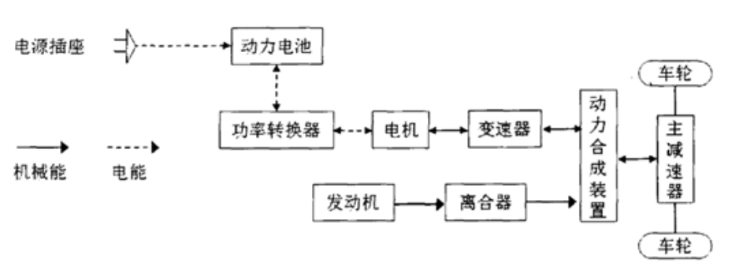
Fig.1 Structure diagram of parallel hybrid electric vehicle

Table 1 Vehicle basic parameters
Vehicle mass/kg Full load mass/kg Wheel diameter/m Windward area/m²
1200 1750 0.381 2.28

Table 2 Performance index of parallel plug-in hybrid
 | demand |  | Numerical value
Dynamic property | Hybrid maximum speed Vmax（km/h） | $$≥170$$
Dynamic property | Maximum gradient（20km/h） | $$≥30$$
Dynamic property | 100 km acceleration time Vmax（km/h） | $$≤13$$

As the main power source of hybrid electric vehicle, the engine directly affects the power output of the vehicle, and the accuracy of its model is very important. Considering that the engine model parameters are difficult to obtain accurately, the static model is usually applied to the simulation of hybrid electric vehicles.
When the high-voltage battery is in a state of loss of power, the engine needs to run independently to maintain the maximum speed of the vehicle, and the maximum power of the engine should not be less than the power required for the vehicle to maintain the maximum speed: the engine model diagram is shown in Figure 2.
$P_{max}i_{e}≥(f_{0}+f_{1}v_{max}+f_{2}{v^{2}}_{max})v_{max}$ （1）
Formula: $P_{max}$ The maximum power of the engine/Kw，$i_{e}$ is the transmission ratio of the gearbox; $f_{0}$ 、$f_{1}$、$f_{2}$ is the sliding resistance factor；$v_{max}$ for maximum speedKm/h.
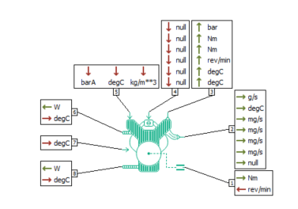
Fig.2 Engine model
The input and output variables of the eight ports in the engine model are relatively complicated. Port 1 is the main output port of the engine, which is connected to the gearbox and mainly outputs the engine torque. Port 2 is the emission port of the engine, with a total of seven output variables, mainly the emission rate of CO, HC, NOx and particles, as well as the engine exhaust temperature and emission gas flow rate; Ports 3 and 4 are the average braking pressure and torque loss rate of the engine respectively; Port 5 is the main control port of the engine, and its four inputs from left to right are: engine load, combustion mode, overheat combustion coefficient, idle speed; Ports 6, 7 and 8 are the combustion chamber temperature, coolant temperature and oil temperature, and the corresponding combustion heat loss and friction loss, respectively.
For parallel hybrid electric vehicles, the drive motor in pure electric mode is the only power source of the vehicle, and the maximum torque should meet the dynamic performance requirements of the vehicle in pure electric mode (acceleration performance, climbing ability, etc.):
$\int_{0}^{h}{\frac{T_{p2}ii_{e}}{Rm}}dt≥v_{t}$ （2）
$T_{p2}i_{e}i_{1st}≥(mgsin\left(\operatorname{atan}\left(d_{max}\right)\right)+f_{0}+f_{1}v+f_{2}v^{2})R$ （3）
Formula:$T_{p2}$Maximum torque for driving motor/Nm; $i$ is the transmission speed ratio; $i_{1}$ a gear ratio for the gearbox; $m$ is vehicle masskg;Ｒ wheel radiusm;$d_{max}$ is the maximum gradient.
When the motor of the hybrid electric vehicle reaches the maximum speed, it is necessary to ensure that the drive motor runs within the normal speed range, that is, its corresponding speed should be lower than the maximum speed:
$\frac{n_{pmax}}{i_{t}}≥\frac{30v}{πR}$ （4）
The model diagram of the drive motor is shown in Figure 3. In AMESim, the motor model is equipped with an inverter, which is an integrated electric generator model. The motor has five ports, with interface 1 to output power loss and input motor temperature. Interface 2 is a power transmission interface, output motor torque, input speed. Interface 3 is an output torque signal. Port 4 receives torque commands. Ports 5 and 6 are voltage and current signals used to connect to the battery module.

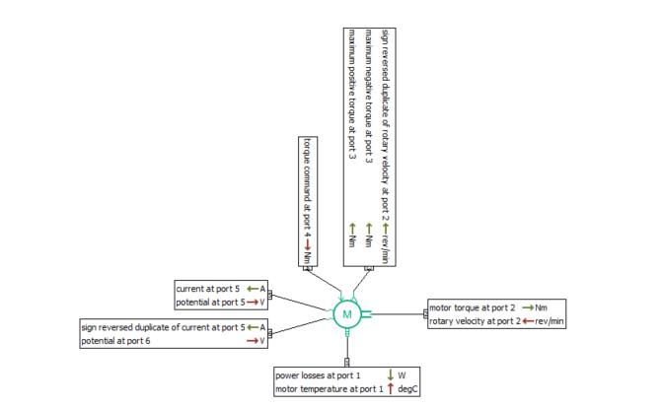
Fig.3 Motor model
The power battery power should meet the driving range requirements under pure electric conditions, and the required power can be calculated according to the constant velocity method. The power required for a car to travel at a constant speed
$p_{etc}=\frac{v_{etc}}{3600μ_{t}}(mgf+\frac{C_{D}Av_{max}^{2}}{21.15})$ （5）
$C=\frac{1000P_{etc}L}{U_{b}ε_{sos}v_{etc}μ_{m}}$ （6）
Formula: L is the driving range/km；$ε_{sos}$ is indicates the battery discharge depth，$ε_{sos}=0.85$；$μ_{m}$ is motor efficiency.
The battery model is shown in Figure 4. The model has four interfaces. Port 1 Output power loss, input the battery temperature signal. Ports 2 and 3 are voltage and current signal ports that are used to connect to the motor model. Port 4 is an output signal port that outputs state of charge (SOC) signals of the battery.

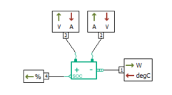
Fig.4 Battery model
According to equations (1) ~ (6), the matching parameters of the power system are shown in Table 3.
Table 3
engine maximum power/kW maximum torque/(N·m)
62 124
motor maximum power maximum torque maximum speed
32/kW 186N·m 4800 r·min
batter rated voltage/V maximum capacity/(A·h)
360 32

The physical model of the vehicle is built by AMESim, as shown in Figure 5. The model consists of driving module, engine module, battery module, vehicle control unit, transmission module, motor module and so on.
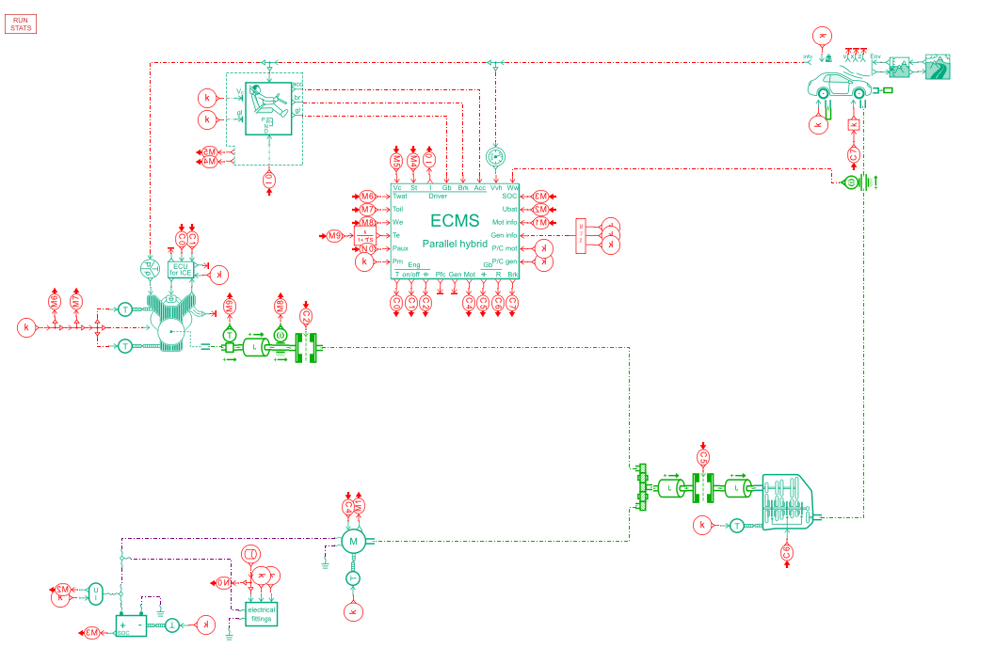
Fig.5 Hybrid electric vehicle model
ECMS (Equivalent Fuel Consumption Minimum Algorithm) is an advanced method for optimizing the energy utilization efficiency of hybrid electric vehicles. It realizes efficient energy utilization by precisely controlling the output power of the motor and dynamically adjusting it according to the instructions of the control strategy module. The vehicle control unit is the vehicle logic control, which can realize the vehicle torque demand, motor torque demand, braking energy recovery plan and other functions.

4 Simulation results and analysis
Economy under Cycle conditions is one of the important indicators of automobile design. In this paper, the global NEDC (New European Driving Cycle) conditions are simulated, including the European endurance standard test conditions and the Japanese JC08 conditions. The simulation speed under different working conditions is followed by the real control speed, and the change of the state of charge (SOC) of the battery is analyzed.
Under NEDC working condition and JC08 working condition, the speed following curve of hybrid electric vehicle and traditional fuel vehicle, and the SOC change curve of hybrid electric vehicle battery are shown in Figure 6-9.
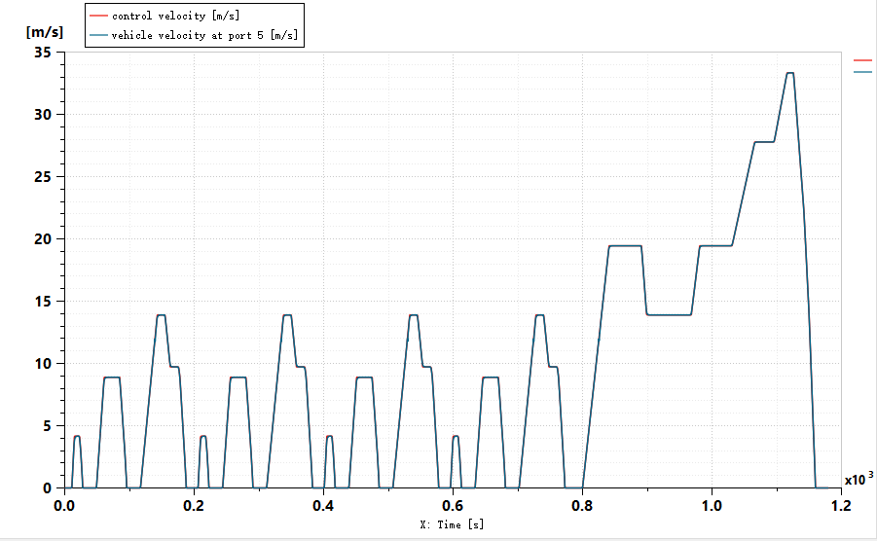
Fig. 6 Vehicle speed following curve under NEDC condition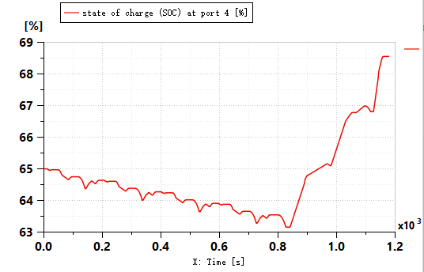
Fig. 7 SOC change curve of battery under NEDC condition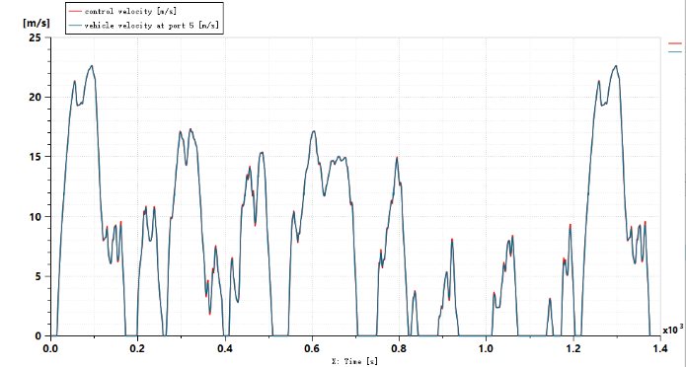
Fig. 8 Vehicle speed following curve under JC08 condition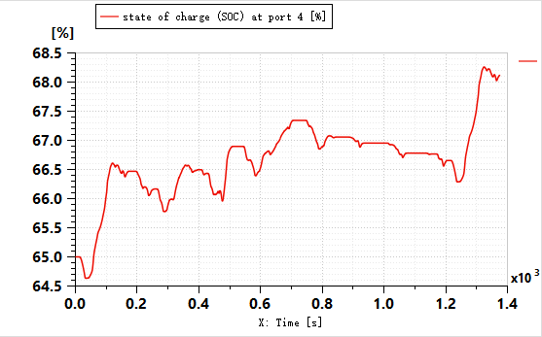
Fig. 9 SOC change curve of battery under JC08 condition

It can be seen from FIG. 6 and FIG. 8 that the matching degree between the simulated vehicle speed and the actual control vehicle speed under NEDC and JC08 conditions almost completely coincides, and the established simulation model is accurate and reliable, and the vehicle speed follows well under the two conditions, meeting the dynamic requirements of each cycle condition. It can be seen from FIG. 7 and FIG. 9 that in the whole cycle, the SOC of the battery does not rise or fall all the time, but changes constantly with the change of the working condition.
Vehicle power is one of the main performance of the vehicle, including 0 ~ 100 km/h acceleration performance, vehicle climbing performance.Fig.10 and 11 respectively show the simulation curve of the maximum speed and the speed curve when the slope is 35%. As can be seen from Figure 10, the speed of the hybrid electric vehicle model built in this time is 101.7km/h at 13s and 170km/h at 41s, respectively, meeting the design requirements of 100km acceleration time and 170km/h maximum speed. As can be seen from Figure 11, when the slope is 35%, the speed can reach 20km/h to meet the design requirements of the maximum gradient. It can be considered that the model selection, parameters setting and vehicle control model of engine, drive motor, generator, power battery and other components meet the requirements of this paper.

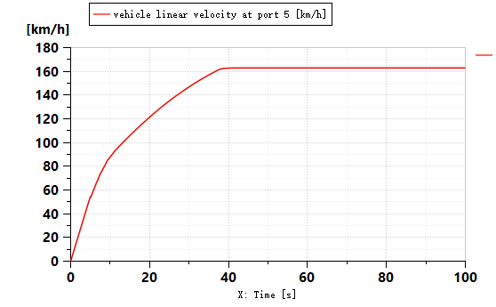
Fig. 10 Maximum speed diagram
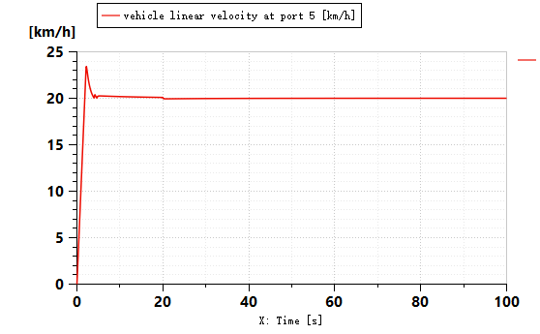
Fig. 11 Maximum climbing speed diagram

Taking a plug-in hybrid electric vehicle as the research object, the simulation model is established based on AMESim, and the power performance and economy of the hybrid vehicle are simulated under two working conditions of NEDC and JCO8. The matching degree between the simulated vehicle speed and the actual control vehicle speed almost completely coincides, and the simulation model is accurate and reliable, which lays a foundation for the subsequent thermal management of the hybrid vehicle.

Reference
- National Bureau of Statistics of China. (2020). China Statistical Yearbook 2020. Beijing: China Statistics Press.
- International Energy Agency (IEA). (2019). CO2 Emissions from Fuel Combustion 2019. Paris: IEA Publications.
- Wang, H., et al. (2020). "Carbon emissions from transportation in China: Trends and drivers." Journal of Cleaner Production, 256, 120725.
- Ministry of Industry and Information Technology of China. (2020). Energy-saving and New Energy Vehicle Technology Roadmap 2.0. Beijing: MIIT.
- State Council of China. (2020). New Energy Vehicle Industry Development Plan (2021-2035). Beijing: State Council.
- Li, J., et al. (2021). "China's 'Dual Carbon' goals: Challenges and opportunities for the automotive industry." Energy Policy, 158, 112543.
- Zhang, X., et al. (2020). "A comprehensive review of new energy vehicle technologies." Renewable and Sustainable Energy Reviews, 110, 109625.
- Wang, Y., et al. (2021). "Advances in battery technologies for hybrid and electric vehicles." Journal of Power Sources, 482, 228708.
- Chen, J., et al. (2022). "Comparative analysis of plug-in hybrid electric vehicles and conventional hybrid electric vehicles." IEEE Transactions on Vehicular Technology, 71(3), 2456-2470.
- Liu, H., et al. (2020). "Energy management strategies for plug-in hybrid electric vehicles: A review." Applied Energy, 285, 116432.
- Ehsani, M., et al. (2018). Modern Electric, Hybrid Electric, and Fuel Cell Vehicles: Fundamentals, Theory, and Design. CRC Press.
- Zhang, X., et al. (2020). "A comprehensive review of hybrid electric vehicle architectures and energy management strategies." Renewable and Sustainable Energy Reviews, 110, 109625.
- Chen, J., et al. (2022). "Comparative analysis of plug-in hybrid electric vehicles and conventional hybrid electric vehicles." IEEE Transactions on Vehicular Technology, 71(3), 2456-2470.
- Zhang, X., et al. (2020). "Energy management strategies for hybrid electric vehicles: A review." Renewable and Sustainable Energy Reviews, 110, 109625.
- Chen, J., et al. (2022). "Model predictive control for hybrid electric vehicles: A comprehensive review." IEEE Transactions on Vehicular Technology, 71(3), 2456-2470.
- Suzuki, T., et al. (2018). "Development of Toyota's hybrid system and its powertrain control." SAE Technical Paper, 2018-01-0412.
- Wang, Y., et al. (2021). "Advances in battery technologies for hybrid and electric vehicles." Journal of Power Sources, 482, 228708.
- Zhang, L., et al. (2019). "Fuel cell technology for hybrid and electric vehicles: Current status and future prospects." International Journal of Hydrogen Energy, 44(23), 12345-12360.
- Liu, H., et al. (2020). "Artificial intelligence-based battery management system for hybrid electric vehicles." Journal of Energy Storage, 30, 101543.
- Kim, S., et al. (2021). "Fast charging and wireless charging technologies for electric vehicles: A review." Energies, 14(5), 1234.
- Li, H., et al. (2019). "Thermal management of hybrid electric vehicles: Challenges and solutions." Applied Thermal Engineering, 147, 29-40.
- Wang, J., et al. (2020). "Advanced thermal management systems for electric and hybrid vehicles." Energy Conversion and Management, 210, 112678.
- Chen, Y., et al. (2021). "Integrated design of powertrain and thermal management systems for hybrid electric vehicles." Applied Energy, 285, 116432.

