**Review Article**

**A Review on Energy Consumption, CO2 Emissions and Policy for Industrial Sector in Kenya**

**ABSTRACT**

This review paper explores the relationship between industrial carbon dioxide (CO2) emissions, energy consumption, and the imperative need for effective energy policies to address climate change and global warming, posing substantial risks to human societies. The study emphasizes the critical importance of scrutinizing energy utilization and emissions trends in line with relevant policies to safeguard the future energy sector. Within Kenya's industrial sector, the analysis reveals a direct correlation between energy consumption and CO2 emission levels, both locally and globally. The industrial sector emerges as a pivotal player, being the primary consumer of coal (100%) and electricity (50%), the second-largest user of biofuels and waste (2.7%), and the third-largest consumer of oil products (6%). Contributing 9.2% to total final energy consumption and responsible for 18% of CO2 emissions in 2021, the sector has experienced a consistent annual growth rate of 4% in energy demand from 1990 to 2021, with projections indicating further increases by 2030. This growth aligns with a 4.1% annual increase in CO2 emissions, propelled by factors such as rapid urbanization, economic expansion, and population growth. Despite the implementation of various policies by the Kenyan government, including climate change regulations, energy-related strategies, and efficiency-specific measures, the industrial sector remains a significant contributor to national energy consumption and CO2 emissions. Recognizing the urgency, the paper advocates for the implementation of robust energy policies to balance demand and mitigate emissions, serving as a foundational resource for future research aimed at reducing energy consumption and CO2 emissions within the industrial sector.

Keywords: Energy, Industry, Electricity, Biofuels and waste, Oil products, Coal, CO2 emissions, Policy, Kenya

**1. Introduction**

The industrial sector, encompassing a wide range of manufacturing and production activities, plays a pivotal role in global economic development. Its contributions to job creation, economic growth, and technological advancements are undeniable [1]. However, this sector is not without its challenges. Among these challenges, high energy consumption and the resulting carbon dioxide (CO2) emissions stand out as pressing issues with serious implications [2,3]. The industrial sector's ever-increasing appetite for energy resources, often derived from non-renewable sources, has led to a significant contribution to greenhouse gas emissions causing global climate change, particularly in the form of CO2 [4].CO2 emissions generated by the industrial sector have been causing much concern globally due to its rapid growth rates because of the growing level of industrialization in many developing nations [5,6]. Addressing the complex problem arising from the unsustainable energy consumption patterns and the consequent environmental impact within industrial landscape is critical.

The global total final energy consumption (TFC) increased from 261,324,389 TJ in 1990 to 422,117,515 TJ in 2021 , representing almost 61.5% change over the period as shown in Table 1 [7,8]. The primary global fuel sources are oil products, constituting 39%, whereas biofuels and waste, electricity, natural gas, and coal make up 10%, 21%, 17%, and 9%, respectively, in 2021. Comparing the years 1990 to 2021, there was an 8% increase in the share of electricity and a 2% increase in the share of natural gas. Conversely, the shares of oil products, coal, and biofuels and wastes decreased by 3%, 3%, and 2%, respectively, over the specified period as shown in Figure 1. The global final energy consumption trends by region and share between 1973 and 2019 are presented in Figure 2 and 3. The top five countries global final energy consumption includes; China, USA, India, Russia and Japan respectively. Organization for Economic Cooperation and Development (OECD) nations lead with 38.1% share of world total final energy consumption followed by China 21% in 2019 while Africa share of world total final energy consumption changed from 3.6% share in 1973 to 6.1% share in 2019. The global final energy consumption trends by sector and share between 1990 and 2021 are presented in Figure 4 and 5. Energy consumption in the industry, transport and residential sectors were predominant in the total final energy consumption (TFC) in 2021, collectively constituting 78% of TFC. In 2021, the industrial sector was the leading total final energy consumption at 30% and responsible for nearly 83% of coal total final consumption (31,558,572 TJ), 39% of natural gas total final consumption (31,050,977 TJ), 8% of oil products total final consumption(12,860,169 TJ), 23.6% biofuels and waste total final consumption(10,322,473 TJ) and 43% of all electricity consumption(37,011,116 TJ)[9,10].Industrial sector global final energy consumption in 1990 stood at 75,215,890 TJ (29%) and increased significantly to 127,139,225 TJ (30%) in 2021. This gives an average global final energy consumption increase of 2.2% per year over the period. The global need for energy is rising at a rapid pace, driven by population and economic expansions, particularly in emerging market economies[11,12].

The global CO2 emissions from fuel combustion increased from 20,540,487.0 Mt of CO2 in 1990 to 33,572,105.0 Mt of CO2 in 2021 [13] as shown in Figure 6. OECD nations lead with 33.6% share of CO2 emissions followed by China 29.5% in 2019 while Africa doubled CO2 emissions from 1.9% share in 1973 to 3.8% share in 2019[14]. Global CO2 emissions from energy combustion and industrial processes rebounded in 2021 to reach their highest ever annual level of 33,572,105.0 Mt of CO2 in 2021 from 31,739,548.0 Mt of CO2 in 2020 (CRIPPA et al., 2023). The 5.8% rise in CO2 emissions in 2021 correlated with the 5.9% growth in global economic output. This signifies the most pronounced linkage between CO2 emissions and Gross Domestic Product (GDP) growth since 2010. During that period, global emissions rebounded by 6.2%, coinciding with a 5.1% expansion in economic output as the world recovered from the Global Financial Crisis[13]. Industrial sector was the third biggest global CO2 emitting sector at 18.9% after electricity and heat producers 43.6% and transport 22.7% in 2021 as shown in Figure 7. The share of electricity and heat producers increased significantly by 6.4% between 1990 and 2021 but industrial and transport sector decreased marginally at 0.4% and 0.2% respectively over the similar period. Industrial sector global CO2 emissions rose from 3,956,800.0 Mt of CO2 in 1990 to 6,340,959.0 Mt of CO2 in 2021 at an annual rate of 2% over the period [16–18]. Global industrial total final energy consumption demand is expected to rise gradually from the current 167 EJ (2023) at a rate of 1.1% per year to 2030 according to World Energy Outlook 2023(IEA, 2023 ). It is critical to enact policies and regulations that encourage industrial energy efficiency in order to reduce energy consumption which in turn lowers CO2 emissions from this sector.

The Africa’s total final energy consumption (TFC) by fuel increased from 11,994,488.0 TJ in 1990 to 25,710,261.0 TJ in 2021 , representing almost 114% change since 1990 as shown in Figure 8 ( IEA, 2021). Biofuels and waste is the main fuel source in Africa representing 52% while oil products, electricity, natural gas and coal represent 28%, 10%, 7% and 3% respectively in 2021 as shown in Figure 9. The share of Biofuels and waste and coal decreased by 6% and 4% while oil products , electricity and natural gas increased by 4%, 2% and 4% respectively between 1990 and 2021. The trends of Africa total final energy consumption by sector between 1990 and 2021 is presented in Figure 10. Energy consumption in the residential, industry and transportation sectors was predominant in the total final energy consumption (TFC) in 1990, collectively constituting 91% of TFC while in 2021 it constituted 90%. In 2021, the industry sector was the third total final energy consumer representing 15% of TFC behind residential (55%) and transport (20%) sectors as shown in Figure 11. Industrial sector Africa’s final energy consumption in 1990 stood at 2,222,442.0 TJ (19%) and increased significantly to 3,783,977.0 TJ (15%) in 2021. This gives an average Africa’s final energy consumption increase of 2.27% per year over the period.

Industrial sector is the leading electrical consumer in Africa at 37% share and followed closely by residential and commercial and public sectors at 36% and 19% share respectively in 2021. Its consumption increased from 501, 332 TJ in 1990 to 937617 TJ in 2021 at a rate of 2.8% per annum over the period. Industry is the third largest consumer of oil products in Africa at 9% after transport (71%) and residential (10%). The consumption increased marginally from 593,531.0 TJ in 1990 to 664,468.0 TJ in 2021 representing an annual increase of 0.4% over the period. Industrial sector is the largest consumer of coal in Africa at 76% followed by residential and commercial and public services sectors at 12% and 6% respectively. The consumption increased marginally from 587,445.0 TJ in 1990 to 679,476.0 TJ in 2021 at a rate of 0.5% per annum. Industrial sector is also the leading consumer of natural gas in Africa at 42% followed by residential sector at 27%. The consumption rose from 214,653.0 TJ in 1990 to 884, 128 TJ in 2021 at annual rate of 10% over the period. The share of Africa’s CO2 emissions from fuel combustion increased from 294 Mt of CO2 in 1973 to 1,278 Mt of CO2 in 2019 representing an annual increase of 7.3% over the period. The Africa’s need for energy is rising at a rapid pace, driven by population and economic expansions, particularly in emerging market economies[11,12]

When it comes to energy use, reducing CO2 emissions and comprehensive legislation for the industrial sector, Kenya and many African countries still lags behind developed nations. Thus, in order to reduce energy consumption and CO2 emissions in industrial sector, it is important to understand energy consumption trends. Thus, the purpose of this paper was to assess the state and future directions of energy policies, CO2 emissions, and energy consumption in Kenya's industrial sector at the national level. The goal is to determine future GHG emission projections and where they should be in order to mitigate the worst effects of climate change.

Table 1: Global total final energy consumption by sector[8]

|  |  |  |  |  |
| --- | --- | --- | --- | --- |
| Sector | 1990 | | 2021 | |
|  | TJ | Share (%) | TJ | Share (%) |
| Industry | 75215890 | 28.8 | 127139225 | 30.1 |
| Transport | 660711 | 25.3 | 112628350 | 26.7 |
| Residential | 634999 | 24.3 | 90645990 | 21.5 |
| Commercial and public services | 18674294 | 7.1 | 33497450 | 7.9 |
| Agriculture / forestry | 6839702 | 2.6 | 9007194 | 2.1 |
| Fishing | 260064 | 0.1 | 321310 | 0.1 |
| Non-specified | 10795747 | 4.1 | 7212645 | 1.7 |
| Non-energy use | 19967653 | 7.6 | 41665351 | 9.9 |
| TOTAL | **261,324,389** | **100** | **422,117,515** | **100** |

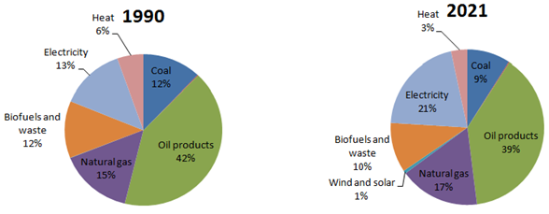

Figure 1: Global total final energy consumption by fuel source in 1990 and 2021

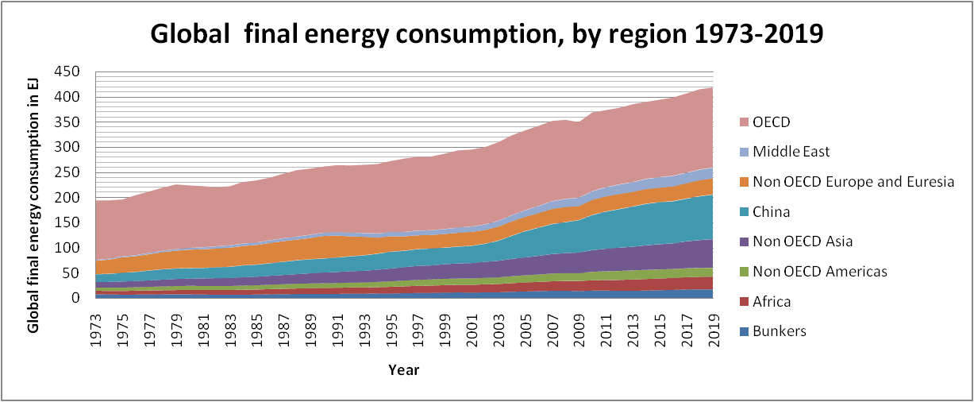

Figure 2: Global final energy consumption from fuel combustion by region, 1973-2019

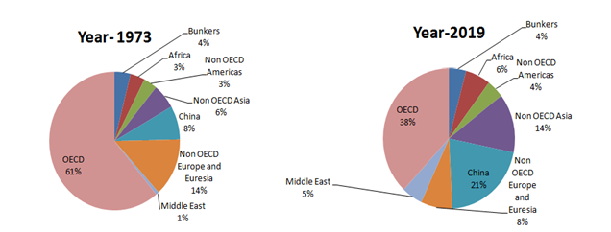

Figure 3: Global final energy consumption shares from fuel combustion by region in 1973 and 2019

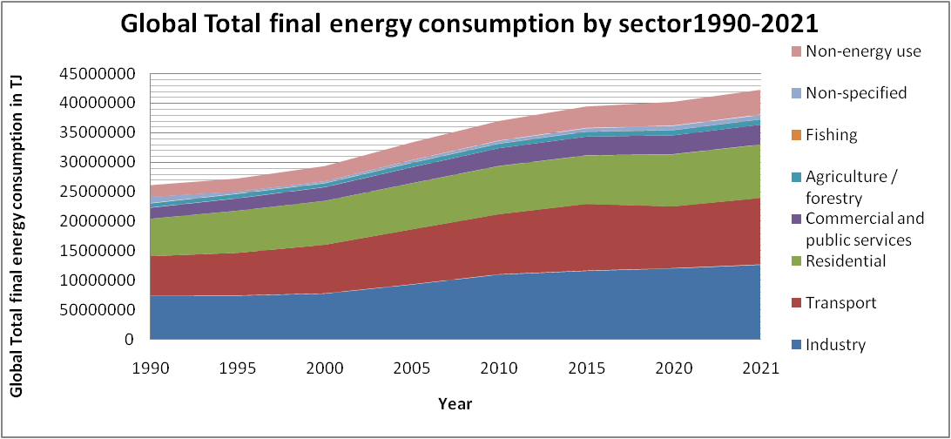

Figure 4: Global total final energy consumption from fuel combustion by sector, 1990-2021

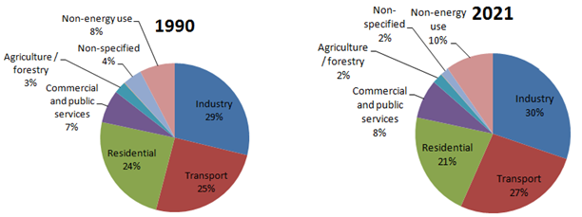

Figure 5: Global total final energy consumption shares from fuel combustion by sector in 1990 and 2021

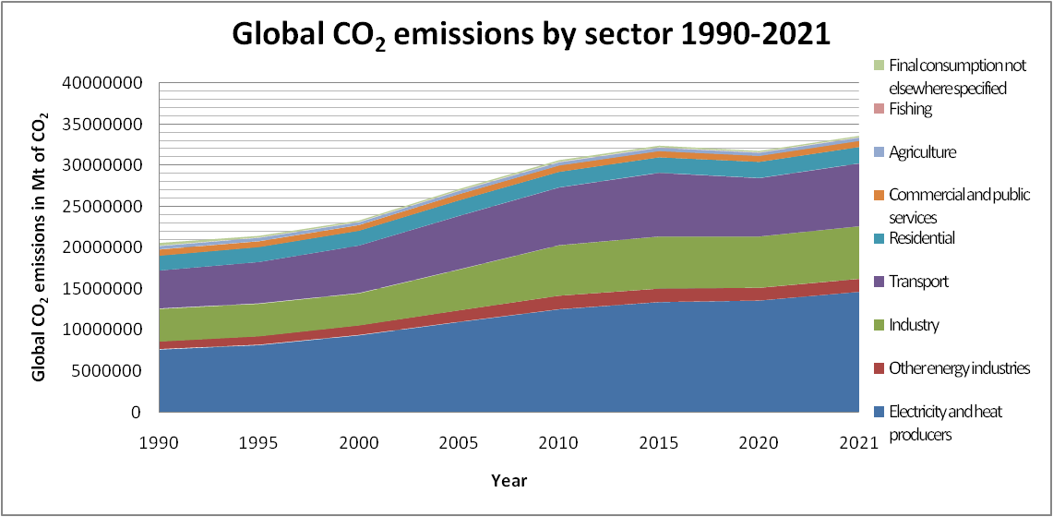

Figure 6: Global total CO2 emissions from energy combustion and industrial processes and their annual change by sector, 1990-2021

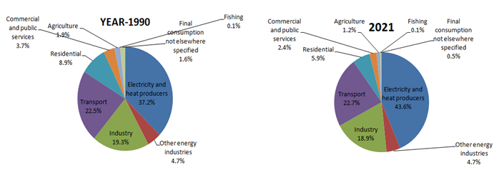

Figure 7: Global CO2 emissions from fuel combustion by sector in 2019 and 2022(Mt of CO2)

The industrial sector depends heavily on energy to produce its output, so any shortcomings in the energy policies would have a detrimental effect on both the growth of the industrial sector and the nation's economy[20,21].Adequate policy implementation would provide a framework for systematic, effective, and efficient energy planning for decision support, assisting policy planners in determining which energy resources should be prioritized for government investment[22]. Therefore, if plans for energy policies are not implemented, it was anticipated that the nation's energy policy situation will worsen. The study's findings on appropriate policies will aid national energy officials in planning an all-fuel energy supply to satisfy demand in the future.

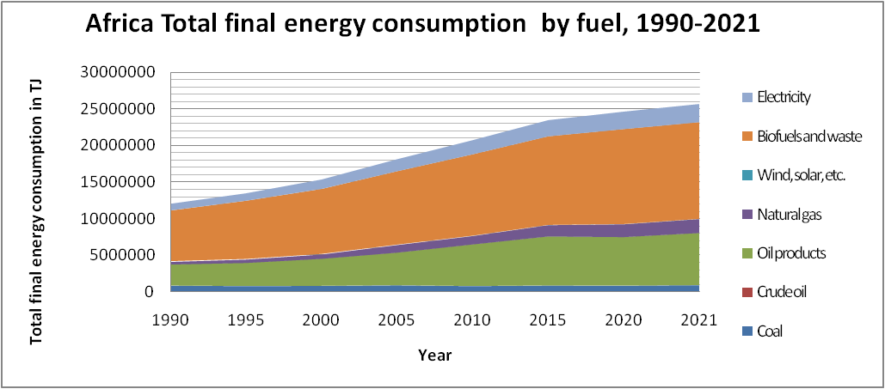

Figure 8: Africa total final energy consumption by fuel, 1990-2021 (TJ)

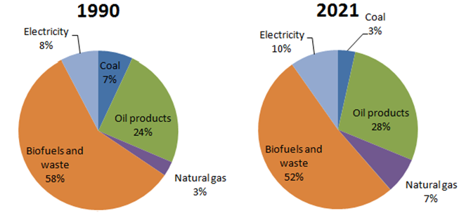

Figure 9: Africa total final energy consumption share by fuel in 1990 and 2021

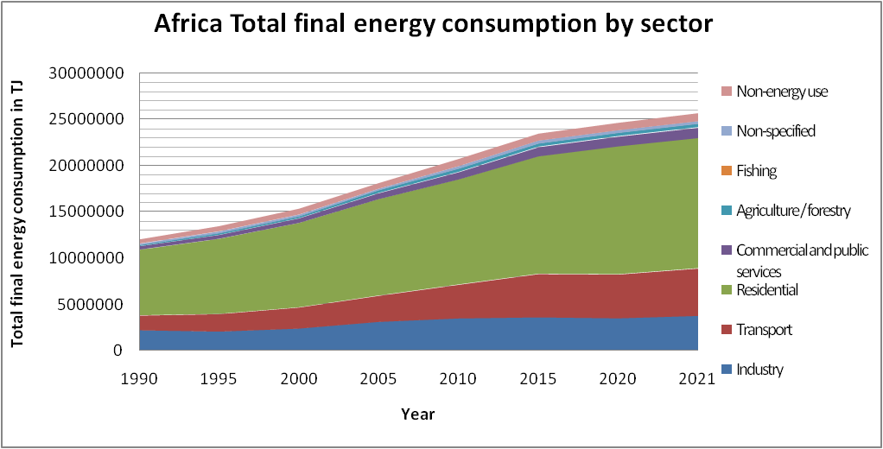

Figure 10: Africa total final energy consumption by sector, 1990-2021 (TJ)

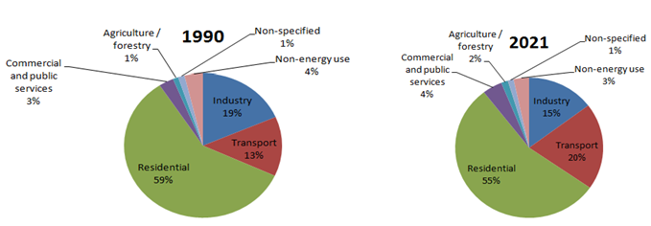

Figure 11: Africa total final energy consumption share by sector in 1990 and 2021

**2. Industrial energy consumption in Kenya**

Kenya’s population is approximately 52 million[23] with gross domestic product (GDP) growth rate of 7.5% per year in 2021.Industrial sector performance grew by 6.9% thus contributing 17% of the overall GDP in 2021[24]. The energy sources in Kenya comprise imported fossil fuels(oil and coal),biomass and electricity from renewable sources, such as hydro, geothermal, solar, and wind[25]. The energy composition in Kenya is predominantly reliant on traditional biomass[26], constituting over two-thirds of the nation's final energy consumption[27,28].

The total final energy consumption (TFC) in Kenya witnessed substantial growth, surging from 297,464.0 TJ in 1990 to 693,501.0 TJ in 2021, marking an almost 133% change over the period, as depicted in the IEA 2021 Figure 12. Notably, biofuels and waste emerged as the primary fuel sources in Kenya, constituting 63% of the total share in 2021. In the same year, oil products, electricity, and coal accounted for 29%, 5%, and 3% respectively, as illustrated in the Figure 13. Comparing 1990 to 2021, there was a 10% decrease in the share of biofuels and waste, while oil products, electricity, and coal increased by 6%, 2%, and 2% respectively.

The national total final electricity consumption saw a rise from 10,447.0 TJ in 1990 to 35,043.0 TJ in 2021, exhibiting an annual growth rate of 7.6%. Simultaneously, total final consumption of oil products increased from 67,138.0 TJ to 198,941.0 TJ, with an annual growth rate of 6.3% over the same period. The total final utilization of biofuels and waste experienced an increase from 215,986.0 TJ to 434,902.0 TJ, growing at a rate of 3.3% per annum. In contrast, total final coal consumption surged from 3,895.0 TJ to 24,617 TJ, displaying significant annual growth rate of 17.2% over the same period.

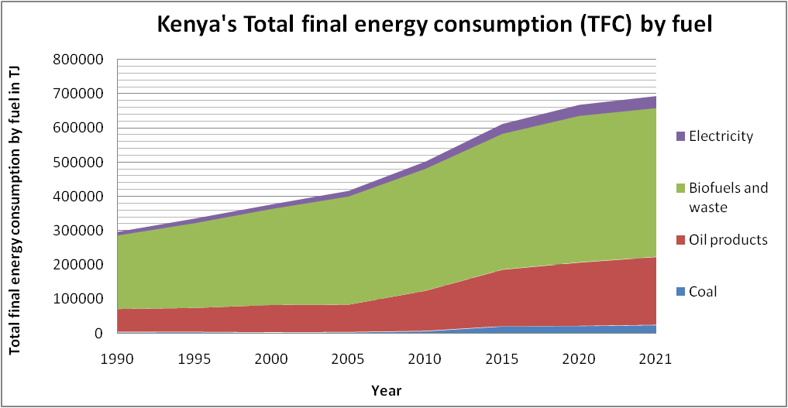Figure 12: Total final consumption (TFC) by fuel, Kenya 1990-2021 (TJ)

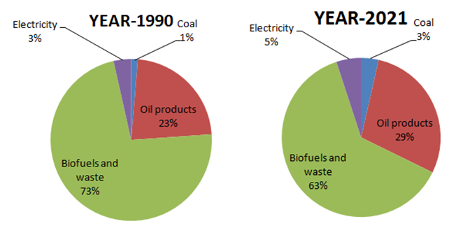

Figure 13: Share of National Total final energy consumption by fuel in 1990 and 2021(TJ)

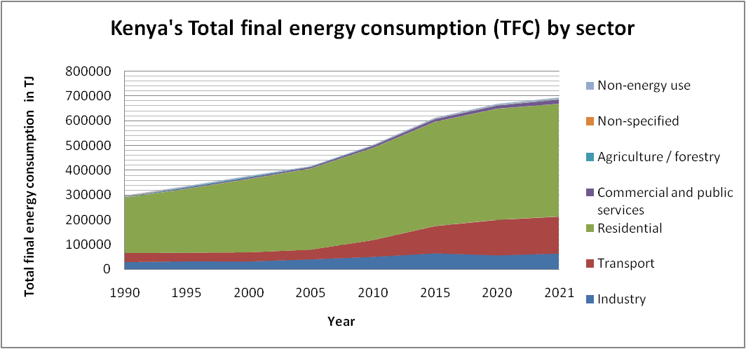

Figure 14: Total final energy consumption (TFC) by sector, Kenya 1990-2021 (TJ)

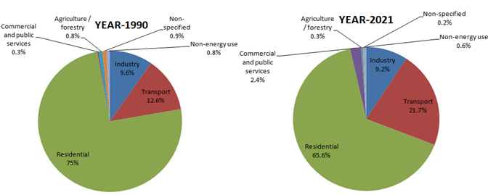

Figure 15: Share of National Total final energy consumption by sector in 1990 and 2021(TJ)

Examining energy consumption trends displayed in Figure 14 by sector, residential, industrial, and transportation sectors collectively represented 97.2% of TFC in 1990, a figure that slightly reduced to 96.5% in 2021. Specifically, in 2021, the residential sector dominated with 65.6%, followed by the transport sector with 21.7%, and the industrial sector as the third-largest consumer with 9.2%, as indicated in the Figure 15. The industrial sector's final energy consumption in Kenya surged from 28,664.0 TJ (9.6%) in 1990 to 63,685.0 TJ (9.2%) in 2021, reflecting an average annual increase of 4% over the period. The escalating demand for energy in Kenya is propelled by rapid population and economic expansions, especially in emerging market economies.

**2.1 Oil products**

Industrial sector is the third largest total final consumer of oil products at 6% (11,974.0 TJ) behind transport sector 76% (150,501.0 TJ) and residential sector 8% (16,863.0 TJ) in 2021. Its oil products consumption rose from 13,710.0 TJ in 1990 to 22,054 TJ in 2015 but dropped significantly to 8,888.0 TJ in 2020 and rose again to 11,974.0 TJ in 2021.

**2.2 Electricity consumption**

Industrial sector is the leading total final electricity consumer at 50% (17,629.0 TJ) followed by residential sector 36% (12,612.0 TJ) and commercial and public services sector 14% (4,800.0 TJ). Electricity consumption by the sector increased at a rate of 4.9% per annum from 7037.0 TJ in 1990 to 17, 629.0 TJ in 2021.

**2.3 Biofuels and waste**

Industrial sector is the second largest total final biofuels and waste consumer at 2.7% far behind residential sector at 97.8% in 2021. Biofuels and waste consumption by sector increased at a rate of 4.4% per annum from 4,020.0 TJ to 9464.0 TJ over the period.

**2.4 Coal consumption**

Industrial sector is the leading total final coal consumer at 24,617.0 TJ. Coal consumption by the sector increased at a rate of 17.2% per annum from 3895.0 TJ in 1990 to 24,617.0 TJ in 2021.

**3. CO2 emissions from industrial sector in Kenya**

The Kenya experienced a considerable surge in CO2 emissions, escalating from 5,513 Mt of CO2 in 1990 to 17,411 Mt of CO2 in 2021, marking an approximate 216% change over the specified period, as depicted in the IEA 2021 Figure 16. In 1990, CO2 emissions from the residential, industrial, and transportation sectors dominated, collectively constituting 84.8% of total emissions, a figure that slightly increased to 86% in 2021. Notably, in 2021, the industrial sector became the second-largest contributor to total CO2 emissions, accounting for 18%, with the transport sector leading at 62%, as illustrated in the Figure 17.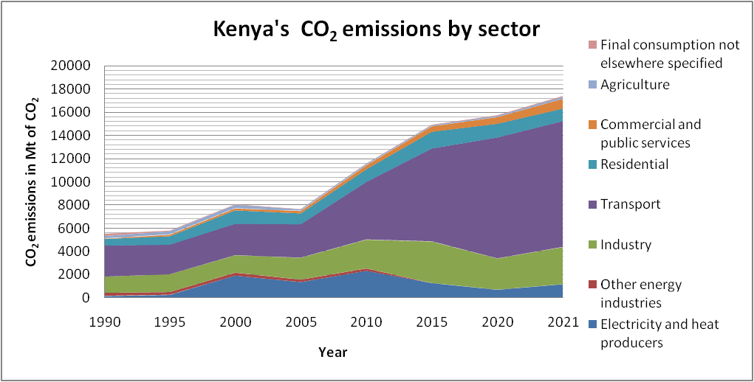

Figure 16: Kenya’s CO2 emissions by sector in 1990-2021 (Mt of CO2)

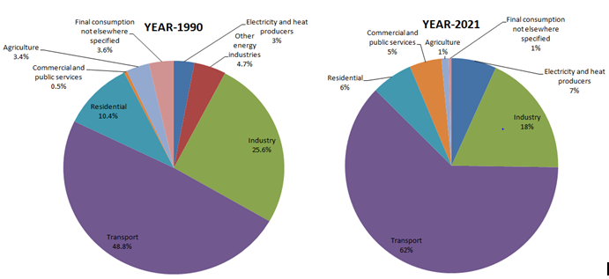

Figure 17: Share of National CO2 emissions by sector, Kenya in 1990 and 2021 (Mt of CO2)

The industrial sector's total final CO2 emissions in 1990 were 1,413 Mt of CO2 (25.6%), surging significantly to 3,211 Mt of CO2 (18%) in 2021. This indicates an average annual increase of 4.1% in total final CO2 emissions over the specified period. Consequently, developing a plan for a low-carbon society[29,30] requires in-depth research into anticipated future trends and an evaluation of industrial emissions along with their potential for reduction[31].

**4. Energy policies in industrial sector in Kenya**

Kenya economy has grown rapidly in the recent years and world energy statistics shows that it has transitioned to lower middle-income status and the largest economy in East Africa and Africa's ninth-biggest economy. Enhancing energy efficiency in the industrial sector is crucial for supporting energy security, promoting environmental sustainability, and optimizing economic performance[32]. This becomes especially vital in initiatives aimed at mitigating climate change. The substantial potential for cost-effective improvements in industrial energy usage and the subsequent reduction in greenhouse gas (GHG) emissions has motivated governments to adopt a number of policies and measures, focusing on enhancing the energy efficiency of their manufacturing industries[33].

Numerous policies and legislative measures have been formulated and others are currently under development, both at the national and county levels in Kenya, to tackle energy efficiency issues. Ongoing reforms are consistently being put into action, with a focus on enhancing the sustainability of the national economy and mitigating greenhouse gas (GHG) emissions. These efforts are directed towards aligning with the goals of the Paris Agreement and attaining Kenya's climate targets outlined in its initial Nationally Determined Contribution (NDC). Some of the industrial policies and regulations employed in Kenya include; Climate change-related regulations and strategies, Energy-related regulations and strategies and energy-efficiency specific regulations and strategies. An overview of pertinent national policies and legislation in Kenya pertaining to energy efficiency is provided in Table 2,3 and 4[27].Energy consumption and carbon emissions forecasting for industrial processes should be recommended as it helps with efficient planning and updating of appropriate energy policies to reduce industrial emissions[2,34]

Table 2: Climate change-related regulations and strategies

|  |  |  |  |
| --- | --- | --- | --- |
| **S/No.** | **Policy and regulation** | **Year** | **Summary** |
| 1 | Climate Change Act | 2016 | This document establishes a framework for responding to climate change and outlines mechanisms and measures for achieving development that is both low-carbon and climate-resilient. Specifically addressing energy efficiency, it mandates the adoption of a National Climate Change Action Plan. The Action Plan is designed to promote energy conservation and efficiency, encourage the utilization of renewable energy across various sectors including end-users, industrial, commercial, transport, and domestic users. Additionally, it outlines measures for mitigating climate change impacts. |
| 2 | National Climate Change Action Plan (NCCAP) | 2018 | The objective is to provide direction for Kenya's initiatives in addressing climate change. It highlights six key sectors for mitigation, with the energy sector being a prominent focus. These sectors are tasked with minimizing their greenhouse gas (GHG) emissions to enable Kenya to achieve its Nationally Determined Contribution target of a 30% reduction in GHG emissions by 2030 compared to the business-as-usual level. Enhancing energy efficiency and conservation is specifically recognized as a crucial area for action. |
| 3 | Sessional Paper No. 4 on Energy | 2004 | The Sessional Paper outlined a policy framework to ensure the provision of cost-effective, affordable, and high-quality energy services to the domestic economy in a sustainable manner. |

Table 3: Energy-related regulations and strategies

|  |  |  |  |
| --- | --- | --- | --- |
| **S/No.** | **Policy and regulation** | **Year** | **Summary** |
| 1 | The Energy Act | 2019 | Established the Energy and Petroleum Regulatory Authority to oversee the planning and execution of nationwide energy efficiency and conservation initiatives. |
| 2 | Energy (Appliances’ Energy Performance and Labelling) Regulations | 2016 | The regulations mandate that designated appliances produced or imported in Kenya undergo energy performance testing in an accredited laboratory, register with the ERC, and display the relevant energy star label. |
| 3 | Energy [10] Regulations (issued by the Energy Regulatory Commission) | 2012 | This document stipulates those commercial buildings, as well as industrial and institutional facilities, surpassing an annual energy consumption of 180,000 kWh, must formulate an energy management plan, conduct energy audits at least once every three years, and implement a minimum of 50% of the energy-saving recommendations within a three-year period. |
| 4 | Energy Management standards | 2018 | The Kenya Bureau of Standards formulated standards for energy management, encompassing energy management systems, energy auditing, and the measurement and verification of energy efficiency performance. |

Table 4: Energy-efficiency specific regulations and strategies

|  |  |  |  |
| --- | --- | --- | --- |
| **S/No.** | **Policy and regulation** | **Year** | **Summary** |
| 1 | Green Economy Strategy and Implementation Plan(GESIP) | 2016 | The GESIP serves as a plan to advance socio-economic transformation, emphasizing low-carbon, resource-efficient, equitable, and inclusive development. Additionally, it concentrates on addressing the socio-economic barriers hindering the achievement of Kenya Vision 2030 and aligns with the goals outlined in the United Nations Conference on Sustainable Development (Rio+20). |
| 2 | Performance Standards for Cooking stoves | 2019 | This document establishes updated Performance Standards for cookstoves. Clean Cooking Association of Kenya (CCAK) has formulated an optional star labeling program for cookstoves available in the market, aligning with these standards. |

**5. Discussions and summary**

* 1. **Energy consumption**

Kenya’s energy demand in the industrial sector grew 4% between 1990 and 2021due to rapid economic growth. The industrial sector accounted for the highest electricity consumption at 50% and ranked as the third-largest consumer of oil products at 6%, following the transport and residential sector in 2021. In addition, the sector remains the main consumer of coal and the second biofuels and waste consumer at 2.7% behind residential sector at 97.8%. The ever rising energy demand by industrial sector is mainly attributed to the fast increasing population and the fact that industry acts as a vital catalyst for economic growth by hosting highly productive economic activities[25,28,35]. The expansion was primarily a result of increased output in other non-metallic mineral product categories, such as cement, leather, related products, and the dairy products subsectors, among others[24].

In addition, high energy demand by industrial sector is linked to increased urbanization. The increasing proportion of the urban population is associated with escalating rates of energy demand, primarily fueled by rising income[36–38]. World Bank data indicates that Kenya's positive economic growth is closely tied to the ongoing increase in urbanization, presently standing at approximately 40%[39] and hence, the rise in energy demand to manufacture building materials like cement, steel, iron sheets etc. To encourage the separation of economic growth from increased energy consumption in the industrial sector, it is recommended to promote economical, energy-saving, and less polluting fuels in order to enhance energy efficiency[40].

* 1. **CO2 emissions**

National CO2 emissions increased gradually during the last five decades at an annual rate of 7% while industrial sector increased at an annual rate of 4.1% over the same period. There is a positive correlation between the shares of energy consumption and the level of CO2 emissions[41–45]. The increase in is attributed to the increase in energy consumption of coal and coal products from 1% (3895.0 TJ) to 3% (24,617.0 TJ) in 2021 and the overall increase in energy demand due to the rising population and rapid economic growth[46,47]. The increase of industrial CO2 emission is expected to slow down in the near future due to the government policy interventions encouraging energy efficiency and renewable energy use adoption[48–50]. The adverse effects of climate change, such as extended periods of drought, unpredictable weather patterns, and the emergence of new pests and diseases, present a substantial risk to socio-economic development in Kenya. Thus, research into projected future trends and an assessment of industrial emissions, including modelling, simulations of industrial CO2 emissions, are necessary, as is an examination of their potential for reduction.

* 1. **Energy policies**

Although the government recognizes the effect of CO2 emissions on climate change, most of the policies and regulations enacted are recent, therefore sensitization is crucial in the industrial sector players[51]. Unlike developed countries which have budget to monitor industrial energy efficiency, Kenya requires financial support to train industry players on energy use best practices. Studies show that energy saving potential exists in many sub-sectors of industrial sector[52] but the challenge is identification of the opportunities due to the skill gap.

Kenya faces challenges to improve industrial energy efficiency compared to those in developed countries in that it lacks comprehensive policies which address energy efficiency across several sub-sectors in industrial sector[20]. In addition, Kenya still lacks behind in energy efficient technologies adoption due to high investment cost and absence of well-trained manpower on energy efficiency. Kenya government can overcome the challenges by encouraging industry players to adopt energy efficient technologies and providing energy subsidies. Therefore, given the current climate change and industrial pollution, it is necessary to improve industrial energy policy due to the negative environmental effects of energy consumption and emissions.

**6. Conclusion**

The industrial, transportation, and residential sectors are the key determinants of national energy consumption in Kenya. Over the past three decades, the industrial sector has experienced a consistent annual increase in energy usage of 4%. This rise can be largely attributed to rapid urbanization, economic expansion, and population growth. Despite national initiatives to curb these trends, both energy demand and CO2 emissions have surged, deviating significantly from the reductions mandated by the Paris Agreement. This indicates a lack of progress in the global reduction of carbon emissions.

To effectively reduce CO2 emissions in the industrial sector, the government should implement targeted policies, regulations, and strategies related to climate change, energy, and energy efficiency. Kenya has also committed to diminishing its carbon footprint by investing in renewable energy projects, which currently contribute to 85% of the nation's electricity. With sufficient funding for industrial energy-efficient technologies, Kenya could align its efforts with those of developed nations in mitigating greenhouse gas emissions.

The review paper identifies research gaps, including a limited understanding of CO2 emission pathways in Kenya. By employing modeling and simulations under various scenarios, researchers can analyze potential trajectories of CO2 emissions. Additionally, there is a scarcity of studies in Kenya focused on forecasting trends. Models can aid researchers in predicting long-term trends in energy consumption and emissions, providing policymakers with valuable insights for crafting sustainable strategies. This review serves as a roadmap for future research endeavors aimed at reducing energy demand and CO2 emissions in the industrial sector, addressing challenges related to climate change mitigation.

**References**

[1] Zheng W, Walsh PP. Economic growth, urbanization and energy consumption—A provincial level analysis of China. Energy Econ 2019;80:153–62.

[2] Hu Y, Man Y. Energy consumption and carbon emissions forecasting for industrial processes: Status, challenges and perspectives. Renew Sustain Energy Rev 2023;182:113405.

[3] Bunse K, Vodicka M, Schönsleben P, Brülhart M, Ernst FO. Integrating energy efficiency performance in production management–gap analysis between industrial needs and scientific literature. J Clean Prod 2011;19:667–79.

[4] Lamb WF, Wiedmann T, Pongratz J, Andrew R, Crippa M, Olivier JG, et al. A review of trends and drivers of greenhouse gas emissions by sector from 1990 to 2018. Environ Res Lett 2021;16:073005.

[5] Yoro KO, Daramola MO. CO2 emission sources, greenhouse gases, and the global warming effect. Adv. Carbon Capture, Elsevier; 2020, p. 3–28.

[6] Iqbal W, Altalbe A, Fatima A, Ali A, Hou Y. A DEA approach for assessing the energy, environmental and economic performance of top 20 industrial countries. Processes 2019;7:902.

[7] Source: IEA, World Energy Balances, 2021.

[8] Browser ESD. IEA, Paris 2022.

[9] UNSD. Energy statistics database 2009.

[10] Nations U. Energy Statistics Pocket Book 2018.

[11] Asif M, Muneer T. Energy supply, its demand and security issues for developed and emerging economies. Renew Sustain Energy Rev 2007;11:1388–413.

[12] Kaygusuz K. Energy for sustainable development: A case of developing countries. Renew Sustain Energy Rev 2012;16:1116–26.

[13] IEA. Global Energy Review: CO2 Emissions in 2021—Analysis 2021.

[14] Statistics IEA. Key world energy statistics. Int Energy Agency Paris Fr 2014.

[15] CRIPPA M, GUIZZARDI D, PAGANI F, BANJA M, MUNTEAN M, SCHAAF E, et al. Emissions database for global atmospheric research 2021.

[16] Crippa M, Guizzardi D, Muntean M, Schaaf E, Solazzo E, Monforti-Ferrario F, et al. Fossil CO2 emissions of all world countries. Luxemb Eur Comm 2020:1–244.

[17] Liu Z, Deng Z, Zhu B, Ciais P, Davis SJ, Tan J, et al. Global patterns of daily CO2 emissions reductions in the first year of COVID-19. Nat Geosci 2022;15:615–20.

[18] Liu Z, Deng Z, Davis S, Ciais P. Monitoring global carbon emissions in 2022. Nat Rev Earth Environ 2023;4:205–6.

[19] International Energy Agency | World Energy Outlook 2023

[20] Ototo EG, Nzai C. Energy Consumption and Performance of Manufacturing Sector in Kenya. IOSR J Econ Finance IOSR-JEF E-ISSN 2021:2321–5933.

[21] Mutua J, Ngui D, Osiolo H, Aligula E, Gachanja J. Consumers satisfaction in the energy sector in Kenya. Energy Policy 2012;48:702–10.

[22] Copeland C. Participatory energy futures as decision support on subnational scales. Environ Policy Gov 2023:eet.2087. https://doi.org/10.1002/eet.2087.

[23] John N, Jalilinasrabady S. Potential of cascaded use of geothermal energy to uplift fish production in Kenyan aquaculture. 2021 Geotherm. Rising Conf. Using Earth Save Earth GRC 2021, Geothermal Resources Council; 2021, p. 486–98.

[24] KNBS R. Economic Survey 2020 2020.

[25] ENERGY E. PETROLEUM STATISTICS REPORT 2019 n.d.

[26] Kimutai S, Kiprop A, Snelder D. Household energy utilization and changing behaviours: evidence from Western Kenya 2019.

[27] Energy M of. Kenya National Energy Efficiency and Conservation Strategy 2020.

[28] Takase M, Kipkoech R, Essandoh PK. A comprehensive review of energy scenario and sustainable energy in Kenya. Fuel Commun 2021;7:100015.

[29] Gachanja J, Muriithi B, Mwabonje O, Mugwe A, Olukuru J, Da Silva IP, et al. Kenya’s Low Carbon Futures: An Assessment Using the KCERT Model. Energies 2023;16:7459.

[30] Koasidis K, Nikas A, Karamaneas A, Saulo M, Tsipouridis I, Campagnolo L, et al. Climate and sustainability co-governance in Kenya: A multi-criteria analysis of stakeholders’ perceptions and consensus. Energy Sustain Dev 2022;68:457–71.

[31] Zhu A, Wang D, Chen Y, Guo Z. Optimization of the Beijing Economy-Energy-Emissions System 2021–2035: A Scenario Simulation Analysis Based on a System Dynamics Model. Sci Prog 2022;105:003685042211182. https://doi.org/10.1177/00368504221118231.

[32] Ahmad T, Zhang D. A critical review of comparative global historical energy consumption and future demand: The story told so far. Energy Rep 2020;6:1973–91.

[33] Tanaka K. Review of policies and measures for energy efficiency in industry sector. Energy Policy 2011;39:6532–50.

[34] Kapp S, Choi J-K, Hong T. Predicting industrial building energy consumption with statistical and machine-learning models informed by physical system parameters. Renew Sustain Energy Rev 2023;172:113045.

[35] Macharia KK, Gathiaka JK, Ngui D. Energy efficiency in the Kenyan manufacturing sector. Energy Policy 2022;161:112715.

[36] Jones DW. How urbanization affects energy-use in developing countries. Energy Policy 1991;19:621–30.

[37] Keho Y. What drives energy consumption in developing countries? The experience of selected African countries. Energy Policy 2016;91:233–46.

[38] Sarkodie SA, Owusu PA, Leirvik T. Global effect of urban sprawl, industrialization, trade and economic development on carbon dioxide emissions. Environ Res Lett 2020;15:034049.

[39] Bakirtas T, Akpolat AG. The relationship between energy consumption, urbanization, and economic growth in new emerging-market countries. Energy 2018;147:110–21.

[40] Chen X, Shuai C, Wu Y, Zhang Y. Understanding the sustainable consumption of energy resources in global industrial sector: Evidences from 114 countries. Environ Impact Assess Rev 2021;90:106609.

[41] Alshehry AS, Belloumi M. Energy consumption, carbon dioxide emissions and economic growth: The case of Saudi Arabia. Renew Sustain Energy Rev 2015;41:237–47.

[42] Ahmad A, Zhao Y, Shahbaz M, Bano S, Zhang Z, Wang S, et al. Carbon emissions, energy consumption and economic growth: An aggregate and disaggregate analysis of the Indian economy. Energy Policy 2016;96:131–43.

[43] Farhani S, Chaibi A, Rault C. CO2 emissions, output, energy consumption, and trade in Tunisia. Econ Model 2014;38:426–34.

[44] Saidi K, Hammami S. The impact of CO2 emissions and economic growth on energy consumption in 58 countries. Energy Rep 2015;1:62–70.

[45] Odugbesan JA, Rjoub H. Relationship Among Economic Growth, Energy Consumption, CO 2 Emission, and Urbanization: Evidence From MINT Countries. SAGE Open 2020;10:215824402091464. https://doi.org/10.1177/2158244020914648.

[46] Hanif I. Impact of fossil fuels energy consumption, energy policies, and urban sprawl on carbon emissions in East Asia and the Pacific: A panel investigation. Energy Strategy Rev 2018;21:16–24.

[47] Ma X, Wang C, Dong B, Gu G, Chen R, Li Y, et al. Carbon emissions from energy consumption in China: its measurement and driving factors. Sci Total Environ 2019;648:1411–20.

[48] Mirza FM, Kanwal A. Energy consumption, carbon emissions and economic growth in Pakistan: Dynamic causality analysis. Renew Sustain Energy Rev 2017;72:1233–40.

[49] Ali MB, Saidur R, Hossain MS. A review on emission analysis in cement industries. Renew Sustain Energy Rev 2011;15:2252–61.

[50] Voumik LC, Ridwan M, Rahman MH, Raihan A. An investigation into the primary causes of carbon dioxide releases in Kenya: Does renewable energy matter to reduce carbon emission? Renew Energy Focus 2023;47:100491.

[51] Madlool NA, Saidur R, Hossain MS, Rahim NA. A critical review on energy use and savings in the cement industries. Renew Sustain Energy Rev 2011;15:2042–60.

[52] Kimutai IK, Kimutai SK. Energy Utilization and Saving Opportunities in Process Industries: Case Study of Textile Manufacturing Industry in Kenya n.d.