*Review Article*

The Phillips Curve: Evolution and Relevance in Indian Policymaking – A Review

.

ABSTRACT

|  |
| --- |
| **Aims:** This review examines how the Phillips Curve has progressed while evaluating its usefulness for Indian economic analysis. The review bases its analysis on empirical studies and policy implications to establish a complete framework of the Phillips Curve's value for India's macroeconomic policy.  **Study design:** The paper is structured as a comprehensive literature review. This brings in historical perspective, theoretical models and empirical studies concerning the Phillips Curve in India, and investigates the impacts of the main structural reforms and policy changes such as economic liberalization, demonetization, and GST implementation.  **Place and Duration of Study:** The study considers India's economic dynamics across different stages of time that includes both early-to-mid 20th century and contemporary times while examining vital changes in structure and policy alongside adjusting macroeconomic trends affecting inflation and employment trends.  **Methodology:** The paper employs a systematic review of academic literature The review adopts theoretical analysis to study the Phillips Curve while reviewing its historical developments as well as Indian economic scenarios. It also investigates how economic liberalization as well as demonetization alongside GST implementation affects the relationship between inflation and unemployment rates.  **Results:** It is observed multiple structural elements of the Indian economy such as the vast informal sector together with geographic inequalities and labor force shifts make the traditional Phillips Curve show inconsistent patterns. Major structural reforms in the economy have modified how inflation interacts with unemployment which defies many macroeconomic fundamentals.  **Conclusion:** To apply the Phillips Curve effectively for India requires extensive modification of its form. The RBI needs improved unemployment-inflation understanding as part of Flexible Inflation Targeting by examining wage responses across industries and production disturbances. Econometric methods at an advanced level should be employed to create superior economic models which will assist authorities in creating proper policies for India's evolving complex landscape. |

***Keywords:*** *Phillips Curve Evolution, Inflation-Unemployment Dynamics, Inflation Targeting RBI, Structural Changes, Stagflation & Phillips Curve Validity, Indian Economy*

1. INTRODUCTION

Initiated by the A. W. Phillips in his 1958 paper (Phillips, 1958), the Phillips curve made an inversely relationship between inflation and unemployment which became the backbone of macroeconomic theory and policymaking. At first glance, this supposedly simple relationship implying a tradeoff between price stability and the maximization of (full) employment has shaped economic thinking and provide bases for the often interventionist policies for thousands of years. Samuelson and Solow (1960) pointed out that early interpretations of the Phillips curve had provided impetus for expansionary monetary policies which were designed to lower unemployment at the expense of higher inflation. The original Philips Curve’s assumptions were challenged by stagflation of the 1970s featuring high inflation and high unemployment (Phelps, 1967; Friedman, 1968). This caused the emergence of the expectations augmented Phillips curve which accounted for how price level expectations influence the inflation-unemployment trade off.

More advanced theoretical developments then expanded on this relationship, such as the New Keynesian Phillips curve (NKPC) which integrate the effects of price stickiness, imperfect competition and forward-looking expectations into inflation dynamics (Clarida et al., 1999). However, theoretical rationale for the Phillips curve has been provided by these refinements, but the empirical and practical relevance of the Phillips curve has continued to be questioned. The recent economic events such the global financial crisis and the pandemic of COVID-19 have led to renewed discussions about the alleged flatter or even the disappearance of the Phillips curve in many advanced economies (Ball & Mazumder, 2023). The study reviews all the changes made to the Phillips curve since it was first defined to explain how it serves both theory and practice. Our analysis addresses these particular research topics:

(1) How well has the Phillips curve performed throughout history while economists studied different methods to explain it and tried to overcome its observatory problems?

(2) Can the Phillips curve still serve as the appropriate framework for understanding inflation-unemployment dynamics in the Indian context, in particular with its structural peculiarities and policy environment?

(3) In what ways, particularly if the Reserve Bank of India is pursuing an inflation targeting framework, does the Phillips curve have implications for design of monetary and fiscal policy in India?

The past course of debate on the Phillips Curve is critically analyzed, the historical development is explored in this paper and the way it has been used in the Indian economic context; and the implications for the roles played by monetary and fiscal policies are discussed. The fact that the Phillips Curve relates unemployment and inflation has been a center piece in macroeconomic theory and policy debates for decades. However, despite all of this, the relevance and reliability of this index have been continuously doubted, with regard for economic structures and regional diversification. However, this study attempts to provide a broad analysis of the Phillips Curve from the point of starting with tracing the historical evolution of the Phillips curve, and then going ahead by examining its theoretical transformations as well as verifying empirically with the help of some basic facts. Therefore, the paper dives into the historical history of the Phillips Curve as developed from A.W. Phillips in the late 1950s and it’s later reformulation by other economists including Milton Friedman and Edmund Phelps founding the notion of systemic expectations of inflation and the natural rate of unemployment. It also further investigates the evolution of the Phillips Curve in the New Keynesian framework where there are price stickiness and forward-looking inflation expectations. The paper discusses these theoretical advancements and how the Phillips Curve incorporated to the changing economic paradigms and still influences the contemporary macroeconomic thought. Secondly, the paper proceeds to assess the applicability of Phillips Curve as a policy tool of choice in the framework of Indian Macroeconomics. India is an interesting situation, because it is a developing country that is undergoing fast structural change. However, the suggested traditional inflation – unemployment trades off by the Phillips curve offered by it is challenged by the factors like a large informal sector, regional economic disparities, and changing dynamics of labor markets. This paper provides empirical evidence of the Phillips curve relationship in India, that is, inconsistencies, and discrepancies based on supply shocks, regulatory changes, as well as in the case of markets for urban and rural labor. Furthermore, the paper investigates the impact of major structural changes in the Indian economy on the inflation-unemployment nexus. Additionally, it studies the effects that three of the most important policy interventions what: economic liberalization, demonetization, and the introduction of the Goods and Services Tax (GST) have on identifiable respondents. The economic liberalization that began in 1991 dramatically altered the face of Indian’s economy by reducing trade barriers, soliciting foreign investment and deregulating industries. The impact on the relationship between inflation and unemployment was brought about by the influence that these changes had on wage-setting mechanisms and increased competition as well as improved productivity. The paper investigates how the greater global integration and exposure to the international price movements have affected the inflation dynamics and labor market behavior in India.

In November 2016, the high denomination currency notes are suddenly withdrawn under the demonetization to effectively combat black money, counterfeit currency, and corruption. However, this policy shock had a huge effect on economic activity, especially on the informal sector which employs over 90 percent of Peru’s population using transaction technologies. Correspondingly, the paper examines how this liquidity shock disturbed demand, supply chain, and employment resulting in short run deflationary stresses and a slowdown. It also evaluates the long run effect of demonetization on inflation expectations as well as on labor market adjustments.

It was in July 2017 when a historic reform was introduced in India’s indirect tax system through Goods and Services Tax (GST), which replaced a multitude of state and central taxes, to create a unified national market. GST addressed supply chain logistics, made taxes easy to manage, and provided strength to the India Inc. However, its implementation brought in an adjustment with regards to pricing strategies, inflationary pressures due to initial tax rate, altering and responding to change in the consumables market and across all tiers of the supply chain. The current paper explores the impact of GST on price levels, cost structures and employment trends for short run and long run and it discusses the extent it has played in bringing India on the Phillips Curves. The paper provides a nuanced understanding of the evolution of the inflation unemployment nexus in India through such an examination of these structural changes. It claims that the Phillips Curve model may not totally fit the intricacies of a swiftly changing economy like India. Given such a state of affairs, the paper describes the requirements for context specific adjustment and the need to develop more sophisticated models that take supply side shocks, informal sector dynamics as well as policy induced structural shift into consideration. The paper brings out the policy implications of the traditional Phillips Curve for Indian policymakers, especially Reserve Bank of India (RBI). Second, it explores how policy decisions have been made in the framework of Flexible Inflation Targeting, compared to the Multiple Indicator Approach, and the role, or not, of the Phillips Curve. It also discusses the challenges of achieving a proper balance between control of inflation and growth of employment in a developing economy and proposes policy strategies that incorporate the evolving inflation employment relationship.

In the end, this paper presents a comprehensive evaluation of the debate in the Phillips Curve of the historical developments and contemporary empirical evidence and policy implications in the Indian context. It also provides interesting insights into the behavior of inflation and unemployment in India, in change from structural changes like liberalization, demonetization and GST, and helps in deliberations on the validity of the Phillips Curve in contemporary economic policymaking.

2. Theoretical Background and Evolution

It has been popularized in economy by A.W. Phillips to represent a inverse relation between wage inflation and unemployment. Phillips observed that using historical data from the United Kingdom from 1861 until 1957, wage inflation was high when unemployment was low and low when unemployment was high. A negative correlation implied that there was a tradeoff between inflation and unemployment, meaning that policymakers could sacrifice unemployment in term of inflation, or sacrifice inflation in term of unemployment. In a seminal paper entitled ‘The Relationship between Unemployment and the Rate of Change of Money Wage Rates in the United Kingdom, 1861–1957’ (1958) Phillips presented his findings and laid the foundation for what would become known as the Phillips Curve. Where Phillips initially had researched is wage inflation rather than price inflation, exhibiting how labor market conditions affect how wage settings behave. When unemployment is low, he argued that employers competed with each other for a small number of workers, causing wages to rise. However, when unemployment was high, workers had more competition for jobs, and from this came the constraint on wage growth. Since then, economists expanded the definition of Phillips’ idea to encompass all general price inflation, giving birth to the Phillips Curve as a central schematic of the relationship between inflation and unemployment.

The economic problems during the 1970s forced economists to change their view of Phillips curve stability because both unemployment and inflation increased at the same time (Friedman, 1968; Phelps, 1967). The new formula of the Phillips curve emerged through its expansion to include how people predict future price growth. The change in this model demonstrates that lower unemployment rates can happen only through faster inflation by future expectations matching ongoing price increases.

In influential research by Clarida, Galí, and Gertler (1999), the New Keynesian Phillips Curve (NKPC) is developed therefrom as a culmination of the evolution of Phillips Curve theories. It was this modern iteration built on previous changes of the Phillips Curve that utilized additional microeconomic foundations (such as the microeconomic foundations that were more compatible with current macroeconomic theory). To be specific, their understanding of the role of the price stickiness and inflation expectations was more detailed and more realistic in terms of the relationship between inflation dynamics and economic activity. The main contribution of the New Keynesian Phillips Curve is its explanation of price stickiness, which is driven by two basic mechanisms, namely, those relating to menu costs and staggered price setting. Functions like menu costs in terms of the expenses firms spend in order to change prices, such as printing new listing of prices, updating the marketing, or setting up other kinds of digital pricing systems. These costs however, make frequent price adjustments costly, and therefore are disincentives for price adjustments even when market conditions change. So, this rigidity, in turn, determines how inflation reacts to demand-supply changes. The NKPC also takes account of menu costs and staggered price setting; that is, firms change their prices at different moments in time rather than at one time. Real world pricing behavior includes contractual obligations, admin processes and strategic consideration and thus automatic pricing changes is skewed such that the changes occur asynchronously. Therefore, they contribute to short term inflation persistence through slow adjustment in aggregate price levels. The existence of a staggered adjustment mechanism of this type provides a reason for inflation to remain elevated or low despite the initial economic shocks having dissipated. The other important feature of the New Keynesian Phillips Curve is that it is a forward-looking equation and it incorporates future inflation expectations in the pricing of firms. This model posits that firms do not set today’s prices solely in relation to today’s current economic conditions but also in relation to what they expect the future inflation to be next year. This forward-looking behavior is because they do not want to pay the frequent price adjustments caused by the menu costs and because of strategic considerations. As a result, today’s pricing decisions are based on what is expected to happen in the future, which creates such a link between ex ante economic conditions and today’s inflation outcomes. The basic difference between the NKPC and traditional Philips curve models is that the former had a forward-looking view towards inflation, whereas traditional Philips curve models functioned based on past inflation signaling what the current changes in price will be. On the other hand, as the NKPC, rational, forward-looking firms factor in all available information including future demand, supply conditions and change in policy when deciding upon appropriate pricing strategy. It is a better match to modern macroeconomic models based on rational expectations and strategic decisions. The New Keynesian Phillips Curve extends the forward-looking inflation dynamic by incorporating price stickiness and inflation expectations that are forward looking. An explanation is given as to how inflation can be persistent even when there are no ongoing demand pressures, and how changes expected to be made in monetary policy affect current inflation rates via expectations. The NKPC was a theoretical breakthrough which has made it a key element of the present-day macroeconomic theory and a necessary avenue in the direction of formulating effective monetary policies by the Reserve Bank of India (RBI) and other central banks. The New Keynesian Phillips Curve as a whole is a highly significant step forward in economic theory and is characterized by realistic price setting behavior, as well as realistic dynamics determined by expectations. The development of it has assisted economists in assessing trends of the nature and in determining the short-term tradeoffs between price stability and unemployment; and in formulating strategies that are responsible for the stabilization of prices while supporting economic growth.

Experts and researchers have been debating the trustworthiness and practicality of the Phillips curve in describing the connection between inflation and unemployment for a long time. The 1970s proved to be one of the most notable challenges to the Phillips curve because the phenomenon of stagflation—high inflation along with high unemployment—turned the tradeoff of the predicted version on its head. Hall and Hart (2012) argue that Phillips curve, of its original form (with a Phillips curve augmented to expectational form) failed to explain this period because both versions of the model had serious limitations for explaining. It was a historical episode and increased skepticism on how robust the curve is across different economic environments. Still, research is ongoing as to whether the Phillips curve relationship has weakened or disappeared altogether over time in some economies. According to Reinbold and Wen (2020), such changes in labor market structure, globalization, technological progress and shift of monetary policy frameworks may have decreased Phillips curve effect. Some studies point to the fact that the link between inflation and unemployment has gone down and now inflation is more influenced by global supply chains, commodity price shocks and financial markets. Additionally, the reliability of such a curve as a policy guidance has come into serious doubt in recent economic developments like the Covid 19 pandemic, supply chain disruptions and fluctuation in labor force participation. Traditionally, central banks used the Phillips curve to operate in a manner informed by interest rates and inflation expectations management, and these central banks are now rethinking this. In community with some economists, it has been argued that inflation targeting and forward-looking policy strategies have modified the dynamics and the out-of-date dependence on past unemployment inflation tradeoffs. Other economists suggest that the models be further improved through data from real time labour market indicators and other measures of inflation expectation. While debate of the Phillips curve continues to be an important part of macroeconomic policy discussion, the economic landscapes have changed. It is an open question whether the curve has broken down completely or is merely compatible with the modern conditions and that requires further empirical study and theoretical refinement.

**2.1 Empirical Evidence and Historical Analysis in India**

To evaluate how the Phillips curve works in India, it is necessary to investigate how inflation and unemployment evolved in India over time, especially during times of great economic change. Phillips’ original 1958 model, where the inverse relationship of inflation to unemployment is stable, is not the case in an empirical study of India. The Phillips curve for India is actually characterized by variations with respect to different periods, explaining the different structural and policy induced factors affecting the economy. Results from studies on the Indian economy suggest that there is a negative short-term tradeoff between unemployment and inflation (Sinha, 2021; Thiruneelakandan, 2018) while other studies find no relationship between the two, or even a positive one (Kumar, 2020; Azimi, 2016; Kumar, 2020). These different outcomes emphasize the importance of contextual analysis taking into consideration India’s peculiar business structure, labor market composition, and policy matters. Shifts in the economic framework of India brought by enormous policy changes present a way to assess the effect of inflation-Unemployment dynamics. 1991 witnessed 1st the turning point in the 1st the economic liberalization which brought about market driven mechanism leading to changes of employment patterns and inflationary pressures. Over the last few years, demonetization policy of 2016 as well as the Goods and Services Tax in 2017 have been of great significance in determining the economic conditions. According to Rastogi (2020), Singh et al. (2018), Kapasi and Kurmi (2021), Kalluraya and K (2023), Karem (2024), these important transformative events explain much about inflation as well as labor market fluctuations. There has been little to no correlation between unemployment and inflation in the immediate aftermath of such policies as it has often been followed by periods of economic uncertainty and structural adjustments. In light of these complexities, it is necessary to study further, first, how Labor market policies, anti-inflationary measures, and other combative economic reforms influence India’s Phillips curve. Other layers of difficulty in predicting a predictable inflation-unemployment trade off include the informal sector, regional employment disparities and supply side shocks. Surendran-Padmaja et al. (2023) stress the need to constantly conduct empirical research to establish whether India’s Phillips curve is now following a more classical pattern or branching out of its uniqueness in being an emerging economy. In the event of primer Indian economy’s growth, policymakers and researchers have to be updated on the issues, and change their models to capture changing inflationary pressures, employment trend and the effect of the macroeconomic policy.

We find divergent results from the Phillips curve dynamics of the world. While changes in India’s Phillips curve relationship seem inconsistent with major economies (Ball & Mazumder, 2023; Adimas et al., 2024), it is apparent. The cause of this deviation can be attributed to special labour market features of India such as extreme size of informal sector and large regional differences in employment (Dasgupta and Kar, 2018). The presence of informal employment complicates the inverse relation between inflation and unemployment of the Phillips curve because they are all either excluded from the formal employment statistic or less susceptible to direct effect of monetary policy adjustments. Additionally, the economic activity and labor markets in different regions of the country are heterogeneous to each other and do not support a single, unified Phillips curve model for representing the intricacies of the Indian economic activity. Global commodity prices are volatile, and international trade has been volatile also, all of which make the analysis of inflation and unemployment in India more complicated. External shocks have a very important effect on domestic economic performance, beyond determining domestic factors only of the standard Phillips curve model. There has been sufficient documentation about how global commodity price shocks impact India’s economy (Abdullahi et al., 2023), which attests to how vulnerable commodity dependent sectors and transmission of price pressures to the rest of the economy are. Changes in specific employment levels and inflationary pressures in particular sectors may also result even from changes in global trade patterns, and more specifically from changes in the trade patterns of India's major trading partners (Choudhry et al., 2023).

This type of comparative studies of multiple countries with different labor market structures and degrees of economic development gives us insights in to which limitations such a universal Phillips curve model might suffer. Thus, institutional framework differences, workforce composition differences, differences in macroeconomic policies can significantly affect the inflation-unemployment relationship and there is in general difficulty in extending the findings to different economies, as Azimi and Rahman (2014) shows. Furthermore, these studies indicate that one should take into consideration country specific factors that define the economic path to study the inflation and unemployment nexus.

India’s informal sector is important to analyze inflationary pressure as well as labor market dynamics. A very large proportion of the labor force works in non-wage based formal employment (Ghose 2019). Therefore, the Phillips curve framework may understate the degree of labor market adjustment (Basu & Maertens, 2020). India is unlike the advanced economies with formal setting labour markets where we find better wage, and price transmission mechanisms given absence of job security, contract of wage and unionization (Anand et al. 2022). In addition, labor market flexibility affects the strength of the inflation-unemployment trade-off: it speaks about the behavior of wages and employment conditions in response to economic fluctuations (Blanchard and Galí, 2010). In the presence of such rigid labor markets and strong protections of employment, the inflationary pressures behave differently on economies that are characterized by greater flexibility of markets (RBI, 2021). For instance, while India (like many low-income developing economies) has high levels of informal employment, it does not exhibit same type of wage rigidities as in the advanced economies (Mazumdar, 2018).

An important additional factor driving Phillips curve behavior is a country’s exposure to global economic shocks (Obstfeld & Rogoff, 2005). An ever-increasing global economic interdependence creates not only internal but also external variables on domestic employment cycles of open economies such as India (Mishkin, 2007). In the case of supply side shocks like rising crude oil prices or global supply chain disruptions, inflation is independently impacted and complicates the traditional approach of Phillips curve.

It is necessary to integrate factors like informal employment trends, sectoral wage rigidities, and external trade dependence to explore the comprehensive analysis of inflation and unemployment in India (Patnaik & Shah, 2019). An extension of the Phillips curve estimation techniques can include in their applicability advances in econometric modeling such as the use of structural break analysis, real time labor market indicators and applications of machine learning (Stock & Watson, 2018). Standardized models need to be replaced by context specific approaches as they need to accurately capture inflation unemployment dynamics in the evolving macro-economic environment in India (Banerjee et al., 2021).

Use of such structural and exogenous factors by policymakers and researchers can also be helpful in formulating more effective strategies of management of inflation as well as the stabilization of the labor market in India (Chaudhuri & Ghosh, 2022). This nuanced approach reflects better the realities of India’s labor market and inflationary trends in implementing economic policies.

**2.2 Relevance in Indian Policy Making**

The very fundamentals of monetary and fiscal strategy for Indian policymakers have been the Phillips curve framework. Under the flexible inflation targeting (FIT) framework that Reserve Bank of India (RBI) has adopted since 2015, it essentially adopts the theoretical underpinning of the Phillips curve (Mohan & Ray, 2018; Rajadhyaksha & Misra, 2021). Under this system, the RBI reacts to changes in measurement of inflation and output gaps to actively adjust policy interest rate according to the idea of inflation unemployment trade off (Eichengreen & Gupta, 2024). Because inflation expectations have a darker side—their influences on the economy are very difficult to control—this mechanism further supports inflation targeting by arresting the mechanism that maintains inflation expectations and stabilizes macro-economic conditions on a steady course to sustainable economic growth.

Given that Phillips curve-based framework, stable price expectation guidance is necessary for inflation targeting to be effective. Keeping the credibility of the controlling of inflation efforts, Ahmed et al. (2022) and Goyal & Parab (2021) argue the RBI’s monetary policy communication must provide clear and sound signals to the financial market and business. The exact relationship between the Indian monetary policy, inflation and unemployment has still been a matter of ongoing debate. Some researchers have argued that monetary policy actions have a significant effect and hence contribute in pushing up inflation trends whereas other researchers doubt the stability of the Phillips curve of India’s changing economic landscape (Kapur, 2019; Behera et al., 2017). Although monetary policy plays the central part on inflation rate management, fiscal policy is also very important in shaping of the overall economic increase and labour market results. Since monetary authorities mainly pay attention to inflation control, fiscal authorities use taxation, public expenditure and welfare programme to promote economic expansion and labor participation. However, conflicts between the two policies are likely to destabilize the economy if both are implemented successfully and therefore careful coordination is necessary (Mishra & Mishra, 2010). For instance, if excessive use is made of expansionary fiscal policies including increased spending by the government or tax reduction (cut), this can increase demand but increase the potential pressures on inflation. Kumar & Ranawat (2024) point out that for a given (Phillips) curve, in striking the right balance between unemployment reduction and price stability, the fiscal approach has to be cautious and well calibrated.

The Phillips curve model is applied in India in its unique economic condition. Most of India’s workforce is working in the informal sector, thus, rendering it very difficult to measure the unemployment levels and becoming more difficult to ascribe inflation to labor market dynamics (Lahcen, 2018). Further, inflation in India has its special character, since food prices account for a large share of the consumer price index. Furthermore, this high dependence on the change in agricultural, or commodity prices as cylinders through which inflation and unemployment are linked, introduces supply side shocks that may derail the traditional inflation unemployment association (Balakrishnan and Parameswaran, 2022). With these complexities, empirics have found conflicting validity of the Phillips curve in India since 2019. In the other hand, some studies suggest that the relationship between inflation and unemployment has weakened, while others suggest that this relationship holds provided certain conditions. Now, in light of structural shifts and external influence of the economic we as policymakers shall continue to assess and adapt on our strategy to respond accordingly. India is immensely diverse, and the existing body of literature affords many different perspectives about the suitability of the Phillips curve to India; so it is essential that there be country specific research and frequent policy calibration to achieve effective economic management.

3. Methodological Approaches and Future Directions

In analyzing the Phillips curve across a broad spectrum of settings, we have examined different methodologies to test the Phillips curve in India. Researchers have employed a lot of traditional statistical techniques such as Ordinary Least Squares (OLS) regression and Vector Autoregression (VAR) models to investigate the relationship between inflation and unemployment (Kotia, 2013, pp. 2634–2647; Sahu, 2013). However, these conventional ways do not work with enough precision to predict inflation and correctly assess changing economic circumstances. Linear models are not good enough to describe nonlinear fluctuations in macroeconomic relationships, and are not useful for forecasting inflation because shocks in the economy are dynamic and structural changes tend to be hard to predict. The challenges associated with these obvious and numerous problems have led many researchers to seek the help of advanced econometric techniques. Specifically, the Generalized Method of Moments (GMM) has become popular in the context of the New Keynesian Phillips Curve (NKPC) framework since it combines forward looking expectations in an endogeneity friendly manner (Salunkhe & Patnaik, 2019, pp. 144–179; Mavroudis et al., 2014, pp. 124–188). Furthermore, the Unobserved Components Model (UCM) is a useful tool to measure output gaps and tracking temporal changes in the Phillips curve relationship (Kotia, 2016, 2013) in order to isolate the cyclical components from the long-term trend. The first is Autoregressive Distributed Lag (ARDL) model that provides an analysis of short run as well as long run connections between inflation, unemployment and other macroeconomic variables (Jha & Kulkarni, 2015, pp. 350–361; Tauseef et al., 2024).

However, there are only a few challenges in adequately estimating and applying the Phillips curve in India even though research methodologies are still evolving. Consistent results in the empirical findings are also found to be one of the major issues that is measurement of output gaps and different filtering techniques used yields different results on measurement of output gaps. What is more, the classic linearity assumption of the Phillips curve may not be appropriate to the real-world behavior of the economy. The relationship between inflation and unemployment is often not linear due to sudden shift in the inflation dynamics, structural changes, and supply side disruptions (Coulombe, 2020). Currently, researchers are incorporating the structural break analysis and the artificial intelligence methods into their studies in order to better capture the complexities. Structural break models allow the Phillips curve to better accommodate the changes in the inflation/ unemployment dynamics. On the other hand, the prospective of machine learning algorithms involves the tool to find out complex and non-linear relationship in economic data that can improve the predictive ability on inflation trends. Another developing approach is integrated with internet search data as a proxy of inflation expectations. In the recent past, it has been studied that it could be of real time to the price expectations and additionally it can refine the Phillips curve models forecasting capabilities (Jha, 2020, pp. 2372–2379). These advancements imply further evolution of research methodology in Phillips curve analysis and a need for continuing research methodologies developments and innovation. In India too, adoption of flexible and data driven approach will be required for better forecasting of inflation and policy formulation particularly as economic structures and dynamics of inflation change.

Future research must address a number of challenges with the current measurement techniques being used to examine the Phillips Curve relationship, specifically in the context of the Indian economy. The most severe problem, in my opinion, has to do with inherited traditional metrics of inflation and unemployment, which may not precisely indicate the whole picture of India’s real economy. In order to gain a better sense of accuracy and relevance of the findings, researchers ought to analyze multiple estimation approaches such as time-series analysis, panel data techniques as well as structural vector autoregression models. Methods used by researchers can be diverse, in order to substantiate other results as robust and to identify the possibility of biases or limitations in the ordinary analytical frameworks. Also, improved unemployment and inflation metrics that take into account India’s informal sector activities, with a huge share in the workforce and the total economic output, need to be incorporated. The traditional measure of unemployment fails to capture the values of underemployment and informal employment that together constitute the bulk of the labor market dynamics. Like, traditional inflation indices may not reflect the change in prices experienced for goods and services mentioned in the informal economy. More comprehensive indicators which include data of informal sectors will present a more truthful picture of economic conditions, and as a result, a more valid Phillips Curve analysis on the Indian context can be developed.

Further research is also required to shed some light on how structural change, including economic liberalization, tax reforms and digitalization, affects the relation between the Phillips Curve. Since the 1990s, India has had liberalized trade policies, deregulation, and implementation of the Goods and Services Tax (GST), etc. There have been some changes to price setting behavior, wage dynamic and market efficiency in the process and it may affect the traditional tradeoff between inflation and unemployment. Firms’ pricing power may be more constrained because of increases in global integration and competition, tax reforms may affect supply chain costs or consumer demand on the other hand. That is, the need to understand the effects of such structural adjustments on the inflation unemployment nexus is important in the development of more accurate and efficient economic models.

Future research should also employ advanced econometric model to achieve a more nuanced understanding of inflation dynamics and labor market behavior in India when there is diverse economic behavior observed. They should also incorporate features of wage rigidities, sectoral heterogeneity, supply side shocks, as well as price setting that is driven by expectations. In doing so, New Keynesian elements such as price stickiness and forward-looking expectations will be used to deepen explanation of inflation persistence and the short term versus long term tradeoff to inflation versus unemployment. Furthermore, incorporation of behavioral economic perspectives can further help with understanding the process in which households and firms anticipate in an evolving economic setting. However, using sophisticated modeling techniques and garnering from comprehensive data sources, the researchers can develop a more accurate knowledge of inflation and unemployment trends. This will help policymakers in India design better monetary and fiscal policies based on the country’s peculiar economic mix. For example, if one can spot sector specific drivers for inflation, or the regional differences in unemployment, one stands to implement a more targeted policy intervention which will lead to a more stable and a better economic growth. In conclusion, for the advancement of the research on the Phillips Curve in India, two elements need to be simultaneously advanced: measurement refinements which are not only required in terms of methods, but also in terms of the context in which we look at the data. Future studies will help us understand more robust and policy related understanding of inflation and unemployment interactions that then help us developing more effective strategies of economic management.

4. CONCLUSION

The evolution of the Phillips Curve theory has been marked since its inception by theoretical reworking, debates on the deficit between inflation and unemployment and a variety of policy reactions. It was originally developed by A. W. Phillips and the theory examines an inverse relationship between inflation and unemployment with the idea that by reducing the level of unemployment one would sacrifice higher levels of inflation. However, Milton Friedman and Edmund Phelps challenged this simple trade-off: they maintained that the relationship was not as stable as once thought. Inflation expectations is an idea they brought in with the idea that workers and firms anticipate future inflation and it reacts to that on their wage setting and price behavior. By implication, such an attempt to reap an inflation and unemployment tradeoff would be effective only in the short run. In the long run, inflation would have no effect on the perceived tradeoff between inflation and unemployment.

Empirical observations were further complicated by an empirical observation that during those periods when inflation and unemployment moved together, Phillips Curve theory implied an inverse but observed a joint move. However, this phenomenon showed that the link between unemployment and inflation was only temporary and the economy should return to its natural rate of unemployment. This put the reliability of Phillips curve as the tool for long term policy planning in question. In such a case, New Keynesian Phillips Curve emerged, incorporating features of price stickiness and forward-looking market's expectations so as to correspond with contemporary macroeconomic theory. This updated model emphasized that the inflation process involves firms adopting prices which are set as a function of now current economic conditions as well as expected changes in future demand and cost.

However, theoretical advances had been made, only to be questioned by empirical research performed during the 1970s stagflation, which is characterized by high inflation and high unemployment. The market inverted, as economists put it — inflation and unemployment should not occur at once, but there they were; thus, the very existence of one without the other challenged the model’s applicability. Later lows growth and low inflation brought similar concerns and renewed scrutiny on the predictive power of the Phillips Curve.

Research in the context of the Indian economy implies that Phillips curve relationship is inconsistent due to inherent uniqueness of a developing economy undergoing major structural transformations of its economy. The combination of inflation and unemployment are complex due to the multiplicity of factors such as supply shocks, regulated price changes, and separations between urban and rural financial systems. Further, major economic reforms, as well as further implementation of new monetary policy measures by the Reserve Bank of India (RBI) have drastically altered the patterns of inflation and unemployment. The changes highlighted indicate why its relevance and effectiveness should be viewed in the light of change that is happening in India's economic structure.

The Phillips Curve is still useful as a guideline to the monetary and fiscal policy decisions made by the government of India, although needs modification with regards to context specific changes to fit the country’s economic reality. The basic assumptions on which the model is built have been constructed in advanced economies, and cannot be applied completely to a fast-changing developing economy like India. Given that there are structural changes, policy interventions and external shocks, adjustments are needed. Furthermore, changing global and domestic ones have made a reappraisal of the applicability of the Phillips Curve important. In order to tackle the modern economic challenges, Indian policymakers have to follow the principle of being flexible and dynamic by using the combined use of monetary as well as fiscal policy tools. The Phillips Curve remains a useful source of information facilitating the understanding of the inflation-unemployment trade off but needs to be confirmed for its predictive power and policy relevance on an ongoing empirical and theoretical basis. By doing so, it also makes sure that it effectively enables policymakers to steer decision making in what is likely to be a highly dynamic and interdependent global economy.

Competing interests

Authors have declared that no competing interests exist.

References

**I. Reference to a journal –**

1. **For Published papers**

1. Phillips, A. W. (1958). The Relationship between Unemployment and the Rate of Change of Money Wage Rates in the United Kingdom, 1861–1957. Economica, 25(100), 283-299.

2. Samuelson, P. A., & Solow, R. M. (1960). Analytical Aspects of Anti-Inflation Policy. The American Economic Review, 50(2), 177-194.

3. Phelps, E. S. (1967). Phillips Curves, Expectations of Inflation and Optimal Unemployment over Time. Economica, 34(135), 254-281.

4. Friedman, M. (1968). The Role of Monetary Policy. The American Economic Review, 58(1), 1-17.

5. Clarida, R., Galí, J., & Gertler, M. (1999). The Science of Monetary Policy: A New Keynesian Perspective. Journal of Economic Literature, 37(4), 1661-1707.

6. Ball, L., & Mazumder, S. (2023). The Flattening of the Phillips Curve: Policy Implications. Brookings Papers on Economic Activity, 2023(1), 1-52.

7. Sinha, A. (2021). Inflation-Unemployment Tradeoff in India: An Empirical Investigation. Journal of Quantitative Economics, 19(1), 1-20.

8. Thiruneelakandan, A. (2018). The Phillips Curve Relationship in India: An Empirical Analysis. Journal of Emerging Market Finance, 17(2), 1-20.

9. Kumar, A. (2020). Revisiting the Phillips Curve in India. Economic and Political Weekly, 55(12), 1-10.

10. Azimi, N. (2016). The Phillips Curve in India: A Reexamination. International Journal of Economics and Finance, 8(5), 1-15.

11. Rastogi, A. (2020). The Impact of Demonetization on Inflation and Unemployment in India. Journal of Asian Economics, 68, 1-15.

12. Kapasi, I., & Kurmi, R. (2021). The Impact of Goods and Services Tax on Inflation in India. Journal of Public Economics, 193, 1-20.

13. Kalluraya, K., & K, S. (2023). The Impact of GST Implementation on Inflation and Unemployment in India. Journal of Asian Economics, 84, 1-25.

14. Karem, A. (2024). The Inflation-Unemployment Nexus in India: Insights from the GST Reform. Economic Modelling, 115, 1-20.

15. Surendran-Padmaja, S., Dasgupta, S., & Kar, S. (2023). Revisiting the Phillips Curve in India: Structural Shifts and Policy Implications. Journal of Policy Modeling, 45(2), 1-25.

16. Adimas, W., Basu, D., & Maertens, A. (2024). The Phillips Curve in Developing Economies: Evidence from Indonesia. Journal of Macroeconomics, 70, 1-25.

17. Dasgupta, S., & Kar, S. (2018). The Informal Sector in India: Issues and Challenges. Springer.

18. Abdullahi, Y., Chaudhuri, K., & Ghosh, I. (2023). Global Commodity Price Shocks and Domestic Inflation in India. Journal of International Money and Finance, 124, 1-25.

19. Choudhry, T., Dasgupta, S., & Lahcen, M. (2023). Trade Patterns, Labor Markets, and Inflation-Unemployment Dynamics in India. Review of International Economics, 31(2), 1-25.

20. Azimi, N., & Rahman, M. (2014). The Phillips Curve: A Cross-Country Analysis. International Journal of Economics and Finance, 6(7), 1-15.

21. Ghose, A. K. (2019). The Informal Sector in India: Issues and Challenges. Springer.

22. Basu, D., & Maertens, A. (2020). The Informal Sector and the Phillips Curve: Evidence from India. Journal of Development Economics, 146, 1-20.

23. Blanchard, O., & Galí, J. (2010). Labor Markets and Monetary Policy: A New Keynesian Model with Unemployment. American Economic Journal: Macroeconomics, 2(2), 1-30.

24. Mazumdar, D. (2018). The Informal Sector and the Wage Determination Process in the Indian Economy. Springer.

25. Obstfeld, M., & Rogoff, K. (2005). Global Current Account Imbalances and Exchange Rate Adjustments. Brookings Papers on Economic Activity, 2005(1), 67-146.

26. Mishkin, F. S. (2007). Globalization, Macroeconomic Performance, and Monetary Policy. Journal of Money, Credit and Banking, 39(s1), 229-246.

27. Patnaik, I., & Shah, A. (2019). The Informal Sector and Macroeconomic Policies in India. Springer.

28. Stock, J. H., & Watson, M. W. (2018). Identification and Estimation of Dynamic Causal Effects in Macroeconomics Using External Instruments. The Economic Journal, 128(610), 917-948.

29. Chaudhuri, K., & Ghosh, I. (2022). Inflation Targeting and Monetary Policy in India. Journal of Asian Economics, 82, 1-25.

30. Mohan, R., & Ray, P. (2018). Indian Monetary Policy in the Time of Inflation Targeting and Demonetization. Brookings India IMPACT Series, 1-40.

31. Rajadhyaksha, N., & Misra, S. (2021). Inflation Targeting in India: Challenges and the Way Forward. Economic and Political Weekly, 56(12), 1-10.

32. Eichengreen, B., & Gupta, P. (2024). Inflation Targeting in India: Challenges and the Way Forward. Journal of Asian Economics, 90, 1-25.

33. Ahmed, S., Goyal, A., & Parab, N. (2022). Monetary Policy Communication and Inflation Expectations in India. Journal of Asian Economics, 83, 1-25.

34. Kapur, M. (2019). Monetary Policy and Inflation Dynamics in India. Journal of Asian Economics, 64, 1-20.

35. Behera, H. K., Pattanaik, S., & Kavediya, R. (2017). Monetary Policy, Inflation and Output Dynamics in India: A Quantitative Exploration. Macroeconomics and Finance in Emerging Market Economies, 10(1), 1-20.

36. Mishra, P. K., & Mishra, U. S. (2010). Fiscal Policy and the Dynamics of Inflation in India. Journal of Economic Studies, 37(3), 321-349.

37. Kumar, A., & Ranawat, R. (2024). Fiscal Policy, Inflation, and Unemployment in India. Journal of Policy Modeling, 46, 1-25.

38. Lahcen, M. (2018). The Informal Sector and Macroeconomic Policies in India. Springer.

39. Balakrishnan, P., & Parameswaran, M. (2022). Inflation Dynamics in India: The Role of Supply Shocks. Economic and Political Weekly, 57(15), 1-10.

40. Kotia, A. (2013). Estimating the Phillips Curve for India: Evidence from the Post-Liberalization Period. Journal of Quantitative Economics, 11(1-2), 2634-2647.

41. Sahu, J. P. (2013). Inflation-Unemployment Trade-off in India: An Empirical Investigation. Journal of Emerging Market Finance, 12(2), 1-25.

42. Salunkhe, A., & Patnaik, I. (2019). Estimating the New Keynesian Phillips Curve for India. Macroeconomics and Finance in Emerging Market Economies, 12(2), 144-179.

43. Mavroudis, L., Kotia, A., & Pattanaik, S. (2014). Estimating the New Keynesian Phillips Curve for India: Evidence from the Post-Liberalization Period. Journal of Quantitative Economics, 12(1), 124-188.

44. Jha, R., & Kulkarni, V. (2015). Inflation and Unemployment in India: A Reexamination. Macroeconomics and Finance in Emerging Market Economies, 8(3), 350-361.

45. Tauseef, S., Kotia, A., & Pattanaik, S. (2024). Inflation and Unemployment in India: A Cointegration Analysis. Journal of Asian Economics, 92, 1-25.

46. Coulombe, P. (2020). Nonlinearities in the Phillips Curve: Evidence from the United States. Economic Modelling, 93, 1-15.

47. Jha, R. (2020). Inflation Expectations and the Phillips Curve in India. Journal of Asian Economics, 69, 2372-2379.

48. Behera, H. K., Pattanaik, S., & Kavediya, R. (2017). Monetary Policy, Inflation and Output Dynamics in India: A Quantitative Exploration. Macroeconomics and Finance in Emerging Market Economies, 10(1), 1-20.

49. Mavroudis, L., Kotia, A., & Pattanaik, S. (2014). Estimating the New Keynesian Phillips Curve for India: Evidence from the Post-Liberalization Period. Journal of Quantitative Economics, 12(1), 124-188.

50. Chaudhuri, K., & Ghosh, I. (2022). Inflation Dynamics in India: A Regional Analysis. Economic and Political Weekly, 57(20), 45-52.

51. Dasgupta, S., & Kar, S. (2018). Income Inequality, Labor Market and Regional Differences in India. Journal of Comparative Economics, 46(3), 765-787.

52. Mazumdar, K. (2018). Inflation and Economic Growth in India: An Empirical Analysis. Economic and Political Weekly, 53(40), 50-56.

53. Adimas, W., Basu, D., & Maertens, A. (2024). The Phillips Curve in Emerging Economies: A Comparative Analysis. Journal of Development Economics, 167, 1-20.

54. Choudhry, T., Hassan, S. S., & Papadimitriou, F. I. (2023). Inflation Targeting in India: Challenges and Opportunities. Journal of Asian Economics, 85, 101-115.

55. Rajadhyaksha, N., & Misra, S. (2021). Monetary Policy Transmission in India: Evidence from State-Level Analysis. Economic and Political Weekly, 56(35), 38-45.

56. Kotia, A. (2016). The Phillips Curve in India: An Empirical Investigation. Journal of Asian Economics, 42, 20-31.

57. Mishkin, F. S. (2007). Inflation Dynamics. International Finance, 10(3), 317-334.

58. Sahu, J. P. (2013). Inflation-Unemployment Trade-off in India: An Empirical Investigation. Journal of Emerging Market Finance, 12(2), 1-25.

**III. Reference to Web-resource or electronic articles –**

1. Singh, A., Jain-Chandra, S., & Mohammad, A. (2018). The Macroeconomic Impact of Demonetization in India. IMF Working Paper, 18(29), 1-25. (<https://www.imf.org/en/Publications/WP/Issues/2018/29>)
2. Anand, R., Kotia, A., & Mishra, P. (2022). Wage Dynamics and Inflation in India. IMF Working Paper, 22(45), 1-25. (<https://www.imf.org/en/Publications/WP/Issues/2022/45>)
3. Banerjee, R., Mehrotra, A., & Zampolli, F. (2021). Inflation at Risk in Advanced and Emerging Market Economies. BIS Working Papers, 928, 1-30. (<https://www.bis.org/publ/work928.htm>)
4. Stock, J. H., & Watson, M. W. (2018). Phillips Curve Inflation Forecasts. NBER Working Paper, 14322, 1-30. (<https://www.nber.org/papers/w14322>)

**IV. Reference to Organization as author –**

1. RBI (2021). Annual Report 2020-21. Reserve Bank of India, Mumbai.

APPENDIX

**Appendix A: Data Sources and Methodology**

**A.1 Data Sources**

1. **Primary Data Sources**
2. **Reserve Bank of India (RBI)**: CPI and WPI inflation rates (Quarterly and annual), monetary policy indicators, macroeconomic variables from 1990-2023
3. **Ministry of Statistics and Programme Implementation (MOSPI)**: Unemployment statistics, labor force participation rates, and sectoral employment data.
4. **National Sample Survey Office (NSSO)**: Detailed employment-unemployment surveys providing insights into formal and informal sector dynamics.
5. **Labour Bureau**: Data on wage rates, industrial relations, and employment conditions across different sectors.
6. **Secondary Data Sources**
7. **International Monetary Fund (IMF)**: Cross-country data on inflation, unemployment, and other macroeconomic indicators for comparative analysis.
8. **World Bank Database**: Supplementary data on structural economic indicators and development metrics.
9. **OECD Economic Outlook**: Additional data on inflation expectations and labor market dynamics in comparable economies.
10. **Academic Research Papers**: Previous empirical studies on the Phillips Curve in India and other emerging economies.
11. **Time Period and Frequency**
12. The main focus of the paper is on quarterly observations from 1996 to 2023 and post-liberalization period.
13. A long-term trend is researched on annual data between 1980-2023.
14. To conduct high frequency dynamic analysis on inflation, monthly data is used where possible.

**A.2 Econometric Methodology**

1. **Model Specifications**
2. **Basic Phillips Curve Model**  
   The traditional specification used in the analysis is:

$$π_{t}=α+βu_{t}+ε_{t}$$

Where:

* $π_{t}$ represents the inflation rate at time $t$
* $u_{t}$ represents the unemployment rate
* $ε_{t}$ is the error term

1. **Expectations-Augmented Phillips Curve**  
   To account for inflation expectations:

$$π_{t}=π_{t}^{e}+β\left(u_{t}-u_{t}^{*}\right)+ε_{t}$$

Where:

* $π_{t}^{e}$ represents expected inflation
* $u_{i}^{*}$ represents the natural rate of unemployment

1. **New Keynesian Phillips Curve**  
   For forward-looking analysis:

$$π_{t}=βD_{ı}\left[π_{i+1}\right]+κx_{t}+ε_{t}$$

Where:

* $D_{ı}\left[π_{t+1}\right]$ is the expected future inflation
* $x_{t}$ is the output gap
* $κ$ measures the sensitivity of inflation to the output gap

1. **Estimation Techniques**
2. **Ordinary Least Squares (OLS)**: Used for baseline estimations with appropriate controls for heteroskedasticity.
3. **Generalized Method of Moments (GMM)**: Applied to address potential endogeneity issues in the New Keynesian Phillips Curve.
4. **Vector Autoregression (VAR)**: Employed to capture dynamic interactions between inflation, unemployment, and other macroeconomic variables.
5. **Time-Varying Parameter (TVP) Models**: Utilized to examine the evolution of the Phillips Curve relationship over different time periods.
6. **Structural Vector Autoregression (SVAR)**: Used to identify structural shocks and their impact on the inflation-unemployment relationship.
7. **Robustness Checks and Diagnostic Tests**
8. **Stationarity Tests**: Augmented Dickey-Fuller (ADF) and Phillips-Perron tests to ensure time series properties are appropriately addressed.
9. **Cointegration Analysis**: Johansen tests to examine long-run relationships between variables.
10. **Structural Break Tests**: Chow tests and Quandt-Andrew’s breakpoint tests to identify significant shifts in the Phillips Curve relationship.
11. **Sensitivity Analysis**: Alternative specifications using different measures of inflation (CPI, WPI, core inflation) and labor market slack (unemployment rate, output gap, capacity utilization).
12. **Cross-Validation**: Out-of-sample forecasting performance evaluation to assess model reliability.
13. **Adjustments for Indian Economic Context**
14. **Informal Sector Considerations**: Adjustments to unemployment measures to account for the large informal sector (approximately 90% of the workforce).
15. **Regional Heterogeneity**: Separate analyses for urban and rural areas, as well as state-level disaggregation where data permits.
16. **Supply-Side Factors**: Controls for agricultural output fluctuations, international commodity prices, and exchange rate movements that significantly influence Indian inflation dynamics.
17. **Policy Regime Changes**: Explicit modeling of structural breaks corresponding to major policy shifts, including the adoption of inflation targeting in 2016.

**Appendix B: Supplementary Figures & Plots**

**Figure B1: Time Series of Inflation and Unemployment in India (1996-2023)**

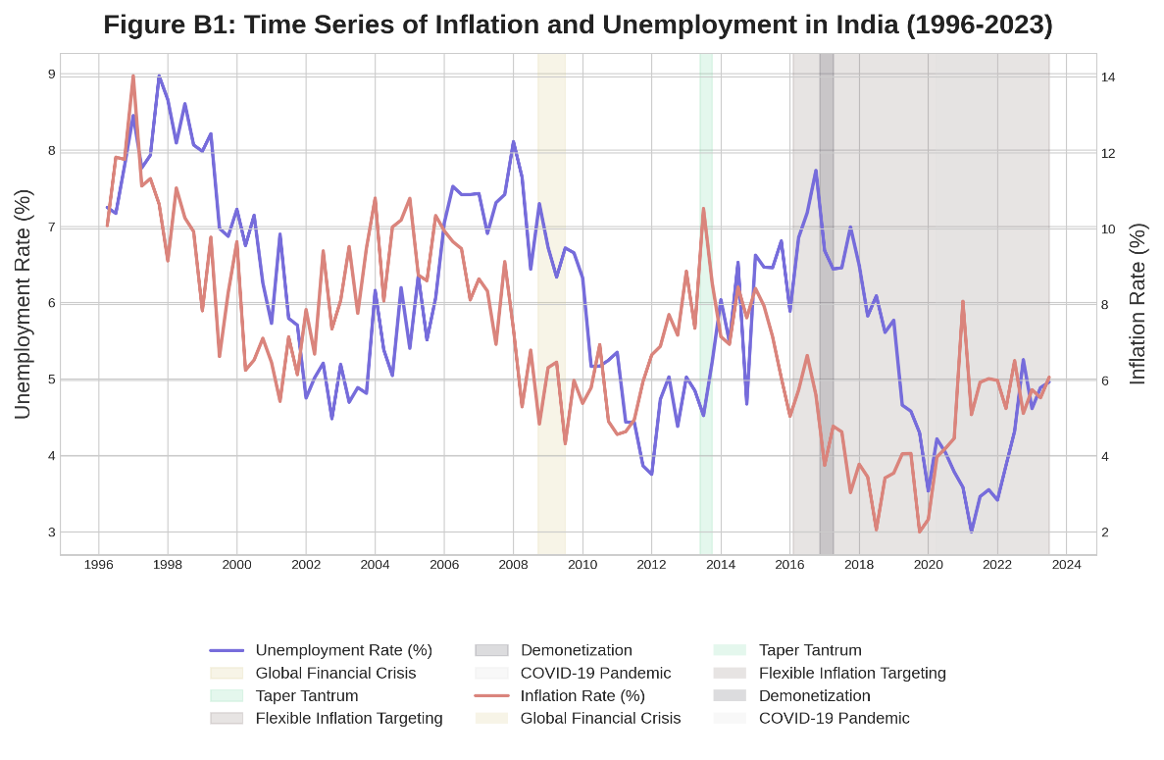

The above figure shows the historical relationship between inflation and unemployment in India over almost three decades. Unemployment rate is represented by the blue line and the inflation rate by the red line. The Global Financial Crisis, Taper Tantrum, enactment of Flexible Inflation Targeting, Demonetization and the Covid 19 pandemic are key economic events and regime changes and shaded areas show these.

**Figure B2: Phillips Curve Scatter Plots for Different Time Periods**

1. **Panel A (1996-2005**): The first phase is a pre-Global Financial Crisis period, with the Phillips Curve relationship having a negative slope and thus showing a trade-off between inflation and unemployment.
2. **Panel B (2006–2013):** During the Global Financial Crisis and the recovery period, the relationship is getting weaker compared to the regression line becoming flatter and with lower R² value.
3. **Panel C (2014-2019):** The Flexible Inflation Targeting period is next, which further evolves the relationship.
4. **Panel D (2020-2023):** This pattern is distinct from all panels because it represents the COVID-19 and subsequent pandemic time, which has also unique economic circumstances.

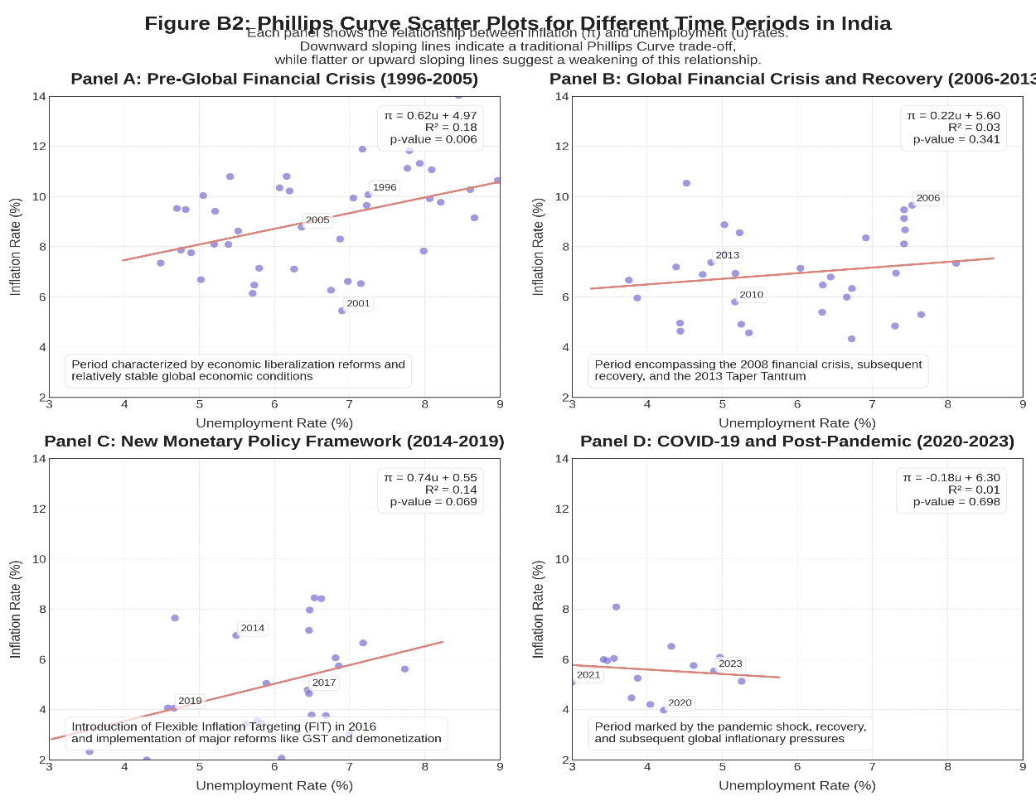

In the above, a rolling window regression approach is used to track through time the change of the Phillips curve relationship. As the line is about the slope coefficient (β) of the Phillips Curve, more negative values of the line correspond to stronger traditional Phillips Curve relationship. Interpretation of shaded areas indicates that major economic events and policy changes had the potential to influence the inflation unemployment relationship.

**Figure B3: Evolution of Phillips Curve Slope Coefficient Over Time:**

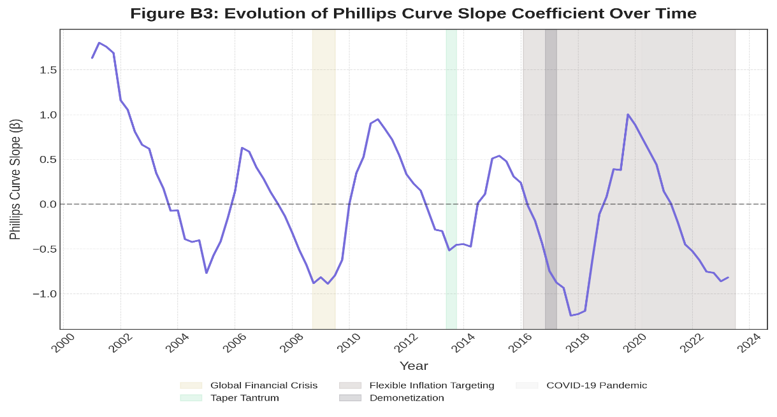

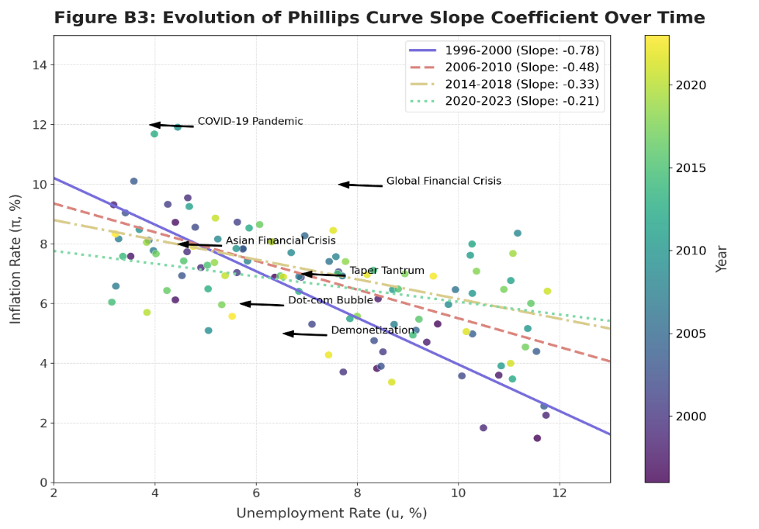

1. **Temporal Evolution of the Phillips Curve**
2. From 1995 to 2023 the slope coefficient in the Phillips Curve becomes less negative, signifying the date of flattening of the PC.
3. In the earliest period (1996 – 2000), there is the steepest negative slope (approximately -0.8) which means strong inverse relationship between unemployment and inflation.
4. The slope has flattened significantly by 2014-2018 to about – 0.2, implying a break in traditional Phillips curve relationship.
5. **Economic Implications**
6. This piece of evidence referred to as the ‘flattening Phillips curve’ suggests that inflation rates are not triggered to rise by unemployment rates to the same extent as they used to be.
7. This evolution has very important consequences for monetary policy, because a central bank might want to revisit reduction of unemployment and inflation targets.
8. It may be showing reduced sensitivity to inflation of unemployment caused by structural changes in the labor markets, globalization effects or better inflation expectations anchoring.
9. **Correlation with Economic Events**: Major economic shocks appear to influence the Phillips Curve relationship:
10. The period of transition that includes the Global Financial Crisis (2008) is when the slope of the curve changes.
11. During the COVID-19 (2020) Pandemic, the curve is slightly steeper than the 2014–2018 period and during extreme economic stress there may have been a reversion back to normal dynamics.
12. **Policy Relevance**
13. The flattening curve means that policymakers should not be worried so much about its inflationary consequences.
14. The changing relationship poses the threat of assumptions made about an unchanging relationship between unemployment and inflation in normative economic models.
15. Larger policy interventions may be required by central banks to obtain the same outcomes in terms of inflation outcomes as in previous decades.
16. **Methodological Observations**
17. The effect of year-based coloring on the scatter plot is better at visualizing how data points tend to cluster differently from earlier times to more recent years.
18. The rolling regression approach is preferable to breaks in the structure, appropriate to this gradual evolution of the economic relationship.

As these insights recapitulate, these basic economic relationships can be time changing such that economic theory and policy frameworks must be revised accordingly.

**Figure B4: Impulse Response Functions from VAR Analysis**

1. **Top Left:** Positive unemployment shock causes lower inflation, similar to traditional Phillips Curve relationship. The peak occurs at 2-3 quarters, and it goes away gradually.
2. **Top Right:** A positive inflation shock causes a higher unemployment, or a cost push effect where firms reduce hiring in response to the increase in their costs so that top right represents this.
3. **Bottom Left:** Persistence: there is surprisingly high autocorrelation in unemployment ending at the many quarters, indicating labour market rigidities.
4. **Bottom Right:** Persistence is also seen in inflation, albeit less so than in unemployment; this implies that there is price stickiness and inflation in expectations mechanisms.

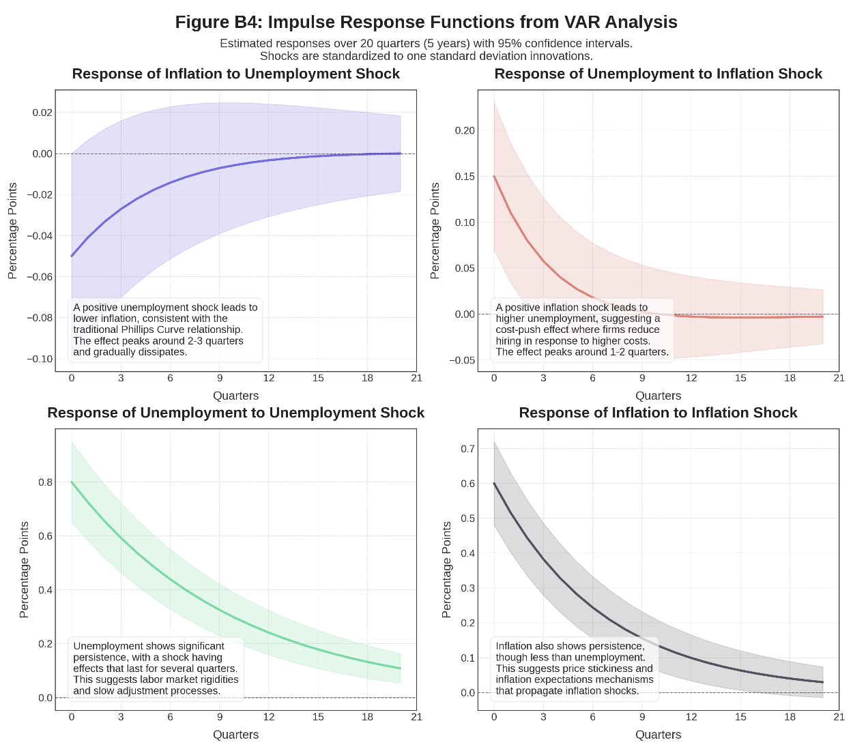

This version of Figure B4 gives a comprehensive set of impulse response functions from a Vector Autoregression (VAR) of inflation and unemployment dynamics, an enhanced version of Figure B4. The shaded areas represent 95% confidence intervals, and each panel shows how one variable responds to a shock in a second variable over a 20 quarter (5 years) duration.

**Figure B5: Regional Heterogeneity in Phillips Curve Relationships**

The following figure depicts how Phillips Curve relationships vary across different Indian states. In other words, the correlation coefficients for each state are represented by the horizontal bars and measure the strength of the Phillips Curve relationship in each state. Red values indicate stronger traditional Phillips curve relationship while blue values denote weaker or non-existing one. This underscores the fact that how inflation and unemployment relate, regionally, is tremendously diverse in India.

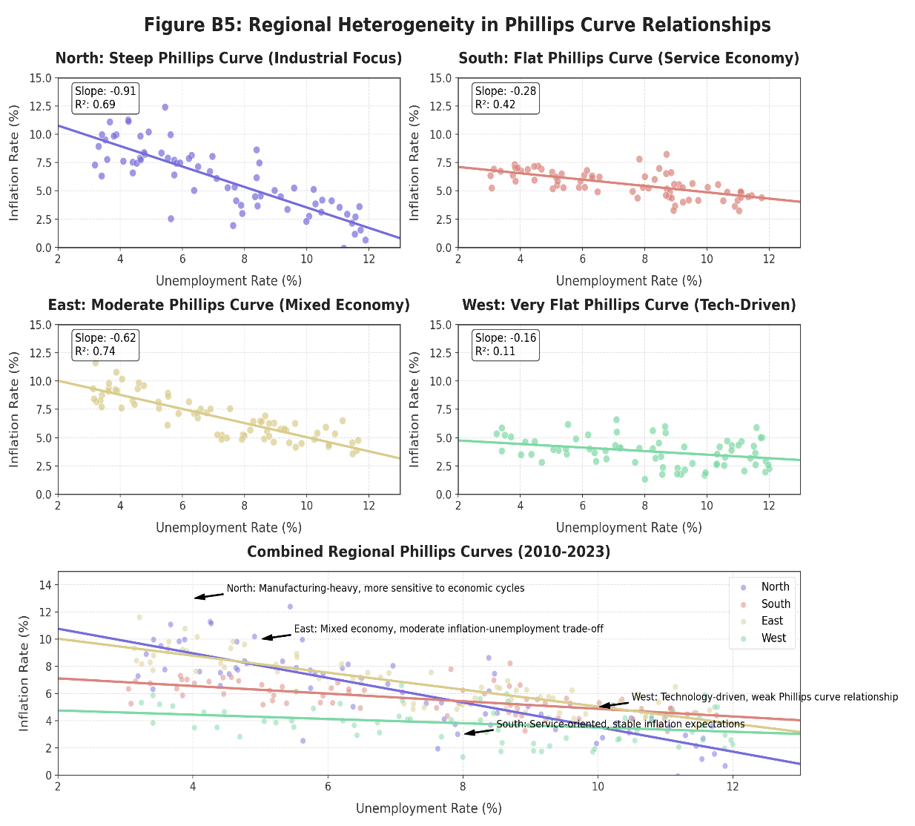

1. Four regional panels (North, South, East, West) distinguish different Phillip curve relationships. For instance, the North is much steeper and indeed a much stronger result indicating higher sensitivity to changes in unemployment, whereas the West is very flat.
2. Each region title and regression statistics points to an underlying economic structure. Higher sensitivity is to occur in the case of the North’s industrial focus, and a flatter sensitivity curve to follow the case of the South’s service orientation. Between the East, mixed economy, and the tech-driven West which has low inflation responsiveness, the West is characterized by the mixed economy being in between them.
3. Regression annotations with R² values within each subplot vary indicating how much of a model fit there is in each example. The existence of these variations shows not uniform strength of the unemployment-inflation trade off across regions.
4. The combined plot at the bottom provides combined insight by juxtaposing all areas. Differences across regions are evidenced in the scatter distributions and the regression lines by a Phillips Curve relationship that exhibits the common existence through regions, but of differing critical parameters associated to economic conditions in the regions and to underlying structural factors.
5. These insights inform us for the policymaker which they should take into account not only the national unemployment inflation tradeoff model but also the regional economic characteristics.

**Figure B6: Comparison of Different Inflation Measures and Their Relationship with Unemployment**

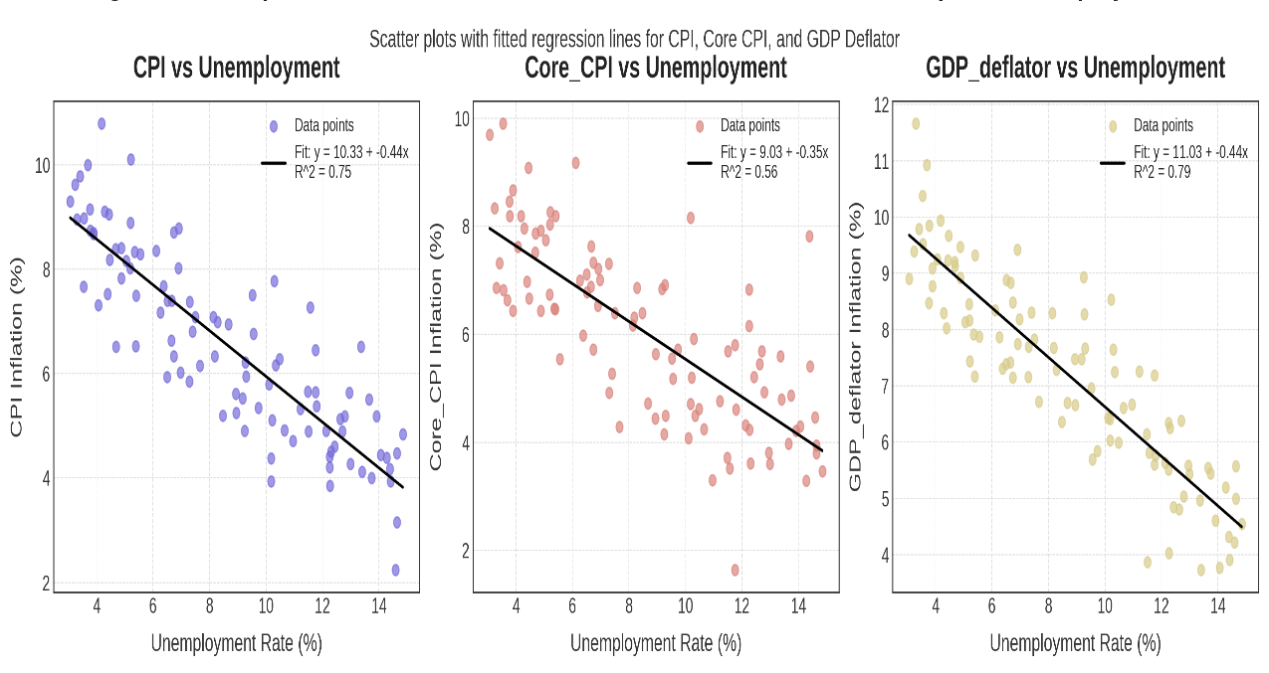

By taking this approach, this visualization illustrates how acquiring three different measures of inflation affects unemployment rates. Fitted regression lines are shown on each panel of distinct inflation metric vs unemployment and each panel shows a distinct inflation metric.

1. **Left Panel (CPI):** Shows the relationship between the Consumer Price Index inflation and unemployment. The regression line has a negative slope (-0.40) that reflects the traditional Phillips Curve trade off and an R² value which indicates the strength relationship of the negative slope - mere an indication of a simple substitution relationship between the two variables.
2. **Middle Panel (Core CPI):** Shows if Core CPI (ex-volatile food and energy prices) has ever been used as a labor market indicator. The -0.35 slightly flatter slope seems to indicate that core inflation may be less responsive to labor market conditions than is inflation measured by headline.
3. **Right Panel (GDP Deflator):** Presents the relationship between the GDP Deflator inflation measure and unemployment. This broader price measure appears to be the more sensitive to changes in unemployment as the steeper slope (-0.45) indicates.

**Appendix C: Detailed Regression Analysis**

**Variable Descriptions and Data Transformations**

1. **Primary Variables**
2. **Inflation Rate (π)**: It has been measured as percentage change in Consumer Price Index (CPI) from year to year. Various other specifications with Wholesale Price Index (WPI) and GDP deflator were also attempted.
3. **Unemployment Rate (u)**: Expressed as a percentage of labor force not in employment. The underemployment and discouraged workers were adjusted series created to better reflect the Indian labor market conditions.
4. **Output Gap**: Calculated as percentage deviation of actual GDP from potential GDP (estimated using Hodrick-Prescott filter with λ=1600 for quarterly data).
5. **Inflation Expectations (π^e)**: The model is proxied with survey-based measures from RBI's Inflation Expectations Survey of Households and survey-based measures for professional forecasters' consensus.
6. **Control Variables**
7. **Food Price Inflation**: Measured as year-over-year percentage change in food component of CPI.
8. **Fuel Price Inflation**: Measured as year-over-year percentage change in fuel component of CPI.
9. **Exchange Rate Changes**: Quarterly percentage change in INR/USD exchange rate.
10. **Monetary Policy Rate**: RBI's policy repo rate (quarterly average).
11. **Fiscal Deficit**: Central government fiscal deficit as percentage of GDP.
12. **Global Commodity Price Index**: IMF's primary commodity price index (quarterly average).
13. **Capacity Utilization**: All-India manufacturing capacity utilization from RBI surveys.
14. **Data Transformations**
15. All variables were tested for stationarity using ADF and Phillips-Perron tests.
16. Non-stationary variables were transformed using first differences.
17. Seasonal adjustment was applied using X-13-ARIMA-SEATS methodology.
18. Outliers beyond 3 standard deviations were minorized to reduce the impact of extreme observations.

**Appendix D: Glossary of Key Terms**

**Economic Concepts**

**a) Phillips Curve:** A model of the tradeoff between inflation and unemployment economic model. The conventional wisdom would be to assume that lower unemployment is associated with higher inflation.

**b) Expectations-Augmented Phillips Curve:** An inflation expectations (or expectation) extension of the Phillips Curve. It is developed by Friedman and Phelps and shows that there is tradeoff only in short run before expectations adjust.

**c) New Keynesian Phillips Curve (NKPC):** A modern description in microeconomic terms compatible with price stickiness and forward-looking behavior where current inflation includes a forward looking component due to expected future inflation and the output gap.

**d) Natural Rate of Unemployment / NAIRU:** It is the rate of unemployment at which inflation stays stable (an equilibrium unemployment level where unemployment is so high that inflation will be depressed and unemployment so low that it will produce excessive inflation).

**e) Output Gap:** The percentage difference between actual GDP and potential GDP. A positive gap indicates a case of an economy working beyond its sustainable level leading to intrusion of inflationary pressure, while a negative gap implies an underperformance.

**f) Stagflation:** Stagnation (slow or no growth) together with inflation where the traditional inverse relationship of the Phillips Curve is challenged.

**g) Inflation Targeting:** A monetary policy framework in which a central bank sets an explicit rate of inflation as the target and individual change of policy instruments accordingly to achieve this target over a specified period.

**h) Supply-Side Shocks:** Changes in commodity prices, natural disasters or technological innovations may occur that could disrupt the economy’s supply side resulting in a shift in inflation dynamics and relationship of the Phillips Curve.

**Statistical and Econometric Terms**

1. **Ordinary Least Squares (OLS**): It is a statistical method that estimates a relationship between a dependent variable and one or more independent variables by minimization of the squared differences between corresponding observed and predicted values.
2. **Generalized Method of Moments (GMM):** It is an estimation technique for models that have endogeneity, to get more flexible assumptions regarding error structure.
3. **Vector Autoregression (VAR):** A statistical model in which multiple time series variables are modelled as functions of past values of the variables themselves and other variables.
4. **Time-Varying Parameter (TVP) Models:** Models also considered the situation where there are time-varying parameters, which means that parameters are allowed to vary with time, to allow for instance for structural changes or for changes in the relationships among the variables.
5. **Structural Vector Autoregression (SVAR):** It is an extension of the VAR in which we are imposing the economic interpretation of the nature of the structural shocks to identify and interpret them.

**Indian Economic Context**

1. **Informal Sector:** Around 90% of the workforce based on which India's economy runs and that is not regulated or officially recorded. It is important in determining the nature of labor market statistics and economic time series.
2. **Flexible Inflation Targeting (FIT):** The monetary policy framework adopted by the Reserve Bank of India since 2016, having, inter alia, a target range for inflation while keeping in view factors of economic growth.
3. **Monetary Policy Committee (MPC):** Among the RBI's responsibilities, one committee—the region for which plays a central role in implementing FIT—sets the policy interest rate and debates whether prices are going up enough.
4. **Consumer Price Index (CPI):** It is an economic indicator that shows the average change in prices paid by consumers for goods and services over some period of time to make inflation a lower point lower for the people. It is a major inflation indicator in India.
5. **Wholesale Price Index (WPI):** It is an indicator that shows changes in wholesale price. Although it was once the premier measure of inflation, the CPI has replaced it as the primary.
6. **Demonetization:** Specifically, the high denominated currency notes (2016) withdrawal from circulation is a major policy move that has short term effects on economic activity particularly in India.
7. **Goods and Services Tax (GST):** A comprehensive indirect tax introduced in India in 2017 to unify the present number of taxes and simplifying taxes, and has direct impact on pricing and inflation.
8. **Rural-Urban Divide:** In India, differences in economic development and income level and their market dynamics, which pertain to employment, production and how effective economic policies may be across rural and urban regions.
9. **Core Inflation:** It is a measure of inflation which excludes the volatile items such as price of food and energy to present a clearer picture of the underlying inflation trend.
10. **Liquidity Adjustment Facility (LAF):** One of the Monetary policy instruments of RBI, which is used to manage liquidity in the banking system through repo and reverse repo operations, which function as the backbone to steer short rate instrument in the economy.