**Original Research Article**

**Selection of Representative Countries in Sino-African Economic and Trade Research-An Analysis from a Logistics Perspective**

**ABSTRACT**

**Aims:**Through the analysis of logistics capabilities, this study provides a more concrete basis for selecting sample countries in the research on Sino-African trade issues.

**Study design:**Using official data sources such as the United Nations, World Bank, International Monetary Fund ( IMF ), China National Knowledge Infrastructure ( CNKI ), and China Customs, this study adopts a logistics capability analysis perspective and selects African sample countries suitable for academic research, taking into account the structure of Sino-African trade.

**Place and Duration of Study:**Sino-African trade data from 2015 to 2024, as recorded by China Customs.

**Methodology:**By analyzing the total trade value between China and Africa from 2015 to 2024, the top 10 countries in terms of total trade volume in each year are selected. Then, the frequency of occurrence in these countries is analyzed. Finally, the selected countries are confirmed by analyzing the level of logistics infrastructure in African countries.

**Results:**In the statistical data from 2015 to 2024, six countries—Ghana, South Africa, Egypt, Angola, Nigeria, and Algeria—appeared with a frequency of 10. The Democratic Republic of the Congo, Kenya, Tanzania, and Morocco appeared with frequencies of 9, 8, 6, and 5, respectively. The Republic of the Congo and Liberia appeared with a frequency of 3, while Guinea, Libya, and Ethiopia appeared with a frequency of 2.

**Conclusion:**Ten countries – Ghana, South Africa, Egypt, Angola, Nigeria, Algeria, Democratic Republic of the Congo, Kenya, Tanzania and Morocco – are the most suitable countries for the sample. Among them, South Africa has the most outstanding capabilities in air transport and rail transport; Egypt has the most outstanding capabilities in container port transportation; Morocco is the most capable in liner shipping.

*Keywords: Sino-African; Economy; International trade; Logistics; supply chain*

**1. INTRODUCTION**

On September 4, 2024, at the Beijing Summit of the ninth Forum on China Africa cooperation, the president Jinping Xi delivered a speech, saying that without the modernization of China and Africa, there would be no modernization of the world (Xi, 2024). At the world economic forum from January 20 to 24, 2025, Africa is considered to be the forefront of economic growth. With the deepening of economic and trade cooperation between China and African countries, domestic scholars' attention to China Africa economic and trade cooperation continues to rise, and relevant research continues to increase (Mao, 2022). The research scope has gradually expanded from the initial trade and investment fields to energy, agriculture, infrastructure, digital economy and other fields. Research in these areas not only helps to deepen China Africa economic and trade cooperation, but also provides strong support for the economic development of African countries. However, in the research of China Africa economic and trade cooperation, researchers on the one hand still focus on the research of macro policies, on the other hand, they mainly stay in the business environment of African countries, China Africa investment and other fields, and rarely explain the reasons for the selection of sample countries. In view of this, in order to ensure that the selected African countries in the future research can be well representative, the author decided to analyze African countries from the perspective of logistics and ultimately select the most representative African countries.

1. **THE CHOICE OF LOGISTICS PERSPECTIVE**

Infrastructure construction is the cornerstone of Africa's development, and improving infrastructure is the common expectation and urgent desire of African countries (Tong et al, 2024). The 2025 Africa Energy Summit held in Tanzania highlighted the problem of power shortage faced by Africa. At present, expanding power supply is one of the most urgent challenges facing Africa's development. About 43% of the people on the African continent still have no access to reliable power supply. Over the past 20 years, China's development financial institutions and commercial banks have played an important role in financing energy infrastructure across the African continent. At the Beijing Summit of the Forum on China Africa Cooperation held in September 2024, China announced its support for Africa's implementation of 30 clean energy and green development projects. In addition to power generation investment, one third of China's investment is used for power grid expansion in Africa. As the "ballast stone" and "propeller" of China Africa relations (Lin et al, 2024), the importance of China Africa economic and trade cooperation is increasingly prominent. The foundation of economic and trade cooperation lies in the development level of logistics between China and African countries. International logistics, as a bridge and link connecting countries around the world, plays a fundamental and key role in today's diversified trade patterns.

With the development of cross-border e-commerce, the demand for international logistics and transportation between China and Africa continues to increase, and the air transportation of e-commerce goods has increased significantly. According to CAAC's 2023 statistical bulletin, by the end of 2023, China had signed 27 bilateral air transport agreements with African countries or regions, further improving transport efficiency and broadening China Africa's transport channels (Tong et al, 2024). Guided by the high-quality opening-up policy, China's cross-border logistics scale is continuously expanding, and the efficiency of cross-border transport and the level of multi-national intermodal transport are also continuously improving. From January to November in 2024, the import and export cargo volume supervised by China's customs reached 509.2034 million tons, an increase of 4.8% compared with last year. Among them, the import freight volume was 3309.985 million tons, up 3.9% year-on-year compared with last year; The export freight volume was 178.2048 million tons, up 6.4% year-on-year compared with last year. During the same period, the total number of inbound and outbound means of transport supervised by China's customs was 36380567 vehicles/vessel, an increase of 27.7% compared with last year. Among them, 30990339 inbound and outbound cars, 4224564 inbound and outbound trains, 365135 inbound and outbound ships, and 800529 inbound and outbound aircraft increased by 29.5%, 13.3%, 8.0% and 68.8% respectively year-on-year compared with last year (see Table 1).

**Table 1 Statistical Express of China Customs Freight Supervision Business from January to November 2024**

|  |  |  |  |  |
| --- | --- | --- | --- | --- |
| **Indicator Name** | **Unit** | **Total volume from January to November** | | |
| **this year** | **Last year** | **±%** |
| Import and export freight volume | 10000 tons | 509203.4 | 486096.3 | 4.8 |
| import | 10000 tons | 330998.5 | 318636.7 | 3.9 |
| export | 10000 tons | 178204.8 | 167459.6 | 6.4 |
| Total number of inbound and outbound means of transport | Vehicle/vessel | 36380567 | 28478775 | 27.7 |
| vehicles | Vehicle | 30990339 | 23937786 | 29.5 |
| trains | section | 4224564 | 3728738 | 13.3 |
| vessels | ship | 365135 | 338087 | 8.0 |
| aircraft | plane | 800529 | 474164 | 68.8 |

*Data source: General Administration of Customs of the people's Republic of China*

With the rapid development of cross-border logistics, China can give better play to the global allocation of resources, so as to improve the level of domestic economic development. Therefore, logistics is indispensable for a country's economy. It is scientific to divide African countries based on logistics capacity and select appropriate representative countries.

1. **THE OVERVIEW OF SINO-AFRICA ECONOMIC AND TRADE RELATIONS**

As a post-development region, Africa has long had the typical characteristics of a "post-colonial" economy, with a single economic structure, high dependence on the European and American markets, and limited investment attractiveness (Sheng et al, 2022). Since the beginning of the 21st century, the prices of bulk commodities and resource commodities in the international market have risen sharply, transportation prices have fallen sharply, and foreign direct investment has been very active (Qi, 2015), and the economies of African countries have achieved relatively good development during this period. However, Patterson.C. Ekocha (Patterson & Ekocha et al, 2020). argue that rapid market liberalization will lead to a surge in imports from developing countries, adversely affecting the local industrial and agricultural sectors, as well as the balance of payments and debt situation. Moreover, the African economy's role as net recipients of trade conflicts in countries such as China, the United States, the United Kingdom, Japan, the European Union, and Canada, coupled with the ongoing legitimacy challenge to the World Trade Organization, could lead Africa to shift from multilateralism to multipolarity. Duggan.Niall (Duggan & Niall, 2023) argues that the agency of African countries plays a non-negligible role in the relationship by discussing the structural and agency approaches in China-Africa relations. Relations between China and African countries will face a certain degree of challenge in the future.

According to the 2023 United Nations List of Least Developed Countries and the World Bank's Country Income Classification, 33 of Africa's 55 countries are LDCs. These countries are often characterized by low incomes, weak human capital, and fragile economies. Among them, Sao Tome and Principe has been approved by the United Nations and plans to graduate from the list of least developed countries in 2024. Despite its high per capita GDP, Djibouti remains a least developed country due to the apparent homogeneity and fragility of its economy. Due to the war in Somalia and South Sudan, there is a lack of systematic data (see Table 2).

**Table 2 List of Least Developed Countries in Africa in 2023**

|  |  |  |  |  |
| --- | --- | --- | --- | --- |
| **Country** | **Region** | **GDP per capita (USD)** | **economic structure**  **(main industries)** | **Unemployment rate (%)(year)** |
| Sierra Leone | West Africa  (12 countries) | 518 | Diamond, iron ore, agriculture | 3.2 (2021) |
| Niger | 610 | Uranium mining and animal husbandry | 0.8 (2021) |
| Liberia | 680 | Rubber, iron ore and ship registration | 3.7 (2022) |
| Guinea-Bissau | 820 | Cashew nuts, fishery | 3.2 (2020) |
| Gambia | 822 | Tourism, peanuts | 11.5 (2022) |
| Burkina Faso | 890 | Agriculture and mining | 5.1 (2021) |
| Mali | 890 | Gold, cotton | 6.4 (2021) |
| Togo | 973 | Phosphate, cotton, entrepot trade | 3.6 (2021) |
| Guinea | 1260 | Bauxite, agriculture | 5.9 (2021) |
| Benin | 1320 | Agriculture and port trade | 2.5 (2022) |
| Senegal | 1640 | Phosphate, fishery and service industry | 18.0 (2022) |
| Mauritania | 2210 | Iron ore, fishery and animal husbandry | 12.8 (2022) |
| Burundi | East Africa  (15 countries) | 259 | Agriculture,  self-sufficiency economy | 2.0 (2020) |
| Mozambique | 548 | Natural gas, coal | 24.5 (2022) |
| Madagascar | 579 | Vanilla, nickel mining, tourism | 2.1 (2021) |
| Eritrea | 642 | Mining and agriculture | —— |
| Malawi | 642 | Tobacco and agricultural assistance | 5.9 (2022) |
| Sudan | 714 | Gold mining, agriculture | —— |
| Rwanda | 1030 | Coffee, oil exploration and service industry | —— |
| Uganda | 1070 | Coffee, oil exploration and service industry | 2.9 (2022) |
| Ethiopia | 1090 | Agriculture and light industry | 19.1 (2022) |
| Tanzania | 1200 | Gold, tourism, agriculture | 2.6 (2022) |
| Zambia | 1310 | Copper mine, agriculture | 12.9 (2022) |
| Comoros | 1580 | Spices and fishery | 14.7 (2022) |
| Djibouti | 3670 | Port logistics, salt industry, military base leasing | 28.0 (2022) |
| Somalia | —— | Animal husbandry, overseas remittance | —— |
| South Sudan | —— | petroleum | —— |
| Central African Republic | Central African  (4 countries) | 511 | Diamond mining, forestry, agriculture | 6.3 (2022) |
| Chad | 710 | Petroleum, animal husbandry | 5.8 (2021) |
| Congo (DRC) | 660 | Cobalt, copper, agriculture | —— |
| Sao Tome and Principe | 2420 | Cocoa and Tourism | 14.2 (2021) |
| Lesotho | South Africa | 1220 | Textile industry, diamond mining, remittances | 24.6 (2022) |

*Date source: United Nations, World Bank, International Monetary Fund*

Taking China-Africa trade as an example, according to the Ministry of Commerce, China has maintained its position as Africa's largest trading partner for 15 consecutive years, and the scale of China-Africa trade has reached new highs, and the structure has been continuously optimized. At the same time, China is also the largest developing country in terms of investment in Africa (Wang, 2024). However, in the decades of trade between China and Africa, African countries' exports have always been in a weak position, that is, Africa has always been in a low value-added stage between the two. The author takes the categories and amounts of import and export products between China and Africa in January ~ October 2024 as the research object, and finds that although the trade balance between China and Africa is generally low, the products exported by Africa to China are mainly primary products, and the value appreciation level is generally low, such as minerals, leather products, rough jewelry, wood pulp, tobacco, etc. (see Table 3).

**Table 3 China Africa trade structure from January to October 2024**

|  |  |  |  |
| --- | --- | --- | --- |
| **Commodity classification** | **Africa exports to China** | **Africa imports from China** | **Proportion of exports in total** |
| Total amount | 558010086297 | 746042667705 | 42.79% |
| Mineral sand, slag and ash | 165789209434 | 100461670 | 99.94% |
| Rawhide (except fur) and leather | 371526075 | 2971454 | 99.21% |
| Jewelry raw stone, precious metal | 57114752219 | 496966581 | 99.14% |
| Mineral fuels and their distillates | 164922445385 | 1487781016 | 99.11% |
| Wood pulp and other fibrous cellulose pulp | 1317048552 | 15670069 | 98.82% |
| Copper and its products | 85013054231 | 1245118195 | 98.56% |
| Other base metals, cermets and their products | 13273466184 | 275260189 | 97.97% |
| Oily nuts and fruits | 14636721501 | 534474713 | 96.48% |
| Cork and cork products | 15757706 | 1338286 | 92.17% |
| Salt, sulfur, lime | 9056877999 | 885061431 | 91.10% |
| Tobacco and its products | 6375368417 | 643018473 | 90.84% |

*Data source: General Administration of Customs of the people's Republic of China*

In recent years, under the impact of the once-in-a-century pandemic and the Ukraine crisis, African regional organizations and countries have become more self-motivated, and their awareness and ability to govern independently have been enhanced (Zhao, 2023). The concept of "African way to solve African problems" originated from the rise of pan-Africanism, as an important concept of the African Union to promote African collective security, it emphasizes the use of African indigenous knowledge to solve African security problems, its essence is to pursue African autonomy, and the key is to emphasize the African way (Lou et al, 2023).

Due to the rapid growth of China's influence in Africa and the lack of sufficient understanding of China's policy towards Africa, some African think tank scholars such as Johanna Malm believe that African countries are often in a weak position in the process of China-Africa economic and trade cooperation, which may make some African countries worry about affecting the stability of their own regimes. At the same time, due to the relatively weak industrial production capacity of African local enterprises, the products they produce can be easily replaced by Chinese products, thus threatening the development of basic industries in African countries (Wang et al, 2023). The above situation has posed a great threat to the development of China-Africa friendship. Therefore, it is very important to enhance the understanding of the logistics situation of African countries and then choose the right location for direct investment, which is very important for the friendly development of China and Africa in the future.

1. **THE SELECTION OF SAMPLES FROM AFRICAN COUNTRIES**

Based on the total trade volume between China and Africa from 2015 to 2024 from the General Administration of Oceans of the People's Republic of China in the past ten years, the author takes the year, country and total trade volume of the year as variables, and uses Stata software to conduct statistical analysis of countries with a total trade volume of more than 100 billion yuan per year, and finds that the probability of South Africa and Angola in 100 years of total trade with China in the scale of 100 billion yuan is 100%, the probability of Nigeria is 70%, and the probability of Egypt is 50% , the Democratic Republic of the Congo corresponds to a probability of 30 per cent (see Table 4). That is, the economic and trade exchanges between South Africa, Angola, and Nigeria and China are closer than those of other African countries.

**Table 4 African countries with a total trade volume of billions in the past decade between China and Africa**

|  |  |  |  |
| --- | --- | --- | --- |
| **Country** | **Freq** | **Percent** | **Cum** |
| South Africa | 10 | 28.57 | 28.57 |
| Angola | 10 | 28.57 | 57.14 |
| Nigeria | 7 | 20.00 | 77.14 |
| Egypt | 5 | 14.29 | 91.43 |
| Democratic Republic of the Congo | 3 | 8.57 | 100.00 |
| Total | 35 | 100.00 |  |

*Data source: General Administration of Customs of the people's Republic of China*

Through further collation of data, the top ten African countries with the largest annual economic and trade exchanges with China are screened, and their frequency can be found that Ghana, South Africa, Egypt, Angola, Nigeria, Algeria, the Democratic Republic of the Congo, Kenya, these eight countries have closer economic and trade exchanges with China than other African countries, as an echelon. Tanzania, Morocco, the Republic of the Congo, Liberia, Guinea, Libya, and Ethiopia, the seven countries that have close economic and trade ties with China, are in the second echelon (see Table 5).

**Table 5 Top 10 African countries in terms of annual trade volume with China from 2015 to 2024**

|  |  |  |  |
| --- | --- | --- | --- |
| **Country** | **Freq** | **Percent** | **Cum** |
| Ghana | 10 | 10 | 10 |
| South Africa | 10 | 10 | 20 |
| Egypt | 10 | 10 | 30 |
| Angola | 10 | 10 | 40 |
| Nigeria | 10 | 10 | 50 |
| Algeria | 10 | 10 | 60 |
| Democratic Republic of the Congo | 9 | 9 | 69 |
| Kenya | 8 | 8 | 77 |
| Tanzania | 6 | 6 | 83 |
| Morocco | 5 | 5 | 88 |
| Republic of Congo | 3 | 3 | 91 |
| Liberia | 3 | 3 | 94 |
| Guinea | 2 | 2 | 96 |
| Libya | 2 | 2 | 98 |
| Ethiopia | 2 | 2 | 100 |
| Total | 100 | 100 |  |

*Data source: General Administration of Customs of the people's Republic of China*

To sum up, in the overall analysis of African countries, priority should be given to the eight countries in the first tier, supplemented by the countries in the second tier.

1. **LOGISTICS INDICATORS FOR MAJOR AFRICAN COUNTRIES**

Based on the China economic and social big data research platform provided by CNKI, the author takes 11 countries, including South Africa, Congo, Angola, Nigeria, Egypt, Guinea, Ghana, Algeria, Morocco, Tanzania, and Kenya, as the research area, and takes 2004-2023 as the research interval, and takes "Air transport, freight (million ton-km)" and "Liner shipping connectivity". index (maximum value in 2004 = 100)”、“Logistics performance index: Overall (1=low to 5=high)”、“Quality of port infrastructure, WEF (1 = extremely underdeveloped to 7 = well developed and efficient by international standards)”、“Railway, goods transported (million ton-km)”、“Road, paved (% of total roads)”、“Container port traffic (TEU: 20 foot equivalent units)”、“Rail lines (total route-km)" and "Road density (km of road per 100 sq. km of land area)" are used to measure the transportation capacity of the target area. The analysis process found "Quality of port infrastructure, WEF (1 = extremely underdeveloped to 7 = well developed and efficient by international standards)", "Road, paved (% of total roads)", "Road density (km of road per 100 sq. km of land area)" are missing. Data from 2020 onwards are also not available. Given the limited statistical capacity of African countries and the impact of the pandemic, the lack of data is too expensive to obtain, so the authors chose to use the remaining indicators to measure the transport capacity of the selected study area.

**5.1 Air Cargo Transport Capacity**

According to the results provided by the China Economic and Social Big Data Research Platform, in the statistical period, the most prominent air cargo transportation capacity of 11 countries is: South Africa, Egypt, Kenya, among which South Africa's air cargo transportation capacity is the most prominent. In order to facilitate the visual display of the data, after hiding the data of South Africa, Egypt and Kenya, the author found that the air cargo transportation capacity of the rest of the countries from large to small is: Morocco, Angola, AlGuinea, Nigeria, Ghana and Tanzania. Data are not available for Congo and Guinea (see Figure 1).

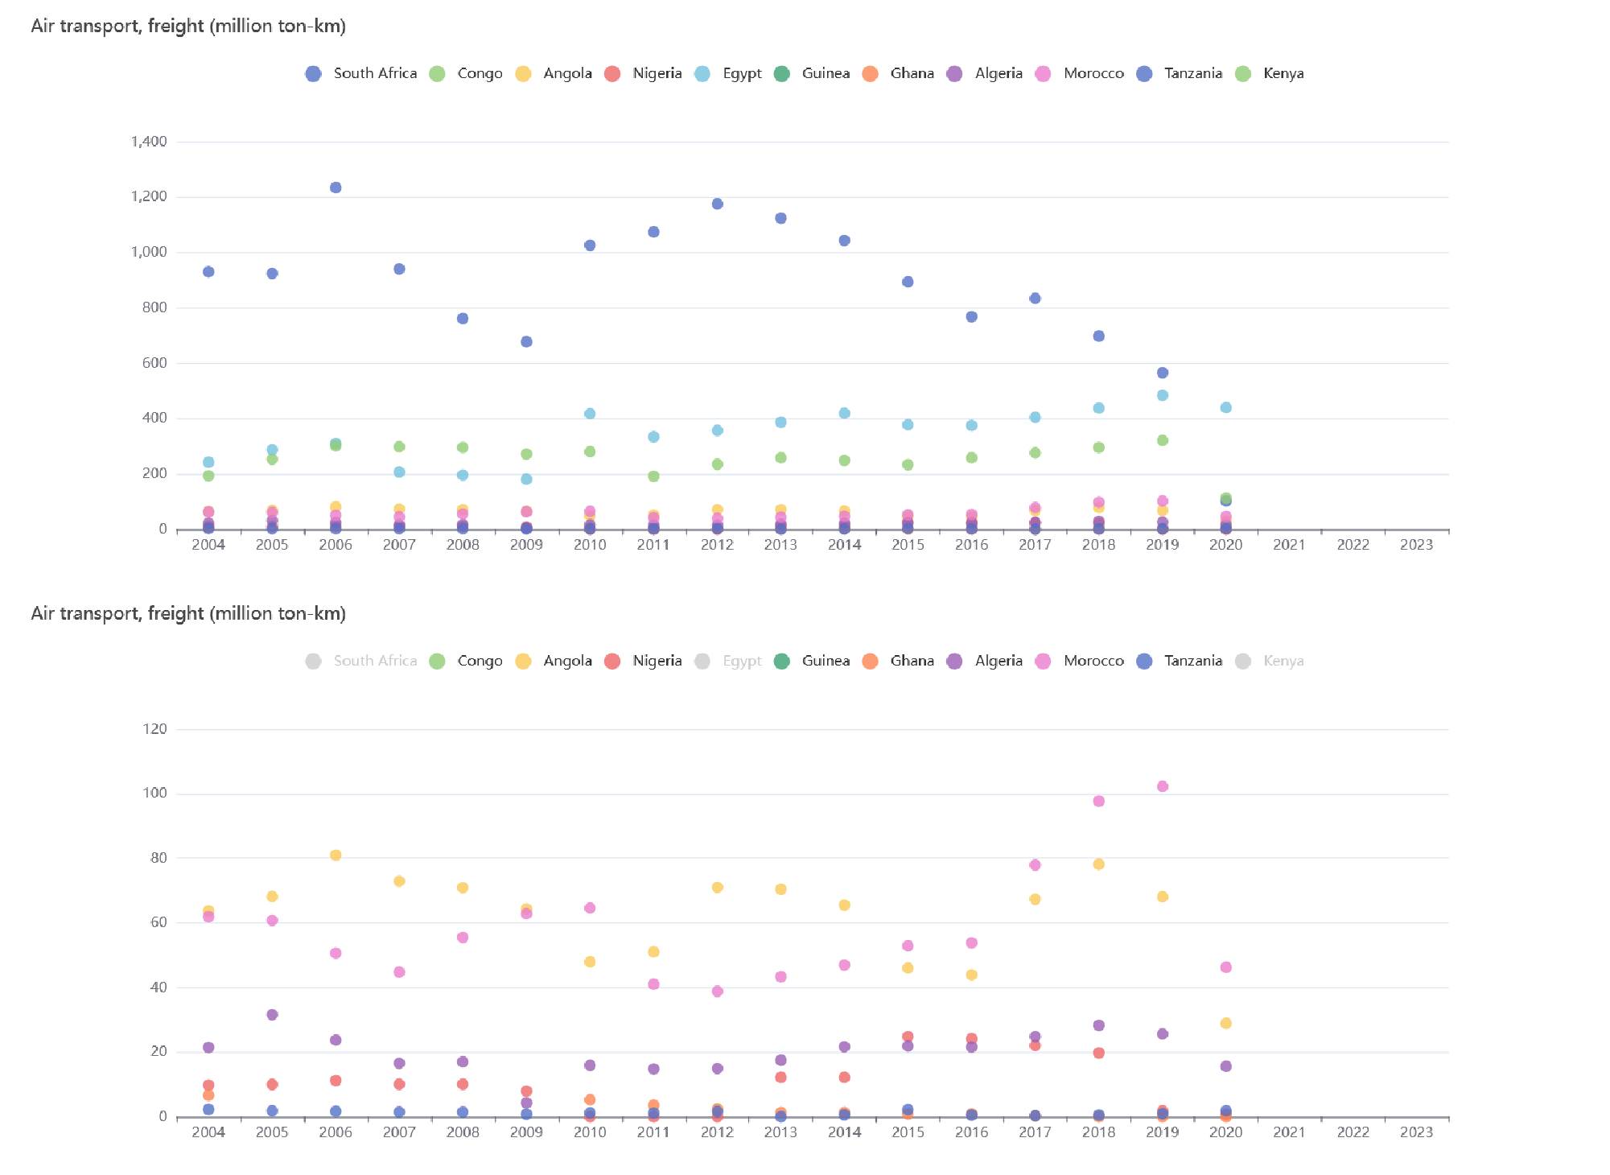

**Figure 1 Air transport, freight (million ton-km)**

*Data source: China Economic and social big data research platform*

**5.2 Liner Shipping Capacity**

According to the results provided by the China Economic and Social Big Data Research Platform, in the statistical period, the coherence indicators of liner shipping in 11 countries are: Morocco, Egypt, South Africa, Ghana, Angola, Nigeria, Kenya, Tanzania, Algeria and Guinea. Of these, data for Congo are missing (see Figure 2).

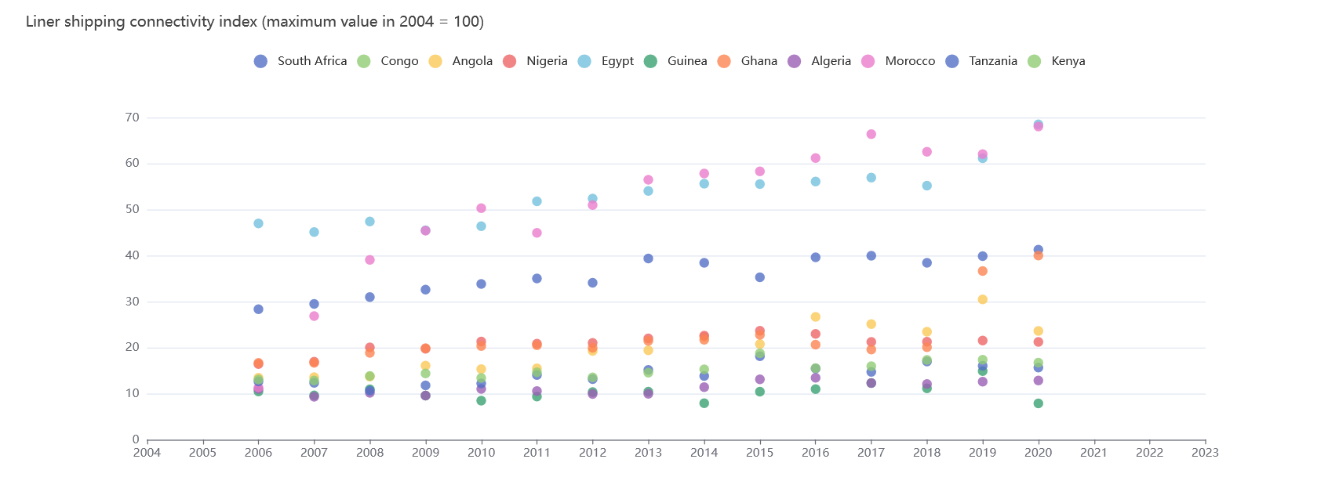

**Figure 2 Liner shipping connectivity index (maximum value in 2004 = 100)**

*Data source: China Economic and social big data research platform*

**5.3 Rail Cargo Transport Capacity**

According to the results provided by the China Economic and Social Big Data Research Platform, among the 11 countries, South Africa has the most leading railway freight transportation capacity and the most prominent advantages in the statistical period. In order to facilitate the visual display of the data, the author hides the data of South Africa and ranks the rest of the countries according to the railway freight transportation capacity from large to small: Morocco, Egypt, Algeria, Kenya, Tanzania, Ghana, and Nigeria. Among them, the relevant data of Congo, Angola and Guinea are missing (see Figure 3).

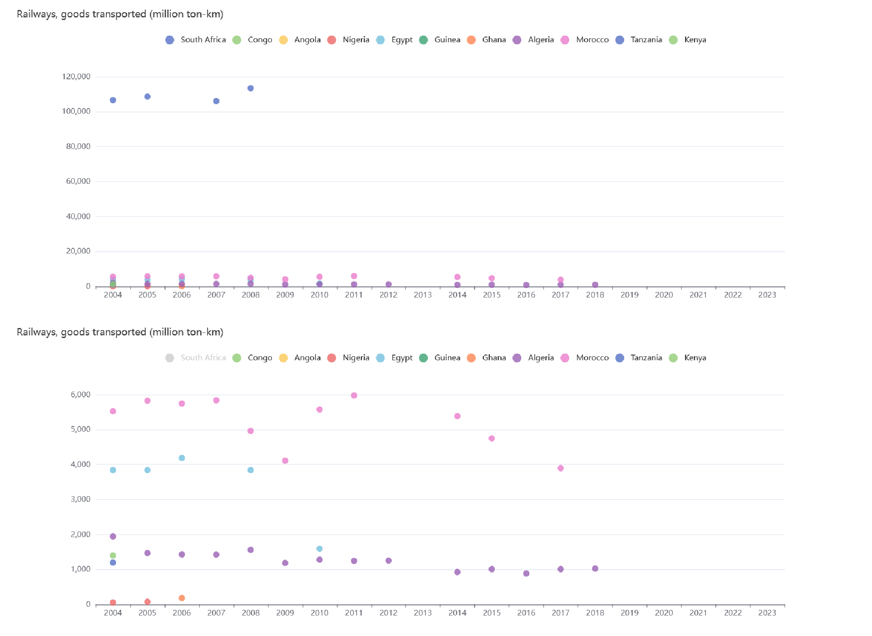

**Figure 3 Railway, goods transported (million ton-km)**

*Data source: China Economic and social big data research platform*

**5.4 Railroad Foundations**

According to the results provided by the China Economic and Social Big Data Research Platform, South Africa has the most outstanding total railway length among the 11 countries in the statistical period, which is consistent with the analysis of railway freight transportation capacity above. In order to facilitate the visual display of the data, after hiding the data of South Africa, the total railway length of the rest of the countries is in descending order: Egypt, Algeria, Nigeria, Tanzania, Morocco, Kenya, and Ghana. Among them, the relevant data of Congo, Angola and Guinea are missing (see Figure 4).

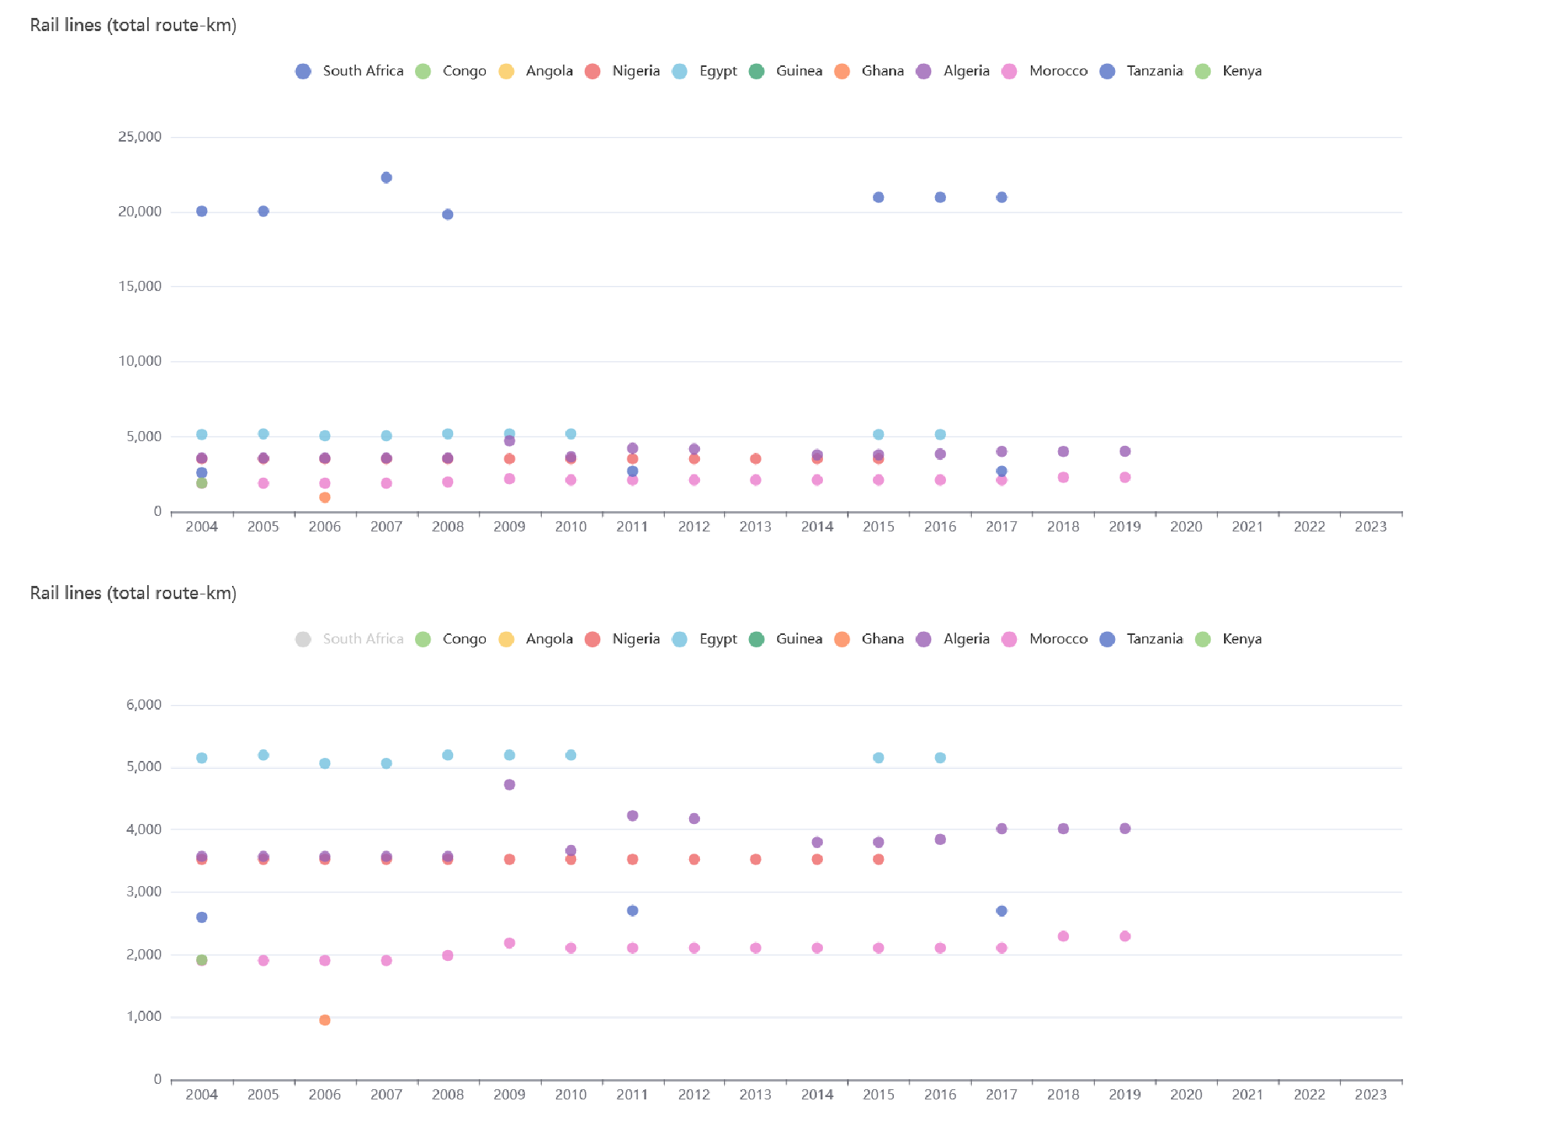

**Figure 4 Rail lines (total route-km)**

*Data source: China Economic and social big data research platform*

**5.5 Container Port Capacity**

According to the results provided by the China Economic and Social Big Data Research Platform, the container port transportation capacity of Egypt, South Africa and Morocco is the most prominent in the statistical period, among which the container port transportation capacity of Morocco is on the rise, and the container port transportation capacity of Egypt and South Africa is on the downward trend. In order to facilitate the data display, after hiding the data of Egypt, South Africa, and Morocco, the container port transportation capacity of the rest of the countries is as follows: Nigeria, Algeria, Kenya, Ghana, Angola, Tanzania, and Guinea. Among them, the relevant data of Congo is missing.

Further analysis shows that the container port capacity of Algeria and Nigeria increased rapidly between 2009 and 2011, but the container port capacity of Algeria has been decreasing since 2015. Container port capacity in Kenya and Ghana has been steadily increasing overall (see Figure 5).

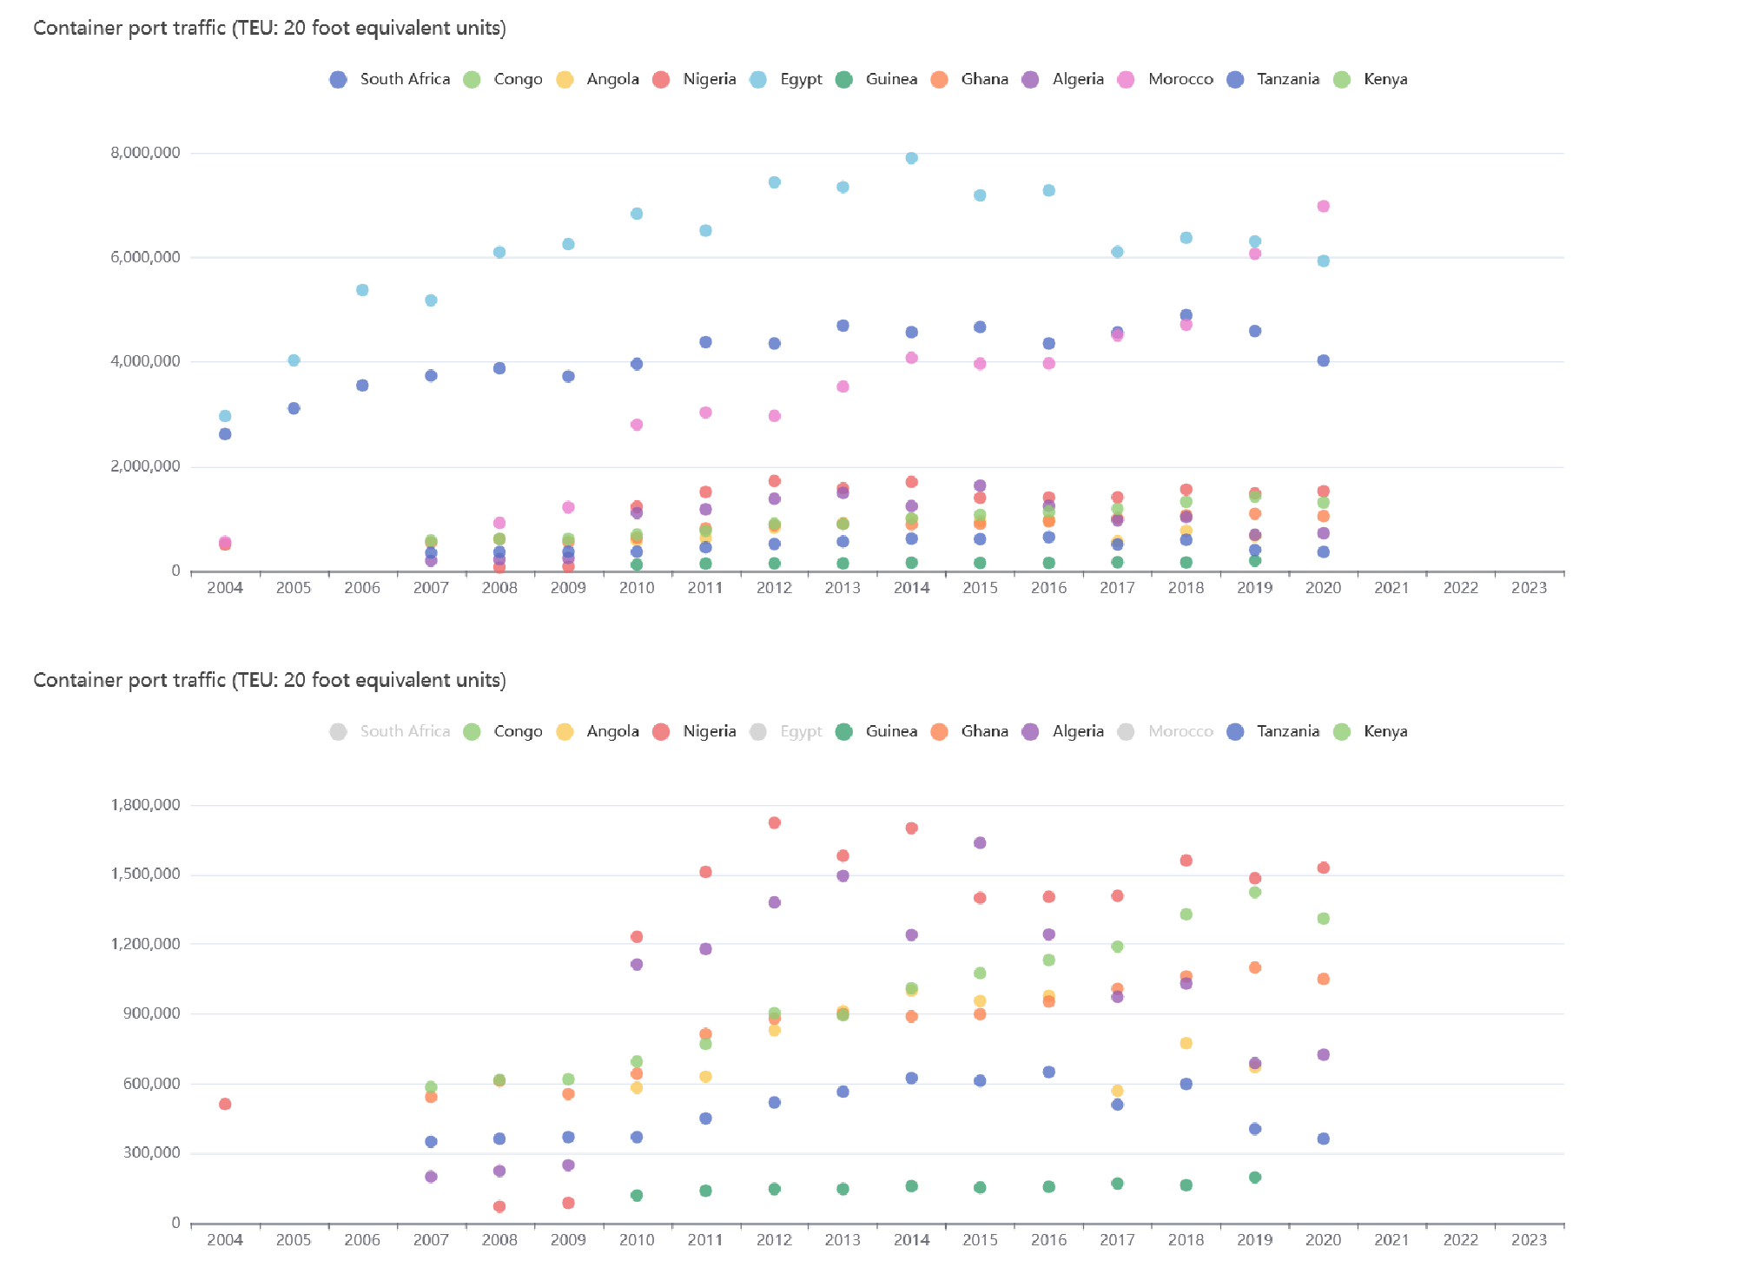

**Figure 5 Container port traffic (TEU: 20 foot equivalent units)**

*Data source: China Economic and social big data research platform*

**5.6 Overall Logistics Performance Indicators**

According to the results provided by the China Economic and Social Big Data Research Platform, the overall logistics performance of South Africa is the most outstanding in the statistical period, which corresponds to the above analysis results. The overall logistics performance of Kenya and Egypt is second only to South Africa and slightly larger than the third tier. The remaining countries are generally in the second to third tier (see figure 6).

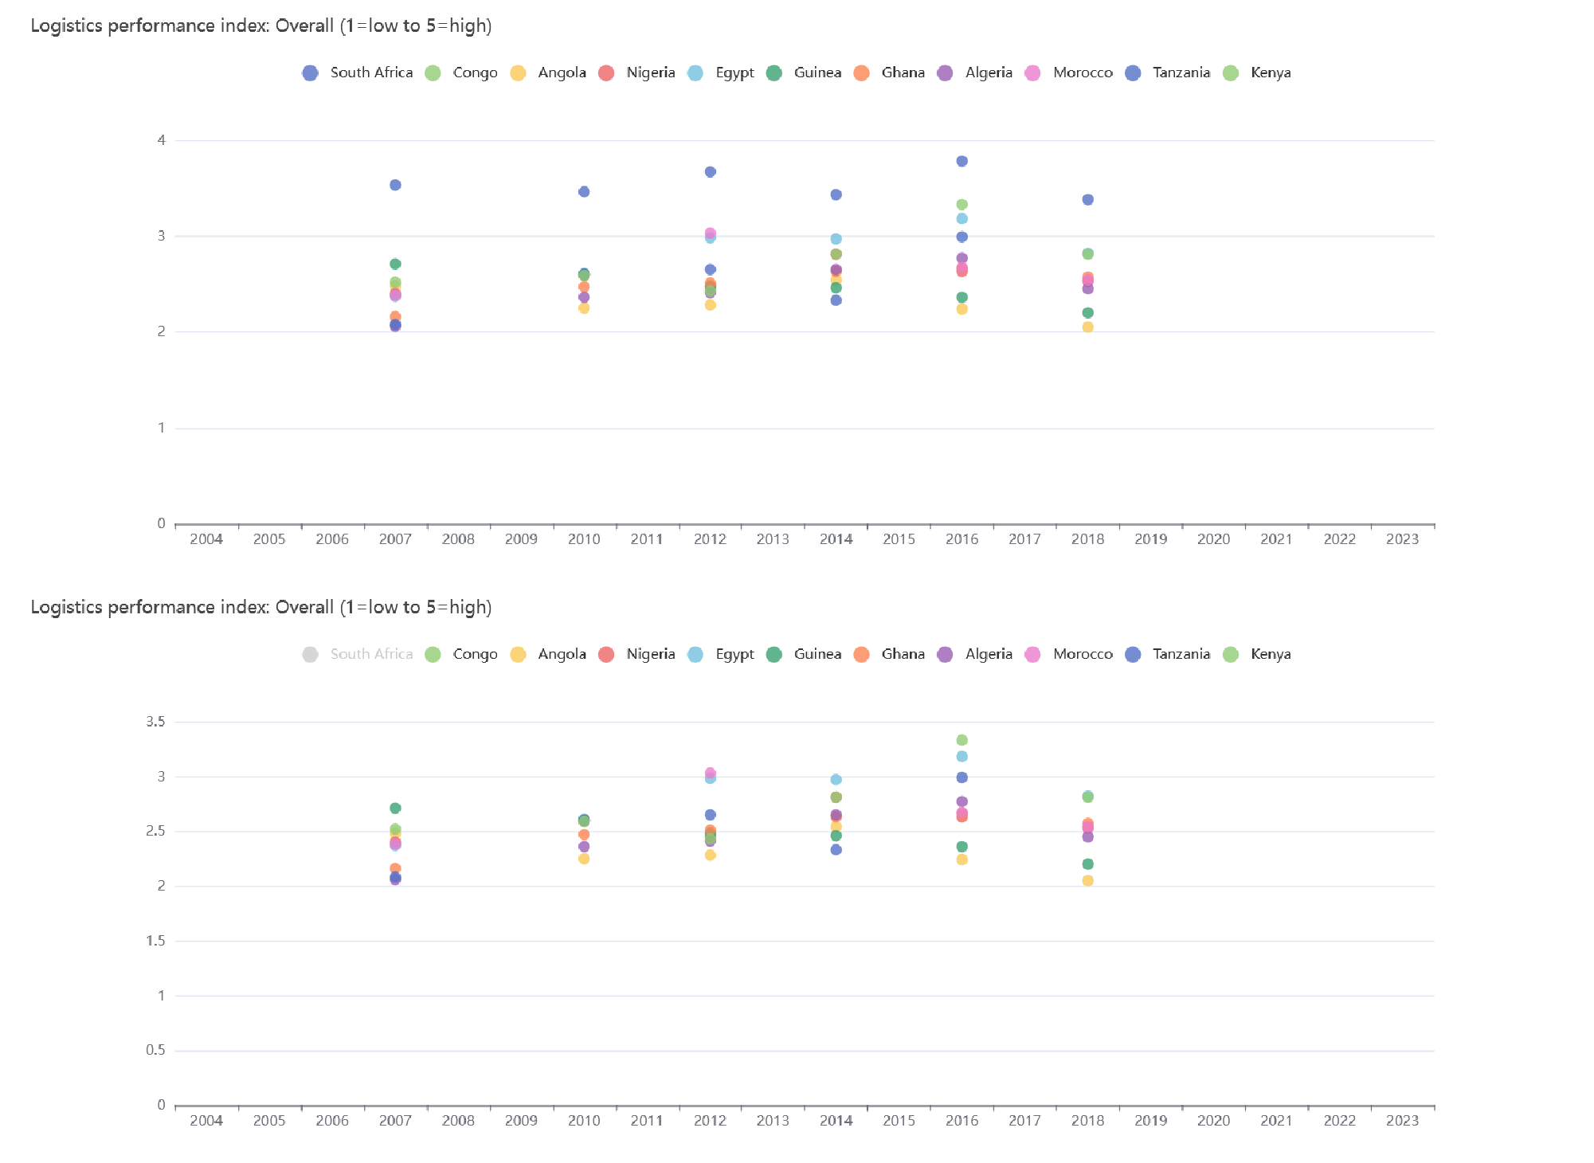

**Figure 6 Logistics performance index: Overall (1=low to 5=high)**

*Data source: China Economic and social big data research platform*

1. **CONCLUSION**

In summary, although Africa's logistics and transportation capacity has improved in recent years, it is still generally at a low level. Among them, South Africa has the most outstanding capabilities in air and rail transportation, followed by liner transportation and container port transportation; Morocco has the most outstanding capabilities in liner shipping, followed by rail and container port transportation; Egypt has the most outstanding capabilities in container port transportation, followed by liner transportation and rail transportation. Although the lack of data from Congo and some countries may cause some errors, it can be judged that South Africa, Egypt and Morocco are the countries with the strongest logistics capacity among African countries. Therefore, when studying China-Africa economic and trade exchanges, based on the consideration of sample representativeness and data acquisition cost, ten countries, namely Ghana, South Africa, Egypt, Angola, Nigeria, Algeria, the Democratic Republic of the Congo, Kenya, Tanzania, and Morocco, are the most suitable as sample countries, and Congo and Guinea are carefully selected as sample countries. Among them, South Africa has the most outstanding capabilities in air transport and rail transport; Egypt has the most outstanding capabilities in container port transportation; Morocco is the most capable in liner shipping.

**DISCLAIMER (ARTIFICIAL INTELLIGENCE)**

Author(s) hereby declare that NO generative AI technologies such as Large Language Models (ChatGPT, COPILOT, etc.) and text-to-image generators have been used during the writing or editing of this manuscript.

**REFERENCES**

Xi, J.P. (2024). Working Together to Advance Modernization and Build a Shared Future for Mankind – Keynote Speech at the Opening Ceremony of the Beijing Summit of the Forum on China-Africa Cooperation. China Industry & Economy, (17), 16-20.

Mao, X.J. (2022). Difficulties and breakthroughs in the high quality development of China Africa economic and trade cooperation -- Based on the analysis of enterprise questionnaire survey West Asia and Africa (06), 74-93+158-159

Tong, J.Y. & Zhang, L. (2024). Why is this two-way passage so popular Yantai daily, 003.doi:10.38267/n.cnki.nytrb.2024.002076

Lin, F. Liu, F.Y. & Jiang, L. (2024). Cross border logistics is more convenient and China Africa trade is more prosperous China Communications News, 001.doi:10.28099/n.cnki.ncjtb.2024.001694

Sheng, J.Y. & Liu, C. (2022). An analysis of the current situation, problems and prospects of China Africa economic and trade cooperation Asia Pacific economy (05), 123-129.doi:10.16407/j.cnki.1000-6052.2022.05.007

Qi, G.Q. (2015). African economic development and foreign capital inflow: trends and challenges International Economic Cooperation (09), 4-8

PATTERSON C. EKEOCHA & JONATHAN E. OGBUABOR. (2020). FROM MULTILATERALISM TO MULTI-POLARISM: A STUDY OF TRADE SHOCK TRANSMISSION BETWEEN SELECTED AFRICAN ECONOMIES, THE BRIC AND THE REST OF THE GLOBAL ECONOMY.The Singapore Economic Review(08),

Duggan. Nial. (2023). The agency problem in readings of Sino-African relations. African Affairs, 122(488), 461-475.

Wang, J.L. (2024). China - Africa economic and trade cooperation has yielded fruitful results People's Daily Overseas Edition, 003.doi:10.28656/n.cnki.nrmrh.2024.000510

Zhao, Y.T. (2023). The new characteristics and effects of Western powers' participation in African governance under the background of Africa's independent development West Asia and Africa (04), 88-109+158-159

Luo, J.B. &Sun, X. (2023). "Solving African problems in an African way": indigenous knowledge exploration of African collective security West Asia and Africa (05), 103-133+159

Wang, E. & Shen, Z.X. (2023). The construction and Enlightenment of African think tanks on Sino African Economic and trade cooperation issues Think tank theory and Practice (06), 92-101.doi:10.19318/j.cnki.issn.2096-1634.2023.06.10