**Seasonal Incidence and Abundance of Insect Fauna in Safflower (*Carthamus tinctorius* L.) of STZ of Telangana, India.**

.

ABSTRACT

A study was conducted at IIOR-Rajendranagar and IIOR-Narkhoda farms in Hyderabad during the *Rabi* season of 2023–2024 to assess the diversity, abundance, and correlation of insect pests with weather parameters. Insect populations were monitored weekly using pitfall traps, sweep nets, sticky traps, and visual counts. A total of 5,929 and 6,751 insect specimens, belonging to 50 families across 12 orders, were recorded. Among these, Diptera (12 families) and Hymenoptera (11 families) were the most dominant orders, followed by Hemiptera, Coleoptera, and Orthoptera. The seasonal incidence of major pests, particularly aphids, were analyzed in relation to meteorological factors such as temperature, relative humidity, evaporation, sunshine duration, wind speed, and rainfall. Aphid infestations were observed from the 48th Standard Meteorological Week (SMW) to the 9th SMW, with peak populations recorded in the 5th SMW. This study provides valuable insights into insect biodiversity and pest-weather interactions, aiding in the development of effective pest management strategies.

*Keywords: [Safflower, insect families, pest, correlation, weather parameter]*

1. INTRODUCTION

Safflower (*Carthamus tinctorius* L.) is an important oilseed crop cultivated in semi-arid regions such as India, Iran, Egypt, Pakistan and Mediterranean countries due to its high drought tolerance and adaptability to low-moisture conditions. In India, safflower is primarily grown in Karnataka, Maharashtra, and Telangana, with a total cultivated area of 1.09 lakh hectares, yielding 90,000 tonnes in 2022–2023 (Indiastat, 2022–2023). In Telangana, safflower is mainly cultivated in Vikarabad, Sangareddy, Nizamabad, Kamareddy, and Nirmal districts as a rainfed Rabi crop. Among the 36 insect species reported on safflower in India (Bharaj *et al*., 2003), the safflower aphid (*Uroleucon compositae* Theobald) is the most destructive, causing yield losses of 35%–72% in severe infestations (Ishaq *et al*., 2004). Aphid population dynamics are influenced by weather conditions. Studies indicate a positive but non-significant correlation with relative humidity (Patil *et al*., 2002) and a negative correlation with temperature (Akashe *et al*., 2008). Aphids typically appear during the pre-branching stage, with low temperatures, high humidity, and cloudy weather favoring their multiplication. As temperature rises and relative humidity declines, aphid population decrease, disappearing as the crop reaches physiological maturity. Understanding these environmental interactions is crucial for developing effective pest management strategies to minimize safflower yield losses.

2. material and methods

The study was conducted at IIOR- Rajendranagar farm and IIOR-Narkhoda farm, during 2023-2024 *Rabi* season, to assess insect diversity and pest populations in safflower crop. Insect collection was carried out at weekly intervals using multiple sampling methods, including pitfall traps, sweep nets, sticky traps, and visual counts.

In safflower, aphids were identified as the major insect pests. Their population dynamics were monitored by selecting 10 randomly tagged plants per field. Observations were made on a 5 cm twig from each tagged plant, and data were recorded weekly to analyze the correlation between aphid populations and plant growth.

3. **RESULTS AND DISCUSSION**

**Comp****osition of insect fauna in safflower**

During the study period a total of 5929 and 6751individuals from 50 families under 12 orders were collected at IIOR-Rajendranagar farm and IIOR-Narkhoda farm. In terms of total families in insect orders the line of sequence in all the locations recorded as followed as: Diptera (12 families), Hymenoptera (11 families), Hemiptera (8 families), Coleoptera (6 families), Orthoptera (4 families), Odonata and Lepidoptera each with two families, whereas Dermaptera, Collembola, Thysanoptera, Ephemeroptera and Neuroptera with one family each. Among all the families reported in different insect orders Aphididae is reported the highest population which is causing more damage to the crop such that it results in formation of black sooty mould interrupts the photosynthesis.

Saeidi *et al*. (2015) conducted a similar investigation on safflower, documenting 4,261 specimens grouped into 31 families and 92 species. Baisame *et al*. (2021) observed the diversity of insect pests and their natural enemies, reporting 13 insect species belonging to 8 orders. Similarly, More *et al*. (2022) examined the diversity of safflower insects and found a visit of 12 insect species.

**Correlation of insect pests with weather parameters in safflower at IIOR- Rajendranagar farm and IIOR-Narkhoda farm**

Safflower aphid during *Rabi* season of 2023-2024 at the IIOR-Rajendranagar farm, the seasonal incidence of safflower aphid (*Uroleucan compositae*) on safflower was observed. The aphid population was first recorded in the 48th SMW with a count of 18 aphids/5 cm twig. The population reached its peak during the 5th SMW, with 158 aphids/5 cm twig, then gradually decreased to 86 aphids/5 cm twig by the 9th SMW (Table 1 and Fig 1).

The aphid population showed a significant positive correlation with sunshine hours but non-significant correlations with maximum temperature (r=0.316NS), wind speed (r=0.215NS), and evaporation (r=0.391NS). Conversely, there was a significant negative correlation with minimum temperature (r=-0.701**) and evening relative humidity (r=-0.697**). Morning relative humidity (r=-0.102NS) and rainfall (r=-0.406NS) showed non-significant correlations (Table 2). These findings were in contrast with those of Kumbhar *et al*. (2018), who reported that low temperatures, cloudy weather, increased relative humidity, and maximum temperature were conducive to aphid multiplication.

Similarly, at IIOR Narkhoda, the aphid population was first recorded in the 48th SMW with a mean population of 26 aphids per 5 cm twig (Plate 1). The population reached peak during the 5th SMW with a mean of 172 aphids per 5 cm twig, then gradually decreased to 82 aphids per 5 cm twig by the 9th SMW (Table 3 and Fig 2).

At IIOR-Narkhoda, the aphid population showed significant positive correlations with maximum (0.605**) and minimum temperature (0.447*), morning relative humidity (0.564**), sunshine hours (0.745**), wind speed (0.548*), and evaporation (0.613**). There were positively non-significant correlations with evening relative humidity (0.228NS) and negatively non-significant correlations with rainfall (-0.268NS) (Table 4). These findings were in alignment with Javed *et al*. (2013), who reported a positive correlation between aphid population and temperature, but contrast findings found with relative humidity, as it was negatively correlated in their study.

**Table 1. Seasonal incidence of safflower aphids observed in rabi 2023-2024 at IIOR-Rajendranagar**

|  |  |  |
| --- | --- | --- |
| **SMW** | **Age of crop (DAS)** | **Number of aphids/5cm twig** |
| 45 | 4 | 0 |
| 46 | 11 | 0 |
| 47 | 18 | 0 |
| 48 | 25 | 18 |
| 49 | 32 | 45 |
| 50 | 39 | 69 |
| 51 | 46 | 92 |
| 52 | 53 | 109 |
| 1 | 60 | 115 |
| 2 | 67 | 127 |
| 3 | 74 | 139 |
| 4 | 81 | 146 |
| 5 | 88 | 158 |
| 6 | 95 | 142 |
| 7 | 102 | 126 |
| 8 | 109 | 104 |
| 9 | 116 | 86 |

**Table 2. Correlation of safflower aphids with weather parameters during *rabi* 2023-2024 at IIOR-Rajendranagar**

|  |  |  |  |  |  |  |  |  |
| --- | --- | --- | --- | --- | --- | --- | --- | --- |
| Pests | Tmax | Tmin | RH I | RH II | Sunshine | Wind speed | Evaporation | Rainfall |
| Aphids | 0.316NS | -0.701** | -0.102NS | -0.697** | 0.631** | 0.215NS | 0.391NS | -0.406NS |

**Fig 1. Correlation of safflower aphid with weather parameters at IIOR- Rajendranagar**

**Table 3. Seasonal incidence of safflower aphids observed in *rabi* 2023-2024 at IIOR-Narkhoda**

|  |  |  |
| --- | --- | --- |
| **SMW** | **Age of crop (DAS)** | **Number of Aphids/5cm twig** |
| 45 | 4 | 0 |
| 46 | 11 | 0 |
| 47 | 18 | 0 |
| 48 | 25 | 26 |
| 49 | 32 | 49 |
| 50 | 39 | 78 |
| 51 | 46 | 96 |
| 52 | 53 | 108 |
| 1 | 60 | 119 |
| 2 | 67 | 125 |
| 3 | 74 | 142 |
| 4 | 81 | 156 |
| 5 | 88 | 172 |
| 6 | 95 | 148 |
| 7 | 102 | 116 |
| 8 | 109 | 98 |
| 9 | 116 | 82 |

**Table 4. Correlation of safflower aphids with weather parameters during *rabi* 2023-2024 at IIOR Narkhoda**

|  |  |  |  |  |  |  |  |  |
| --- | --- | --- | --- | --- | --- | --- | --- | --- |
| Pests | Tmax | Tmin | RH I | RH II | Rainfall | Sunshine hours | Wind  speed | Evaporation |
| Aphids | 0.605** | 0.447* | 0.564** | 0.228NS | -0.268NS | 0.745** | 0.548* | 0.613** |

**Fig 2. Correlation of safflower aphids with weather parameters at IIOR-Narkhoda**

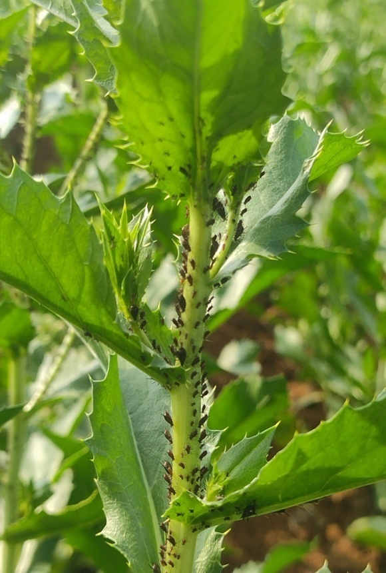

**Plate 1. Safflower aphid (*Carthamus tinctorius* L.)**

4. Conclusion

These findings emphasize the role of weather parameters in influencing aphid population dynamics and highlight the need for climate-based pest management strategies. The study contributes to understanding insect biodiversity in safflower and aids in developing targeted pest control measures to enhance crop productivity. Further research incorporating long-term monitoring and predictive modeling could enhance pest forecasting and management efforts in safflower cultivation.

**DISCLAIMER (ARTIFICIAL INTELLIGENCE)**

Author(s) hereby declare that NO generative AI technologies such as Large Language Models (ChatGPT, COPILOT, etc) and text-to-image generators have been used during writing or editing of this manuscript.

References

Akashe, V. B., Gud, M. A., Shinde, S. K., & Kadam J.R. (2010). Population dynamics of safflower aphid, *Uroleucon compositae* (Theobald) as influenced by weather parameters. Journal of Agrometeorology, 12(1), 102-104.

Basiame, K., Tiroesele & Emongor V. 2021. Abundance and diversity of safflower insect pests and their natural enemies. RUFORUM Working Document Series. 19 (1): 170-173.

Bharaj, G. S., Deshpande, S.L., & Saxena, M.K. 2003. Field screening of safflower genotypes for resistance against safflower aphid.-National Seminar: Stress Mgmt. Oilseeds. In International Seminar Oil Research. January. 28-30.

https://www.indiastat.com

Ishaq, M., Usman, M., Asif, M & Khan, I. A. 2004. Integrated pest management of mango against mealy bug and fruit fly. International Journal of Agricultural Biology. 6(3):452-454.

Javed, H., Iqbal, J & Khan, T. M. 2013. Studies on population dynamics of insect pest of safflower, *Carthamus tinctorius* L. Pakistan Journal of Zoology. 45 (1): 213 217.

Kumbhar, S. C., Mutkule, D. S., Bade, A. S & Sarukh, P.L. 2018. Bio-efficacy of newer insecticides against safflower aphid, (*Uroleucon compositae* Theobald). Journal of Entomology and Zoology Studies. 6 (4): 1741-1747.

More, A. V., More, D.G., Gore, S.H., Zatal, N. D & Gambhire, V. S. 2022. Diversity and foraging behaviour of safflower (*Carthamus tinctorius* L.) pollinators. The Pharma Innovation Journal. 11 (11): 661-667.

Patil, A. J., Murumkar, D. R & Tambe, S. I. 2002. Genetic variability studies in safflower germplasm screened for early rabi situations. 85-88.

Saeidi, K., Mirfakhraei, S., Mehrkhou, F & Valizadegan, O. 2015. Biodiversity of insects associated with safflower (*Carthamus tinctorius*) crop in Gachsaran, Iran. Journal of Entomological and Acarological Research. 47 (1): 26-30.