***Original Research Article***

**Role of soil factors on survival and virulence of *Ganoderma gibbosum* causing basal stem rot in coconut**

**ABSTRACT**

Basal stem rot caused by *Ganoderma* spp. is an important disease responsible for severe yield losses in coconut. As a soil-borne pathogen, *Ganoderma* can persist in soil for longer periods, and its survival and virulence are significantly affected by soil conditions. Soil moisture levels such as 20%, 40%, 60%, 80%, 100% of field capacity and flooded conditions were evaluated for their effects on survival and virulence of *Ganoderma gibbosum*. The pathogen was able to survive and cause disease at all soil moisture levels tested, with lower moisture levels being more favorable. Complete root infection or survival until six months was observed when soil moisture contents were 20%, 40% and 60% of field capacity. Among different soil types viz., sandy soil, sandy loam soil, silty soil and clayey soil evaluated, *Ganoderma* was able to survive and cause infections in sandy soils, silty soils and sandy loam soils better than clayey soils. Developing effective management strategies for *Ganoderma* requires an understanding of the effect of soil factors.

*Keywords: Ganoderma; basal stem rot; soil moisture; soil texture*

1. **INTRODUCTION**

The coconut palm (Cocos nucifera L.), a member of the Arecaceae family, is a vital plantation crop in India, providing livelihoods to millions of farmers. The coconut palm is renowned for its adaptability and is frequently referred to as "Kalpavriksha," or the "tree of life," since almost every portion of the plant has important practical and commercial uses. Although coconut palms are hardy and can withstand a wide variety of environmental conditions, diseases play an important role in reducing coconut yields in India. The basal stem rot of coconut caused by *Ganoderma* spp., is one such serious disease that reduces palm productivity and ultimately causes palm death. In the coastal districts of Andhra Pradesh, coconut plantations established on sandy and red soils have reported Basal Stem Rot (BSR) incidence rates as high as 62.5% (Srinivasalu et al.2003).

The pathogen is soil-borne and the disease is typically seen in sandy or sandy loam soils in coastal regions where coconuts are produced under rainfed conditions. The spread of the disease is facilitated by stagnant water and poor drainage during the rainy season. Deficits in soil moisture over the summer, the presence of old diseased stumps in the garden, root injury, and failure to follow recommended cultural techniques can contribute to disease transmission. Additionally, they may persist in soil for a long period and have several resistant stages such as chlamydospores, basidiospores, resistant mycelium, and pseudosclerotia (Snehalatharani et al. 2016).

The survival and virulence of the pathogen is greatly affected by soil conditions (Surichandraselvan and Bhaskaran, 1999; Karthikeyan et al. 2006). Developing successful management measures for basal stem rot requires an understanding of how soil factors such as soil moisture and soil texture affect the survival and virulence of *Ganoderma*. Through the identification of soil characteristics that either facilitate or hinder the pathogen, agricultural practices can be modified to reduce the risk of disease.

1. **MATERIALS AND METHODS**

**2.1 Collection and Isolation of the pathogen**

Samples of sporocarps, barks from infected stem and infected roots were collected from coconut gardens showing symptoms of BSR. Collected fresh basidiocarps were rinsed with sterile distilled water, and after being air-dried, were cut into small pieces and surface sterilized using 0.1% HgCl2 followed by washing three times in sterile water to eliminate any HgCl2 residue. The samples were kept in polypropylene bags along with wet cotton at room temperature for about 3-4 days. Upon observation of mycelial growth, was transferred to Potato Dextrose Agar (PDA) medium or to *Ganoderma* Specific Medium (GSM).

Upon successful isolation, pure culturing of the isolates was carried out by hyphal tip culture method by transferring the tip of a single hyphae growing from the colony to a fresh PDA plate and was maintained thereafter at 28±1**°**C.

**2.2 Determination of field capacity**

Field capacity of sandy loam soil (Sand-68%; Silt-23%; Clay-10%) collected from the coconut garden located in Kasaragod, Kerala, India was estimated. The field capacity level was determined by flooding the soil kept in a small plastic cup with several holes at the bottom to drain free water. The top portion of the cup was covered with a thin plastic film to avoid evaporation losses and allowed it to drain overnight. Wet weight was estimated when the gravitational water seized. The amount of water required to attain the desired field capacity levels was calculated from this. The experiments were carried out in triplicates (Chang, 2003).

**2.3 Effect of soil moisture on survival of *Ganoderma***

To estimate the effect of different soil moisture contents on the survival of *Ganoderma*, artificially inoculated root bits were placed in pots maintained at different field capacity levels. The soil moisture content was adjusted to 20%, 40%, 60%, 80%, 100% of field capacity or the soil was flooded with water. Coconut root bits dipped in the mycelial suspension of *Ganoderma* for 1 hour were utilized. The soil from each treatment was placed in separate containers and the inoculated root bits were placed 2-3 cm below soil level. To sustain consistent soil moisture levels, the cap of the containers was sealed with tape. Observations were taken 2, 3, 4, 5 and 6 months after inoculation to estimate if the pathogen could infect and survive in these root bits maintained at different soil moisture levels. Non-inoculated root bits kept at different moisture levels served as control. Three containers were prepared for each soil moisture treatment to serve as replicates. After respective incubation periods, root bits were thoroughly washed with tap water, blotted dry and placed on *Ganoderma* selective media at 25°C. Survival in root bits was calculated as percentage of root bits from which *Ganoderma* emerged after 4 days of incubation.

**2.4 Effect of soil moisture on virulence of *Ganoderma***

In each plastic cup, coconut root bits were placed at the bottom and sterilized soil was applied on top. The soil moisture content was adjusted to 20%, 40%, 60%, 80%, 100% of field capacity or the soil was flooded with water. The condition was maintained for 1 month by sealing the top portion of each cup. About 1g of sorghum grains inoculated with *Ganoderma* were placed on top of soil and observations were recorded after 1 month. Three containers were prepared for each soil moisture treatment to serve as replicates. The ability of the pathogen to grow, invade the soil and infect the root bits placed at the bottom was recorded for each treatment.

**2.5 Estimation of soil texture**

The effect of different soil types viz., sandy soil, sandy loam soil, silt and clay soils were checked for their effects on survival as well as the virulence of *Ganoderma.* Soil texture was analyzed by the pipette method and based on the USDA texture triangle, class divisions were assigned (Palihakkara and Vitharana, 2019).

About 20g of soil was weighed and transferred to a capped glass bottle to determine the percentages of sand, silt and clay in soil samples. To this, 5 mL Na hexametaphosphate and water up to a depth of 10cm were added and stirred continuously for 5 minutes. Transfer the contents to a 500 ml cylinder and make up the volume to 500 ml. The cylinder was inverted several times to resuspend soil. After 48 seconds, 25 ml of aliquot was pipetted out from the upper 10cm of the suspension. The pipetted suspensions were transferred into a beaker and subsequently oven-dried at 105 °C until a constant weight was reached. This gives the combined mass of silt and clay. After 40 minutes, again 25 mL aliquot was pipetted out from the upper 5cm of the suspension. Aliquot was transferred to a beaker and oven-dried at 105 °C. The net weight of this gives the mass of clay. The remaining soil solution was passed through a 0.05 mm sieve. Sand particles retained on the sieve were collected into a beaker and oven-dried at 105 °C. Percentage sand, soil and clay were calculated using the below equations.

$$Sand \left(\%\right)= \frac{Mass of sand in total sample}{Total mass of soil}*100$$

$$Silt\left(\%\right)=20*\frac{Mass of silt+clay-Mass of clay}{Total mass of soil}*100$$

$$Clay\left(\%\right)=20*\frac{Mass of clay in aliquot}{Total mass of soil}*100$$

**2.6 Effect of soil texture on survival of *Ganoderma***

To estimate the effect of different soil textures on the survival of *Ganoderma*, artificially inoculated root bits were placed in pots maintained at different soil types. Coconut root bits dipped in the mycelial suspension for 1 hour were utilized. These root bits were placed 2-3 cm below soil level. Observations were taken 2, 3, 4 and 5 months after inoculation to estimate if the pathogen could infect and survive in these root bits maintained at different soil textures.

**2.7 Effect of soil texture on virulence of *Ganoderma***

In each plastic cup, coconut root bits were placed in the bottom and sterilized soil was applied on top. About 1g of sorghum grains inoculated with *Ganoderma* were placed on top of soil and observations were recorded after 1 month. The ability of the pathogen to grow, invade the soil and infect the root bits placed at the bottom was recorded.

**2.8 Statistical Analysis**

Statistical Analysis of data was done using R Studio version 2023.12.0+369 (RStudio Team, 2020). The percentage data were transformed using square root transformation and were subsequently analyzed using Analysis of Variance (ANOVA). Mean comparisons were performed using the Least Significant Difference (LSD) test at a significance level of P ≤ 0.05.

1. **RESULTS AND DISCUSSION**

**3.1 Results**

**3.1.1 Isolation and Identification of the pathogen**

The pathogen was successfully isolated from sporocarp collected from coconut palm showing symptoms of basal stem rot. Based on the nucleotide homology and phylogenetic analysis, the fungus was identified to be *Ganoderma* *gibbosum* (Accession no. PQ439679).

**3.1.2 Effect of soil moisture content on survival of the pathogen**

Complete root infection or survival until six months was observed when soil moisture contents were 20%, 40% and 60% of field capacity. After 2 months of incubation, 91.6% and 83.3% of root survival were observed for 80 % of field capacity and field capacity level treatments, respectively. Under flooded conditions, *Ganoderma gibbossum* was recovered from infected root bits even after 6 months of incubation (Table 1 and Fig. 1). At all incubation periods, treatments such as the field capacity level and flooded conditions were statistically at par. *G. gibbosum* could infect and survive in much drier soil moisture levels compared to higher moisture levels. However, recovery of the pathogen at higher moisture levels especially in flooded conditions can be correlated to chlamydospore production.

**Table 1. Survival (%) of *G. gibbosum* at different soil moisture levels**

|  |  |  |  |  |  |
| --- | --- | --- | --- | --- | --- |
| **Treatments** | **Survival (%) of *Ganoderma*** | | | | |
| **2 MAI\*** | **3 MAI** | **4 MAI** | **5 MAI** | **6 MAI** |
| 20% of FC** | 100  (10.00)*** | 100  (10.00) | 100  (10.00) | 100  (10.00) | 100  (10.00) |
| 40% of FC | 100  (10.00) | 100  (10.00) | 100  (10.00) | 100  (10.00) | 100  (10.00) |
| 60% of FC | 100  (10.00) | 100  (10.00) | 100  (10.00) | 100  (10.00) | 100  (10.00) |
| 80% of FC | 91.6  (9.564) | 87.5  (9.347) | 83.3  (9.129) | 79.16  (8.88) | 79.16  (8.88) |
| FC | 83.3  (9.129) | 83.3  (9.129) | 83.3   |  | | --- | | (9.129) | | 79.16   |  | | --- | | (8.88) | | 79.16   |  | | --- | | (8.88) | |
| Flooded condition | 83.3   |  | | --- | | (9.129) | | 83.3   |  | | --- | | (9.129) | | 79.16   |  | | --- | | (8.88) | | 79.16   |  | | --- | | (8.88) | | 79.1   |  | | --- | | (8.88) | |
| **SEm (±)** | 0.102 | 0.088 | 0.098 | 0.169 | 0.169 |
| **CD**(p=0.05) | 0.306 | 0.265 | 0.293 | 0.507 | 0.507 |
| **CV** | 2.108 | 1.832 | 2.041 | 3.564 | 3.564 |

*Months After Incubation

**Field Capacity

**Data in parenthesis are square root transformed values

**3.1.3 Effect of soil moisture on virulence of *Ganoderma***

For lower moisture levels viz., 20%, 40% and 60% of field capacity, 100% infection was observed. For higher moisture levels such as 80 % of field capacity, field capacity level and flooded conditions, 95.83%, 83.34% and 83.34% infection were observed (Fig. 2). Therefore, it was evident that at all moisture levels, the pathogen can successfully invade the soil and cause infection.

**3.1.4 Effect of soil texture on survival of pathogen**

To estimate the role of soil texture on the survival of *G. gibbosum*, artificially inoculated root bits were placed in small plastic cups maintained at different soil textures. Soil texture was analyzed by the pipette method and the class division was assigned based on the USDA texture triangle (Table 2).

**Table 2. Composition of soil types**

|  |  |
| --- | --- |
| **Soil texture** | **Composition** |
| Sandy soil | Sand-90%; Silt-8%; Clay-2% |
| Sandy loam soil | Sand-68%; Silt-23%; Clay-10% |
| Silty soil | Sand-7%; Silt-88%; Clay-5% |
| Clayey soil | Sand-9%; Silt-6%; Clay-85% |

The pathogen could survive in all the soils tested even though some decreasing trends were observed towards 6 months of inoculation (Fig. 3). At 2 MAI, 100% root infection was observed for sandy, sandy loam and silty soils which decreased to 95.8%, 75% and 83 %, respectively, after incubation of 6 months. The pathogen could also survive in clay soils but relatively less compared to other soil textures tested. After 2 months of incubation, about 79% of roots were infected in clay soils which decreased to 58.3% after 6 months, indicating the inability of the pathogen to survive longer periods in clayey soils (Table 3).

**Table 3. Survival (%) of *G. gibbosum* in different soil texture**

|  |  |  |  |  |  |
| --- | --- | --- | --- | --- | --- |
| **Treatments** | **Survival (%) of *Ganoderma*** | | | | |
| **2 MAI\*** | **3 MAI** | **4 MAI** | **5 MAI** | **6 MAI** |
| Sandy soil | 100  (10.00)** | 100  (10.00) | 100  (10.00) | 100  (10.00) | 95.8  (9.61) |
| Sandy loam soil | 100  (10.00) | 100  (10.00) | 91.6  (9.61) | 83.3  (9.18) | 75  (8.70) |
| Silty soil | 100  (10.00) | 100  (10.00) | 100  (10.00) | 95.8  (9.833) | 83.3  (9.18) |
| Clayey soil | 79.1  (8.94) | 79.1  (8.94) | 75  (8.70) | 62.5  (7.95) | 58.3  (7.68) |
| **SEm (±)** | 0.12 | 0.12 | 0.186 | 0.174 | 0.243 |
| **CD (p=0.05)** | 0.373 | 0.373 | 0.581 | 0.541 | 0.758 |
| **CV** | 2.449 | 2.449 | 3.881 | 3.75 | 5.534 |

*Months After Incubation

**Data in parenthesis are square root transformed values

**3.1.5 Effect of soil texture on virulence of *Ganoderma***

To study the effect of different soil types on the virulence of *G. gibbosum*, the ability of the pathogen inoculated on top of sterile soil maintained at different soil types to grow, invade the soil and infect the root bits placed at the bottom of small plastic cups were recorded. Observations were recorded one month after inoculation (Fig. 4). A varied percentage of infection was observed for all soil types with a greater number of roots infected in the case of sandy, silty and sandy loam soils compared to clay soils (Table 4).

**Table 4. Root infection (%) by *G. gibbosum* in different soil textures**

|  |  |
| --- | --- |
| **Treatments** | **Percentage of roots**  **infected** |
| Sandy soil | 95.83 (9.619) * |
| Sandy loam soil | 83.3 (9.165) |
| Silty soil | 91.6 (9.835) |
| Clayey soil | 79.16 (8.946) |
| **SEm (±)** | 0.214 |
| **CD (p=0.05)** | 0.647 |
| **CV** | 5.098 |

*Data in parenthesis are square root transformed values

**3.2 Discussion**

The present investigation on the effect of soil moisture content on survival and virulence of *Ganoderma*, indicated that the pathogen was able to survive and cause disease at all soil moisture levels tested, with lower moisture levels being more favorable. Chlamydospores are important for the long-term survival of *Ganoderma* spp. and these structures may provide resistance to severe environmental stresses such as flooding (Chang, 2003). Coastal soils with a high soil moisture content as conducive to the growth of *G. boninense* (Gurmit, 1990).

The studies conducted by Garett (1944) and Stover (1953) also point out that most root infecting fungi require low moisture levels. The disease is seen severely during the summer months which may be due to lack of soil moisture (Vijayan and Natarajan, 1975). However, moisture deficiency during the summer months and water logging in the rainy season are also favorable conditions for the pathogen (Kumar and Nambiar, 1990; Karthikeyan et al. 2006).

The disease is more common in sandy or sandy loam areas in coastal areas (Jayalakshmi and Khan, 2003). The present investigation also indicates that the pathogen could infect and survive more in these soil types. Higher percentages of soil sand fraction will increase the basal stem rot disease incidence (Susanto et al. 2013). Indrayadi et al. (2023) observed that seedling mortality was significantly higher in soils with low clay content compared to those with higher clay content when *Ganoderma philippii* was inoculated onto *Acacia mangium* and *Eucalyptus pellita* seedlings grown in different soil textures.

Root infection percentages were higher in sandy soils compared to other soil types. This can be attributed to the higher porosity found in the sandy soils where the pathogen could spread more compared to clayey soils making the inoculum move faster to the root bits (Susanto et al. 2013). Fungi typically exhibit enhanced growth in soils characterized by an extensive network of pores (Ritz and Young, 2004). When mineral soils possess a low clay content and a high sand content, fungi spread more quickly and further (Gill et al. 2000). Peat soils with high clay contents have very low bulk density and this discourages mycelial development (Zhang et al. 2017). The presence of large cracks and biopores in peat soil can reduce the survival and limit the spread of fungal mycelium. (Otten et al. 2001).

1. **CONCLUSION**

*Ganoderma* *gibbosum* was able to survive and cause infection at all soil moisture levels tested. Eventhough the survival rates were higher at lower moisture levels, recovery of the pathogen at higher moisture levels especially in flooded conditions can be correlated to its ability for chlamydospore production. *Ganoderma* can survive and cause infections in sandy soils, silty soils and sandy loam soils better than clayey soils. In conclusion, this study aims to provide an understanding on the role soil moisture and texture in the survival and virulence of *Ganoderma* and are expected to contribute to the development of effective management practices.

**REFERENCES**

Chang, T. (2003). Effect of soil moisture content on the survival of *Ganoderma* species and other wood-inhabiting fungi. Plant disease, 87(10), 1201-1204.

Garett, S.D. (1944). Root disease fungi. Waltham, Massachusetts: Chronic Botanica Co.

Gill, J.S., Sivasithamparam, K., & Smettem, K.R.J. (2000). Soil types with different texture affects development of *Rhizoctonia* root rot of wheat seedlings. Plant and Soil, 221(2), 113-120.

Gurmit, S. (1991). *Ganoderma*- the scourge of oil palm in the coastal area. In: Proceedings of *Ganoderma* workshop, Bangi, Selangor, Malaysia, Palm Oil Research Institute of Malaysia. pp 7-35.

Indrayadi, H., Glen, M., Fahrizawati, F., Siregar, B.A., Rimbawanto, A., Mardai, M., Tjahjono, B., & Mohammed, C. (2023). Effect of soil types on root infection of *Acacia mangium* and *Eucalyptus pellita* by *Ganoderma philippii* and *Pyrrhoderma noxium*. Biodiversitas Journal of Biological Diversity, 24(4), 2358-2364.

Jayalakshmi, V., & Khan, H.H. (2003). *Ganoderma*/Thanjavur Wilt/Basal Stem Rot Disease of Coconut. Indian coconut journal, 33(11), 10-16.

Karthikeyan, M., Bhaskaran, R., Radhika, K., Mathiyazhagan, S., Sandosskumar, R., Samiyappan, R., & Velazhahan, R. (2006). Influence of weather factors on the epidemiology of *Ganoderma* disease of coconut in Tamil Nadu. Journal Of Plantation Crops, 34(2), 103-106.

Kumar, S.N.S., & Nambiar, K.K.N. (1990). *Ganoderma* disease of arecanut palm-isolation, pathogenicity and control. Journal of plantation crops, 18(1),14-18.

Otten, W., Hall, D., Harris, K., Ritz, K., Young, I.M., & Gilligan, C.A. (2001). Soil physics, fungal epidemiology and the spread of *Rhizoctonia solani*. New Phytologist, 151(2), 459-468.

Palihakkara, P.D.B.J., & Vitharana, U.W.A. (2019). A time-efficient and accurate texture analysing method for tropical soils. Journal of Agriculture and Value Addition, 2(2), 1-9.

Ritz, K., & Young, I.M. (2004). Interactions between soil structure and fungi. Mycologist, 18(2), 52-59.

RStudio Team. (2020). RStudio: Integrated development environment for R. RStudio, PBC: Boston, MA, USA. <http://www.rstudio.com/>.

Snehalatharani, A., Maheswarappa, H. P., Devappa, V., & Malhotra, S. K. (2016). Status of coconut basal stem rot disease in India–a review. Indian Journal of Agricultural Sciences, 86(12),1519–1529.

Srinivasalu, B., K. Aruna, D.V. R. Rao., & Hameed Khan, H. (2003). Epidemiology of Basal Stem Rot (*Ganoderma* wilt) disease of coconut in Andra Pradesh. Indian Journal of Plant Protection, 31(1), 48-50.

Stover, R.H. (1953). The effect of soil moisture on *Fusarium* species. Canadian Journal of Botany, 31(5), 693-697.

Surichandraselvan, M., & Bhaskaran R. (1999). Management of *Ganoderma* / Thanjavur wilt of coconut by non-chemical methods. Indian Coconut Journal**,** 30(8), 4–5.

Susanto, A., Prasetyo, A. E., & Wening, S. (2013). Infection rate of *Ganoderma* at four soil texture classes. Jurnal Fitopatologi Indonesia, 9(2), 39-46. <https://doi.org/10.14692/jfi.9.2.39>

Vijayan, K.M., & Natarajan, S. (1975). Influence of fertilizers and manures on the incidence and progress of coconut wilt disease of Tamil Nadu. Coconut Bulletin, 5(9), 1-5.

Zhang, Z., Zhou, X., Tian, L., Ma, L., Luo, S., Zhang, J., Li, X., & Tian, C. (2017). Fungal communities in ancient peatlands developed from different periods in the Sanjiang Plain, China. PLoS One, 12(12), e0187575.

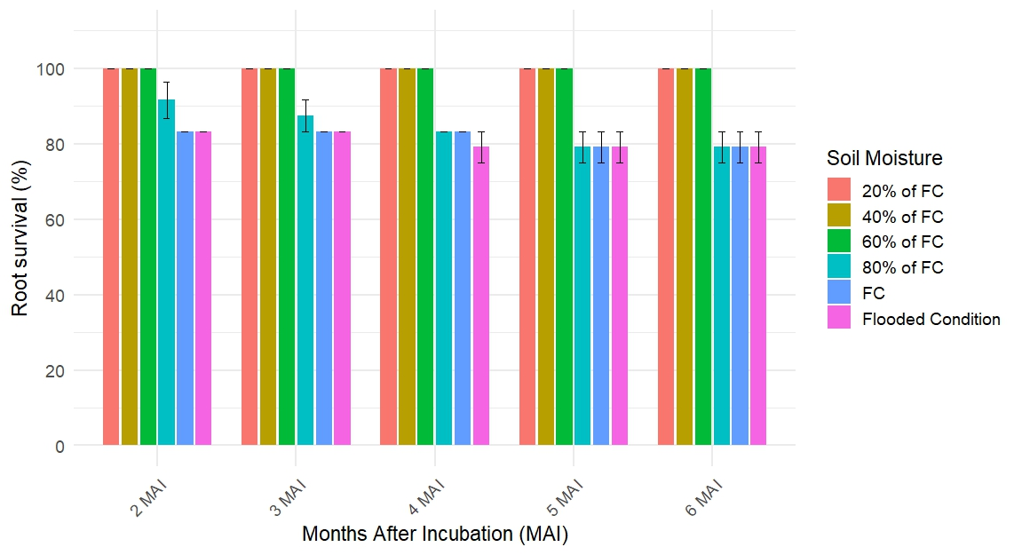

**Fig. 1. Effect of soil moisture content on survival of *G. gibbosum***

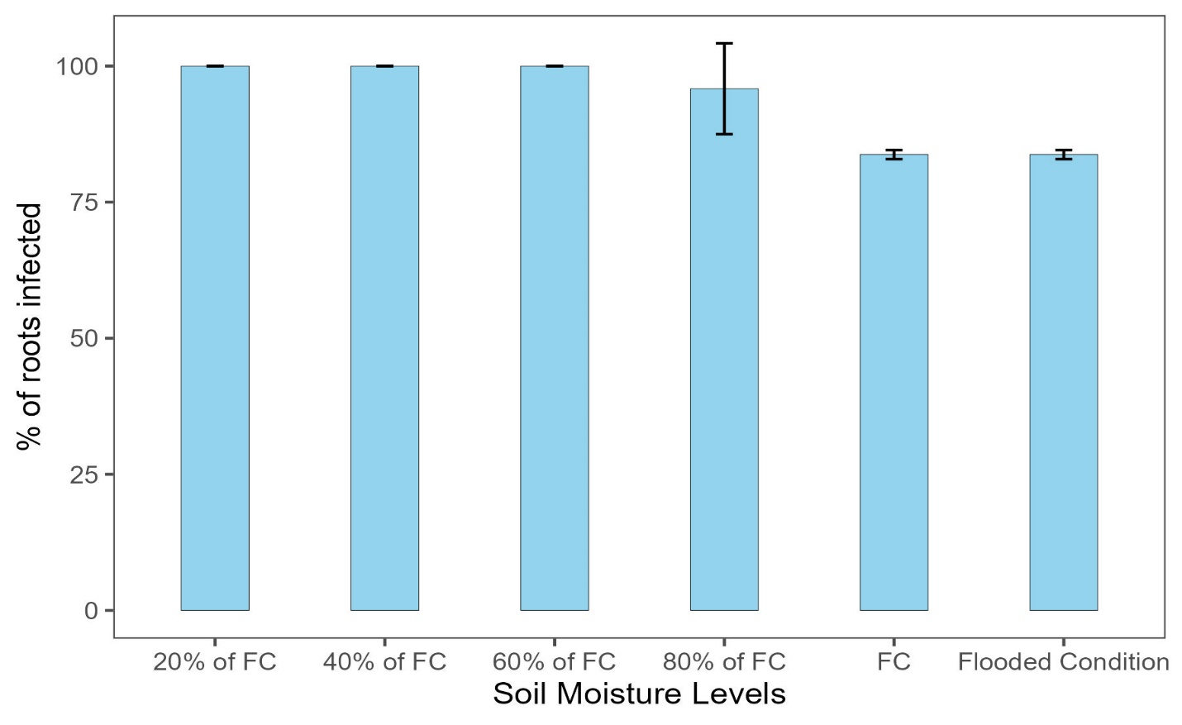

**Fig. 2. Effect of soil moisture content on virulence of *G. gibbosum***

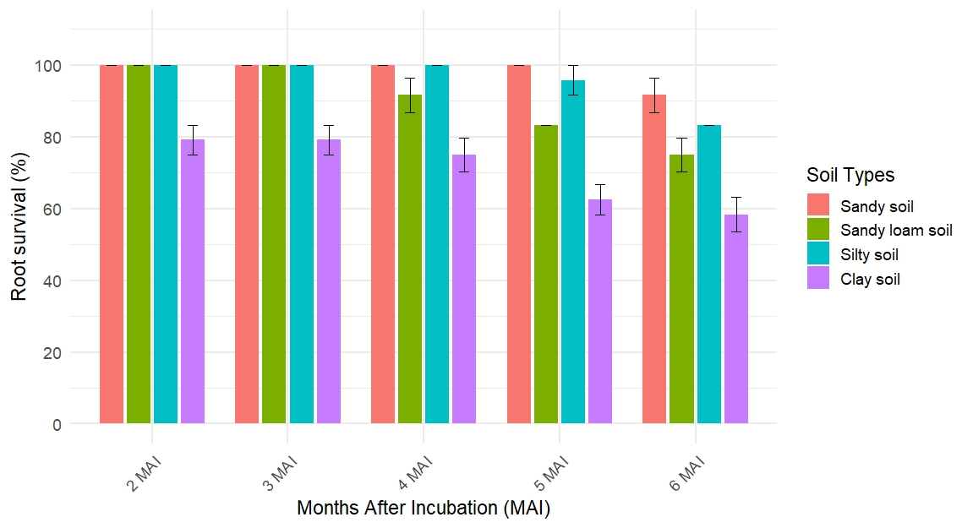

**Fig. 3. Effect of soil texture on survival of *G. gibbosum***

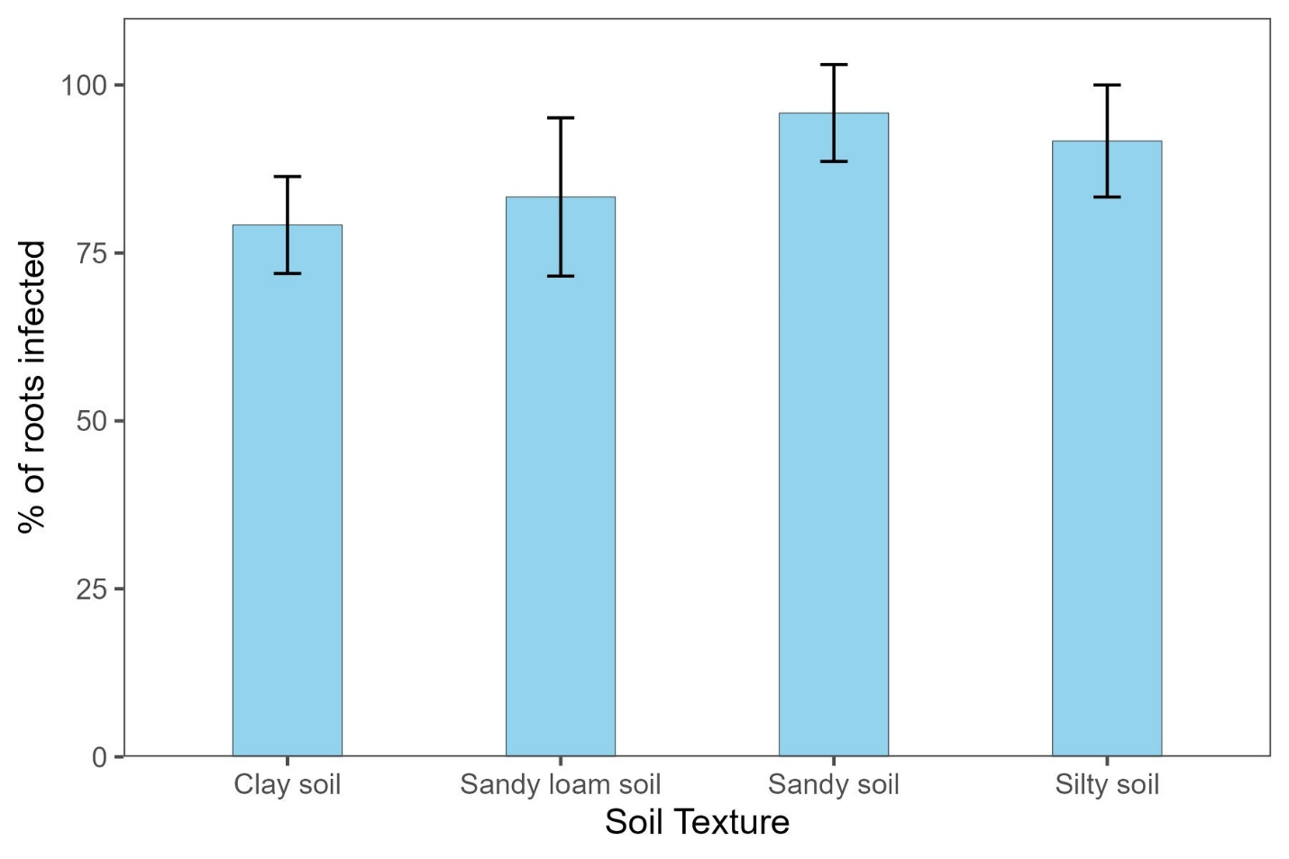

**Fig. 4. Effect of soil texture on virulence of *G. gibbosum***