Method Article
Standardizing a Method for Apical Rooted Cutting (ARC) Technology in Potato Seed Production for Indian Agriculture

Abstract
Apical rooted cuttings (ARC) present a groundbreaking solution to India's persistent challenges in potato seed production, offering a decentralized and cost-effective alternative to traditional methods. Currently, potato seed production in India is heavily centralized in the northern region, necessitating long-distance transportation of seeds to other parts of the country. This not only incurs significant transportation costs but also delays seed availability, often leading to suboptimal planting times, reduced yields, and crop failures. ARC technology, rooted in tissue culture, enables the production of mini-tubers through a decentralized system, empowering farmers to produce their own high-quality seeds within a shorter timeframe. While this protocol was initially developed for global applications, this research focuses on standardizing ARC technology specifically for Indian conditions, ensuring its adaptability and effectiveness in diverse agro-climatic zones. By rooting and multiplying apical cuttings in controlled screen house environments before transplanting them into fields, this method provides an efficient pathway for mini-tuber production. ARC technology reduces seed miles, minimizes input and transportation costs, and enhances farmers' profitability. Furthermore, it strengthens the seed value chain, revolutionizing potato seed production and contributing to sustainable agricultural practices. This innovative approach is gaining widespread recognition for its potential to transform potato cultivation in India and beyond.
Keywords: Agronomy; Apical root cuttings (ARC); Potato seed production; Sustainable agriculture; Decentralized seed systems; Tissue culture technology.

Introduction
Potato (Solanum tuberosum L.) is a cornerstone of global food security, renowned for its high productivity, nutritional value, and adaptability. Recognized as the world’s third most important food crop after rice and wheat by the FAO (2008), potatoes play a critical role in addressing food and nutritional demands. India, the second-largest producer of potatoes after China, faces the challenge of meeting the growing demand driven by population growth and economic development. According to the Central Potato Research Institute (CPRI, 2015), India is projected to produce 122 million metric tons (MT) of potatoes by 2050. However, achieving these targets is hindered by several constraints, including water scarcity, erratic weather patterns, post-harvest losses, and pest-related issues. Among these, the availability of high-quality, a disease-free seed potato remains a critical factor influencing productivity and cost-efficiency.
The traditional seed potato production system in India relies on tuber indexing to detect and eliminate viral infections, followed by clonal multiplication across successive generations. While effective, this system is plagued by limitations such as low multiplication rates and the heightened risk of viral contamination due to prolonged field exposure. To overcome these challenges, a modified seed production system integrating tissue culture technology has been introduced. This innovative approach utilizes apical stem cuttings derived from tissue-cultured plantlets as an alternative to conventional mini-tubers. By removing the apical bud, lateral buds are stimulated, promoting lateral growth and significantly enhancing the multiplication rate. This method enables the mass propagation of disease-free plantlets, thereby improving the production of G0 potato seeds (Dawson, 2005; Naik and Karihaloo, 2007; Mbiyu et al., 2012; Sumarni et al., 2014).
Apical stem cuttings from disease-free G0 plants offer a robust and efficient method for producing true-to-type, disease-free G1 seed tubers. The G0 mini-tubers generate multiple-budded shoots, which can further multiply G0 stocks under less stringent conditions (Nikmatullah et al., 2018). This technique holds immense potential for scaling up the production of disease-free G1 potato seed tubers within a short timeframe, enabling market-scale seed production (GIZ-CIP, 2023). By decentralizing seed production and reducing dependency on traditional methods, apical rooted cutting (ARC) technology is poised to revolutionize potato cultivation in India, addressing both yield constraints and economic challenges faced by farmers.

Methodology

In-Vitro Multiplication of Potato Plantlets
The initial phase of ARC technology focuses on the multiplication of disease-free potato plantlets using tissue culture techniques. This step is critical for establishing a robust foundation of healthy mother stock, which is essential for subsequent propagation.

Media Preparation
The success of tissue culture propagation relies on the preparation of a nutrient-rich artificial medium. The most commonly used medium is the full-strength MS (Murashige and Skoog) medium, developed in 1962. This medium replaces natural soil and provides all essential nutrients required for plant growth and development. The preparation involves dissolving four stock solutions in double-distilled water, supplemented with sucrose and other additives to maintain an optimal pH of 5.7. After autoclaving for sterilization, the medium is dispensed into sterilized glass bottles. To ensure the viability of the cultures, the media is refreshed every 3 to 4 days during the plant culture process.

Culturing
The culturing process begins with disease-free stock plants obtained through meristem culture, which serves as the initial material. In-vitro plantlets aged 3–4 weeks are used for sub-culturing. This step is conducted under laminar airflow conditions to maintain sterility and prevent contamination. Within the laminar flow hood, the in-vitro plantlets are carefully segmented at the internodal regions, discarding the root portion. Approximately 15–20 nodal cuttings are placed in each glass jar containing the prepared media. Wide-mouthed plastic containers are preferred for this process, as they facilitate better growth and handling.

Incubation
The nodal cuttings, serving as explants, are inoculated onto the MS basal salt medium and transferred to a growth chamber. The growth chamber maintains a controlled environment with a temperature range of 22–25°C and a photoperiod of 16 hours of light and 8 hours of darkness. Cool white fluorescent lights, regulated by an automatic timer, provide the necessary illumination. Within 3–4 weeks, the nodal cuttings develop into individual plants. This rapid cycle allows for the continuous multiplication of in-vitro plants, which can either be used for further propagation or for the production of apical rooted cuttings (ARCs). The process is repeated as needed to achieve the desired volume of disease-free plantlets (Figure 1).
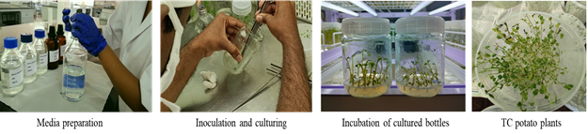
Figure 1: Potato seed production via Apical Rooted Cutting (ARC) technology through tissue culture technique

Preparation of Nursery Beds for Mother Plant Multiplication

Bed Construction and Medium Preparation
Nursery beds are constructed using a combination of bricks, coco compost, and anti-weed mats. The standard dimensions for the beds are 4 feet in width and 10 feet in length, with a bed height of 4 inches. This height is carefully maintained to promote robust root growth and ensure proper drainage. Once the basic structure is formed, an anti-weed mat is placed over the bed to secure the growing medium and prevent weed infestation. The growing medium used in the beds is high-quality coir pith, which is known for its excellent water retention and aeration properties. The pH of the coir pith should ideally be maintained between 6.5 and 7 to create a favorable environment for plant growth. Additionally, the electrical conductivity (EC) of the medium must be monitored and kept below 1 to avoid salinity stress on the plants.

Irrigation and Water Quality Management
Before planting, the nursery beds are evenly watered to ensure the medium is adequately moist. The quality of irrigation water is a crucial factor in the success of the nursery. Regular testing of the water is essential to ensure it is free from contaminants and has an appropriate pH and EC level. Poor-quality water can negatively impact plant health and growth.

Planting of Tissue Culture Saplings
Once the beds are prepared and moistened, tissue culture saplings are planted at a spacing of 5 x 4 inches. Each sapling is planted at a depth of 2 inches to ensure proper root establishment and stability. This spacing allows adequate room for growth and minimizes competition for nutrients and light among the plants. The careful placement of saplings ensures uniform growth and facilitates easier maintenance and monitoring (Figure 2).
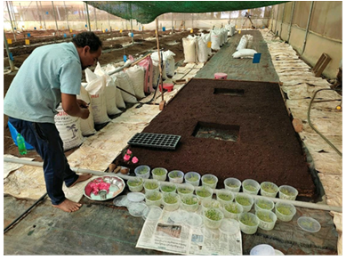
Figure 2: Preparation of mother beds for the multiplication of tissue cultured plants

Transplantation and Multiplication Mother Plants

Transplantation of In-Vitro Plantlets
Carefully remove the in-vitro plantlets from their tissue culture containers, ensuring minimal damage to the roots and stems. Thoroughly wash the plantlets to remove any residual media attached to the roots and stems. This step is essential to prevent contamination and promote healthy growth. Transplant the cleaned plantlets into the prepared nursery beds. To ensure optimal establishment, avoid immediate watering and fertilizer application after planting. This allows the plantlets to acclimate to their new environment and reduces the risk of transplant shock (Fig. 3).

Apical Cutting and Rooting Process
After 2–3 weeks of transplantation, the in-vitro saplings are ready for their first apical cutting. In colder winter climates, this process may take 3–5 days longer compared to warmer conditions. The apical portion of the mother plant, consisting of two nodes and four leaves, is carefully cut at a height of approximately 2 inches. The cuttings are briefly dipped in water for 2–3 seconds to maintain hydration before being planted in the nursery beds at a spacing of 4 inches. Within a week, the newly planted cuttings begin to develop roots. By 15 days, the cuttings are fully established and ready for the next round of apical cutting. Simultaneously, the original in-vitro plantlets continue to produce new apical shoots, which can be used for further planting.

Exponential Multiplication of Mother Plants
This cyclical process of cutting and regrowth leads to exponential multiplication of mother plants, with the number of cuttings doubling every 15 days. Over a period of four months, a single in-vitro plantlet has the potential to produce up to 250 cuttings, demonstrating the efficiency and scalability of ARC technology (Figure 3).
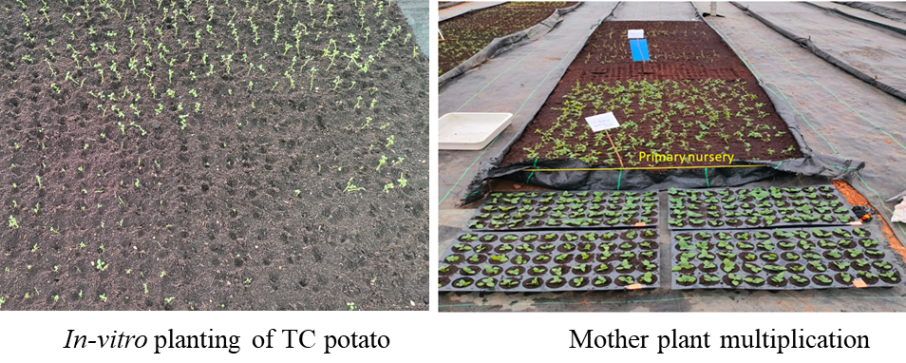
Figure 3: Multiplication of tissue cultured seed potato plants

Production of Apical Rooted Cuttings (ARCs) for Field Planting
Once the mother plants reach maturity and weather conditions are favorable, apical cuttings are prepared for rooting in portrays. These cuttings typically become transplant-ready within 2–3 weeks, making them suitable for transplantation either in a polyhouse or an open field. Prior to transplantation, the plants undergo a hardening process, which involves reducing water availability and gradually increasing light intensity. This step ensures that the plants are robust and better adapted to field conditions. On the day of transplantation, well-rooted cuttings are carefully transported to the main field using folded trays to minimize damage.
To safeguard the plants against potential pest infestations, a prophylactic spray against sucking pests is recommended at the nursery level. This provides primary protection and enhances the plants' resilience at the farm level. For long-distance transportation, ARCs can be efficiently shipped via air cargo using thermocol boxes, which maintain the necessary environmental conditions. Optimal field establishment is achieved when the ARCs are planted within 24 hours of transportation.
The mini-tubers harvested from the ARCs are classified as G0 seeds. To break dormancy, these tubers are stored in cold storage for sixty days. After this period, they are ready for use in G1 seed tuber production. Standard agronomic practices, consistent with regular potato cultivation, are followed to ensure healthy growth and high yields (Figure 4).
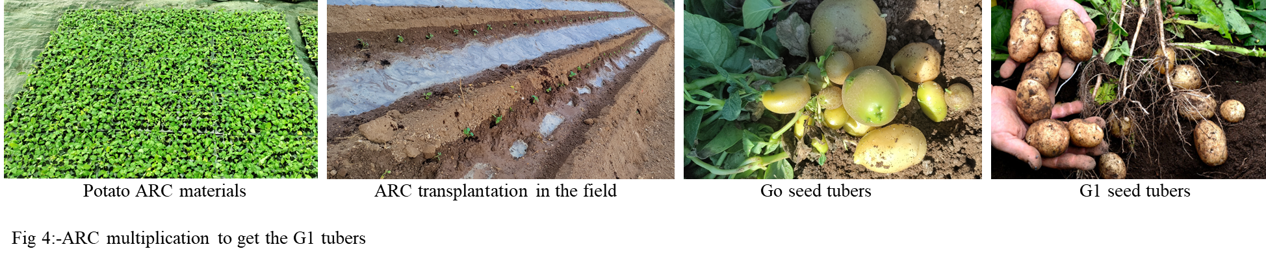
Figure 4. Multiplication of apical root cuttings for G1 tuber production.

Harvesting and Storage of Seed Potatoes
After harvesting, seed potatoes undergo a series of meticulous processing and storage steps to ensure quality, uniformity, and longevity. The first step involves sorting the potatoes into three size categories: large, medium, and small (10–35 mm). This categorization ensures uniformity, which is critical for efficient market distribution and planting purposes. Following sorting, the seed potatoes are treated with a 3% boric acid solution to prevent disease and maintain seed viability. During the grading process, any disease-affected tubers are carefully removed to prevent the spread of pathogens and ensure the overall health of the seed stock.
Once graded, the potatoes are dried in the shade to remove excess moisture, which helps prevent rot during storage. The dried potatoes are then packed grade-wise in gunny bags, ensuring uniformity and ease of handling. Proper storage conditions are essential to maintain the quality of the seed potatoes. They are stored in cool, dark environments with adequate ventilation to prevent sprouting and decay. Cold storage plays a crucial role in breaking dormancy, a process that typically takes 50–60 days. This dormancy breakage prepares the potatoes for planting or consumption, ensuring optimal growth and development.
These carefully managed processes—sorting, treatment, grading, drying, and storage—preserve the quality and extend the shelf life of the seed potatoes, making them market-ready and suitable for future cultivation. By adhering to these practices, farmers can ensure the production of high-quality seed potatoes that meet both agricultural and commercial standards.

Validation and Application of the ARC Method
The standardized ARC method has demonstrated significant efficiency in producing disease-free, high-quality potato seeds. Key outcomes include:
- Rapid Multiplication: A single in-vitro plantlet can produce up to 250 cuttings within four months, enabling large-scale seed production.
- Cost-Effectiveness: By decentralizing seed production, the method reduces transportation costs and seed miles, making high-quality seeds more accessible to farmers.
- Farmer Empowerment: Farmers can produce their own seeds, reducing dependency on external sources and enhancing profitability.
- Sustainability: The method minimizes the risk of disease transmission and promotes sustainable agricultural practices.

Conclusion
Apical rooted cuttings (ARCs), derived from nuclear stock material, are maintained in a juvenile state throughout the production cycle, ensuring consistent quality and vigor. The adoption of ARC technology, along with G0 mini-tubers, has significantly enhanced the prosperity of potato farmers worldwide. By enabling decentralized seed production, ARC empowers farmers to produce their own high-quality seeds within a short timeframe, reducing dependency on external seed sources and minimizing costs associated with transportation and procurement. This innovative approach has led to increased incomes and higher production levels for farmers who have embraced the technology. ARC technology stands out as a cost-effective and efficient alternative to traditional methods such as aeroponics for mini-tuber production. Its rapid multiplication rate and ability to produce disease-free, true-to-type seeds make it particularly promising for major potato-producing regions, especially in highland areas. Beyond economic benefits, ARC technology strengthens the entire seed potato value chain, ensuring a reliable supply of quality seeds and fostering sustainable agricultural practices. By revolutionizing potato seed production, ARC technology not only boosts farmer profitability but also contributes to global food security and the resilience of potato cultivation systems.

COMPETING INTERESTS DISCLAIMER:
Authors have declared that they have no known competing financial interests OR non-financial interests OR personal relationships that could have appeared to influence the work reported in this paper.

References
- Nikmatullah, A., Ramadhan I. and Sarjan, M. (2018) Growth and yield of apical stem cuttings of white potato (Solanum tuberosum L.) derived from disease-free G0 plants. Journal of Applied Horticulture, 20(2): 139-145, 2018
- Advancement in Potato Production Technology and its Future Prospects 2019, ICAR-Central Potato Research Institute, Shimla, Himachal Pradesh, India 2015.
- CPRI. Vision 2050. ICAR-Central Potato Research Institute, Shimla, Himachal Pradesh, India 2015. Dawson, P. 2005. AGB/2005/167.
- FAO. Potatoes, nutrition and diet. FAO’s Nutrition and Consumer Protection Division, Rome, Italy Available at http://www.fao.org/potato 2008/en/potato/factsheets.html 2008.
- Local seed potato production through rooted apical cutting (RAC) technology, a compilation of two years of learning in Karnataka, International Potato Centre (CIP), and University of Horticultural Sciences, Bengaluru, India, March 2023.
- Mbiyu, M.W., J. Muthoni,J. Kabira, G. Elmar, C. Muchira, P. Pwaipwai, J. Ngaruiya, S. Otieno and J. Onditi, 2012. Use of aeroponics technique for potato (Solanum tuberosum) minitubers production in Kenya. J. Hort. For., 4(11): 172-177, DOI: 10.5897/JHF12.012.
- Naik, P.S. and J.L. Karihaloo, 2007. Micropropagation of production of quality potato seed in Asia Pacific. Asia Pacific Consor. On Agric.Biotech. (APCoAB), Asia-Pacific Assoc. of Agric. Res. Ins. (APAARI), Bangkok, Thailand.
- Potato seed system development – alternative potato seed supply system for Indonesia. Final Report, Appedix 7. Austral. Ctr. for Intl. Agric. Res., Australia.
- Sumarni E., Ardiansyah and N. Farid, 2014. Aplikasi nozel pada dua varietas kentang untuk produksi benih secara aeroponik. J. Biofisika, 10(1): 1-7.

