**Influence of Different Concentrations of GA3 on Germination of Dragon Fruit (*Hylocereus undatus*) seeds**

**ABSTRACT**

The impact of different concentrations of gibberellic acid (GA₃) on the germination and early seedling growth of dragon fruit (*Hylocereus undatus*) was studied at Karunya Institute of Technology and Sciences, Coimbatore. Seeds were soaked in different concentrations of GA3 along with a control (distilled water), 60, 80, 100, 120, and 140 ppm GA₃ for 12 hours before undergoing germination tests. The experiment followed a Completely Randomized Design (CRD) with six treatments, each replicated three times. Key germination parameters, including germination percentage, germination rate, mean germination time, seed vigor index, and germination value, were assessed. Results showed that 140 ppm GA₃ significantly improved germination rate (16.44), seed vigor index (243.00), and survival percentage (96.67%), making it the most effective concentration. Higher GA₃ levels accelerated germination but showed no significant impact on chlorophyll content, fresh weight, or root number. These findings highlight 140 ppm GA₃ is an optimal concentration for improving seed germination and early seedling growth in dragon fruit cultivation.

*Keywords: Dragon fruit; Gibberellic acid (GA₃); Seed germination; Germination rate; Seed vigor, Survival percentage*

1. **INTRODUCTION**

Dragon fruit (*Hylocereus undatus*) commonly known by various names viz. Pitaya, Strawberry Pear, Night Blooming Cereous, Queen of Night, and Honorable Queen (Martin *et al.*, 1987) was once valued for its bright color and exotic appearance, but now it's gaining attention for its impressive health benefits. Packed with powerful natural compounds like flavonoids, phenols, anthocyanins, and betalains, this fruit offers anti-inflammatory, antioxidant, anti-cancer, and anti-microbial properties. These bioactive compounds make dragon fruit more than just a tasty treat—it’s a nutritious superfood that supports overall health (Kumar *et al.*, 2018).

India have a lot of potential for growing this crop in semiarid areas, but one of the main obstacles is, the lack of planting material for large-scale production. It is possible to propagate dragon fruit asexually by cutting stems and grafting, or sexually by using seeds. Obtaining diversity for the purpose of improving the breeding program is the goal of this straightforward approach through seeds   
(Pimenta, 1990).

The sexual reproduction method allows for the preservation of the diversity of phytogenetic resources and species conservation through germplasm banks, as well as the scientific investigation of factors that influence germination biology and the provision of genetic variability required for the selection of desirable traits in a breeding program (Salgotra and Chauhan, 2023).

The use of GA3 has also been shown to improve seed germination in guava (Hosseini *et al*., 2020), in Rangpur lime (Dilip *et al*. 2017), in acid lime (Joshi *et al.* 2015), in pummelo (Khopkar *et al.* 2014), in loquat (Al-Hawezy, 2013), in papaya (Anburani and Shakila, 2010) and in jackfruit (Maiti *et al.*, 2003).

Therefore, this study was conducted to investigate the effect of the different concentration of GA₃ on the seed germination of dragon fruit.

1. **MATERIAL AND METHODS**

The experiment was conducted during December, 2024 under a shade net at Karunya Institute of Technology and Sciences, Karunya Nagar, Coimbatore.

A well-ripened, white-fleshed dragon fruit weighing 480 g was sourced from a local farmer at a dragon fruit farm in Madampatti, Coimbatore. The seeds were extracted by scooping followed by macerating the pulp of fruit and rinsing them thoroughly under running water. They were then spread on butter paper and shade-dried for 48 hours. The dried seeds were soaked in a GA₃ solutions at concentrations of control, 60, 80, 100, 120, and 140 ppm for 12 hours, while the control seeds were soaked in distilled water for the same duration. After removing the seeds from GA3 solution, the tests were conducted.

The experiment followed a completely randomized design (CRD) with six treatments (five GA₃ concentrations and a control), each replicated three times. Each petri dish was considered one replicate, containing 50 seeds per replicate.

* 1. **Germination test**

Sowing was carried out by placing the seeds between two Whatman Grade-1 filter papers inside petri dishes, with each dish holding 50 seeds. The filter papers were moistened daily with distilled water to ensure adequate humidity.

The parameters for germination test were: Germination percentage (%), Germination Rate (seeds per day), Mean Germination Time (MGT) (days), Germination Energy (%), Seed Vigor Index (SVI), Mean Germination Rate (MSR) (seeds per day), Mean Daily Germination Percentage (%), Peak Value (PV), Germination Value (GV), Survival percentage (%).

* 1. **Transplantation**

The emerged seedlings were transplanted into 50-plug trays on the 14th day of germination, with each tray representing one replication. A total of 18 trays were filled with well-sieved sand, and one seedling was planted in each plug.

**2.3 Emergence test**

After 40 days of sowing shoot, root, and physiological parameters were monitored. Five seedlings were selected from each replication for parameter observation.

Shoot parameters: Seedling length (cm), Fresh weight of seedling (g), Dry weight of seedling (g).

Root parameters: Root Length (cm), Fresh weight of roots (g), Number of roots per seedling

Physiological parameter: Total chlorophyll content (SPAD)

* 1. **Statistical analysis**

The data collected from all the parameters were analyzed. The analysis was conducted using the STAR package. The significance of the treatments was determined by comparing the mean differences between treatments using the Critical Difference (CD) at a 5% level of significance.

**Table 1.** **Seed germination treatment with different GA3 combinations**

|  |  |
| --- | --- |
| **Treatment** | **Concentration** |
| T1 | Control (distilled water) |
| T2 | GA3 @ 60ppm |
| T3 | GA3 @ 80ppm |
| T4 | GA3 @ 100ppm |
| T5 | GA3 @ 120ppm |
| T6 | GA3 @ 140ppm |

1. **RESULTS AND DISCUSSION**

**3.1 Germination parameters:**

* **Germination Percentage (%):** The control group had the lowest germination percentage (92.00%), while all GA₃ treatments at 80 ppm and above achieved 100% germination by the 8th day after sowing. GA₃ at 60 ppm (T2) slightly improved germination (98.67%), indicating GA₃ enhances early seed germination. The study suggested that GA₃ acts on the embryo, inducing the synthesis of hydrolyzing enzymes like α-amylase and protease, which hydrolyze stored food reserves. These hydrolyzed nutrients are then utilized for embryo growth, enhancing germination and seedling vigor (Leite *et al.*, 2003).
* **Germination Rate and Mean Germination Rate (MGR) (seeds per day):** The highest germination rate (16.44) was observed at 140 ppm (T6), suggesting that increasing GA₃ concentration speeds up germination rate. The control had the lowest germination rate (12.26), confirming the positive effect of GA₃. Whereas the highest MGR was recorded at 140 ppm (T6) (0.3254), followed by 100 ppm (T4) (0.3113). The control group had the lowest MGR (0.2517), reinforcing that GA₃ enhances the speed of germination. The results are in conformity with germination of mango stones where the control group reported a maximum of days and the stones treated with highest GA3 concentration (200 ppm) required lesser days to initiate and 50% of the time to germinate (Reshma and Simi, 2019). The capacity of the pre-sowing treatment of different GA3 to shorten the germination time and eliminate the growth obstruction in the embryo is the cause of the variation in germination rate (Muralidhara *et al.*, 2015). While Chemical stimulation on seedling emergence and the rate of various growth processes, such as cell elongation, cell division, and cell multiplication, may be the cause of the differences in the number of days needed for possible germination (Patel *et al.*, 2016).
* **Mean Germination Time (MGT) (days):** MGT decreased as GA₃ concentration increased, with the value at 140 ppm (T6) (3.07). The control had the lowest MGT (3.98) indicating that without GA₃, seeds take longer to germinate, while higher GA₃ concentrations promote faster germination. The increasing germination rate and reduced MGT at higher GA₃ concentrations are consistent with findings in grapes (*Vitis vinifera*), where GA₃ accelerated germination by promoting enzymatic activity and endosperm weakening (Cheng *et al.*, 2013).
* **Germination Energy (%):** GI was calculated on the third day of germination, as it showed the highest number of germinations. Therefore, the third day was considered to determine the most effective concentration. The lowest germination energy was observed in the control group (29.33), while the highest was at 140 ppm (T6) (90.67). This suggests that higher GA₃ concentrations improve the initial energy of germination, resulting in more vigorous early seedling growth.

This support the research where the study was conducted to investigate the effect of soaking seeds of two pistachio cultivars in gibberellin. Seeds treated with 200 mg/L GA₃ showed a germination nergy of 59.4%, which was higher than the 49.4% recorded for the control group (0 mg/L GA₃). This indicates that GA₃ has a positive impact on germination energy (Kadhim *et al.*, 2023)

* **Seed Vigor Index:** The seed vigor index increased significantly with GA₃ concentration, reaching its peak at 140 ppm (T6) (243.00). The control (T1) had the lowest vigor index (80.96), highlighting that GA₃ improves seedling strength and growth potential. The high vigor of the seedlings may be the result of growth media that keeps the moisture content and aeration levels adequate for the seedlings growth, particularly for the anchoring and development of the roots (Mtambalika *et al.*, 2014). This observation aligns with research conducted, which demonstrated that applying gibberellic acid (GA₃) after anthesis significantly enhanced seed vigor in indica hybrid rice (*Oryza sativa* L.) (Wang *et al.,* 2019).
* **Mean Daily Germination (%):** 140 ppm (T6) resulted in the highest daily germination rate (6.33%), while the control had the lowest (2.00%). This shows that GA₃ ensures a steady and rapid daily germination process. The research was conducted on Khirni (*Manilkara hexandra*), where seeds treated with 200 ppm GA₃ showed the highest mean daily germination percentage (3.48) compared to other treatments (Samir *et al.*, 2015)
* **Peak Value and Germination Value:** 140 ppm (T6) had the highest peak value (30.22) and germination value (191.46), indicating T6 superior overall seedling performance. The control (T1) had significantly lower values (9.83 and 19.89, respectively), showing that GA₃ treatments substantially improve germination quality. This supports the finding that was performed in Khirni (*Manilkara hexandra*) to investigate how various pre-sowing treatments affected the peak value and germination value of khirni seeds. When compared to other treatments such as distilled water, thiourea (1, 2%), potassium nitrate (1, 2%) and control (without soaking) for 36 hours, Gibberellic acid produced the best results (Samir *et al.*, 2015). The optimal quantity of gibberellic acid may boost seed germination by enhancing the synthesis of hydrolase enzymes, especially alpha-amylase (Prasad and Prasad, 2009).
* **Survival Percentage (%):** The highest survival percentage (96.67%) was recorded in 140 ppm (T6). Treatments 120 ppm (T5) (92.00%) and 100 (T4) (90.00%) also showed relatively high survival percentages and were statistically similar. The lowest survival percentage (80.00%) was observed in 80 ppm (T2). T6 had significantly better survival than T2 whereas the other treatments fell into intermediate groups. The findings in aonla, demonstrated the highest survival percentage at higher GA3 concentration. The early germination, healthy seedlings, and a good number and length of roots may be the cause, which improved the seedlings' chances of surviving (Manekar *et al.*, 2011). The concentration for survivability may vary depending on the species.

**Table 2. Influence of different concentrations of GA3 on germination parameters.**

|  |  |  |  |  |  |  |  |  |  |
| --- | --- | --- | --- | --- | --- | --- | --- | --- | --- |
| **Treatment** | **Germination percentage**  **(%)** | **Germination rate (seeds per day)** | **MGT**  **(days)** | **Germination energy (%)** | **SVI** | **MGR**  **(germinated seeds per day)** | **Mean daily germination percentage**  **(% per day)** | **PV** | **GV** |
| T1 | 92.00b | 12.26d | 3.98c | 29.33c | 80.96b | 0.2517d | 2.00c | 9.83c | 19.89c |
| T2 | 98.67a | 13.65c | 3.79c | 40.67c | 125.83b | 0.2649d | 2.90c | 14.44c | 47.71c |
| T3 | 100a | 15.11b | 3.45b | 67.33b | 220.45a | 0.2896c | 4.76b | 22.44b | 107.65b |
| T4 | 100a | 15.87ab | 3.21ab | 77.33ab | 232.64a | 0.3113ab | 5.38ab | 25.78ab | 139.05b |
| T5 | 100a | 15.56ab | 3.29ab | 69.33b | 227.97a | 0.3043bc | 4.81b | 23.11b | 111.43b |
| T6 | 100a | 16.44a | 3.07a | 90.67a | 243.00a | 0.3254a | 6.33a | 30.22a | 191.46a |
| CD (5%) | 3.0237 | 1.1834 | 0.2731 | 16.8144 | 58.5147 | 0.0188 | 1.1631 | 5.0971 | 39.4666 |
| SE | 1.39 | 0.5432 | 0.1254 | 7.72 | 26.86 | 0.0086 | 0.5338 | 2.34 | 18.11 |

|  |  |  |  |  |  |  |  |  |
| --- | --- | --- | --- | --- | --- | --- | --- | --- |
| **Treatment** | T1 | T2 | T3 | T4 | T5 | T6 | CD (0.05) | SE |
| **Survival percentage (%)** | 86.67bc | 80.00c | 88.67abc | 90.00ab | 92.00ab | 96.67a | 3.0237 | 1.39 |

*Common letters are non-significant according to LSD (Least Significant Difference) at a 5% probability level.

**Table 3.** **Percentage of survived seedlings in response to different treatment**

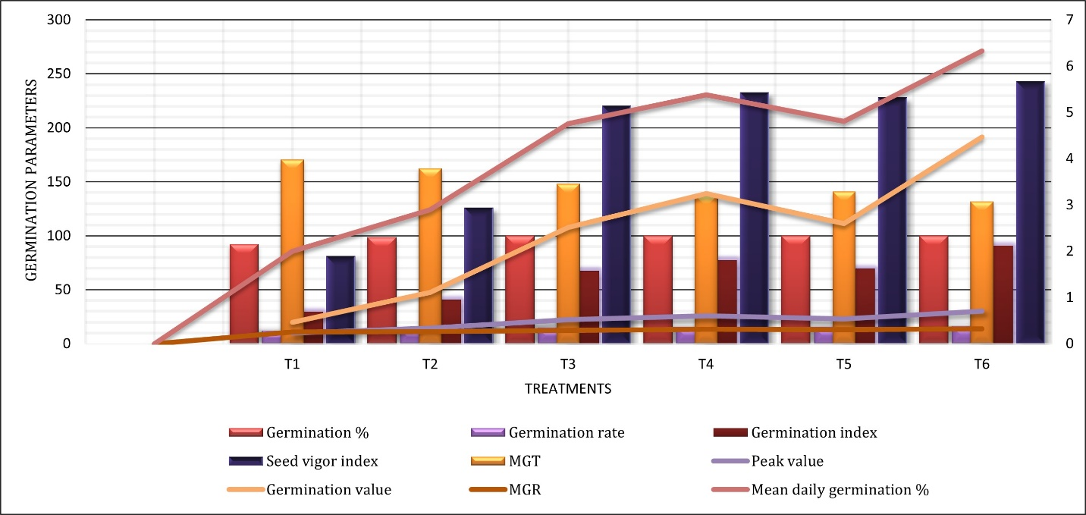

**T1 – Control (Distilled water), T2 – GA3 @ 60 ppm, T3 – GA3 @ 80 ppm,   
T4 – GA3 @ 100 ppm, T5 - GA3 @ 120 ppm and T6 - GA3 @ 140 ppm**

**Fig. 1.** **Influence of different concentration of GA3 on germination parameters in dragon fruit seed.**

**3.2 Shoot, Root, Physiological Parameters.**

* **Root Length (cm)**: The longest roots (2.45 cm) were observed at GA₃ at 120 ppm (T5), which was significantly higher than all other treatments. The shortest root length (1.71 cm) was recorded at GA₃ at 140 ppm (T6), significantly lower than the control (T1). The exogenous treatment of GA3 may have contributed to the increase in root length by inducing the development of gluconeogenic enzymes during the early stages of seed germination. This could account for the enhanced vigor and germination characteristics that are reflected in the increased root length (Hota *et al*., 2018). Elevated gibberellin levels at the initial stages of root development suppress middle cortex (MC) formation, while a subsequent decrease in gibberellin levels facilitates its development (Gong *et al.*, 2016).
* **Seedling Length (cm) and Fresh Weight of Roots (g)**: Maximum seedling length (3.75 cm) was observed at GA₃ at 80 ppm (T2), significantly different from most treatments. The shortest seedling length (3.05 cm) was recorded at GA₃ at 140 ppm (T6), highlighting a growth reduction at higher GA₃ doses. The highest fresh weight of roots (0.0337 g) was recorded at GA₃ at 80 ppm, which was significantly higher than the control (0.0097 g). GA₃ at 140 ppm (0.0236 g) showed a decline in root fresh weight, possibly indicating or higher GA3 negatively impacts biomass accumulation. Research in false wheatgrass (*Leymus chinensis*) demonstrated that GA₃ treatment at all concentration levels significantly enhanced seed germination rates compared with the control. However, higher concentrations slightly compromised the promoting effect of some growth parameters compared to lower. This is consistent with findings that phytohormones only work within a certain concentration range (Ma *et al.*, 2018).
* **Dry Weight of Seedlings (g)**: The highest dry weight of seedlings (0.0197 g) was recorded at GA₃at 140 ppm (T6), significantly higher than the control and most other treatments. This suggests that high GA₃ levels promote dry matter accumulation but may restrict overall elongation growth. It was studied that spraying 'Hass' avocado trees with gibberellic acid (GA₃) speeds up the accumulation of dry matter in the mesocarp. Their findings showed that fruits receiving GA₃ treatment attained legal maturity about four weeks sooner than those that were not treated, suggesting that GA₃ effectively boosts the rate of dry matter accumulation (Salazar-García *et al*., 2007). Seedling dry weight is a crucial factor in seed studies as it directly reflects seedling vigor. Seeds with higher dry weight and strong germination potential are considered ideal for long-term storage (Sharma *et al.*, 2016).
* **Total chlorophyll content, Fresh weight of seedlings, Number of roots:** The *p*-value (0.0965, 0.6864, 0.5508) for chlorophyll content, fresh weight of seedlings (g), number of roots respectively are greater than the common significance level (*α* = 0.05), indicating no statistically significant difference among did not significantly influence these parameters in seedlings at the 5% significance level. These observations suggest that while GA₃ can influence certain growth parameters, its effect on traits such as chlorophyll content, fresh weight, and root number may not always be significant. The variability in response could be attributed to factors such as plant species, environmental conditions, and the specific concentrations of GA₃ used.

**Table 4.** **Influence of different concentration of GA3 on different shoot, root, physiological parameters.**

|  |  |  |  |  |
| --- | --- | --- | --- | --- |
| **Treatment** | **Root length (cm)** | **Seedling length (cm)** | **Fresh weight of roots (g)** | **Dry weight of seedlings (g)** |
| T1 | 1.71b | 3.61ab | 0.0097c | 0.0098b |
| T2 | 1.81b | 3.19bc | 0.0145c | 0.0061b |
| T3 | 1.83b | 3.75a | 0.0337a | 0.0109b |
| T4 | 1.79b | 3.39abc | 0.0301ab | 0.0085b |
| T5 | 1.97b | 3.61ab | 0.0323ab | 0.0117b |
| T6 | 2.45a | 3.05c | 0.0236b | 0.0197a |
| CD (5%) | 0.3335 | 0.4382 | 0.0088 | 0.0063 |
| SE | 0.1530 | 0.2011 | 0.0040 | 0.0029 |

*Common letters are non-significant according to LSD (Least Significant Difference) at a 5% probability level.

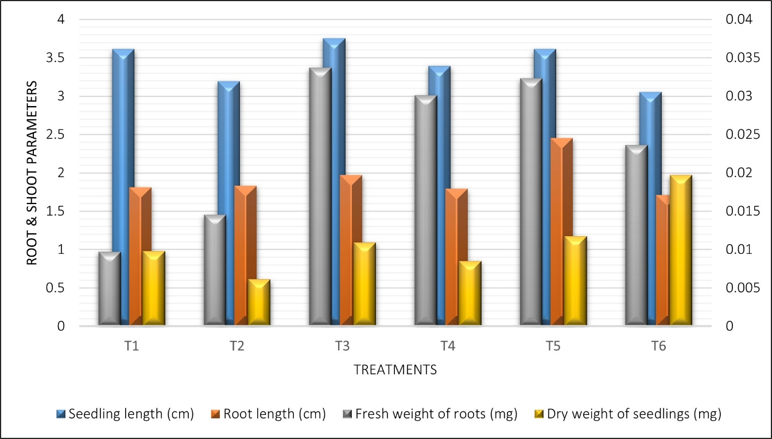

**T1 – Control (Distilled water), T2 – GA3 @ 60 ppm, T3 – GA3 @ 80 ppm,   
T4 – GA3 @ 100 ppm, T5 - GA3 @ 120 ppm and T6 - GA3 @ 140 ppm**

**Fig. 2.** **Influence of different concentration of GA3 on shoot, root and physiological parameters.**

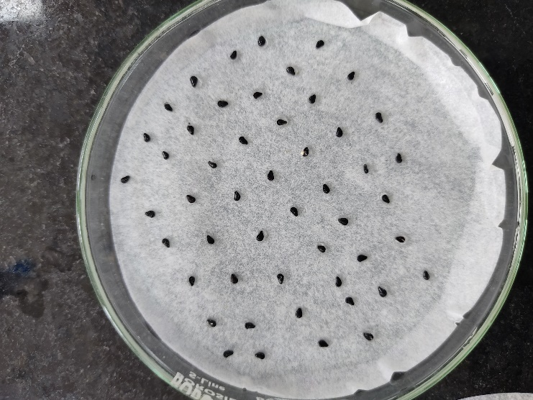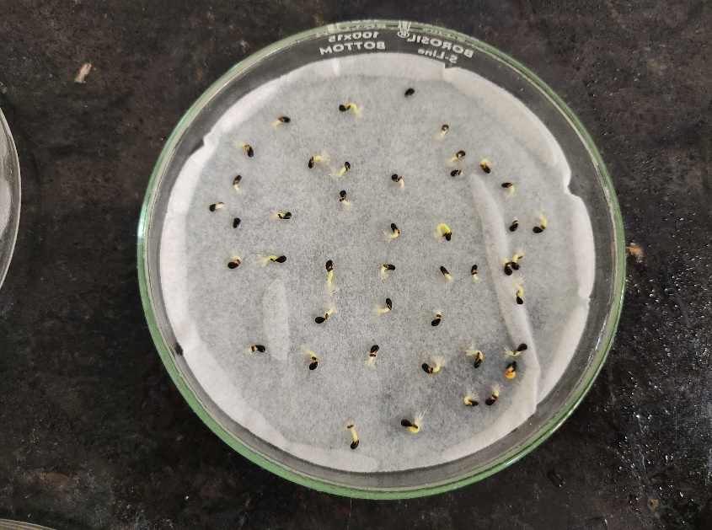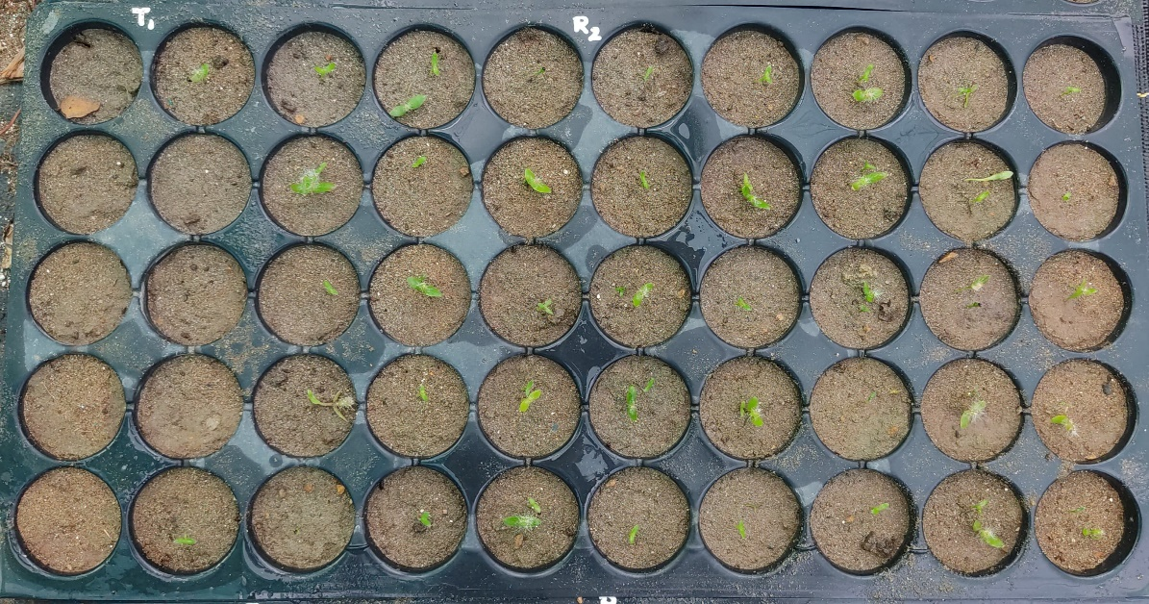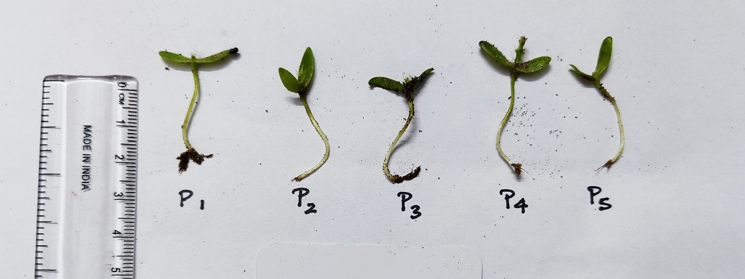

**D**

**B**

**A**A

**C**

**Fig. 3. A. Seeds are placed equidistantly on filter paper. B. Seeds are germinated. C. The germinated seeds are transplanted into protrays. D. The parameters are observed and recorded.**

**CONCLUSION**

This study demonstrated that gibberellic acid (GA₃) significantly influences the germination and early seedling growth of dragon fruit (*Hylocereus undatus*). Among the tested concentrations, 140 ppm GA₃ resulted in the fastest germination rate, highest seed vigor index, and maximum survival percentage, making it the optimal concentration for improving seedling performance. Lower concentrations (60–80 ppm) still enhanced germination compared to the control but were less effective than higher doses. The findings confirm that GA₃ enhances seed germination by breaking dormancy, promoting enzymatic activity and accelerating seedling establishment. However, excessive concentrations may not necessarily improve all grow3th parameters, as seen in the non-significant differences in chlorophyll content, fresh weight, and root number. Overall, the application of 140 ppm GA₃ is recommended for maximizing germination efficiency, seedling vigor, and survival in dragon fruit cultivation.

Future studies could explore long-term effects on field establishment and fruiting potential to further optimize GA₃ application in commercial production.

**REFERENCES**

Al-Hawezy, S. M. N. (2013). The role of different concentrations of GA₃ on seed germination and seedling growth of loquat (*Eriobotrya japonica* L.). *IOSR Journal of Agriculture and Veterinary Science, 4*, 3–6.

Anburani, A., & Shakila, A. (2010). Influence of seed treatment on the enhancement of germination and seedling vigor of papaya. *Acta Horticulturae, 851*, 295–298.

Cheng, C., Xu, X., Singer, S. D., Li, J., Zhang, H., Gao, M., & Wang, X. (2013). Effect of GA₃ treatment on seed development and seed-related gene expression in grape. *PLoS ONE, 8*(11).

Dilip, W. S., Singh, D., Moharana, D., Rout, S., & Patra, S. S. (2017). Effect of gibberellic acid (GA) at different concentrations and time intervals on seed germination and seedling growth of Rangpur lime. *Journal of Agroecology and Natural Resource Management, 4*, 157–165.

Gong, X., Flores-Vergara, M. A., Hong, J. H., Chu, H., Lim, J., Franks, R. G., & Xu, J. (2016). SEUSS integrates gibberellin signaling with transcriptional inputs from the SHR-SCR-SCL3 module to regulate middle cortex formation in the *Arabidopsis* root. *Plant Physiology, 170*(3), 1675–1683.

Hosseini, M. S., Zahedi, S. M., Hoveizeh, N. F., Li, L., Rafiee, M., & Farooq, M. (2020). Improving seed germination and seedling growth of guava under heat and osmotic stresses by chemical and hormonal seed treatments. *Bragantia, 79*(4), 512–524.

Hota, S. N., Karna, A. K., Jain, P. K., & Dakhad, B. (2018). Effect of gibberellic acid on germination, growth, and survival of jamun (*Syzygium cumini* L. Skeels). *The Pharma Innovation Journal, 7*(8), 323–326.

Joshi, A. S., Sahoo, A. K., Bhoyar, R. K., & Meshram, P. C. (2015). Effect of various plant growth-promoting substances on seedling growth of acid lime. *Trends in Biosciences, 5*(19), 5222–5225.

Kadhim, Z. K. (2023). Effectiveness of soaking with gibberellic acid and kinetin on germination and growth indicators of two cultivars of pistachio (*Pistacia vera* L.). *IOP Conference Series: Earth and Environmental Science, 1158*(4), 042065.

Khopkar, R. R., Nagaharshitha, D., Haldavanekar, P. C., & Parulekar, Y. R. (2017). Studies on seed germination of pummelo (*Citrus grandis* L. Osbeck). *International Journal of Agricultural Science and Research, 7*, 257–264.

Kumar, S. B., Issac, R., & Prabha, M. L. (2018). Functional and health-promoting bioactivities of dragon fruit. *Drug Invention Today, 10*, 3307–3310.

Leite, V. M., Rosolem, C. A., & Rodrigues, J. D. (2003). Gibberellin and cytokinin effects on soybean growth. *Scientia Agricola, 60*(3), 537–541.

Ma, H. Y., Zhao, D. D., Ning, Q. R., Wei, J. P., Li, Y., Wang, M. M., & Liang, Z. W. (2018). A multi-year beneficial effect of seed priming with gibberellic acid-3 (GA₃) on plant growth and production in a perennial grass, *Leymus chinensis*. *Scientific Reports, 8*, 13214.

Maiti, C. S., Wangchu, L., & Sen, S. K. (2003). Effect of pre-sowing seed treatments with different chemicals on seed germination and seedling growth of jackfruit (*Artocarpus heterophyllus* Lam.). *Environment and Ecology, 21*(2), 290–292.

Manekar, R. S., Sable, P. B., & Rane, M. M. (2011). Influence of different plant growth regulators on seed germination and subsequent seedling growth of aonla (*Emblica officinalis* Gaertn.). *Green Farming, 2*(4), 477–478.

Martin, F. W., Camel, C. W. A., & Ruberte, R. M. (1987). *Perennial edible fruits of the tropics: An invention* (Agriculture Handbook No. 642). USDA.

Muralidhara, B. M., Reddy, Y. T. N., Akshita, H. J., & Srilatha, V. (2015). Effect of pre-sowing treatments on germination, growth, and vigor of polyembryonic mango seedlings. *Environment and Ecology, 33*(3), 1014–1018.

Mtambalika, K., Munthali, C., Gondwe, D., & Missanjo, E. (2014). Effect of seed size of *Afzelia quanzensis* on germination and seedling growth. *International Journal of Forestry Research, 2014*, 384565.

Patel, R. J., Ahlawat, T. R., Singh, A., Momin, S. K., & Gavri, C. (2016). Effect of pre-sowing treatments on stone germination and shoot growth of mango (*Mangifera indica* L.) seedlings. *International Journal of Agricultural Sciences, 8*(52), 2437–2440.

Pimenta, B. E. (1990). *El nopa tunero*. Afisco, University of Guadalajara, Mexico.

Prasad, B., & Prasad, R. (2009). Selection of suitable growth regulators and their concentration for better germination and seedling growth of Himalayan dogwood (*Benthamidia capitata* Wall ex. Roxb.). *Indian Journal of Forestry, 32*(4), 523–527.

Reshma, U. R., & Simi, S. (2019). Effect of pre-sowing treatments, sowing positions, and age of stones after extraction on germination of mango. *International Journal of Current Microbiology and Applied Sciences, 8*(4), 2565–2573.

Salazar-García, S., Cossio-Vargas, L. E., González-Durán, I. J. L., & Lovatt, C. J. (2007). Foliar-applied GA₃ advances fruit maturity and allows off-season harvest of ‘Hass’ avocado. *HortScience, 42*(2), 257–261.

Salgotra, R. K., & Chauhan, B. S. (2023). Genetic diversity, conservation, and utilization of plant genetic resources. *Genes, 14*(1), 174.

Samir, M., Rai, R., & Prasad, B. (2015). Seed germination behavior as influenced by pre-sowing treatments in khirni. *Journal of Hill Agriculture, 6*(1), 132–135.

Sharma, N., Shukla, Y. R., & Mehta, D. K. (2016). Seed priming and its consequences on seedling vigor of bell pepper (*Capsicum annuum* L.) under low-temperature conditions. *International Journal of Bio-resource and Stress Management, 6*(6), 759–764.

Wang, X., Zheng, H., Tang, Q., Mo, W., & Ma, J. (2019). Effects of gibberellic acid application after anthesis on seed vigor of *Indica* hybrid rice (*Oryza sativa* L.). *Agronomy, 9*(12), 861.