Standardization of priming method and media for enhancing the seedling growth, vigor, germination parameters in papaya variety CO8

ABSTRACT
Background: Papaya (Carica papaya Linn.) is widely recognized for its nutritional and dietary benefits across the globe. Papaya is a widely cultivated fruit with significant nutritional and medicinal value. Papaya is a tropical fruit characterized by its lozenge shape and vibrant coloration, ranging from orange red and yellow-green to yellow-orange hues, with a rich orange pulp. It also contains numerous biologically active compounds, including chymopapain and papain. Papain, in particular, plays a crucial role in aiding the digestive system and has been utilized in the treatment of arthritis.
Methodology: The experiment was conducted at the nursery, Karunya Institute of Technology and Science, Coimbatore during 2024 to study the effect of eleven treatment viz, Control, Water soaking, Coconut water (50%), Coconut water (100%), Kinetin 25ppm, Kinetin 50ppm, GA₃ 100ppm, GA₃ 200ppm, Salicylic acid 1Mm, Vermiwash 50%, Humic acid 1% for 24 hours. This experiment was laid out in factorial completely randomized design with three replications in pots.
Results: Among all the treatments, kinetin 25 ppm (P₅) for 24 hours showed positive significant influence on seed germination, seedling growth parameters. Whereas, the lowest was recorded in control (P₁) without priming. Similarly, combination of kinetin 25ppm and media supplemented with trichoderma was found to be the best for improving seedling vigor and germination of papaya seedlings.
Conclusion: Kinetin 25ppm treatment for 24 hours significantly enhanced seed germination and seedling growth parameters in papaya, especially when combined with trichoderma-supplemented media. The control treatment showed the lowest germination and seedling vigor.
Key words: Papaya; Growth parameters; Germination; seedling growth; seed priming; seedling vigor.

1.INTRODUCTION
Papaya (Carica papaya L.) is a tasty fruit from the Caricaceae family. It was originated in tropical regions of southern Mexico and Central America. India is the world's largest producer of papaya, having highest area and productivity. India cultivates 97.7 thousand hectares of papaya, producing 5.95 million MT. Papaya cultivation is common in the states like Karnataka, Gujarat, Orissa, West Bengal, Assam, Kerala, Maharashtra, and Madhya Pradesh while Andhra Pradesh took prime position in papaya cultivation. This crop is easy to grow, requires less space, yield can be expected early compared to other fruit crops. It is also having good nutritional value and with high vitamin-A content (1500-2020 IU/100 g pulp). (Ram, 2005).
The papaya plant can reach up to 10 meters and has a single central stalk. Papaya trees are dioecious, meaning they produce both male and female flowers in different plants. Growing demand for unripe papaya as a table fruit and vegetable is prompting growers to increase production. Papaya is primarily propagated through seed. Papaya farmers confront challenges in the nursery stage, including poor seed germination, low seedling vigour, and diseases such as damping off and viral infections. Compared to fresh papaya seeds, stored seeds germinate more quickly; nevertheless, prolonged storage results in asynchronous, delayed germination with a low germination percentage (Andred et al. 2008). Papaya seed germination is also influenced by external factors such as the growing media's pH and nutritional conditions, storage conditions and duration, biotic and abiotic stress. Papaya seeds' have sarcotesta can be eliminated by chemical priming or water prewashing, which promotes germination (Lange 1961; Yahiro 1979; Perez et al. 1980; Okeyo and Ouma 2008). The most crucial factors for effective output under the nursery system of papaya growing are proper seed germination and seedling growth. The amount of soil and nutrients available to seeds that germinate in containers is restricted. In addition, media should have high drainage, water-holding capacity, and other chemical and physical characteristics. Therefore, it is preferable to offer soil media or a mixture that satisfies the needs for optimal seed germination and improved seedling growth. Seed priming involves soaking seeds in a solution for a set period of time before planting. Commercial seed priming is used to speed up germination and improve seedling uniformity (Samfield et al. 1990; Wartidiningsih et al. 1994). Pre-soaking seeds in water or soluble endogenous hormones has been shown to improve germination. As papaya cultivation becomes more commercialized, there is a greater demand for high-quality seeds from established varieties. Proper seed germination and seedling growth are crucial for successful seedling production in the nursery technique. Climate variability also affects seed germination and seedling growth.
Even though several commercial varieties are available there is a problem of germination and disease in papaya nursery, this will affect the productivity. Considering the problems associated with papaya seed germination and nursery techniques, an attempt was made to standardize the suitable growing media and priming agents for successful production of CO8 papaya seedlings under Coimbatore condition.

2.MATERIALS AND METHODS

An investigation was carried out at North Farm, School of Agricultural Sciences, Karunya Institute of Technology and Sciences, Coimbatore, Tamil Nadu, India during 2024. The details of material used and methods adopted for the investigation are outlined in this chapter.
Location : Karunya Institute of Technology and Sciences, Nursery
Variety : CO8 papaya
Design : FCRD
Year : 2024-2025
Treatment : 11
Replication : 3
Combination : 33
2.2 Treatment Details
There were 11 treatments of different priming agent and 3 different media.
Factor -1: Priming
Factor -1: Priming
P₁ | Control (without priming)
P₂ | Water soaking
P₃ | Coconut water (50%)
P₄ | Coconut water (100%)
P₅ | Kinetin 25ppm
P₆ | Kinetin 50ppm
P₇ | GA₃ 100ppm
P₈ | GA₃ 200ppm
P₉ | Salicylic acid 1mM
P₁₀ | Vermiwash 50%
P₁₁ | Humic acid 1%

Factor-2: Media
Factor-2: Media
M₁ | 2:1:1 (Soil+ Cocopeat + FYM) + Trichoderma
M₂ | 2:1:1 (Soil+ Cocopeat + FYM) +Trichoderma +Azospirillum
M₃ | 2:1:1 (Soil+ Cocopeat + FYM) + Trichoderma + Vermicompost

2.3 Seed extraction
Papaya fruits (Carica papaya) were collected at the fully ripe stage from the Tamil Nadu Agricultural University (TNAU) for the purpose of seed extraction. The seeds were removed from the fruits through a washing process, followed by rubbing with sand to effectively remove the sarcotesta. The seeds were then dried in the shade for a period of 2-3 days to reduce their moisture content to a level conducive to seed priming. This drying process was done under controlled conditions, ensuring that the seeds did not lose viability during the drying procedure. Following the drying phase, a minimum of 10 seeds per replication were selected for the priming treatment. Seed priming is a process in which seeds are pre-soaked in a solution or under controlled conditions to enhance germination rates. In this study, the priming treatment was applied for a duration of 24 hours.
2.4 Brief description of preparation prime agent is discussed below
- Control (P₁): Treatment are treated without no priming agent
- Water soaking (P₂): Seeds are soaked in 100ml diluted water.
- Coconut water @ 50% (P₃): Seeds are soaked at 50% coconut water and 50% diluted water.
- Coconut water @ 100% (P₄): Seeds are soaked in pure coconut water.
- Kinetin @ 25 ppm (P₅): Seeds are soaked in a 25-ppm concentration of kinetin.
- Kinetin @ 50 ppm (P₆): Seeds are soaked in a 50-ppm concentration of kinetin
- GA₃ @ 100 ppm (P₇): Seeds are soaked in a 100-ppm concentration of GA₃.
- GA₃ @ 250ppm (P₈): Seeds are soaked in a 200-ppm concentration of GA₃.
- Salicylic acid @ 1 mM (P₉): Seeds are soaked in a 1 mM concentration of salicylic acid.
- Vermiwash @ 50% (P₁₀): Seeds are soaked in diluted Vermiwash 50% concentration and 50 % diluted water.
- Humic acid @ 1% (P₁₁): Seeds are soaked in a 1% concentration of humic acid with 99 % diluted water.
2.5 Soaking of seeds
The extracted seeds were soaked in plastic bottles for 24 hr in different priming agents viz., solution of coconut water, kinetin, GA₃, salicylic acid, vermiwash, humic acid in different concentration was added in each bottle as per treatment separately.
2.6 Preparation of growing media, filling of pots and sowing of treated seeds
The pots having a size of 4×5 inches were selected and filled with different growing medias. The common media in all the pots was soil + cocopeat + FYM in the ratio 2:1:1 additionally trichoderma, trichoderma + azospirillum and trichoderma + vermicompost was added to all the pots replication wise. The treated seeds were sown in pots. The proper care was taken while sowing seeds which should not be placed too deep. The depth of sowing was maintained up to 2 cm. The care was also taken to cover these seeds with thin layer of top soil.
2.7 Cultural practices
Cultural operations like irrigation, weeding etc. was done as per the requirement.
2.8 Observation recorded
2.8.1 Seedling height (cm)
Seedling height 10 seedling from bottom tip of end of largest leaf at 45th was measured and expressed in cm.
2.8.2 Number of leaves (No.)
The count of leaves per seedling was taken from 10 selected seedlings in each replication and average was calculated finally expressed in number.
2.8.3 Collar thickness (mm)
The girth of collar was measured using vernier calliper from all 10 seedling and average was calculated and expressed in mm.
2.8.4 Germination percentage (%)
Germination percentage was calculated by counting number of papaya seeds germinated out of total seed dibbled into the pot average was done and expressed in percentage.
2.8.5 Survival percentage
This was recorded at the end of the experiment (45-60 days after sowing)
2.9 Statistical analysis
The statistical analysis was done in factorial completely randomised design with eleven treatment and three replications using the software grapes. The significance was measured at 5%.

3.EXPERIMENTAL RESULTS
An investigation was conducted at Karunya Institute of Technology and Sciences, North Farm shade net during 2024. The experiment results are present in this chapter.
The details of the results obtained immediately after extracting and sowing are discussed below.
3.1 Growth parameters
The growth parameters like seedling height, number of leaves and collar thickness was recorded at 45 days after sowing. The maximum seedling height was recorded in P₅: kinetin @ 25ppm (10.43 cm), whereas the lowest (5.26 cm) seedling height was recorded in P₁ control. The maximum number of leaves (10.78) was found to be significantly superior in P₅ (kinetin 25ppm) compared to other treatments. In contrast, the lowest number of leaves (5.61) was recorded in P₁ control. The priming agent P₅ (kinetin 25ppm) exhibited the highest collar thickness of 5.31 mm, which was significantly superior to other treatments, while the lowest collar thickness (1.22 mm) was observed in P₁ control. It is depicted in table 1.
The influence of different growing medias on seedling height, number of leaves and collar thickness was recorded at 45 days after sowing. Among three different growing medias M₃ 2:1:1 (soil+ cocopeat + FYM) along with bioagents like trichoderma and vermicompost showed maximum seedling height (8.13 cm) and lowest seedling height was noticed in M₁ (soil+ cocopeat + FYM) trichoderma (7.80 cm). Similarly, M₃ (soil: cocopeat: FYM in a 2:1:1 ratio trichoderma and vermicompost) recorded the maximum number of leaves (7.94) and lowest in M₁ (7.62). The media comprising of (2:1:1 combination of soil, cocopeat, and FYM, supplemented with trichoderma and vermicompost) M₃ produced the maximum collar thickness (3.75 mm) and lowest in M₁(3.32 mm). It is depicted in table 2.
Out of 33 combinations studied the combination of P₅M₃ kinetin 25ppm (soil+ cocopeat + FYM) trichoderma and vermicompost recorded maximum seedling height of (10.65 cm) and lowest in P₁M₁ (5.25 cm) control (soil+ cocopeat + FYM) trichoderma. Similar trend was also observed for number of leaves and collar thickness i.e. P₅M₃ showed maximum number of leaves (11.04) and lowest was observed in P₁M₁ (5.27). Collar thickness was highest in P₅M₃ (5.48 mm) and lowest in P₁M₁ (1.13 mm). It is depicted in table 3.
Table 1. Effect of different Priming methods on growth parameters of papaya cv. CO8
Priming | Seedling height  (cm) | Number of leaves (No.) | Collar thickness  (mm)
P₁: Control (without priming) | 5.26 | 5.61 | 1.22
P₂: Water soaking | 5.66 | 6.58 | 1.69
P₃: Coconut water (50%) | 7.06 | 6.54 | 1.83
P₄: Coconut water (100%) | 7.37 | 6.21 | 3.04
P₅: Kinetin 25ppm | 10.43 | 10.78 | 5.31
P₆: Kinetin 50ppm | 7.82 | 7.37 | 4.57
P₇: GA3 100ppm | 8.20 | 7.52 | 4.26
P₈: GA3 200ppm | 9.11 | 8.22 | 3.84
P₉: Salicylic acid 1mM | 9.05 | 8.63 | 4.38
P₁₀: Vermiwash 50% | 9.07 | 9.19 | 3.94
P₁₁: Humic acid 1% | 8.97 | 8.94 | 4.51
S.Em. ± | 0.12 | 0.09 | 0.042
C.D. at 5 % | 0.344 | 0.28 | 0.12
C.V | 3.664 | 3.09 | 2.90

Table 2. Effect of growing medias on growth parameters of papaya cv. CO8
Media | Seedling height  (cm) | Number of leaves  (No.) | Collar thickness  (mm)
M₁:2:1:1 (Soil+ Cocopeat + FYM) + Trichoderma | 7.80 | 7.62 | 3.32
M₂: 2:1:1 (Soil+ Cocopeat FYM) +Trichoderma+Azospirillum | 8.07 | 7.78 | 3.46
M₃: 2:1:1 (Soil+ Cocopeat + FYM) + Trichoderma + Vermicompost | 8.13 | 7.94 | 3.75
S.Em. ± | 0.12 | 0.051 | 0.022
C.D. at 5 % | 0.344 | 0.148 | 0.063
C.V | 3.664 | 3.099 | 2.902
FYM – Farmyard Manure

Table 3. Interaction of priming media and growing media on growth parameters of papaya cv. CO8
Priming + Media  Combination | Seedling height  (cm) | Number of leaves  (No.) | Collar thickness  (mm)
P₁M₁ | 5.25 | 5.27 | 1.13
P₁M₂ | 5.50 | 5.95 | 1.25
P₁M₃ | 5.05 | 5.62 | 1.29
P₂M₁ | 5.25 | 6.60 | 1.57
P₂M₂ | 5.70 | 6.64 | 1.77
P₂M₃ | 6.05 | 6.50 | 1.74
P₃M₁ | 7.30 | 6.75 | 1.82
P₃M₂ | 6.85 | 6.49 | 1.86
P₃M₃ | 7.05 | 6.37 | 1.82
P₄M₁ | 7.30 | 5.68 | 2.27
P₄M₂ | 7.47 | 6.33 | 2.58
P₄M₃ | 7.34 | 6.63 | 4.28
P₅M₁ | 10.30 | 10.64 | 5.14
P₅M₂ | 10.34 | 10.65 | 5.33
P₅M₃ | 10.65 | 11.04 | 5.48
P₆M₁ | 7.30 | 7.22 | 4.39
P₆M₂ | 7.83 | 7.27 | 4.74
P₆M₃ | 8.35 | 7.62 | 4.57
P₇M₁ | 7.75 | 6.87 | 3.88
P₇M₂ | 8.45 | 7.59 | 4.17
P₇M₃ | 8.45 | 8.11 | 4.73
P₈M₁ | 9.30 | 8.60 | 3.98
P₈M₂ | 9.45 | 8.44 | 3.79
P₈M₃ | 8.65 | 7.63 | 3.81
P₉M₁ | 7.91 | 8.59 | 4.17
P₉M₂ | 9.49 | 8.03 | 4.48
P₉M₃ | 9.74 | 9.27 | 4.51
P₁₀M₁ | 8.80 | 9.06 | 3.82
P₁₀M₂ | 9.65 | 8.90 | 3.69
P₁₀M₃ | 8.76 | 9.60 | 4.30
P₁₁M₁ | 9.45 | 8.55 | 4.39
P₁₁M₂ | 8.75 | 9.35 | 4.44
P₁₁M₃ | 8.71 | 8.94 | 4.72
S.Em. ± | 0.207 | 0.171 | 0.072
C.D. at 5 % | 0.597 | 0.491 | 0.207
C.V | 3.664 | 3.099 | 2.902

3.2 Germination parameters
Germination percentage and survival percentage was recorded at 45 days after sowing. There was a significant influence of priming agents on germination percentage and survival percentage of papaya seeds. The priming agent P₅ kinetin 25 ppm demonstrated a significantly superior germination percentage of 96.16%, outperforming all other treatments. The lowest germination percentage of 35.66% was observed in the control treatment P₁ without no priming agent. Treatment P₅ Kinetin 25 ppm demonstrated a significantly superior survival percentage of (97.33%), while the lowest survival percentage was observed in P₁ control without priming agent (38.33%). It is depicted in table 4.
With respect to growing media, M₃, which comprised of 2:1:1 ratio of soil, cocopeat, and FYM, supplemented with trichoderma and vermicompost, recorded the highest germination percentage of 74.77% and survival percentage of 76.54%. Where it was lowest in M₁ (soil+ cocopeat + FYM) trichoderma germination percentage of 70.31% and survival percentage of 74.72%. It is depicted in table 5.
The interaction between priming agents and growing medias had a significant influence on germination and survival percentage. The combination of P₅ (kinetin 25 ppm) with M₃ (2:1:1 soil + cocopeat + FYM, supplemented with trichoderma and vermicompost) was found to be significantly superior for obtaining the maximum germination percentage of (99.0%) and survival percentage of (97.0%). It was lowest in P₁M₁(soil+ cocopeat + FYM) trichoderma. germination percentage (32.0%) and lowest in survival percentage (36.0%). It is depicted in table 6.
Table 4. Influence of priming methods and media on germination parameters of papaya
Priming | Germination percentage (%) | Survival percentage (%)
P₁: Control (without priming) | 35.66 | 38.33
P₂: Water soaking | 44.83 | 54.33
P₃: Coconut water (50%) | 54.33 | 60.66
P₄: Coconut water (100%) | 64.83 | 75.00
P₅: Kinetin 25ppm | 96.16 | 97.33
P₆: Kinetin 50ppm | 82.16 | 82.66
P₇: GA3 100ppm | 70.83 | 78.66
P₈: GA3 200ppm | 88.66 | 87.16
P₉: Salicylic acid 1mM | 76.50 | 86.16
P₁₀: Vermiwash 50% | 86.16 | 80.00
P₁₁: Humic acid 1% | 87.83 | 87.33
S.Em. ± | 1.13 | 1.179
C.D. at 5 % | 3.252 | 3.391
C.V | 3.865 | 3.837

Table 5. Effect of growing medias on germination percentage and survival percentage at 45 DAS of papaya variety CO8 for immediate after sowing
Media | Germination percentage (%) | Survival percentage (%)
M₁:2:1:1 (Soil+ Cocopeat + FYM) + Trichoderma | 70.31 | 74.72
M₂: 2:1:1 (Soil+ Cocopeat FYM) +Trichoderma +Azospirillum | 69.81 | 74.45
M₃: 2:1:1 (Soil+ Cocopeat + FYM) + Trichoderma + Vermicompost | 74.77 | 76.54
S.Em. ± | 0.59 | 0.615
C.D. at 5 % | 1.699 | 1.771
C.V | 3.865 | 3.837
FYM – Farmyard Manure
Table 6. Interaction effect of priming methods and growing medias on germination percentage and survival percentage of papaya for immediate after sowing
Priming + Media  Combination | Germination percentage  (%) | Survival percentage  (%)
P₁M₁ | 32.0 | 36.0
P₁M₂ | 36.0 | 41.0
P₁M₃ | 39.0 | 38.0
P₂M₁ | 47.5 | 52.5
P₂M₂ | 42.0 | 54.0
P₂M₃ | 45.0 | 56.5
P₃M₁ | 52.0 | 62.0
P₃M₂ | 47.5 | 55.0
P₃M₃ | 63.5 | 65.0
P₄M₁ | 66.5 | 71.0
P₄M₂ | 54.5 | 76.5
P₄M₃ | 73.5 | 77.5
P₅M₁ | 93.5 | 97.5
P₅M₂ | 96.0 | 97.5
P₅M₃ | 99.0 | 97.0
P₆M₁ | 82.0 | 81.0
P₆M₂ | 83.5 | 85.0
P₆M₃ | 81.0 | 82.0
P₇M₁ | 62.5 | 78.0
P₇M₂ | 71.0 | 75.0
P₇M₃ | 79.0 | 83.0
P₈M₁ | 87.5 | 90.0
P₈M₂ | 90.5 | 86.5
P₈M₃ | 88.0 | 85.0
P₉M₁ | 78.0 | 88.5
P₉M₂ | 76.0 | 85.0
P₉M₃ | 75.5 | 85.0
P₁₀M₁ | 81.5 | 76.5
P₁₀M₂ | 84.5 | 78.5
P₁₀M₃ | 92.5 | 85.0
P₁₁M₁ | 90.5 | 89.0
P₁₁M₂ | 86.5 | 85.0
P₁₁M₃ | 86.5 | 89.0
S.Em. ± | 1.958 | 2.041
C.D. at 5 % | 5.633 | 5.873
C.V | 3.865 | 3.837

4.DISCUSSION
The present investigation was conducted at North Farm, School of Agricultural Sciences, Karunya Institute of Technology and Sciences, Coimbatore, Tamil Nadu, India during 2024. The possible explanation for the results obtained are discussed in this chapter.
4.1 Growth parameters
Treatment P₅ registered highest seedling height (10.43 cm) whereas, lowest was observed in P₁ (5.26 cm). This might be due to effect on cell enlargement, cell growth, physio-chemical properties of protoplasm, respiration and nucleic acid, metabolism etc. The same trend was also observed by following researchers viz., Vachhani et al. (2014) in sapota, Upadhyay et al. (2015), Nagar et al. (2016), HB Bagul et al. (2018) in papaya, Ramesh Singh Yadav et al. (2018) in custard apple. The mechanism involves kinetin stimulating the activity of enzyme hydrolases, which loosen the cell wall, allowing for cell elongation. Additionally, kinetin enhances the synthesis of proteins required for growth and division, contributing to increased biomass and plant stature in papaya. (Barche et al. 2010, Babu et al. 2010). Regarding the number of leaves, P₅ registered highest (10.78) and lowest in P₁ (5.61). From the physiological point of view, leaf is the most important photosynthetic site of the plant. It is the source from which the plant derives energy for its metabolic activities. The primary function of leaves is the carbon assimilation. According to Raju et al. using vermicompost and cocopeat as growing mediums provides an adequate nutrient supply, promoting rapid cell division and elongation. This leads to an increased number of leaves in cucumber plants. Additionally, the application of exogenous kinetin enhances leaf growth in strawberries. Bisht et al. reported that kinetin indeed promotes leaf area expansion by enhancing cell division and elongation. It stimulates the growth of epidermal and parenchymal cells, leading to larger leaves. vermicompost contributes to this process by enriching the soil with beneficial microbes like phosphate-solubilizing bacteria, azotobacter, and azospirillum. These microbes improve nutrient availability, especially nitrogen and phosphorus, which are crucial for leaf development and overall plant growth. The synergy between kinetin and vermicompost can significantly enhance leaf area and vitality in fruit crops. Girth of the collar was highest in P₅ (5.31 mm) and lowest in P₁ (1.22 mm). Increase in collar girth in P₅ might be due to the increase in number of leaves and plant height this is symbolizes the healthy nature of the seedlings. The priming agent kinetin enhanced the rate of cell division and elongation of stem portion, stimulation of cambium and its immediate cell progeny as observed by Dhankhar and Singh (1996) in aonla.
4.2 Germination parameters
Germination of seed was started at 15 days after sowing and it was continued upto 32 days. Germination percentage was significantly influenced by both main factors: seed quality and priming treatments. Germination of seeds of papaya was significantly influenced by kinetin 25 ppm. The germination percentage was highest in P₅ (96.16%) and lowest in P₁ (35.66%). Highest germination percentage in kinetin @ 25 ppm might be due to fact that the synthesis of amino acids in plants is accelerated, which is indirectly exhibited by enhanced growth and their parts. The increase in germination percentage in the treatment with kinetin might be due to the involvement of kinetin in the activation of cytological enzymes along with an increase in cell wall plasticity and better water absorption. (Babu et al. 2010). Similar trend was observed for survival percentage P₅ registered highest (97.33%) and lowest in P₁ (38.33%). The findings are in line with the results obtained by (Ambica and Balakrishnan, 2015). This enhancement in cellular activity likely promoted faster seedling germination and overall growth. Additionally, vermicompost's has the ability to retain more water and air could have facilitated rapid and early enzymatic action, leading to the synthesis of essential metabolites for cell multiplication. It may also have supported the breakdown of the seed coat, allowing the embryo to develop into a seedling at an earlier stage. (Meera et al. 2018)
5.CONCLUSION
It can be concluded from the present investigation that, P₅ kinetin 25 ppm found to be best priming agent, M₃ 2:1:1 (soil+ cocopeat + FYM) + trichoderma and vermicompost was found to be best growing media. The combination of P₅ and M₃ was found to be best for improving the growth and germination of papaya var CO-8 a in the nursery when the sowing was taken immediately after seed extraction.
8. REFERENCES

Ambica S., & Balakrishnan K. (2015). Enhancing germination and seedling vigour in cluster bean by organic priming. Scientific Research and Essays, 10(8), 298–301.
Anburani A., & Shakila A. (2010). Influence of seed treatment on the enhancement of germination and seedling vigour of papaya. Acta Horticulture, 851, 295-298.
Andrade., M., J. Ayala., I. Alia, H., Rodriguez., C. Acosta & V. Lopez. (2008). Effect of germination promoters and substrates in the development of papaya seedlings. Revista de la Facultad de Agronomia, 25, 617- 635.
Bagul HB., Parmar AB., Parmar BR., Pandey AK., & Jnanendra M. 2018. Effect of pre-sowing seed treatments on germination and growth of papaya (Carica papaya L.) seedlings cv. red lady. The Pharma Innovation Journal, 7(1), 95-97
Barche S., K. Singh Kirad & D. B. Singh (2010). Response of seed Treatment on Germination, Growth, Survivability and economics of different cultivars of Papaya (Carica Papaya L). Acta Horticulture, 851, 279-281.
Barche, S., Singh Kirad, K., & Singh, D. B. (2008). Response of seed treatment on germination, growth, survivability and economics of different cultivars of papaya (Carica papaya L.). In II International Symposium on Papaya. 851 (pp. 279-284).
Chandni, B., Kanzaria., D. R., Karmur., N. N., Sandh, M., Parsana, J. S., & Patel, H. N. (2022). Effect of sarcotesta on papaya seedling. The Pharma innovation journal. 11(8), 1412-1415.
Chattopadhyay R.R. (2003) Possible mechanism of hepatoprotective activity of Azadirachta indica leaf extract Part II. Journal of Ethnopharmacology, 89, 217-219.
Dayeswari D, Auxcilia J, Vijayakumar RM, et al. (2018). Role of KNO₃, KCl, KH₂PO₄, GA₃, halopolymer and PPFM on seed germination, seedling growth and vigour of TNAU papaya CO. 8 (Carica papaya L.). Journal of Biotechnology and Crop Science, 7(11), 140–146.
Desai, A., Trivedi, A., Panchal, B., & Desai, V. (2017). Improvement of papaya seed germination by different growth regulator and growing media under net house condition. InternationalJournal of Current Microbiology and Applied Sciences, 6(9).
Dhankhar DS., & Singh M. (1996) Seed germination and seedling growth in aonla (Phyllanthus emblica Linn.) as influenced by gibberellic acid and thiourea. Crop Research, 12(3), 363-366.
Hossain, F., Islam, N., Ali, S., Kayes, A., & Choudhury, S. (2023). GA₃ and growing medium influence papaya seed germination and seedling growth. Trends in Horticulture, 6(2), 3263.
Kadam AB., Singh DB., & Kade RA. (2010). Effect of plant growth regulators and potassium nitrate on growth of seedling of Kagzi lime. The Asian Journal of Horticulture.5(2), 431-434.
Khajjak, A. H., Memon, N., Wahocho, N. A., Sharif, N., Minao, T. F., Siddique, I. M., Jamali, M. F., Akhtar, N., Azam, M., & Irshad, U. (2022). Effect of seed priming on germination and seedling growth of papaya (Carica papaya L.). Plant cell biotechnology and molecular biology, 1–12.
Lange, A.H. (1961). Effect of the sarcotesta on germination of Carica papaya. Botanical Gazette.122(4), 305-311.
Maneesha, S. R. (2019). Effect of calcium nitrate and potassium nitrate priming on seed germination and seedling vigour of papaya (Carica papaya L.). Journal of Horticultural Sciences, 14(2), 149-154.
Meera Solanki, Kanzaria DR, Jignasa Rajatiya, Farheen Halepotara (2018). Effect of GA3 and different containers on seed germination and seedling growth of papaya (Carica papaya L.) cv. Madhubindu. International Journal of Chemical Studies, 6(5), 535-538
Nagar, S.K., Vihol, N.J., Arvind, R.K. & Shashi. 2016. Effect of Different Growing Media on Germination and Establishment of Seedlings of Papaya (Carica papaya L.) cv. Madhu Bindu under Net House Conditions. The Bioscan, 11 (3), 1465-1468.
Nagar, S.K., Vihol, N.J., Arvind, R.K. & Shashi. 2016. Effect of Different Growing Media on Germination and Establishment of Seedlings of Papaya (Carica papaya L.) cv. Madhu Bindu under Net House Conditions. The Bioscan. 11 (3), 1465-1468.
Okeyo, A. & Ouma, G. 2008. Effects of washing and media on the germination of papaya (C. papaya). Agricultura Tropica et Subtropica. 41(1), 21-26.
Pérez, A., Reyes, M.N. & Cuevas, J. (1980). Germination of two papaya varieties: effect of seed aeration, K-treatment, removing of the sarcotesta, high temperature, soaking in distilled water, and age of seeds. Journal of Agriculture of the University of Puerto Rico, 64(2), 173-180.
Ram M. (2005). Papaya. Indian council of Agricultural Research, New Delhi. 142-143.
Rani, M., Singh, G., Singh, N., & Kumar, D. (2024). Effect of Gibbrellic Acid, Kinetin and Potassium Nitrate on Seed Germination of Papaya (Carica papaya L.) cv. Red Lady. Asian Journal of Advances in Agricultural Research, 24(7), 53-60.
Ritchie, S. & Gilroy, S. (1998). Gibberellins: Regulating Genes and Germination. New Physiologist. 140, 363-383.
Samfield, DM., Zajicek, J. & Cobb, B.G. (1990). Germination of Coreopsis lanceolata and Echinacea purpurea seeds following priming and storage. Horticulture Science. 25, 1605-1606.
Upadhyay, N.V., Kumar, A.R. & Patel, K.M. (2015). Effect of Different Growing Media and Containers on Growth of Seedlings of Papaya (Carica papaya L.) cv. Madhu Bindu. Trends in Biosciences. 8 (1), 231-235.
Vachhani KB., Gohil JH., Pandey R & Ray NR. (2014). Influence of chemicals, PGR‟s and cow dung slurry as seed treatment on germiability, growth and development of Khirni (Manilkara hexandra) under net house condition. Trends in Biosciences, 7(14), 1641-1643.
Wartidiningsih, N., Geneve, R.L., Kcstcr, S.T. (1994). Osmotic priming or chilling stratification improves seed germination of purple coneflower. Horticulture Science. 29,1445-1448.
Yadav R S, Sharma TR, Pandey SK & Maske G. (2018). Effect of GA3 and cow urine on germination and morphology of custard apple. International Journal of Chemical Studies, 6(4): 1131-1134
Yahiro, M. (1979). Effects of seed-petreatments on the promotion of germination in papaya, Carica papaya L. Memoirs of the Faculty of Agriculture, Kagoshima University, 15(24), 49-54.

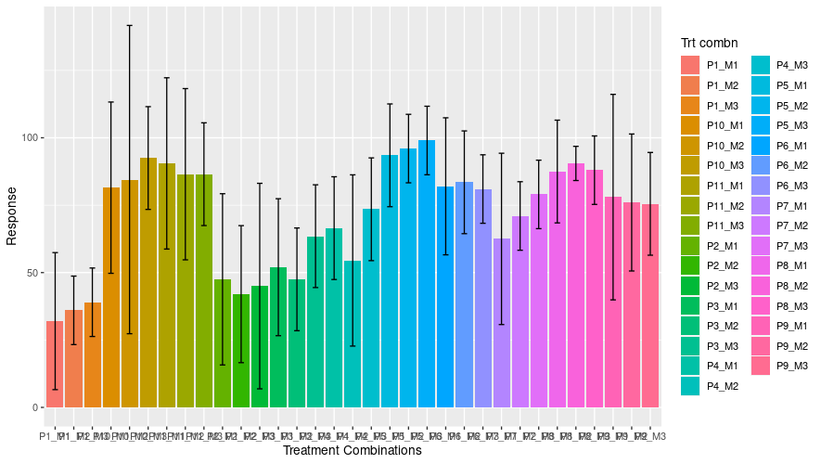
Fig. 1. Germination trend of papaya variety CO-8
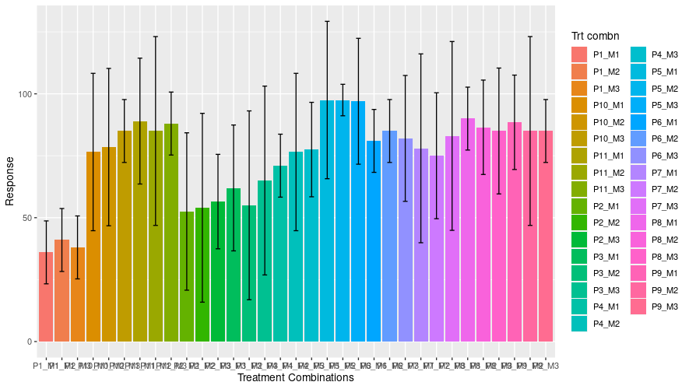
Fig. 2. Survival percentage of papaya CO-8 in nursery

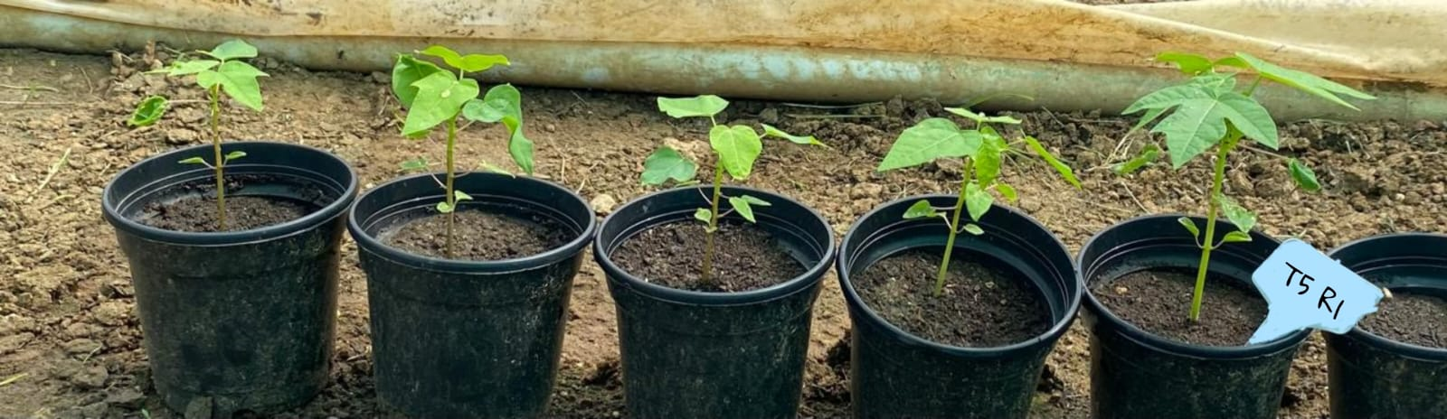

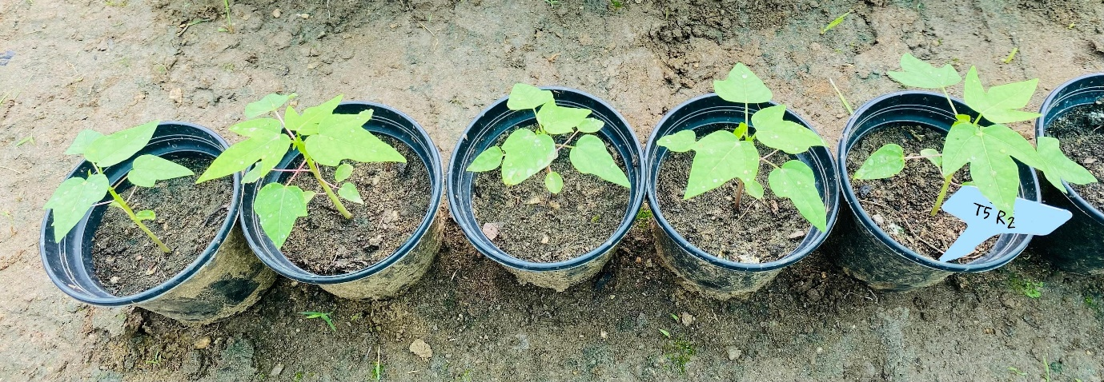
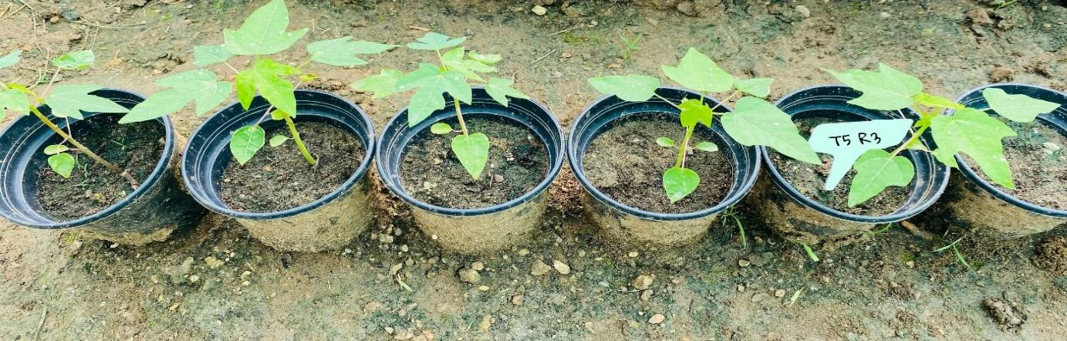

Fig. 3. Best performing treatment in nursery

