***Review Article***

**The Role of Cancer-Associated Fibroblasts in the Microenvironment of Invasive Ductal Carcinoma (IDC) Breast Cancer**

**ABSTRACT**

There has been an increase in the amount of studies focusing on the relevance of tumour microenvironment (TME) in metastasis of breast cancer. Cancer-associated fibroblasts (CAFs) is one of the most abundant cells found in the TME that play key roles in the metastasis of cancers particularly in invasive ductal carcinoma (IDC), a common type of breast cancer. In a bid to constantly find novel treatments to address limited number of therapy that are currently available, CAFs have emerged as a target for many research. This review aims to explore the multifaceted role of CAFs in IDC progression, highlighting their involvement in tumour growth, angiogenesis, epithelial-to-mesenchymal transition (EMT), immune modulation, and drug resistance. Additional focus was also placed on potential therapeutic benefit of targeting CAFs. A comprehensive review of recent studies on the subject of CAF in relation to tumours, specifically on IDC was conducted. Studied paper included research on CAF biology, CAF interactions within the TME, and existing therapeutic approaches targeting CAFs in IDC. Data from preclinical and clinical studies were dully analysed from distinct scholarly sources to evaluate the current understanding of CAFs in IDC. Findings reiterated that CAFs are crucial to the dynamics of the TME and they influence the dynamics of tumour progression.  CAFs facilitate tumour progression through various mechanisms, some of which are: secretion of pro-tumourigenic factors, ECM remodelling, also playing a part in suppression of immune responses. CAF-targeted drugs have shown promising results in treatment for patients. Mechanisms of CAF-targeting drugs is by inhibition of TGF-β signalling, reprogramming of CAFs, and nanoparticle-based drug delivery, show promise but face challenges related to CAF heterogeneity and off-target effects. Interestingly, CAF being a key mediator of the TME in cancer also present potential diagnostic and prognostic value to assesses IDC progression. Targeting CAFs offers a promising approach for IDC treatment, though more research is needed to refine strategies for selective CAF targeting and overcoming therapeutic challenges.

Keywords: invasive ductal carcinoma, Cancer-associated fibroblasts. CAFs in IDC, tumour microenvironment, TGF-β signalling

**1. INTRODUCTION**

Invasive Ductal Carcinoma (IDC) is the most common histological subtype of breast cancer that is diagnosed in many parts of the world. According to many studies, this type of breast cancer accounts for approximately 80% of all invasive breast malignancies known so far from reviewed studies, although its incidence varies significantly across geographic regions (Fernández-Nogueira et al., 2021). In developed countries, for example, routine screening and access to healthcare services may be a factor for earlier diagnosis, contributing to improved survival rates in affected patients. Conversely, in low- and middle-income countries, barriers such as limited access to screening programs, diagnostic tools, and timely treatment result in later-stage presentations and poorer outcomes (Soongsathitanon et al., 2021; Huang et al., 2023).

With regard to origin, IDC usually originates in the epithelial lining of the breast ducts (Figure 1), which is meant to transport the mother’s milk to the nipple. It has also been proven that IDC tumour cells become invasive when the malignant cells breach the basement membrane of the duct and start to infiltrate the surrounding stromal tissue present around that region This may be seen in the demonstration labelled Figure 1 (Huang et al., 2023). This progression distinguishes IDC from ductal carcinoma in situ (DCIS), which contrastingly remains confined to the ducts without evidence of invasion seen on the tissue. Clinically, IDC presents a potential for metastasis, which may lead to secondary tumour formation in distant organs such as the liver, lungs, and bones (Fernández-Nogueira et al., 2021; Hu et al., 2022). The heterogeneity of IDC has been found to be diverse encompassing different molecular subtypes (Li et al., 2023; Wang et al., 2024). There are also some risk factors that have been reported. This may include a combination of genetic predisposition, such as BRCA1/2 mutations, and modifiable factors like reproductive history. Hormone replacement therapy has also been reported in a recent study by Støer et al. (2024). Other factors are obesity, and lifestyle choices (Støer et al., 2024; Yan et al., 2021).

The tumour microenvironment (TME) is a dynamic ecosystem in cancer. This is typically so in cases like IDC which is the focus of this research.  In the TME, there are varying compositions of different mixes of both cellular and non-cellular components, and each of these has a contribution to tumour development. Cellular elements include cancer-associated fibroblasts (CAFs), immune cells such as macrophages and lymphocytes, endothelial cells, and adipocytes. While the non-cellular components primarily consist of the extracellular matrix (ECM), which provides structural integrity and biochemical signalling- a phenomenon also known to contribute to oncogenesis. Aside from tumour growth, the listed factors may also facilitate immune evasion and therapeutic resistance (Huang et al., 2023). The ECM, for example, undergoes extensive remodelling mediated by matrix metalloproteinases (MMPs), which results in a pro-invasive niche for cancer cells. Similarly, studies report that CAFs actively secrete cytokines, growth factors, and ECM proteins that enhance tumour aggressiveness and metastasis (Fernández-Nogueira et al., 2021; Hu et al., 2022. The complexity of the TME is significant in oncology as it may serve as a therapeutic target in IDC (Huang et al., 2023).

Cancer-Associated Fibroblasts (CAFs) are key orchestrators of tumour progression in IDC (Li et al., 2023; Wang et al., 2024). They are specific types of fibroblasts and according to researchers, they are derived from a number of origins. For example, they can arise from resident fibroblasts, they can also originate from mesenchymal stem cells. Some of these origins are represented in the image labelled Figure 2. Origins have also been traced to epithelial-to-mesenchymal transition (Huang et al., 2023). CAFs exhibit a highly activated phenotype which most studies reviewed report as the expression of alpha-smooth muscle actin (α-SMA) and fibroblast activation protein (FAP). Some specific aspects of the TME are modulated by these fibroblasts through specific mechanisms. Including mechanisms such as the secretion of pro-tumourigenic factors like transforming growth factor-beta (TGF-β), vascular endothelial growth factor (VEGF), and fibroblast growth factor (FGF) (Li et al., 2023; Wang et al., 2024). Additionally, CAFs contribute to ECM remodelling, immune modulation, and the metabolic reprogramming of cancer cells, thereby fostering an environment conducive to tumour growth and invasion. Understanding the role of CAFs in IDC is crucial for identifying novel therapeutic strategies aimed at reprogramming or targeting these cells to disrupt tumour-stromal interactions (Wang et al., 2024).

This review describes the multidimensional role of Cancer-Associated Fibroblasts in the progression of Invasive Ductal Carcinoma. We seek to highlight CAFs’ significance in IDC pathogenesis by exploring their origins as well as their functional contributions within the TME (Li et al., 2023; Wang et al., 2024). More so, the review will examine the potential of targeting CAFs for therapeutic intervention (Pei et al., 2023).

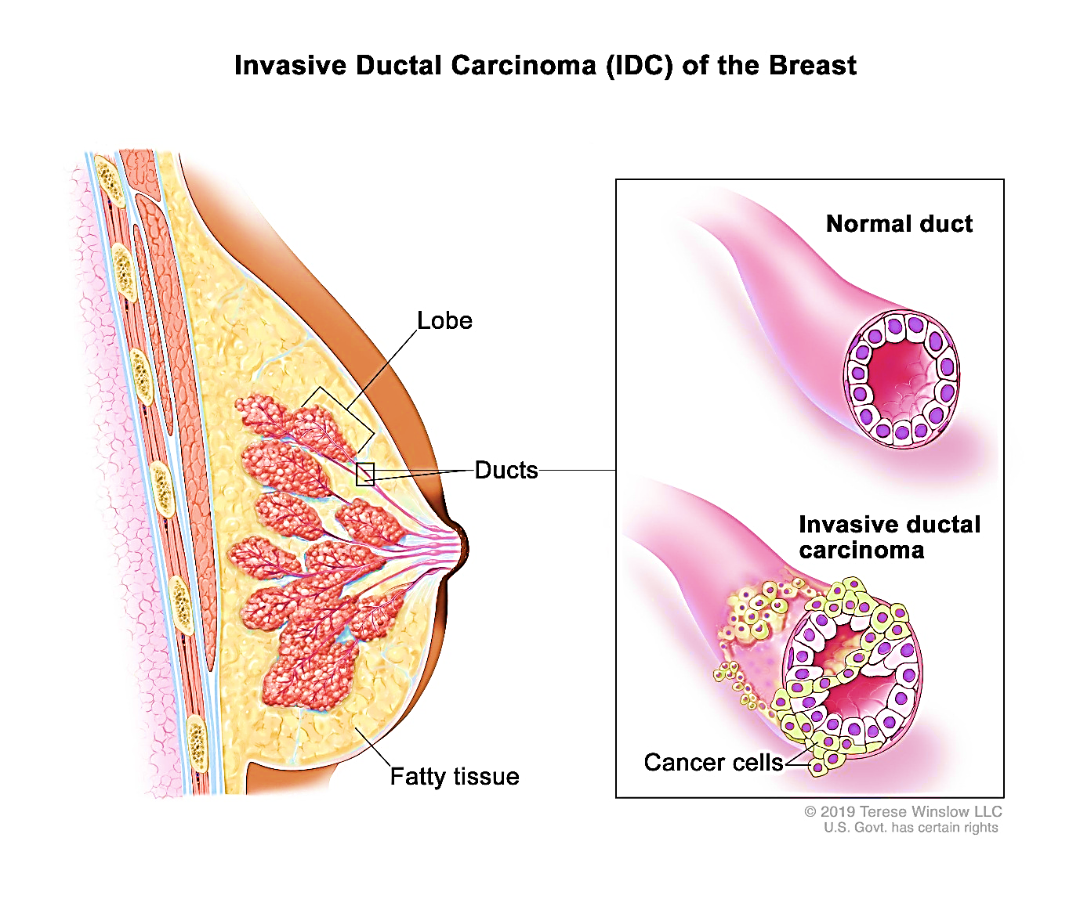

Figure 1: Invasive ductal carcinoma (IDC) of the breast begins in the lining of a breast duct (milk duct) and spreads outside the duct to other tissues in the breast (National Institute of Cancer, 2018)

**2. Overview of Cancer-Associated Fibroblasts (CAFs)**

Cancer-associated fibroblasts in TME have a hand in promoting cancer growth and generating metabolic crosstalk with cancer cells by creating an immunosuppressive microenvironment conducive to oncogenesis. It is noteworthy that CAFs differ from normal fibroblasts in their morphology and also in their functions (Zhang et al., 2023). Unlike quiescent fibroblasts, CAFs exhibit an activated phenotype. One way this is identified is by the expression of markers such as alpha-smooth muscle actin (α-SMA), fibroblast activation protein (FAP), and platelet-derived growth factor receptor-beta (PDGFR-β) (Asif et al., 2021; Pei et al., 2023).

One main source of CAFs is regular fibroblasts in nearby tissues, which change when they come into contact with cancer-related substances (Hu et al., 2022). Also, we may consider some special repair cells present which are known as mesenchymal stem cells (MSCs) that are recruited from distant sites and may differentiate into CAFs under the influence of cytokines and growth factors secreted by cancer cells (Hu et al., 2022; Huang et al., 2023). In addition, blood vessel cells can change into CAFs through a process called endothelial-to-mesenchymal transition (EndMT) (Hu et al., 2022; Papai et al., 2022). This variety of origins persuade the conclusion that the complexity of CAF biology have a critical role in shaping the tumour microenvironment (Asif et al., 2021).

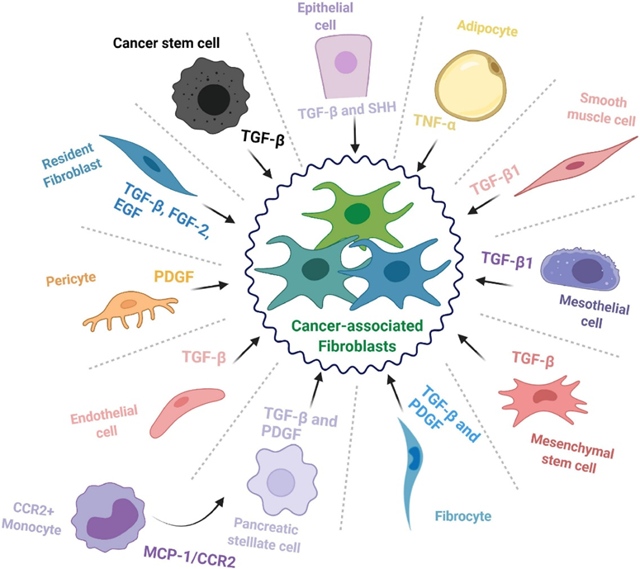

Figure 2. The cellular origins of cancer-associated fibroblasts. The cell types that contribute to the cancer-associated fibroblast (CAF) population and some of the major factors and signalling pathways involved in the transition toward a CAF phenotype (Manoukian et al., 2021).

**2.1 Surface Markers of CAFs**

The heterogeneity of CAF is reflected in their expression of specific surface markers and secreted factors, which essentially dictate their diverse roles in tumour progression. Some common markers used to identify CAFs may include α-SMA, FAP, PDGFR-β, and tenascin-C (Hu et al., 2022). However, these listed markers are not universally expressed in all CAFs, and the differences explain their diversity. For instance, α-SMA is a hallmark of myofibroblast-like CAFs, which are involved in extracellular matrix remodelling, while FAP-positive CAFs are associated with promoting tumour cell invasion and immune suppression. PDGFR-β, expressed on a subset of CAFs, mediates their proliferation and interaction with other stromal components (Hu et al., 2022; Papai et al., 2022).

**2.2 Mechanisms of CAF Activation**

CAF activation occurs by a variety of mechanisms. This includes a complex interplay of signals coming from the tumour cells. Other signals are also involved including those from cytokines, growth factors, and extracellular matrix components. A key protein in this process is transforming growth factor-beta (TGF-β), which helps turn normal fibroblasts and repair cells (mesenchymal stem cells) into active CAFs (Papai et al., 2022). TGF-β signalling is often amplified in the tumour microenvironment, promoting the acquisition of the CAF phenotype through Smad-dependent and Smad-independent pathways. It is documented that some platelet-derived growth factor (PDGF) also plays a critical role in this pathway, stimulating CAF proliferation and enhancing their pro-tumourigenic activities (Zhao et al., 2023).

In addition to growth factors, cytokines such as IL-6 and IL-1β contribute to CAF activation by modulating their inflammatory and metabolic properties. The extracellular matrix itself provides mechanical and biochemical cues that sustain CAF activation (Papai et al., 2022). For example, stiffened ECM resulting from collagen cross-linking by lysyl oxidase reinforces the contractile phenotype of myofibroblastic CAFs. Also, cancer cells release exosomes containing microRNAs and proteins that reprogram fibroblasts into CAFs. The interplay of these signalling pathways not only drives CAF activation but also perpetuates their tumour-promoting functions within the IDC microenvironment (Papai et al., 2022; Nandhini et al., 2024).

**3. Role of CAFs in IDC Progression**

The roles of CAFs reported in studies may be explored based on their relevance to cancer progression. Intermittently, studies have also reported subtypes which may determine functionality. Some of these are myofibroblastic CAFs, inflammatory CAFs, and immune-regulatory CAFs. Firstly, Myofibroblastic CAFs are primarily involved in Extracellular Matrix (ECM) deposition and remodelling, they contribute to the formation of a stiff, desmoplastic stroma that facilitates cancer cell invasion. While inflammatory CAFs secrete pro-inflammatory cytokines such as interleukin-6 (IL-6) and tumour necrosis factor-alpha (TNF-α) and all these enhance tumour progression and angiogenesis (Joshi et al., 2021). The third class CAFs known as Immune-regulatory CAFs suppress anti-tumour immunity by recruiting regulatory T-cells and myeloid-derived suppressor cells, as well as by expressing immune checkpoint molecules (Cords et al., 2024). The functional diversity of CAFs highlights their multifaceted contributions to IDC pathogenesis, making them attractive targets for therapeutic intervention (Fang et al., 2023).

**3.1 Facilitation of Tumour Growth**

**3.1.1 Growth factor secretion**

CAFs secrete some growth factors, including epidermal growth factor (EGF), fibroblast growth factors (FGFs), and insulin-like growth factor 1 (IGF-1). All these are capable of directly stimulating cancer cell proliferation. This goes a long way to accelerate the propagation of more cancer cells. For example, studies such as that carried out by Garvey et al. (2020), have shown that the EGF released by CAFs activates the EGFR pathway, and in IDC cells, it promotes cell cycle progression and tumor growth. Additionally, CAFs produce extracellular matrix (ECM) components such as collagen and fibronectin. It is therefore related that as such components are produced the higher the structural support for the expanding tumour mass as reported by Liu et al., (2020).

**3.1.2 Modulation of ECM composition**

In terms of the mechanistic aspect of the TME, CAFs modulate the availability of nutrients and oxygen. They do this by releasing lactate and pyruvate into the tumour microenvironment through aerobic glycolysis, which is a phenomenon known as the "reverse Warburg effect." Since cancer cell utilizes these components for energy, it may explain why CAFs may be a great promoter of oncogenesis (Zhang et al., 2024). Also, we can also recall findings showing that CAFs secrete some cytokines such as interleukin-6 (IL-6) and tumour necrosis factor-alpha (TNF-α). Such factors support oncogenic signalling in cancer cells, thereby enhancing their survival and proliferation (Zhang et al., 2024).

**3.2       Promotion of Angiogenesis**

Angiogenesis which is known as the formation of new blood vessels, is another critical process in IDC progression like any other cancer, that is significantly influenced by CAFs. A probable mechanism of how angiogenesis is supported is through the secretion of endothelial growth factor (VEGF) by CAFs. It is also known that VEGF is a potent pro-angiogenic factor that stimulates endothelial cell proliferation and migration. Elevated levels of VEGF may play a big role in the increased amount of micro blood vessels seen in IDC, as documented in several studies (Lavie et al., 2022). There are other angiogenic factors that CAFs may also be capable of releasing, to aggravate further angiogenesis. Angiopoietins, platelet-derived growth factor (PDGF), and matrix metalloproteinases (MMPs) are important chemicals that have been linked with CAF secretion. All these facilitate angiogenesis and consequently support cancer progression (Tajaldini et al., 2022).

CAF’s enhancement of angiogenesis is also through hypoxia-inducible factor-1 alpha (HIF-1α) activation under low-oxygen conditions within the tumour. It is key to note that Hypoxic CAFs upregulate VEGF and other angiogenic mediators, further compounding the angiogenic switch. In addition, CAFs promote endothelial cell recruitment and sprouting by secreting stromal cell-derived factor-1 (SDF-1), which binds to CXCR4 receptors on endothelial cells (Petrova et al., 2018). This paracrine signalling axis has been shown to accelerate neovascularization in IDC models. The ability of CAFs to orchestrate angiogenesis makes it a major contributor to IDC progression by ensuring a steady supply of nutrients and oxygen to the tumour (Tajaldini et al., 2022).

**3.3 Induction of Epithelial-to-Mesenchymal Transition (EMT)**

CAF-mediated induction of epithelial-to-mesenchymal transition (EMT) as we mentioned earlier is a key occurrence in IDC. It is a process where epithelial cancer cells lose their cell-cell adhesion. This makes them transform into mesenchymal cells that are capable of migration and invasion (Petrova et al., 2018).

The mechanism involved might be complex but it can begin when CAFs secrete Transforming Growth Factor-beta (TGF-β). Researchers consider TGF-β as a known activator of the EMT process, through Smad-dependent and non-Smad signalling pathways in cancer cells. Additional mechanism has to do with TGF-β inducing the downregulation of epithelial markers such as E-cadherin and upregulation of mesenchymal markers like N-cadherin and vimentin. All these lead to increased transition from epithelial cells to mesenchymal cells which then facilitates further invasion of surrounding tissues (Petrova et al., 2018).

To add to that, there are other EMT-inducing factors that have been mentioned in studies that are produced by CAFs. Most importantly the hepatocyte growth factor (HGF) and IL-6 –a cytokine which activate the JAK/STAT pathway. CAF-derived exosomes may also play a part in EMT regulation. We realized that these CAF-derived vesicles carry microRNAs, that are capable of modulating EMT-related gene expression in IDC cells. This implies that the process involves epigenetic alterations (Kobayashi et al,2022).

**3.4 Role in Modulating Immunity**

Ordinarily, immune cells are expected to mount a reasonable response against cancer cells. However, this has been known to not be the case in most cancer types which is usually due to specific immune modulation and immune invasion by tumour cells (Panda et al., 2025). In contribution, there are growing reports that CAfs may also play a role in modulating the immune response to tumours. CAFs secrete immunomodulatory cytokines and chemokines, such as interleukin-6 (IL-6), interleukin-10 (IL-10), and transforming growth factor-beta (TGF-β). Cytokines are suppressive to specialized immune cells, which may explain the suppressive immune response seen by immune cells in IDC. To support that, the cytokine TGF-β has been reported to inhibit the differentiation and proliferation of effector T-cells while promoting the expansion of regulatory T-cells (Tregs) (Amos and Choi, 2021). In such patients, there is a substantial dampening of immune anti-tumour activity. CAFs contribute to immune evasion by expressing immune checkpoint ligands, such as programmed death ligand-1 (PD-L1). The inhibitory effect of PD-1 ligand on interaction with T cells has also been recently corroborated in the literature (Ajutor et al., 2025). CAFs also recruit myeloid-derived suppressor cells (MDSCs) and tumour-associated macrophages (TAMs) through the secretion of chemokines like CXCL12 and CCL2. These recruited immune cells, we believe may be the strongest suppressors of anti-tumour immunity seen in IDC progression making CAFs a pro-tumorigenic factor (Tajaldini et al., 2022).

**3.5 Contribution to Drug Resistance**

A lot of factors can contribute to drug resistance in IDC as we have seen in most studies relating to cancer. One primary mechanism involved in all of these is the secretion of soluble factors, such as hepatocyte growth factor (HGF), interleukin-6 (IL-6), and stromal cell-derived factor-1 (SDF-1), which activate signalling pathways like PI3K/AKT, JAK/STAT, and MAPK in cancer cells. We have earlier discussed how some of these pathways intricately promote cell survival, invasion and proliferation (Petrova et al., 2018). Due to their role, these pathways can promote drug resistance. Inadvertently, when we consider that some of these factors are secreted by CAFs, it is inferential that CAFs are an indirect contributor to drug resistance (Tanaka et al., 2021).

CAF-derived IL-6 has been shown to upregulate anti-apoptotic proteins, such as Bcl-2, in IDC cells, leading to resistance against apoptosis-inducing drugs.

CAFs may also modulate drug sensitivity through ECM remodelling. The deposition of dense ECM proteins, including collagen and fibronectin as discussed earlier, creates a physical barrier that impairs drug penetration into the tumour. Since these desmoplastic reactions are driven by CAFs, it is easy to agree with studies implicating the role of CAFs in drug resistance. Another mechanism we must mention is the transfer of drug-resistant traits via CAF-derived exosomes (Zhang et al., 2024). These exosomes contain microRNAs, proteins, and metabolites that alter the gene expression profiles of cancer cells. So even when they are not initially coded in the genes, tumours can exhibit traits that make them resistant to drugs. For instance, CAF-derived exosomal miR-21 has been implicated in promoting resistance to tyrosine kinase inhibitors by targeting tumour suppressor genes in IDC cells.

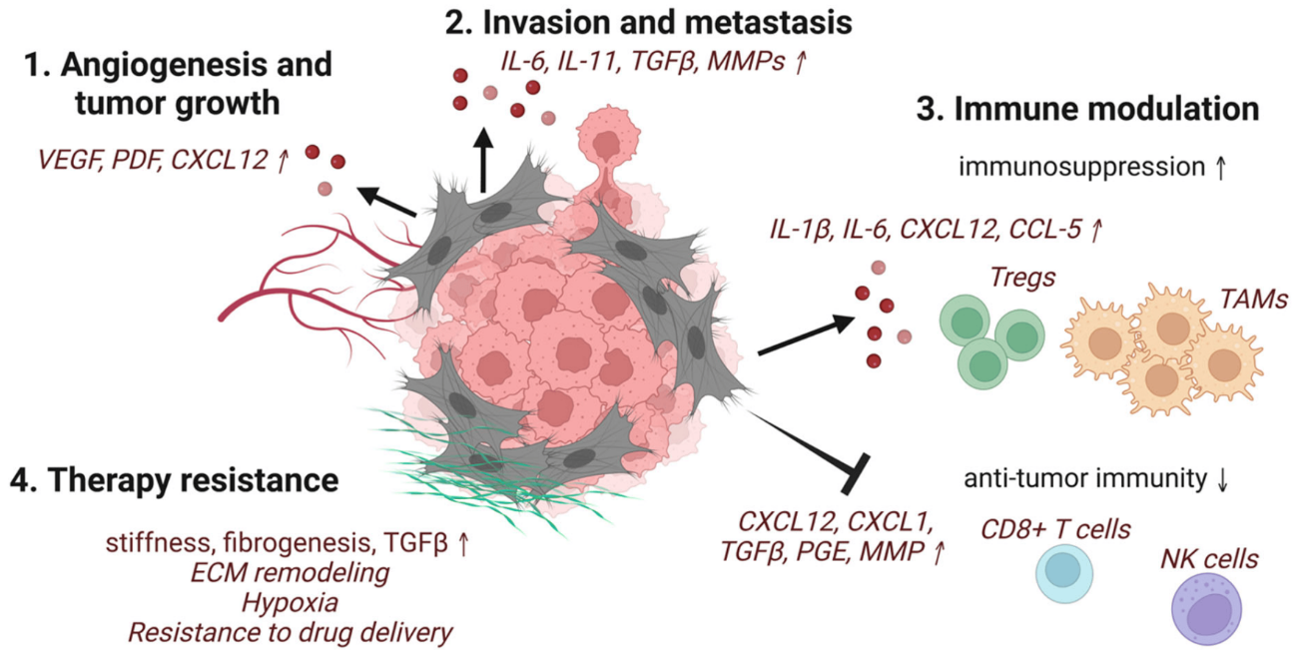

Figure 3. Schematic representation of some of the selected pro-tumorigenic functions of CAFs (Glabman et al., 2022)

**4. CAFs Targeting as Therapeutic Targets in IDC**

CAFs in invasive ductal carcinoma (IDC) have had a provocative effect on oncology and catalyzed the development of therapeutic strategies aimed at modulating their activity. The goal is to target the activation of CAFs, their secreted factors and pathways, and their interactions with tumour cells to counteract their tumour-promoting roles effectively.

**4.1   Inhibition of CAF Activation**

studies and strategies to inhibit CAF activation are some of the earliest therapeutic strategies. CAF activation is mainly driven by TGF-β molecules, therfore creating TGF-β inhibitors, including small molecules and monoclonal antibodies, has demonstrated great potential in preclinical studies so far (Glabman et al., 2022). A presentable example is Galunisertib (LY2157299), an oral, small molecule inhibitor of TGF-β receptor kinase. It has been evaluated in clinical trials for various cancers. It showed promising results in reducing CAF activation and suppressing tumour progression in several cancer models. It showed a great potential for blocking TGF-β signalling, thereby helping to attenuate ECM remodelling and reverse immune suppression. However, clinical translation of such drugs remains challenging due to the pleiotropic roles of TGF-β in normal tissue homeostasis (Faivre et al., 2019).

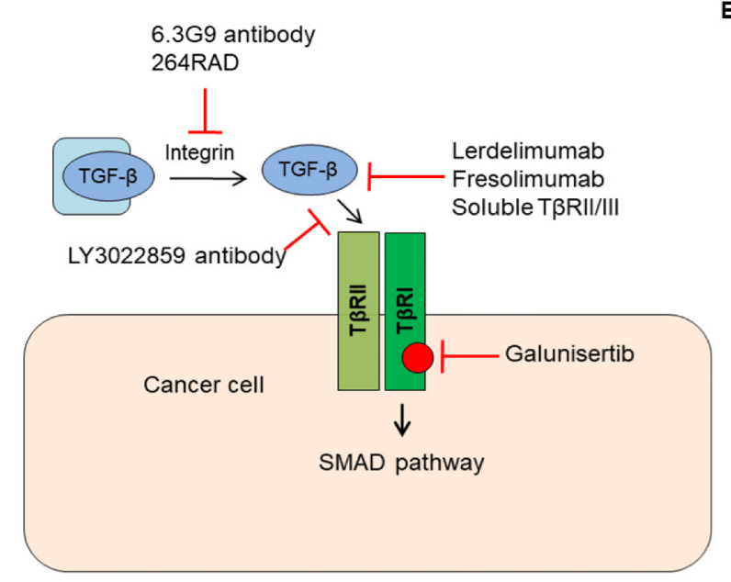

**Figure 4: Targeting TGF-β signaling in cancer. Various TGFβ signaling inhibitors including neutralizing antibodies, ligand traps, and receptor kinase inhibitors are depicted (Huynh et al., 2019).**

**4.2 Targeting CAF-Secreted Factors or Pathways**

Another approach that is ongoing is one which focuses on targeting the factors secreted by CAFs. By targeting these secreted factors that are contributing to cancer invasion and progression, we can reverse some of the altered TME that support cancer growth (Faivre et al., 2019). Some of the targeted factors are cytokines, chemokines, growth factors, and ECM components. VEGF (vascular endothelial growth factor), a pro-angiogenic factor secreted by CAFs, has been singled out by many researchers as a prominent target. We now have proposed anti-VEGF agents, such as bevacizumab, in production to disrupt CAF-driven angiogenesis. So far, results have been promising with encouraging clinical efficacy in certain cancer patients (Chu et al., 2023). Similarly, inhibitors that seek to block CAF-secreted CXCL12, a chemokine that attracts immunosuppressive cells to the tumour microenvironment, are under investigation (Chu et al., 2023).

**4.3 Disrupting CAF-Tumour Cell Interactions**

Therapeutic interventions that are capable of disrupting CAF-tumour cell interactions are also being looked at. Although we agree with many researchers who may think this aspect might be a bit complicated in clinical settings. Considerably, integrins for example, mediate the adhesion between CAF and cancer cells, which means they can be a good target for IDC therapy. This has birthed the production of Integrin inhibitors, such as cilengitide, which is being produced by the adhesive interaction between CAF and tumour cells effectively reducing metastatic potential (Girnius et al., 2024).

Other emerging strategies found also include reprogramming CAFs to adopt a tumour-suppressive phenotype rather than eradicating them entirely. Agents such as all-trans retinoic acid (ATRA) and BMP4 (bone morphogenetic protein 4) have been shown to reverse activated CAFs to a quiescent state, reducing their tumourigenic activity (Girnius et al., 2024).

**4.4 Challenges** **in Therapeutic Targeting**

One major challenge in targeting cancer-associated fibroblasts (CAFs) in IDC is their heterogeneity. CAFs are not a single, uniform cell type but a mix of different subpopulations with varying markers like α-SMA, FAP, and PDGFR-β. The issue arises because these markers are not unique to CAFs, meaning that therapies targeting them could also affect normal cells. Therefore, in such cases, clinicians run a risk of off-target effects, which are a concern in any cancer treatment. Furthermore, the role of CAFs beyond cancer may also be affected. They do play functional roles, such as in wound healing and tissue repair, so targeting them entirely could cause unintended damage (Li et al., 2023).

**5. Diagnostic and Prognostic Value of CAFs in IDC**

Diagnosis and prognosis is a key aspect of treatment for IDC. For most cancers, the earlier the diagnosis, the better the chances of survival for the patient. Given how integral CAF might be in the progression of IDC tumours, there is a potential for the integration of CAF-related biomarkers into imaging and liquid biopsy platforms. This will enhance IDC diagnosis and treatment monitoring by combining histopathological methods with emerging molecular technologies. When it comes to related key biomarkers. FAP is one highly specific marker of activated fibroblasts which correlates with IDC progression and invasiveness.  It has already been reported that laboratory investigation of some key biomarkers such as α-SMA, FAP, PDGFR-β, and periostin shows overexpression and correlation with IDC-associated stromal tissues (Gómez-Cuadrado et al., 2022). These can be detected in the laboratory through IHC staining or molecular assays. Additionally, CAF signatures, which have to do with specific gene and protein expression profiles, may offer prognostic value by reflecting tumour heterogeneity and patient outcomes. These signatures are defined by specific gene and protein expression profiles, which can be detected by various gene expression investigation techniques like microarrays and RNA-Seq offer critical prognostic insights into IDC (Gómez-Cuadrado et al., 2022).

**6. Future Directions and Research Gaps**

Moving forward, the role of CAFs in other aspects like extracellular vesicle communication and metabolic reprogramming remains underexplored. We believe explorative studies on the interactions of CAFs with CME components can further improve knowledge of the roles CAFs play in IDC. Multi-omics approaches integrating transcriptomics, proteomics, and metabolomics could also uncover new therapeutic targets.

**6.1 Understanding CAF Plasticity**

CAFs exhibit dynamic plasticity, meaning they can sometimes transition between subtypes in response to tumour signals. However, the regulatory mechanisms remain unclear. Researchers believe that epigenetic modifications, including DNA methylation and histone acetylation, may play crucial roles in CAF plasticity. Therefore, identifying and understanding key regulators may reveal how CAFs evolve and interact with IDC cells. In-depth research into single-cell transcriptomics and spatial proteomics could uncover distinct CAF subsets involved in metastasis and therapy resistance.

**6.2 Advancing Preclinical Models**

Traditional 2D cultures fail to replicate CAF-cancer interactions. Advanced 3D organoid models and co-culture systems better simulate tumour-stromal dynamics, allowing for studies on ECM remodelling, immune modulation, and angiogenesis.

Genetically engineered mouse models (GEMMs) offer deeper insights. CAF-specific knockout models, targeting FAP or PDGFR-β, have demonstrated significant effects on tumor progression. Expanding these models to other markers will refine CAF-targeted therapies.

**6.3 Integration with Precision Medicine**

CAF research can enhance precision medicine in IDC. Stromal biomarkers aid in patient stratification, guiding the use of therapies such as FAP inhibitors and TGF-β blockers. Liquid biopsy platforms detecting CAF-derived biomarkers could enable real-time monitoring of treatment response targeting for each patient. Personalized CAF-targeted therapies could improve efficacy while minimizing side effects.

**7. Conclusion**

It is conceivable that CAFs are integral controllers of the tumour microenvironment in the context of invasive ductal carcinoma (IDC). Their activities, explored in this review show that they play a key role in promoting tumorigenesis and resistance to therapy. Their complex interactions with tumour cells, immune cells, and the extracellular matrix create a supportive niche that enhances the malignancy of IDC. This makes them a reasonable target for treating IDC in affected patients. Although early trials have shown significant potential, challenges such as CAF heterogeneity and risk of off-target effects exist and will need critical consideration. This is a concern in any cancer treatment and must be addressed. It is certain that the continued exploration of CAF biology, combined with advances in precision medicine, will be critical to developing effective therapies for IDC treatments centred around CAFs. Future indication suggests that understanding and manipulating CAFs' functions could ultimately lead to better clinical outcomes for affected patients battling this aggressive cancer.

**List of abbreviations**

**ATRA** – All-Trans Retinoic Acid

**BMP4** – Bone Morphogenetic Protein 4

**BRCA1/2** – Breast Cancer Gene 1/2

**CAFs** – Cancer-Associated Fibroblasts

**CCL2** – C-C Motif Chemokine Ligand 2

**CXCL12** – C-X-C Motif Chemokine Ligand 12

**CXCR4** – C-X-C Chemokine Receptor Type 4

**DCIS** – Ductal Carcinoma In Situ

**ECM** – Extracellular Matrix

**EMT** – Epithelial-to-Mesenchymal Transition

**FAP** – Fibroblast Activation Protein

**FGF** – Fibroblast Growth Factor

**GEMMs** – Genetically Engineered Mouse Models

**HGF** – Hepatocyte Growth Factor

**HIF-1α** – Hypoxia-Inducible Factor 1-Alpha

**IDC** – Invasive Ductal Carcinoma

**IHC** – Immunohistochemistry

**IL-10** – Interleukin-10

**IL-6** – Interleukin-6

**JAK/STAT** – Janus Kinase/Signal Transducer and Activator of Transcription Pathway

**MAPK** – Mitogen-Activated Protein Kinase

**MDSCs** – Myeloid-Derived Suppressor Cells

**MMPs** – Matrix Metalloproteinases

**PDGFR-β** – Platelet-Derived Growth Factor Receptor-Beta

**PD-L1** – Programmed Death Ligand-1

**PI3K/AKT** – Phosphatidylinositol 3-Kinase/Protein Kinase B Pathway

**RNA-Seq** – RNA Sequencing

**SDF-1** – Stromal Cell-Derived Factor-1

**TAMs** – Tumour-Associated Macrophages

**TGF-β** – Transforming Growth Factor-Beta

**TME** – Tumour Microenvironment

**TNF-α** – Tumour Necrosis Factor-Alpha

**VEGF** – Vascular Endothelial Growth Factor

**α-SMA** – Alpha-Smooth Muscle Actin

References

1. Ajutor, Lawrence John, Fatima Bello Sani, Elijah Nehemiah Kama, Kingsley Ugonna Ugoagwu, Adegbesan Abiodun Christopher, Daniel Temiloluwa Oyedemi, Peter Bemigho Adewoyin, Olayinka Esther Agbetanmije, Adepeju Matilda Adekoya, and Erere Godsent Onyeugbo. 2025. “The Role of Bioelectric Signals in Cancer Genome Regulation and Potential Therapeutic Implication: An Overview”. *Journal of Cancer and Tumor International* 15 (1):24-37. https://doi.org/10.9734/jcti/2025/v15i1280.
2. Amos, S. E., & Choi, Y. S. (2021). The cancer microenvironment: mechanical challenges of the metastatic cascade. *Frontiers in Bioengineering and Biotechnology*, *9*, 625859.
3. Anampa, J. D., Lin, S., Obeng-Gyasi, S., & Xue, X. (2025). Treatment and survival differences between patients with invasive lobular carcinoma versus invasive ductal carcinoma of the breast. *Cancer Epidemiology, Biomarkers & Prevention*, *34*(1), 125-132.
4. Asif, P. J., Longobardi, C., Hahne, M., & Medema, J. P. (2021). The role of cancer-associated fibroblasts in cancer invasion and metastasis. *Cancers*, *13*(18), 4720.
5. Chen, Y., McAndrews, K. M., & Kalluri, R. (2021). Clinical and therapeutic relevance of cancer-associated fibroblasts. *Nature reviews Clinical oncology*, *18*(12), 792-804.
6. Chu, Y., Fang, Y., Wu, H., Chen, J., & Cheng, L. (2022). Vocal fold fibroblasts promote angiogenesis in vocal fold leukoplakia by secreting pro-angiogenic factors. *Auris Nasus Larynx*, *49*(6), 1009-1018.
7. Cords, L., de Souza, N., & Bodenmiller, B. (2024). Classifying cancer-associated fibroblasts—The good, the bad, and the target. *Cancer Cell*, *42*(9), 1480-1485.
8. Faivre, S., Santoro, A., Kelley, R. K., Gane, E. D., Costentin, C. E., Gueorguieva, I., ... & Giannelli, G. (2019). Novel transforming growth factor beta receptor I kinase inhibitor galunisertib (LY2157299) in advanced hepatocellular carcinoma. *Liver International*, *39*(8), 1468-1477.
9. Fang, Z., Meng, Q., Xu, J., Wang, W., Zhang, B., Liu, J., ... & Shi, S. (2023). Signaling pathways in cancer‐associated fibroblasts: recent advances and future perspectives. *Cancer Communications*, *43*(1), 3-41.
10. Fernández-Nogueira, P., Fuster, G., Gutierrez-Uzquiza, Á., Gascón, P., Carbó, N., & Bragado, P. (2021). Cancer-associated fibroblasts in breast cancer treatment response and metastasis. *Cancers*, *13*(13), 3146.
11. Girnius, N., Henstridge, A. Z., Marks, B., Yu, J. K., Gray, G. K., Sander, C., ... & Luna, A. (2024). Cilengitide sensitivity is predicted by overall integrin expression in breast cancer. *Breast Cancer Research*, *26*(1), 187.
12. Gómez-Cuadrado, L., Bullock, E., Mabruk, Z., Zhao, H., Souleimanova, M., Noer, P. R., ... & Brunton, V. G. (2022). Characterisation of the stromal microenvironment in lobular breast cancer. *Cancers*, *14*(4), 904.
13. Hashmi, A. A., Zia, S., Yaqeen, S. R., Ahmed, O., Asghar, I. A., Islam, S., ... & Ali, J. (2021). Mucinous breast carcinoma: clinicopathological comparison with invasive ductal carcinoma. *Cureus*, *13*(3).
14. Hu, D., Li, Z., Zheng, B., Lin, X., Pan, Y., Gong, P., ... & Wang, L. (2022). Cancer‐associated fibroblasts in breast cancer: Challenges and opportunities. *Cancer Communications*, *42*(5), 401-434.
15. Hu, D., Li, Z., Zheng, B., Lin, X., Pan, Y., Gong, P., ... & Wang, L. (2022). Cancer‐associated fibroblasts in breast cancer: Challenges and opportunities. *Cancer Communications*, *42*(5), 401-434
16. Huang, T., Lu, C., Zhang, Y., Lin, B. Y., Zhang, Z. J., Zhu, D., ... & Lu, Y. (2023). Effect of activating cancer-associated fibroblasts biomarker TNC on immune cell infiltration and prognosis in breast cancer. *Annals of Medicine*, *55*(2), 2250987.
17. Huynh, L. K., Hipolito, C. J., & ten Dijke, P. (2019). A Perspective on the Development of TGF-β Inhibitors for Cancer Treatment. Biomolecules, 9(11), 743. https://doi.org/10.3390/biom9110743
18. Joshi, R. S., Kanugula, S. S., Sudhir, S., Pereira, M. P., Jain, S., & Aghi, M. K. (2021). The role of cancer-associated fibroblasts in tumor progression. *Cancers*, *13*(6), 1399.
19. Kobayashi, H., Gieniec, K. A., Lannagan, T. R., Wang, T., Asai, N., Mizutani, Y., ... & Worthley, D. L. (2022). The origin and contribution of cancer-associated fibroblasts in colorectal carcinogenesis. *Gastroenterology*, *162*(3), 890-906.
20. Lavie, D., Ben-Shmuel, A., Erez, N., & Scherz-Shouval, R. (2022). Cancer-associated fibroblasts in the single-cell era. *Nature cancer*, *3*(7), 793-807.
21. Li, Y., Wang, C., Huang, T., Yu, X., & Tian, B. (2023). The role of cancer-associated fibroblasts in breast cancer metastasis. *Frontiers in Oncology*, *13*, 1194835.
22. Mouabbi, J. A., Hassan, A., Lim, B., Hortobagyi, G. N., Tripathy, D., & Layman, R. M. (2022). Invasive lobular carcinoma: an understudied emergent subtype of breast cancer. *Breast cancer research and treatment*, *193*(2), 253-264.
23. Nandhini, J., & Karthikeyan, E. (2024). Crosstalk between cancer-associated fibroblasts (CAF) and tumour cells in head and neck cancer-Unraveling the complex pathway and CAF-targeted therapy. *Oral Oncology Reports*, 100690.
24. Panda, V. K., Mishra, B., Mahapatra, S., Swain, B., Malhotra, D., Saha, S., ... & Kundu, G. C. (2025). Molecular Insights on Signaling Cascades in Breast Cancer: A Comprehensive Review. *Cancers*, *17*(2), 234.
25. Papait, A., Romoli, J., Stefani, F. R., Chiodelli, P., Montresor, M. C., Agoni, L., ... & Parolini, O. (2022). Fight the cancer, hit the CAF!. *Cancers*, *14*(15), 3570.
26. Pei, L., Liu, Y., Liu, L., Gao, S., Gao, X., Feng, Y., ... & Wang, C. (2023). Roles of cancer-associated fibroblasts (CAFs) in anti-PD-1/PD-L1 immunotherapy for solid cancers. *Molecular cancer*, *22*(1), 29.
27. Petrova, V., Annicchiarico-Petruzzelli, M., Melino, G., & Amelio, I. (2018). The hypoxic tumour microenvironment. *Oncogenesis*, *7*(1), 10.
28. Soongsathitanon, J., Jamjuntra, P., Sumransub, N., Yangngam, S., De la Fuente, M., Landskron, G., ... & Thuwajit, C. (2021). Crosstalk between Tumor‐Infiltrating Immune Cells and Cancer‐Associated Fibroblasts in Tumor Growth and Immunosuppression of Breast Cancer. *Journal of Immunology Research*, *2021*(1), 8840066.
29. Tajaldini, M., Saeedi, M., Amiriani, T., Amiriani, A. H., Sedighi, S., Dehghan, M., ... & Khori, V. (2022). Cancer-associated fibroblasts (CAFs) and tumor-associated macrophages (TAMs); where do they stand in tumorigenesis and how they can change the face of cancer therapy?. *European Journal of Pharmacology*, *928*, 175087.
30. Tanaka, K., Masuda, N., Hayashi, N., Sagara, Y., Hara, F., Kadoya, T., ... & Iwata, H. (2021). Clinicopathological predictors of postoperative upstaging to invasive ductal carcinoma (IDC) in patients preoperatively diagnosed with ductal carcinoma in situ (DCIS): a multi-institutional retrospective cohort study. *Breast Cancer*, *28*, 896-903.
31. Wang, J., Li, B., Luo, M., Huang, J., Zhang, K., Zheng, S., ... & Zhou, J. (2024). Progression from ductal carcinoma in situ to invasive breast cancer: molecular features and clinical significance. *Signal Transduction and Targeted Therapy*, *9*(1), 83.
32. Wu, F., Yang, J., Liu, J., Wang, Y., Mu, J., Zeng, Q., ... & Zhou, H. (2021). Signaling pathways in cancer-associated fibroblasts and targeted therapy for cancer. *Signal Transduction and Targeted Therapy*, *6*(1), 218.
33. Yan, Z., Sheng, Z., Zheng, Y., Feng, R., Xiao, Q., Shi, L., ... & Zhang, B. (2021). Cancer-associated fibroblast-derived exosomal miR-18b promotes breast cancer invasion and metastasis by regulating TCEAL7. *Cell Death & Disease*, *12*(12), 1120.
34. Zhang, F., Ma, Y., Li, D., Wei, J., Chen, K., Zhang, E., ... & Yang, Y. (2024). Cancer associated fibroblasts and metabolic reprogramming: unraveling the intricate crosstalk in tumor evolution. *Journal of Hematology & Oncology*, *17*(1), 80.
35. Zhang, H., Yue, X., Chen, Z., Liu, C., Wu, W., Zhang, N., ... & Liu, G. (2023). Define cancer-associated fibroblasts (CAFs) in the tumor microenvironment: new opportunities in cancer immunotherapy and advances in clinical trials. *Molecular Cancer*, *22*(1), 159.
36. Zhao, H. (2021). The prognosis of invasive ductal carcinoma, lobular carcinoma and mixed ductal and lobular carcinoma according to molecular subtypes of the breast. *Breast Cancer*, *28*, 187-195.
37. Zhao, Z., Li, T., Sun, L., Yuan, Y., & Zhu, Y. (2023). Potential mechanisms of cancer-associated fibroblasts in therapeutic resistance. *Biomedicine & Pharmacotherapy*, *166*, 115425.