**Ethical and Regulatory Challenges for Contract Research Organizations conducting (outsourced) clinical research in Sub-Saharan Africa.**

**ABSTRACT**

**Introduction**

Contract Research Organizations (CROs), Clinical Research Centers/Networks and private research institutions play an important role in the clinical research process, especially in the drug discovery and development process. They act as essential partners for pharmaceutical drug delivery/development and biotech companies. Over the last few decades, the demand for outsourcing of clinical research by pharmaceutical companies has increased, with the market for CRO and private research institutional services growing significantly. This trend has been driven by a need for increased productivity and efficiency to meet the increasing research and development costs, as well as the complexities associated with modern drug development.

**Statement of objective.**

Historically, drug discovery services were predominantly conducted in-house, safeguarding intellectual property and close collaboration with internal teams. However, the competitive nature of the sector has motivated pharmaceutical companies to adopt an outsourcing model, allowing them to decentralize, outsourced and exploit specialized expertise and technologies offered by the CROs. These partnerships enable drug developers to accelerate the identification and validation of promising drug candidates through streamlined pre-clinical and clinical trial processes.

**Methodology**;

This is an overview that we used the search the source documents from organizations, access to websites and google search to assemble our information, through data mining. The google search gave us information on the contract organizations with online visibility. Vital information from annual reports, web information system management of the different organizations were accessible for easy navigations.

**Findings:**

Through data mining contract research organization operating in Cameroon and Sub Saharan Africa that were available and accessible on line were identified. The list is not exhaustive as some CROs may be in existence but we could not have access to their activities and home page for enough visibility online.

**Conclusion/Recommendation**:

Ultimately, the success of CROs will depend on their adaptability to emerging trends and the ability to foster collaboration among stakeholders. By embracing these opportunities while proactively tackling the challenges, the sector can pave the way for transformative breakthroughs that not only bring new therapies to market faster but also improve the overall health of populations worldwide.

As we look ahead, the synergy between innovation, strategic partnerships, and a commitment to excellence for CROs shall be the cornerstones of future success in conducting clinical research for Pharmaceutical drug discovery and development Based on the regulatory demanding nature of CROs must have a legal jurisdiction and recognition of their operation, and conform the norms and standard laid down by regulatory authorities and the states of their jurisdiction They offer a wide range of services to support the development and execution of clinical trials, ensuring compliance with regulatory requirements and ethical standards.

Clinical Research Organizations (CROs) play a pivotal role in the pharmaceutical, biotechnology, and medical device industries as a research service delivery provider on a contract basis.

**Key words**- ethical, regulatory, contract research organization, private institution, service outsourcing, clinical research

**INTRODUCTION**

Clinical research plays a critical role in health care delivery. It is through clinical research that scientists develop new treatments, cures and preventive measures that help control the spread of diseases [1]. What is very important is that clinical research guarantees that specific disease treatments that are brought to the market have been proven safe, effective and of good quality, with known potential side effects well documented and accessible to patients to make a choice of whether to consume or not [2]. CROs and other services providers deliver a diverse range of services, encompassing everything from initial research and development to clinical trial management. They implement advanced technologies, including artificial intelligence (AI) and machine learning (ML), to enhance data analysis and improve operational efficiency [2]. These innovations are particularly crucial in understanding the complexities of personalized medicine and the demands of patient-centered drug development. This paper gives an overview of the ethical and regulatory challenges of CROs, private research institutions conducting clinical research outsourced by pharma companies

The clinical research process is marked not only by scientific rigor but also by an obligatory adherence and respect of ethical standards. The advent of COVID-19 pandemics brought to live the necessity of standard and norms: While clinical researchers are aware of the sense of urgency regarding the need for treatments and vaccines, they feel obliged to follow ethical protocols, ensuring their data is accurate and transparent and that any treatments are properly tested before approval for marketing authorization (MA) [3, 4].

The Goals of Clinical Research

The ultimate goal of clinical research is to increase medical knowledge and improve patient care. For the conclusions resulting from clinical research to be valid and applicable, the research must be conducted deliberately via systematic investigation and data collection [5].

**Definition of terms**

**Clinical Research:** The National Institutes of Health (NIH) define clinical research as medical research that tests new treatments and therapies on people [1].

**Clinical trials:**

Clinical trials are research studies that test a medical, surgical, or behavioral intervention in people. These trials are the primary way that researchers determine if a new form of treatment or prevention, such as a new drug, diet, or medical device (for example, a pacemaker), is safe and effective in people [4]. NIH defines clinical trials as research studies that assign one or more interventions to human subjects to determine the effect of the interventions on health-related outcomes, both biomedical and behavioral [1].

**Contract Research Organization (CRO**): is a company that provides support to the pharmaceutical, biotechnology, and medical device industries. CROs provide sponsors of (pharmaceutical, biotech and medical device companies) with research management services. Traditional CROs provide clinical trial management services, while laboratory CROs provide drug discovery, manufacturing, laboratory and bioanalytical services [6]. An illustration of CROs functionality is illustrated in Figure 1..

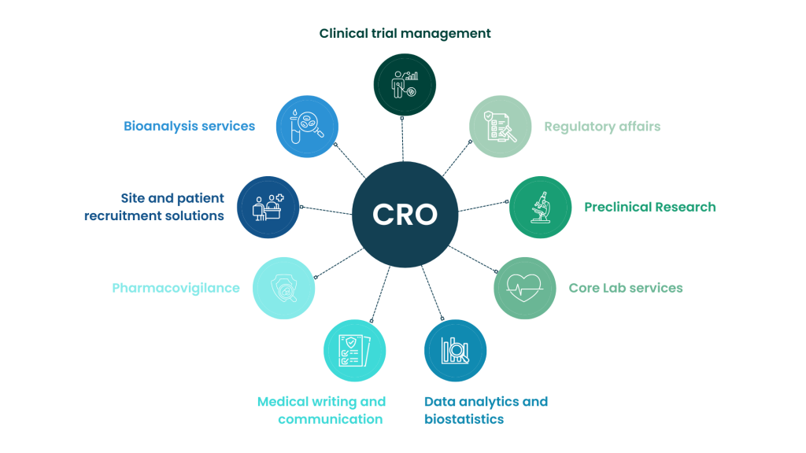

**Figure 1: CRO process and mission [3].**

**Cameroon Indicators of Clinical Research Regulatory Authority**

The National Pharmaceutical Regulatory Authority is the principal Medicine Regulatory Authority (NPRA) in Cameroon. However, it has 5 main actors that work collaboratively to complete the significant objectives of the NPRA. These actors (with French acronyms) include:

**The Department of Pharmacy, Drugs and Laboratories (DPML**).

The DPML is considered as the heart of pharmaceutical regulations in Cameroon and is one of the central technical divisions of the Ministry of Public Health [7]. DPML under the 2013 Act on the organization of the Ministry of Public Health, charges the DPML to develop and monitor the implementation of the national policy for the supply of pharmaceutical products including medical devices, collect and disseminate pharmaceutical information, among others.

**The General Inspectorate of Pharmaceutical Services and Laboratories (IGSPL).**

This service under the Minster of Public health coordinate the control of pharmaceutical services and laboratories in the country to assure good manufacturing practice and quality of drugs, vaccines and medical devices [6]

**The National Laboratory for the Quality Control of Drugs and Expertise (LANACOME).**

National Laboratory for Quality Control of Medicines and Expertise (LANACOME), by decree No. 96/055 of March 12, 1996. This decree confers on the laboratory the status of Public Administrative Establishment (EPA), endowed with legal personality and financial autonomy.

LANACOME function as a project supported by the World Health Organization, which characterizes it as a Laboratory which cover the Central African Region. For this, the WHO provides technical assistance, ongoing training of staff in the implementation of analysis procedures and methods, and the supply of reagents and reference substances.

Quality control activities for medicines and related products: vaccines, food products, food supplements, cosmetic products, condoms and medical devices. Research on the quality of medicines in circulation in collaboration with technical and financial partners (WHO), collaborative studies, etc.

Some expertise in narcotics, some medical plants and medical devices such as breathalyzers

· Some evaluations of Marketing Authorization application files. Continuing training and internships for students from university institutions.

**National Central Supply of Medicines and Essential Consumables (CENAME**)

Decree No 2005/252 of 30 june 2005 relating to the creation, organization and functioning of the National Central Supply of Medicines and Essential consumable (French acronym CENAME). This structure was created to;

Ensure the availability, permanence and accessibility of essential medicines and medical devices throughout the national territory. Guarantee the quality of the essential medicines and medical devices that it distributes in accordance with the quality standards prescribed by the regulations in force; Provide regional funds for health promotion and other approved structures with essential medicines and medical devices at the best quality/price ratio; Carry out any other complementary or related operations that may be linked to its corporate purpose; Carry out any other mission entrusted to it by the public authorities and relating to its corporate purpose.

CANAME in order to ensure the availability, permanence and accessibility of essential medicines and medical devices, provide the following services to clients; The acquisition of products from local and foreign suppliers; The storage of products according to good practices in force; The distribution of products in all regions of Cameroon; Quality management throughout the chain.

**The Division of Operational Research in Health (DROS).**

The Ministry of Public Health in Cameroon is responsible for the maintenance and implementation of all public health services. DROS is an administrative division under the Ministry of Public Health in Cameroon. They are charged with coordinating all health research, regulation and policies in Cameroon. They support they government to make national health policy decisions and the conduct of clinical research in Cameroon**.**

**Product Registration Module.**

The National Medicines Commission oversees the assessment of applications for the approval of pharmaceutical products to be placed on the market. The various forms and guidelines needed for registrations can be downloaded from the DPML website [7]

**Inspections Module for both Good Distribution Practice (GDP) and Good Manufacturing Practice (GMP).**

GDP and GMP both deal with quality assurance, but they do so in separate supply chain sectors. While GDP makes sure the product is created correctly until it is delivered to the patient, GMP makes sure it is made correctly from the beginning [5, 6]. Good distribution practice (GDP) describes the minimum standards that a wholesale distributor must meet to ensure that the quality and integrity of medicines is maintained throughout the supply chain. Regulatory inspections on GDP and GMP are done in Cameroon. The IGSPL usually does this. Inspectors are mandated by the law to inspect the premises where pharmaceutical activities take place, whether in public or private establishments. Inspections are legal obligations by the government that are done at least once in a year [8]. There is no information on the technologies used for regulatory inspections [7].

**Laboratory Information Management System**

Cameroon has a Biological and medical analysis laboratories database. However, information on the database is currently not available. There is also a logistics information management system that is being developed to have the logistical data they need to effectively manage the health product supply chain [7].

**Pharmacovigilance**

Cameroon has a national pharmacovigilance system. The main aim of this system to protect the safety of all citizens in the use of health products. The system would also help detect possible adverse drug reactions early. These reactions could occur under the use of health products in normal conditions, abuse, misuse, poor quality of the product, among others. The national pharmacovigilance system consists of the national pharmacovigilance commission, the pharmacovigilance centre and the pharmacovigilance technical committee [7]. A citizen, patient or health worker can report an adverse drug reaction. The reporter can either download a from the DPML website or Report using the online form available on the website [7, 8].

**Clinical Trials**

Clinical trials are conducted in Cameroon; however, a study needs to be authorized by the Pharmaceutical Authority before the study can be initiated. The investigator must apply for an ethical clearance which is overseen by the national ethics committee or an institutional review board [8]

**Post Marketing Surveillance**

Cameroon performs post-market surveillance studies to monitor and assess pharmaceutical products that are authorized on the market. The national pharmacovigilance commission in Cameroon was created by the Ministry of health (MoH) to monitor adverse events in drugs, regulatory compliance of medical devices and the homologated medicinal products in use [9].

**Import and Export**

There is little information on the exportation of drugs. Regarding importation, regulations provided are focused on the authorization of imports for psychotropic substances, narcotic drugs, dermo-corticoids and chemical precursors. Only drugs approved in Cameroon are subject to an Official Import Authorization (AOI) request. An Official Import Authorization form can be acquired from the Office of Standards and Pharmaceutical Legislation at the DPML premises. The application goes through a verification process. The Official Import Authorization forms are processed and signed by the Minister of Public Health before it is discharged at the Office of Standards and Pharmaceutical Legislation. Information on systems used for this process is not available [9]. In Cameroon non, approved drugs can only be imported for research purposes.

**Licensure – Professionals and Premises**

The DPML licenses pharmaceutical establishments and professionals to discharge their duties, respectively. There is no information on the availability of a system or portal with regards to licensing. To gain a license to operate as a pharmaceutical establishment or operate as a pharmaceutical professional in Cameroon, the applicant must first meet the indicated requirements in the guidelines. The applicant must then complete the necessary forms, which are available on the website together with the necessary supporting documents. These must be submitted to the DPML for screening and evaluation. Upon evaluation and consideration, the application would then be approved, and a certificate would be given to the applicant [7].

**Monitoring and Evaluation**

There is a system in place for the monitoring and evaluation of good distribution and good manufacturing practice in the drug and medical devices chain in Cameroon. However, there is no information regarding the processes and activities involved in monitoring and evaluation. Monitoring and evaluation are obligatory in all aspects of clinical research developments. There is the need for the monitoring and evaluation of clinical research studies, especially clinical trials with ethical clearance approval by ethical committee. This is to guarantee effective implementation of studies in the field [9]

**Track and Trace Module**

According to the procedure manual for standard management of drug operations in Cameroon, stock cards are used to track the movement of pharmaceutical products in the supply chain. The movements mainly involve the arrival and departure from a point—for example, manufacturer, wholesale or distribution. Drug stock managers are responsible for updating the stocks available regularly. However, there is no indication of a system which is used in this process [7].

**Mapping of Private Contract Research Organization/institution in Cameroon.**

There has been a great interest in clinical research in Cameroon through partnership with foreign actors and pharmaceutical companies promoting interventional studies in Cameroon. This research interest has created the need for clinical research organization incubation hubs. There is the need to identify some of those CROs established in Cameroon, for a better understand of their ethical regulation compliance. The CROs identified in Cameroon but not exhaustive can be shown in Table 1.

|  |  |  |  |
| --- | --- | --- | --- |
| **Table 1: The identified Private Contract Research Organization/institution in Cameroon** | | | |
| **No** | **Centres/Organizations** | **Research Portfolio** | **LOCATION/**  **CREATION** |
| 1 | Center for Research on Emerging and Re-Emerging Diseases (CREMER) | IMPM-IRD UMI virology laboratory.  research on all emerging and re-emerging viral diseases | Yaoundé, |
| 2 | Centre for Research and Military Health (CRESAR), Cameroon | Medical and Biomedical research in Military community | Yaoundé |
| 3 | Pasteur Center of Cameroon (CPC): | Member of the International Network of Pasteur Institutes (RIIP), Main mission of fighting infectious diseases | Yaoundé |
| 4 | Higher Institute for Scientific and Medical Research (ISM) | Non-profit institution Better known as CRFilMT (Center for Research on Filariasis and Other Tropical Diseases. | Yaoundé  created in 2005 |
| 5 | CRENC: Clinical Research Education, Networking Cameroon | Clinical Research Education, Networking and Consultancy | Yaoundé |
| 6 | Health Research Foundation (HRF) | Multidisciplinary platform that uses applied research to lead change in health care | Yaoundé |
| 7 | International Medical Corps | Working in refugee camps vulnerable populations to implement health programs that include disease surveillance, nutrition activities, gender-based violence (GBV), prevention and response to mental health, psychosocial support (MHPSS) and child protection | Adamawa, East, Far North, North and Northwest |
| 8 | Health education and research foundation (HERO) | Health care research |  |
| 9 | SGS Health Science Cameroun S.A | Conducts early and late phase clinical trials throughout the world. | Douala |
| 10 | Centre for medicinal plants and traditional medicine research (IMPM) | Research on Traditional medicine pharmacopoeia provide appropriate medicines and therapies using local natural substances | Yaoundé |
| 11 | ICAP AT Columbia university | Works with the Ministry of Public Health to assess the impact of Cameroon’s HIV response. Focused on strengthening HIV treatment and care services, reduce perinatal transmission of HIV and increasing access to antiretroviral therapy (ART) for HIV-infected women and their families | Yaoundé, 2003 |
| 12 | WCG CenterWatch Clinical Services | Global Clinical Trial Relationships Survey with sponsors and CROs during the pandemic | Not identified |
| 13 | National Agency for Research on AIDS and Viral Hepatitis (ANRS) | Clinical research in infectious diseases (HIV, Hepatitis) |  |
| 14 | The Cameroon Health Initiative at UAB (CHI UAB) is a | Iimprove the health of women and children in close collaboration with Cameroon partners | 2013 |
| 15 | Chantal Biya international reference centre (CIRCB) | Reference Centre for Africa working in a partnership with African Synergy Against AIDS and Suffering. It also works in close collaboration with UNESCO and the World Foundation for AIDS Research and Prevention for the transfer of technology. | Yaounde |
| 16 | FHI 360 | Improving education, health and civil society. initiatives to provide HIV services | Yaounde |
| 17 | Infiuss Health | Transforming clinical research by removing the biggest barriers that slow studies down. As a complete AI-powered ecosystem with project management, | Not indicated |
| 18 | The clinical research network of excellence for Central Africa (CANTAM) (TB), HIV/AIDS and malaria. | The aim of strengthening the individual, institutional and infrastructural capacities in three Central African countries (Cameroon, Gabon and Republic of Congo) along with Germany to conduct clinical trials on tuberculosis | Yaoundé, 2008 |
| 19 | Health Education and Research Organisation (HERO), Bamenda Center for Health Promotion and Research (BCHPR), | Research in health promotion, rural community development. | Bamenda, Cameroon |
| 20 | Elizabeth Glaser Pediatric AIDS Foundation in Cameroon (EGPAF-Cameroon) | Supported the first five PMTCT health facilities in Cameroon in partnership with the Cameroon Baptist Convention Health Services (CBCHS). | Bamenda in 2000 |
| 21 | Medicine without Boarders (MSF) | Supports local authorities with medical and nutritional care, and responses to health emergencies and malaria outbreaks | Yaoundé |
| 22 | Centre for Research in Infectious Diseases (CRID). | Provide an excellent environment to perform high quality and internationally approved research on vector –borne diseases in Cameroon and Africa. Contribute to capacity building by training the next generations of African scientists. | Yaoundé |
| 23 | Research Foundation in Tropical Disease REFOTDE | Research in Diseases and the Environment issues | Yaoundé |
| 24 | The Clinton Health Access Initiative (CHAI) | A global health organization Collaboration with governments to drive change across entire health system | Yaoundé |
| 25 | Centre for Health Implementation and Translational Research (CHITRES) | A Global Health Research outfit of the Fobang Institute for innovation in Science and Technology (FINISTECH), providing solution to government through evaluation of programs and clinical trials on interventions, including research on host and pathogen genomics. | Yaoundé |
| 26 | The OCCGEAC (OCEAC),  Organization Coordination and Cooperation for the fight against the Grandes Endémies in Africa Central | Organization Coordination and Cooperation for the fight against the Grandes Endémies in Africa Central was created 1963 in Yaoundé by the will of Ministers of Health Cameroon, Congo, Gabon, CAR and Chad. This creation corresponded then to the vast movement of regroupment and cooperation which settled in Africa. | Yaoundé |

**Selection of Contract Research Organization for outsourcing and Funding of Projects**

Selecting a Contract Research Organization (CRO) for developing drugs, devices, or vaccines requires a comprehensive evaluation of the organization’s capabilities, reliability, and track record. Conducting site visits and engaging with the CRO's team offers valuable insights into their operational practices and culture. Such in-depth assessments are vital to determine a CRO’s fitness for clinical development projects, especially regarding regulatory filings through Phase I-III clinical trials for drugs, devices, and vaccines [9, 10].

**REGULATORY REQUIREMENTS FOR CONDUCTING A CLINICAL TRIAL RESEARCH BY A CRO**.

In general, regulatory requirements for conducting a clinical trial research include operating a recognized accredited institution, obtaining ethical approval from an institutional review board (IRB) or ethics committee, obtaining regulatory approval from the appropriate regulatory agency, and adhering to Good Clinical Practice (GCP) guidelines [11]. The U.S. Food and Drug Administration (FDA) has describes the various types of clinical research under the following groups, which include the following [12]:

**Treatment research** typically studies new medicines, psychotherapy approaches, medical devices, surgical and therapeutic techniques, and other intervention innovations.

**Prevention research** focuses on ways to stop the development or return of diseases via medicine, vitamins, vaccines and lifestyle changes.

**Diagnostic research** looks for effective techniques to identify disorders and provide doctors and clinicians with prediction rules for spotting the diseases in patients.

**Genetic studies** examine the link between genes and disease with the goal of improving disease prediction and estimating the chances of an individual contracting a specific disease.

**Epidemiological studies** are intended to spot patterns, causes and ways to control diseases in certain populations by identifying risk factors and protective factors for those diseases.

**Clinical studies** are also referred to as observational studies, as the NIH’s National Institute on Aging explains. Clinical studies observe people in normal settings to group volunteers by characteristic and note changes over time. The results of these studies often lead to potential new clinical trials.

**Importance of Ethical Review Process in Clinical Research**

Ethics in clinical research are emphasized for several reasons. Not only do ethical strategies ensure the integrity of the research results, they also protect the safety of patients who volunteer to participate in the trials. Ethical parameters help prevent participants from being exploited or treated unfairly by the research team. Government regulations require that all proposed clinical trials be approved by an institutional review board to ensure that the trials are ethical and that the rights of participants are protected. A major ethical concern related to clinical trials is whether participants are fully informed about the risks entailed in the trials and the likelihood that they will not personally benefit from the research [13, 14].

**Ethical Concerns Of Clinical Research**

Though these abuses may feel like they exist only in a distant past, important ethical issues confront clinical researchers even today. To curb such abuses, federal regulations mandate that any research conducted with a human participant be reviewed and approved by an institutional review board (IRB) beforehand and periodically throughout the research. The committee members may include physician-researchers, statisticians and community advocates. Apart from a handful of exceptions, all research subjects must give their informed consent to participate, including disclosure of information about the study’s processes and goals. However, the area of informed consent is the source of much conflict and debate among medical research organizations [6, 15].

**Vulnerable Populations**

The FDA’s criteria for research approval states that research involving vulnerable populations must consider the unique characteristics of those groups and the impact their research may have as a result of these attributes of that population. Vulnerable populations include children, prisoners, pregnant women, physically and mentally disabled people and economically or educationally disadvantaged people. The challenges clinical research face when conducting clinical trials especially on vulnerable population are multiple: While it is important that women and all other segments of the population be represented in clinical research, care must be taken when tests involve women who are pregnant or breastfeeding to ensure no harm comes to their child [16].

When conducting research on children, scientists must be sure they have the child’s informed consent to participate even though the child is legally considered incompetent to assent on their own. The consent of the child’s parents or legal guardians must be obtained. Clinical research that involves patients who have an incurable disease must make sure the patient isn’t consenting because of any false assumptions of benefiting personally from the research [2, 17]. Reports show that in some developing countries, the financial incentive to participate in several trials serially or simultaneously endangers healthy volunteers. Research indicates that a high percentage of these volunteers withhold critical information so that they will qualify to participate in a paid research study. Resources discussing the fair treatment of vulnerable populations who take part in clinical research include the following [18]:

**Monetary Compensation**

Another ethical consideration for researchers is how much they should pay their participants. Many programs compensate volunteers only for their out-of-pocket expenses, but some patient advocates believe compensation should go above and beyond that, actually incentivizing participation in clinical trials. Ethical concerns relating to paying clinical research participants center on the undue influence and coercive effect of offering money in exchange for accepting the risk of contracting a disease or otherwise being harmed by the research process. The lack of guidelines for establishing fair compensation brought into question the ethics of the pharmaceutical firms that funds studies and stand to profit greatly from the products being tested. For highlight on monetary compensation of study participation has been well elaborated in the resources found at: Food and Drug Administration, Payment and Reimbursement to Research Subjects [19-21].

**Patient Recruitment**

Patient recruitment is usually the most time-consuming aspect of clinical trials. Researchers are always seeking more efficient ways of finding volunteers, without compromising clinical quality. However, an entire industry has been created to help researchers recruit patients to participate in their studies. For example, the company Antidote is one of 15 clinical trial recruitment firms that are in the business of connecting medical researchers with patients who are candidates for specific clinical trials. Researchers may compete for patients who meet the cirteria for their proposed trials, as explained in *Contemporary Clinical Trials Communication*. The interests and wellbeing of patients must come before any other research considerations, including the need to inform patients of all their options as well as all risks and benefits. on the ethics of human gene editing [6, 22].

**IMPORTANCE OF ETHICAL CONSIDERATIONS IN CLINICAL RESEARCH**

Ethical concerns continue to be paramount in shaping the procedures for clinical research in a way that protects patients while still advancing the public interest. Ongoing attention to these ethical concerns is vital to ensure that clinical trials remain valid, effective and moral [23]. Despite the advantages of outsourcing, the CRO industry faces challenges, including maintaining reliable partnerships and adapting to rapid industry shifts. As the pharmaceutical industry increasingly seek to enhance their research portfolios and optimize clinical studies designs, the role of CROs becomes more vital. Ultimately, effective collaboration between CROs and their pharmaceutical partners can lead to successful drug candidates reaching the market, addressing unmet medical needs, and driving advancements in healthcare [24].

**CONTRACT RESEARCH ORGANIZATION (CRO)**

Contract Research Organizations (CROs) play a vital role in clinical trial management. They are specialized companies that provide support to sponsors in conducting clinical trials. Their role is to ensure that the clinical trial is conducted efficiently and effectively, while complying with regulatory requirements and ethical principles. In this blog post, we will discuss the roles and responsibilities of CROs in clinical trial management [22].

**The Contract Research Organization Platform**

A CRO is an institution or company that provides support to sponsors in the conduct of a clinical research, especially interventional/clinical trial study. The CRO may be contracted by the sponsor to manage various aspects of the clinical trial, such as site selection, participant recruitment, data management, monitoring, and safety reporting. CROs play an essential role in ensuring that clinical trials are conducted efficiently, effectively, and in compliance with regulatory requirements and ethical principles [25]. A classical CRO organigram is illustrated in Figure 2.

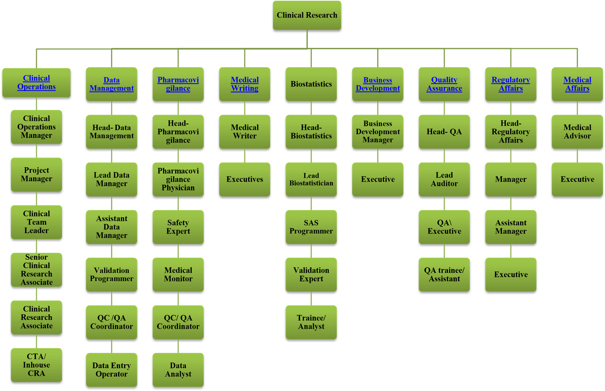

**Figure 2: A typical organizational chart of CRO [4]**

**Roles and Responsibilities of CROs in Clinical Research Management**

**Site Selection and Management**

The CRO is responsible for identifying and selecting suitable clinical sites for the trial. The CRO must ensure that the selected sites have the necessary infrastructure and expertise to conduct the trial. The CRO is also responsible for managing the activities of the clinical sites, including training, monitoring, and support [25].

**Study Design and Protocol Development**

The CRO may provide input into the design of the trial and assist with the development of the protocol. The CRO must ensure that the trial is designed in a way that is feasible, ethical, and scientifically sound. The CRO must also ensure that the protocol is followed during the conduct of the trial [19]]

**Regulatory Compliance**

The CRO is responsible for ensuring that the trial complies with all applicable regulatory requirements and guidelines. The CRO must ensure that the trial is conducted in compliance with the International Conference on Harmonization (ICH) guidelines, Good Clinical Practice (GCP) guidelines, and local regulatory requirements [26]]

**Data Management**

The CRO is responsible for managing the collection, storage, and analysis of trial data. The CRO must ensure that the data is collected and recorded accurately and that it is securely stored. The CRO is also responsible for ensuring that the data is analyzed according to the statistical analysis plan outlined in the protocol [15]. Clinical data management is a highly regulated process as illustrated in figure 3. And figure 4

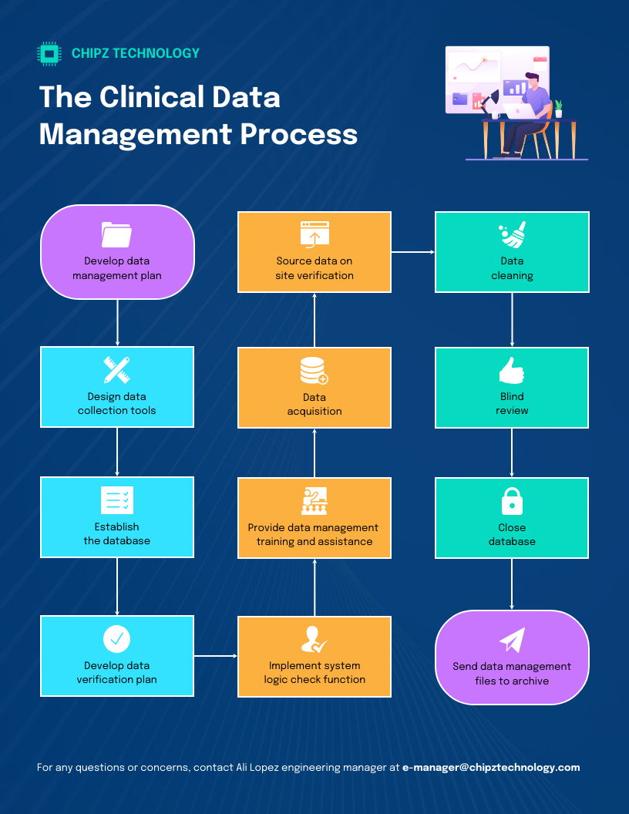

Figure 3. Clinical Data Management Process

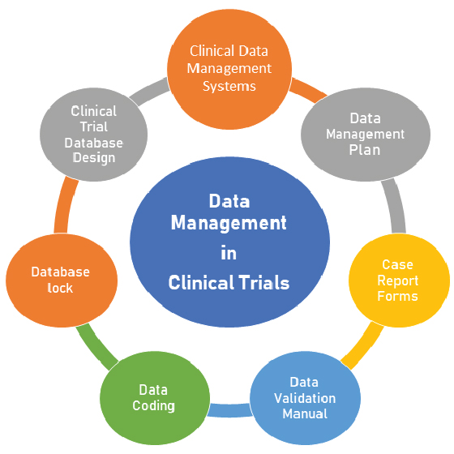

**Figure 4. Data management process in clinical trials**.

**CRO Monitoring and Oversight**

The CRO is responsible for monitoring the progress of the trial and ensuring that it is conducted according to the protocol. The CRO must ensure that the clinical sites are following the protocol and that the trial is being conducted in compliance with regulatory requirements and ethical principles [27, 28].

**Safety Reporting**

The CRO is responsible for ensuring that adverse events and other safety issues are reported to the appropriate regulatory authorities and that appropriate measures are taken to mitigate any risks to trial participants. The CRO must have a system in place for collecting, reviewing, and reporting adverse events and other safety information [ref]. CROs play a vital role in clinical trial management. They provide support to sponsors in conducting clinical trials efficiently and effectively, while ensuring that the trial is conducted in compliance with regulatory requirements and ethical principles. The CRO’s roles and responsibilities include site selection and management, study design and protocol development, regulatory compliance, data management, monitoring and oversight, and safety reporting. By fulfilling these roles and responsibilities, the CRO can help to ensure the success of the trial and the development of new, effective treatments for patients [29].

**Clinical Sites establishment**

A clinical site is a facility, such as a hospital or clinic, where clinical trials are conducted. Clinical sites are responsible for conducting the trial according to the protocol and ensuring that the data collected is accurate and reliable. Clinical sites are responsible for recruiting and enrolling study participants, administering the study intervention, and collecting data [5, 30].

Clinical sites play a crucial role in the success of clinical trials. They are responsible for conducting the trial according to the protocol and ensuring that the data collected is accurate and reliable. Clinical site personnel are in direct contact with study participants and are responsible for ensuring that they receive appropriate care and that their rights and welfare are protected. In this blog post, we will discuss the roles and responsibilities of clinical sites in clinical trial management [31]].

**Roles and Responsibilities of Clinical Sites Management team (CSMT) in the clinical trials management and recruitment.**

**Participant Recruitment**

The clinical site management team (CSMT) is responsible for identifying and recruiting suitable participants for the trial. The site must ensure that participants meet the eligibility criteria for the trial and that they understand the study procedures and risks [32f].

**Informed Consent**

The CSMT is responsible for obtaining informed consent from trial participants before they are enrolled in the trial. The site must ensure that the participant understands the study procedures, the risks and benefits of participation, and that they have the right to withdraw from the trial at any time [9]]

**Conduct Study**

The CSMT is responsible for conducting the trial according to the protocol. The site must ensure that the study procedures are followed, the study intervention is administered correctly, and the data is collected accurately.

**Safety Reporting**

The CSMT is responsible for reporting adverse events and other safety issues to the sponsor and regulatory authorities. The site must have a system in place for collecting, reviewing, and reporting adverse events and other safety information.

**Compliance with Regulations and Guidelines**

The CSMT is responsible for complying with all applicable regulations and guidelines. The site must ensure that the trial is conducted in compliance with the International Conference on Harmonization (ICH) guidelines, Good Clinical Practice (GCP) guidelines, and local regulatory requirements [32].

The CSMTs play a crucial role in clinical trial management. They are responsible for recruiting and enrolling study participants, administering the study intervention, and collecting data. The clinical site’s roles and responsibilities include participant recruitment, obtaining informed consent, study conduct, safety reporting, and compliance with regulations and guidelines. By fulfilling these roles and responsibilities, clinical sites can help to ensure the success of the trial and the development of new, effective treatments for patients [33].

Clinical trial management is a complex process that requires collaboration between various stakeholders. Sponsors, CROs, and clinical sites all have important roles and responsibilities in ensuring that a clinical trial is conducted safely, ethically, and in compliance with all applicable regulations and guidelines. By working together and fulfilling their respective roles, these stakeholders can help to ensure the successful completion of a clinical trial and the development of new, effective treatments for patients [2, 34].

**Conditions and eligibility of Operation and Selection of CRO participation in Clinical research**

Key criteria to select a CRO as a service provider for clinical research activities include its service catalog, experience, knowledge of the disease, access to patients, geographical coverage, quality management, responsiveness, staff continuity and proficiency, technology, financial stability, and pricing. CROs operation from an ethico-legal standpoint needs to gain recognition from the region of operation by the competent authorities. Respect the ethical norms and standards associated to clinical research activities [35]. The qualities of attributes of the CROs can be elucidated as follows:

**Staff technical competence**

The CRO’s workforce should not only show continuity but also technical competence. Clinical trials must be handled by qualified specialists. In order to guarantee technical ability, sponsors can audit the CRO’s internal training policies and records. In addition, detailed CVs of the CRO’s personnel assigned to the study should be reviewed to check employee education and expertise [37].

**Technology Advancement**

Clinical trials involve multiple complex processes that generate large amounts of data. Technology plays a crucial role to ensure efficient study management and streamlined data collection, cleaning, analysis, and reporting. Does the CRO use advanced tools to increase trial management efficiency? What kind of Electronic Data Capture (EDC) and electronic Trial Master File (eTMF) systems will be used? Have these tools shown good results in other studies? Sponsors should look for CROs with strong technological capabilities that optimize study management and guarantee data quality.

**Financial Stability**

Clinical trials are large projects implying substantial investments, and having to change a CRO in the middle of a study is a risk that causes technical and financial problems. A CRO must be a trusted long-term partner not exposed to serious financial hurdles. Sponsors want to work with solid companies that insure continuity of service. How many clients does the CRO have? How long has the company been operating for? Have revenues been increasing in recent years? Is the CRO experiencing growth? Sponsors are advised to check the CRO’s financial health to verify the stability of such an important partner. [11, 38]

**Service Catalog:** One of the first questions to be asked when selecting a CRO is whether it provides the range of services required for the clinical trial. Clinical trials involve many tasks, so it is advisable to hire a full service CRO able to cover as many areas as possible, in order to keep the number of vendors low. Basic services CROs should be able to offer include regulatory affairs, site selection and activation, site management, monitoring, data management, logistics, pharmacovigilance, biostatistics, medical writing, and project management.

**Experience-Longevity/Competence of service expertise:** One key consideration to choose a partner CRO is the verification of its experience. How many years has the CRO been in the business for? How many trials has it managed? In which phases? In which countries? Does it have expertise in specific therapeutic areas? Not only should the CRO have experience providing service as an organization, but it should count on seasoned staff mastering the ins and outs of clinical trial management [39f].

**Knowledge of the disease**

The CRO staff’s knowledge of the disease under investigation really makes a difference when managing a clinical trial. For instance, project managers, clinical research associates (CRAs), and data managers of a defined CRO with expert knowledge in diabetes studies will greatly help and guide the sponsor in trial design, monitoring, and data management. There is a need to seek information of the team of a CRO before outsourcing is done. Which clinical aspects should be considered when writing a diabetes or any disease protocol? Which type of variables for assessment data are critical to ensure robust results? Which endpoints should be selected? What recruitment strategies shall be used, inclusion exclusion criteria. What is the best monitoring strategy? Which details should be closely monitored to avoid undesired protocol deviations? Knowledgeable, competent CRO personnel can make highly valuable contributions in all aspect of the research [17, 40].

**Access to patients**

One of the most valuable benefits CROs can offer to clinical trial sponsors is quick access to subjects for participation in a study. CRO with long standing good relations with the population and creation of a data base of participants, established sites with high enrollment potential are most likely to be highly solicited for their services by Pharma companies. CROs continually interact with many hospitals and investigators, so they can recommend sites able to recruit the type of patients needed in a specific trial. Does the CRO have contact with investigators specialized in the disease to be studied? Can the CRO provide access to hospital networks with strong recruitment capabilities? Sponsors should select a CRO that will facilitate access to trial participants, saving them time in site selection. CRO with good health information system management (HISM)/communication network are highly solicited [41].

**Geographical coverage**

Territorial service coverage becomes very relevant in clinical trials of larger size, multicentered trials, which require the involvement of various countries. The phase III multicenter international trials (particularly those studying rare diseases) will need local services in each of the many countries where the research is conducted (e.g. regulatory services, onsite monitoring). Does the candidate CRO have trial management capabilities in several countries? Is the CRO able to conduct studies in the United States and Europe? Or will it be necessary to hire more CROs to cover additional nations increasing thus the list of vendors? Do the have collaborative network system for coordinate material transfer agreement, data sharing agreement and sustain a robust data system management board? [r42]

**Pricing**

CRO’s service rates should be evaluated. The price of service offerings may not be the most important factor when selecting a CRO, but still sponsors need to conduct their trials within budget. Sponsors must expect sound, well structured, and detailed budgets from CROs. A number of different financial proposals should be requested, assessed, and compared. Is the bid well organized with clear cost breakdowns and justifications? Are hourly rates within market standards? Is any budget item unclear or overpriced? [43]

**Quality management**

The importance of quality assurance in clinical trials cannot be overemphasized. Compliance and high-quality data are everything for trial sponsors, as this is the ground on which their drug development programs depend. Reliable CROs have quality management systems in place, in order to meet the principles of Good Clinical Practice (GCP), and international quality standards (e.g. ISO 9001). Study sponsors should conduct vendor audits at the CRO’s facilities, for an onsite authentication of its quality control practices. How does the CRO handle protocol deviations? Are correction and preventive action (CAPA) plans effectively managed? For CROs to manage the CAPA plan, they need to follow a structured process that includes identifying the issue, evaluating its severity, investigating the root cause, determining resolution options, implementing corrective and preventive actions, monitoring their efficacy, and modifying procedures as needed based on feedback. Is the CRO’s personnel well trained? Is the company ISO 9001 certified? Sponsors should look into these aspects before delegating their projects [25, 33].

**Responsiveness/Timely delivery of job**

Although it should not be the case, getting poor attention from vendors is sometimes a reality. Some suppliers show neither closeness nor responsiveness to their clients, and this might also happen with CROs. Clinical trial sponsors should choose a CRO fully committed to their needs, a loyal team that pays full attention to their requests. It may happen that larger CROs could prioritize bigger clients, while leaving aside smaller projects. In these cases, a small-size, more agile CRO can be a better option. Sponsors should detect whether they are getting appropriate attention and quick responses from the candidate CRO from day one, and highly value this service commitment when making the final choice. CROs must plan their jobs to meet the dead line and timely delivery of work outsourced to them to maintain a good reputation and build client confidence [44].

**Staff continuity**

Many CROs have problems with staff retention, even with turnover levels above 20% for seven of the last ten years, according to a report [1]. Continuous personnel changes in a CRO can negatively affect service quality and the relationships between the CRO, the sponsor’s team, and the clinical site staff. On the other hand, long-term CRO staff continuity improves and consolidates clinical trial management processes. Sponsors need to revise the CRO’s turnover rates to verify whether a solid skilled team will provide seamless support during the course of the study [45].

**Clinical Research Centres in Africa**

CRO has increased in Africa to meet the clinical research needs to address poverty related diseases and emergent diseases. Some centres that are very active in Clinical research in Africa include Nigeria, Senegal, Burkina Faso, Ghana, Mali, Gambia, Kenya, Zambia, Uganda, Rwanda and South Africa as mapped in Figure 5. And table 2.

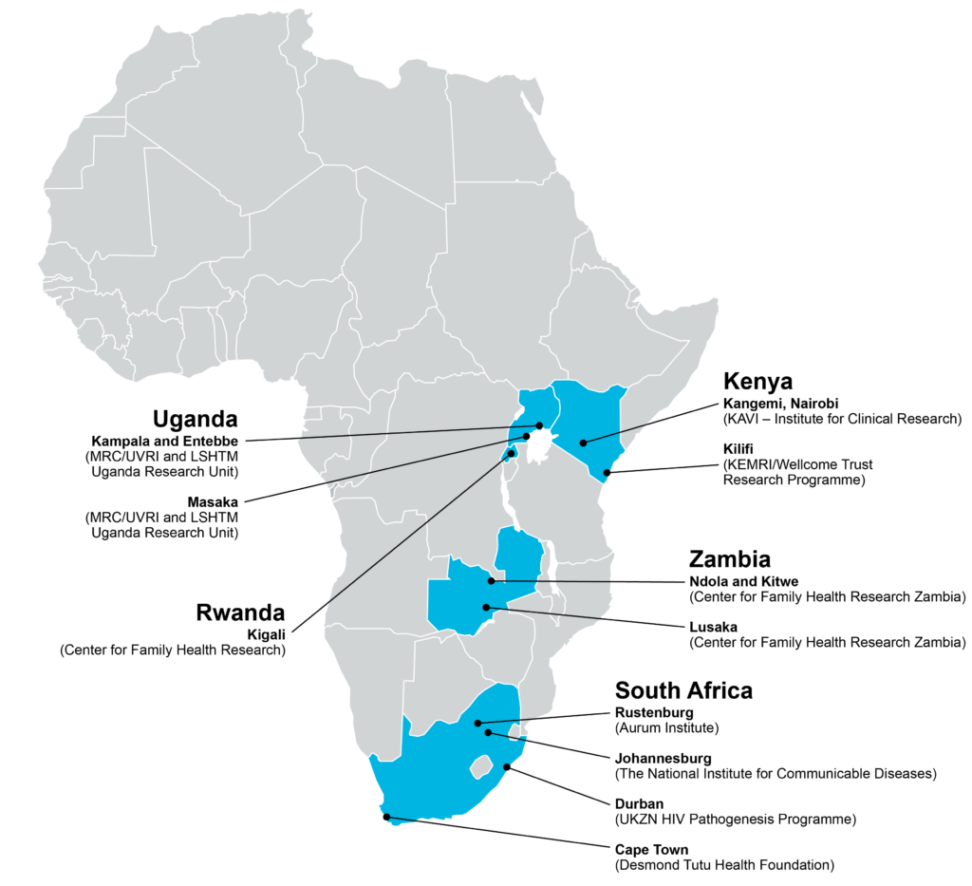

**Figure 5. Clinical Research Centres in sub Saharan Africa [22].**

Table 2. Some identified institutions of CRO in Africa [18, 22].

|  |  |  |
| --- | --- | --- |
| No | CRO Institutions | Site Location |
| 1 | The Aurum Institute | Rustenburg & Tembisa, South Africa |
| 2 | Center for Family Health Research (CFHR) | Kigali, Rwanda |
| 3 | Center for Family Health Research in Zambia (CFHRZ) | Lusaka & Ndola, Zambia |
| 4 | Desmond Tutu Health Foundation (DTHF) | Cape Town, South Africa |
| 5 | KAVI-Institute for Clinical Research (KAVI-ICR) | Nairobi, Kenya |
| 6 | Kenya Medical Research Institute-Wellcome Trust Research Programme (KWTRP) | Kilifi, Kenya |
| 7 | Medical Research Council/Uganda  Virus Research Institute Uganda/London School of Hygiene and Tropical Medicine Uganda Research Unit on AIDS (MRC/UVRI/LSHTM) | Entebbe (HQ), Masaka, Kampala, Uganda Uganda |
| 8 | The National Institute for Communicable Diseases (NICD). | Johannesburg, South Africa |
| 9 | Uganda Virus Research Institute-IAVI HIV Vaccine Program (UVRI-IAVI). | Entebbe, Uganda |
| 10 | University of KwaZulu-Natal HIV Pathogenesis Programme (HPP). | Durban, South Africa |

**CHALLENGES IN CRO AND DRUG DISCOVERY**

The Contract Research Organization (CRO) and drug discovery and development sectors are faced with multiple challenges that can be a limiting factor to their growth and quality service delivery: These challenges are listed though not exhaustive as follows;

**Technological Disruption**: Rapid advancements in technology can outpace the capabilities of existing processes and systems, necessitating continual adaptation and innovation to stay competitive. Sometimes new technologies may require regulatory approval before application into the clinical research processes [23].

**Regulatory landscape**: Working under tight regulatory compliance environment and often varied regulatory landscapes across different regions can be very challenging for CROs working in collaboration with the drug discovery and development companies. As regulations become increasingly stringent, the compliance burden grows, leading to longer timelines and higher pharmacoeconomic costs of operation

**Sustainable Patient Recruitment and Retention**: Recruiting and maintaining patient participation in clinical trials is an ongoing struggle. The complexity and length of trials can discourage patients participation in studies and putting CROs under pressure adopt innovative recruitment strategies, including leveraging digital platforms.

**Intellectual Property Issues**: Outsourcing clinical research activities presents concerns on data security and intellectual property loss. Many pharmaceutical and biotechnology firms are reluctant to share sensitive information with CROs, which can slow down collaboration and research progress.There is therefore the need for pharmaceutical companies to sign a legally binding memorandum of understanding, data sharing agreements with CROs before in service engagement deal is completed

**Economic Volatility**: Fluctuations in the economy and geopolitical uncertainties can impact market stability, affecting investment and operational decisions within the CRO and drug discovery sectors. CROs are ideal working in a political and environmentally stable environment, to assure a sustainable quality in delivery as a service provider. These challenges highlight the need for CROs and drug discovery companies to enhance their operational efficiencies, leverage technology, and foster collaborations to navigate the evolving landscape effectively.

**Limited Human resource expertise**: The lack of qualified professionals in the CRO industry is challenging to engage different types and complex clinical research projects. As CROs compete with biotech companies and pharmaceutical companies for skilled scientists and experts, attracting and retaining talent becomes increasingly competitive and very challenging

**Return on investment/High Costs**: The costs associated with clinical trials and drug development in on a steady increase and will continue to rise, driven by the need for advanced technology, robust quality assurance, and adherence to international standards. This financial pressure can limit the scope and scale of research initiatives.

**APPROACHES TO ADDRESS CROs CHALLENGES**

Navigating the complex landscape of drug development and clinical trials requires innovative strategies to address various challenges. The way forward. Here are some strategic approaches to overcoming these hurdles:

1. **Enhancing Target Validation**: Leveraging advanced technologies such as genomics and bioinformatics can refine target identification and validation processes. These tools facilitate a deeper understanding of biological mechanisms, allowing for the development of more effective psychotherapeutic agents and reducing the risk of failure early in the research and development (R&D) process.
2. **Emphasizing Soft Skills in Scientific Training**: Integrating business acumen and soft skills into scientific education is essential. Training programs that focus on communication, teamwork, and critical thinking empower scientists to navigate the complexities of drug development more effectively, thereby enhancing project management and improving overall efficiency.
3. **Decentralized Clinical Trials**: Implementing decentralized trial models can address patient recruitment challenges by leveraging digital platforms for outreach and engagement. Utilizing social media and online marketing can broaden participant access, while telemedicine solutions can facilitate ongoing patient retention and reduce logistical barriers.
4. **Strengthening Intellectual Property Management**: To mitigate risks associated with data leakage in outsourced clinical trials, establishing robust intellectual property (IP) agreements and maintaining strict data governance protocols is critical. This will help reassure stakeholders about the confidentiality and integrity of their proprietary information
5. **Addressing Workforce Shortages**: Developing partnerships between academia and industry can create a pipeline for skilled professionals, ensuring a continuous supply of qualified experts. Collaborative training initiatives can also help bridge the gap between theoretical knowledge and practical application in clinical settings.
6. **Navigating Regulatory Complexity**: Staying abreast of regulatory changes and fostering relationships with regulatory agencies can streamline the approval process. Utilizing regulatory consultants or forming dedicated compliance teams can help organizations navigate the intricate landscape of drug approval more effectively.

T**HE FUTURE OF CRO FOR DRUG DISCOVERY AND DEVELOPMENT**

The future of Contract Research Organizations (CROs) and the drug discovery and development is gaining a major and significant transformation, driven by technological advancements, increasing R&D investment, and a rising burden of chronic diseases. As the number of outsourcing of clinical trials continues to grow, particularly in emerging markets, CROs will be able to sustain its crucial role in facilitating efficient drug development processes as service providers [44].

The integration of digital tools will enhance patient recruitment and management strategies, moving away from traditional methods toward tech-enabled solutions. Electronic data capture (EDC) systems will streamline data collection, improving both accuracy and efficiency. This trend toward digitalization will not only reduce costs but also accelerate timelines, allowing for quicker drug development cycles [45].

A key growth driver for CROs will be the rising prevalence of chronic diseases, necessitating more robust drug development efforts across various therapeutic areas, especially oncology. As pharmaceutical companies face high drug development costs and pressures to deliver returns on investments, outsourcing to CROs will become increasingly attractive. CROs with specialized skills and the ability to leverage technology will be better positioned to meet these needs [46]. Moreover, the race for talent will become more critical, as access to skilled professionals capable of delivering innovative solutions will define competitive advantage. Organizations that can effectively attract and retain this talent, while providing faster, more efficient services, will likely see significant market growth.

The landscape of Contract Research Organizations (CROs) and drug discovery presents a dynamic interplay of opportunities and challenges that will shape the future of the pharmaceutical industry. As CROs continue to provide essential support in navigating the complexities of drug development, their role in facilitating efficient clinical trials and ensuring regulatory compliance becomes increasingly vital [47, 48]. The advancements in technology, particularly digital tools and innovative methodologies, offer immense potential to streamline processes, enhance patient engagement, and improve outcomes. However, these biopharma companies must also grapple with the challenges of managing costs, addressing recruitment needs, and maintaining rigorous standards of safety and efficacy within study protocols [49].

Ultimately, the success of CROs and the drug discovery process will depend on their adaptability to emerging trends and the ability to foster collaboration among stakeholders. By embracing these opportunities while proactively tackling the challenges, the sector can pave the way for transformative breakthroughs that not only bring new therapies to market faster but also improve the overall health of populations worldwide. As we look ahead, the synergy between innovation, strategic partnerships, and a commitment to excellence will be the cornerstones of future success in drug discovery and development [13, 50].

**CONCLUSION**

Contract Research Organizations (CROs) play a pivotal role in the pharmaceutical, biotechnology, and medical device industries as a research service delivery provider on a contract basis. Based on the regulatory demanding nature of clinical research the CROs must have a legal jurisdiction and recognition of their operation, and conform the norms and standard laid down by regulatory authorities and the states of their jurisdiction They offer a wide range of services to support the development and execution of clinical trials, ensuring compliance with regulatory requirements and ethical standards. CRO selection requires careful examination. In order to make a well-grounded decision, sponsors should focus on evaluating the CRO’s service portfolio, expertise, clinical knowledge, access to patients, territorial reach, quality of service, workforce continuity and skills, tools, financial strength, and costs. Careers in clinical research offer exciting opportunities for individuals interested in the scientific, regulatory, and operational aspects of drug development. By partnering with CROs and pursuing careers in clinical research, professionals can contribute to the advancement of medical science and the development of innovative therapies.

**DISCLAIMER (ARTIFICIAL INTELLIGENCE)**

**Author(s) hereby declare that NO generative** AI technologies such as Large Language Models (ChatGPT, COPILOT, etc) and text-to-image generators have been used during writing or editing of manuscripts.

**CONSENT**

It is not applicable for review study.

.

ETHICAL APPROVAL

Not applicable.

**REFERENCES**

1. Muthuswamy V. Ethical issues in clinical research. Perspectives in Clinical Research January-March 2013, 4 (1):1-5; Website: www.picronline.org, DOI: 10.4103/2229-3485.106369
2. Frost J, Britten N. Learning from a Feasibility Trial of a Simple Intervention: Is Research a Barrier to Service Delivery, or is Service Delivery a Barrier to Research? Healthcare 2020, 8, 53; doi:10.3390/healthcare8010053. [www.mdpi.com/journal/healthcare](http://www.mdpi.com/journal/healthcare).
3. NIH/SEED.America’s Seed Funds; The NIH: An Innovator’s Guide for Evaluating a CRO in Clinical Research; NIHSEED, seed.nih.gov
4. Aguilera B, DeGrazia D, Rid A. Regulating international clinical research: an ethical framework for policy-makers BMJ Global Health 2020;5: e002287. doi:10.1136/bmjgh-2020-002287
5. Indian Council of Medical Research. Ethical Guidelines for Biomedical research on Human Participants. New Delhi: 2006.
6. Wendler D. The Ethics of Clinical Research, First published Fri Jan 30, 2009; substantive revision Thu Sep 20, 2012, Stanford encyclopedia of Philosophy.
7. DPML: Drug and Medicine regulation in Cameroon. DPML.cm/indexphb/fr.info@dpml.cm last consulted 13 August, 2024.
8. Angwafor F. Monitoring and Evaluation. AUDA-NEPAD. African Medicine Regulation and Homologation programme (AMRH), 2011.
9. Fokunang CN, Tembe-Fokunang EA, Awah PK, Djuidje NM, Chi P, Ateudjieu J, Langsi R, Kaptue L, Abena OMT.The Role of Ethics in Public Health Clinical Research. In Current Topic in Public Health, 2013, INTECH. http://dx.doi.org/10.5772/52478 https://www.researchgate.net/publication/283491336
10. Emanuel EJ, Wendler D, Grady C. What makes clinical research ethical? JAMA 2000.
11. The Belmont Report - Ethical Principles and Guidelines for the protection of human subjects of research, 1979.
12. World Medical Association (WMA) Declaration of Helsinki – Ethical Principles for Medical Research Involving Human Subjects, 2000,
13. Meslin EM. Protecting human subjects from harm through improved risk judgments. IRB 1990; 12:7-10.
14. Garrard E, Dawson A. What is the role of the research ethics committee? Paternalism, inducements, and harm in research ethics. J Med Ethics 2005;31: 419-23.
15. Macklin R. On paying money to research subjects: 'Due' and 'Undue' inducements. IRB 1981; 3:1-6.
16. Nuffield Council on Bioethics. What happens after research is over? Research related to health care in developing countries, 2002.
17. Dilts, DMA, Sandler S,. Cheng, J, Crites L, Ferranti A, et al. Development of clinical trials in a cooperative group setting: The Eastern Cooperative Oncology Group. Clinical Cancer Research, 2008 14(11):3427–3433.
18. Glickman, SWJ, McHutchison ED, Peterson CB, Cairns RA, Harrington RM, Califf AM and Schulman KA. Ethical and scientific implications of the globalization of clinical research. New England Journal of Medicine 2008; 360:816–823.
19. Adjei AA, Harris AE, Awuah B. Roberts LR, Rivers BM, Yates CC, Newman LA, Sarkodie BD, Davis MB, Asare-Aboagye Y Unmet Needs in Oncology Clinical Research and Treatment in Africa: Focus on Ghana. Oncologist. 2022 Sep 2;27(9):760-767. doi: 10.1093/oncolo/oyac109.
20. Nebie EI, Sawadogo HN, van Eeuwijk P, Signorell A, Reus E, Utzinger J, Burri C.Opportunities and challenges for decentralized clinical trials in sub-Saharan Africa: a qualitative study.BMJ Open. 2023 Sep 22;13(9): e075903. doi: 10.1136/bmjopen-2023-075903.
21. Toto N, Douglas E, Gmeiner M, Barrett LK, Lindblad R, Makhaza L, Nedi W, Phulusa J, Quinnan GV, Sawyer LA, Thole H, Van Voorhis WC, Iroh Tam PY.
22. Conducting clinical trials in sub-Saharan Africa: challenges and lessons learned from the Malawi Cryptosporidium study.Trials. 2020 Jul 25;21(1):680. doi: 10.1186/s13063-020-04620-8.
23. Strother RM, Gopal S, Wirth M, Chadburn A, Noy A, Cesarman E, Lee JY, Remick SC, Busakhala N, Kaimila B, Mberi E, Ndlovu N, Omoding A, Krown SE.
24. Challenges of HIV Lymphoma Clinical Trials in Africa: Lessons from the AIDS Malignancy Consortium 068 Study. JCO Glob Oncol. 2020 Jul; 6:1034-1040. doi: 10.1200/GO.20.00152.
25. Weemeling DP. Clinical research regulatory issues. Am J Health Syst Pharm. 1999 Feb 1;56(3):252-6. doi: 10.1093/ajhp/56.3. 252..
26. Cornetta K, Smith FO. Regulatory issues for clinical gene therapy trials. Gene Ther. 2002 Jul 1;13(10):1143-9. doi: 10.1089/104303402320138925.
27. Knoepfler PS Key anticipated regulatory issues for clinical use of human induced pluripotent stem cells. .Regen Med. 2012 Sep;7(5):713-20. doi: 10.2217/rme.12.51.
28. Alten R, Cronstein BN. Clinicla trial development for biosimilars. Semin Arthritis. Rheum.
29. .Semin Arthritis Rheum. 2015 Jun;44(6 Suppl): S2-8. doi: 10.1016/j.semarthrit.2015.04.002.
30. Mermet-Bouvier P, Whalen MD vulnerability and clinical research: Mapping the challenges for Stakeholders. Ther inno.Regul. Sci. 2020 Sep;54(5):1037-1046. doi: 10.1007/s43441-020-00121-7.
31. Syed S, Boland BS, Bourke LT, Chen LA, Churchill L, Dobes A, Greene A, Heller C, Jayson C, Kostiuk B, Moss A, Najdawi F, Plung L, Rioux JD, Rosen MJ, Torres J, Zulqarnain F, Challenges in IBD research 2024: Precision Medicine. J. Inflamm Bowel Dis. 2024 May 23;30 (Supplement_2): S39-S54. doi: 10.1093/ibd/izae084.
32. Koonrung SN, Hirayama K. Ethical and regulatory challenges in genetic and genomic research involving stored biological specimen. Front Genet. 2022 Oct 21;13: 1062188. doi: 10.3389/fgene.2022.1062188.
33. Califf RM, Sugarman J. Exploring the ethical and regulatory issues in pragmatic clinical trials. Clin Trials. 2015 Oct;12(5):436-41. doi: 10.1177/1740774515598334
34. Ali J, Califf R, Sugarman J.Anticipated Ethics and Regulatory Challenges in PCORnet: The National Patient-Centered Clinical Research Network. Account Res. 2016;23(2):79-96. doi: 10.1080/08989621.2015.1023951.
35. Jeyaraman N, Ramasubramanian S, Yadav S, Balaji S, Muthu S, Jeyaraman M Regulatory Challenges and Frameworks for Fog Computing in Healthcare.
36. .Cureus. 2024 Aug 13;16(8): e66779. doi: 10.7759/cureus.66779.
37. Burt T, Sharma P, Dhillon S, Manchanda M, Mittal S, Trehan N. Clinical Research Environment in India: Challenges and Proposed Solutions. J Clin Res Bioeth. 2014 Nov 1;5(6):1-8. doi: 10.4172/2155-9627.1000201.
38. Villarreal CL, Price MA, Moreno AN, Zenteno A, Saenz C, Toppo A, Herrera-Escobar JP, Sims CA, Bulger EM Regulatory challenges in conducting human subjects research in emergency settings: The National Trauma Research Action Plan (NTRAP) scoping review; (NTRAP) Investigators Group National Trauma Research Action Plan.Trauma Surg Acute Care Open. 2023 Mar 2;8(1): e001044. doi: 10.1136/tsaco-2022-001044.
39. Lahey T The ethics of clinical research in low- and middle-income countries. Handb Clin Neurol. 2013; 118:301-13. doi: 10.1016/B978-0-444-53501-6.00025-1.Califf RM, Sugarman J. Exploring the ethical and regulatory issues in pragmatic clinical trials. Clin Trials. 2015 Oct;12(5):436-41. doi: 10.1177/1740774515598334. Epub 2015 Sep 15.
40. Baracaldo-Santamaría D, Feliciano-Alfonso JE, Ramirez-Grueso R, Rojas-Rodríguez LC, Dominguez-Dominguez CA, Calderon-Ospina CA. Making Sense of Composite Endpoints in Clinical Research.J Clin Med. 2023 Jun 29;12(13):4371. doi: 10.3390/jcm12134371.
41. Canedo JA, Rondão F, Ferreira CG, Ferrari BL, Mathias C. Lessons from implementing a clinical research network in Brazil. Am Soc Clin Oncol Educ Book. 2022 Apr; 42:1-10. doi: 10.1200/EDBK_349949.
42. Nebie EI, Sawadogo HN, van Eeuwijk P, Signorell A, Reus E, Utzinger J, Burri C. Opportunities and challenges for decentralized clinical trials in sub Saharan Africa: a qualitative study. BMJ Open. 2023 Sep 22;13(9): e075903. doi: 10.1136/bmjopen-2023-075903.
43. Bhardwaj P, Kumar J, Yadav RK. Patients driving the clinical trials designs. Democracy in clinical research. Rev Recent Clin Trials. 2019;14(4):237-246. doi: 10.2174/1574887114666190808142339. Phapale P [Pharmaco-metabolomics opportunities in drug development and clinical research.](https://pubmed.ncbi.nlm.nih.gov/38715865/) .Anal Sci Adv. 2021 Sep 30;2(11-12):611-616. doi: 10.1002/ansa.202000178.
44. Biswas P. Pharmacovigilance in Asia. Clinical research on transcatheter aortic valve replacement for bicuspid aortic valve disease: Principles, Challenges, and an Agenda for the Future. .J .Pharmacol Pharmacother. 2013 Dec;4(Suppl 1): S7-S19. doi: 10.4103/0976-500X.120941.
45. Ahmad Y, Madhavan MV, Baron SJ, Forrest JK, Borger MA, Leipsic JA, Cavalcante JL, Wang DD, McCarthy P, Szerlip M, Kapadia S, Makkar R, Mack MJ, Leon MB, Cohen DJ.Struct Heart. 2022 Nov 1;7(1):100102. doi: 10.1016/j.shj.2022.100102.
46. Brunoni AR, Nitsche MA, Bolognini N, Bikson M, Wagner T, Merabet L, Edwards DJ, Valero-Cabre A, Rotenberg A, Pascual-Leone A, Ferrucci R, Priori A, Boggio PS, Fregni F [Clinical research with transcranial direct current stimulation (tDCS): challenges and future directions.](https://pubmed.ncbi.nlm.nih.gov/22037126/) .Brain Stimul. 2012 Jul;5(3):175-195. doi: 10.1016/j.brs.2011.03.002.
47. Do A, Ilagan-Ying YC, Mehal WZ, Lim JK. Drug development of nonalcoholic fatty liver disease: challenges in research regulatory pathwaysand study end points. .Expert Opin Drug Discov. 2021 Feb;16(2):125-134. doi: 10.1080/17460441.2020.1811674.
48. Rossitto M, Fiscarelli EV, Rosati p. Chaleenges and promises for planning future clinical research into bacteriophage therapy against Pseudomonas aeruginosa in cyctic fibrosis: An argumentative review. .Front Microbiol. 2018 May 4; 9:775. doi: 10.3389/fmicb.2018.00775.
49. Ribeiro EFO, Belmiro AAMLM, Boas LCV, Niemann CU. How to set up a clinical research centre in Brazil, as an example of a middle-income country. Semin Hematol. 2023 Sep;60(4):233-242. doi: 10.1053/j.seminhematol.2023.08.004.
50. Yang M, Abudureyimu M, Wang X, Zhou Y, Zhang Y PHB2 ameliorates Doxorubicin-induced cardiomyopathy through interaction with NDUFV2 , Ren J.Redox Biol. 2023 Sep;65:102812. doi: 10.1016/j.redox.2023.102812.
51. Scavone C, di Mauro G, Mascolo A, Berrino L, Rossi F, Capuano A. The New Paradigms in clinical research. From early access programs to the novel therapeutic approaches for unmet medical needs. Front Pharmacol. 2019 Feb 13; 10:111. doi: 10.3389/fphar.2019.00111.
52. Mohamadi, Amin; Asghari, Fariba; Rashidian, Arash (2014). "Continuing review of ethics in clinical trials: a surveillance study in Iran". Journal of Medical Ethics and History of Medicine. 7: 22. PMC 4648212.