Orthopedic Recovery in Worker’s Compensation Patients Utilizing Digital Health Remote Patient Monitoring

Abstract
Research on orthopedic recovery for injured workers covered by the United States Worker’s Compensation System is limited, revealing challenges with poorer outcomes and low engagement. Current literature shows non-compliance to home exercise plans as high as 70%. One possible solution to address these challenges is through digital health solutions. For example, Recupe from Plethy uses a mobile app paired with a sensor and a designed, live coach to enhance engagement and has been shown to improve home exercise adherence and outcomes in Group Health.
This study followed 1018 injured workers over two years who used Recupe in conjunction with medical and physical therapy or occupational therapy care for their work injury recovery. The patient population was primarily aged 40-60, with a slightly higher proportion of females than males. The most commonly injured body regions were the shoulder, lumbar spine, and knee. Analysis shows that 72% of injured workers engaged in the Recupe app at least 3 times per week, with 52 percent engaging over 75 percent of days. Additionally, average pain scores improved 3.9 points out of 10.
Digital health seems to significantly improve an injured worker’s engagement and adherence to their home exercise plans. Moreover, the observed pain improvement suggests progress in recovery. Though injured workers were onboarded a day after referral, this averaged to be 44 days after the date of injury. Such a delay likely slows recovery. Despite this, digital health shows good promise and warrants further study in the Worker’s Compensation space.
To summarize, digital health, tested with the Recupe solution, greatly improved engagement compared to previous research. Thus, injured workers are more likely to follow a home exercise plan that healthcare practitioner have prescribed for their recovery.

Introduction
Orthopedic conditions are frequently treated in healthcare settings, both surgically and through physical or occupational therapy, and this is well published. [1][2][3] Post-surgical recovery has been studied heavily, and non-surgical rehabilitation for conditions in the knee and spine have also been researched. [4][5]
﻿However, there is much less data on orthopedics in the United States Worker’s Compensation arena, most of which show challenges in the Workers' Compensation space. For example, one study showed that negative outcomes increased by two-fold compared to similar patients not in worker’s compensation.[6] Another study found significantly poorer outcomes with upper extremity surgeries, [7] and similar poor recovery after lumbar disc surgery. [8]

There is little data on home exercises for Worker’s Compensation, but in Group Health, home exercise effectiveness and pain improvements are documented. [9] [10] One new addition to the worker’s compensation arena is digital health, through Remote Patient Monitoring (RPM). RPM has been used for tracking outcomes in patients with co-morbidities such as smoking tobacco, diabetes, and obesity. [11][12][13][14][15] For orthopedics, digital health can guide patients through a care journey, including a home exercise plan. Healthcare providers prescribe home exercise plans to ensure full recovery for their patients, documented with improvements in Range of Motion (ROM, WOMAC, and Berg Balance Scale). [16][17] The challenge is that patients often have very poor non-compliance with these plans, 70% non-compliance from one study, and overestimated on exercise diaries. [18][19]
Fortunately, studies using digital health to augment rehabilitation have been promising. One such digital health platform is Recupe from Plethy, which features home exercises enhanced by a wearable sensor to accurately measure movement and a designated coach to support the patient during their recovery journey. [20] Patients using Recupe digital health report good engagement, such as from one study where they exercised around 5 out of 7 days per week. [21] Some of this is due to tools such as the live coach and an in-app mood check, where poor mood correlated well with poor engagement. [22]
With the good engagement from Recupe use, patients who underwent total knee arthroplasty experienced faster ROM gain, reaching 120 degrees 25 days sooner per expected trajectory, significantly fewer manipulation under anesthesia procedures, and this was done with movements specific to patients. [23] The goal of this study is to examine injured workers covered by Worker’s Compensation undergoing treatment for orthopedic diagnoses using digital health and gather normative data. With this, comparisons can be made with other studies investigating similar populations. [24][25]

Methods and procedures
Data was gathered from all injured workers covered by Worker’s Compensation using Recupe as part of their recovery from orthopedic injuries. Diagnoses ranged throughout the body. Recupe was used to follow their home exercise plan and provide monitoring and check-ins by a coach.
This data was gathered and analyzed on Amazon Web Services Quicksight software. Graphical visualizations were created.

Results
This data covers 8/1/22 to 2/28/25. All injured workers were prescribed Recupe in addition to their normal medical and therapy visits as a result of a work injury.

Total patients – 1018

Table 1: Patients By Age Group
Not reported 13
10-19 6
20-29 115
30-39 204
40-49 214
50-59 285
60-69 161
70-79 18
80-89 1
90-100 1

Table 2: Gender by Age Group
10-19 | Female | 3
10-19 | Male | 3
20-29 | Female | 56
20-29 | Male | 55
20-29 | Patient declined to answer | 2
20-29 | Transgender | 2
30-39 | Male | 105
30-39 | Female | 96
30-39 | Patient declined to answer | 2
30-39 | Transgender | 1
40-49 | Female | 113
40-49 | Male | 97
40-49 | Patient declined to answer | 2
40-49 | none stated | 1
40-49 | Non-binary | 1
50-59 | Female | 180
50-59 | Male | 100
50-59 | none stated | 4
50-59 | Patient declined to answer | 1
60-69 | Female | 84
60-69 | Male | 71
60-69 | Patient declined to answer | 4
60-69 | none stated | 1
60-69 | Other | 1
70-79 | Female | 9
70-79 | Male | 9
80-89 | Female | 1
90-100 | Male | 1
none stated | Female | 8
none stated | Male | 5

There is an option for “Decline to Answer.” None stated indicates that the injured worker did not mark anything.

Figure 1
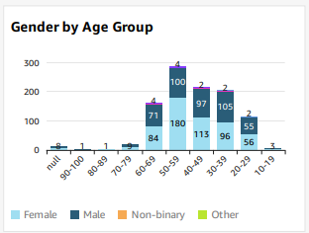

Joint Involved
Shoulder, Lumbar Spine, and Knees were the most affected areas.

Figure 2

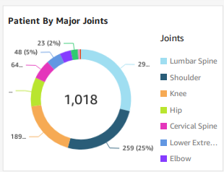
- Shoulder 192 – 29%
- Lumbar Spine 160 – 25%
- Knee 136 – 21%
- Hip – 60 – 9%
- Cervical Spine – 31 – 5%
- Other Lower Extremity – 29 – 4%
- Elbow 24 – 4%
- Thoracic Spine 15 – 2%

Language
Though most preferred English, a sizeable number preferred Spanish.

Figure 3
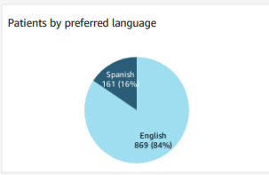

Mood Reported
Neutral moods were the most reported. Patients could report multiple moods throughout their recovery.
Figure 4
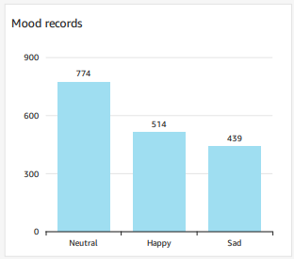

Time to Onboarding:
Referral date to onboarding Recupe - 1 day.
Days to onboarding after date of injury (average) – 44 days

Engagement
Engagement was defined as performance of the assigned HEP at least partially in a day.
Figure 5
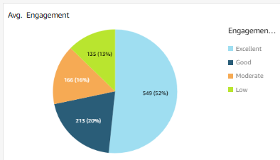

Engagement scale :
engagement < 25%, 'Low',
engagement 25 – 49%, 'Moderate',
engagement 50 – 74%, 'Good',
engagement 75 – 100%, 'Excellent'

Pain
Pain was compared from the start to the end of a patient’s recovery.
Average Pain decreased – 3.9/10

Figure 6
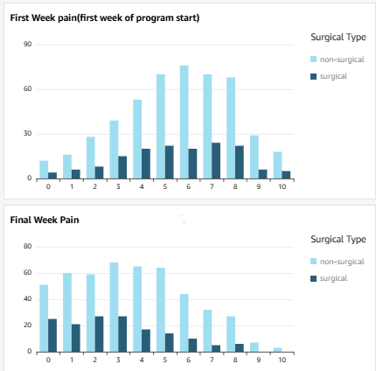

So, for this population of United States Worker’s Compensation patients, with 72% performing Home Exercises at least half of the days, pain decreased by 3.9 points out of 10 over their course of treatment.

Discussion:
From the data, several clear benefits for digital health are evident. First, injured workers using Recupe engaged well, with 72% engaging at least 50% of the days and 60% engaging over 75% of the days. This is far superior to previous research. Second, pain decreased substantially for all injured workers both surgical and non-surgical, suggesting recovery occurred. Third, mood records were most commonly neutral, with a lesser but still sizeable number of low reports. This small number suggests that low reported mood can be used as an indicator in Worker’s Compensation, much like in orthopedics. [26]

However, there were challenges noted. Though injured workers onboarded quickly after referral, 44 days had already passed from the date of injury. Since prompt treatment tends to lead to improved recovery, this could prolong treatment times.

To better understand the benefits of digital health, further research should be performed. Ideally, return-to-work times and healthcare utilization metrics should be investigated. Also, these can be compared to industry guidelines, such as from ODG or other agencies.

Some weaknesses include the lack of a control group not using digital health, as well as standardization of the population. However, the sample size appears large enough to identify clear trends in engagement and recovery. Also, since there is so little normative data concerning the United States Worker’s Compensation system, it is good to see that good engagement can result in recovery.

Ethics
Study IRB approval and Conflict of Interest review have been completed through BRANY. The Principal Investigator/lead author is an employee of Plethy.

COMPETING INTERESTS DISCLAIMER:
Authors have declared that they have no known competing financial interests OR non-financial interests OR personal relationships that could have appeared to influence the work reported in this paper.

References
- Artz, Neil, et al. "Effectiveness of physiotherapy exercise following total knee replacement: systematic review and meta-analysis." BMC musculoskeletal disorders 16.1 (2015): 1-21.
- Genêt F, Schnitzler A, Lapeyre E, Roche N, Autret K, Fermanian C, Poiraudeau S. Change of impairment, disability and patient satisfaction after total knee arthroplasty in secondary care practice. InAnnales de réadaptation et de médecine physique 2008 Nov 1 (Vol. 51, No. 8, pp. 671-682). Elsevier Masson.
- Kaye, Alan David, et al. "Enhanced recovery pathways in orthopedic surgery." Journal of Anaesthesiology Clinical Pharmacology 35.Suppl 1 (2019): S35-S39.
- McAlindon, Timothy E., et al. "OARSI guidelines for the non-surgical management of knee osteoarthritis." Osteoarthritis and cartilage 22.3 (2014): 363-388.
- Murphy, Donald R., et al. "A non-surgical approach to the management of lumbar spinal stenosis: a prospective observational cohort study." BMC Musculoskeletal Disorders 7 (2006): 1-8.
- De Moraes, Vinícius Ynoe, et al. "Workers’ compensation status: does it affect orthopaedic surgery outcomes? A meta-analysis." PloS one 7.12 (2012): e50251.
- Gruson, Konrad I., et al. "Workers' compensation and outcomes of upper extremity surgery." JAAOS-Journal of the American Academy of Orthopaedic Surgeons 21.2 (2013): 67-77.
- Anderson, Joshua T., et al. "Return to work after diskogenic fusion in workers' compensation subjects." Orthopedics 38.12 (2015): e1065-e1072.
- Yilmaz H, Polat HA, Erkin G, Akkurt E, Küçükşen S. Effectiveness of home exercise program in patients with knee osteoarthritis. European Journal of General Medicine. 2013 Jan 1;10(2):102-7.

- Thomas KS, Muir KR, Doherty M, Jones AC, O'reilly SC, Bassey EJ. Home based exercise programme for knee pain and knee osteoarthritis: randomised controlled trial. Bmj. 2002 Oct 5;325(7367):752.
- Collins, Jamie E., et al. "Effect of obesity on pain and functional recovery following total knee arthroplasty." JBJS 99.21 (2017): 1812-1818.
- Maniar, Rajesh N., et al. "WHO class of obesity influences functional recovery post-TKA." Clinics in Orthopedic Surgery 10.1 (2018): 26-32.
- Boyce, Louis, et al. "The outcomes of total knee arthroplasty in morbidly obese patients: a systematic review of the literature." Archives of orthopaedic and trauma surgery 139 (2019): 553-560.
- Petito, Lucia C., et al. "Remote physiologic monitoring for hypertension in primary care: a prospective pragmatic pilot study in electronic health records using propensity score matching." Jamia Open 6.1 (2023): ooac111.
- Michaud, Tzeyu L., et al. "Association between weight loss and glycemic outcomes: a post hoc analysis of a remote patient monitoring program for diabetes management." Telemedicine and e-Health 26.5 (2020): 621-628.
- Shim GY, Kim EH, Lee SJ, Chang CB, Lee YS, Lee JI, Hwang JH, Lim JY. Postoperative rehabilitation using a digital healthcare system in patients with total knee arthroplasty: a randomized controlled trial. Archives of Orthopaedic and Trauma Surgery. 2023 May 2:1-0.
- Hui , T., Subramanian , S., & Kamath , A. (2023). Can We Improve Clinical Outcomes and Patient Engagement after TKA Using a Digital Health Remote Monitoring Platform? Perioperative Results with Recupe . Journal of Advances in Medicine and Medical Research, 35(16), 78–84. https://doi.org/10.9734/jammr/2023/v35i165091
- Essery R, Geraghty AW, Kirby S, Yardley L. Predictors of adherence to home-based physical therapies: A systematic review. Disability and Rehabilitation. 2017;39(6):519-34.
- Nicolson, Philippa JA, et al. "Self-reported home exercise adherence: a validity and reliability study using concealed accelerometers." Journal of Orthopaedic & Sports Physical Therapy 48.12 (2018): 943-950.
- Ershadi G, Hughes S, Sundaram R, Sarrafzadeh M. Comprehensive Musculoskeletal Care Platform Enabling At-home Patient Care. InVISIGRAPP (2: HUCAPP) 2022 (pp. 190-196).
- Hui, T., Greene, H., Sasaura, P., Subramanian, S., Sharew , B. A., & Woldebirhan, Y. (2023). Improved Range of Motion and Decreased Complications After Total Knee Arthroplasty with Use of Plethy Recupe Remote Patient Monitoring: A Retrospective Study. Journal of Advances in Medicine and Medical Research, 35(22), 54–61. https://doi.org/10.9734/jammr/2023/v35i225246
- Hui T, West A, Gorham J, Woldebirhan Y, Subramanian S. Decreased Mood Correlated with Decreased Exercise Adherence and Increased Pain. JAMMR [Internet].2023;35(14):72-6.
- Hui , Timothy, Hunter Greene, Paul Sasaura, Subu Subramanian, Bereket Ayalneh Sharew, Yordanos Woldebirhan, and Jamin Gorham. 2024. “Post-Operative Range of Motion Exercises Performed Most Days at 50% Maximum ROM With Recupe Digital Health Improved ROM Recovery and Reduced Complications”. Journal of Advances in Medicine and Medical Research 36 (1):145-50. https://doi.org/10.9734/jammr/2024/v36i15358.
- Bolander, Richard P., et al. "Characterization of the Relative Change in Objective and Subjective Metrics by Baselining Patients Who Have Wearable Technology Before Total Knee Arthroplasty." The Journal of arthroplasty 39.8 (2024): S130-S136.
- Mangal, Rohan K., et al. "Normative Values for Daily Functional Recovery Patterns Following Total Knee Arthroplasty." The Journal of arthroplasty 39.11 (2024): 2731-2736.
- Pinnington, Mark A., Julia Miller, and Ian Stanley. "An evaluation of prompt access to physiotherapy in the management of low back pain in primary care." Family Practice 21.4 (2004): 372-380.

