*Original Research Article*

**Photobiomodulation therapy reduces inflammation and improves skin flap survival**

**ABSTRACT**

Photobiomodulation, a noninvasive and efficient technique, has the potential to improve microcirculation and promote neovascularization. Therefore, photobiomodulation has emerged as a promising method for reducing the risk of skin flap necrosis. This study aimed to evaluate the effect of photobiomodulation on inflammatory cells and cytokine levels in skin flaps in a murine model. Forty-eight adult male mice (Balb/C, 20-25g) were divided into control (n=24) and experiment (n=24) groups. Skin flap was raised on the dorsum of each animal, with the experiment group receiving irradiation. Photobiomodulation treatment had a wavelength of 660 nm, radiant exposure of 2 J/cm2 for 20 s in the internal vascular pedicle of the flap. Animals were euthanized on the 4th, 7th, and 10th postoperative day. A skin sample was collected for histological assessment, and a blood sample was immediately taken to determine interleukin levels. Results showed that PBM treatment significantly decreased flap necrosis at all evaluation times, accompanied by a significantly reduced pro-inflammatory interleukin (IL) IL-1β, IL-6 and tumor necrosis factor-alpha (TNF-α) while increasing the levels of the anti-inflammatory IL-10. In addition, photobiomodulation treatment led to a significant reduction in inflammatory cells in the skin flaps. These findings suggest that photobiomodulation enhances the healing process and promotes tissue reconstruction in skin flaps, partly through the modulation of inflammatory mediators.

Keywords: photobiomodulation, cytokines, low intensity laser, inflammation, necrosis.

**1. INTRODUCTION**

The cutaneous flap is a commonly employed surgical technique that involves transferring a segment of tissue from one area to another while preserving the vascular and nervous pedicle. This technique aims to restore the shape and function of a body area with significant cutaneous loss (Lucas, 2017, Moon et al., 2018). However, it has a high potential for postoperative complications, often leading to necrosis due to low tissue perfusion and decreased nutrient support (Hsueh et al., 2016, Deng et al., 2019). These complications can result in increased secondary surgeries and prolonged, painful, and costly treatments, causing significant suffering for the patient (Yuan et al., 2021).

The loss of a skin flap can be attributed to many factors, such as systemics (infections, arteriosclerosis, hypotension, and malnutrition), and local (compression, tension, and angulation of the flap). Furthermore, the major complication attributed to intrinsic factor is flap ischemia, which is caused by insufficient blood circulation following the sectioning of skin vessels and sympathetic nerves (Prado et al., 2009).

Various exogenous interventions have been explored in an effort to minimize the progression of necrosis in skin flap surgery and promote early angiogenesis. These approaches include strategies aimed at reducing oxidative stress, inhibiting apoptosis, administering vasodilators, and employing pharmacological treatments. However, there is a lack of adjuvant therapies that enhance the survival of skin flaps without substantial side effects or risks (Yuan et al., 2021, Fang et al., 2019).

Photobiomodulation (PBM) therapy has emerged as a promising approach in the management of complex wounds and has the potential to improve plastic surgery when used as an adjuvant treatment for skin flaps (Kuffler, 2016). During PBM therapy, laser light interacts with cells and tissues, stimulating phagocytes, activating mast cells, and increasing mitochondrial adenosine triphosphate (ATP) production. This process results in the proliferation of various cell types and promotes anti-inflammatory effects (Rocha Junior et al., 2006). Research indicates that PBM accelerates wound healing and promotes angiogenesis, thereby minimizing or preventing the formation of necrotic tissue in cutaneous flaps (Baldan et al., 2012, Bossini et al., 2009). Preventing necrosis in cutaneous flaps is crucial for enhancing local neovascularization and increasing blood supply to ischemic tissues. Additionally, the literature suggests that PBM can be an alternative therapy to increase the viability of skin flaps and attenuate skin flap-related necrosis (Chang et al., 2024). However, it is important to highlight that existing investigations have not yet provided a comprehensive assessment of how PBM therapy specifically influences the cellular response in the skin flap.

The objective of this study was to evaluate the effect of PBM therapy on reducing skin flap necrosis. Additionally, we sought to gain a deeper understanding of the potential benefits and mechanisms of photobiomodulation in improving skin flap viability and healing. This was achieved by analyzing the inflammatory infiltrate within the flap and assessing the levels of some pro- and anti-inflammatory cytokines in the blood.

**2. MATERIAL AND METHODS**

**2.1 Ethical Aspects**

This study was approved by the Research Ethics Committee of Nove de Julho University (UNINOVE) under protocol number 5380040918 for animal studies. An experimental, interventional, and randomized study was conducted in the UNINOVE animal facility, following the Ethical Norms for Animal Experimentation of the Council for International Organizations of Medical Sciences (CIOMS), the norms of the Brazilian Society of Laboratory Animal Science (SBCAL/COBEA), and current national legislation on Procedures for the Scientific Use of Animals (Federal Law 11,794, of October 9, 2008). Forty-eight Balb/C mice weighing between 22-25 grams, were housed in a controlled environment with a 12/12-hour light-dark cycle and maintained at a temperature of 21 ± 2ºC. They had ad libitum access to food and water.

**2.2 Induction of experimental model of Skin Flap**

The animals underwent anesthesia through an intraperitoneal injection of ketamine (100 mg/kg, Dopalen, Ceva Saúde Animal Ltda, Paulinia São Paulo – Brazil) and xylazine (20 mg/kg, Xilazin, Syntec do Brasil Ltda, Cotia, São Paulo – Brazil) to ensure analgesic control. Following that, the animals were positioned on a flat surface with their limbs extended and underwent depilation of their back. The area for the random skin flap of the cranial base was demarcated, respecting the lower angles of the scapulae and the upper bones of the girdle as anatomical boundaries. This demarcation was done in the pelvic region of the animals. Subsequently, a random skin flap with a cranial base was created. The surgical marking was performed with the flap measuring 3 cm in length and 1 cm in width. The flap was then raised from the back of the animals in both experimental groups. The flap, consisting of the superficial fascia, carnosous panculum, subcutaneous tissue, and skin, was then elevated and placed back in its original position. Prior to repositioning, a plastic barrier with the same dimensions as the flap was interposed between the superficial fascia and the superficial muscle layer. This barrier served to prevent revascularization of the flap by the underlying bed.

**2.3 Groups of study**

A total of 48 animals were included in this study and were randomly assigned to two experimental groups, the control group: animals in this group had a skin flap (SF) created without receiving any additional treatment; in the treated group animals had a skin flap (SF) created and were subsequently treated with PBM, forming the SF + PBM group. The animals were evaluated at 4, 7-, and 10-days post-treatment.

**2.4 Protocol of Laser irradiation**

The PBMT was applied along the entire length of the vascular pedicle during the flap elevation surgery. The animals were irradiated with a 660 nm (Therapy XT, DMC®, São Carlos, SP, Brazil) with a beam area of 0,04 cm2 and 100 mW power. The SF + PBM group were irradiated at a fluence of 50 J/cm2 for 20 s, and 2 J of energy were delivered. The irradiation technique consistently involved careful positioning of the pen to ensure that the light beams intersected the vascular pedicle at a 90º angle. We performed irradiation within a 1cm x 1cm area located on the ventral side of the pedicle, using a continuous scanning method along three horizontal lines for a duration of 20 s. Throughout all irradiation sessions, we employed the contact technique to optimize the delivery of light therapy.

**2.5 Assessment of the extent of flap necrosis area**

The assessment of flap necrosis area was conducted using standardized digital photography (Canon EOS Rebel T7i camera equipped with an EFS 18-55mm lens). Viable tissue was defined as having characteristics such as softness, pink coloration, warmth, and the presence of hair, while necrotic tissue exhibited rigidness, darkened appearance, coldness, and absence of hair. These distinct areas were precisely delineated on the animals, allowing for the quantification of the percentage of necrotic tissue in each group. To compare the extent of necrosis between the PBM-treated group and the control group, we utilized computational analysis with the Image J program (the National Institutes of Health). The photographs were taken on the day of euthanasia, ensuring consistency and accurate representation of the skin flaps.

**2.6 Inflammatory cell count**

To quantify the inflammatory cells, longitudinal sections were obtained from the transition zone between healthy skin and the onset of tissue necrosis, with a focus on the epidermis, dermis, and superficial subcutaneous tissue. The sections were stained using hematoxylin-eosin and examined under 20x magnification. Cell counts were conducted using a standardized random area of 700 x 600 pixels. The inflammatory cells were identified and counted through computational analysis using the ImageJ software (National Institutes of Health).

**2.7 Quantification of Cytokines in Blood**

Blood samples were collected from the animals to determine the levels of IL-6, IL-1β, IL-10, and TNF-α cytokines. In brief, 96-well plates were coated with 50 μL of the capture antibody, diluted in PBS, and incubated at 37ºC for 2 hours. Following this, the remaining binding sites were blocked with 200 μL of blocking buffer containing 3% gelatin in PBS, and the plates were incubated at 4ºC for 18 hours. After washing the plates with PBS/Tween20 (0.05%), 50 μL of samples or recombinant standards were added to each well, followed by a 1-hour incubation at 37ºC. The plates were then washed with 0.05% PBS/Tween20, and cytokine binding was detected by adding biotinylated capture antibody (diluted in 1% PBS-gelatin, 5 μg/mL, 50 μL/well) and incubating for 1 hour at 37ºC. After another round of washing, 50 μL of avidin-alkaline phosphatase (diluted 1:15000 in PBS-1% gelatin) were added and incubated for 1 hour at room temperature, followed by washing. For color development, a chromogenic substrate, ρ-nitrophenyl phosphate (diluted 1:5 in 1 M TRIS-HCl pH 9.8 and 0.5 M saline), was added (200 μL/mL). The absorbance was measured at 405 nm using an ELISA reader (Labsystems Multiscan), and the results were compared to a standard curve generated with recombinant cytokines.

**2.8 Statistical Analysis**

For data analysis, the means and standard error of the mean (SEM) were calculated and compared using analysis of variance (ANOVA) in GraphPad Prism 10 software (GraphPad Software, San Diego, CA, USA). Post-hoc comparisons were conducted using the Tukey test, and statistical significance was determined at a significance level of p ≤ 0.05.

**3. RESULTS**

* 1. **Macroscopic evaluation of the Skin flap necrotic area**

The results showed that at 4-10 days, all animals in the SF group presented 80% of the total skin flap area necrotic. However, when intracutaneous PBM was applied after skin flap elevation the flaps showed significantly more survival areas than that of the SF group by 47% (p< 0.001), 24% (p< 0.05), and 41% (p< 0.001) on days 4, 7, and 10, respectively (fig. 1).

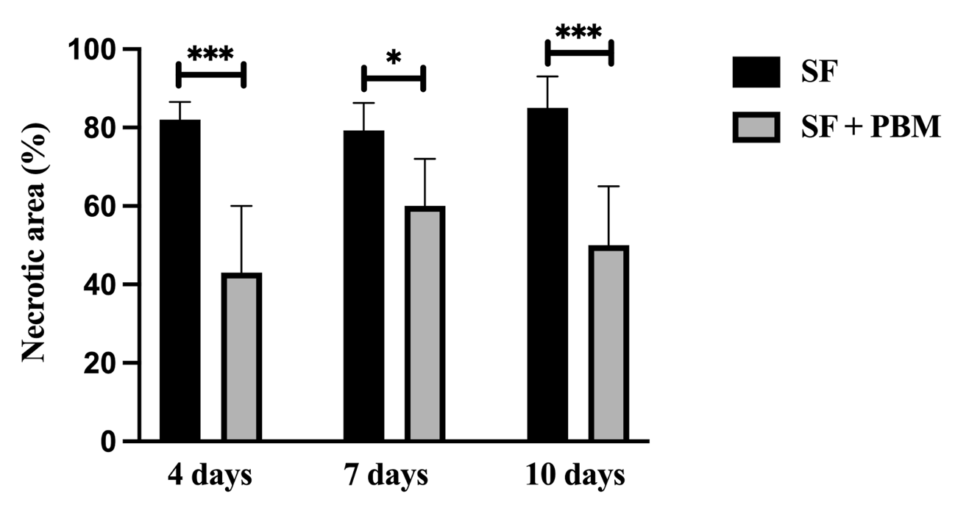

**Figure 1 – Average percentage of necrotic area.** Control group (SF) and the PBM treated group (SF + PBM). The results refer to the use of 8 mice in each experimental group. Values expressed as mean and standard deviation. \**p* < 0.05, and \*\*\**p* < 0.001.

* 1. **Inflammatory cell counting**

The SF procedure led to an increase in inflammatory cells in the transition zone between healthy skin and the onset of tissue necrosis throughout the entire period analyzed (110 ± 15 cells; 115 ± 30 cells; 107 ± 25 cells on day 4, 7 and 10 respectively). However, PBM treatment significantly reduced this cell migration on all postoperative days (51 ± 18 cells, 42 ± 15 cells; 54 ± 20 cells on day 4, 7 and 10 respectively) (Fig. 2).

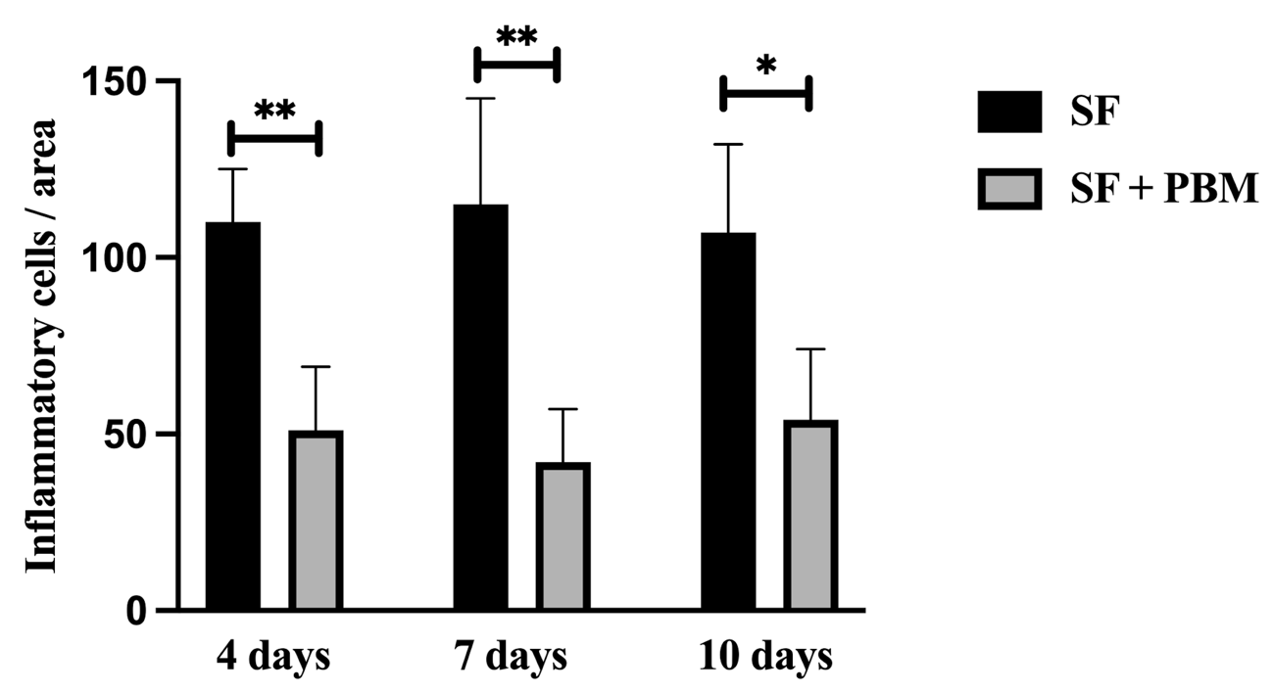

**Figure 2 - Effect of PBM on the inflammatory cells in the skin flap.** Control group (SF) and the PBM treated group (SF + PBM). The results refer to the use of 8 mice in each experimental group. Values expressed as mean and standard deviation. \**p* < 0.05 and \*\**p* < 0.01.

**3.3 Cytokines quantification**

The concentrations of inflammatory cytokines (IL-1β, IL-6, TNF-α, and IL-10) in the blood were measured using ELISA (Fig. 3). The skin flap (SF) procedure resulted in a significant increase in all pro-inflammatory mediators at each evaluated time point (4, 7, and 10 days). Photobiomodulation therapy (PBMT) significantly decreased IL-1β levels by 47%, 52%, and 56% on days 4, 7, and 10, respectively (Fig. 3A). Similarly, PBM irradiation reduced IL-6 levels by 76%, 62%, and 51% on days 4, 7, and 10, respectively (Fig. 3B). TNF-α levels were also reduced by 68%, 55%, and 59% on days 4, 7, and 10, respectively (Fig. 3C). Additionally, a marked decrease in the anti-inflammatory mediator IL-10 was observed following the SF procedure at all time points. However, PBM treatment consistently elevated IL-10 levels by 160%, 87%, and 119% on days 4, 7, and 10, respectively (Fig. 3D).

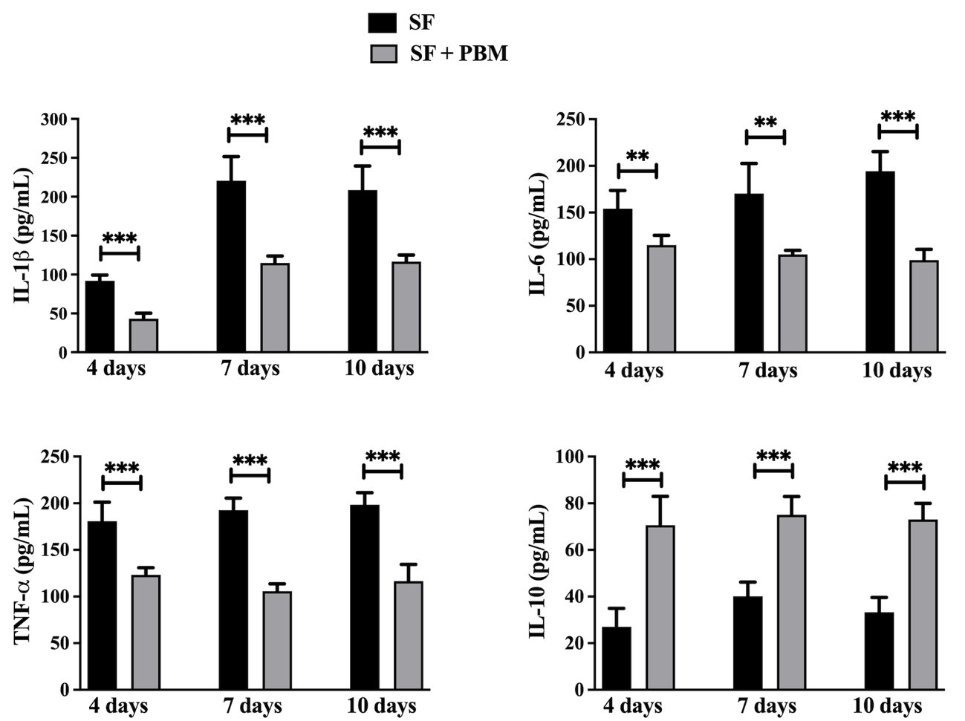

**Figure 3 - Effect of PBM on IL-1 β (A), IL-6 (B), TNF- α (C), and IL-10 (D) levels in blood of the animals.** Control group (SF) and the PBM treated group (SF + PBM). The results refer to the use of 8 mice in each experimental group. Values expressed as mean and standard deviation. \*\**p* < 0.01, and \*\*\**p* < 0.001.

**4. DISCUSSION**

The use of skin flaps is a widely practiced surgical technique in plastic surgery. It involves the transfer of tissue from one area to another, while maintaining the vascular and nervous pedicle. However, tissue loss can occur, with the main cause being the interruption of blood flow, leading to perfusion decrease and progression to necrosis (Lucas, 2017, Hsueh et al., 2016, Deng et al., 2019). Photobiomodulation (PBM) has emerged as a noninvasive alternative for enhancing skin flap viability [12]. While several studies have shown PBM's beneficial effects in improving skin flap survival, the underlying mechanisms behind this protective effect remain unclear. Here, we investigate the effect of PBM in skin flap evaluating the reduction of necrosis, the inflammatory cells, and the release of pro- and anti-inflammatory cytokines.

The literature explores several methods for applying PBM to skin flaps, with the number of application points ranging from 1 to 24. The application site of PBM also varies, being administered in the cranial portion, directly on the surface of the flap, around it, or both inside and outside the flap (Chang et al., 2024). Here, we applied PBM therapy intraoperatively along the entire vascular length during flap elevation surgery by scanning the vascular pedicle, this technique ensures that the entire length of the skin flap receives the PBM. Although most studies utilize PBM post-surgery and across multiple points, our approach is supported by literature suggesting that a single point of PBM irradiation is sufficient to stimulate blood flow (Pinfildi et al., 2013).

In our study, the percentage of flap necrosis was evaluated on days 4, 7 and 10 postoperatively. We observed a reduction in necrotic areas in animals treated with PBM compared to those not treated. Similar results have been reported in the literature (see review by Chang et al. 2024). However, most studies applied PBM for several consecutive days after surgery, we demonstrated that a single application was sufficient to reduce necrosis.

Inflammatory responses due to the accumulation of inflammatory cells have a negative impact on the survival of random skin grafts (Qing-Bo et al., 2016). Furthermore, the production of inflammatory mediators by these immune cells exacerbates ischemia and tissue damage (Kang et al., 2014, Bächle et al., 2011). Preventing immune responses and inflammation may enhance skin flap survival. Therefore, it is plausible that PBM helps prevent tissue necrosis by modulating inflammation. To test this hypothesis, we assessed inflammatory cells in tissue and the levels of pro- and anti-inflammatory cytokines in the blood of animals.

In this study, the epidermis in necrotic regions at the transition zone between healthy and affected skin exhibited significant inflammatory cell infiltration. Our findings demonstrated that PBM therapy in mice effectively reduced the number of inflammatory cells in this transition zone. Moreover, it lowered pro-inflammatory cytokine levels while increasing anti-inflammatory cytokines. These results highlight PBM’s ability to modulate inflammation, directly contributing to the expansion of viable tissue in PBM-treated animals. Similar to our study, Esteves et al. (2022) showed that TNF-α expression were reduced in the skin flap that was treated with red PBM with an energy dose of 7.30J consequently, increasing skin flap viability in rats. In addition, Esteves Jr et al. (2012) showed the ability of the PBM treatment to reduced COX-2 expression in the flap. COX-2 is a central enzyme in the inflammatory process, driving the production of pro-inflammatory prostaglandins that mediate pain, swelling, and tissue damage (Ricciotti et al., 2011). Therefore, we suggest that PBM therapy may protect skin flaps from necrosis through an indirect mechanism involving the suppression of inflammation.

Our study has certain limitations, particularly in the scanning application method, which prevents precise measurement of the energy delivered to specific points on the skin flap. However, this approach ensures that the entire area is uniformly exposed to PBM energy. Another limitation concerns the inflammatory cell counts. While we evaluated the total cell migration to the tissue, the differential cell count was not performed, which could have identified the specific inflammatory cell types present during the evaluated period.

**5. CONCLUSION**

PBM significantly reduced the area of distal necrosis in the flaps. PBM may enhance skin flap survival by mitigating inflammation through both the reduction of inflammatory cells and pro-inflammatory cytokines, while also promoting the production of the endogenous anti-inflammatory cytokine IL-10.

**ETHICAL APPROVAL**

The animals were obtained from the University Nove de Julho and the experiments were approved by the Animal Care Committee University Nove de Julho (CoEP-UNINOVE, nº 5380040918/2018). The methods used in the present study were carried out in accordance with the relevant guidelines.

**DISCLAIMER (ARTIFICIAL INTELLIGENCE)**

The authors acknowledge the use of **DeepSeek**, an AI-powered writing assistant, to improve the clarity, grammar, and readability of the manuscript. The content and scientific integrity of the work remain the sole responsibility of the authors.:

1.The original manuscript, drafted in Brazilian Portuguese, was translated into English, and AI was used to refine the grammar and ensure the final text met academic English standards.

2.Specific prompts were created to direct the AI in correcting grammatical errors and ensuring the translation adhered to academic norms.

**REFERENCES**

Bächle A.C., Mörsdorf P., Rezaeian, Ong M.F., Harder Y., Menger M.D. (2011) N-acetylcysteine attenuates leukocytic inflammation and microvascular perfusion failure in critically ischemic random pattern flaps. Microvasc Res 82: 28–34. https://doi: 10.1016/j.mvr.2011.03.010

Baldan C.S., Marques A.P., Schiavinato A.M., Casarotto R.A. (2012) The effects of different doses of 670 nm diode laser on skin flap survival in rats. Acta Cirúrgica Brasileira 27 (2):155. https:// DOI: [10.1590/s0102-86502012000200010](https://doi.org/10.1590/s0102-86502012000200010)

Bossini P.S., Fangel R., Habenschus R.M., Renno A.C., Benze B., Zuanon J.A., et al. (2009) Low-level laser therapy (670 nm) on viability of random skin flap in rats. Lasers Med Sci 24:209–213. https://DOI: [10.1590/s0102-86502012000200010](https://doi.org/10.1590/s0102-86502012000200010)

Chang A.J.B.A., Pinto E.A.F.B., Silva D.R., David A.C., Matos LP, Marcos R.L., et al (2024) Photobiomodulation in promoting increased Skin Flap Viability: a systematic review of animal studies. Lasers in Medical Science 39:109. <https://doi.org/10.1007/s10103-024-04055-6>

Deng C, Wu B, Wei Z, Zhang Z., Zhang T., Wang D. (2019). A Systematic Study of Vascular Distribution Characteristics and Axis Design of Various Flap Types. Med Sci Monit 25: 721-729. <https://www.ncbi.nlm.nih.gov/pmc/articles/PMC6357821/pdf/medscimonit-25-721.pdf>

Esteves G.R., Junior I.E., Masson I.F.B., Machado A.F.P., Oliveira M.C.D., Baldan C.S., et al (2022) Photobiomodulation effect in tumoral necrosis factor-alpha(TNF-α) on the viability of random skin flap in rats. Lasers Med Sci 37:1495–1501. https://doi.org/10.1007/s10103-021-03303-3

Esteves Jr. I., Masson I.B., Oshima C.T.F., Paiotti A.P.R., Plapler H. (2012) Low-level laser irradiation, cyclooxygenase-2 (COX-2) expression and necrosis of random skin flaps in rats. Lasers Med. Science 27:3-655-660. https: doi: 10.1007/s10103-011-1011-1

Fang M.J., Qi C.Y., Chen X.Y., Hu P.Y., Wang J.W., Xu P.F., et al (2019) Effects of batroxobin treatment on the survival of random skin flaps in rats. Int. Immunopharmacol 72:235–242. https://doi: [10.1016/j.intimp.2019.04.011](https://doi.org/10.1016/j.intimp.2019.04.011)

Hsueh Y.Y., Wang D.H., Huang T.C., Chang Y.J., Shao W.C., Tuan T.L, et al (2016) Novel skin chamber for rat ischemic flap studies in regenerative wound repair. Stem Cell Res Ther 17;7(1):72. <https://pubmed.ncbi.nlm.nih.gov/27188874/>

Kang N., Hai Y., Liang F., Gao C.J., Liu X.H. (2014) Preconditioned hyperbaric oxygenation protects skin flap grafts in rats against ischemia/reperfusion injury. Mol. Med. Rep. 9: 2124–2130. https:// DOI: [10.3892/mmr.2014.2064](https://doi.org/10.3892/mmr.2014.2064)

Kuffler D.P. (2016) Photobiomodulation in promoting wound healing: a review. Regen Med. 2016 Jan;11(1):107-22. doi: 10.2217/rme.15.82

Lucas J.B .(2017) The Physiology and Biomechanics of Skin Flaps. Facial Plastic Surgery Clinics of North America 25(3): 303–311. <https://doi:10.1016/j.fsc.2017.03.003>

Moon J.H., Rhee Y.H., Ahn J.C., Kim B., Lee S.J., Chung P.S. (2018) Enhanced survival of ischemic skin flap by combined treatment with bone marrow-derived stem cells and low-level light irradiation. Lasers Med Sci 33:1–9. <https://doi10.1007/s10103-017-2312-9>

Pinfildi C.E., Hochman B.S., Nishioka M.A., Sheliga T.R., Neves M.A.I., Liebano R.E., et al (2013) What is better in TRAM flap survival: LLLT single or multi-irradiation? Lasers Med Sci 28:755–761. https://DOI 10.1007/s10103-012-1130-3

Prado R.P., Pinfildi C.E., Liebano R.E., Hochman B.S., Ferreirta L.M. (2009) Effect of Application Site of Low-Level Laser Therapy in Random Cutaneous Flap Viability in Rats. Photomedicine and Laser Surgery 27(3):411–416. https://doi:[10.1089/pho.2008.2320](https://doi.org/10.1089/pho.2008.2320)

Qing-Bo L.V., Gao X., Lin D.S., Chen Y., Cao B., Zhou K.L. (2016) Effects of diammonium glycyrrhizinate on random skin flap survival in rats: An experimental study. Biomed Rep 5(3): 383–389. https://doi: [10.3892/br.2016.733](https://doi.org/10.3892%2Fbr.2016.733)

Ricciotti E, FitzGerald GA (2011) Prostaglandins and Inflammation. Arteriosclerosis, Thrombosis, and Vascular Biology 31(5): 986–1000. <https://doi.org/10.1161/ATVBAHA.110.207449>

Rocha Junior A.M., Andrade L.E.F., Oliveira R.G., Farias R.E., Andrade L.C.F., Aarestrup F.M. (2006) Modulação da proliferação fibroblástica e da resposta inflamatória pela terapia a laser de baixa intensidade no processo de reparo tecidual. An Bras Dermatol 81:150-6. <https://doi.org/10.1590/S0365-05962006000200006>

Li Y., Jiang Q.L., Van der Merwe L., Lou D.H., Lin C. (2021) Preclinical efficacy of stem cell therapy for skin flap: a systematic review and meta-analysis. Stem Cell Research &amp; Therapy 12:28. <https://doi.org/10.1186/s13287-020-02103-w>