Case report

Atraumatic Extraction of an Anterior Tooth with Immediate Implant Placement and Provisional Restoration: A Case Report

Abstract
Introduction: Implant dentistry aims at rehabilitating lost teeth by restoring function and aesthetics through a fixed prosthesis over the implant. Rehabilitating lost teeth in the anterior maxilla region is a significant challenge due to the high aesthetic demands. The evolution of applied techniques has shown greater success when atraumatic extraction and implant placement are performed simultaneously, along with bone grafting and provisional restoration. Objective: To report a clinical case of atraumatic extraction of tooth 21, immediate implant placement, xenograft, and screw-retained provisional restoration. Case report: Atraumatic extraction was performed while maintaining the alveolar framework, implant placement in the palatal bone remnant with minimal primary stability for the fabrication of a screw-retained provisional restoration, and filling the alveolar gap with bovine xenograft. The provisional restoration was maintained for six months in infraocclusion, during which a new imaging examination demonstrated success in vertical and horizontal bone preservation. It was also possible to preserve the gingival framework, achieving an adequate emergence profile. Conclusion: This clinical case met the prerequisites for performing the most current and favorable techniques. Thus, it was possible to preserve the alveolar framework and obtain a satisfactory result, even without performing connective tissue grafting.

Keywords: Tooth Extraction, Bone Graft, Dental Implant, Implant-Supported Dental
Prosthesis, Bone Regeneration.

Introduction

Implant dentistry focuses on replacing missing teeth. Initially, the primary concern was purely functional, aiming to restore the patient's masticatory capacity and improve their quality of life. Over the years, with the advancement of techniques and materials, in addition to functionality, there has been an increased emphasis on aesthetics (BLOCK, 2018).
The success of implant treatment depends on various pre-, trans-, and post-operative factors related to the patient's health condition, habits, and oral care, as well as factors associated with the professional and the technique used. Thus, achieving optimal results requires a thorough evaluation of all these factors and meticulous preoperative and prosthetic planning (AMORIM et al., 2019).
Currently, aesthetic dentistry represents the primary goal of most dental interventions. Patients have increasingly higher aesthetic expectations, and it is the professional's responsibility to utilize materials and multidisciplinary approaches, considering mechanical and biological factors (occlusion and periodontium), as well as psychological aspects, particularly patient expectations (ALIKHASI et al., 2022).
Early implantology techniques recommended a long interval between tooth extraction and implant placement, requiring at least two surgical procedures. Nowadays, in many cases, it is possible to perform tooth extraction and immediate implant placement in the same surgical session, offering multiple benefits to the patient, particularly in terms of comfort and aesthetics (BLOCK, 2018; ZUCCHELLI et al., 2018).
The evaluation of the outcomes of single-implant treatments in aesthetic areas depends directly on the surrounding tissues. The remaining bone and connective tissue, keratinized gingiva, and presence of papillae contribute to the quality of the peri-implant framework, leading to better aesthetic results (ZUCCHELLI et al., 2018).
Aesthetic complications in implants in the anterior maxillary region are often related to peri-implant vertical and horizontal bone loss, loss of papillae, and inadequate implant design and positioning. Once these aesthetic issues occur, they are difficult to correct and often require complex and delicate surgical techniques, which are more traumatic for the patient and have an uncertain prognosis (RAMANAUSKAITI; SADER, 2022).
To prevent aesthetic complications related to bone and gingival volume loss, atraumatic extraction techniques can be employed, along with digital planning of implant positioning using a surgical guide and the placement of a provisional crown in the same surgical procedure. This approach helps preserve the original alveolar structure, providing more predictable outcomes (SALVIANO et al., 2023).
Among various techniques for extraction and immediate implant placement, preserving the buccal bone wall has shown the best results. Additionally, flapless surgery combined with hard and soft tissue grafting appears to be the best approach in multiple clinical cases analyzed in a recent systematic review (WU et al., 2023).
For the appropriate selection of immediate implant treatment in the anterior maxillary region, it is crucial to classify the post-extraction socket as type 1, 2 or 3. A type 1 socket has an intact buccal bone wall and soft tissues, making it the most favorable and predictable situation. Type 2 sockets may resemble type 1 when soft tissues are preserved; however, in this case, the buccal bone wall is partially lost. A type 3 socket is the least favorable, as it lacks the buccal bone plate entirely and exhibits significant soft tissue loss and gingival recession (ELIAN et al., 2007).
Understanding the behavior of hard and soft tissues in post-extraction sockets is essential. In a systematic review, Tan et al. (2012) analyzed 20 studies and observed that horizontal bone resorption is greater than vertical resorption within the first six months after extraction. The buccal side experiences more significant bone volume loss compared to the lingual side. Regarding soft tissues, an increase in thickness was observed after six months, though the underlying biological mechanisms remain unclear. Additionally, soft tissue thickness is greater on the lingual side than on the buccal side.
Immediate implant placement into a fresh socket yields better results when the gap between the implant and the remaining bone wall is filled with a hard tissue graft. A meta-analysis demonstrated that horizontal bone resorption is 54% lower when the gap is filled with a bone graft compared to immediate implant placement without grafting in a fresh socket. Furthermore, soft tissue preservation, including papillae, is improved, enhancing aesthetics in single-tooth cases in the anterior maxilla (SEYSSENS et al., 2022).
According to Parelli and Abramowicz (2015), the decision to perform immediate implant placement and immediate loading should consider multiple factors and is not recommended in cases with significant bone defects, poor bone quality, or acute infection. The same authors reported that immediate loading—defined as placing a prosthesis on the implant within 72 hours of insertion—has shown excellent success rates, approaching 95%. However, the success of immediate loading primarily depends on achieving adequate primary stability.
Sarfaraz et al. (2018) investigated the relationship between primary stability, insertion torque, and treatment success. Since primary stability refers to the initial firmness of the dental implant upon insertion into the bone, the authors concluded that achieving an insertion torque of at least 30 Ncm (Newton-centimeter) is sufficient for successful immediate loading implant treatment.
The objective of this study was to report a clinical case in which a patient underwent atraumatic extraction of tooth 21, immediate implant placement in the palatal bone remnant, gap filling with bovine xenograft, and a screw-retained provisional restoration in infraocclusion.

Case report
Patient I.C.R.M., a 56-year-old healthy woman with a history of hysterectomy approximately 15 years ago, was undergoing hormone replacement therapy. She reported a past adverse reaction to injectable voltaren, was normotensive, and had no other reported health issues. She was receiving dental treatment at the Federal University of Vales do Jequitinhonha and Mucuri (UFVJM) when she was referred to a private specialized endodontic service for evaluation of a fistula near tooth 21.
At her initial appointment on November 23, 2023, the patient reported a history of childhood trauma that resulted in a fracture of tooth 21, followed by endodontic therapy and aesthetic rehabilitation with composite resin. Clinical examination revealed the presence of a fistula, grade 1 mobility in tooth 21, and mild gingival discomfort. She reported recent use of nimesulide 100 mg every 12 hours for inflammation control and amoxicillin 500 mg every 8 hours, as prescribed by the UFVJM team.
An initial radiograph was taken with a gutta-percha cone inserted into the fistula for tracing, confirming its relationship with the distal middle third of the root, while the apical region showed good bone integrity and satisfactory root canal filling (Figure 1).

Figure 1. Initial radiograph
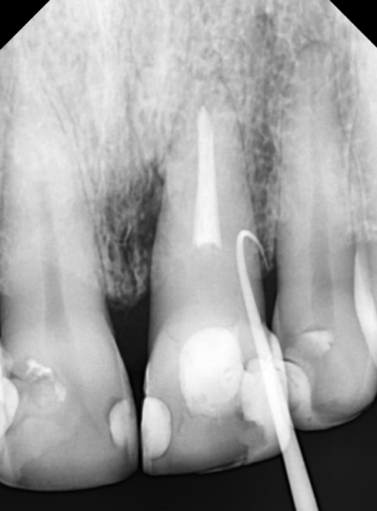

Due to suspicion of a crack or fracture in the middle third of the root, a computed tomography (CT) scan of the anterior maxilla was requested for diagnostic confirmation and clinical treatment planning. The examination confirmed an image consistent with a fissure in the cervical region of tooth 21 (Figures 2 and 3).
Figure 2. Initial CT scan
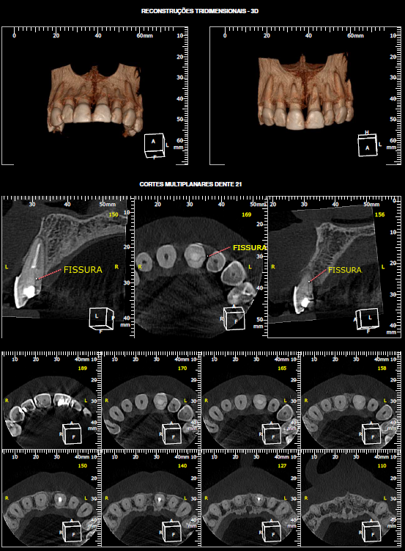

Figure 3. Final CT scan

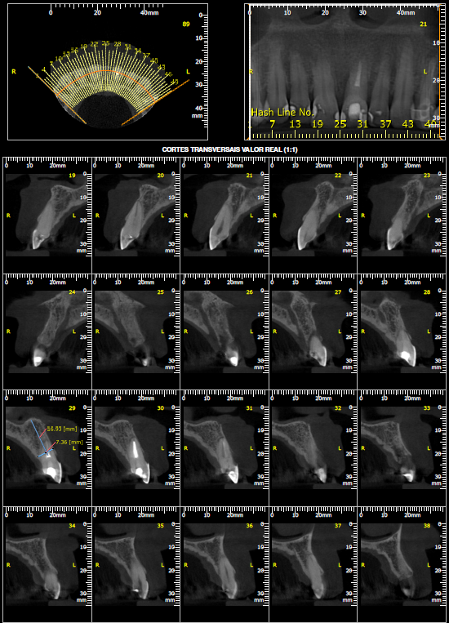

Given the impossibility of rehabilitating the tooth, a treatment plan was developed for the atraumatic extraction of tooth 21 and immediate implant placement, with the possibility of a screw-retained provisional restoration depending on the torque and primary stability achieved at the time of implant insertion.
Preoperative blood tests were requested to assess the patient's overall health. The complete blood count showed results within normal ranges, as did the coagulation profile, fasting blood glucose, glycated hemoglobin, calcium, and phosphorus levels.
A preliminary impression of the anterior maxilla was taken to fabricate an acrylic resin surgical guide, ensuring optimal three-dimensional positioning of the implant to enhance the prosthetic outcome. Additionally, preoperative photographs were taken, revealing a favorable gingival profile and a low smile line, which facilitates achieving an aesthetically pleasing result (Figures 4, 5, and 6).

Figure 4. Extraoral photo of the preoperative condition
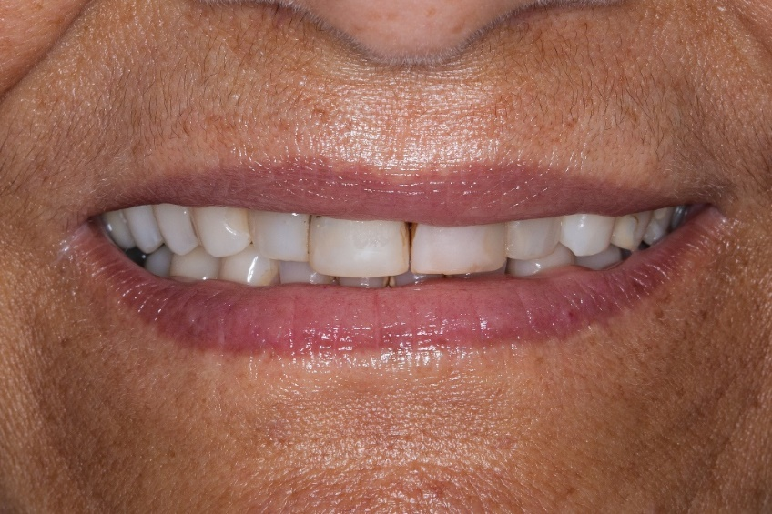

Figure 5. Intraoral photo of the preoperative condition
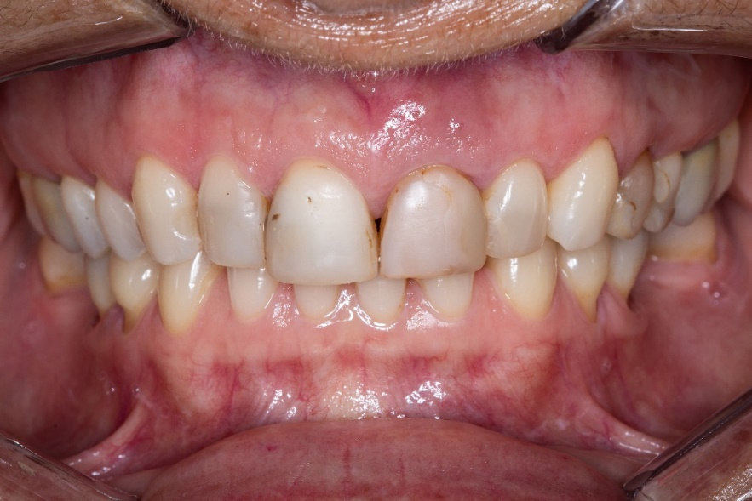

Figure 6. Intraoral photo of the preoperative condition

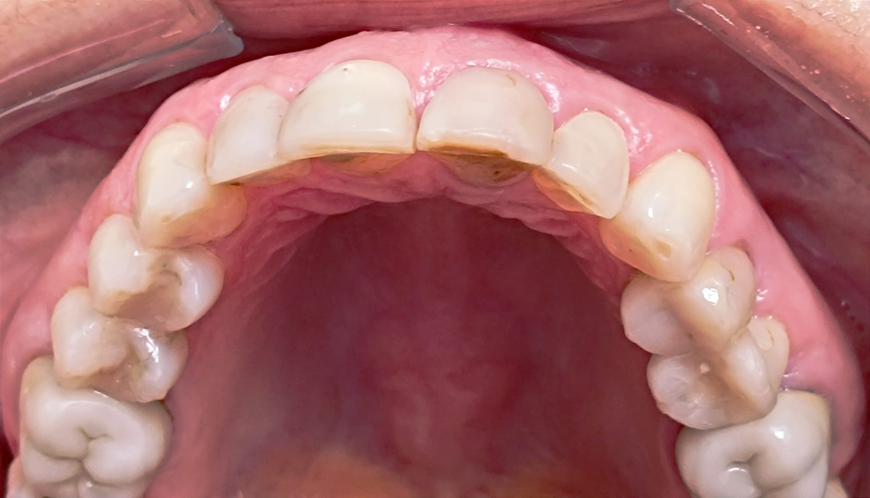

The patient was prescribed preoperative medication, including 4 mg of dexamethasone and 1 g of amoxicillin, to be taken one hour before the surgical procedure. At this time, the fistula was inactive, with no visible secretion or pain, and only mild grade 1 mobility was observed. During the preoperative physical examination, the patient presented a heart rate (HR) of 75 beats per minute (bpm), peripheral oxygen saturation (SpO²) of approximately 98%, and blood pressure of 110/70 mmHg.
Intraoral antisepsis was performed with a 1-minute rinse using 0.12% Chlorhexidine, and extraoral antisepsis was carried out with 2% Chlorhexidine. The chosen anesthetic was 2% lidocaine with 1:100,000 epinephrine (DFL brand), with two cartridges administered using the infiltration technique for blocking the anterior superior alveolar nerve and half a cartridge for blocking the nasopalatine nerve.
No incision was made, as the atraumatic extraction technique was chosen to preserve the alveolar framework as much as possible. A straight flexible periotome and a mallet were used on the mesial, distal, and palatal surfaces of the root of tooth 21. The buccal surface was not manipulated at any time to preserve the buccal bone plate, which was found to have minimal thickness upon examination by computed tomography. Gentle luxation and rotational movements were performed with forceps 69 until the complete extraction of tooth 21, at which point a cervical third root fracture and granulation tissue adhered to the fissure region were visually confirmed (Figure 7).

Figure 7. Tooth 21 immediately after extraction, showing a fissure in the cervical third of the root and granulation tissue.
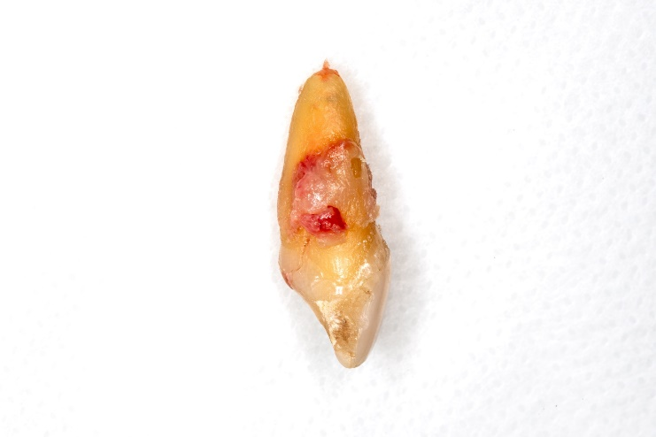

The condition of the socket after atraumatic extraction was very favorable, with minimal trauma in the papilla region, preserving the entire previous framework, as illustrated in the following photograph (Figure 8).
Figure 8. Socket immediately after extraction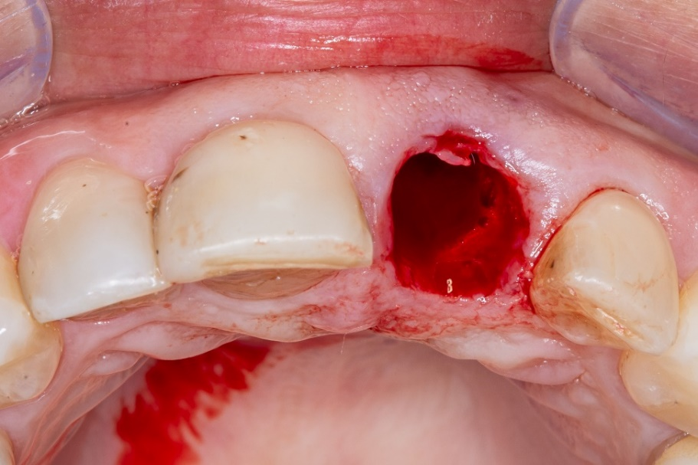

Next, the surgical guide made of acrylic was inserted, with the perforation site aligning with the cingulum region of the palatal surface of the lost tooth, ensuring proper three-dimensional positioning of the implant (Figure 9).
Figure 9. Guided device.
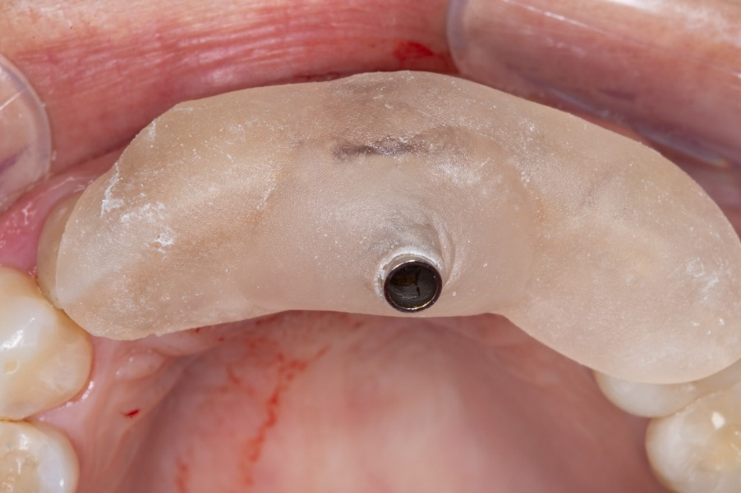

The initial drilling was performed using the lance drill from the Strong surgical kit by SIN Implantes, compatible with the selected implant: a Cone Morse Strong SW with a 3.8mm diameter and 11.5mm length, featuring a hybrid macrogeometry with a cylindrical body and a conical apex, suitable for all bone densities. The initial drill, as well as the 2.0mm, 3.05mm, and 3.3mm diameter drills, were used at 800 rotations per minute (RPM) as per the manufacturer's guidelines, with concurrent irrigation using 0.9% saline solution to prevent bone overheating. The three-dimensional positioning of the drilling was properly verified using the direction indicator included in the surgical kit (Figure 10).
Figure 10. Position of the implant.
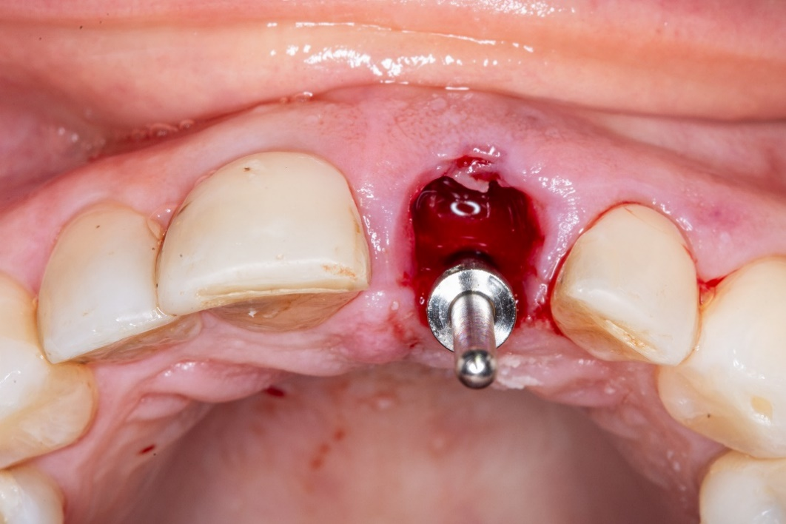

The implant was inserted using a contra-angle handpiece at 30 RPM. After the implant insertion was completed, the torque was verified using the ratchet from the Strong SW surgical kit, achieving more than 30 Ncm, confirming the minimum primary stability required for immediate load provisionalization.

Upon completing the implant insertion stage, the final position was verified, and the condition of the buccal GAP was assessed, which was expected since the implant was placed in the remaining palatal bone.

The GAP was filled using Lumina-Bone xenograft with medium granulation from the manufacturer Criteria, after protecting the internal part of the implant with the cover screw. No significant compression of the graft granules was performed in the GAP to allow blood perfusion between the particles (Figure 11).

Figure 11. Implant and bone graft placed.
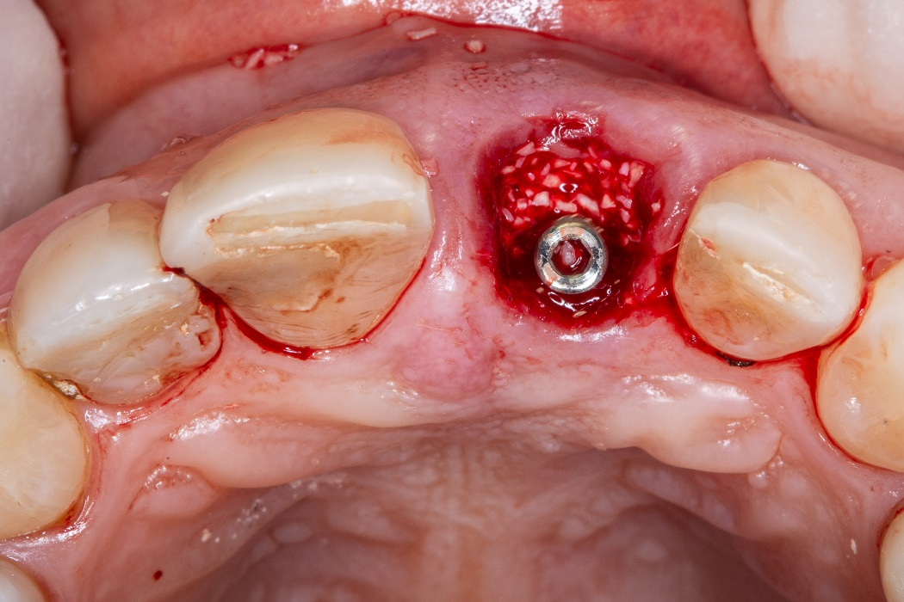

After completing the surgical stage, the prosthetic stage began. The extracted tooth's own crown was used, with the root portion removed using a bur, along with the palatal part of the crown, to allow for subsequent capture of the implant. This approach helps maintain aesthetic predictability.

The crown was transformed into a veneer, leaving the palatal part with adequate space to fit the provisional cylinder, which would be screwed into the implant.

The veneer obtained from the extracted tooth was properly conditioned with 37% phosphoric acid Condac from the manufacturer FGM for 1 minute. Then, silane (bonding agent) from the manufacturer Ângelus was applied, and after evaporation, a layer of Espe Single Bond adhesive from the manufacturer 3M was applied to promote the adhesion of Master Flow resin from the manufacturer Biodinâmica, shade A2, during the implant capture and provisional finishing.

After completing the provisional restoration filling with resin, finishing and polishing were performed, especially in the cervical region, which is in contact with the gingival framework in a critical area. This helps maintain a favorable emergence profile, where the gingiva follows the contour of the prosthesis and mimics the natural anatomy of a tooth.

The provisional restoration was then placed in position and screwed into the implant with a torque of 20 Ncm, following the manufacturer's guidelines (SIN Implantes). Next, the internal screw was protected with a small piece of teflon, and the provisional cylinder was sealed using Master Flow resin. With the aid of articulating paper, the patient's occlusion was checked, ensuring that the provisional remained infraocclusal, with no contact points with its antagonist, either in occlusion or during disocclusion.

At the end of the procedure, a satisfactory esthetic outcome was achieved, closely resembling the patient's initial condition, with only a slight hematoma in the adjacent soft tissues (Figure 12). A periapical radiograph was also taken to assess the immediate results of the procedure (Figure 13).

Figure 12. Post-op.
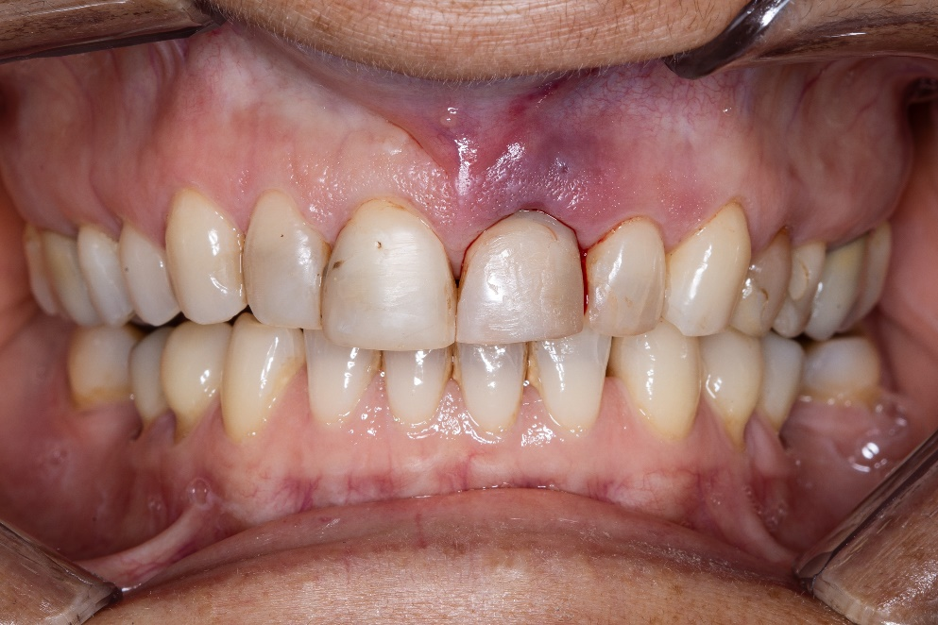

Figure 13. Periapical radiograph
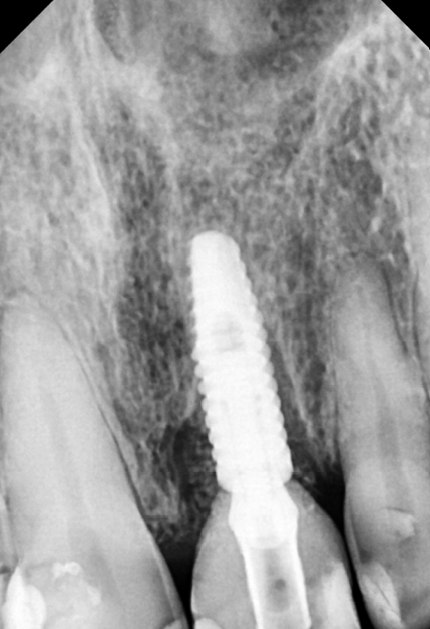

The patient was given post-operative care instructions, which included: rest and avoiding the use of the tooth for masticatory function; application of ice for the first 24 to 48 hours and consumption of only cold foods; avoiding rinsing or spitting for the first 24 hours, with gentle hygiene of the area using a cotton swab soaked in 0.12% chlorhexidine; use of prescribed post-operative medications (amoxicillin 500 mg every 8 hours for 7 days, dexamethasone 4 mg in the morning for 3 days, and dipyrone 1 g every 8 hours as needed for pain); A follow-up appointment in 10 days for case evaluation.
At the 10-day follow-up, the patient's condition was excellent, reporting only mild pain on the first post-operative day, which was managed with an analgesic, with no edema or signs of infection. The provisional restoration was well-adapted, and the gingival condition was also favorable. No intervention was necessary during the follow-up appointment (Figure 14).

Figure 14. Post-op of 10 days.
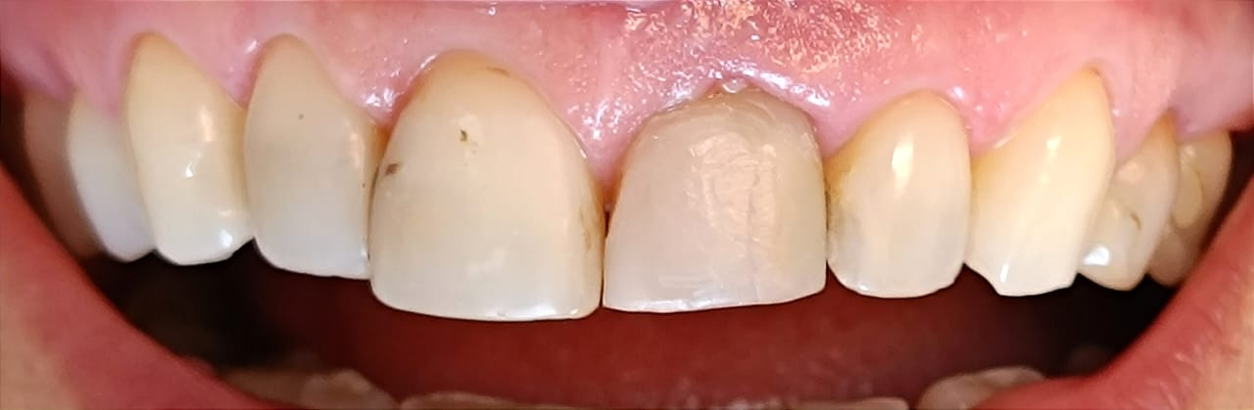

The patient was instructed to return after six months for a new computed tomography scan and to continue the treatment with the fabrication of a definitive metal-ceramic prosthesis. The treatment outcome was observed in the Computed Tomography scan in Figure 15.
Figure 15: CT after 6 months.
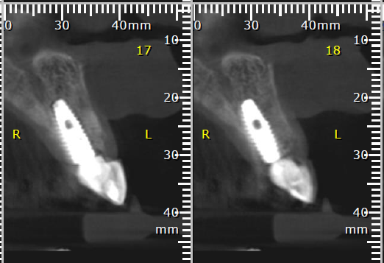

As demonstrated in the imaging exam in Figure 15, osseointegration of the implant and an excellent vestibular bone volume are observed, confirming the success of the treatment in terms of preserving both vertical and horizontal bone dimensions. In an occlusal view photographed after six months, a slight loss of horizontal dimension on the vestibular side is noted (Figure 16); however, the vertical dimension remains preserved, as shown in the frontal intraoral photograph (Figure 17).
Figure 16. Occlusal view.
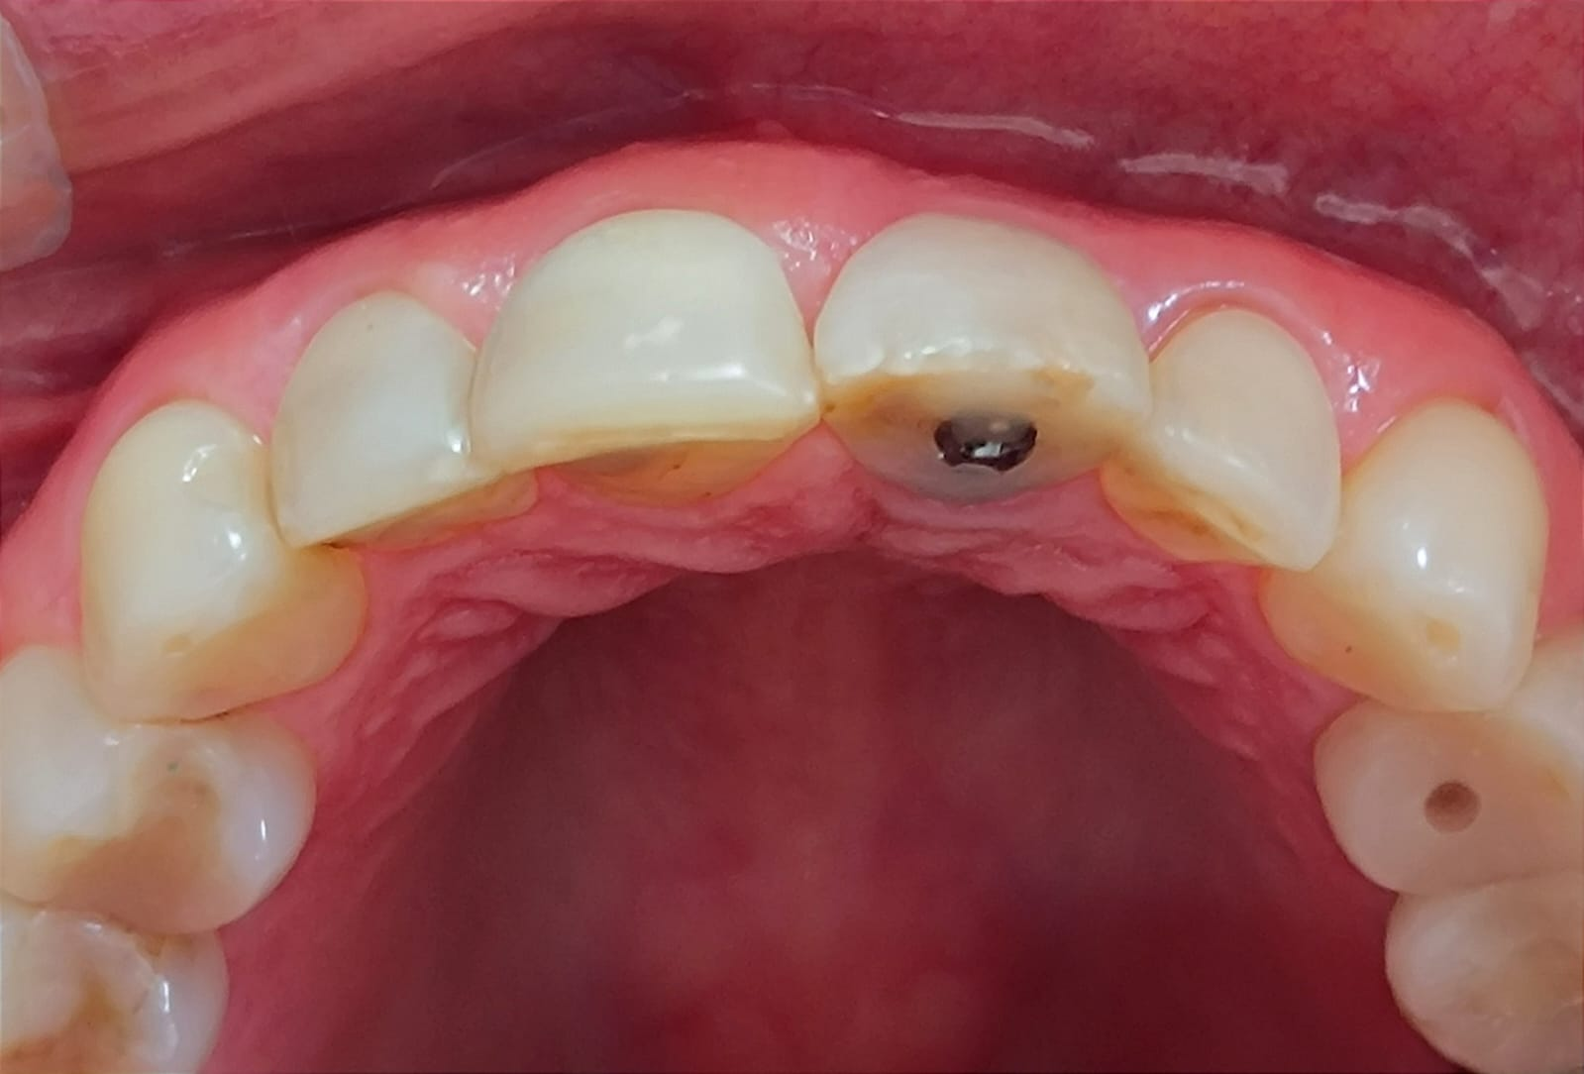

Figure 17. Intraoral picture after 6 months.
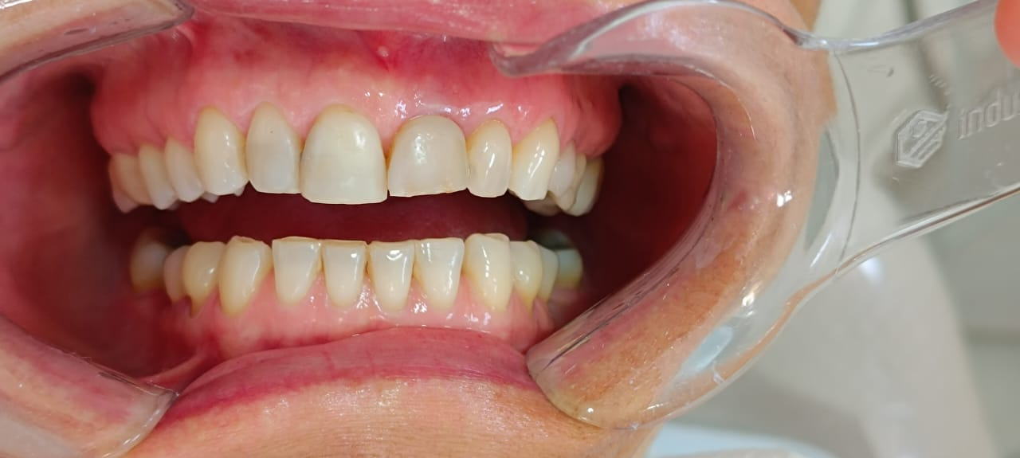

The provisional was removed to assess the emergence profile after six months, and the result was satisfactory regarding the preservation of the papillae and the alveolar framework, as shown in figures 17 and 18.
Figure 18. Emergence profile after six months.
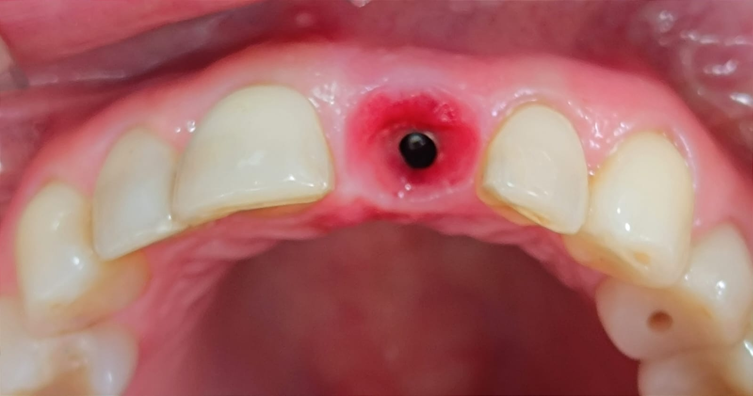

Figure 19. Emergence profile after six months.
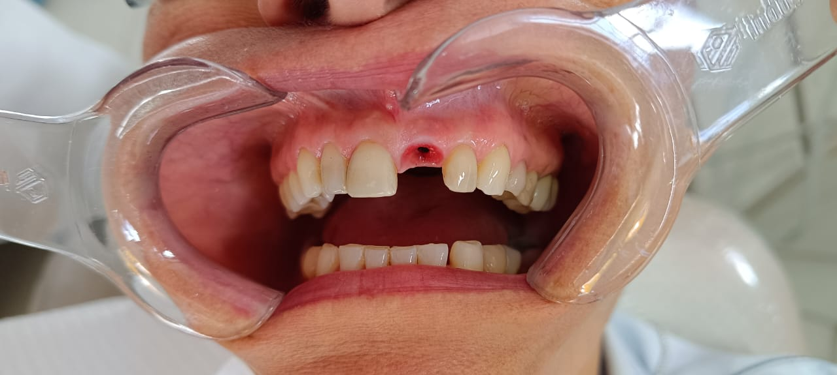

3 Discussion

The objective of this clinical case was to replace tooth 21 with a dental implant, as maintaining the tooth was no longer feasible due to the presence of a crack. Since this is an aesthetic area, every effort was made to minimize trauma and place the implant in an appropriate three-dimensional position to achieve a satisfactory result concerning the health and aesthetics of the peri-implant tissues. Additionally, the fabrication of the definitive prosthesis has better predictability through reverse planning and the use of a surgical guide.

Current science shows that atraumatic extraction yields significantly better outcomes for the patient in terms of both post-operative pain and inflammation, as well as aesthetics. Various devices and techniques, combined with the operator's experience, allow for the vertical removal of the tooth with minimal trauma to the periodontal tissues (Makki et al., 2021). In this clinical case, a flexible straight periotome and a hammer were used to sever the periodontal ligament fibers on the interproximal and palatal surfaces, avoiding any contact with the vestibular bone plate to preserve it. The effective removal of the dental element was performed using forceps with delicate rotational and lateral movements, resulting in a fresh socket with intact bone crest, papillae, and vestibular bone plate.

Gamborena et al. (2021) outlined critical steps for predictability in immediate implant surgeries in the aesthetic zone. Essential preoperative steps include planning the provisional restoration, using atraumatic extraction techniques, selecting the implant according to bone availability, bone grafting and guided implant placement, inserting the abutment and provisional crown, and placing a connective tissue graft. In planning this clinical case, all the steps suggested by Gamborena et al. (2021) were followed within their limitations, except for the connective tissue graft, as the patient has a low smile line and minimal gingival aesthetic demands.

The patient was informed that, if necessary, she could undergo a delayed second-stage surgery, as suggested by Zucchelli et al. (2020) in cases with peri-implant aesthetic compromise. In their study, Zucchelli et al. (2020) describe the most current surgical option as the insertion of a connective tissue graft using the tunneling technique, aimed at increasing vestibular volume and improving aesthetics, especially from an occlusal view, without requiring visible incisions.

The decision to perform bone and connective tissue grafting yields the best aesthetic results and ensures implant longevity by maintaining a satisfactory peri-implant tissue volume (Gamborena et al., 2020). Scientific evidence confirms that bone grafting in the immediate implant technique provides superior results in horizontal bone preservation and soft tissue stability compared to immediate implant placement without bone grafting (Seyssens, 2022). In this clinical case, the results observed in the computed tomography scan after six months confirm the presence of good bone volume on the vestibular aspect of the implant, corroborating findings from other studies.

In an occlusal view at the six-month post-operative mark, a slight loss of vestibular volume in the implant region is noticeable when compared to the vestibular bone volume of adjacent teeth. This occurrence is expected and described in the literature, as noted by Mao et al. (2021) in a systematic review and meta-analysis on the subject. Their study included patients who underwent implant placement in the aesthetic maxillary region, with follow-ups ranging from 4 to 12 months postoperatively. The review observed horizontal and vertical volume loss over time, varying according to preoperative bone thickness, defect dimensions, bone graft usage, and restoration type. Once again, the use of bone grafting was shown to significantly contribute to reduced horizontal bone volume loss.

Cooper et al. (2014) and Su et al. (2010) studied implant-supported restorations (crowns) and observed that the emergence profile, which consists of the shape and position of soft tissues around the implant restoration, produces better aesthetic results when critical and subcritical zones are respected during crown fabrication, whether provisional or definitive. When the provisional restoration is properly shaped and polished, especially in the area contacting the critical zone, excellent aesthetic outcomes can be achieved in terms of peri-implant tissue volume, color, and quality. An optimal aesthetic result and an appropriate emergence profile were obtained through the fabrication of an immediate-load provisional, adhering to current scientific recommendations.

It is important to highlight that this clinical case presented favorable aspects for achieving a satisfactory outcome. However, success was only possible due to reverse planning and the use of a surgical guide. Additionally, the use of a well-executed atraumatic extraction technique, combined with the operator's experience, contributed to the preservation of the alveolar framework. Filling the GAP with bone graft and the ability to place a screw-retained provisional on the implant allowed the procedure to be performed without the need for incision and suturing, maximizing post-operative comfort for the patient.

Conclusion

This clinical case report aimed to follow the most up-to-date scientific recommendations and techniques while considering the patient's limitations and preferences. Given the favorable clinical conditions, particularly the low smile line and the preservation of the vestibular bone plate, a satisfactory outcome was achieved in maintaining the aesthetics of both hard and soft tissues. The importance of reverse planning and the use of a surgical guide is emphasized to ensure predictable results and proper three-dimensional implant positioning.

REFERENCES
ALIKHASI, Marzieh; YOUSEFI, Parisa; AFRASHTEHFAR, Kelvin I. Smile Design: Mechanical Considerations. Dental Clinics of North America, v. 66, n. 3, p. 477-487, jul. 2022.

AMORIM, Adriana Vanderlei do; COMUNIAN, Claudio Rômulo; FERREIRA NETO, Milton D'Almeida; CRUZ, Emerson Flamarion da. Implantodontia: Histórico, evolução e atualidades. ID on line. Revista de Psicologia, v. 13, n. 45, 30 maio 2019.

BLOCK, Michael S. Dental Implants: The Last 100 Years. Journal of Oral and Maxillofacial Surgery, v. 76, n. 1, p. 11-26, jan. 2018.

COOPER, Lyndon F.; RESIDE, Glenn J.; RAES, Filiep; SOLIVA GARRIGA, Joan; GINER TARRIDA, Luis; WILTFANG, Jörg; KERN, Matthias; DE BRUYN, Hugo. Immediate provisionalization of dental implants placed in healed alveolar ridges and extraction sockets: a 5-year prospective evaluation. International Journal of Oral and Maxillofacial Implants, v. 29, n. 3, p. 709-717, maio-jun. 2014.

ELIAN, Nicolas; CHO, Sang-Choon; FROUM, Stuart; SMITH, Richard B.; TARNOW, Dennis P. A simplified socket classification and repair technique. Practical Procedures and Aesthetic Dentistry, v. 19, n. 2, p. 99-104, mar. 2007.

GAMBORENA, Iñaki; SASAKI, Yoshihiro; BLATZ, Markus B. Predictable immediate implant placement and restoration in the esthetic zone. Journal of Esthetic and Restorative Dentistry, v. 33, p. 158-172, 2021.

MAKKI, Alaa Z; NASSAR, Afnan A; ALHARBI, Wajan M; BISHARAH, Walaa F; MONA, A. Alabdali; ALQURASHI, Anwar M; BASANDAWA, Noor A. Evaluation of post-extraction healing after atraumatic axial tooth extraction using Benex system II versus conventional extraction: Randomized control trial. Journal of Dental Sciences, v. 16, n. 4, p. 1382-1388, dez. 2021.

MAO, Zhen; LEE, Chun-Teh; HE, Si Meng; ZHANG, Shu; BAO, Jibo; XIE, Zhi Gang. Buccal bone dimensional changes at immediate implant sites in the maxillary esthetic zone within a 4-12-month follow-up period: A systematic review and meta-analysis. Clinical Implant Dentistry and Related Research, v. 23, n. 6, p. 883-903, dez. 2021.

PARELLI, James; ABRAMOWICZ, Shelly. Immediate placement and immediate loading: surgical technique and clinical pearls. Dental Clinics of North America, v. 59, n. 2, p. 345-355, abr. 2015.

RAMANAUSKAITE, Ausra; SADER, Robert. Esthetic complications in implant dentistry. Periodontology 2000, v. 88, p. 73-85, 2022.

SALVIANO, Saulo Henrique; LOPES, João Carlos Amorim; BRUM, Igor da Silva; MACHADO, Kelly; PEDRAZZI, Marco Tulio; CARVALHO, Jorge José de. Digital planning for immediate implants in anterior esthetic area: immediate result and follow-up after 3 years of clinical outcome-case report. Dent J (Basel), Basel, v. 11, n. 1, p. 15, 2023.

SARFARAZ, Hasan; JOHRI, Shefali; SUCHETA, P; RAO, Sripathi. Study to assess the relationship between insertion torque value and implant stability quotient and its influence on timing of functional implant loading. Journal of Indian Prosthodontic Society, v. 18, p. 139-146, 2018.

SEYSSENS, Lorenz; EECKHOUT, Célien; COSYN, Jan. Immediate implant placement with or without socket grafting: A systematic review and meta-analysis. Clinical Implant Dentistry and Related Research, v. 24, n. 3, p. 289-308, mar. 2022.

SU, Huan; GONZÁLEZ-MARTÍN, Oscar; WEISGOLD, Arnold; LEE, Ernesto. Considerations of implant abutment and crown contour: critical contour and subcritical contour. Journal of Prosthetic Dentistry, v. 30, n. 4, p. 240-249, 2010.

TAN, Wah Lay; WONG,Terry L T; WONG, May C M; LANG, Niklaus P. The behavior of hard and soft tissues following tooth extraction: A systematic review. Clinical Oral Implants Research, v. 23, n. 7, p. 855-865, jul. 2012.

WU, Xin-Yu; Shi, Jun-Yu; Buti, Jacopo; Lai, Hong-Chang; Tonetti, Maurizio S. Buccal bone thickness and mid-facial soft tissue recession after various surgical approaches for immediate implant placement: A systematic review and network meta-analysis of controlled trials. Journal of Clinical Periodontology, v. 50, n. 4, p. 533-546, abr. 2023.

ZUCCHELLI, Giovanni; SHARMA, Praveen; MOUNSSIF, Ilham. Esthetics in periodontics and implantology. Periodontology 2000, v. 77, n. 1, p. 7-18, jun. 2018.

ZUCHELLI, Giovanni; TAVELLI, Lorenzo; McGUIRE, Michael K; RASPERINI, Giulio; FEINBERG, Stephen E; WANG, Hom-Lay; GIANNOBILE, William V. Autogenous soft tissue grafting for periodontal and peri-implant plastic surgical reconstruction. Journal of Periodontology, v. 91, n. 1, p. 9-16, jan. 2020.

