*Original Research Article*

Evaluation of Halitosis and its Risk Factors in Professional Fishermen in a Port Region

.

ABSTRACT

|  |
| --- |
| **Aims:** Fishermen are a vulnerable population, but no studies on halitosis in them have been found. This study aims to observe the presence of halitosis and its risk factors in professional fishermen in a Port Region (*Baixada Santista,* SP, Brazil).  **Study design:** Observational study.  **Place and Duration of Study:** Port region of *Baixada Santista*, SP, Brazil. between November 2022 and March 2023.  **Methodology:** Twenty-one participants who work professionally as fishermen and 21 participants with similar characteristics of gender and age for the control group were selected. The Oral ChromaTM device was used to perform halimetry through gas chromatography and the KKCare portable device was also used to detect bad breath. Data on risk factors were collected in a clinical examination and submitted to descriptive statistical analysis. Data from OralChromaTM and KKCare were analyzed for normality using the Shapiro-Wilk test. Since the hypothesis of normality was rejected (p<0.001), the Mann-Whitney test and the Spearman correlation were used.  **Results:** Although no statistically significant difference was verified between the groups in the halimetry tests, fishermen seem to have worse habits and oral conditions.  **Conclusion:** There is a high need for the promotion of oral health in fishermen, in order to prevent halitosis in this population. This is the first study to assess halitosis in fishermen, stressing the need for prevention of the risk factors in these workers. |

*Keywords: Fishermen, Halitosis, Port Workers, Prevention*

1. INTRODUCTION

Fishermen are one of the largest and most traditional categories of workers in the world, representing, in 2014, approximately 38 million people, of which 90% are dedicated to this activity full or part time [1]. Professional fishing is a relevant productive, as well as amateur fishing, both with great socioeconomic importance and in need of planning. Despite their high participation in economic production, fishing communities are among the poorest population groups. An estimated 5.8 million fishermen worldwide earn less than US$1 a day, according to 2012 data from the World Bank [2]. This job, since it consists of an arduous practice, where one works without a fixed schedule and under varied climatic conditions, can lead to irregularities in diet, tension, use of tobacco, alcohol and the installation of deleterious habits associated with poverty, which can be related changes and deficiency in oral health [3-5].

Halitosis, also known as bad breath, is a term used to define an unpleasant and fetid odor that emanates from the mouth. The word halitosis originates from the Latin, “halitu” means expired air and “osi” alteration. It is, therefore, the odor exhaled by the lungs, mouth and nostrils. Halitosis can have respiratory origin (sinusitis and tonsillitis), digestive origin (gastric eruption, dyspepsia, neoplasms and duodenal ulcer), and also metabolic and systemic origin (diabetes, febrile illnesses, hormonal alterations, dry mouth, stress). However, most of the time, it originates in the oral cavity due to the existence of caries and poor oral hygiene. Bacterial products from deep periodontal pockets, food stagnation in caries lesions and, mainly, the tongue coating, cause bad breath. Bacterial products of anaerobic oral bacteria are of paramount importance. These bacteria live among the papillae that make up the tongue. The proteins degraded by bacteria are amino acids; two basic types cysteine and methionine, which are rich in sulfur [6]. Bacteria can thrive and survive in an environment where oxygen is not present. The prevalence of halitosis in the world population is very variable. Bad breath affects approximately 2.4% to 57.9% of samples when evaluated by the organoleptic method or gas chromatography [7].

Measuring malodour is an important aspect of determining the magnitude of the problem in individual patients and how it impacts them. The gold standard for measuring bad breath isorganoleptic test, in which a previously trained and calibrated operator gives a classification for the odor that he feels exhaling from the patient's mouth. However, gas chromatography is a more objective method for measuring breath and, due to the COVID-19 pandemic and the reflection on biosafety it has brought, the execution of the organoleptic test has become questionable. By using a sulfur detector, one can specifically detect volatile sulfur compounds (VSCs), such as sulfhydride, methylmercaptan and dimethylsulfide, the main components of oral malodour. A gas chromatograph is an expensive device, and it is not used much clinically. Most breathing clinics use portable meters, that are valid, but cannot differentiate between the 3 VSCs. OralChromaTM (Abilit Corp., Osaka, Japan) has been introduced to the market to detect VSCs. This is a cheaper instrument that can be used everywhere. Unlike standard chromatography, it does not need a special carrier gas such as nitrogen or helium. It uses ambient air as the carrier gas for the chromatographic column. It differentiates and quantifies the 3 VSCs separately, yielding a more comprehensive assessment of production by the oral microflora [8].

The most commonly found forms of treatment for halitosis in the literature are the use of tongue scrapers and some mouthwashes [9,10], and among these, tongue scrapers are the most effective conventional method for the mechanical removal of tongue coating. Antimicrobial photodynamic therapy (aPDT) represents an alternative to conventional antibacterial, antifungal and antiviral treatments, in addition to its possible effectiveness against drug-resistant microorganisms. The association of conventional treatments and aPDT has shown very satisfactory results in the treatment of bacterial infections in the dentistry [11-16].

The correct diagnosis and treatment of halitosis in the general population are relatively current issues that still need further studies. Regarding treatment, oral hygiene guidelines have shown promising results. When considering the presence of halitosis in fishermen, no publications related to this topic have been found. Consequently, this study aims to observe the presence of halitosis and its risk factors in professional fishermen in a Port Region.

2. methodology

Twenty-one participants who work as fishermen in the Port of Santos, São Paulo, Brazil, and are exposed to the daily conditions of this type of professional activity were selected (Fishermen Group). The recruited fishermen work in octopus boats on the coast of *Baixada Santista,* SP, Brazil. For the Control Group of the study, 21 participants, paired in gender and age with the group of fishermen, but who did not perform work activities related to fishing, were selected. The sample was selected by convenience. The participants signed an Informed Consent Form and underwent a careful anamnesis. Then, halimetry was performed, both with the OralChromaTM device and with the KKCare Detector Portable device. The project was approved by the Research Ethics Committee of *Universidade Metropolitana de Santos*, under number 63032022.6.0000.5509.

**2.1 Inclusion criteria**

Participants who work as fishermen were included in this research, and individuals who do not work with fishing were allocated in the control group. Participants were required to be over 18 years of age and in good general health.

**2.2 Exclusion criteria**

Individuals with dentofacial anomalies (such as cleft lip, palatine and nasopalatine fissures), who were undergoing oncological treatment, with systemic alterations (gastrointestinal, renal, hepatic) and under antibiotic treatment up to 1 month before the survey were excluded from the study.

**2.3 Clinical Examination**

The participants underwent a careful physical-clinical examination, considering the classic maneuvers of inspection, palpation, percussion and auscultation. A complete anamnesis to know their history in order to evaluate possible factors related to the presence of halitosis was also performed.

**2.4 Coated Tongue Index**

The participants were submitted to an evaluation of the presence of the tongue coating. It was defined by the Coated Tongue Index (CTI) proposed by Shimizu *et al.* [17]. The tongue was divided into 9 parts, and each part was given a score, being 0 – absence of tongue coating, 1 – presence of tongue coating with visible papillae, 2 – thickness of tongue coating that makes it impossible to visualize the papillae. These grades were added, divided by 18, and multiplied by 100, to obtain a final index of 0-100%.

**2.5 Halimetry with OralChromaTM**

The collection of oral air followed the manufacturer's guidelines (Oral ChromaTM Manual Instruction), where the participant is instructed to rinse their mouth with cysteine (10 mM) for 1 minute, then remain with their mouth closed for another 1 minute. A syringe from the same manufacturer is introduced into the patient's mouth to collect oral air. For 1 minute, the patient remained with his/her mouth closed, breathing through the nose, without touching the syringe with his tongue. The plunger is pulled out, we again empty the syringe into the patient's mouth and again pull the plunger to fill the syringe with the breath sample. The tip of the syringe is wiped with gauze to remove moisture from the saliva, the gas injection needle is placed on the syringe, and the plunger is adjusted to 0.5 ml. The collected gases are injected into the device's inlet port with a single movement [8]. The device takes 8 minutes to measure all three VSCs.

**2.6 Halimetry with KKCare**

Air collection followed the manufacturer's guidelines for the KKCare Portable Detector, a device with an advanced semiconductor sensor, with fine sensitivity and fast results, simple and convenient to use. It takes about 9 seconds to turn on, the participant blows for 5 seconds on the output device and the final result appears in 5 seconds, in digital and cartoon mode. Results are shown in 5 levels: very good (0), normal (1), not so good (2), bad (3), very bad (4).

**2.7 Orientations**

Patients were instructed on oral hygiene through oral explanations and a folder they received via WhatsApp, with the correct technique for toothbrushing and tongue cleaning.

**2.8 Statistical Analysis**

Data on risk factors collected in the clinical examination was submitted to descriptive statistical analysis. Data from OralChormaTM and KKCare were analyzed for normality using the Shapiro-Wilk test. Since the hypothesis of normality was rejected (p<0.001), the Mann-Whitney test and the Spearman correlation were used.

3. results and discussion

All participants included in both the Fishermen and Control groups were male. The ages were also similar between groups, being the mean age for the Fishermen Group equal to 47,85 and 45,38 in the Control Group.

The presence of some systemic factors may be related to bad breath. Consequently, participants were asked if they had any health problems, used medication, smoked, considered themselves mouth breathers, and used any illicit drugs. In the Fishermen Group, 24% of the participants claimed to have health problems, 38% reported the use of medications, 29% of them smoked, 5% said “yes” to mouth breathing and 5% admitted to using drugs. In the Control Group, 33% of the participants claimed to have health problems, 38% reported the use of medications, 5% of them smoked, 19% said “yes” to mouth breathing and no participant admitted to using drugs. It is important to report that, in both groups, the most frequent systemic diseases were hypertension and diabetes, and the drugs used for these conditions were also were the most cited by the participants.

Participants were asked about oral hygiene habits, which also change oral odor. They were firstly asked about the frequency of teeth brushing. When asked many times a day they brushed their teeth, 28% of the Fishermen Group answered twice a day, 29% answered from to 2 to 3 times a day, 19% said they do it once a day, 19% answered 3 times a day, and 5% reported only brushing their teeth once every two days. In the Control Group, 30% of the participants said they brush their teeth 3 times a day, 20% answered once a day, 15% brush 4 times a day, 10% answered from to 2 to 3 times a day, 10% said they brush their teeth 2 times a day, 10% answered from 2 to 4 times, and 5% answered 6 times a day.

Other habits, such as the use of dental floss, tongue cleaning, use of mouthwash and the sensations of dry mouth or bad breath were also questioned, since the sensations may indicate hyposalivation and end up stimulating, or not, the frequency of hygiene habits. In the Fishermen Group, 14% of the participants reported the use of mouthwashes, 19% said that they floss their teeth, 62% told us they clean their tongues, 29% had dry mouth sensation, and 24% reported bad breath sensation. In the Control Group, 62% of the participants reported the use of mouthwashes, 81% said that they floss their teeth, 90% told us they clean their tongues, 19% had dry mouth sensation, and 5% reported bad breath sensation.

The presence of caries and periodontal diseases were evaluated in the clinical examination, since the presence of these conditions is directly linked to halitosis. In the Fishermen Group, 71% of the participants had carious lesions, 76% had signs of periodontal problems, 10% had mucosal desquamation and 90% had dry lips. In the Control Group, 14% of the participants had carious lesions, 48% had signs of periodontal problems, no participants had mucosal desquamation, and 24% had dry lips. It is important to emphasize that these participants had at least one evident caries lesion and that the most observed gingival alterations were the presence of calculus or biofilm and gingivitis. Mucosal desquamation and lip dryness were also included in the study, and their importance is linked to the fact that the tongue coating is also composed of desquamated epithelial cells.

The presence of restorations, crowns, prostheses, implants, absence of dental elements, residual roots, fractured crowns, crowding and orthodontic appliances was also evaluated during the clinical examination. These elements can change the breath, according to the retention of biofilm on their surfaces. In the Fishermen Group, 5% of the participants had at least one restauration, 10% had one or more total crowns, 33% had prothesis, 5% had implants, 90% had at least one missing tooth, 29% had residual roots, 19% had fractured crows, 0% had teeth crowding and 0% used orthodontic devices. In the Control Group, 71% of the participants had at least one restauration, 33% had one or more total crowns, 14% had prothesis, 14% had implants, 38% had at least one missing tooth, 5% had residual roots, 10% had fractured crows, 10% had teeth crowding and 5% used orthodontic devices.

When analyzing the OralChromaTM results, the limits of each VSC were considered. For sulfhydride (SH2), a gas originating mainly from the tongue coating, the limit of 112 ppb was considered. For methyl mercaptan (CH3SH), a gas of predominantly periodontal origin, values up to 26 ppb were considered normal. For dimethylsulfide (CH3SCH3), gas of systemic origin, the value of 8 ppb was considered. The percentage of participants who were above these values is shown in Figure 1. It is important to include the information that most participants in both groups obtained a value equal to zero in the evaluation of methylmercaptan and dimethylsulfide.

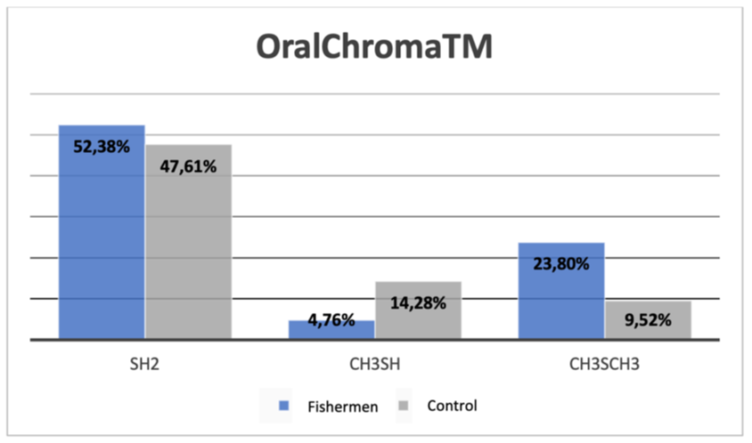

**Figure 1:** **Percentage of participants who had values above the thresholds for sulfhydride, methylmercaptan and dimethylsulfide gases in the analysis with OralChromaTM.**

Since sulfhydride was the most commonly found gas in both groups, the results obtained in ppb were submitted to the Shapiro-Wilk normality test. The hypothesis of normality was rejected (p<0.001), so the Mann-Whitney test was used for comparison between groups. However, no statistically significant difference was found between the Fishermen Group and the Control Group (p=0.705). The data referring to the sulfhydride analysis are detailed in Table 1 and Figure 2.

**Table 1: Minimum, maximum, median and interquartile range of sulfhydride analysis in participants of Fishermen and Control groups.**

|  |  |  |
| --- | --- | --- |
|  | **Fishermen Group (n=21)** | **Control Group (n=21)** |
| **Minimum (ppb)** | 0 | 0 |
| **Maximum (ppb)** | 1058 | 1616 |
| **Median (ppb)** | 113 | 88 |
| **25th percentile** | 0 | 41 |
| **50th percentile** | 113 | 88 |
| **75th percentile** | 302 | 361 |

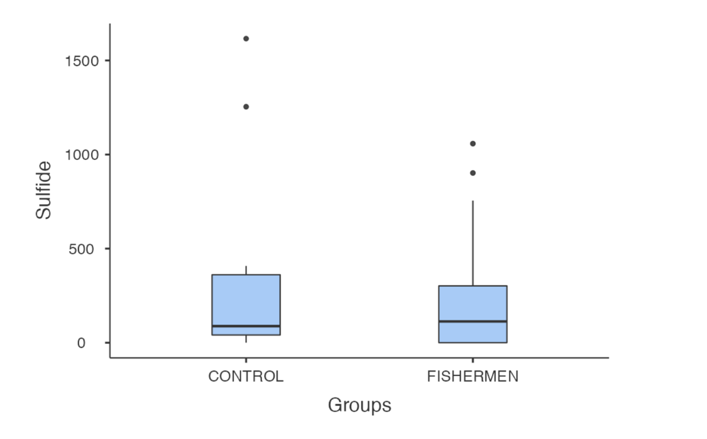

**Figure 2: Boxplot of the comparison of sulfhydride (ppb) between groups.**

A correlation was expected between the Coated Tongue Index (CTI) and the amount of sulfhydride found in the participants. However, this correlation was not demonstrated by Spearman's Correlation Coefficient (p=0.312) and as shown in the scatter plot in Figure 3.

**Figure 3: Scatter plot relating the Coated Tongue Index (CTI) and the sulfhydride (ppb) when analyzed by OralChromaTM.**

The results of the analysis of the KKCare portable breath tester are shown in Figure 4. These data were also submitted to the normality test, which was rejected (p<0.001). The Mann-Whitney test was used again and no statistically significant difference was found between the Fishermen Group and the Control Group (p=0.904). Mann-Whitney test was used again and no statistically significant difference was found between the Fishermen Group and the Control Group (p=0.904).

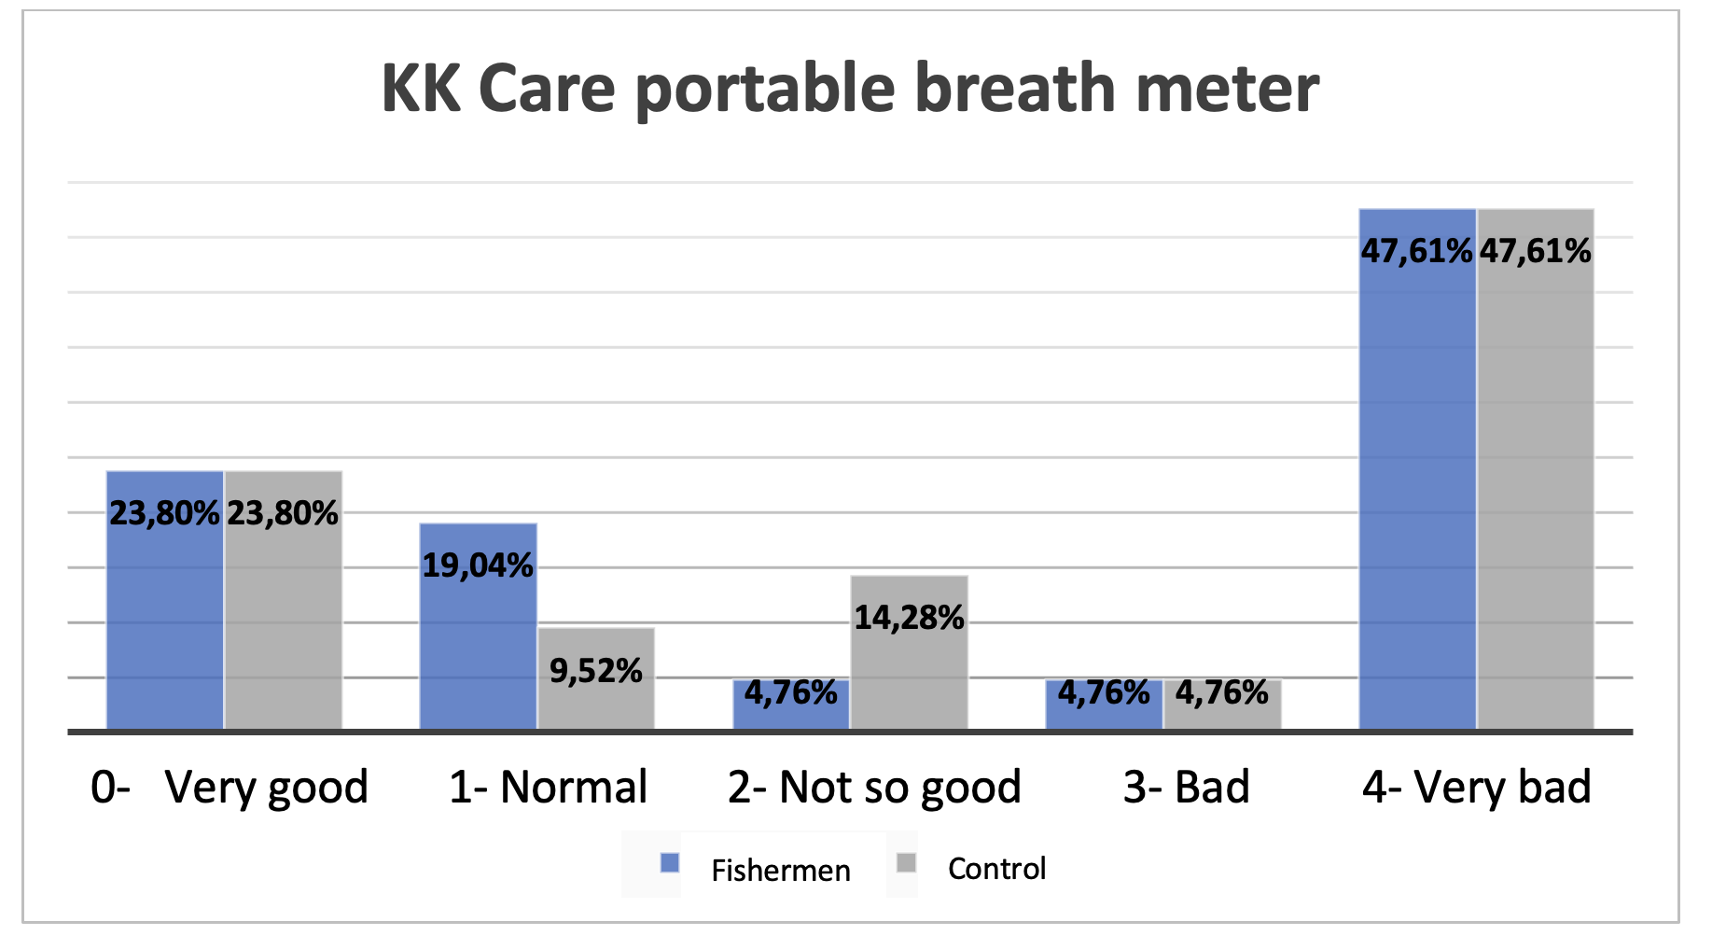

**Figure 4: Portable breath meter analysis results.**

Our results show that, although there is no statistically significant difference between the groups in the results referring to the halimetry tests, the fishermen seem to have worse habits and oral conditions, in relation to the control. Smoking, for example, was found in a higher percentage in the Fishermen Group (29%) when compared to the Control Group (5%). Some fishermen even reported smoking more cigarettes on board, due to job stress. The frequency of brushing and oral hygiene habits, such as the use of mouthwashes, dental floss and the habit of cleaning the tongue are also lower in the Fishermen Group. In addition, they had higher rates of caries, periodontal problems, mucosal dryness, absence of dental elements, presence of residual roots and fractured teeth.

In a 2014 study, Chandroth *et al.* [18] could observe that the majority of the population of fishermen studied used chewing gum (42.9%) to clean their teeth and 30% had lesions in the oral mucosa. Leukoplakia (13.8%) was the most common lesion, mainly on the lip, and the prevalence of these lesions was significantly associated with age, gender, oral hygiene practices and adverse habits. Questionable hygiene habits and the practice of adverse habits are factors that corroborate the results of our study.

Other studies evaluated the general oral conditions of fishermen. A 2014 study in India evaluated the oral conditions of 1100 fishermen and 1100 non-fishermen [19]. Fishermen had significantly higher prevalence of periodontal disease and dental caries than the group of non-fishermen (p = 0.001), in agreement with Singh *et al.* [20]. This 2018 study, conducted in Malaysia, selected 242 multiracial fishermen, aged between 18 and 75, from five fishing villages. Interviews were conducted with participants using a pre-validated WHO oral health questionnaire. The prevalence of oral health problems in this study was 47.5%. "income", "type of fishing", "additional occupation", "age" (years), "frequency of pies, rolls consumed" and "frequency of sweets and soft drinks consumed" were significant predictors of the fishermen's oral health status [20]. In the present study, the presence of caries and periodontal diseases was also higher in the Fishermen Group, when compared to the Control Group.

In 2017, Dany *et al.* conducted an assessment of the periodontal health of Indian fishermen [21]. More than 800 fishermen were evaluated. The Community Periodontal Index assessment and Attachment Loss measurement showed that 100% of the study subjects suffered from one form of periodontal disease or another. Furthermore, 90.26% of the study participants consumed smoke or smokeless tobacco. Alcoholism was also observed in 78.81% of the study subjects. The study explored the possibility of correlating these habits with the results of the periodontal disease index. In our results, in addition to reports of smoking, a participant from the Fishermen Group also reported the use of cocaine at parties. Data regarding alcohol consumption were not collected in our study.

As limitations of the study, we can mention the limited number of participants, due to the convenience sample, and the lack of complementary exams, such as radiographs, for documentation and confirmation of some diagnoses.

4. Conclusion

Although no statistically significant difference was verified between the groups in the results referring to the halimetry tests, the fishermen seem to have worse habits and oral conditions, in relation to the control. The population of fishermen is then susceptible to developing halitosis since they are exposed to risk factors for the appearance of this pathology, causing even more trouble for this category of workers who already suffer from all their working conditions. In view of this, we observe the high need for treatment of this population with a health policy that emphasizes the promotion and prevention of oral health, in addition to traditional curative care.

Consent (where ever applicable)

All authors declare that written informed consent was obtained from the participants.

Ethical approval (where ever applicable)

All authors hereby declare that all experiments have been examined and approved by the appropriate ethics committee and have therefore been performed in accordance with the ethical standards laid down in the 1964 Declaration of Helsinki. The project was approved by the Research Ethics Committee of UNIMES, with approval number 63032022.6.0000.5509.

References

FAO. The state of world fisheries and aquaculture 2016: contributing to food security and nutrition for all. Rome: FAO; 2016: [200 p.]. Available from: www.fao.org/3/a-i5555e.pdf.

World Bank. Hidden harvest. The global contribution of capture fisheries.

Washington, DF: World Bank; 2012. Available from: https://openknowledge.worldbank.org/bitstream/handle/10986/11873/664690ES W0P1210120HiddenHarvest0web.pdfsequence=1&isAllowed=y

Anzil KSA, Mathews J, Sai AG, Kiran M, Kevin S, Sunith S. Prevalence of Deleterious Oral Habits and Oral Mucosal Lesions among Fishermen Population of Mahe, South India. J Contemp Dent Pract 2016;17(9):745-749.

Yukun Wang, Shuifen Zhan, Yan Liu & Yan Li. Occupational hazards to health of port workers International Journal of Occupational Safety and Ergonomics 2016; DOI:10.1080/10803548.2016.1199501.

FAO. Committee on Fisheries. Good practices in the governance of small- scale fisheries: sharing of experiences and lessons learned in responsible fisheries for social and economic development. Roma: FAO; 2011.

Tanwir F, Momin IA. Halitosis. Pakistan Oral & Dental Journal 2011;31(2):304- 308.

Aimetti M, Perotto S, Castiglione A, Ercoli E, Romano F. Prevalence estimation of halitosis and its association with oral health-related parameters in an adult population of a city in North Italy. J Clin Periodontol. 2015. doi: 10.1111/jcpe.12474.

Tangerman A, Winkel EG. The portable gas chromatograph OralChroma: a method of choice to detect oral and extra-oral halitosis. JBreath Res 2008;2(1): 17010,2008.

Slot DE, De Geest S, van der Weijden FA, Quirynen M. Treatment of oral malodour. Medium-term efficacy of mechanical and/or chemical agents: -a systematic review. J Clin Periodontol. 2015;42(Suppl.16):S303–S316. doi: 10.1111/jcpe.12378.

Seemann R, Conceicao MD, Filippi A, Greenman J, Lenton P, Nachnani S, et al.

Halitosis management by the general dental practitioner—results of an international consensus workshop. J. Breath Res.2014;8:017101.

Motta, Pamella de Barros et al. Effect of Photodynamic Therapy on Halitosis: A Systematic Review of Randomized Controlled Trials. Sensors, v. 22, n. 2, p. 469, 2022.

Lopes, Rubia Garcia et al. Immediate results of photodynamic therapy for the treatment of halitosis in adolescents: a randomized, controlled, clinical trial. Lasers in medical science, v. 31, n. 1, p. 41-47, 2016.

Costa da Mota, Ana Carolina et al. Effect of photodynamic therapy for the treatment of halitosis in adolescents–a controlled, microbiological, clinical trial. Journal of biophotonics, v. 9, n. 11-12, p. 1337-1343, 2016.

Gonçalves, Marcela Leticia Leal et al. Effect of photodynamic therapy in the reduction of halitosis in patients with multiple sclerosis: clinical trial. Journal of breath research, v. 11, n. 4, p. 046006, 2017.

Gonçalves, Marcela Leticia Leal et al. Antimicrobial photodynamic therapy with Bixa orellana extract and blue LED in the reduction of halitosis – A randomized, controlled clinical trial. Photodiagnosis and Photodynamic Therapy, v. 30, p. 101751, 2020.

Da Mota, Ana Carolina Costa et al. Effect of antimicrobial photodynamic therapy with red led and methylene blue on the reduction of halitosis: controlled microbiological clinical trial. Lasers Med Sci, https://doi.org/10.1007/s10103021-03325-x., 2021.

Shimizu T, Ueda T, Sakurai K. New method for evaluation of tongue-coating status. J Oral Rehabil, v 34, n. 6, p. 442-7, 2007.

Chandroth SV, Venugopal HK, Puthenveetil S, Jayaram A, Mathews J, Suresh N, Al Kheraif AA, Ramakrishnaiah R, Divakar DD, Asawa K, Tak A, Tak M. Prevalence of oral mucosal lesions among fishermen of Kutch coast, Gujarat, India. Int Marit Health. 2014;65(4):192-8. doi: 10.5603/IMH.2014.0037.

Asawa K, Pujara P, Tak M, Nagarajappa R, Aapaliya P, Bhanushali N, Mishra P, Sharma A. Oral health status of fishermen and non-fishermen community of Kutch district, Gujarat, India: a comparative study. Int Marit Health. 2014;65(1):1-6. doi: 10.5603/MH.2014.0001.

Singh MK, Abdulrahman SA, Rashid A. Assessment of oral health status and associated lifestyle factors among Malaysian Fishermen in Teluk Bahang, Penang: An analytical cross-sectional study. Indian J Dent Res [serial online] 2018 [cited 2021 Mar 29 ];29:378-390.

Dany SS, Naik C, Satpahty AK, Tangade P, Shah AF, Prashant R. Periodontal Health Status of Fishermen of Coastal Odisha, India. IJMSIR. 2017;2(5):83-96.