***Systematic Review***

What are the predictors of pain in patients with Temporomandibular Disorder (TMD)?- A Systematic review

**ABSTRACT**

**The aim of the present study was to perform a systematic literature review investigating the more frequent predictors of pain in patients with temporomandibular disorder (TMD).**

**Types of study reviewed: observational cohort studies that evaluated predictors of pain in patients with TMD.**

**Results: The search strategy led to the retrieval of 714 studies, 78 articles of which were submitted to analysis and 18 were eligible for review. The selected studies were separated by predictors of pain in TMD: sleep (n = 2), parafunction (n = 2), psychosocial factors (n = 10), genetic factors (n = 3), myofascial pain (n = 2), occlusion (n = 1). Two articles were included in the review of two predictors.**

**Conclusion: The predictors most associated with TMD are psychosocial factors, parafunction, sleep, genetic factors, occlusion and myofascial pain.**

**Implications for practice: Knowledge regarding predictors of pain in patients with TMD can assist in the diagnosis and treatment using the biopsychosocial model and, consequently, diminish the chronicity of this condition.**

**Keywords: temporomandibular joint disorders, risk factors, predictors for pain, orofacial pain, biopsychosocial model.**

**INTRODUCTION**

Temporomandibular disorder (TMD) constitutes a set of joint and muscle conditions of the craniomandibular-cervical region that can trigger signs and symptoms, such as pain in the region of the temporomandibular joint (TMJ), headache, pain in the muscles of mastication, otalgia, facial pain, functional limitation, neck pain, fatigue, limited mouth opening, pain when chewing, ringing in the ears, jaw pain. Many aspects of the etiology of TMD are unclear (IASP, 2009) and there is evidence that its pathogeny is multifactorial, involving functional, anatomic and psychosocial elements – a complex interaction among biological mechanisms, psychological states, environmental conditions, intrinsic and extrinsic load on the TMJ, microtraumas and macrotrauma (De LEEW et al., 2008; KAFAS et al., 2006; NASSIF et al., 2003; MAGNUSSON et al., 2000., IASP, 2009).

The complexity of this disorder is evidenced by the occurrence of comorbidities, which are additional clinical entities that occur within the clinical course of an index disease or base disease. Base diseases combined with chronic pain conditions exert negative impacts and hinder the establishment of the proper diagnosis. Comorbidities are associated with a poorer prognosis and diminish the likelihood of successful therapy. Headache, cervical spine disorders and fibromyalgia are some of the comorbidities that have negative repercussions in cases of TMD (COSTA et al., 2017). The prevalence and incidence of this disorder have been the subject of epidemiological studies (GAUER et al., 2015; CHAVES et al., 2017). It is estimated that 50 to 70% of the population have signs of TMD at some point in life and 20 to 25% have symptoms of the disorder. (OLIVEIRA et al., 2006). The overall prevalence of TMJ was approximately 31% for adults/elderly and 11% for children/adolescents, and the most prevalent TMJ was DDwR (VALESAN et al., 2021)

TMD is considered the third most prevalent condition among common problems of chronic pain (PEDRONI CR, 2003; GAUER et al., 2015; FERREIRA et al., 2016). Factors such as stress and anxiety are highly associated with this condition and moderate to severe degrees of somatization and depression are found in individuals with TMD and pain (PAULINO et al.,2018; CANALES et al., 2018; PARK et al., 2020).

Pain is defined as an unpleasant sensory and emotional experience related or similar to real or potential tissue damage. Moreover, pain is always personal – an experience influenced to different degrees by biological, individual and emotional factors. Although pain generally plays an adaptive role, it can have diverse effects on functioning as well as social and psychological wellbeing (SRINIVASA et al., 2020).

According to the biopsychosocial model, biological, psychological and social factors exert an influence on health. The literature considers sleep disorders, anxiety, depression somatization, lifestyle, bruxism, parafunctions, interpersonal relationships, social support, the degree of pain intensity, diverse physical symptoms and the female sex to be predictors of pain in individuals with TMD (VELLY et al., 2011; KINDLER et al., 2012; FILLINGIM et al., 2011). Thus, it is evident that there is no simple cause-and-effect relation between a single factor and TMD. Biomechanical, neuromuscular, biopsychosocial and neurobiological factors can contribute to this disorder (ATTALLAH et al., 2014).

The individuals with TMD who most seek care are symptomatic and, despite the existence of a consensus regarding the multifactor etiology, divergent opinions are found regarding the of these triggering etiological factors of pain in such individuals. Symptoms of pain may be related to factors beyond structural changes and it remains unclear to what extent these aspects can be considered predisposing, perpetuating or triggering factors. Therefore, to contribute to a better understanding of these issues, the aim of the present study was to conduct a systematic literature review investigating predictors of pain associated with temporomandibular disorder.

**STUDY DESIGN**

The present systematic review was conducted to identify the main predictors of pain in individuals with TMD reported in the literature. This study was developed following the guidelines of the Preferred Reporting Items of Systematic Reviews and Meta-Analyses (PRISMA) and the protocol was registered in the PROSPERO database under number CRD 42020183099.

**SEARCH STRATEGY**

Searches for potentially eligible papers were conducted in the Medline, EMBASE, BVS, *Literatura para Saúde da América Latina e do Caribe* (LILACS [Latin American and Caribbean Health Sciences Literature]) and the Cochrane Collaboration’s Center Register of Controlled Clinical Trials (CENTRAL) databases considering articles published up to March 2021. The keywords were developed using the Yale MeSH analyzer (http://MeSH.med.yale.edu/), each database was last consulted in April 2021.

For the present systematic review, articles written in English, Portuguese and Spanish were considered. Studies involving animals and those without an observational cohort design were excluded. Duplicate articles were removed. The terms “temporomandibular disorder” and “pain” were verified using the Medical Subject Headings (MeSH) of the US National Library of Medicine and respective Entry Terms were added to the search field to make the search more sensitive and effective. The search terms were “temporomandibular dysfunction”; AND “pain” OR” temporomandibular disorders AND pain predictors

The selection of articles was performed by first screening the titles and abstracts. Next, the full texts of potentially relevant articles were obtained and analyzed considering the eligibility criteria.

A standard data extraction form was used to collect the following information from the studies selected for the present review: authors, years of publication, population, sample size, diagnostic criteria, pain scale, comparisons and results. Self-reported results for pain were also evaluated in this review.

**SELECTION OF STUDIES**

Only observational cohort studies were selected. A specific process was used for the selection of studies to be analyzed. With aid of RAYYAN software, all duplicates were identified and removed. The following steps consisted of the exclusion of irrelevant studies based on the analysis of the titles, abstracts and full articles. During the selection process, additional studies were identified from the reference lists of the selected articles.

**PATIENT SELECTION TEST**

The present systematic review only included studies that employed a TMD assessment method and pain scale recognized as a “gold standard” – clinical evaluation based on the experience of the evaluator and diagnostic criteria validated in the literature. The studies needed to include patients without TMD and/or with TMD, at least muscular TMD with pain diagnosed using the Research Diagnostic Criteria for Temporomandibular Disorders (RDC/TMD and/or DC/TMD); adults (> 18 years of age); musculoskeletal disorder; no history of surgery in the temporomandibular region; and no other serious comorbidity, such as fracture in the region, cancer or neurological disease.

**QUALITY APPRAISAL**

The studies selected for the present review were submitted to a quality appraisal by two independent reviewers (LMA and TC). Each article was classified based on a scored checklist containing general items in accordance with the guidelines of the *Strengthening the Reporting of Observational Studies in Epidemiology* (modified STROBE statement) (HIGGINGS et al., 2008). Divergences of opinion between the two reviewers were resolved by consulting a third reviewer (D.A.B.G). The appraisal protocol was composed of 24 items scored between either 0 and 1 points (19 items) or 0 and 2 points (3 items), with a maximum score of 25 points. Items 6, 8, 9, 12, 13, 15, 16 and 22 were not pertinent to the present review and were therefore excluded from the analysis (Table 1)

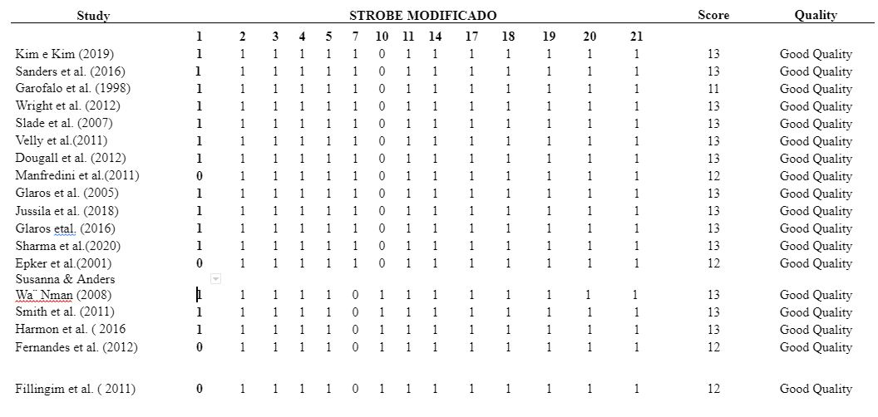

**Table 1**: Methodological quality and reporting of eligible studies (N = 18)

**Risk of bias (quality) assessment:**

The Quality In Prognosis Studies (QUIPS) tool was used to assess RoB in prognostic factor studies. This tool consists of several prompting items categorized into six domains, and each domain is judged on a three-grade scale (low, moderate, or high risk of bias). It is based on recommendations from a comprehensive review of critical appraisal in prognosis reviews and is informed by epidemiologic principles (STERNE JAC et al., 2016). The QUIPS tool uses six important domains that should be critically analyzed when assessing validity and bias in studies of prognostic factors: (1) study participation, (2) study attrition, (3) prognostic factor measurement, (4) outcome measurement, (5) study confounding, and (6) statistical analysis and reporting. The tool includes prompting items related to these six areas with suggestions for operationalization and grading (Table 2).

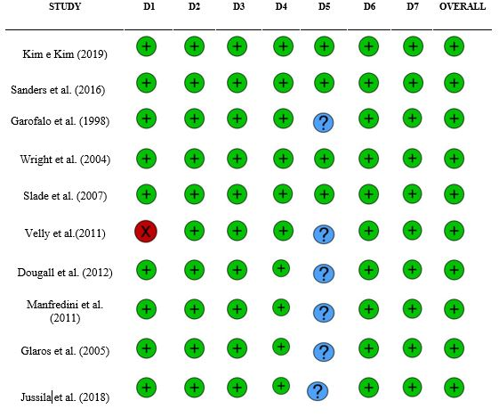

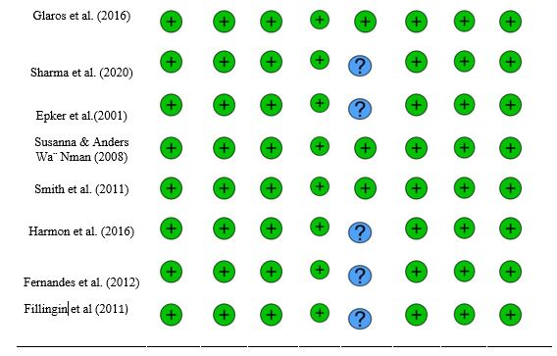

**Table 2. Risk of Bias summary for methodological quality.**

Overall quality of evidence and strength of recommendation was determined using the Grading of Recommendations, Assessment, Development and Evaluations (GRADE) criteria (Guyatt et al., 2008). The final GRADE score incorporated the 4 categories, quality, consistency, directness and effect size. Evidence quality was based on the overall GRADE scores for each comparison and graded: high (at least 4 points overall), moderate (3 points), low (2 points), or very low (1 or less).

**OUTCOME MEASURES**

Studies investigating the pain outcome were included in the present review.

**DATA ANALYSIS**

The studies were analyzed considering the participants, diagnosis and pain. Mean and standard deviation values of the responses reported in each study were used for the comparison and interpretation of the results among the studies.

**RESULTS**

The searches of the databases led to the retrieval of 714 articles, 78 of which were selected for analysis (Fig. 1). After the reading of the articles, only 18 were eligible for the present review. The eligible studies were separated by predictors of pain in TMD:sleep (two articles), parafunction (two articles), psychosocial factors (twelve articles), genetic factors (three articles), myofascial pain (two articles) and occlusion (one article). Meta-analysis was not possible due to the variability in the study designs.

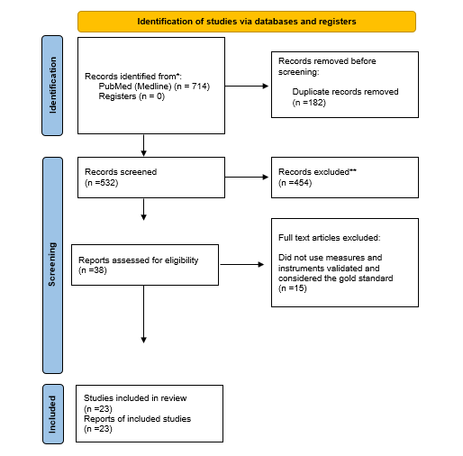

**Figure 1. PRISMA flowchart describing the selection of articles.**

**METHODOLOGICAL QUALITY OF STUDIES**

Based on the checklist used for this review, the quality scores ranged from 12 to 14 points, demonstrating that all studies included had good methodological quality.

**PARTICIPANTS**

The studies in the present review had a total of 9,449 participants ranging in age from 18 to 65 years. Some studies did not distinguish sex (Tabela. 3).

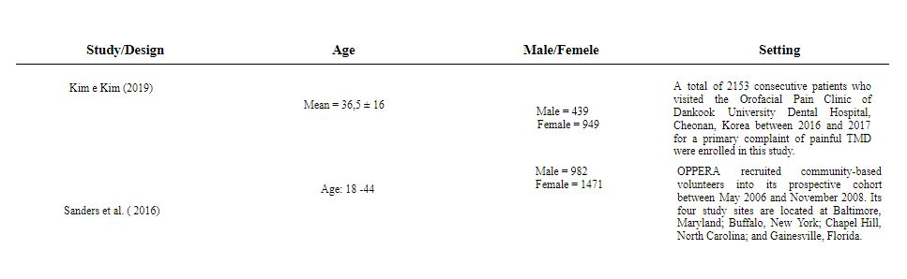

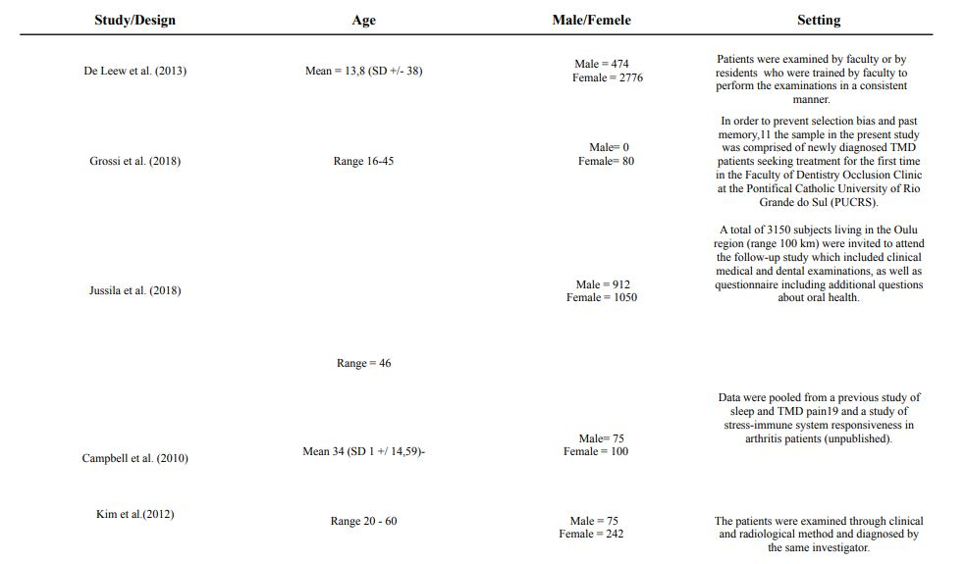

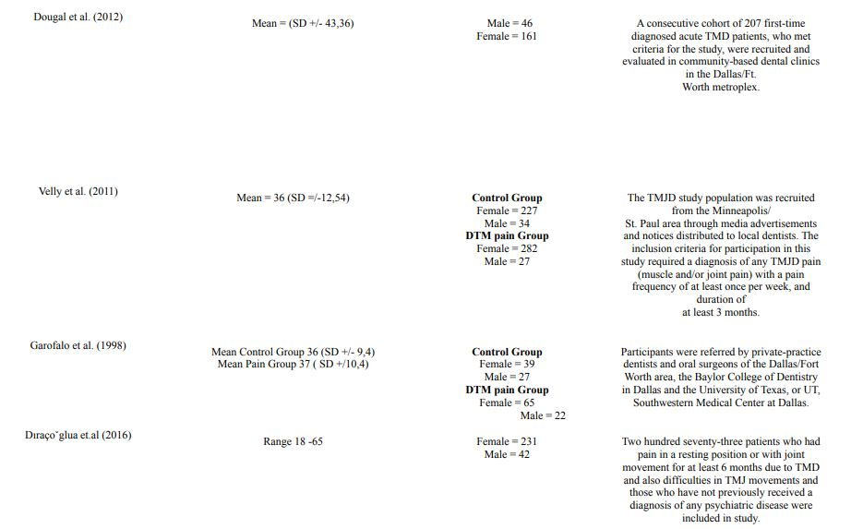

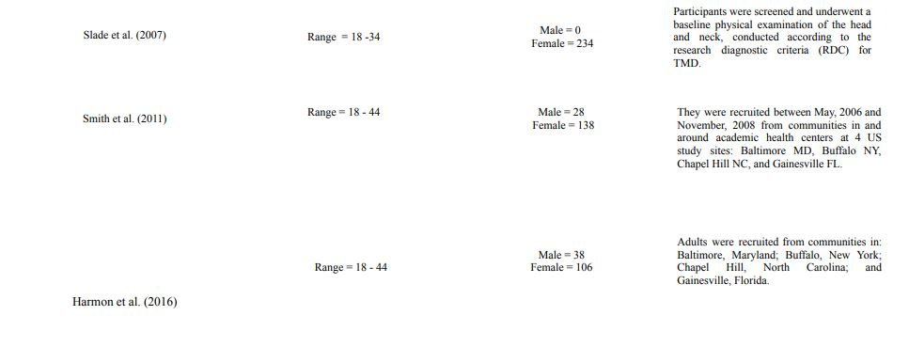

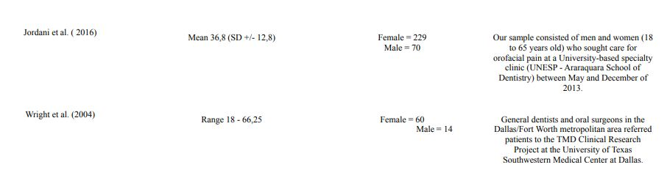

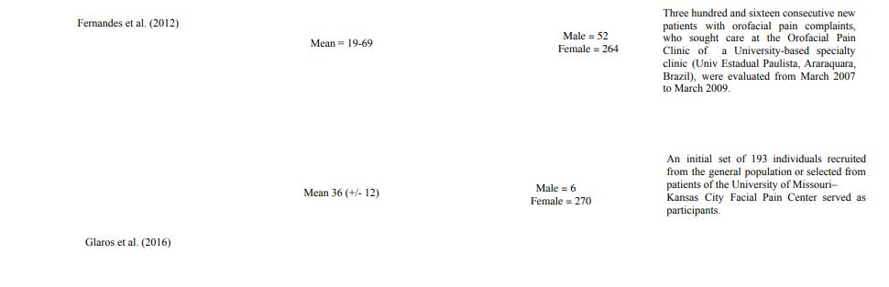

**______________________________________________________________________**

**Table 3. Demographic Results of Studies select for review.**

**DIAGNOSTIC TOOL**

All studies selected for this review used the RDC/TMD or its updated version (DC/TMD) for the inclusion of participants.

**OUTCOME MEASURES**

The present review only included studies that used validated methods and outcome measures. The main outcomes were sleep, genetic factors, occlusal factors, parafunction, psychosocial factors and myofascial pain.

Risk of Bias Assessment

All studies were ultimately judged as low risk of bias. Diatchenko et al., (2005) initially presented as high ROB. It was written in a style relevant to its background of genetics and according to the journal requirements in which it was published and in order to review it fairly, the supporting information was obtained from the journal website.

**RESULTS OF STUDIES SELECTED FOR REVIEW**

**SLEEP**

Two studies evaluated sleep as an outcome using the Pittsburgh Sleep Quality Index and found that individuals with TMD had poor sleep quality. In the study, higher indices regarding sleep duration, alteration and latency were found in individuals with mixed TMD compared to those with only muscle or joint TMD, whereas sleep quality was poor in all groups. In the study by Sanders et al. (2016), the risk of having TMD was greater among individuals with worse sleep quality assessed in a particular period independently of sleep quality at baseline (KIM and KIM, 2019).

**GENETIC FACTORS**

Three studies addressed genetic factors through DNA analysis and genotyping combined with the use of questionnaires and/or assessment indices. Smith et al. (2011) reported that, besides the two genes already studied as risk factors for TMD (HTR2A and COMT), other genes may also be important markers of risk for this disorder (NR3C1, CAMK4, CHRM2, IFRD1 and GRK5), although the findings need to be replicated in independent cohorts. Slade et al. (2007) conducted a study with 254 women between 18 and 34 years of age who underwent psychological tests, quantitative pain sensitivity tests and an adjustment of catechol-O- methyltransferase (COMT) and found that the adjustment of the COMT gene did not affect the pain response in patients with psychological alterations. Harmon et al. (2016) tested the hypothesis that circulating levels of omentin-1 are lower individuals with pain and TMD compared to controls without TMD; however, the fact that omentin-1 was measured in the blood plasma indicates that cytokines related to inflammation in painful TMD are not exclusive to temporomandibular tissue, as these substances have a systemic presence.

**OCCLUSION**

Only one article was found addressing the occlusion outcome. The prospective study (duration: one year) conducted by Marklund & A. Wa ̈nman (2008) showed that mandibular instability (unilateral contacts in centric relation) combined with teeth clenching in women in the reproductive age was a predictor of an increase in pain.

**PARAFUNCTION**

Two of the studies included in the present review investigated parafunction. Fernandes et al. (2012) found that the risk of myofascial pain and arthralgia in patients with TMD increased in the presence of self-reported sleep bruxism in comparison to the control group, along with an increase in the risk of moderate levels of depression and nonspecific physical symptoms. Glaros et al. (2016) found that stress, muscle tension and parafunctional habits are triggers for pain in TMD.

**PSYCHOSOCIAL FACTORS**

Among the outcomes investigated, emotional factors were addressed in the largest number of studies (n = 10). Glaros et al. (2005) found that groups of patients with myofascial TMD and mixed TMD had higher levels of stress and mood disorders than the group with disk displacement alone. Jussila et al. (2018) found a strong association between self-rated health status and general health problems, depression, migraine, fibromyalgia, gastrointestinal disease and symptoms to related TMD pain as well as pain upon palpation of the masticatory muscles and TMJs. Manfredini et al. (2011) found that severe depression and somatization reached frequencies of 25.4% and 35.9%, respectively, among patients diagnosed with TMD by Axis I and that patients diagnosed with disk displacement were less affected by these problems. Dougall et al. (2012) evaluated depression scores in groups of individuals with and without TMD; individuals with myofascial TMD combined with disk displacement or joint pain had higher levels of depression, whereas no significant differences were found among the groups with isolated diagnoses (myofascial TMD, disk displacement or joint pain alone). In a prospective study, Velly et al. (2011) found that patients with generalized pain, catastrophizing, depression and greater pain intensity at the onset of the study had intensified pain over time, but, after the adjustments in the data analysis, depression and generalized pain were no longer associated with pain intensity over the 18-month period. Garofalo et al. (1998) found a stronger correlation between depression and somatization in patients with chronic TMD compared to patients with non-chronic TMD. Wright et al. (2012) found significant differences between high risk and low risk groups for chronic TMD: the manner of coping with the disease, obesity, orofacial symptoms, excessive jaw use behaviors, depression, anxiety, physical symptoms, feelings of stress, negative mood states and greater sensitivity to heat pain exerted an influence on pain intensity in the patients. Fernandes et al. (2012) investigated associations between pain and psychological aspects in four different groups: Group 1- patients with TMD and without pain or sleep bruxism; Group 2 - patients with TMD, without pain and with sleep bruxism; Group 3- patients with TMD, with pain and without sleep bruxism; and Group 4 - patients with TMD, pain and sleep bruxism. The patients in Group 4 had greater frequencies of moderate and severe depression that those in the other groups. Slade et al. (2007) conducted a prospective cohort study with healthy women and found that the phenotype for pain and psychological characteristics associated with the pain phenotype were risk factors for pain in TMD, but the psychological aspect alone was insufficient to explain a complex condition of TMD.

In a cooperation with the Orofacial Pain Prospective Evaluation and Risk Assessment (OPPERA) project, Fillingim et al. (2011) made important psychosocial discoveries. At total of 1633 individuals were in the control group without TMD and 185 were in the case group with TMD. All participants were recruited between May 2006 and November 2008 and underwent a battery of psychosocial evaluations addressing affective distress, psychosocial stress, somatic awareness and pain coping and catastrophizing. Patients with symptoms of TMD had higher levels of the indices compared to the control group.

**MYOFASCIAL PAIN**

Epker et al. (1990) found that patients with myofascial pain and high average pain scores in the first three months of TMD were more likely to develop chronic TMD. Sharma et al. (2020) evaluated pain sensitivity in patients with TMD, finding that jaw injury was strongly associated with a higher risk of painful TMD and the risk was greater in individuals with greater sensitivity to heat pain.

|  |  |  |  |  |  |  |
| --- | --- | --- | --- | --- | --- | --- |
| **Study** | **Clinical area** | **Type of Study** | **Diagnosis** | **Outcomes** | **Scale of Outcomes** | **Conclusion** |
|  |  |  |  |  |  |  |
| Kim e Kim   (2019) | Sleep | Observational cohort | RDC - TMD | Sleep | Pittsburgh (PSQI) | The results suggest that patients with TMD  have poor sleep quality. |
|  |  |  |  |  |  |  |
| Sanders et al.  (2016) | Sleep | Observational cohort | RDC - TMD | Sleep | Pittsburg (PSQI) | Our findings point to directions for future research. Psychometrists will continue to test the properties of the sleep quality. OPPERA researchers are interested in determining whether sleep quality can be a mediator of the relationship between psychological stress and TMD incidence. Another issue in particular interest for  doctors is whether interventions that improve sleep quality prevent the onset of pain in patients in high-risk groups and mitigate pain in people with existing pain disorder. |
| Smith et al. (2011) | Genetic | Observational cohort | RDC - TMD | 358 genes involved in pain processes | Pain Research Panel, | The OPPERA findings provided evidence supporting previously reported associations between TMD and 2 genes: HTR2A and COMT. Other genes were revealed as potential new genetic risk factors for TMD, including NR3C1, CAMK4, CHRM2, IFRD1, and GRK5. |
|  |  |  |  |  |  |  |
| Harmon et al. (2016) | Genetic | Observational cohort | RDC – TMD | Coexistem pain condictions Body Mass index Genetic condictions omentin 1 | Comprehensive Pain Symptom and Questionnaire (CPSQ) Weight by hight Blood plasma collection and storage calorimetric ELISA | A unadjusted association between omentin -1 and chronic painful TMD was statiscally non-significant (P =0.72). Following adjustment for covariates, odds of TMD pain decreased 36% per standard deviation increase in circulating omentin -1. |
|  |  |  |  |  |  |  |
| Slade et al. (2007) | Genetic/Psychosocial | Observational cohort | RDC – TMD | COMT  Experimental Pain Procedures | Blood samples for genotyping 4 COMT SNPs: Brief Symptom Inventory  Perceived Stress Scale Profile of Mood States-Bi-Polar Trait  Anxiety Inventory (STAI) Index Pain Phenotype: | The BSI depression subscale was selected as the one psychological variable in which there was some potential for confounding due to COMT haplotype. |
|  |  |  |  |  |  |  |
| Susanna & Anders  Wa¨ Nman (2008) | Occlusal | Observational cohort | RDC – TMD | Overbite and Overjet  Dental occlusion - Contact Intercuspal Position - Contact in eccentric positions | Clinical Examination | Female were more prone to developing frequent myofascial pain and to perceiving local muscle soreness. Both self-reported bruxism and registered mandibular instability in ICP showed association with the 1-year period prevalence of myofascial signs and symptoms in the jaw face region. |
|  |  |  |  |  |  |  |
| Fernandes et al. (2012) | Parafunction/  Psychosocial | Observational cohort | RDC – TMD | sleep bruxism depression  non-specific physical symptoms | SB was diagnosed in accordance EIXO II | Taking individuals without painful TMD as controls, the risk for myofascial pain and arthralgia was increased in individuals with self-reported SB. Compared with the controls, the presence of SB only did not increase the odds of having moderate ⁄ severe levels of depression. |
|  |  |  |  |  |  |  |
| Glaros et al. (2016) | Parafunction | Observational cohort | RDC – TMD | Tension Distress PainTMJ | Participants were asked when they became fully alert and capable of responding to a page after awakening, and they were also asked when they typically retired for the evening. | Our findings provide compelling evidence that stress and muscle tension are triggers for TMJD pain. From a clinical perspective, the results suggest that providers carefully assess the role of oral parafunctional behaviors, including chronic lowlevel parafunctions, in patients complaining of TMJD-related myofascial pain and arthralgia. Patients may not be aware of these behaviors. |
| Jussila et al. (2018) | Psychosocial | Observational cohort | DC – TMD | Employement Self report Conditions Depression Fibromyalgia Gastrointestinal disease  palpation in TMJs | Self Report Questionnaire | A strong association was found between self-reported health condition as well as generais health problems. depression, migraine, fibromyalgia (FM), gastrointestinal diseases and TMD pain-related symptoms and pain on palpation in the masticatory muscles and TMJs. |
|  |  |  |  |  |  |  |
| Glaros et al. (2005) | Psychosocial | Observational cohort | RDC – TMD | Mood parafunctions stress | Questionaire by page | On this measure, both the Miofacial pain (M) and Myofacial and arthralgya (MA) groups had significantly higher levels than did the control group and indicate more stress. |
| Manfredini et al. (2011) | Psychosocial | Observational cohort | RDC – TMD | Psychological Aspects | Eixo II | Depression and somatization scores, are the most accurate predictors of high pain-related disability, thus suggesting that psychosocial findings are much more relevant than physical ones to determine the level of chronic pain rades. |
| Dougal et al. (2012) | Psychosocial | Observational cohort | RDC – TMD | Depression and Somatization. mental and physical health-related quality of life Beck Depression Inventory-II Chewing Performance | Characteristic Pain Inventory Graded Chronic Pain Scale Symptom Check List-90 Medical Outcomes Shortform-36 Health Status Questionnaire Beck Depression Inventory-II Chewing Performance | Participants with a mutual diagnosis of MPD and either DD or DJD had significantly higher levels of depression compared to participants with no TMD diagnoses, but participants with MPD only or with DD or DJD did not differ from the other groups. |
| Velly et al. (2011) | Psychosocial | Observational cohort | RDC – TMD | catastrophizing and depression widespread pain, worst pain intensity | Beck Depression Inventory e Coping Strategies Questionnaire Widespread pain | Patients who had generalized pain, catastrophization, depression and pain intensity at the beginning of the study had the pain intensified over time, however when making correlation adjustments for data analysis, depression and generalized pain ceased to be related to pain intensity over 18 months. |
| Garofalo et al. (1998) | Psychosocial | Observational cohort | RDC – TMD | Somatization Depression Gener Pain intensitivy | Characteristic Pain Intensity Graded Chronic Pain SCL-90-R† Depression Scale SCL-90-R† Nonspecific Symptoms | Depression, somatization and non-specific physical symptoms had higher rates in patients with chronic TMD. |
| Fillingim et al. (2011) | Psychosocial | Observational cohort | RDC – TMD | Anxiety  Depression       Catastrophizing   Negative Mood                   Measures of stress                   Psychological factors negative affectivity           somatic symptoms passive pain coping                  Active pain coping                 Pain Sensitivy             Cardiac Autonimic Function              Genetic Predictors | SCL 90R  Short Form, EPQ-R  State-Trait Anxiety Inventory  The Profile of Mood States–Bipolar  The Perceived Stress Scale  The Life Experiences Survey  The Lifetime Stressor List/PTSD  The Coping Strategies Questionnaire–Revised  (CSQ-R)  The Pain Catastrophizing Scale (PCS)  SCL 90R)  Short Form, EPQ-R | The findings to date from OPPERA’s studies of  first-onset TMD and chronic TMD show unequivocally that TMD is a complex disorder that must be envisaged within a biopsychosocial model of illness. It is a misnomer and no longer appropriate to regard TMD solely as a localized orofacial pain condition. Likewise, it is pointless to envisage a single cause, nor even to expect that any one cause might be necessary or sufficient. For the majority of people with chronic TMD, the condition is a multisystem disorder with overlapping comorbidity. One of the clinical challenges is to distinguish incidental findings from those that have prognostic or etiologic significance. |
|  |  |  |  |  |  |  |
| Wright et al. (2004) | Psychosocial | Observational cohort | RDC – TMD | Demographic characteristics     Psychosocial variables             Physical examination         Functional measures.            Depression           Pain intensitity             Related life interference and the ability to manage pain | General information questionnaire; Beck Depression Inventory-II, or BDI-II,22 Pain inventory, or MPI, CPI  Schedule for Nonadaptive  and Adaptive Personality, or SNAP, mesure of dimensionas of personalista;  Coping–Revised | Our study has built on previous research that found self-reports of pain and physical examination findings to be predictive of the progression from acute to chronic pain. By adding predictive biopsychosocial variables to the algorithm, we have provided health care providers with a more complete snapshot of patients who are at risk of  developing chronic TMD. Early intervention of a biopsychosocial nature then may be initiated to prevent the costly and time-consuming progression from acute to chronic pain. |
| Slade et al. (2007) | Psychosocial | Observational cohort | RDC – TMD | COMT Genotyping         psychological characteristics     Experimental Pain Procedures Used to Index Pain Phenotype | blood samples for genotyping 4 COMT SNPs:  Brief Symptom Inventory (BSI)  Perceived Stress Scale (PSS) | The findings from this study, if confirmed in other populations, would provide a rationale for the development and evaluation of the efficacy of interventions for TMD that target psychological characteristics or that compensate for decreased COMT activity. |
| Epker et al. (2001) | Myofascial Pain | Observational cohort | RDC – TMD | Clinical psychology         Physical examination       graded chronic  pain | Beck  Depression Inventory, or BDI; the MPI; and the MMPI-2  EIXO II | Efforts to predict which patients with acute TMD are   most likely to develop chronic TMD have important clinical prevention and treatment implications. |
| Sharma et al. (2020) | Myofascial Pain | Observational cohort | RDC – TMD | Depression  Anxiety               posttraumatic stress disorder               perceived stress moods states                   States–Bipolar                physical symptoms | Symptom Checklist–90 Revised  posttraumatic stress disorder perceived stress mood states                              Comprehensive Pain and Symptom Questionnaire                 Coping Strategies  Questionnaire–Revised                          Oral Behaviors Checklis | Injury-associated risk of painful TMD was elevated in people with high sensitivity to heat pain compared to people with low sensitivity to heat pain. Jaw injury was strongly associated with elevated painful TMD risk, and the risk was amplified in subjects who had enhanced sensitivity to heat pain at enrollment. |

**Table 4. Results of Studies selected for review**

**DISCUSSION**

The aim of the present literature review was to investigate predictors of pain most often associated with temporomandibular disorder. Based on the studies selected, psychosocial factors, parafunction, sleep, genetic factors, occlusion and myofascial pain are associated with TMD. We discuss each of these factors below.

**SLEEP**

The bidirectional association between pain and sleep is well established: pain disturbs sleep and poor sleep exacerbates pain. One of the studies by the OPPERA group found that the TMD rate increased by 40% for each standard deviation decrease in sleep quality (SANDERS, SLADE et al., 2013). This finding is in agreement with data reported in the studies selected for the present systematic review, as indices of sleep duration, alteration and latency were higher in individuals with mixed TMD (KIM and KIM, 2019). Moreover, the risk of TMD was proportionally higher among individuals with poorer sleep quality, demonstrating that compromised sleep is a strong prognostic factor for pain (SANDERS et al., 2016., SLADE et al., 2016; FINAN et al., 2013).

**GENETIC FACTORS**

Theassociation between genetic markers of TMD and pain has been widely investigated. A reduction in the activity of the enzyme COMT alone was not related with an increase in experimental sensitivity to pain, as pain sensitivity was significant in patients with psychological alterations (SLADE et al., 2007). Screening for biomarkers could be useful to the adoption of a broader vision regarding the multiple variables associated with orofacial pain (SVENSSON et al., 2016). The OPPERA study described a broad gamut of factors that can be considered clinical risk factors, such as catechol-O-methyltransferase (COMT), the serotonin receptor HTR2A and more than 20 other single-nucleotide polymorphisms, which is in agreement with the findings described in the present review (SMITH et al., 2011). It should be pointed out that the results described in the articles selected for the present review go beyond the model proposed by Maixner et al. (2011), who suggest that psychological suffering and pain intensity are influenced by environmental factors and constitute a three-dimensional model in which several factors must coexist and be regulated by genetic factors in order for the entire clinical condition to emerge in a patient.

**OCCLUSION**

The association between malocclusion and TMD has been widely discussed in the literature. In a prevalence study, Manfredini et al. (2015) found no significant association between static or dynamic occlusion and pain reported by adult patients with TMD. In contrast, Selaimen et al. (2007) found a positive association between changes in dynamic occlusion and myofascial pain in patients with TMD. Selaimen et al. (2007) considered the inclusion of parafunction in these patients, suggesting that the association with occlusion alone may not be sufficient to affirm an association with pain. Some studies have highlighted aspects of dynamic occlusion, such as an absence of disocclusion guides, a difference > 2 mm between the position of the occlusion in habitual maximum intercuspation and centric relation and interfering contacts during mediotrusive and laterotrusive movements in the centric relation associated with factors such as teeth clenching, anxiety and depression, can contribute to the severity of TMD with regards to myofascial pain (MANFREDINI et al., 2017; SCHIFFMAN et al., 1992). In the past and even today, many dentists treat the occlusion of patients as a way of preventing or treating TMD. In the present review, only one article reported the occlusion to be a possible predictor of pain (Marklund & Wannan, 2008). The outcome of the study showed that individuals with mandibular instability develop higher levels of pain in TMD. There is a need to investigate risk factors without forgetting that TMD has a multifactor etiology and should therefore be assessed using a comprehensive model without losing the details of each outcome involved, thereby increasing the odds of a correct diagnosis and adequate planning of interventions (DIATCHENKO et al., 2006; SLADE et al., 2013).

**PARAFUNCTION**

Based on the findings of the studies included in the present review, bruxism is more closely associated with myogenous TMD in combination with other groups than disk displacement, arthralgia or myogenous TMD alone. Manfredini et al. (2012) found similar results in an Israeli population, but different data in an Italian population, in which bruxism was found in all types of TMD. Thus, the articles selected for this review provide convincing evidence that stress and muscle tension are triggers for pain and TMD. From the clinical standpoint, the findings suggest that healthcare providers should carefully assess the role of oral parafunctional behaviors, including any type of parafunction in patients with TMD related to myofascial pain and arthralgia.

**PSYCHOSOCIAL FACTORS**

The literature on the association between emotional factors and pain is vast, but only a few studies employed adequate methods for the assessment of prediction factors. In the present review, the data are clear regarding the greater occurrence of chronic pain and TMD in women, as demonstrated in study conducted by Dougall et al. (2012). The etiological factors that contribute to this situation are widely discussed. Grossi et al. (2018) describe relevant facts regarding the physical and emotional abuses to which women are submitted. According to Seymour (2016), women are more likely to experience tension because they are abused 8.5-fold more than men, their ligaments are more elastic, and they have a fourfold greater likelihood of having dislocated TMJs. Anxiety, depression, somatization and catastrophizing were the most frequent emotional factors found in the studies and are related to clinical pain conditions in TMD (GLAROS et al., 2005; MANFREDINI et al., 2011; FILLINGIM et al., 2011; FERNANDES et al., 2012; SLADE et al., 2007). Therefore, these factors can be considered predictors. Another fact that is clear in the literature is that individuals with myofascial TMD and combined TMD (myofascial and joint) have higher scores with regards to psychological alterations (VELLY et al., 2011; MANFREDINI et al., 2011; GLAROS et al., 2005).

**MYOFASCIAL PAIN**

The heat pain reported in the study conducted by Sharma et al. (2020) may be an indication of a phenotype for generalized inflammation, which amplifies the process of the nociceptive system or prolongs pain due to the persistence of the injury or nociceptive excitability (SLADE et al. 2011). Alternately, greater sensitivity to heat pain inhibits descending nociceptive systems , making the injury more painful (OSSIPOV et al. 2014). Based on the studies reviewed it is clear that pain is not linear (SHARMA et al., 2020; JUSSILA et al., 2008; WRIGHT et al., 2002). The main purpose of a predictive model is to provide clinicians a way to identify and intervene to avoid the chronicity of the condition (EPKER et al., 1990). The data presented are in agreement with the most recent definition declared by the International Association for the Study of Pain, which unites importance concepts: pain is always personal; it is an experience influenced to different degrees by biological, personal and emotional factors; individuals learn about the concept of pain through life experiences; reports of individuals regarding their experience with pain should be respected; although pain generally plays an adaptive role, it can have diverse effects on functioning as well as social and psychological wellbeing (SRINIVASA et al., 2020).

**CONCLUSION**

The predictors most associated with temporomandibular disorder are psychosocial factors, parafunction, sleep, genetic factors, occlusion and myofascial pain.

**METHODOLOGICAL LIMITATIONS**

Observational cohort studies were chosen to establish a predictive relationship for pain, there are few studies in this methodological design and in addition they are more complex studies with greater chances of risk of bias because they have several ways of being conducted.

**CLINICAL CONSIDERATIONS**

Knowledge regarding predictors of pain in patients with TMD can assist in the diagnosis and treatment using the biopsychosocial model and, consequently, diminish the chronicity of TMD.

**REFERENCES**

1 ATTALLAH MM, VISSCHER CM, VAN SELMS MKA, LOBBBEZOO F. Is there an association between temporomandibular disorders and playing a musical instrument? A review of literature. Journal of oral rehabilitation [Internet]. 2014 Jul;41(7):532–41.

2 CANALES GDLT, CÂMARA-SOUZA MB, LORA VRMM, GUARDA-NARDINI L, CONTI PCR, GARCIA RMR, et al. Prevalence of psychosocial impairment in Temporomandibular Disorder patients: a systematic review. J Oral Rehabil 2018; 45(11): 881-889.

3 CHAVES PJ, Oliveira FEM, Damázio LCM. Incidence of postural changes and temporomandibular disorders in students. Acta Ortop Bras 2017; 25(4): 162-164.

4 COSTA YM, CONTI PCR, de FARIA FAC, BONJARDIM LR. Temporomandibular disorders and painful comorbidities: clinical association and underlying mechanisms. Oral Surgery, Oral Medicine, Oral Pathology and Oral Radiology [Internet]. 2017 Mar;123(3):288–97.

5 DE LEEUW, R., american academy of orafacial pain: guidelines for assessment diagnosis and managements. 4th Ed. Quintenssence Publishing, Chigago, pp.131-141, 2008.

6 DIATCHENKO L, et al. Three Major Haplotypes of the b2 Adrenergic Receptor Define Psychological Profile, Blood Pressure, and the Risk for Development of a Common Musculoskeletal Pain Disorder. American Journal of Medical Genetics Part B (Neuropsychiatric Genetics) 141B:449–462 (2006).

7 DOUGALL, Angela Liegey, Carmen A. Jimenez, Robbie A. Haggard et al. Biopsychossocial factors associated with the subcategories of acute temporomandibular joint disorders. J Orofac Pain. 2012; 26(1): 7–16.

8 EPKER J, ROBERT J. GATCHEL, EDWARD ELLIS III, A MODEL FOR PREDICTING CHRONIC TMD: PPRACTICAL APPLICATION IN CLINICAL SETTINGS. JADA, Vol. 130, October 1999.

9 FERNANDES et al. Sleep bruxism increases the risk for painful temporomandibular disorder, depression and non-specific physical symptoms. Journal of Oral Rehabilitation 2012.

10 FERREIRA CLP, SILVA MAMR, FELICIO CM. Sinais e sintomas de desordem temporomandibular em mulheres e homens. CoDAS [internet]. 2016 Feb [citado em 2020 Feb 24]; 28(1): 17-21. Disponível em:<http://www.scielo.br/scielo.php>? script=sci_arttext&pid=S2317- 17822016000100017&lng=en.

11 FILLINGIM et al. Potential Psychosocial Risk Factors for Chronic TMD: Descriptive Data and Empirically Identified Domains from the OPPERA Case-Control Study. The Journal of Pain, Vol 12, no 11 (November), Suppl. 3, 2011: pp T46-T60.

12 GAROFALO, JOHN P. PH.D.; ROBERT J. GATCHEL, PH.D.; A. LAVONNE WESLEY, PH.D.; EDWARD ELLIS III, Predicting chronicity in acute temperomandibular joint disroders using the The Research Diagnostic Criteria.JADA, Vol. 129, April 1998.

13 GAUER RL, SEMIDEY MJ. Diagnosis and treatment of temporomandibular disorders. Am Fam Physician 2015; 91(6): 378-386.

14 GLAROS AG, KAREN WILLIAMS, R.D.H. LEONARD LAUSTEN, M.S. The role of parafunctions, emotions and stress in predicting facial pain. JADA, Vol. 136 www.ada.org/goto/jada April 2005.

15 GLAROS AG, J.M et al. Longitudinal Multilevel Modeling of Facial Pain, Muscle Tension, and Stress. Journal of Dental Research ﻿1–7© International & American Associations for Dental Research 2016.

16 GORMAN C, PARR A. The new science of headaches. Preventing Headaches. Time. 2002 Oct. p. 76–82.

17 GROSSI et al. Evaluation of sexual, physical, and emotional abuse in woman with Temporomandibular disorders. A Case Control – Study. Quintessence, 2018.

18 HARMON et al. Circulation Omentin 1 and Chronic painful Temooromandibular disorders. Journal of orofacial pain and headache, 2016.

19 higgings

20 INTERNATIONAL ASSOCIATION FOR THE STUDY OF PAIN. Temporomandibular disorder pain. 2009. Disponível em: <http://www.iasppain.org/AM/AMTemplate.cfm?Section=Home&CONTENTID=9294&TEMPLATE=/CM/ContentDisplay.cfm&SECTION=Home>. Acesso em: 14 de Outubro de 2012.

21 JUSSILA,P JAMO KNUUTILA, SAMPO SALMELA, RITVA Näpänkangas, Jari Päkkilä, Pertti Pirttiniemi & Aune Raustia (2018): Association of risk factors with temporomandibular disorders in the Northern Finland Birth Cohort 1966, Acta Odontologica Scandinavica.

22 KAFAS, P.; LEESON, R. Assessment of pain in temporomandibular disorders: the biopsychosocial complexity. Int J Oral Maxilofacial Surg. v.35, n.2, p.145-9, 2006.

23 KINDLER S et al. Depressive and Anxiety Symptoms as Risk Factors for Temporomandibular Joint Pain: A Prospective Cohort Study in the General Population. The Journal of Pain, Vol 13, No 12 (December), 2012: pp 1188-1197

24 KIM HYE-KYOUNG & KIM MEE-EUN. Phenotyping 1488 patients with painful temporomandibular disorders and its relevance to subjective sleep quality: A key step for stratified medicine, CRANIO®, <https://doi.org/10.1080/08869634.2019.1682750> Published online: 29 Oct 2019.

25 [MAGNUSSON T](https://www.ncbi.nlm.nih.gov/pubmed/?term=Magnusson%20T%5BAuthor%5D&cauthor=true&cauthor_uid=11203765) , [EGERMARK I](https://www.ncbi.nlm.nih.gov/pubmed/?term=Egermark%20I%5BAuthor%5D&cauthor=true&cauthor_uid=11203765) , [CARLSSON GE](https://www.ncbi.nlm.nih.gov/pubmed/?term=Carlsson%20GE%5BAuthor%5D&cauthor=true&cauthor_uid=11203765) . A longitudinal epidemiologic study of signs and symptoms of temporomandibular disorders from 15 to 35 years of age . [J Orofac Pain .](https://www.ncbi.nlm.nih.gov/pubmed/11203765) 2000 ; 14 ( 4 ) : 310 - 9

26 MAIXNER W, J. D. GREENSPAN, R. DUBNER et al. Potential autonomic risk factors for chronic TMD: descriptive data and empirically identified domains from the OPPERA case-control study,”Journal of Pain,vol.12,no.11,pp.T75–T91,2011.

27 MANFREDINI et al. Correlation of RDC/TMD axis I diagnoses and axis II pain-related disability. A multicenter study. Clin Oral Invest (2011) 15:749–756.

28 MANFREDINI et al. TEMPOROMANDIBULAR DISORDERS AND DENTAL OCCLUSION. A SYSTEMATIC REVIEW OF ASSOCIATION STUDIES: END OF AN ERA? Journal of Oral Reabilitation, 2017.

29 MANFREDINI et al. Dental occlusion, body posture, and temporomandibular disorders: where we are now and where we are heading for. J Oral Rehabil 2012; 39: 463-471.

30 NASSIF, N.J.; AL-SALLEEH, F.; AL-ADMAWI, M. The prevalence and treatment needs of symptoms and signs of temporomandibular disorders among young adult males. J Oral Rehabil. v.30, p.944-50, 2003.

31 OLIVEIRA AS, Dias EM, Contato RG, Berzin F. Prevalence study of signs and symptoms of temporomandibular desordens in Brazilian college students. Braz Oral Res. 2006;20: 3-7.

32 OSSIPOV MH, MORIMURA K, PORRECA F. 2014. Descending pain modulation and chronification of pain. Curr Opin Support Palliat Care. 8(2):143–151.

33 PARK S, HEO HA, YUN KI, Pyo SW. High prevalence of stress and suicidal ideation in women with temporomandibular disorder: A population-based cross-sectional survey. Cranio 2020 Jan 30: 1-7.

34 PAULINO MR, MOREIRA VG, LEMOS GA, SILVA PLP, BONAN PRF, BATISTA AUD. Prevalência de sinais e sintomas de disfunção temporomandibular em estudantes pré-vestibulandos: associação de fatores emocionais, hábitos parafuncionais e impacto na qualidade de vida. Ciên Saúde Coletiva [internet]. 2018 Jan [citado em 2020 Feb 24]; 23(1): 173-186.Disponível em:<http://www.scielo.br/scielo.php>? script=sci_arttext&pid=S1413-81232018000100173&lng=en.

35 PEDRONI CR, OLIVEIRA AS, GUARATINI MI. Prevalence study of signs and symptoms of temporomandibular disorders in university students. J Oral Rehabil. 2003;30:283-9. 24.

36 RAYYAN *-* A web and mobile app for systematic reviews

37 SANDERS et al. General health status and incidence of first-onset temporomandibular disorder: the OPPERA prospective cohort study. *J Pain.* 14:T51-62, 2013.

38 SANDERS et al. Subjective Sleep Quality Deteriorates Prior to Development of Painful Temporomandibular Disorder. *Journal of Pain, 2016.*

39 SELAIMER et al. Occlusal Risk Factors for Temporomandibular Disorders.Angle Orthodontist, Vol 77, No 3, 2007.

40 SEVENSSON P. E A. KUMAR, Assessment of risk factors for oro-facial pain and recent developments in classification: implications for management. Journal of Oral Reabilitation, 43; 977-989, 2016.

41 SHARMA, R. OHRBACH, R.B. FILLINGIM, J.D. GREENSPAN, and G. SLADE. Pain Sensitivity Modifies Risk of Injury- Related Temporomandibular Disorder.Journal of Dental Research 1–7, 2020 Article reuse guidelines: sagepub.com/journals-permissions DOI: 10.1177/0022034520913247 journals.sagepub.com/home/jdr.

42 SCHIFFMAN E.L., J.R. FRICTON a^Jt/ D. HALEY*. The relationship of occlusion, parafunctional habits and recent hfe events to mandibular dysfunction in a non-patient population. *Journal of Oral Rehabilitation,* 1992, Volume 19, pages 201-223 .

43 SEYMOUR, RT (DDS) (2016) Why women?, CRANIO®, 34:6, 353-355, DOI: [10.1080/08869634.2016.1235536](https://doi.org/10.1080/08869634.2016.1235536)

44 SLADE GD, CONRAD MS, DIATCHENKO L, RASHID NU, ZHONG S, SMITH S, RHODES J, MEDVEDEV A, MAKAROV S, MAIXNER W, et al. 2011. Cytokine biomarkers and chronic pain: association of genes, transcription, and circulating proteins with temporomandibular disorders and widespread palpation tenderness. Pain. 152(12):2802–2812.

45 SLADE et al. Painful Temporomandibular Disorder: Decade of Discovery from OPPERA Studies. International & American Associations for Dental Research 2016.

46 SMITH et al. Potential Genetic Risk Factors for Chronic TMD: Genetic Associations from the OPPERA Case Control Study. The Journal of Pain, Vol 12, No 11 (November), Suppl. 3, 2011: pp T92-T101.

47 SRINIVASA N. RAJA. et al, The revised International Association for the Study of Pain definition of pain: concepts, challenges, and compromises: **PAIN,** 2020.

48 SUSANNA MARKLUND & ANDERS WA¨ NMAN Incidence and prevalence of myofascial pain in the jaw face region. A one-year prospective study on dental students: Acta Odontologica Scandinavica; 66: 113121, 2008.

49 STERNE JAC, HERNÁN MA, REEVES BC, SAVOVIĆ J, BERKMAN ND, VISWANATHAN M, HENRY D, ALTMAN DG, ANSARI MT, BOUTRON I, CARPENTER JR, CHAN AW, CHURCHILL R, DEEKS JJ, HRÓBJARTSSON A, KIRKHAM J, JÜNI P, LOKE YK, PIGOTT TD, RAMSAY CR, REGIDOR D, ROTHSTEIN HR, SANDHU L, SANTAGUIDA PL, SCHÜNEMANN HJ, SHEA B, SHRIER I, TUGWELL P, TURNER L, VALENTINE JC, WADDINGTON H, WATERS E, WELLS GA, WHITING PF, HIGGINS JPT. [ROBINS-I: a tool for assessing risk of bias in non-randomized studies of interventions](http://www.bmj.com/content/355/bmj.i4919). BMJ 2016; 355; i4919; doi: 10.1136/bmj. i4919.

50 VALESAN et al, Prevalence of temporomandibular joint disorders: a systematic review and meta-analysis: Clinical Oral Investigations 25:441–453 2021.

51 Roberto Ramos Garanhani2 & Daniel Bonotto3 & Eduardo Januzzi4 & Beatriz Dulcineia Mendes de Souza5

52 VELLY, A.M., John O. Look, Charles Carlson, Patrícia A. Lento, Jejum Kang, Christina A. Holcroft, James R. Fricton. The effect of catastrophizing and depression on chronic pain – a prospective cohort study of temporomandibular muscle and joint pain disorders. PAIN 152 2377–2383, 2011.

53 WRIGHT AR, ROBERT J. GATCHEL, LYNN WILDENSTEIN, M.A.; RICHARD RIGGS, D.D.S.; PETER BUSCHANG, EDWARD ELLIS III, D.D.S., M.S.." Biopsychosocial differences between high-risk and low-risk patients with acute TMD-related pain, 135 (2004) 474-483. doi:10.14219/jada.archive.2004.0213.