Study Protocol

Effects of photobiomodulation in the prevention of pressure injuries in patients diagnosed with COVID-19: a randomized, controlled, double-blind clinical protocol

1. ABSTRACT
The high incidence of pressure injuries (PIs) is considered a serious public health problem and a negative indicator of nursing care quality. This study aimed to evaluate the preventive effects of photobiomodulation (PBM) applied to areas most susceptible to PI development in hospitalized patients with COVID-19. This randomized, controlled, double-blind clinical protocol included hospitalized participants at high or moderate risk of developing PIs. Participants were randomized into two groups: the Control Group (n=70), which received the hospital's standard operational procedures for PI prevention, and the PBM Group (n=70), which undergone the same procedures as the control group, along with PBM treatment applied once per day for 10 minutes to each of the three most commonly affected regions (sacral and bilateral calcaneal areas). PBM will be administered using a 264-LED panel consisting of 132 LEDs at 660 nm and 132 LEDs at 850 nm. The PI incidence is planned to be evaluated every 48 hours after hospital admission for a period of one month. Statistical analysis will be performed considering α=0.05.

Keywords: pressure ulcer, photobiomodulation, low-level laser therapy, primary prevention.

2.INTRODUCTION

Photobiomodulation has been shown to reduce inflammation, promote angiogenesis, enhance immature muscle fiber formation, and improve collagen deposition and organization (Ribeiro et al., 2015). Applying LED panels to areas with a high incidence of pressure injuries (PIs), such as the sacral and calcaneal regions, may help prevent their development. Studies have demonstrated a significant increase in microcirculation when LED therapy is applied at 625, 660, and 850 nm wavelengths with an energy density of 2.4 J/cm² (Frangez et al., 2017). Growing evidence also supports PBM’s potential for healing and preventing tissue damage.
Pressure injuries represent a serious public health problem and negatively indicate nursing care quality (Rogenski & Kurcgant, 2012; Hyun et al., 2014; Polancich et al., 2021). With high prevalence in both public and private hospitals, PIs significantly impact patients' quality of life and lead to increased hospitalization duration and costs. Therefore, in addition to existing best practices implemented in healthcare institutions, exploring new strategies to reduce PI incidence is essential.
This study protocol includes patients diagnosed with COVID-19, who present significant systemic complications and a high risk of developing PIs. Given the limited scientific evidence on PBM use with the tested dosimetric parameters for PI prevention, this study aims to offer valuable insights that could inform future clinical applications and underscore the need for further randomized, controlled, double-blind clinical trials.

3. METHODOLOGY

3.1 Study Design
This randomized, controlled, double-blind clinical trial was approved by the Research Ethics Committee of Universidade Nove de Julho (CAAE 48359121.0.0000.5511). The study aimed to evaluate the effects of photobiomodulation (PBM) in preventing pressure injuries (PIs) in patients with COVID-19 infection who were hospitalized.

3.2 Participant Selection
The study participants were hospitalized patients at Hospital Profª Lydia Storópoli (HPLS). The hospital had 180 ward beds and 30 intensive care unit (ICU) beds dedicated to treating patients with COVID-19. This was a single-center clinical trial with two parallel groups, each comprising seventy participants, totaling 140 participants. The study was designed following the SPIRIT Statement guidelines (https://www.spirit-statement.org/).

3.3 Inclusion Criteria
Participants eligible for inclusion in the study were those hospitalized at Hospital Profª Lydia Storópoli with a confirmed diagnosis of COVID-19. They had to present a very high, high, or moderate risk of developing pressure injuries, as determined by the Braden Scale for Pressure Injury Risk Assessment (14 points or less) (Jansen et al., 2020). Additionally, participants had to be 18 years or older and include individuals of both sexes.

3.4 Exclusion Criteria
Participants were excluded if they presented any condition affecting the lumbar or calcaneal regions, such as active neoplasms, established osteomyelitis, pre-existing deep tissue injuries, or necrotic or infected lesions. Individuals with a history of photosensitivity, those with significant neurological or psychiatric disorders, or those diagnosed with diabetes mellitus were also excluded from the study.

3.5 Blinding

The study was conducted by a team of researchers, including one researcher responsible for supervising the interventions, which involved either the application or simulated application of PBM as a preventive measure. This researcher was the only one aware of the intervention performed on each participant. Another researcher conducted the initial outcome assessment and subsequent re-evaluations while remaining blinded to the experimental and control groups. Statistical analysis was also performed in a blinded manner by a statistician who received de-identified data. Additionally, patients were blinded regarding whether they received PBM or its simulation. The intervention was performed immediately after the daily bedside bath.

3.6 Sample Description

To determine the number of participants in each experimental group, a sample size calculation was performed based on the variability of results from the study by Moore et al. (2011), which evaluated the outcome "incidence of pressure injuries". The calculation was based on an incidence of 3% PI occurrence in the experimental group and 11% in the control group (Moore et al., 2011).
It has been reported (Pezzarossa et al., 2021; Yu et al., 2021) that in COVID-19 patients, the most affected regions by ulcers (gluteal region, calcaneus, nasal mucosa, tongue, lips, and urethra) develop PIs even under minimal pressure. These initially manifest as inflammation and progress to thick eschars. For this reason, an effect of 15% was estimated for the control group in this study.
The sample size calculation was performed using G-Power 3.1.9.4 software with the following specifications: Z-test method, a significance level of 0.05 (resulting in a 5% Type I error and a 95% confidence interval), an absolute error of 5%, and a power of 80%. Consequently, the required sample size was determined to be 140 individuals, with 70 participants per group.

3.7 Participant Randomization
The allocation sequence was prepared by an individual not involved in the study, who was also responsible for preparing the sealed envelopes. The website www.sealedenvelope.com generated a randomized sequence, ensuring a balanced (1:1) allocation of 140 participants into two groups. Opaque envelopes were sequentially numbered and contained a sheet specifying the assigned experimental group (Group 1 or Group 2) according to the randomization sequence. These envelopes were sealed and stored securely, remaining unopened until the time of treatment or its simulation. The researcher responsible for administering the intervention opened the envelope (without altering the numerical sequence of the remaining envelopes) and performed the assigned procedure. Only this researcher was aware of the intervention applied to each participant.

3.8 Study Protocol and Group Composition
A researcher collected participant characterization data. Upon hospital admission, skin assessment, and pressure injury (PI) risk evaluation using the Braden Scale were conducted. The collected data were recorded in an Excel spreadsheet. Hospitalized participants were assessed for PI risk every 48 hours. If a risk was identified and the patient met the inclusion criteria, preventive measures were initiated, including barrier protection and application or non-application of PBM, according to the study's randomization. If a participant developed a pressure injury, an incident report was filed, and the nursing supervisor was informed to notify the researcher.

3.9 Risk Assessment

Braden Scale for Pressure Injury Risk Assessment - The Braden Scale consists of six subscales that evaluate six key risk factors: sensory perception, activity, mobility, moisture, nutrition, friction, and shear. The total score ranges from 6 to 23 points, determining the presence or absence of risk for pressure injuries (PIs). Five subscales are scored from 1 to 4, while the sixth subscale is scored from 1 to 3.
A score of 1 represents the highest risk, whereas a score of 4 indicates a lower risk for PI development. Therefore, the lower the total score, the greater the predisposition to developing pressure injuries (Vieira, 2009; Gomes et al., 2011). Participants were classified according to the total score received at admission or during reassessment every 48 hours. Those classified as very high, high, or moderate risk (14 points or less) were included in the study.
3.10 Study groups
Control/Sham Group (n=70): Participants in this group received the preventive care protocol routinely performed at the hospital. The researcher responsible for applying PBM simulated the irradiation by positioning the devices in the exact locations as described for the PBM group; however, the equipment remained turned off.
PBM Group: Participants allocated to this group received PBM once daily on the sacral and calcaneal regions for their hospitalization, in addition to the hospital's standard preventive care.
Irradiation was performed using a Sportlux (Brazil, SP) LED panel (Figure 1), the specifications of which are detailed in Table 1.

Table 1: Dosimetric Parameters for Preventive PBM
Technical Parameters | Sportllux
Light Source | LED
Application Technique | Contact
Wavelength | 132 LEDs com 660nm
 | 132 LEDs com 850nm
Spectral Band | 20 nm
Beam Area at Target | 0,5 cm²
Average Power per LED | 8mW
Irradiance | 16 mW/cm²
Application Time | 10 minutos
Energy per LED | 4,8J
Radiant Exposure | 9,6J/cm²
Light Emission Angle | 120°

The irradiated sites were the bilateral calcaneal regions (10 minutes each) and the sacral region (10 minutes).
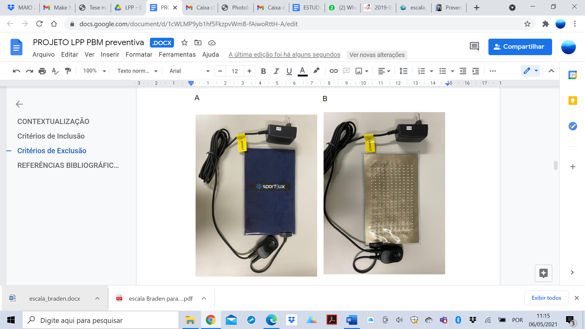
Figure 1: Sportlux LED panel used for preventive irradiation of areas most susceptible to pressure injury development.

3.11 Intervention and Follow-Up
In addition to photobiomodulation treatment, patients received the same preventive care measures recommended for the control group. Participants randomized to both groups were evaluated for 30 days. However, the collected data were still analyzed to see if a patient had been discharged before this period. If participants chose to withdraw from the study, their data were statistically analyzed following the intention-to-treat principle.
3.12 Outcomes
Primary Outcome
- Incidence of Pressure Injuries (PIs): The incidence of PI was assessed from hospital admission, with evaluations conducted every 48 hours for one month or until hospital discharge if it occurred earlier. The number of positive PI cases was recorded in the control and PBM groups.
Secondary Outcomes
- Time to PI Onset: The number of days from hospital admission until the first evidence of PI was recorded, considering even Stage 1 lesions, characterized by non-blanchable erythema with intact skin (Vieira, 2019).
- Correlation Between PI Incidence and Anthropometric Data: During hospitalization, participants’ demographic data (age, sex, and race) were recorded. These data were analyzed for potential correlations with PI development risk in the evaluated groups. All collected information was stored in an Excel spreadsheet.
3.13 Statistical Analysis
Statistical analysis was conducted blinded by a statistician who received the dataset without group identification. The data were subjected to appropriate statistical tests to evaluate differences between the experimental groups and assess statistical distribution. Nominal variables obtained from medical records were analyzed using the chi-square test. All statistical analyses were performed using SPSS software, with a significance level of α = 0.05.
3.14 Ethical Considerations
All individuals invited to participate in the study received verbal and written explanations of the study, as described in the Informed Consent Form (ICF). If the patient or their legal representative agreed to participate, they signed the ICF and received a copy. The study was conducted following the Declaration of Helsinki, registered on Plataforma Brasil, and submitted to the Research Ethics Committee (CEP) of UNINOVE. It commenced only after the research project was approved, following current resolutions.

.Data availability Statement- all data will be available for the readers.
Ethical Approval
The protocol for this study was approved by the Research Ethics Committee of Nove de Julho University (03645518030015511).
Dissemination policy: All data share trial results with participants, healthcare professionals, the public, and relevant groups.
Disclaimer (Artificial intelligence)
Authors hereby declare that generative AI technologies, specifically OpenAI’s ChatGPT (version GPT-4o), were used during the editing process to enhance the English language quality of this manuscript.

4. REFERENCES
- Vieira PA. Efetividade da implantação de protocolos de prevenção de lesões por pressão: revisão integrativa da literatura [dissertation]. São Carlos: Universidade Federal de São Carlos; 2019. Available from: https://repositorio.ufscar.br/handle/ufscar/11911.
- Gomes ACL, Mendonça DG. Avaliação do custo de tratamento de úlceras por pressão em pacientes hospitalizados. Cien Saude Colet. 2011;16:267-277.
- Moore Z, Cowman S. Pressure ulcer prevalence and prevention practices in care of the older person in the Republic of Ireland. J Clin Nurs. 2011;21(3-4):362-371.
- Jansen RCS, Silva KBA, Moura MES. A Escala de Braden na avaliação do risco para lesão por pressão. Rev Bras Enferm. 2020;73(6):e20190413. doi:10.1590/0034-7167-2019-0413.
- Pezzarossa E, Ungari M, Caresana G, et al. Acute generalized exanthematous pustulosis (AGEP) in 12 patients treated for SARS-CoV-2 positive pneumonia. Am J Dermatopathol. 2021;Publish Ahead of Print. doi:10.1097/DAD.0000000000001819.
- Yu N, Li Z, Long X, et al. Pressure injury: a non-negligible comorbidity for critical COVID-19 patients. J Plast Reconstr Aesthet Surg. 2021;74(3):644-710.
- Rogenski NM, Kurcgant P. The incidence of pressure ulcers after the implementation of a prevention protocol. Rev Latino Am Enfermagem. 2012;20(2):333-339.
- Hyun S, Li X, Vermillion B, et al. Body mass index and pressure ulcers: improved predictability of pressure ulcers in intensive care patients. Am J Crit Care. 2014;23(6):494-500.
- Polancich S, Hall AG, Miltner R, et al. Learning during crisis: the impact of COVID-19 on hospital-acquired pressure injury incidence. J Healthc Qual. 2021;43(3):137-144.
- Ribeiro BG, Alves AN, Dos Santos LAD, et al. The effect of low-level laser therapy (LLLT) applied prior to muscle injury. Lasers Surg Med. 2015;47(7):571-578.
- Frangez I, et al. Significant increase in microcirculation with LED therapy at 625, 660, and 850 nm wavelengths. Lasers Med Sci. 2017.

