**Microbial diversity of rhizosphere soils of sugarcane fields under waterlogged conditions**

**Abstract**

Waterlogging, one of the major abiotic stresses adversely affects crop growth, development, and yield contributing attributes. The microbial community, such as fungi and bacteria in the rhizosphere, has special importance to crop productivity. In the present study, the microbial diversity of rhizospheric soils of sugarcane fields with plant and ratoon crops under normal and waterlogged conditions was evaluated along with soil and plant attributes. For microbial diversity, microbial DNA was isolated, and high throughput gene sequencing of 16SRNA was performed using four soil samples of different sugarcane fields viz., waterlogged ratoon crop (S1), waterlogged plant crop (S2), control plant crop (S3) and ratoon crop (S4), along with soil composition. Results obtained indicated lower soil pH, organic matter, and available nitrogen, but higher potassium, phosphorus, and EC values in waterlogged soil as compared to the control plot. Plant attributes of sugarcane genotypes determined indicated higher cane height and root weight, while leaf parameters decreased due to waterlogging. Raw reads of microbial populations of rhizosphere soils of control and waterlogged plots with plant and ratoon crops were sequenced based on 16S rRNA (V3-V4 regions) genes and deposited in NCBI metagenome (Bethesda, MD, USA) under SRA module, and these can be accessed through Accession Nos. SRR26190803 (Ratoon crop control), SRR26190804 (Plant crop control), SRR26190805 (Plant crop waterlogged), and SRR26190806 (Ratoon crop waterlogged) under Bio-project PRJNA1020738. A total of 153066 OTUs were identified, with 91% classified under Kingdom Bacteria in waterlogged ratoon crop (S1) and 92% in waterlogged plant crop (S2), 94% in control plant crop (S3) and 94% in ratoon crop (S4) and 6 – 9 % from all samples were assigned to unknown species. Taxonomic analysis revealed that the bacterial community structure of the sugarcane rhizosphere soils predominantly consisted of the phyla Proteobacteria (24-61%), Actinobacteria (2-27%), Gemmatimonadetes (2-5%), Chloroflexi (7-16%), Cyanobacteria (2-3%), and Acidobacteria (7-8%), Planctomyces (4-11%), Bacteriodetes (1-10%) and Firmicutes (3-58%) in control and waterlogged plots. In the waterlogged rhizosphere, Proteobacteria (24-28%), Actinobacteria (22-27%), Chloroflexi (7-16%), Acidobacteria (7-8%), Planctomyces (4-11%), and Gemmatimonadetes (2-5%) were the dominant phyla. The alpha diversity of the bacteria community significantly increased due to waterlogging. A significant positive relation was observed among microbial communities viz., Acidobacteria, Cyanobacteria, Chloroflexi, Planctomycetes, Proteobacteria, Actinobacteria, and Gemmatimonadetes with plant height, root weight and cane length. waterlogged ratoon (S1) showed a higher abundance of genus Planctomyces, Bacillus, Gemmata, Streptomyces, Rhodoplanes, Balneimonas, Nitrospira, S2 with Anaeromyxobacter, Kaistobacter, Anaerolinea, S3 having Paenibacillus, Acinetobacter, Brevibacillu and S4 with Chloronema genus. This study reveals that the sugarcane rhizosphere has a rich pool of bacterial communities even under waterlogging stress, and which may help to improve waterlogging tolerance in sugarcane. Ratoon crop field under waterlogged and control conditions showed a higher Simpson index with greater evenness in species diversity as compared to the plant crop field. These data underpin future improvement of the waterlogging tolerance of sugarcane via the soil microbial community.

**Key words: Sugarcane, Waterlogging, Plant crop, Ratoon crop, Microbial diversity**

**Introduction**

Sugarcane, an important cash crop, occupies about 2.67 percent of the total cultivable area in India and shares 7.5% of the total agricultural production. Globally, more than 111 countries grow sugarcane, producing 133 MT of white sugar. About 75 percent of the world’s sugar (sucrose) supply is from sugarcane, and the other 25 percent is from sugar beet. Ratooning is very important in sugarcane production. After the harvest of sugarcane, the underground portion of the stubbles gives rise to a succeeding crop, known as a ratoon crop. Sugarcane ratooning is a planting system generally adopted by each sugarcane-producing country. However, the number of ratoons varies from 1 to 8. The proportion of the ratoon cane is generally around 50% of the cultivated area and can even reach 75% in some regions. The average proportion is 50–55% in tropical areas, while approximately 40–45% in subtropical areas (Singh et al. 2015). Poor stubble bud sprouting is one of the major problems causing low ratoon productivity in subtropical India. In sugarcane, waterlogging is one of the major abiotic stresses affecting cane and sugar productivity. In many parts of India, like eastern UP, northern Bihar, and the deltaic region of Tamil Nadu, sugarcane suffers from waterlogging during the elongation phase because of heavy monsoon rains and poor drainage facilities. Higher water table during the grand growth phase adversely affects cane weight and shoot population due to a shift in respiratory metabolism from aerobic to anaerobic condition. Waterlogging not only reduced shoot root growth and leaf emergence rate but also destroyed root function, hormone balance, and nutrient availability. Sugarcane crops affected by waterlogging stress showed aerial rooting, cane lodging, and decreased cane and sugar yield. Plant development, soil health, and ecosystem functions are all significantly impacted by the interaction between waterlogging and soil microbial activity. In the soil, waterlogging lowers the amount of accessible oxygen, causing anaerobic conditions. This change has an impact on the soil's nutrient cycling, lowering plants' access to nitrogen. Root development and general plant health may also be impacted due to waterlogging. Certain pathogens responsible for root rot and other plant diseases can thrive in wet soils. Waterlogging also affects the plant mycobiome in sugarcane by increasing Basidiomycota and decreasing Ascomycota, having many fungal genera such as Trichoderma, Aspergillus, Talaromyces, Exophiala, Cladosporium, Phoma, Penicillium, Purpureocillium, and Chaetomium, which stimulate plant growth (Leelastwattanagul et al. 2023). Investigating the microbiome of plants under waterlogging stress can yield innovative, naturally occurring methods for enhancing plant resilience to waterlogging stress. Plants protected against waterlogging stress by Bacillus sps inoculation produce 1-aminocyclopropane-1-carboxylic acid deaminase, which reduces ethylene levels generated by stress (Ali and Kim, 2018). While Acido-bacteria and Ascomycota showed a drop in relative abundance, Chloroflexi, Actinobacteria, and Basidiomycota showed an increase in the periodically wet field. Numerous studies have shown that during stress, plants' microbial communities alter (Omae and Tsuda 2022; Ullah et al. 2019). There are many different kinds of bacteria in the globe that might lead to severe illness. But the majority of microbes are good for the environment (Yousefi et al. 2021). Numerous economically significant crops have beneficial bacteria that have been isolated by various microbiological techniques (Baldani et al. 2002; De Souza et al. 2016; Subramaniam et al. 2020; Zhang et al. 2020). This study compared the soil microbial community in both plant and ratoon crop under waterlogging and control conditions and their relationship plant attributes. It also looked at the impact of waterlogging stress on the physicochemical characteristics of the rhizosphere soil in a sugarcane growing plots.

**Materials and Methods**

Sugarcane cultivars were grown for two cycles, plant and ratoon crops in the sub-tropical region of India at Kharika block research farm of ICAR-Indian Institute of Sugarcane Research (26.78°N, 80.99°E, 111 msl), Lucknow under control and waterlogged conditions. Using three bud setts, the first planting was completed in the first week of March. Cane was harvested when it reached maturity (11 months), and the ratoon crop was started. Ten months were needed for the ratoon crop to reach maturity. As per standard agronomic procedures, the appropriate doses of nitrogen (150 kg/ha), phosphorus (60 kg/ha), and potassium (60 kg/ha) were applied as urea, muriate of potash (MOP), and di-ammonium phosphate (DAP), respectively. The waterlogging condition was created by filling deep plots up to 1 meter in height for 3 months during the grand growth phase (July to September). Rhizosphere soil samples of sugarcane fields with plant and ratoon crops of both waterlogged and control plots were collected in autoclaved plastic tubes before harvesting. Sample details is as: waterlogged ratoon crop (S1), waterlogged plant crop (S2), control plant crop (S3), and control ratoon crop (S4). The soil properties and nutrient composition of the rhizosphere soil were examined using four sets of samples in three replications. Then DNA was isolated using rhizosphere soils and the quality of DNA was checked on 0.8% agarose gel and quantified by picogreen method using Victor 3 fluorometry. DNA (25 ng) of each sample was utilized to amplify the 16S rRNA V3–V4 region of bacteria. Following the Illumina qPCR Quantification Protocol Guide, we quantified the generated libraries. Sequencing was done in duplicates for each DNA sample, which represented three biological replicates. Qiime (Quantitative Insights Into Microbial Ecology v.1.9.0) software was utilized for additional downstream analysis after FastQC (v0.11.7) completed the quality inspection of the raw data.

All homologous sequences from each sample were grouped into Operational Taxonomic Units (OTUs). The most abundant representative sequences from these clusters were selected. A total of 154,420 representative sequences were utilized for taxonomic classification, resulting in 153,066 sequences being categorized as OTUs. Taxonomic identification was conducted at the Phylum, Class, Order, Family, and Genus levels using the clustered OTUs. A defined sequence similarity threshold of one or more samples was employed to delineate the OTU. To identify OTUs for the current study, the UCLUST method was executed against the Green genes. After aligning the sequences to a reference database with a sequence similarity threshold of 97%, we obtained the OTU abundance table. Then, the data was normalized to the smallest library size using total sum normalization and inputted into Microbiome Analyst (Dhariwal et al. 2017; Chong et al. 2020) with the default settings. We applied a 10% low variance filter using the interquartile range and maintained a minimum count of four to ensure a 20% prevalence. To analyze diversity, we used rarefaction analysis based on Mothur v.1.21.1 to calculate the Chao1, ACE (Abundance-based Coverage Estimator), Simpson, and Shannon diversity indices, which measure species richness and evenness within each microbial community. Alpha diversity was employed to study species diversity within a sample or environment. The OTU representative sequence was used for the taxonomic identification of plant and ratoon samples in both controlled and waterlogged conditions at the phylum, class, order, family, genus, and species classification levels. A heat map indicating the abundance of each category in every sample was generated at different classification levels, with each square representing the degree of abundance. Clustering was performed using the ward clustering algorithm, and the measurement tool used was Euclidean distance.

**Statistical analysis:** The experiment encompassing plant and ratoon crops under control and waterlogged conditions followed the completely randomized design with three replications. All the data used are average of three replications and taxonomical analysis was performed using software inbuilt test.

**Results and Discussion**

**Soil analysis & Microbial diversity**

The soil properties and nutrient composition of the rhizospheric soil in waterlogged and control plots with plant and ratoon crop were examined. The data revealed that the waterlogged affected soil had lower pH, organic matter, and available nitrogen content. Potassium, phosphorus, and EC values were relatively higher in soils of waterlogged plots as compared to the control plot. Similar to sugar beet, there was a comparatively larger accessible K level in wet rhizosphere soil (Li et al., 2023). Soil pH indicated a slightly lower value under waterlogged fields with plant and ratoon crops compared to control plots (Table 1).

**Table 1: Soil chemical properties in relation to waterlogging stress**

|  |  |  |  |  |  |  |  |
| --- | --- | --- | --- | --- | --- | --- | --- |
| **Crop type** | **Treatment** | **pH** | **EC** | **Organic matter** % | **Available nitrogen (kg/ha)** | **Available P2O5**  **(kg/ha)** | **Available K2O**  **(kg/ha)** |
| **Plant crop** | **Control** | 8.55 | 0.18 | 0.37 | 138.09 | 29.15 | 231.44 |
| **Waterlogged** | 8.09 | 0.29 | 0.27 | 125.50 | 71.23 | 378.72 |
| **Ratoon crop** | **Control** | 8.40 | 0.18 | 0.28 | 138.09 | 27.54 | 236.70 |
| **Waterlogged** | 8.08 | 0.28 | 0.26 | 100.4 0 | 80.40 | 510.22 |

**Table 2: Plant growth attributes of plant and ratoon crops under control and waterlogged conditions**

|  |  |  |  |  |  |  |  |  |  |  |  |  |  |
| --- | --- | --- | --- | --- | --- | --- | --- | --- | --- | --- | --- | --- | --- |
| Treatment | Plant height (cm) | Leaf No | Leaf Length (cm) | Leaf width (cm) | Leaf area (cm2) | Leaf wt (kg) | Stalk wt (kg) | Leaf sheath wt (kg) | Root wt (kg) | WCwt (kg) |  | SCW | Cane length (cm) |
| S1 | 245 | 34 | 139.6 | 3.2 | 282 | 0.328 | 2.68 | 0.24 | 0.064 | 3.31 |  | 0.664 | 260 |
| S2 | 243 | 25 | 124.0 | 3.1 | 379 | 0.170 | 1.77 | 0.14 | 0.050 | 2.19 |  | 0.821 | 238 |
| S3 | 227 | 27 | 143.0 | 4.3 | 616 | 0.270 | 2.01 | 0.22 | 0.030 | 2.6 |  | 0.856 | 231 |
| S4 | 210 | 33 | 140.8 | 3.4 | 303 | 0.292 | 2.25 | 0.22 | 0.021 | 2.78 |  | 0.589 | 210 |

WCwt= whole clump weight

**S1: waterlogged ratoon crop (WRC) , S2: waterlogged plant crop (WPC) , S3: control plant crop (CPC) and S4: control ratoon crop (CRC)**

Plant attributes of twenty four genotypes indicated higher cane height and root weight, while leaf parameters decreased due to waterlogging (Table 2). The bacterial community of plant and ratoon crop rhizosphere soil samples was compared under control and waterlogged conditions by sequencing bacterial genomes associated with these four sets of samples. Raw reads of microbial populations in the soil rhizosphere of control and waterlogged plots with plant and ratoon crops were sequenced based on 16S rRNA (V3-V4 regions) genes. The data discussed in this publication has been deposited in NCBI metagenome (Bethesda, MD, USA) under SRA module and can be accessed through Accession Nos. SRR26190803 (Ratoon crop control), SRR26190804 (Plant crop control), SRR26190805 (Plant crop waterlogged), and SRR26190806 (Ratoon crop waterlogged) under Bio-project PRJNA1020738. A total of 153066 OTUs were identified, with 91% classified under Kingdom Bacteria in waterlogged ratoon crop (S1) and 92% in waterlogged plant crop (S2), 94% in control plant crop (S3) and 94% in ratoon crop (S4) and 6 – 9 % from all samples were assigned to unknown species. The waterlogged ratoon crop sample showed 77274 OTUs, while the plant crop had 71394 and the control plant crop had 26268. The control ratoon crop had 23561 exclusive OTUs, with the control plot exhibiting a relatively lower number of OTUs among these samples. These OTUs were further grouped in phylum, class, order, family and genus level (Fig. 1a&b).

|  |  |
| --- | --- |
|  | D:\METAGENOMIC DATA FILE\report\venn.png |
| **Fig.1 a: Operational taxonomic units (OTUs) of microbial communities found in rhizosphere soil of Waterlogged (WL) and control plots with ratoon and plant crops of sugarcane** | **Fig.1 b: Venn Diagram showing Shared OTUs between different samples.**  **S1: waterlogged ratoon crop (WRC),S2: waterlogged plant crop (WPC), S3: control plant crop (CPC) and S4: control ratoon crop (CRC)** |

**At Phylum level**

The current study revealed the distribution of microbial communities across various phyla. Actinobacteria constituted 27% under waterlogged ratoon, 22% in waterlogged plant, and only 2% in control plant conditions. The phylum Firmicutes exhibited a range from 3% to 58% across different soil types, with the highest percentage (58%) observed in control plot and the lowest in waterlogged plot (3%) with plant crop. In the case of control ratoons, phylum Proteobacteria accounted for 61%, the highest proportion, while waterlogged plant and ratoons fields showed 28% and 24%, respectively. Other notable phyla present included Acidobacteria, Cyanobacteria, Chloroflexi, Bacteroidetes, Planctomycetes, and Gemmatimonadetes in all samples(Fig.2). The results obtained align with earlier studies indicated a significant presence of microbial communities belonging to the Planctomycetes, Proteobacteria, Acidobacteria, Bacteroidetes, Firmicutes and Actinobacteria phyla in sugarcane rhizosphere (Navarrete et al. 2005; Pisa et al. 2011; Dong et al. 2018). The current investigation revealed that the microbial community in the rhizosphere of the control plant crop was predominantly composed of Proteobacteria (31%) and Firmicutes (58%) (Fig.2).

**Fig.2: Relative abundance at Phylum level in different samples. S1: waterlogged ratoon crop (WRC), S2: waterlogged plant crop (WPC) , S3: control plant crop (CPC) and S4: control ratoon crop (CRC)**

In contrast, the ratoon crop demonstrated a higher prevalence of Proteobacteria (61%), along with Firmicutes (19%) and Bacteroidetes (10%) in its rhizosphere soil (Fig 2&3). A higher abundance of Proteobacteria in rhizosphere soil directly correlates with increased production of indole acetic acid (IAA) (Pereira et al. 2019). In addition, Actinobacteria play a crucial role in nitrogen fixation. The prevalence of Acidobacteria in waterlogged soils is a key factor in the soil's acidity, and a greater presence of Actinobacteria significantly enhances the yield of crops grown in these challenging waterlogged conditions. Microbial communities viz., Acidobacteria, Cyanobacteria, Chloroflexi, Planctomycetes, Proteobacteria, Actinobacteria and Gemmatimonadetes showed significant positive relationship with plant height, root weight and cane length (Table 3).

**Figure 3: Abundance of microbial communities at Phyla level in different samples**

**Table 3: Correlation among microbial community at phyla level and plant attributes**

|  |  |  |  |  |  |  |  |  |  |  |  |
| --- | --- | --- | --- | --- | --- | --- | --- | --- | --- | --- | --- |
| *Plant attributes* | Acidobacteria | Actinobacteria | Bacteridetes | Chloroflexi | Cyanobateria | Firmicutes | Gemmatimonadetedes | Nitrospirae | Planctomycetes | Proteobacteria | Thermi |
| Plant height | 0.895 | 0.909 | -0.293 | 0.737 | 0.600 | -0.190 | 0.865 | 0.889 | 0.747 | 0.966 | 0.014 |
| Leaf No | 0.026 | 0.050 | 0.827 | -0.282 | 0.188 | 0.302 | -0.204 | 0.056 | 0.437 | -0.209 | -0.373 |
| Leaf Length | -0.600 | -0.551 | 0.135 | -0.905 | -0.653 | 0.891 | -0.800 | -0.578 | -0.188 | -0.670 | 0.460 |
| Leaf width | -0.742 | -0.705 | -0.648 | -0.809 | -0.967 | 0.779 | -0.757 | -0.743 | -0.648 | -0.595 | 0.921 |
| Leaf area | -0.527 | -0.504 | -0.907 | -0.481 | -0.816 | 0.513 | -0.453 | -0.540 | -0.627 | -0.301 | 0.924 |
| Leaf wt | -0.178 | -0.129 | 0.472 | -0.586 | -0.193 | 0.715 | -0.443 | -0.148 | 0.286 | -0.336 | 0.108 |
| Stalk wt | 0.238 | 0.279 | 0.619 | -0.190 | 0.229 | 0.446 | -0.034 | 0.267 | 0.650 | 0.047 | -0.172 |
| LS wt | -0.301 | -0.247 | 0.327 | -0.702 | -0.359 | 0.822 | -0.556 | -0.273 | 0.157 | -0.423 | 0.272 |
| Root wt | 0.956 | 0.974 | 0.022 | 0.714 | 0.736 | -0.167 | 0.859 | 0.960 | 0.927 | 0.942 | -0.184 |
| WCwt | 0.172 | 0.219 | 0.537 | -0.276 | 0.125 | 0.549 | -0.107 | 0.202 | 0.599 | -0.002 | -0.056 |
| SCW | 0.024 | 0.030 | -0.976 | 0.134 | -0.312 | 0.070 | 0.160 | 0.001 | -0.273 | 0.280 | 0.676 |
| Cane length | 0.732 | 0.777 | -0.090 | 0.337 | 0.405 | 0.284 | 0.551 | 0.743 | 0.854 | 0.729 | 0.160 |

At the class level, 12% of the organisms were classified under Actinobacteria in the waterlogged ratoon (S1), while 10% were identified in the waterlogged plant crop plot (S2). The class Bacilli exhibited a significant presence, accounting for 57% in the control plant crop (S3) and 18% in the control ratoon. In contrast, the control ratoon crop (S4) showed that 60% of the operational taxonomic units (OTUs) were categorized as Gamma Proteobacteria, with 18% found in the rhizosphere of the control plant crop (S3). The abundance percentages of Bacilli (2-7%) and Gamma Proteobacteria (3-4%) were notably low under waterlogged conditions. (Fig 4). The variation in the percentage abundance across all classes is illustrated in Fig. 4 and Table 2. The representation of Planctomycetia was recorded at only 3% in waterlogged plant crops and 10% in ratoon crops, whereas the presence of Chloroflexi was higher in waterlogged ratoon crops (2%) compared to control ratoon crops (1%). These discrepancies in the microbial community may be attributed to the differing interactions between soil microbes and planting conditions. Lin et al. (2013) noted the impact of ratoon on soil enzyme activities and protein expression, suggesting that the altered microbial dynamics are reflected in the waterlogged plant and ratoon samples of sugarcane.

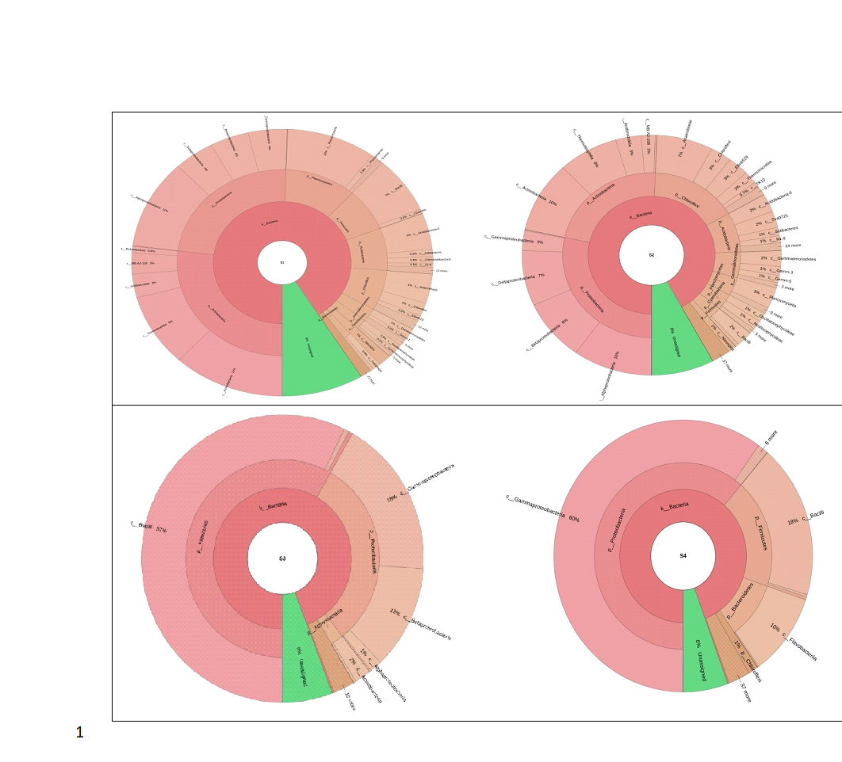

**Fig 4: Class level classification of microbial community. S1: waterlogged ratoon crop (WRC) , S2: waterlogged plant crop (WPC) , S3: control plant crop (CPC) and S4: control ratoon crop (CRC)**

At the order level, 12% of the operational taxonomic units (OTUs) were identified as Actinomycetales in the waterlogged ratoon (S1), while 10% were noted in the waterlogged plant crop (S2). In the control plant (S3), 57% of the OTUs were classified under O_Bacillales, with 18% in the control ratoon crop (S4) and between 2% and 7% in both waterlogged crops (S1 and S2). Additionally, 59% of the OTUs in the control ratoon (S4) were categorized as O_Enterobacteriales, compared to 15% in the control plant crop (S3) (Fig.5).

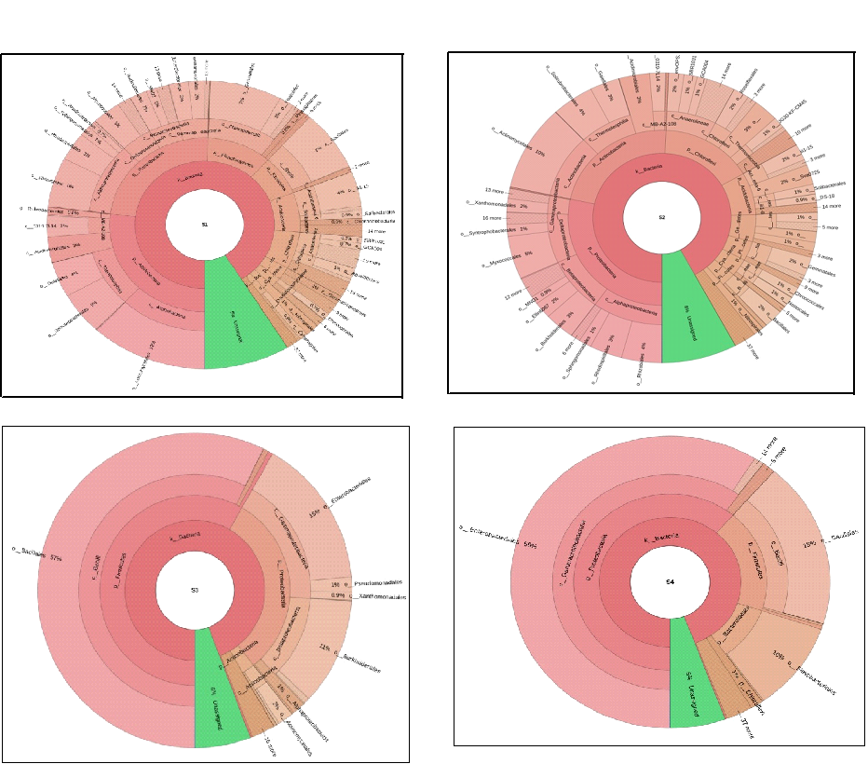

**Fig.5: Order level classification S1: waterlogged ratoon crop (WRC), S2: waterlogged plant crop (WPC) , S3: control plant crop (CPC) and S4: control ratoon crop (CRC)**

At the family level, 6% of operational taxonomic units (OTUs) in sample S1 were classified under the family Gemmataceae, while 4% of OTUs in sample S2 were categorized within Nocardioidaceae. In sample S3, a significant 53% of the OTUs were associated with F_Paenibacillaceae, with lower percentages of 9% in sample S4 and minimal representation (1-2%) in samples S1 and S2. Additionally, 59% of the OTUs in sample S4 were classified under F_Enterobacteriaceae, compared to 15% in sample S3, as illustrated in Figure 6.

|  |  |
| --- | --- |
|  |  |
|  |  |

**Fig. 6: Microbial community at family level in control and waterlogged condition. S1: waterlogged ratoon crop (WRC) , S2: waterlogged plant crop (WPC) , S3: control plant crop (CPC) and S4: control ratoon crop (CRC)**

At the genus level, a significant number of operational taxonomic units (OTUs) in samples S1 and S2 (>41.0%) belonged to an unknown genus. In the control plant sample (S3), 50% of the OTUs were identified as G_Brevibacillus, while samples S4, S2, and S1 exhibited 8%, 0.9%, and 2% of OTUs assigned to this genus, respectively. Additionally, in sample S4, 59% of the OTUs were categorized under an unknown genus and 24% in S3 sample. Based on the Heat Map prepared, rhizosphere soil under a waterlogged ratoon (S1) showed a higher abundance of microbial communities belonging to family Pirelluaceae, Gaiellaceae, Syntrophobacteraceae, Bradyrhizobiaceae, Microccaceae, *etc* and genus Planctomyces, Bacillus, Gemmata, Streptomyces, Rhodoplanes, Balneimonas, Nitrospira, S2 with Anaeromyxobacter, Kaistobacter, Anaerolinea, S3 having Paenibacillus, Acinetobacter, Brevibacillu and S4 with Chloronema genus and Enterobacteriaceae family (Fig.7 , Table 4).

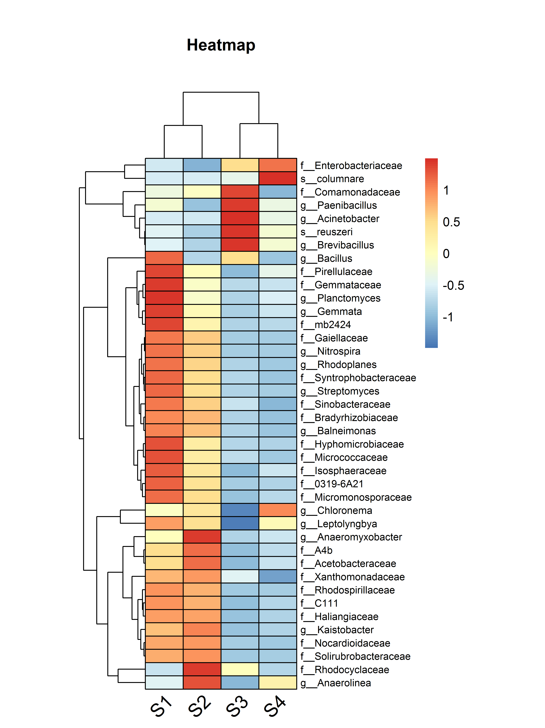

**Fig. 7: Heat map plot depicting abundance of genus among the samples. S1: waterlogged ratoon crop (WRC) S2: waterlogged plant crop (WPC) , S3: control plant crop (CPC) and S4: control ratoon crop (CRC)**

**Table 4: An Abundance of genus among waterlogged and control plots with plant and ratoon crops.**

**S1: waterlogged ratoon crop (WRC), S2: waterlogged plant crop (WPC), S3: control plant crop (CPC), S4: control ratoon crop (CRC)**

|  |  |  |  |  |
| --- | --- | --- | --- | --- |
| **Name of genus** | **Abundance of genus** | | | |
| **S1** | **S2** | **S3** | **S4** |
| Paenibacillus | 239 | 88 | 534 | 211 |
| Anaerolinea | 80 | 331 | 0 | 174 |
| Chloronema | 162 | 214 | 0 | 290 |
| Leptolyngbya | 244 | 200 | 0 | 159 |
| Kaistobacter | 364 | 433 | 50 | 78 |
| Balneimonas | 330 | 273 | 54 | 37 |
| Streptomyces | 331 | 223 | 30 | 19 |
| Planctomyces | 447 | 150 | 17 | 68 |
| Gemmata | 1036 | 428 | 13 | 105 |
| Nitrospira | 341 | 261 | 45 | 46 |
| Rhodoplanes | 501 | 75 | 40 | 686 |
| Anaeromyxobacter | 210 | 574 | 0 | 50 |
| Acinetobacter | 38 | 30 | 461 | 80 |
| Bacillus | 1128 | 412 | 878 | 363 |
| Brevibacillus | 78 | 35 | 337 | 120 |

Alpha diversity indicates the number of species present within a sample or environment. This measure tends to increase with greater sequencing depth, and rarefaction plots serve as a valuable tool for comparing alpha diversity across multiple samples that may differ in sequence depth. A rarefaction analysis utilizing Mothur version 1.21.1 assessed various diversity indices, including ACE, Chao, jackknife, Sobs, Simpson, and Shannon indices. The findings revealed that the plant crop soil sample demonstrated a higher species richness (Chao1 = 26789; Shannon index = 4.546) compared to the ratoon soil sample (Chao1 = 25605; Shannon index = 3.883) under control conditions. Conversely, under waterlogged conditions, the ratoon soil exhibited greater species richness (Chao1 = 80890; Shannon index = 9.837) than the plant cane soil (Chao1 = 74133; Shannon index = 9.481) (Table 5). A higher value of the Shannon index for the plant crop soil sample suggested more biodiversity as compared to the ratoon sample under control plot conditions. The Simpson index for the waterlogged ratoon (0.616 x 10-3) and the plant crop (0.569 x 10-3) indicated that, despite the ratoon crop field having a higher index, it demonstrated greater evenness in species diversity than the plant crop field. In the control plot, a higher Simpson index was also noted for the ratoon crop (0.145) in comparison to the plant crop (0.104) in the current study. Kim et al. (2017) found that samples with a high Simpson index exhibited low microbial biodiversity. The greater evenness indicating lower biodiversity and reduced species richness observed in the ratoon rhizosphere further underscored the significance of the microbial community influencing crop yield. Correlation analysis among various diversity indices and plant attributes indicated a significant positive relation between Simpson index and leaf attributes and negative with plant height, root weight, single cane weight and cane length. Ace, Chao, Sobs, and Shannon index showed positive relation with yield contributing attributes, cane length and single cane weight (Table 6).

**Table 5: Rarefaction indices show the diversity in each sample. S1: waterlogged ratoon crop (WRC), S2: waterlogged plant crop (WPC), S3: control plant crop (CPC) and S4: control ratoon crop (CRC)**

|  |  |  |  |  |  |  |
| --- | --- | --- | --- | --- | --- | --- |
| Group | Simpson | Ace | JackKife | Sobs | Chao | Shannon |
| S1 | 0.000616 | 87422.049 | 9384 | 77274 | 80890.220833 | 9.837737 |
| S2 | 0.000569 | 79477.480636 | 85155 | 71394 | 74133.299809 | 9.48184 |
| S3 | 0.10464 | 27925.230563 | 29572 | 26268 | 26789.310404 | 4.54668 |
| S4 | 0.145429 | 27844.766197 | 29665 | 23561 | 25605.829948 | 3.883467 |

**Table 6: Correlation among diversity indices and Plant attributes**

|  |  |  |  |  |  |  |  |  |  |  |  |  |
| --- | --- | --- | --- | --- | --- | --- | --- | --- | --- | --- | --- | --- |
| **Rarefaction indices** | **Plant height** | **Leaf No** | **Leaf Length** | **Leaf**  **width** | **Leaf area** | **SCW** | **Cane length** | **WCwt (kg)** | **Leaf wt (kg)** | **Stalk wt (kg)** | **LS wt** | **Root wt (kg)** |
| **Simpson** | -0.975 | 0.189 | 0.631 | 0.582 | 0.287 | -0.283 | -0.871 | -0.031 | 0.296 | -0.077 | 0.381 | -0.955 |
| **Ace** | 0.902 | 0.018 | -0.594 | -0.738 | -0.510 | 0.041 | 0.838 | 0.168 | -0.176 | 0.234 | -0.296 | 0.962 |
| **JackKnife** | 0.231 | -0.808 | -0.907 | -0.306 | 0.091 | 0.507 | -0.165 | -0.913 | -0.990 | -0.866 | -0.997 | 0.013 |
| **Sobs** | 0.918 | -0.017 | -0.603 | -0.715 | -0.475 | 0.081 | 0.847 | 0.146 | -0.197 | 0.208 | -0.312 | 0.965 |
| **Chao** | 0.908 | 0.003 | -0.599 | -0.729 | -0.496 | 0.058 | 0.842 | 0.158 | -0.186 | 0.222 | -0.304 | 0.963 |
| **Shannon** | 0.936 | -0.074 | -0.626 | -0.687 | -0.426 | 0.141 | 0.850 | 0.101 | -0.239 | 0.160 | -0.346 | 0.962 |

SCW- Single cane weight, wcwt-whole clump weight, LS- leaf sheath

Research findings indicate that waterlogging stress has a considerable impact on the composition of microbial communities associated with sugarcane plant. The relative soil water content rises under waterlogged conditions, leading to an increase in the prevalence of dominant bacterial phyla, Proteobacteria, Actinobacteria, Firmicutes, Chloroflexi, Acidobacteria, Planctomyces, Gemmatimonadetes, *etc*. The ratoon crop field showed a higher Simpson index with greater evenness in species diversity as compared to the plant crop field under both waterlogged and control conditions. In the current study, a significant enrichment of Proteobacteria and Firmicutes was observed in the rhizosphere of sugarcane fields subjected to waterlogging treatment in comparison to the control treatment.

**Conflict of Interest Statement**

The authors declare that they have no conflict of interest in the publication.

**Data availability**

The data supporting the findings of this study were generated entirely through experiments conducted by the authors. These data are available upon reasonable request.

**References**

Ali S., Kim W. C. (2018). Plant growth promotion under water: decrease of waterlogging-induced ACC and ethylene levels by ACC deaminase-producing bacteria. Frontiers in Microbiology 9. doi:  10.3389/fmicb.2018.01096

Baldani JI, Reis VM, Baldani VLD, Döbereiner J (2002) Review: a brief story of nitrogen fixation in sugarcane a—reasons for success in Brazil. Funct Plant Biol 29:417–423

De Souza RSC, Okura VK, Armanhi JSL, Jorrín B, Lozano N, Da Silva MJ, González-Guerrero M, De Araújo LM, Verza NC, Bagheri HC, Imperial J,  [Arruda](https://pubmed.ncbi.nlm.nih.gov/?term=Arruda+P&cauthor_id=27358031) P (2016) Unlocking the bacterial and fungal communities assemblages of sugarcane microbiome. Sci Rep 6:28774, doi: 10.1038/srep28774.

Dhariwal A, Chong J, Habib S, King I, Agellon LB, Xia J (2017) Microbiome analyst—a web-based tool for comprehensive statistical, visual and meta-analysis of microbiome data. Nucleic Acids Res 45:180–188

Dong M, Yang Z, Cheng G, Peng L, Xu Q, Xu J (2018) Diversity of the bacterial microbiome in the roots of four Saccharum species: S. spontaneum, S. robustum, S. barberi, and S. officinarum. Front Microbiol 9:267

Jain R et al. (2023). Performance of ratoon crop under waterlogged conditions. Advances in Applied Research. 15: 1-11

Jain R, Singh A, Singh SP, Chandra A, Pathak AD (2017). Variation in juice quality traits of sugarcane genotypes under waterlogged condition in subtropical India. Climate Change and Environ. Sustainability. 5: 50-58

Jain R, Singh A, Singh CP, Rajeev Kumar, Singh SP, Chandra A, Srivastava VK, Pathak AD (2018) Rooting pattern and anatomical alterations in roots of sugarcane genotypes under waterlogged conditions. Climate Change and Environ. Sustainability 6: 139-153.

Jain R, Singh A, Singh S, Singh SP, Srivastava VK, Chandra A, Pathak AD, Solomon S (2017). Physio-biochemical characterization of sugarcane genotypes for waterlogging tolerance. World J Agric Sci 13: 90-97.

Kim BR, Shin J, Guevarra R, Lee JH, Kim DW, Seol KH, Lee JH, Kim HB, Isaacson RE (2017) Deciphering diversity indices for a better understanding of microbial communities. J Microbiol Biotechnol 27:2089–2093

Leelastwattanagul O, Sutheeworapong S, Khoiri AN, et al. (2023) Soil microbiome analysis reveals effects of periodic waterlogging stress on sugarcane growth. Plos one. 2023 ;18(11):e0293834. DOI: 10.1371/journal.pone.0293834.

Li, T. Meihui Wang, Rufei Cui, Bingchen Li, Tong Wu, Yonglong Liu, Gui Geng, Yao Xu, Yuguang Wang, (2023) Waterlogging stress alters the structure of sugar beet rhizosphere microbial community structure and recruiting potentially beneficial bacterial. Ecotoxicology and Environmental Safety, 262: 115172, ISSN 0147-6513, https://doi.org/10.1016/j.ecoenv.2023.115172.

Lin W, Wu L, Lin S, Zhang A, Zhou M, Lin R, Wang H, Chen J, Zhang Z, Lin R (2013) Metaproteomic analysis of ratoon sugarcane rhizospheric soil. BMC Microbiol 13:135

Navarrete AA, Diniz TR, Braga LP, Silva GG, Franchini JC, Rossetto R, Edwards RA, Tsai SM (2005) Multi-analytical approach reveals potential microbial indicators in soil for sugarcane model systems. PLoS ONE 10(6): e0129765

 Omae, Tsuda NK (2022) Plant-microbiota interactions in abiotic stress environments. Mol Plant-Microbe Interact: MPMI, 511-526

Pereira LB, Andrade GS, Meneghin SP, Vicentini R, Ottoboni LM (2019) Prospecting plant growth-promoting bacteria isolated from the rhizosphere of sugarcane under drought stress. Curr Microbiol 76:1345–1354

Pisa G, Magnani GS, Weber H, Souza EM, Faoro H, Monteiro RA, Daros E, Baura V, Bespalhok JP, Pedrosa FO, Cruz LM (2011) Diversity of 16S rRNA genes from bacteria of sugarcane rhizosphere soil. Brazilian J Med Biol Resh 44:1215–1221

Singh H., Rathore A.K., Tamrakar S.K. Agro-techniques for ratoon management in sugarcane. Indian Sugar. 2015;65:32–34.

Subramaniam G, Thakur V, Saxena RK, Vadlamudi S, Purohit S, Kumar V, Rathore A, Chitikineni A,

Ullah A, Akbar A, Luo Q, Hamid Khan A, Manghwar H, Shaban M, Yang X (2019) Microbiome diversity in cotton rhizosphere under normal and drought conditions. Microb Ecol 77:429–439

Yousefi SR. Alshamsi AH , Amiri O, Salavati-Niasari M (2021) Synthesis, characterization and application of Co/Co3O4 nanocomposites as an effective photocatalyst for discoloration of organic dye contaminants in wastewater and antibacterial properties.J. Mol. Liq 337, Article 116405

Zhang L, Chen W, Jiang Q, Fei Z, Xiao M (2020) Genome analysis of plant growth-promoting rhizobacterium Pseudomonas chlororaphis sub sp. aurantiaca JD37 and insights from comparison of genomics with three Pseudomonas strains. Microbiol Res 237:126483