***Review Article***

**Gut Microbiota and Its Impact on Children with Autism Spectrum Disorder**

**Abstract:**

There is a substantial relationship between gut microbiota and autism spectrum disorder (ASD). Studies have found that there are significant changes in microbial composition between people with ASD, their unaffected siblings, and healthy controls. Though results are still unstable, bacterial species like *Clostridium*, *Sutterella*, *Desulfovibrio*, *Lactobacillus*, *Bacterodies*, and *Faecalibacterium* are more common in ASD patients. Because up to 90% of people with autism spectrum disorder (ASD) experience gastrointestinal (GI) problems, it is thought that the gut-brain axis is important in the development of ASD. The gut microbiota is made up of *Bacteroidetes*, *Firmicutes*, *Proteobacteria*, and *Actinobacteria*. It is affected by a number of variables, including nutrition, which can change the composition of the microbiota and the function of the brain through neuroendocrine and immunological pathways. Therapeutic methods that focus on the microbiome, including probiotics, microbiota transfer therapy, and specific diets, have demonstrated promise in reducing gastrointestinal and behavioral symptoms in individuals with autism spectrum disorder (ASD). However, even if there are hopeful results from preclinical and observational research, strong clinical trials are necessary to determine whether there is a cause-and-effect relationship and the treatment is effective. Furthermore, the food and lifestyle of the mother may increase the chance of autism spectrum disorder (ASD), which underscores the need of having a thorough understanding of the connections between the gut, brain, and microbiome. Microbiome-based therapies show promise, but further study is needed to fully understand their potential for managing autism spectrum disorder (ASD).

**Introduction:**

In addition to having a strong genetic component, autism spectrum disorder refers to a condition that describes the constellation of early-appearing social communication deficits, including difficulty with conversational skills, nonverbal communication issues, and difficulties understanding other people's thoughts and feelings, as well as repetitive sensory-motor behaviors, such as hand flapping and figure flicking, rocking back and forth, and spinning objects [2,3]. ASD has a complicated genetic foundation that includes genes related to central nervous system (CNS) development [4]. The symptoms of autism often appear during infancy or, at most, the first three years of life. Almost all people with autism have a history of linguistic delay; many, but not all, have mental handicap. Because there is a lot of opportunity for error in normal development, other disorders are often correlated with language impairment, and it is necessary to measure the presence of specific social deficits across different language levels (e.g., assessing social skills in a nonverbal child differs from assessing social skills in a verbal child), researchers studying the link between autism and language impairment must be careful when choosing their measures and comparison groups [5]. Although post-mortem, neuroimaging, and electrophysiological investigations have shown mild morphological and functional alterations, autism does not show significant brain damage [6].

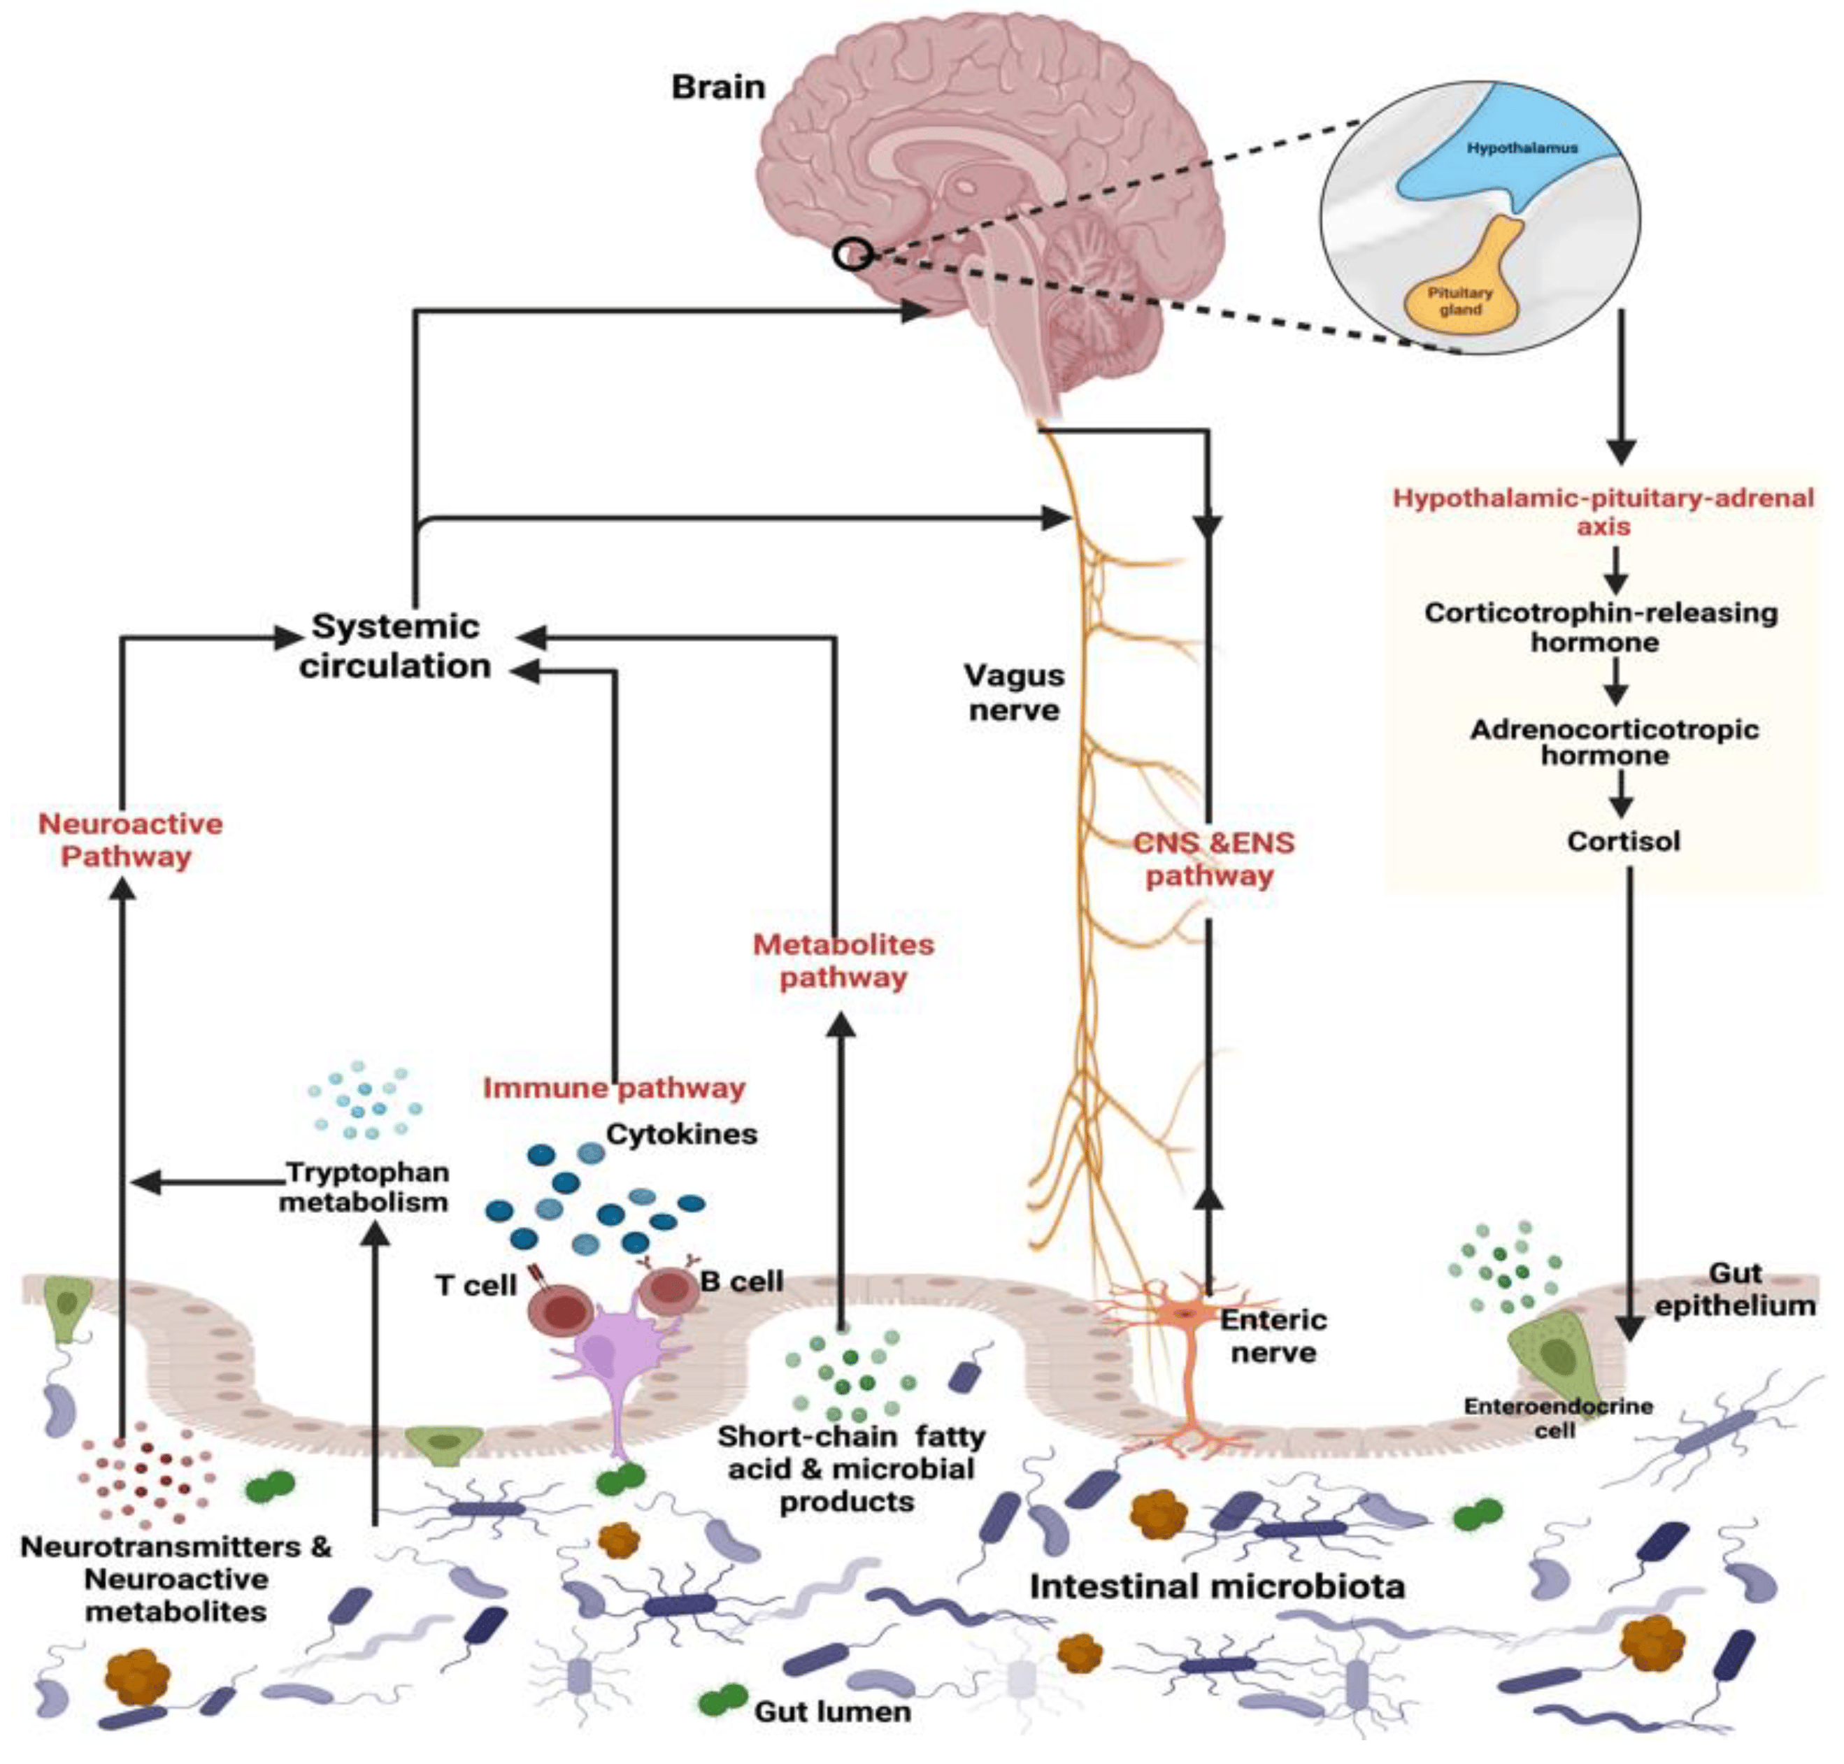

**Fig1: The figure shows the Gut-Brain-Axis and its bidirectional relationship with Gut microbiota, CNS and Hypothalamic axis [1].**

Numerous potential risk factors for autism spectrum disorder have been proposed. Several systematic reviews and meta-analyses have investigated prenatal and postpartum factors, as well as those related to the mother's food and lifestyle. A higher likelihood of autism spectrum disorder (ASD) has been independently associated with both advanced maternal age (40 years or older) and advanced paternal age (50 years or older), according to many research. A higher incidence of ASD has also been linked to short interpregnancy intervals (less than 24 months). A slightly increased incidence of both developmental delay and autism spectrum disorder (ASD) has been associated with a number of variables. Some of these factors are more narrowly focused, such a mother's history of autoimmune disease or a recent hospitalization for a bacterial or viral infection; others are more broadly defined, and they include non-optimal pregnancy characteristics like a mother's metabolic problem, weight gain, or hypertension [2].

The estimated autism prevalence was around 4 per 10,000 persons when the first methodical investigations were carried out in the 1960s. On the other hand, the current estimates for the whole spectrum of autism range from 60 per 10,000 persons. This 15-fold increase has caused concerns of an epidemic [6]. An estimate of the worldwide prevalence of autism spectrum disorder (ASD) based on an evaluation commissioned by the World Health Organization (WHO) in 2012 came out as around 1%. According to more recent studies, 1.5% of developed nations' population has ASD [2].

Although the specific etiopathogenesis of autism spectrum disorder (ASD) is not well understood, research conducted in recent decades has indicated that the link between the Gut microbiota and the brain may play a role in people with autism or other neuropsychiatric diseases [7]. The prevalence of stereotyped behaviors and social communication difficulties are the main diagnostic markers of human autism spectrum disorder (ASD). Other behavioral abnormalities, such as anxiety, seizures, and hyperactivity, are also common in people with ASD [8]. People with autism spectrum disorder (ASD) may have a variety of other conditions at the same time, including gastrointestinal (GI) symptoms and increased permeability of the epithelial barrier in the gut. Those with gastrointestinal problems report higher anxiety and other bodily issues than those with autism spectrum condition who do not have gastrointestinal symptoms.. They also have less social contact [7]

Microbiota are the whole population of microorganisms colonizing a given area together with other species including protozoan, fungus, archaea, and viruses [9]. Most significant part of the typical microbiota, however, is bacteria [10]. Bacterial colonization can be classified into three categories: mutualistic, commensalistic, and opportunistic. Mutualism is a term that describes a situation in which both creatures benefit from living together. As a result, the majority of the bacteria in the intestines are not commensalistic (even though they are referred to as commensals); instead, they are mutualistic, as both the bacteria and the human body gain advantages from their presence. In a commensalistic relationship, one organism benefits while the other is not affected in any way. If a microorganism is opportunistic, it means that it does not cause disease under normal settings, but it can produce disease if conditions become favorable [10]. The human gastrointestinal (GI) tract is one of the biggest interfaces in the human body, ranging between 250 and 400 square meters. It links the antigens, environmental factors, and host to one other. Microorganisms thought to inhabit the gastrointestinal system count more than 10^14. Compared to human cells, this is almost ten times the count of bacterial cells and more than one hundred times the quantity of genetic material (microbiome) found in the human genome [11]. Human health and illness depend much on the bacteria; in fact, they are sometimes referred to as our "forgotten organ" [12]. The gut flora communicates with immune system to enable the maturation or development of immune cells properly  [13]. It is supposed that gut flora is important in influencing neuronal behavior through the gut-brain axis. Research has shown that gut microbiota has an impact on cognitive ability, repetitive behaviors, and social interactions in many animal models. Stress-induced intestinal permeability allows endotoxins to enter the bloodstream, which causes an immunological response. This process describes how gut microbiota might affect neurological diseases. By encouraging the passage of neurotoxins into the brain and by interfering with neurotransmitter systems, this peripheral inflammation can also have an effect on mental health [14] .

The gut microbiota may govern the Central Nervous system through the "Microbiome-gut-brain axis" in both directions. It may also influence brain function and behavior through immunological, metabolic, endocrine, and neurological pathways. Microbiota can create a variety of compounds that can affect how the brain works, including Short-chain fatty acids (SCFAs), Propionate, and Butyrate. A disturbance of microbiota and their end metabolites could lead to immunological dysfunction and mitochondrial metabolic malfunction, which may contribute to the pathogenesis of ASD [15]. In this work, we examine evidence of dysbiosis in autism spectrum disorder (ASD). We pay particular attention to the potential connection between gastrointestinal issues, inflammation, and neurobehavioral indications in children with autism.

**The Gut Microbiota:**

A group of microorganisms that live in the human digestive system is known as the gut microbiota [16]. The microbiota of the human large intestine is extremely complicated and consists of hundreds of different bacterial species (also known as phylotypes). In adults, the volume of colonic contents is approximately 250 ml, and the number of bacteria present is roughly 1011 cells per ml of colonic contents [16]. The gut microbial species that live in a single person have been discovered to contain 3.3 million genes. This is a huge number compared to the approximately 23,000 genes in the human genome, which highlights the potential impact of these species on human health [17].

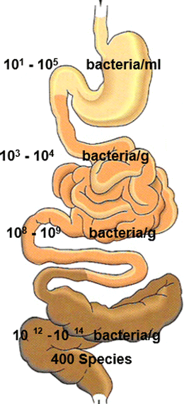

**Fig2: The figure shows Bacterial Distribution along with Human gastrointestinal track.**

The gut microbiota of a healthy adult is made up of four major phyla, which together make up more than 90% of the total bacterial population. These phyla are *Bacteroidetes* (which include the genera *Bacteroides* and *Prevotella* and are Gram negative), *Firmicutes* (which include the genera *Lactobacillus*, *Clostridium*, and *Ruminococcus* and are Gram positive), *Proteobacteria* (which include Enterobacter species), and *Actinobacteria* (which include *Bifidobacterium*). The minor phyla are *Fusobacteria* and *Verrucomicrobia* [1]. The makeup of the gut microbiota can vary significantly both within a single person and between different people.

When there are no bacteria in the gastrointestinal system, it causes serious complications with the progression of Gut-associated lymph tissues, low levels of secretory IgA antibodies in the intestines, and fewer or smaller Mesenteric lymph nodes [18]. From the moment of birth, the Gut microbiota evolves with the host and the host's metabolic and neurological programming. Consequently, the progression of this microbial population is rather vital for later in life health. Along with preventing the colonization of infections, the gut microbiota plays a part in immune system development, food absorption, and metabolism. The Gut bacteria effects the brain development and behavior by modulating the neuroendocrine, neuroimmune, and autonomic nerve systems [19]. The infant-gut microbiota interaction begins at the time of birth and continues to evolve over the first few years of life [20] . Dysbiosis can occur as a result of a variety of perinatal factors, including cesarean section delivery, type of feeding, antimicrobial therapy, gestational age, and environment, all of which can change the way bacteria colonize [21]. Compared to healthy offspring, offspring with autism spectrum disorder (ASD) have a significantly higher number of altered patterns of bacterial metabolites. The metabolites contained elevated amounts of 3-(3-hydroxyphenyl)-3-hydroxypropionic acid (HPHPA), which is a catabolic byproduct of Clostridia [1].

## The Microbiome as a Potential Mediator of Risk Factors in ASD:

There are around 9.9 million bacterial genes in the human gut, which includes about 1 kilogram of bacteria [19]. The process of initial colonization begins after birth, when maternal microbes are obtained during vaginal delivery. On the other hand, recent studies suggest that maternal microbiota can potentially be obtained during pregnancy. Breast milk is high in human oligosaccharides, which help support the microbiota of the newborn. Though, the composition of microbiota throughout premature life can be reformed by many factors such as birth techniques, hygiene, and feeding patterns, including formula feeding [22]. Research studies have shown that children who are fed formula have a reduced diversity of gut bacteria than children who are breastfed [23]. The most prevalent forms of bacteria detected in the intestines of a healthy baby are Bifidobacterium and Lactobacillus. On the other hand, the gut continues to be unstable during the first few years of life, during the weaning phase, and when solid foods are introduced. The stomach becomes more stable and takes on a composition that is more similar to that of an adult's around the age of three. The two most frequent phyla of bacteria found in the Gut of a healthy adults are Firmicutes and Bacteroidetes. Actinobacteria, Proteobacteria, and Verrucomicrobia are only a small part of the microbiota [22].

Gastrointestinal (GI) symptoms and gut microbiome dysbiosis are both prevalent comorbidities that individuals with autism spectrum disorder (ASD) commonly suffer. These health conditions are also known to be associated to the severity of symptoms in people with ASD. It was shown that the gut microbiomes of people with autism spectrum disorder (ASD) were considerably different from those of other patients [23]. Dysbiosis of the Gut microbiota, in particular, is linked with the advancement of inflammatory syndromes, such as inflammatory bowel disease (IBD) [21]. Both children with autism spectrum disorder (ASD) and animal models of ASD are found to have variations in the composition of their gut microbiota and its metabolites. The idea that the microbiota has an effect on behavioral outcomes in animal models of neurodevelopmental and neurological diseases is supported by the fact that animals raised without microbial colonization show abnormalities in a variety of sophisticated behaviors. Two different studies have shown that germ-free mice are less likely to interact with a new mouse than with an object that is not social, and they are also less likely to interact with an unknown mouse than with an animal that they are familiar with [8]. There is enough scientific evidence to show that gut microbiota of patients with autism spectrum disorder (ASD) is different from that of healthy individuals [24].

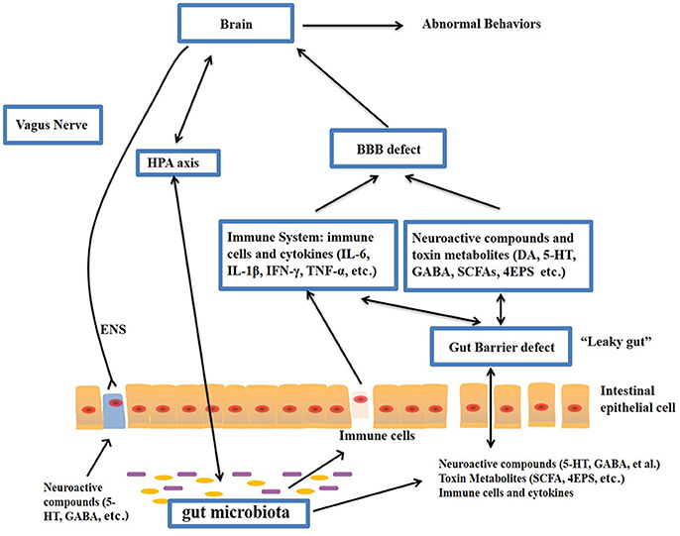

**Fig3: The figure shows the Potential relationship between Gut Microbiota and Autism Spectrum disorder [19].**

[**Gut-Brain Axis**](https://www.mdpi.com/2072-6643/11/3/521#sec5-nutrients-11-00521)**:**

The "Microbiota-gut-brain axis," which is a two-way communication network between the Gut and the brain, may allow the microbiota in our gastrointestinal system to influence how our brains work and how we behave [24]. Enteric nervous system (ENS) is located in the mucosa of gastrointestinal tract and is important for controlling the functioning of the gastrointestinal system. It is made up of millions of neurons. As a result, the gut is referred to as a "second brain" [19]. The bidirectional route is made up of both efferent and afferent impulses. The enteroendocrine system, cytokines, metabolites, gut products, and neuroactive substances are all involved in the transmission of afferent signals from the gastrointestinal tract to the brain. Efferent signals, which include neuroendocrine and autonomic modulation, begin in the brain and travel to the gut wall. In this pathway, 90% of the vagal fibers connecting the brain and the gut are afferent, which indicates that the intestine is more of a transmitter than a receiver [23]. Gut bacteria affect a variety of aspects of gut physiology, including the integrity of the intestinal barrier, the regeneration of epithelial cells, the creation of mucus, and gastrointestinal motility [8].

#### Gut Permeability:

A significant factor in the relationship between autism spectrum disorder (ASD) and Gut is the increased permeability of the intestinal tract in people with autism spectrum disorder (ASD), which is referred to as a "leaky gut" [19]. Leaky gut syndrome is the disorder wherein small or large intestine's epithelial barrier function is disturbed. As a result, the number and variety of chemicals and cells that may move between the stomach and the circulatory system, and vice versa, increases [3]. Intestinal permeability prohibits the contents of the intestines from entering the circulation, therefore preventing subsequent immunological inflammatory responses and gastrointestinal diseases. Intestinal permeability is determined by the lactulose test, mannitol test, and zonulin test [3,19]. The relationship between stomach and brain in the development of Autism is thought may be due to increased Gut permeability, which has been linked to Autism spectrum disorder (ASD). For instance, injecting Propionic acid, which is generated through bacteria in the intestines, into the brains of rats has been found to trigger neuroinflammation and symptoms that are comparable to those of autism spectrum disorder (ASD). This might be the reason children with autism spectrum disorder (ASD) have more severe symptoms when they eat food preservatives including propionic acid [3].

#### Immune System Pathway:

The microbiota, gut, and brain are all connected in a two-way relationship, and immunological pathways have an key role in this link, allowing gut and brain to affect each other. Because gut mucosal surfaces are continuously exposed to both pathogenic and helpful microbes, which can elicit an immunological response, gut microbial composition have a critical role in controlling immune hemostasis. Change in the gut microbial makeup has been linked to the deficiency in the immune system. For instance, Germ-free mice have a higher microglia density in different regions of the brain compared to mice that are raised in a specialized pathogen-free (SPF) environment. In addition, these GF mice exhibited unusual social avoidance behavior and a weak immunological response to viral infections. After supplementing germ-free mice with microbial Short-chain fatty acids (SCFAs), both microglia abnormalities and symptoms associated with autism spectrum disorder (ASD) were improved. The gut flora can indirectly influence the innate immune system, which can alter the level of pro-inflammatory and anti-inflammatory cytokines in the blood. These cytokines have a direct effect on microglia homeostasis [3].

Neurotransmitters are the means by which the microbiota communicate with the brain. Neuroactive substances like Dopamine (DA), 5-HT, γ-aminobutyric acid (GABA), and Histamine are produced by the gut microbiota and can either trigger or hinder the central neurons via the vagus nerve. Immunological pathways are another way that the stomach and brain can interact. Pro-inflammatory cytokines such IL-1β, IL-6, IL-8, and IL-12p40 have been found to be elevated in the plasma of people with ASD in numerous investigations. Gut permeability is increased by immunological reactions to toxins generated by pathogenic bacteria and localized inflammation.

**Dietary Intervention: What is the Evidence?**

The interaction between the gut and the CNS could manifest in a variety of ways. One of these is through the modulation of the immune system and the sympathetic nervous system, which can occur as a result of circulating levels of pro-inflammatory and anti-inflammatory cytokines or the synthesis of metabolites such as short-chain fatty acids (SCFAs) [25]. Short-chain fatty acids (SCFAs) are formed when microorganisms digest fiber, and they can be found in high amounts in the colon. While certain SCFAs, such as Propionic acid (PPA), can be harmful to the nervous system when present in excessive numbers and studies have shown that they can cause behavioral abnormalities in mice models, short-chain fatty acid (SCFA) metabolites from commensal microbiota are often healthy for the host [22]. It is thought that the deterioration in the integrity of the intestinal barrier is related to changes in the Gut microbiota. This may cause fatty acid and lipopolysaccharide (LPS) leakage and an increase in toxin absorption from the gastrointestinal lumen.. These substances interact on Toll-like receptor 4 to cause systemic inflammation, which profoundly affects the central nervous system [25].

Several studies have shown that the diet containing high fat for pregnant women lowers the number of non-pathogenic Campylobacter and the Bacteroides in human babies. Buffington et al. state that when mothers take diet containing high fat, it induces dysbiosis and autism-like traits, but these changes can be reversed using Lactobacillus reuteri. While offspring born by cesarean section have gut microbiota identical to that of their mother's skin Microbiota, which is dominated by Staphylococcus, Corynebacterium, and Propionibacterium spp., while infants born vaginally have Gut microbiota similar to their mother's vaginal microbiota, which is dominated by Lactobacillus, Prevotella, or Sneathia spp. High Staphylococcus aureus concentrations can generate toxins that induce diarrhea, bloating, and nausea[19].

While there have been several research that have shown changes to the bacterial gut microbiota in people with autism spectrum disorder (ASD), there have been fewer studies that have looked at the association among gut fungus and ASD. The yeast in the stomach, predominantly Candida albicans, causes the body to absorb less carbs and minerals and to release more toxins. Kantarcioglu et al. identified 338 yeast strains from 415 feces samples taken from persons with autism spectrum disorder (ASD). Candida, especially Candida albicans, made up 81.4% of the yeast strain. Non-autistic healthy subjects had a lower yeast isolated rate (19.6%) [19].

**Role of Propionic Acid:**

*Clostridium*, *Bacteroidetes*, *Desulfovibrio*, *Veillonella*, *Megasphaera*, and Propionibacterium are the main producers of PPA, a short-chain fatty acid that can pass the blood-brain barrier and cause behaviors similar to those of ASD. According to Thomas et al., high amounts of PPA administered intracerebroventricularly cause some Autistic-like symptoms in mice (Thomas et al., 2012), and PPA administered intraventricularly to rats causes hyperactivity, repetitive behaviors, and abnormal motor movements that are comparable to the behavioral and electrographic abnormalities seen in people with ASD. PPA causes rats to behave less socially, most likely via changing certain neurotransmitters like serotonin and dopamine [19].

**Potential Therapeutic Aspects:**

**Antibiotics:**

At this time, there are no proven or effective treatments for ASD. The therapies for ASD that have been authorised and recommended include rehabilitation, educational therapy, and psycho-pharmacological techniques [25]. As a result, parents have begun to seek out alternative therapies that lack strong scientific support. These treatments, which include the use of vitamins and other supplements or the adoption of elimination diets, can be costly and possibly harmful (for example, a gluten-free and casein-free diet) [26].

Due to the growing recognition of gut dysbiosis and its role in autism spectrum disorder (ASD), research is concentrating on rebalancing the gut microbiota as a potential treatment for these conditions. This method involves administering oral pre-probiotics and faecal microbiota transplants (FMT).

Antibiotics can be used to treat gastrointestinal illnesses because they have the ability to change the makeup of Gut microbiota. Research shows that early exposure to antibiotics may lead to autism, yet there are also cases in which antibiotics have been used to treat autism. For example, aminoglycosides can help relieve some symptoms of autism. [27]. We have a few more FDA-approved drugs for treating autism, such as glutamate antagonists, in addition to aminoglycosides.[28]

**Usage of Probiotics in the Treatment of Autism Spectrum Disorder:**

The presence of aberrant gut microbiota and the activation of the mucosal immune response are two of the defining characteristics of autism. Therefore, the administration of probiotic bacteria in autism is regarded a therapeutic approach for the goal of lowering inflammation, restoring epithelial barrier function, alleviating specific behavioral difficulties, and restoring normal gut microbiota [29]. The majority of the probiotic research on autism spectrum disorder (ASD) has focused on strains of Lactobacillus and Bifidobacterium [30]. In a cohort study of 22 kids with autism spectrum disorder (ASD) ranging from 4 to 10 years old, oral supplementation with Lactobacillus acidophilus twice daily for a period of two months improved the children's capacity to concentrate and fulfill commands, such as following directions more effectively. Sadly, there was no evidence of any effects on either behavioral or emotional deterioration [31].It has been observed that the utilization of probiotics and prebiotics contributes to the reduction of gastrointestinal issues and inflammation through the regulation of the microbiota [30].

The therapeutic impact of a three-week oral therapy with a combination of Bifidobacteria and Lactobacilli strains (ProtexinR) was investigated in a recent study that was carried out on hamsters in which autistic-like behaviors were caused by the administration of PPA and clindamycin. Clindamycin and PPA both enhanced the excitotoxicity of glutamate in the brains of hamsters, which resulted in a decrease in magnesium and GABA levels [32].

## The Developing Role of the Flavonoids in the Autism Spectrum:

## Flavonoids are a large category of polyphenolic compounds that are often found in the human diet because they are present in fruits, vegetables, and drinks manufactured from plants. The six main subclasses are flavones, flavonols, flavanones, flavanols, anthocyanins, and isoflavones. These molecules have a wide range of favorable biochemical effects that are associated with a number of illnesses, including mood disorders and neurodevelopmental disorders [33-35]. Flavonoids and their subclasses have been proven in several experimental investigations to have the ability to modify biochemical signaling pathways. These pathways are associated with endogenous antioxidant systems, increased mitochondrial activity, and reduced neuroinflammation. Flavonoids have been linked to neuroinflammation associated with major neurological and psychiatric disorders, including ASD. They do this by regulating important signaling pathways, such as the cAMP response element-binding protein (CREB) pathway, Janus kinase and signal transducer and activator of transcription proteins (JAK/STAT) pathway, nuclear factor kappa-light-chain-enhancer of activated B cells (NF-κB) pathway, and Toll-like receptor (TLR) pathway [36,37]. These actions may help reduce the pro-inflammatory condition of offspring with autism spectrum disorder (ASD) who show signs of increased stress reactivity and hyperarousal. Moreover, flavonoids may improve neuro-cognitive function and promote neurogenesis in both healthy and pathological situations by interacting with a broad range of neuronal signaling cascades [38]. Benzodiazepine receptor activation is another way that certain natural flavonoids may have anxiolytic effects [39].

References

1. Lord, C., et al., *Autism spectrum disorder.* 2018. **392**(10146): p. 508-520.

2. Dargenio, V.N., et al., *Intestinal barrier dysfunction and microbiota–gut–brain axis: Possible implications in the pathogenesis and treatment of autism spectrum disorder.* 2023. **15**(7): p. 1620.

3. Risch, N., et al., *Familial recurrence of autism spectrum disorder: evaluating genetic and environmental contributions.* 2014. **171**(11): p. 1206-1213.

4. Lord, C., et al., *Autism spectrum disorders.* 2000. **28**(2): p. 355-363.

5. Lord, C., et al., *Autism spectrum disorder.* 2020. **6**(1): p. 1-23.

6. Martínez-González, A.E. and P.J.M. Andreo-Martínez, *The role of gut microbiota in gastrointestinal symptoms of children with ASD.* 2019. **55**(8): p. 408.

7. Vuong, H.E. and E.Y.J.B.p. Hsiao, *Emerging roles for the gut microbiome in autism spectrum disorder.* 2017. **81**(5): p. 411-423.

8. Jandhyala, S.M., et al., *Role of the normal gut microbiota.* 2015. **21**(29): p. 8787.

9. Biedermann, L. and G.J.E.j.o.p. Rogler, *The intestinal microbiota: its role in health and disease.* 2015. **174**: p. 151-167.

10. Thursby, E. and N.J.B.j. Juge, *Introduction to the human gut microbiota.* 2017. **474**(11): p. 1823-1836.

11. O'Hara, A.M. and F.J.E.r. Shanahan, *The gut flora as a forgotten organ.* 2006. **7**(7): p. 688-693.

12. Chow, J., et al., *Host–bacterial symbiosis in health and disease.* 2010. **107**: p. 243-274.

13. Hou, K., et al., *Microbiota in health and diseases.* 2022. **7**(1): p. 1-28.

14. Zou, R., et al., *Changes in the gut microbiota of children with autism spectrum disorder.* 2020. **13**(9): p. 1614-1625.

15. Scott, K.P., et al., *The influence of diet on the gut microbiota.* 2013. **69**(1): p. 52-60.

16. Al Bander, Z., et al., *The gut microbiota and inflammation: an overview.* 2020. **17**(20): p. 7618.

17. Fattorusso, A., et al., *Autism spectrum disorders and the gut microbiota.* 2019. **11**(3): p. 521.

18. Janssen, A.W. and S.J.T.F.J. Kersten, *The role of the gut microbiota in metabolic health.* 2015. **29**(8): p. 3111-3123.

19. Li, Q., et al., *The gut microbiota and autism spectrum disorders.* 2017. **11**: p. 120.

20. Derrien, M., A.-S. Alvarez, and W.M.J.T.i.m. de Vos, *The gut microbiota in the first decade of life.* 2019. **27**(12): p. 997-1010.

21. Butel, M.-J., et al., *The developing gut microbiota and its consequences for health.* 2018. **9**(6): p. 590-597.

22. Hughes, H.K., et al., *The gut microbiota and dysbiosis in autism spectrum disorders.* 2018. **18**: p. 1-15.

23. Alharthi, A., et al., *The human gut microbiome as a potential factor in autism spectrum disorder.* 2022. **23**(3): p. 1363.

24. Zou, R., et al., *Dysbiosis of gut fungal microbiota in children with autism spectrum disorders.* 2021. **51**: p. 267-275.

25. Santocchi, E., et al., *Gut to brain interaction in Autism Spectrum Disorders: a randomized controlled trial on the role of probiotics on clinical, biochemical and neurophysiological parameters.* 2016. **16**: p. 1-16.

26. Rao, A.V., et al., *A randomized, double-blind, placebo-controlled pilot study of a probiotic in emotional symptoms of chronic fatigue syndrome.* 2009. **1**: p. 1-6.

27. Mehra, A., et al., *Gut microbiota and Autism Spectrum Disorder: From pathogenesis to potential therapeutic perspectives.* 2023. **13**(2): p. 135-149.

28. Ghanizadeh, A. and B.J.I.j.o.c.n. Michael, *Beta-lactam antibiotics as a possible novel therapy for managing epilepsy and autism, a case report and review of literature.* 2015. **9**(1): p. 99.

29. Kałużna-Czaplińska, J., E. Socha, and J.J.N.r. Rynkowski, *B vitamin supplementation reduces excretion of urinary dicarboxylic acids in autistic children.* 2011. **31**(7): p. 497-502.

30. Tomova, A., et al., *Gastrointestinal microbiota in children with autism in Slovakia.* 2015. **138**: p. 179-187.

31. Kałużna-Czaplińska, J. and S.J.N. Błaszczyk, *The level of arabinitol in autistic children after probiotic therapy.* 2012. **28**(2): p. 124-126.

32. El-Ansary, A., et al., *Probiotic treatment reduces the autistic-like excitation/inhibition imbalance in juvenile hamsters induced by orally administered propionic acid and clindamycin.* 2018. **33**: p. 1155-1164.

33. Savino, R., et al., *The emerging role of flavonoids in autism spectrum disorder: a systematic review.* 2023. **12**(10): p. 3520.

34. Parker-Athill, E., et al., *Flavonoids, a prenatal prophylaxis via targeting JAK2/STAT3 signaling to oppose IL-6/MIA associated autism.* 2009. **217**(1-2): p. 20-27.

35. Du, X. and R.J.N.i. Hill, *7, 8-Dihydroxyflavone as a pro-neurotrophic treatment for neurodevelopmental disorders.* 2015. **89**: p. 170-180.

36. Davinelli, S., et al., *Polyphenols as caloric restriction mimetics regulating mitochondrial biogenesis and mitophagy.* 2020. **31**(7): p. 536-550.

37. Hamsalakshmi, et al., *Therapeutic benefits of flavonoids against neuroinflammation: a systematic review.* 2022: p. 1-26.

38. Davinelli, S., et al., *Dietary flavonoids and adult neurogenesis: Potential implications for brain aging.* 2023. **21**(3): p. 651.

39. Paladini, A., et al., *Flavonoids and the central nervous system: from forgotten factors to potent anxiolytic compounds.* 1999. **51**(5): p. 519-526.

1. Fattorusso A, Di Genova L, Dell’Isola GB, Mencaroni E, Esposito SJN. Autism spectrum disorders and the gut microbiota. (2019); 11(3): 521.

2. Lord C, Elsabbagh M, Baird G, Veenstra-Vanderweele JJTl. Autism spectrum disorder. (2018); 392(10146): 508-520.

3. Dargenio VN, Dargenio C, Castellaneta S, De Giacomo A, Laguardia M, et al. Intestinal barrier dysfunction and microbiota–gut–brain axis: Possible implications in the pathogenesis and treatment of autism spectrum disorder. (2023); 15(7): 1620.

4. Risch N, Hoffmann TJ, Anderson M, Croen LA, Grether JK, et al. Familial recurrence of autism spectrum disorder: evaluating genetic and environmental contributions. (2014); 171(11): 1206-1213.

5. Lord C, Cook EH, Leventhal BL, Amaral DGJN. Autism spectrum disorders. (2000); 28(2): 355-363.

6. Lord C, Brugha TS, Charman T, Cusack J, Dumas G, et al. Autism spectrum disorder. (2020); 6(1): 1-23.

7. Martínez-González AE, Andreo-Martínez PJM. The role of gut microbiota in gastrointestinal symptoms of children with ASD. (2019); 55(8): 408.

8. Vuong HE, Hsiao EYJBp. Emerging roles for the gut microbiome in autism spectrum disorder. (2017); 81(5): 411-423.

9. Jandhyala SM, Talukdar R, Subramanyam C, Vuyyuru H, Sasikala M, et al. Role of the normal gut microbiota. (2015); 21(29): 8787.

10. Biedermann L, Rogler GJEjop. The intestinal microbiota: its role in health and disease. (2015); 174151-167.

11. Thursby E, Juge NJBj. Introduction to the human gut microbiota. (2017); 474(11): 1823-1836.

12. O'Hara AM, Shanahan FJEr. The gut flora as a forgotten organ. (2006); 7(7): 688-693.

13. Chow J, Lee SM, Shen Y, Khosravi A, Mazmanian SKJAii. Host–bacterial symbiosis in health and disease. (2010); 107243-274.

14. Hou K, Wu Z-X, Chen X-Y, Wang J-Q, Zhang D, et al. Microbiota in health and diseases. (2022); 7(1): 1-28.

15. Zou R, Xu F, Wang Y, Duan M, Guo M, et al. Changes in the gut microbiota of children with autism spectrum disorder. (2020); 13(9): 1614-1625.

16. Scott KP, Gratz SW, Sheridan PO, Flint HJ, Duncan SHJPr. The influence of diet on the gut microbiota. (2013); 69(1): 52-60.

17. Al Bander Z, Nitert MD, Mousa A, Naderpoor NJIjoer, health p. The gut microbiota and inflammation: an overview. (2020); 17(20): 7618.

18. Janssen AW, Kersten SJTFJ. The role of the gut microbiota in metabolic health. (2015); 29(8): 3111-3123.

19. Li Q, Han Y, Dy ABC, Hagerman RJJFicn. The gut microbiota and autism spectrum disorders. (2017); 11120.

20. Derrien M, Alvarez A-S, de Vos WMJTim. The gut microbiota in the first decade of life. (2019); 27(12): 997-1010.

21. Butel M-J, Waligora-Dupriet A-J, Wydau-Dematteis SJJoDOoH, Disease. The developing gut microbiota and its consequences for health. (2018); 9(6): 590-597.

22. Hughes HK, Rose D, Ashwood PJCn, reports n. The gut microbiota and dysbiosis in autism spectrum disorders. (2018); 181-15.

23. Alharthi A, Alhazmi S, Alburae N, Bahieldin AJIjoms. The human gut microbiome as a potential factor in autism spectrum disorder. (2022); 23(3): 1363.

24. Zou R, Wang Y, Duan M, Guo M, Zhang Q, et al. Dysbiosis of gut fungal microbiota in children with autism spectrum disorders. (2021); 51267-275.

25. Santocchi E, Guiducci L, Fulceri F, Billeci L, Buzzigoli E, et al. Gut to brain interaction in Autism Spectrum Disorders: a randomized controlled trial on the role of probiotics on clinical, biochemical and neurophysiological parameters. (2016); 161-16.

26. Rao AV, Bested AC, Beaulne TM, Katzman MA, Iorio C, et al. A randomized, double-blind, placebo-controlled pilot study of a probiotic in emotional symptoms of chronic fatigue syndrome. (2009); 11-6.

27. Mehra A, Arora G, Sahni G, Kaur M, Singh H, et al. Gut microbiota and Autism Spectrum Disorder: From pathogenesis to potential therapeutic perspectives. (2023); 13(2): 135-149.

28. Ghanizadeh A, Michael BJIjocn. Beta-lactam antibiotics as a possible novel therapy for managing epilepsy and autism, a case report and review of literature. (2015); 9(1): 99.

29. Kałużna-Czaplińska J, Socha E, Rynkowski JJNr. B vitamin supplementation reduces excretion of urinary dicarboxylic acids in autistic children. (2011); 31(7): 497-502.

30. Tomova A, Husarova V, Lakatosova S, Bakos J, Vlkova B, et al. Gastrointestinal microbiota in children with autism in Slovakia. (2015); 138179-187.

31. Kałużna-Czaplińska J, Błaszczyk SJN. The level of arabinitol in autistic children after probiotic therapy. (2012); 28(2): 124-126.

32. El-Ansary A, Bacha AB, Bjørklund G, Al-Orf N, Bhat RS, et al. Probiotic treatment reduces the autistic-like excitation/inhibition imbalance in juvenile hamsters induced by orally administered propionic acid and clindamycin. (2018); 331155-1164.

33. Savino R, Medoro A, Ali S, Scapagnini G, Maes M, et al. The emerging role of flavonoids in autism spectrum disorder: a systematic review. (2023); 12(10): 3520.

34. Parker-Athill E, Luo D, Bailey A, Giunta B, Tian J, et al. Flavonoids, a prenatal prophylaxis via targeting JAK2/STAT3 signaling to oppose IL-6/MIA associated autism. (2009); 217(1-2): 20-27.

35. Du X, Hill RJNi. 7, 8-Dihydroxyflavone as a pro-neurotrophic treatment for neurodevelopmental disorders. (2015); 89170-180.

36. Davinelli S, De Stefani D, De Vivo I, Scapagnini GJTiE, Metabolism. Polyphenols as caloric restriction mimetics regulating mitochondrial biogenesis and mitophagy. (2020); 31(7): 536-550.

37. Hamsalakshmi, Alex AM, Arehally Marappa M, Joghee S, Chidambaram SBJI. Therapeutic benefits of flavonoids against neuroinflammation: a systematic review. (2022); 1-26.

38. Davinelli S, Medoro A, Ali S, Passarella D, Intrieri M, et al. Dietary flavonoids and adult neurogenesis: Potential implications for brain aging. (2023); 21(3): 651.

39. Paladini A, Marder M, Viola H, Wolfman C, Wasowski C, et al. Flavonoids and the central nervous system: from forgotten factors to potent anxiolytic compounds. (1999); 51(5): 519-526.