*Original Research Article*

Cultural and morphological variability among five strains of *Pleurotus* spp.

ABSTRACT

|  |
| --- |
| In the present investigation, the effect of different solid media (PDA, MEA, YEA, CDA and CEA), temperature (15°C, 20°C, 25°C and 30°C) and pH (5.0, 6.0, 7.0 and 8.0) on the mycelial growth of *Pleurotus* spp. *viz.*, *P. sajor-caju, P. ostreatus, P. citrinopileatus, P. florida* and *P. djamor* were studied. The maximum mycelial growth, among all the culture media tested was observed on Malt Extract Agar followed by Potato Dextrose Agar and Carrot Extract Agar where on the other minimum growth was noticed in Czapek’s Dox Agar. The effect of different pH for the mycelial growth was tested and it was noted that different *Pleurotus* species exhibited maximum mycelial growth at pH 7.0 followed by pH 6.0. Thus, temperature also played a significant role in the growth of mycelium. The effect of different temperature was evaluated for the growth of *Pleurotus* spp. where mycelial growth of all strains on 20°C was recorded to be optimum followed by 25°C, respectively and the growth of mycelium was much slower on 15°C. |

*Keywords: Pleurotus species, culture media, pH, temperature, mycelium*

1. INTRODUCTION

Oyster mushrooms are one among the edible fungi cultivated all over the world especially in South East Asia, India, Europe and Africa (Mandeel et al., 2005). They are rich in proteins, dietary fibers and vitamins such as vitamin B, vitamin D and minerals (potassium and magnesium) (Sanmee et al., 2003; Chang and Miles, 2004). Mushrooms possess a wide variety of medicinal properties and are effective against certain life-threatening diseases. The major medicinal properties of mushrooms include anticancer, antibiotic, antiviral activities, immunity and blood lipid lowering effects (Nayana et al*.*, 2000; Manpreet et al., 2004).The cultivation of mushroom is highly influenced by various factors such as spawn, growing media, pH, temperature, moisture content and light intensity (Sardar et al., 2015). The mycelium of mushroom is used for medicinal and therapeutic purposes; mycelial biomass powder can be used to formulate various types of health tablets and capsules. The identification of suitable agar media is essential to obtain maximum yield and quality of mushroom spawn (Mahadevan and Shanmugasundaram, 2018).

The identification of suitable culture media, temperature, pH and substrates is necessary to obtain high yield and good quality mushroom. (Sardar et al., 2015). The major problem for the cultivation of mushroom in tropical regions has been the high temperatures (27°C and 35°C). Hence, selection of cultivable mushroom species which are tolerance to high temperatures is necessary for optimum yield and quality. The *Pleurotus* species were cultured aseptically on PDA at different temperature ranges (15°C, 20°C, 25°C 30°C and 35°C) and found that it grows best at 25°C. It was recorded that at pH 6.0 different *Pleurotus* species exhibited maximum mycelium growth, however minimum growth was noted at pH 4.0 (Sardar *et al.*, 2015).

They require high humidity 80-90% and high temperature i.e. 25-30% for vegetative growth (spawn run) and low temperature (18-25°C) for fruiting. The study of mycelial nature is an important factor in determining the cultivation aspects of medicinally important mushrooms. Mushroom production has been limited throughout the world due to incompetence, incapability and lack of technical knowledge to cultivate edible mushrooms. Several results have been reported by several researchers on the effects of different culture media and substrates on the mycelial growth, nature of growth and quality of mushroom mycelium. Hence, the present experiment was carried out for investigating the mycelial growth and nature of different oyster mushroom species on different media, pH and temperature.

2. material and methods

**2.1 Experimental area**

The experiment was conducted in Plant Pathology Laboratory, RIMT University, Punjab during 2020-2021 where a total of three experiments were carried out. The experiment was to observed the morphological characteristics and evaluate the effect of different solid media, temperatures and pH levels on the mycelial growth of *Pleurotus* spp.

**2.2 Experimental design**

The total three experiments were laid out in a completely randomized design (CRD) with replicates of three in each treatment and the data presented are the mean values obtained from these experiments.

**2.3 Procurement and maintenance of pure culture**

The mushroom culture was procured from Directorate of Mushroom Research, Chambaghat, Solan (H.P). The different *Pleurotus* spp. *viz.,* *P. sajor-caju, P. ostreatus, P. citrinopileatus, P. florida and P. djamor* was maintained under 2 – 5°C where Potato Dextrose Agar (PDA) was used as the culture medium for maintaining the pure mycelial culture.

**2.4 Morphological characteristics of *Pleurotus* species**

The spore print of oyster mushroom was taken by transferring the medium-aged pileus on a sterilized black paper sheets as per the method described by Deepa (2016). After six hours, the bell jar and pileus were removed and the spore print thus obtained on paper was observed and recorded. Additionally, the observations such as color of pileus and stipe, diameter of stipe and pileus were also recorded.

**2.5 Cultural and physiological studies**

**2.5.1 Effect of different solid media for the mycelial growth of *Pleurotus* species**

In solid media studies, 20 ml of sterilized media were poured under aseptic conditions in 90 mm Petri plates. After solidification, mycelial bits of 5 mm diameter of test culture were inoculated and incubated at 24±1°C for 14 days. The culture media *viz.,* Potato Dextrose Agar (PDA), Malt Extract Agar (MEA), Yeast Extract Agar (YEA), Czapek’s Dox Agar (CDA) and Carrot Extract Agar (CEA) were used to find out the best suitable medium for the mycelial growth of *Pleurotus* species. The observations such as nature of mycelial growth and average colony diameter, after completion of growth in any one of the treatment were recorded. For each treatment, three replications were maintained and statistical analysis was carried out using Completely Randomized Design (CRD).

**2.5.2 Effect of liquid media on the mycelial growth of oyster mushroom**

To determine the best suitable liquid media for the mycelial growth of *P. sajor-caju, P. ostreatus, P. citrinopileatus, P. florida* and *P. djamor*, six different liquid media *viz.,* Potato Dextrose Broth (PDB), Malt Extract Broth (MEB), Yeast Extract Broth (YEB), Czapek’s Dox Broth (CDB), Carrot Extract Broth (CEB) and Wheat Extract Broth (WEB) were evaluated. For the evaluation of fresh and dry mycelial weight, 20ml of above mentioned liquid culture (broth) were prepared and autoclaved at 1.02 kg/cm2 pressure for 30 minutes, and poured into 100 ml conical flask under aseptic condition after cooling. The flasks were inoculated with a 5 mm diameter culture disc from 7 days old culture using an inoculating needle. The inoculated flasks were then incubated at 24 ± 1oC for 14-21 days. Thereafter, fresh and dry mycelial weight was determined when any of the treatment was completely covered with the mycelial mat. The broth was filtered through Whatman filter paper No.1 and fresh mycelial mat were collected and weighed. For evaluating dry weight, the mycelium mat was continuously dried in an oven at 60o C till the constant weight was achieved. The fresh and dry mycelial weight of each treatment was observed and recorded. Three replicates for each treatment were maintained and statistical analysis was carried out using Completely Randomized Design (CRD).

**2.5.3 Effect of different temperature for the mycelial growth of *Pleurotus* species**

Inoculated Petri plates (90 mm) containing PDA medium along with mycelium of *Pleurotus* spp. were incubated at various temperature *viz.*, 15°C, 20°C, 25°C and 30°C in different incubators. In case of different temperatures, the growth was recorded at 14 DAI. Each treatment was replicated thrice and data was analyzed statistically using Completely Randomized Design (CRD).

**2.5.4 Effect of different pH for the mycelial growth of *Pleurotus* species**

The *Pleurotus* species was tested for their pH requirement. Therefore, different level of pH (5.0, 6.0, 7.0 and 8.0) was maintained on PDA media. The plates were incubated at temperature at 24±1°C for 14 days. The data were analyzed statistically using CRD. In case of different pH level, the mycelial growth was recorded at 14 DAI.

**2.6 Statistical analysis**

All the treatments were replicated thrice in CRD (Completely Randomized Design) and the experimental data was statistically analyzed using the analysis of variance (ANOVA) procedure by OPSTAT software.

3. results and discussion

**3.1 Morphological characteristics of *Pleurotus* species**

The macroscopic characteristics of different *Pleurotus* species viz., *Pleurotus sajor- caju, Pleurotus ostreatus* and *Pleurotus florida,* such as nature of sporocarp, color of fruiting bodies, nature and size of pileus, stipe, gills and spore print color were observed and discussed below in detailed.

**3.1.1 Mycelial growth of *Pleurotus* spp. on different culture media**

The solid media *viz.,* Potato Dextrose Agar (PDA), Malt Extract Agar (MEA), Yeast Extract Agar (YEA), Czapek’s Dox Agar (CDA) and Carrot Extract Agar (CEA) were evaluated to find out the suitable medium for the mycelial growth of *Pleurotus* species. The data presented in Table 1 showed that *Pleurotus* species exhibited maximum mycelial growth in MEA followed by PDA and minimum mycelial growth was seen in CDA (Table 1). The average colony diameter of *P. sajor-caju*, *P. ostreatus, P. citrinopileatus, P. florida and P. djamor* was recorded between 32.33 mm to 90.00 mm, 31.67 mm to 90.00 mm, 38.00 to 90.00 mm, 56.33 mm to 90.00 mm and 33.00 mm to 90.00 mm, respectively (Fig. 1).The maximum mycelial growth of *P. sajor-caju* , *P. ostreatus* and *P. florida* and *P. djamor* was recorded on MEA (90.00 mm), and minimum on CDA (32.33, 31.67, 56.33 and 33.00 mm) except *P. citrinopileatus* showed highest colony diameter on PDA (90.00 mm) and lowest on CDA (38.00 mm).

**Table 1.** Effect of different solid media for the mycelial growth of *Pleurotus* species

|  |  |  |  |  |  |  |
| --- | --- | --- | --- | --- | --- | --- |
| Sl. No. | Media | Mycelial growth (mm) | | | | |
|  |  | *P. sajor-caju* | *P. ostreatus* | *P. citrinopileatus* | *P. florida* | *P. djamor* |
| 1 | PDA | 88.67 | 88.33 | 87.67 | 90.00 | 87.33 |
| 2 | MEA | 90.00 | 90.00 | 90.00 | 88.00 | 90.00 |
| 3 | YEA | 63.00 | 62.67 | 72.00 | 75.33 | 80.67 |
| 4 | CDA | 32.33 | 31.67 | 38.00 | 56.33 | 33.00 |
| 5 | CEA | 85.00 | 82.33 | 75.00 | 87.67 | 85.00 |
| C.D0.05 | Treatment | 0.93 | | | | |
|  | Species | 0.93 | | | | |
|  | T x S | 2.08 | | | | |

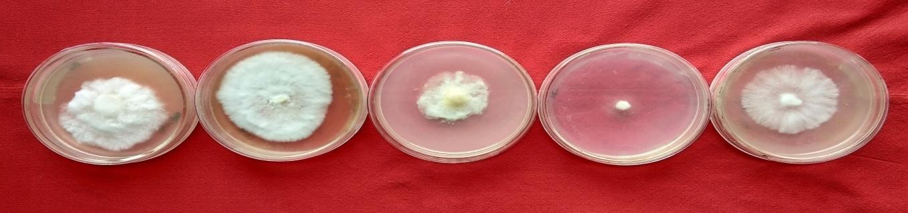

**PDA**

**MEA**

**YEA**

**CDA**

**CEA**

***Pleurotus sajor-caju***

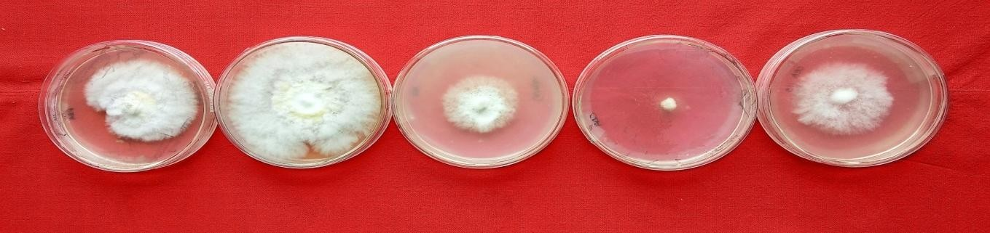

**PDA**

**MEA**

**YEA**

**CDA**

**CEA**

***Pleurotus ostreatus***

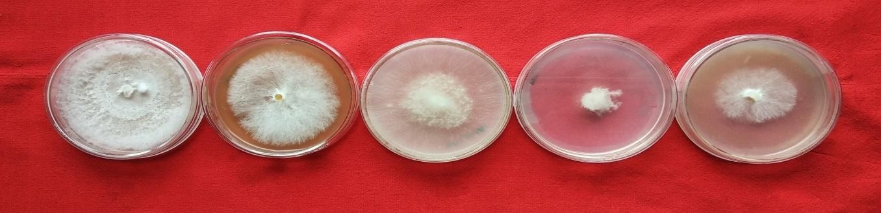

**PDA**

**MEA**

**YEA**

**CDA**

**CEA**

***Pleurotus citrinopileatus***

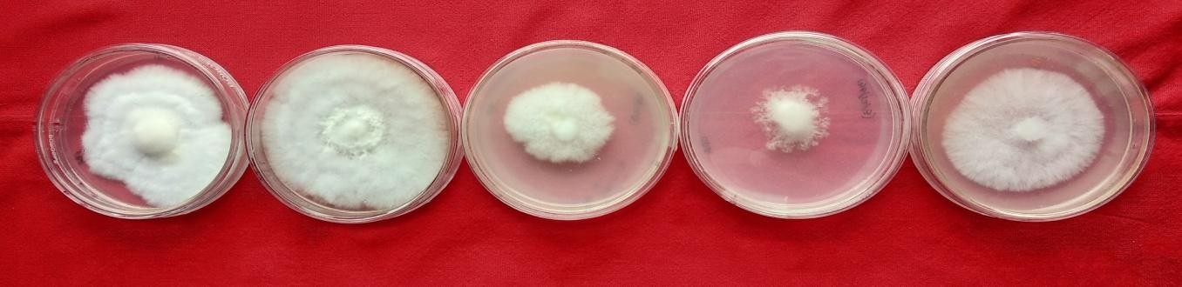

**PDA**

**MEA**

**YEA**

**CDA**

**CEA**

***Pleurotus florida***

***Pleurotus djamor***

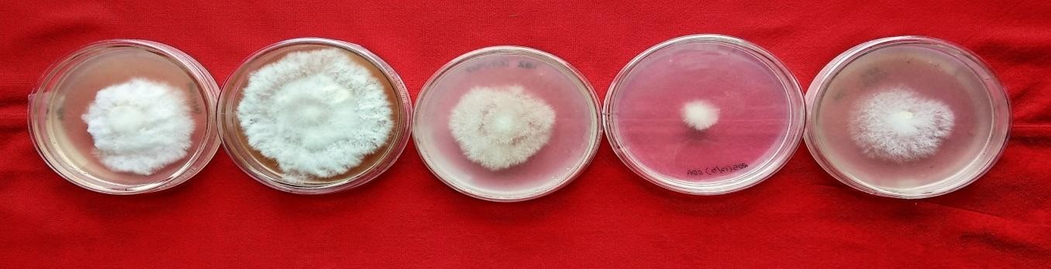

**PDA**

**MEA**

**YEA**

**CDA**

**CEA**

Fig. 1: Cultural characteristics of *Pleurotus* spp. on different solid media of Potato Dextrose Agar (PDA), Malt Extract Agar (MEA), Yeast Extract Agar (YEA), Czapek’s Dox Agar (CDA) and Carrot ExtractAgar(CEA)

**3.1.2 Mycelial growth of *Pleurotus* spp. at different temperature**

The isolates of *Pleurotus spp.*  was incubated at five different temperature regimes ranging between 15°C to 30°C for 14 days. The data presented in Table 2 indicates that maximum mycelial growth of *Pleurotus* species was observed at 20°C and minimum mycelial growth at 35⁰C (Fig. 2). The maximum mycelial growth was showed by *P. sajor-caju*, *Pleurotus ostreatus*, *P. citrinopileatus* and *P. djamor at* 20°C (90.00 mm) and minimum at 15°C. At 25°C, *Pleurotus florida* recorded maximum mycelial colony diameter (90.00 mm) followed by 88.67 mm at 20°C.

**Table 2.** Effect of different temperature for the mycelial growth of *Pleurotus* species

|  |  |  |  |  |  |  |
| --- | --- | --- | --- | --- | --- | --- |
| Sl. No. | Media | Mycelial growth (mm) | | | | |
|  |  | *P. sajor-caju* | *P. ostreatus* | *P. citrinopileatus* | *P. florida* | *P. djamor* |
| 1 | 15oC | 57.00 | 82.33 | 53.00 | 63.00 | 87.00 |
| 2 | 20oC | 87.67 | 90.00 | 90.00 | 88.67 | 90.00 |
| 3 | 25oC | 90.00 | 77.33 | 76.67 | 90.00 | 88.67 |
| 4 | 30oC | 76.33 | 65.00 | 59.00 | 48.33 | 72.00 |
| C.D0.05 | Treatment | 0.97 | | | | |
|  | Species | 1.09 | | | | |
|  | T x S | 2.18 | | | | |

**3.1.3 Mycelial growth of *Pleurotus* spp. on different pH levels**

The PDA media was adjusted at different pH levels of 5.0, 6.0, 7.0 and 8.0 and incubated at 24±1⁰C and the growth was recorded on 14 DAI. The result presented in Table 3 revealed that the maximum mycelial growth was seen in pH 7.0 followed by pH 6.0 while the minimum growth was recorded in pH 8.0.

**Table 3.** Effect of different pH for the mycelial growth of *Pleurotus* species

|  |  |  |  |  |  |  |
| --- | --- | --- | --- | --- | --- | --- |
| Sl. No. | Media | Mycelial growth (mm) | | | | |
|  |  | *P. sajor-caju* | *P. ostreatus* | *P. citrinopileatus* | *P. florida* | *P. djamor* |
| 1 | 5 | 88.00 | 77.00 | 63.67 | 43.00 | 66.67 |
| 2 | 6 | 64.67 | 64.33 | 90.00 | 90.00 | 82.00 |
| 3 | 7 | 90.00 | 90.00 | 88.33 | 75.00 | 90.00 |
| 4 | 8 | 54.67 | 56.00 | 54.00 | 84.00 | 73.00 |
| C.D0.05 | Treatment | 1.23 | | | | |
|  | Species | 1.38 | | | | |
|  | T x S | 2.77 | | | | |

The maximum and minimum colony diameter of *P. sajor-caju, Pleurotus ostreatus* and *P. djamor* was recorded at pH 7.0 (90.00 mm) and pH 8.0 (54.67, 56.00 and 84.00 mm). However, the average colony diameter of *P. citrinopileatus* and *Pleurotus florida* was found maximum at pH 6.0 (90.00 mm) while least growth was recorded in pH 8.0 (54.00 and 43.00 mm). Therefore, it is evident from the experimental data that the maximum colony diameter of *Pleurotus sajor-caju, Pleurotus ostreatus* and *Pleurotus djamor* was noted at pH 7.0 while in case of *Pleurotus citrinopileatus* and *Pleurotus florida* maximum colony was noticed in pH 6.0. The *Pleurotus* species was tested for its suitability at different pH range between 5.0 - 8.0 and it was observed that pH 7.0 have maximum mycelial growth followed by pH 6.0 (Fig 3).

The above experimental data are in accordance with Jatav *et al.,* (2012) who observed malt extract as the most suitable medium for the growth of *Pleurotus* species. Sardar *et al.,* (2015) noted that PDA was the suitable media for the mycelial growth of *Pleurotus* species. Nasium et al., (2001) reported that *Pleurotus* spp. showed maximum growth on MEA. Various solid media were evaluated on the effect of different media *viz.,* CMA, MEA, PDA, OMA. Among them, MEA has maximum mycelial growth while minimum in CDA. The mycelium of *P. sajor-caju* (Baral et al., 2018) was grown maximum in MEA medium*.* Kumar and Kushwaha (2014) showed PDA as the best media for different *Pleurotus* species.

Earlier, optimum temperature within this range was reported by Zharare et al., (2010) recording the maximum mycelial growth of *Pleurotus* strains at 20-25°C. *Pleurotus* spp. showed maximum mycelial growth at 25oC as reported by Nayak *et al.* (2015). Rout *et al*. (2015) examined on the mycelial growth of oyster species and observed mycelial growth of oyster mushroom better at 25oC. Sardar et al., (2015) reported growth of *Pleurotus* spp. at 25°C. Similarly, Gorai and Sharma (2018) recorded 25°C as the optimum temperature for most of the *Pleurotus* species.

According to Yadav and Chandra (2014) investigations, the mycelial growth of *Pleurotus* spp. performed well at pH 7.0. Sardar *et al.,* 2015 found that *Pleurotus* species exhibited maximum mycelial growth at pH 6.0. Gorai and Sharma (2018) observed maximum growth of mycelium at pH 6.5 - 7.5. The maximum mycelial growth of *Pleurotus* species was obtained at pH 7.0 (Kushwaha *et al.,* 2011; Sutha and Eswaran, 2016). Tolentino *et al.,* (2016) observed that the best mycelial growth for *P. sajor-caju* was evident at pH 7.

4. Conclusion

Malt Extract Agar (MEA) was found to be the best suitable media for the mycelial growth of different *Pleurotus* species followed by potato dextrose agar (PDA) media. The maximum mycelial growth of *Pleurotus* species was recorded at 20°C followed by 25°C and minimum growth was noticed at 30°C which was statistically at par with 15°C. The pH 7.0 was found to be the best for the mycelial growth of *Pleurotus* species tested followed by pH 6.0.

Competing interests

There is no competing interests

References

Baral, D., Roy, A. and Thapa, A. (2018). Strain improvement in oyster mushroom (*Pleurotus* spp.) through hybridization. *The Pharma Innovation Journal,* 7 **(4)**: 286-289.

Chang, S.T. and Miles, P.G. (2004). Mushrooms: cultivation, nutritional value, medicinal effect, and environmental impact. 2nd Edition.

Gorai, B. and Sharma, R. (2018). Determination of optimum temperature and pH for mycelial growth of *Pleurotus* spp. strains. *International Journal of Microbiology Research*, 10 **(6)**: 1287-1289.

Jatav, R.S., Gupta, A.K., Anila, D. and Meena, A.K. (2012). Studies of different physical factors on mycelia growth of blue oyster mushroom (*H. ulmarius* (Bull.) Redhead). *International Journal of Agricultural and Statistical Science,* 8 **(1):** 347-354.

Kumar, R. and Kushwaha, K.P.S. (2014). Evaluation of different strains of oyster mushroom for their cultural, morphological and yield attributes. Proceeding of the 8th International Conference on Mushroom Biology and Mushroom Products.

Kushwaha, K.P., Singh, P.K., Mishra, K.K. and Bhardwaj, S.B. (2011). Cultural and morphological studies of *Hypsizygus ulmarius*, Blue oyster mushroom. *Pantnagar Journal of Research,* 9 **(2)**: 202-205.

Mahadevan, K. and Shanmugasundaram, K. (2018). Comparative effect of different culture media on mycelial growth performance of *Pleurotus sapidus*. *Journal of Pharmacognosy and Phytochemistry,* 7 **(4):** 874-878.

Mandeel, Q., Al-Laith, A. and Mohamed, S. (2005). Cultivation of oyster mushrooms (*Pleurotus* spp.) on various lignocellulosic wastes. *World Journal of Microbiology and Biotechnology,* **4**:601-607.

Manpreet, K., Giridhar, S., Khanna, P.K. (2004). *In vitro* and in vivo antioxidant potentials of *Pleurotus florida* in experimental animals. *Mushroom Research*, **13**:21-26.

Nasium, G., Malik, S.H, Bajwa, R., Afzal, M., Mian, S.W. (2001). Effect of three different culture media on mycelial growth of oyster and chinese mushroom. *Journal of Biological Sciences,* 1 **(12):** 1130-1133.

Nayak, B.K., Bathmarajan, V., Nanda, A. (2015). Effect of substrate and environmental parameters on the production of oyster mushroom in Pondicherry. Der Pharmacia Letter **7:** 74-79.

Narayana, J. and Janardhanan, K.K. (2000). Antioxidant and antitumor activity *of Pleurotus florida*. *Current Science,* **9**:941-943.

Rout, M.K., Mohapatra, K.B., Mohanty, P. and Chandan, S.S. (2015). Studies on effect of incubation temperature and light intensity on mycelial growth of oyster species. *Journal of Crop and Weed,* **11:** 44-46.

Sanmee, R., Dell, B., Lumyong. P., Izumori, K.and Lumyoung, S. (2003). Nutritive value of popular wild edible mushrooms from northern Thailand. *Food Chemistry,* **82**:527-532.

Sardar, H., Ali, M.A., Ayyub, C.M. and Ahmad, R. (2015). Effects of different culture media, temperature and pH levels on growth of wild and exotic *Pleutrous* species. *Pakistan Journal of Phytopathology,* 27 **(2):** 139- 145.

Sutha, R.K. and Eswaran, A. (2016). Effect of surface sterilants on the tissue germination and biomass production of *Hypsizygus ulmarius* (Bull.:Fr.) Redhead (blue oyster mushroom). *Asian Journal of Pharmaceutical and Biological Research,* 7 **(1):** 2289-2293.

Tolentino, J.J.V., Kalaw, S.P., Reyes, R.G. and Undan, J.R. (2016). Mycelial growth performance of three species on corn varieties in the Philippines. *Advances in Environmental Biology,* 10 **(7)**: 155-160.

Yadav, M.K. and Chandra, R. (2014). Evaluation of culture media, pH and temperature for mycelial growth of different strains of *Pleurotus* species. *Agriculture Science Digest*, **34**: 299 – 302.

Zharare, G.E., Kabanda, S.M. and Poku, J.Z. (2010). Effect of temperature and hydrogen peroxide on mycelial growth of light *Pleurotus* strains. *Scientia Horticulture*. **125**: 95-102.