***Review Article***

**Exogenously Applied Double-Stranded RNAs: A Novel Strategy to Trigger RNA Silencing for Sustainable Plant Disease Management**

**Abstract**

The emergence of plant diseases poses a significant threat to global food security and agricultural sustainability. Conventional management strategies, including chemical pesticides, often lead to environmental threats and human health concerns, while cultural practices frequently exhibit limited efficacy. Furthermore, the unavailability of resistant sources, particularly against viral pathogens, necessitates the development of innovative control measures. RNA interference (RNAi), a highly specific gene silencing mechanism, has emerged as a promising approach for plant disease management. Among RNAi-based strategies, the exogenous application of synthetic double-stranded RNAs (ds-RNAs) has gained attention for its ability to induce RNA silencing in pathogens. This approach involves the delivery of ds-RNAs designed to target essential pathogen genes, leading to sequence-specific suppression upon uptake. Foliar spraying and mechanical application have been employed as effective delivery methods, while advancements in nanotechnology have enhanced ds-RNA stability, uptake efficiency, and persistence under field conditions. Several studies have demonstrated the efficacy of exogenous ds-RNA applications in mitigating disease severity and enhancing plant resistance across diverse patho-systems. However, challenges remain in optimizing ds-RNA design, improving uptake efficiency, addressing environmental persistence, and establishing regulatory frameworks for field deployment. Despite these challenges, exogenous RNAi represents a sustainable and environmentally safe alternative to conventional chemical control methods, particularly in cases where genetic resistance is unavailable, offering a novel paradigm for plant disease management.

**Keywords:** ds-RNA, Agricultural sustainability, RNA interference, *Botrytis cinerea* and *Meloidogyne incognita*

**Introduction**

The agricultural sector plays a crucial role in supporting the economies of developing nations such as India. However, biotic stresses, including pests, fungal pathogens, oomycetes (Bebber and Gurr, 2015), bacterial infections, and nematode infestations, significantly reduce crop yields annually (Halder *et al*., 2022). Various plant protection strategies, including cultural practices, host resistance, and chemical pesticides, face limitations due to low efficacy, the rapid emergence of resistant pathogen strains (Fisher *et al*., 2018), environmental concerns, and health risks. Consequently, there is an increasing demand for sustainable and eco-friendly disease management strategies that minimize ecological and human health impacts. The use of biomolecules such as nucleic acids, lipids, sugars, and proteins, which leverage endogenous plant defence mechanisms, has emerged as a promising alternative to chemical pesticides (Qiao *et al*., 2021). Advances in plant-pathogen interaction research have deepened our understanding of disease development and resistance, facilitating novel disease management strategies. RNA interference (RNAi)-based approaches have shown considerable potential for plant disease control (Kuo and Falk, 2020); however, the critical question remains: to what extent can this strategy effectively enhance the self-protection of our food crops?

**History of RNA silencing**

In 1928, Wingard observed that tobacco plants infected with tobacco ringspot virus (TobRV) developed symptoms only on initially infected leaves, while upper leaves remained asymptomatic and resistant, a phenomenon termed “recovery” (Griffith, 1928). This suggested RNA interference (RNAi) as a viral defence mechanism, but its mechanisms remained unclear until 1997 (Baulcombe, 2004). In 1972, bidirectional transcription during phage infection was shown to generate double-stranded RNA (dsRNA), reducing gene product synthesis (Spiegelman et al., 1972). In 1983, small complementary RNAs in bacteria were identified as translation inhibitors by blocking mRNA-ribosome binding (Simons and Kleckner, 1983). Although RNA duplex formation in prokaryotes is unrelated to RNAi, antisense RNA has been developed as a gene suppression tool. In 1990, Napoli and Jorgensen observed gene silencing in petunias when additional pigment biosynthesis genes led to reduced pigmentation, termed "co-suppression" (Napoli et al., 1990). In 1992, Romano and Macino reported a similar phenomenon, "quelling," in *Neurospora crassa* (Romano and Macino, 1992). In 1993, Lindbo et al. proposed post-transcriptional gene silencing (PTGS) in TEV-immune transgenic plants, where RNA-dependent RNA polymerases (RDRs) generated small complementary RNAs, leading to RNA degradation (Lindbo et al., 1993). Dougherty and Parks (1995) refined this model, suggesting that 10–20 nucleotide RNA molecules conferred sequence specificity in RNA degradation (Dougherty and Parks, 1995). RNA silencing was first identified in animals when Guo and Kemphues (1995) observed degradation of C. elegans par-1 mRNA upon introducing sense or antisense RNA. In 1998, Fire and Mello demonstrated that dsRNA induced gene silencing in C. elegans, coining "RNA interference" (RNAi) (Fire et al., 1998). They received the Nobel Prize in 2006 for this discovery. That year, engineered E. coli expressing dsRNA silenced genes in nematode larvae upon ingestion, confirming RNA-mediated interspecies information transfer (Timmons and Fire, 1998). Meanwhile, Waterhouse et al. (1998) showed that dsRNA triggered silencing in plants, with a single self-complementary transcript being sufficient to induce RNAi. In 1999, Hamilton and Baulcombe identified small interfering RNAs (siRNAs) as key molecules in sequence-specific gene silencing. These 21–25 nucleotide siRNAs derived from dsRNA guided mRNA degradation (Hamilton and Baulcombe, 1999). In 2000, two studies in Drosophila cell extracts confirmed dsRNA processing into 21–23 nucleotide siRNAs that bound and cleaved complementary mRNA (Hammond et al., 2000; Zamore et al., 2000). In 2001, Bernstein et al. identified Dicer, an RNase III enzyme, as the catalyst generating ~22-nucleotide siRNAs from dsRNA (Bernstein et al., 2001).

**RNA Silencing: Transgenic *vs*. Non-Transgenic Approaches**

RNA interference (RNAi), also known as gene quelling in fungi (Romano & Macino, 1992), post-transcriptional gene silencing (PTGS) in eukaryotes (De Carvalho et al., 1992), and co-suppression in plants (Napoli et al., 1990), is a conserved eukaryotic mechanism regulating post-transcriptional gene expression (Hannon, 2002) and defending against viruses and transposons (Holoch & Moazed, 2015). Over the past decade, RNAi has emerged as a precise genetic tool for silencing target genes in insects, mammals, and fungi (Tomoyasu et al., 2008), offering sequence-specific pest control with minimal non-target effects (Huvenne & Smagghe, 2010). In agriculture, RNAi provides an efficient alternative to traditional breeding, addressing limitations like long cycles and resistance breakdown. Host-induced gene silencing (HIGS) and spray-induced gene silencing (SIGS) are key RNAi-based strategies for pest and pathogen control (Nowara et al., 2010; Koch et al., 2016, 2019). HIGS involves genetically engineered plants producing dsRNA targeting pathogen virulence genes, reducing pathogenicity upon infection (Koch et al., 2013). Genetic transformation is commonly achieved via *Agrobacterium tumefaciens*, which transfers modified T-DNA into the plant genome (Schumann & D’Arcy, 2010; Lacroix & Citovsky, 2019), enabling stable RNAi-based resistance across generations (Horsch et al., 1985). RNAi-based antiviral resistance significantly impacted agriculture, particularly in developing PRSV-resistant papaya in Hawaii, where it preserved the industry despite the absence of alternative controls (Gonsalves, 2006). Engineered plants produce dsRNA or hairpin RNAs to trigger RNAi (Waterhouse et al., 1998), but commercial adoption remains limited due to intellectual property restrictions, high regulatory costs (Dalakouras et al., 2020), prolonged approval processes (Ghosh et al., 2023), and public concerns about GMOs (Pixley et al., 2019). In contrast, SIGS, a non-transgenic approach using exogenous dsRNA applications, offers a cost-effective, flexible alternative for disease management (Kuo & Falk, 2020; Taning et al., 2020), with costs ranging from USD 0.5–1 per gram.

**Spray-Induced Gene Silencing (SIGS): A Non-Transgenic Alternative**

Non-transgenic RNA interference (RNAi) involves the exogenous application of double-stranded RNAs (ds-RNAs) via foliar sprays, trunk or stem injections, root absorption, or seed treatments (He *et al*., 2022). Upon application, dsRNA is absorbed by plant cells or pathogens, triggering RNA silencing (Kamthan *et al*., 2015). However, the plant cell wall acts as a physical barrier, influencing dsRNA uptake efficiency (Islam *et al*., 2019). Consequently, the effective delivery of exogenous ds-RNAs, siRNAs, or hp-RNAs into plant cells is regarded as a critical step in activating the RNA interference (RNAi) machinery. Exogenous ds-RNAs can activate RNAi in both plants and pathogens (Dubrovina & Kiselev, 2019). The effectiveness of delivery varies among plant organs. High-pressure leaf and bud spraying being more efficient than petiole absorption or trunk injection (Dalakouras *et al*., 2018). Additionally, bio-clay-loaded ds-RNAs exhibited enhanced uptake into the spongy mesophyll compared to naked dsRNA (Mitter *et al*., 2017). Spray-applied dsRNA uptake was significantly higher in wounded wheat coleoptiles than in intact tissues (Song *et al*., 2018).

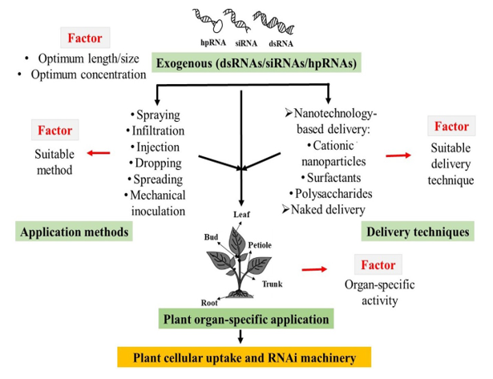**Methods of exogenous application of dsRNA (Das and Sherif, 2020)**

**Fig 1. Illustrating the methods of exogenous application of dsRNA**

**Advantage and disadvantage of SIGS**

Non-transgenic RNAi enables pathogen control without genetic modification, improving regulatory approval and public acceptance. Its adaptability allows application across diverse plant species and pathogens. However, challenges such as dsRNA degradation, delivery efficiency, and the need for sustained efficacy remain (Mitter et al., 2017). These limitations in SIGS can be mitigated using nanoparticles like clay nanosheets, carbon nanotubes, and cationic nanoparticles, alongside surfactants or peptide-based RNA delivery systems. Such carriers enhance dsRNA stability, uptake, and gradual release, ensuring prolonged protection. Nanoparticles also improve agrochemical efficiency, promoting plant growth, nutrient absorption, and soil health (Worrall et al., 2018). Additionally, nano sensors enable real-time crop health monitoring and early disease detection, preventing large-scale outbreaks. Nanotechnology applications in agriculture follow two approaches: (a) direct nanoparticle use and (b) nanoparticle-based pesticide formulations for targeted delivery (Ghosh et al., 2023).

To address these challenges, Mitter et al. (2017) developed ‘Bio-Clay,’ using layered double hydroxide (LDH) nanosheets to encapsulate dsRNA, extending RNAi protection from 5 to 20 days and enabling systemic movement (Xu et al., 2006). LDH-loaded dsRNA targeting Cucumber Mosaic Virus (CMV) in tobacco provided over 20 days of protection, with resistance in newly emerged leaves (Mitter et al., 2017a). Similarly, Koch et al. (2016) successfully suppressed *Fusarium graminearum* in barley using foliar dsRNA targeting *CYP51* genes, essential for fungal ergosterol biosynthesis. By enhancing dsRNA stability, delivery, and systemic movement, nanoparticles make SIGS a viable and sustainable RNAi-based crop protection strategy.

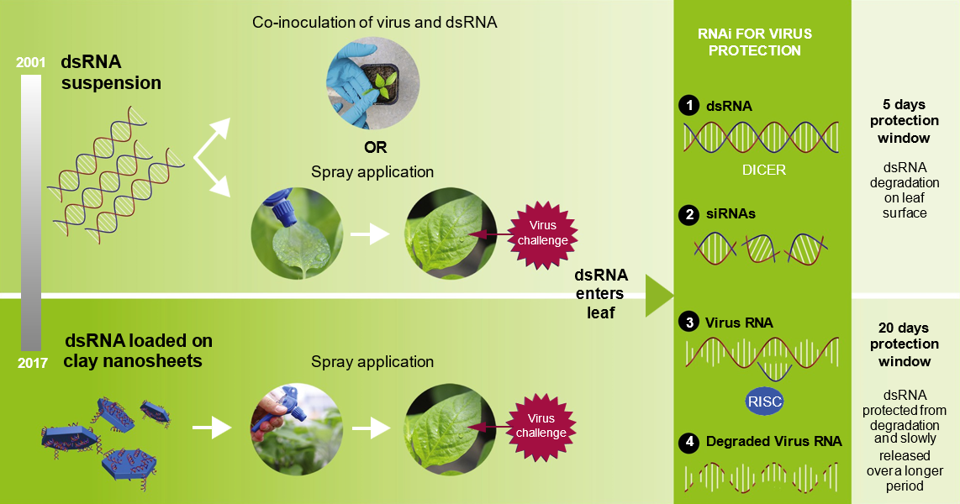

Fig.2: A schematic representation illustrates exogenous dsRNA application via naked dsRNA (upper) and nanosheet-loaded dsRNA (lower)

Naked dsRNA, delivered through co-inoculation or foliar spray, induces RNAi for up to five days. In contrast, nanosheet-loaded dsRNA, applied via foliar spraying, enhances stability and controlled release, extending RNAi-mediated protection for up to 20 days post-application (**Mitter *et al*., 2017**).

**Illustration of the various Nano bioconjugates in crop protection**

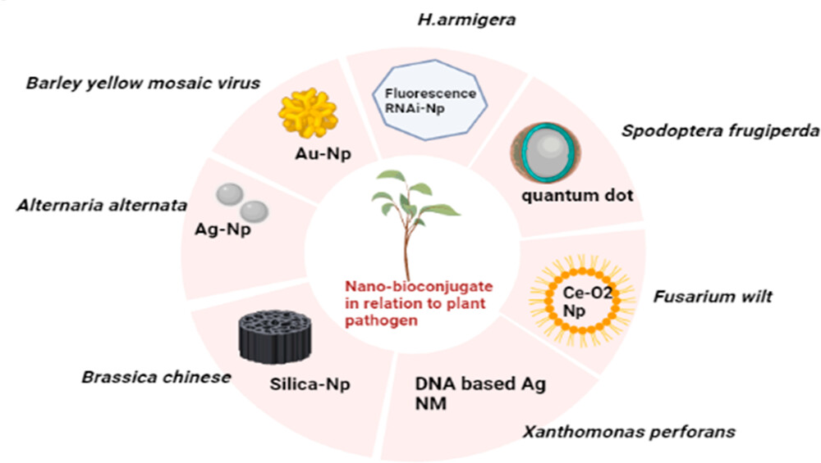

**Ghosh, *et al*., 2023**

**Fig .3 Different Nano bioconjugates in crop protection**

**Mode of entry and movement of dsRNA in plant**

The uptake and translocation of dsRNA in plants occur through multiple pathways. After foliar application, dsRNA penetrates through wounds or direct cellular uptake, crossing the cuticle, apoplast, cell wall, and plasma membrane to access the RNAi machinery. Dicer-like proteins process dsRNA into primary siRNAs, which trigger gene silencing and are amplified into secondary siRNAs by RDR6 and DCLs. These secondary siRNAs spread via plasmodesmata to mesophyll cells and vascular tissues, enabling systemic RNAi-mediated defence against pathogens through phloem translocation (**Kim *et al*., 2019; Broglie *et al*., 1991**). Once the dsRNA has successfully entered the plant and moved through its vascular system, the Mechanisms of RNAi take place.

**Kim *et al.,* 2019**

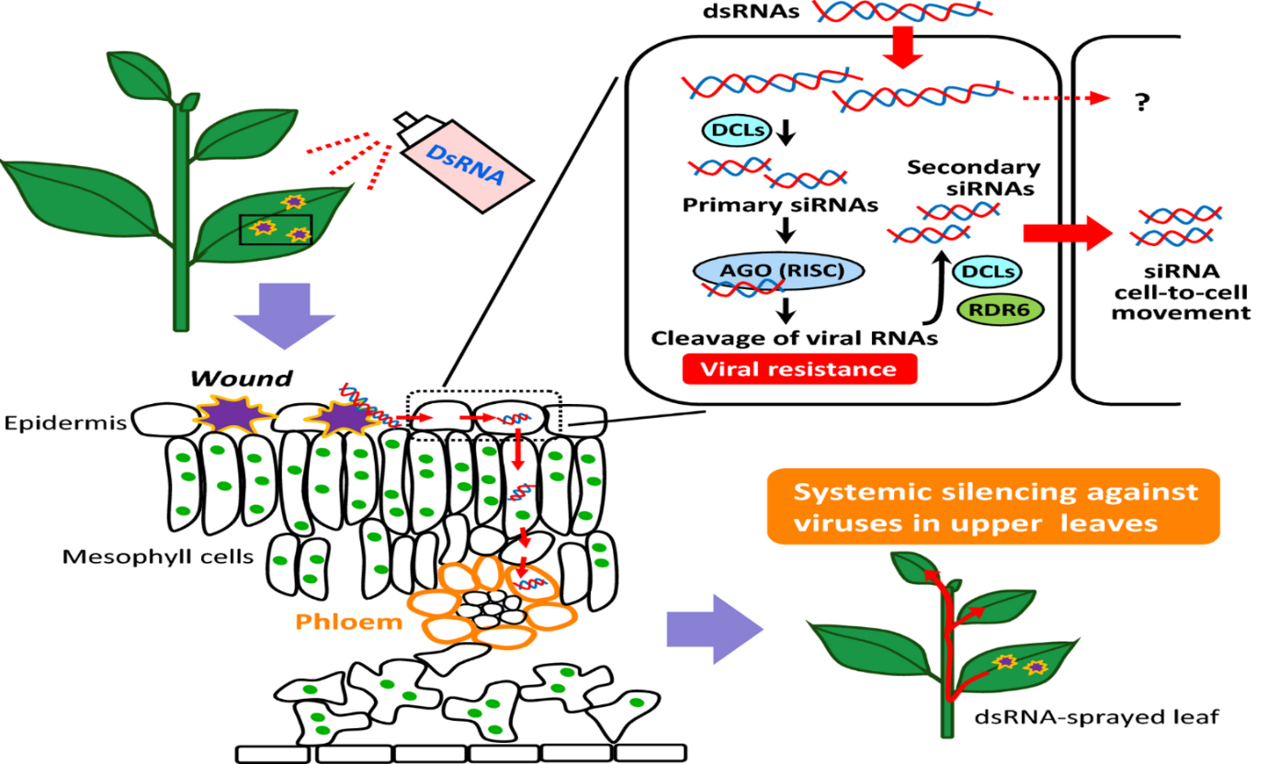

**Fig.4 Uptake and translocation of dsRNA in plants**

**Mechanisms of spray inducing gene silencing**

RNA silencing is triggered by double-stranded RNA (dsRNA), leading to homology-dependent gene suppression. Upon absorption, exogenous ds-RNAs are cleaved by Dicer-like enzyme into small interfering RNAs (siRNAs) or microRNAs (miRNAs), which silence pathogen genes or disrupt their development (**Zrachya *et al*., 2007**). These small RNAs are incorporated into the RNA-Induced Silencing Complex (RISC), guided by Argonaute (Ago) proteins. The Argonaute (Ago) protein consists of two key domains: the PAZ domain, which binds to siRNA, and the PIWI domain, which imparts endo-nucleolytic (slicer) activity to RISCs programmed for the cleavage of target RNAs (**Brodersen and Voinnet, 2006**). RISC complex targets complementary RNA sequences, leading to their cleavage (siRNAs) or inhibition of translation (miRNAs), regulating gene expression and defending against viruses and transposons (**Torres-Martinez & Ruiz-Vázquez, 2017**). In specific instances, RNA-dependent RNA polymerases play a key role in amplifying the RNA silencing process, thereby promoting sustained and continuous gene silencing. This amplification ensures long-term suppression of targeted genes, contributing to more effective regulation (**Sijen et al., 2001**).

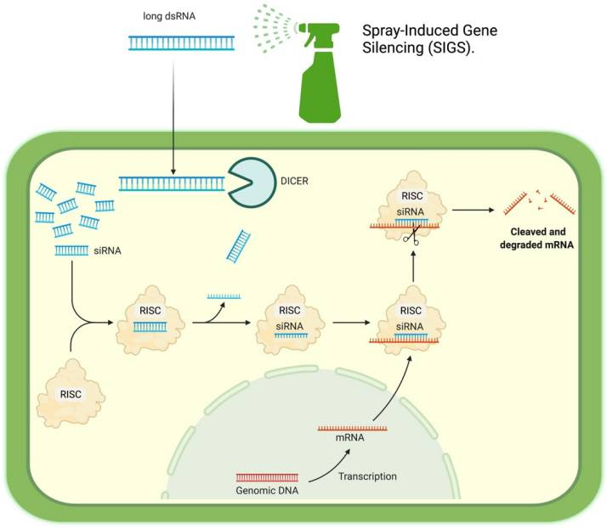

**(Soto and Cerdas, 2021)**

**Fig 5: Spray Induced Gene Silencing (SIGS)**

In both insect and plant cells, Dicer/Dicer-like (DCL) proteins process double-stranded RNA into siRNAs, which associate with Argonaute (AGO) proteins to form RNA-Induced Silencing Complexes (RISCs). In insect cells, siRNAs bind to Argonaute (AGO) proteins, forming RNA-Induced Silencing Complexes (RISCs), which recognize and degrade complementary mRNA sequences, thereby inducing post-transcriptional gene silencing (PTGS). In plants, siRNAs generated by DCL4, DCL2, and DCL3 are loaded onto AGO1 and AGO4, regulating gene expression through multiple mechanisms. These include mRNA cleavage, amplification of secondary siRNAs via RNA-dependent RNA polymerase (RDRP), transcriptional gene silencing (TGS) through histone modifications, and de novo DNA methylation, contributing to epigenetic regulation and immune responses (**Vatanparast et al., 2024**).

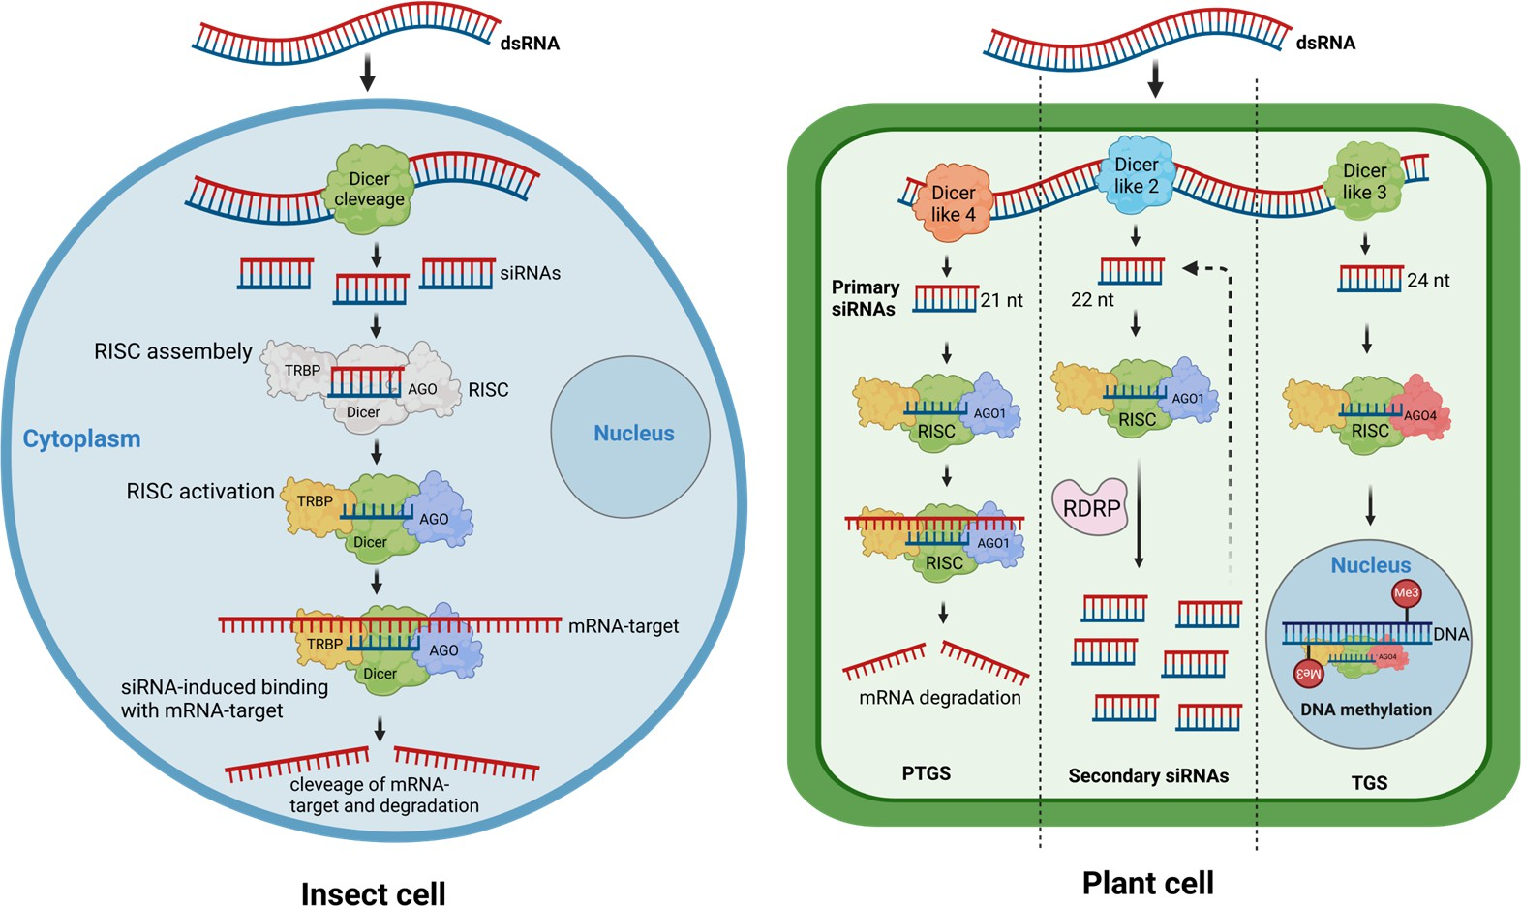

**Fig.6: A schematic representation of the RNA interference pathway (exogenous) in insect cells (on the left) and plant cells (on the right) (Vatanparast *et al*., 2024)**

**Methods of dsRNA production**

Currently, the exogenous application of dsRNA represents a promising strategy for utilizing RNAi to manage pathogens in agriculture. For implementing exogenous approaches, silencing experiments have been effectively conducted using sequence-specific small RNA molecules generated through various methods. The production of dsRNA can be achieved through either in vitro or in vivo synthesis techniques (**Gebremichael *et al*., 2021**).

**Voloudakis *et al*., 2015**

**Fig .7 Comparison of In-vitro and In-vivo methods for dsRNA production**

**In-vitro methods:** The in vitro methods for dsRNA production typically involve enzymatic or transcription-based approaches. In vitro methods offer controlled, reproducible systems for synthesizing high-quality dsRNA.

**One-step PCR, Transcription and hybridization**

The target sequence of interest is cloned into a plasmid vector containing T7 RNA polymerase promoters on both sides of the poly-linker region. The poly-linker region, also known as a multiple cloning site (MCS), is a short sequence in a plasmid vector that contains multiple restriction enzyme recognition sites. This region allows for the insertion of foreign DNA fragments at specific locations using compatible restriction enzymes, facilitating cloning and genetic modifications. After cloning, PCR amplification is performed using T7-specific primers, and the product is analysed on an agarose gel. The amplified DNA then undergoes in vitro transcription by T7 RNA polymerase, generating complementary single-stranded RNA (ssRNA) molecules. These ss-RNAs are subsequently annealed to form double-stranded RNA (dsRNA).

**Two-step PCR, Transcription and hybridization**

This method is a popular approach for synthesizing double-stranded RNA (dsRNA) in vitro. The target gene sequence is amplified using PCR with specific primers containing T7 RNA polymerase promoter sequences at their 5′ ends, followed by a second PCR to incorporate the T7 promoter at the opposite end of the target gene sequence. The amplified product is analysed via agarose gel electrophoresis to confirm its size and quantity. The PCR products then serve as templates for in vitro transcription using T7 RNA polymerase, generating two complementary single-stranded RNA (ssRNA) molecules. These ss-RNAs are subsequently mixed and annealed to form double-stranded RNA (dsRNA).

**One-step PCR, Transcription and Replication**

In this approach, in vitro, synthesized dsRNA is obtained in a single reaction that combines the catalytic activities of T7 DdRP & phi6 RdRP. A specific DNA sequence is amplified using PCR, incorporating a T7 promoter at one end and phi6 RNA-dependent RNA polymerase (RdRP) at the other end. The PCR product is further run on agarose gel to validate the accuracy of PCR amplification. T7 DNA dependent RNA polymerase (T7 DdRP) binds to the T7 promoter on the PCR product and initiates transcription, resulting, synthesis of single-stranded RNA (ssRNA) from the DNA template. The phi6 RNA dependent RNA polymerase (phi6 RdRP) recognizes the specific sequence on the ssRNA and utilize as a template to synthesize a complementary RNA strand.

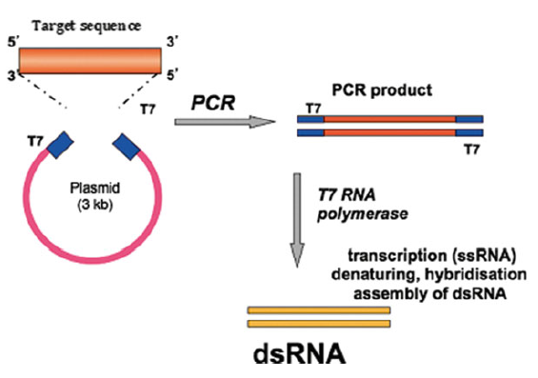

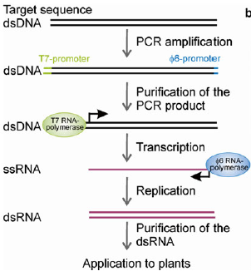

Fig .8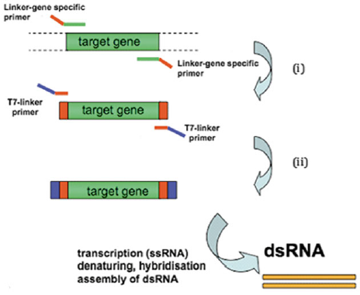: **One-step PCR, Transcription and hybridization**

Fig .10: **One-step PCR, Transcription and Replication**

**Voloudakis *et al*., 2015**

Fig .9: **Two-step PCR, Transcription and hybridization**

**In-vivo methods**

***Escherichia coli* using T7 RNA Polymerase**

To date, most studies have utilized *Escherichia coli* strains, particularly the RNase III-deficient *E. coli* HT115/DE3, for dsRNA production under the regulation of an inducible T7 promoter (**He *et al*., 2022**). Several of the techniques used for the production of recombinant proteins in *E coli* have also been adapted for the production of double-stranded RNAs (**Nwokeoji *et al*., 2017**). The T7 DNA-dependent RNA polymerase (T7 DdRp) system is among the most commonly employed expression systems for protein production. It is highly characterized, with a variety of genetically engineered *Escherichia coli* strains commercially available to accommodate specific recombinant products. This accessibility minimizes the time and cost required for optimization in small-scale laboratory applications and serves as a cost-efficient foundation for research laboratories to produce larger quantities of dsRNA as an alternative to in vitro transcription (IVT) (**Tegel *et al*., 2011**).

dsRNA sequences from selected genes were cloned into vectors L4440 and pClone_VR_2 using primers with restriction sites, amplified via PCR, verified on agarose gel, and purified. The fragments and vectors were digested, ligated with T4 DNA ligase, and transformed into E. coli DH5α. Recombinant colonies were screened, plasmids extracted, and introduced into E. coli HT115 (DE3). Cultures were grown in LB medium with ampicillin, stored as glycerol stocks, and induced with IPTG or lactose using a fed-batch fermentation strategy. Bacterial pellets were collected and stored at -20°C for dsRNA extraction, with production optimized using LB, TB, and M9 media with glycerol (**Rosa *et al*., 2024**).

***Pseudomonas syringae*****using Phage phi6 Polymerase complex**

A bacteriophage-based dsRNA production system using Pseudomonas syringae and ϕ6 RNA-dependent RNA polymerase (RdRp) offers an alternative to E. coli-based systems (Aalto et al., 2007). This method involves co-transfection with three plasmids: one encoding T7 DNA-dependent RNA polymerase (DdRp), another carrying ϕ6 L genes for RdRp and capsid proteins, and a third containing a single-stranded RNA (ssRNA) template flanked by T7 and ϕ6 promoters. T7 DdRp transcribes ssRNA, which is encapsulated in ϕ6 capsids, where ϕ6 RdRp synthesizes the complementary strand, forming a dsRNA duplex. Encapsulation shields dsRNA from RNase degradation, yielding ~1.6 mg per gram of wet cells. However, initial instability and inefficiencies in processing diverse RNA sequences led to modifications incorporating additional ϕ6 genes, enhancing plasmid stability, dsRNA yield, and reproducibility. The optimized system effectively suppressed Tobacco Mosaic Virus (TMV) via exogenous dsRNA application (Niehl et al., 2018). Despite these improvements, dsRNA production in P. syringae (7 mg/L at 4 × 10⁹ cells/mL) remains lower than in E. coli (182 mg/L) (Papić *et al*., 2018), with limitations including slower growth rates and complex transfection requirements (Young *et al*., 1977).

**Application of Spray Induced Gene Silencing (SIGS)**

The efficacy of RNAi technology in managing fungal plant pathogens depends on overcoming structural and physiological barriers of the fungal cell wall and ensuring efficient dsRNA delivery to actively growing hyphal regions (**Šečić *et al*., 2021**). This review examines the application of RNAi-based strategies to enhance crop yield and resistance against pests and pathogens. Topical application of dsRNA or siRNA targeting ergosterol biosynthesis genes (*CYP51A, CYP51B,* and *CYP51C*) in *Fusarium graminearum* inhibited fungal growth in barley, with dsRNA translocated through the plant vascular system and processed into siRNAs by fungal DICER-LIKE1 (FgDCL-1) (Wang et al., 2016). Similarly, dsRNA targeting *ARGONAUTE* and *DICER* genes in *F. graminearum* provided effective protection in barley (**Werner *et al*., 2020**). Spray-induced gene silencing (SIGS) targeting *Sclerotinia sclerotiorum*, *Botrytis cinerea* in oilseed rape and *Arabidopsis thaliana*, and *Fusarium asiaticum* in wheat significantly reduced fungal infection and disease progression (**McLoughlin *et al*., 2018**). SIGS has also been employed to control sheath blight in rice by targeting *Rhizoctonia solani*. Topical application of dsRNA targeting vesicle trafficking genes *DYNACTIN 1 (DCN1)* and *SUPPRESSOR OF ACTIN 1 (SAC1)*, along with a polygalacturonase virulence gene, effectively reduced fungal biomass and disease symptoms in rice (**Qiao *et al*., 2021**).

Certain Pathogens like *Fusarium* species can produce mycotoxins that contaminate crops, especially grains, and pose significant health risks to humans, animals, and ecosystems (**Moonjely *et al*., 2023**). Targeting genes essential for mycotoxin production has demonstrated significant potential in controlling pathogen spread and decreasing mycotoxin contamination in crops. For instance, the application of dsRNA targeting the *F. culmorum* TRI5 gene resulted in a 53–85% reduction in the production of the trichothecene mycotoxin deoxynivalenol (DON) and notably inhibited fungal growth on wheat leaves (**Tretiakova *et al*., 2022**). Silencing of the *PMA1* gene in *F. graminearum* led to a 90% reduction in DON production and a decrease in pathogenicity by 34.21–35.4% (**Wu *et al*., 2023**).

Late blight, one of the most prevalent potato diseases, is caused by the oomycete *Phytophthora infestans*, which forms zoosporangia that penetrate the epidermis and cuticle to invade leaf tissues (**Hernández-Soto *et al*., 2021**). This results in the spread of the disease throughout the plant, with lesions becoming black after a few days. By utilizing RNAi-mediated post-transcriptional gene silencing, the downregulation of the *StDND1*, *StDMR1*, and *StDMR6* genes can enhance resistance to such pathogens (**Sun *et al*., 2022**).

The protective effect of topically applied virus-specific dsRNAs against plant viruses has been well-documented (**Mitter *et al*., 2017a**). This approach was first demonstrated against *Pepper mild mottle virus* (PMMoV), *Alfalfa mosaic virus* (AMV), and *Tobacco etch virus* (TEV), where mechanically applied dsRNA derived from viral sequences targeting replicase genes effectively suppressed viral infections in their respective host plants (**Tenllado and Díaz-Ruíz, 2001**). Since then, numerous studies have further validated the external application of dsRNA as a strategy to confer viral resistance across various plant species and against a wide range of viruses (**Mitter *et al*., 2017a**).

The use of RNAi for insect pest control has been proposed for over a decade (**Baum *et al*., 2007**). However, the first successful demonstration of exogenous dsRNA application against insect pests was in a study where dsRNA targeting an arginine kinase gene was applied to citrus trees and grapevines, effectively controlling psyllids and sharpshooter pests (**Hunter *et al*., 2012**). After that, the potential of dsRNAs in insect pest management was further demonstrated in various studies (**Cagliari *et al*., 2019**). For example, spraying leaves of *Brassica oleracea* and *Brassica alboglabra* with siRNAs targeting the acetylcholine esterase gene *AchE1* resulted in substantial mortality of the diamondback moth, *Plutella xylostella*, both under controlled laboratory conditions and in the field (**Gong *et al*., 2013**).

**Table 1 Applications of Exogenous dsRNA for Managing Plant Pathogenic Viruses**

|  |  |  |  |  |  |
| --- | --- | --- | --- | --- | --- |
| **Target gene** | **Origin of RNA** | **Application Methods** | **Host Plant** | **Effect** | **References** |
| Coat protein of Sugarcane Mosaic virus | Crude extracts of bacterially expressed hp-RNA | Escherichia coli HT115 co-inoculation spray with dsRNA-producing bacteria | Maize | Total inhibition of virus infection | Gan *et al*., 2010 |
| Nuclear inclusion b-protein of Bean Common Mosaic Virus | Chemically synthesized ds-RNAs | Manual inoculation via coborundum | Tobacco | Reduction of infection up to 45% | Worrall *et al*., 2019 |
| CP gene of Papaya Ringspot Virus (PRSV) | *In vivo* production of ihpRNA-CP279 in RNase III-deficient *Escherichia coli* strain M-JM109lacY. | Mechanically inoculated | Papaya | 65% of papaya plants being free of symptoms and appearing resistant to PRSV | Shen *et al*., 2014 |
| RP gene of PMMoV, TEV, and AMV | *In vitro* synthesized dsRNA using T3 and T7 RNA polymerase | Mechanical inoculation | Tobacco, pepper | Resistance to PMMoV, TEV, and AMV | Tenllado and Díaz-Ruíz (2001) |
| RP gene of PMMoV | Crude extracts of bacterially expressed dsRNA | Mechanical inoculation or spraying with atomizer | Tobacco | Resistance to PMMoV | Tenllado *et al.,* 2003 |
| CMV 2b gene of Cucumber Mosaic Virus (CMV) | *In vivo* production of ds-RNAs in *E. coli* HT115 | Spray inoculation coated with LDH clay nanosheets. | Cow pea | Significant reduction in the formation of local necrotic lesions | Mitter *et al*., 2017a |
| **Target gene** | **Origin of RNA** | **Application Methods** | **Host Plant** | **Effect** | **References** |
| Coat protein and TMV p126 | *in vitro* synthesis dsRNA | dsRNA (virus co-inoculated rubbed on carborundum-dusted tobacco leaves | Tobacco | Efficient inhibition of viral propagation | Niehl *et al*., 2018 |
| Coat protein of Tomato Yellow Leaf Curl Virus (TYLCV) | bacterial expression using *Escherichia coli* minicells |  | Tomato, tobacco | Decrease disease severity and TYLCV viral concentration | Liu *et al*., 2020 |
| HC-Pro and CP genes of Zucchini Yellow Mosaic Virus (ZYMV) | *In vitro* synthesized ds-RNAs | Mechanical inoculation | cucumber, watermelon, squash | Resistance to ZYMV | Kaldis *et al.,* (2018) |
| Viroid-specific ds-RNAs | *In vitro* synthesized dsRNA and siRNA | Mechanical inoculation | Tomato, chrysanthemum, gynura | Resistance to PSTVd, CEVd and CChMVd | Carbonell *et al.,* (2008) |
| CP gene of cognate *Potato virus Y* | *In vitro* transcription and hybridization. | Spray application of ds-RNAs | Potato | Showed higher resistance and exhibited normal growth compared with PVY-treated plants. | Routhu *et al*., 2023 |
| RP gene of PMMoV; 2b supressor of CMV2b | *In vitro* transcribed RP dsRNA, crude extracts of bacterially expressed 2b dsRNA naked /LDH loaded | Spray inoculation | Tobacco, cowpea | Resistance to PMMoV and CMV | Mitter *et al.* (2017) |
| **Target gene** | **Origin of RNA** | **Application Methods** | **Host Plant** | **Effect** | **References** |
| CGSPCu16 isolate of Cucumber green mottle mosaic virus (CGMMV) | *In vivo* production of ds-RNAs in *E. coli* HT115 | Rubbing, spraying or agro-inoculation | Cucumber | limiting CGMMV disease progress and expression of symptoms | Martin *et al*., 2022 |
| Coat protein of Cymbidium mosaic virus | Crude extracts of bacterially produced ds-RNAs and ss-RNAs. | Mechanically inoculated | Orchids | Resistance to Cymbidium mosaic virus | Lau *et al*., 2014 |
| NSs gene of groundnut bud necrosis virus (GBNV) | *In vivo* production of ds-RNAs in *E. coli* HT115 | Gentle rubbing of Ds-NSs RNA aqueous suspension on the adaxial surface with Celite | Cow pea, tobacco | Significant reduction in symptom expression as well as the viral load | Gupta *et al*., 2021 |
| N and NSs genes of Tomato spotted wilt disease (TSWD) | In vitro synthesized ds-RNAs | dsRNA Rubbed on the leaves | Tobacco | Resistance to TSWV in tobacco | Konakalla *et al*., 2021 |
| RdRp, NP and MP gene of Pigeon pea sterility mosaic virus | In vitro synthesized ds-RNAs | dsRNA Rubbed on the leaves | Pigeon pea | Reasonable level of protection was observed | Patil *et al*., 2021 |
| CP gene of Pea Seed-borne Mosaic Virus (PSbMV) | in-vitro synthesized PSbMV dsRNA | dsRNA spray | Pea | dsRNA application one day prior inoculation significantly lowered PSbMV concentration in pea plants | Safarova *et al*., 2014 |

**Table 2 : Applications of Exogenous dsRNA for Managing Plant Pathogenic fungi**

|  |  |  |  |  |  |
| --- | --- | --- | --- | --- | --- |
| **Target gene** | **Origin of RNA** | **Application Methods** | **Host Plant** | **Effect** | **References** |
| BcEF2, BcCYP51, Bcchs1 gene of *Botrytis cinerea* | bacterial expression using the L4440 plasmid in HT115 (DE3) E. coli cells | High pressure spraying, petiole adsorption, and Post harvest spray directly on grape bunches | Grape | Reduction in disease symptoms | Nerva *et al*., 2020 |
| TR15 gene of *Fusarium culmorum* | *In vitro* synthesis of dsRNA (dsTRI5RNA) | Spraying | Wheat | 53–85% reduction in the production of the trichothecene mycotoxin deoxynivalenol (DON) and notably inhibited fungal growth on wheat leaves | Tretiakova *et al*., 2022 |
| CHS6 gene of *Macrophomina phaseolina* | *In-vitro* synthesis of dsRNA | siRNA was directly introduced into fungal culture | Arabidopsis | Suppress growth of the fungus, decreases in colony sizes, and mycelial densities | Forster and Shuai, 2020 |
| CYP51, chitin synthase 1, Elongation factor 2 gene of Fusarium oxysporum | bacterial expression using the L4440 plasmid in HT115 (DE3) E. coli cells | Topical delivery with clay nanosheets | Tomato | Reduction in fungal growth | Mosa and Youssef, 2021 |
| CYP51A, CYP51B and CYP51C from *F. graminearum* | *In vitro* synthesized CYP3-dsRNA | Spray application of CYP3-dsRNA | Barley | Inhibition of fungal growth, weaker disease symptoms | Koch *et al*., 2016 |
| **Target gene** | **Origin of RNA** | **Application Methods** | **Host Plant** | **Effect** | **References** |
| peroxidase, TIM44, Thioredoxin reductase, Necrosis-inducing peptide 1 gene of *Botrytis cinerea* | *In vitro* synthesized ds-RNAs | Foliar RNA application to the leaf surface with Silwet L-77 | Canola | Inhibition of fungal growth, weaker disease symptoms | McLoughlin *et al*., 2018 |
| Faβ2Tub-3 gene of *Magnaporthe oryzae* | *In vitro* using MEGA-script RNAi Kit | Naked, sprayed dsRNA | Barley | Silence the β2-tubulin gene in *F. asiaticum,* Reduction in disease symptoms and fungal biomass | Gu *et al*., 2019 |
| PvDCL1 and pvDCL2 gene of *Plasmopara viticola* | Chemically synthesized by Agro-RNA | dsRNA sprayed post-inoculation | Grape vine | Reduction in pathogen growth | Haile *et al*., 2021 |
| Acetyl-CoA acyltransferase 40S ribosomal protein S16, Glycine cleavage system H-protein gene of *Phakopsora pachyrhizi* | *In vitro* synthesized double-stranded RNAs (ds-RNAs) | Spraying | Soybean | Reduction of up to 73% infection and 75% biomass | Hu *et al*., 2020 |
| DCL1 and DCL2 genes of *Botrytis cinerea* | *In vitro* synthesized dsRNA | RNA dropped onto the surface of each plant specimen | Tomato, rose, strawberry, grape, lettuce, onion | Inhibition of fungal growth, weaker disease symptoms | Wang *et al*. (2016) |
| Myosin 5 gene of *F. asiaticum* | *In vitro* synthesized dsRNA | RNA spraying; fungal inoculation | Wheat | Reduced pathogenicity & fungicide resistance | Song *et al*., 2018 |
| **Target gene** | **Origin of RNA** | **Application Methods** | **Host Plant** | **Effect** | **References** |
| *SDH*, *EF-1⊍*, *Hsp90*, *PLD-3* and *GPI-HAM34* genes of *P. infestans* | *In vitro* transcription | Spraying of single and multigene-targeted naked dsRNA and a dsRNA–nano-clay formulation | Potato | Inhibition of mycelium growth and sporulation | Sharma *et al*., 2022 |
| *DCTN1*, *SAC1*, and *PG* genes of *Rhizoctonia solani* | *In vitro* synthesis of dsRNA | Drop inoculation of dsRNA | Rice | Significantly inhibited plant disease symptoms and fungal biomass | Qiao *et al*., 2021 |
| *pgxB*, *VPS51*, *DCTN1*, *SAC1* genes of Aspergillus niger | *In vitro* synthesis of dsRNA | Drop inoculation of dsRNA | Tomato, apple, and grape | Significantly inhibited plant disease symptoms | Qiao *et al*., 2021 |
| *Chs3a*, *Chs3b*, *DCL1*, *DCL2* genes of *Botryotinia* *fuckeliana* (grey mold) | Bacterial expression system using engineered *Escherichia coli* minicells | Topical spray with Minicell (*Escherichia coli*-derived nucleated minicells) nanocarriers | Strawberry | Knockdown of target genes, leading to significant reduction in fungal growth | Islam *et al*., 2021 |
| Nuclear condensin, coatomers alpha and zeta, DNA-directed RNA polymerase, ARP 2/3, cap methyltransferase, proteasome Pre4 genes of *Mycosphaerella fijiensis* | *In vitro* MEGA-script kit | dsRNA spore suspension | Banana | Silencing of target genes and inhibit spore germination | Mumbanza *et al*., 2013 |

**Table 3 : Applications of Exogenous dsRNA for Managing insects**

|  |  |  |  |  |  |
| --- | --- | --- | --- | --- | --- |
| **Target gene** | **Origin of RNA** | **Application Methods** | **Host Plant** | **Effect** | **References** |
| *INT* gene of beet armyworm (*Spodoptera exigua*) |  | bacterial expression of dsRNA using recombinant *E. coli* strain HT115 | Chinese cabbage | Significant reduction in SeINT expression led to insect mortality and treated larvae exhibited increased susceptibility to Cry toxin | Kim *et al*., 2015 |
| *AK* gene of Asian corn borer | In vitro synthesized dsRNA | Trunk injection, Root spraying and soil drenching | citrange | Increased insect’s mortality | Hunter *et al*., 2012 |
| *TLR-7* gene of *Bemisia tabaci* |  | leaf immersion method and Recombinant *Isaria fumosorosea* | Hibiscus |  | Chen *et al*., 2015 |
| *Actin*, *CHS1*, and *V-ATPase* genes of citrus mealybug (*Planococcus citri*) |  | VIGS using recombinant TMV | Tobacco | Lower fecundity and pronounced death of insects. | Khan *et al*., 2013 |
| *Bur* and V-ATPase genes of Cotton mealybug (*Phenacoccus Solenopsis*) |  | VIGS using recombinant PVX | Tobacco | Physical deformities or died of insects | Khan *et al*., 2018 |
| **Target gene** | **Origin of RNA** | **Application Methods** | **Host Plant** | **Effect** | **References** |
| *Actin* gene of Colorado potato beetle | In vitro synthesized dsRNA | RNA was spread over the leaf surface using pipette tip. | Potato | Lowered biological activity of Colorado potato beetle | San Miguel and Scott, 2016 |
| *CHSA* gene of beet armyworm (*Spodoptera exigua*) |  | bacterial expression of dsRNA using recombinant *E. coli* strain HT115 | Chinese cabbage | A substantial decline in survival rates and target gene expression levels | Tian *et al*., 2009 |
| *BiP*, *Armet* genes of Red Flour Beetle (*Tribolium castaneum*) |  | diet supplemented with dsRNA-BAPC nanoparticles | Insect rearing on wheat flour | Increased mortality up to 75 per cent | Avila *et al*., 2018 |
| *Cyp18A1* and *Ces* genes of Brown plant hopper | In vitro synthesized ds-RNA | Soaking of Seed or Root | Rice | Knock down of gene and insect’s mortality increased | Li *et al*., 2015 |
| *TREH, ATPD,*  *ATPE, and*  *CHS1* gene of Soybean aphid (*Aphis glycines*) |  | Transdermal dsRNA delivery system | Soybean | Knockdown of gene expression | Yan *et al*., 2020 |
| *Juvenile hormone methyltransferase, Acetylcholine esterase* genes of gram pod borer (*Helicoverpa armigera*) |  | Hand-held mist sprayer | Chick pea | 100 per cent insect mortality | Kolge *et al*., 2021 |

**RNAi based products**

The SmartStax® Pro maize (Mon87411), Bayer’s first RNAi-based product, was approved in the U.S. (2017) and China (2021) (**De Schutter *et al*., 2022**). It combines RNAi-mediated silencing of the SNF7 gene in western corn rootworm (*Diabrotica virgifera virgifera*) with Bt Cry3Bb1 toxin and glyphosate resistance (**Bolognesi *et al*., 2012**). SNF7 suppression disrupts transmembrane protein trafficking, reducing root damage, while the Bt toxin enhances pest resistance (**Romeis and Widmer, 2020**). However, its adoption has declined due to concerns over genetic modification. Furthermore, the first sprayable dsRNA-based product Ledprona (Calantha), is authorized by US Environmental Protection Agency (EPA) in 2023 for commercial application to safeguard potato leaves from damage caused by Colorado potato beetle (*Leptinotarsa decemlineata*) ((**He *et al*., 2024**). The success of such products is driving interest in exogenous dsRNA applications as a GM-free pest control strategy.

**Bayer's Bio-Direct**

* This product is being developed to control Varroa destructor mites, which are a major parasite of honeybees.
* Field tests have shown that Bio-Direct can be effective in reducing mite levels and increasing colony survival rates (**De** **Schutter *et al.,* 2022**).

**Conclusion**

The application of exogenous double-stranded RNA (dsRNA) represents a promising and sustainable approach for RNAi-based plant disease management. This strategy enables targeted gene silencing in plant pathogens without genetic modification, offering an environmentally friendly alternative to conventional chemical pesticides. Advances in dsRNA stability, delivery mechanisms, and formulation techniques are enhancing its efficacy and field applicability. However, challenges such as RNA degradation, cost-effective production, and regulatory frameworks must be addressed for large-scale adoption. Continued research and innovation in exogenous RNAi technology will be crucial in integrating this approach into sustainable crop protection programs, reducing reliance on traditional agrochemicals while ensuring global food security.

**References**

1. Aalto, A. P., Sarin, L. P., Van Dijk, A. A., Saarma, M., Poranen, M. M., Arumäe, U., *et al*. (2007). Large-scale production of dsRNA and siRNA pools for RNA interference utilizing bacteriophage φ6 RNA-dependent RNA polymerase. *RNA*, **13**: 422–429.
2. Avila, L. A., Chandrasekar, R., Wilkinson, K. E., Balthazor, J., Heerman, M., Bechard, J., *et al*. (2018). Delivery of lethal ds-RNAs in insect diets by branched amphiphilic peptide capsules. *Journal of controlled release*, **273**: 139-146.
3. Baulcombe, D. (2004). RNA silencing in plants. *Nature*, **431**: 356–363.
4. Baum, J. A., Bogaert, T., Clinton, W., Heck, G. R., Feldmann, P., Ilagan, O., Johnson, S. *et al*. (2007). Control of coleopteran insect pests through RNA interference. *Nature Biotechnology*, **25**: 1322-1326.
5. Bebber, D. P. and Gurr, S. J. (2015). Crop-destroying fungal and oomycete pathogens challenge food security. *Fungal genetics and biology*, **74**: 62-64.
6. Bernstein, E., Caudy, A. A., Hammond, S. M., and Hannon, G. J. (2001). Role for a bidentate ribonuclease in the initiation step of RNA interference. *Nature*, **409**: 363–366.
7. Bolognesi, R., Ramaseshadri, P., Anderson, J., Bachman, P., Clinton, W., Flannagan, R., *et al*. (2012). Characterizing the mechanism of action of double-stranded RNA activity against western corn rootworm (*Diabrotica virgifera* LeConte). *PLoS One*, **7**(10): e47534.
8. Brodersen P., and Voinnet O. (2006). The diversity of RNA silencing pathways in plants. *Trends Genet*, **22**: 268-80.
9. Broglie, K. I., Chet, M., Holliday, M. N. (1991). Transgenic plants with enhanced resistance to fungal pathogen *Rhizoctonia solani*. *Science*, **254**: 1194.
10. Business Insider. GMO papaya saved an $11 million industry in Hawaii – and set off a political storm. [https://geneticliteracyproject.org/2017/06/26/gmo-papayas-saved-11-million-indus try-set-off-political-storm-hawaii/](https://geneticliteracyproject.org/2017/06/26/gmo-papayas-saved-11-million-indus%20try-set-off-political-storm-hawaii/).
11. Cagliari, D., Dias, N. P., Galdeano, D. M., dos Santos, E. Á., Smagghe, G., and Zotti, M. J. (2019). Management of pest insects and plant diseases by nontransformative RNAi. *Frontiers in Plant Science*, **10**: 1319.
12. Carbonell, A., de Alba, Á. E. M., Flores, R., and Gago, S. (2008). Double-stranded RNA interferes in a sequence-specific manner with the infection of representative members of the two viroid families. *Virology*, **371**(1), 44-53.
13. Chen, X., Li, L., Hu, Q., Zhang, B., Wu, W., Jin, F., and Jiang, J. (2015). Expression of dsRNA in recombinant *Isaria fumosorosea* strain targets the TLR7 gene in *Bemisia tabaci*. *BMC biotechnology*, **15**: 1-8.
14. da Rosa, J., Viana, A. J. C., Ferreira, F. R. A., Koltun, A., Mertz-Henning, L. M., Marin, S. R. R., *et al*. (2024). Optimizing dsRNA engineering strategies and production in E. coli HT115 (DE3). *Journal of Industrial Microbiology and Biotechnology*, **51**: kuae028.
15. Dalakouras, A., Jarausch, W., Buchholz, G., Bassler, A., Braun, M., Manthey, T., *et al*. (2018). Delivery of hairpin RNAs and small RNAs into woody and herbaceous plants by trunk injection and petiole absorption. *Frontiers in Plant Science*, **9**: 1253.
16. Dalakouras, A., Wassenegger, M., Dadami, E., Ganopoulos, I., Pappas, M. L., and Papadopoulou, K. (2020). Genetically modified organism-free RNA interference: exogenous application of RNA molecules in plants. *Plant Physiology*, **182**: 38–50.
17. Das, P. R., and Sherif, S. M. (2020). Application of Exogenous dsRNAs induced RNAi in Agriculture: Challenges and Triumphs. *Frontiers Plant Sciences*, **11**: 946.
18. De Carvalho, F., Gheysen, G., Kushnir, S., Van Montagu, M., Inze, D., and Castresana, C. (1992). Suppression of β-1,3-glucanase transgene expression in homozygous plants. *EMBO Journal*, **11**: 2595–2602.
19. De Schutter, K., Taning, C. N. T., Van Daele, L., Van Damme, E. J., Dubruel, P., and Smagghe, G. (2022). RNAi-based biocontrol products: Market status, regulatory aspects, and risk assessment. *Frontiers in Insect Science*, **1**: 818037.
20. Delgado-Martín, J., Ruiz, L., Janssen, D., & Velasco, L. (2022). Exogenous Application of dsRNA for the Control of Viruses in Cucurbits. *Frontiers in Plant Science*, **13**: 895953.
21. Dougherty, W. G., and Parks, T. D. (1995). Transgenes and gene suppression: telling us something new? *Current Opinion in Cell Biology*, **7**: 399–405.
22. Dubrovina, A. S., and Kiselev, K. V. (2019). Exogenous RNAs for gene regulation and plant resistance. *International Journal of Molecular Sciences*, **20**: E2282.
23. Fire, A., Xu, S., Montgomery, M. K., Kostas, S. A., Driver, S. E., and Mello, C. C. (1998). Potent and specific genetic interference by double-stranded RNA in *Caenorhabditis elegans*. *Nature,* **391**: 806–811.
24. Fisher, M. C., Hawkins, N. J., Sanglard, D. and Gurr, S. J. (2018). Worldwide emergence of resistance to antifungal drugs challenges human health and food security. *Science*, **360**: 739-742.
25. Forster, H., and Shuai, B. (2020). Exogenous siRNAs against chitin synthase gene suppress the growth of the pathogenic fungus *Macrophomina* *phaseolina*. *Mycologia*, **112**: 699–710.
26. Gan, D., Zhang, J., Jiang, H., Jiang, T., Zhu, S., and Cheng, B. (2010). Bacterially expressed dsRNA protects maize against SCMV infection. *Plant Cell Reports*, **29**: 1261–1268.
27. Gebremichael, D. E., Haile, Z. M., Negrini, F., Sabbadini, S., Capriotti, L., Mezzetti, B., and Baraldi, E. (2021). RNA Interference Strategies for Future Management of Plant Pathogenic Fungi: Prospects and Challenges. *Plants*, **10**(4): 650.
28. Ghosh, S., Patra, S., and Ray, S. (2023). A Combinatorial Nano-based Spray-Induced Gene Silencing Technique for Crop Protection and Improvement. *ACS omega*, **8**(25): 22345-22351.
29. Gong, L., Chen, Y., Hu, Z., and Hu, M. (2013). Testing insecticidal activity of novel chemically synthesized siRNA against Plutella xylostella under laboratory and field conditions. *PLoS ONE*, **8**: e62990.
30. Gonsalves, D. (2006). Transgenic papaya: development, release, impact and challenges. *Advances in Virus Research***, 67**: 317–354.
31. Griffith, F. (1928). The significance of pneumococcal types. *Journal of hygiene*, **27**: 113–159.
32. Gu, K. X., Song, X., Xiao, X. M., and Duan, X. X. (2019). A β-tubulin dsRNA derived from Fusarium asiaticum confers plant resistance to multiple phytopathogens and reduces fungicide resistance. *Pesticide Biochemistry and Physiology*, **153**: 36–46.
33. Guo, S., and Kemphues, K. J. (1995). par-1, a gene required for establishing polarity in *C. elegans* embryos, encodes a putative Ser/Thr kinase that is asymmetrically distributed. *Cell*, **81**: 611– 620.
34. Gupta, D., Singh, O. W., Basavaraj, Y. B., Roy, A., Mukherjee, S. K., and Mandal, B. (2021). Direct Foliar Application of dsRNA Derived From the Full-Length Gene of NSs of Groundnut Bud Necrosis Virus Limits Virus Accumulation and Symptom Expression. *Frontiers in Plant Science*, **12**: 734618.
35. Haile, Z. M., Gebremichael, D. E., Capriotti, L., Molesini, B., Negrini, F., Collina, M., Sabbadini, S., Mezzetti, B., and Baraldi, E. (2021). Double-stranded RNA targeting dicer-Like genes compromises the pathogenicity of *Plasmopara viticola* on grapevine. *Frontiers in Plant Science*, **12**: 667539.
36. Halder, K., Chaudhuri, A., Abdin, M. Z., Majee, M., and Datta, A. (2022). RNA Interference for Improving Disease Resistance in Plants and Its Relevance in This Clustered Regularly Interspaced Short Palindromic Repeats-Dominated Era in Terms of dsRNA-Based Biopesticides. *Frontiers in Plant Science****,* 13**: 885128.
37. Hamilton, A. J., and Baulcombe, D. C. (1999). A species of small antisense RNA in posttranscriptional gene silencing in plants. *Science*, **286**: 950–952.
38. Hammond, S. M., Bernstein, E., Beach, D., and Hannon, G. J. (2000). An RNA-directed nuclease mediates post-transcriptional gene silencing in Drosophila cells. *Nature*, **404**: 293–296.
39. Hannon, G. J. (2002). RNA interference. *Nature,* **418**: 244–251.
40. He, L., Huang, Y., and Tang, X. (2022). RNAi based pest control: Production, application and the fate of dsRNA. *Frontiers in Bioengineering and Biotechnology*, **10**: 1080576.
41. He, L., Zhou, Y., Mo, Q., Huang, Y., & Tang, X. (2024). Spray-induced gene silencing in phytopathogen: Mechanisms, applications, and progress. *Advanced Agrochem*i*cals*.
42. Hernández-Soto, A., and Chacón-Cerdas, R. (2021). RNAi Crop Protection Advances. *International Journal of Molecular Sciences*, **22**: 12148.
43. Hernández-Soto, A., Echeverría-Beirute, F., and Guzmán-Hernández, T. (2021). The RNAi as a tool to control tropical pathogens. *Agronomia Mesoamericana*, 326−337.
44. Holoch, D. and Moazed, D. (2015). RNA-mediated epigenetic regulation of gene expression. *Nature Reviews Genetics*, **16**: 71–84.
45. Horsch, R. B., Fry, J. E., Hoffmann, N. L., Eichholtz, D., Rogers, S. G., and Fraley, R. T. (1985). A simple and general method for transferring genes into plants. *Science*, **227**: 1229–1231.
46. Hu, D., Chen, Z., Zhang, C., and Ganiger, M. (2020). Reduction of *Phakopsora pachyrhizi* infection on soybean through host-and spray-induced gene silencing. *Molecular Plant Pathology*, **21**: 794–807.
47. Hunter, W. B., Glick, E., Paldi, N., and Bextine, B. R. (2012). Advances in RNA interference: DsRNA treatment in trees and grapevines for insect pest suppression. *Southwestern Entomologist*, **37**: 85-87.
48. Hunter, W. B., Glick, E., Paldi, N., and Bextine, B. R. (2012). Advances in RNA interference: dsRNA treatment in trees and grapevines for insect pest suppression. *Southwest Entomologists*, **37**(1): 85-87.
49. Huvenne, H., and Smagghe, G. (**2010).** Mechanisms of dsRNA uptake in insects and potential of RNAi for pest control: A review. *Journal of Insect Physiology*, **56**: 227–235.
50. Islam, M. T., Davis, Z., Chen, L., Englaender, J., Zomorodi, S., Frank, J., *et al*. (2021). Minicell-based fungal RNAi delivery for sustainable crop protection. *Microbial Biotechnology*, **14**: 1847–1856.
51. Islam, M. T., Lee, B. R., Park, S. H., La, V. H., Jung, W. J., Bae, D. W., *et al*. (2019). Hormonal regulations in soluble and cell-wall bound phenolic accumulation in two cultivars of Brassica napus contrasting susceptibility to *Xanthomonas campestris* pv. *Campestris*. *Plant Sciences*, **285**: 132–140.
52. Kaldis, A., Berbati, M., Melita, O., Reppa, C., Holeva, M., Otten, P., and Voloudakis, A. (2018). Exogenously applied dsRNA molecules deriving from the Zucchini yellow mosaic virus (ZYMV) genome move systemically and protect cucurbits against ZYMV. *Molecular plant pathology*, **19**(4): 883-895.
53. Kamthan, A., Chaudhuri, A., Kamthan, M., and Datta, A. (2015). Small RNAs in plants: recent development and application for crop improvement. *Frontiers in Plant Science*, **6**: 208.
54. Khan, A. M., Ashfaq, M., Khan, A. A., Naseem, M. T., and Mansoor, S. (2018). Evaluation of potential RNA‐interference‐target genes to control cotton mealybug, *Phenacoccus solenopsis* (Hemiptera: Pseudococcuidae). *Insect science*, **25**(5): 778-786.
55. Khan, A. M., Ashfaq, M., Kiss, Z., Khan, A. A., Mansoor, S., and Falk, B. W. (2013). Use of recombinant tobacco mosaic virus to achieve RNA interference in plants against the citrus mealybug, *Planococcus citri* (Hemiptera: Pseudococcidae). *PloS one*, **8**(9), e73657.
56. Kim, E., Park, Y., and Kim, Y. (2015). A transformed bacterium expressing double-stranded RNA specific to integrin β1 enhances Bt toxin efficacy against a polyphagous insect pest, *Spodoptera exigua*. *PloS one*, **10**(7): e0132631.
57. Kim, H., Shimura, H., and Masuta, C. (2019). Advancing toward commercial application of RNA silencing‑based strategies to protect plants from viral diseases. *Journal of general plant pathology,* **85**: 321-328.
58. Koch, A., Biedenkopf, D., Furch, A., Weber, L., Rossbach, O., Abdellatef, E., *et al*. (2016). An RNAi-based control of *Fusarium graminearum* Infections through spraying of long ds-RNAs involves a plant passage and is controlled by the fungal silencing machinery. *PLOS Pathogens*, **12**: e1005901.
59. Koch, A., Biedenkopf, D., Furch, A., Weber, L., Rossbach, O., Abdellatef, E., *et al*. (2016 ). An RNAi Based Control of *Fusarium graminearum* Infections Through Spraying of Long dsRNAs Involves a Plant Passage and Is Controlled by the Fungal Silencing Machinery. *PLOS Pathogens*, **12**: e1005901.
60. Koch, A., Biedenkopf, D., Furch, A., Weber, L., Rossbach, O., Abdellatef, E., *et al*. (2016). An RNAi Based Control of *Fusarium graminearum* Infections Through Spraying of Long ds-RNAs Involves a Plant Passage and Is Controlled by the Fungal Silencing Machinery. *PLoS Pathogens*, **12**(10): e1005901.
61. Koch, A., Höfle, L., Werner, B. T., Imani, J., Schmidt, A., Jelonek, L., *et al*. (2019). SIGS vs HIGS: a study on the efficacy of two dsRNA delivery strategies to silence *Fusarium* FgCYP51 genes in infected host and non-host plants. *Molecular Plant Pathology*, **20**: 1636–1644.
62. Koch, A., Kumar, N., Weber, L., Keller, H., Imani, J., and Kogel, K. H. (2013). Host-induced gene silencing of cytochrome P450 lanosterol C14α-demethylase–encoding genes confers strong resistance to Fusarium species. *Proceedings of the National Academy of Sciences*, **110**(48): 19324-19329.
63. Kolge, H., Kadam, K., Galande, S., Lanjekar, V., and Ghormade, V. (2021). New frontiers in pest control: chitosan nanoparticles-shielded dsRNA as an effective topical RNAi spray for gram pod borer biocontrol. *ACS Applied Bio Materials*, **4**(6): 5145-5157.
64. Konakalla, N. C., Bag, S., Deraniyagala, A. S., Culbreath, A. K., and Pappu, H. R. (2021). Induction of Plant Resistance in Tobacco (Nicotiana tabacum) against Tomato Spotted Wilt Orthotospovirus through Foliar Application of dsRNA. *Viruses*, **13**: 662.
65. Kuo, Y. W., and Falk, B. W. (2020). RNA interference approaches for plant disease control. *BioTechniques*, **69**(6): 469-477.
66. Lacroix, B., and Citovsky, V. (2019). Pathways of DNA transfer to plants from *Agrobacterium tumefaciens* and related bacterial species. *Annual Review of Phytopathology*, **57**: 231–251.
67. Lau, S. E., Mazumdar, P., Hee, T. W., Song, A. L. A., Othman, R.Y., and Harikrishna, J. A. (2014). Crude extracts of bacterially-expressed dsRNA protect orchid plants against Cymbidium mosaic virus during transplantation from in vitro culture. *Journal of Horticultural Science and Biotechnology*, **89**: 569–576.
68. Li, H., Guan, R., Guo, H., and Miao, X. (2015). New insights into an RNAi approach for plant defence against piercing‐sucking and stem‐borer insect pests. *Plant, cell & environment*, **38**(11): 2277-2285.
69. Lindbo, J. A., and Falk, B. W. (2017). The impact of ‘coat protein-mediated virus resistance’ in applied plant pathology and basic research. *Phytopathology*, **107**(6): 624–634.
70. Lindbo, J. A., Siolva-Rosales, L., Proebsting, W. M., and Dougherty, W. G. (1993). Induction of a highly specific antiviral state in transgenic plants: Implications for regulation of gene expression and virus resistance. *Plant Cell*, **5**: 1749–1759.
71. Liu, Q., Li, Y., Xu, K., Li, D., Hu, H., Zhou, F., Song, P., *et al*. (2020). Clay nanosheet-mediated delivery of recombinant plasmids expressing artificial miRNAs via leaf spray to prevent infection by plant DNA viruses. *Horticulture Research*, **7**: 179.
72. McLoughlin, A. G., Wytinck, N., Walker, P. L., Girard, I. J., Rashid, K. Y., De Kievit, T., *et al*. (2018) Identification and application of exogenous dsRNA confers plant protection against *Sclerotinia sclerotiorum* and *Botrytis cinerea*. *Scientific Reports,* **8**: 7320.
73. McLoughlin, A. G., Wytinck, N., Walker, P. L., Girard, I. J., Rashid, K. Y., de Kievit, T., *et al*. (2018). Identification and application of exogenous dsRNA confers plant protection against *Sclerotinia sclerotiorum* and *Botrytis cinerea*. *Scientific Reports*, **8**: 7320.
74. Mitter, N., Worrall, E. A., Robinson, K. E., Carroll, B. J., and Xu Ping, Z. (2017). Induction of virus resistance by exogenous application of dsRNA. *Current opinion in virology*, **26**: 49-55.
75. Mitter, N., Worrall, E. A., Robinson, K. E., Li, P., Jain, R. G., Taochy, C., *et al*. (2017a). Clay nanosheets for topical delivery of RNAi for sustained protection against plant viruses. *Nat Plants*, **3**: 16207.
76. Moonjely, S., Ebert, M., Paton-Glassbrook, D., *et al*. (2023). Update on the state of research to manage Fusarium head blight. *Fungal Genetics and Biology*, **169**: 103829.
77. Mosa, M. A., and Youssef, K. (2021). Topical delivery of host induced RNAi silencing by layered double hydroxide nanosheets: An efficient tool to decipher pathogenicity gene function of *Fusarium crown* and root rot in tomato. *Physiological and Molecular Plant Pathology*, **115**: 101684.
78. Mumbanza, F. M., Kiggundu, A., Tusiime, G., Tushemereirwe, W. K., Niblett, C., and Bailey, A. (2013). In Vitro antifungal activity of synthetic dsRNA molecules against two pathogens of banana, *Fusarium oxysporum* f. sp. *cubense* and *Mycosphaerella fijiensis*. *Pest Management Science*, **69**: 1155–1162.
79. Napoli, C., Lemieux, C., and Jorgensen, R. (1990). Introduction of a chimeric chalcone synthase gene into Petunia results in reversible co-suppression of homologous genes in trans. *Plant Cell*, **2**: 279–289.
80. Nerva, L., Sandrini, M., Gambino, G., and Chitarra, W. (2020). Double-stranded RNAs (ds-RNAs) as a sustainable tool against gray mold (*Botrytis cinerea*) in grapevine: Effectiveness of different application methods in an open-air environment. *Biomolecules,* **10**: 200.
81. Niehl, A., Soininen, M., Poranen, M. M., and Heinlein, M. (2018). Synthetic biology approach for plant protection using dsRNA. *Plant Biotechnology Journal*, **16**: 1679–1687.
82. Nowara, D., Schweizer, P., Gay, A., Lacomme, C., Shaw, J., Ridout, C., *et al*. (2010). HIGS: Host-induced gene silencing in the obligate biotrophic fungal pathogen *Blumeria graminis*. *Plant Cell*, **22**: 3130–3141.
83. Nwokeoji, A. O., Kung, A.-W., Kilby, P. M., Portwood, D. E., and Dickman, M. J. (2017). Purification and characterisation of dsRNA using ion pair reverse phase chromatography and mass spectrometry. *Journal of Chromatography A*, **1484**: 14–25.
84. Pandolfini, T., Molesini, B., Avesani, L., Spena, A., and Polverari, A. (2003). Expression of self-complementary hairpin RNA under the control of the rolC promoter confers systemic disease resistance to plum pox virus without preventing local infection. *BMC biotechnology*, **3**: 1-15.
85. Papić, L., Rivas, J., Toledo, S., and Romero, J. (2018). Double-stranded RNA production and the kinetics of recombinant Escherichia coli HT115 in fed-batch culture. *Biotechnology Reports*, **20**: e00292.
86. Patil, B. L., Raghu, R., Dangwal, M., Byregowda, M., & Voloudakis, A. (2021). Exogenous dsRNA-mediated field protection against Pigeon pea sterility mosaic emaravirus. *Journal of Plant Biochemistry and Biotechnology*, **30**, 400-405.
87. Pixley, K. V., Falck-Zepeda, J. B., Giller, K. E., *et al*. (2019). Genome editing, gene drives, and synthetic biology: will they contribute to disease-resistant crops, and who will benefit? *Annual Review of Phytopathology*, **57**: 165–188.
88. Qiao, L., Lan, C., Capriotti, L., Ah‐Fong, A., Nino Sanchez, J., Hamby, R., *et al*. (2021). Spray‐induced gene silencing for disease control is dependent on the efficiency of pathogen RNA uptake. *Plant Biotechnology Journal*, **19**(9): 1756-1768.
89. Romano, N., and Macino, G. (1992). Quelling: transient inactivation of gene expression in *Neurospora crassa* by transformation with homologous sequences. Molecular Microbiology, **6**(22): 3343-3353.
90. Romano, N., and Macino, G. (1992). Quelling: transient inactivation of gene expression in *Neurospora crassa* by transformation with homologous sequences. *Molecular Microbiology*, **6**: 3343–3353.
91. Romeis, J., & Widmer, F. (2020). Assessing the risks of topically applied dsRNA-based products to non-target arthropods. *Frontiers in plant science*, 11: 679.
92. Rosa, C., Kuo, Y. W., Wuriyanghan, H., and Falk, B. W. (2018). RNA interference mechanisms and applications in plant pathology. *Annual Review of Phytopathology*, **56**: 581–610.
93. Routhu, G. K., Borah, M., Siddappa, S., & Nath, P. D. (2023). Topical application of coat protein specific dsRNA molecules confers resistance against cognate Potato virus Y (PVY) infecting potato of North-East India. *Gene Reports*, **31**: 101776.
94. Safarova, D., Brazda, P., and Navratil, M. (2014). Incidence, distribution and molecular characterization of Pea seed-borne mosaic virus (PSbMV) in Egypt. *Czech Journal of Genetics and Plant Breeding***,** 50: 105–108.
95. San Miguel, K., and Scott, J. G. (2016). The next generation of insecticides: dsRNA is stable as a foliar‐applied insecticide. *Pest management science*, **72**(4): 801-809.
96. Schumann, G. L., and D’Arcy, C. J. (2010). Essential Plant Pathology. *The American Phyto pathological Society, MN*, USA.
97. Šečić, E., and Kogel, K. H. (2021). Requirements for fungal uptake of dsRNA and gene silencing in RNAi-based crop protection strategies. *Current Opinion in Biotechnology*, **70**: 136–142.
98. Sharma, S., Bairwa, A., Tomar, M., Kumar, R., Bhardwaj, V., Jeevalatha, A., *et al*. (2022). Spraying of dsRNA molecules derived from Phytophthora infestans, along with nano-clay carriers as a proof of concept for developing novel protection strategy for potato late blight. *Pest Management Science*, **78**(7).
99. Shen, W., Yang, G., Chen, Y., Yan, P., Tue, D., Li, X., and Zhou, P. (2014). Resistance of non-transgenic papaya plants to papaya ringspot virus (PRSV) mediated by intron-containing hairpin dsRNAs expressed in bacteria. *Acta Virologica*, **58**: 261–266.
100. Sijen, T., Fleenor, J., Simmer, F., Thijssen, K. L., Parrish, S., Timmons, L., *et al*. (2001). On the role of RNA amplification in dsRNA-triggered gene silencing. *Cell*, **107**(4): 465-476.
101. Simons, R.W., and Kleckner, N. (1983). Translational control of IS10 transposition. *Cell*, **34**: 683–691.
102. Song, X. S., Gu, K. X., Duan, X. X., Xiao, X. M., Hou, Y. P., Duan, Y. B., *et al*. (2018). Secondary amplification of siRNA machinery limits the application of spray-induced gene silencing. *Molecular Plant Pathology*, **19**: 2543–2560.
103. Song, X. S., Gu, K. X., Duan, X. X., Xiao, X. M., Hou, Y. P., Duan, Y. B., *et al*. (2018). A myosin5 dsRNA that reduces the fungicide resistance and pathogenicity of Fusarium asiaticum. *Pesticide Biochemistry and Physiology*, **150**: 1–9.
104. Spiegelman, W. G., Reichardt, L. F., Yaniv, M., Heinemann, S. F., Kaiser, A. D., and Eisen, H. (1972). Bidirectional transcription and the regulation of Phage lambda repressor synthesis. *Proceedings of the National Academy of Sciences of the United States of America*, **69**: 3156‐3160.
105. Sun, K., Schipper, D., Jacobsen, E., Visser, R. G., Govers, F., Bouwmeester, K., and Bai, Y. (2022). Silencing susceptibility genes in potato hinders primary infection with phytophthora infestans at different stages. *Horticulture Research*, **9**: 9.
106. Taning, C. N. T., Arpaia, S., Christiaens, O., Dietz-Pfeilstetter, A., Jones, H., Mezzetti, B., *et al*. (2020). RNA-based biocontrol compounds: Current status and perspectives to reach the market. *Pest Management Science*, **76**: 841–845.
107. Tegel, H., Ottosson, J., and Hober, S. (2011). Enhancing the protein production levels in Escherichia coli with a strong promoter. *FEBS Journal*, **278**: 729–739.
108. Tenllado, F., and Dıaz-Ruız, J. R. (2001). Double-stranded RNA-mediated ́ interference with plant virus infection. *Journal of Virology***, 75**: 12288-12297.
109. Tenllado, F., and Dıaz-Ruız, J. R. (2001). Double-stranded RNA-mediated interference with plant virus infection. ***Journal of virology***, **75**(24); 12288-12297.
110. Tenllado, F., Martínez-García, B., Vargas, M., and Díaz-Ruíz, J. R. (2003). Crude extracts of bacterially expressed dsRNA can be used to protect plants against virus infections. *Bmc Biotechnology*, **3**: 1-11.
111. Tian, H., Peng, H., Yao, Q., Chen, H., Xie, Q., Tang, B., and Zhang, W. (2009). Developmental control of a lepidopteran pest Spodoptera exigua by ingestion of bacteria expressing dsRNA of a non-midgut gene. *PloS one*, **4**(7): e6225.
112. Timmons, L., and Fire, A. (1998). Specific interference by ingested dsRNA. *Nature*, **395**: 854.
113. Tomoyasu, Y., Miller, S. C., Tomita, S., Schoppmeier, M., Grossmann, D., & Bucher, G. (2008). Exploring systemic RNA interference in insects: a genome-wide survey for RNAi genes in Tribolium. *Genome biology*, **9**: 1-22.
114. Torres-Martinez, S. & Ruiz-Vázquez, R. M. (2017). The RNAi universe in fungi: a varied landscape of small RNAs and biological functions. *Annual Review of Microbiology*, **71**: 371–391.
115. Tretiakova, P., Voegele, R. T., Soloviev, A., and Link, T. I. (2022). Successful silencing of the mycotoxin synthesis gene TRI5 in *Fusarium culmorum* and observation of reduced virulence in VIGS and SIGS experiments. *Genes (Basel),* **13**: 395.
116. Tretiakova, P., Voegele, R. T., Soloviev, A., *et al*. (2022). Successful silencing of the mycotoxin synthesis gene TRI5 in *Fusarium culmorum* and observation of reduced virulence in VIGS and SIGS experiments. *Genes*, **13**(3): 395.
117. Vatanparast, M., Merkel, L., and Amari, K. (2024).Exogenous Application of dsRNA in Plant Protection: Efficiency, Safety Concerns and Risk Assessment. *International Journal of Molecular Sciences,* **25**: 6530.
118. Voloudakis, A. E., Holeva, M. C., Sarin, L. P., Bamford, D. H., Vargas, M., Poranen, M. M., & Tenllado, F. (2015). Efficient double-stranded RNA production methods for utilization in plant virus control. *Plant Virology Protocols: New Approaches to Detect Viruses and Host Responses*, **1236**: 255-274.
119. Wang, M., Weiberg, A., Lin, F. M., Thomma, B. P. H. J., Huang, H.-D., and Jin, H. (2016). Bidirectional cross-kingdom RNAi and fungal uptake of external RNAs confer plant protection. *Nature Plants*, **2**: 151.
120. Wang, M., Weiberg, A., Lin, F., Thomma, B., and Huang, H. (2016). Bidirectional cross-kingdom RNAi and fungal uptake of external RNAs confer plant protection. *Nat Plants*, **2**: 16151.
121. Waterhouse, P. M., Graham, M. W., and Wang, M. B. (1998). Virus resistance and gene silencing in plants can be induced by simultaneous expression of sense and antisense RNA. *Proceedings of the National Academy of Sciences of the United States of America*, **95**: 13959–13964.
122. Waterhouse, P. M., Graham, M. W., and Wang, M. B. (1998). Virus resistance and gene silencing in plants can be induced by simultaneous expression of sense and antisense RNA. *Proceedings of the National Academy of Sciences*, USA, **95**(23): 13959–13964.
123. Werner, B. T., Gaffar, F. Y., Schuemann, J., Biedenkopf, D., and Koch, A. M. (2020). RNA-spray-mediated silencing of *Fusarium graminearum* AGO and DCL genes improve barley disease resistance. *Frontiers in Plant Science*, **11**: 476.
124. Worrall, E. A., Bravo-Cazar, A., Nilon, A. T., Fletcher, S. J., Robinson, K. E., Carr, J. P., and Mitter, N. (2019). Exogenous application of RNAi-inducing double-stranded RNA inhibits aphid-mediated transmission of a plant virus. *Frontiers in Plant Science*, **10**: 43913.
125. Worrall, E., Hamid, A., Mody, K., Mitter, N., and Pappu, H. (2018). Nanotechnology for plant disease management. *Agronomy*, **8**(12): 285.
126. Wu, L. Y., Chen, F. R., Wang, P. W., *et al*. (2023). Application of dsRNA of FgPMA1 for disease control on *Fusarium graminearum*. *Journal of Integrative Agriculture*, In press.
127. Xu, Z. P., Stevenson, G. S., Lu, C. Q., Lu, G. Q., Bartlett, P. F., and Gray, P. P. (2006). Stable suspension of layered double hydroxide nanoparticles in aqueous solution. *Journal of the American Chemical Society*, **128**: 36-37.
128. Yan, S., Qian, J., Cai, C., Ma, Z., Li, J., Yin, M., *et al*. (2020). Spray method application of transdermal dsRNA delivery system for efficient gene silencing and pest control on soybean aphid *Aphis glycines*. *Journal of Pest Science*, **93**: 449-459.
129. Young, J., Luketina, R., and Marshall, A. M. (1977). The Effects on Temperature on Growth in vitro of *Pseudomonas syringae* and *Xanthomonas pruni*. *Journal Of Applied Bacteriology,* **42**: 345–354.
130. Zamore, P. D., Tuschl, T., Sharp, P. A., and Bartel, D. P. (2000). RNAi: double-stranded RNA directs the ATP-dependent cleavage of mRNA at 21 to 23 nucleotide intervals. *Cell*, **101**: 25–33.
131. Zrachya, A., Kumar, P. P., Ramakrishnan, U., Levy, Y., Loyter, A., Arazi, T., *et al*. (2007). Production of siRNA targeted against TYLCV coat protein transcripts leads to silencing of its expression and resistance to the virus. *Transgenic research*, **16**: 385-398.