Short Research Article

CRISPR-Cas9 Mediated Anthocyanin Biofortification in Tomato (Solanum lycopersicum): A Precision Genome Editing Approach

Abstract
Dietary anthocyanins are vital antioxidants with well-documented health benefits, offering protection against chronic diseases such as cardiovascular disorders, metabolic syndrome, and neurodegenerative conditions. However, the suboptimal levels of anthocyanins in consumed foods limit their potential health benefits. Leveraging commonly consumed crops for anthocyanin biofortification offers a practical and sustainable strategy for incorporating anthocyanins into daily diets to improve public health. Tomato (Solanum lycopersicum) is an ideal candidate for anthocyanin biofortification due to its worldwide cultivation, widespread consumption, and dietary prominence. Cultivated tomatoes have lost their ability to synthesize anthocyanins due to domestication-driven genetic modifications. However, some wild tomato species exhibit light-dependent anthocyanin accumulation in fruit. Anthocyanin fruit (Aft) locus was characterized in wild tomato, which is responsible for anthocyanin accumulation. Aft encodes a functional anthocyanin activator AN2like (R2R3-MYB transcription factor). Cultivated tomatoes contain a non-functional allele of AN2like and therefore fail to produce anthocyanins. To reintroduce anthocyanin biosynthesis in cultivated tomatoes, the AN2like^{Aft} gene from anthocyanin-rich (Aft) tomatoees can be precisely integrated into the non-functional AN2like^{aft} locus via CRISPR-Cas9 mediated homology directed repair (HDR). This study presents a novel approach for restoring anthocyanin biosynthesis in cultivated tomatoes using CRISPR-Cas9 HDR mediated gene replacement.
Keywords: Anthocyanin, Anthocyanin biofortification, CRISPR-Cas9 mediated homology directed repair, Anthocyanin fruit, SlAN2like, R2R3-MYB regulator

Background
Reducing the global burden of chronic diseases, including cardiovascular disorders, metabolic syndrome, certain cancers, and age-related degenerative diseases, is one of the most pressing challenges for the coming decades. These diseases are often exacerbated by oxidative stress, a key factor in cellular damage and aging. Anthocyanins, a group of water-soluble pigments belonging to the flavonoid class of secondary metabolites, exhibit strong antioxidant properties that mitigate oxidative stress and associated pathologies diseases (Chen et al., 2024; Gonzali & Perata, 2020; Muscolo et al., 2024). Regular dietary intake of anthocyanins has been linked to reduced risks of cardiovascular disorders, type-2 diabetes, neurodegenerative conditions, metabolic syndrome, and certain cancers (Cammareri et al., 2024; Godyla-Jabłoński et al., 2024; Martemucci et al., 2024; Muscolo et al., 2024; Suzauddula et al., 2024). Additionally, anthocyanins contribute to lowering low-density lipoprotein (LDL) levels and reducing the likelihood of vision-related disorders such as myopia and glaucoma (Chen et al., 2024; Sbai et al., 2024). These multifaceted health-promoting effects underscore the importance of incorporating anthocyanin- rich foods into daily diets to improve public health outcomes.
Given their substantial nutritional advantages, leveraging widely consumed crops for anthocyanin biofortification presents a practical and sustainable strategy. Among various staple crops, tomato (Solanum lycopersicum) is an ideal candidate for anthocyanin enrichment due to its worldwide cultivation, widespread consumption, and central role in human diets.
Tomato domestication has largely prioritized traits such as fruit size, yield, and uniform ripening, inadvertently leading to the loss of anthocyanin biosynthesis in the fruit (Colanero, Perata, et al., 2020; Gonzali et al., 2009; Menconi et al., 2024). Unlike cultivated tomatoes, certain wild tomato species, including Solanum chilense (LA1963 and LA2884), and Solanum pennellii v. puberulum (LA1926), exhibited anthocyanin accumulation in both the fruit peel and pulp (Colanero, Perata, et al., 2020; Willits et al., 2005). Other wild relatives, such as Solanum chmielewskii (LA1330), and Solanum peruvianum (LA0111) show anthocyanin accumulation specifically in the fruit peel (Colanero, Perata, et al., 2020; Willits et al., 2005). Cultivated tomato varieties fail to produce anthocyanin in their fruits due to insufficient activation of the anthocyanin biosynthesis pathway (Colanero, Perata, et al., 2020; Gonzali et al., 2009; Menconi et al., 2024).
To reintroduce anthocyanin biosynthesis in cultivated tomatoes, targeted breeding programs have focused on introgressing loci such as Anthocyanin fruit (Aft), atroviolacea (atv), and Aubergine (Abg) (Colanero, Perata, et al., 2020; Menconi et al., 2024). Among these, the Aft locus has proven to be the most effective in restoring anthocyanin accumulation. Several R2R3 MYB-encoding genes, including SlAN2, SlANT1, SlANT1like, and SlAN2like, have been identified within the Aft-introgressed genomic region (Menconi et al., 2024). Notably, emerging evidence suggests that SlAN2like serves as the master regulator of anthocyanin biosynthesis pathway in tomatoes (Colanero, Tagliani, et al., 2020; Sun et al., 2019; S. Yan et al., 2020). However, cultivated tomato varieties harbour a non-functional allele of SlAN2like, preventing anthocyanin production despite the presence of biosynthesis pathway genes (Colanero, Tagliani, et al., 2020; Sun et al., 2019; S. Yan et al., 2020).
In addition to traditional breeding, genetic engineering approaches have successfully introduced anthocyanin biosynthesis in tomato fruit. Transgenic expression of Rosea1 (Ros1), and Delila (Del) genes from snapdragon (Antirrhinum majus) under the fruit-specific SlE8 promoter has enabled substantial anthocyanin accumulation in tomato fruit (Gonzali & Perata, 2020). While transgenic strategies demonstrate feasibility, recent advances in precision genome editing technologies, particularly Clustered regularly interspaced short palindromic repeats (CRISPR)/ CRISPR-associated protein-9 (Cas9), offer a more targeted and regulatory-compliant alternative (Tiwari et al., 2023).
Using CRISPR-Cas9-mediated homology directed repair (HDR), the functional SlAN2like^{Aft} cassette from anthocyanin-rich (Aft) tomatoes can be precisely integrated into the non-functional SlAN2like^{aft} locus of cultivated tomatoes. This approach will effectively restore the anthocyanin biosynthesis pathway without perturbing other physiological processes. Among the various Aft genes from wild tomato species, the ScAN2like gene from Solanum chilense (MN242012) has been identified as the most promising candidate for activating anthocyanin biosynthesis in tomato fruit (Sun et al., 2019). CRISPR-Cas9 HDR-mediated integration of ScAN2like into the elite tomato cultivars represents a transformative step towards stable anthocyanin biofortification.
Beyond human health benefits, anthocyanin-enriched tomatoes exhibit superior agronomic traits. Studies have demonstrated that anthocyanin accumulation in tomato fruit delays overripening and enhance resistance to Botrytis cinerea, a major post-harvest pathogen, thereby extending shelf life and reducing food spoilage (Zhang et al., 2013). The combined benefits of superior nutrition value and extended post-harvest stability establish anthocyanin-enriched tomatoes as a sustainable and transformative advancement in modern agriculture.
Anthocyanin biosynthesis pathway in tomato: The biosynthesis of anthocyanins occurs in distinct stages within the flavonoid biosynthesis pathway (Fig 1). The initial stage, typical to all flavonoids, involves the conversion of phenylalanine, the starting substrate. This process is catalyzed by phenylalanine ammonia-lyase (PAL), cinnamate 4-hydroxylase (C4H), and cinnamoyl-CoA ligase (4CL), resulting in the formation of coumaroyl-CoA (Gonzali et al., 2009; Menconi et al., 2024). The second stage focuses on the synthesis of anthocyanin precursors, specifically dihydroflavonols. This step involves key enzymes such as chalcone synthase (CHS), chalcone isomerase (CHI), flavanone-3-hydroxylase (F3H), flavanone 3′-hydroxylase (F3′H), and flavanone 3′5′-hydroxylase (F3′5′H), which collectively facilitate the early synthesis of anthocyanins (Gonzali et al., 2009; Menconi et al., 2024). The genes encoding CHS, CHI, and F3H, are collectively referred to as early biosynthetic genes (EBGs). Following this, dihydroflavonol 4-reductase (DFR) catalyzes the reduction of dihydroflavonols to leucoanthocyanidins. These colorless intermediates are then converted to anthocyanidins through the action of anthocyanidin synthetase (ANS). In plant cells, anthocyanidins are typically glycosylated by flavonoid 3-O-glucosyltransferase (UFGT), forming stable anthocyanin glycosides. F3′5′H, DFR, ANS, and UFGT, primarily responsible for anthocyanin synthesis and accumulation, are classified as late biosynthetic genes (LBGs). Once synthesized in the cytosol, anthocyanins are transported into the vacuole by glutathione S-transferase (GST), where they accumulate and contribute to pigmentation.
Molecular regulation of the anthocyanin biosynthesis: Anthocyanin biosynthesis pathway responds to multiple environmental and developmental signals and is tightly regulated at the transcriptional level (Liu et al., 2018; Menconi et al., 2024; Sunil & Shetty, 2022). The expression of structural genes (LBGs) coding for the enzymes of the pathway are regulated by conserved regulatory complex, comprises of R2R3-MYB transcription factors, a subgroup of IIIf basic Helix-Loop-Helix (bHLH) transcription factor, and a WD-repeat protein (WDR). The MYB-bHLH-WDR (MBW) complex plays a central role in anthocyanin biosynthesis regulation (Liu et al., 2018; Menconi et al., 2024; Sunil & Shetty, 2022). The bHLH and WDR are constitutively expressed in tomato plants, while MYB TFs can be activators or repressors of the anthocyanin synthesis (LaFountain & Yuan, 2021; H. Yan et al., 2021). In tomatoes, the anthocyanin locus lies in the long arm of chromosome 10, which contains several R2R3-MYB genes, SlAN2 (Solyc10g086250), SlANT1 (Solyc10g086260), SlANT1like (Solyc10g086270), and SlAN2like (Solyc10g086290) (Menconi et al., 2024). Cultivated tomatoes contain a non-functional allele of SlAN2like and fail to produce anthocyanins (Colanero, Perata, et al., 2020; Menconi et al., 2024). Two different MBW complexes have been identified in tomato: first MBW-complex, formed by an R2R3-MYB (SlAN2 in vegetative tissues, and SlAN2like in tomato fruit), bHLH factor SlJAF13, and WDR SlAN11 (S. Yan et al., 2020). The first MBW complex activates the expression of gene SlAN1, encoding the second bHLH (S. Yan et al., 2020). SlAN1 (bHLH2) participates in the second MBW complex with SlAN2like and SlAN11 proteins, which activate the expression of LBGs in the pathway (Fig 2).
Materials and Methods
To effectively employ CRISPR-Cas9 mediated genome editing for anthocyanin biofortification in cultivated tomatoes, precise targeting of key regulatory gene involved in anthocyanin biosynthesis is essential. Since SlAN2like (Solyc10g086290) has been identified as the master regulator of the anthocyanin biosynthesis pathway, genome editing strategies must focus on restoring SlAN2like functional activity to facilitate anthocyanin accumulation in tomato fruits.
The genomic sequence of SlAN2like was retrieved from Sol Genomics Network (https://solgenomics.sgn.cornell.edu/), and exon sequences were used as input for guide RNAs (gRNAs) design using the CRISPOR tool (https://crispor.gi.ucsc.edu/). The Solanum lycopersicum reference genome Tomato-SolGenomics.net SL4 ITAG4 was selected to enhance target specificity, while a 20bp-NGG sequence was chosen as the Protospacer Adjacent Motif (PAM) to ensure efficient Cas9 recognition and cleavage. To assess the structural integrity of the designed gRNAs, their minimum free energy and secondary structure were predicted using the RNAfold web server (http://rna.tbi.univie.ac.at/cgi-bin/RNAWebSuite/RNAfold.cgi). Potential off-target effects were analyzed using CRISPOR tool to ensure high specificity.
Construct for the activation of anthocyanin accumulation in cultivated tomato was designed to replace the non-functional SlAN2like with the functional wild variant using CRISPR-Cas9 mediated HDR.
Results and Discussion
In plant somatic cells, the CRISPR-Cas9 mediated HDR pathway utilizes a homologous DNA template to facilitate precise genome modifications. The efficiency of gene targeting via HDR is governed by two critical factors: the induction of double-strand DNA breaks (DSBs) and availability of homologous DNA template at cleavage site (Vu et al., 2020). CRISPR-Cas9 functions as a highly efficient molecular scissor for DSB generation, with its activity precisely regulated by gRNA, ensuring targeted genome modifications with high specificity and accuracy. To precisely target the SlAN2like gene, gRNAs were strategically designed. A total of 45 gRNAs were predicted within the coding region of SlAN2like, of which 17 were classified as inefficient (Supplemental Table). Five highly efficient gRNAs (3forw, 18forw, 23rev, 26rev, and 29forw) were selected based on high MIT and CFD scores, minimal off-target effects, and optimal free energy parameters (Table 1). These selected gRNAs offer a precise and efficient strategy for targeted genome editing of the SlAN2like gene, ensuring high specificity and minimal unintended modifications.
Building upon this, a CRISPR-Cas9 based gene-targeting vector was designed to precisely replace the non-functional SlAN2like gene in cultivated tomatoes with the functional ScAN2like gene from Solanum chilense, an anthocyanin-rich wild tomato species. This construct was engineered to facilitate precise gene replacement via HDR, incorporating essential components such as the donor template (homologous DNA template) for HDR, the Cas9 expression cassette, and the gRNA expression cassette (Fig 3). The donor template contains a left homology arm corresponding to the endogenous SlAN2like promoter and a right homology arm carrying the ScAN2like gene and terminator, ensuring site specific recombination. To achieve fruit-specific anthocyanin biosynthesis while minimizing unintended effects in vegetative tissues, the SlE8 promoter was incorporated into to drive ScAN2like expression exclusively in ripening tomato fruit. Additionally, the donor template harbours a selectable marker cassette (NeoR/KanR) to enable efficient screening and selection of successfully transformed plants.
For efficient gene delivery and stable genome integration, Agrobacterium tumefaciens-mediated transformation can be employed using the designed CRISPR-Cas9 gene targeting vector. The combination of Agrobacterium-mediated transformation and CRISPR-Cas9 mediated genome editing enables a robust biofortification strategy, ensuring successful anthocyanin enhancement in elite tomato cultivars. This strategic genome-editing approach offers a novel solution to reverse the domestication-driven loss of anthocyanin accumulation in cultivated tomatoes. The successful restoration of anthocyanin biosynthesis will not only provide significant health benefits but also enhance agronomic traits by delaying overripening and increase resistance to post-harvest pathogens such as Botrytis cinerea.
Conclusion
This study presents a novel approach for restoring anthocyanin biosynthesis in cultivated tomatoes using CRISPR-Cas9 HDR mediated gene replacement of SlAN2like with ScAN2like from Solanum chilense, offering a sustainable anthocyanin biofortification strategy that aligns with global efforts to combat chronic disease burdens, enhance food security, and promotes resilient agricultural practices.

Statements and Declarations

Availability of data and material

All relevant data are also included within the manuscript and its supplementary materials.

Figure Legends

Fig 1. Scheme of anthocyanin biosynthesis pathway in wild and cultivated tomatoes. In wild tomato species such as Solanum chilense and Solanum pennellii, the anthocyanin biosynthesis pathway is fully active, leading to the accumulation of anthocyanins in the fruit. In contrast, cultivated tomato (Solanum lycopersicum var. esculentum) lacks a fully functional anthocyanin biosynthesis pathway, resulting in the inability to synthesize anthocyanins in its fruit. Instead, cultivated tomatoes predominantly accumulate intermediates such as naringenin chalcone and flavonols, indicating an incomplete flux through the anthocyanin biosynthetic pathway.
Enzymes abbreviations: PAL, phenylalanine ammonia-lyase; C4H, cinnamate-4-hydroxylase; 4CL, 4-coumaroyl:CoA-ligase; FLS, flavanol synthase; CHS, chalcone synthase; CHI, chalcone isomerase; F3H, flavanone-3-hydroxylase; F3'H, flavonoid 3'-hydroxylase; F3'5'H, flavonoid 3' 5'-hydroxylase; DFR, dihydroflavonol 4-reductase; ASN, anthocyanidin synthase; and UFGT, uridine diphosphate-dependent flavonoid 3-O-glucosyltransferase: GST, glutathione S-transferase.
Fig 2. A model illustrating the regulatory role of SlAN2like and SlMYBATV in the anthocyanin biosynthesis pathway in tomato fruit. The regulation of anthocyanin biosynthesis in tomato is a complex process mediated by multiple transcription factors and regulatory proteins. Light-induced expression of SlHY5 plays a crucial role in this pathway by activating the transcription of SlAN1 and LBGs, which are essential for anthocyanin accumulation. However, the expression of SlAN2like appears to be independent of SlHY5 regulation. The SlAN2like protein, a member of the R2R3-MYB transcription factor family, interacts with SlJAF13 (bHLH1) and SlAN11 (WD40 repeat protein) to form the first MYB-bHLH-WDR (MBW) complex (SlAN2like-SlJAF13-SlAN11). This complex activates the transcription of SlAN1 (bHLH2) and SlAN11 (WDR) in Aft/Aft atv/atv tomato (right). Subsequently, SlAN2like further interacts with SlAN1 (bHLH2) and SlAN11 (WDR), forming a second MBW complex (SlAN2like–SlAN1–SlAN11). The second MBW complex activate the expression of LBGs, leading to high accumulation of anthocyanins in the fruit. In contrast, in Aft/Aft ATV/ATV tomato (left) the first MBW-complex (SlAN2like-SlJAF13-SlAN11) activate the expression of the repressor SlMYBATV (R3-MYB). The SlMYBATV protein compete with SlAN2like for interaction with SlJAF13, thereby inhibiting the formation of SlAN2like-SlJAF13-SlAN11 complex. This inhibition suppresses the expression of SlAN1, SlAN11, and LBGs, resulting in reduced anthocyanin accumulation.
This regulatory model highlights the critical roles of SlAN2like and SlMYBATV in modulating anthocyanin biosynthesis through competitive complex formation, providing insights into the genetic mechanisms underlying anthocyanin accumulation in tomato fruit.
Fig 3. Schematic representation of the SlAN2like targeting construct designed to restore anthocyanin biosynthesis in cultivated tomatoes through CRISPR-Cas9 homology directed repair. (a) Donor template for homology-directed repair (HDR), incorporating the functional ScAN2like gene under the control of fruit specific promoter. (b) CRISPR-Cas9 gene targeting vector facilitating precise replacement of the non-functional SlAN2like allele with the active ScAN2like via Agrobacterium-mediated transformation. The construct includes SlAN2like promoter and gene homology arm for targeted integration, a selection cassette for selection of transformed plants, and regulatory elements ensuring efficient Cas9 and gRNA expression.

References
Cammareri, M., Frary, A., Frary, A., & Grandillo, S. (2024). Genetic and Biotechnological Approaches to Improve Fruit Bioactive Content: A Focus on Eggplant and Tomato Anthocyanins. International Journal of Molecular Sciences, 25(12), 6811. https://doi.org/10.3390/ijms25126811
Chen, S., Jia, Y., Wu, Y., & Ren, F. (2024). Anthocyanin and its Bioavailability, Health Benefits, and Applications: A Comprehensive Review. Food Reviews International, 40(10), 3666–3689. https://doi.org/10.1080/87559129.2024.2369696
Colanero, S., Perata, P., & Gonzali, S. (2020). What’s behind Purple Tomatoes? Insight into the Mechanisms of Anthocyanin Synthesis in Tomato Fruits. Plant Physiology, 182(4), 1841–1853. https://doi.org/10.1104/pp.19.01530
Colanero, S., Tagliani, A., Perata, P., & Gonzali, S. (2020). Alternative Splicing in the Anthocyanin Fruit Gene Encoding an R2R3 MYB Transcription Factor Affects Anthocyanin Biosynthesis in Tomato Fruits. Plant Communications, 1(1), 100006. https://doi.org/10.1016/j.xplc.2019.100006
Godyla-Jabłoński, M., Raczkowska, E., Jodkowska, A., Kucharska, A. Z., Sozański, T., & Bronkowska, M. (2024). Effects of Anthocyanins on Components of Metabolic Syndrome—A Review. Nutrients, 16(8), 1103. https://doi.org/10.3390/nu16081103
Gonzali, S., Mazzucato, A., & Perata, P. (2009). Purple as a tomato: towards high anthocyanin tomatoes. Trends in Plant Science, 14(5), 237–241. https://doi.org/10.1016/j.tplants.2009.02.001
Gonzali, S., & Perata, P. (2020). Anthocyanins from Purple Tomatoes as Novel Antioxidants to Promote Human Health. Antioxidants, 9(10), 1017. https://doi.org/10.3390/antiox9101017
LaFountain, A. M., & Yuan, Y. (2021). Repressors of anthocyanin biosynthesis. New Phytologist, 231(3), 933–949. https://doi.org/10.1111/nph.17397
Liu, Y., Tikunov, Y., Schouten, R. E., Marcelis, L. F. M., Visser, R. G. F., & Bovy, A. (2018). Anthocyanin Biosynthesis and Degradation Mechanisms in Solanaceous Vegetables: A Review. Frontiers in Chemistry, 6. https://doi.org/10.3389/fchem.2018.00052
Martemucci, G., Khalil, M., Di Luca, A., Abdallah, H., & D’Alessandro, A. G. (2024). Comprehensive Strategies for Metabolic Syndrome: How Nutrition, Dietary Polyphenols, Physical Activity, and Lifestyle Modifications Address Diabesity, Cardiovascular Diseases, and Neurodegenerative Conditions. Metabolites, 14(6), 327. https://doi.org/10.3390/metabo14060327
Menconi, J., Perata, P., & Gonzali, S. (2024). In pursuit of purple: anthocyanin biosynthesis in fruits of the tomato clade. Trends in Plant Science, 29(5), 589–604. https://doi.org/10.1016/j.tplants.2023.12.010
Muscolo, A., Mariateresa, O., Giulio, T., & Mariateresa, R. (2024). Oxidative Stress: The Role of Antioxidant Phytochemicals in the Prevention and Treatment of Diseases. International Journal of Molecular Sciences, 25(6), 3264. https://doi.org/10.3390/ijms25063264
Sbai, O., Torrisi, F., Fabrizio, F. P., Rabbeni, G., & Perrone, L. (2024). Effect of the Mediterranean Diet (MeDi) on the Progression of Retinal Disease: A Narrative Review. Nutrients, 16(18), 3169. https://doi.org/10.3390/nu16183169
Sun, C., Deng, L., Du, M., Zhao, J., Chen, Q., Huang, T., Jiang, H., Li, C. B., & Li, C. (2019). A Transcriptional Network Promotes Anthocyanin Biosynthesis in Tomato Flesh. Molecular Plant. https://doi.org/10.1016/j.molp.2019.10.010
Sunil, L., & Shetty, N. P. (2022). Biosynthesis and regulation of anthocyanin pathway genes. Applied Microbiology and Biotechnology, 106(5–6), 1783–1798. https://doi.org/10.1007/s00253-022-11835-z
Suzauddula, M., Kobayashi, K., Park, S., Sun, X. S., & Wang, W. (2024). Bioengineered Anthocyanin-Enriched Tomatoes: A Novel Approach to Colorectal Cancer Prevention. Foods, 13(18), 2991. https://doi.org/10.3390/foods13182991
Tiwari, J. K., Singh, A. K., & Behera, T. K. (2023). CRISPR/Cas genome editing in tomato improvement: Advances and applications. Frontiers in Plant Science, 14. https://doi.org/10.3389/fpls.2023.1121209
Vu, T. Van, Sivankalyani, V., Kim, E., Doan, D. T. H., Tran, M. T., Kim, J., Sung, Y. W., Park, M., Kang, Y. J., & Kim, J. (2020). Highly efficient homology‐directed repair using CRISPR/Cpf1‐geminiviral replicon in tomato. Plant Biotechnology Journal, 18(10), 2133–2143. https://doi.org/10.1111/pbi.13373
Willits, M. G., Kramer, C. M., Prata, R. T. N., De Luca, V., Potter, B. G., Stephens, J. C., & Graser, G. (2005). Utilization of the genetic resources of wild species to create a nontransgenic high flavonoid tomato. Journal of Agricultural and Food Chemistry, 53(4), 1231–1236. https://doi.org/10.1021/jf049355i
Yan, H., Pei, X., Zhang, H., Li, X., Zhang, X., Zhao, M., Chiang, V. L., Sederoff, R. R., & Zhao, X. (2021). MYB-Mediated Regulation of Anthocyanin Biosynthesis. International Journal of Molecular Sciences, 22(6), 3103. https://doi.org/10.3390/ijms22063103
Yan, S., Chen, N., Huang, Z., Li, D., Zhi, J., Yu, B., Liu, X., Cao, B., & Qiu, Z. (2020). Anthocyanin Fruit encodes an R2R3-MYB transcription factor, SlAN2-like, activating the transcription of SlMYBATV to fine-tune anthocyanin content in tomato fruit. New Phytologist, 225(5), 2048–2063. https://doi.org/10.1111/nph.16272
Zhang, Y., Butelli, E., De Stefano, R., Schoonbeek, H., Magusin, A., Pagliarani, C., Wellner, N., Hill, L., Orzaez, D., Granell, A., Jones, J. D. G., & Martin, C. (2013). Anthocyanins Double the Shelf Life of Tomatoes by Delaying Overripening and Reducing Susceptibility to Gray Mold. Current Biology, 23(12), 1094–1100. https://doi.org/10.1016/j.cub.2013.04.072

Figure 1
Fig 1. Scheme of anthocyanin biosynthesis pathway in wild and cultivated tomatoes. In wild tomato species such as Solanum chilense and Solanum pennellii, the anthocyanin biosynthesis pathway is fully active, leading to the accumulation of anthocyanins in the fruit. In contrast, cultivated tomato (Solanum lycopersicum var. esculentum) lacks a fully functional anthocyanin biosynthesis pathway, resulting in the inability to synthesize anthocyanins in its fruit. Instead, cultivated tomatoes predominantly accumulate intermediates such as naringenin chalcone and flavonols, indicating an incomplete flux through the anthocyanin biosynthetic pathway.
Enzymes abbreviations: PAL, phenylalanine ammonia-lyase; C4H, cinnamate-4-hydroxylase; 4CL, 4-coumaroyl:CoA-ligase; FLS, flavanol synthase; CHS, chalcone synthase; CHI, chalcone isomerase; F3H, flavanone-3-hydroxylase; F3'H, flavonoid 3'-hydroxylase; F3'5'H, flavonoid 3' 5'-hydroxylase; DFR, dihydroflavonol 4-reductase; ASN, anthocyanidin synthase; and UFGT, uridine diphosphate-dependent flavonoid 3-O-glucosyltransferase: GST, glutathione S-transferase.

Figure 2
Fig 2. A model illustrating the regulatory role of SlAN2like and SlMYBATV in the anthocyanin biosynthesis pathway in tomato fruit. The regulation of anthocyanin biosynthesis in tomato is a complex process mediated by multiple transcription factors and regulatory proteins. Light-induced expression of SlHY5 plays a crucial role in this pathway by activating the transcription of SlAN1 and LBGs, which are essential for anthocyanin accumulation. However, the expression of SlAN2like appears to be independent of SlHY5 regulation. The SlAN2like protein, a member of the R2R3-MYB transcription factor family, interacts with SlJAF13 (bHLH1) and SlAN11 (WD40 repeat protein) to form the first MYB-bHLH-WDR (MBW) complex (SlAN2like-SlJAF13-SlAN11). This complex activates the transcription of SlAN1 (bHLH2) and SlAN11 (WDR) in Aft/Aft atv/atv tomato (right). Subsequently, SlAN2like further interacts with SlAN1 (bHLH2) and SlAN11 (WDR), forming a second MBW complex (SlAN2like–SlAN1–SlAN11). The second MBW complex activate the expression of LBGs, leading to high accumulation of anthocyanins in the fruit. In contrast, in Aft/Aft ATV/ATV tomato (left) the first MBW-complex (SlAN2like-SlJAF13-SlAN11) activate the expression of the repressor SlMYBATV (R3-MYB). The SlMYBATV protein compete with SlAN2like for interaction with SlJAF13, thereby inhibiting the formation of SlAN2like-SlJAF13-SlAN11 complex. This inhibition suppresses the expression of SlAN1, SlAN11, and LBGs, resulting in reduced anthocyanin accumulation.
This regulatory model highlights the critical roles of SlAN2like and SlMYBATV in modulating anthocyanin biosynthesis through competitive complex formation, providing insights into the genetic mechanisms underlying anthocyanin accumulation in tomato fruit.

Figure 3
Fig 3. Schematic representation of the SlAN2like targeting construct designed to restore anthocyanin biosynthesis in cultivated tomatoes through CRISPR-Cas9 homology directed repair. (a) Donor template for homology-directed repair (HDR), incorporating the functional ScAN2like gene under the control of fruit specific promoter. (b) CRISPR-Cas9 gene targeting vector facilitating precise replacement of the non-functional SlAN2like allele with the active ScAN2like via Agrobacterium-mediated transformation. The construct includes SlAN2like promoter and gene homology arm for targeted integration, a selection cassette for selection of transformed plants, and regulatory elements ensuring efficient Cas9 and gRNA expression.

Table 1. List of highly efficient gRNAs designed against SlAN2like gene.
S.  No | Guide Id | gRNA + PAM + RE | MIT Specificity Score | CFD Specificity Score | Off-targets for  0-1-2-3-4 mismatches  + next to PAM | Target Region | Minimum Free Energy  kcal/mol | Secondary Structure
1. | 3forw | AAGACATTGGGAGTGAGAAAAGG  Enzymes: Asp700I | 86 | 91 | 0 - 0 - 0 - 5 - 51  0 - 0 - 0 - 0 - 1  56 off-targets | Exon 1 | 0.00 | 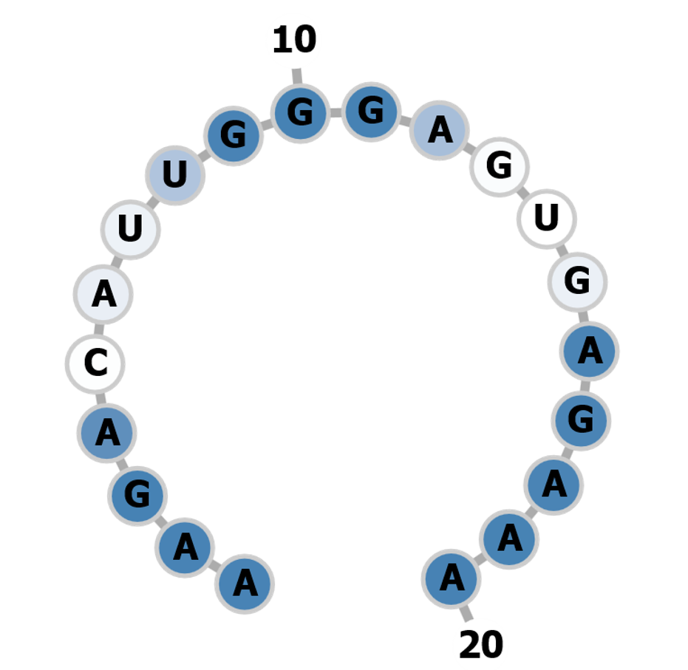
2. | 18forw | CTACGACCACGACCAAGACCAGG  Enzymes: MnlI, EcoO109I, PpuMI, PspPI, Bme18I, LpnPI, BstNI, BslI, StyD4I | 95 | 99 | 0 - 0 - 0 - 6 - 24  0 - 0 - 0 - 1 - 0  30 off-targets | Exon3 | 0.00 | 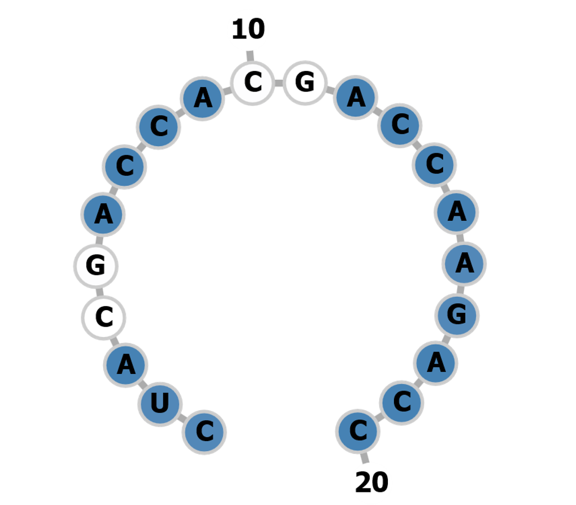
3. | 23rev | GCTTTCAGTGATAATCTTGAGGG  Enzymes: SmoI, Hpy188III, BpuEI | 91 | 93 | 0 - 0 - 0 - 3 - 38  0 - 0 - 0 - 0 - 1  41 off-targets | Exon3 | 0.00 | 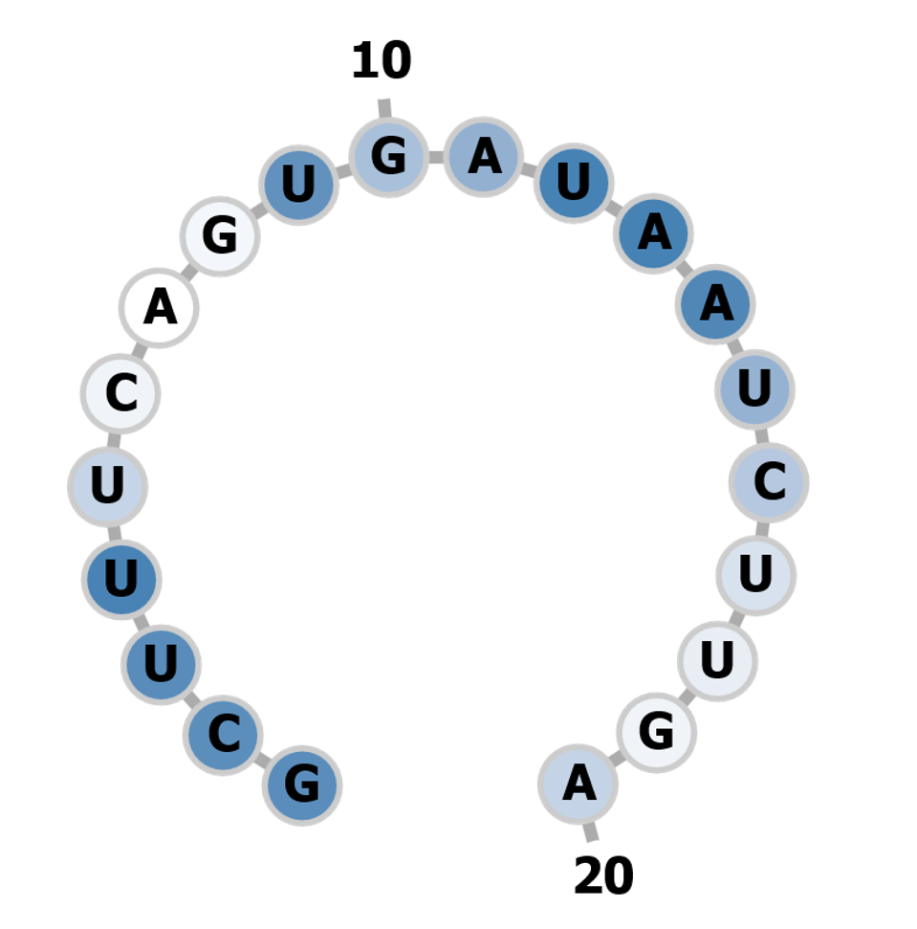
4. | 26rev | TACTTATTCTCTTGTATCTGAGG  Enzymes: BstDEI, BseRI, Hpy188I | 88 | 90 | 0 - 0 - 1 - 6 - 61  0 - 0 - 0 - 0 - 2  68 off-targets | Exon3 | 0.00 | 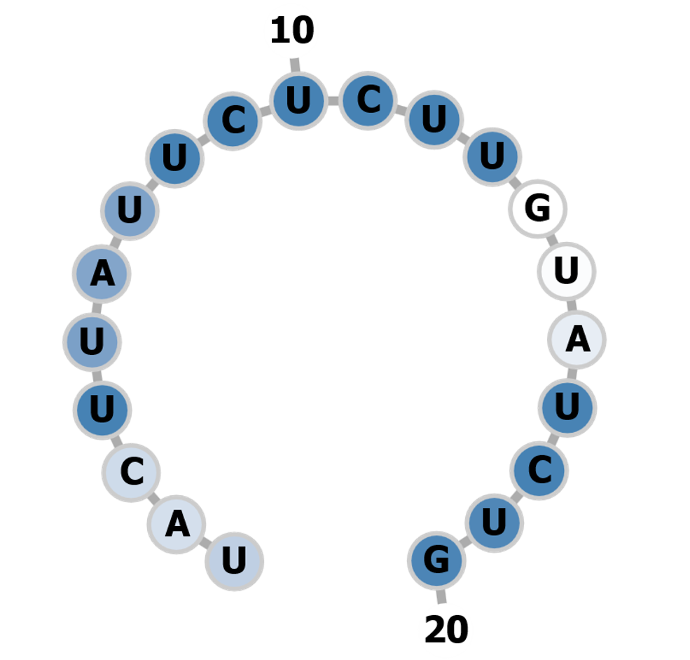
5. | 29forw | GTTGCCAAATTTGTTGTATGAGG | 84 | 93 | 0 - 0 - 2 - 4 - 58  0 - 0 - 0 - 1 - 5  64 off-targets | Exon3 | 0.00 | 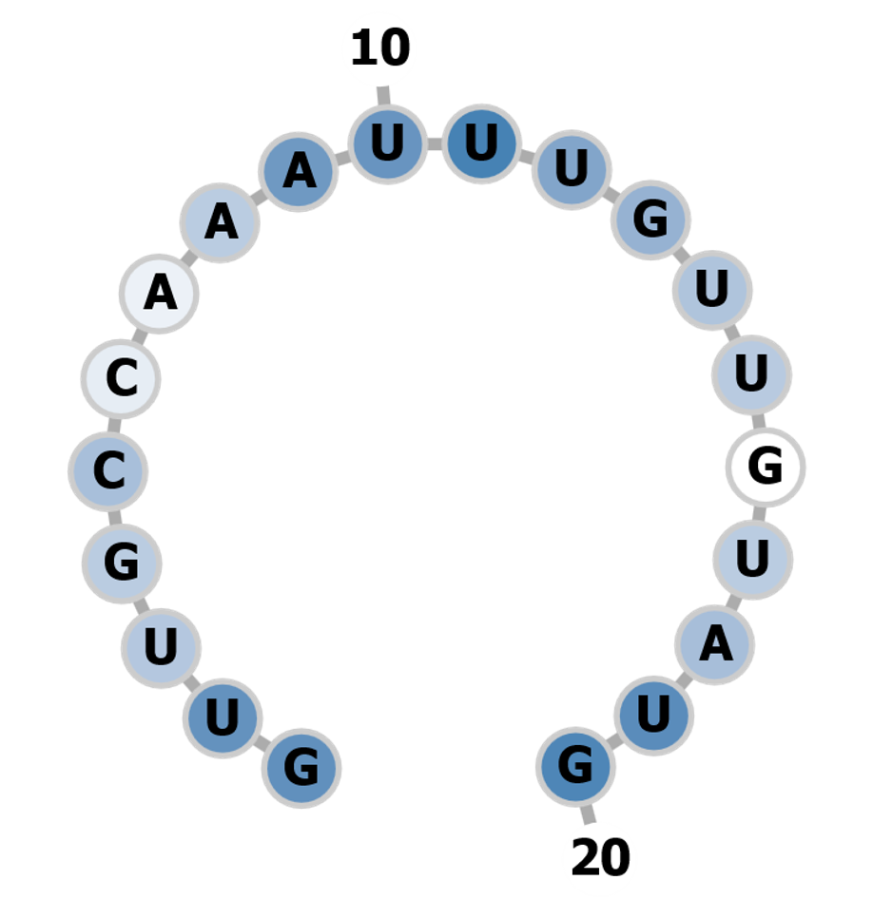

Supplemental_Table

List of designed gRNAs against SlAN2like gene
S.No | Guide Id | gRNA + PAM + RE | MIT Specificity Score | CFD Specificity Score | Off-targets for  0-1-2-3-4 mismatches  + next to PAM | Target Region | Minimum Free Energy  kcal/mol | Secondary Structure
1. | 1rev | TTTTCTCACTCCCAATGTCTTGG  Inefficient  This guide contains the sequence TTTT. It cannot be transcribed with a U6 or U3 promoter, as TTTT terminates the transcription. | 96 | 96 | 0 - 0 - 0 - 5 - 21  0 - 0 - 0 - 0 - 0  26 off-targets | Exon 1
2. | 2forw | ATGAATATTGCCAAGACATTGGG  Inefficient  This guide contains one of the motifs described by Graf et al, Cell Reports 2019. The guide ends with TTC or TTT or contains only T and C in the last four nucleotides and more than 2 Ts or at least one TT and one T or C ('TT-motif'). These guides should be avoided in polymerase III (Pol III)-based gene editing experiments requiring high sgRNA expression levels. | 88 | 95 | 0 - 0 - 1 - 9 - 43  0 - 0 - 0 - 0 - 1  53 off-targets | Exon 1
3. | 3forw | AAGACATTGGGAGTGAGAAAAGG  Enzymes: Asp700I | 86 | 91 | 0 - 0 - 0 - 5 - 51  0 - 0 - 0 - 0 - 1  56 off-targets | Exon 1 | 0.00
4. | 4forw | TGTATTGACAAGTATGGAGAAGG | 84 | 92 | 0 - 0 - 2 - 7 - 44  0 - 0 - 1 - 1 - 1  53 off-targets | Exon 1 | -0.90 | 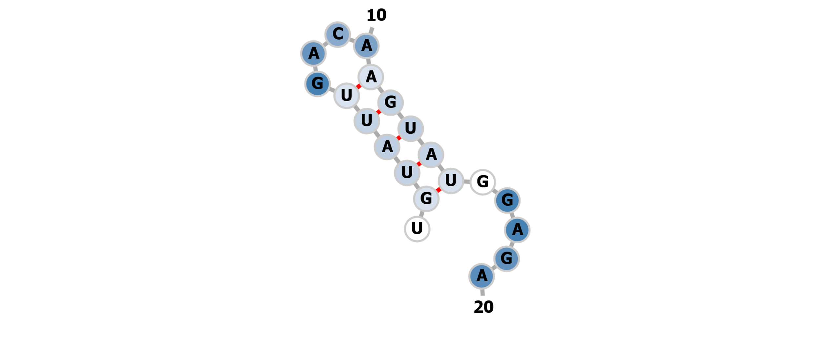
5. | 5forw | AGGAAATGTATTGACAAGTATGG | 81 | 92 | 0 - 0 - 5 - 7 - 80  0 - 0 - 0 - 0 - 1  92 off-targets | Exon 1 | 0.00 | 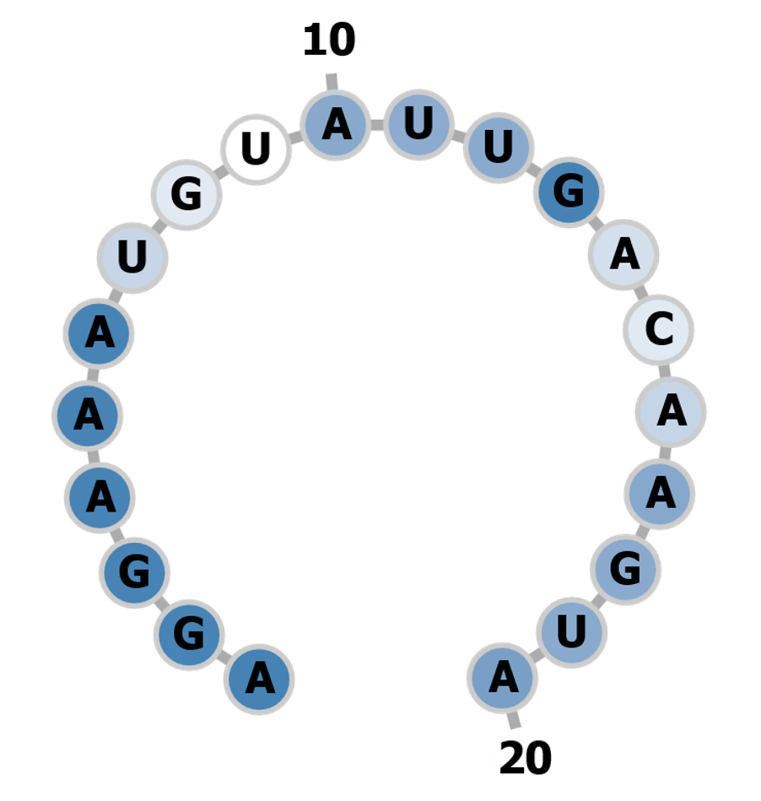
6. | 6forw | AAGATGAAGATATTCTTTTGAGG  Inefficient  Not suitable with U6 and U3 promoter. | 54 | 84 | 0 - 1 - 10 - 34 - 172  0 - 1 - 2 - 2 - 1  217 off-targets | Exon 1
7. | 7forw | ACAAGTATGGAGAAGGAAAGTGG  Enzymes: LweI | 54 | 85 | 0 - 1 - 1 - 12 - 92  0 - 0 - 0 - 0 - 2  106 off-targets | Exon 1 | 0.00 | 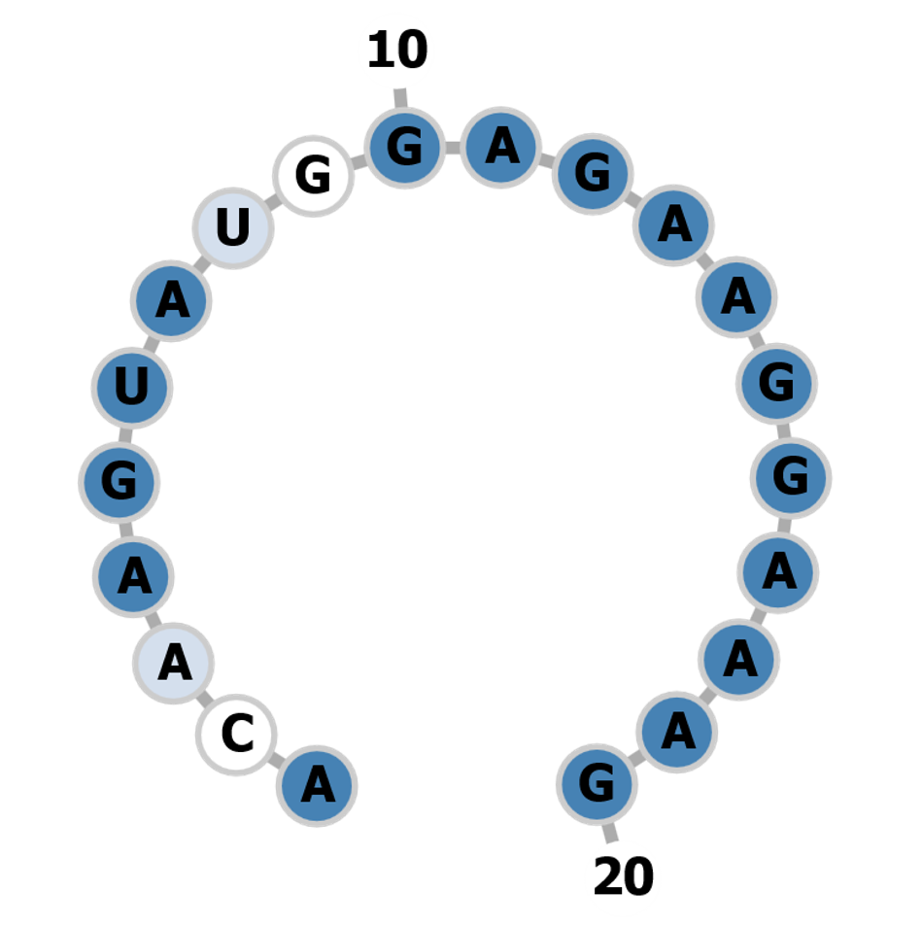
8. | 8forw | TGGGAGTGAGAAAAGGTTCATGG  Inefficient  Enzymes: NlaIII, Asp700I | 32 | 92 | 1 - 1 - 1 - 7 - 32  1 - 1 - 0 - 1 - 1  42 off-targets | Exon 1
9. | 9forw | CAAGAGAGGTGACTTTGCTCTGG  Enzymes: TspDTI, Hpy188III, BtsCI | 82 | 98 | 1 - 0 - 0 - 3 - 13  1 - 0 - 0 - 0 - 0  17 off-targets | Exon2 | -1.80 | 
10. | 10forw | TTGAGACTTCACAAGCTTCTAGG  Inefficient  Enzymes: HindIII, MaeI | 81 | 93 | 0 - 1 - 5 - 5 - 59  0 - 0 - 0 - 0 - 2  70 off-targets | Exon2
11. | 11forw | GTCGAAAGAGTTGTAGACTGAGG  Enzymes: BstDEI, Hpy166II, FblI | 45 | 96 | 0 - 1 - 10 - 10 - 20  0 - 1 - 4 - 1 - 1  41 off-targets | Exon2 | -1.40 | 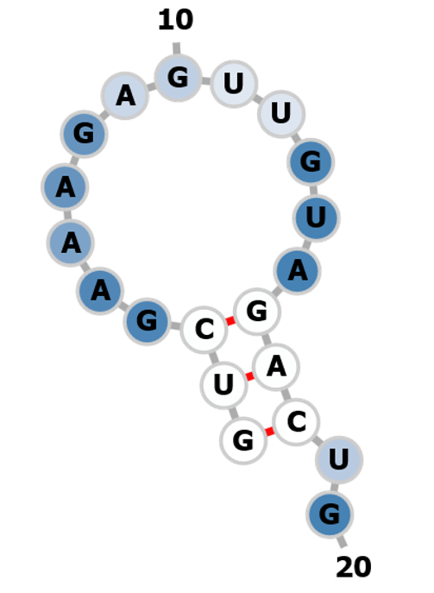
12. | 12forw | TGAGGTGGTTGAATTATCTAAGG  Enzymes: BshFI, BstDEI | 37 | 81 | 0 - 2 - 9 - 34 - 204  0 - 0 - 1 - 3 - 3  249 off-targets | Exon2 | -2.60 | 
13. | 13forw | AAGTCACCTCTCTTGATATGTGG  Enzymes: BshFI | 30 | 94 | 2 - 1 - 0 - 3 - 31  2 - 0 - 0 - 1 - 1  37 off-targets | Exon2 | -0.60 | 
14. | 14forw | GAAAGAGTTGTAGACTGAGGTGG  Enzymes: BstDEI, AgsI | 24 | 84 | 1 - 3 - 6 - 37 - 60  1 - 1 - 0 - 0 - 0  107 off-targets | Exon2 | -0.40 | 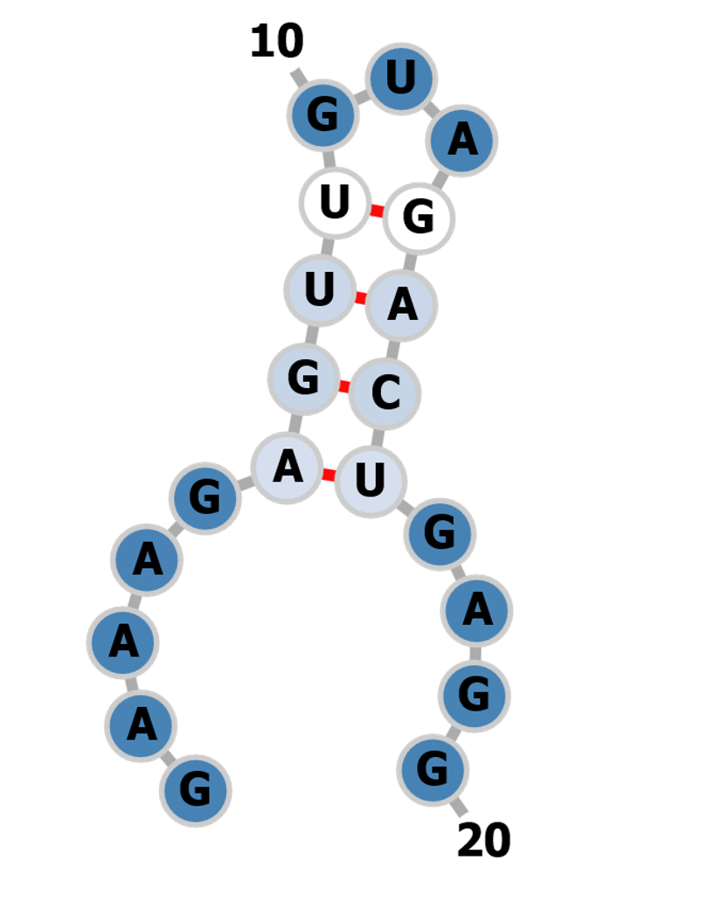
15. | 15forw | CTAAGGCCACATATCAAGAGAGG  Enzymes: AsuHPI, Hpy188III, MaeIII, Tsp45I | 23 | 93 | 2 - 2 - 1 - 8 - 24  2 - 0 - 0 - 0 - 1  37 off-targets | Exon2 | 0.00 | 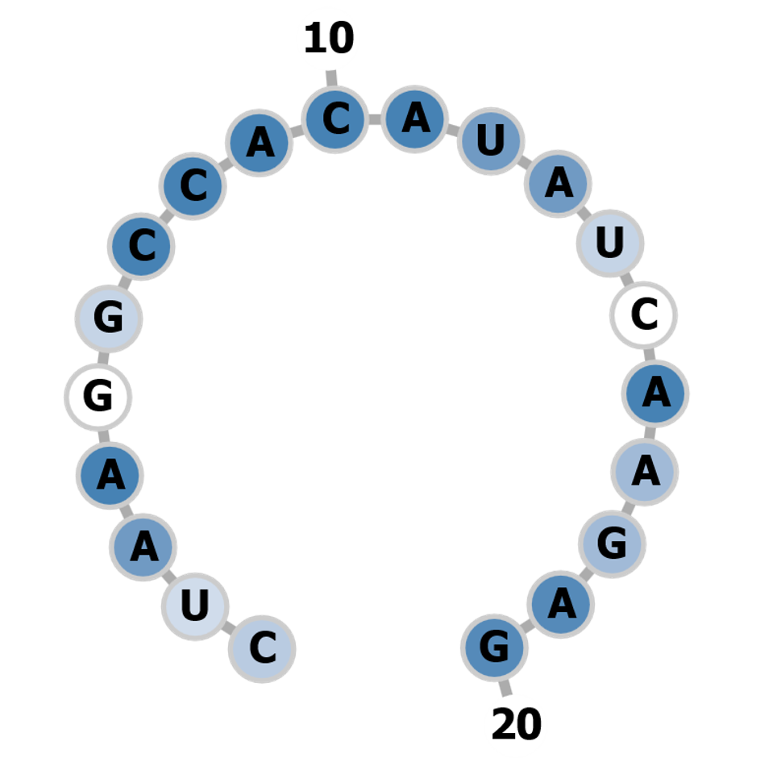
16. | 16rev | CGAGGTTGAGGTCCTGGTCTTGG  Enzymes: BslI | 97 | 99 | 0 - 0 - 1 - 0 - 34  0 - 0 - 0 - 0 - 0  35 off-targets | Exon3 | -1.70 | 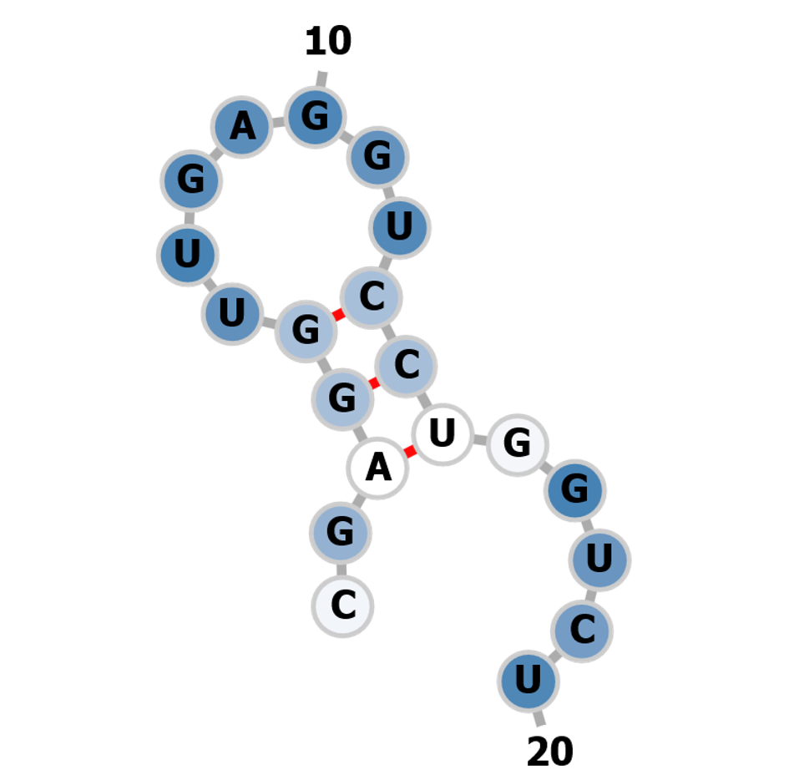
17. | 17rev | AAGGTTCGAGGTTGAGGTCCTGG  Enzymes: EcoO109I, PpuMI, PspPI, Bme18I, LpnPI, BstNI, StyD4I | 96 | 98 | 0 - 0 - 0 - 0 - 27  0 - 0 - 0 - 0 - 0  27 off-targets | Exon3 | -0.30 | 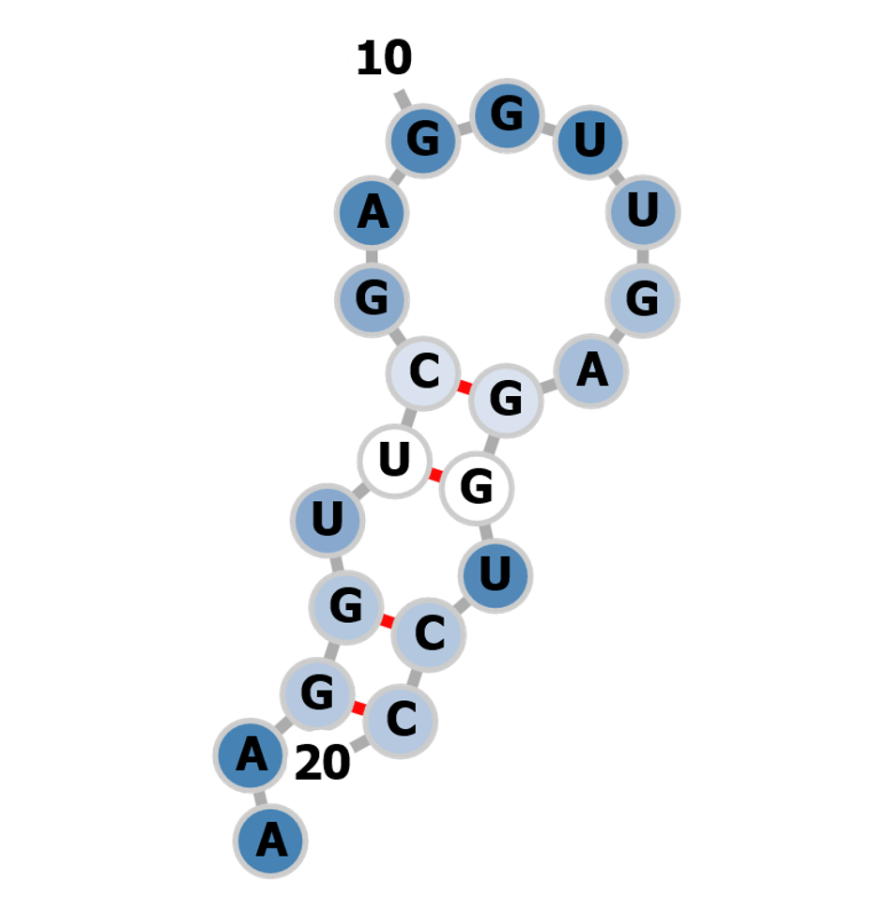
18. | 18forw | CTACGACCACGACCAAGACCAGG  Enzymes: MnlI, EcoO109I, PpuMI, PspPI, Bme18I, LpnPI, BstNI, BslI, StyD4I | 95 | 99 | 0 - 0 - 0 - 6 - 24  0 - 0 - 0 - 1 - 0  30 off-targets | Exon3 | 0.00
19. | 19forw | TAGACGATGATGGAGTTCAATGG  Enzymes: AgsI, Hpy166II | 95 | 96 | 0 - 0 - 0 - 3 - 26  0 - 0 - 0 - 1 - 1  29 off-targets | Exon3 | -0.60 | 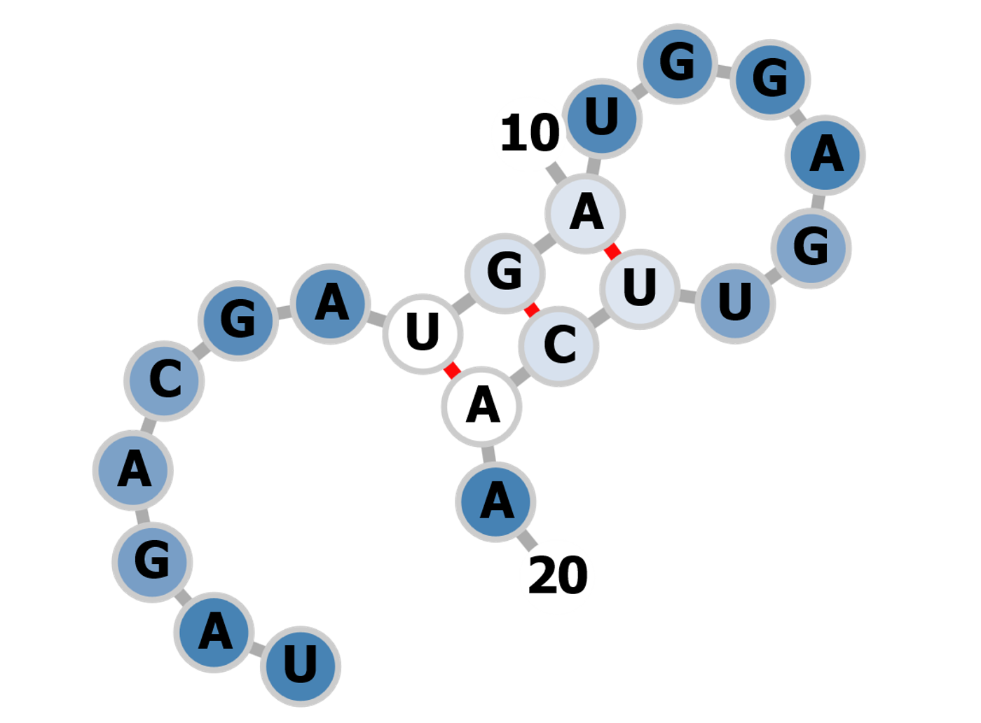
20. | 20forw | AACAGCAGTATTGAACTTTGAGG  Inefficient | 95 | 96 | 0 - 0 - 0 - 2 - 27  0 - 0 - 0 - 1 - 1  29 off-targets | Exon3
21. | 21rev | TGAGGTCCTGGTCTTGGTCGTGG | 94 | 97 | 0 - 0 - 0 - 3 - 27  0 - 0 - 0 - 0 - 1  30 off-targets | Exon3 | -1.00 | 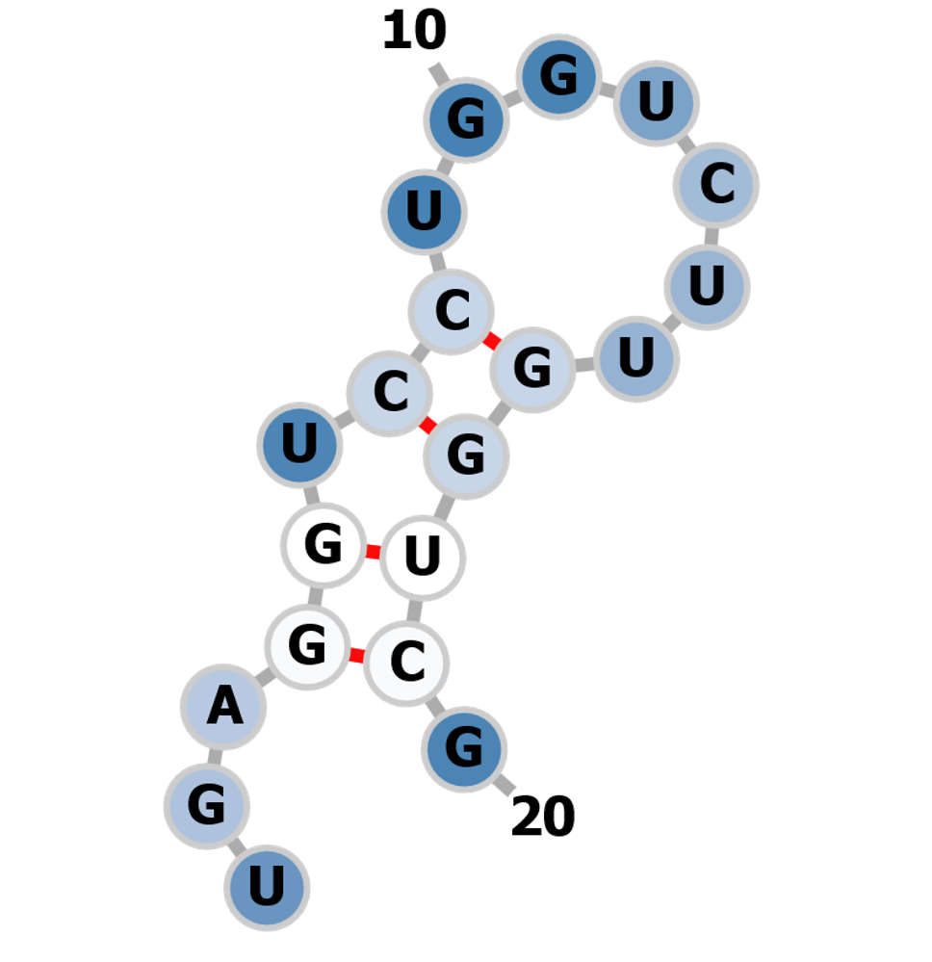
22. | 22rev | TTTTCACTTGAGAAGGTTCGAGG  Inefficient  Not suitable with U6 and U3 promoter | 94 | 96 | 0 - 0 - 0 - 7 - 26  0 - 0 - 0 - 2 - 0  33 off-targets | Exon3
23. | 23rev | GCTTTCAGTGATAATCTTGAGGG  Enzymes: SmoI, Hpy188III, BpuEI | 91 | 93 | 0 - 0 - 0 - 3 - 38  0 - 0 - 0 - 0 - 1  41 off-targets | Exon3 | 0.00
24. | 24rev | TTATTCTCTTGTATCTGAGGAGG  Enzymes: BstDEI, BseRI, Hpy188I | 90 | 94 | 0 - 0 - 2 - 4 - 40  0 - 0 - 0 - 3 - 1  46 off-targets | Exon3 | -2.60 | 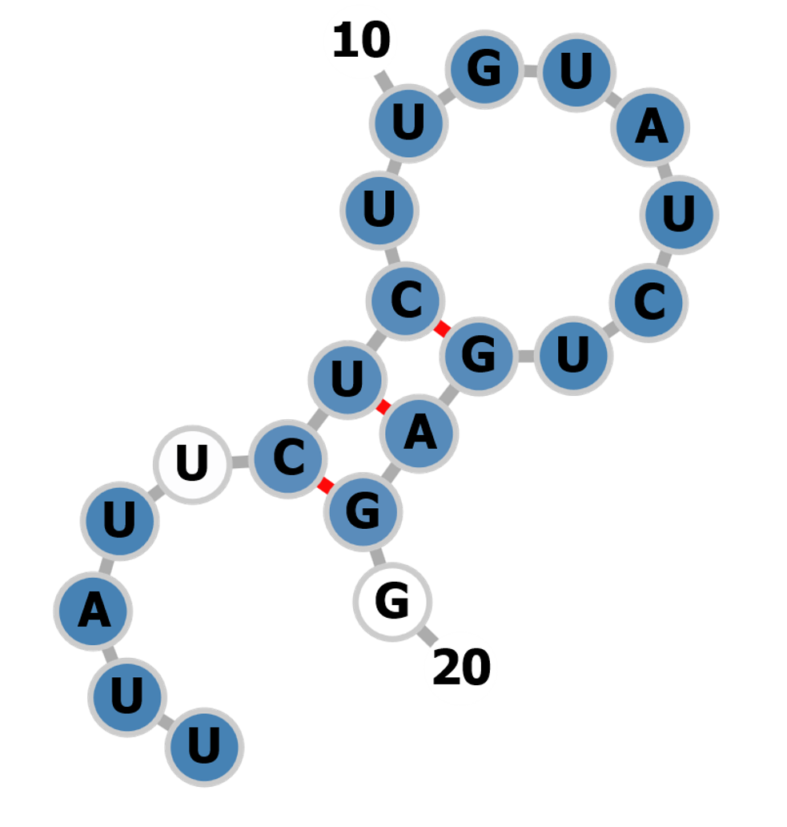
25. | 25forw | ACGATGATGGAGTTCAATGGTGG  Enzymes: Hpy166II | 90 | 96 | 0 - 0 - 0 - 10 - 31  0 - 0 - 0 - 1 - 1  41 off-targets | Exon3 | -1.40 | 
26. | 26rev | TACTTATTCTCTTGTATCTGAGG  Enzymes: BstDEI, BseRI, Hpy188I | 88 | 90 | 0 - 0 - 1 - 6 - 61  0 - 0 - 0 - 0 - 2  68 off-targets | Exon3 | 0.00
27. | 270rev | ATCATTTTCTCCATGTTGCATGG  Inefficient  Not suitable with U6 and U7 | 87 | 85 | 0 - 0 - 0 - 13 - 92  0 - 0 - 0 - 0 - 1  105 off-targets | Exon3
28. | 28rev | CTTGAGAAGGTTCGAGGTTGAGG  Enzymes: Bme18I, PpuMI, LpnPI, PspPI, EcoO109I | 86 | 95 | 0 - 0 - 0 - 12 - 67  0 - 0 - 0 - 0 - 1  79 off-targets | Exon3 | -3.80 | 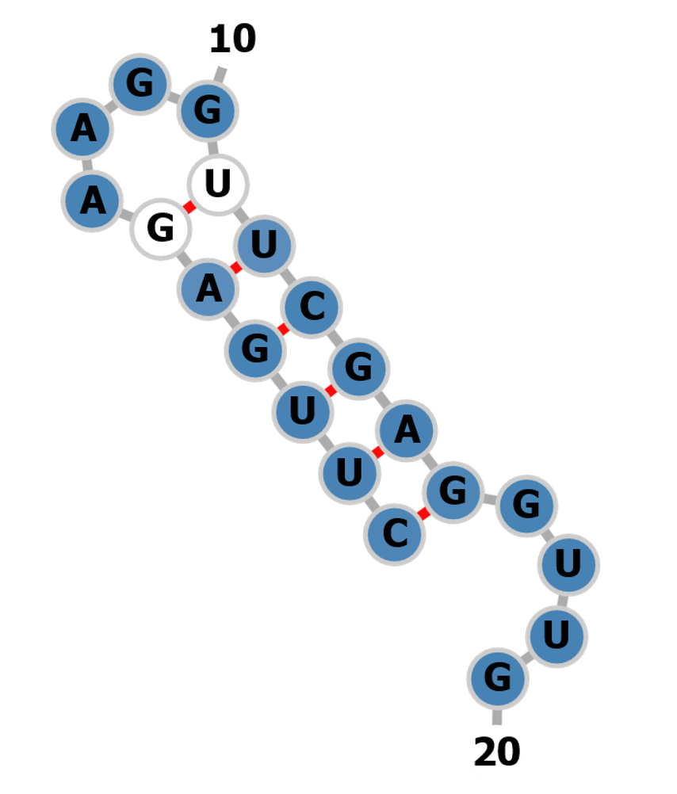
29. | 29forw | GTTGCCAAATTTGTTGTATGAGG | 84 | 93 | 0 - 0 - 2 - 4 - 58  0 - 0 - 0 - 1 - 5  64 off-targets | Exon3 | 0.00
30. | 30rev | TTATTAATAACTTCTTGTGTAGG  Inefficient  Low GC content | 81 | 88 | 0 - 0 - 3 - 19 - 97  0 - 0 - 1 - 1 - 1  119 off-targets | Exon3
31. | 31rev | AATATTATTTTCACTTGAGAAGG  Inefficient  Low GC content  Not suitable with U6 and U3 | 81 | 85 | 0 - 0 - 4 - 17 - 140  0 - 0 - 0 - 2 - 0  161 off-targets | Exon3
32. | 32rev | GATGACGGTGTTTTTTTTGTTGG  Inefficient  Not suitable with U6 and U7 | 80 | 86 | 0 - 0 - 0 - 14 - 70  0 - 0 - 0 - 3 - 2  84 off-targets | Exon3
33. | 33rev | TGCTTTCAGTGATAATCTTGAGG  Inefficient | 78 | 86 | 0 - 0 - 0 - 13 - 120  0 - 0 - 0 - 5 - 4  133 off-targets | Exon3
34. | 34rev | TGTTCCTCATACAACAAATTTGG  Enzymes: XapI, MluCI | 78 | 94 | 0 - 0 - 1 - 13 - 71  0 - 0 - 0 - 1 - 1  85 off-targets | Exon3 | -0.10 | 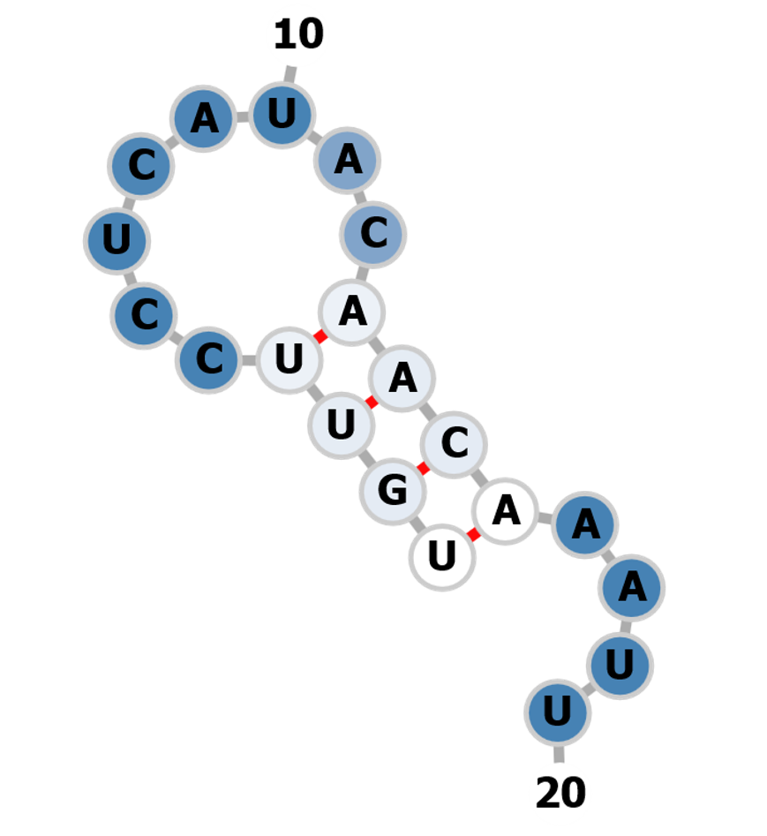
35. | 35rev | TCATCGTCTATAGACGATGACGG  Enzymes: HpyCH4III | 75 | 97 | 0 - 1 - 5 - 2 - 25  0 - 1 - 0 - 0 - 0  33 off-targets | Exon3 | -9.90 | 
36. | 36forw | TCATCGTCTATAGACGATGATGG | 75 | 97 | 0 - 1 - 5 - 2 - 25  0 - 1 - 0 - 0 - 0  33 off-targets | Exon3 | -9.90
37. | 37forw | TTTCAGTTGATATTGACCTATGG  Enzymes: HinfI, PfeI | 68 | 69 | 0 - 0 - 4 - 19 - 152  0 - 0 - 0 - 4 - 2  175 off-targets | Exon3 | -2.00 | 
38. | 38forw | AATTCAACAACCATGCAACATGG  Enzymes: NlaIII | 67 | 90 | 0 - 0 - 3 - 110 - 83  0 - 0 - 2 - 103 - 1  196 off-targets | Exon3 | 0.00 | 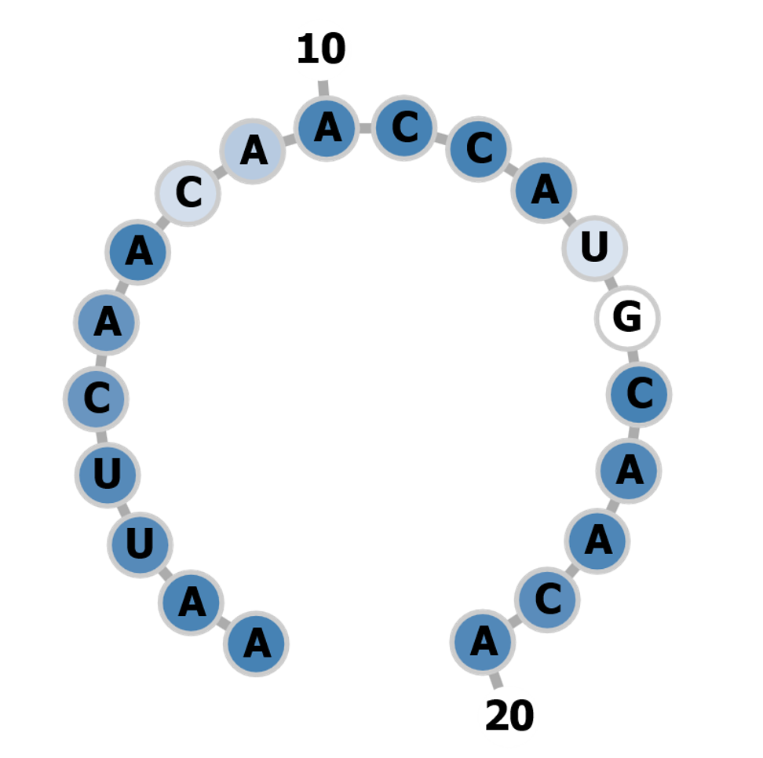
39. | 39forw | CAAGTGAAAATAATATTTCTTGG  Inefficient  Low GC content | 63 | 76 | 0 - 0 - 4 - 28 - 201  0 - 0 - 2 - 6 - 8  233 off-targets | Exon3
40. | 40forw | GGAAAATTGGAAAGAATTTGAGG  Inefficient | 61 | 79 | 0 - 0 - 4 - 36 - 174  0 - 0 - 0 - 2 - 8  214 off-targets | Exon3
41. | 41rev | ACATCGTTTGCTGTTCTTCCAGG  Inefficient | 58 | 91 | 0 - 2 - 2 - 5 - 26  0 - 0 - 0 - 0 - 0  35 off-targets | Exon3
42. | 42forw | TCAATGGTGGACAAATTTACTGG  Inefficient | 46 | 92 | 0 - 1 - 2 - 8 - 41  0 - 1 - 0 - 0 - 0  52 off-targets | Exon3
43. | 43forw | GGACAAATTTACTGGAAAATTGG  Enzymes: MluCI | 40 | 81 | 0 - 1 - 4 - 23 - 155  0 - 0 - 1 - 1 - 1  183 off-targets | Exon3 | 0.00 | 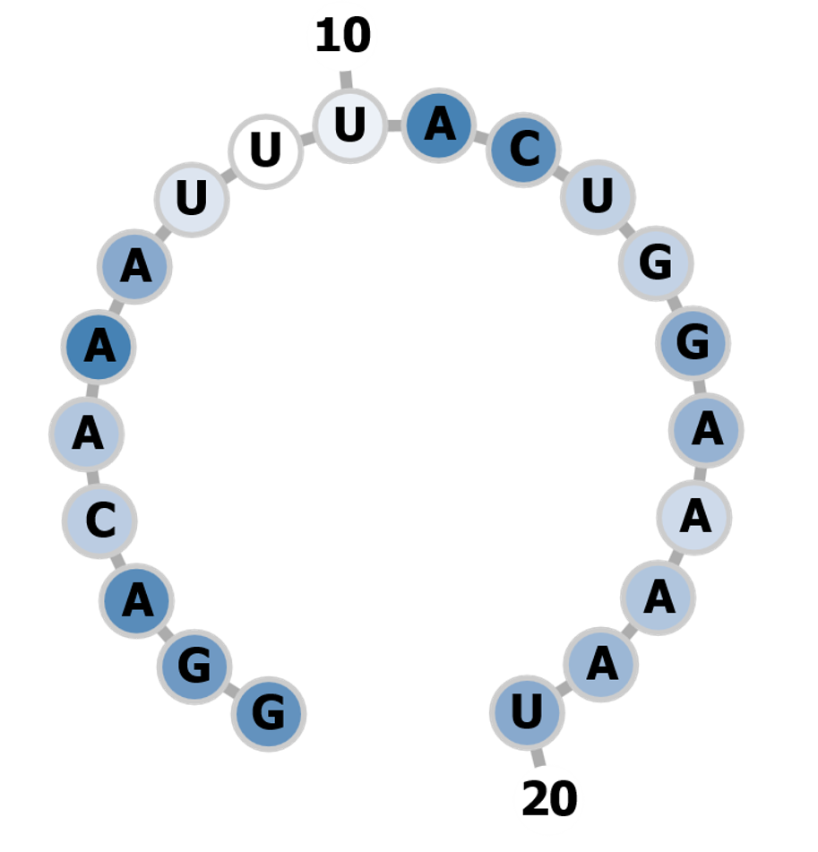
44. | 44forw | CTTATTGCTGGGAGACTTCCTGG  Inefficient | 34 | 97 | 0 - 4 - 1 - 2 - 9  0 - 0 - 0 - 0 - 0  16 off-targets | Exon3
45. | 45forw | CAAACGATGTGAAAAACTATTGG | 30 | 93 | 1 - 2 - 1 - 36 - 38  1 - 1 - 1 - 0 - 1  78 off-targets | Exon3 | 0.00 | 