**Investigating the Best Growth Medium for Dragon Fruit Propagation *(Hylocereus polyrhizus)***

**Abstract**

The evolution of a suitable plant growing media is needed to intercept sustainability concerns related to the horticultural plant production process. Unorthodox growing media constituents with unique physicochemical properties are currently used without knowing about their effect on microbial activity which play an important role in plant growth and development. The impact of different growing media on the performance of dragon fruit (*Hylocereus polyrhizus*) cuttings was assessed using randomized block statistical design of experiments with a significance level of p < 0.05 in a research study conducted at the horticultural experimental area, Khalsa College Amritsar during 2022-23. To analyze the significant effect for the growth of cuttings sixteen treatments such as soil, sand, vermicompost, cocopeat, sawdust and their combinations with soil were assayed. Morphological parameters like sprouting, plant height, fresh and dry shoot and root weight were measured. Results indicated that using vermicompost combined with soil (50 % for each) proved to be the best for the sprouting and survival of the cuttings along with the most vegetative growth parameters in terms of plant height, shoot and root length, diameter and weight on fresh and dry basis where as the media combination of soil and vermicompost increased the primary and secondary root formation respectively. Hence our results showed that vermicompost when added to soil possesses the potential for improving the dragon fruit plant characters. However, it appears to be marked differences between vermicompost and other media in terms of their nutrient content and their effects on the plant growth.

**Keywords:** Cuttings, Cocopeat, Growing media, Sprouting, Survival, Vermicompost

**Introduction**

Among exotic fruits dragon fruit (*Hylocereus spp*.) is a superior exotic fruit with cultivation benefits and marketing potential in Indian markets (Wakchaure *et al* 2023). It is a perennial climbing cactus has a triangular, green, fleshy stem belongs to family Cactaceae and genus Hylocereus (Hossain *et al* 2021)and is known by various names, including Thang loy, Pitajava, Tuna, Pitajaya, Junco, and Tasajo and also nicknamed as Pitaya, Strawberry Pear, Night blooming cereus, Belle of the night, Conderella plant and Chintapalli. Its English vernacular name, *Hylocereus polyrhizus*, refers to its prominent scaly spikes on the fruit's exterior (Minz *et al* 2021).Dragon fruit is an evergreen vine of 1.5 to 2.5 m height with three winged green stems, branched segments with wavy wings and spines. Aerial roots are grown on the underside of the stem which on absorption of water keep the stem on vertical surface (Crane and Balerdi 2005; Merten 2003). Dragon fruit has functional, antiradical, anti-proliferative, and nutraceuticalproperties including vitamins, minerals, complex carbohydrates, antioxidants, and dietary fibers (Wakchaure *et al* 2021). Consumption of dragon fruit promotes healthy gut bacteria growth and betacyanin (Liaotrakoon 2013) while also having low calories, zero cholesterol and higher antioxidants (Patel and Ishnava 2019). It also acts as a natural probiotic, stimulating the growth of microflora (Lactobacilli and Bifidobacteria) and suppressing the growth of gastro intestinal pathogens (Sonawane 2017).Dragon fruit is usually propagated through seed or cuttings. Although seedpropagation is very simple but seeds are not true to type and loose their viability after a certain time span (Seran and Thiresh 2015). Propagation through cuttings leads to production of more plantlets with profuse shoots and roots (Zee et al 2004).According to Ghosh and Bera (2015) stem cuttings forms aerial roots which adhere to the surface upon which the vines are grown. Successful propagation of dragon fruit is attributed to the appropriate growing medium. It proved to be more effective for better growth of plants than single material (Shanker et al 2019).Beneficial effect of various growing media on growth of the plants through cuttings has been reported (Markosa et al 2018). Therefore, multiplication of dragon fruit cuttings can be done with an appropriate medium devoid of any fertilizer application (Singh and Kaur 2021).

**Materials and methods**

**Plant materials and growth conditions:** The investigation was carried out during 2022-2023 at the horticultural experimental block Khalsa College, Amritsar. The experimental area is situated in central plains of Punjab at 31 0 61’ N latitude and 74 0 -92’ E longitude with an average elevation of 228.86 m above mean sea level representing the sub-tropical humid climatic conditions with an annual rainfall of 735 mm.The soil of experimental field was sandy loam with good drainage and uniform texture with average NPK status .The dragon fruit cuttings were sourced from one year old healthy mother plants of cv. American Beauty growing at dragon fruit and nursery production at Village- Thullewal, Nangal (Barnala).The cuttings of dragon fruit (*Hylocereus polyrhizus*)were treated in different media *viz.* soil, sand, vermicompost, cocopeat, sawdust and mixtures at different ratios by volume basis.

**Growth characters :** To compare the growth of dragon fruit (*Hylocereus polyrhizus)* cuttings affected by different media, the days to sprout initiation , number of sprouts per cutting, plant height, average shoot length, length of longest shoot, average shoot diameter, total chlorophyll, primary roots per cutting, secondary roots per cutting, root thickness, average root length, root volume , fresh and dry weights of shoots and roots per cutting , survival percentage after 120 days of planting were measured.

**Total chlorophyll (mg g-1):** Reagent: Dimethyl sulphoxide (DMSO)

Tissue (0.1g) was taken and dipped in 5 ml DMSO solution. The samples were kept in water bath at 60-70˚C for 1 hr for pigment extraction. The absorbance was recorded at 645 and 663 nm wavelength using spectrophotometer and the total chlorophyll (mg g-1) was quantified by using following formulae:

|  |  |  |
| --- | --- | --- |
| Total Chl = | 20.2 (A645) + 8.02 (A663) × | V |
| 1000×W |

**Survival percentage (%):**The number of cuttings survived under each treatment in each replication was recorded and the survival percentage of cuttings was worked out with the help of following formula:

|  |  |  |
| --- | --- | --- |
| Survival (%) = | No. of cuttings survived | ×100 |
| Total no. of cuttings per treatment |

**Statistical analysis:** The data regarding sprouting and growth parameters of cuttings were collected and processed in MS-Excel. The experimental treatments were laid out in a randomized complete block design. The statistical analysis of data which comprised of nine treatments and three replications were analyzed by randomized complete block design using R studio software. Students test of least significance was calculated at the 5% level of and significance to compare treatment means by Duncan’s multiple range test.

**Results**

The growing media exhibited a significant effect (p≤0.05) on the average days to sprout initiation of cutting (Fig.1). Minimum (13.24) days to sprout initiation was noticed in soil+ vermicompost (1:1). Statistically analysed data (p≤0.05) depicted the vermicompost to be significantly superior with the highest 5.35 sprout formation per cutting.

Significantly the highest number of primary (11.33) and secondary (230.11) roots was produced in the plants grown from the cuttings in vermicompost substrate (Table 1). Rooting medium acts as one of the most important factor affecting the rooting of cuttings. The present study proved evidence regarding effect of the composition of the growth media on the rooting success of dragon fruit cuttings. The soil+ vermicompost (1:1) tended to produce the longer (27.44cm) roots (Fig.2- A),maximum (3.80 mm) root diameter, highest root volume (1.88cm3) , heaviest roots (2.66g) in terms of root fresh weight and maximum (0.84g) root dry weight (Fig.-B-D).

The data showed that the combination of soil+ vermicompost (1:1) tended to produce the maximum average (113.34) plant height, shoot length(23.07 cm) ,longest (30.43cm) shoot, highest (24.85mm) average shoot diameter, heaviest shoot fresh weight (94.74g) and highest (14.24g) shoot dry weight of dragon fruit cuttings.

The results of the study showed that growing media has a significant effect (p≤0.05) on the survival of cuttings. All the plants from cuttings survived in all the growing media having a growth rate of 55-95%.Above 90% survivability was noticed in some of the growing media. The highest survival (95.91%) was noticed in the cuttings sown in the media combination of soil + vermicompost (1:1). The growing media had significant influence (p≤0.05) on the total chlorophyll content of dragon fruit cuttings. Maximum (0.92 mg g-1) was calculated in the cuttings planted under the growing media combination of soil+vermicompost (1:1)**.**

**Fig.1.**Days to sprout initiation (A), and number of sprouts (B) of dragon fruit (*Hylocereus polyrhizus*) cuttings transplants in different types of growing media at 120 days . Vertical bars indicate standard errors of the means calculated by Duncan’s multiple range test at *p* ≤ 0.05.

**Table 1.Effect of various growing media on root characteristics of dragon fruit cuttings**

|  |  |  |  |
| --- | --- | --- | --- |
| **Treatments** | **Primary roots per cutting** | **Secondary roots per cutting** | **Root diameter(mm)** |
| T1 –Soil | 5.37±0.39f | 49.10±0.09h | 0.27±0.02h |
| T2 –Sand | 7.24±0.30e | 86.09±0.08g | 2.05±0.03c |
| T3- Vermicompost | 11.33±0.29a | 230.11±0.09a | 2.94±0.03b |
| T4- Cocopeat | 3.26±0.27g | 37.11±0.09i | 1.64±0.03d |
| T5- Sawdust | 11.22±0.35a | 189.51±0.44b | 1.45±0.03e |
| T6- Soil+ sand(1:1) | 9.17±0.18c | 127.17±0.15d | 2.09±0.02c |
| T7- Soil+vermicompost (1:1) | 7.34±0.30e | 97.09±0.07f | 3.80±0.06a |
| T8- Soil+ cocopeat (1:1) | 8.16±0.16d | 110.15±0.13e | 1.15±0.03f |
| T9- Soil+sawdust (1:1) | 10.28±0.32b | 158.03±0.03c | 1.03±0.03g |
| Mean | 8.15 | 120.48 | 1.82 |
| CD(p≤0.05) | 0.33 | 0.54 | 0.06 |

The subscript letters signifies that the treatments means with similar letters are not significantly different at 5% level of significance, while the means with different letters are significantly different at 5%level of significance. These letters have been affixed based on CD-value comparison of treatment means.

**Fig.2** Average root length (cm) (A), root volume(cm3) (B) and root fresh weight (g) and root dry weight (D) of dragon fruit (*Hylocereus polyrhizus*) cuttings transplants in different types of growing media at 120 days . Vertical bars indicate standard errors of the means calculated by Duncan’s multiple range test at *p* ≤ 0.05.

**Table 2.Effect of various growing media on average plant height (cm),shoot length(cm),length of longest shoot (cm) and shoot diameter (mm) of dragon fruit cuttings**

|  |  |  |  |  |
| --- | --- | --- | --- | --- |
| **Treatments** | **Plant height (cm)** | **Average shoot length(cm)** | **Length of longest shoot (cm)** | **Average shoot diameter(mm)** |
| T1 –Soil | 96.54 ±0.24b | 18.37±0.10b | 29.44±0.39b | 21.74±0.02b |
| T2 –Sand | 63.44 ±0.32f | 11.24±0.10g | 20.58±0.19f | 18.35±0.02e |
| T3- Vermicompost | 87.74 ±0.24d | 16.75±0.11d | 26.37±0.39d | 19.34±0.03d |
| T4- Cocopeat | 51.50 ±0.16h | 8.29±0.03i | 18.48±0.08g | 21.06±0.03c |
| T5- Sawdust | 59.73 ±0.29g | 10.49±0.15h | 20.33±0.34f | 15.55±0.04g |
| T6- Soil+ sand(1:1) | 72.37 ±0.15e | 13.63±0.09f | 23.36±0.33e | 17.34±0.04f |
| T7- Soil+vermicompost (1:1) | 113.34 ±0.29a | 23.07±0.07a | 30.43±0.41 a | 24.85±0.02a |
| T8- Soil+ cocopeat (1:1) | 72.54 ±0.35e | 14.31±0.05e | 23.46±0.08e | 14.14±0.04i |
| T9- Soil+sawdust (1:1) | 94.80 ± 0.15c | 17.30±0.06c | 28.23±0.23c | 14.95±0.03h |
| Mean | 79.11 | 14.83 | 24.52 | 18.59 |
| CD(p≤0.05) | 0.45 | 0.16 | 0.46 | 0.45 |

The subscript letters signifies that the treatments means with similar letters are not significantly different at 5% level of significance, while the means with different letters are significantly different at 5%level of significance. These letters have been affixed based on CD-value comparison of treatment means.

**Fig.3** Shoot fresh weight (g) (A) and shoot dry weight (g) (B) of dragon fruit (*Hylocereus polyrhizus*) cuttings transplants in different types of growing media at 120 days . Vertical bars indicate standard errors of the means calculated by Duncan’s multiple range test at *p* ≤ 0.05.

**Fig.4.** Survival percentage (A) and Total chlorophyll (mg g-1) (B)of dragon fruit (*Hylocereus polyrhizus*) cuttings transplants in different types of growing media at 120 days . Vertical bars indicate standard errors of the means calculated by Duncan’s multiple range test at *p* ≤ 0.05.

**Discussion**

In the current study, Favourable compatible conditions provided by vermicompost might be the reason for earlier sprout initiation in cuttings as reported by Tani *et al* (2021) in dragon fruitcuttings. Lesser days taken for sproutinitiation due to vermicompost in guava and dragon fruit has also been revealed by Awasthi *et al* (2008) and Minz (2021) which is in agreement with the present findings. The higher organic matter in vermicompost resulting in the increased formation of nitro genic and phosphoric nutrients in the cells might have contributed to the more sprout formation (Sudarjat *et al* 2018).Good water holding capacity and high nutrient levels in the soil also accelerates the growth (Lopez-Bucio *et al* 2003;Norman *et al* 2005).The research results of Panchal *et al* (2014) in sapota, Rashmita *et al* (2016) in pear, Shah *et al* (2021) in grapes and Tani *et al* (2021) in dragon fruit revealed the increased sprout formation with vermicompost medium which supports the present research outcome.

Various factors such as oxygen, water and nutrient availability interacting within a rooting medium affect the rooting success roots (Alikhani *et al* 2011). It can be attributed to the congenial effect of the media. Combination of media supplemented with vermicompost increased porosity and looseness. Also better water holding and retention capacity to prevented desiccation of the cuttings due to increased aeration within the medium thus increasing length of root as reported by Sudarjat *et al* (2018) and Tani *et al* (2021) in dragon fruit cuttings. The root production with more diameter in soil supplemented with vermicompost can be attributed to the crumbled nature of growing media with nutrient availability resulting in root growth. The root acceleration leading to root vascular cambium formed the thickest roots. The present findings are in agreement with Kumar and Sangyan (2015) in cuttings of lemon, Rathwa *et al* (2017) in pomegranate and Tani *et al* (2021) in dragon fruit cuttings. Improvement in the root volume might be due to the better absorption of water and nutrients resulting in higher rate of plant growth (Wilcox *et al* 2004). The seedlings with strong root system due to better rooting media might have possessed higher root volume (Campo *et al* 2008).The present results revealed the linkage of organic amendments with root biomass which resulted in increased root growth Jindo *et al* (2012) reported that humic acid produced in the vermicompost aids in nutrient and water uptake ,cell differentiation and lateral root formation. The phosphorus in the medium is directly correlated with root growth promotion (Barita *et al* 2018) and also increased the root dry weight (Preusch *et al* 2004).The supply of high minerals with humic substances increased the root molecular weight as described by Madhavi *et al* (2021) in strawberry. Khot (2017) reported the highest dry weight with the same media in Bullock’s heart and Tani *et al* (2021) in dragon fruit.

The application of vermicompost as a growing medium improved the chemical properties of the soil.The availability of the nutrients in the soil affected the plant growth and development (Raffo *et al* 2014).As a result of it the increased plant height was the outcome of the research study. The research study of Tani *et al* (2021)in dragon fruit are in support with the present findings. The enhanced plant growth with the addition of vermicompost as the growing media has also been reported by Norman *et al* (2005). Panchal *et al* (2014) revealed the increased plant growth by vermicompost in khirni. Sudarjat *et al* (2018) also stated the vermicompost to be better media than others for plant growth in dragon fruit cuttings. The increased shoot length with media supplemented with vermicompost might be attributed to the nutritional superiority containing sufficient macro and micro nutrients, better water holding capacity, greater aeration, porosity and good drainage than other growing media which helped in forming better root and shoot development. The cuttings of dragon fruit tree respond well to the organic matter which might be the reason for greater shoot length (Antunes *et al* 2021). The enhanced shoot length can also be indirectly related to the hormonal effect that humic substances present in vermicompost exert on the plants (Cordeiro *et al* 2010).

Similar study with a conclusion that soil + vermicompost recorded the longest shoot length as compared to other media conducted by Sudarjat *et al* (2018) in dragon fruit cuttings are in line with the present findings. The better synergistic effect of the growing resulting in increased porosity and along with better water holding and water retention ability might be the reason that vermicompost when mixed with soil produced the maximum length of the shoot. This result is equivalent to result found by Sudarjat *et al*(2018) in dragon fruit which is in agreement with the present results. The availability of higher amount of growth promoting nutrients, proper aeration, improved soil status and ample moisture retention in the media combination might be the reason for higher shoot diameter (Atiyeh *et al* 2002). The similar results have been achieved by Tani *et al* (2021) in dragon fruit. Positive interaction between the media composition enriching nutrients which in turn improved the physical and chemical properties of media might have increased the fresh and dry weight of shoot (Atiyeh *et al* 2002).Presence of humic acid and growth substance properties in vermicompost which when combined with the soil and sand might have resulted in the increased plant growth in terms of heavier shoots (Arancon and Edwards 2005).The researchstudy of Dhakar *et al* (2016) also revealed an increased growth with vermicompost in papaya and Yadav *et al* (2012) in acid lime which is in line with the present findings. Tani *et al* (2021) advocated an increased shoot weight with vermicompost and soil which is also in support with the present investigation results.

Higher survivability can be attributed to the favourable physical soil conditions by vermicompost which resulted in the activation of biochemical processes (Wazir *et al* 2003). The application of vermicompost as a growing media hence improved the soil fertility resulting in the plant survival (Sudarjat *et al* 2018). The research study of Rashmita *et al* (2016) depicting the same results in pear are in agreement with the present results. Increase in survival of dragon fruit plants with vermicompost has also been revealed by Tani *et al* (2021) which are in agreement with the present study. Awasti *et al* (2008) in guava and Minz (2021) in dragon fruit cuttings also reported the same.Chlorophyll synthesis requires nitrogen and phosphorous from soil (Li *et al* 2018). Addition of vermicompost to soil increased the organic matter which in turn increased the plant growth (Sudarjat *et al* 2018). Hence increased amounts of them might be the reason for enhanced chlorophyll content. The literature evidencing the fact is not available.

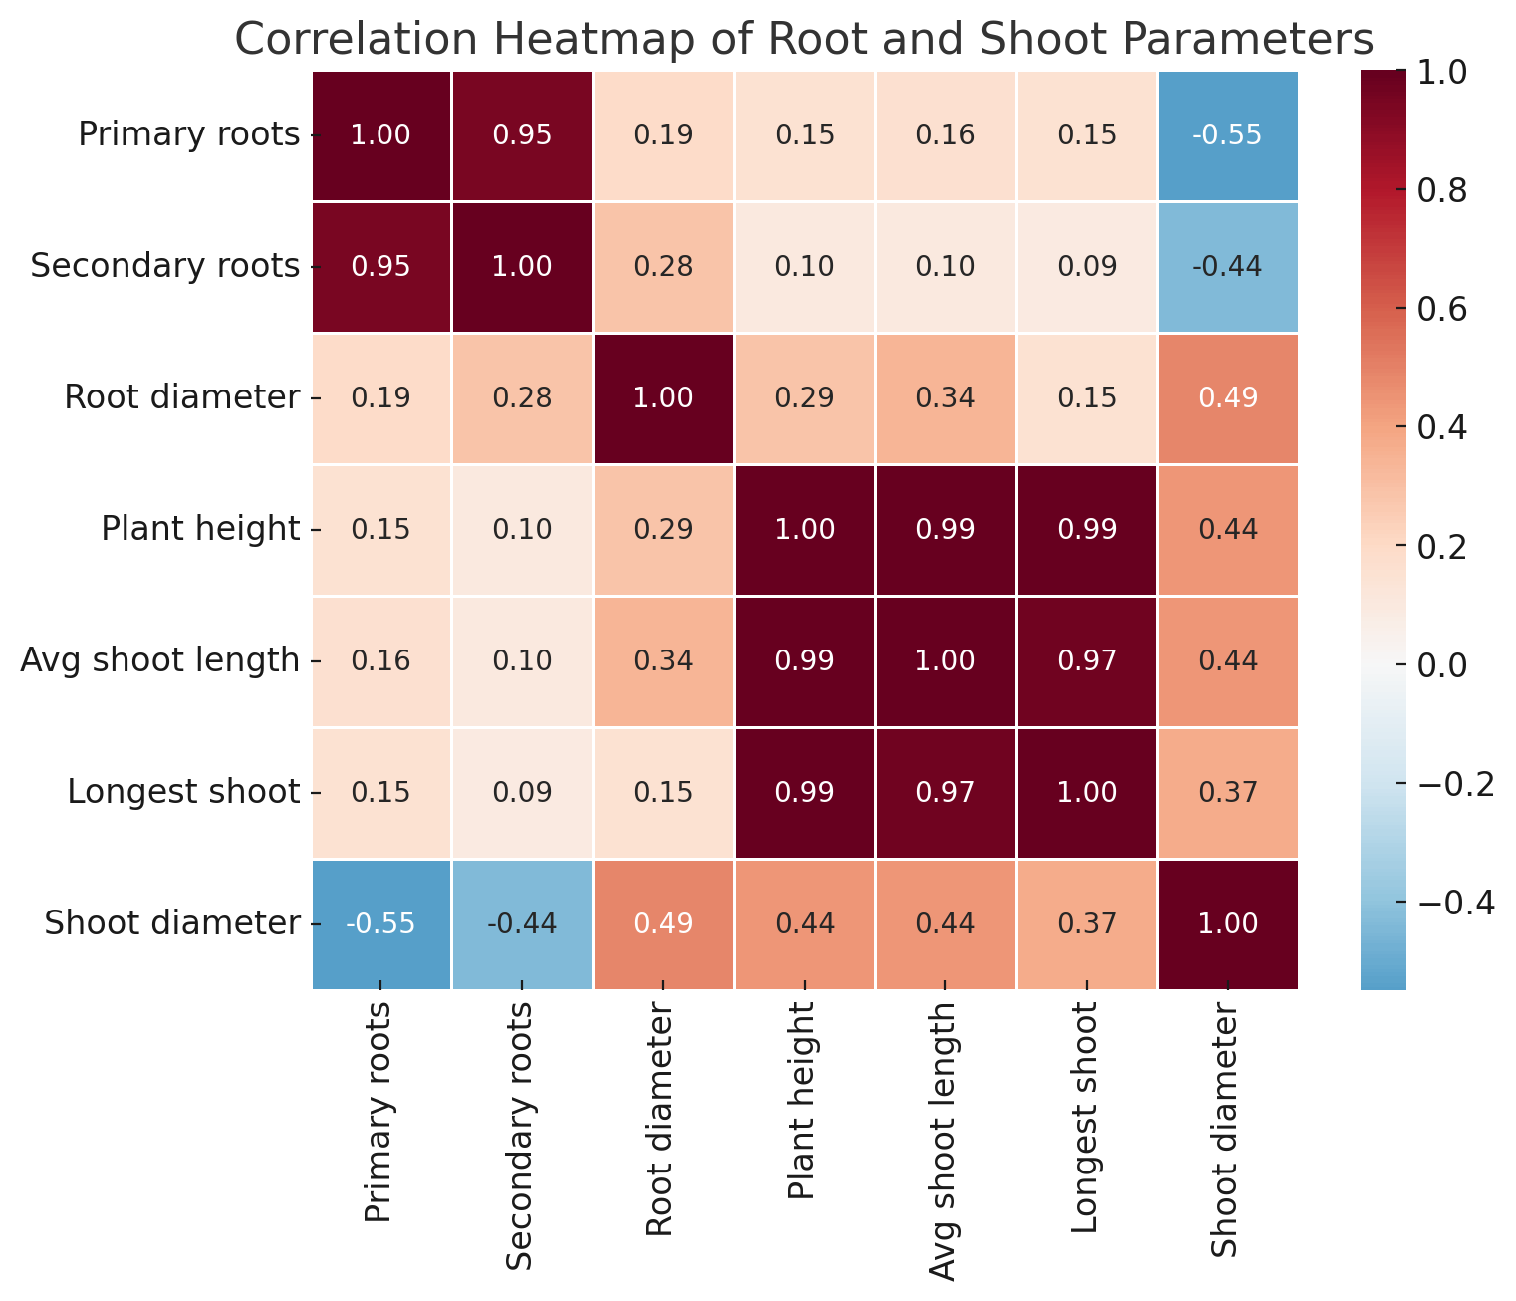The correlation analysis of various plant growth parameters revealed significant relationships between root and shoot characteristics across different growing media treatments. A strong positive correlation was observed between primary and secondary roots (r = 0.89), while root diameter showed weak positive correlations with both primary (r = 0.13) and secondary roots (r = 0.15). Plant height demonstrated very strong positive correlations with average shoot length (r = 0.98), length of longest shoot (r = 0.97), and average shoot diameter (r = 0.71), indicating synchronized shoot development. However, the root-shoot relationships were more moderate, with root diameter showing a moderate positive correlation with plant height (r = 0.45) and other shoot measurements. Primary and secondary roots exhibited relatively weak correlations with shoot measurements, suggesting somewhat independent development between root and shoot systems. These findings indicate that while shoot growth characteristics develop in a highly coordinated manner, root development may be influenced by different factors in the growing media, which has important implications for optimizing plant growth conditions in various substrates.

**Conclusion**

The research study concluded that vermicompost can be used as an ingredient along with soil as a growing media as it not solely attributed to the quality of mineral nutrition but also to produce plant growth hormones and humic acids. Furthermore, increased microbial activity and their biomass results in increasing rooting cuttings resulting in the plant growth and vigour. Due to this there will be a reduction in the amount of artificial hormones required for the plant growth and use of expensive inorganic fertilisers. Vermicomposting should be encouraged as the macro-organisms (Earth worms) used in the process are available at little cost.

**Ethics Approval Statement**

The study did not involve an experiment on humans and animals.

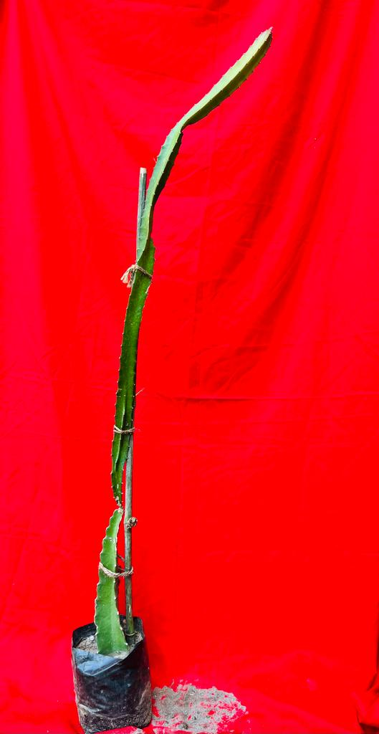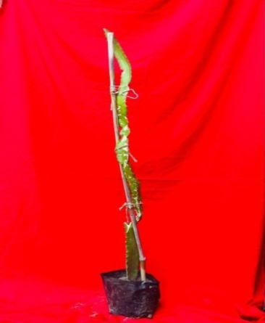

**Fig.5(a)Vermicompost Fig.5(b)Soil+Vermicompost(1:1)**

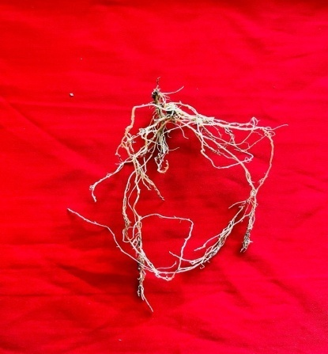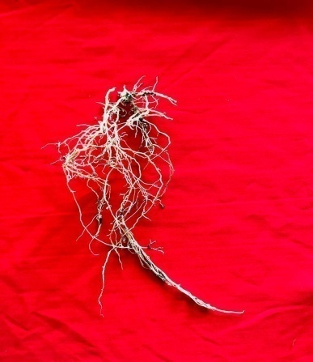

**Fig.5 (c) Vermicompost Fig.5(d) Soil+Vermicompost(1:1)**

**Fig.5 :** Result are depicted in 5(a),5(b),5(c),5(d) under the shoot and root parameters of dragon fruit (*Hylocereus polyrhizus*) cuttings transplants in different types of growing media at 120 days.

**References**

Alikhani L, Anasari K, Jamnezhad M and Tabatabaie Z (2011) Effect of different media and cuttings on growth and rooting of pomegranate cuttings. *Iran J Plant Physiol* **1**:199-203.

Antunes, L.F.S. ,Vaz,A.F.S., Silva, M.S.R.A., Correia, M.E.F., Cruvinel, F. F., Martelleto and L.A.P., 2021.Millicompost: Sustainable substrate for the production of dragon fruit seedlings (*Selenicereusundatus*).*Cleaner Engineering and Technology*,4:100-07.

Arancon, N.Q., Edwards and C.A., 2005.Effects of vermicomposts on plant growth. *Soil Ecology Laboratory, The Ohio State University, Columbus, OH*,43210,16-18.

Atiyeh, R.M., Lee, S.S., Edwards, C.A., Arancon, N.Q. and Metzager, J., 2002. The influence of humic acid derived from earthworm processes organic waste on plant growth. *Bioresource Technology*,84:7-14.

Awasthi, P., Lal, S. and Singh, B.C., 2008.Influence of stooling time and IBA concentrations on growth attributes of stooled shoots in guava Pant Prabhat. *Progressive Resource*,3:154-56.

Barita, Y., Prihastanti, E., Haryanti, S. and Subagio, A.,2018. The influence of granting npk fertilizer and nanosilic fertilizers on the growth of Ganyong plant (*Canna edulis* Ker.) *Journal of Physics: Conference Series*:1025.

Campo, J.G. , Palacio, S., Rontome, C. P. and Marti, Gm, 2008.Effect of root system morphology on root –sprouting and shoot –rooting abilities in 123 plant species from eroded lands in north-east Spain. *Annals of Botany*,,98:439-47.

Cordeiro, F., Fernandes, M.S. and Souza, S., 2010.Influencia dos ´acidoshúmicos no metabolismo vegetal podeserconsideradaumarespostaauxínica?Rev. Ciˆenc. Vida,30:111–31.

Crane, J.H.and Balerdi, C.F., 2005.Pitaya (Dragonfruit) Growing in the florida home landscape. series of the horticultural sciences department UF/IFAS Extension (HS1068). The University of Florida.

Dhakar, S.S.,Kaushik, R.A. and Sarolia, D.K., 2016. Influence of growing media and containers on germination and seedling growth of papaya (*Carica papaya* L.) cv. PusaNanha. *Green Farming* ,7:451-54.

Ghosh, S. N. and Bera, B.,2015.Studies on standardization of propagation methods of some minor fruit crops in India. *International Journal of Minor Fruits, Medicinal and Aromatic Plants*,1:31-36.

Hossain, F.M., Numan, S.M.N. and Akhtar, S., 2021. Cultivation, Nutritional value and health benefits of Dragon fruit (*Hylocereus* spp.): A Review. *International Journal of Horticultural Science and Technology*,8: 259-69*.*

Jindo, K., Martim, S.A., Navarro, E.C., Perez- Alfocea, F., Hernandez, T.,Garcia, C. and Canellas, L.P., 2012.Root growth promotion by humic acids from composted and non-composted urban organic wastes. *Plant Soil*,353:209–20.

Khot, A.A., 2017.Effect of different potting media on success and growth of Bullock’s Heart (*Annonareticulata*L.).*M.Sc. Agri. Thesis* submitted to Dr. B. S. KonkanKrishiVidyapeeth, Dapoli Maharashtra.

Kumar, V.and Sangyan, V., 2015.Growing media for healthy seedling production.,2:19-20.

Li,Y., He, N.,Hou, J. , Xu, L., Liu, C., Zhang, J., Wang, Q., Zhang, X. and Wu, X., 2018.Factors influencing leaf chlorophyll content in natural forests at the biome scale. *Frontiers in Ecology and Evolution*,6.

Liaotrakoon, W., 2013.Characterization of Dragon fruit (*Hylocereus* spp.) components with valorization potential.*PhD thesis*, Ghent University ,Belgium , 217.

Lopez-Bucio, J., A. and Ramirez- Cruz ,Herrera-Estrella, L., 2003.The role of nutrient availability in regulating root architecture.*Current Opinion in Plant Biology* ,6:280-87.

Madhavi,B.G.K., Khan, F., Bhujel, A., Jaihuni, M., Kim, N. E., Moon, B.E. and Kima, H.T., 2021. Influence of different growing media on the growth and development of strawberry plants. *Heliyon,*7:70-71.

Markoska, V., Spalevic, V. and Gulaboski, R., 2018.A research on the influence of porosity on perlite substrate and its interaction on porosity of two types of soil and peat substrate.*Agriculture and Forestry*,64:15-29.

Minz, V., Panigrahi, K., H.and Sangeeta, 2021. Effect of different plant growth regulators and media on shooting of stem cuttings in dragon fruit .*Journal of Pharmaceutical Innovation*,10:330-32.

Merten,S., 2003.A Review of *Hylocereus* production in the United States*.Journal of ProfessionalAssociation for Cactus Development*,59:8-105.

Norman, Q., Arancon and Edwards, C.A., 2005.Effects of vermicomposts on plant growth.*International Symposium Workshop o*n Vermit Technologies for Developing Countries, Los Banos Philippines:1-25.

Panchal, G.P., Parasana, J.S., Patel, S.R. and Patel, M.V., 2014. Effect of different growing medias and levels IBA on growth and development of khirni (*Manilkarahexandra*Roxb) seedlings cv. local. *Global Jounalof Bio-Science and Biotechnology,*3:379- 83.

### Patel, S.K. and Ishnava, K.B., 2019.In – vitro antioxidant and antimicrobial activity of fruit pulp and peel of *Hylocerusundatus* (Haworth) Britton and Rose. *Asian Journal of Ethnopharmacologyand Medicinal Foods,*5:30-34.

Preusch, P.L., Takeda, F.and Tworkoski, T.J., 2004. N and P uptake by strawberry plants grown with composted poultry litter. *Scientia Horticulturae*,102:91-103.

Raffo, A., Baiamonte, I., Bucci, R., D'Aloise, A.,Kelderer, M., Matteazzi, A., Moneta, E., Nardo,N.,Paoletti, F.and Peparaio, M., 2014. Effects of different organic and conventional fertilisers on flavour related quality attributes of cv. Golden Delicious apples. *LWT-Food Science andTechnology*,59:964-972.

Rashmita,Misra, S., Tudu, S. and Shanker, K., 2016.Effect of different media on rooting and survival of pear (*Pyruspyrifolia* L.) cuttings cv. patharnakh. *International Journal of Bio-resource and Stress Management*,7:636- 40.

Rathwa, A.D., Singh, V., Patel, D.D. and Patel, A.H., 2017. Influence of propagation media on growth of hardwood and semi-hardwood cuttings of pomegranate cv. Bhagwa. *Trends in Bioscience*,10:,6023-27.

Seran, H.T. and Thiresh, A., 2015.Root and shoot growth of dragon fruit (*Hylocereuundatus*) stem cutting as influenced by indolebutytic acid.*Journal of Agriculture and Biological* Sciences,1:27-30.

Shah,S.U., Ayub, Q., Hussain, I., Khan, S.M., Ali, S. and Khan, M.A., 2021.Effect of different growing media on survival and growth of grape (*Vitisvinifera*) cuttings. *Journal Advances of Nutrition Science and Technology*,1:117-124.

Shanker, K.,Misra, S., Topwal, M. and Singh, V.K., 2019. Research review on use of different rooting media in fruit crops. *Journal of Pharmacognosy and Phytochemistry*,8:258-61.

Singh, D. and Kaur, A., 2021.Response of rooting media on sprouting propagation through cuttings in peach (*Prunuspersica*)cv. Shan-i-Punjab.*Research on Crops*,22:68-73.

Sonawane ,M.S., 2017.Nutritive and medicinal value of Dragon fruit. *Asian Journal of Agricultural and Horticultural Research*,12:267-71.

Sudarjat, I., Wardhani, V. and Mubarok, S., 2018. Different growing media effect on the cutting quality of two dragon fruit species (*Hylocereus* sp.).*Journal ofAgronomy*,17:174-79.

Tani,M., Panigrahi, K.H., Sarkar, A., Thakur, G. and Tahelyani, 2021. Studies on the effect of different growing media on survivability, root and shoot growth of dragon fruit (*Hylocereus polyrhizus* L.) cuttings. *Journal of Pharmaceutical Innovation*,10:1497-1503.

Wakchaure, G.C., Kumar, S,Meena, K.K., Rane, J. and Pathak, H., 2021. Dragon fruit cultivation in India: Scope, constraints and policy issues. Technical bulletin No. 27. ICAR–National Institute of abiotic stress management, Baramati, Pune, Maharashtra, India :47-50.

Wakchaure, G. C., Minhas, P.S., Kumar, S., Mane, P., Kumar, P. S., Rane, J. and Pathak, H., 2023.Long term response of dragon fruit (*Hylocereus undatus*) to transformed rooting zone of a shallow soil improving yield, storage quality and profitability in a draught prone semi-arid agro-ecosystem. *Saudi Journal of Biological Sciences ,*30: 103-06.

Wazir,M.G., Amin, N.U., Ishtiaq, M., Aziz, A. and Khan, I.A .,2003.Effects of different soil media on the growth of Dracaena dermensis var. Janet Craige cuttings. *Sarhad Journal of Agriculture*,19:31-40.

Wilcox,C.S., Ferguson,J.W., Fernandez, G.C.J. and Nowak, R.S., 2004. Fine root growth dynamics of four Mojave Desert shrubs as related to soil moisture and microsite. *Journal of Arid Environment*,56:129-48.

Yadav, R.K., Jain, M.C. and Jhakar, R.P., 2012. Effect of media on growth and development of acid lime (*Citrus aurantifolia*Swingle) with or without *Azotobacter.African Journal of Agricultural Research*,7: 6421-26.

Zee, F., Yen, C.R. and Nishina, M.,2004.Pitaya (Dragon fruit, Strawberry pear)Fruit and Nuts 9.Cooperative Extension Service, College of Tropical Agriculture and Human Resources, University of Hawaii at Manoa, Honolulu, Hawaii.